Scalable liposomes functionalization via membrane lipid exchange mechanisms
Xizi Long^{a,b,‡}, Chiho Kataoka-Hamai^{c,d}, Chialun Ho^{b,d,e}, Wei-Lun Huang^{f,g}, Yi-Ho Kuo^{h}, Li-Ting Yang^{h}, Wei-Peng Li^{b,f,h,i,‡,}*, and Akihiro Okamoto^{b,d,e,j,}*
ªThe Key Laboratory of Typical Environmental Pollution and Health Hazards of Hunan Province, School of Public Health, Hengyang Medical School, University of South China, Hengyang 421001, China
^{b}International Center for Materials Nanoarchitectonics, National Institute for Materials Science, Tsukuba, Ibaraki 305-0044, Japan
^{c}Research Center for Functional Materials, National Institute for Materials Science, Tsukuba, Ibaraki 305-0044, Japan
^{d}Research Center for Macromolecules and Biomaterials, National Institute for Materials Science, Tsukuba, Ibaraki 305-0044, Japan
^{e}Graduate School of Chemical Sciences and Engineering, Hokkaido University, Hokkaido 060-8628, Japan
^{f}Center of Applied Nanomedicine, National Cheng Kung University, Tainan 701, Taiwan
^{g}Department of Medical Laboratory Science and Biotechnology, College of Medicine, National Cheng Kung University, Tainan 701, Taiwan.
^{h}Department of Medicinal and Applied Chemistry, Kaohsiung Medical University, Kaohsiung 807, Taiwan
^{i}Drug Development and Value Creation Research Center, Kaohsiung Medical University, Kaohsiung 807, Taiwan
^{j}Tsukuba, Graduate School of Science and Technology Degree Programs in Life and Earth Sciences Institute for Innovation for Future Earth (IRFE) and Laboratory for Integrated Science and Materials (LiSM), Tokyo Institute of Technology.

KEYWORDS: liposome, outer-membrane vesicles, extracellular electron transport, cytochrome, Shewanella oneidensis MR-1

ABSTRACT Extracellular vesicles are pivotal in intercellular communication and hold significant promise for medical applications. However, limitations in their mass production and challenges in replicating their complex functions with artificial liposomes necessitate innovative solutions. We functionalize liposomes by combining the scalable production advantages of artificial liposomes with the vesicle fusion and formation mechanisms of bacteria. By incubating the gram-negative Shewanella oneidensis MR-1, known for its electrochemically active outer membrane cytochromes (OMCs), with liposomes containing 1,2-dioleoyl-sn-glycero-3-phosphoethanolamine for 24 hours, we achieved a substantial yield of membrane-integrated liposomes (MILs) incorporating OMCs. Circular dichroism spectroscopy confirmed the preservation of redox activity and strong inter-heme exciton coupling in the OMCs. These components were successfully delivered to Escherichia coli K-12 by incubation with MILs, retaining their functionality. Furthermore, the slow membrane exchange process did not result in cellular viability loss or lysis, allowing for the recycling of microbial cells and minimizing contaminants from lysed cells, which is advantageous for scaling up. Building on our previous work where MIL-coated titanium dioxide nanoparticles significantly enhanced radical production and effectively treated orthotopic liver tumors in vivo, our methodology to generate the MIL has promising potential to spearhead novel integrations of synthetic and biological systems for medical technologies.

1. INTRODUCTION
In the rapidly evolving field of biotechnological applications, cell-secreted extracellular vesicles (EVs), particularly bacterial outer-membrane vesicles (OMVs), have gained significant attention for their potential [1-4]. These vesicles naturally transport enzymes, genes, and membrane proteins, positioning them at the forefront of innovations in liquid biopsy, immunotherapy, and other areas of intercellular communication and biofunctional exploration [5-8]. However, the promise of these natural nanoparticles is hindered by substantial challenges: inefficiencies, high costs, and long cultivation times inherent in their biological production, dictated by the genomic blueprint of their parent cells [9,10].
In response, artificial liposomes have emerged as viable alternatives, mimicking the structural and functional attributes of EVs while offering scalability [11,12]. Advanced manufacturing techniques, such as extrusion and microfluidics, facilitate this transition. However, developing sophisticated, fully functionalized liposomes that closely mimic natural EVs requires significant advancements in bioengineering. This involves strategic surface modification of liposomes with various biological molecules, achieved through cutting-edge chemical engineering tactics [13-17]. These modifications aim to endow artificial vesicles with proteins, nucleic acids, and other bioactive components necessary for functional parity with natural counterparts. Achieving such mimicry, critical for biocompatibility and immune evasion, remains a significant scientific challenge [18-22].
This study combines the scalable production benefits of artificial liposomes with the nuanced OMV formation mechanisms of bacteria. By incorporating 1,2-dioleoyl-sn-glycero-3-phosphoethanolamine (DOPE), a lipid known for its high fluidity [23,24], into our liposome formulation, we enhance membrane fusion, paving the way for the creation of hybrid liposome-bacteria vesicles (Scheme 1). We call this production method liposome-induced membrane exchange (LIME). Using Shewanella, a model organism known for its outer membrane cytochromes (OMCs) with optical and redox functionalities [25-27], we explore the integration of these properties within the hybrid vesicles through spectroscopy and electrochemistry. Additionally, we employed membrane fusion fluorochromes and lipidomics to confirm the lipid exchange process. This study represents a seminal intersection of material science and biotechnology, proposing a scalable method for fabricating bio-inspired nanomaterials. By synergizing artificial vesicles with the functional intricacies of natural systems, our work bridges a crucial scientific gap and sets a new standard in the nanomaterials domain [20]. This approach highlights the potential of bio-hybrid materials in advancing biotechnological applications, promising a future where synthetic and biological systems converge for innovative solutions.
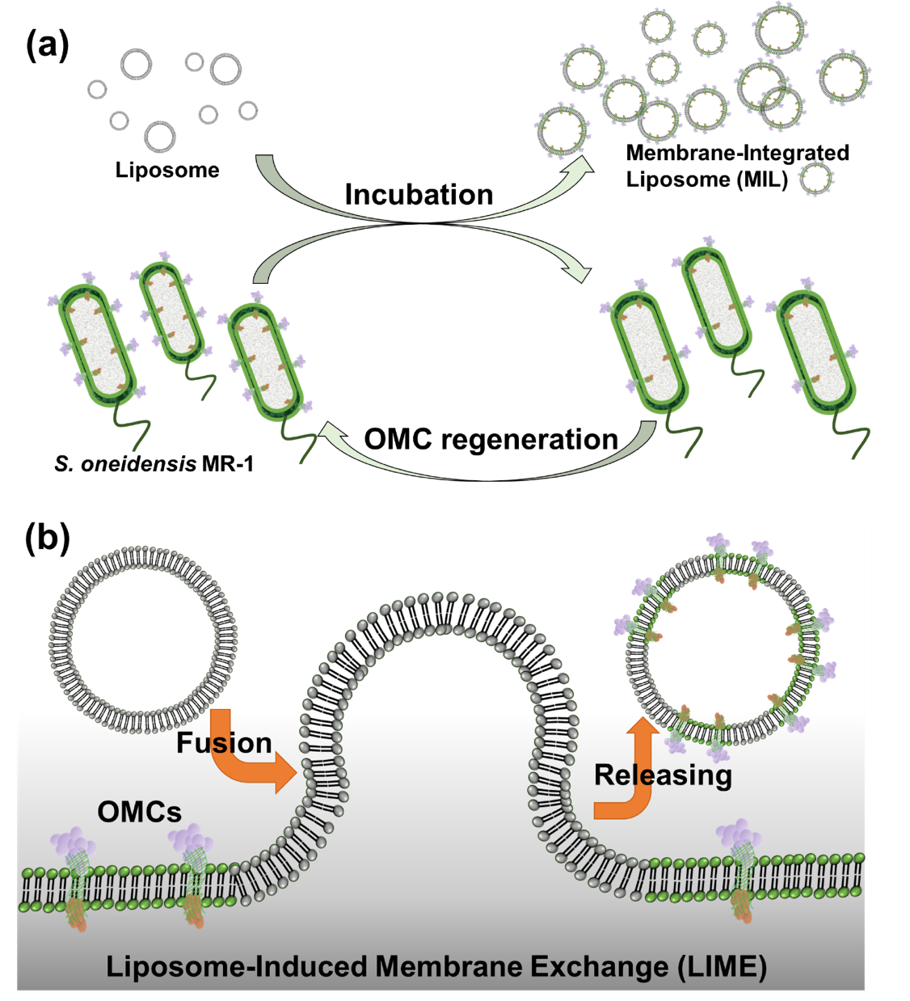
Scheme 1. Membrane-integrated liposome (MIL) production via liposome-induced membrane exchange (LIME). (a) Schematic illustration demonstrating the production of MILs. Shewanella oneidensis MR-1 with outer-membrane cytochrome (OMC) complex are incubated with liposomes, enabling bacterial cell and scalable MIL production. (b) Detailed model of the LIME process. This panel illustrates the fusion between the liposome and S. oneidensis MR-1, followed by the release of MILs carrying OMCs.

2. EXPERIMENTAL SECTION
2.1. Materials. All reagents were of analytical purity and used without further purification. Sodium lactate solution (CH₃CH(OH)COONa, 70%), ammonium chloride (NH₄Cl, 99.5%), calcium chloride dihydrate (CaCl₂·2H₂O, 95%), sodium bicarbonate (NaHCO₃, 99.5%), sodium chloride (NaCl, 99.5%), and magnesium chloride hexahydrate (MgCl₂·6H₂O, 98%) were bought from Wako. 2-[4-(2-hydroxyethyl)-1-piperazinyl] ethanesulfonic acid (HEPES, C₈H₁₈N₂O₄S, 99%) was purchased from Dojindo. LB broth (Luria-Bertani, miller), and yeast extract were obtained from BD. 1,2-dioleoyl-sn-glycero-3-phosphoethanolamine (DOPE), and 1,2-dioleoyl-sn-glycero-3-phosphocholine (DOPC) were purchased from Avanti Polar Lipids, Inc. N-(Texas Red sulfonyl)-1,2-dihexadecanoyl-snglycero-3-phosphoethanolamine, triethylammonium salt (Texas Red®-DHPE) was purchased from Biotium. Chloroform (CHCl₃, 99%), sodium phosphate dibasic (Na₂HPO₄, 99%), and sodium phosphate monobasic (NaH₂PO₄, 99%) were bought from Sigma-Aldrich. FM™ 1-43 Dye (N-(3-Triethylammoniumpropyl)-4-(4-(Dibutylamino) Styryl) Pyridinium Dibromide) was obtained from Invitrogen. Deionized water was obtained by using a Millipore direct-Q water purification system.
2.2. Preparation of DM medium with 10 mM lactate (DM-L). These materials contained 1.25 g of NaHCO₃, 0.04 g of CaCl₂, 0.5 g of NH₄Cl, 0.1 g of MgCl₂, 5 g of NaCl, 3.6 g of HEPES, and 0.25 g of yeast extract were added in 0.5 L of ultrapure water. Then, the solution was autoclaved at 122 ℃ for 25 min to obtain the sterile DM medium. The 0.8 g filtered sodium lactate solution (70%) was added to sterile DM medium to harvest the DM-L medium.
2.2. Preparation of liposome. The extrusion method was applied to prepare the liposomes. The extruder was obtained from Avanti Polar Lipids, Inc. The 100 mg of DOPC and DOPE powder were dissolved in 5 mL of chloroform as lipid stock solutions, respectively. 0.252 mL DOPC and 0.059 mL DOPE were mixed together in a glass bottle, and then the mixture was dried through N₂ gas purging to form the lipid film. Afterward, 0.8 mL of PBS buffer was added to the bottle, and the sample was fizzed with liquid nitrogen until forming the ice phase. Then, the sample was melted by immersing it in a warm bath. The cooling-melting process was repeated several times until the lipid film was completely dispersed into the buffer. The polycarbonate membrane with 100 nm pores was set inside the extractor. Then, the lipid solution filled up the syringe and injected into the extractor for extruding operation at least ten times. Afterward, the liposomes were obtained and stored in the refrigerator for future use.
For the preparation of TR dye-loaded liposomes, an adjustive of 1 % Texas Red®-DHPE was added to the lipid mixture and followed the same fabrication process.
2.4. Cell culture of S. oneidensis MR-1 and E. coli. The bacteria were sub-cultured in 15 mL of sterile LB solution for aerobic incubation at 30 °C. After 20 hours, the culture solution was centrifuged at 6000 rpm for 10 min, and then the bacterial pellet was dispersed by DM-L. The cells were washed with DM-L at least two times before use in further experiments. UV-vis was used to measure the optical density at 600 nm (OD₆₀₀) of bacteria.
2.5. Liposome-induced membrane exchange process. 0.5 mL of liposomes (1 mg) were added in 1 mL of S. oneidensis MR-1 of OD₆₀₀ at 1.0, and then the sample was sharked in 30 °C incubation for 20 hours. After that, the solution was centrifuged at 6000 rpm for 5 min to obtain the supernatant and it was centrifuged again to remove bacteria. Afterward, the supernatant was filtered with 0.45 um of porous size to remove residual bacteria completely. Then, the solution was centrifuged through ultracentrifugation (210,000 g, 4 h) to get the MIL for further characterization and use.
For TEM analysis, before loading with the MIL sample, the copper carbon-coated grid (Electron Microscopy Sciences) was subjected to glow discharge treatment. The MIL sample was loaded onto the copper carbon-coated grid and negatively stained with 2% uranyl acetate (Merck & Co., Inc.) for 30 sec. The samples were then air-dry and examined with JEM-1400 Transmission Electron Microscope (JEOL).
2.6. Electrochemical measurement. The sealed reactor with the three electrodes system was used for related electrochemical measurements. The 6.5 mL DM-L medium was added into the reactor, and then the oxygen in this sealed system was removed by N₂ purging for 20 min. Afterward, the reactor was connected with the potentiostat at 30 °C for further electrochemical analysis. The electrode was poised at a potential of +0.2 V for starting measurement. After 30 min, the 0.1 mL of E. coli. suspension was injected into the reactor with a final concentration of 0.8 optical density (OD₆₀₀). After another 30 min, 200 μL of MIL at different concentrations (0.5, 1, 5, and 10 mg/mL) or DM-L was added to the reactors correlated to their experimental group. For the group of MIL (5 mg/mL) alone, the same experiment process was followed, but no bacteria were provided in the reactor. The concentration of MIL was determined by protein assay.
2.7. Fluorescence imaging for observation of fusion and liberation processes. For the observation of fusion, TR dye-loaded liposome (TR-liposome) was applied with S. oneidensis MR-1. After incubation for 20 hours, the sample was centrifuged at 6000 ppm for 5 min to obtain the bacterial pellet and re-dispersed in the fresh DM-L. The washing process was conducted at least two times to remove free TR-liposomes. Then, the imaging was observed through a fluorescence microscope with excitation at 590 nm and emission at the range of 620-700 nm.
For the observation of MIL liberation, FM™ 1-43 Dye was used to stain the MR-1 cells in a standard protocol of dye staining. The dye-stained cells were co-incubation with liposomes at 30 °C for 20 hours. Afterward, the sample was dropped on the glass slide for further observation via a microscope with excitation at 590 nm and emission detection at a range of 620-700 nm.

3. RESULTS
3.1. Nanoparticle production via incubating liposome with S. oneidensis MR-1
Liposomes, composed of 80% 1,2-dioleoyl-sn-glycero-3-phosphocholine (DOPC) and 20% dioleoyl-sn-glycero-3-phosphoethanolamine (DOPE), were synthesized using a standard extrusion method, resulting in a uniform size distribution of 70-100 nm (see Supplementary Fig. S1). These liposomes were incubated with a culture of S. oneidensis MR-1 in a defined medium (DM) at 30°C for 20 hours under vigorous shaking conditions. Following incubation, bacteria and supernatant were separated via centrifugation (Fig. 1a). The bacterial pellet that had been exposed to the liposomes exhibited a significant reduction in orange coloration compared to control pellets (Fig. 1b), indicating a possible interaction between the liposomes and OMCs.
To confirm this notion, the pellet was resuspended and subjected to UV-visible spectroscopy using an integrating sphere. This analysis revealed a decrease in absorption at the Soret band at 410 nm, suggesting that the liposomes facilitated the release of OMCs from the cellular membrane into the supernatant (Fig. 1c). Importantly, this release did not result from cellular lysis, as the viability of the bacteria was not compromised by the addition of liposomes (Fig. 1d and S2). This observation suggests that OMCs were released from the cellular membrane into solution and/or liposome fractions, without compromising cell integrity.
Further analysis of the supernatant that had been exposed to liposomes revealed significantly increased absorbance compared to that from a regular culture without liposomes (Fig. 1e). To differentiate between soluble cytochromes and those associated with liposomes, the supernatant was subjected to ultracentrifugation. This process yielded a bright red pellet indicative of OMCs that had been transferred to the liposome fraction (Fig. 1f). Transmission electron microscopy (TEM) of the pellet confirmed the presence of vesicular structures with diameters ranging from 50 to 200 nm, notably larger than the original added liposomes (Fig. 2a). Dynamic light scattering (DLS) analysis provided a size profile consistent between the supernatant and pellet, supporting that the absorption peaks of OMCs in supernatant sample correspond to these nanoparticles (Fig. 2b). Moreover, inductively coupled plasma mass spectroscopy (ICP-MS) quantified iron content in the pellet at 358.2 ppb (Fig. 2c), further substantiating the integration of OMC into the liposomes. The protein concentration and particle number reached their maximum values when 50 µL of the stock liposome solution was added to the MR-1 cell suspension, as shown in Figs S3 and S4. Furthermore, the size of the MILs remained stable for at least 21 days when stored at 4 °C, as confirmed by TEM and DLS analyses. In contrast, clustering of the MILs was observed after three days of storage at 25 °C, indicating that the lipid fluidity within the MILs is preserved under room temperature (Figs S5 and S6).
Contrastingly, the supernatant from the culture not co-incubated with liposomes did not yield a visible pellet (Fig. 1f), indicating a significantly low yield of native outer membrane vesicles (OMVs) from the typical culture after 20 hours of incubation. Although insufficient biogenic OMVs were harvested for DLS, TEM analysis of this control sample revealed particles with diameters ranging from 20 to 80 nm (Fig. 2c inset), demonstrating a distinct size profile from the nanoparticles obtained in co-incubation with liposomes. These findings suggest that the interaction between liposomes and MR-1 cells results in the integration of microbial membrane components into the liposomes, forming what we have termed membrane-integrated liposomes (MIL).
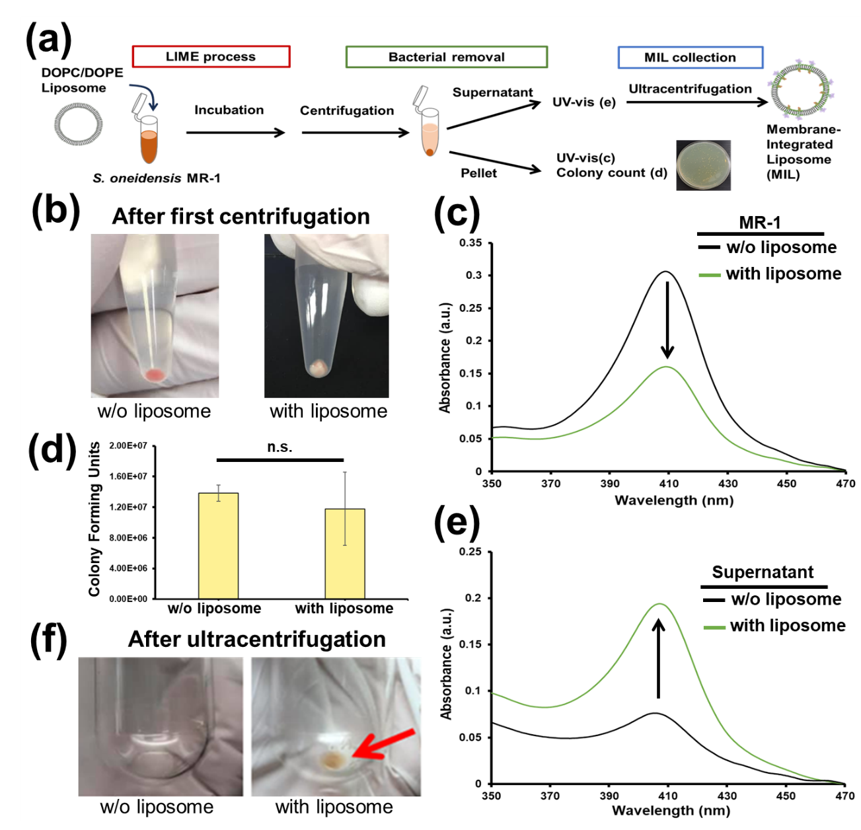
Fig. 1. Effect of coincubation with liposome and S. oneidensis MR-1. (a) The illustration showed the experimental procedure of LIME. (b) The bacterial pellet obtained after incubation and centrifugation was shown in the photos. (c) The diffraction transmission UV-vis spectra of S. oneidensis MR-1 cell after incubating with and without liposome. (d) The colony assay of bacterial pellets from normal and LIME cultures to check the cellular viability. (e) UV-vis spectra of the supernatant solution after centrifugation at 6000 rpm for 5 minutes to remove cells. (f) The photograph of the pellet collected with and without fusion with liposome after ultracentrifugation (50,000 rpm, 210,000 g, 4 h). (Pellet was labeled by red arrow). No visible pellet was observed w/o liposome dosage.

3.2. Identification and characterization of OMCs in the MIL
We confirmed the presence of OMCs in the MIL using sodium dodecyl sulfate polyacrylamide gel electrophoresis (SDS-PAGE) (Fig. 2d). Coomassie Brilliant Blue (CBB) staining revealed a series of protein bands closely matching those previously reported for MR-1 outer-membrane components, indicating the transfer of these proteins to the MIL [28]. Furthermore, heme staining highlighted specific bands corresponding to the OMCs components, MtrC, MtrA, and OmcA proteins, confirming their presence in the MIL. Additional verification was provided by redox-dependent staining with 3,3'-diaminobenzidine (DAB) and osmium tetroxide, which facilitated high-resolution transmission electron microscopy (HR-TEM) observations (Fig. S7) [29,30]. This redox-dependent staining method that targets cytochromes indicate the localization of OMCs in the MIL surface.
Circular dichroism (CD) spectroscopy was employed to specifically quantify OMCs with exclusively higher inter-heme exciton coupling among ten heme centers compared with other cytochromes in MR-1 [31].³¹ The CD spectra of the MIL-containing solution displayed distinct signals at 392 and 417 nm, characteristic of the MtrCAB-OmcA complex in both intact bacteria and purified proteins (Fig. 2e and S8) [31,32]. Normalizing signal intensity to heme concentration revealed that the differential molar absorptivity (∆ε) was comparable with that of intact MR-1 cells, indicating preserved inter-heme coupling within the OMCs in MIL [31].³¹ Notably, approximately 51.7% of the OMCs were transferred to the MIL, well consistent with the observations in Fig. 1c.
Moreover, redox activity was retained in these proteins as indicated by a red-shift of approximately 7 nm in characteristic peaks under anaerobic conditions, demonstrating their redox functional integrity outside the host cell environment (Fig. 2f) [31]. This redox state-dependence was further corroborated by UV-visible spectroscopy measurements (Fig. S9), affirming that both redox activity and inter-heme interactions are maintained in the non-host MIL environment. The heme-staining electrophoresis profiles at various time points demonstrated the sustained presence of MtrC and OmcA for over two weeks, even at 25 °C, in amounts comparable to those observed in MILs stored at 4 °C (Fig. S10). In contrast, the gradual decrease in MtrA levels at both 4 °C and 25 °C may be attributed to its intrinsic ability to dynamically associate and dissociate with the porin MtrB.
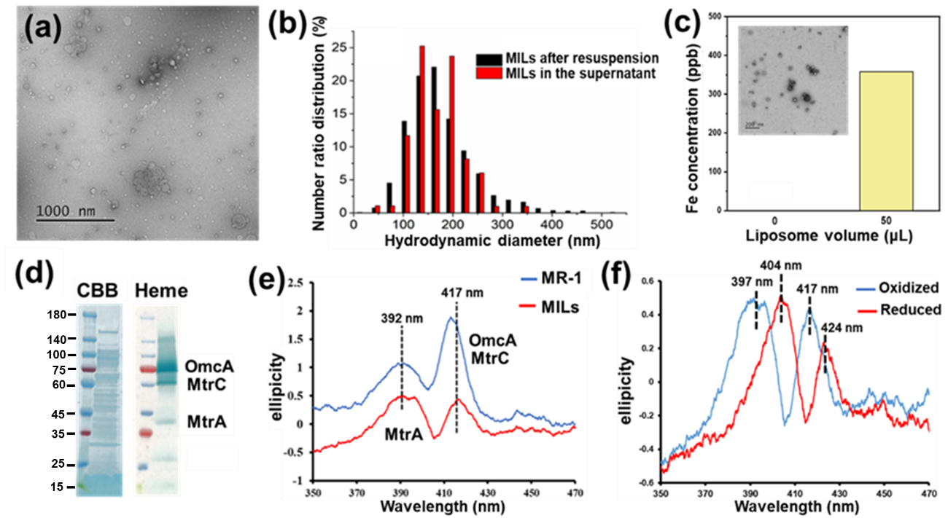
Fig. 2. Characterization of nanoparticle form liposome-microbe incubation. (a) The TEM image of vesicular MILs stained with 2% uranyl acetate shows size distribution as 63.9 ± 24.5 nm. (b) The size distribution of MIL in the supernatant and the resuspended solution. The MIL in supernatant was directly injected into Zetaview analyzer. The resuspended MIL sample was obtained after ultra-centrifugation. (c) The Fe quantitative analysis of OMVs and MILs by inductively coupled plasma mass spectroscopy (ICP-MS, Thermo Fisher Scientific iCAP TQ). The analyzed OMVs and MILs were respectively made by adding 0 and 50 μL liposomes in the LIME reaction of S. oneidensis MR-1, then concentrating ten times before ICP-AES measurement. (d) Protein profiles of MIL, stained with the Coomassie brilliant blue (CBB) and heme-reactive 3,3ʹ,5,5ʹ-tetramethylbenzidine-H₂O₂ (heme staining). The numbers at the left side of markers show the scale of the molecular weight in kilodaltons. (e) Circular Dichroism (CD) spectra of S. oneidensis MR-1 and MIL dispersed in defined medium (DM). Samples are collected after 20 hours’ incubation. (f) The CD spectra of S. oneidensis MR-1 supernatant under oxidative and reductive condition. The supernatant was reduced by adding sodium dithionite (50 mg/3 mL).

3.3. Preserved OMCs function after the MIL merging into E. coli
A pivotal application of functionalized liposomes is the delivery of biological molecules. In this context, we investigated whether MIL could deliver OMCs complex to Escherichia coli while preserving their function and activity (Fig. 3a). It is previously documented that genetically engineered E. coli overexpressing MtrCAB proteins can produce electrical current similar to MR-1 [33]. To assess the functionality of MIL in a similar capacity, we measured the impact of MIL on the current production of E. coli. Adding MIL with five mg/ml protein concentration to the bioreactor, which contained wild-type E. coli and 10 mM glucose with an indium tin oxide (ITO) working electrode poised at +200 mV vs saturated Ag/AgCl reference electrode, resulted in a five-fold increase in current production compared to controls without MIL at 15 hours (Fig. 3b). Notably, MIL alone produced no current, underscoring the necessity of bacterial metabolic reaction to transfer electron to the ITO electrode. When varying the concentration of MILs added, the current generation by MIL-fused E. coli reached a plateau at a protein concentration of 5 mg/mL, indicating that the maximum delivery of outer membrane cytochromes (OMCs) had been achieved. The current production with MIL was not only comparable to that observed in MR-1 but also significantly higher than that in genetically engineered E. coli containing the MtrCAB complex under identical conditions, which showed 1.2-fold enhancement [34]. This suggests that MIL introduction achieves a more efficient incorporation of MtrCAB than traditional genetic engineering methods.
To confirm the incorporation of OMCs into the outer membrane of E. coli, we analyzed the localization and function of OMCs after the electrochemical measurement. UV-visible spectroscopy of the bacterial resuspension post-MIL removal revealed that the MIL successfully donated OMCs to E. coli (Fig. 3c). SDS-PAGE analysis identified specific protein bands corresponding to MtrC and OmcA in the membrane fraction of E. coli, whereas these bands were absent in native E. coli (Fig. 3d). MtrA was not detected in the membrane fraction of E. coli, most likely due to the decomposition or loss of MtrA. CD spectroscopy was utilized to examine the intra-heme exciton coupling in MIL-integrated E. coli. While the native E. coli exhibited no characteristic peaks in the CD spectrum, the MIL-integrated E. coli displayed a peak at approximately 410 nm under oxidative conditions (Fig. 3e). Different cellular backgrounds would explain the different peak wavelengths from MR-1 [35]. No CD signals were detected in the supernatant, indicating efficient fusion of MIL into E. coli cells and preservation of strong multi-heme exciton coupling.
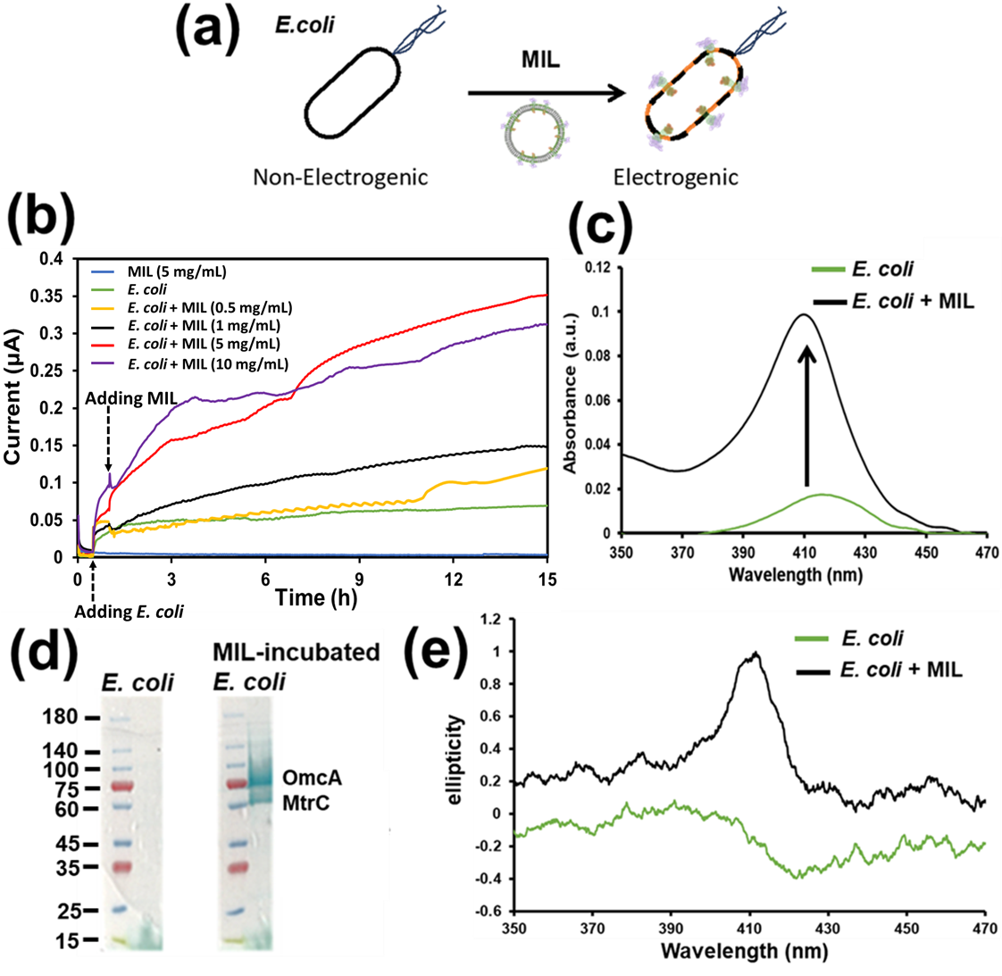
Fig. 3. The MIL increasing electron transfer capacity of E. coli. (a) The schematic of bioelectricity enhancement of E. coli through transplant of electrochemically active MIL to bacterial outer membrane for facilitating metabolic electrons transfer to the electrode. (b) The single-potential amperograms of E. coli, E. coli + MIL and MIL alone at 0.2 V versus the saturated Ag/AgCl reference electrode at 30 °C. The E. coli (0.8 O.D. in final concentration) and 200 μL MIL (0.5, 1, 5, and 10 mg/mL of protein amount) were added into the electrochemical reactors at 0.5 and 1 h, respectively. (c) The UV-vis spectra of E. coli, MIL-fused E. coli, and its supernatant. (d) Protein profiles of E. coli and E. coli incubated in the presence of MIL (MIL-incubated E. coli), stained with heme-reactive 3,3ʹ,5,5ʹ-tetramethylbenzidine-H₂O₂ (heme staining). The numbers at the left side of markers show the scale of the molecular weight in kilodaltons. (e) The CD spectrum of E. coli, MIL-fused E. coli, and its supernatant.

3.4. OML production mechanism via Liposome-Microbe Interaction
To investigate the mechanism of OMCs transfer from MR-1 cells to DOPE-DOPC liposomes, we continuously monitored their interaction. We noted a significant elevation in the total protein concentration in the supernatant, peaking after 20 hours of incubation (Fig. S11), suggesting a gradual transfer of OMCs from the cells to the liposomes. TEM provided insights into the physical interactions between the liposomes and MR-1 cells after 2 and 24 hours. These interactions were evident as direct contact between the liposome and microbial cell surfaces. Despite notable differences in protein content, the cellular size remained constant (Fig. 4a and 4b), with cellular shape consistency also confirmed by Scanning Electron Microscopy (SEM) (Fig. S12). A significant decrease in MIL production was observed when using 100% DOPC liposomes compared to 20% DOPE-doped liposomes (Fig. S13), emphasizing the critical role of the highly fluid DOPE component in promoting membrane activation and fusion. Given that OMCs are outer-membrane-bound protein complexes, these findings indicate a dynamic exchange of lipids and proteins between the liposomes and the outer membrane, facilitating the OMC transfer to the MILs without altering cellular morphology.
To track the lipid exchange directly, we utilized a fluorescence labeling method. By integrating 1% TR-DOPC—a fluorescent probe-grafted lipid—into the liposomes, we produced TR-liposomes that enabled visualization of the liposome-bacteria fusion events. The fluorescence spectrum of the TR-liposomes showed a broad emission peak at 620 nm under excitation at 590 nm, confirming successful probe integration (Fig. S14). The fusion between the TR-liposome and the MR-1 membrane was evident from the fluorescence observed in TR-merged cells, in stark contrast to the non-fluorescent native cells (Fig. S15). Dark-field fluorescence imaging indicated that 54.8% of the MR-1 cells displayed noticeable fluorescence after exposure to TR-liposomes, further validating the fusion (Fig. 4c).
Furthermore, the lipid transfer to the liposomes from MR-1 cells was confirmed using FM™ 1-43 dye, a recognized cell membrane probe. Fluorescence imaging of the FM-stained cells clearly outlined the rod-shaped contours of the bacterial cells (Fig. S16). Following a standard 20-hour incubation, no changes in fluorescence patterns were noted, suggesting maintained membrane integrity. However, post-incubation with the liposomes revealed a significant transformation, with a loss of the characteristic rod-shaped contours and the appearance of numerous small, round fluorescent spots, indicating that outer membrane lipids were transferred to the MILs.
Lipidomic analysis revealed substantial changes in the membrane lipid composition of MR-1 cells post-fusion after a 20-hour incubation. Initially, the bacterial cells predominantly contained phosphatidylethanolamine (PE) at 92.87% and a minuscule quantity of phosphatidylcholine (PC) at 0.011%. After liposome fusion, the ratios of PE and PC shifted to 84.89% and 1.9%, respectively, demonstrating the incorporation of liposome-derived lipids (Fig. 4d). The LIME process notably altered the carboxylic acid chain lengths in the lipids of MR-1 cells. Pre-fusion, MR-1 cells showed a predominance of C34:1 (88.34%) and C34:2 (11.64%) in their native PC composition. Post-fusion, there was a substantial decrease in these ratios and an increase in C36:1/C36:2 ratios, reflecting the introduction of external lipids into the cell membrane (Fig. 4e and f). These findings underscore a complex mechanism of membrane exchange, involving lipid and protein migration and reorganization, that transforms the cell membrane composition and function through the LIME process.
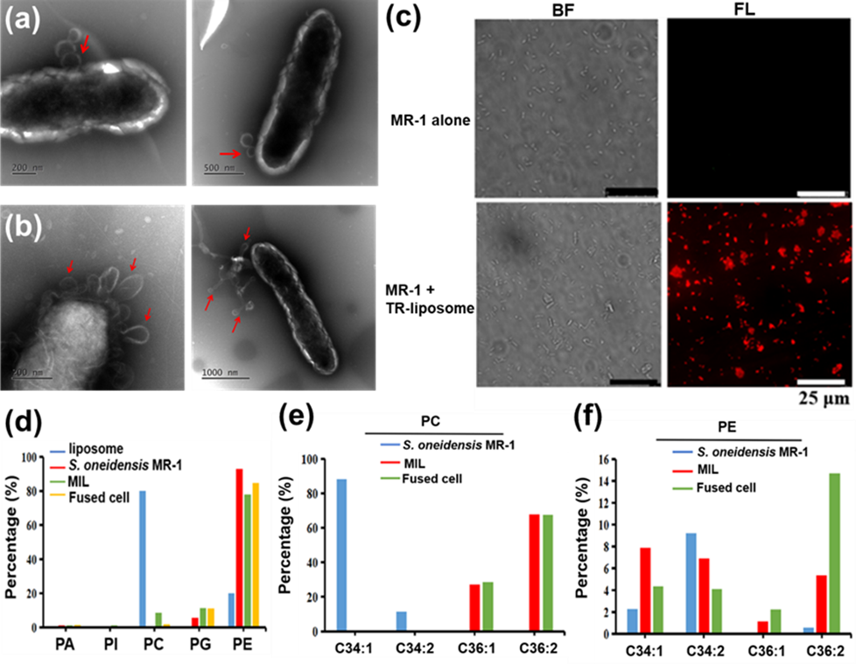
Fig. 4. Exploration of LIME mechanism through lipidomic analysis. The TEM images of S. oneidensis MR-1 after the incubation for (a) 2 and (b) 24 hours with liposome. The red arrows indicate the positions of liposome fusion and MIL budding for a and b, respectively. (c) The bright field (BF) and fluorescence (FL) images of MR-1 and TR-inserted MR-1. The scale bars were all set as 25 µm for these images. (d) Lipidomic analysis revealed the percentage of lipid type in liposome, S. oneidensis MR-1, MIL, and fused cells. (e, f) Comparing the ratio of lipid types (PC and PE) in S. oneidensis MR-1, MIL, and fused cells.

4. DISCUSSION AND CONCLUSION
Our results highlight the effectiveness of our novel co-incubation strategy in producing MILs that incorporate essential elements of the bacterial outer membrane, including OMCs. By directly transferring OMCs from S. oneidensis MR-1 to artificial liposomes, we show that any membrane component can be integrated without causing cell death or loss of functionality through membrane exchanging processes. This strategy not only overcomes the limitations of current liposome functionalization techniques but also represents a significant advancement in integrating biological complexity with nanoscale engineering [13-17, 20].
This method addresses the challenges of mimicking natural EVs, such as low productivity, high costs, and extended culture times, as well as the immunogenicity and limited functionality of traditional artificial liposomes [18,19,21,22]. The LIME process for liposome functionalization offers significant resource advantages. Approximately 60% of outer membrane cytochromes (OMCs) were successfully transferred to the liposomes, and viability assays confirmed that LIME does not induce cellular stress or lysis, allowing post-LIME cells to be recycled for subsequent use, thereby reducing costs for culture medium and enhancing scalability (Fig. 1 and 2) [36,37]. Scaling up the LIME process requires only standard industrial microbial culture tanks and separation systems, such as multi-segment filtration, which further simplifies its implementation [38].
Compared to existing methods (Table S1), LIME demonstrates unique features that overcome key limitations in current approaches to liposome functionalization. For example, strategies involving sophisticated surface modifications of liposomes using advanced chemical engineering techniques often encounter significant drawbacks, including residual chemical contaminants in final products, high costs associated with artificial protein preparation, complex synthesis procedures, and non-native protein architecture [39-46]. Genetic engineering approaches, which enable cells to secrete functionalized liposomes with native protein architectures, hold promise for future applications [42]. However, the genetic engineering technique relies on specialized expertise and equipment, limiting their widespread adoption. Additionally, the high cost and limited cell type applicability for genetic engineering techniques have also significantly restricted their recent development. An alternative strategy involves the direct integration of liposomes with membrane fragments derived from cell lysates [43-46]. While this method is cost-effective and straightforward, it has significant limitations, including contamination risks from residual detergents, heavy metal ions, chemicals, cytotoxins, and pathogenic genes, which compromise the purity, properties, and clinical applicability of the resulting liposomes. In contrast, the LIME process offers a practical and scalable solution, addressing these limitations and paving the way for the production of functionalized liposomes that closely mimic natural EVs, while maintaining high purity and broad applicability in clinical and industrial settings.
MIL produced via the LIME method were highly stable in the biological environments and no noticeable negative effect in cultured animal cell viability, functioning properly to enhance electron mobility in catalytic reactions for treating orthotopic liver tumors in vivo [20]. The upconversion nanoparticle (UCNP) coated with electroactive MIL shows considerable enhancement in the luminescence feature for in vitro cell imaging, attributed to the reductive MIL donating additional electrons into the UCNP core and activating the photoluminescence system [47]. Our approach facilitates the use of liposomes as versatile platforms for various biomedical applications, from precision medicine to sustainable biocatalytic processes [7,20].
Delivery of intact OMCs to E. coli increased microbial current production, indicating the formation of a direct electron transfer pathway [33,34]. This fusion of MILs to the outer membrane likely facilitates the delivery of encapsulated substrates to the cell interior, crucial for drug delivery and cell engineering applications. Additionally, when combined with synthetic biology to modify membrane-bound biomolecules [33], this method offers a robust, scalable solution for designing functionalized liposomes, potentially revolutionizing fields like drug delivery [22].
The transfer of OMCs to MILs is associated with a lipid exchange mechanism between the outer membrane and the liposome (Fig. 4). While membrane fusion between liposomes or EVs and cellular membranes has been proposed [23,24], the post-fusion release of vesicles is not fully understood. Our TEM images show physical interactions between the liposome and MR-1 cells even after 24 hours incubation where protein export to the liposome saturated, suggesting that there is equilibrium between cellular membrane and liposome contents. In line with this, the ideal conditions for the LIME process include an optimized ratio of liposomes to bacterial cells (Figs. S3 and S4), continuous shaking to prevent bacterial sedimentation, sufficient incubation time to achieve maximal MIL yield (Fig. S11), the absence of nutrients that could trigger lipid internalization, and a temperature range conducive to maintaining bacterial activity.
The lack of change in living cell numbers indicates that MILs are not produced through cellular explosion or lysis but rather through a membrane blebbing mechanism, driven by the excess lipid supply from liposomes. Analysis of encapsulated substrates would support this hypothesis [48]. While 60% of OMCs were transferred to the liposomes, the surface area of MILs is significantly larger than the cellular surface, potentially reducing OMC density on MIL surfaces. The composition of the liposomes used is a critical determinant of membrane fusion efficiency, influenced by factors such as surface charge, lipid-membrane interactions, and the stability of the lipids in the bilayer structure [49,50]. Positively charged liposomes are particularly effective in promoting membrane fusion due to enhanced electrostatic interactions with the negatively charged bacterial surface. Previous studies have described the fusion of positively charged liposomes with cell membranes and subsequent membrane detachment under conditions of excess liposome fusion, although hybrid vesicle production was not addressed [49]. In this study, liposomes composed of quaternary amine cation-terminal DOPC and primary amine cation-terminal DOPE exhibited strong positive charge properties, enabling robust electrostatic interactions with S. oneidensis MR-1. Moving forward toward practical applications, future research will aim to optimize the lipid composition, materials, and dosages to further enhance the efficiency of protein transfer and improve MIL performance for various applications.
In conclusion, our study introduces a novel technique that bridges microbial processes and material science, setting a precedent for the development of bio-inspired materials. This approach expands the potential of functionalized liposomes as sophisticated biomimetic devices capable of unprecedented interactions within biological systems, suggesting a paradigm shift in biomimetic nanocarrier design and manufacture. As we explore the synergies between microbial processes and nanomaterial engineering, the horizon of possibilities broadens, paving the way for advancements previously deemed unattainable.

ASSOCIATED CONTENT
Supporting Information. Additional Table S1, stability evaluation, NTA result, zeta potential analysis, EM images, fluorescence images, emission spectra, CD analysis, UV-Vis spectrum, colony assay, and protein assay.

AUTHOR INFORMATION
Corresponding Author
Wei-Peng Li; Email: wpli@kmu.edu.tw
Akihiro Okamoto; Email: okamoto.akihiro@nims.go.jp
Author Contributions
Concept, A. Okamoto; methodology, X. Long, C. Kataoka-Hamai, and W.-P. Li; validation, X. Long, C. Ho, W.-L. Huang, Y.-H. Kuo, L.-T. Yang, and W.-P. Li; data analysis, X. Long, W.-P. Li, and A. Okamoto; resources, W.-P. Li and A. Okamoto; writing—original draft preparation, X. Long, and W.-P. Li; writing—review and editing, A. Okamoto. All authors have read and agreed to the published version of the manuscript. ‡W.-P. Li and X. Long contributed equally to this work.
Notes
The authors declare that they have no competing financial interests.

ACKNOWLEDGMENT
This work was financially supported by a Grant-in-Aid for Research from the Japan Society for the Promotion of Science KAKENHI (Grant No. 17H04969); PRIME, the Japan Agency for Medical Research and Development (19gm6010002h0004); JST, PRESTO (Grant No. JPMJPR19H1), Japan; and the postdoctoral program from Japan Society for the Promotion of Science (Grant No. P20105). Prof. Li acknowledges the financial support provided by the National Science and Technology Council (NSTC), Taiwan (112-2113-M-037-014-MY2 and 113-2320-B-037-007-), and the Yushan Young Scholar Program of the Ministry of Education of Taiwan. Prof. Huang acknowledges the financial support in part by Higher Education Sprout Project, Ministry of Education to the Headquarters of University Advancement at National Cheng Kung University. The authors thank the Core Facility Center of National Cheng Kung University in Taiwan for providing their research equipment (EM000600 of NSTC 110-2731-M-006-001 and EM000800 JEOL JEM-2100F Cs STEM) for use in this study. We thank the technical services provided by “the i-MANI center of the National Core Facility for Biopharmaceuticals, Ministry of Science and Technology, Taiwan” as well as the technical service from the Instrument Development Center of the National Cheng Kung University.

REFERENCES
- C. Schwechheimer, M. J. Kuehn, Outer-membrane Vesicles from Gram-negative Bacteria: Biogenesis and Functions. Nat. Rev. Microbiol. 13 (2015) 605-619.
- A. T. Jan, Outer Membrane Vesicles (OMVs) of Gram-negative Bacteria: A Perspective Update. Front. Microbiol. 8 (2017) 1053.
- J. C. Contreras-Naranjo, H.-J. Wu, V. M. Ugaz, Microfluidics for Exosome Isolation and Analysis: Enabling Liquid Biopsy for Personalized Medicine. Lab Chip 17 (2017) 3558-3577.
- A. T. Srivatsav, S. Kapoor, The Emerging World of Membrane Vesicles: Functional Relevance, Theranostic Avenues and Tools for Investigating Membrane Function. Front Mol Biosci. 8 (2021) 640355.
- K. E. Bonnington, and M. J. Kuehn, Protein Selection and Export via Outer Membrane Vesicles. Biochim. Biophys. Acta 8 (2014) 1612-1619.
- G. Qing, N. Gong, X. Chen, J. Chen, H. Zhang, Y. Wang, R. Wang, S. Zhang, Z. Zhang, X. Zhao, Y. Luo, X.-J. Liang, Natural and Engineered Bacterial Outer Membrane Vesicles. Biophys. Rep. 5 (2019) 184-198.
- P. Martins, D. Machado, T. H. Theizen, J. P. O. Guarnieri, B. G. Bernardes, G. P. Gomide, M. A. F. Corat, C. Abbehausen, J. L. P. Módena, C. F. O. R. Melo, K. N. Morishita, R. R. Catharino, C. W. Arns, M. Lancellott, Outer Membrane Vesicles from Neisseria Meningitidis (Proteossome) Used for Nanostructured Zika Virus Vaccine Production. Scientific Reports 8 (2018) 8290.
- X. Liu, X. Jing, Y. Ye, J. Zhan, J. Ye, S. Zhou, Bacterial Vesicles Mediate Extracellular Electron Transfer. Environ. Sci. Technol. Lett. 7 (2019) 27-34.
- M. Toyofuku, Bacterial Communication through Membrane Vesicles. Biosci. Biotechnol. Biochem. 83 (2019) 1599-1605.
- N. L. Syn, L. Wang, E. K.-H. Chow, C. T. Lim, B.-C. Goh, Exosomes in Cancer Nanomedicine and Immunotherapy: Prospects and Challenges. Trends biotechnol. 35 (2017) 665-676.
- A. Akbarzadeh1, R. Rezaei-Sadabady, S. Davaran, S. W. Joo, N. Zarghami, Y. Hanifehpour, M. Samiei, M. Kouhi, K. Nejati-Koshki, Liposome: Classification, Preparation, and Applications. Nanoscale Research Letters 8 (2013) 102.
- Y. P. Patil, S. Jadhav, Novel Methods for Liposome Preparation. Chemistry and Physics of Lipids 2014, 177, 8-18.
- C. Wang, X. Lan, L. Zhu, Y. Wang, X. Gao, J. Li, H. Tian, Z. Liang, W. Xu, Construction Strategy of Functionalized Liposomes and Multidimensional Application. Small (2024) 2309031.
- Z. Zhang, Z. Feng, X. Zhao, D. Jean, Z. Yu, E. R. Chapman, Functionalization and Higher-Order Organization of Liposomes with DNA Nanostructures. Nat. Commun. 14 (2023) 5256.
- A. Ohradanova-Repic, E. Nogueira, I. Hartl, A. C. Gomes, A. Preto, E. Steinhuber, V. Mühlgrabner, M. Repic, M. Kuttke, A. Zwirzitz, M. Prouza, M. Suchanek, G. Wozniak-Knopp, V. Horejsi, G. Schabbauer, A. Cavaco-Paulo, H. Stockinger, Fab Antibody Fragment-Functionalized Liposomes for Specific Targeting of Antigen-Positive Cells. Nanomedicine: Nanotechnology, Biology, and Medicine 14 (2018) 123-130.
- M. M. A. Mitry, F. Greco, H. M. I. Osborn, In Vivo Applications of Bioorthogonal Reactions: Chemistry and Targeting Mechanisms. Chem. Eur. J. 29 (2023) e202203942.
- V. D. Leo, A. M. Maurelli, L. Giotta, L. Catucci, Liposomes Containing Nanoparticles: Preparation and Applications. Colloids and Surfaces B: Biointerfaces 218 (2022) 112737.
- X. Y. Zhu, T. Y. Wang, H. R. Jia, F. G. Wu, Immunocyte-Derived Nanodrugs for Cancer Therapy. Adv. Funct. Mater. 32 (2022) 2207181.
- R. Tian, Z. Wang, R. Niu, H. Wang, W. Guan, J. Chang, Tumor Exosome Mimicking Nanoparticles for Tumor Combinatorial Chemo-Photothermal Therapy. Front. Bioeng. Biotechnol. 8 (2020) 1010.
- Y. C. Chen, Y. T. Li, C. L. Lee, Y. T. Kuo, W. C. Lin, C. Ho, M. C. Hsu, X. Long, J. S. Chen, W. P. Li, C. H. Su, A. Okamoto, C. S. Yeh, Electroactive Membrane Fusion-Liposome for Increased Electron Transfer to Enhance Radiodynamic Therapy. Nat. Nanotechnol. 18 (2023) 1492-1501.
- L. Jiang, Y. Zhu, P. Luan, J. Xu, G. Ru, J.-G. Fu, N. Sang, Y. Xiong, Y. He, G.-Q. Lin, J. Wang, J. Zhang, R. Li, Bacteria-Anchoring Hybrid Liposome Capable of Absorbing Multiple Toxins for Antivirulence Therapy of Escherichia coli Infection. ACS Nano 15 (2021) 4173-4185.
- S. Rayamajhi, T. D. T. Nguyen, R. Marasini, S. Aryal, Macrophage-Derived Exosome-Mimetic Hybrid Vesicles for Tumor Targeted Drug Delivery. Acta Biomaterialia 94 (2019) 482-494.
- A. E. Gad, G. D. Eytan, Chlorophylls as Probes for Membrane Fusion Polymyxin B-induced Fusion of Liposomes. Biochim. Biophys. Acta 727 (1983) 170-176.
- Z. Wang, Y. Ma, H. Khalil, R. Wang, T. Lu, W. Zhao,Y. Zhang, J. Chen, T. Chen, Fusion Between Fluid Liposomes and Intact Bacteria: Study of Driving Parameters and In Vitro Bactericidal Efficacy. Int. J. Nanomed. 11 (2016) 4025-4036.
- L. Shi, H. Dong, G. Reguera, H. Beyenal, A. Lu, J. Liu, H.-Q. Yu, J. K. Fredrickson, Extracellular Electron Transfer Mechanisms Between Microorganisms and Minerals. Nat. Rev. Microbiol. 14 (2016) 651-662.
- M. J. Edwards, G. F. White, J. N. Butt, D. J. Richardson, T, A. Clarke, The Crystal Structure of a Biological Insulated Transmembrane Molecular Wire, Cell, 181 (2020) 665-673.
- A. Okamoto, K. Hashimoto, K. H. Nealson, R. Nakamura, Rate Enhancement of Bacterial Extracellular Electron Transport Involves Bound Flavin Semiquinones, Proc. Nat. Acad. Sci. USA 110 (2013) 7856-7861.
- C. R. Myers, J. M. Myers, Localization of Cytochromes to the Outer Membrane of Anaerobically Grown Shewanella putrefaciens MR-1, Journal of Bacteriology 174 (1992) 3429-3438.
- A. M. Seligman, M. J. Karnovsky, H. L. Wasserkrug, J. S. Hanker, Nondroplet Ultrastructural Demonstration of Cytochrome Oxidase Activity with a Polymerizing Osmiophilic Reagent, Diaminobenzidine (DAB). J. Cell Biol. 38 (1968) 1-14.
- X. Deng, N. Dohmae, K. H. Nealson, K. Hashimoto, A. Okamoto, Multi-heme Cytochromes Provide a Pathway for Survival in Energy-limited Environments. Sci. Adv. 4 (2018) eaao5682.
- Y. Tokunou, P. Chinotaikul, S. Hattori, T. A. Clarke, L. Shi, K. Hashimoto, K. Ishii, A. Okamoto, Whole-cell Circular Dichroism Difference Spectroscopy Reveals an In Vivo-specific Deca-heme Conformation in Bacterial Surface Cytochromes. Chem. Commun. 54 (2018) 13933-13936.
- Y. Tokunou, A. Okamoto, Geometrical Changes in the Hemes of Bacterial Surface c-Type Cytochromes Reveal Flexibility in Their Binding Affinity with Minerals. Langmuir 35 (2019) 7529-7537.
- H. M. Jensen, A. E. Albers, K. R. Malley, Y. Y. Londer, B. E. Cohen, B. A. Helms, P. Weigele, J. T. Groves, C. M. Ajo-Franklin, Engineering of a synthetic electron conduit in living cells, Proc. Natl. Acad. Sci. USA 107 (2010) 19213-19218.
- X. Long, Y. Tokunou, A. Okamoto, Mechano-control of Extracellular Electron Transport Rate via Modification of Inter-heme Coupling in Bacterial Surface Cytochrome. Environ. Sci. Technol. 57 (2023) 7421-7430.
- X. Long, A. Okamoto, Outer Membrane Compositions Enhance the Rate of Extracellular Electron Transport via Cell-Surface MtrC Protein in Shewanella oneidensis MR-1. Bioresour. Technol. 320 (2021) 124290.
- J. Walther, R. Godawat, C. Hwang, Y. Abe, A. Sinclair, K. Konstantinov, The Business Impact of an Integrated Continuous Biomanufacturing Platform for Recombinant Protein Production. J. Biotechnol. 213 (2015) 3-12.
- S. G. Desai, Continuous and Semi-continuous Cell Culture for Production of Blood Clotting Factors. J. Biotechnol. 213 (2015) 20-27.
- Y. Dong, Y. Zhang, D. Liu, Z. Chen, Strain and Process Engineering Toward Continuous Industrial Fermentation. Front. Chem. Sci. Eng. 17 (2023) 1336-1353.
- Z. Zhang, Z. Feng, X. Zhao, D. Jean, Z. Yu, E. R. Chapman, Functionalization and Higher-order Organization of Liposomes with DNA Nanostructures. Nat. Commun. 14 (2023) 5256.
- V. Makwana, J. Karanjia, T. Haselhorst, S. Anoopkumar-Dukie, S. Rudrawar, Liposomal Doxorubicin as Targeted Delivery Platform: Current Trends in Surface Functionalization. International Journal of Pharmaceutics 593 (2021) 120117.
- Y. Xiao, Q. Liu, A. J. Clulow, T Li, M. Manohar, E. P. Gilbert, L. Campo, A. Hawley, B. J. Boyd, PEGylation and Surface Functionalization of Liposomes Containing Drug Nanocrystals for Cell-targeted Delivery. Colloids and Surfaces B: Biointerfaces 182 (2019) 110362.
- V. Premjani, D. Tilley, S. Gruenheid, H. L. Moual, J. A. Samis, Enterohemorrhagic Escherichia coli OmpT Regulates Outer Membrane Vesicle Biogenesis. FEMS Microbiol. Lett. 355 (2014) 185-192.
- T. Shinoda, N. Shinya, K. Ito, Y. Ishizuka-Katsura, N. Ohsawa, T. Terada, K. Hirata, Y. Kawano, M. Yamamoto, T. Tomita, Y. Ishibashi, Y. Hirabayashi, T. Kimura-Someya, M Shirouzu, S. Yokoyama, Cell-free Methods to Produce Structurally Intact Mammalian Membrane Proteins. Scientific Reports 6 (2016) 30442.
- L. Liu, X. Bai, M. V. Martikainen, A. Kårlund, M. Roponen, W. Xu, G. Hu, E. Tasciotti, V. P. Lehto, Cell Membrane Coating Integrity Affects the Internalization Mechanism of Biomimetic Nanoparticles. Nat. Commun. 12 (2021) 5726.
- W. Lei, C. Yang, Y. Wu, G. Ru, X. He, X. Tong, S. Wang, Nanocarriers Surface Engineered with Cell Membranes for Cancer Targeted Chemotherapy. Journal of Nanobiotechnology 20 (2022) 45.
- X. Luo, C. Li, Z. Guo, H. Wang, P. He, Y Zhao, Y. Lin, C. He, Y. Hou, Y. Zhang, G. Du, Bacterial and Cancerous Cell Membrane Fused Liposome Coordinates with PD-L1 Inhibitor for Cancer Immunotherapy. Nano Res. 17 (2024) 8389-8401.
- L. C. Wang, H. K. Chen, W. J. Wang, F. Y. Hsu, H. Z. Huang, R. T. Kuo, W. P. Li, H. K. Tian, C. S. Yeh, Boosting Upconversion Efficiency in Optically Inert Shelled Structures with Electroactive Membrane through Electron Donation. Advanced Materials (2024) 2404120.
- M. Toyofuku, S. Schild, M. Kaparakis-Liaskos, L. Eberl. Composition and Functions of Bacterial Membrane Vesicles. Nat. Rev. Microbiol. 21 (2023) 415-430.
- A. Scheeder, M. Brockhoff, E. N. Ward, G. S. K. Schierle, I. Mela, C. F. Kaminski, Molecular Mechanisms of Cationic Fusogenic Liposome Interactions with Bacterial Envelopes. J. Am. Chem. Soc. 145 (2023) 28240-28250.
- A. Sardar, N. Dewangan, B. Panda, D. Bhowmick, P. K. Tarafdar, Lipid and Lipidation in Membrane Fusion. The Journal of Membrane Biology 255 (2022) 691-703.

ToC
