Insights into reduction of hysteresis in (Mn, Fe)₂(P, Si) compounds by experimental approach and Landau theory

Z. Wang ª, E. Dengina ª, Anna Kosogor ^{b,c}, T. Hiroto ª, Xin Tang ^{a,} *, N. Kulesh ª, A. Bolyachkin ª, T. Ohkubo ª, H. Sepehri-Amin ª
ª National Institute for Materials Science (NIMS), Tsukuba, Ibaraki 305-0047, Japan
^{b} Institute of Magnetism NASU and MESU, Kyiv, 03142, Ukraine
^{c} University of Vienna, Faculty of Physics, Boltzmanngasse 5, A-1090 Vienna, Austria

* Corresponding author: tang.xin@nims.go.jp

The giant magnetocaloric effect in (Mn, Fe)₂(P, Si) based alloys arises from a magnetoelastic ferromagnetic-paramagnetic (FM-PM) phase transition accompanied by a large thermal hysteresis. The thermal hysteresis leads to an undesirable irreversibility of the magnetocaloric effect (MCE) during cyclic operation, impeding the practical application in solid-state magnetic refrigeration. Here, we present pre-existing PM nuclei play a role in reducing hysteresis. A combinatorial analysis, using in situ X-ray diffraction (XRD) and magneto-optical Kerr effect (MOKE) microscopy, reveals that the residual PM phases at the ferromagnetic state of the compound acts as the nuclei for the growth of the PM phases. This is kinetically favorable for the FM-PM phase transition and contributes to a smaller hysteresis from an extrinsic perspective. In addition, the smaller changes in the lattice constants during the phase transition indicates a weakened first-order phase transition. Through a combined effect of intrinsic and extrinsic contributions, a giant MCE in the magnetic entropy change of 16 J kg^{–1} K⁻¹ under 2 T and a low thermal hysteresis of 3.0 K were achieved in a basic Mn–Fe–Si–P quaternary system for room temperature applications. Furthermore, based on Landau theory and experimentally obtained data, we established an H-T phase diagram and unveiled the crucial role of the magnetoelastic coupling in manipulating thermal hysteresis. Overall, the findings in this work offer a strategy to mitigate hysteresis while retaining a large MCE through extrinsic control.

Keywords: (Mn, Fe)₂(P, Si) magnetocaloric materials; Thermal hysteresis; Magnetoelastic phase transition; Paramagnetic nucleus; Magnetoelastic coupling

1. Introduction
In comparison with gas compression refrigeration, the solid-state magnetic refrigeration technology based on the magnetocaloric effect (MCE) offers energy-efficient and environmentally friendly advantages [1]. The MCE can be characterized by the isothermal entropy change (ΔS_{m}) or the adiabatic temperature change (ΔT_{ad}) upon the variation of external magnetic fields. In 1976, Pecharsky and Gschneidner et al. proposed a prototype room-temperature refrigerator using Gd as the refrigeration material [2, 3]. Gd, known as a second-order magnetic transition (SOMT) material, exhibits a small gradient of magnetization near its Curie temperature (T_{c}), leading to a small magnetocaloric response in ΔS_{m}. Giant MCE can be realized by exploiting the magneto-structural transition in numerous first-order magnetic transition (FOMT) materials, such as Gd₅(Si, Ge)₄ [3], Fe–Rh [4], Ni–M–X (M = Mn, Co and X = Si, Ge, In, or Sn) [5-7], and La(Fe, Si)₁₃-based [8] compounds. In these materials, the giant MCE can be attributed to the abrupt magnetization change near their transition temperatures (T_{tr}) due to the FOMT.
Among these giant MCE materials, low-cost (Mn, Fe)₂(P, Si)-based compounds with a hexagonal structure (space group P$\overline{\text{6}}$2m), exhibit a ΔS_{m} of >20 J/kg·K at a moderate magnetic field of 2 T and tunable transition temperature from 71 K to 451 K [9, 10]. These properties make the (Mn, Fe)₂(P, Si) compound a competitive candidate for the active magnetic regeneration (AMR) cycle [11]. However, the magnetic phase transition in Mn–Fe–Si–P involves a discontinuous change in lattice parameters at the transition temperature, inducing a thermal hysteresis above 10 K [12]. This not only deteriorates the reversibility of MCE due to hysteresis loss but also the durability under cyclic operation. The main approach to reduce the thermal hysteresis is to weaken FOMT by doping different elements, such as the light element B [12-14], 3d transition metal (V, Co, Ni) [15, 16], 4d transition metal (Zr, Nb, Mo, Ru) [17-20], and other (Al, Ge) [21, 22]. However, the reduction in thermal hysteresis comes at the expense of ΔS_{m}. For instance, with V doping, the hysteresis was reduced from 1.1 to 0.7 K, and the entropy change at 2 T was deteriorated from 14.9 to 8.4 J/kg·K [18]. Among these studies, it is noteworthy that the optimum addition of B can lead to a favorable combination of small hysteresis of 1.6 K and large magnetic entropy change of 14.5 J/kg·K at 2 T [15]. However, this approach has been shown to be effective within a specific compositional range; its broader applicability remains an open question [23]. In addition, from an application perspective, relatively simple compositions are desired, which is beneficial for the upscaling process. Dung et al. found that with the increase of x above 1.4 in Mn_{x}Fe_{1.95-x}P_{0.50}Si_{0.50} quaternary system, SOMT with an eliminated hysteresis can be realized with the degradation of ΔS_{m} to below 10 J/kg·K at 2 T [26]. However, the transition temperature for such hysteresis-free compounds falls below 240 K, far from the desirable temperature range for room temperature applications.
In this study, we revisited (Mn, Fe)₂(P, Si)-based quaternary system with different Mn contents. Analysis of -ΔS_{m} vs. ΔT_{hys} in Fig. 1(a) demonstrated that a well-balanced MCE and thermal hysteresis can be achieved solely by adjusting the Mn content in the Mn–Fe–Si–P quaternary system. Note that the magnetocaloric properties of these compounds can be comparable and even superior to those of widely reported B-doped systems [13, 14, 24-33]. This advantage is further highlighted when T_{tr} is narrowed to the range of 290~310 K (Fig. 1(b)). The developed compounds in this study display different hysteresis upon change of Mn concentration x. This allows us to investigate the fundamental origins of hysteresis within a basic quaternary (Mn, Fe)₂(P, Si)-based system. Through in situ X-ray diffraction (XRD) analysis and a magneto-optical Kerr effect microscopy (MOKE), we found that the residual paramagnetic phase (PM) at the ferromagnetic state of the sample acts as the nuclei of ferromagnetic-paramagnetic (FM-PM) phase transition. This reduces the energy barrier required for FOMT, reducing a thermal hysteresis extrinsically. Furthermore, integrating experimental magnetization measurements, the H-T phase diagrams were explored within the Landau theory, which reveal the critical role of the magnetoelastic coupling in controlling the thermal hysteresis.
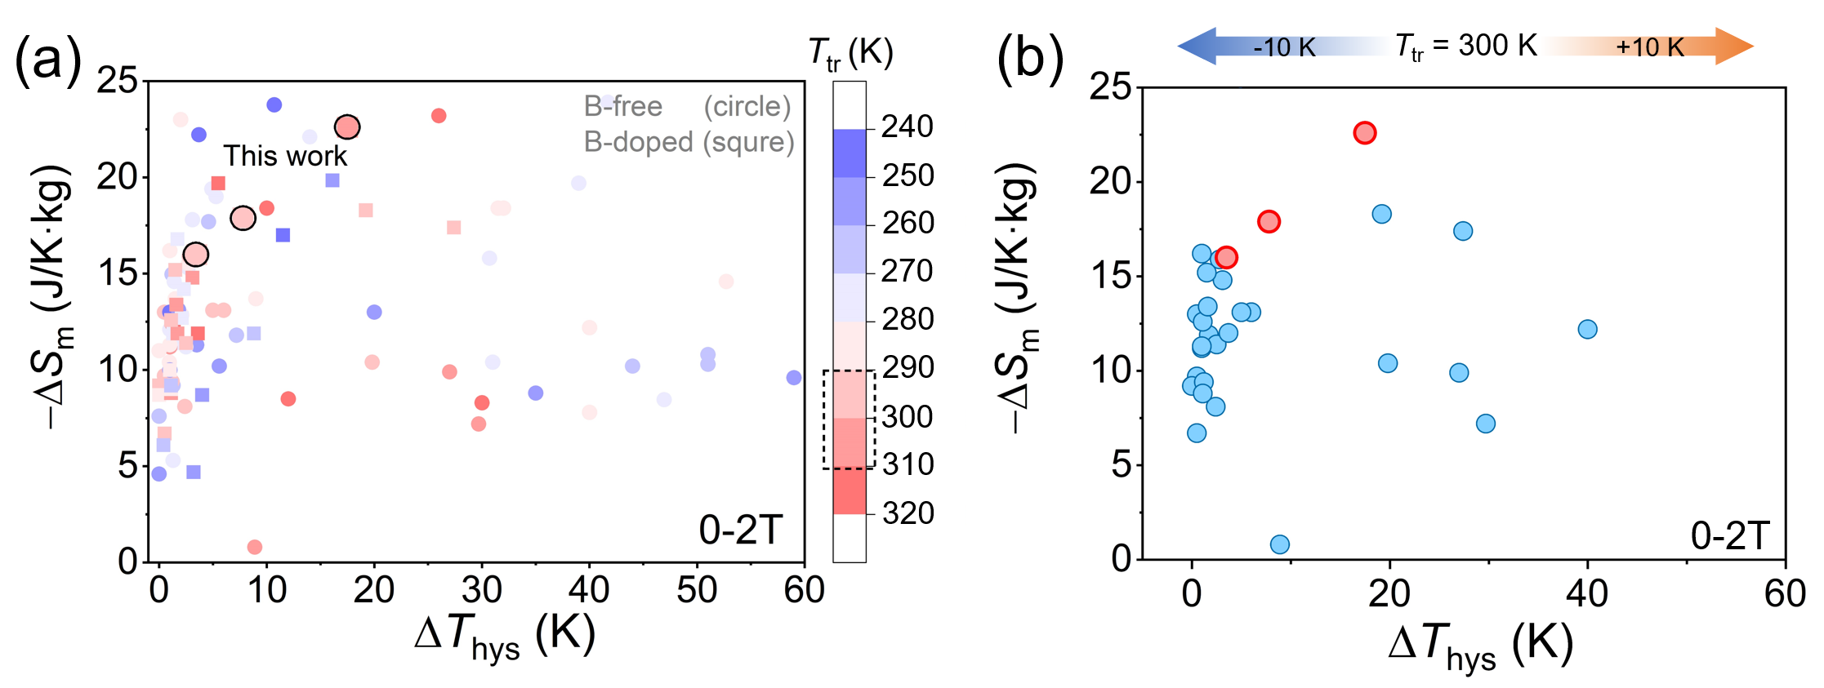
Fig. 1. (a) Summarized entropy change -ΔS_{m} vs. thermal hysteresis ΔT_{hys} of Fe₂P-type magnetocaloric compounds with transition temperature T_{tr} from 241 to 320 K, including the data with (square) B-doped [13, 14, 24-34] and (circle) B-free alloys [9, 13, 16, 17, 23, 26, 35-65]. The results reported in this work are shown with the black-edged red circles. (b) Benchmark of -ΔS_{m} vs. ΔT_{hys} within a narrower temperature interval T_{tr} of 300 ±10 K.
2. Experimental details
Polycrystalline Mn_{x}Fe_{2-x}(P_{0.48}Si_{0.52})_{1.03} as-cast ingots with the nominal x of 0.98 1.18, 1.22, and 1.26 were prepared by induction melting using high-purity Mn, Fe, Mn₂P, and Si as starting materials. Hereinafter, the four samples with different Mn: Fe ratios are denoted as samples Mn_{0.98}, Mn_{1.18}, Mn_{1.22}, and Mn_{1.26}, respectively. A slight off-stoichiometry in the metal/non-metal ratio of 2: 1.03 was selected to maximize the volume fraction of the Fe₂P-type matrix phase following our previous work [66]. An extra 10 wt.% of Mn was added to compensate the evaporation loss of this metal during the induction melting. All the ingot slices were wrapped in Molybdenum foil and sealed in quartz ampoules under 80 kPa of Ar. Thereafter, the as-cast ingots were annealed at various temperatures from 1100 to 1200 ºC for 5 hours, followed by water quenching, to obtain the largest MCE in terms of ΔSm. More detailed information on annealing conditions was described in the Figure S1 (supplementary file). The weight losses of Mn_{x}Fe_{2-x}P_{0.48}Si_{0.52} samples during the annealing process range from 2 to 5 wt.%. The outermost surface layers of samples were polished to remove oxides before all measurements.
The thermomagnetic properties of prepared samples were examined by a superconducting quantum interference device vibrating sample magnetometer, SQUID-VSM (Quantum Design MPMS SQUID VSM). At least three ingots for each composition were prepared and processed with their optimal annealing conditions to confirm the reproducibility of thermomagnetic curves (Figure S2, supplementary file). The scanning electron microscopy (SEM) was performed using a Carl Zeiss CrossBeam 1540EsB microscope equipped with an energy-dispersive spectroscopy (EDS) detector, Bruker XFlash 6 series. The overall alloy compositions, obtained from low-magnification SEM-EDS maps, were listed in Table S1 (supplementary file). The tendency of measured alloy composition is generally consistent with nominal compositions. In situ XRD experiments during a cooling and heating cycle, under a purged nitrogen atmosphere of 1 atm, was performed on a X-ray diffractometer (SmartLab with TTK-600 chamber, Rigaku) using a Cu Kα source at 45 kV and 200 mV. Before heating, the samples were pre-cooled down to 240 K, well below the transition temperature. The heating and cooling rates of 2 K/min rate was employed to detect phase transition around their respective transition temperature. To ensure the temperature homogeneity, we dwelled 5 min before each temperature measurements. The magneto-optical Kerr effect (MOKE) microscopy was performed using an Evico Magnetics microscope equipped with a heating system for in situ observation of the magnetostructural phase transition upon heating.

3. Results and discussions
3.1. Experimental results
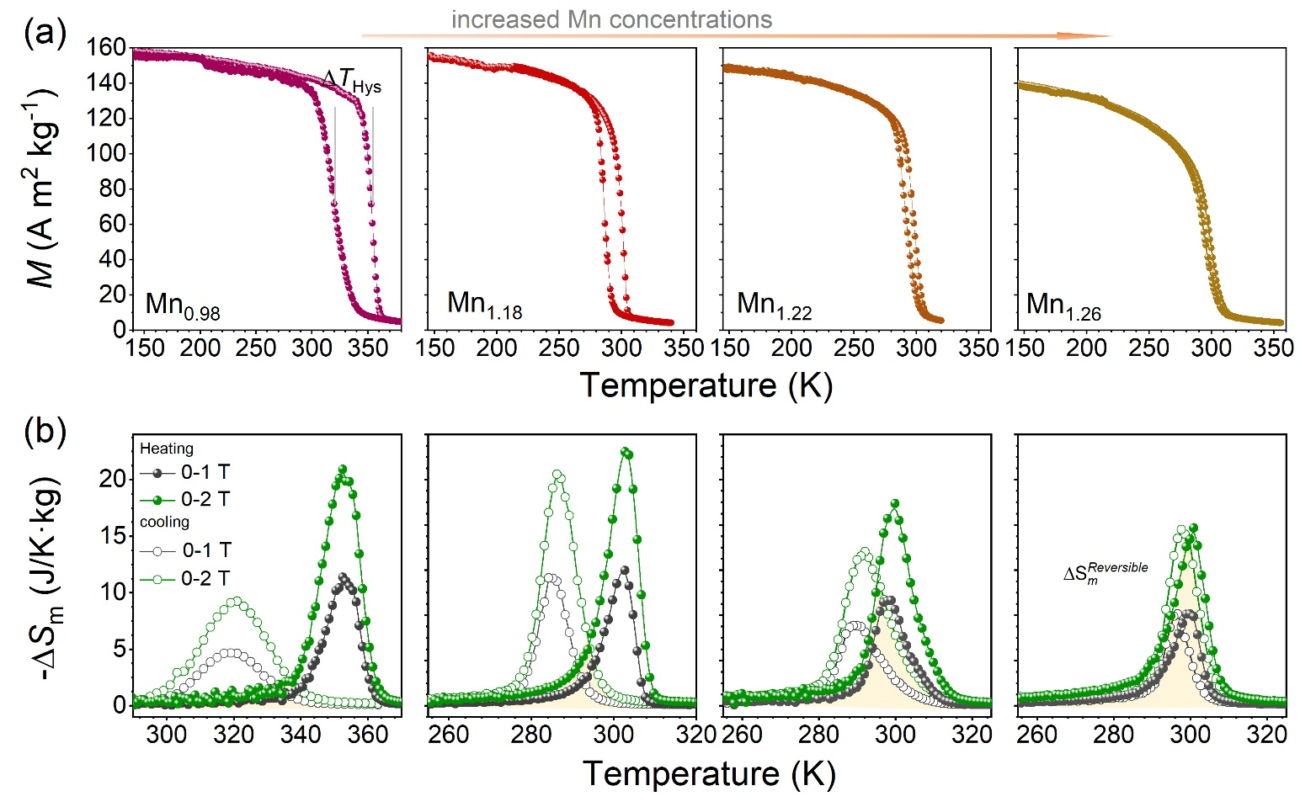
Fig. 2. (a) Temperature dependencies of magnetization under an applied magnetic field of 1 T during heating and cooling process of Mn_{x}Fe_{2-x}(P_{0.48}Si_{0.52})_{1.03} powdery compounds with a nominal x = 0.98, 1.18, 1.22, and 1.26. (b) Corresponding -ΔS_{m} during heating and cooling cycle as a function of temperature under a field change of 1 and 2 T. The overlapped area represents the reversible -ΔS_{m} for a field change of 2 T.
Figure 2(a) shows the M–T curves measured under a constant magnetic field of 1 T for the optimally annealed Mn_{x}Fe_{2-x}(P_{0.48}Si_{0.52})_{1.03} alloys. During the heating process, typical FM-PM magnetoelastic phase transitions were observed for all samples. The transition temperature for each M–T curve was determined as the temperature at which the derivative (dM/dT) was maximum. The thermal hysteresis, defined as ΔT_{hys,} represents the T_{tr} difference upon cooling and heating. Table 1 summarizes the magnetocaloric properties and structural parameters of the prepared alloys in more detail. With tailoring x from 0.98 to 1.18, T_{tr} (heating) was found to decrease from 353.7 to 302.3 K. However, with increase of x from 1.18 to 1.26, the transition temperature does not change too much as the transition temperature is sensitive to matrix phase compositions (the matrix phase composition is listed in the next section) that can be influenced by annealing condition. This can be evidenced in the literature [26]. More details are provided in supplementary note 1. The ΔT_{hys} values demonstrated a monotonous reduction from 35.7 to a minimum of 3.0 K with increase of x. Such a strong correlation between the ΔT_{hys} and Mn concentration in the alloys indicates that substituting Fe with Mn can weaken the FOMT in Mn–Fe–P–Si system.
The key figure of merit of MCE, -ΔS_{m}, was determined using the Maxwell equation via measuring isofield M–T curves upon heating and cooling near their transition temperatures, plotted in Fig. 2(b). The -Δ${\text{S}}_{\text{m}}^{\text{heating}}$ values for Mn_{0.98} were 11.4 and 21.0 J/kg·K under 1 and 2 T magnetic field, respectively, while -Δ${\text{S}}_{\text{m}}^{\text{heating}}$ for Mn_{1.18} were evaluated to be 12.1 and 22.6 J/kg·K under 1 and 2 T magnetic field, respectively. Such -Δ${\text{S}}_{\text{m}}^{\text{heating}}$ values are larger than those of most Mn–Fe–Si–P alloys reported in the literature (Fig. 1), but this was accompanied with a remarkable hysteresis of 35.7 and 17.0 K for Mn_{0.98} and Mn_{1.18}, respectively. Increasing x to 1.22 and 1.26 resulted in a substantial reduction in the thermal hysteresis down to 8.0 and 3.0 K, respectively. Meanwhile, we found that -Δ${\text{S}}_{\text{m}}^{\text{heating}}$ slightly degraded to 17.9 and 16.0 J/kg·K under 2 T, respectively. Thus, a well-balanced combination of small hysteresis and large -Δ${\text{S}}_{\text{m}}^{\text{heating}}$was achieved in the Mn–Fe–Si–P quaternary system without doping any other elements, as shown in Fig. 2(b). Furthermore, among all the developed compounds, the maximum overlapping area of -Δ${\text{S}}_{\text{m}}^{\text{heating}}$ and -Δ${\text{S}}_{\text{m}}^{\text{cooling}}$curves in Mn_{1.26} sample suggests the largest reversible -ΔS_{m} under cycling conditions [19, 46, 67] due to smaller hysteresis in this sample. Note that this reversible magnetic entropy change is determined based on a complete phase transition scenario and may differ from the values obtained during actual cyclic operation [68]. Hereafter, Mn_{1.18}, Mn_{1.22}, and Mn_{1.26} were selected for further investigation, as they have comparable transition temperatures close to the room temperature. And -ΔS_{m} upon heating is used as the default magnetic entropy change unless otherwise specified.
Table 1. The summarized properties and structural parameters of Mn_{x}Fe_{2-x}(P_{0.48}Si_{0.52})_{1.03} alloys with x = 0.98, 1.18, 1.22, and 1.26: Transition temperature (T_{tr}) on heating and cooling and thermal hysteresis (ΔT_{hys}) under a 1T field and magnetic entropy change (-Δ${\text{S}}_{\text{m}}^{\text{heating}}$) measured under a magnetic field change of 1 and 2 T, the lattice parameters a and c, the c/a ratio, the unit-cell volume V and the mass fractions of the matrix phase at paramagnetic state and the impurity phase.
Samples | T_{tr} (heating), K | T_{tr} (cooling), K | ΔT_{hys}, K | -Δ${\text{S}}_{\text{m}}^{\text{heating}}$, J/kg·K |  | a (Å) | c (Å) | c/a | V (Å) | Matrix phase (wt.%) | 3:1 type impurity phase (wt.%) | 5:3 type impurity phase (wt.%)
 |  |  |  | 0–1 T | 0–2T
Mn_{0.98} | 353.7 | 318.0 | 35.7 | 11.4 | 21.0 | 6.0575 | 3.4755 | 0.5737 | 110.44 | 95.7 | 4.3 | 0
Mn_{1.18} | 302.3 | 285.3 | 17.0 | 12.1 | 22.6 | 6.0829 | 3.4575 | 0.5684 | 110.80 | 92.7 | 6.1 | 1.2
Mn_{1.22} | 298.1 | 290.1 | 8.0 | 9.5 | 17.9 | 6.0985 | 3.4494 | 0.5656 | 111.10 | 93.0 | 6.2 | 0.8
Mn_{1.26} | 300.0 | 297.0 | 3.0 | 8.2 | 16.0 | 6.1022 | 3.4462 | 0.5648 | 111.13 | 94.8 | 5.2 | 0

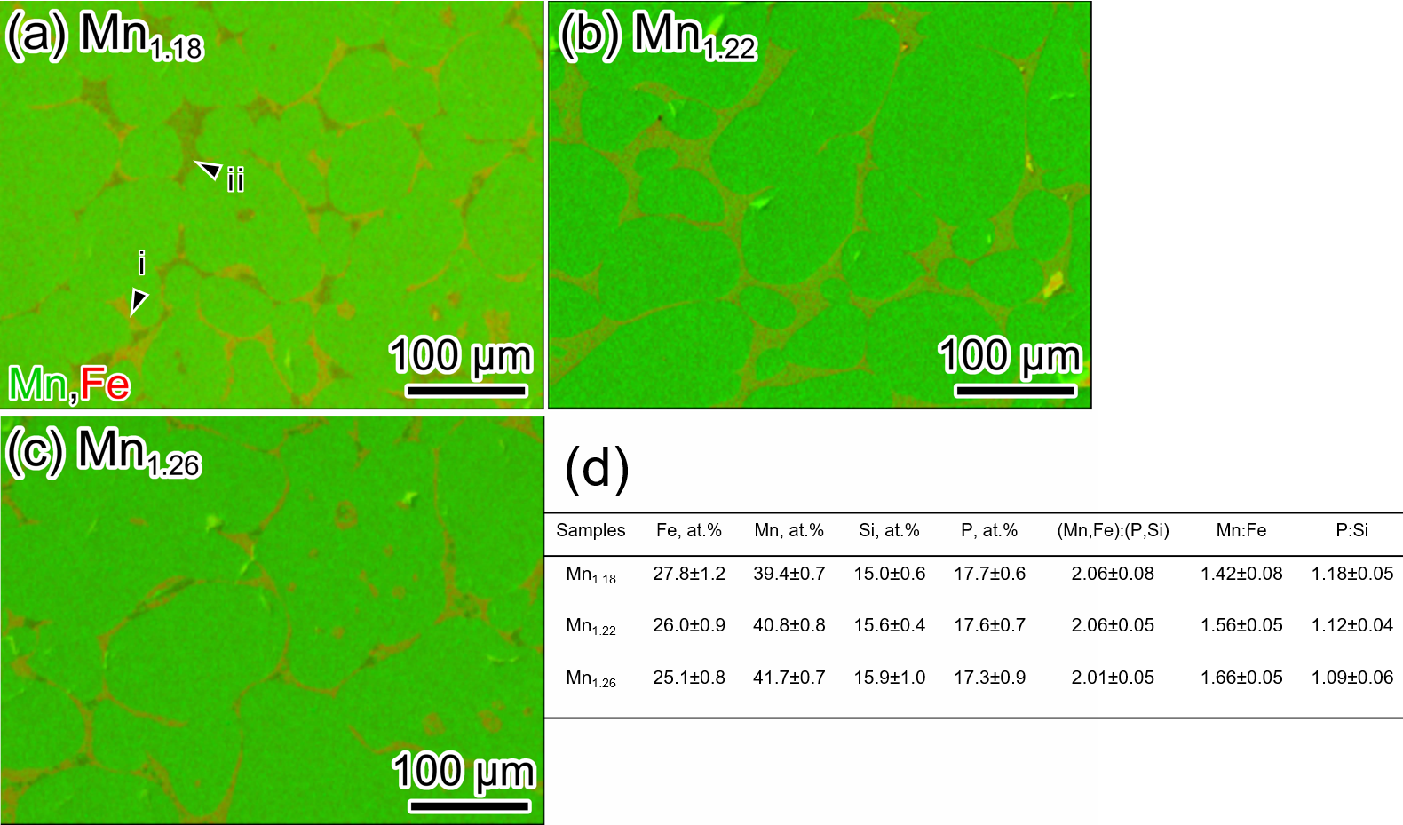
Fig. 3. SEM-EDS maps of Mn, and Fe elements taken from the (a) Mn_{1.18}, (b) Mn_{1.22}, and (c) Mn_{1.26} alloys. (d) The table with compositions in the matrix grains of the observed three samples.
It is well-known that the transition temperature and strength of FOMT is sensitive to the composition of matrix phase in Mn–Fe–Si–P system. Herein, we analyzed the composition of matrix phase using SEM-EDS technique. For all samples in this work, no compositional fluctuations can be detected in the matrix regions, indicating a uniform composition within the (Mn, Fe)₂(P, Si) matrix phase. In addition, the secondary phases located at so-called “grain boundary” region are mainly comprised of major 3:1 phase (region i) and minor 5:3 phase (region ii) based on compositional analysis. The composition of matrix phase is further statistically analyzed and summarized in the table in Fig. 3(d), wherein only a slight composition change occurs upon x, such as metallic Mn: Fe and nonmetallic Si: P. The T_{tr} is usually controlled by the Mn: Fe and P: Si ratios of the matrix phase, namely, an increase in ratios would reduce the transition temperature [26, 60]. The ratio of Mn: Fe in our case is monotonously increased from 1.42 ± 0.08 for Mn_{1.18} to 1.66 ± 0.05 for Mn_{1.26}. but its resultant negative contributions to T_{tr} is compensated by reduced P: Si ratios [54]. This well explains all three samples can maintain a similar T_{tr} around room temperature despite alloying different Mn contents.
Fig. 4(a-c) shows the XRD patterns measured at 240 K, well below the transition temperature, for three samples observed above. The quantitative XRD results illustrate that the matrix phase of Mn_{1.18} sample entirely transforms into a low-temperature ferromagnetic (FM) phase upon cooling process, as listed in Fig. 4(d). In contrast, residual PM phases with a mass fraction of about 10 and 12 wt.% remains at 240 K for Mn_{1.22} and Mn_{1.26}, respectively, which has been rarely reported in the Mn–Fe–Si–P system. Gottschall et al. [68, 69] exploited the co-existence of martensite/austenite phases in minor loops to achieve good reversibility in Heusler alloys. This indicates coexistence of these phases can be advantageous in reducing hysteresis. In this work, we can find that the presence of PM phase at the ferromagnetic state of Mn–Fe–Si–P samples has correlation to the thermal hysteresis. For instance, the Mn_{1.18} sample shows no PM residual phase with a hysteresis of 17.0 K. As the PM phase increases from 10 to 12 wt.%, the thermal hysteresis decreases from 8.0 to 3.0 K in Mn_{1.22} and Mn_{1.26} samples, respectively.
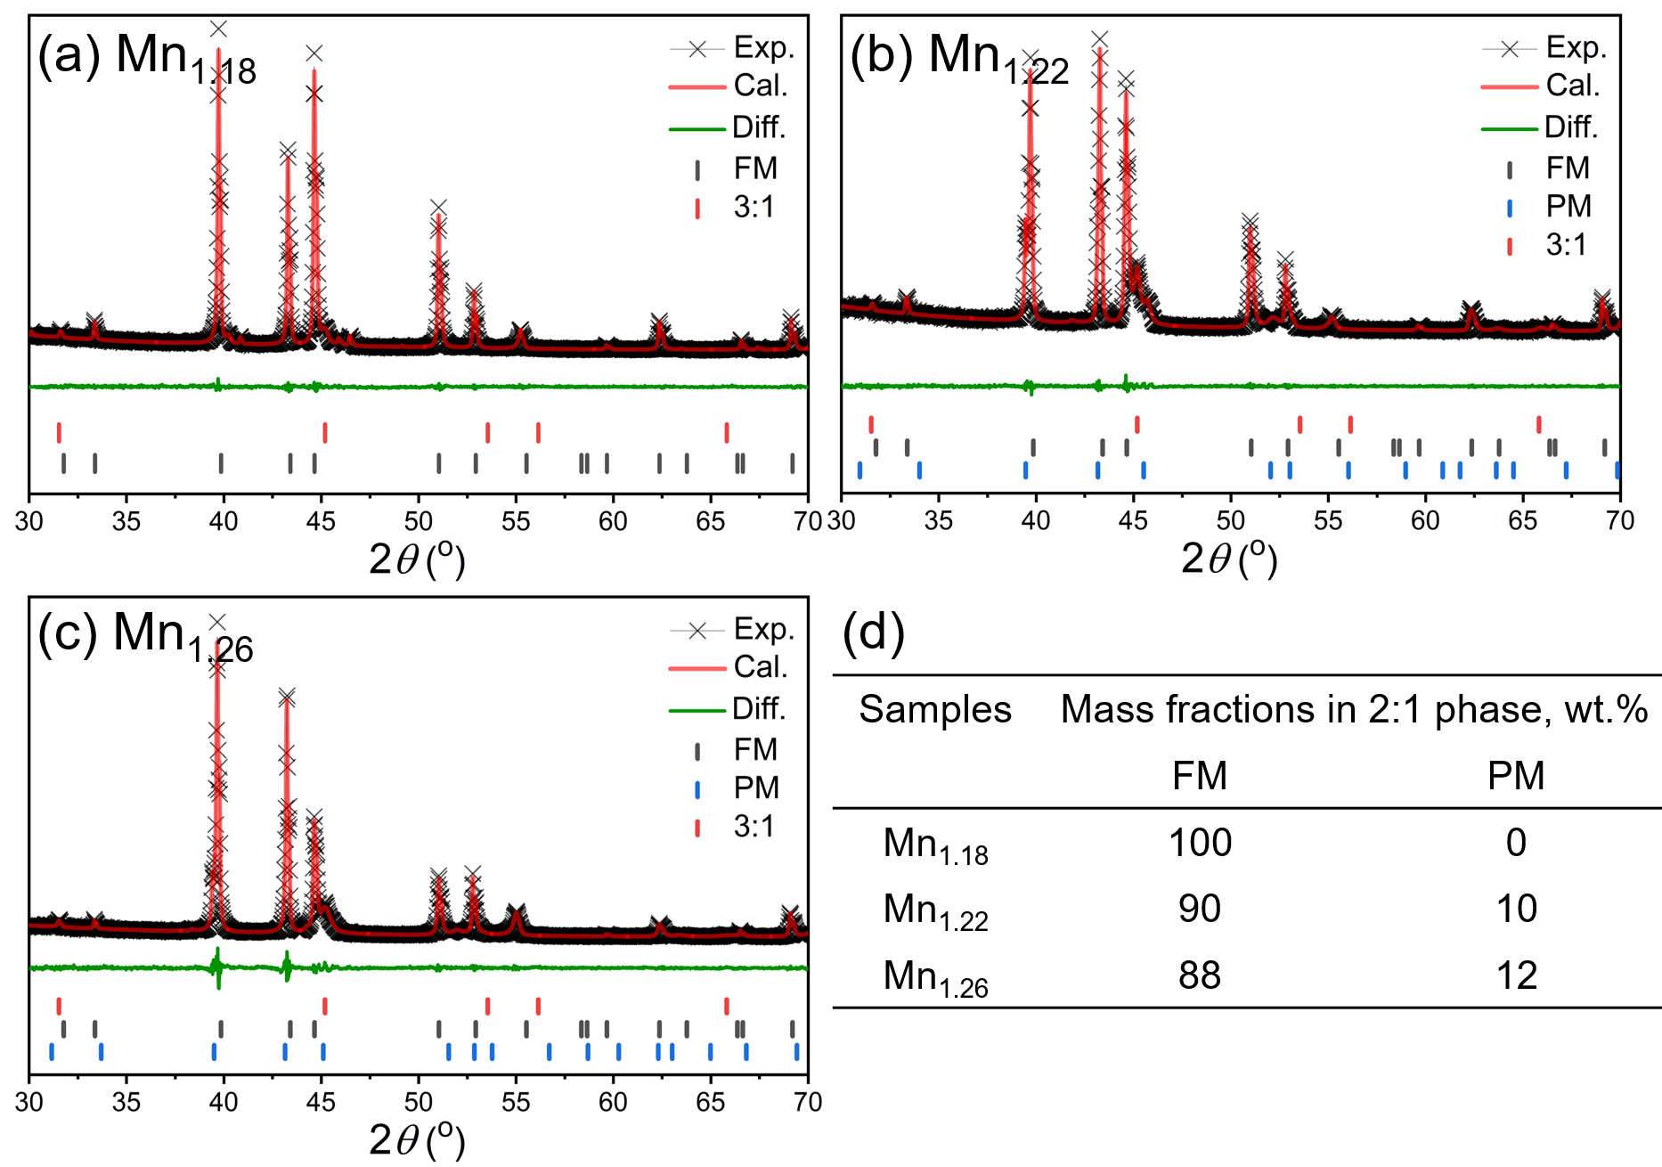
Fig. 4. XRD patterns measured at 240 K under a zero magnetic field for (a) Mn_{1.18}, (b) Mn_{1.22}, and (c) Mn_{1.26}. (d) The mass proportion of ferromagnetic (FM) and paramagnetic (PM) phases in the (Mn, Fe)₂(P, Si) phase extracted from the XRD data.
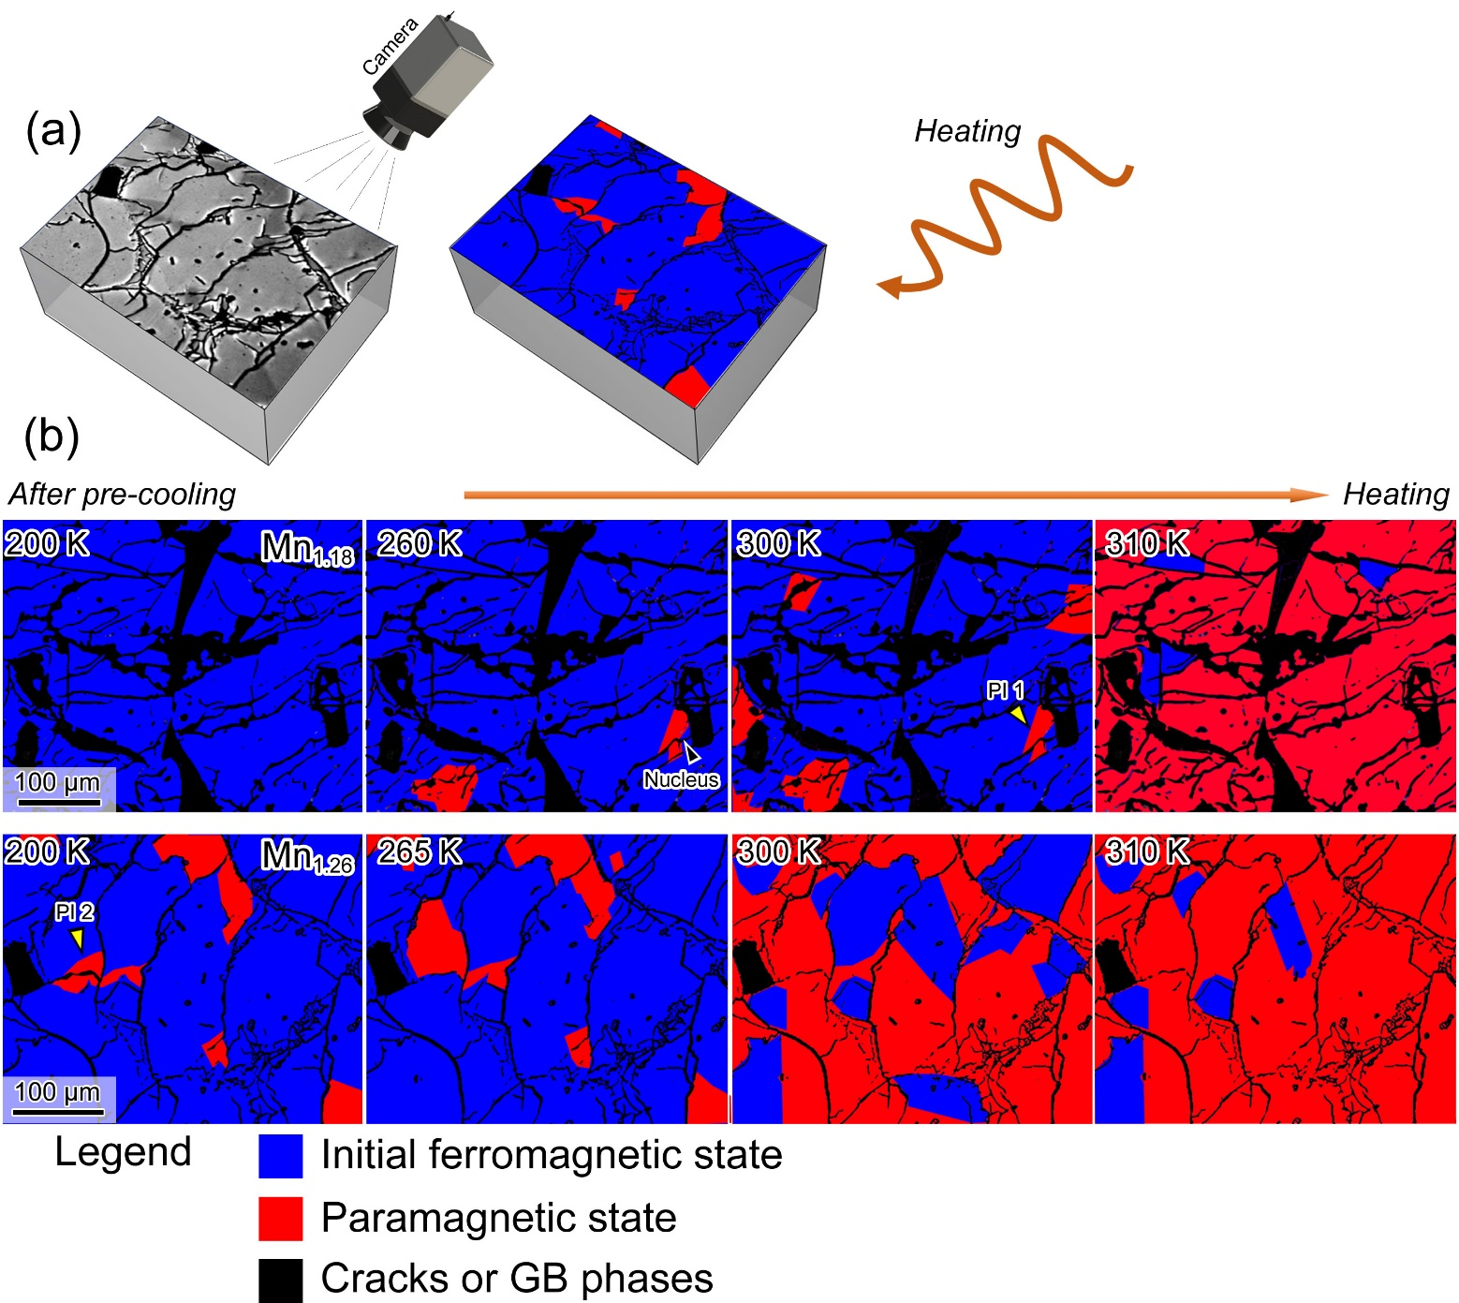
Fig. 5. (a) Schematic illustration of the original and processed magnetic domains on bulk Mn_{1.26} sample observed with MOKE microscope. (b) Temperature dependent MOKE images of Mn_{1.18} (upper row) and Mn_{1.26} (bottom row) showing the phase nucleation and propagation during heating process.
The influence of the residual paramagnetic (PM) phase in the ferromagnetic state of Mn–Fe–Si–P samples on the phase transition is investigated by visualizing the thermally driven phase transition through MOKE. Since the MOKE is observed in a zero-field state, corresponding M–T curves under a small field of 0.005 T were attached as Figure S4 (Supplementary Information). At 200 K, the Mn_{1.26} sample comprised the low-temperature FM phase with grey contrast and some inclusions of the high-temperature PM phase with dark contrast (Fig. 5(a)), which is consistent with the lower magnetization in M–T curves measured under a field of 0.005 T. To enhance the imaging contrast, the FM and PM phases were colored in blue and red, respectively, as schematically illustrated in Fig. 5(a). In contrast, the Mn_{1.18} sample with large hysteresis does not show such a mixed state at 200 K that is consistent with the XRD data at 240 K. Additionally, the Mn_{1.18} sample exhibits a higher areal density of cracks, indicating inferior mechanical properties to the amplitude of the discontinuities on a and c parameters. Upon heating to 260 K, the PM phase starts nucleating next to the cracks in the Mn_{1.18} sample. As the temperature increases to 300 K, an increase in PM nuclei is observed, but the already-nucleated PM phase does not propagate, suggesting a strong pinning effect at the PM/FM phase interface (PI 1), marked in Fig. 5 with yellow arrow. At 310 K, the cascade propagation of nucleated PM phase is observed, which is replication of a sharp phase transition in M-T curves and might be correlated to a strong FOMT in Mn_{1.18} sample with a large hysteresis. On the other hand, for the Mn_{1.26} sample, an increase in temperature from 200 K to 265 K results in the growth of the PM phase along with the observation of more PM nuclei. The weakened pinning effect allows the PM phase to easily propagate into neighboring matrix grains, as the PM/FM interface (PI 2) is marked with a yellow arrow. These results indicate that the FM-PM phase transition occurs over a wider temperature range, leading to a less sharp phase transition and weaker FOMT in the Mn_{1.26} sample. When the sample is in its ferromagnetic state, existence of paramagnetic nucleus would become the FM/PM transition seeds that lower the energy barrier required for phase transition as no additional energy needed for nucleation of the paramagnetic phase, thereby reducing the hysteresis.
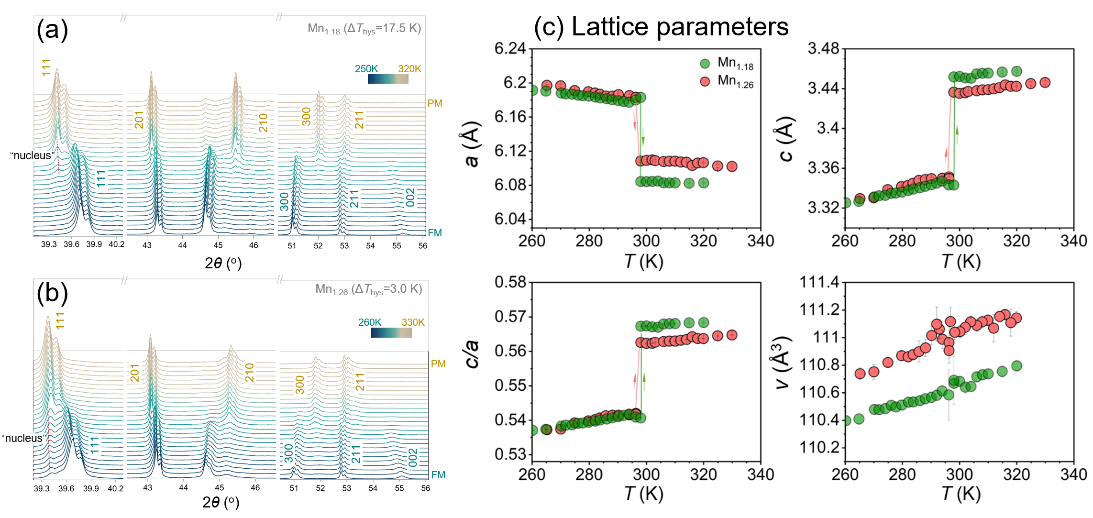
Fig. 6. In situ XRD waterfall plots of (a) Mn_{1.18} and (b) Mn_{1.26} upon heating under a zero field. (c) Lattice parameters vs. temperature extracted from XRD patterns, including a, c, c/a ratio, and V.
Figure 6 shows in situ XRD experiments to elucidate the detailed phase transition process during heating of Mn_{1.18} and Mn_{1.26} powdery samples. Note that the samples were cooled down to 240 K, well below the transition temperature of the samples prior to the XRD experiment. The evolution of 111 peak around 2θ of 39.4º indicates that a small amount of PM phase “nucleus” (marked with a red dotted line) emerges when Mn_{1.18} is heated to about 288 K. In contrast, strong 111 peak in low-hysteresis Mn_{1.26} suggests the dual phases exist after cooling down the sample and throughout the entire heating process, which is consistent with MOKE results. In addition, the change of the lattice parameters upon transition, is primarily evaluated by analyzing the magnitude of diffraction peak shifts. The peak shift during phase transition is less pronounced in the Mn_{1.26} sample with low hysteresis compared to the Mn_{1.18} sample with large hysteresis. Based on the in situ XRD data, the changes in lattice constants were extracted for Mn_{1.18} and Mn_{1.26} samples upon heating, including a, c, c/a ratio, and volume V, respectively, as shown in Fig. 6(c). When heating to around T_{tr}, the dramatic lattice contraction in a and expansion in c are captured. Interestingly, the impact of alloy compositions on the lattice constants of Fe₂P type phases at the PM state is more pronounced than at the FM state. This leads to the different changes of lattice constants around T_{tr}, such as a, c, c/a ratio. For instance, the lattice parameter a change from a similar initial value of ~6.18 Å in FM state to 6.08 Å for Mn_{1.18} and 6.11 Å for Mn_{1.26} in PM state. Thus, the observed phase transition depending on Mn concentrations results into different changes in lattice constants. However, the unit cell volume V keeps a continuous change throughout the entire heating process. The smaller change in lattice parameters for Mn_{1.26} sample has revealed a weaker magnetoelastic coupling during the phase transition, which indicates weakened first-order character of transition.
3.2. Landau-type theoretical analysis
Above, a comprehensive experimental investigation was conducted to examine the impact of extrinsic (presence of PM nucleus) and intrinsic (change in lattice parameter upon phase transition) factors on thermal hysteresis in Mn–Fe–Si–P alloys. The first-order phase transitions are always accompanied by hysteresis associated with the existence of a region of metastability of two phases. The Landau theory proves to be a powerful method for comprehensively describing various categories of phase transitions [70]. As it was shown in the XRD part (Fig. 6), Mn–Fe–Si–P alloys undergo the magnetoelastic FM to PM transition without symmetry and volume change, while only the change in lattice constants occurs. In such a case the primary order parameter is magnetization, M, while the deformation is a secondary order parameter, $ε$. The primary order parameter is a main variable in Landau theory that characterizes the phase transition, while the secondary order parameter is another property of the system that may undergo a change during a phase transition, but its change is not as significant or fundamental as that of the primary order parameter [70]. The primary order parameter is distinguished from secondary order parameter by the fact that the coefficient of the square of the primary parameter in the expression for free energy goes to zero at the transition temperature $T_{c}$ and then changes sign. For the simplicity, we consider the one-component order parameter M, and the deformation $ε$ along z axis, in this case the Gibbs potential in the presence of magnetic field H can be expressed as:
$G=G_{0}+\frac{1}{2}α(T)M^{2}+\frac{1}{4}βM^{4}+\frac{1}{6}γM^{6}+G_{el}+G_{me}-μ_{0}HM$, (1)
where $α(T)=α_{0}(T-T_{c})$ is a temperature-dependent coefficient that governs the transition temperature $T_{c}$, the coefficients $α_{0},γ>0$ are phenomenological constants. Depending on the sign of the coefficient $β$, either a first-order phase transition (if $β<0$) or a second-order phase transition (if $β>0$) occurs. It should be noted, that usually purely magnetic (without changes in crystal lattice) PM-FM phase transitions are second-order phase transitions, while first-order PM-FM phase transitions are observed for magnetoelastic or magnetostructural phase transitions [71]. This suggests that exactly elastic system and magnetoelastic coupling is responsible for the appearance of first-order PM-FM phase transitions. In particular, the magnetoelastic Bean-Rodbell theory was proposed to explain the first-order PM-FM phase transition in Mn–As, which is associated with a substantial volume change [72]. They showed that if the exchange energy (or Curie temperature) depends on the lattice volume, under certain conditions the behavior of the system may be the usual second-order transition, but it can in fact become a first-order phase transition. Noteworthy that recent experiments for doped ErCo_{2-x}Fe_{x} alloys confirmed the switch from the first-order magnetostructural to second-order magnetic phase transition by reducing volume and lattice change during transition [73]. The magnetoelastic Bean-Rodbell model has been successfully applied to describe first-order magnetocaloric effect (MCE) materials, as discussed in Ref. [74] and references therein. The Landau-type expansion of the Gibbs free energy allows for the estimation of the energy landscape and, consequently, the energy barriers characterizing the MCE system. The case of Mn–Fe–Si–P alloys differs from the Bean-Rodbell approach because no volume change was detected experimentally as shown in Fig. 6; instead, changes in lattice constants occur. Therefore, here we propose an alternative method for applying the magnetoelastic model to phase transitions where no volume change occurs, but only lattice changes take place. In this case, one should analyze the elastic and magnetoelastic energy (Eq. (1)). The detailed explanation of construction of free energy in the case of secondary order parameter is presented in [70], according to it, the elastic energy can be expanded in series of $ε$:
$G_{el}=λε+C'ε^{2}/2+Dε^{3}/3+...$, (2)
where the polynomial coefficients are elastic constants. The magnetoelastic energy is expressed as following $G_{me}=δ_{me}εM^{2}$, where $δ_{me}$ is magnetoelastic coupling coefficient. The minimization of the function $∂G/∂ε=0$ gives:
$λ+C'ε+Dε^{2}+δ_{me}M^{2}=0$. (3)
The $λ$ value is associated with thermal expansion of the material along z axis, so with some deformation $ε$, which is not induced by phase transition at $T_{c}$. It can be excluded from the energy by redesignation $ε=e+e_{0}$, where $e_{0}$ is initial value of deformation $ε$ at phase transition temperature. This value is determined by the equation $λ+C'e_{0}+De_{0}^{2}+...=0$. This equation can be included into the background free energy $G_{0}$. Therefore, Eq. (3) can be rewritten in the form.
$e=-δ_{me}M^{2}/C$, (4)
where coefficient C differs from $C'$ by additives that depend on $e_{0}$ due to the presence in Eq. (3) such terms as $Dε^{2}$. Considering Eqs. (1), (2), (4) one can exclude $ε$ from the Gibbs potential:
$G=G_{0}+\frac{1}{2}α^{*}(T)M^{2}+\frac{1}{4}β^{*}M^{4}+\frac{1}{6}γM^{6}-μ_{0}HM$, (5)
where renormalized coefficients are expressed as
$$α^{*}(T)=α(T)-2e_{0}δ_{me},$$$β^{*}=β-2δ_{me}^{2}/C.$ (6)
Therefore, the interrelation between primary and secondary order parameters leads to the renormalization of energy coefficients connected with primary order parameter, M. This behavior exemplifies the typical relationship between primary and secondary order parameters (for more details see [70]). The stronger is magnetoelastic coupling the more pronounced is change in energy coefficients. The magnetoelastic coupling results in a shift of the magnetoelastic phase transition temperature, $T_{c}^{*}$, because the phase transition temperature corresponds to condition, where the coefficient of the square of the primary parameter equals to zero. This condition for renormalized energy coefficient $α^{*}(T_{c}^{*})=α(T)-2e_{0}δ_{me}=0$ is distinct from the condition $α(T_{c})=α_{0}(T-T_{c})=0$, associated with the purely magnetic phase transition temperature, $T_{c}$. Therefore, the temperature of magnetoelastic phase transition can be expressed as following:
$T_{c}^{*}=T_{c}+2e_{0}δ_{me}/α_{0}$. (7)
It is seen that in the absence of magnetoelastic coupling $T_{c}^{*}$ and $T_{c}$ coincide. Another important point is the renormalization of the coefficient $β^{*}$, the sign of which predetermines the order of the phase transition. Evidently, the presence of magnetoelastic coupling can lead to the change of the sign of coefficient $β^{*}$, switching purely magnetic second-order PM-FM phase transition ($β>0$) to the first-order magnetoelastic phase transition ($β^{*}<0$).
Now we can analyze first-order magnetoelastic phase transition ($β^{*}<0$), which is described by the potential Eq. (5). The equation of state can be found from the minimum condition $∂G/∂M=0$
$μ_{0}H=α^{*}(T)M+β^{*}M^{3}+γM^{5}$ (8)
and condition $∂^{2}G/∂M^{2}≥0$:
$α^{*}(T)+3β^{*}M^{2}+5γM^{4}≥0$. (9)
In the absence of magnetic field, the PM phase is stable when $T>T_{c}^{*}$, the ferromagnetic phase is stable when
$T<T_{2}=T_{c}^{*}+{\left(β^{*}\right)}^{2}/4γα_{0}$, (10)
the region of coexistence of two phases is expressed as $T_{c}^{*}-T_{2}$:
$ΔT={\left(β^{*}\right)}^{2}/4γα_{0}$. (11)
The region where two phases coexist represents a metastable state, resulting in overcooling and overheating processes, which, in turn, lead to the thermal hysteresis observed in first-order phase transitions. As so, the temperatures $T_{c}^{*}$ (Eq. (7)) and $T_{2}$ (Eq. (10)) correspond to the transition temperature on cooling and heating, respectively. The value $ΔT={\left(β^{*}\right)}^{2}/4γα_{0}$ is a thermal hysteresis observed in zero magnetic field.
To comprehend the hysteresis behavior under the influence of an applied magnetic field, one should examine Eq. (5). Such kind of potential (2-4-6 series in order parameter and bilinear coupling between order parameter and external field) was previously analyzed in Ref. [75], where a phase diagram for such transition was constructed. It has been shown that phase diagram has two phase stability boundaries lines, which meet at the critical point and the first-order phase transition disappears. The coordinates of this points can be found from equation of state Eq. (8) along with conditions $∂^{2}G/∂M^{2}=0$, $∂^{3}G/∂M^{3}=0$ and in our case result in
$$μ_{0}H^{cr}=3\sqrt{6}γ{\left(|β^{*}|/5γ\right)}^{5/2},$$$T^{cr}=T_{c}^{*}+9{\left(β^{*}\right)}^{2}/20γα_{0}.$ (12)
The temperatures of phase stability can be found from Eq. (8)
$T=T_{c}^{*}-(β^{*}M^{3}+γM^{5}-μ_{0}H)/α_{0}M$, (13)
where characteristic solutions, which correspond to metastable states, can be found from the condition$∂T/∂M=0$ [75]:
$μ_{0}H+2β^{*}M^{3}+4γM^{5}=0$. (14)
Substituting the solutions of Eq. (14) into Eq. (13) one can plot the stability boundaries of FM and PM phases on temperature-magnetic field phase diagram.
The energy coefficients in the potential equation (5) were determined through the fitting of theoretical magnetization versus temperature curves to experimental data (Fig. 7). The fitting was applied to all samples with x = 0.98, 1.18, 1.22, 1.26, a mass density of is accepted. The parameters and , which are independent of the $δ_{me}$ value, remained constant, while the renormalized parameters $β^{*}$ and $T_{c}^{*}$ were adjusted for each sample composition. Table 2 presents the parameters used in calculations ($β^{*}$ and $T_{c}^{*}$). These values, along with Eqs. (13) and (14), enable the computation of transition temperatures (T_{tr}) during heating and cooling under a 1 T magnetic field, as well as the hysteresis width (ΔT_{hys}) (see Table 2). The absolute value of the coefficient $|β^{*}|$ decreases with an increasing concentration of x, corresponding to the observed reduction in hysteresis as x increases. This reduction in coefficient $|β^{*}|$ can be attributed to the decrease in magnetoelastic coupling, consistent with the dual decrease in the lattice parameters' jump during the phase transition with an increase in x concentration (Fig. 6). This decrease of coefficient $|β^{*}|$ provides the good agreement between computed transition temperatures and hysteresis widths (Table 2) and experimental data presented in Table 1.
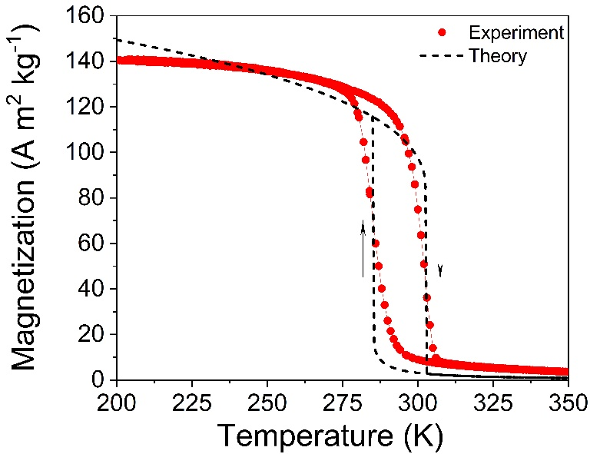
Fig. 7. Experimental and theoretical temperature dependencies of magnetization obtained for Mn_{1.18} sample under a magnetic field of 1 T.
Table 2. Parameters used for calculations ($β^{*}$, $T_{c}^{*}$) along with the computed transition temperatures and hysteresis under a magnetic field of 1 T.
Samples | $β^{*}$, T⁴kg³/J³ | $T_{c}^{*}$, K | T_{tr} (heating), K | T_{tr} (cooling), K | $ΔT_{hys}$, K
Mn_{0.98} | -13.3 × 10⁻⁵ | 312 | 352.0 | 318.0 | 34
Mn_{1.18} | -9.9 × 10⁻⁵ | 280 | 302.8 | 285.4 | 17.4
Mn_{1.22} | -7.0 × 10⁻⁵ | 286 | 297.9 | 290.8 | 7.1
Mn_{1.26} | -5.5 × 10⁻⁵ | 291 | 298.4 | 295.4 | 3

Fig. 8 illustrates the experimental and theoretical H-T phase diagrams obtained for Mn_{1.18} and Mn_{1.26} samples. The experimental phase diagram depicts the dependencies of T_{tr} obtained during the heating and cooling of specimens in a magnetic field. Dashed lines represent linear approximations to the experimental points. The theoretical diagram, calculated from Eqs. (13) and (14), defines regions of stability for the FM and PM phases. The intervening area constitutes the metastable region, where both phases can coexist. The presence of the metastable region gives rise to overcooling and overheating processes, intrinsic to the temperature hysteresis observed in first-order phase transitions. The hysteresis decreases when approaching the critical point ($T^{cr},H^{cr}$), where first-order phase transition disappears. It's noteworthy that the emergence of a critical point on the phase diagram is observed under specific conditions for various potentials [70, 74]. In particular, the interrelation between the critical point and thermal hysteresis has been theoretically investigated for magnetic phase transitions in Mn–As alloy [76] and structural phase transitions in Heusler alloys [77]. The experimental confirmation of hysteresis disappearance at the critical point was observed during structural phase transitions in Ni–Fe–Co–Ga and Fe–Pd alloys [78, 79]. Moreover, the reduction of thermal hysteresis when approaching critical point was experimentally observed for the Mn_{1.32}Fe_{0.71}P_{0.5}Si_{0.56} alloy specimen [46], the coordinates of critical point were 317 K, 16.7 T, which is quite close to our case for Mn_{1.18}.
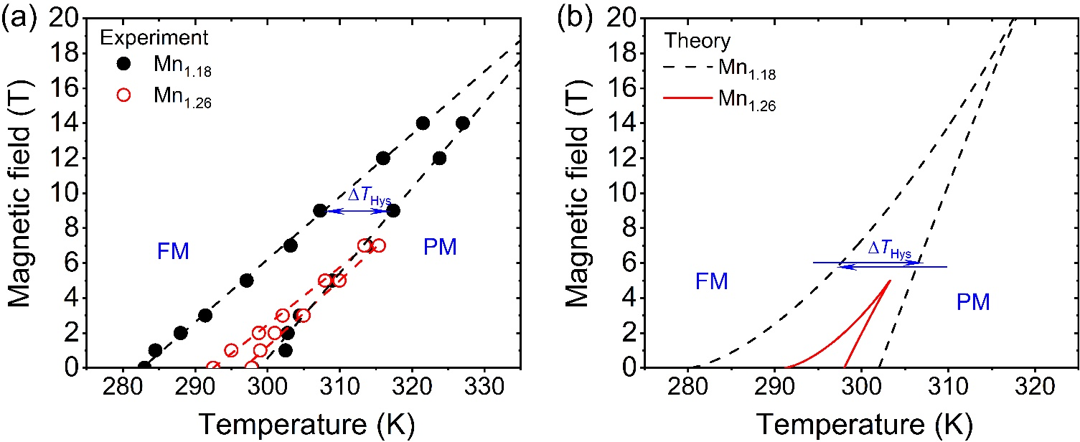
Fig. 8. Experimental (a) and theoretical (b) phase diagrams obtained for Mn_{1.18} and Mn_{1.26}. The critical point indicates the end of first-order phase transition.
As the concentration of Mn increases, the phase stability lines merge, leading to a noticeable decrease in hysteresis. This reduction can be attributed to the decrease in magnetoelastic coupling, resulting in a decrease in the absolute value of the coefficient $β^{*}$, which predetermines the hysteresis width (Eq. (11)). The coordinates of the critical point, where the first-order phase transition disappears, are also influenced by the value of $β^{*}$. The smaller $|β^{*}|$ is, the smaller the critical magnetic field where the magnetically induced first-order PM-FM phase transition is observed (Eq. (12)). It should be noted that the energy coefficient $β^{*}$ can be influenced not only by magnetoelastic interactions but also by changes in the electronic structure of the material [80]. Noteworthy that Equation (11) describes the intrinsic hysteresis linked to the metastability region inherent in first-order phase transitions. Nevertheless, extrinsic factors such as microstructure, heterogeneous nucleation, or kinetic effects also play a role in the hysteresis. Thus, the coefficient $β^{*}$ obtained through fitting theoretical curves to experimental data encapsulates the combined influence of factors affecting hysteresis.

Discussions
We have explored the potential of the (Mn, Fe)₂(P, Si) quaternary system and realized well-balanced magnetocaloric properties, i.e., small thermal hysteresis of 3.0 K and large -ΔS_{m} of 16 J kg^{–1} K⁻¹ at 2 T. The obtained properties are comparable to the best properties reported to far in (Mn, Fe)₂(P, Si) for room temperature refrigeration. In addition, the thermal hysteresis can be tuned depending on Mn concentration x in Mn_{x}Fe_{2-x}(P_{0.48}Si_{0.52})_{1.03} alloys, as reported in literature [57]. This enables us to investigate the origin of the thermal hysteresis for the studied compounds. Under the framework of the Landau theory [74, 81-83], the FOMT is theoretically controlled by different energy barriers between the local and global minima in the Gibbs free energy within one cooling and heating cycle, leading to the hysteresis. The origin of the energy barrier for the phase transition can generally be classified into intrinsic and extrinsic contributions [84]. The intrinsic aspect is related to a change in crystallographic structure parameters, e.g., symmetry, lattice parameters, volume of a unit cell. This in turn alters the electronic structure and its associated magnetism. While the extrinsic influence is linked to the microstructure, such as grain size, defects, phase boundaries, etc. and kinetics under the external stimulus. For the (Mn, Fe)₂(P, Si) system, lowering lattice parameter change across the phase transition has been widely known for minimization of hysteresis due to weakening of FOMT. In this work, we characterized the strength of FOMT by tracking the phase transition using in situ XRD technique. As x increases from 1.18 to 1.26 in the Mn_{x}Fe_{2-x}(P_{0.48}Si_{0.52})_{1.03} alloys, the lattice constant changes across the transition were reduced, revealing a weaker magnetoelastic coupling. Thereby, the hysteresis is reduced from 17.0 K to 3.0 K from intrinsic aspect. Of particular interest is that we report for the first time that the residual PM phase in the ferromagnetic state of the sample also plays a role in reducing the thermal hysteresis. For a low-hysteresis Mn_{1.26} sample, the pre-existing PM phase acts as a nucleus for growth of PM phase during the phase transition as revealed by MOKE observation. As a result, the propagation of PM becomes kinetically easier compared to the large-hysteresis Mn_{1.18} sample. This phenomenon reduces the energy required for the phase transition, which could be an additional extrinsic factor for the small hysteresis in the Mn_{1.26} sample.
In order to describe the influence of magnetoelastic coupling within the (Mn, Fe)₂(P, Si) system, an analysis of magnetic, magnetoelastic, and elastic energies was conducted using the Landau theory framework. The presence of magnetoelastic coupling was found to result in the renormalization of coefficients in the Landau expansion for the Gibbs potential (Eqs. (5), (6)). The renormalization of coefficient $α^{*}$ by the magnetoelastic coupling coefficient $δ_{me}$ leads to the shift of phase transition temperature. Simultaneously, the renormalization of the $β^{*}$ coefficient by magnetoelastic coupling results in the hysteresis variation. The H–T phase diagram was analyzed both theoretically and experimentally. Through fitting theoretical data to experimental points, energy coefficients were determined for different samples. It has been shown that increase of x in Mn_{x}Fe_{2-x}(P_{0.48}Si_{0.52})_{1.03} alloys leads to the decrease of absolute value of the energy coefficient $|β^{*}|$ consequently leading to a reduction in thermal hysteresis. The observed decline in $|β^{*}|$ with increasing x was attributed to a corresponding decrease in the magnetoelastic coupling coefficient $δ_{me}$. This observation aligns with the decrease in the lattice constant jump as x increases, capturing the weakening of the magnetoelastic phase transition.
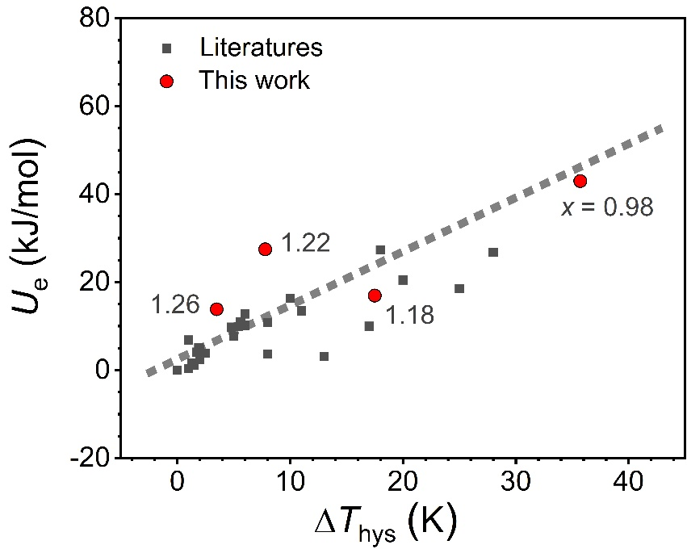
Fig. 9. The summarized elastic strain energy U_{e} at T_{tr} as a function of thermal hysteresis ΔT_{hys} for the (Mn, Fe)₂(P, Si) alloys [9, 14, 19, 28, 33, 34, 37, 47, 50, 85, 86]. The dashed line is a guide to the eyes.
The elastic energy is strongly correlated with thermal hysteresis during magnetoelastic and magnetostructural phase transitions, so let us analyze the elastic strain energy U_{e} caused by phase transition in (Mn, Fe)₂(P, Si) based magnetocaloric alloys. The U_{e} is estimated by formula below [14, 19, 87]:
U_{e} = (C₁₁ + C₁₂) ${e }_{1}^{2}$ + 2C₁₃e₁ e₃ + $\frac{1}{2}$C₃₃ ${e }_{3}^{2}$.
The elastic constants C₁₁ = 308.4, C₁₂ = 120.0, C₁₃ = 144.0, and C₃₃ = 227.8 GPa are taken from Refs. [14, 87]. As the symmetry of 2:1 type hexagonal crystals, the tensile strain within the ab plane is e₁ = e₂ = Δa/a and along the c axis e₃ = Δc/c. The volume change across the FOMT is an almost constant, e₁ = $-\frac{1}{2}$e₃ [14].
To confirm the extrinsic contribution from nucleus, the relationship between the elastic strain energy and thermal hysteresis for the data adopted from literature and our experimental data were plotted in Fig. 9. Compared to data reported in literature, the Mn_{1.22} and Mn_{1.26} samples exhibit larger elastic strain energy but smaller thermal hysteresis than expected. This can be attributed to the pre-existing nucleus in both samples that reduces the energy barrier required for phase transition as observed by MOKE.

Conclusion
In conclusion, we have reported that the thermal hysteresis in quaternary (Mn_{x}Fe_{2-x})(P_{0.48}Si_{0.52})_{1.03} magnetocaloric compounds can be substantially reduced by tailoring the Mn content from x = 0.98 to 1.26. As a result, a giant MCE in magnetic entropy change of 16 J/kg·K under 2 T external magnetic field and low hysteresis of 3.0 K were simultaneously achieved in the Mn_{1.26}Fe_{0.74}(P_{0.48}Si_{0.52})_{1.03} sample. To elucidate the cause of the reduced hysteresis, we performed MOKE observations and found that the pre-existing paramagnetic (PM) phase in the low-temperature ferromagnetic state of the sample acts as a nucleus for the growth of the PM phase. Therefore, the residual PM phase is kinetically favorable for driving the FM-PM phase transition in the Mn_{1.26} sample. In addition to the extrinsic origin mentioned above, an increase in Mn: Fe ratios in chemical compositions reduces the change in lattice constants (a, c) as reported by Dung et al. [57]. It effectively lowers the energy barrier between PM and FM phases in the energy landscape, thereby reducing the detrimental hysteresis from the intrinsic aspect, as detected by in situ XRD. The H-T phase diagram is constructed using Landau theory and is in agreement with experimental measurements, showing that the reduction in the thermal hysteresis is due to weakened magnetoelastic coupling. This work provides guidelines for the material design to realize a giant magnetocaloric effects (MCEs) with controllable hysteresis in (Mn, Fe)₂(P, Si) based quaternary system for efficient magnetic refrigeration.

Acknowledgments
This work was in part supported by ERATO “Magnetic Thermal Management Materials” (grant no. JPMJER2201) from JST, Japan, and MEXT Program: Data Creation and Utilization-Type Material Research and Development Project (Digital Transformation Initiative Center for Magnetic Materials) Grant Number JPMXP1122715503.
References
[1] V. Franco, J.S. Blázquez, J.J. Ipus, J.Y. Law, L.M. Moreno-Ramírez, A. Conde, Magnetocaloric effect: From materials research to refrigeration devices, Progress in Materials Science 93 (2018) 112-232.
[2] K.A. Gschneidner Jr, V.K. Pecharsky, Magnetic refrigeration, TMS Annual Meeting, 1997, pp. 209-221.
[3] V.K. Pecharsky, J.K.A. Gschneidner, Giant magnetocaloric effect in Gd₅(Si₂Ge₂), Physical Review Letters 78(23) (1997) 4494-4497.
[4] S.A. Nikitin, G. Myalikgulyev, A.M. Tishin, M.P. Annaorazov, K.A. Asatryan, A.L. Tyurin, The magnetocaloric effect in Fe₄₉Rh₅₁ compound, Physics Letters A 148(6) (1990) 363-366.
[5] R. Kainuma, Y. Imano, W. Ito, Y. Sutou, H. Morito, S. Okamoto, O. Kitakami, K. Oikawa, A. Fujita, T. Kanomata, K. Ishida, Magnetic-field-induced shape recovery by reverse phase transformation, Nature 439(7079) (2006) 957-960.
[6] T. Krenke, E. Duman, M. Acet, E.F. Wassermann, X. Moya, L. Mañosa, A. Planes, Inverse magnetocaloric effect in ferromagnetic Ni–Mn–Sn alloys, Nature Materials 4(6) (2005) 450-454.
[7] Z. Han, D. Wang, B. Qian, J. Feng, X. Jiang, Y. Du, Phase transitions, magnetocaloric effect and magnetoresistance in Ni–Co–Mn–Sn ferromagnetic shape memory alloy, Japanese Journal of Applied Physics 49(1R) (2010) 010211.
[8] F.-X. Hu, B.-G. Shen, J.-R. Sun, Z.-H. Cheng, G.-H. Rao, X.-X. Zhang, Influence of negative lattice expansion and metamagnetic transition on magnetic entropy change in the compound LaFe_{11.4}Si_{1.6}, Applied Physics Letters 78(23) (2001) 3675-3677.
[9] Z.Q. Ou, L. Zhang, N.H. Dung, L. Caron, E. Brück, Structure, magnetism and magnetocalorics of Fe-rich (Mn,Fe)_{1.95}P_{1-x}Si_{x} melt-spun ribbons, Journal of Alloys and Compounds 710 (2017) 446-451.
[10] J. Lai, A. Bolyachkin, N. Terada, S. Dieb, X. Tang, T. Ohkubo, H. Sepehri-Amin, K. Hono, Machine learning assisted development of Fe₂P-type magnetocaloric compounds for cryogenic applications, Acta Materialia 232 (2022) 117942.
[11] D. Pineda Quijano, C. Infante Ferreira, E. Brück, Layering strategies for active magnetocaloric regenerators using MnFePSi for heat pump applications, Applied Thermal Engineering 232 (2023) 120962.
[12] F. Guillou, G. Porcari, H. Yibole, N. van Dijk, E. Brück, Taming the first-order transition in giant magnetocaloric materials, Advanced Materials 26(17) (2014) 2671-2675.
[13] X.F. Miao, N.V. Thang, L. Caron, H. Yibole, R.I. Smith, N.H. van Dijk, E. Brück, Tuning the magnetoelastic transition in (Mn,Fe)₂(P,Si) by B, C, and N doping, Scripta Materialia 124 (2016) 129-132.
[14] M. Maschek, X. You, M.F.J. Boeije, D. Chernyshov, N.H. van Dijk, E. Brück, Charge redistribution and the magnetoelastic transition across the first-order magnetic transition in (Mn,Fe)₂(P,Si,B), Physical Review B 98(22) (2018) 224413.
[15] J. Lai, X. You, J. Law, V. Franco, B. Huang, D. Bessas, M. Maschek, D. Zeng, N. van Dijk, E. Brück, Ultra-low hysteresis in giant magnetocaloric Mn_{1-x}V_{x}Fe_{0.95}(P,Si,B) compounds, Journal of Alloys and Compounds 930 (2023) 167336.
[16] Z.Q. Ou, N.H. Dung, L. Zhang, L. Caron, E. Torun, N.H. van Dijk, O. Tegus, E. Brück, Transition metal substitution in Fe₂P-based MnFe_{0.95}P_{0.50}Si_{0.50} magnetocaloric compounds, Journal of Alloys and Compounds 730 (2018) 392-398.
[17] S. Hu, X. Miao, J. Liu, Z. Ou, M. Cong, O. Haschuluu, Y. Gong, F. Qian, Y. You, Y. Zhang, F. Xu, E. Brück, Small hysteresis and giant magnetocaloric effect in Nb-substituted (Mn,Fe)₂(P,Si) alloys, Intermetallics 114 (2019) 106602.
[18] J.T. Feng, F.J. Qian, D.N. Shi, H. Yang, Effect of Zr substitution on the crystal structure, magnetoelastic transition and magnetocaloric properties of (Mn,Fe)₂(P,Si) alloys, Applied Physics 9 (2019) 358–364.
[19] X. Miao, Y. Gong, F. Zhang, Y. You, L. Caron, F. Qian, W. Guo, Y. Zhang, Y. Gong, F. Xu, N. van Dijk, E. Brück, Enhanced reversibility of the magnetoelastic transition in (Mn,Fe)₂(P,Si) alloys via minimizing the transition-induced elastic strain energy, Journal of Materials Science & Technology 103 (2022) 165-176.
[20] H. Wada, K. Nakamura, K. Katagiri, T. Ohnishi, K. Yamashita, A. Matsushita, Tuning the Curie temperature and thermal hysteresis of giant magnetocaloric (MnFe)₂P_{X} (X = Ge and Si) compounds by the Ru substitution, Japanese Journal of Applied Physics 53(6) (2014).
[21] D.M. Liu, H. Zhang, S.B. Wang, W.Q. Xiao, Z.L. Zhang, N. Tian, C.X. Liu, M. Yue, Q.Z. Huang, J.X. Zhang, J.W. Lynn, The effect of Al doping on the crystal structure and magnetocaloric behavior of Mn_{1.2}Fe_{0.8}P_{1−x}Ge_{x} compounds, Journal of Alloys and Compounds 633 (2015) 120-126.
[22] D.T. Cam Thanh, E. Brück, O. Tegus, J.C.P. Klaasse, K.H.J. Buschow, Influence of Si and Ge on the magnetic phase transition and magnetocaloric properties of MnFe(P,Si,Ge), Journal of Magnetism and Magnetic Materials 310(2, Part 3) (2007) e1012-e1014.
[23] F. Guillou, H. Yibole, G. Porcari, L. Zhang, N.H. van Dijk, E. Brück, Magnetocaloric effect, cyclability and coefficient of refrigerant performance in the MnFe(P, Si, B) system, Journal of Applied Physics 116(6) (2014).
[24] Z.G. Zheng, W.H. Wang, Q. Zhou, L. Lei, Y. Hong, D.C. Zeng, Y. Mozharivskyj, Microstructure and magnetocaloric effects of Mn_{1.2}Fe_{0.8}P_{0.6}Si_{0.4}B_{0.05} alloys prepared by ball milling and spinning methods, Journal of Magnetism and Magnetic Materials 477 (2019) 203-208.
[25] M. Wu, X. Yang, R. Zou, F. Qian, S. Hu, W. Wang, G. Zhong, X. Miao, F. Xu, A time-, energy-, and cost-efficient way of preparing (MnFe)₂(P,Si)-type magnetocaloric materials, Materials Letters 236 (2019) 579-582.
[26] J.W. Lai, Z.G. Zheng, B.W. Huang, H.Y. Yu, Z.G. Qiu, Y.L. Mao, S. Zhang, F.M. Xiao, D.C. Zeng, K. Goubitz, E. Brück, Microstructure formation and magnetocaloric effect of the Fe₂P-type phase in (Mn,Fe)₂(P, Si, B) alloys, Journal of Alloys and Compounds 735 (2018) 2567-2573.
[27] Z.G. Zheng, Z.R. Zhu, H.Y. Yu, D.C. Zeng, Y.H. Li, A. He, Y. Mozharivskyj, Large magnetic entropy change and magnetic phase transitions in rapidly quenched bulk Mn-Fe-P-Si alloys, Journal of Alloys and Compounds 725 (2017) 1069-1076.
[28] N.V. Thang, N.H. Dijk, E. Brück, Tuneable giant magnetocaloric effect in (Mn,Fe)₂(P,Si) materials by Co-B and Ni-B Co-doping, Materials, 2017.
[29] Z.G. Zheng, Z.C. Tan, H.Y. Yu, J.L. Zhang, D.C. Zeng, V. Franco, Structural, magnetic properties and magnetocaloric effect of Mn_{1.2}Fe_{0.8}P_{1−x}Si_{x}B_{0.03} compounds, Materials Research Bulletin 77 (2016) 29-34.
[30] E. Brück, H. Yibole, L. Zhang, A universal metric for ferroic energy materials, Philosophical Transactions of the Royal Society A: Mathematical, Physical and Engineering Sciences 374(2074) (2016) 20150303.
[31] H.Y. Yu, Z.R. Zhu, J.W. Lai, Z.G. Zheng, D.C. Zeng, J.L. Zhang, Enhance magnetocaloric effects in Mn_{1.15}Fe_{0.85}P_{0.52}Si_{0.45}B_{0.03} alloy achieved by copper-mould casting and annealing treatments, Journal of Alloys and Compounds 649 (2015) 1043-1047.
[32] H. Yibole, F. Guillou, L. Caron, E. Jiménez, F.M.F. de Groot, P. Roy, R. de Groot, N.H. van Dijk, E. Brück, Moment evolution across the ferromagnetic phase transition of giant magnetocaloric (Mn,Fe)₂(P,Si,B) compounds, Physical Review B 91(1) (2015) 014429.
[33] F. Guillou, H. Yibole, N.H. van Dijk, E. Brück, Effect of boron substitution on the ferromagnetic transition of MnFe_{0.95}P_{2/3}Si_{1/3}, Journal of Alloys and Compounds 632 (2015) 717-722.
[34] W.H. Wang, Z.G. Zheng, C.F. Li, Y. Hong, L. Lei, D.C. Zeng, Effect of Cu and B Co-doping on magnetocaloric effect, phase transition, and mechanical properties of Mn_{1.05}Fe_{0.9}P_{0.5-x}Si_{0.5}Cu_{0.10}B_{x} alloys, Journal of Magnetism and Magnetic Materials 517 (2021) 167380.
[35] C.F. Li, Z.G. Zheng, W.H. Wang, J.Y. Liu, L. Lei, D.C. Zeng, Effect of M/NM ratios on structural and magnetic properties of (Mn,Fe)₂(P,Si) compounds, Physica B: Condensed Matter 594 (2020) 412309.
[36] Q. Zhou, Z.G. Zheng, W.H. Wang, L. Lei, A. He, D.C. Zeng, Carbon doping in the Mn_{1.15}Fe_{0.80}P_{0.50}Si_{0.50} materials: Structure, phase transition and magnetocaloric properties, Intermetallics 106 (2019) 94-99.
[37] A. He, Y. Mozharivskyj, Structural and magnetic properties of the MnFeSi_{x}P_{1-x} magnetocaloric phases, Intermetallics 105 (2019) 56-60.
[38] Q. Zhou, Z.G. Zheng, Z.G. Qiu, Y. Hong, Y. Mozharivskyj, D.C. Zeng, Effect of carbon doping on the structure and magnetocaloric properties of Mn_{1.15}Fe_{0.80}P_{0.50}Si_{0.50} compounds, Journal of Superconductivity and Novel Magnetism 32(12) (2019) 3987-3994.
[39] W.H. Wang, Z.G. Zheng, B. Huang, J.W. Lai, Q. Zhou, L. Lei, D.C. Zeng, Magnetocaloric effect, corrosion and mechanical properties of Mn_{1.05}Fe_{0.9}P_{0.5}Si_{0.5}Cu_{x} alloys, Intermetallics 113 (2019) 106539.
[40] Jiating Feng, Fengjiao Qian, Daning Shi, H. Yang, Effect of Zr substitution on the crystal structure, magnetoelastic transition and magnetocaloric properties of (Mn,Fe)₂(P,Si) alloys, Applied Physics 9(8) (2019) 357-364.
[41] J. Lai, B. Huang, X. Miao, N. Van Thang, X. You, M. Maschek, L. van Eijck, D. Zeng, N. van Dijk, E. Brück, Combined effect of annealing temperature and vanadium substitution for mangetocaloric Mn_{1.2-x}V_{x}Fe_{0.75}P_{0.5}Si_{0.5} alloys, Journal of Alloys and Compounds 803 (2019) 671-677.
[42] Jason H. Grebenkemper, Joshua D. Bocarsly, Emily E. Levin, Gareth Seward, Colin Heikes, Craig Brown, Sumohan Misra, Fabian Seeler, Kerstin Schierle-Arndt, Stephen D. Wilson, Ram Seshadri, Rapid microwave preparation and composition tuning of the high-performance magnetocalorics (Mn,Fe)₂(P,Si), ACS Applied Materials & Interfaces 10 (2018) 7208-7213.
[43] N.V. Thang, H. Yibole, X.F. Miao, K. Goubitz, L. van Eijck, N.H. van Dijk, E. Brück, Effect of carbon doping on the structure and magnetic phase transition in (Mn,Fe₂(P,Si)), Jom 69(8) (2017) 1432-1438.
[44] N.V. Thang, H. Yibole, N.H. van Dijk, E. Brück, Effect of heat treatment conditions on MnFe(P,Si,B) compounds for room-temperature magnetic refrigeration, Journal of Alloys and Compounds 699 (2017) 633-637.
[45] T. Ohnishi, K. Soejima, K. Yamashita, H. Wada, Magnetocaloric properties of (MnFeRu)₂(PSi) as magnetic refrigerants near room temperature, Magnetochemistry, 2017.
[46] M. Fries, L. Pfeuffer, E. Bruder, T. Gottschall, S. Ener, L.V.B. Diop, T. Gröb, K.P. Skokov, O. Gutfleisch, Microstructural and magnetic properties of Mn-Fe-P-Si (Fe₂P-type) magnetocaloric compounds, Acta Materialia 132 (2017) 222-229.
[47] A. He, V. Svitlyk, Y. Mozharivskyj, Synthetic approach for (Mn,Fe)₂(Si,P) magnetocaloric materials: Purity, structural, magnetic, and magnetocaloric properties, Inorganic Chemistry 56(5) (2017) 2827-2833.
[48] Geng Yaoxiang, TEGUS Ojied, Wang Haibin, Dong Chuang, Wang Yuxin, Effect of Sn addition on microstructure and magnetism of MnFe(P, Si) alloy, Acta Metallurgica Sinica 53 (2017) 77-82.
[49] T.V. Christiaanse, O. Campbell, P.V. Trevizoli, S. Misra, D. van Asten, L. Zhang, P. Govindappa, I. Niknia, R. Teyber, A. Rowe, A concise approach for building the s-T diagram for Mn–Fe–P–Si hysteretic magnetocaloric material, Journal of Physics D: Applied Physics 50(36) (2017) 365001.
[50] N.V. Thang, X.F. Miao, N.H. van Dijk, E. Brück, Structural and magnetocaloric properties of (Mn,Fe)₂(P,Si) materials with added nitrogen, Journal of Alloys and Compounds 670 (2016) 123-127.
[51] V. Höglin, J. Cedervall, M.S. Andersson, T. Sarkar, M. Hudl, P. Nordblad, Y. Andersson, M. Sahlberg, Phase diagram, structures and magnetism of the FeMnP_{1−x}Si_{x}-system, RSC Advances 5(11) (2015) 8278-8284.
[52] M. Yue, M.F. Xu, H.G. Zhang, D.T. Zhang, D.M. Liu, Z. Altounian, Structural and magnetocaloric properties of MnFeP_{1−x}Si_{x} compounds prepared by spark plasma sintering, IEEE Transactions on Magnetics 51(11) (2015) 1-4.
[53] N.V. Thang, N.H. van Dijk, E. Brück, Effects of milling conditions on nano-scale MnFe(P,Si) particles by surfactant-assisted high-energy ball milling, Physics Procedia 75 (2015) 1104-1111.
[54] H. Yibole, F. Guillou, L. Zhang, N.H. van Dijk, E. Brück, Direct measurement of the magnetocaloric effect in MnFe(P,X)(X = As, Ge, Si) materials, Journal of Physics D: Applied Physics 47(7) (2014) 075002.
[55] K. Katagiri, K. Nakamura, H. Wada, Magnetocaloric properties and magnetic refrigerant capacity of MnFeP_{1−x}Si_{x}, Journal of Alloys and Compounds 553 (2013) 286-290.
[56] N.H. Dung, Z.Q. Ou, L. Caron, L. Zhang, D.T.C. Thanh, G.A. de Wijs, R.A. de Groot, K.H.J. Buschow, E. Brück, Mixed magnetism for refrigeration and energy conversion, Advanced Energy Materials 1(6) (2011) 1215-1219.
[57] N.H. Dung, L. Zhang, Z.Q. Ou, E. Brück, From first-order magneto-elastic to magneto-structural transition in (Mn,Fe)_{1.95}P_{0.50}Si_{0.50} compounds, Applied Physics Letters 99(9) (2011) 092511.
[58] D.T. Cam Thanh, E. Brück, N.T. Trung, J.C.P. Klaasse, K.H.J. Buschow, Z.Q. Ou, O. Tegus, L. Caron, Structure, magnetism, and magnetocaloric properties of MnFeP_{1−x}Si_{x} compounds, Journal of Applied Physics 103(7) (2008) 07B318.
[59] O. Tegus, E. Brück, L. Zhang, Dagula, K.H.J. Buschow, F.R. de Boer, Magnetic-phase transitions and magnetocaloric effects, Physica B: Condensed Matter 319(1) (2002) 174-192.
[60] E. Brück, O. Tegus, X.W. Li, F.R. de Boer, K.H.J. Buschow, Magnetic refrigeration—towards room-temperature applications, Physica B: Condensed Matter 327(2) (2003) 431-437.
[61] S. Bhattacharjee, N. Kramer, C. Hanley, A.K. Pathak, M. Khan, Magnetocaloric properties of Co-doped Mn_{0.5}Fe_{0.5}Ni_{1−x}Co_{x}Si_{0.94}Al_{0.06} intermetallic alloys, AIP Advances 13(2) (2023) 025236.
[62] Zhao Xinran, Bu Qingyi, Xing Souyuan, Tana B., Jiang Yongjing, Yi bole h., Wuren Tuya, Li Ruifang, Tegus O., O. Zhiqiang, Enhancement on the mechanical properties and nature of first-order magnetic phase transition of Sn-doped Mn-Fe-P-Si giant magnetocaloric compounds (in chinese), Functional Materials 54(10) (2023) 10098-10103.
[63] F. Zhang, S. Smits, A. Kiecana, I. Batashev, Q. Shen, N. van Dijk, E. Brück, Impact of W doping on Fe-rich (Mn,Fe)₂(P,Si) based giant magnetocaloric materials, Journal of Alloys and Compounds 933 (2023) 167802.
[64] F. Zhang, I. Batashev, N. van Dijk, E. Brück, Effect of off-stoichiometry and Ta doping on Fe-rich (Mn,Fe)₂(P,Si) based giant magnetocaloric materials, Scripta Materialia 226 (2023) 115253.
[65] H.Y. Wang, Z.G. Zheng, X.L. Chen, S. Da, Z.G. Qiu, D.C. Zeng, Q.B. Xia, Improving work temperature span and reversibility of magnetoelastic transition of (Mn,Fe)₂(P,Si) alloys by Mg doping, Journal of Magnetism and Magnetic Materials 574 (2023) 170696.
[66] J. Lai, X. Tang, H. Sepehri-Amin, K. Hono, Tuning transition temperature of magnetocaloric Mn_{1.8}Fe_{0.2}(P_{0.59}Si_{0.41})_{x} alloys for cryogenic magnetic refrigeration, Scripta Materialia 183 (2020) 127-132.
[67] B. Kaeswurm, V. Franco, K.P. Skokov, O. Gutfleisch, Assessment of the magnetocaloric effect in La,Pr(Fe,Si) under cycling, Journal of Magnetism and Magnetic Materials 406 (2016) 259-265.
[68] T. Gottschall, E. Stern-Taulats, L. Mañosa, A. Planes, K.P. Skokov, O. Gutfleisch, Reversibility of minor hysteresis loops in magnetocaloric Heusler alloys, Applied Physics Letters 110(22) (2017) 223904.
[69] T. Gottschall, K.P. Skokov, B. Frincu, O. Gutfleisch, Large reversible magnetocaloric effect in Ni-Mn-In-Co, Applied Physics Letters 106(2) (2015) 021901.
[70] J. C. Tolédano, P. Tolédano, Landau theory of phase transitions, Application to structural, incommensurate, magnetic and liquid crystal systems, World Scientific Publishing Company1987.
[71] S.V. Vonsovskij, Magnetism, Wiley1974.
[72] C.P. Bean, D.S. Rodbell, Magnetic disorder as a first-order phase transformation, Physical Review 126(1) (1962) 104-115.
[73] X. Tang, H. Sepehri-Amin, N. Terada, A. Martin-Cid, I. Kurniawan, S. Kobayashi, Y. Kotani, H. Takeya, J. Lai, Y. Matsushita, T. Ohkubo, Y. Miura, T. Nakamura, K. Hono, Magnetic refrigeration material operating at a full temperature range required for hydrogen liquefaction, Nat. Commun. 13(1) (2022) 1817.
[74] V. Basso, M. Piazzi, C. Bennati, C. Curcio, Hysteresis and phase transition kinetics in magnetocaloric materials, Physica Status Solidi (B) 255(2) (2018) 1700278.
[75] D.I. Uzunov, Introduction to the theory of critical phenomena, mean field, fluctuations and renormalization, World Scientific1993.
[76] A.M.G. Carvalho, A.A. Coelho, S. Gama, F.C.G. Gandra, P.J. von Ranke, N.A. de Oliveira, Investigation of the first-order metamagnetic transitions and the colossal magnetocaloric effect using a Landau expansion applied to MnAs compound, The European Physical Journal B 68(1) (2009) 67-72.
[77] A. Kosogor, N.J. Matsishin, V.A. L’vov, Modelling of hysteresis loops taken during the stress- and temperature-induced martensitic transformations, Phase Transitions 86(8) (2013) 796-810.
[78] A. Kosogor, V.A. L’vov, V.A. Chernenko, E. Villa, J.M. Barandiaran, T. Fukuda, T. Terai, T. Kakeshita, Hysteretic and anhysteretic tensile stress–strain behavior of Ni–Fe(Co)–Ga single crystal: Experiment and theory, Acta Materialia 66 (2014) 79-85.
[79] F. Xiao, T. Fukuda, T. Kakeshita, Critical point of martensitic transformation under stress in an Fe-31.2Pd (at.%) shape memory alloy, Philosophical Magazine 95(12) (2015) 1390-1398.
[80] H. Yamada, Metamagnetic transition and susceptibility maximum in an itinerant-electron system, Physical Review B 47(17) (1993) 11211-11219.
[81] L. Landau, The theory of phase transitions, Nature 138(3498) (1936) 840-841.
[82] N.H. van Dijk, Landau model evaluation of the magnetic entropy change in magnetocaloric materials, Journal of Magnetism and Magnetic Materials 529 (2021) 167871.
[83] O.V. Barabanov, A. Kosogor, Landau theory of ferroelastic phase transitions: Application to martensitic phase transformations, Low Temperature Physics 48(3) (2022) 206-211.
[84] O. Gutfleisch, T. Gottschall, M. Fries, D. Benke, I. Radulov, K.P. Skokov, H. Wende, M. Gruner, M. Acet, P. Entel, M. Farle, Mastering hysteresis in magnetocaloric materials, Philosophical Transactions of the Royal Society A: Mathematical, Physical and Engineering Sciences 374(2074) (2016) 20150308.
[85] N.H. Dung, L. Zhang, Z.Q. Ou, E. Brück, Magnetoelastic coupling and magnetocaloric effect in hexagonal Mn–Fe–P–Si compounds, Scripta Materialia 67(12) (2012) 975-978.
[86] D. Fruchart, S. Haj-Khlifa, P. de Rango, M. Balli, R. Zach, W. Chajec, P. Fornal, J. Stanek, S. Kaprzyk, J. Tobola, Structure and magnetic properties of bulk synthesized Mn_{2−x}Fe_{x}P_{1−y}Si_{y} compounds from magnetization, ⁵⁷Fe Mössbauer spectroscopy, and electronic structure calculations, Crystals, 2019.
[87] P. Roy, E. Torun, R.A. de Groot, Effect of doping and elastic properties in (Mn, Fe)₂(Si, P), Physical Review B 93(9) (2016) 094110.

Figures’ caption
Fig. 1. (a) Summarized entropy change -ΔS_{m} vs. thermal hysteresis ΔT_{hys} of Fe₂P-type magnetocaloric compounds with transition temperature T_{tr} from 241 to 320 K, including the data with (square) B-doped [13, 14, 24-34] and (circle) B-free alloys [9, 13, 16, 17, 23, 26, 35-65]. The results reported in this work are shown with the black-edged red circles. (b) Benchmark of -ΔS_{m} vs. ΔT_{hys} within a narrower temperature interval T_{tr} of 300 ±10 K.
Fig. 2. (a) Temperature dependencies of magnetization under an applied magnetic field of 1 T during heating and cooling process of Mn_{x}Fe_{2-x}(P_{0.48}Si_{0.52})_{1.03} powdery compounds with a nominal x = 0.98, 1.18, 1.22, and 1.26. (b) Corresponding -ΔS_{m} during heating and cooling cycle as a function of temperature under applied magnetic fields of 0–1 and 0–2 T. The overlapped area represents the reversible -ΔS_{m} for a field change of 2 T.
Fig. 3. SEM-EDS maps of Mn, and Fe elements taken from the (a) Mn_{1.18}, (b) Mn_{1.22}, and (c) Mn_{1.26} alloys. (d) The table with compositions in the matrix grains of the observed three samples.
Fig. 4. XRD patterns measured at 240 K under a zero magnetic field for (a) Mn_{1.18}, (b) Mn_{1.22}, and (c) Mn_{1.26}. (d) The mass proportion of ferromagnetic (FM) and paramagnetic (PM) phases in the (Mn, Fe)₂(P, Si) phase extracted from the XRD data.

Fig. 5. (a) Schematic illustration of the original and processed magnetic domains on bulk Mn_{1.26} sample observed with MOKE microscope. (b) Temperature dependent MOKE images of Mn_{1.18} (upper row) and Mn_{1.26} (bottom row) showing the phase nucleation and propagation during heating process.
Fig. 6. In situ XRD waterfall plots of (a) Mn_{1.18} and (b) Mn_{1.26} upon heating under a zero field. (c) Lattice parameters vs. temperature extracted from XRD patterns, including a, c, c/a ratio, and V.

Fig. 7. Experimental and theoretical temperature dependencies of magnetization obtained for Mn_{1.18} sample under a magnetic field of 1 T.
Fig. 8. Experimental (a) and theoretical (b) phase diagrams obtained for Mn_{1.18} and Mn_{1.26}. The critical point indicates the end of first-order phase transition.

Fig. 9. The summarized elastic strain energy U_{e} at T_{tr} as a function of thermal hysteresis ΔT_{Thys} for the (Mn, Fe)₂(P, Si) alloys [9, 14, 19, 28, 33, 34, 37, 47, 50, 85, 86]. The dashed line is a guide to the eyes.

