Received 00th January 20xx,
- National Institute for Materials Science (NIMS), 1-1 Namiki, Tsukuba, Ibaraki 305-0044, Japan
- Interdisciplinary Graduate School of Engineering Sciences, Kyusyu University, 6-1, Kasugakoen, Kasuga, Fukuoka 816-8580, Japan
- Department of Chemistry and Materials Science, Graduate School of Science and Engineering, Tokyo Institute of Technology, 2-12-1 Ookayama, Meguro-ku, Tokyo 152-8552, Japan
- Materials DX Research Center for Element Strategy, Tokyo Institute of Technology, 4259 Nagatsuta, Midori-ku, Yokohama 226-8503, Japan
* Corresponding author: Hiroyo Segawa (SEGAWA.Hiroyo@nims.go.jp)
Electronic supplementary information (ESI) available: The data of XRD, SEM, AFM and XAFS can be found in ESI.
Accepted 00th January 20xx
DOI: 10.1039/x0xx00000x

Synthesis and characterization of oxynitride glass films to develop a host for the divalent-europium-centres
Xun Liu,^{a,b} Takeo Ohsawa,ª Jian Xu,ª Masatoshi Yanagida,ª Kohsei Takahashi,ª Takashi Takeda,ª Tetsuo Kishi,^{c} Tetsuji Yano,^{c} Hiroyo Segawa,^{a,c,*}, Naoki Ohashi^{a,b,d}
This study investigates the synthesis and characterization of europium-doped strontium-aluminium-silicon-oxynitride glass films. These films were prepared using the sol-gel method, followed by ammonolysis at 1000 °C. Extending the ammonolysis duration proved critical for enhancing luminescence efficiency, with a peak internal quantum efficiency of 37% achieved after 24 h. Infrared absorption, X-ray photoemission, and thermal desorption analyses suggest that nitrogen incorporation occurs early in ammonolysis. The formation of a stable glass structure involving Si-N-Si and Si-O-Si bonds was identified as the rate-limiting step in oxynitride glass development. Additionally, the fabricated film was integrated into a halide perovskite solar cell to assess its ultraviolet-to-visible conversion performance.

- Introduction
Solar cell technologies have garnered significant attention owing to the increasing demand for renewable energy in the sustainable development of human society. Maximizing solar cell efficiency requires harnessing a broader range of the solar spectrum for power generation. According to the Shockley-Queisser limit,¹ conventional solar cells use semiconductors with energy bandgaps in the near-infrared (NIR) range, limiting the effective use of shorter-wavelength photons, such as ultraviolet (UV) light. While applying window layers² has improved efficiency in the shorter wavelength range,^{3–5} excess photon energy from this wavelength remains a significant challenge for solar cells. This excess energy results in thermalization, reducing overall efficiency.^{6,7} Furthermore, high-energy photons excite elements within the solar cell stack, such as the cover glass and transparent electrodes, causing degradation and reducing cell lifetime.^{7,8} Addressing these engineering challenges is essential for advancing solar cell technology.
Extensive research and development have focused on improving solar cell efficiency by fabricating multi-junction and tandem cells^{9–13} and mitigating light scattering and reflection.^{14,15} Among these approaches, wavelength conversion from UV to visible (VIS) or near-infrared (NIR) is a promising approach for harnessing short-wavelength light.^{16–18} This process involves absorbing short-wavelength photons and re-emitting them at longer wavelengths. The Stokes shift allows excess energy to remain within the luminescent layer, reducing heat generation at semiconductor junctions. Wavelength conversion from UV to NIR appropriate for generation particularly benefits solar cells in outer space, where they are exposed to unfiltered solar radiation. The integration of optical structures, such as wave-guides, and luminescent material is also considered as the luminescent solar concentrators.^{19–22} Hence, solar cell technology needs luminescent layers exhibiting high efficiency and durability.
Typically, luminescent layers for solar cells applications (LLSCs) consist of a matrix¹⁷ embedded with luminescent materials such as quantum dots,^{23–26} organic molecules,^{27–29} or rare-earth ions/complexes.^{18,30–37} Matrix materials must exhibit high transmittance, especially in the wavelength range where solar cells achieve optimal efficiency. This requires high transparency and a low refractive index in the NIR. Consequently, organic polymers like polymethyl methacrylate^{27,38} or polyvinyl acetate³³ are considered suitable matrices for dispersing luminescent materials. However, these polymers degrade over time due to radical reactions induced by short-wavelength light, particularly UV light.³⁹ Considering device longevity and durability, using inorganic materials like crystals^{16,30,32,37,40} or glasses^{25,34–36} as matrices for LLSCs is worth exploring.
In addition to reliability and durability, achieving high quantum efficiency (QE) of luminescence and a high optical absorption coefficient for short-wavelength light are critical requirements. Rare-earth ions are conventionally employed as luminescence centres to improve QE.^{30,32,41} However, their low absorption coefficients pose a disadvantage in LLSCs.⁴¹ Efforts to address this drawback include using certain organic complexes that transfer energy from organic ligands with high absorption coefficients to rare-earth ions.³³
A promising luminescence centre for LLSCs is divalent europium ions (Eu²⁺), which exhibit high absorbance for short-wavelength light and strong broad-band emission in the VIS range due to 4f-5d electronic transitions.^{42–47} While many luminescent materials use oxides as hosts, they are unsuitable for activating the bright luminescence of Eu²⁺ centers.^{37,48} Conversely, oxynitrides have been identified as advantageous hosts, owing to the strong nephelauxetic effect of nitrogen ligands and crystal field splitting of the 4f and 5d states of Eu²⁺, which enhance luminescence efficiency.³⁷ Notably, Eu²⁺-doped oxynitride phosphors such as α-SiAlON (yellow phosphor), β-SiAlON (green phosphor), and CaAlSiN₃ (red phosphor) are well known for their high QE.⁴⁸ However, these crystalline oxynitride phosphors require high-temperature synthesis to achieve high crystallinity, and a large grain size, like 10 μm, is preferred to maximize QE.⁴⁹ However, phosphor size should be less than 100 nm for luminescent films suitable for LLSCs to reduce light scattering.50 Thus, dispersing crystalline oxynitride phosphor grains in a transparent matrix may not be ideal, necessitating new methods to synthesize monolithic oxynitride films as hosts for Eu²⁺ centres.
This study aims to develop transparent oxynitride glass films as hosts for Eu²⁺ centres. However, synthesizing transparent oxynitride glasses with a high nitrogen content is challenging. This is because traditional melting methods carried out under a low oxygen partial pressure result in a decrease in transparency and a change in colour to black, due to the formation of silicide particles.^{51,52} The sol-gel process is a promising alternative method of fabricating oxynitride glasses because it allows glass to be prepared directly from liquid solutions, eliminating the need for high-temperature melting.⁵³ Silica gels produced using the sol-gel method can be sintered at around 1000°C in an ammonia atmosphere to facilitate nitrogen incorporation into the glass network.^{54,55} This demonstrates the potential of the sol-gel method for achieving precise compositional control and enhanced nitrogen incorporation in silicon oxynitride glasses. In our group, we have successfully used this method to produce luminescent oxynitride glass powder doped with Eu²⁺ via sol-gel synthesis and ammonolysis.⁵⁶ The sol-gel method also has the advantage that large-area deposition can be achieved at low cost, which is advantageous in LLSC applications.
In this study, we synthesized Eu-doped Sr-Si-Al-O-N glass films using our technique—sol-gel synthesis and ammonolysis. In addition, we investigated the influence of ammonolysis on glass composition, valence state of Eu ions, and surface morphology to enhance luminescence efficiency and transparency. Furthermore, we demonstrated the performance of the obtained films by applying them to lead halide perovskite solar cells.
2. Experimental Section
2.1. Sample preparation
The films were synthesized using the sol-gel method. All chemical reagents were purchased from FUJIFILM Wako Pure Chemical Corporation. Tetraethoxysilane (TEOS, > 95%) was hydrolysed with distilled water and nitric acid (TEOS: H₂O: HNO₃ = 1:4.7:0.001, molar ratio) to form silica sols. The silica sol was stirred for 1 h before a solution containing ethanol (> 99.5%) and N,N-dimethylformamide (DMF, > 99.5%)—into which Al(NO₃)₃･9H₂O (99.9%) and Eu(NO₃)₃･6H₂O (99.9%) were dissolved—was added to the silica sol and stirred for 15 min. Subsequently, an aqueous solution of Sr(NO₃)₂ (> 98%, Wako) was added to the mixture and stirred for another 15 min. The nominal cation ratio in the resultant sol was Si:Al:Sr:Eu = 85:15:10:5 (molar ratio), and the nominal ratio between sources and solvents in the obtained sol was TEOS: EtOH: DMF: H₂O = 1:4.7:4.7:14.1 (molar ratio). The obtained sol was spin-coated onto a silica glass substrate (0.5 mm thick) at 3000 rpm for 30 s and dried at 150 °C for 10 min. The coating process was repeated twice to achieve the desired film thickness.
Nitridation of the obtained films was performed through ammonolysis using a tube furnace by flowing NH₃ gas (99.999%, Showa Denko K.K.) at a 500 mL/min rate. The furnace temperature was increased to 1000 °C at a ramp rate of 330 °C/h and maintained at 1000 °C. To assess the influence of ammonolysis duration (t_{n}), four different durations were examined: 0, 6, 12, and 24 h. Films corresponding to these durations are identified as N-0, N-6, N-12, and N-24, respectively. The film identified as N-0, corresponding to t_{n} = 0, was prepared by cooling it to room temperature immediately after the furnace reached 1000 °C.
In addition to films prepared by ammonolysis, two reference samples were prepared to compare the valence states of Eu ions (Eu²⁺ or Eu³⁺). One reference sample (O-6) was heated at 1000 °C for 6 h in air, achieving an oxide glass film containing a higher valence state Eu (Eu³⁺). Conversely, the second reference sample (H-6) was prepared to obtain an oxide glass film containing Eu ions with lower valency (Eu²⁺). This film underwent two-step heat treatment: first, the gel film was heated at 800 °C for 6 h in air to oxidize and remove organic components, followed by heating at 1000 °C for 6 h in an H₂/Ar gas mixture (H₂/Ar = 4/96 by volume).

2.2. Analyses and characterization
The absence of crystalline phases in the obtained films was evaluated using X-ray diffraction (XRD) with a conventional diffractometer (Smart Lab, Rigaku) employing Cu Kα radiation. The XRD data were collected 2θ range of 10–80° at a step size of 0.020°. The film morphology and thickness were investigated using a field-emission scanning electron microscope (FE-SEM; S-4800, Hitachi). The surfaces were coated with carbon and observed by 10 kV of accelerating voltage. Surface roughness was characterized with an atomic force microscope (AFM; AFM5000II, Hitachi High-Tech Science Corp., Tokyo, Japan).
Chemical bond characteristics and composition in the films were analysed using an X-ray photoelectron spectrometer (XPS) (PHI-Quantes, ULVAC-PHI, Inc., Tokyo, Japan) with a monochromatic Al Kα X-ray source. The pressure in the XPS chamber was maintained at 1×10⁻⁸ Torr during measurements. Ar⁺ ion sputtering at an acceleration voltage of 1 kV was performed for about 30 min to remove surface contamination like adsorbed water molecules. A surface charge neutralizer, or "flood gun," was used to enable measurements for insulating films. Alongside XPS, chemical state analyses were conducted using Fourier-transform infrared (FT IR) spectroscopy (NICOLET iS50 FT IR, Thermo Fisher Scientific Inc., Yokohama, Japan), adopting an attenuated total reflectance (ATR) geometry with a Ge prism. The spectra were collected in the range of 650–1500 cm⁻¹ with a resolution of 1.928 cm⁻¹.
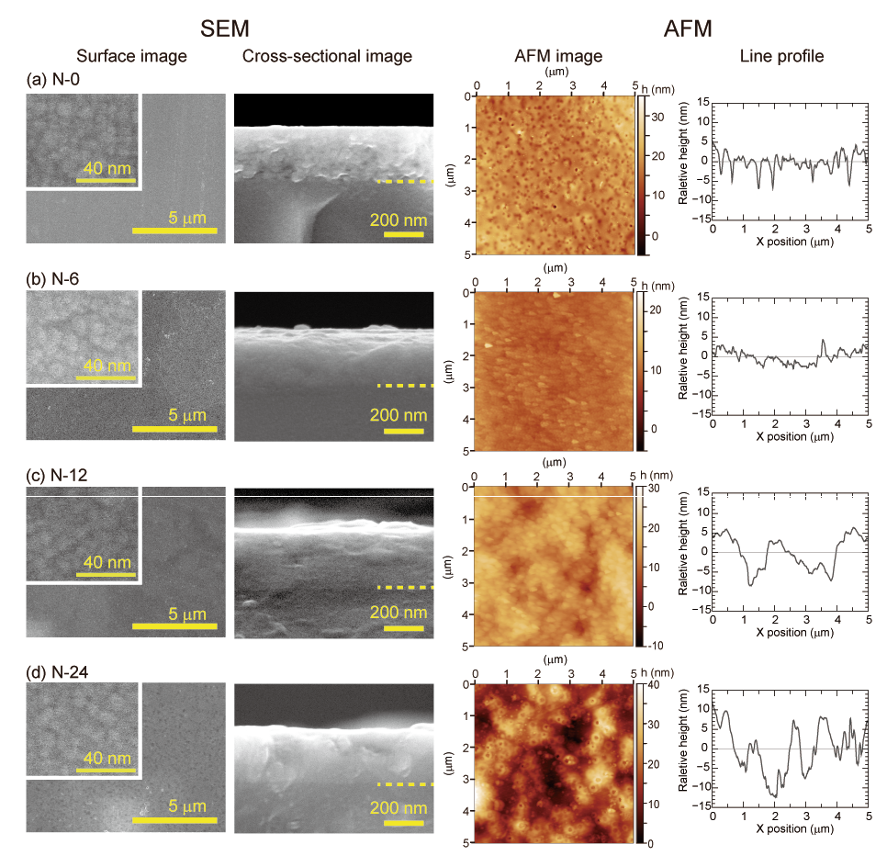
The valence state of Eu ions in the films was assessed using Eu-L_{III} X-ray absorption near edge structure (XANES). XANES spectra were collected using the fluorescence method in the 6600–7600 eV energy range at the synchrotron facility (BL-9A and BL-12C, Photon Factory of KEK, Tsukuba, Japan). Reference XANES spectra for crystalline Eu₂O₃ and EuS were also recorded. The obtained spectra were analysed using the Demeter Athena software package.⁵⁷
Figure 1. Microstructures of the films after ammonolysis observed with the FE-SEM (left) and the AFM (right): (a)-(d) for 0, 6, 12 and 24 h, respectively. The dot lines in the cross-sectional SEM images indicate film/substrate interfaces. AFM line prefile represent relative height profile in a line parallel to the x-axis at the centre position of the AFM image.
Thermal desorption spectra (TDS) were measured using an EMD-WA1000S system (ESCO, Tokyo, Japan) to explore relationships between chemical composition and spectroscopic features. The base pressure in the analytical chamber was maintained at 10⁻⁷ Pa or lower. Desorbed fragments from the sample during heating were analysed using a quadrupole mass spectrometer. The TDS measurement protocol involved heating to 1000 °C at a ramp rate of 3 °C/min, holding at 1000 °C for 3 h, and subsequently cooling to room temperature. This heating cycle was repeated twice to ensure complete desorption.

2.3. Characterization of LLSC's performance
Optical transmittance spectra in the UV and VIS range were measured using a spectrophotometer (SolidSpec-3700, Shimadzu) across a 200–700 nm range at 0.5 nm intervals. An integrating sphere composed of BaSO₄ was employed during these measurements to eliminate the influence of scattering on the resultant spectra. Photoluminescence (PL) and photoluminescence excitation (PLE) spectra were obtained using a fluorescence spectrophotometer (F-7100, Hitachi High-Tech Corp., Tokyo, Japan) at approximately 25 °C. The PL spectra were excited by UV light at λ = 280 nm, measured in the range 400-700 nm and PLE spectra were monitored at the wavelength of maximum emission intensity in a range 220-460 nm in 1 nm intervals.
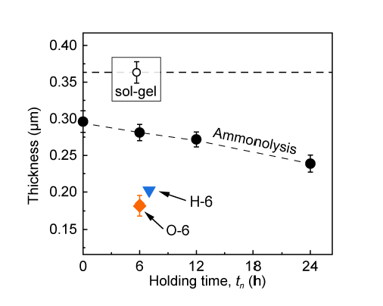
In addition to conventional measurements, the QE of luminescence was measured using a double-integrating hemisphere system (QE-2100, Otsuka Electronics, Hirakata, Japan) at room temperature (see Figure S1) and QE values were calculated referring to a literature.58 Subsequently, the films possessing higher QE was integrated into a homemade perovskite solar cell59 without any specific optical coatings on the surface exposed to the incident light using a solar simulator (SM250IQE, Bunkoukeiki Co., Ltd., Tokyo, Japan) .The data was collected in the range 300-900 nm in 5 nm intervals.
Figure 2. Film thickness before and after thermal treatment as a function of the heating time at 1000 °C.

3. Results and Discussion
3.1. Surface morphology of films
All films obtained via ammonolysis exhibited only a halo in their XRD patterns, confirming their amorphous nature (Figure S2). Similarly, XRD results identified the films heated in air (O-6) as amorphous. Conversely, β-cristobalite and α-quartz crystallized in the H-6 film, which was heated in a hydrogen-containing atmosphere.
SEM images and AFM images of the films after ammonolysis treatment are shown in Figure 1. The FE-SEM images of the surface and the cross-sectional images of the film after thermal treatment are shown in the left panels. High-magnification SEM images in the insets revealed that the grain size was consistently around 5-10 nm across different heating conditions, likely reflecting the initial grain size of the gel. Low-magnification SEM images represent the surface of the films has few uneven. On the other hand, the AFM images show height variations within a range of a few tens of nanometres. The surface undulation depended on the ammonolysis time. The N-24 appears as an uneven shape with a height of about 20 nm in cycles of about 1 μm. A comparison between the SEM and AFM images reveals that the contrast observed in the SEM images is attributed to surface roughness post ammonolysis.
Cross-sectional SEM images of the film/substrate interfaces of the samples after ammonolysis are shown in Figure 1. These images indicate shrinkage in film thickness due to thermal treatment and good adhesion between the film and substrate post-heat treatment. Notably, the film/substrate interface was not easily discernible, as no voids or cracks were observed. The interface could be identified by a slight contrast difference between the film and substrate. Film thickness and the changes induced by heat treatments were measured and summarized in Figure 2 and Table S1. The thickness of the gel film became thinner with increased heating time. The thickness was approximately 80% of the original thickness for the N-0 film and around 65% for the N-24 film. The films heated in air or Ar/H₂ gas streams were shrank by approximately 50 % of their original thickness, making them much thinner than those after ammonolysis. This reduction is attributed to densification, a common effect of heating silica-based gel films. Thermal treatment is a common method of increasing the transparency of such films.⁵³ Thermal temperature at 1000°C—near the glass transition temperature of these oxide glasses—enhanced mass transport, likely inducing densification. SEM images of H-6 and O-6 indicated densification (Fig. S3), with no pores observed. The AFM images also show that O-6 and H-6 have higher flatness than the films after ammonolysis. Although crystallization occurred slightly in the H-6 films, a substantial glass phase remained, acting as a sintering agent for densification, as Figure S2 suggests.
Conversely, films undergoing ammonolysis were expected to undergo further volume shrinkage post-nitridation as the number of atoms in the formula unit decreased, as shown in Eq. (1).
$SiO_{2}+xN_{2}→Si\left(O_{2-3x}N_{2x}\right)+\frac{3x}{2}O_{2}$ (1)
Here, three oxide ions are replaced by two nitride ions to maintain charge neutrality: that may lead to reduction of the film volume. However, the thickness of films post ammonolysis exceeded that of H-6 and O-6, probably because of their surface undulations. The precise reason for this surface undulation remains unclear, but it is plausible that fine grains slowly agglomerate during thermal treatment. As can be inferred from the fact that dense bodies could not be formed when silica gel bulks were sintered in ammonia,⁶⁰ the particle coalescence rate in ammonia atmosphere is likely slow enough to prevent densification at 1000 °C. Thus, the film surface may densify partially, resulting in an undulating surface structure forming.
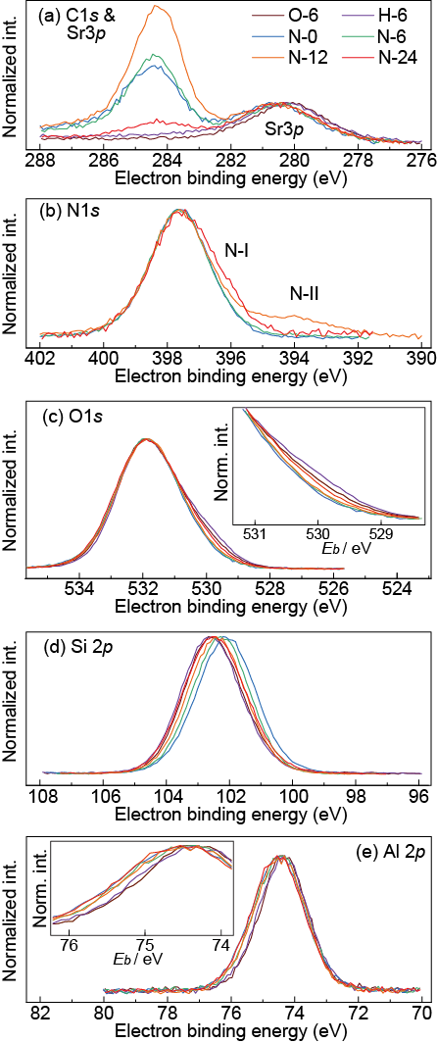
Formation of such undulating surface may be effective in avoiding cracking and delamination, since the formation of monolithic oxynitride film with 100% relative density on a silica substrate must result in cracking due to internal stress from volume shrinkage and thermal expansion coefficient mismatch. The filling density of particles in hexagonal and cubic close packing is approximately 74%. Although density of the oxynitride glass has not been evaluated accurately, comparison of the thickness of the films after nitridation and oxidation indicates the sol-gel synthesis followed by ammonolysis achieved not obvious densification (sintering) but efficient packing of grains. Thus, obtained undulating surface structures enables the production of homogeneous films without cracking and peeling. The prepared oxide films exhibited exceptionally smooth, pore-free surfaces, making them suitable for LLSC applications in minimizing light scattering. Conversely, post-ammonolysis films displayed a granular structure composed of nano-sized fine grains with insignificant surface roughness. As the surface roughness and grain sizes are much smaller than the visible wavelength range (λ = 380-780 nm), light scattering due to the microstructure of the films is negligible. These results suggest that this film formation process is suitable for fabrication of LLSCs, as it minimizes light scattering.
Figure 3 XPS spectra of the films after thermal treatment. The electron binding energies were normalized by the peak maximum of O1s core-level peak.

3.2. Chemical states of the glass matrix
The XPS measurement results are presented in Figure 3. As a charge neutralizer was used during XPS measurement, normalizing the electron binding energy (E_{b}) was necessary. In Figure 3(a), the C1s core-level spectral profile was broad and asymmetric, with residual organic components remaining in the films even after thermal treatment, resulting in a complex C1s peak profile. Additionally, the C1s peak intensity was too weak for some films after sputtering to be used for referencing. Therefore, O1s peaks, which exhibited a clearer shape, were used for E_{b} normalization.
We first examined the spectra in the N1s core-level region, shown in Figure 3(b), before evaluating the nitrogen concentration in the films. Peaks corresponding to the N1s core level were always found in the spectra of the films post ammonolysis, with the E_{b} at the peak maximum nearly identical for all films. The main peak is attributed to the nitrogen that is covalently bonded to silicon. Variations in the N1s profile indicate that the chemical state of nitrogen varies as nitridation progresses. A shoulder, N-I, was also visible in the N1s region. The increasing intensity of N-I with t_{n} suggests that the chemical component relating to the N-I feature is likely associated with the formation of oxynitride glass. Within the main band, the N1s level of HN(-Si)₂ or H₂N-Si, which may form during the ammonolysis, is known to shift slightly to -0.1 or -0.2 eV, respectively, compared to N(-Si)₃.⁶¹⁻⁶³ This indicates that the main band contains these species. Deconvolution of the main band may provide an estimate of the abundance ratio of these species. However, the deconvolution of the broad band is difficult to achieve at this stage without any information on the abundance ratio. A distinct spectral tail in the N1s region, denoted as N-II in the figure, was only present in the N-12 spectra. Considered from previous studies,^{58–60} the broader tail N-II might be assigned to negative states such as N³⁻, which were formed as intermediate products during ammonolysis. From the spectra, the formation of the negative nitrogen species such as N³⁻ occurred when t_{n} is from 6 to 12 hours. The lack of proportionality between the relative intensities of N-I and N-II to t_{n} suggests that reactions during ammonolysis are not limited to simple nitrogen-for-oxygen substitution.
In contrast to the C1s and N1s regions, the spectra in the O1s core-level region (Figure 3 (c)) appeared less sensitive to thermal treatment conditions. As shown in the inset of Figure 3 (c), the relative intensity of the spectral tail varies with these conditions, indicating that ammonolysis alters the chemical state of oxygen. However, the overall chemical state of oxygen in the films closely resembles that of ordinary oxide ions (O²⁻). Hence, the integrated spectral intensity in this O1s range reflects the oxygen concentration in the films.
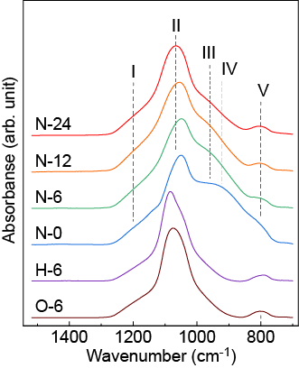
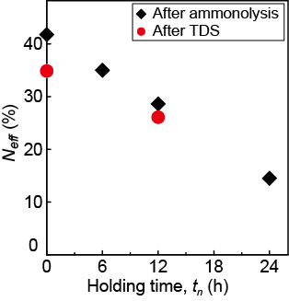
Figure 4 presents the estimated effective nitrogen concentrations (N_{eff}) as a function of t_{n}, the definition of N_{eff} is given in the supporting information. This result reveals that the N_{eff} in the films is higher at shorter t_{n} and that it decreases as the t_{n} increases. This trend suggests that the chemical state of nitrogen changes as nitridation progresses, forming nitride ions from 6 to 12 hours. These findings imply that nitridation proceeds through intermediate structures.
Figure 5 FT IR spectra of the films after thermal treatment. The spectra were numerically treated to avoid the deformation of the spectral profile due to the application of the ATR method.
Figure 4 Nitrogen concentration (Neff) of the films as a function of the holding time at 1000 °C during ammonolysis. Black and red symbols represent Neff of the films after ammonolysis and thermal desorption (TDS) measurement, respectively.
As aforementioned, the spectral features in the N1s region, such as the relative intensity of the N-II feature, did not systematically change with t_{n}. Conversely, the spectral profile of the Al2p core level showed more systematic changes in response to t_{n} or N_{eff}. A shoulder component at higher E_{b} (Figure 3(e)) became more pronounced with increasing t_{n}. The spectral tail in the Al2p region was most evident in the N-24 film, indicating that the intensity of the spectral shoulder in the Al2p region was not directly proportional to N_{eff} but rather to t_{n}. The Sr3p spectra (Figure 3(a)) displayed similarities with Al2p. Owing to the overlapping spectral tails of C1s and Sr3p, detailed analysis of the Sr3p higher-E_{b} tail was challenging. However, the Sr3p peak shifted to higher E_{b} after ammonolysis, mirroring the spectra behaviour of the Al2p profile.
The Si2p core-level spectra also depended on t_{n} (Figure 3(d)). However, the behaviour of Si2p differed slightly from that of Al2p. With ammonolysis, the Si2p peak maximum shifted to higher E_{b}. Specifically, the peak for N-0 appeared at the lowest E_{b}, while the peak for N-24 was similar to that of O-6. This trend suggests that the magnitude of the Si2p shift corresponds to N_{eff}, indicating that the chemical state of silicon is more sensitive to N_{eff} than that of aluminium. Notably, the spectra tail behaviour in the O1s peak resembled that of Si2p. The spectral tail was less pronounced for the N-0 film and increased with tn. The spectral profile for the N-24 film closely resembled that of O-6. Such similarities in the spectral profiles between N-24 and O-6 were common features observed in the O1s and Si2p regions.
The FT-IR measurement results are shown in Figure 5. Notably, the spectral profile was numerically treated with the ATR correction tool installed in the equipment, assuming that the refractive index of the film was 1.45, a typical value for pure silica glass. The spectra exhibited multiple peaks, labelled as bands I–V. Among them, peaks at approximately 1200 cm^{‑1} (band-I) and 1080 cm^{‑1} (band-II) correspond to the asymmetric stretching mode of Si-O-Si bonds.^{64,65} The presence of crystalline phases in H-6, as detected by XRD, likely explains the sharper spectral features in band-II compared to O-6, where no crystalline phase was detected. In the region of band II, the stretching vibration of Al-O-Si bonds is expected also around 1065 cm⁻¹.⁶⁶ However, it is not distinctly visible due to the broadening of band- II and the low aluminium concentration, suggesting minimal contribution. Additionally, band-III, observed in both H-6 and O-6 films (Figure 5), may originate from the stretching mode of Al-O bonds^{66–69} or the asymmetric stretching mode of Si-OH.^{65,70,71} Films prepared by ammonolysis might not exhibit band-III, owing to its overlap with band-IV. The precise nature of band-V—whether related to Si-OH or Al-O—remains unclear. The presence of hydroxyl group (OH) is discussed using TDS results in the latter part of this section.
In addition to the vibrational modes discussed earlier, band-IV appears in these films. According to previous studies,^{72,73} the peak around 900–950 cm⁻¹ (band-IV) corresponds to Si-N stretching vibration. The intensity of band-IV decreases with increasing t_{n}, a trend similar to the decrease in N_{eff}, as shown in Figure 4. Notably, the intensity of band-IV is not a measure for N_{eff}, as various species of nitrogen exist in the films. For instance, XPS results indicate the presence of nitride ions. Further investigation of additional vibrational modes, such as N-O, N-H, and N-C, would enhance understanding the chemical state of nitrogen after ammonolysis. However, such modes were not examined in this study, as ATR measurements using the Ge prism was the only viable method for thin-film samples. However, we assume that most of the nitrogen introduced into the films participated in Si-N bonding, as indicated by changes in the Si2p spectral profile with variations in N_{eff}. The spectral profile of the N-24 film with less N_{eff} closely resembles that of O-6. Hence, band-IV is considered a fingerprint for nitrogen in the present samples. Additionally, the broadening of band-IV in films with shorter t_{n} likely reflects structural distortions in Si-N bonds.
Here, we examine the consistency between XPS and FT-IR results. The peak position of band-II shifted to low energy side with t_{n}. This trend indicates that Si-O-Si glass structure changes with t_{n}., which represents that the covalency of Si-O-Si network became high after long time ammonolysis. Additionally, the Si2p core-level peak of N-24 closely corresponds to that of O-6 than that of the films with shorter t_{n}, further aligning with the intensity behaviour of band-II. Notably, the intentional addition of Si-alkyl groups causes a shift of Si-O vibrational modes.⁷⁴ Under ammonolysis, decomposition and desorption of organic components take longer than thermal treatment in oxygen-rich environments. Hence, ammonolysis performed in this study comprised two steps: initially, excess nitrogen was introduced into the gel film, followed by structural relaxation, including organic decomposition, leading to the formation of a three-dimensional (3D) glass network composed of [SiO_{x}N_{y}] polyhedrons. Thus, the relative intensities of band-II and Si2p core-level peaks are indicators of oxynitride glass formation.
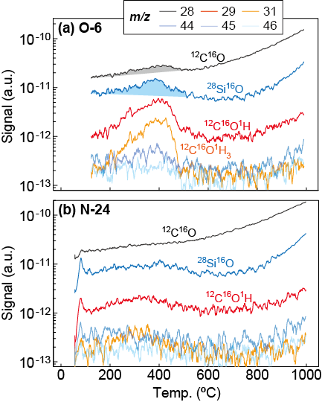
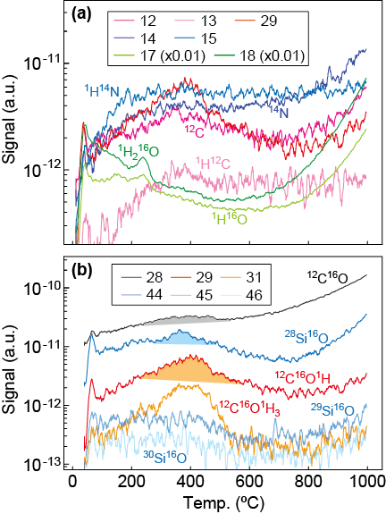
TDS measurements confirm that the glass structure is stabilized during ammonolysis. Figure 6 presents the TDS spectra of the N-0 film for some selected mass/charge (m/Z) values. A prominent desorption profile was observed for m/Z = 17 and 18, corresponding to ¹⁶O¹H and ¹H₂¹⁶O, respectively. The water desorption started at a relatively low temperature (100 °C). Desorption of ¹⁶O¹H and ¹H₂¹⁶O was evident even for the N-24 film, indicating that Si-OH contributes significantly to band-III in FT-IR spectra for the post-ammonolysis films. Given the high hydrogen gas concentration during ammonolysis—a byproduct from the decomposition of ammonia—the film after ammonolysis contains OH groups.
Figure 7 TDS of the O-6 (a) and N-24 films (b). The assignment of the fragments is given in the text.
Figure 6 TDS profile of the N 0 film. The mass/charge values are identified with legend, and the assignment of the fragments is described in the text.
Higher-intensity signals at m/Z = 28 and 44 were observed. The signal at m/Z = 28 is attributed to ²⁸Si, ¹²C¹⁶O, or ¹⁴N₂. Other possible contributions, such as ¹H¹³C¹⁴N and ¹³C¹⁵N, were excluded due to the chemical environment employed for material preparation. Similarly, m/Z = 44 is attributed to ¹²C¹⁶O₂, ²⁸Si¹⁶O, and ¹²C₂¹H₄. The desorption profiles of m/Z = 28 and 44 exhibited distinct behaviours. The peak intensity for m/Z = 28 occurred around 420 °C, whereas that of m/Z = 44 was around 380 °C. However, the signal profile for m/Z = 45 and 46 closely paralleled that of m/Z = 44, and their intensity ratios matched the natural abundance of silicon isotopes. Hence, m/Z = 44 was attributed ²⁸Si¹⁶O. Owing to the similarity in signal profiles among m/Z = 12, 13, 28, 29, these signals were attributed to the desorption of hydrocarbon species. The signal at m/Z = 15 was assigned to ¹H¹⁴N rather than ¹H₃¹²C, as it did not align with other carbon-related signals, such as m/Z = 12 and 13. The profile for m/Z = 14, lacking an obvious peak around 300–400 °C differed from the ¹²C-related fragment but showed similar behaviour at higher temperatures. Hence, m/Z = 14 was attributed to a mixture of ¹H₂¹²C and ¹⁴N. From these assignments, it is evident that silica-based fragments, molecular desorption products, hydrocarbons, water, and ammonia-related fragments were detected by TDS.
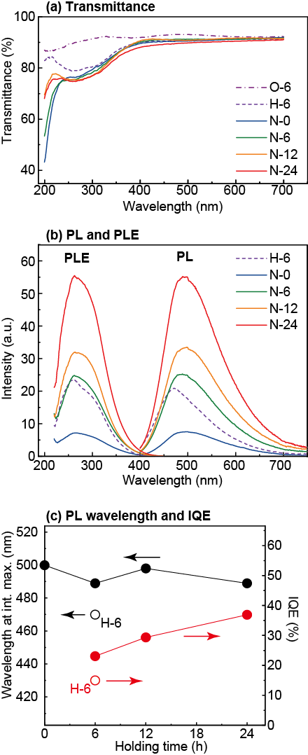
Given the clear desorption of ¹H¹⁴N in the N-0 film, N_{eff} in the films after TDS was evaluated using XPS. The results, shown in Figure 4, indicate a decrease in N_{eff} owing to desorption during TDS. Notably, the film experienced programmed heating in a vacuum at 1000 °C for 6 h during TDS. Interestingly, N_{eff} in the N-0 film after TDS aligned closely with that in the N-6 film before TDS, indicating that the thermal relaxation required for a thermodynamically stable oxynitride glass occurs gradually. The N1s spectra of N-0 film primarily corresponded to nitrogen bonded to silicon, while the FT-IR spectra indicated that the formation of a glass network, represented by the intensity of band-II absorption, was not achieved. This suggests that in the early stages of ammonolysis, nitrogen from ammonia is incorporated into the films as terminal groups, such as –NH₂.⁵³⁻⁵⁵ The subsequent polymerization to form a network structure, as expressed in Eq. (2), is likely a rate-limiting step in forming thermally stable oxynitride glass structures.
Figure 7 Optical properties of the synthesized films. (a) Optical transmittance spectra of the films after thermal treatment, (b) Photoluminescence (λ_{ex} = 280 nm) and photoluminescence excitation spectra (PLE) (λ_{em} = PL peak intensity maximum), and (c) Wavelength at PL peak intensity maximum and internal quantum efficiency versus holding time at 1000 °C for thermal treatment. Black and red circles are for films heated in ammonia and hydrogen, respectively.
$[\text{-Si-N}{\text{H}}_{2}]\text{ + }[\text{N}{\text{H}}_{2}\text{-Si-}]→[-\text{Si-N-Si}-]+\frac{1}{2}N_{2}\text{+2}{\text{H}}_{2}$ (2)
Figure 7 compares the TDS profile of N-24 with that of O-6, alongside the N-0 profile shown in Figure 6. Although O-6 was heated in air, the desorption of organic components was clearly observed, indicating that a 6 h heat treatment was insufficient for the complete removal of organic material. Given that the C1s core-level spectra for O-6 were negligibly small, these organic species were embedded deeper within the film. Additionally, the desorption of SiO-related fragments was detected from O-6, suggesting that some silicon remained partially oxidized and was not integrated into the glass network, even after prolonged heating. This explains the broader FT-IR spectrum of O-6, specifically the higher shoulder and tail intensities in the 950-1050 cm⁻¹ range. The TDS signal for N-24 was weaker than that for N-0 and O-6, indicating that despite the absence of oxygen during ammonolysis, hydrocarbon desorption was nearly complete after 24 h. Notably, the desorption of SiO-related fragments in N-24 was minimal, indicating that the formation of a glass network structure composed of [SiO_{x}N_{y}] polyhedron was nearly complete after 24 h of ammonolysis, allowing the glass structure to sufficiently relax.
In summary, XPS, FT IR, and TDS analyses confirm that the oxynitride glass structure in N-24 was fully formed after 24 h of ammonolysis. The estimated Neff value in the N-24 film was 15%, considerably lower than that in the N 0 films. However, XPS and FT-IR results indicate that polymerization for forming the glass network structure—as represented by Eq. (2)—is a rate-limiting step. A prolonged thermal treatment, such as 24 h, appears necessary to achieve a glass network structure composed of [SiO_{x}N_{y}] polyhedrons. Further characterization, such as ²⁹Si nuclear magnetic resonance, may reveal further details of the reaction kinetics during ammonolysis.

3.3. Chemical states of Eu ions
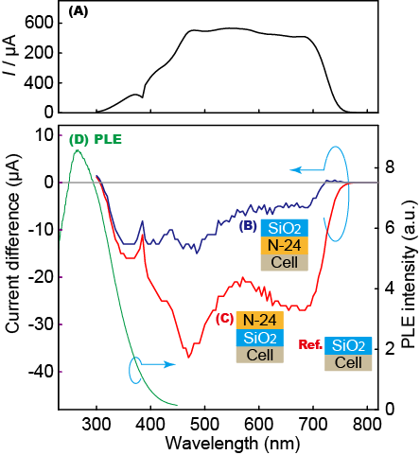
The local structure of Eu Ions was estimated using XANES spectra at the Eu L_{III}-edge. The spectra exhibited two peaks at approximately 6978 and 6984 eV, corresponding to Eu²⁺ and Eu³⁺ ions, respectively (Figure S4(a)).⁵⁶ The ratio of the Eu³⁺ to total Eu was estimated by curve fittings (Figure S4(b)) to obtain integrated peak intensities. The results indicate that the ratio of Eu²⁺ increased with t_{n}. Specifically, in H-6 and N-6 samples, Eu²⁺ accounted for 80% of the total Eu, increasing to over 95% in N-24. As aforementioned, the glass structure formation was slow, and changes in total chemical composition, especially N_{eff}, occurred as the reaction evolved. The hydrogen concentration in the films was not analysed due to the small sample mass. However, it is likely that hydrogen concentration changed with t_{n}, correlating with changes in N_{eff}. Given these complexities, precisely describing the mechanism governing the Eu valence state remains challenging. The steep decrease in Eu valence charge suggests that the formation of Eu²⁺ was nearly completed by N-12, while nitridation continued up to N-24. This suggests that changes in Eu valence and nitridation progress independently of each other in opposite directions.
Figure 9 Spectral response of the solar cell. Generated current of a naked cell (A), differences in photovoltaic current with and without an oxynitride glass layer (B and C), and the PLE spectrum of the N-24 film (D). Cell configurations of (B) and (C) are shown in the inset.

3.4. Optical properties
The UV and VIS transmittance spectra of the prepared films are shown in Figure 8(a). All films exhibited high transmittance (> 88%) within the 400 to 700 nm wavelength (λ) range. The film heated in air (O-6) displayed higher transmittance in the λ = 200-400 nm range, whereas the other films showed reduced UV transmittance. The decreased transmittance at λ = 200-220 nm is attributed to optical bandgap narrowing induced by nitridation, as it correlates with the nitrogen concentration depicted in Figure 4. The higher absorption in films with shorter t_{n} suggests that increased nitridation enhances UV absorption. Conversely, transmittance in the λ = 240-400 nm range was reduced in films prepared by ammonolysis and H-6. Among the films prepared by ammonolysis, N-24 showed the least transmittance, which appears to correlate with the abundance of Eu²⁺ ions, as estimated from XANES spectra. Thus, absorption in the λ = 240-400 nm range is attributed to the f-d transition of Eu²⁺ ions.
Another possibility is enhanced light scattering caused by the microstructure shown in Figure S3. Granular structures and compositional fluctuations—inhomogeneity in refractive index—contribute to scattering at shorter wavelengths, while the smooth and homogeneous glass structure of H-6 and O-6 cannot cause significant light scattering.
The PL and PLE spectra of the films are shown in Figure 8(b). The O-6 film did not exhibit luminescence, whereas broadband luminescence centred at λ = 490 nm, attributed to the 4f⁶5d → 4f⁷ transition of Eu²⁺, was observed in films containing Eu²⁺ ions. The luminescence intensity increased with higher Eu²⁺ concentrations. As indicated in Eq. (2), the current results demonstrate changes in the glass structure with tn. Although we could not detail local coordination structures around Eu²⁺ ions owing to insufficient data, a more detailed analysis of the local structure around Eu²⁺ and the host glass network structure is essential for optimizing luminescence properties.
The PLE spectra exhibited a peak at λ = 250 nm, supporting the conclusion that the 240-400 nm absorption band in the transmission spectra results from the excitation of Eu²⁺ ions. However, energy transfer from the glass matrix to Eu ions is not a dominant mechanism for luminescence. Optical absorption by the oxynitride glass matrix at λ < 240 nm was observed; however, the PLE spectra suggest that these shorter-wavelength photons do not contribute significantly to luminescence. Thus, optimizing the coordination structure to prevent energy dissipation remains crucial.
Although the Eu valence states in N-12 and N-24 appear similar, the internal quantum efficiency (IQE) shown in Figure 8(c) indicates that the IQE of N-24 is much higher than that of N-12. This highlights the importance of the glass matrix structure in determining luminescence efficiency. The obtained IQE value was close to the reported Sr₃Si_{8-x}Al_{x}O_{7+x}N_{8-x}: Eu²⁺ crystal phosphor, which has an IQE of 45%. As forming a 3D glass network in oxynitride glass takes time, further improvements in IQE may be possible through the optimization of nitridation and thermal treatment processes.

3.5. Device performance
Figure 9 illustrates the performance of a solar cell integrated with theN-24 film. Spectrum A is the spectral response of the original solar cell. Spectra B and C show the difference in current magnitude between cells with and without the oxynitride film, with a positive value indicating enhanced efficiency owing to the application of the oxynitride film. In the VIS range, the reduction in current due to the N-24 film was more pronounced in the film-on-top configuration (spectrum C) compared to the substrate-on-top configuration (spectrum B). This difference likely arises from the scattering and reflection of incident light by the oxynitride film. The substrate-on-top configuration appears to yield higher efficiency due to the suppression of light reflection and scattering.
A notable behaviour is observed for λ < 450 nm. The curvature of spectrum C appears parallel to the PLE spectrum of the N-24 film (spectrum D). Additionally, spectra B and C are nearly identical in λ < 350 nm, suggesting that the N-24 film functions as an LLSC. Although we could not evaluate the spectral response for λ < 300 nm due to instrumental limitations, the results suggest that the oxynitride luminescent film demonstrates significant benefits in this range. The current difference at 300 nm becomes positive, indicating that the luminescence of the film outweighs the energy loss from reflection and scattering at this wavelength.
Further reducing light scattering and reflection is necessary, as the film-on-top configuration exhibited greater energy loss. However, these results encourage the continued development of LLSCs, including luminescent solar concentrators, with the oxynitride glass system. It should be also pointed that using oxynitride with Eu²⁺ centre to luminescent solar concentrator is a promising idea as it has been demonstrated that the UV-to-VIS conversion of this material works for selective absorption of UV and utilization of UV to photovoltaic power generation.

4. Conclusion
Europium-doped strontium-aluminium-silicon-oxynitride glass films were prepared through ammonolysis of sol-gel-derived films. Structural and compositional analyses revealed that a long reaction period (t_{n}) is necessary to achieve a thermally stable glass structure. The rate-limiting step in forming oxynitride glass structures was not the introduction of nitrogen but rather the formation of Si-N-Si and Si-O-Si bonds. An oxynitride glass with a nitrogen concentration of approximately 14% was achieved through ammonolysis at 1000 °C for 24 h. Additionally, the developed process effectively stabilized divalent Eu ions (Eu²⁺) for UV-to-VIS conversion, with more than 90% of Eu ions becoming divalent after 12 h of ammonolysis.
However, prolonged thermal treatment was essential to achieve a high IQE, underscoring the influence of the host matrix structure—specifically, the glass structure—on luminescence efficiency. The results suggest that forming a 3D glass network composed of [SiO_{x}N_{y}] polyhedrons is crucial for optimizing luminescence efficiency. Furthermore, improved photovoltaic performance in the UV range was confirmed, demonstrating the usefulness of the oxynitride glass with bright Eu²⁺ luminescence. However, challenges, such as reducing reflection and scattering in the VIS range remain and must be addressed for practical applications.
Author contributions
Xun Liu: Data curation, Formal analysis, Investigation, Visualization, Writing – original draft Writing – review & editing
Takeo Ohsawa : Investigation, Resources, Writing – review & editing
Jian Xu: Investigation, Writing – review & editing
Masatoshi Yanagida: Investigation, Resources, Writing – review & editing
Kohsei Takahashi: Investigation, Writing – review & editing
Takashi Takeda; Resources, Writing – review & editing
Tetsuo Kishi: Writing – review & editing
Tetsuji Yano: Supervision, Writing – review & editing
Hiroyo Segawa: Conceptualization, Data curation, Formal analysis, Funding acquisition, Investigation, Methodology, Project administration, Resources, Supervision, Writing – original draft, Writing – review & editing
Naoki Ohashi Conceptualization, Data curation, Formal analysis, Funding acquisition, Methodology, Project administration, Resources, Supervision, Visualization, Writing – review & editing
Conflicts of interest
There are no conflicts to declare.
Data availability
The data supporting this article have been included as part of the ESI.
Acknowledgements
Part of this study was included in the master's thesis of LX at the Tokyo Institute of Technology (2023) and will be incorporated into the PhD thesis of LX. A part of this study was conducted at the Tokodai Institute for Elemental Strategy with support from Grant Number JPMXP0112101001 and at the Data-Driven Materials Research Institute for Electronics under support from JPMXP1122683430. This work was performed with the approval of the Photon Factory Program Advisory Committee (Proposal Nos. 2020G105 and 2022G095) and was supported by the Advanced Research Infrastructure for Materials and Nanotechnology in Japan (ARIM) under Grant Number JPMXP1224NM5408. The authors at NIMS gratefully acknowledge the technical assistance of Ms. Kazuko Nakajima.
References

- 1 W. Shockley and H. J. Queisser, J Appl Phys, 1961, 32, 510–519.
- 2 J. M. Woodall and H. J. Hovel, Appl Phys Lett, 1972, 21, 379–381.
- 3 Q. Sun, H. Deng, Q. Yan, B. Lin, W. Xie, J. Tang, C. Zhang, Q. Zheng, J. Wu, J. Yu and S. Cheng, ACS Appl Energy Mater, 2021, 4, 14467–14475.
- 4 D. Liang, Y. Kang, Y. Huo, Y. Chen, Y. Cui and J. S. Harris, Nano Lett, 2013, 13, 4850–4856.
- 5 N. K. Das, S. F. U. Farhad, A. K. Sen Gupta, E. M. K. I. Ahamed, M. A. Matin and N. Amin, Opt Mater (Amst), 2024, 155, 115816.
- 6 B. S. Richards, Solar Energy Materials and Solar Cells, 2006, 90, 1189–1207.
- 7 C. Chen, S. Zheng and H. Song, Chem Soc Rev, 2021, 50, 7250–7329.
- 8 A. Sinha, J. Qian, S. L. Moffitt, K. Hurst, K. Terwilliger, D. C. Miller, L. T. Schelhas and P. Hacke, Progress in Photovoltaics: Research and Applications, 2023, 31, 36–51.
- 9 J. F. Geisz, R. M. France, K. L. Schulte, M. A. Steiner, A. G. Norman, H. L. Guthrey, M. R. Young, T. Song and T. Moriarty, Nature Energy 2020 5:4, 2020, 5, 326–335.
- 10 H. Li and W. Zhang, Chem Rev, 2020, 120, 9835–9950.
- 11 G. Xie, H. Li, J. Fang, X. Wang, L. Gan, N. Huang, H. Peng, X. Lin and L. Qiu, J Mater Chem C Mater, 2025, 13, 6309–6318.
- 12 X. Liu, J. Li, X. Cui, X. Wang and D. Yang, J Mater Chem C Mater, 2023, 11, 426–455.
- 13 Z. Zhao, S. Chu, J. Lv, Q. Chen, Z. Xiao, S. Lu and Z. Kan, J Mater Chem C Mater, 2023, 11, 11167–11174.
- 14 R. Witteck, B. Min, H. Schulte-Huxel, H. Holst, B. Veith-Wolf, F. Kiefer, M. R. Vogt, M. Köntges, R. Peibst and R. Brendel, physica status solidi (RRL) – Rapid Research Letters, 2017, 11, 1700178.
- 15 H. P. Wang, D. H. Lien, M. L. Tsai, C. A. Lin, H. C. Chang, K. Y. Lai and J. H. He, J Mater Chem C Mater, 2014, 2, 3144–3171.
- 16 H. J. Hovel, R. T. Hodgson and J. M. Woodall, Solar Energy Materials, 1979, 2, 19–29.
- 17 E. Klampaftis, D. Ross, K. R. McIntosh and B. S. Richards, Solar Energy Materials and Solar Cells, 2009, 93, 1182–1194.
- 18 G. Griffini, F. Bella, F. Nisic, C. Dragonetti, D. Roberto, M. Levi, R. Bongiovanni and S. Turri, Adv Energy Mater, 2015, 5, 1401312.
- 19 Y. Liu, Y. Iso and T. Isobe, J Mater Chem C Mater, 2025, 13, 786–792.
- 20 J. Choi and S. J. Kim, J Mater Chem C Mater, 2024, 12, 12026–12036.
- 21 C. Yang, W. Sheng, M. Moemeni, M. Bates, C. K. Herrera, B. Borhan, R. R. Lunt, C. Yang, M. Bates, C. K. Herrera, R. R. Lunt, W. Sheng, M. Moemeni and B. Borhan, Adv Energy Mater, 2021, 11, 2003581.
- 22 M. G. Debije and P. P. C. Verbunt, Adv Energy Mater, 2012, 2, 12–35.
- 23 L. Xu, S. Yuan, L. Ma, B. Zhang, T. Fang, X. Li and J. Song, J Mater Chem A Mater, 2021, 9, 18947–18973.
- 24 M. M. Tavakoli, H. T. Dastjerdi, D. Prochowicz, P. Yadav, R. Tavakoli, M. Saliba and Z. Fan, J Mater Chem A Mater, 2019, 7, 14753–14760.
- 25 H. C. Lim, J. J. Koo, J. Il Kim, J. K. Lee, Z. H. Kim and J. I. Hong, New Journal of Chemistry, 2019, 43, 18843–18847.
- 26 S. Hase, Y. Iso and T. Isobe, J Mater Chem C Mater, 2022, 10, 3523–3530.
- 27 D. Alonso-Álvarez, D. Ross, E. Klampaftis, K. R. McIntosh, S. Jia, P. Storiz, T. Stolz and B. S. Richards, Progress in Photovoltaics: Research and Applications, 2015, 23, 479–497.
- 28 F. Bella, G. Griffini, J.-P. Correa-Baena, G. Saracco, M. Grätzel, A. Hagfeldt, S. Turri and C. Gerbaldi, Science (1979), 2016, 354, 203–206.
- 29 T. Uekert, A. Solodovnyk, S. Ponomarenko, A. Osvet, I. Levchuk, J. Gast, M. Batentschuk, K. Forberich, E. Stern, H. J. Egelhaaf and C. J. Brabec, Solar Energy Materials and Solar Cells, 2016, 155, 1–8.
- 30 J. Zheng, H. Mehrvarz, C. Liao, J. Bing, X. Cui, Y. Li, V. R. Goncąles, C. F. J. Lau, D. S. Lee, Y. Li, M. Zhang, J. Kim, Y. Cho, L. G. Caro, S. Tang, C. Chen, S. Huang and A. W. Y. Ho-Baillie, ACS Energy Lett, 2019, 4, 2623–2631.
- 31 D. Yang, H. Liang, Y. Liu, M. Hou, L. Kan, Y. Yang and Z. Zang, Dalton Transactions, 2020, 49, 4725–4731.
- 32 N. Chander, A. F. Khan, P. S. Chandrasekhar, E. Thouti, S. K. Swami, V. Dutta and V. K. Komarala, Appl Phys Lett, 2014, 105, 33904.
- 33 S. Marchionna, F. Meinardi, M. Acciarri, S. Binetti, A. Papagni, S. Pizzini, V. Malatesta and R. Tubino, J Lumin, 2006, 118, 325–329.
- 34 J. J. Velázquez, V. D. Rodríguez, A. C. Yanes, J. Del Castillo and J. Méndez-Ramos, Appl Phys B, 2012, 108, 577–583.
- 35 Y. Katayama and S. Tanabe, Materials 2010, Vol. 3, Pages 2405-2411, 2010, 3, 2405–2411.
- 36 Z. CHENG, L. PAN, F. SU, M. CAO and Z. SUN, Surface Review and Letters, 2009, 16, 669–673.
- 37 L. Wang, R. J. Xie, T. Suehiro, T. Takeda and N. Hirosaki, Chem Rev, 2018, 118, 1951–2009.
- 38 D. Ross, E. Klampaftis, J. Fritsche, M. Bauer and B. S. Richards, Solar Energy Materials and Solar Cells, 2012, 103, 11–16.
- 39 B. Ye, Y. Li, Z. Chen, Q. Y. Wu, W. L. Wang, T. Wang and H. Y. Hu, Water Res, 2017, 124, 381–387.
- 40 Z. Hosseini, W. K. Huang, C. M. Tsai, T. M. Chen, N. Taghavinia and E. W. G. Diau, ACS Appl Mater Interfaces, 2013, 5, 5397–5402.
- 41 C. Strümpel, M. McCann, G. Beaucarne, V. Arkhipov, A. Slaoui, V. Švrček, C. del Cañizo and I. Tobias, Solar Energy Materials and Solar Cells, 2007, 91, 238–249.
- 42 S. V. Eliseeva and J. C. G. Bünzli, New Journal of Chemistry, 2011, 35, 1165–1176.
- 43 X. Qin, X. Liu, W. Huang, M. Bettinelli and X. Liu, Chem Rev, 2017, 117, 4488–4527.
- 44 P. Dorenbos, J Lumin, 2003, 104, 239–260.
- 45 L. Kuang, F. Zhang, J. Zhang, X. Zhu, X. Tian, J. Shao, Y. Liu, X. Xu and Z. Liu, J Mater Chem C Mater, 2024, 12, 17298–17304.
- 46 H. Yuan, S. Jin, S. Zheng, R. Xie, T. Pang, B. Zhuang, F. Huang and D. Chen, J Mater Chem C Mater, 2024, 12, 1430–1439.
- 47 J. Zhang, X. Li, W. Zeng, D. Liu, L. Lu, H. Dai, J. Yuan, J. Shao, Z. Liu, J. Yu and X. Xu, J Mater Chem C Mater, 2024, 12, 7580–7587.
- 48 R. J. Xie and N. Hirosaki, Sci Technol Adv Mater, 2007, 8, 588–600.
- 49 S. Li, L. Wang, D. Tang, Y. Cho, X. Liu, X. Zhou, L. Lu, L. Zhang, T. Takeda, N. Hirosaki and R. J. Xie, Chemistry of Materials, 2018, 30, 494–505.
- 50 Y. Iso, S. Takeshita and T. Isobe, J Electrochem Soc, 2012, 159, J72–J76.
- 51 S. Ali, A. Ellison, J. Luo and M. Edén, Journal of the American Ceramic Society, 2023, 106, 1748–1765.
- 52 S. Ali, B. Jonson, M. J. Pomeroy and S. Hampshire, Ceram Int, 2015, 41, 3345–3354.
- 53 C. J. Brinker and G. W. Scherer, Sol-Gel Science: The Physics and Chemistry of Sol-Gel Processing, 2013, 1–908, Academic Press, San Diego, 1990.
- 54 C.J. Brinker, D.M. Haaland, J. Am. Ceram. Soc., 1983, 66, 758–765.
- 55 C.J. Brinker, D.M. Haaland, R.E. Loehman, J. Non-Cryst. Solids, 1983, 56, 179–184.
- 56 S. Watanabe, Y. Osawa, S. Machida, K. Katsumata, A. Yasumori, K. Takahashi, K. Deguchi, S. Ohki and H. Segawa, J Non Cryst Solids, 2021, 573, 121107.
- 57 B. Ravel and M. Newville, J Synchrotron Radiat, 2005, 12, 537–541.
- 58 N. Hirosaki, R. J. Xie, K. Kimoto, T. Sekiguchi, Y. Yamamoto, T. Suehiro and M. Mitomo, Appl Phys Lett, 2005, 86, 1–3.
- 59 N. Pant, M. Yanagida, Y. Shirai and K. Miyano, Applied Physics Express, 2020, 13, 025505.
- 60 Y. Osawa, K. Iwasaki, T. Nakanishi, A. Yasumori, Y. Matsui, T. Nishimura, T. Ohsawa, H. Segawa, N. Ohashi, J. Am. Ceram. Soc., 2021, 104(9), 4420-4432.
- 61 R. K. Brow, C. G. Pantano and D. C. Boyd, Journal of the American Ceramic Society, 1984, 67, c72–c74.
- 62 J. R. Shallenberger, D. A. Cole and S. W. Novak, Journal of Vacuum Science & Technology A: Vacuum, Surfaces, and Films, 1999, 17, 1086–1090.
- 63 M. Takahashi, T. Mizokuro, Y. Nishioka and H. Kobayashi, Surf Sci, 2002, 518, 72–80.
- 64 A. Bertoluzza, C. Fagnano, M. Antonietta Morelli, V. Gottardi and M. Guglielmi, J Non Cryst Solids, 1982, 48, 117–128.
- 65 H. Aguiar, J. Serra, P. González and B. León, J Non Cryst Solids, 2009, 355, 475–480.
- 66 B. T. Poe, P. F. McMillan, C. A. Angell and R. K. Sato, Chem Geol, 1992, 96, 333–349.
- 67 D. N. Goldstein, J. A. McCormick and S. M. George, Journal of Physical Chemistry C, 2008, 112, 19530–19539.
- 68 J. M. Reyes, B. M. Perez Ramos, C. Z. Islas, W. C. Arriaga, P. R. Quintero and A. T. Jacome, J Electrochem Soc, 2013, 160, B201–B206.
- 69 N. H. Shalaby, R. A. Elsalamony and A. M. A. El Naggar, New Journal of Chemistry, 2018, 42, 9177–9186.
- 70 W. A. Pliskin and H. S. Lehman, J Electrochem Soc, 1965, 112, 1013.
- 71 M. G. Garnica-Romo, J. M. Yañez-Limón, M. Villicaña, J. F. Pérez-Robles, R. Zamorano-Ulloa and J. González-Hernandez, Journal of Physics and Chemistry of Solids, 2004, 65, 1045–1052.
- 72 H. Ono, T. Ikarashi, Y. Miura, E. Hasegawa, K. Ando and T. Kitano, Appl Phys Lett, 1999, 74, 203–205.
- 73 M. Klanjšek Gunde and M. Maček, physica status solidi (a), 2001, 183, 439–449.
- 74 S. R. Darmakkolla, H. Tran, A. Gupta and S. B. Rananavare, RSC Adv, 2016, 6, 93219–93230.

- Citations should appear here in the format A. Name, B. Name and C. Name, Journal Title, 2000, 35, 3523; A. Name, B. Name and C. Name, Journal Title, 2000, 35, 3523.

