Pitfalls in Artificial Intelligence Powered Discovery due to Electrocatalyst Evaluation Methodologies
Abraham Castro Garcia¹ and Ken Sakaushi^{1,2,3,*}
¹Research Center for Energy and Environmental Materials, National Institute for Materials Science, 1-1 Namiki, Tsukuba, Ibaraki 305-0044, Japan
²Churchill College, Storey's Way, Cambridge CB3 0DS, United Kingdom
³Cavendish Laboratory, University of Cambridge, JJ Thomson Avenue, Cambridge CB3 0HE, United Kingdom
*Email: sakaushi.ken@nims.go.jp

Abstract
The explosive increase in popularity and increased accessibility to artificial intelligence and data science tools has opened the door for exploring previously deemed “too large” experimental spaces efficiently in experimental chemistry. This is of special interest for the field of electrocatalysis where the development of new materials has relied largely on trial-and-error approaches that are not time and resource-efficient. By leveraging these approaches, experimentalists can more effectively find promising electrocatalyst compositions and synthesis conditions that result in lower overpotentials and higher electrocatalyst durability. In this technical note, we use oxygen evolution electrocatalysts as a model to highlight potential pitfalls in the use of data-driven strategies for electrocatalyst development, focusing on the importance choice of optimization metrics, normalization of data and common errors that may appear during this kind of approaches.

Keywords: oxygen evolution reaction, water electrolysis, data-driven material discovery, Bayesian optimization, machine learning

Introduction
Recent advances in cost-effective artificial intelligence (AI) and as well as affordable computing accessibility have allowed us to explore seemingly impossibly big experimental search spaces efficiently and discover promising materials effectively¹⁻⁶ . Especially, accessible ready-to-deploy algorithms including a wide spectrum of types of AI, such as machine-leaning (ML) or Bayesian optimization (BO), a subset of ML, have enabled experimentalists to apply “human-in-the-loop” approaches.⁷⁻⁸ Relying either on own’s pure experimental data or taking advantage of data available in the literature, experimentalists can explore their defined experimental space and find materials with better properties much more efficiently. Examples of successful application can be found not only in electrocatalysis⁹⁻¹¹ but also in finding better alloys¹², semiconductors¹³ or polymers¹⁴. These research outcomes indicate that the AI-powered methodology would be essential tool in research in the very near future.
In this context, as the carbon neutrality goal is set by 2050, water electrolysis technology is highly demanded to produce renewable, green hydrogen from electricity. Therefore, accelerated discovery of active and durable electrocatalysts with affordable elements are also demanded as still the present water electrolyzers are relied on the expensive and limited platinum-group-metals (PGMs)¹⁵. The electrocatalytic reaction at the cathode, i.e. hydrogen evolution reaction (HER), is comparatively simpler and has been extensively studied since long time ago.¹⁶⁻²¹ As the result, several promising cost-effective electrocatalysts have been found.^{22, 23} At the anode where the oxygen evolution reaction (OER) takes place, due to the sluggish electrode kinetics that involves four electrons, OER requires higher overpotential even for the most active catalyst of Iridium oxide.²⁴ Therefore, various data-driven strategies can be seen in order to discovery electrocatalysts which can be substituted with Ir.
However, in fact, the explosive popularity of these new data science-assisted/ML-assisted approaches invite the possibility of unconventional mistakes and errors in the cycles of experimentation, data processing and re-training of models. These mistakes and errors are indeed new therefore we are facing an open discussion about how to solve the issues. Particularly, in the case of electrocatalysis these problems are further accentuated due to the complexities associated with reliably measuring electrochemical phenomena²⁵, variety of experimental approaches²⁶ and abundance of non-standardized home-made equipment. This issue is not new as Kita²⁷ and Trasatti²⁸ independently have found out that the data quality is crucially important to find out a structure-property relationship in electrochemistry. Issues such as proper application of iR correction²⁹, interpretation and estimation of catalyst durability³⁰⁻³² and careless application of the concept of electrochemically active surface area (ECSA)^{33, 34} have already been addressed in other works. Thus, in this Technical Note, by employing OER electrocatalysts as a model system, we aim to offer guidance on what we believe to be the most correct way to implement BO-based data-driven approaches for the exploration of massive experimental material search spaces, highlighting key pitfalls and problems (Scheme 1), as well providing advice on how to overcome or minimize them.

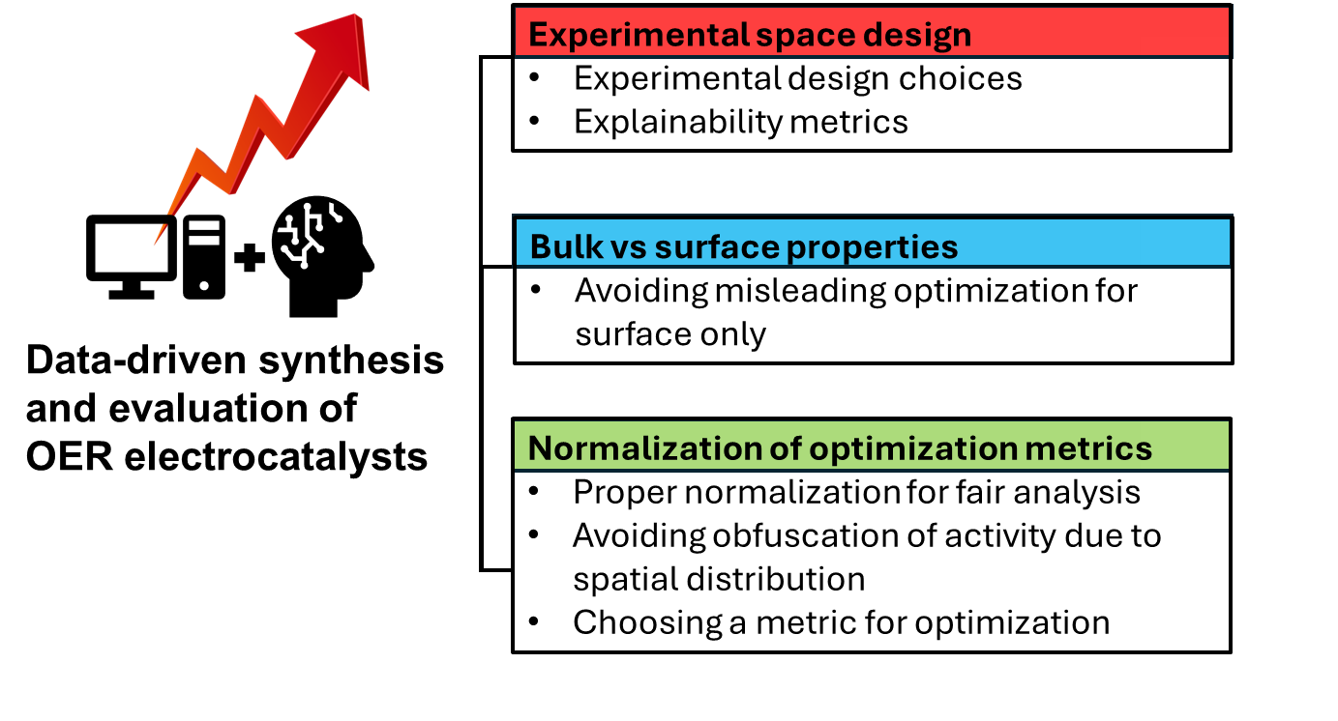
Scheme 1. Issues covered in this Technical Note regarding data-driven synthesis and evaluation of OER electrocatalysts.

Technical background
In the context of the study of water splitting electrocatalysts, using a simple 3-electrode arrangement is most convenient due to the ease with which the experimenter can test many electrocatalysts quickly. Although the conditions of this type of experiment are often touted not to be representative of large scale industrial electrolyzers, it remains a practical way to quickly screen many electrocatalysts, which could then be further evaluated in more realistic conditions on an industrial level. In terms of the composition of the working electrode, geometrically well-defined, flat, conducting substrates such as etched Titanium are used for ease of current normalization and lack of contribution to current. The electrocatalytically active phase of the working electrode is deposited through drop casting of catalyst ink or precursor salt solutions of the species of interest.
Regarding the human-in-the-loop approach, its most basic form is illustrated in Figure 1 a), where once an experimental space has been defined, synthesis, evaluation and data integration and synthesis recommendation are carried out cyclically until results of interest have been found, or the metric of interest no longer shows improvement after repeated cycles⁹. In Figure 1 b) we emphasize the critical importance of understanding the difference between the “material space” of the experimental space and the “electrochemical space”. The material space in this context refers to the reagents and synthesis conditions used to synthesize new OER electrocatalysts, which can be described with symbols (such as element symbols, or chemical formulas), synthesis conditions (catalyst deposition method, sample treatment) and reaction conditions (temperature, stirring, choice of electrolyte, pH), and are machine-readable. The values and symbols that constitute this material space should ideally be closely correlated with the optimization target (usually overpotential and durability, in this case). However, due to the complex phenomena that may take place both during synthesis and testing of the electrocatalyst, it will often be the case that the variables in an electrochemical experimental design would not be perfectly (or strongly) correlated with the target to be optimized. In addition, experimental variables do not have deep explanative power by themselves, especially when it comes to catalyst composition. The “electrochemical space” consists of those metrics or measurable properties that know are causative and can explain the electrochemical behaviors observed, examples include: ECSA, active site identity, impedance, adsorption energies, textural and pore properties. An overlap or correlation between these two spaces allows for the creation of meaningful, well-defined hypotheses that can be tested, and aids in finding mechanistic explanations to the performance of the electrocatalysts performance. This is true for all data-driven human-in-the-loop approaches, whether they involve ML or BO.

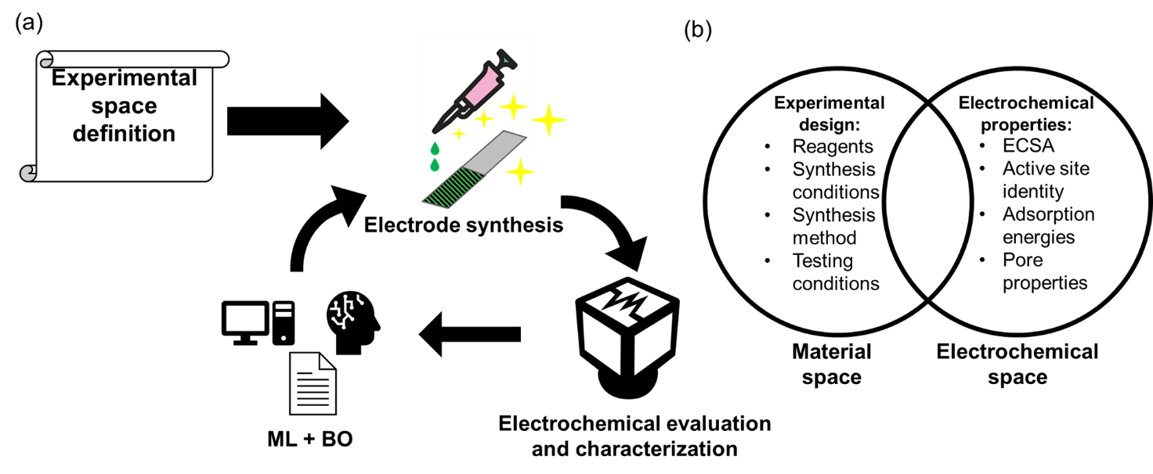
Figure 1. a) Representation of human-in-the-loop data science and experimentation approach, where once an experimental space has been defined, electrocatalyst synthesis and evaluation are carried out in succession, then, metrics obtained from this experimental component are used to further suggest promising new experimental conditions. b) Relationship between experimental design and the measurable properties it should translate into.

Bulk vs surface properties and how optimization for surface can be misleading
We present the following experimental data to exemplify how ill-conceived selection of optimization metrics when studying electrocatalysts can lead to misleading results. Initially, we proposed stacking 14 layers of ruthenium oxide (RuO_{x}) on a Titanium substrate, then, depositing 6 layers of a combination of 5 different transition metals in equimolar proportion (among: Sc, Ti, V, Cr, Mn, Fe, Co, Ni, Cu, Zn, Sr, Y, Zr, Nb, Mo, Ag, Hf, Ta, W, Au), forming a protective layer structure that would increase durability of RuO_{x} and find lower overpotentials. This proposed experimental space includes 15504 possible candidates.
Initially, 8 electrocatalysts with random elemental compositions were tested, subsequently, this data was fed into a BO algorithm previously developed⁷, proposing 4 new electrocatalyst compositions each cycle. For this optimization process two metrics were selected, the first one being overpotential area under a chronopotentiometry (CP) curve @ 50 mA/cm² for 1 hour, the second being the percentual increase in overpotential from t = 0 to t = 1 hour. By attempting to minimize both metrics, we intended to find catalysts with both lower overpotential and more durability. This process was repeated for 9 loops, for a total of 44 electrocatalysts tested. As experiment-recommendation loops progressed, smaller changes in overpotential after 1 hour of CP were found, as expected and for area under CP graph a less pronounced pattern was found in an increasing direction, seemingly indicating the possibility of a trade-off like relationship between high durability and low overpotential
These experimental results are shown together in Figure 2 as a plot where the metrics we have obtained over the course of the experimental work indeed form a pareto front (indicating there’s always a tradeoff between our optimization metrics), with a few elements being prone to minimal change in overpotential after 1 hour of CP @ 50 mA/cm² (Ti, Cr and Mn), whereas Fe was present almost invariably in most catalysts due to its well-understood positive effect in electrocatalyst properties³⁵. Interestingly, when compared to a RuO_{x} benchmark (only 14 layers of RuO_{x}), catalysts with even lower overpotential were found. More of these results can be observed in Table S1, Figures S1 and S2.

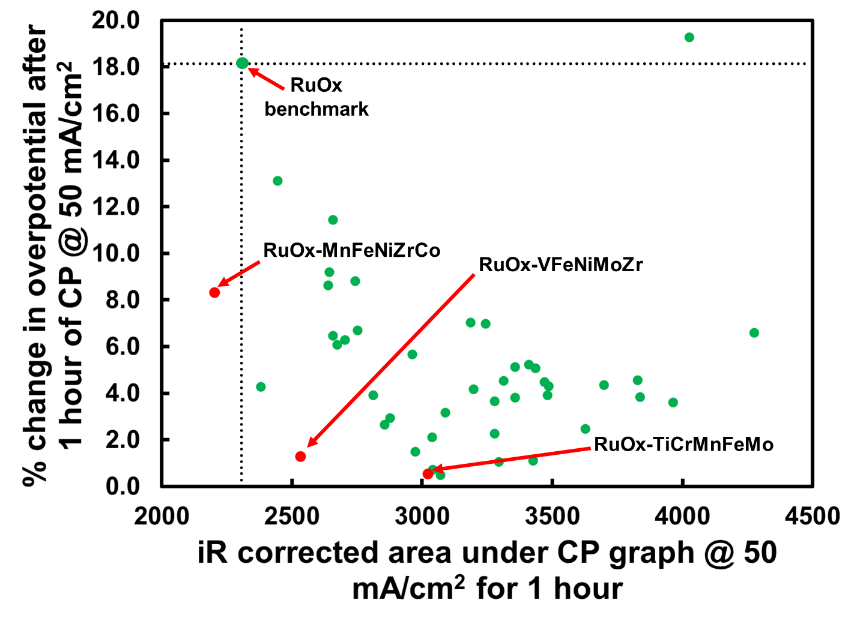
Figure 2. Plot illustrating % change in overpotential after 1 hour CP @ 50 mA/ cm² and area iR corrected area under CP graph.

Satisfied with the results we had found; we decided to test the most promising compositions at higher temperature order to ascertain their durability. Disappointingly, it became apparent that our best synthesized electrocatalysts were not necessarily much more durable than the RuO_{x} benchmark when measured with CP @ 100 mA/cm² at 80 °C, as can be observed in Figure 3 a). Further testing at room temperature with simpler catalysts compositions, at the same conditions as the experiments for longer periods of time, clarified that indeed the behavior of our “best” catalysts was only initially different from that of pure RuO_{x}, as shown in Figure 3 b).

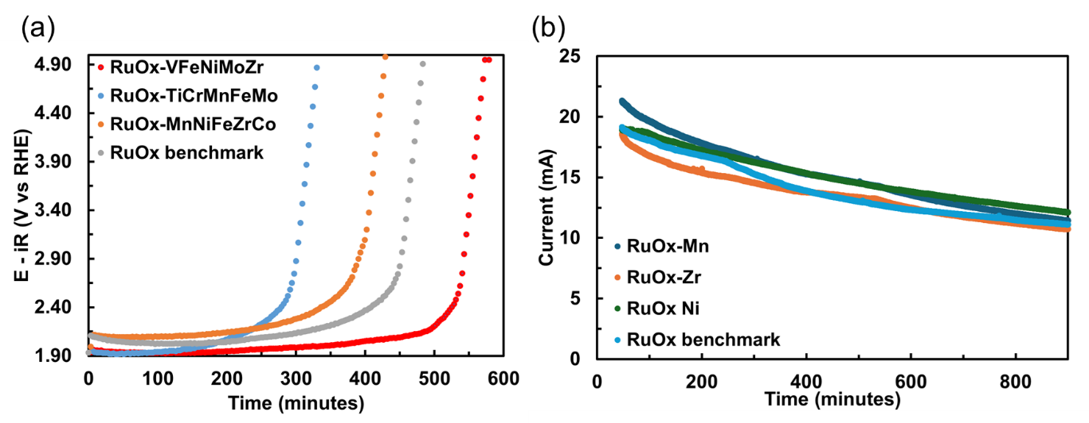
Figure 3. a) Performance of optimized electrocatalysts during CP @100 mA/cm² at 80 °C, pH 9.2 Na₂CO₃-NaHCO₃ buffer. b) Performance of simpler multi-layer catalysts during chronoamperometry at 1 V vs RHE, 0.1 M KOH electrolyte (pH13) at room temperature.

Reanalyzing our hypothesis, it became apparent that, for a “protective layer” strategy to enhance electrocatalyst durability to work, this layer would have to be not only resistant to dissolution, somehow stabilize RuO_{x}, and presumably also migrate downwards as the reaction is happening. Perhaps, in spite successful application of this protective layer strategy for other ends, such as minimizing the selectivity of an electrocatalyst towards the chlorine reaction³⁶, this strategy would be unlikely to increase the durability of the catalyst.
This failure exemplifies a major potential pitfall in the usage of human-in-the-loop approaches to optimize electrocatalyst properties, that unless we can ascertain that the behavior initially observed in the electrocatalyst surface (i.e. the outermost layer) is going to be the same as the bulk of the electrocatalyst, it is possible that short term testing, such as linear sweep voltammetry (LSV) short-term CP or chronoamperometry (CA) are not reflective of the long term performance of the electrocatalyst at all. In this case this is more straightforward due to the intentional deposition of multiple metal layers, but other similar examples exist where combining Ir or Ru with other metal oxides results in different dissolution rates for different components of the catalyst^{36, 37}. This is especially critical for catalysts composed of complex, amorphous structures comprised of different various elements where there is the possibility of there being various types of active sites with different dissolution rates, and by extension more complicated behavior over time than would otherwise initially appear.

Problems with current normalization and selection of metrics for electrocatalyst property optimization
In the case of an experimental approach that involves the use of geometrically well-defined substrates (such as Ti substrates, as in this paper), where the electrocatalytically active species are deposited on top of it, normalization can be problematic. If the surface where the electrocatalyst is deposited is not highly accurate, substantial differences in electrochemical response can be observed across different samples, even if the catalyst loading is the same. This is of special concern for electrocatalysts made by drop casting or ink spraying^{38,39}.
The reason for these differences in performance is that the electrochemical response observed at a given potential is not a function of the total number of active sites in the electrocatalyst sample, but rather of the number of active sites currently accessible to the electrolyte at a given point in time. In Figure 4 a) we exemplify this by using the same loading of RuO_{x} on Ti substrates, but deliberately varying the area of spread of the catalyst precursor. As can be observed, to a certain extent indeed larger area spread of the catalyst results in higher observed current at a given potential during LSV measurements, though it does not scale proportionately with the increase in observed geometric area, presumably due to higher roughness factor in smaller geometric area samples. However, the effect on the apparent durability of the catalyst during CP is especially devilish. This can be observed in Figure 4 b), where it appears that the RuO_{x} electrocatalysts dispersed in lower area seem more durable than those spread in larger area at the same surface-area-normalized current density.

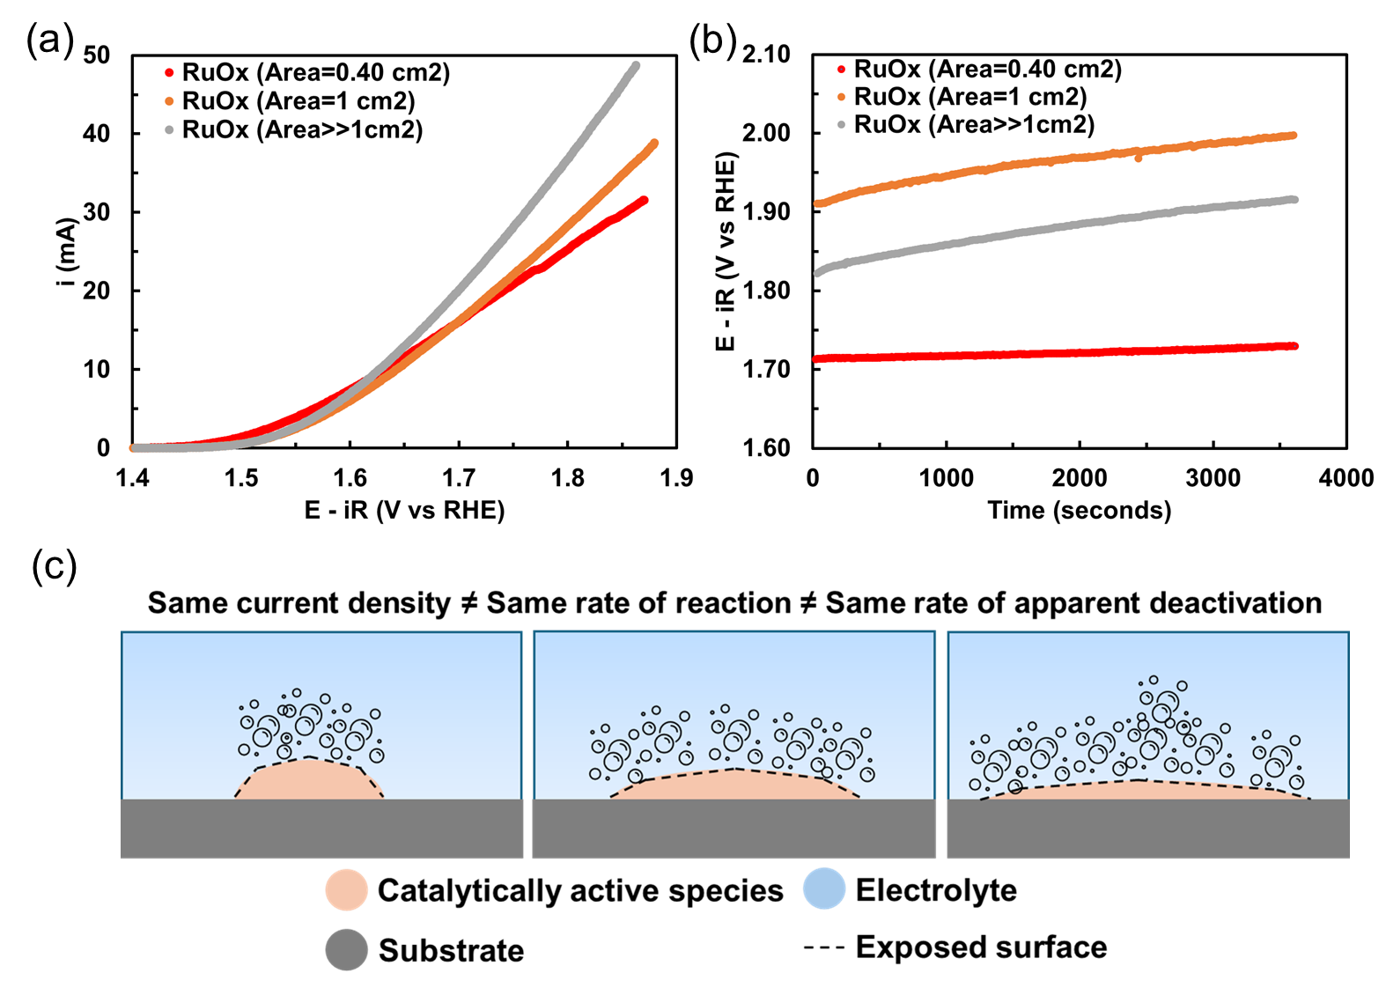
Figure 4. Testing of RuO_{x} in 0.1 M KOH electrolyte, room temperature. a) LSV curves of RuO_{x} electrocatalysts with the same metal loading but different spatial spread conditions. b) CP measurements at 50 mA/cm². c) Representative illustration for the mismatch in apparent deactivation in relation to current density and reaction rate.

However, this is highly misleading, the reason for this apparent high durability of the low spread catalysts is that deactivation is not a function of current density normalized by surface area or loading mass, but of current itself, i.e. absolute number of electrons consumed to drive the reaction.
In the understanding that these catalysts have the same mass loading, durability should be governed mostly by the dissolution of catalytically active species over time, which is mediated by the absolute current measured (and in turn, this being proportional to a number of equivalents of oxygen, in this case). As it happens, the electrocatalysts spread with lower area seems more durable because the active sites stacked on top of each other, resulting in roughly the same number of active sites always being exposed to the electrolyte at a given point in time and being subject to lower current, as illustrated in Figure 4 c). This creates an apparent tradeoff between activity and durability that is not mediated in any way by the chemical properties of the electrocatalytically active species, but rather purely by their spatial distribution on the substrate surface. In practice, this means that researchers also cannot blindly normalize by catalyst mass loading unless they can ensure that the spatial distribution of the catalyst across all samples is the same. In fact, even if that were to be the case, there are reports of how in some electrocatalysts, particularly Fe-containing catalysts, porosity can impose mass transfer limitations (even at very low metal loading) that can obfuscate activity under certain conditions, such as elevated temperature⁴⁰. Although normalizing by ECSA may seem tempting, its determination requires careful consideration³³ and comparison across many different electrocatalyst compositions would probably lend itself to inaccuracies.
Regarding choosing target metric (s) for optimization, essentially finding an electrocatalyst that achieves the highest current at a given potential should be indicative of better activity. An iR correction should be applied to the measurement to compensate for the resistance of the electrolyte, we echo the opinion of previous work⁴¹ emphasizing the importance of not compensating the resistance increase that comes as a consequence of the catalyst layer, unless one is exclusively interested in studying the intrinsic activity of a given electrocatalyst.
Based on the current state of the literature, it should be a priority to find not only active but also durable catalysts as well. Although not exhaustive, Table 1 lists some of the metrics that can be used to optimize catalyst performance, each with their own pros and cons. Other metrics can be used, so long as they accurately represent the target property that is being optimized.

Table 1. Useful metrics for optimization of OER electrocatalyst performance.
Metric | Pros, cons and considerations
Area below CP graph at target current density for a window of time | - Smaller area for a window of time is indicative of higher durability and lower overpotential  - Represents overpotential and durability  - Time consuming  - Short measurement times are prone to misinterpretation
Area below CA graph at a fixed potential for a window of time | - Larger area means better performance and higher durability  - Easy to interpret, as loss of activity is arguably due to active site dissolution and substrate passivation  - Time consuming  - Does not reflect the response to dynamic potential changes
Potential at target current density | - Indicative of activity, lower potential required should indicate better activity  - Fast to measure  - Does not reflect durability in a meaningful way  - Sensible to time-dependent changes on the catalyst surface, such as activation or agglomeration of catalyst
Electrochemical Impedance Spectroscopy (EIS) | - Essential for practical purposes, although electron transport is not equal to catalytic activity  - Can provide insight into surface area, surface roughness and stability.  - Essential if the aim goes beyond determination of intrinsic activity  - Fast to measure
• = consideration, + = pro, - = con

Summary
In this Technical Note, an overview of the logic and conceptual design of data-driven synthesis of electrocatalysts under human-in-the-loop framework and evaluation of the activities of these materials in OER are presented, in addition to describing potential issues that may arise during the execution of such experimental approach. We underscore the importance of understanding that the initial performance of a given electrocatalyst (dependent on surface) may not be representative of its performance over a longer period of time (dependent on bulk) and should be carefully considered when choosing optimization metrics. It is also noted that observed performance of a given electrocatalyst can be severely affected by the spatial distribution of the active species, in terms of surface coverage, texture and porosity. This issue can presumably be minimized by using very accurate electrocatalyst deposition approaches across all samples for fair comparison.
Finally, a suggestion for future direction is rather clear: coming studies based on data-driven approaches should focus not only on optimizing overpotential,⁹ but also spontaneously on durability¹¹ to discover non-PGM based electrocatalysts that may be compatible with industrial applications in the future, and/or on microscopic mechanism⁴² which would empower to expand our limited knowledge on electrochemistry.

Experimental section
Chemicals. RuCl₃·xH₂O (Ru > 40%) was purchased from Tokyo Chemical Industry Co., Ltd. MnCl₂·4H₂O (99.0%), NiCl₂·6H₂O (98.0%), FeCl₂·4H₂O (99.0%), AgNO₃ (99.8%), (>99.5%), KOH (>85%), and ethanol (99.5%) were from Wako Fuji Co. Ltd. ZnCl₂ (99.95%) was purchased from Alfa Aesar. CoCl₂·6H₂O (99.0%) was purchased from Hayashi Pure Chemical Ind., Ltd. H₂SO₄ (96.0%) was from KANTO CHEMICAL CO., INC. Ultrapure water (18.2 MΩ·cm, Milli-Q IQ Element, Merck AG, Germany) was used to prepare electrolytes.
Pretreatment of Ti foil. The titanium (Ti) foil (Ti, 99.5%, Nilaco, 0.05×5×30 mm) was cleaned by ethanol and ultrapure water and subsequently etched in an oxalic acid solution (10%) at 80 °C for 1 h. Finally, the mixture was rinsed by ultrapure water and dried in air.
Synthesis of RuO_{x}. A precursor solution (0.05 M RuCl₃ in ethanol) was dropped (1.25 μL) on the pretreated Ti substrate (dropped region 5×10 mm, or more as needed) and subsequently annealed at 350 °C for 1 min in air. The above process was repeated another thirteen times and finally annealed at 460 °C for 70 min in air.
Synthesis RuO_{x}-Metals electrocatalysts. A precursor solution (0.05 M RuCl₃ in ethanol) was dropped (1.25 μL) on the pretreated Ti substrate (dropped region 5×10 mm, or more as needed) and subsequently annealed at 350 °C for 1 min in air. The above process was repeated another thirteen times and subsequently a multi-metal solution of chloride salts (0.05 M in ethanol) was dropped (1.25 μL) 6 times, once again annealing at 350 °C for 1 min in air each time, finally annealed at 460 °C for 70 min in air.
Supporting information
The supporting information is available free of charge at: tabulated optimization metrics for all the synthesized electrocatalysts are available, in addition to LSV and CP measurements of relevant electrocatalyst samples (PDF).
Acknowledgement
KS was indebted to Churchill College, Cambridge, and Cavendish Laboratory, the University of Cambridge by Visiting By-Fellowship, and National Institute for Materials Science. This work was supported by GteX Program Japan Grant Number JPMJGX23H2, and was partially supported by Japan Science and Technology Agency (JST) as part of Adopting Sustainable Partnerships for Innovative Research Ecosystem (ASPIRE), Grant Number JPMJAP2421.

References:
(1) Butler, K. T., Davies, D. W., Cartwright, H., Isayev, O., & Walsh, A. (2018). Machine learning for molecular and materials science. Nature, 559(7715), 547–555. https://doi.org/10.1038/s41586-018-0337-2
(2) Pollice, R., dos Passos Gomes, G., Aldeghi, M., Hickman, R. J., Krenn, M., Lavigne, C., Lindner-D’Addario, M., Nigam, A., Ser, C. T., Yao, Z., & Aspuru-Guzik, A. (2021). Data-driven strategies for accelerated materials design. Acc. Chem. Res., 54(4), 849–860. https://doi.org/10.1021/acs.accounts.0c00785
(3) Yao, Z., Lum, Y., Johnston, A., Mejia-Mendoza, L. M., Zhou, X., Wen, Y., Aspuru-Guzik, A., Sargent, E. H., & Seh, Z. W. (2022). Machine learning for a sustainable energy future. Nat. Rev. Mater., 8(3), 202–215. https://doi.org/10.1038/s41578-022-00490-5
(4) Merchant, A., Batzner, S., Schoenholz, S. S., Aykol, M., Cheon, G., & Cubuk, E. D. (2023). Scaling deep learning for materials discovery. Nature, 624(7990), 80–85. https://doi.org/10.1038/s41586-023-06735-9
(5) Szymanski, N. J., Rendy, B., Fei, Y., Kumar, R. E., He, T., Milsted, D., McDermott, M. J., Gallant, M., Cubuk, E. D., Merchant, A., Kim, H., Jain, A., Bartel, C. J., Persson, K., Zeng, Y., & Ceder, G. (2023). An Autonomous Laboratory for the accelerated synthesis of novel materials. Nature, 624(7990), 86–91. https://doi.org/10.1038/s41586-023-06734-w
(6) Angello, N. H., Friday, D. M., Hwang, C., Yi, S., Cheng, A. H., Torres-Flores, T. C., Jira, E. R., Wang, W., Aspuru-Guzik, A., Burke, M. D., Schroeder, C. M., Diao, Y., & Jackson, N. E. (2024). Closed-loop transfer enables artificial intelligence to yield chemical knowledge. Nature, 633(8029), 351–358. https://doi.org/10.1038/s41586-024-07892-1
(7) Motoyama, Y., Tamura, R., Yoshimi, K., Terayama, K., Ueno, T., & Tsuda, K. (2022). Bayesian optimization package: Physbo. Comput. Phys. Commun., 278, 108405. https://doi.org/10.1016/j.cpc.2022.108405
(8) Johnson, H. M., Gusev, F., Dull, J. T., Seo, Y., Priestley, R. D., Isayev, O., & Rand, B. P. (2024). Discovery of crystallizable organic semiconductors with machine learning. J. Am. Chem. Soc., 146(31), 21583–21590. https://doi.org/10.1021/jacs.4c05245
(9) Sakaushi, K., Hoisang, W., & Tamura, R. (2023). Human–machine collaboration for accelerated discovery of promising oxygen evolution electrocatalysts with on-demand elements. ACS Cent. Sci., 9(12), 2216–2224. https://doi.org/10.1021/acscentsci.3c01009
(10) Esterhuizen, J. A., Mathur, A., Goldsmith, B. R., & Linic, S. (2024). High-performance iridium–molybdenum oxide electrocatalysts for water oxidation in acid: Bayesian optimization discovery and experimental testing. J. Am. Chem. Soc., 146(8), 5511–5522. https://doi.org/10.1021/jacs.3c13491
(11) Wang, M., Sakaushi, K. (2025). Accelerated Electrocatalyst Degradation Testing by Accurate and Robust Forecasting of Multidimensional Kinetic Model with Bayesian Data Assimilation. ACS Energy Lett., 10(1), 22-29. https://doi.org/10.1021/acsenergylett.4c02868
(12) Rao, Z., Tung, P.-Y., Xie, R., Wei, Y., Zhang, H., Ferrari, A., Klaver, T. P. C., Körmann, F., Sukumar, P. T., Kwiatkowski da Silva, A., Chen, Y., Li, Z., Ponge, D., Neugebauer, J., Gutfleisch, O., Bauer, S., & Raabe, D. (2022). Machine learning–enabled high-entropy alloy discovery. Science, 378(6615), 78–85. https://doi.org/10.1126/science.abo4940
(13) Johnson, H. M., Gusev, F., Dull, J. T., Seo, Y., Priestley, R. D., Isayev, O., & Rand, B. P. (2024). Discovery of crystallizable organic semiconductors with machine learning. J. Am. Chem. Soc., 146(31), 21583–21590. https://doi.org/10.1021/jacs.4c05245
(14) Ristoski, P., Zubarev, D. Y., Gentile, A. L., Park, N., Sanders, D., Gruhl, D., Kato, L., & Welch, S. (2020). Expert-in-the-loop AI for polymer discovery. Proceedings of the 29th ACM International Conference on Information & Knowledge Management, 2701–2708. https://doi.org/10.1145/3340531.3416020
(15) Hoisang, W., & Sakaushi, K. (2022). Key criteria for next-generation dimensionally stable electrodes towards large-scale green hydrogen production by water electrolysis. Curr. Opin. Electrochem., 36, 101136. https://doi.org/10.1016/j.coelec.2022.101136
(16) Strmcnik, D., Lopes, P. P., Genorio, B., Stamenkovic, V. R., & Markovic, N. M. (2016). Design principles for hydrogen evolution reaction catalyst materials. Nano Energy, 29, 29–36. https://doi.org/10.1016/j.nanoen.2016.04.017
(17) Caspari, W. A. (1899). Ueber elektrolytische gasentwickelung. Zeitschrift Für Physikalische Chemie, 30U(1), 89–97. https://doi.org/10.1515/zpch-1899-3004
(18) Tafel, J. (1905). Über die polarisation Bei Kathodischer Wasserstoffentwicklung. Zeitschrift Für Physikalische Chemie, 50U(1), 641–712. https://doi.org/10.1515/zpch-1905-5043
(19) The quantum mechanics of Electrolysis. (1931). Proceedings of the Royal Society of London. Series A, Containing Papers of a Mathematical and Physical Character, 134(823), 137–154. https://doi.org/10.1098/rspa.1931.0187
(20) Sakaushi, K. (2020). Quantum Proton tunneling in multi-electron/-proton transfer electrode processes. Faraday Discuss., 221, 428–448. https://doi.org/10.1039/c9fd00032a
(21) Sakaushi, K. (2020a). Quantum electrocatalysts: Theoretical picture, electrochemical kinetic isotope effect analysis, and conjecture to understand microscopic mechanisms. Phys. Chem. Chem. Phys., 22(20), 11219–11243. https://doi.org/10.1039/d0cp01052a
(22) Ledendecker, M., Krick Calderón, S., Papp, C., Steinrück, H., Antonietti, M., & Shalom, M. (2015). The synthesis of nanostructured ni5p4 films and their use as a non‐noble bifunctional electrocatalyst for full water splitting. Angew. Chem., Int. Ed., 54(42), 12361–12365. https://doi.org/10.1002/anie.201502438
(23) Ledendecker, M., Mondschein, J. S., Kasian, O., Geiger, S., Göhl, D., Schalenbach, M., Zeradjanin, A., Cherevko, S., Schaak, R. E., & Mayrhofer, K. (2017). Stability and activity of non‐noble‐metal‐based catalysts toward the hydrogen evolution reaction. Angew. Chem., Int. Ed., 56(33), 9767–9771. https://doi.org/10.1002/anie.201704021
(24) Clapp, M., Zalitis, C. M., & Ryan, M. (2023). Perspectives on current and future iridium demand and iridium oxide catalysts for PEM water electrolysis. Catal. Today, 420, 114140. https://doi.org/10.1016/j.cattod.2023.114140
(25) Smith, G., & Dickinson, E. J. (2022). Error, reproducibility and uncertainty in experiments for Electrochemical Energy Technologies. Nat. Commun. , 13(1). https://doi.org/10.1038/s41467-022-34594-x
(26) Bandarenka, A. S., Ventosa, E., Maljusch, A., Masa, J., & Schuhmann, W. (2014). Techniques and methodologies in modern electrocatalysis: Evaluation of activity, selectivity and stability of catalytic materials. The Analyst, 139(6), 1274. https://doi.org/10.1039/c3an01647a
(27) Kita, H. (1966). Periodic variation of exchange current density of hydrogen electrode reaction with atomic number and reaction mechanism. J. Electrochem. Soc., 113(11), 1095. https://doi.org/10.1149/1.2423772
(28) Trasatti, S. (1972). Work function, electronegativity, and electrochemical behaviour of metals: III. Electrolytic hydrogen evolution in acid solutions. J. Electroanal. Chem., 39(1), 163–184. https://doi.org/10.1016/S0022-0728(72)80485-6
(29) Barnartt, S. (1961). Magnitude of IR-drop corrections in electrode polarization measurements made with a Luggin-Haber capillary. J. Electrochem. Soc., 108(1), 102. https://doi.org/10.1149/1.2427994
(30) Geiger, S., Kasian, O., Ledendecker, M., Pizzutilo, E., Mingers, A. M., Fu, W. T., Diaz-Morales, O., Li, Z., Oellers, T., Fruchter, L., Ludwig, A., Mayrhofer, K. J., Koper, M. T., & Cherevko, S. (2018). The stability number as a metric for electrocatalyst stability benchmarking. Nat. Catal., 1(7), 508–515. https://doi.org/10.1038/s41929-018-0085-6
(31) Frydendal, R., Paoli, E. A., Knudsen, B. P., Wickman, B., Malacrida, P., Stephens, I. E., & Chorkendorff, I. (2014). Benchmarking the stability of oxygen evolution reaction catalysts: The importance of monitoring mass losses. ChemElectroChem, 1(12), 2075–2081. https://doi.org/10.1002/celc.201402262
(32) Murawski, J., Scott, S. B., Rao, R., Rigg, K., Zalitis, C., Stevens, J., Sharman, J., Hinds, G., & Stephens, I. E. (2024). Benchmarking stability of iridium oxide in acidic media under oxygen evolution conditions: A review: Part I. Johnson Matthey Technology Review, 68(1), 121–146. https://doi.org/10.1595/205651323x16848455435118
(33) Parsons, R. (1959). The relation between the capacity of the electrode double layer and the adsorption of surface-active material. Trans. Faraday Soc., 55, 999. https://doi.org/10.1039/tf9595500999
(34) Trasatti, S., & Petrii, O. A. (1992). Real surface area measurements in electrochemistry. J. Electroanal. Chem., 327(1–2), 353–376. https://doi.org/10.1016/0022-0728(92)80162-w
(35) Anantharaj, Sengeni, Kundu, S., & Noda, S. (2021). “The Fe effect”: A review unveiling the critical roles of Fe in enhancing OER activity of Ni and Co based catalysts. Nano Energy, 80, 105514. https://doi.org/10.1016/j.nanoen.2020.105514
(36) Vos, J. G., Wezendonk, T. A., Jeremiasse, A. W., & Koper, M. T. (2018). MnOx/IrOx as selective oxygen evolution Electrocatalyst in acidic chloride solution. J. Am. Chem. Soc., 140(32), 10270–10281. https://doi.org/10.1021/jacs.8b05382
(37) Hubert, M. A., Patel, A. M., Gallo, A., Liu, Y., Valle, E., Ben-Naim, M., Sanchez, J., Sokaras, D., Sinclair, R., Nørskov, J. K., King, L. A., Bajdich, M., & Jaramillo, T. F. (2020). Acidic oxygen evolution reaction activity–stability relationships in Ru-based Pyrochlores. ACS Catal., 10(20), 12182–12196. https://doi.org/10.1021/acscatal.0c02252
(38) Schmidt, T. J., Gasteiger, H. A., Stäb, G. D., Urban, P. M., Kolb, D. M. & Behm, R. J. (1998). Characterization of High‐Surface‐Area Electrocatalysts Using a Rotating Disk Electrode Configuration. J. Electrochem. Soc., 145(7), 134-145. https://iopscience.iop.org/article/10.1149/1.1838642/
(39) Kaliyaraj Selva Kumar, A., Zhang, Y., Li, D., & Compton, R. G. (2020). A mini-review: How reliable is the drop casting technique? Electrochem. Commun., 121, 106867. https://doi.org/10.1016/j.elecom.2020.106867
(40) Ahmad, M. U., Suresh, G., & Bang, J. H. (2024). Rescrutinizing the iron effect on oxygen evolution reaction catalysts under industrially relevant working conditions: Overlooked mass transfer limitation driven by the Iron Incorporation. ACS Energy Lett., 9(10), 4953–4958. https://doi.org/10.1021/acsenergylett.4c01942
(41) Zheng, W. (2023). iR compensation for electrocatalysis studies: Considerations and recommendations. ACS Energy Lett., 8(4), 1952–1958. https://doi.org/10.1021/acsenergylett.3c00366
(42) Sakaushi, K., Watanabe, A., Kumeda, T., Shibuta, Y. (2022). Fast-Decoding Algorithm for Electrode Processes at Electrified Interfaces by Mean-Field Kinetic Model and Bayesian Data Assimilation: An Active-Data-Mining Approach for the Efficient Search and Discovery of Electrocatalysts. ACS Appl. Mater. Int., 14(20) 22889–22902. https://doi.org/10.1021/acsami.1c21038

For Table of Contents Only

