In-situ Photopolymerization of Smectic B Liquid-Crystalline Electrolytes from Mesogenic Phosphate–Diacrylate/Ionic Liquid Complexes for High-Performance Soft Ionic Actuators

Chengyang Liu and Masafumi Yoshio*

C. Liu, M. Yoshio
Research Center for Macromolecules and Biomaterials
National Institute for Materials Science
Tsukuba, Ibaraki 305-0047, Japan
E-mail: YOSHIO.Masafumi@nims.go.jp

C. Liu, M. Yoshio
Graduate School of Chemical Sciences and Engineering
Hokkaido University
Sapporo, Hokkaido 060-8628, Japan

M. Yoshio
PRESTO
Japan Science and Technology Agency
Kawaguchi, Saitama, 332-0012, Japan

Funding: JST, PRESTO (Grant Number JPMJPR23QB), JSPS KAKENHI (Grant Number 25H01263), and Murata Science and Education Foundation (Grant Number HTF0202)
Keywords: soft actuator, liquid crystal, self-assembly, smectic B, photopolymerization

Abstract: Nanostructured liquid-crystalline (LC) electrolyte membranes hold significant promise for achieving both efficient ion transport and mechanical robustness–key requirements for high-performance ionic actuators. Here, we report an in-situ photopolymerization strategy to fabricate flexible electrolyte membranes composed of highly ion-conductive LC complexes formed from a mesogenic phosphate and a photopolymerizable LC diacrylate, complexed with the ionic liquid EMImTFSI. The blend self-assembles into a smectic B (SmB) phase, forming two-dimensional (2D) ionic conduction pathways that are retained after polymerization. The resulting membrane, in which LC electrolytes are embedded within a photocured polymer matrix, exhibits ionic conductivity (10⁻⁴ S cm⁻¹) at room temperature and excellent mechanical flexibility. When integrated with PEDOT:PSS film electrodes, the actuator demonstrates a peak-to-peak bending strain of 1.11% under ±3 V at 0.01 Hz and maintains a displacement of 6 μm at 150 Hz. A blocking force of 1.6 mN is recorded at ±3 V and 0.1 Hz, outperforming previously reported actuators of larger size. The actuator also demonstrates outstanding durability, with bending strain increasing to 159% of its initial value after 50,000 actuation cycles. This work presents a simple and effective strategy for creating high-performance nanostructured electrolytes, paving the way for next-generation soft actuators for robotics.

1. Introduction
Ionic actuators have emerged as promising candidates for next-generation soft robotic systems, artificial muscles, and bioinspired haptic interfaces due to their ability to generate significant deformations under low-voltage stimuli^{[1–5]}. The electrolyte membrane plays a critical role in determining actuator performance, as its electrochemical and mechanical properties directly influence response speed, bending deformation, durability, and force generation^{[6–9]}. Therefore, developing electrolyte membranes with high ionic conductivity, mechanical robustness, and structural stability remains a central challenge in advancing ionic actuators. Achieving high-capacity electrode materials is equally important for improving actuator efficiency and overall functionality.
Nanostructured organic materials, including amphiphilic block copolymers^{[10–12]}, covalent organic frameworks (COFs)^{[13,14]}, and liquid crystals^{[15–18]} have attracted considerable attention as electrolytes for ionic actuators. Among these, liquid-crystalline (LC) electrolytes offer distinct advantages over conventional polymer electrolytes due to their self-assembled nanostructures, efficient ion transport, long-range alignability, and tunable mechanical properties^{[19–26]}. These features contribute to enhanced performance in actuators. Previous studies have focused on incorporating highly fluid smectic A (SmA) LC electrolytes–comprising phosphate-functionalized mesogenic molecules complexed with lithium salts or ionic liquids–into vinylpolymer matrices, such as poly(vinyl chloride) (PVC) or poly(vinylidene-co-hexafluoropropylene) (PVDF-HFP)^{[9]}. These systems form free-standing liquid crystal/polymer composite electrolyte membranes via solvent evaporation and microphase separation between the polymer and LC phases. While effectively in immobilizing the LC phase within porous polymer frameworks, these approaches often lead to overly soft membranes, limiting actuator performance and causing undesirable back-relaxation behavior during operation. Moreover, controlling membrane thickness on a large scale (centimeter-level) remains a significant challenge.
To overcome these limitations, we introduce a novel approach for fabricating LC/polymer composite membranes by utilizing in-situ photopolymerization of an LC monomer within a high-viscosity smectic B (SmB) LC electrolyte. The SmB phase is characterized by well-ordered mesogen layers that enhance ion transport along the direction paralell to the layers^{[27]}, thereby enabling the construction of robust LC electrolytes with ordered two-dimensional (2D) ion transport pathways. In this study, we combine an SmB LC electrolyte composed of a newly developed phosphate-functionalized mesogenic molecule (PPO), complexed with the ionic liquid 1-ethyl-3-methylimidazolium bis(trifluoromethanesulfonyl)imide (EMImTFSI), with a polymerizable dimeric rod-like LC molecule (DA) to form a homogeneous blend (Figure 1). The interplay of π–π interactions and ion–dipole interactions between the mesogenic units, along with partial phase separation, contribute to the formation of a stable LC electrolyte. In-situ photopolymerization then results in the formation of a free-standing, flexible electrolyte membrane that retains the SmB nanostructure while exhibiting enhanced ionic conductivity.
When integrated with poly(3,4-ethylenedioxythiophene) doped with poly(stylenesulfonate) (PEDOT:PSS) electrodes, the resulting actuator demonstrates excellent electromechanical performance, achieving a large peak-to-peak bending strain of 1.11% under ±3 V at 0.01 Hz, and maintaining effective displacement even at 150 Hz, covering the frequency range relevant to key human tactile receptors. Additionally, a high blocking force of 1.6 mN is achieved at ±3 V and 1 Hz, surpassing the performance of previously reported actuators with larger dimensions. The actuator also exhibits exceptional durability, with a 159% increase in bending strain after 50,000 cycles. These results highlight the potential of SmB-phase-based LC electrolytes as high-performance materials for bioinspired sensing and actuation applications.

2. Results and Discussion
2.1. Materials Design
Organophosphates are considered a new class of promising solvents for dissolving alkaline metal salts owing to their moderate dielectric constants and intrinsic flame-retardant properties^{[28,29]}, which have been widely explored in electrochemical energy storage applications. In our previous work, we demonstrated that the incorporating organophosphate moieties as ion-conducting functional groups in self-assembled LC electrolytes for ionic actuators significantly enhances ionic conductivity, exceeding that of conventional carbonate-based systems, while also providing intrinsic flame retardancy^{[9,30]}. This dual functionality not only improves electrochemical performance but also enhances the safety characteristics of solid-state electrolytes, expanding their potential for practical applications. Recently, we introduced a series of phosphate-based LC molecules exhibiting either hexagonal columnar (Col_{h}) or smectic A (SmA) layered mesophases^{[9,16,18]}. By employing physical crosslinking and phase separation techniques, these materials were incorporated into liquid crystal/polymer composite electrolytes, which demonstrated excellent bending and cycling performance in electrically responsive ionic actuators. However, the weak intermolecular interactions limited the stability of the self-assembled LC structure to temperatures below 40 °C. In addition, the low-viscosity of the SmA phase hinderes the generation of high forces.
In this study, we designed and synthesized two molecules, PPO and DA, as shown in Figure 1A. The LC electrolyte is primarily composed of PPO as the ion-conducting medium and DA as the photopolymerizable mesogen to function as a mechanical support. Together with ionic liquids (ILs), these components undergo photopolymerization to form LC polymer electrolyte membranes. PPO features a molecular structure composed of a pentylcyclohexyl unit and two phenyl rings, which act as ion-insulating segments, while a diethyl phosphate group serves as the primary ionophilic segment. In comparison to previously reported rod-like SmA LC molecules, the inclusion of an additional rigid phenyl ring enhances intermolecular interactions through π–π interactions, improving the thermal stability of the self-assembled LC phase and increasing the material's viscosity. DA is a polymerizable dimeric rod-like LC molecule that includes an oligo(ethylene glycol) spacer. Its linear architecture promotes crosslinking, as the terminal acrylate groups undergo radical photopolymerization upon UV irradiation. The rigid phenyl units in DA engage in π–π interactions with PPO, helping maintain the integrity of the LC phase and contributing to the high viscosity of the liquid cystals. In contrast to the disordered aggregation observed in physically crosslinked systems of vinyl polymers, the chemical crosslinking introduced by DA effectively preserves the overall LC order. Additionally, the oligo(ethylene glycol) spacer not only increases molecular flexibility but also elevates ion transport efficiency, further enhancing the electrolyte performance.
Figure 1. (A) Molecular structures of PPO and DA. (B) LC electrolyte membrane prepared by photopolymerization of a mixture of liquid crystal electrolyte and polymerizable DA. (C) Ionic actuator fabricated by sandwiching the LC/polymer composite electrolyte membrane between two PEDOT:PSS electrodes, demonstrating bending deformation under an applied voltage (left). The actuator mimics the motion of a human leg kicking a soccer ball (right).

The LC electrolyte mixture was prepared by combining PPO and IL, with a 50:50 molar ratio of PPO to IL (denoted as PPO/IL(50)). This mixture was then blended with DA at an 80:20 weight ratio (PPO/IL(50):DA) to form a new LC formulation (Figure 1B, left). Upon UV-induced photopolymerization, an LC polymer electrolyte membrane was obtained (Figure 1B, right). By sandwiching the membrane between two PEDOT:PSS films, a soft ionic actuator was fabricated. This actuator demonstrated significant improvements in actuation frequency, durability, and generated force, showcasing its potential for applications in soft robotics (Figure 1C).

2.2 Liquid-crystalline properties
The identification of liquid crystallinity was carried out using several analytical techniques. Polarized optical microscopy (POM) was used to observe the optical textures of the materials and to confirm the presence of LC phases. X-ray diffraction (XRD) was employed to determine the specific mesophases at room temperature and analyze the corresponding d-spacing parameters. Differential scanning calorimetry (DSC) was utilized to investigate the temperature range of phase transitions. This section examines the LC behavior of PPO mixed with ILs or a lithium salt containing three different cations (EMImTFSI, 1-butyl-3-methylimidazolum TFSI (BMImTFSI), and lithium TFSI (LiTFSI)) at molar ratios of 80:20, 60:40, and 50:50 to evaluate the influence of cation size and ion content on liquid crystal formation. In addition, Fourier transform infrared spectroscopy (FT-IR) was performed to investigate ion–ion and ion–dipole interactions within these systems.
A summary of the phase transition temperatures for PPO and its mixtures is provided in Figure S1, and representative DSC thermograms of PPO and its equimolar mixtures are shown in Figure S2. At room temperature, PPO appears as a highly viscous, translucent, and soft solid (Figure 2A). The POM image reveals a characteristic Maltese cross or focal conic texture, indicative of a smectic LC phase (Figure 2B). The XRD pattern shows diffraction peaks at 2θ in a reciprocal d-spacing ratio of 1:2:3:4, along with a sharp peak near 19°, indicating that PPO adopts a smectic B (SmB) layered structure at room temperature (Figure 2C). Upon heating to 132 °C, PPO gradually transitions to an SmA phase, and the LC order disappears above 144 °C. At 132 °C, the XRD pattern indicates a slight increase in layer spacing, while the sharp wide-angle reflection at 4.6 Å disappears and is replaced by a broad halo, characteristic of the SmA phase (Figure S3).
PPO mixtures with EMImTFSI, BMImTFSI, and LiTFSI also undergo SmB-to-SmA phase transitions (Figure S1–S4). As shown in Figure S5, all three equimolar mixtures exhibit focal conic textures under POM at room temperature, consistent with smectic LC ordering. Corresponding XRD patterns exhibit reflection in a 1:2:3 reciprocal ratio and a sharp peak near 19°, further indicating the presence of the SmB phase (Figure S4). The measured d-spacings for all three systems are larger than the molecular length of PPO but smaller than twice that length, suggesting an interdigitated molecular arrangement. Variations in d-spacing were observed among the samples, which can be attributed to differences in cation size. As summarized in Table 1, the average layer spacing (d) increases with increasing cation volume. PPO/BMImTFSI(50), which contains the largest cation, exhibits the largest d-spacing, followed by PPO/EMImTFSI(50), and then PPO/LiTFSI(50). These results reveal a clear correlation between cation size and the smectic layer spacing, indicating that the molecular dimensions of the ionic species play a critical role in determining the structural organization of the LC phase.

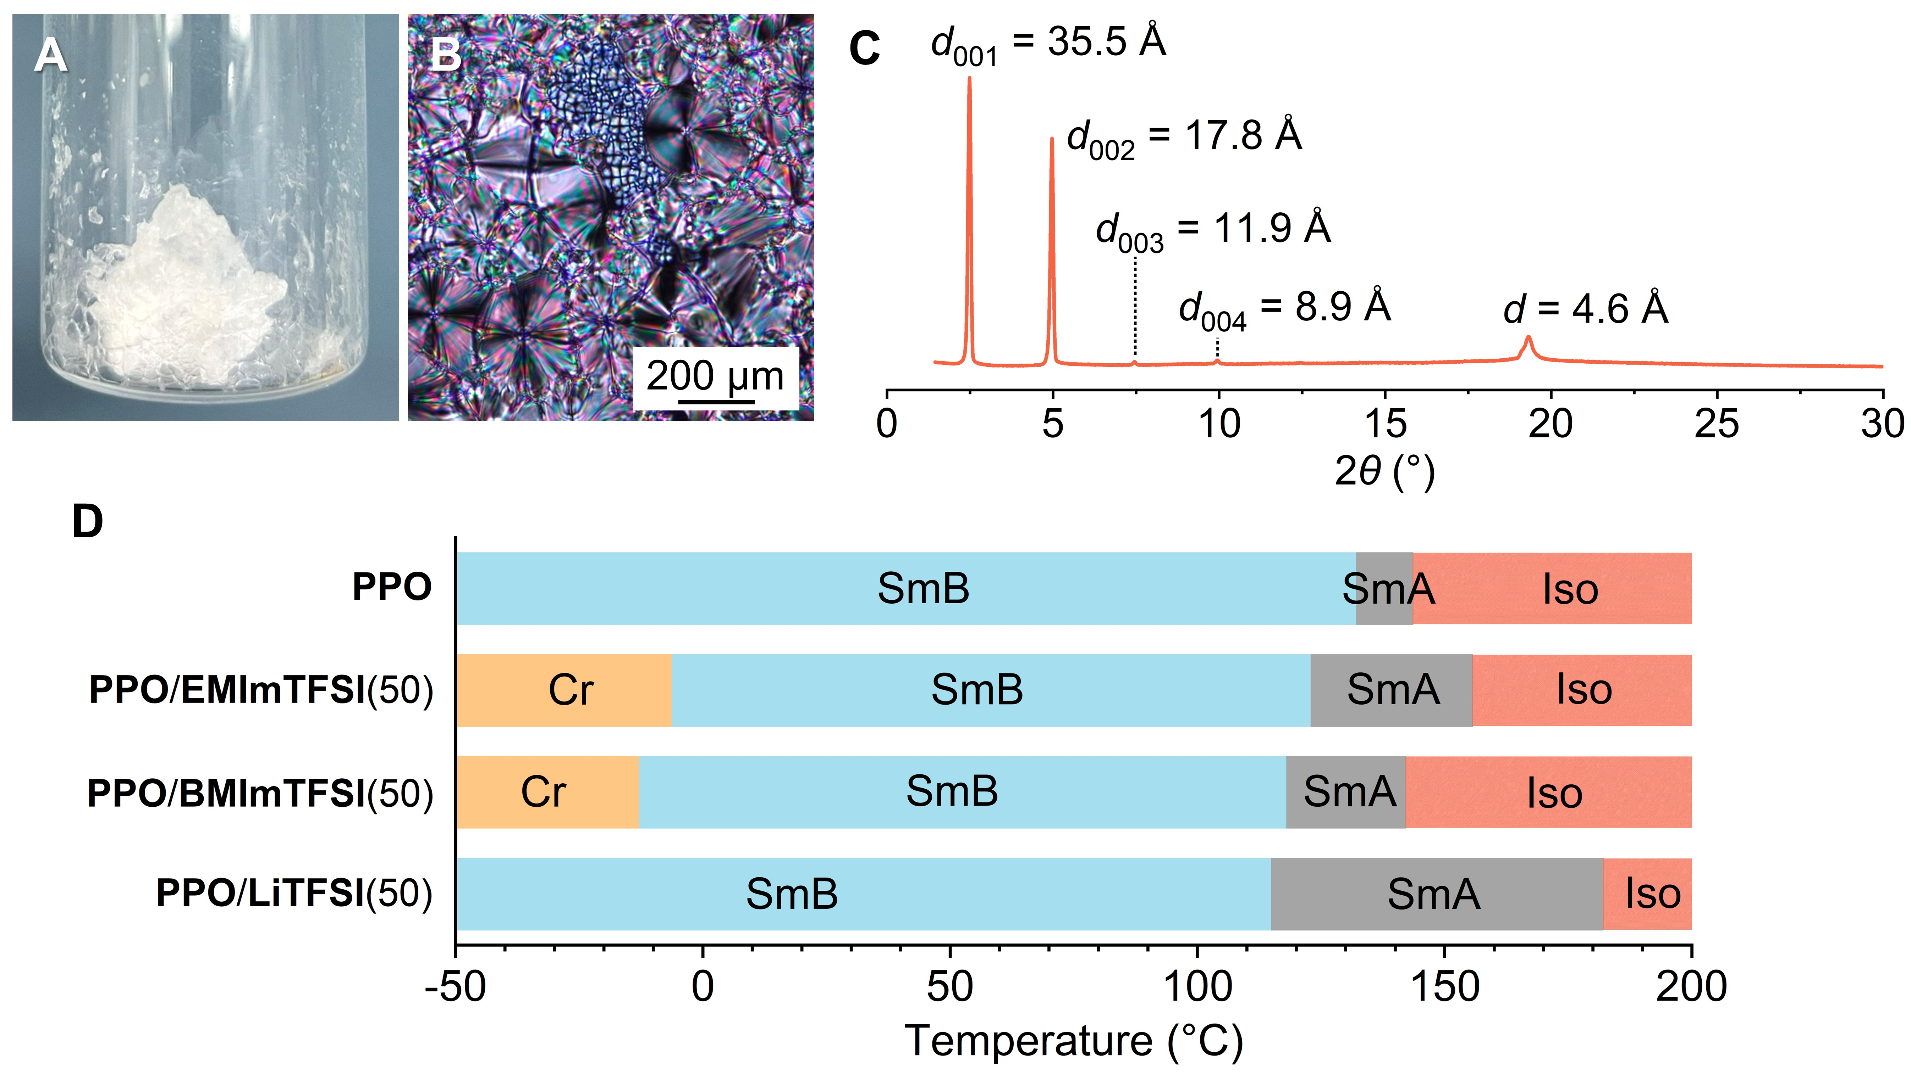
Figure 2. (A) Photograph, (B) POM image, and (C) XRD pattern of pure PPO compound. (D) Phase transition temperatures of the pure PPO compound, PPO/EMImTFSI(50), PPO/BMImTFSI(50), and PPO/LiTFSI(50) determined from the peak tops of DSC measurements during the heating process. Cr: Crystalline; SmB: Smectic B; SmA: Smectic A; Iso: Isotropic.

Table 1. d-Spacing values of the pure PPO compound, PPO/EMImTFSI(50), PPO/BMImTFSI(50), and PPO/LiTFSI(50) determined from XRD measurements.
d-spacing | d₀₀₁ [Å] | d₀₀₂ [Å] | d₀₀₃ [Å] | d₀₀₄ [Å] | d [Å]
PPO | 35.5 | 17.8 | 11.9 | 8.9 | 35.6
PPO/EMImTFSI(50) | 50.1 | 25.0 | 16.5 | – | 49.9
PPO/BMImTFSI(50) | 52.3 | 26.2 | 18.0 | – | 52.9
PPO/LiTFSI(50) | 45.1 | 22.4 | 14.9 | – | 44.9
The average layer spacing (d) was calculated as d = (d₀₀₁+2d₀₀₂+3d₀₀₃+4d₀₀₄)/4 or (d₀₀₁+2d₀₀₂+3d₀₀₃)/3, depending on the available diffraction peaks.

In the mixtures, cation size significantly influences the phase transition temperatures. As shown in Figure 2D, the SmA-isotropic liquid (Iso) transition temperatures are 142 °C for PPO/BMImTFSI(50), 156 °C for PPO/EMImTFSI(50), and 182 °C for PPO/LiTFSI(50), demonstrating a clear trend in which larger cations result in lower transition temperatures. This behavior can be attributed to the increased intermolecular spacing induced by larger cations, which weakens intermolecular interactions due to steric hindrance and promotes molecular disorder at lower temperatures. Moreover, mixtures containing smaller cations exhibit a broader temperature range of the smectic phase, indicating greater thermal robustness of the LC structure.
Ion content also plays an important role in the phase transition behavior. The SmB-SmA transition temperatures of all three systems decrease with increasing ion concentration (Figure S1). Furthermore, the d-spacing in the SmB phase increases with higher ion content, which is primarily attributed to the expansion of layered ionic channels driven by increased ion incorporation. Notably, while the clearing temperature (SmA→Iso) of the LiTFSI-containing mixtures is significantly higher than that of pure PPO, the SmA-Iso transition temperatures of the IL-based mixtures remain largely unchanged.
The self-assembly of PPO with various ILs or lithium salts into LC phases is primarily driven by π–π interactions, dipole–dipole interactions, and ion–dipole interactions, which collectively induce nanosegregation. As shown in the FT-IR spectra (Figure S6), the characteristic absorption peak of the P=O group at 1242 cm⁻¹ shifts to lower wavenumbers upon the addition of EMImTFSI, BMImTFSI, or LiTFSI. This peak overlaps with the –CF₃ vibration of the TFSI⁻ anion, indicating the formation of P=O···cation ion–dipole interactions between PPO and the cations. Notably, the BMIm⁺ and EMIm⁺ cations induce a shift in the P–O–C stretching band from 1026 cm⁻¹ to 1030 cm⁻¹ and 1028 cm⁻¹, respectively, whereas Li⁺ does not cause a noticeable shift in this band. This difference is attributed to the larger ionic radii of BMIm⁺ and EMIm⁺, which allow simultaneous interactions with both P=O and P–O–C groups. In contrast, the smaller Li⁺ cation preferentially coordinates with the more electronegative P=O group. These results suggest that the nature and size of the cation significantly influence its specific interactions with PPO, thereby affecting the formation and stability of the LC phase.

2.3 Ionic Conductivity
Ionic conductivity plays a crucial role in determining the performance of ionic actuators, particularly in terms of their response speed. By comparing the conductivities of LC electrolytes formed by PPO with different ILs and a lithium salt, we can identify the formulation with the highest ionic conductivity and prioritize it for subsequent actuator development. Room-temperature ionic conductivities were measured for PPO mixed with EMImTFSI, BMImTFSI, and LiTFSI at varying ion contents (Figure S7). Among these, mixtures with ILs exhibit significantly higher conductivities than those with LiTFSI. For both PPO/EMImTFSI and PPO/BMImTFSI, ionic conductivity increases steadily with rising ion content. In contrast, PPO/LiTFSI shows a slight decrease in conductivity when the LiTFSI molar ratio exceeds 40%, likely due to excessive ion aggregation or stronger coordination between Li⁺ and the phosphate groups.
Figure 3 shows the temperature-dependent ionic conductivities of PPO/EMImTFSI(50), PPO/BMImTFSI(50), and PPO/LiTFSI(50), each of which forms an SmB phase. Among these, PPO/EMImTFSI(50) exhibits the highest ionic conductivity, reaching 3.9 × 10⁻⁴ S cm⁻¹ at room temperature. This is followed by PPO/BMImTFSI(50) with an ionic conductivity of 8.7 × 10⁻⁵ S cm⁻¹, while PPO/LiTFSI(50) shows the lowest value of 5.9 × 10⁻⁷ S cm⁻¹. In IL-based systems, the intrinsic ionic conductivity of EMImTFSI (9.2–10.2 × 10⁻³ S cm⁻¹) is higher than that of BMImTFSI (3.4–4.1 × 10⁻³ S cm⁻¹), which explains the superior conductivity observed in PPO/EMImTFSI(50). In contrast, the small ionic radius of Li⁺ in the lithium salt system results in stronger interactions with the P=O groups, leading to a higher activation energy barrier for ion hopping between adjacent phosphate sites, and ultimately the lowest ionic conductivity among the three systems.

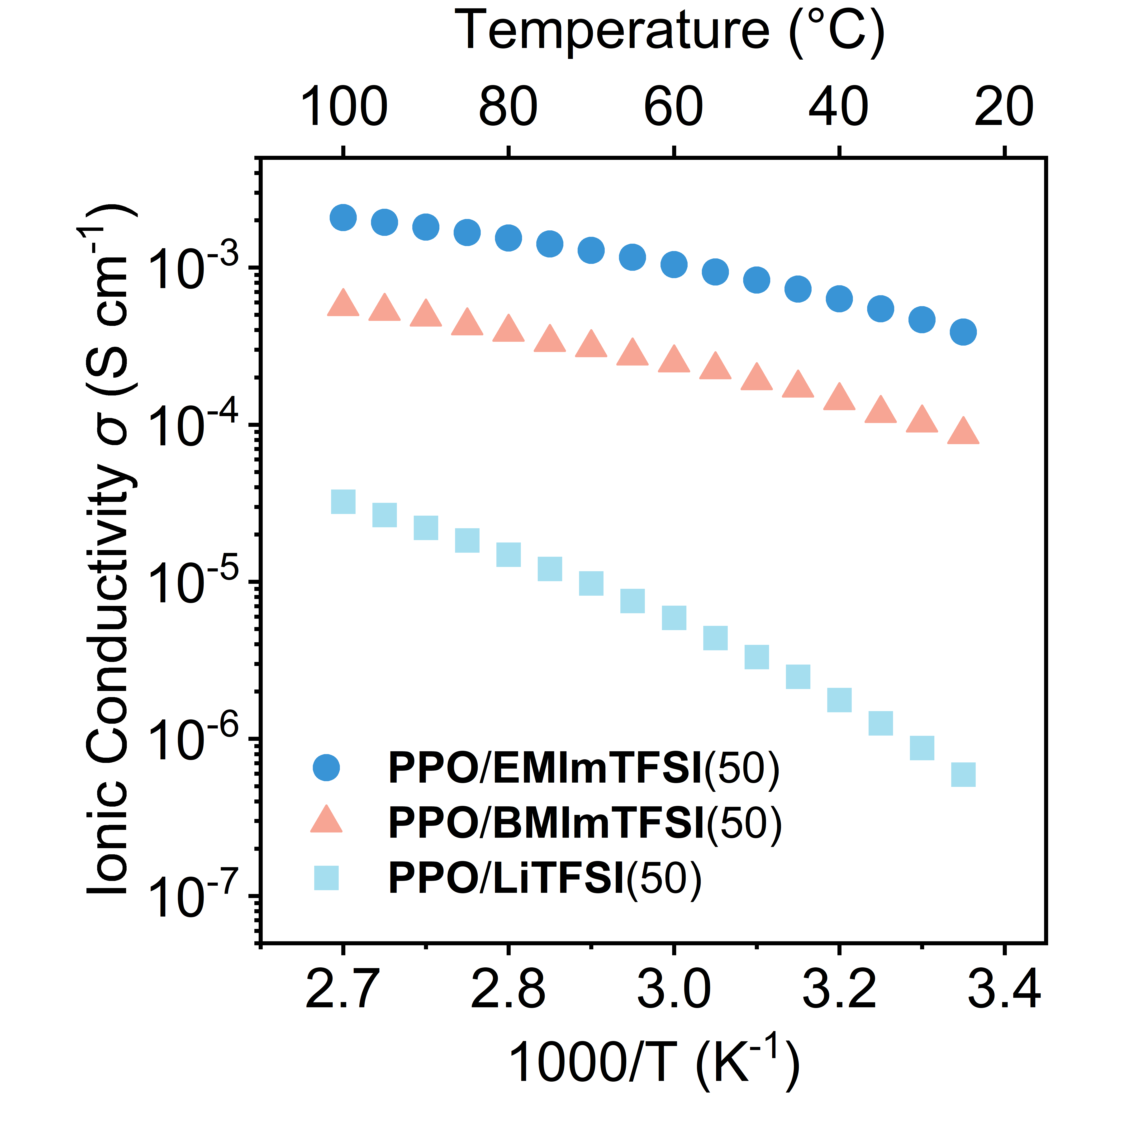
Figure 3. Temperature-dependent ionic conductivities of PPO/EMImTFSI(50), PPO/BMImTFSI(50), and PPO/LiTFSI(50).

All three systems follow the Arrhenius equation within the temperature range of room temperature to 60 °C (Figure S8), indicating that ionic transport occurs via a thermally activated hopping mechanism along phosphate groups within the self-assembled ionic channels under an applied electric field. The activation energies (E_{a}) were calculated as 23 kJ mol⁻¹ for PPO/EMImTFSI(50), 24 kJ mol⁻¹ for PPO/BMImTFSI(50), and 54 kJ mol⁻¹ for PPO/LiTFSI(50). Among them, PPO/EMImTFSI(50) exhibits the lowest energy barrier for ion transport, correlating with its highest ionic conductivity. This enhanced ionic transport effriciency is attributed to the well-organized SmB layered ionic pathways and the inherently low viscosity of EMImTFSI.
We further examined conductivity behavior across the temperature range of the SmB phase (Figure S9). Noticeable fluctuations are observed near the SmA→Iso phase transition, particularly in PPO/BMImTFSI(50), which also exhibits conductivity changes at the SmB→SmA transition. In contrast, PPO/EMImTFSI(50) and PPO/LiTFSI(50) do not show clear conductivity changes associated with SmB→Iso transitions. This lack of sensitivity may be attributed to the low enthalpy associated with the phase transition, resulting in minimal impact on ionic mobility, as supported by the weak endothermic signals observed in the DSC thermograms (Figure S2).
Based on the collective ionic conductivity measurements and activation energy analyses, PPO/EMImTFSI(50) was selected as the optimal material for the subsequent fabrication of LC electrolyte membranes and ionic actuators in this study.

2.4 Liquid-Crystalline Electrolyte/Polymer Membrane
An ionic actuator typically consists of an electrolyte membrane sandwiched between two electrode films. Upon voltage application, ion migration through the membrane toward the electrodes induces volume changes on both sides of the actuator, resulting in mechanical deformation^{[31,32]}. Therefore, the electrolyte membrane plays a critical role in determining the overall performance of the ionic actuator. In our previous work, liquid crystals were blended with vinyl polymers such as PVC and PVDF-HFP in a solvent, and subsequent solvent evaporation induced microphase separation^{[9,30]}. This process led to the immobilization of the liquid crystals within the porous network formed by the polymer matrix.
In this study, an ion-containing liquid crystal was mixed with a polymerizable dimeric rod-shaped liquid crystal to prepare a composite system. Three LC mixtures with varying PPO/EMImTFSI(50):DA ratios–9:1, 8:2, and 7:3–were prepared. The 9:1 composition failed to form a stable film under UV irradiation and was therefore excluded from further investigation (Figure S10 and S11). In terms of ionic conductivity, the 8:2 composition exhibited slightly higher values than the 7:3 composition, both before and after polymerization (Figure S12). Regarding mechanical properties, the 8:2 film showed a Young’s modulus of 1.41 MPa and a breaking strain of 80%, while the 7:3 film exhibited a higher Young’s modulus of 3.45 MPa but a reduced breaking strain of 39% (Figure S13). Considering the balance between ionic conductivity and mechanical flexibility, we selected the PPO/EMImTFSI(50):DA = 8:2 film as the optimal electrolyte material for actuator applications.
Upon mixing, the two LC components formed a homogeneous blend, in which π–π interactions and ion–dipole interactions between the mesogenic units promoted the formation of a new LC electrolyte, in which FT-IR spectra exhibit the stretching peak of aromatic C=C and acrylate group C=O on the DA molecule shifts from 1505 cm⁻¹and 1719 cm⁻¹ to 1507 cm⁻¹ and 1723 cm⁻¹, respecitively (Figure S14) . The resulting mixture was photopolymerized to produce an LC electrolyte membrane.
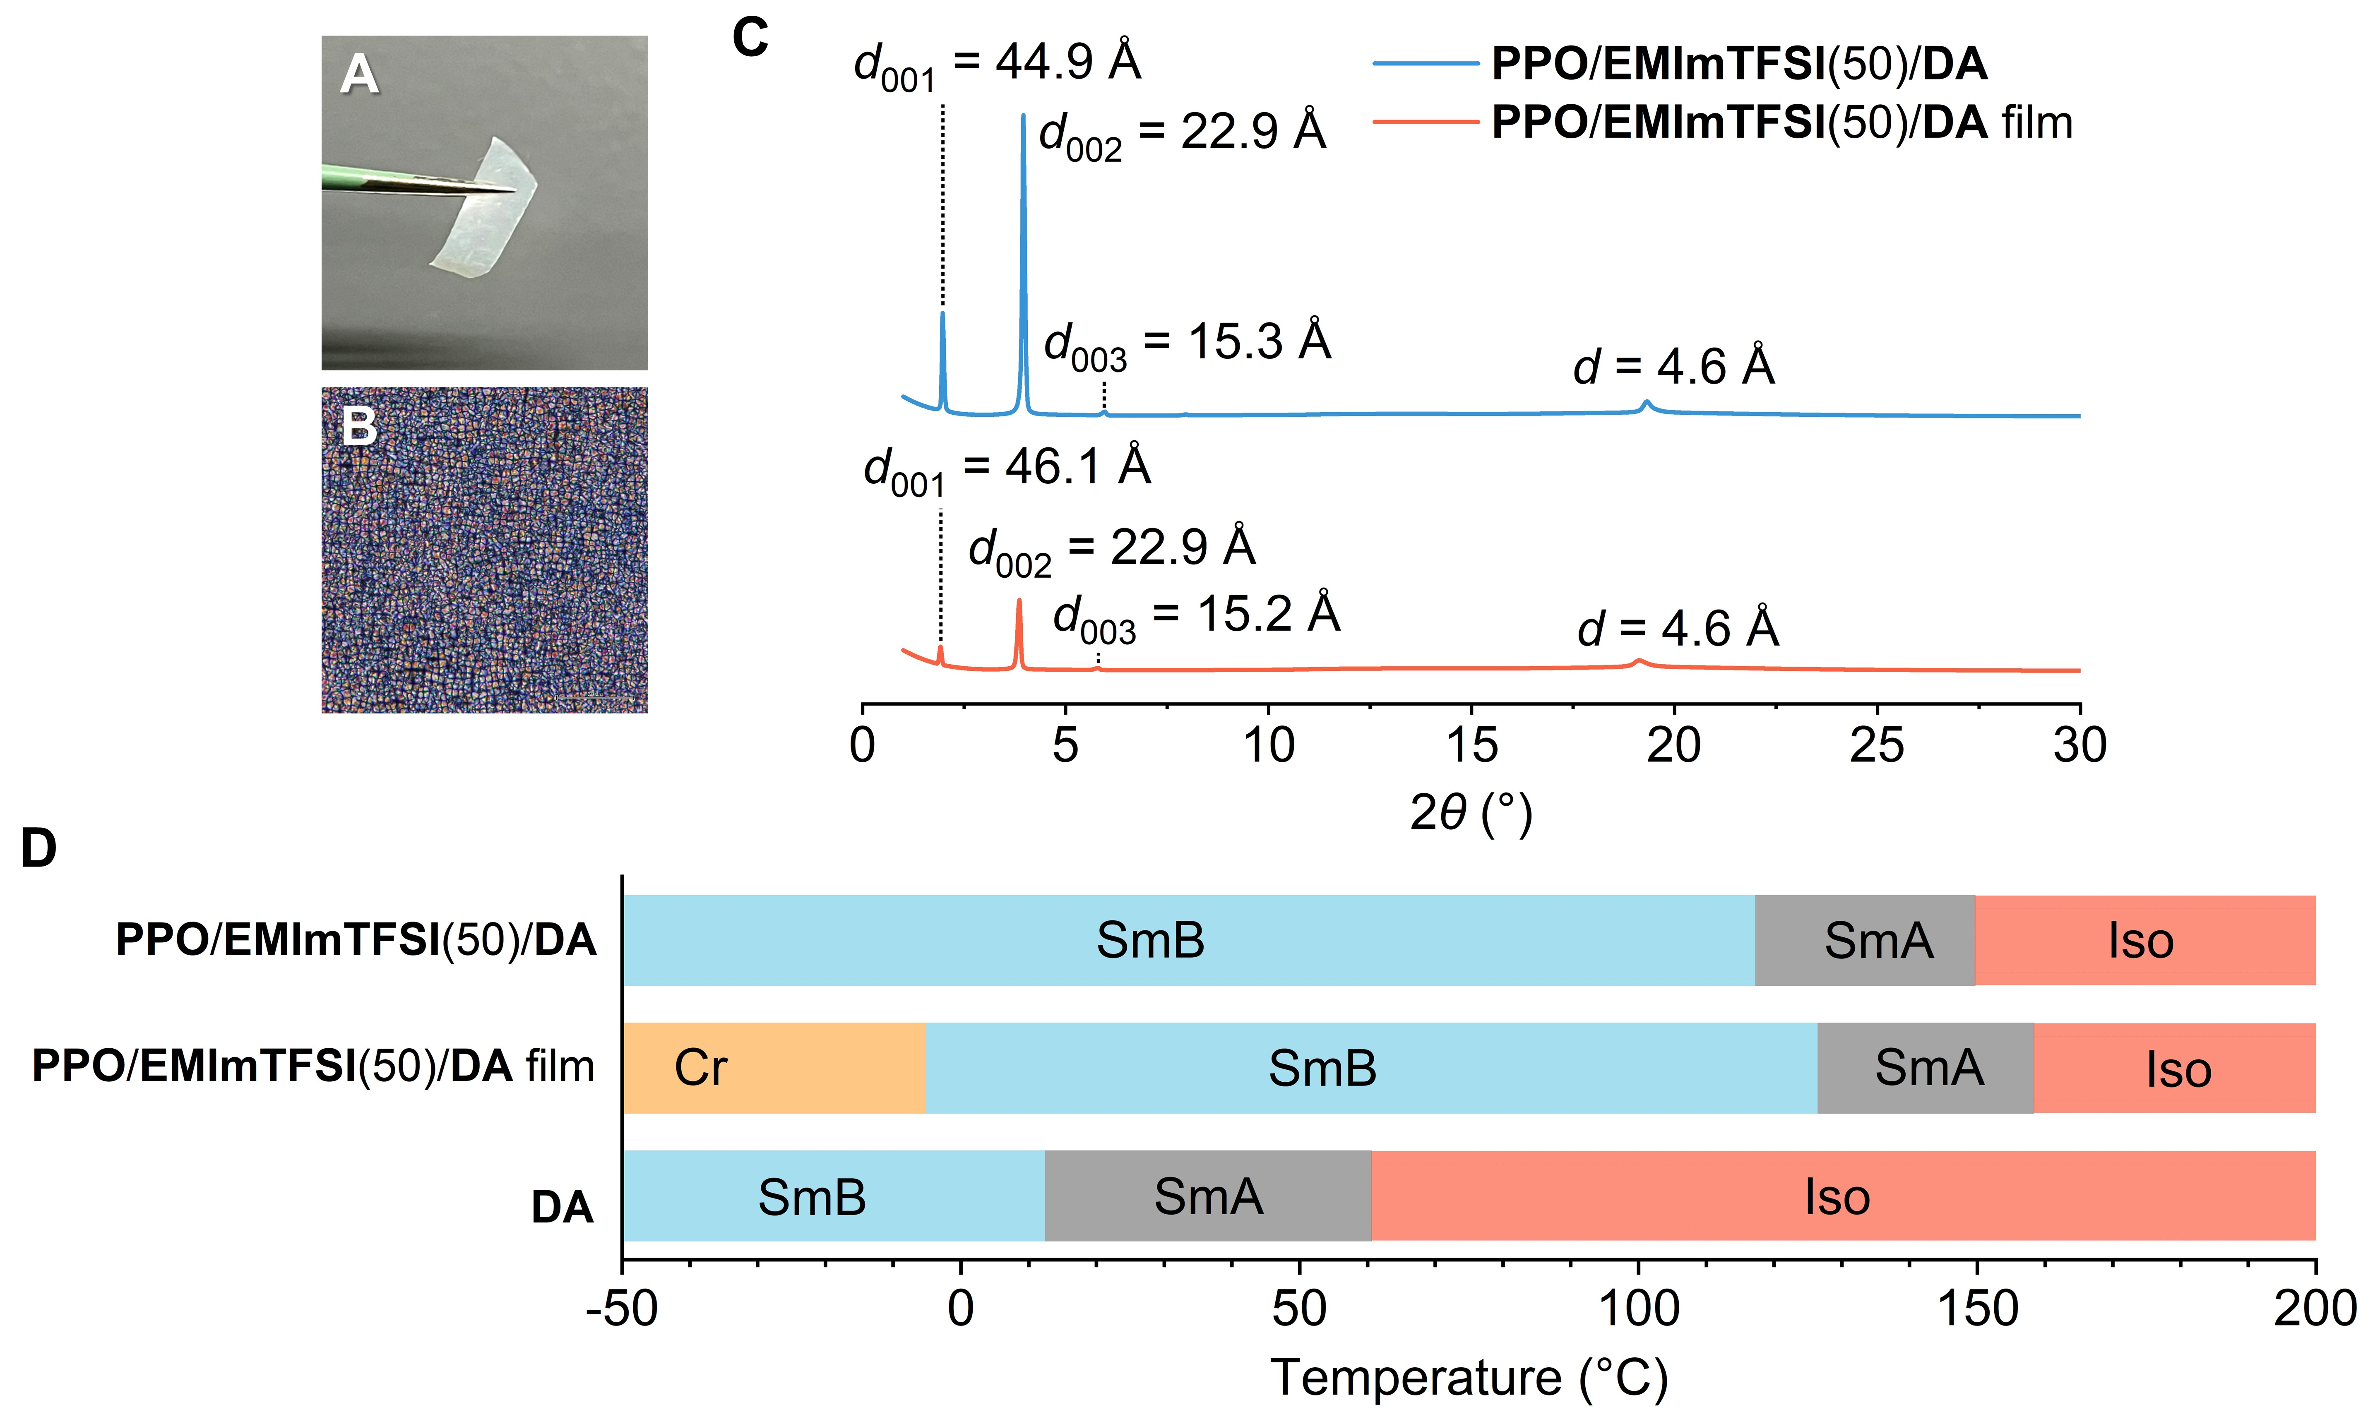
Figure 4. (A) Photograph and (B) POM image of the PPO/EMImTFSI(50)/DA film. (C) XRD patterns of PPO/EMImTFSI(50)/DA before polymerization and the PPO/EMImTFSI(50)/DA film after polymerization. (D) Phase transition temperatures of PPO/EMImTFSI(50), the photopolymerized PPO/EMImTFSI(50)/DA film, and DA, determined from the peak tops of DSC measurements during the heating process.

Figure 4A shows a photograph of the PPO/EMImTFSI(50) film obtained via photopolymerization, appearing as a soft, semi-transparent membrane. POM reveals a characteristic Maltese cross birefringence pattern, which remains unchanged before and after polymerization, suggesting that the PPO/EMImTFSI(50) film retains its smectic phase (Figure 4B). XRD patterns further support this observation, showing diffraction peaks with a reciprocal d-spacing ratio of 1:2:3, along with a sharp reflection near 19°, both before and after polymerization (Figure 4C). The XRD pattern of pure DA exhibits a single sharp peak with a d-spacing of 28.6 Å (Figure S15), consistent with a U-shaped conformation, as illustrated in Figure 1A. Upon mixing with PPO/EMImTFSI(50), this characteristic peak disappears, suggesting the formation of a homogeneous phase. These results confirm that PPO/EMImTFSI(50) exhibits an SmB layered structure, and that this LC phase is preserved during polymerization. The presence of this structure implies the formation of 2D ionic transport pathways within the membrane. To evaluate the structural stability of the SmB LC phase under mechanical stress, we performed XRD measurements on the PPO/EMImTFSI(50)/DA film after destructive tensile testing. The result showed that, compared to the unstressed film, the diffraction peaks became broader and the d-spacing slightly increased. Despite these changes, the SmB phase remained intact. These observations suggest that the LC lattice experiences mild distortion during stretching but retains its overall layer order (Figure S16). Figure 4D and Figure S17 compare the phase transition behaviors of DA, PPO/EMImTFSI(50)/DA, and the photopolymerized PPO/EMImTFSI(50)/DA film. During cooling, DA exhibit no crystallization, whereas cold crystallization occurs during heating. In contrast, PPO/EMImTFSI(50) remains crystalline below −6 °C. Notably, PPO/EMImTFSI(50)/DA shows no crystallization over the same temperature range, indicating the formation of a homogeneous phase among PPO, EMImTFSI, and DA. However, after polymerization, the PPO/EMImTFSI(50)/DA film exhibits crystallization below −5 °C, similar to PPO/EMImTFSI(50), suggesting partial phase separation between the polymerizable DA and PPO/EMImTFSI(50) during photocuring.
To further investigate the microstructure of the membrane, scanning electron microscopy (SEM) was employed to observe the morphology after the removal of PPO/EMImTFSI(50) by ethanol washing (Figure 5). SEM images of the PPO/EMImTFSI(50)/DA film reveal a porous surface morphology (Figures 5A–C), with densely distributed pores varying in sizes, in which the largest reaches approximately 20 μm in diameter. These observations suggest that the phase-separated PPO/EMImTFSI(50) was partially extracted by ethanol washing. Higher magnification images further reveal nanoscale voids along the inner walls of the pores, with the internal structure exhibiting a layered arrangement. Cross-sectional SEM images at the film edge (Figures 5D–F) shows the a wavy, layered morphology. In the magnified views, numerous nanoscale pores can be observed, closely resembling the inner-wall structures seen in Figure 5C. These findings suggest that the phase-separated PPO/EMImTFSI(50) was partially removed during ethanol washing, leaving behind a layered polymerized structure formed by the stacked assembly of DA and PPO, with interconnected internal pathways.

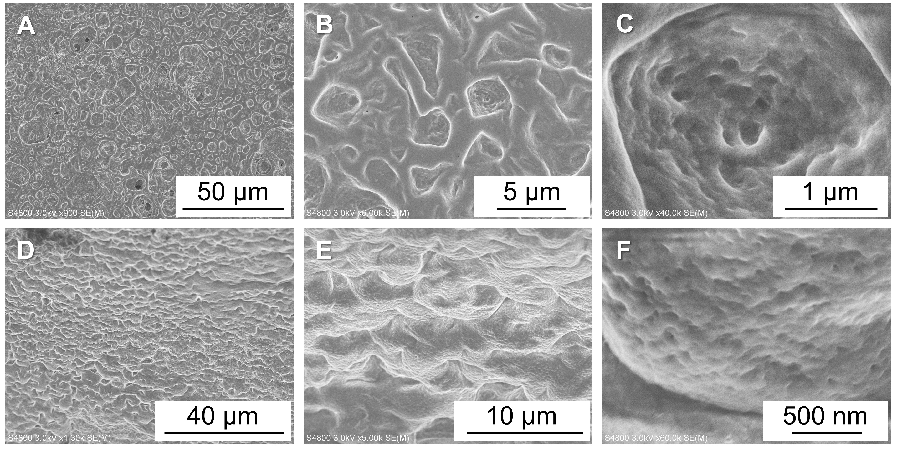
Figure 5. SEM images of the surface (upper panels, A–C) and cross-sectional (lower panels, D–F) views of the photopolymerized PPO/EMImTFSI(50)/DA film after ethanol washing to extract the liquid crystal electrolyte (PPO/EMImTFSI(50)) from the photopolymerized network of DA. (A, D) Low-magnification images; (B, E) medium-magnification images; and (C, F) high-magnification images.

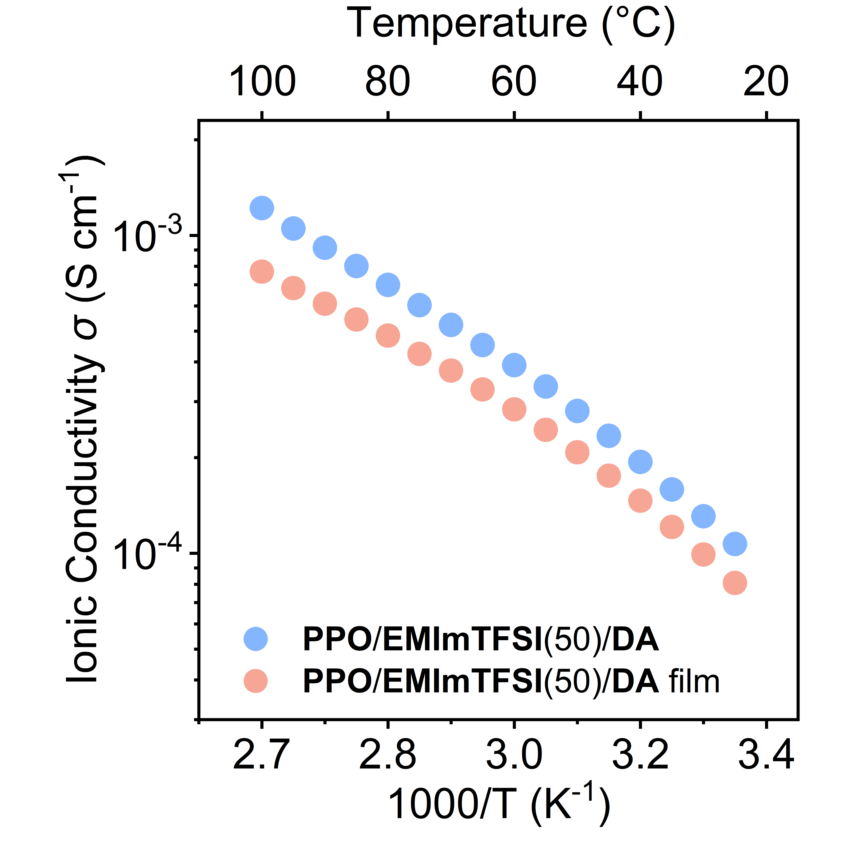
Figure 6. Temperature-dependent ionic conductivities of PPO/EMImTFSI(50)/DA before polymerization and the photopolymerized PPO/EMImTFSI(50)/DA film.

The preservation of 2D ionic pathways plays a vital role in maintaining the high ionic conductivity in PPO/EMImTFSI(50). Figure 6 exhibits the temperature-dependent ionic conductivity of PPO/EMImTFSI(50)/DA before and after photopolymerization. A slight decrease in ionic conductivity is observed after polymerization. However, the room-temperature ionic conductivity remains relatively high at 8.1 × 10⁻⁵ S cm⁻¹, close to the 10⁻⁴ S cm⁻¹ value of the uncured sample. These results indicate that the high ionic conductivity is primarily attributed to the self-assembled SmB phase, which forms self-assembled 2D ionic transport pathways. The fact that conductivity is largely retained after polymerization suggests that the SmB structure remains intact throughout the photocuring process. Nevertheless, the slight reduction in conductivity implies that polymerization imposes some restrictions on the molecular mobility of the LC components, which may partially hinder ion migration.

2.5 Actuation Performance
The working principle of ionic actuators is typically based on ion migration under an applied electric field. When a voltage is applied, ions in the electrolyte migrate into the electrode layers, inducing volumetric changes that generate mechanical deformation. In this study, PEDOT:PSS was employed as the electrode material (see Supporting Information), while a photopolymerized PPO/EMImTFSI(50)/DA film served as the solid-state electrolyte. The actuator was fabricated by sandwiching the PPO/EMImTFSI(50)/DA film between two PEDOT:PSS layers (see Supporting Information). Upon applying a voltage across the electrodes, cations from the electrolyte migrate into the PEDOT:PSS layer at the cathode side, causing it to swell due to electrochemical doping according to the reaction: PEDOT:PSS + EMIm⁺ ⇔ PEDOT⁺ + EMIm⁺:PSS⁻. This anisotropic expansion results in bending of the actuator toward the anode, enabling directional actuation under electrical stimulation.
Figure 7A shows a photograph of the actuator with dimensions of 3 mm × 1.5 mm with a thickness of 72 μm, placed between two stainless steel clamps. Copper foil was inserted between the PEDOT:PSS electrodes and the clamps to prevent electrode damage. When a voltage of ±3 V at 0.01 Hz was applied, the actuator exhibited excellent bending strain performance, achieving a maximum strain of 1.11% as measured at a point 6 mm from the from the clamped edge. Moreover, the actuator demonstrates outstanding performance at high frequencies (Figure 7B). Under an applied voltage of ±3 V at 150 Hz, it achieves a peak-to-peak displacement of 6 μm, which represents a highly competitive level among current soft ionic actuators. Human tactile perception relies on several mechanoreceptors, each sensitive to specific frequency ranges: Meissner corpuscles (~10–50 Hz), Merkel cells (<10 Hz), Pacinian corpuscles (~60–400 Hz), and Ruffini endings (<100 Hz)^{[33–35]}. The actuation frequency range achieved in this study covers the operational ranges of three out of the four major mechanoreceptors, indicating its potential for simulating a wide spectrum of tactile sensations in artificial haptic systems.
The generated force is another critical parameter in evaluating the practical applicability of ionic actuators. In our previous work, liquid crystal/polymer composite electrolyte membranes were fabricated by blending phosphate-based liquid crystals with vinyl polymers. However, actuators based on these soft electrolyte membranes exhibited low blocking forces and were prone to back relaxation due to the insufficient mechanical robustness of the electrolyte layer. In contrast, the present study addresses these limitations by employing high-viscosity SmB phases combined with large-sized cations. This strategy significantly enhances the mechanical integrity and electromechanical performance of the electrolyte membrane. The newly developed actuator demonstrated a blocking force of 1.6 mN under an applied voltage of ±3 V at 0.1 Hz (Figure 7C). Notably, this value surpasses that of our previously reported large-sized actuator (4 mm × 20 mm), which generated less than 0.5 mN, despite the more compact dimensions of the current device.
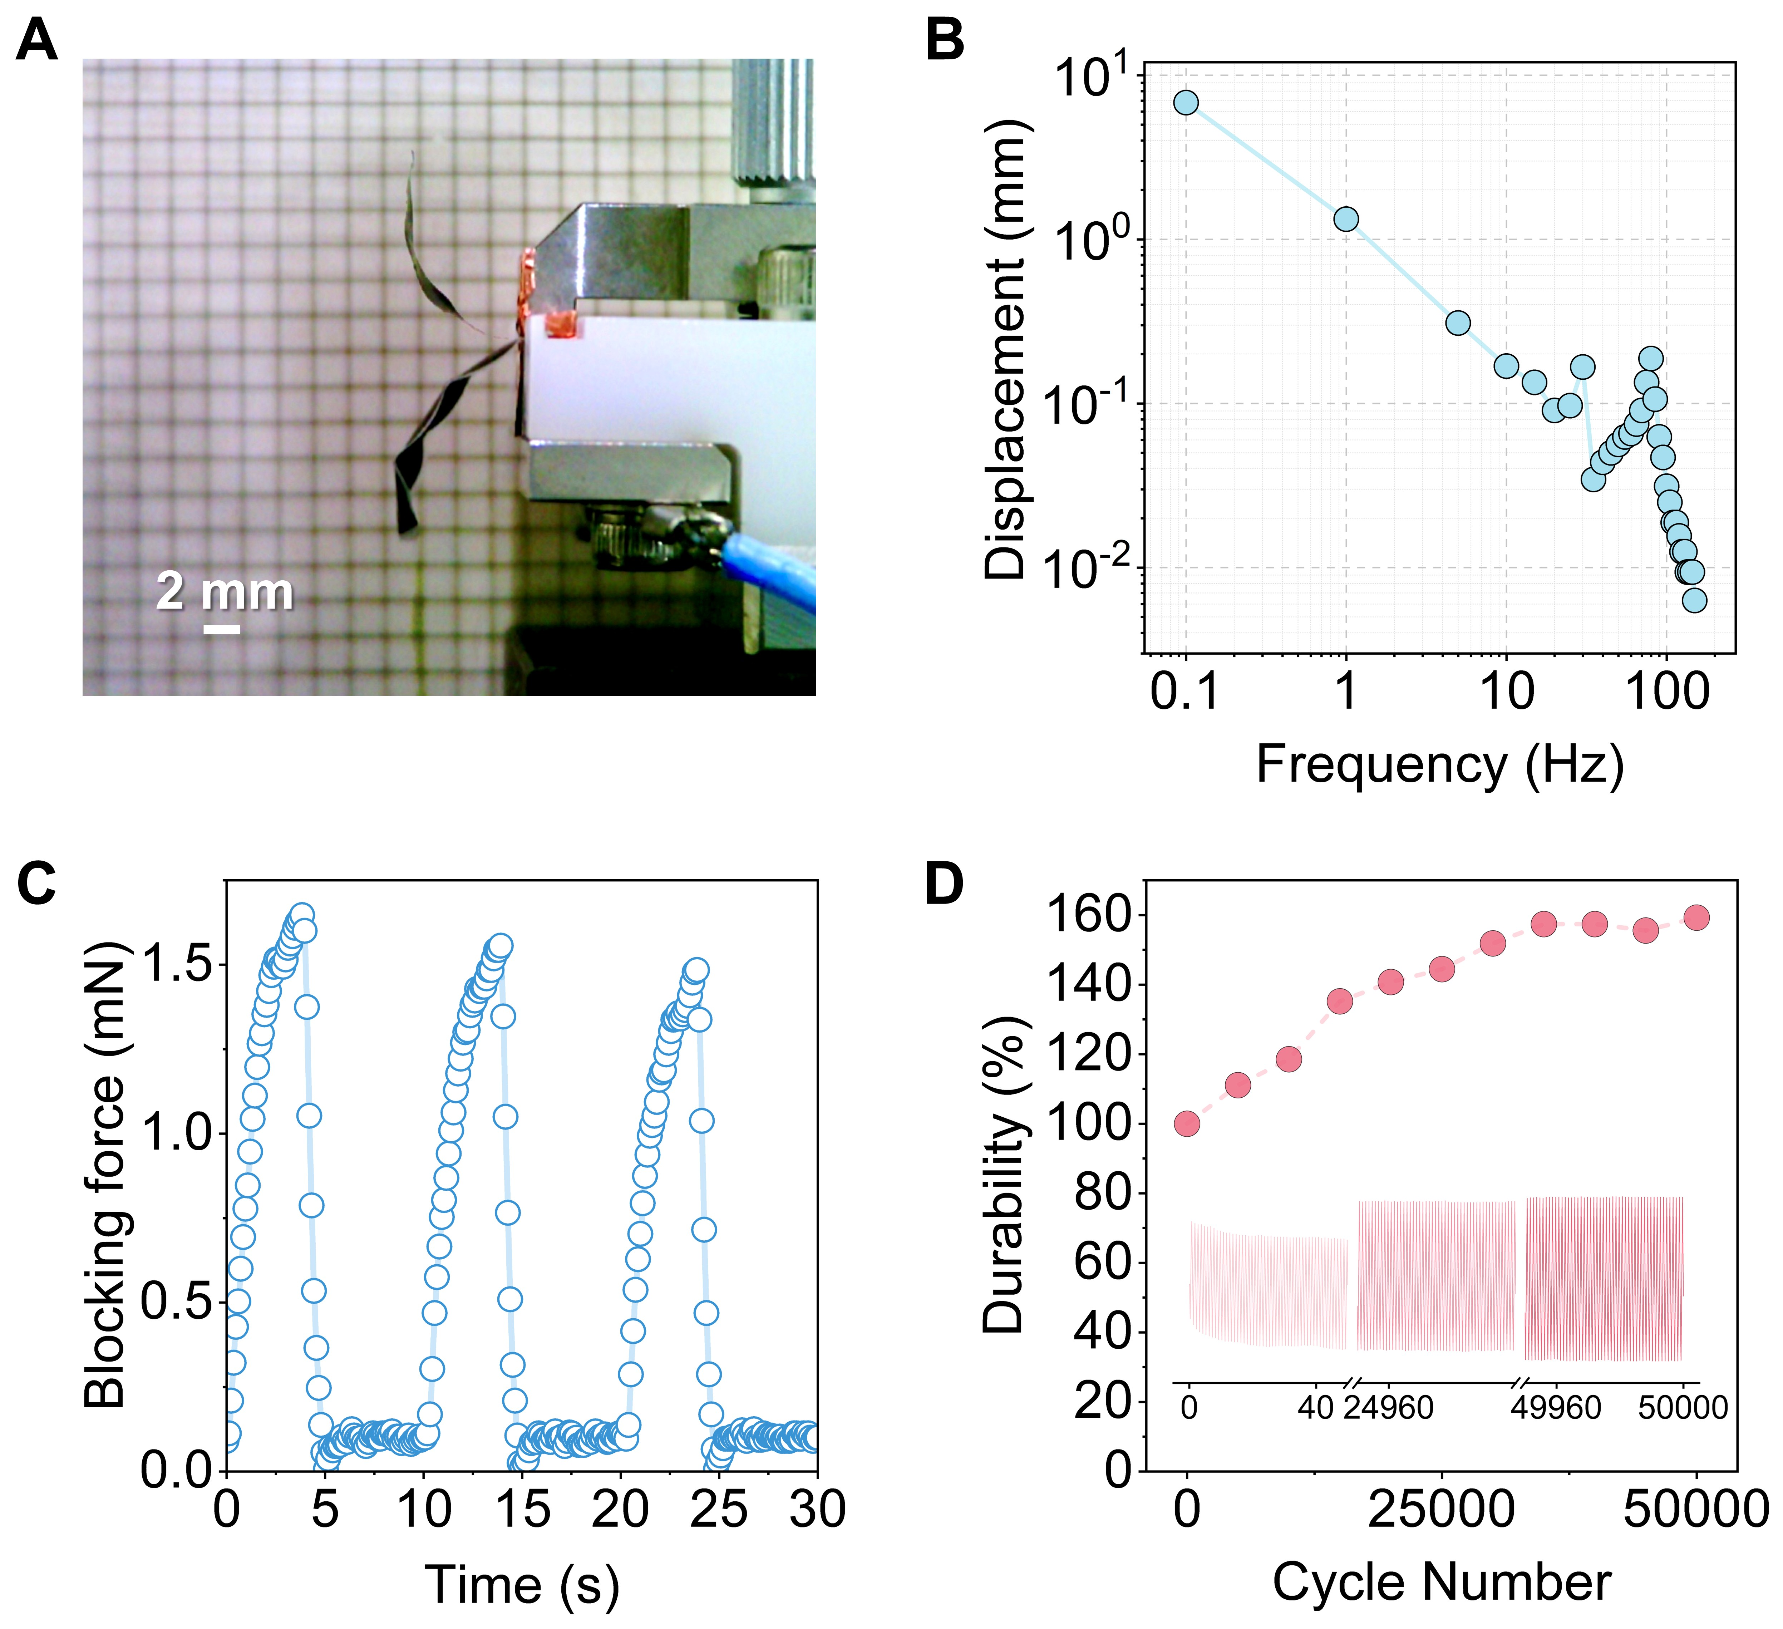
Figure 7. (A) Actuation photograph of the PEDOT:PSS | photopolymerized PPO/EMImTFSI(50)/DA film | PEDOT:PSS actuator under an applied voltage of ±3 V at 0.01 Hz. (B) Frequency-dependent peak-to-peak displacement of the actuator. (C) Blocking force of the actuator under ±3 V at 0.1 Hz. (D) Durability performance of the actuator under ±3 V at 1 Hz.
Durability is a crucial factor for the practical application of ionic actuators. Figure 7D shows a durability test conducted under a square wave voltage of ±3 V at 1 Hz. Remarkably, after 50,000 actuation cycles, the actuator not only retained its performance but exhibited a 59% increase in bending deformation compared to its initial value, reaching 159% of the original displacement. This enhancement is likely attributed to the gradual infiltration of the LC electrolyte or IL into deeper regions of the PEDOT:PSS electrode, improving interfacial contact and effective utilization of the active material over time.
As a demonstration of practical utility, a 104 µm-thick actuator–comprising a photopolymerized PPO/EMImTFSI(50)/DA film sandwiched between PEDOT:PSS electrodes–was used to kick a metallic spring, mimicking the motion of a human leg (Figure 8). The actuator was clamped between two stainless steel electrodes to simulate the leg, while an 89 mg metallic spring coil served as the ball. Under AC voltages of ±1 V, ±2 V, and ±3 V at 0.01 Hz, the spring was kicked distances of 0.4, 0.6, and 1.0 cm, respectively. This voltage-dependent displacement clearly demonstrates the actuator’s ability to generate increased force with higher voltage due to enhanced ion accumulation within the PEDOT:PSS electrodes and at the electrode/electrolyte interface. Further improvemtns in output force may be achieved in future designs by stacking multiple actuator layers^{[16]} or increasing the thickness of both the electrolyte membrane and the electrodes^{[36]}.

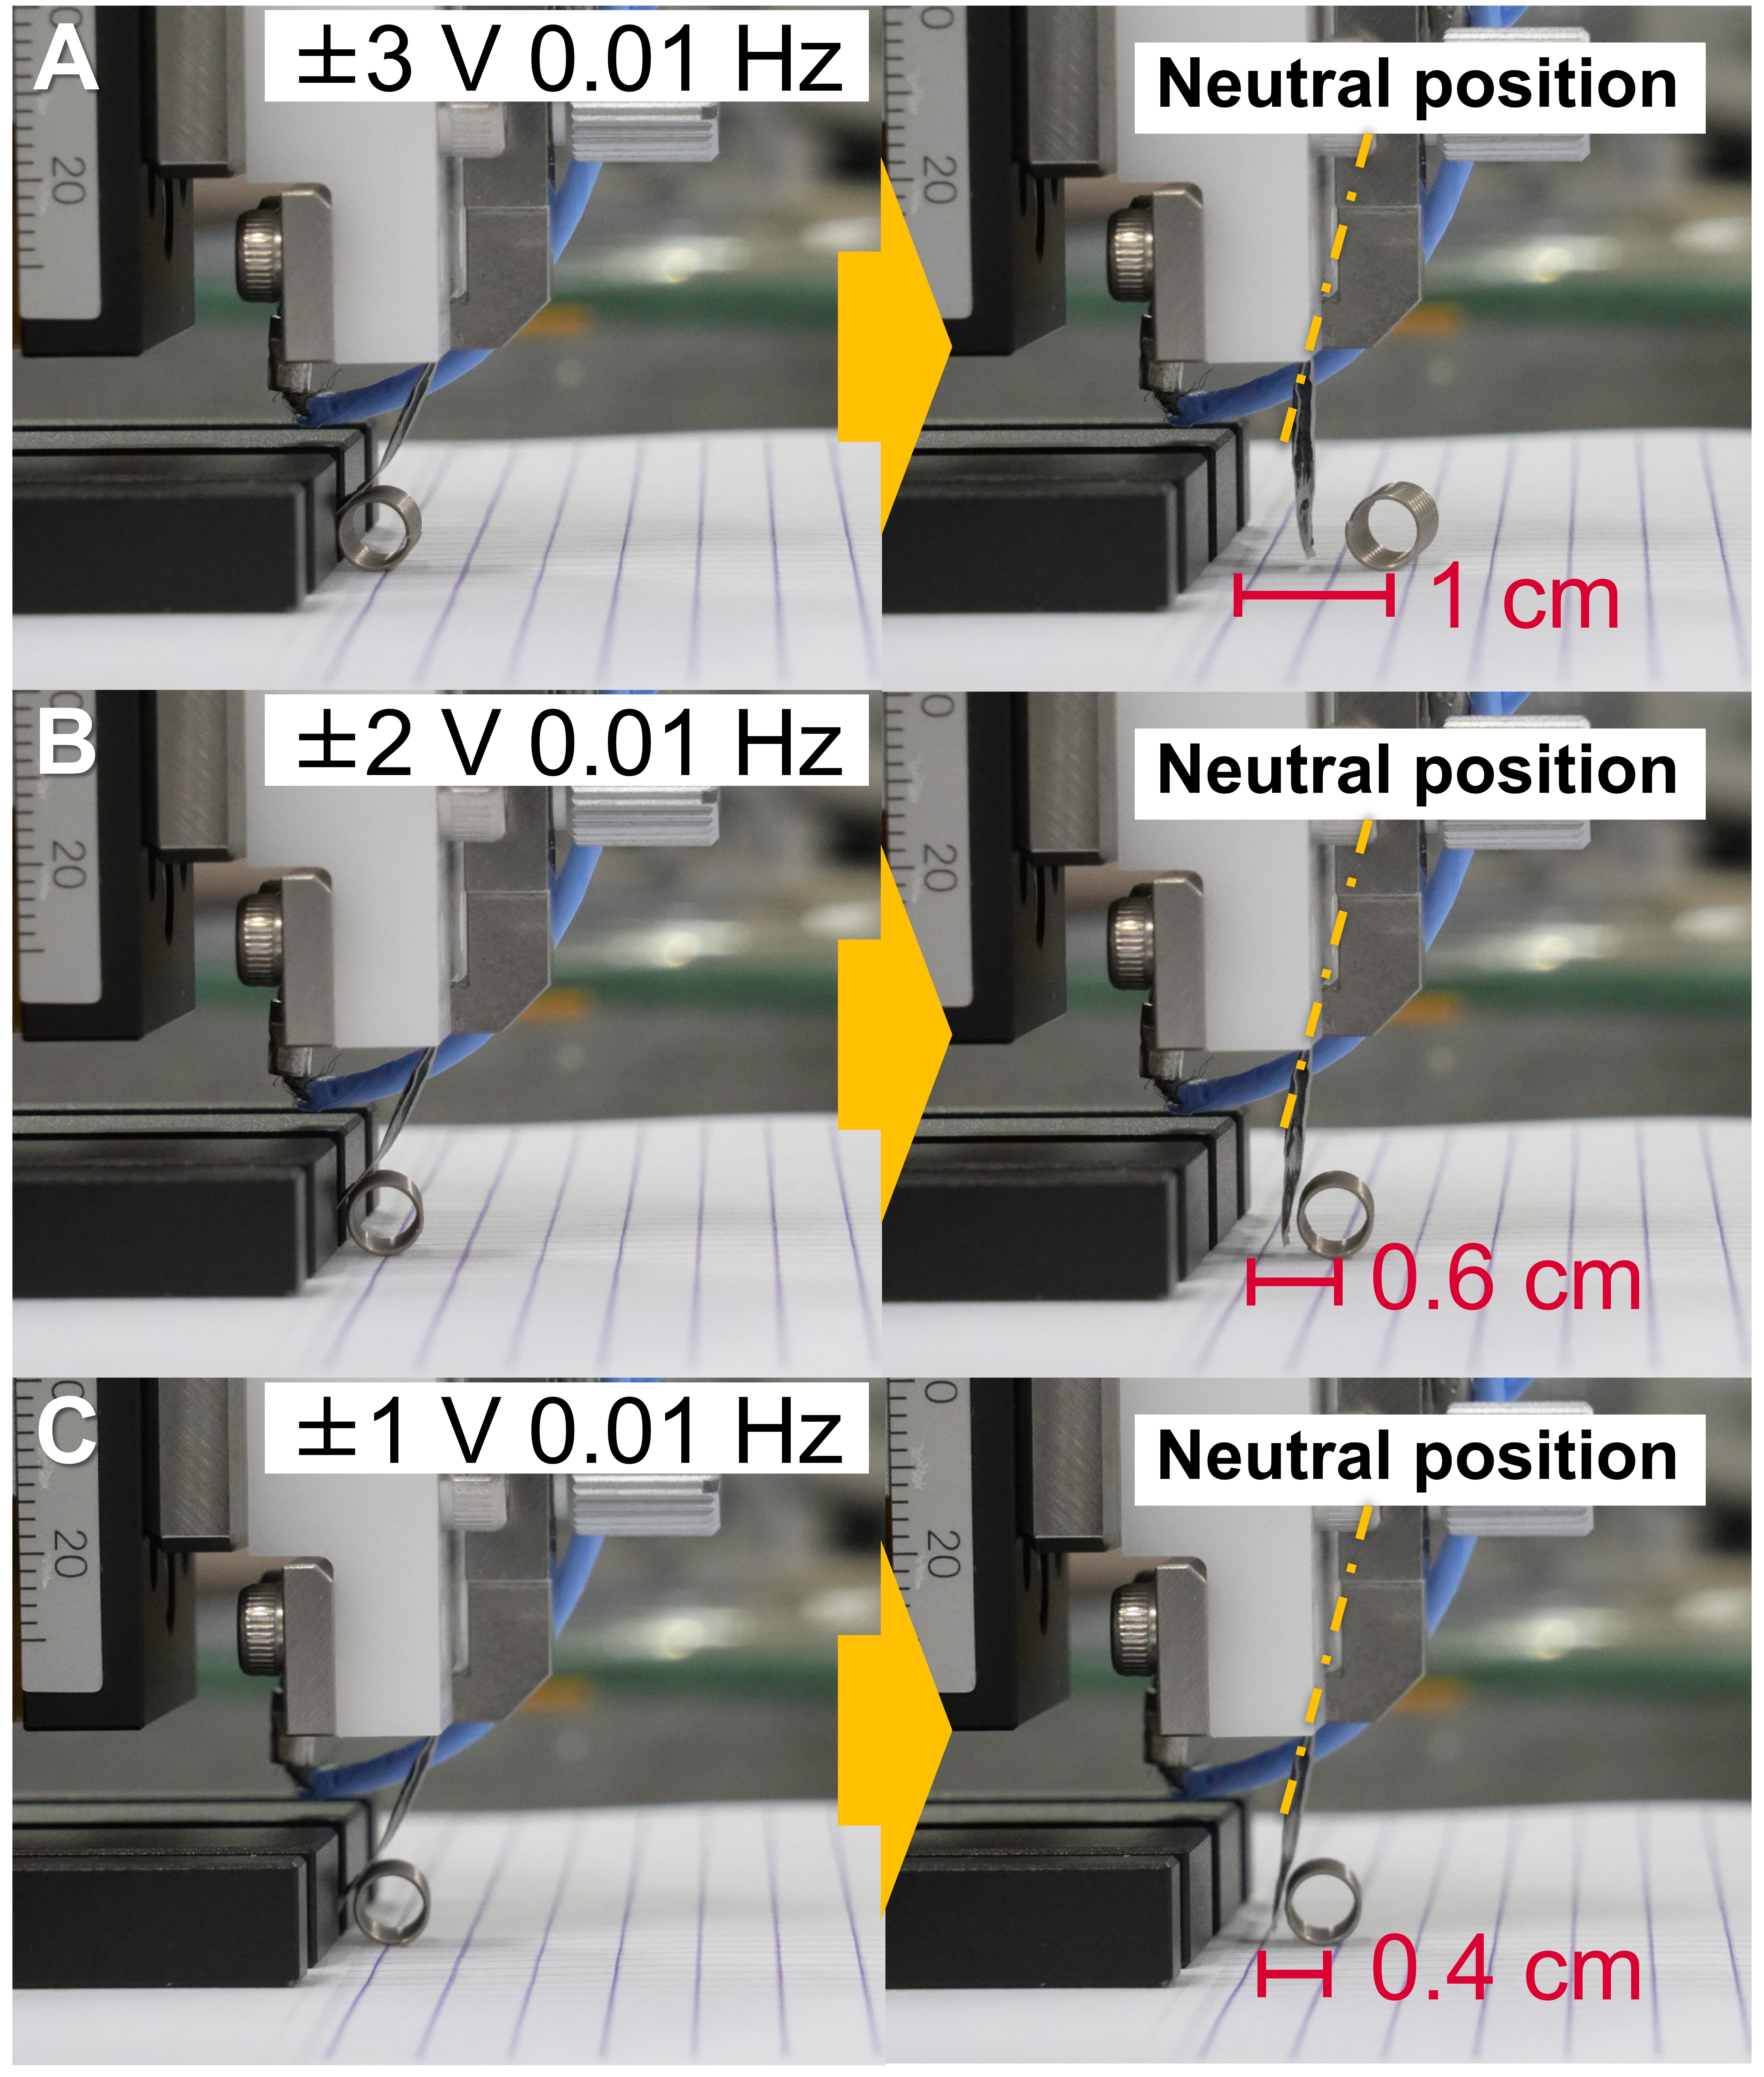
Figure 8. Demonstration of a 104 μm-thick soft actuator composed of a PEDOT:PSS | photopolymerized PPO/EMImTFSI(50)/DA film | PEDOT:PSS trilayer structure, mimicking a human leg kicking a ball. In this setup, the actuator functions as the leg, and a metallic spring coil represents the ball. Upon actuation with an AC voltage of (A) 3 V, (B) 2 V, and (C) 1 V at 0.01 Hz, the spring is propelled increasing distances with higher voltages, demonstrating voltage-dependent force generation.

In summary, LC electrolyte membranes incorporating high-viscosity SmB phases deliver superior performance when integrated into PEDOT:PSS-based ionic actuators. The combination of self-assembled 2D ionic pathways and the intrinsic high conductivity of the ionic liquid enhances response speed and deformation under low-frequency actuation. The high viscosity also contributes to greater force output, thereby expanding the practical utility of these actuators in soft robotics, mechanical grippers, tactile interfaces, and other advanced electromechanical systems.

3. Conclusion
In this study, we developed a high-performance LC electrolyte membrane for application in ionic actuators. The membrane was fabricated via photopolymerization and features an SmB phase with layered ionic pathways, composed of a rod-like phosphate-functionalized LC molecule (PPO), an ionic liquid (EMImTFSI), and a photopolymerizable rod-like mesogen (DA). The resulting LC electrolyte membrane with 2D ionic pathways exhibits a high room-temperature ionic conductivity of 8.1 × 10⁻⁵ S cm⁻¹. In actuator performance tests, the LC electrolyte membrane demonstrated excellent bending strain, frequency responsiveness, force generation, and durability, owing to its high ionic conductivity and mechanical robustness. The actuator achieved a maximum strain of 1.11% under a square wave voltage of ±3 V at 0.01 Hz, without exhibiting back relaxation. It also maintained a displacement of 6 μm even at 150 Hz, demonstraing excellent frequency responsiveness. Despite its small dimensions, the actuator generated a blocking force of 1.6 mN under ±3 V at 0.1 Hz. Furthermore, during durability testing at ±3 V and 1 Hz, the actuator’s peak-to-peak displacement increased to 159% of its initial value after 50,000 cycles. This study presents a novel strategy for fabricating nanostructured electrolyte membrane utilizing the synergistic interactions between ion-conducting liquid crystals and photopolymerizable mesogens. This approach enables the development of electrolyte membranes with both high ionic conductivity and mechanical stability, advancing the performance of ionic actuators. Beyond enhancing actuator performance, the materials and methodologies developed here hold significant promise for future applications in haptic interfaces and soft robotics.

4. Experimental Section
4.1 Measurements
NMR spectra (¹H and ¹³C) were obtained using a JEOL ECZ 400S spectrometer. Chemical shifts (δ, in ppm) were determined relative to the residual signals of deuterated solvents as internal standards: CDCl₃ (δ = 7.26 ppm for ¹H NMR, 400 MHz and δ = 77.16 ppm for ¹³C NMR, 100 MHz), CD₃OD (δ = 3.31 ppm for ¹H NMR, 400 MHz), and CD₂Cl₂ (δ = 5.32 ppm for ¹H NMR, 400 MHz and δ = 53.84 ppm for ¹³C NMR, 100 MHz). High-resolution mass spectra (HRMS) were obtained on a Bruker micrOTOF II spectrometer equipped with a positive-mode atmospheric-pressure chemical ionization (APCI) source. Fourier transform infrared (FT-IR) spectra were collected with a Bruker ALPHA II spectrometer. Polarized optical microscopy (POM) was employed to examine the optical textures of the samples, using an Olympus BX51N-31P-O3 microscope equipped with a DP22 digital camera and a LINKAM T95-HS temperature controller with an LTS420E heating stage. X-ray diffraction (XRD) patterns were collected over a 2θ range of 1–30° using a Rigaku Miniflex 600 diffractometer with Cu Kα radiation and a nickel filter to eliminate Kß radiation. Differential scanning calorimetry (DSC) was performed on a NETZSCH DSC 3500 Sirius instrument. The surface and cross-sectional morphologies of the actuators were observed using a HITACHI S-4800 field emission scanning electron microscope (FE-SEM). Ionic conductivity was measured using a Metrohm AUTOLAB PGSTAT128N electrochemical impedance meter (see Supporting Information). The actuator’s displacement and blocking force under applied voltages controlled by a function generator and a potentiostat were measured using a Keyence LK-HD500 laser displacement sensor and a KYOWA LTS-50GA load cell. (see Supporting Information).

4.2 Materials
All reagents listed below were used without further purification: 4-(trans-4-pentylcyclohexyl)phenol, trifluoromethanesulfonic acid anhydride, 4-(4,4,5,5-tetramethyl-1,3,2-dioxaborolan-2-yl)anisole, diethyl chlorophosphate, 4-[[6-(acryloyloxy)hexyl]oxy]benzoic acid, 6-chloro-1-hexanol, 1-ethyl-3-methylimidazolium bis(trifluoromethanesulfonyl)imide (EMImTFSI), 1-ethyl-3-(3-dimethylaminopropyl)carbodiimide hydrochloride (EDC), boron tribromide (BBr₃), 4-dimethylaminopyridine (DMAP), and lithium bis(trifluoromethanesulfonyl)imide (LiTFSI), 4-methoxyphenol were purchased from Tokyo Chemical Industry (TCI, Japan). Tetrakis(triphenylphosphine)palladium(0) [Pd(PPh₃)₄], 2,2-dimethoxy-2-phenylacetophenone was obtained from Sigma-Aldrich. was supplied. Solvents including pyridine, tetrahydrofuran (THF), N,N-dimethylformamide (DMF), ethyl acetate (EtOAc), dichloromethane (DCM), 1,4-dioxane, hexane, chloroform, methanol, and acetone, as well as potassium carbonate (K₂CO₃) and 1-butyl-3-methylimidazolium bis(trifluoromethanesulfonyl)imide (BMImTFSI) were obtained from Kanto Chemical Co., Inc. (Cica, Japan). Tetrabutylammonium iodide (TBAI) was sourced from Nacalai Tesque (Japan). Bis(4-hydroxyphenyl)tetra(ethylene glycol) was synthesized following previously reported procedures^{[37]}. PEDOT:PSS (Clevios PH1000, Heraeus) was used as received.
4.3 Synthesis of PPO
The synthetic pathway for PPO is depicted in Scheme 1.
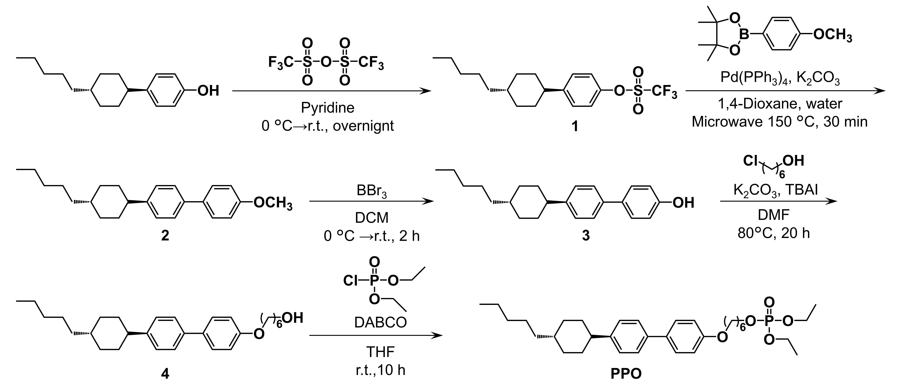
Scheme 1 Synthetic pathway for PPO.

Synthesis of 6-{4-[4-(trans-4-pentylcyclohexyl)phenyl]phenyloxy}hexyl diethyl phosphate (PPO): To a solution of compound 4 (0.74g, 1.75 mmol) and 1,4-diazabicyclo[2.2.2]octane (0.59 g, 5.26 mmol) in anhydrous THF (20 mL) under an argon atmosphere, diethyl chlorophosphate (0.38 mL, 2.63 mmol) was slowly added at room temperature. After stiring for 10 hours, the mixture was extracted with CHCl₃ and washed with a 5% aqueous hydrochloric acid and water. The combined organic layers was collected, dried over anhydrous MgSO₄, and filtered. After solvent removal under reduced pressure, the crude product was purified by silica gel chromatography using an n-hexane/EtOAc gradient from 1/0 to 2/8, followed by recycling preparative GPC (CHCl₃ as an eluent), affording compound PPO as an transluscent liquid crystal at room temperature in 80% yield. ¹H NMR (400 MHz, CD₃OD, δ/ppm) δ = 7.47 (q, J = 7.9 Hz, 4H; ArH), 7.23 (d, J = 7.8 Hz, 2H; ArH), 6.95 (d, J = 8.2 Hz, 2H; ArH), 4.13−3.97 (m, 8H; CH₂), 2.48 (t, J = 12.1 Hz, 1H; CH), 1.91−1.70 (m, 8H; CH₂), 1.59−1.46 (m, 6H; CH, CH₂), 1.37−1.22 (m, 15H; CH₂, CH₃), 1.16−1.05 (m, 2H; CH₂), 0.92 (t, J = 6.9 Hz, 3H; CH₃); ¹³C NMR (100 MHz, CDCl₃) δ = 158.5, 146.5, 138.5, 133.7, 128.0, 127.3, 126.7, 114.8, 67.9, 67.6, 67.6, 63.8, 63.7, 44.4, 37.5, 37.4, 34.5, 33.7, 32.3, 30.4, 30.3, 29.3, 26.8, 25.8, 25.4, 22.8, 16.3, 16.2, 14.2. HRMS(APCI): m/z calcd. for C₃₃H₅₁O₅P [M]⁺, 558.3474; found, 558.3468.

4.4 Synthesis of DA
The synthetic pathway of DA is illustrated in Scheme 2.
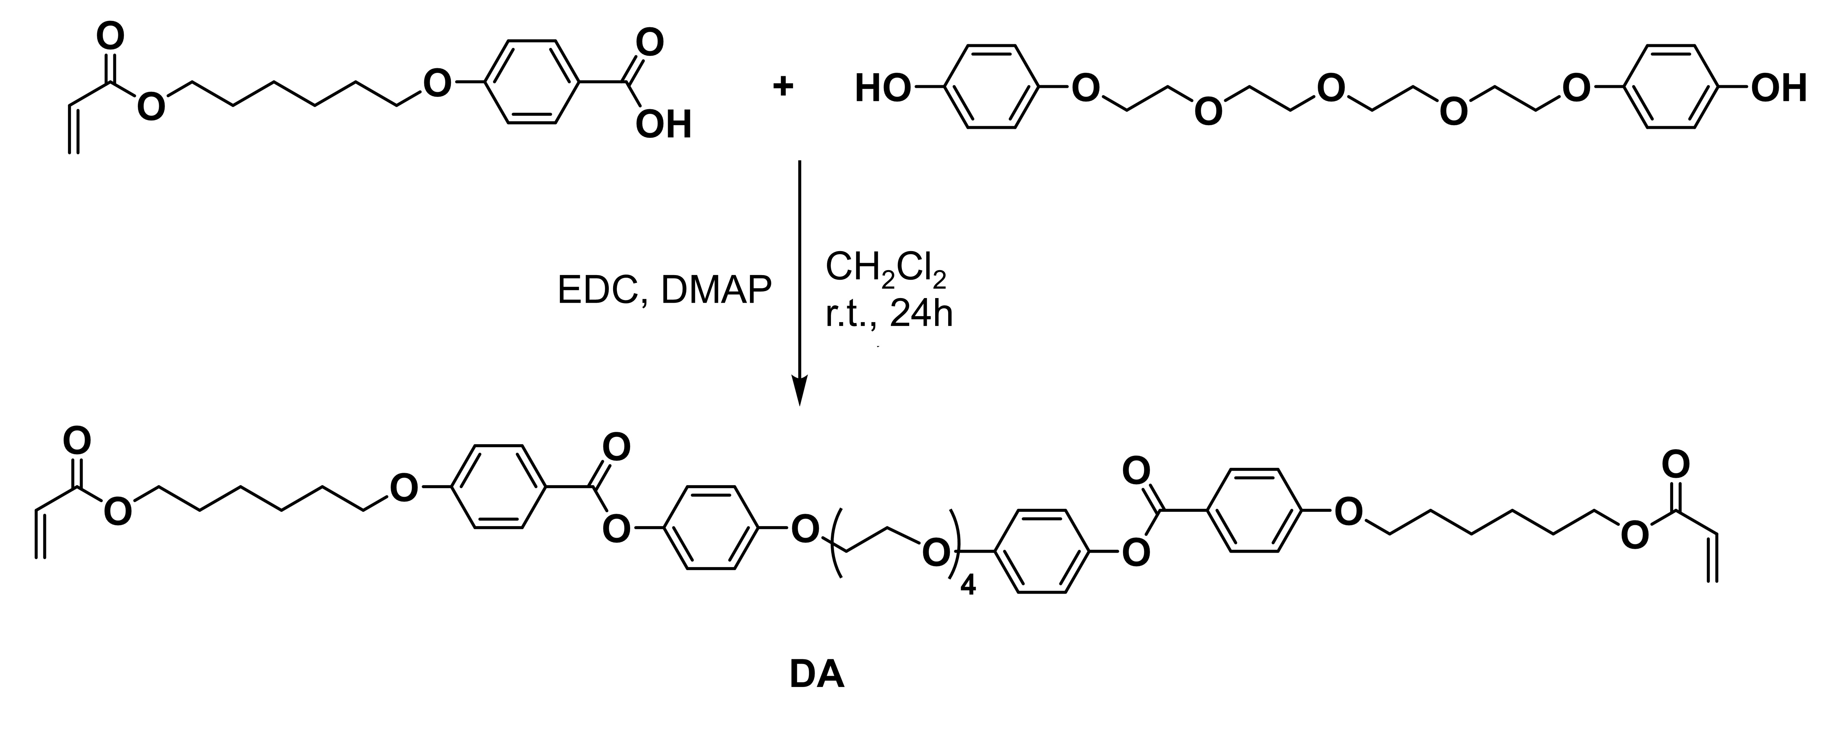
Scheme 2 Synthetic pathway of DA.
Synthesis of Bis{[[[4-(6-acryloyloxy)hexyl]oxy]phenylcarbonyloxy]phenyl}tetra (ethylene glycol) (DA): EDC (2.83 g, 14.7 mmol) was added to a stirred solution of 4-[[6-(acryloyloxy)hexyl]oxy]benzoic acid (4.31 g, 14.7 mmol), bis(4-hydroxyphenyl)tetra(ethylene glycol) (1.86 g, 4.92 mmol), and DMAP (0.18 g, 1.5 mmol) in CH₂Cl₂ (20 mL) at room temperature under an argon atmosphere. After stirring for 24 hours, the reaction mixture was extracted with CHCl₃ and EtOAc and then washed with water. The organic layer was separated, dried over MgSO₄, and filtered. Following solvent removal under reduced pressure, the crude product was purified by silica gel column chromatography (CHCl₃/EtOAc = 9/1). Further purification by preparative GPC afforded compound DA as a white powder ((2.68 g, 2.89 mmol, yield: 59%). ¹H NMR (400 MHz, CD₂Cl₂, δ/ppm) δ = 8.10 (dt, J = 9.5, 2.5 Hz, 4H, ArH), 7.10 (td, J = 6.2, 4.0 Hz, 4H, ArH), 6.99−6.93 (m, 8H, ArH), 6.36 (dd, J = 17.2, 1.6 Hz, 2H, =CH₂), 6.12 (dd, J = 17.4, 10.5 Hz, 2H, =CH), 5.81 (dd, J = 10.3, 1.6 Hz, 2H, =CH₂), 4.17−4.03 (m, 12H, CH₂), 3.83 (dd, J = 5.5, 4.1 Hz, 4H, CH₂), 3.67 (dtd, J = 18.5, 4.0, 1.8 Hz, 8H, CH₂), 1.87−1.68 (m, 8H, CH₂), 1.55-1.42 (m, 8H, CH₂). ¹³C NMR (100 MHz, CD₂Cl₂) δ = 166.7, 165.8, 164.1, 157.1, 145.4, 132.7, 130.9, 129.3, 123.3, 122.3, 115.7, 114.9, 71.4, 71.3, 70.3, 68.9, 68.6, 65.1, 29.7, 29.2, 26.4, 26.3. HRMS(APCI): m/z calcd. for C₅₂H₆₂O₁₅ [M + H]⁺, 927.4122; found, 927.4135.
4.5 Preparation of Liquid Crystal–Salt Complexes
PPO and ILs (EMImTFSI or BMImTFSI) or LiTFSI were weighed at a 1:1 molar ratio and placed in a vial. A small amount of acetone was added to fully dissolve the components. The resulting solution was then heated in a drying oven at 85 °C. Once the solvent had visibly evaporated, the sample was further dried under reduced pressure for 12 hours. The resulting material was then collected for subsequent use.

4.6 Preparation of Liquid-Crystalline/Polymer Membrane
A mixture of PPO/EMImTFSI(50) and DA was prepared at a weight ratio of 80:20 and placed in a glass vial. A photoinitiator (2,2-dimethoxy-2-phenylacetophenone, 1 wt% relative to DA) and an inhibitor (4-methoxyphenol, 0.1 wt%) were added, followed by the addition of a small amount of acetone to ensure complete dissolution. The solution was then heated at 85 °C to evaporate the solvent. After visible evaporation, the sample was dried under reduced pressure at room temperature overnight and subsequently used for further experiments.
For membrane fabrication, a 10 mg sample of the PPO/EMImTFSI(50)/DA was placed on a silicon substrate and heated until reaching its isotropic phase. A 60 μm-thick polyimide tape was used as a spacer, and the sample was carefully covered with a glass slide, applying gentle pressure to achieve uniform thickness. The assembly was then exposed to UV light (intensity: 30 mW/cm²) for 5 minutes, with the glass side facing upward, to complete photopolymerization. After curing, the resulting LC membrane was carefully removed from the glass slide for subsequent applications.

Acknowledgements
This work was supported by JST, PRESTO (Grant Number JPMJPR23QB), JSPS KAKENHI (Grant Number 25H01263), and Murata Science and Education Foundation (Grant Number HTF0202).

Data Availability Statement
The data that support the findings of this study are available from the corresponding author upon reasonable request.

References
[1] S. Chen, L. Yu, W. Shen, B. Fong, Y. Li, P. Dong, H. Qin, S. Yao, Adv. Funct. Mater. 2024, 34, 2314515.
[2] C. De Pascali, G. A. Naselli, S. Palagi, R. B. N. Scharff, B. Mazzolai, Sci. Robot. 2022, 7, eabn4155.
[3] E. H. Rumley, D. Preninger, A. Shagan Shomron, P. Rothemund, F. Hartmann, M. Baumgartner, N. Kellaris, A. Stojanovic, Z. Yoder, B. Karrer, C. Keplinger, M. Kaltenbrunner, Sci. Adv. 2023, 9, eadf5551.
[4] Y. Qiu, Z. Lu, Q. Pei, ACS Appl. Mater. Interfaces 2018, 10, 24807.
[5] C. J. Payne, I. Wamala, D. Bautista-Salinas, M. Saeed, D. Van Story, T. Thalhofer, M. A. Horvath, C. Abah, P. J. Del Nido, C. J. Walsh, N. V. Vasilyev, Sci. Robot. 2017, 2, eaan6736.
[6] C.-H. Wu, W. Meng, M. Yoshio, ACS Mater. Lett. 2022, 4, 153.
[7] G. Wu, X. Wu, Y. Xu, H. Cheng, J. Meng, Q. Yu, X. Shi, K. Zhang, W. Chen, S. Chen, Adv. Mater. 2019, 31, 1806492.
[8] S. Cao, J. Aimi, M. Yoshio, ACS Appl. Mater. Interfaces 2022, 14, 43701.
[9] C. Liu, M. Yoshio, ACS Appl. Mater. Interfaces 2024, 16, 27750.
[10] V. H. Nguyen, J. Kim, R. Tabassian, M. Kotal, K. Jun, J. Oh, J. Son, M. T. Manzoor, K. J. Kim, I. Oh, Adv. Sci. 2019, 6, 1801196.
[11] O. Kim, T. J. Shin, M. J. Park, Nat. Commun. 2013, 4, 2208.
[12] E. Margaretta, G. B. Fahs, D. L. Inglefield Jr., C. Jangu, D. Wang, J. R. Heflin, R. B. Moore, T. E. Long, ACS Appl. Mater. Interfaces, 2016, 8, 1280.
[13] F. Yu, J.-H. Ciou, S. Chen, W. C. Poh, J. Chen, J. Chen, K. Haruethai, J. Lv, D. Gao, P. S. Lee, Nat. Commun. 2022, 13, 390.
[14] M. Mahato, R. Tabassian, V. H. Nguyen, S. Oh, S. Nam, K. J. Kim, I. Oh, Adv. Funct. Mater. 2020, 30, 2003863.
[15] C. Feng, C. P. H. Rajapaksha, J. M. Cedillo, C. Piedrahita, J. Cao, V. Kaphle, B. Lüssem, T. Kyu, A. Jákli, Macro. Rapid Commun. 2019, 40, 1900299.
[16] C. Liu, M. Yoshio, Mater. Today Chem. 2025, 46, 102715.
[17] M. Yoshio, C.-H. Wu, C. Liu, Adv. Funct. Mater. 2024, 2314087.
[18] C. Liu, M. Yoshio, Sci. Technol. Adv. Mater. 2025, 26, 2475738.
[19] T. Kato, M. Yoshio, T. Ichikawa, B. Soberats, H. Ohno, M. Funahashi, Nat. Rev. Mater. 2017, 2, 17001.
[20] B.-K. Cho, RSC Adv. 2014, 4, 395.
[21] B.-K. Cho, A. Jain, S. M. Gruner, U. Wiesner, Science 2004, 305, 1598.
[22] T. Ichikawa, T. Kato, H. Ohno, Chem. Commun. 2019, 55, 8205.
[23] S. Ueda, J. Kagimoto, T. Ichikawa, T. Kato, H. Ohno, Adv. Mater. 2011, 23, 3071.
[24] J. Luo, J. You, S. Tan, C. Wang, Y. Wu, ACS Appl. Mater. Interfaces, 2020, 12, 45611.
[25] X. Liu, S. Tan, C. Wang, Y. Wu, J. Appl. Polym. Sci. 2024, 141, e55376.
[26] Y. Ma, Q. Yang, S. Liu, S. Lei, S. Tan, C. Wang, Y. Wu, Nano Energy 2025, 133, 110517.
[27] M. Yoshio, T. Mukai, M. Yoshizawa, H. Ohno, T. Kato, Mol. Cryst. Liq. Cryst. 2004, 413, 99.
[28] G. Zeng, S. Xiong, Y. Qian, L. Ci, J. Feng, J. Electrochem. Soc. 2019, 166, A1217.
[29] J. Wang, Y. Yamada, K. Sodeyama, E. Watanabe, K. Takada, Y. Tateyama, A. Yamada, Nat. Energy 2018, 3, 22.
[30] C. Liu, S. Cao, M. Yoshio, Adv. Funct. Mater. 2023, 33, 2300538.
[31] J. Ahn, J. Gu, J. Choi, C. Han, Y. Jeong, J. Park, S. Cho, Y. S. Oh, J. Jeong, M. Amjadi, I. Park, Adv. Mater. Technol. 2022, 7, 2200041.
[32] M. Li, A. Pal, A. Aghakhani, A. Pena-Francesch, M. Sitti, Nat. Rev. Mater. 2021, 7, 235.
[33] D. Purves, S. M. Williams, Eds., Neuroscience, 3. ed., Sinauer Associates, Sunderland, Mass, 2004.
[34] V. E. Abraira, D. D. Ginty, Neuron 2013, 79, 618.
[35] M. W. M. Tan, H. Wang, D. Gao, P. Huang, P. S. Lee, Chem. Soc. Rev. 2024, 53, 3485.

[36] S. Cao, C. Liu, M. Yoshio, Mater. Chem. Front. 2023, 7, 2828.
[37] M. P. L. Werts, M. Van Den Boogaard, G. M. Tsivgoulis, G. Hadziioannou, Macromolecules 2003, 36, 7004.

Supporting Information
Supporting Information is available from the Wiley Online Library or from the author.
The table of contents entry should be 50–60 words long and should be written in the present tense. The text should be different from the abstract text.

Title: In-situ Photopolymerization of Smectic B Liquid-Crystalline Electrolytes from Mesogenic Phosphate–Diacrylate/Ionic Liquid Complexes for High-Performance Soft Ionic Actuators
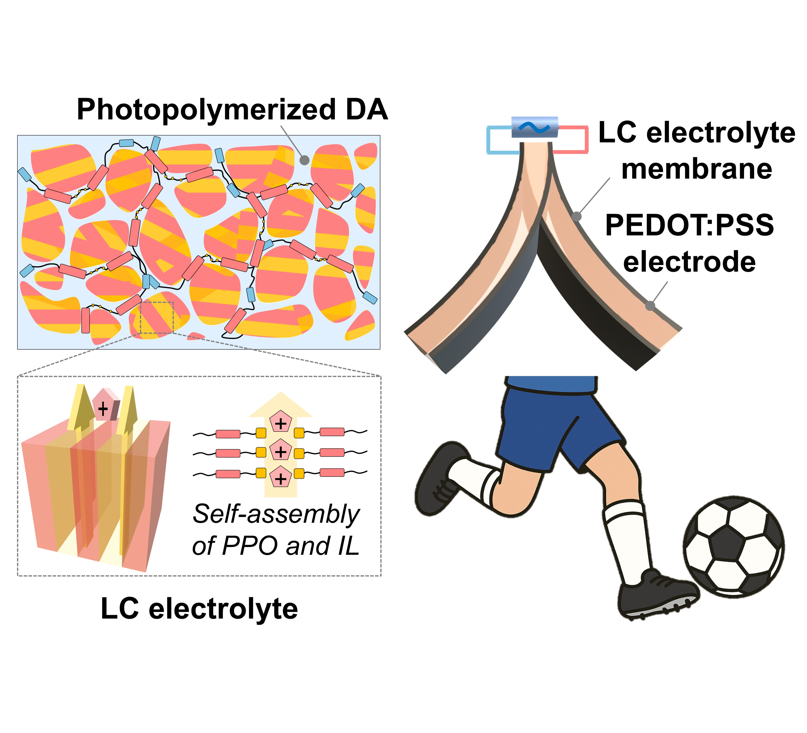
A flexible liquid-crystalline electrolyte membrane via in-situ photopolymerization of a phosphate-functionalized mesogen, ionic liquid, and diacrylate monomer is developed. The resulting SmB-phase structure enables 2D ion transport with high conductivity (10⁻⁴ S cm⁻¹). Integrated actuators exhibit 1.11% strain, 6 μm displacement at 150 Hz, and superior durability, offering a promising strategy for advanced soft robotics.

