Conversion of the (001) strontium titanate surface to titanium monoxide via ultrafast high-temperature sintering

Keita Ihara¹, Toshiki Sato¹, Tomoharu Tokunaga¹, Shunsuke Kobayashi^{1,} ², Kiyoshi Kobayashi, Takahisa Yamamoto¹ *

¹Department of Materials Design Innovation Engineering, Nagoya University, Furo-cho, Chikusa-ku, Nagoya, Aichi 464-8603, Japan
²Nanostructures Research Laboratory, Japan Fine Ceramics Center, 2-4-1 Mutsuno, Atsuta-ku, Nagoya, Aichi 456-8587, Japan

* Corresponding author: yamamoto.takahisa@material.nagoya-u.ac.jp

Keywords: strontium titanate, surface reconstruction, titanium monoxide, ultrafast high-temperature sintering, electrical conductance

Abstract
The reconstruction of crystal surfaces (the alteration of the surface structure from that of the bulk) is imperative for the development of catalysts and energy-related materials. In this study, ultrafast high-temperature sintering (UHS) was employed to rapidly heat and reconstruct a model surface, namely the (001) surface of a SrTiO₃ single crystal. The structural changes were investigated by X-ray diffraction, scanning transmission electron microscopy, and electron energy-loss spectroscopy. Following treatment at 1650 °C for 180 s using UHS, a gold-colored transformation was observed on the surface; however, this was not the case after treatment at 1550 °C. Microscopic and spectroscopic analysis have revealed that the gold-colored surface layer possesses a thickness of approximately 100 nm, predominantly comprising rock salt-type cubic TiO. Furthermore, the electrical conductivity exhibited by the surface layer was very close to that reported for cubic TiO. The reconstruction mechanism of the (001) surface during UHS treatment was inferred to be similar to the incongruent sublimation of the SrTiO₃ surface that has previously been observed under vacuum at extremely low oxygen partial pressures. In conclusion, UHS has been demonstrated to be a highly efficacious technique for expeditious reconstruction of crystal surfaces, encompassing other metal oxides.
1. Introduction
The chemical activity and electrical properties of crystalline materials are often related to the structure of their surfaces. Therefore, developing methods to reconstruct the crystal surface structure is important for the advancement of catalytic, energy, and environmental materials [1-5]. When oxide crystals are heat-treated at high temperatures, surface reconstruction occurs, thereby modifying the original structure, depending on the heat treatment temperature and oxygen partial pressure [6-11]. To date, numerous studies on surface structuring have been published for the (001) surface of SrTiO₃, a typical example of perovskite oxides, which is the focus of the present study [12-15]. For instance, Szot et al. reported that SrO or SrO-related microcrystals form on the surface after heat treatment at 900 - 1100 °C in air [16,17]. Bachelet et al. showed that a step-terrace structure terminated by SrO atomic layer is formed by heating at 1300 °C in air [18]. These studies suggest that the Sr/Ti atomic ratio of the SrTiO₃ surface becomes Sr-rich upon heating at sufficiently high oxygen partial pressures, irrespective of the differences in the resulting surface structure or morphology. Notably, Sr vacancies have been identified as the dominant point defect in SrTiO₃ at temperatures under approximately 1400 °C in air [19,20]. Under these conditions, Sr exhibits ex-diffusion from the region very close to the surface, creating Sr vacancies there and promoting the formation of Sr-rich structures on the (001) SrTiO₃ surface. This surface structuring mechanism is consistent with a framework based on the point defect chemistry of SrTiO₃ and the heat treatment temperature and oxygen partial pressure [19-21].
Conversely, the formation of titanium oxides is observed in a reducing atmosphere. Szot et al. reported that when heat treatment is performed above 900 °C under low oxygen partial pressures, fine TiO or TiO₂ precipitates appear on the surface [17]. This is not consistent with the surface structure predicted according to the equilibrium point defect chemistry of SrTiO₃ because oxygen-deficient SrTiO₃, expressed as SrTiO_{3-δ}, is expected to form under low oxygen partial pressures [19,20]. Rodenbücher et al. subjected SrTiO₃ to heat treatment under vacuum, utilizing a lower oxygen partial pressure by combining titanium metal powder with SrTiO₃, where the titanium metal powder functioned as a reducing agent [22]. They reported that incongruent sublimation occurs at temperatures above approximately 600 °C, causing strontium to volatilize from the SrTiO₃ surface. In a subsequent study, they created TiO nanowires on the (001) surface of SrTiO₃ single crystals by leveraging incongruent sublimation [23]. These findings also show that the structure generated under non-equilibrium (decomposition) conditions differs from that formed based on the equilibrium point defect chemistry. Overall, performing a high-temperature heat treatment under vacuum represents an attractive approach for reconstructing the surface structure of SrTiO₃ crystals.
In the present study, ultrafast high-temperature sintering (UHS) employing carbon felt as a heat source is utilized to promote rapid surface reconstruction at a low oxygen partial pressure on (001) surfaces of SrTiO₃ single crystals under vacuum conditions. The utilization of carbon felt as a heating medium offers the distinct benefit of markedly reducing the oxygen partial pressure during UHS. Consequently, the prospect of Ti diffusion onto the SrTiO₃ surface is precluded, as titanium metal is not required to function as a reducing agent. Moreover, carbon felt exhibits an exceptionally low heat capacity. This property enables expeditious temperature elevation, thereby facilitating surface reconstruction within a brief temporal span [24-26]. At a sufficiently high processing temperature, it was revealed that a gold-colored layer forms on the (001) surface of SrTiO₃ single crystal, which was characterized herein.

2. Materials and Methods
Samples (approximately 2.5 mm × 2 mm × 0.5 mm) were prepared by machining commercially available SrTiO₃ single crystals (10 mm × 10 mm × 0.5 mm, Shinkosha Co., Ltd.), provided by the manufacturer with a mirror-polished (001) surface. UHS treatment was conducted using a custom apparatus, as presented in Fig. 1 [27].

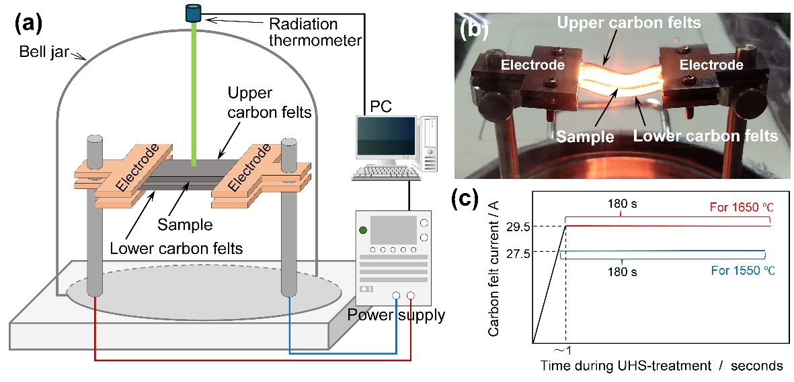
Figure 1. (a) Illustration of the custom UHS apparatus, (b) photograph showing the experimental setup and illuminated carbon felts during UHS, and (c) plot showing the carbon felts currents used during UHS treatment.

Two carbon felts with a size of approximately 2 mm × 20 mm × 90 mm (GF-20-2FSH, Nippon Carbon Corp.) were used as a resistive heater, installed in a vacuum chamber with a base pressure controlled at approximately 10⁻⁴ Pa. The sample was inserted between the upper and lower carbon felts, at the center position between the electrodes (Fig. 1(a) and (b)). The sample was rapidly heated by flowing electric current through both carbon felts, controlled using a direct current power supply (PWR1201ML, Kikusui Electronics Industries, Ltd.). The sample temperature was determined using the finite element method (Autodesk Inventor Professional 2025, Autodesk Inc.), based on the temperature of the upper carbon felt measured using a radiation thermometer (FTKX-TNE0240, Japan Sensor Corp.). The calculation and calibration of the sample temperature are described in our previous report [27]. In the present case, the currents applied to the stacked carbon felts were set at 27.5 A and 29.5 A, corresponding to sample temperatures of approximately 1550 °C and 1650 °C, respectively. The currents were raised to the set value within approximately 1 s and held for 180 s (Fig. 1(c)). After UHS treatment, the surface microstructure, composition, constituent phases, and valences of titanium were analyzed by X-ray diffraction (XRD; D2 PHASER, Bruker Corp.) using Cu Kα-line radiation, scanning transmission electron microscopy (STEM, ARM-200FC, JEOL, Tokyo, Japan), and electron energy-loss (EEL) spectroscopy using an imaging filter system (Quantum ER, Gatan, Pleasanton, CA, US), installed in the STEM. The cross-section of the sample surface for STEM and EEL analysis was prepared by a focused ion beam (FIB, MI4000L, Hitachi High-Tech Corp.). Furthermore, the electrical conductance of the UHS-treated sample was measured using a two-probe method under a direct current electric field at room temperature, utilizing tungsten probes (AX-LP5-TS02, Axis Co., Ltd.) connected to a potentiostat (VSP-300, Bio-Logic Science Instruments Ltd.). The temperature dependence of the electrical conductance was measured between 20 K and 300 K in a helium cryostat connected to a current source (Model 220, Tektronix Inc.) and an electrometer (Model 6517A, Tektronix Inc.) by the four-terminal method, where faced and pointed electrodes were created on both longitudinal end sides and surfaces using platinum paste. The spacing between two current terminals was approximately 430 µm.

3. Results and Discussion
Fig. 2 shows optical micrographs of the UHS-treated sample surfaces. Note that the surface of the sample processed at 1650 °C exhibits gold coloration and a streaky pattern (Figs. 2(a) and (b)), whereas the sample processed at 1550 °C exhibits dark gray coloration and a smoother surface (Figs. 2(c) and (d)). The dark gray coloration observed at 1550 °C corresponds to reduced SrTiO₃ due to the incorporation of oxygen vacancies [28]. UHS treatment at 1650 °C significantly alters the surface within 180 s, forming a different structure that exhibits gold coloration.
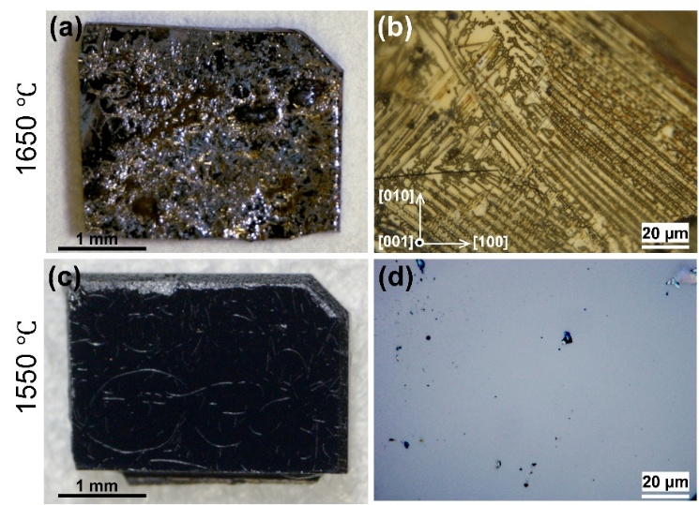
Figure 2. Photographs of samples obtained after UHS treatment at (a), (b) 1650 °C and (c), (d) 1550 °C, for 180 s.

Fig. 3 shows XRD profiles obtained from the surfaces of the samples processed at (a) 1650 °C, and (b) 1550 °C. Diffraction peaks of cubic TiO (a rock salt structure with a lattice constant of 0.417 nm [29]) are observed in the gold-colored surface of the sample processed at 1650 °C, as indicated with red notations, in addition to the diffraction peaks related to the {001} crystallographic orientation of the SrTiO₃ single crystal (Fig. 3(a)). In contrast, no diffraction peaks of cubic TiO are observed in the dark gay-colored surface of the sample processed at 1550 °C (Fig. 3(b)).
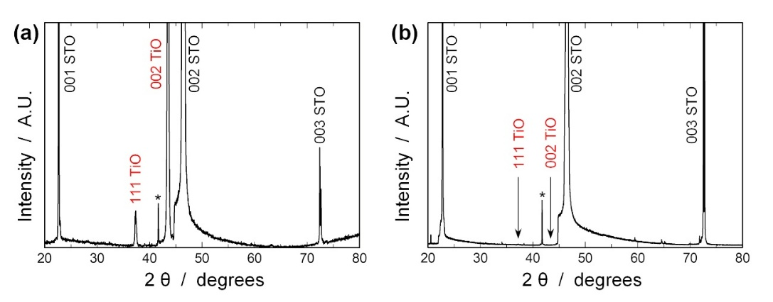
Figure 3. XRD profiles obtained from the surfaces UHS-treated at (a) 1650 °C and (b) 1550 °C, for 180 s. The peak marked with an asterisk is probably a diffraction peak from TiC.

Fig. 4 shows the microstructural analysis results performed for the sample processed at 1650 °C, whose surface exhibits gold-coloration. Fig. 4(a) is high angle annular dark field (HAADF)-STEM image of the cross-section including the gold-colored surface area, Figs. 4(b) and (c) are selected area diffraction (SAD) patterns, and Figs. 4(d) and (e) are Ti L₂₃-edges, which are taken from the areas indicated with A and B in Fig. 4(a), respectively. Two areas with different contrasts, dark and light gray, are observed in HAADF-STEM image (Fig. 4(a)), in which the gold-colored surface region in the optical microscope image corresponds to the dark gray region in the HAADF-STEM image. This region is formed as a layer approximately 100 nm thick on the surface with a portion extending into the crystal interior. The streaky pattern observed in the optical microscope image (Fig. 2(b)) corresponds to the concave structure in Fig. 4(a). The SAD pattern (Fig. 4(b)) obtained from the gold-colored region (dark gray region in Fig. 4(a)) was identified as cubic TiO (a rock salt structure with a lattice constant of 0.417 nm [29]). This result is consistent with the XRD measurement results shown in Fig. 3(a). Furthermore, as shown in Fig. 4(d), the Ti L₂₃ electron energy-loss near-edge structure (ELNES) (red line) obtained from the gold-colored region (dark gray region in Fig. 4(a)) is consistent with the Ti L₂₃ ELNES (blue line) obtained from cubic TiO in the oxide film on the surface of hydride-dehydride Ti powders reported by Q. Tao et al. [30]. The gold-colored region can be considered to be cubic TiO, as also shown in the XRD measurement results in Fig. 3. This is consistent with the gold coloration of cubic TiO reported by M.D. Banus et al [31].
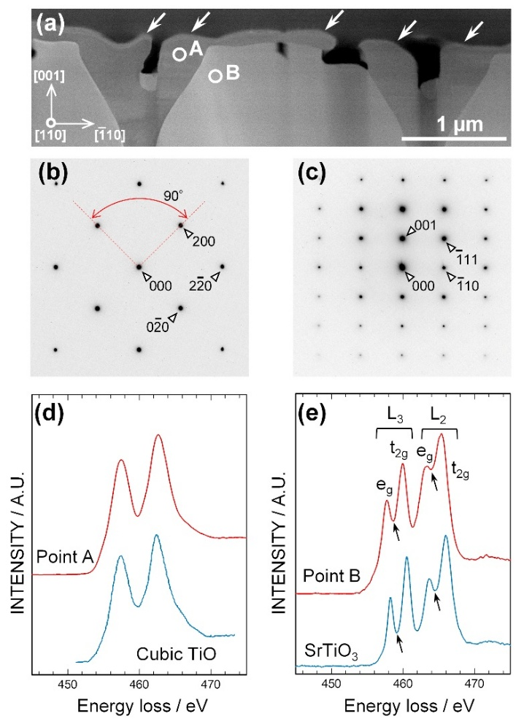
Figure 4. (a) HAADF-STEM image taken from the cross-section of the UHS-treated surface at 1650 °C for 180 s. SAD patterns taken from the areas at (b) A and (c) B indicated in (a). Ti L₂₃ ELNES colored with red taken from the areas at (d) A and (e) B indicated in (a). The Ti L₂₃ ELNES colored with blue in (d) and (e) are reference ELNES for cubic TiO [30] and SrTiO₃ [33], respectively.
On the other hand, the regions outside the cubic TiO region were confirmed to be reduced SrTiO₃ (Figs. 4(c) and (e)). The SAD pattern (Fig. 4(c)) obtained from the light gray contrast region was identified as slightly expanded SrTiO₃, whose lattice constant is approximately 0.3910 nm, slightly larger than the lattice constant of SrTiO₃, 0.3903⁷ nm, reported by M. Onoda et al. [32]. Fig. 4(e) compares Ti L₂₃ ELNES from the light gray contrast region with that from SrTiO₃ sintered at 1300 °C in air [33]. The intensity at a base between e_{g} and t_{2g} peaks, which constitutes the Ti L₂ and L₃-edges, is increased in the light gray contrast region as indicated by the arrows. This is due to the weakness of the crystal field splitting (e_{g}/t_{2g} splitting) between Ti and O, which is caused by the formation of oxygen vacancies [33-35].
Fig. 5 shows the current-voltage characteristics obtained at room temperature (Figs. 5(b-c)), taken from the sample processed at 1650 °C. For the measurement, the sample was polished at a slight inclination, as illustrated in Fig. 5(a), to expose the boundary between the gold-colored surface region and the underlying SrTiO₃. The current-voltage characteristics were measured separately for the two regions near the boundary using tungsten probes with a spacing of 57 µm. As shown in Fig. 5(b), the SrTiO₃ surface exhibits Schottky characteristics, which is attributed to the reduction that occurs during UHS treatment, converting the insulator to n-type SrTiO_{3-δ} [36]. In contrast, as shown in Fig. 5(c), the gold-colored region exhibits very close to linear characteristics, demonstrating metallic contact with the tungsten probes. Furthermore, the current-voltage characteristics were taken from a platinum surface (blue line in Fig. 5(c)) using the same tungsten probe spacing, revealing that the room-temperature electrical conductance of the gold-colored region was approximately 40 % that of platinum.
Fig. 5(d) shows the temperature dependence of the electrical conductance measured by the four-terminal method using electrodes formed with platinum paste. The electrical conductance slightly increases with decreasing temperature from 300 K to 20 K, which indicates metallic behavior. Fig. 5(e) shows the reported temperature dependence of the electrical conductivity for the magnéli phases (i.e., Ti_{n}O_{2n-1}, n = 4 ~ 9) [37] and cubic and monoclinic TiO [31], where those of TiO with different O/Ti atomic ratios are shown [38]. The electrical conductivity of the Ti_{n}O_{2n-1} series is greatly reduced with a decrease in temperature down to approximately 80 K. The steep decrease in the electrical conductivity observed in Ti₄O₇, Ti₅O₉ and Ti₆O₁₁ is due to the semiconductor-semiconductor or metal-semiconductor transition [37,39]. Conversely, the electrical conductivities of monoclinic and cubic TiO change continuously down to approximately 70 K [31,40]. The temperature dependence of the electrical conductance for the gold-colored surface obtained in the present work exhibits the temperature dependence of the electrical conductance approximately between those of monoclinic TiO and cubic TiO.
As described so far, it was confirmed that the SrTiO₃ (001) surface can be converted to gold-colored TiO by performing UHS treatment at 1650°C for 180 s. The converted (001) surface layer showed diffraction peaks that could be identified as cubic TiO in the XRD measurement (Fig. 3(c)) and SAD pattern (Fig. 4(b)). Furthermore, the Ti L₂₃-edge ELNES shown in Fig. 4(d) is also consistent with that previously reported in cubic TiO. From these facts, it can be concluded that cubic TiO was formed on the (001) surface of SrTiO₃ single crystal after UHS treatment at 1650 °C. In contrast, the temperature dependence of electrical conductance, as shown in Fig. 5(d), showed a slight increase with decreasing temperature. This temperature

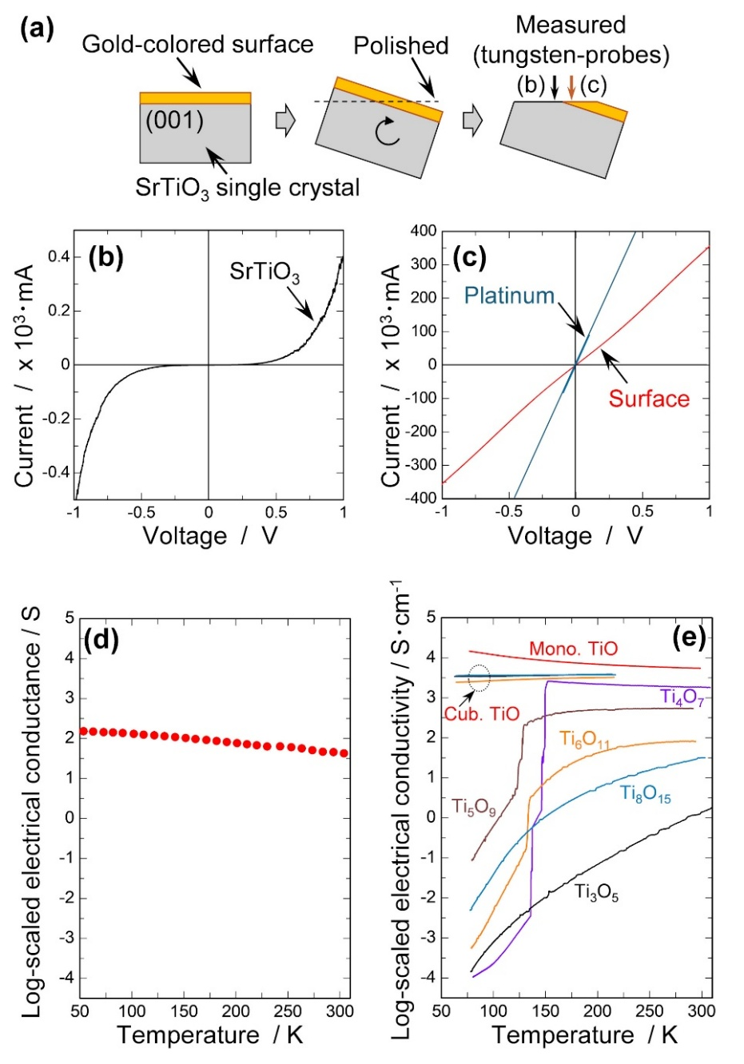
Figure 5. (a) Illustration of the sample preparation conducted for the current-voltage measurements. Current-voltage properties obtained at room temperature for (b) SrTiO₃, (c) gold-colored (red line), and platinum (blue line) surfaces. (d) Temperature dependence of the electrical conductivity for the gold-colored surface obtained by the terminal method. (e) Temperature dependence of the electrical conductivity for previously reported titanium oxide samples [31, 37].
dependence of electrical conductivity corresponds to the characteristics between monoclinic TiO and cubic TiO. Considering the results in Figs. 3 and 4, it can be inferred that the compound formed on the SrTiO₃ surface after UHS treatment at 1650°C has a basic frame of cubic TiO, with a slight variation in the Ti/O ratio.
The incongruent sublimation of SrTiO₃, which occurs in a vacuum with an extremely low oxygen partial pressure [22], can be considered an effective method for modifying the surface structure of SrTiO₃ by heat treatment alone. In addition, UHS treatment can enable us to cause the surface reconstruction due to the incongruent sublimation in a very short duration. It is possible that this phenomenon may occur in other oxides as well, including materials with a perovskite structure containing alkaline earth ions, as pointed out by Rodenbücher et al [22]. The heat treatment method using UHS treatment under low oxygen partial pressure is expected to be one of the new methods for modifying oxide crystal surfaces using incongruent sublimation of the surface.

4. Conclusions
We performed UHS treatment on the (001) surface of SrTiO₃ single crystals and investigated the resulting surface structure and electrical properties. The conclusions are summarized as follows.
- The (001) surface of the SrTiO₃ single crystal exhibited gold coloration after UHS treatment at 1650 °C in a vacuum for 180 s, indicating the formation of a surface structure that differed from the bulk.
- Diffraction peaks assigned to cubic TiO appeared in the XRD profile of the (001) surface of the SrTiO₃ single crystal after UHS treatment at 1650 °C in a vacuum for 180 s. STEM observation performed for a cross-section of the surface revealed the formation of a thin layer with a thickness of 100 nm. SAD pattern assigned the gold-colored region as cubic TiO. Ti L₂₃-egde obtained from EEL analysis showed similar fine structure to that of previously reported cubic TiO. Moreover, the electrical properties of the surface layer exhibited metallic conductance. Considering these findings, the gold-colored layer on the SrTiO₃ (001) surface after UHS treatment at 1650 °C is expected to be cubic TiO, which is consistent with previous reports that cubic TiO exhibits gold-coloration.
- The formation of cubic TiO on the (001) surface of SrTiO₃ single crystals could be considered to result from incongruent sublimation [22]. Under the appropriate annealing conditions, this method may be favorable for rapidly structuring other oxide crystallized and/or layered surfaces using high temperatures and vacuum.

Acknowledgments
This study was financially supported by JSPS KAKENHI (Grant Number 24K01156) and CREST (JPMJCR1996) from the Japan Science and Technology Agency (JST). A part of this study was supported by Advanced Research Infrastructure for Materials and Nanotechnology in Japan (ARIM) of the Ministry of Education, Culture, Sports, Science and Technology (MEXT).

References
[1] Y. Zeng, M. Zhao, Z. Huang, W. Zhu, J. Zheng, Q. Jiang, Z. Wang, H. Liang, Surface reconstruction of water splitting electrocatalysts, Adv. Energy Mater., 12 (2022) 2201713. https://doi.org/10.1002/aenm.202201713.
[2] U. Diebold, The surface science of titanium dioxide, Surf. Sci., 48 (2003) 53-229. https://doi.org/10.1016/S0167-5729(02)00100-0.
[3] H. Huang, H. Song, J. Kou, C. Lu, J. Ye, Atomic-level insights into surface engineering of semiconductors for photocatalytic CO₂ reduction, J. Ener. Chem., 67 (2022) 309–341. https://doi.org/10.1016/j.jechem.2021.10.015.
[4] T. Seyller, Electronic properties of SiC surfaces and interfaces: some fundamental and technological aspects, Appl. Phys. A, 85 (2006) 371–385. https://doi.org/10.1007/s00339-006-3690-1.
[5] P. Chen, Y. Tong, C. Wu, Y. Xie, Surface/interfacial engineering of inorganic low-dimensional electrode materials for electrocatalysis, Acc. Chem. Res., 51 (2018) 51, 2857−2866. https://doi.org/10.1021/acs.accounts.8b00266.
[6] M. Li, W. Hebenstreit, U. Diebold, Morphology change of oxygen-restructured TiO₂ (110) surfaces by UHV annealing: Formation of a low-temperature (1 x 2) structure, Phys. Rev. B, 61 (2000) 4926 – 4933. https://doi.org/10.1103/PhysRevB.61.4926.
[7] G.S. Parkinson, Iron oxide surfaces, Surf. Sci. Rep., 71 (2016) 272–365. https://doi.org/10.1016/j.surfrep.2016.02.001.
[8] J.E. Kleibeuker, G. Koster, W. Siemons, D. Dubbink, B. Kuiper, J.L. Blok, C.-H. Yang, J. Ravichandran, R. Ramesh, J.E. ten Elshof, D.H.A. Blank, G. Rijnders, Atomically defined rare-earth scandate crystal surfaces, Adv. Funct. Mater., 20 (2010) 3490–3496, http://dx.doi.org/10.1002/adfm.201000889.
[9] M. Gillet, C. Lemire, E. Gillet, K. Aguir, The role of surface oxygen vacancies upon WO₃ conductivity, Surf. Sci., 532–535 (2003) 519–525. https://doi.org/10.1016/S0039-6028(03)00477-1.
[10] S. Venkataiah, S.V. J. Chandra, U. Chalapathi, Ch.V.V. Ramana, S. Uthanna, Oxygen partial pressure influenced stoichiometry, structural, electrical, and optical properties of DC reactive sputtered hafnium oxide films, Surf. Inter. Anal., 53 (2021) 206–214. https://doi.org/10.1002/sia.6902.
[11] Y. Tokuda, T. Irimoto, N. Nishikawa, Y. Katsuyama, S. Kobayashi, T. Tokunaga, T. Yamamoto, Direct determination of a topmost atomic layer of (100) surfaces on (La_{0.3}Sr_{0.7})(Al_{0.65}Ta_{0.35})O₃ single crystals annealed in air by high-resolution scanning transmission electron microscopy, Surf. Interface Anal., 54 (2022) 212–217. https://doi.org/10.1002/sia.7043.
[12] A. Biswas, P.B. Rossen, J. Ravichandran, Y.-H. Chu, Y.-W. Lee, C.-H. Yang, R. Ramesh, Y.H. Jeong, Selective A- or B-site single termination on surfaces of layered oxide SrLaAlO₄, Appl. Phys. Lett., 102 (2013) 051603. http://dx.doi.org/10.1063/1.4790575.
[13] D. S. Deak, Strontium titanate surfaces, Mater. Sci. Technol., 23 (2007) 127-136. https://doi.org/10.1179/174328407X154383.
[14] J. Wang, M. Fu, X.S. Wu, D. Bai, Surface structure of strontium titanate, J. Appl. Phys., 105 (2009) 083526. https://doi.org/10.1063/1.3106615.
[15] Y. Katsuyama, S. Kayukawa, T. Tokunaga, S. Kobayashi, S. Hidaka, A. Nakamura, T. Yamamoto, Variation of (001) surface structures of strontium titanate single crystals caused by flash event under direct/alternative current electric fields, Ceram. Inter., 50 (2024) 37366-37372. https://doi.org/10.1016/j.ceramint.2024.05.055.
[16] K. Szot, W. Speier, U. Breuer, R. Meyer, J. Szade, R. Waser, Formation of micro-crystals on the (100) surface of SrTiO₃ at elevated temperatures, Surf. Sci., 460 (2000) 122-128. https://doi.org/10.1016/S0039-6028(00)00522-7.
[17] K. Szot, W. Speier, Surfaces of reduced and oxidized SrTiO₃ from atomic force microscopy, Phys. Rev. B, 60 (1999) 5909-5926. https://doi.org/10.1103/PhysRevB.60.5909.
[18] R. Bachelet, F. Sánchez, F. J. Palomares, C. Ocal, J. Fontcuberta, Atomically flat SrO-terminated SrTiO₃ (001) substrate, Appl. Phys. Lett., 95 (2009) 141915. https://doi.org/10.1063/1.3240869.
[19] R. Moos, K.H. Hardtl, Defect chemistry of donor-doped and undoped strontium titanate ceramics between 1000 °C and 1400 °C, J. Am. Ceram. Soc., 80 (1997) 2549–2562. https://doi.org/10.1111/j.1151-2916.1997.tb03157.x.
[20] C. Rodenbücher, C. Korte, T. Schmitz-Kempen, S. Bette, K. Szot, A physical method for investigating defect chemistry in solid metal oxides. APL Mater., 9 (2021) 011106. https://doi.org/10.1063/5.0033891.
[21] T. Mizoguchi, Y. Sato, J. P. Buban, K. Matsunaga, T. Yamamoto, Y. Ikuhara, Sr vacancy segregation by heat treatment at SrTiO₃ grain boundary, Appl. Phys. Lett., 87 (2005) 241920 (2005). https://doi.org/10.1063/1.2146051.
[22] C. Rodenbücher, P. Meuffels W. Speier, M. Ermrich, D. Wrana, F. Krok, K. Szot, Stability and decomposition of perovskite-type titanates upon high-temperature reduction, Phys. Status Solidi RRL, 11 (2017) 1700222. https://doi.org/10.1002/pssr.201700222.
[23] D. Wrana, C. Rodenbücher, B.R. Jany, O. Kryshtal, G. Cempura, A. Kruk, P. Indyka, K. Szot, F. Krok, A bottom-up process of self-formation of highly conductive titanium oxide (TiO) nanowires on reduced SrTiO₃, Nanoscale, 11 (2019) 89-97. https://doi.org/10.1039/c8nr04545c.
[24] C. Wang, et al., A general method to synthesize and sinter bulk ceramics in seconds, Science, 368 (2020) 521–526. https://doi.org/10.1126/science.aaz7681.
[25] M. Kermani, C. Hu, S. Grasso, From pit fire to ultrafast high-temperature sintering (UHS): A review on ultrarapid consolidation, Ceram. Inter., 49 (2023) 4017–4029. https://doi.org/10.1016/j.ceramint.2022.11.091.
[26] R. Murakami, B. Feng, K. Matsui, S. Kondo, N. Shibata, Y. Ikuhara, Fabrication of 3YSZ with single tetragonal phase by ultrafast high-temperature sintering, Ceram. Inter., 50 (2024) 37308–37313. https://doi.org/10.1016/j.ceramint.2024.04.118.
[27] T. Sato, A. Kodaira, T. Tokunaga, K. Morita, T. Yamamoto, Healing behavior of microcracks on the surface of yttria-stabilized polycrystals using an ultrafast high-temperature sintering method, Ceram. Inter., 51 (2025) 4178-4184. https://doi.org/10.1016/j.ceramint.2024.11.394.
[28] T. Hoshina, R. Sase, J. Nishiyama, H. Takaeda, T. Tdurumi, Effect of oxygen vacancies on intrinsic dielectric permittivity of strontium titanate ceramics, J. Ceram. Soc. Jpn., 126 (2018) 263-268. https://doi.org/10.2109/jcersj2.17250.
[29] M.E. Straumanis, Absorption correction in precision determination of lattice parameters, J. Appl. Phys., 30 (1959) 1965 – 1969. https://doi.org/10.1063/1.1735098.
[30] Q. Tao, W. Ding, G. Chen, X. Qu, M. Qin, Towards an atomic-scale understanding of oxide film in the Ti powder surface, Scr. Mater., 210 (2022) 114471. https://doi.org/10.1016/j.scriptamat.2021.114471.
[31] M.D. Banus, T.B. Reed, A.J. Strauss, Electrical and magnetic properties of TiO and VO, Phys. Rev. B, 5 (1972) 2775-2784. https://doi.org/10.1103/PhysRevB.5.2775.
[32] M. Onoda, S. Tsukahara, The upper limit of thermoelectric power factors in the metal–band-insulator crossover of the perovskite-type oxygen deficient system SrTiO_{3−δ/2}, J. Phys. Condens. Matter, 23 (2011) 045604. https://doi:10.1088/0953-8984/23/4/045604.
[33] M. Seko, S. Inagaki, T. Tokunaga, S. Kobayashi, A. Nakamura, T. Yamamoto, Applying an alternating current to strontium titanate minimizes the change, J. Euro. Ceram. Soc., 44 (2024) 2965-2971. https://doi.org/10.1016/j.jeurceramsoc.2023.12.046.
[34] Y. Li , Q. Wang, M. An, K. Li , N. Wehbe, Q. Zhang, S. Dong, T. Wu, Nanoscale chemical and valence evolution at the metal/oxide interface: a case study of Ti/SrTiO₃, Adv. Mater. Interfaces, 3 (2016) 1600201. https://doi.org/10.1002/admi.201600201.
[35] A. Ohtomo, D.A. Muller, J.L. Grazul, H. Hwang, Epitaxial growth and electronic structure of LaTiOx films, Appl. Phys. Lett. 80 (2002) 3922–3925, https://doi.org/10.1063/1.1481767.
[36] W. Jiang, M. Noman, Y.M. Liu, J.A. Bain, P.A. Salvador, M. Skowronski, Mobility of oxygen vacancy in SrTiO₃ and its implications for oxygen-migration-based resistance switching, J. Appl. Phys., 110 (2011) 034509. https://doi.org/10.1063/1.3622623.
[37] R. F. Bartholomew, Electrical properties of some titanium oxides, Phys. Rev., 187 (1969) 828-833. https://doi.org/10.1103/PhysRev.187.828.
[38] M. Cancarevic, M. Zinkevich, F. Aldinger, Thermodynamic description of the Ti–O system using the associate model for the liquid phase, computer coupling of phase diagrams and thermochemistry, 31 (2007) 330–342. https://doi.org/10.1016/j.calphad.2007.01.009.
[39] A.D. Inglis, Y. L. Page, P. Strobel, C.M. Hurd, Electrical conductance of crystalline Ti_{n}O_{2n-1} for n=4-9, J. Phys. C: Solid State Phys., 16 (1983) 317-333. https://doi.org/10.1088/0022-3719/16/2/015.
[40] Y. Fan, C. Zhang, X. Liu, Y. Lin, G. Gao, C. Ma, Y. Yin, X. Li, Structure and transport properties of titanium oxide (Ti₂O, TiO_{1+δ}, and Ti₃O₅) thin films, J. Alloy. Comp., 786 (2019) 607-613. https://doi.org/10.1016/J.JALLCOM.2019.01.381.

Graphic Abstract

