A weak-solvation strategy for modulating Li ion solvation sheath to enable fast-charging Li-ion batteries
Yiyi Zheng^{a,} †, Jiapei Li ^{b, c,} †, Tian Zhang^{b, c,} †, Qiaohui Duanª, Shuyu Dongª, Zhiqiang Guan^{c,d}, Dewu Lin^{e}, Wenjun Zhang^{b,c}, Denis Y. W. Yu^{f}*

ª School of Energy and Environment, City University of Hong Kong, Tat Chee Ave, Kowloon, Hong Kong, China.
^{b} Center of Super-Diamond and Advanced Films (COSDAF), City University of Hong Kong, Tat Chee Ave, Kowloon, Hong Kong, China.
^{c} Department of Materials Science and Engineering, City University of Hong Kong, Tat Chee Ave, Kowloon, Hong Kong, China.
^{d} Department of Chemistry, City University of Hong Kong, Tat Chee Ave, Kowloon, Hong Kong, China.
^{e} State Key Laboratory of Advanced Waterproof Materials, School of Advanced Materials, Peking University, Shenzhen Graduate School, Shenzhen, China.
^{f} Research Center for Energy and Environmental Materials (GREEN), National Institute for Materials Science, Tsukuba, Ibaraki 305-0044, Japan.
* corresponding author: yu.denis@nims.go.jp
† These authors contributed equally to this work.

Abstract: Graphite is the common anode material used in lithium-ion batteries (LIBs). However, they show poor kinetics in traditional carbonate-based electrolytes, which limits the fast-charging performance of the corresponding LIBs. Here, a weak-solvation strategy is introduced to modulate the local environment around the Li ions and the electrode/electrolyte interfacial chemistry to facilitate Li⁺ transport. Specifically, the study finds the use of methyl acetate (MA) as a co-solvent with lithium bis(fluorosulfonyl)imide (LiFSI) salt and ethyl methyl carbonate (EMC) can weaken the interactions of Li⁺ with the solvent molecules, generating a LiF-rich solid electrolyte interphase on the graphite anode, thereby improving its fast-charging performance. In addition, the desolvation energy of Li⁺ is further reduced by fluorinating EMC (FEMC), owing to the strong electron-withdrawing effect of fluorine. With a 1 M LiFSI FEMC/MA (1:1, v) + 10 wt% fluorinated ethylene carbonate electrolyte, graphite anode shows a lithiation capacity of about 230 mAh g⁻¹ at 1488 mA g⁻¹ (4 C_{graphite} rate), significantly higher than that obtained in a LiPF₆-based conventional electrolyte. The weakly-solvating electrolyte with LiFSI, FEMC and MA is also compatible with LiFePO₄ cathodes, where a LiFePO₄ | graphite full cell can be cycled even at a charging rate of 4.5 C_{fullcell}.
Keywords: lithium-ion battery; graphite anode; solvation structure; weakly-solvating electrolyte; fast-charging performance.

Introduction
In recent years, the rapid development of electric vehicles has significantly accelerated the research on fast-charging of lithium-ion batteries (LIBs). So far, the rate performance of commercial LIBs is mainly limited by the large barrier to remove Li ions from the electrolyte (desolvation energy), the high resistance at the electrode/electrolyte interfaces and the slow acceptance of Li ions into the graphite anode. They are affected by the solvation structure of the electrolyte and governed by the interactions among the Li ions, solvent molecules and anions in it. Thus one of the strategies to improve fast-charging capability of LIBs lies in optimizing the electrolyte systems to enhance Li⁺ transport kinetics and control the graphite/electrolyte interfacial reactions.^{[1, 2]}
Specifically, depending on how the Li ions are coordinated with the solvent molecules and the anions, the solvation structure of Li⁺ in an electrolyte is divided into three components: solvent-separated ion pairs (SSIP), contact ion pairs (CIP), and aggregates (AGG).^{[3]} The amount of each component in an electrolyte is determined by the type of solvents and salts used, and the concentration of the salt. Changing the Li ion solvation structure will not only change the physical properties such as ionic conductivity, viscosity and desolvation energy of the electrolyte but also have large effect on the composition of the solid electrolyte interphase (SEI) formed, as SEI is a reaction product between the electrolyte and the surface of the active materials. In particular, the primary solvation sheath of Li ion is proposed to serve as an SEI precursor where the solvents within it dominate the interfacial chemistry.^{[4]}
Conventional LIB electrolytes contain mainly SSIP, as Li ions are typically coordinated with strongly-solvating solvents while anions in the electrolyte are bystanders and do not participate in the solvation structure. To tailor the solvation environment, several new electrolyte systems are proposed in recent years. For example, high-concentration electrolytes (HCEs) and localized high-concentration electrolytes (LHCEs) increase the salt concentration to enhance anion participation in the solvation sheath, thereby promoting the formation of CIP/AGG structures and improving the rate performance of graphite electrodes.^{[5, 6]} However, increasing salt concentration often leads to increased viscosity, poor wettability of the separator and electrodes and higher cost, which are not favorable for large-scale applications.
In contrast, weakly-solvating electrolytes (WSE) are based on the use of solvents with reduced solvating ability to weaken the Li⁺-solvent interactions, thereby regulating the Li ion solvation environment. When the coordination strength of solvents decreases, anions can participate in the solvation structure, increasing the fraction of anion-involved structures such as CIP and AGG in the electrolyte. Unlike HCE and LHCE, which primarily rely on increasing salt concentration to modify the solvation structure, WSE can induce similar anion-enriched solvation characteristics even at moderate salt concentrations.^{[7]} To date, most reported WSE systems are based on ether solvents. For example, Zhang et al. constructed a WSE using 1,4-dioxane (1,4-DX) with 1 M lithium bis(fluorosulfonyl)imide (LiFSI), achieving 54% capacity utilization at 4 C for graphite anode.^{[4]} Similarly, Cheng et al. employed 1,3-dioxane (DOL) with LiFSI which enable a capacity of around 350 mAh g⁻¹ at C/5 rate for graphite anode.^{[8]} In comparison, studies on ester-based weakly solvated electrolytes remain relatively limited, and the correlations among solvation structure, interfacial chemistry, and kinetic performance have yet to be systematically elucidated.
In this study, we design a WSE system with LiFSI salt using methyl acetate (MA) and ethyl methyl carbonate (EMC) as the main solvents, as both MA and EMC are chain esters with lower dielectric constants than cyclic carbonates, and their linear molecular configuration reduces the electron density of the carbonyl oxygen, effectively weakening the interaction with Li ions. As fluorine atoms have stronger electron-withdrawing nature than hydrogen, the effect of fluorination on the solvation structure and interfacial chemistry is further explored by replacing EMC with fluorinated EMC (FEMC) in the electrolyte.
The electrolytes are applied to half cells with graphite anode to study how the change in solvation structure influences its fast-charging capability, solid electrolyte interphase (SEI) composition and impedance. Specifically, a 1 M LiFSI FEMC/MA (1:1 v) + 10 wt% fluorinated ethylene carbonate (FEC) electrolyte enables graphite anode to give a reversible capacity of approximately 230 mAh g⁻¹ at a 4 C_{graphite} lithiation rate. The experimental results are correlated with theoretical calculations to validate the effect of the weakly-solvating solvent.

Experimental
Preparation of electrolyte and electrode
The solvents including methyl acetate (MA), ethyl methyl carbonate (EMC), (2,2,2-trifluoroethyl) methyl carbonate (FEMC), fluoroethylene carbonate (FEC), ethylene carbonate (EC) and diethyl carbonate (DEC) were received from Sigma Aldrich. The commercially available Li salts, including LiPF₆, lithium bis(fluorosulfonyl)imide (LiFSI) were ordered from DoDoChem (purity ≥ 99.9%). Electrolytes were prepared in an argon-filled glove box (MBraun) with less than 0.1 ppm O₂ and H₂O levels. The formula of the electrolytes tested in this study are as follows, where the weight percentage of FEC is with respect to the mass of the corresponding electrolytes prior to its addition:
Traditional electrolyte (TE): 1 M LiPF₆ in EC/DEC (1:1, v)
1 M LiFSI EE: 1 M LiFSI in EC/EMC (1:1, v) + 10 wt% FEC
1 M LiPF₆ EM: 1 M LiPF₆ in EMC/MA (1:1, v) + 10 wt% FEC
1 M LiFSI EM: 1 M LiFSI in EMC/MA (1:1, v) + 10 wt% FEC
1 M LiFSI FM: 1 M LiFSI in FEMC/MA (1:1, v) + 10 wt% FEC
The anode was prepared by coating a slurry mixture of 90 wt% graphite (SHANSHAN Advanced Materials Co., Ltd.), 5 wt% carbon black (AB - acetylene black, Alfa Aesar) as the conducting agent and 5 wt% sodium carboxymethyl cellulose (Na-CMC in de-ionized water (Sigma Aldrich-low viscosity)) as the binder on copper foil. After drying at 80 ℃ for 0.5 h and pressed, the electrode was punched into disks with a diameter of 12 mm. The average active mass loading of the electrodes was 1.2 mg cm⁻² with an electrode density of 1.2 g cm⁻³ after pressing.
For full cell fabrication, LiFePO₄ (LFP) electrode and graphite electrode were purchased from Guangdong Canrd New Energy Technology Co., Ltd. The LFP and graphite electrodes were punched into disks with a diameter of 15.8 mm and 16.0 mm, respectively. The average active mass loading of the LFP electrode is 10.5 mg cm⁻² with an electrode density of 1.4 g cm⁻³, whereas that for the graphite electrode is 5.4 mg cm⁻² with an electrode density of 1.1 g cm⁻³. The full cells are cathode-limited with an N/P ratio of around 1.2. Before transferring into an Ar-filled glovebox, all the electrodes were further dried at 150°C for 4 h in vacuum.
Battery assembly
2032-type coin cells were used to evaluate the electrochemical performances of the different electrolytes. The dried graphite electrode was assembled with a piece of separator (Celgard 2500), 120 μL of electrolyte and lithium metal as counter electrode. The cells were rested for 12 h to allow for electrolyte wetting. The full cells were assembled the same way but with LFP as the cathode and graphite as the anode.
Electrochemical measurements
The cycling and rate performances for the half cells were performed on a Neware battery testing system with a voltage range of 0.01-1.5 V at different current densities based on the mass of graphite active material. For cycle performance, the graphite electrodes were tested with a current rate of 0.1 C_{graphite} (1 C_{graphite} = 372 mA g⁻¹) for 3 cycles followed by 4 C_{graphite} discharge/0.2 C_{graphite} charge for subsequent cycles. For rate performance, delithiation rate (defined as charging here) is kept at 0.2 C_{graphite} while the lithiation rate (defined as discharging here) is varied. All the cycle and rate performance tests were conducted under a constant current condition. Electrochemical impedance spectra (EIS) were acquired on a VMP3-potentiostat (Bio-Logic) from 10 mHz to 1 MHz with an AC amplitude of 10 mV at the charge (delithiated) state. All the cells were held at 1.5 V for 1.5 h before EIS test. For temperature dependent EIS test, all the graphite | Li half cells were cycled at 0.1 C_{graphite} for 3 times, and also held at 1.5 V for 1.5 h before testing at 5, 15, 25, 35 and 45 °C.
The voltage range for full cell test is between 2.5-3.8 V, and the current rate is calculated based on the mass of the LFP cathode. Linear sweep voltammetry (LSV) measurement was also carried out using VMP3-potentiostat (Bio-Logic). Carbon-coated aluminum electrodes and lithium metals were used as electrodes for the LSV tests.
Characterizations
For postmortem analyses, the test cells were disassembled in the glovebox and the extracted graphite electrodes were washed with dimethyl carbonate (DMC) solvent in the glovebox to remove the residue salt. X-ray photoelectron spectroscopy (XPS) was performed using Thermo Scientific K-Alpha on the electrodes. Before the XPS test, a vacuum transfer holder was used to transfer the sample. High resolution transmission electron microscopy (HRTEM) was performed using a HRTEM JEOL JEM-2100F. Raman spectra were obtained by using a Raman spectrometer (WITec RAMAN alpha 300R) equipped with a 532 nm laser.
Computation Details
The electrostatic potential (ESP) distributions, binding and desolvation energies were evaluated using density functional theory (DFT) with the Gaussian 16 software package. The Becke, three-parameter, Lee-Yang-Parr (B3LYP) exchange-correlation functional was employed in conjunction with the 6-311++G (d,p) basis set. Molecular dynamics (MD) simulations were conducted to study the coordination number around a Li ion in the electrolyte and also the amount of SSIP, CIP and AGG in the solvation structure. The number of LiFSI, MA, EMC, FEMC and FEC molecules used in the electrolyte models for MD simulations are listed in Table 1.

Table 1. The number of molecules in different electrolytes in the MD models.
Electrolyte | LiFSI | MA | EMC | FEMC | FEC
1 M LiFSI EM (1 M LiFSI in EMC/MA + 10 wt% FEC) | 50 | 315 | 243 | 0 | 54
1 M LiFSI FM (1 M LiFSI in FEMC/MA + 10 wt% FEC) | 50 | 315 | 0 | 207 | 62

The MD simulations employed the Condensed-phase optimized molecular potential for atomistic simulation studies (COMPASS) III force field. Electrostatic interactions were handled via the Ewald summation technique, while van der Waals forces were calculated using an atom-based approach.^{[9]} Simulations proceeded with a two-phase equilibration approach: first, the systems were subjected to NPT (constant number of particles, pressure and temperature) conditions at 298 K for 200 ps to ensure the correct density and structural integrity of the amorphous cell, with a fixed time step of 1.0 fs.^{[10]} Subsequently, the systems were stabilized under NVT (constant number of particles, volume and temperature) conditions for 2000 ps, allowing for the relaxation and equilibration of molecular dynamics.^{[11]} The final 200 ps NVT results were used to analyze the radial distribution function (RDF) and coordination number and to select specific solvation sheath structures for subsequent DFT calculations.

Table 2. The density, molecular weight and dielectric constants of the solvents used in this work.^{[12, 13]}
Solvent | Density (g cm⁻³) | Molecular weight (g mol⁻¹) | Dielectric constant at 25 °C
EC | 1.322 | 88.060 | 89.780 (40 °C)
MA | 0.934 | 74.080 | 6.680
EMC | 1.010 | 104.100 | 2.960
FEMC | 1.308 | 158.080 | 7.270
FEC | 1.410 | 106.050 | 107.000

Results and discussions
Analysis of the solvation structure of the weakly-solvating electrolyte
Li ions interact with solvent molecules in the electrolyte to a certain degree. By changing the solvent, the solvation structure around the Li ions can be adjusted, which in turn affects the migration of Li ions and the corresponding electrochemical performances of the electrodes. Traditionally, ethylene carbonate (EC) is used as a co-solvent in LIB electrolytes because it has a high dielectric constant, increasing the solubility of salt in the electrolyte. However, it also has strong interaction with Li ions and therefore making it more difficult for the ions to desolvate from the electrolyte. To facilitate higher power and faster Li⁺ transport, we propose to replace EC with a “weakly-solvating” solvent that have weaker interaction with Li⁺. In this study, we have chosen to use MA as it has a low dielectric constant of below 10 (see Table 2) and low viscosity. As the other co-solvent, EMC was selected due to its widespread application in LIBs. FEMC, a fluorinated analogue of EMC, is also used to further investigate the influence of molecular structure on electrolyte behavior.
The interaction between the solvents and Li ions can first be studied theoretically by density functional theory (DFT) calculations of the electrostatic potential (ESP) distribution across different regions of a molecule, which allows identification of the coordination sites and the polarity strength of the solvent molecules (Figure 1). For ester-based solvents, the carbonyl oxygen atoms typically possess relatively high electronegativity, and therefore are the sites where Li ions tend to coordinate with. The more negative the ESP value of the carbonyl oxygen is, the stronger its coordination strength with Li⁺ is. As shown in Figure 1a, the carbonyl region of EC has an electrostatic potential of around -0.0592 Ha, the most negative among all the solvents, which indicates that EC has the strongest interaction with Li⁺. While MA, EMC, and FEC exhibit similar electrostatic potential of around -0.0545 to -0.0575 Ha, the electrostatic potential of the carbonyl group of FEMC is the lowest (-0.0424 Ha), likely due to the change in electron distribution induced by the substitution of hydrogen with fluorine atoms, which implies weaker interaction with Li ions.
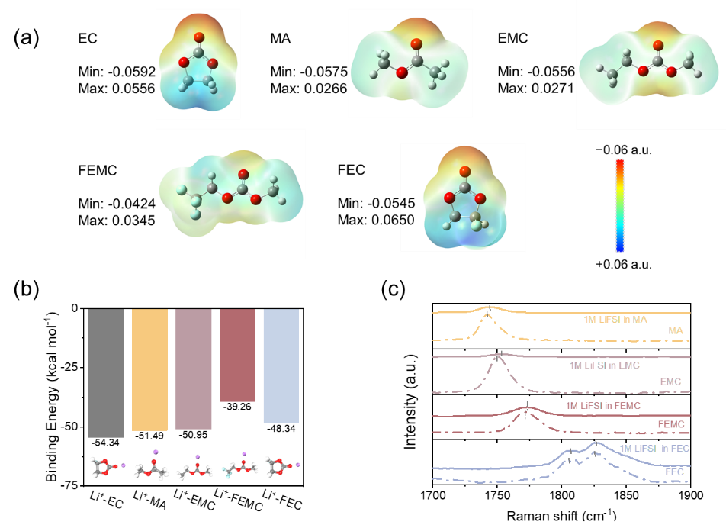
Figure 1. (a) Comparison of molecular structure and ESP of different solvents (white – hydrogen, grey – carbon, red – oxygen, cyan – fluorine). 1 Ha (a.u.) = 27.211 eV; (b) binding energy of Li⁺ to different solvents; (c) Raman spectra of MA, EMC, FEMC, and FEC and those dissolved with 1 M LiFSI.
In addition to ESP maps, the binding energies of different solvent molecules with Li ions can also be calculated by DFT by subtracting the sum of the energies of the individual components from the energy of the complex formed by the Li ion and the solvent molecules. As shown in Figure 1b, the binding energy of Li⁺-EC (-54.34 kcal mol⁻¹) is the most negative, suggesting that it is more difficult to remove Li⁺ from a Li⁺-EC complex. In comparison, the binding energies of Li⁺-EMC and Li⁺-MA are -50.95 and -51.49 kcal mol⁻¹, respectively, which are less negative than EC. This indicates that the interaction between EMC (or MA) and Li ions is weaker than that of EC. It is noteworthy that the binding energy for Li⁺-FEMC is only -39.26 kcal mol⁻¹, which indicates that FEMC is the least likely to bind with Li ions among these solvents, suggesting that replacing EMC with FEMC in the electrolyte can further decrease its interaction with Li ions. This phenomenon, where the fluorination of a solvent weakens its interaction with Li ions, is also observed with EC and FEC, which has a binding energy of -54.34 and -48.34 kcal mol⁻¹, respectively with Li⁺.
In addition to simulation results, the differences in the interaction strength between these solvents and Li ions are also experimentally verified. Figure 1c and Figure S1 compare the Raman spectra of MA, EMC, FEMC and FEC solvents with those dissolved with 1 M LiFSI. The region between 1700 and 1900 cm⁻¹ corresponds to the vibration of C=O stretching of the solvents.^{[14]} Note that two peaks appear in this region for FEC, both corresponding to the C=O stretching vibrations, where the lower-wavenumber peak is associated with tightly packed environments, while the higher-wavenumber peak corresponds to loosely packed ones.^{[15, 16]} In general, a shift of a Raman peak indicates a change in the surrounding environment of the chemical group, for example an interaction between Li ions with the solvent molecule, and the degree of peak shift reflects how strong the interaction is.^{[17]} The peak for 1 M LiFSI in FEMC is at 1773.0 cm⁻¹, which is close to that of FEMC solvent at 1772.3 cm⁻¹. In contrast, the peaks of 1 M LiFSI MA, EMC or FEC all show a positive shift of 2 to 3 cm⁻¹ compared to the respective solvent. From the degree of shift in the Raman peaks (Table 3), it can be inferred that Li ions have similar interaction with MA, EMC and FEC, while the interaction is weaker with FEMC, consistent with the DFT simulation as shown before.
Apart from the C=O stretching vibrations, shift in Raman peaks are also observed around 730 - 740 cm⁻¹, corresponding to the vibration of FSI⁻ (Figure S2), further proving that the solvation structures of the electrolytes are different. In particular, a larger shift is observed for 1 M LiFSI FEMC compared to other electrolytes, indicating that the FEMC solvent leads to more interaction of FSI⁻ in the electrolyte, consistent with the DFT results.

Table 3. The shift of Raman peak between the pristine solvent and the one with 1 M LiFSI.
Solvent | Raman peak position of C=O stretching for 1 M LiFSI in solvent | Raman peak position of C=O stretching for pristine solvent | Raman peak shift / cm⁻¹
MA | 1744.7 | 1741.7 | 3
EMC | 1754.1 | 1751.0 | ~3
FEMC | 1773.0 | 1772.3 | <1
FEC | 1807.9/1827.0 | 1806.0/1825.2 | ~2

Based on the information from the interaction between the solvent molecules and Li⁺, we thus design the following weakly-solvating electrolytes to study their effects on fast-charging performance of graphite anode:
1 M LiFSI EM: 1 M LiFSI in EMC/MA (1:1, v) + 10 wt% FEC
1 M LiFSI FM: 1 M LiFSI in FEMC/MA (1:1, v) + 10 wt% FEC
Common cyclic carbonate such as EC is replaced by MA, while FEC is introduced to enhance the stability of the electrode–electrolyte interface at both the graphite and Li counter electrodes.^{[18]} LiFSI is chosen as the salt because it can enable higher charge capacity with graphite anode in a previous study.^{[19]}
To further understand the Li⁺ solvation structure in the two electrolytes, MD was used to simulate the radial distribution functions (RDF) and Li⁺ coordination numbers. Typical snapshots of the two electrolytes in the MD simulations are shown in Figure 2a and b. In the 1 M LiFSI EM electrolyte, the initial peak that appears at 1.92 Å represents the average distance between the Li ions and the oxygen atoms in EMC (Li⁺-O_{EMC}), followed by the peaks of Li⁺-O_{MA}, Li⁺-O_{FSI-} and Li⁺-O_{FEC} (Figure 2c). In contrast, in the 1 M LiFSI FM electrolyte, the initial peak that appears at 1.98 Å is the peak of Li⁺-O_{MA}, followed by the peaks of Li⁺-O_{FEMC}, Li⁺-O_{FSI-} and Li⁺-O_{FEC} (Figure 2d). This difference suggests that replacing EMC with FEMC results in a significant alteration of the solvation structure within the electrolyte. A distance of 3.5 Å from the Li ions is chosen to determine its coordination number, as it is at the minimum point between the peaks in the RDF profiles where solvent densities are almost zero. As shown in Figure 2e, for the 1 M LiFSI EM electrolyte, the Li⁺ coordination number for EMC and MA is 1.57 and 2.05, respectively. In comparison, for the 1 M LiFSI FM electrolyte, the Li⁺ coordination number for FEMC and MA is 0.91 and 2.71, respectively. The results indicate that when EMC is substituted with FEMC, there are fewer FEMC and more MA molecules in the solvation shell around the Li ion. This suggests that there is less interaction between FEMC and Li⁺ compared with EMC, consistent with the previous Raman data. Note that the coordination number of FEC in both electrolytes is less than 0.3, suggesting that FEC has little contribution to the solvation structure of Li⁺ in the electrolyte, though it helps stabilize the SEI on the graphite, as discussed in a later section.

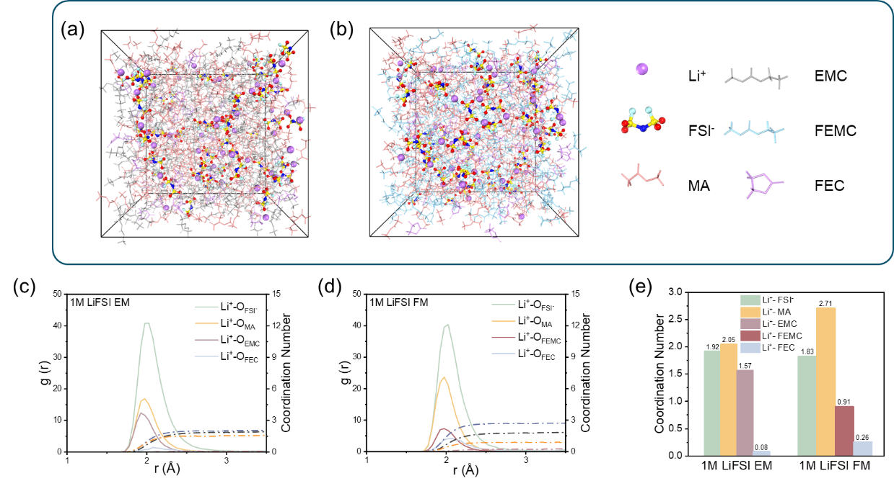
Figure 2. Snapshots of electrolytes intercepted in MD simulations for the (a) 1 M LiFSI EM electrolyte and (b) 1 M LiFSI FM electrolyte; RDF of (c) 1 M LiFSI EM electrolyte, (d) 1 M LiFSI FM electrolyte; (e) Li⁺ coordination number in 1 M LiFSI EM and 1 M LiFSI FM.

Weakly-solvating solvents reduce the affinity between Li ions and solvent molecules, often leading to a shift in the distribution of solvation structures within the electrolyte. The proportion of SSIP, CIP and AGG in an electrolyte can be determined by counting the number of anions within 3.5 Å of each Li ion in the MD simulations. In both electrolytes studied, the proportion of SSIP remains small, at around 3.4-3.5%, indicating more contribution of anions in the solvation structure. The proportion of AGG reaches 68.9% in the 1 M LiFSI FM electrolyte, significantly higher than the 54.0% observed in the 1 M LiFSI EM electrolyte (Figure 3a). This result indicates that more anions exist in the form of AGG in the 1 M LiFSI FM electrolyte. Raman spectroscopy further supports this conclusion (Figure 3b). The peaks in the 700–800 cm⁻¹ region correspond to the S–N–S vibrational mode of FSI⁻.^{[20]} In the 1 M LiFSI FM electrolyte, this peak appears at 741 cm⁻¹, showing a blue shift relative to the 738 cm⁻¹ peak in the 1 M LiFSI EM electrolyte, also indicating a greater tendency of FSI⁻ to form AGG in the 1 M LiFSI FM electrolyte. These findings suggest that MA and FEMC weakens the interaction with Li ion, thereby promoting the formation of larger solvation structures. Moreover, the increased AGG content in the 1 M LiFSI FM electrolyte further confirms that the substitution of EMC with FEMC enhances the weak solvation characteristics of the system.
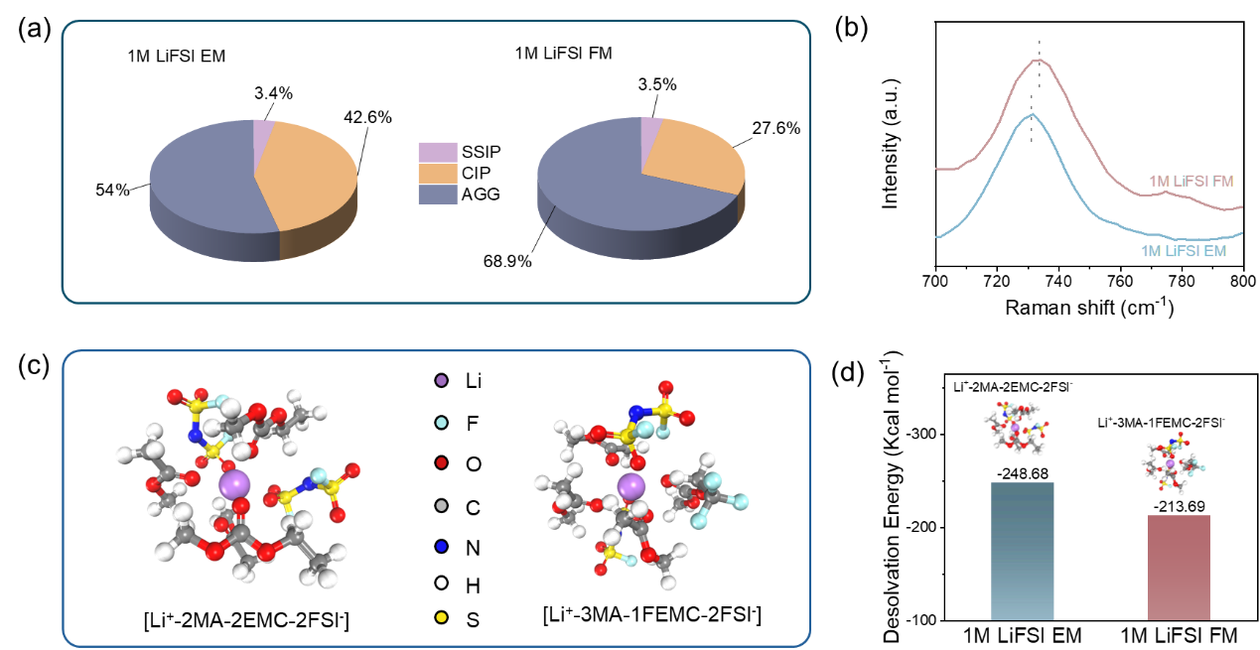
Figure 3. (a) The proportion of different solvation structures in the two electrolytes; (b) Raman spectra of different electrolytes in the range of 700 – 800 cm⁻¹; (c) optimized geometries of Li⁺ - solvent from DFT calculation of 1 M LiFSI EM electrolyte and 1 M LiFSI FM electrolyte; (d) desolvation energy of Li⁺ in the two electrolytes obtained from DFT calculations.

The molecular structure of the solvents and the desolvation energy of Li ions in the first solvation shell can be further calculated using DFT. Among all possible combinations in the 1 M LiFSI EM electrolyte, the results show that the [Li⁺-2MA-2EMC-2FSI⁻] structure is the most energetically favorable (Figure 3c). In comparison, for the 1 M LiFSI FM electrolyte, the [Li⁺-3MA-1FEMC-2FSI⁻] structure is the most energetically favorable (Figure 3c). This indicates that the solvation shell contains more MA molecules in the presence of FEMC, consistent with MD simulations. The energy that is needed to remove the Li⁺ from the structure (desolvation) in the 1 M LiFSI EM and 1 M LiFSI FM electrolyte is 248.68 and 213.69 kcal mol⁻¹, respectively, where the value for 1 M LiFSI FM is about 14% lower (Figure 3d).

Electrochemical performances of graphite anodes
Electrochemical performances of graphite anodes are measured in half cells with Li counter electrodes in the two electrolytes. Figure S3a and b show the 1st discharge-charge curves of the graphite electrodes in 1 M LiFSI EM and 1 M LiFSI FM electrolytes without FEC, which exhibit a prolonged initial plateau at around 0.6 V with an initial Coulombic efficiency (ICE) of only 59.2% and 48.0% (Figure S3c), respectively due to decomposition of MA/EMC/FEMC on the graphite surface. The difference in ICE between 1 M LiFSI EM and 1 M LiFSI FM likely reflects the different reactivity of EMC versus FEMC. The addition of 10 wt% FEC is shown to suppress the initial plateau at 0.6 V and significantly improve the ICE, as FEC promotes the formation of a more stable SEI. This is verified by cyclic voltammetry (CV) measurements where an addition peak at around 1.3 - 1.4 V, corresponding to the reduction of FEC,^{[21]} and an absence of distinct peak at approximately 0.6 V are observed with FEC-containing electrolytes (Figure S4).
To verify the effect of the electrolytes, three control electrolytes are also tested. TE is a common electrolyte used in LIBs. The 1 M LiFSI EE electrolyte is tested to compare the effect of EC and MA, while the 1 M LiPF₆ EM electrolyte is made to study the effect of the salt.
Figure 4, Figure S5 and Figure S6 show the electrochemical performances of graphite half cells in the different electrolytes. As shown in Figure 4a, the cell with TE shows poor rate performance. Starting from 0.5 C_{graphite}, the capacity of the battery using the TE electrolyte is significantly reduced. In contrast, both graphite electrodes in 1 M LiFSI EM and 1 M LiFSI FM electrolytes exhibit excellent fast-charging capabilities. At a Li intercalation rate of 4 C_{graphite}, the graphite electrodes using these two electrolytes demonstrate capacities of around 150 mAh g⁻¹ and 200 mAh g⁻¹, respectively, while the capacities of cells using TE is only around 25 mAh g⁻¹, respectively.
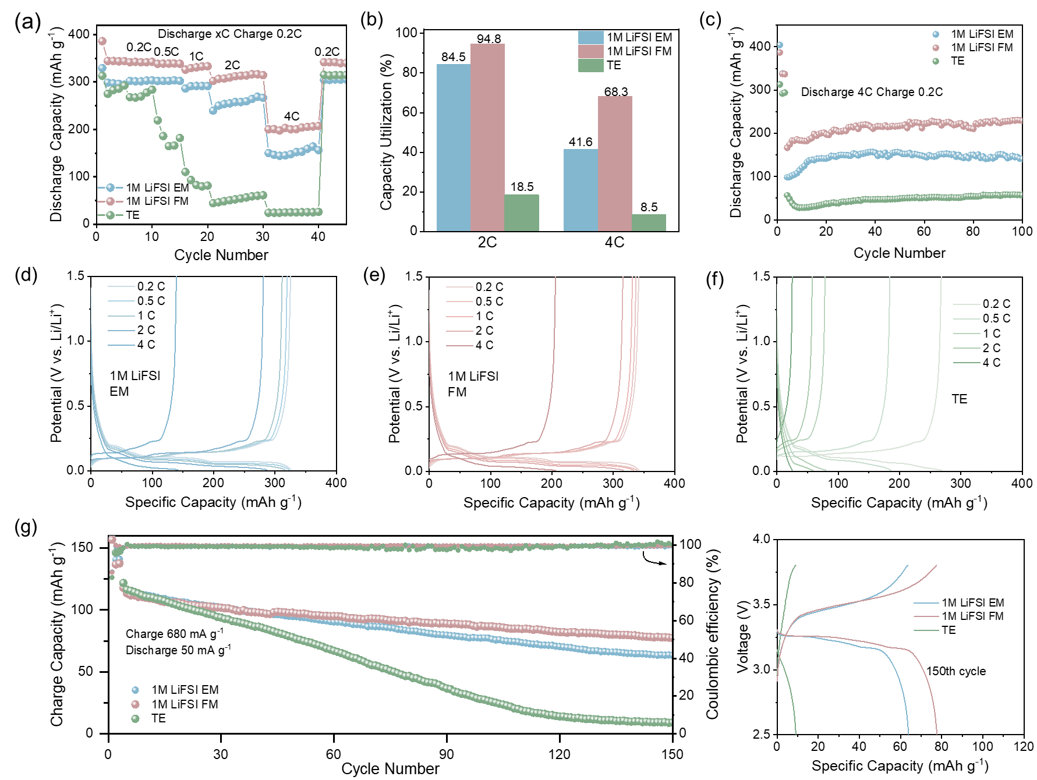
(h)
Figure 4. (a) Rate performances, (b) capacity utilization at 2 C_{graphite} and 4 C_{graphite}, and (c) cycle performances of the graphite electrodes with different electrolytes; corresponding charge-discharge curves of the graphite electrodes at different current rates in (d) 1 M LiFSI EM electrolyte, (e) 1 M LiFSI FM electrolyte and (f) TE electrolyte; (g) cycle performance of the LFP | graphite coin cells with various electrolytes; (h) corresponding charge-discharge curves of the cells at the 150th cycle.

At 2 C_{graphite} and 4 C_{graphite}, the battery using 1 M LiFSI FM electrolyte demonstrates 94.8% and 68.3% capacity utilization compared to that at 0.2 C_{graphite}, both of which are higher than those of the batteries using 1 M LiFSI EM and TE (Figure 4b). The graphite half cells were also subjected to cycling tests with 1 M LiFSI EM, 1 M LiFSI FM and TE electrolyte, where stable performances are observed for all the cells (Figure 4c). When the current density is increased to 4 C_{graphite}, the batteries using 1 M LiFSI EM and 1 M LiFSI FM electrolytes still show stable capacity of around 140 and 230 mAh g⁻¹, respectively. Under the same conditions, the batteries with TE only retain a capacity of around 50 mAh g⁻¹, significantly lower than those using 1 M LiFSI EM and 1 M LiFSI FM electrolytes. Figure 4d-f show the charge and discharge curves of the graphite electrodes using different electrolytes at various current densities, where the polarization variations can be more clearly observed. For the battery with TE, voltage polarization significantly increases with current density. However, for the graphite electrodes using 1 M LiFSI EM and 1 M LiFSI FM, noticeable polarization is observed only when the current is increased to 4 C_{graphite}. The cell with 1 M LiFSI FM electrolyte shows the lowest voltage polarization. This also suggests that the resistance to Li⁺-ion migration in the cell with 1 M LiFSI FM electrolyte is the lowest, compared to that with 1 M LiFSI EM and TE.
The enhanced rate performance of graphite anode in 1 M LiFSI FM electrolyte compared to 1 M LiFSI EM electrolyte is more likely attributed to the regulation of solvation structure and the SEI, as 1 M LiFSI FM has a higher viscosity and lower ionic conductivity than 1 M LiFSI EM (Figure S7).
Similarly, at the same 4 C_{graphite} rate, the graphite electrodes with the 1 M LiFSI EE and 1 M LiPF₆ EM control electrolytes exhibit a capacity of only about 75 and 60 mAh g⁻¹, respectively (Figure S5 and Figure S6). The much higher rate performance with 1 M LiFSI EM over 1 M LiFSI EE and 1 M LiPF₆ EM suggests that that EC and LiPF₆ have adverse effect on fast charging capability of graphite. Previous study has shown that the binding energies between Li⁺ and PF₆⁻ versus Li⁺ and FSI⁻ are different.^{[22]} So, replacing the salt will altering the solvation structure of the electrolyte and possibly also affect the composition of the SEI, leading to the observed difference in rate performances.
Furthermore, to investigate the suitability of the two MA-based electrolytes for full-cell applications, LSV tests were conducted on coin cells with a carbon-coated Al foil and Li metal to study the oxidative stability of the 1 M LiFSI EM and 1 M LiFSI FM electrolytes (Figure S8). As the decomposition voltage of both electrolytes is around 4 V, LiFePO₄ (LFP) is chosen as the cathode material in the full-cell tests. The LFP and graphite electrodes have a high mass loading of 10 and 5 mg cm⁻², respectively and the full cells were tested initial at 50 mA (g LFP)⁻¹ for 3 cycles. In subsequent cycles, the cells were charged with a current rate of 680 mA (g LFP)⁻¹ corresponding to around 4.5 C_{fullcell} (1 C_{fullcell} = 150 mA g⁻¹) and discharged with 50 mA (g LFP)⁻¹ between 2.5 and 3.8 V to study their fast-charging capabilities. The cycle performances of the cells are shown in Figure 4g. With cycling, the full cell with TE electrolyte shows faster capacity fading than the batteries with 1 M LiFSI EM and 1 M LiFSI FM electrolyte. In addition, the cells using TE electrolyte exhibited higher polarization during cycling (Figure 4h). This could be due to the loss of active lithium from side reaction between the TE electrolyte and the plated lithium. This is consistent with the lower average Coulombic efficiencies of cells with TE electrolyte during cycling (CE: 1 M LiFSI EM: 99.3%, 1 M LiFSI FM: 99.6%, TE: 98.9%).

Electrolyte/Anode Interface
In electrochemical tests, graphite anodes with 1 M LiFSI EM or 1 M LiFSI FM electrolyte exhibit superior rate performance compared to that with TE electrolyte. In particular, the one with 1 M LiFSI FM electrolyte outperforms that with 1 M LiFSI EM electrolyte in terms of fast-charging performance. Part of the reason may lie in the difference in the composition and thickness of the SEI formed on graphite with the different electrolytes. X-ray photoelectron spectroscopy (XPS) is first employed to investigate the composition of the SEI on the graphite anode with the 1 M LiFSI EM and 1 M LiFSI FM electrolytes, TE after 3 cycles at 0.1 C_{graphite} at the charged state (Figure 5 and Figure S9). The XPS profiles are then deconvoluted to study their differences. For the O 1s spectra, the peaks at 533.0 eV, 531.5 eV, 530.5 eV and 528.5 eV correspond to C-O, C=O, and Li-O and Li₂O, respectively.^{[23-25]} For the C 1s spectra, the peaks at 290.2 eV, 289.0 eV, 286.5 eV and 284.8 eV correspond to Li₂CO₃, C=O, C-O and C-C/C-H, respectively.^{[23, 26, 27]} For the F 1s spectra, the peaks at 688.0 eV and 685.2 eV correspond to S-F/C-F and LiF, respectively.^{[23, 28, 29]}

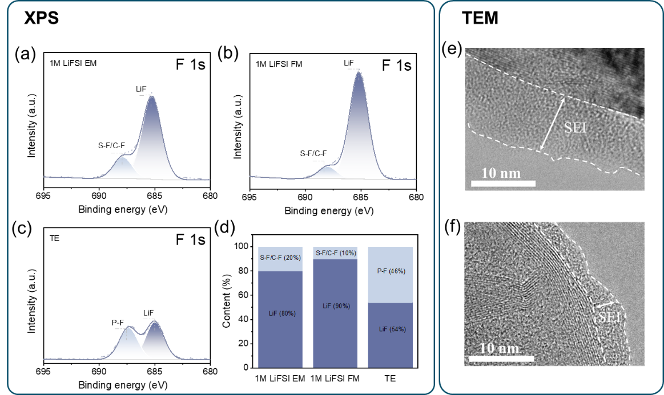
Figure 5. F 1s XPS spectra of graphite electrodes after 3 cycles at 0.1 C using different electrolytes. (a) 1 M LiFSI EM electrolyte; (b) 1 M LiFSI FM electrolyte; (c) TE electrolyte; (d) comparison of fluorine-containing substances on the surface of graphite electrodes with different electrolytes. HRTEM images of graphite electrodes with (e) 1 M LiFSI EM electrolyte and (f) 1 M LiFSI FM electrolyte after 10 cycles at 4 C_{graphite}.

As shown in Figure 5, the SEI on the surface of the graphite electrode consists of both inorganic and organic components. Notably, on the surface of graphite electrodes using 1 M LiFSI EM and 1 M LiFSI FM electrolytes, the proportion of LiF is approximately 80% and 90%, respectively. In contrast, the proportion of LiF in the SEI on the surface of graphite electrodes using TE electrolyte is only about 54%. This result suggests that 1 M LiFSI EM and 1 M LiFSI FM electrolytes promote the generation of LiF-rich SEI. The higher LiF content, especially for 1 M LiFSI FM, could be due to the decomposition of FEMC and FEC, and also the preferential reduction of FSI⁻ in the CIP/AGG dominated electrolyte. LiF was previous reported to enhance the Li ion conductivity of the SEI through its surface conduction mechanism^{[30]} and promote fast-charging performance.^{[31-35]}
In addition to the composition of SEI, the electrolytes also affect the thickness of the SEI layer, as observed by HRTEM. Figure 5e and f show a thinner and more uniform SEI for 1 M LiFSI FM, a characteristic that helps enhance the performance of the graphite electrode at high rates.
To investigate the impedance differences of SEI on graphite electrodes using 1 M LiFSI FM electrolyte and 1 M LiFSI EM electrolyte, electrochemical impedance spectroscopy (EIS) can be used for analysis. Given that the SEI is not static during cycling, EIS tests were performed on the graphite | Li half cells after three cycles at 0.1 C_{graphite} and followed by 10 cycles at 4 C_{graphite} with 1 M LiFSI EM or 1 M LiFSI FM electrolyte at the fully delithiated state (1.5 V). The Nyquist plots (Figure 6a and b) are fitted with a model as shown in Figure 6c. R_{e} represents the bulk resistance of the cell, reflecting the overall ohmic contribution from the electrolyte, separator, electrodes, and other cell components. R_{SEI} - C_{SEI} corresponds to the high - frequency response and represents the resistance and capacitance of the SEI film on the electrode surface. R_{CT} - C_{dl} corresponds to the mid-frequency response and represents the charge-transfer resistance (R_{CT}) and the associated double-layer capacitance. Z_{W} denotes the Warburg impedance, corresponding to the low-frequency sloping line, which reflects the contribution of Li⁺ diffusion at the electrode - electrolyte interface. Our fitting results show that R_{CT} is of the order of 10¹⁰ Ω or more, much bigger than that of R_{SEI}, as the EIS is taken at the full delithiated state. Therefore, the obtained EIS can be attributed mainly to the SEI.
R_{SEI} of graphite with 1 M LiFSI EM is 37.4 Ω (after 3 cycles at 0.1 C_{graphite}) and 33.3 Ω (after 10 cycles at 4 C_{graphite}), which is higher than that with 1 M LiFSI FM (29.0 Ω and 22.8 Ω), respectively (Figure 6c and Table S1). The result suggests that the SEI on the graphite anode formed with 1 M LiFSI FM electrolyte is less resistive to Li ion transport. The decrease of R_{SEI} after cycling may be due to the SEI composition being further changed in the subsequent cycles or the reduction in impedance of the Li counter electrode.
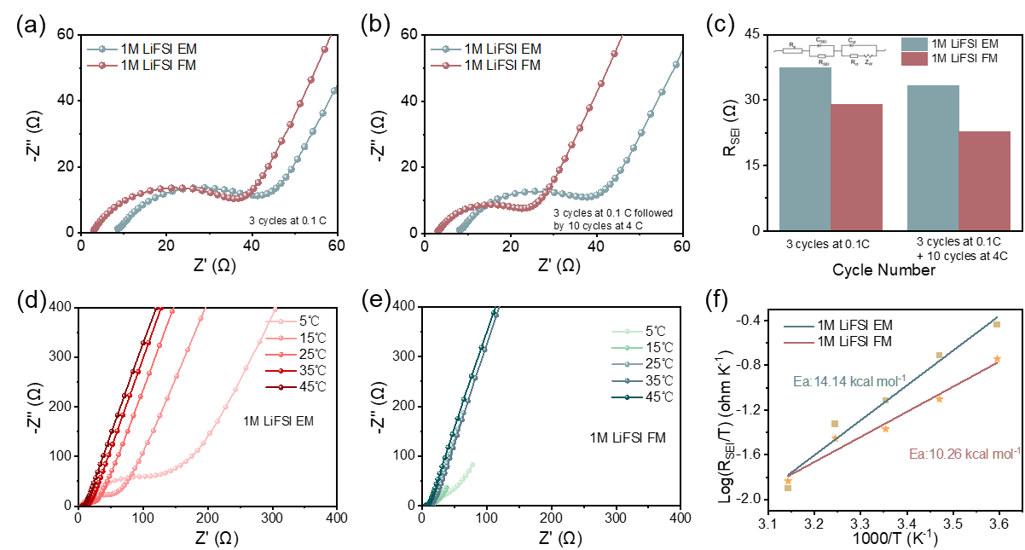
Figure 6. EIS spectra of the cells using different electrolytes after (a) 3 initial cycles at 0.1 C_{graphite} and (b) 10 more cycles at 4 C_{graphite}; (c) fitted values of R_{SEI} of graphite electrodes using different electrolytes after different cycles. EIS spectra of the cells tested at different temperatures with (d) 1 M LiFSI EM, (e) 1 M LiFSI FM; (f) plot of $\log{\frac{R_{SEI}}{T}}$ vs. 1000 T⁻¹ for graphite | Li half cells using different electrolytes.

Temperature-dependent EIS tests were also conducted on graphite electrodes between 5 °C and 45 °C to measure the activation energy (E_{a}) for the SEI impedance. The impedance of the SEI is related to E_{a} by the following equation:
$$\log{R_{SEI}=\log{\frac{RTd_{SEI}}{4z^{2}F^{2}a^{2}cv}+\frac{E_{a}}{2.303RT}}}$$
where z is the charge of the Li ion, F is the Faraday number, a is the half-jump distance of Li ion in SEI, c is the concentration of mobile cationic defects in the crystal lattice of the SEI, v is the vibrational frequency in the lattice, E_{a} is the activation energy, R is the gas constant, d_{SEI} is the film’s thickness and T is temperature in Kelvin.^{[36]} By plotting $\log{\frac{R_{SEI}}{T}}$ vs. 1000 T⁻¹, E_{a} can be determined from the slope of the line.
Here, E_{a} is found to be 14.14, 10.26 and 16.23 kcal mol⁻¹ for graphite anode with 1 M LiFSI EM, 1 M LiFSI FM electrolytes and TE, respectively (Figure 6d – f, Table S2 and Figure S10). The results show the difference in SEI formed by the different electrolytes, and the lower activation energy is consistent with the better rate performance of the graphite anode.

Conclusions
This study investigates the impact of the solvation structure of electrolytes on the fast-charging performance of graphite anodes for LIBs. The results, supported by both experimental and simulation data, demonstrate that both weakly-solvating electrolytes with MA are capable of forming a solvation environment dominated by CIP/AGG structures with 1 M LiFSI. Specifically, when EMC is replaced by FEMC, the proportion of AGG structures in the electrolyte is significantly increased. The desolvation energy of Li⁺ is reduced, which allows faster kinetic at high current densities compared to traditional electrolyte. In addition, the FSI⁻ anions in the Li⁺ solvation sheath and the fluorinated solvents are preferentially reduce at the interface, thereby inducing a LiF-rich SEI that lowers Li⁺ transport resistance across the interphase and enables faster ion transport.
These findings provide valuable insights into electrolyte design and optimization of fast-charging batteries, emphasizing the significance of solvation structure on Li ion migration and SEI formation.

Acknowledgement
The work described in this paper was supported by the National Institute for Materials Science (NIMS).

References
[1]. S. Lei, Z. Zeng, S. Cheng, J. Xie, Fast‐charging of lithium‐ion batteries: A review of electrolyte design aspects, Battery Energy, 2 (2023) 20230018.
[2]. E. Logan, J. Dahn, Electrolyte design for fast-charging Li-ion batteries, Trends in Chemistry, 2 (2020) 354-366.
[3]. Y. Liu, H. Shi, Z.-S. Wu, Recent status, key strategies and challenging perspectives of fast-charging graphite anodes for lithium-ion batteries, ENERGY & ENVIRONMENTAL SCIENCE, 16 (2023) 4834-4871.
[4]. Y.X. Yao, X. Chen, C. Yan, X.Q. Zhang, W.L. Cai, J.Q. Huang, Q. Zhang, Regulating interfacial chemistry in lithium‐ion batteries by a weakly solvating electrolyte, Angewandte Chemie International Edition, 60 (2021) 4090-4097.
[5]. Y. Yamada, K. Furukawa, K. Sodeyama, K. Kikuchi, M. Yaegashi, Y. Tateyama, A. Yamada, Unusual Stability of Acetonitrile-Based Superconcentrated Electrolytes for Fast-Charging Lithium-Ion Batteries, Journal of the American Chemical Society, 136 (2014) 5039-5046.
[6]. L.-L. Jiang, C. Yan, Y.-X. Yao, W. Cai, J.-Q. Huang, Q. Zhang, Inhibiting Solvent Co-Intercalation in a Graphite Anode by a Localized High-Concentration Electrolyte in Fast-Charging Batteries, Angewandte Chemie International Edition, 60 (2021) 3402-3406.
[7]. X. Zhu, Y. Mo, J. Chen, G. Liu, Y. Wang, X. Dong, A weakly-solvated ether-based electrolyte for fast-charging graphite anode, Chinese Chemical Letters, 35 (2024) 109146.
[8]. D. Xia, E.P. Kamphaus, A. Hu, S. Hwang, L. Tao, S. Sainio, D. Nordlund, Y. Fu, H. Huang, L. Cheng, Design criteria of dilute ether electrolytes toward reversible and fast intercalation chemistry of graphite anode in Li-ion batteries, ACS Energy Letters, 8 (2023) 1379-1389.
[9]. A.Y. Toukmaji, J.A. Board Jr, Ewald summation techniques in perspective: a survey, Computer physics communications, 95 (1996) 73-92.
[10]. G. Kalibaeva, M. Ferrario, G. Ciccotti, Constant pressure-constant temperature molecular dynamics: A correct constrained NPT ensemble using the molecular virial, Molecular Physics, 101 (2003) 765-778.
[11]. Q. Ke, X. Gong, S. Liao, C. Duan, L. Li, Effects of thermostats/barostats on physical properties of liquids by molecular dynamics simulations, Journal of Molecular Liquids, 365 (2022) 120116.
[12]. Y. Sasaki, Organic electrolytes of secondary lithium batteries, Electrochemistry, 76 (2008) 2-15.
[13]. E. Logan, E.M. Tonita, K. Gering, J. Li, X. Ma, L. Beaulieu, J. Dahn, A study of the physical properties of Li-ion battery electrolytes containing esters, Journal of The Electrochemical Society, 165 (2018) A21.
[14]. B. Klassen, R. Aroca, M. Nazri, G. Nazri, Raman spectra and transport properties of lithium perchlorate in ethylene carbonate based binary solvent systems for lithium batteries, The Journal of Physical Chemistry B, 102 (1998) 4795-4801.
[15]. Y. Horowitz, H.-G. Steinruck, H.-L. Han, C. Cao, I.I. Abate, Y. Tsao, M.F. Toney, G.A. Somorjai, Fluoroethylene carbonate induces ordered electrolyte interface on silicon and sapphire surfaces as revealed by sum frequency generation vibrational spectroscopy and X-ray reflectivity, Nano Letters, 18 (2018) 2105-2111.
[16]. G. Yang, R.L. Sacci, I.N. Ivanov, R.E. Ruther, K.A. Hays, Y. Zhang, P.-F. Cao, G.M. Veith, N.J. Dudney, T. Saito, Probing electrolyte solvents at solid/liquid interface using gap-mode surface-enhanced Raman spectroscopy, Journal of The Electrochemical Society, 166 (2019) A178.
[17]. G. Yang, I.N. Ivanov, R.E. Ruther, R.L. Sacci, V. Subjakova, D.T. Hallinan, J. Nanda, Electrolyte solvation structure at solid–liquid interface probed by nanogap surface-enhanced Raman spectroscopy, ACS NANO, 12 (2018) 10159-10170.
[18]. B. Han, Y. Zou, G. Xu, S. Hu, Y. Kang, Y. Qian, J. Wu, X. Ma, J. Yao, T. Li, Additive stabilization of SEI on graphite observed using cryo-electron microscopy, ENERGY & ENVIRONMENTAL SCIENCE, 14 (2021) 4882-4889.
[19]. Y. Zheng, T. Zhang, P.-K. Lee, Q. Duan, X. Li, S. Dong, T. Tan, Y. Wang, D.Y. W. Yu, Boosting Li-ion transport for graphite electrodes with lithium bis (fluorosulfonyl) imide salt and methyl acetate additive for fast-charging Li-ion batteries, Electrochimica Acta, 500 (2024) 144718.
[20]. K. Kimura, J. Motomatsu, Y. Tominaga, Correlation between solvation structure and ion-conductive behavior of concentrated poly (ethylene carbonate)-based electrolytes, The Journal of Physical Chemistry C, 120 (2016) 12385-12391.
[21]. C. Xu, F. Lindgren, B. Philippe, M. Gorgoi, F. Bjorefors, K. Edstrom, T. Gustafsson, Improved performance of the silicon anode for Li-ion batteries: understanding the surface modification mechanism of fluoroethylene carbonate as an effective electrolyte additive, Chemistry of Materials, 27 (2015) 2591-2599.
[22]. Y. Zhao, Z. Hu, Z. Zhao, X. Chen, S. Zhang, J. Gao, J. Luo, Strong solvent and dual lithium salts enable fast-charging lithium-ion batteries operating from− 78 to 60° C, Journal of the American Chemical Society, 145 (2023) 22184-22193.
[23]. S. Oswald, Binding energy referencing for XPS in alkali metal-based battery materials research (I): Basic model investigations, Applied Surface Science, 351 (2015) 492-503.
[24]. R. Larciprete, S. Gardonio, L. Petaccia, S. Lizzit, Atomic oxygen functionalization of double walled C nanotubes, CARBON, 47 (2009) 2579-2589.
[25]. Y. Chen, L. Yao, X. Chen, J. Jin, M. Wu, Q. Wang, W. Zha, Z. Wen, Double-faced bond coupling to induce an ultrastable lithium/Li6PS5Cl interface for high-performance all-solid-state batteries, ACS Applied Materials & Interfaces, 14 (2022) 11950-11961.
[26]. R. Dedryvère, S. Laruelle, S. Grugeon, P. Poizot, D. Gonbeau, J.-M. Tarascon, Contribution of X-ray photoelectron spectroscopy to the study of the electrochemical reactivity of CoO toward lithium, Chemistry of Materials, 16 (2004) 1056-1061.
[27]. H. Chen, J. Liu, X. Zhou, H. Ji, S. Liu, M. Wang, T. Qian, C. Yan, Rapid leakage responsive and self-healing Li-metal batteries, Chemical Engineering Journal, 404 (2021) 126470.
[28]. S. Wu, J. Hwang, K. Matsumoto, R. Hagiwara, The Rational Design of Low-Barrier Fluorinated Aluminum Substrates for Anode‑Free Sodium Metal Battery, Advanced Energy Materials, 13 (2023) 2302468.
[29]. Y. Gu, S. Fang, L. Yang, S.-i. Hirano, A non-flammable electrolyte for long-life lithium ion batteries operating over a wide-temperature range, Journal of Materials Chemistry A, 9 (2021) 15363-15372.
[30]. J. Sun, J. Yan, F. Li, J. Li, J. Ma, G. Xu, P. Han, G. Hou, Y. Tang, S. Dong, Deciphering the Lithium‐Ion Conduction Mechanism of LiH in Solid‐Electrolyte Interphase, Advanced Materials, 36 (2024) 2405384.
[31]. C. Sun, X. Ji, S. Weng, R. Li, X. Huang, C. Zhu, X. Xiao, T. Deng, L. Fan, L. Chen, X. Wang, C. Wang, X. Fan, 50C Fast-Charge Li-Ion Batteries using a Graphite Anode, Advanced Materials, 34 (2022) 2206020.
[32]. Y. Liao, W. Lin, Y. Zhang, J. Yang, Z. Li, Y. Ren, D. Wang, Y. Huang, L. Yuan, A Weakly Solvating Ether Electrolyte Enables Fast-Charging and Wide-Temperature Lithium-Ion Pouch Cells, ACS NANO, 18 (2024) 20762-20771.
[33]. K. An, D. Kim, Y.H.T. Tran, D.T.T. Vu, S.J. Park, J. Heo, Y.J. Lee, S.-W. Song, Weakly Binding Molecules-Based Fast Charging Li-Ion Batteries, Advanced Functional Materials, 34 (2024) 2311782.
[34]. C. Song, S.H. Han, Y. Choi, H.R. Shin, M.K. Kim, C. Gong, D. Chen, J.-W. Lee, S. Hong, N.-S. Choi, Geometric Design of Interface Structures and Electrolyte Solvation Chemistry for Fast Charging Lithium-Ion Batteries, Advanced Materials, 37 (2025) 2418773.
[35]. H. Guo, Y. Tian, Y. Liu, Y. Bai, J. Wu, F. Kang, B. Li, Inner Lithium Fluoride (LiF)-Rich Solid Electrolyte Interphase Enabled by a Smaller Solvation Sheath for Fast-Charging Lithium Batteries, ACS Applied Materials & Interfaces, 15 (2023) 1201-1209.
[36]. E. Peled, The electrochemical behavior of alkali and alkaline earth metals in nonaqueous battery systems—the solid electrolyte interphase model, Journal of The Electrochemical Society, 126 (1979) 2047.

