Odd-stoichiometry and Secondary Phase Relations in Higher Manganese Silicides

Nagendra Singh Chauhan^{1,2}*, Shivalingam Goud Sara³, Amrita Bhattacharya,³* Takao Mori,^{2,4} and Yuzuru Miyazaki¹

¹Department of Applied Physics, Graduate School of Engineering, Tohoku University, Sendai, Miyagi, Japan - 980-8579.
²International Center for Materials Nanoarchitectonics (WPI-MANA), National Institute for Materials Science (NIMS), Namiki 1-1, Tsukuba, 305-0047, Japan.
³Department of Metallurgical Engineering & Material Science, Indian Institute of Technology, Mumbai, Maharashtra, India – 400076.
⁴Graduate School of Pure and Applied Sciences, University of Tsukuba, 1-1-1 Tennodai, Tsukuba, Ibaraki 305-8573, Japan.

Abstract
Higher manganese silicides (denoted as MnSi_{γ}) are a prominent class of intermetallic compound for thermoelectric applications that crystallizes into a Nowotny Chimney Ladder (NCL) phase and constitutes a higher concentration of silicon with odd stoichiometry typically represented by an irrational number. In this work, we present the genesis of Si odd stoichiometry and secondary phase relations in silicon-rich and silicon-deficient MnSi_{x} to present the significance of labile (i.e., easily alterable) Si-subsystem in inheriting the modulated lattice structure with characteristic anharmonicity as found using density functional theory-based phonon calculation in Mn₄Si_{7,} a representative commensurate structure. The transport properties show an interrelation to the presence of a secondary phase, which is driven by the odd stoichiometry, where the thermoelectric figure of merit is found to be optimal for MnSi_{1.74}. The structural characterization of rapidly solidified melt-spun ribbons and spark plasma sintered bulk specimens reveal a characteristic presence of MnSi and Si as secondary phases in Si-deficient (x ~ 1.5) and Si-excess (x ~ 2) compositions of nominal MnSi_{x}, respectively that coexists with the major MnSi_{γ} based NCL phase. This study provides the fundamental basis of phase evolution and the relevance of odd stoichiometry in silicon-rich manganese silicides which exhibits fascinating phonon dynamics in optimal MnSi_{1.74} stoichiometry.
Keywords- Thermoelectrics; Higher Manganese Silicides; stoichiometry; secondary phases; transport phenomena.
- Introduction. Stoichiometry has played a critical role in the development of various transition metal silicides (TMS) for attaining a wide range of functionalities in electronic devices such as solar cells, transistors, microelectronics, light-emitting diodes etc.^{1,2} The variation in the stoichiometry of the silicide phase significantly influences not only its crystal structure but also their physical properties, including transport properties and reactivity in TMS.³ Thus, stoichiometric alteration and its control during synthesis is a widely explored paradigm for deriving exotic functional properties in simple binary systems of TMS such as Mn-Si, Ni-Si, Co-Si, Ti-Si, etc.^{4,5} In the Mn-Si binary system, Mn and Si atoms crystallize in a stoichiometry of 1:1 to form a face-centered cubic sublattice of Mn-atoms with Si atoms occupying the interstitial sites, and are actively explored as a weak itinerant helimagnet for understanding nanomagnetism and its application to spintronics.^{6,7} While in metal-rich silicides i.e., in Mn₅Si₃ with an unusual antiferromagnetic magnetic ordering, the Mn atoms form a sublattice with a hexagonal close-packed structure, and the Si atoms occupy tetrahedral interstitial sites.^{8,9} In contrast, silicon-rich higher manganese silicides (HMSs) i.e., MnSi_{x} which crystallizes in Nowotny Chimney Ladder (NCL) phase, display a unique modulated crystal structure wherein the tetragonal cell elongates variably along the c-axis for [Mn] and [Si]-subsystems.¹⁰
Several compounds with structural and stoichiometric variations have been identified with silicon-rich and pseudo-binary compositions having an unusual odd-stoichiometry (including Mn₄Si₇,^{11,12} Mn₁₁Si₁₉,¹³ Mn₁₅Si₂₆,¹⁴ and Mn₂₇Si₄₇¹⁵) which has garnered extensive interest in thermoelectric (TE) materials research, owing to their remarkable electrical and thermal transport properties.^{16–19} The odd-stoichiometry (x) i.e. Si/Mn ratio in MnSi_{x} refers to the empirical observations wherein the ratio of Mn:Si atoms upon synthesis is generally found to be an irrational number that ranges between 1.72 - 1.75.^{10,17,20} The inevitable and incommensurate presence of multiple phases in the synthesized MnSi_{x} crystals with varying stoichiometry has primarily led to the obscure interpretation of structure and bonding in MnSi_{x}. To address this challenge in structural interpretation, Miyazaki et al.²¹ adopted the (3+1) dimensional superspace formalism following Yamamoto et al.^{22,23} to redefine stoichiometry of HMS phase in terms of γ, which as the component of modulation vector (00γ) represents the incommensurate c-axis length ratio γ = ${c_{Mn}}/{c_{Si}}$ and relates well to the stoichiometry.²⁴
Depending on the nominal composition, dopants, thermal history, and synthesis methodology, various x ≈ γ values have been reported to date.²⁵ In this study, we present the mechanistic origin of odd stoichiometry on TE transport properties and secondary phase relation of silicon-rich manganese silicide MnSi_{x}, synthesized by melt spinning and spark plasma sintering. To realize Si-deficient, stoichiometric, and Si-rich compositions with reference to HMS phase (with an evaluated²¹ γ ≈ x ~ 1.736), nominal composition corresponding to x =1.5, 1.74 and 2 were considered during synthesis. The significance of odd stoichiometry for realizing efficient TE conversion is revealed and established by temperature-dependent electrical and thermal transport properties. While the structural characterization upholds the existence of secondary phases to be related to stoichiometric alterations in the synthesized polycrystals. The basis for higher power factor and low thermal conductivity in stoichiometric HMS composition were corroborated using electronic structure and phonon dispersion calculation. The origin of secondary phase formation in silicon rich manganese silicides is investigated and the structural modulation and its interrelation to the stoichiometry and transport properties of HMS provides fundamental scope for improved material design.
- Results.
2.1 XRD Patterns & Lattice Parameters. The XRD patterns of the pulverized melt spun ribbons (hereafter referred to as MS) and sintered (hereafter referred to as MS-SPS) specimens of MnSi_{x} (x = 1.5, 1.74, and 2) polycrystals are shown in Fig. 1 (a) and 1(b), respectively. Owing to the superspace symmetry of HMS, indexing the Bragg peaks in their XRD patterns requires the use of four integers i.e., hklm. These integers correspond to peaks hkl0, hk0m, and hklm, which are the fundamental reflections from the [Mn]-subsystem, [Si]-subsystem, and satellite, respectively.²⁴ Remarkably, rapid solidification by melt spinning can prevent the occurrence of peritectic reaction at around 1473 K, thus enabling synthesis of undoped MnSi_{1.74} without the MnSi phase (i.e. HMS phase denoted as MnSi_{γ} hereafter). This has been reported previously²⁶ and is shown in Fig. 1 for comparison. In the XRD pattern for Si-deficient (x ~ 1.5) ribbons, in addition to the dominant HMS phase, peaks that correspond to the cubic MnSi phase (Space Group – P2₁3, No.198) were also observed and indicated by a filled triangle (▲) in Figure 1(a). Whereas for Si-rich (x ~ 2) ribbons, beside the major HMS phase, peaks corresponding to the Si phase indicated by a filled circle (●) were also indicated in the XRD pattern.
The XRD patterns of MS-SPS as shown in Fig. 1(b), exhibit sharper peaks with higher relative peak intensity. The retention of existing peaks with no new peak appearance in XRD patterns implies that the crystal structure of the synthesized polycrystals of MnSi_{x} (x =1.5, 1.74, and 2) show no remarkable change during sintering. However, it is noteworthy that subtle structural changes, such as alteration in lattice parameters or crystallite size, require a comparison of structural parameters obtained after the refinement of XRD patterns. The refined cell parameters i.e., of the dominant HMS phase are shown for comparison in Fig. 1(c), wherein the estimated standard deviations presented in Table 1 are well within the size of symbols. Interestingly, the common a unit cell parameter for the tetragonal [Mn] and [Si]-subsystem as schematically shown in Fig. 1(d) was the lowest for MnSi_{1.74} polycrystals which decreases upon sintering. The $c_{Mn}$ for all the MnSi_{x} decreases upon sintering, which was more significantly observed for MnSi_{1.74} polycrystals, which suggests that when Si is assimilated into HMS polycrystals after the peritectic reaction, it reduces the $c_{Mn}$ through compression of the [Mn]-subsystem, because of populating the [Si]-subsystem. In contrast, a considerable lowering of $c_{Si}$ for MnSi₂ polycrystals was evaluated, suggesting the labile Si atoms in [Si]-subsystem induces excess Si in the modulated lattice structure of MnSi_{γ} to precipitate.
Remarkably, the changes in γ with varying stoichiometry (1.5 ≥ x ≥ 2) in the synthesized nominal MnSi_{x} polycrystals are marginal (1.736 ≥ γ = ${c_{Mn}}/{c_{Si}}$ ≥ 1.741) for the HMS phase. This provides a new structural understanding to explain peak rearrangement during high-temperature phase transitions, secondary phase evolution, and modulated lattice structure in the MnSi_{γ}. Structural understanding of MnSi_{γ} thus needs to be reviewed, leading to a reinterpretation of previous discussions and conclusions. The supplementary figures S1-S6 display the refined XRD patterns obtained from Le Bail analysis, which include the observed, calculated, and different profiles as well as the Bragg peaks. The refined unit cell parameters for the major HMS phase and corresponding secondary phases are also tabulated in Table 1.
2.2 Microstructure and its Evolution. To elucidate stoichiometry-induced microstructural changes in MnSi_{x} (x = 1.5, 1.74, and 2) specimens, electron micrographs in SE-mode and BSE-mode at low magnification for the contact and free surface of MS ribbons are shown in Fig. 2(a – c) and Fig. 2(d – f), respectively. At the contact surface, the micrographs reveal an oriented columnar grain structure which can be attributed to the directional solidification. The tangential direction within the ribbon of wheel contact is indicated by the arrow in the SE-SEM micrographs in Fig. 2(a – c). As the cooling rate is very high at the contact surface the microstructure contains both amorphous and crystalline regions. At the free surface shown in Fig. 2(d – f), a high degree of crystallinity driven by a relatively slower cooling rate is evident. The crystallites exhibit a more equiaxed and characteristic microstructure showing a relation to the stoichiometry in MnSi_{x}. The free surface at high magnification is displayed in Fig. 2(g – i), to reveal the distinctive formation of secondary phases with stoichiometric changes which are analysed with EDS. For MnSi_{1.5} starry flower-shaped bright phase corresponding to Mn-rich phases (x > 1) or monosilicide (x ~ 1) appears embedded within the silicon-rich (1.4 < x < 1.72) matrix. In MnSi_{1.74} microstructure, larger and more developed crystallites are found with varying composition (1.4 < x < 1.72), which agrees well with their peritectic formation. For MnSi₂ ribbons, crystallites (x ~ 1.57) appear floating within the silicon-rich sea (x ~ 1.85), suggesting that despite Si-rich nominal composition (x ~ 2), the formation of HMS phase (1.72 < x < 1.75) happens by peritectic formation. The characterization of the quenched microstructure during rapid consolidation offers insights into the solidification kinetics and mechanisms of silicon rich manganese silicides.
Upon sintering the melt-spun ribbons undergo heating and consolidation into a dense and homogeneous bulk, wherein nanosized grains/ particles bonded at high temperature within the ribbons. The electron micrographs for polished sintered specimens are shown in Fig. 3. The BSE image in Fig. 3(a) for MnSi_{1.5} specimens shows developed bright monosilicide phases embedded within the HMS matrix, which at high magnification is shown in Fig. 3(b). The corresponding SE-SEM image (Fig. 3(c)) indicates the high density of the samples, while elemental mapping shown alongside indicates the MnSi phase with Mn-richness and Si-deficiency in the elemental maps. The BSE image (Fig. 3(d)) for MnSi_{1.74} specimens indicates free-Si denoted by dark regions and parallel MnSi-striations formed randomly in grains. The nascent MnSi-striations at high magnification found in certain domains are shown in Fig 3(e), with corresponding SE-SEM image (Fig. 3(f)) along with the elemental mapping. The BSE image (Fig. 3(g)) for MnSi₂ specimens indicates eutectic microstructure of dark regions (Si) and bright HMS phases. The eutectic microstructure at high magnification is shown in Fig 3(h), with the corresponding SE-SEM image in Fig 3(i), and corresponding elemental mapping.
  - Electronic Band Structure & Density of States. The electronic band structure is calculated along the high symmetry path in the first BZ of the tetragonal crystal structure as shown in Fig. 4(a). The relaxed lattice parameter of the tetragonal unit cell of Mn₄Si₇ is found to be 5.50 Å and 17.35 Å along the a and c axis, respectively, which are consistent with the previously reported values from both theoretical²⁷ and experimental²⁸ reports. From the electronic band structure calculation, Mn₄Si₇ is found to be a semiconductor with an indirect band gap of 0.797 eV with the valence band maximum (VBM) at Γ and the conduction band minimum (CBM) at X points in the first BZ as shown in Fig. 4(b). The experimentally reported band gap is around 0.4 eV which is very low when compared to the theoretically calculated value and the discrepancy is mainly due to the presence of stacking faults in the synthesized samples as reported by Migas et al.²⁷ In the conduction band, the second and third minima are found to be present at Z and R points with an energy difference of 0.006 and 0.008 eV from the CBM, respectively, which indicates band convergence, improving the band degeneracy in the conduction band of the compound. Also, the bands are found to be flat, indicating the heavier band effective mass. Increased band degeneracy and higher effective mass indicate larger S and lower σ. Density of states (DOS) calculation revealed that the compound is non-magnetic with similar DOS in spin-up and spin-down channels and the total magnetization is found to be zero, which agrees with the previous theoretical results.²⁷ Further, the individual elemental and orbital contributions to DOS showed that d – orbitals of Mn have a major contribution around the Fermi level as shown in Figure 4(b), which implies that the features at the band extrema are more dependent on Mn as compared to Si and electronic transport properties can be tuned by doping or substituting at Mn sites.
  - Electrical Transport Properties. The temperature-dependent σ(T) of MnSi_{x} (x =1.5, 1.74, and 2) is displayed in Figure 4(c), where it is evident that the σ of all the specimens, regardless of the nominal composition, decreases as the temperature increases, indicating their degenerate semiconducting electrical transport behavior. However, at higher temperature σ(T) for MnSi_{1.5}, MnSi_{1.74}, and MnSi₂ lowers up to 773 K, 823 K, and 723 K respectively and begins rising thereafter indicating the onset of bipolar conductivity. Among the synthesized polycrystal, σ decreases $\left(σ_{Mn{Si}_{1.5}}<σ_{Mn{Si}_{1.74}}<σ_{Mn{Si}_{2}}\right)$ with Si stoichiometry in the measured temperature range which can be attributed to the associated formation of secondary phases i.e., metallic MnSi and semiconducting Si phases in the polycrystals. The temperature-dependent S(T) plotted in Fig. 4(d) shows p-type conduction which gradually increases with rising temperature due to an inverse correlation with σ, but then decreases due to the onset of bipolar conduction. For MnSi_{1.5}, MnSi_{1.74}, and MnSi_{1.5}, the S value at higher temperatures reach a maximum of 773 K, 873 K, and 823 K, respectively, and start decreasing thereafter. This signifies the onset of bipolar conductivity from thermally activated minority charge carriers, which is closely related to the stoichiometry of the samples.
In transport modeling, understanding the behaviour of the reduced Fermi level (i.e., electron chemical potential) expressed as η = ${E_{F}}/{k_{B}T}$ with temperature is critical for designing and optimizing the performance of a thermoelectric materials as it provides insights into electrical transport properties. The measured S(T) and σ(T) allows the determination of conductive “quality” of charge carriers in the material which expressed as $σ_{E_{o}}$ and can be evaluated using the analytical expressions in the limits when |S| is large (i.e. within 5% when |S| > 120 μV/K) as.²⁹
$$σ_{E_{o}}=σ.exp\left[\frac{\left|S\right|}{{k_{B}}/e}-2\right]$$ | (1)
The η indicates the doping level which depends on defects and impurities and can be extracted by following the relation $σ=σ_{E_{o}}ln(1+e^{η})$ in the measured temperature regime as²⁹
$$η=\ln\left[exp\left(\frac{σ}{σ_{E_{o}}}\right)-1\right]$$ | (2)
In MnSi_{γ,} a p-type degenerate semiconductors, the Fermi level (E_{F}) lies inside the valence band edge (E_{V}) as shown in Fig. 4(b). The variation of η(T) with temperature is shown in Fig. 5(a), which indicates positive values for MnSi_{x} (x = 1.5, 1.74 and 2) suggesting a significant number of holes in the valence band being occupied, resulting in a very high $n_{H}$. With increasing temperature, η approaches zero in case of MnSi_{γ} and MnSi₂, while it is lowered for MnSi_{1.5} suggesting the shift in Fermi level towards the mid of the energy gap (E_{g} ~ 0.7 eV) between the valence and conduction bands, promoting excitation of minority charge carriers i.e., electrons. Interestingly, the negative values of η for MnSi_{γ} and MnSi₂ subsequently at higher temperature in the measured temperature range suggests that only a small fraction of holes in the valence band remains occupied, as most of the holes remain unfilled due to recombination events with electrons. In contrast, for MnSi_{1.5} the lowered yet positive values of η is indicative of the higher energy states of holes in the valence band. These interpretations are shown schematically in Fig. 5(b) and agree well to the calculated electronic band structure (Fig. 4(a)) for the representative commensurate Mn₄Si₇ structure suggesting that secondary phase formation induced by changing stoichiometry results in shift of the Fermi level near the valence band edge.
It is well recognized and shown in Fig. 5(c), that the carrier concentration (n) is a monotonically increasing function of η, thus changing η will lead to changes in doping levels. The η > 0 for x = 1.5 - 2.0 in MnSi_{x} suggests higher doping levels, which increases with η as $η_{Mn{Si}_{2}}<η_{Mn{Si}_{1.74}}<η_{Mn{Si}_{1.5}}$. The result of hall measurement at room temperature as shown in Fig. 5(d), indicates conformity to this empirical observation, wherein carrier concentration (n_{H}) for MnSi_{1.5} is relatively higher corresponding to it higher η. Interestingly, although the carrier mobility (μ_{H}) for MnSi₂ is marginally higher than MnSi_{1.74} , a significant decrease in n_{H} results in poor hole conductivity. Moreover, the higher doping levels enhances the occurrence of significant carriers scattering, thereby limiting μ_{H}, especially at high doping levels, as observed for MnSi_{1.5} polycrystals. Therefore, Si-deficient MnSi_{γ} compositions are likely to exhibit higher n_{H}, whereas Si-excess MnSi_{γ} compositions are expected to have higher μ_{H}.
2.5 Thermal Transport Properties. The temperature-dependent thermal transport of MnSi_{x} (x =1.5, 1.74, and 2) polycrystals is shown in Figure 6 (a – d). The κ(T) shown in Fig. 6(a) displays a higher value for MnSi₂ and MnSi_{1.5} at lower and higher temperatures. While the κ(T) values in the synthesized MnSi_{1.74} remains significantly lower than its MnSi₂ and MnSi_{1.5} counterpart, indicating the relevance of stoichiometry and the deteriorating presence of secondary phases in lowering the κ. To relate the electrical and thermal conductivities in the synthesized polycrystals, Lorenz number (L) values shown in Fig. 6(b) are estimated using the relation $L=\left[1.5+exp\left[\frac{-\left|S\right|}{116}\right]\right]*{10}^{-8}$ and was evaluated to be in the range of (1.6 – 2.0)×10^{–8} WΩK^{–2}). A higher κ_{e} displayed in Fig. 6(c) for MnSi_{1.5} > MnSi_{1.74} > MnSi₂ implies increased and decreased hole mobility due to formation of MnSi and Si phases, respectively in MnSi_{1.74} polycrystal, while increasing κ_{e}(T) with temperature promotes heat conduction, thereby making a significant contribution to the overall heat transport at higher temperatures. The $κ_{L}$ was evaluated using the equation $κ_{L}=κ-κ_{e}$ and is shown in Fig. 6(d). As indicated, $κ_{L}$ contributes majorly to κ, while at higher temperatures both MnSi₂ and MnSi_{1.5} exhibit similar and a higher $κ_{L}$ in comparison to MnSi_{1.74}. Thus, phonon confinement and phonon transport in MnSi_{1.74} polycrystals may originate from the twisting phonons in its quasi-one-dimensional substructure as has been established previously.³⁰ The secondary phase formation in Si-excess and Si-deficient counterpart of MnSi_{1.74} based NCL phase is detrimental to the phonon scattering and seemingly provides a pathway for conduction of phonons.
2.6 Phonon Dynamics. The phonon dispersion along the high symmetry K – path of the tetragonal lattice is shown in Fig. 7(a). The calculations show the existence of low lying flat optical branches which have energy as low as 10 meV, which agrees with the previously reported experimental and theoretical calculations.³⁰ The acoustic and one of the optical phonon modes are shown in colour in the insets of Figure 7(a) along the Γ – X and Γ – Z paths. These modes are denoted as twisting-optical, longitudinal acoustic (LA), transverse acoustic (TA, TA′) based on their respective polarizations. Unlike most known bulk compounds, a low energy optical mode is found along the Γ – X direction which has energy lower than the acoustic modes. The reason for the occurrence of this mode is due to the twisting motion of Si helices interacting with the adjacent helices and the Mn ladder, as elucidated by Chen et al.³⁰ Along the Γ – X direction, LA mode undergoes consecutive avoided crossings to reach the BZ boundary at 12 meV. The transverse acoustic modes i.e., the TA and TA′ also undergo the avoided crossing with twisting optical and LA modes and reach the BZ boundary at around 7 and 12 meV respectively. Twisting mode reaches the BZ boundary at ~ 7 meV, which is close to the energy reached by the TA mode along Γ – X direction.
So far, the compounds which exhibit these avoided crossings have been reported to have low lattice thermal conductivity,^{31–35} and in Mn₄Si_{7,} along with avoided crossings, twisting of phonon modes is observed due to the coupling of acoustic and optical phonon modes. Also, in Γ – Z direction, twisting-optical and TA modes overlap with similar energies and significantly large separation of LA, TA, and TA′ is observed, which can be attributed to the anisotropy of the crystal structure of Mn₄Si₇. Due to the twisting of phonons from the acoustic-optical phonon coupling, anisotropic crystal structure, and multiple avoided crossings, the lattice thermal conductivity of the compound is reported to be low. Phonon partial DOS calculations displayed in Fig. 7(b), revealed that at the lower (< 20 meV) and higher (> 40 meV) energies, Si has a major contribution to the phonon dispersion whereas in the mid-range energies, phonon modes of Si and Mn hybridizes and contribute to the phonon dispersion.
- Discussion. Silicon-rich manganese silicides crystallizing into a complex NCL phase can be described as an inlay of Mn and Si subsystems, where the Mn atoms form the restricted chimney frame wall, within which Si atoms are arranged as spiral ladders. Although the HMS phases have a similar tetragonal cell of [Mn] and [Si] subsystems, the stacking lengths along the c-axis differ, which creates spacing anomalies. Moreover, a variation in the three-dimensional (3D) arrangement of consecutive Si subsystems relative to Mn subsystems is prone to orientational anomalies. These structural anomalies typically result in a periodic difference with an inherent distortion in the order of stacking planes. The interstitial diffusion within the crystal lattice facilitates the movement of Si atoms along the c-axis, which can be particularly relevant for the assumption that Si atoms are confined in chimneys. If the equilibrium Si concentration changes, it can only be balanced by a shift of the Si ladder along the chimney.
The structural stability and electrical properties of MnSi_{γ} adhere well to the 14-electron rule, which states that a compound containing a transition metal will have greater structural stability when it has 14 valence electrons (VEC) in its outermost shell as it enables them to form stronger covalent bonds.³⁶ The (3+1) dimensional superspace approach is particularly useful for understanding the behaviour of incommensurate NCL phase, which exhibit multiple phases and structural transformations. It allows for the prediction of phase transitions and the identification of new phases based on thermodynamic conditions. The stoichiometry of MnSi_{γ} showed interrelation to the evolution of sub-structures with distinct phases, wherein the synthesized Si-deficient and Si-excess reveal the growth of MnSi and Si as secondary phases in diffraction patterns and electron micrographs. The rapidly solidified melt-spun ribbons of MnSi_{1.5}, MnSi_{1.74,} and MnSi₂ polycrystals reveal the peritectic formation of MnSi_{γ} with the complementary presence of nascent MnSi and Si phase. The microstructure of MS ribbons at the contact surface constitutes nano-crystallite with both amorphous and crystalline regions, while the free surface exhibits a distinctive formation of secondary phases showing relation to stoichiometry.
The sintered nanostructured bulk of MnSi_{γ} exhibits eliminated porosity and improved homogeneity of secondary phases within the microstructure. It was inferred that the TE transport properties and microstructure of MnSi_{x} can vary depending on the stoichiometry, wherein the stoichiometric alteration leads to metallic MnSi and semiconducting Si phases within the polycrystals of NCL phase of MnSi_{γ} for the Si-deficient and Si-excess compositions. Although the segregation of secondary phases is inevitable as observed previously for silicon-rich manganese silicides-based compositions, a nominal composition with x ~ 1.74 in MnSi_{x} favours the formation of the NCL phase. This can be related to the atomic packing factor and distinct stability of the c-axis length ratio i.e., γ = ${c_{Mn}}/{c_{Si}}$ of [Mn] and [Si] subsystems, as labile Si atoms easily move along the c-axis, the NCL phases can adjust the Si concentration in a quasi-continuous manner to optimize its bonding energy. Owing to the narrow line phase nature of incommensurate composite crystals of HMS, a nominal composition MnSi_{1.74} being the closest approximation, minimizes the formation of secondary phases during the synthesis process. Fig. 8(a) displays the temperature-dependent electrical power factor (S²σ) with higher value observed for MnSi_{1.74} polycrystals, reaching ~ 1.7 x 10⁻³ Wm^{–1}K^{–2} in the 673-773 K range, while lower value of power factor was evaluated for MnSi_{1.5} and MnSi₂ which indicates the detrimental impact of secondary phases in MnSi_{γ} crystals. Weighted mobility ($μ_{w}$),³⁷ a weighted average contribution of all energy levels to the overall mobility of the carrier in a crystal is shown for the synthesized specimens in Fig. 8(b) and is evaluated by the measured values of the S and σ following analysis provided by Snyder et al.³⁷ The highest $μ_{w}$ evaluated for MnSi_{1.74} corresponds well with its maximum power factor realized among composition, wherein lowest $μ_{w}$ corresponds to Si-excess MnSi₂ polycrystals.
The temperature-dependent zT for the synthesized MS-SPS polycrystals is indicated in Fig. 8(c) indicates the highest zT for nominal MnSi_{1.74}. Furthermore, materials quality factor (B) i.e., an alternative measure of the effectiveness of a material in converting heat into electricity is also evaluated as $B={\left(\frac{k_{B}}{e}\right)}^{2}\frac{σ_{E_{o}}}{κ_{L}}T$, and is shown in Fig. 8(b).²⁹ and corroborates well with both $μ_{w}$ and QF. Thus, evaluated $μ_{w}$, QF and zT which are vital performance parameters for assessing the TE transport properties of materials, suggests that MnSi_{1.74} polycrystals to outperform in terms of TE conversion efficiency, when compared with its stoichiometric variants. Moreover, the optimization of the transport properties i.e., higher electrical power factor and lowest κ, further establish the relevance of nominal MnSi_{1.74} polycrystals for TE application in comparison to its stoichiometric variants. The stoichiometry of MnSi_{x} affects its transport properties significantly, making it an important parameter to control during the synthesis. The nominal composition of MnSi_{x}, where x is a number close to 1.74, is the most appropriate composition for synthesizing the silicon-rich manganese silicides with improved NCL phase quality having minimal formation of secondary phases, Degenerate semiconducting transport and phonon dynamics exhibited by commensurate approximation i.e., Mn₄Si₇ of incommensurate composite crystals of HMS suggest a MnSi_{1.74} to be the most optimal composition for attaining higher power factor and lowest thermal conductivity, thereby resulting in a significantly improved zT when compared to Si-rich and Si-deficient HMS compositions. The mechanistic origin of secondary phase formation offers insights for studying similar NCL phases at the nanoscale, and the relation between structural modulation, stoichiometry, and transport properties offers a basis for material design to realize higher TE performances in MnSi_{γ} and similar NCL phases.
- Conclusion. Silicon-rich manganese silicides (MnSi_{x}) display odd stoichiometry and follow a peritectic solidification reaction on cooling upon melt, which leads to the formation of undesired secondary phases. This work elucidates the growth mechanism of prevalent secondary phases in MnSi_{γ} and reveals their interdependence with stoichiometry. The labile Si atoms in [Si]-subsystems favour γ ~ 1.74 for the NCL phase formation and a nominal composition MnSi_{1.74} being the closest approximation, minimizes the formation of secondary phases during the synthesis process. The evolution of metallic MnSi and semiconducting Si has been extensively found to co-exist along with the MnSi_{γ} NCL phase matrix for Si-deficient and Si-excess compositions, which display inferior zT. Thus, controlling the stoichiometry and minimizing the secondary phases in MnSi_{x} polycrystals holds the key to optimizing the transport properties which is competitive and promising for mid-temperature TE applications. These finding sheds light on the underlying mechanisms responsible for the unusual stoichiometry observed in HMS.
- Experimental Details.
5.1 Material Synthesis – Ingots with a nominal composition of Si-deficient (x ~ 1.5), stoichiometric (x ~ 1.74), and Si-excess (x ~ 2) of MnSi_{x} alloys were synthesized in an arc-melting furnace (GMAC-1100, G.E.S Corporation, Japan) under high-purity Argon atmosphere from weighed granular Mn (4N, 2 – 5 mm) and Si (5N, 2 – 5 mm). The broken button-shaped arc-melted ingots were induction melted at a temperature of around 1500 K, and the molten liquid was rapidly cooled by injecting it onto a water-cooled rolling copper wheel rotating at 3000 rpm under argon atmospheres in melt-spun equipment (RQM-T-20, Makabe Giken Ltd., Japan), resulting in the production of melt-spun (hereafter indicates as MS) ribbons. To achieve bulk consolidation of MS-ribbons, they were crushed into a fine powder and placed inside a graphite die ~ 10 mm inner diameter employing spark plasma sintering (hereafter referred to as MS-SPS) using the (LABOX-325R, NJS Co., Ltd, Japan) at a temperature of 1223 K and under a pressure of 50 MPa. The resulting polycrystalline samples exhibited a volumetric density > 97% of the theoretical density, and specimens for characterization were obtained from the sintered bulk along the in-plane and out-plane directions relative to the uniaxial press axis.
5.2 Structural Characterization. The X-ray diffraction (XRD) patterns of pulverized fine powder from MS ribbons and SPS specimens were obtained at room temperature using an advanced powder XRD diffractometer (D8 Advance, Bruker AXS, Germany). The crystal structure parameters were evaluated through a Le Bail analysis on the JANA2006 software, utilizing the (3+1) dimensional superspace formalism and superspace group (I4₁/amd (00γ)00ss).³⁸ Scanning electron microscopy (SEM) with energy dispersive spectroscopy (EDS) provided by JEOL (JSM-IT 100, Japan) was used to examine the morphological features, elemental mapping, and compositional consistency in secondary electron (SE) and backscattered electron (BSE) modes.
5.3 Thermoelectric Characterization. The polycrystalline sintered MS-SPS bulk specimens were evaluated for their TE transport properties by conducting measurements in both in-plane and out-plane directions over a temperature range of 300 – 1023 K. The thermal diffusivity (D) and specific heat (C_{P}) were measured for a circular disk-shaped sample, which had a diameter of around 10 mm and a thickness ≈ 2 mm, using the flash diffusivity method (LFA467HT HyperFlash, Netzsch, Germany). At the same time, the σ and S were assessed using a four-probe DC method (ZEM–3, Ulvac-Riko, Japan) in a helium atmosphere on rectangular bar-shaped specimens, with dimensions around 10 mm × 2 mm × 2 mm. The estimated measurement uncertainties are ± 10% (κ), ± 7% (σ), and ± 7% (S), leading to an overall error propagation of approximately ~16% for zT estimates. The Hall coefficient ($R_{H}$) was measured at 50-300 K using the physical properties measurement system (PPMS, Quantum Design, Japan), with the magnetic field swept from –5.0 T to 5.0 T. Based on this measurement, the carrier concentration ($n_{H}=1/eR_{H}$), and carrier mobility ($μ_{H}=σR_{H}$) were subsequently determined, where e is the elementary charge.
5.4 Computational Details.
5.4.1. Electronic structure calculations. A plane-wave based formulation of density functional theory (DFT) as implemented in the Vienna ab initio simulation package (VASP)³⁹ under the generalized – gradient approximation (GGA)⁴⁰ with projector augmented wave (PAW) method⁴¹ is used for all the calculations. The initial structure has been generated using VESTA⁴² considering the experimentally determined positional parameters of Mn₄Si₇ as reported by Gottlieb et al.¹¹ The primitive unit cell of Mn₄Si₇ has 44 atoms (Mn: 16 and Si: 28), with a tetragonal symmetry (space group: P-4c2, 116). Structural relaxation, electronic band structure, and density of states calculations are performed using a plane-wave cut-off and energy convergence criteria of 520 eV and 10⁻⁸ eV, respectively. Monkhorst-pack grid sizes of 8×8×2 and 16×16×4 is used for sampling the Brillouin zone (BZ) for structural relaxation and density of states calculation, respectively.
5.4.2 Phonon dispersion calculations: Phonopy⁴³ is employed to calculate the phonon dispersion using the inter-atomic force constants calculated from the finite difference approach⁴⁴. Using Phonopy, 2×2×2 supercells of Mn₄Si₇ are created with finite displacement method. The forces in the displaced structures are calculated using VASP as a force calculator. The convergence criterion for the energy was set to a strict 10⁻⁸ eV with an energy cut-off of 520 eV and a 2 × 2 × 1 Monkhorst – Pack grid was used to sample the BZ. To calculate total and partial phonon density of states calculations, a q – mesh sampling of 19 ×19×19 is used.
Acknowledgment. We thank the members of the Miyazaki Research Group at Tohoku University, Sendai, Japan for their insightful discussions and support. This work was partly supported by the Grant-in-aid for Scientific research (A) – (Grant No. 20H00394) from the Ministry of Education, Culture, Sports, Science, and Technology (MEXT), Japan and the Japan Society for the Promotion of Science, Japan (Grant No is: 22H04580).
Conflict of Interest: The authors have no conflict of interest to declare.
Data availability statement: The data that support the findings of this study are available upon request from the authors.
Tables
Table 1. Refined structural parameters MnSi_{γ} phase and secondary phases for melt-spun ribbons, and sintered bulk of nominal MnSi_{x} (x =1.5, 1.74, and 2) polycrystals.

Compositions |  | MnSi_{γ} |  |  |  | Si | MnSi | GOF
 |  | a (Å) | $c_{Si}$ (Å) | $c_{Mn}$(Å) | γ | a (Å) | a (Å)
MnSi_{1.5} | MS | 5.5265(3) | 2.5095(3) | 4.3677(3) | 1.7404(2) | - | 4.5637(3) | 1.31
MnSi_{1.5} | MS-SPS | 5.5271(2) | 2.5078(2) | 4.3669(2) | 1.7414(1) | - | 4.5623(1) | 1.22
MnSi_{1.74} | MS | 5.5270(4) | 2.5150(1) | 4.3684(4) | 1.7360(2) | 5.4296(2) | - | 1.22
MnSi_{1.74} | MS-SPS | 5.5246(1) | 2.5183(1) | 4.3662(1) | 1.7341(1) | 5.4272(2) | - | 1.39
MnSi₂ | MS | 5.5308(3) | 2.5160(3) | 4.3686(3) | 1.7363(1) | 5.4302(8) | - | 1.27
MnSi₂ | MS-SPS | 5.5286(2) | 2.5081(2) | 4.3682(2) | 1.7417(2) | 5.4304(4) | - | 1.42

Figures
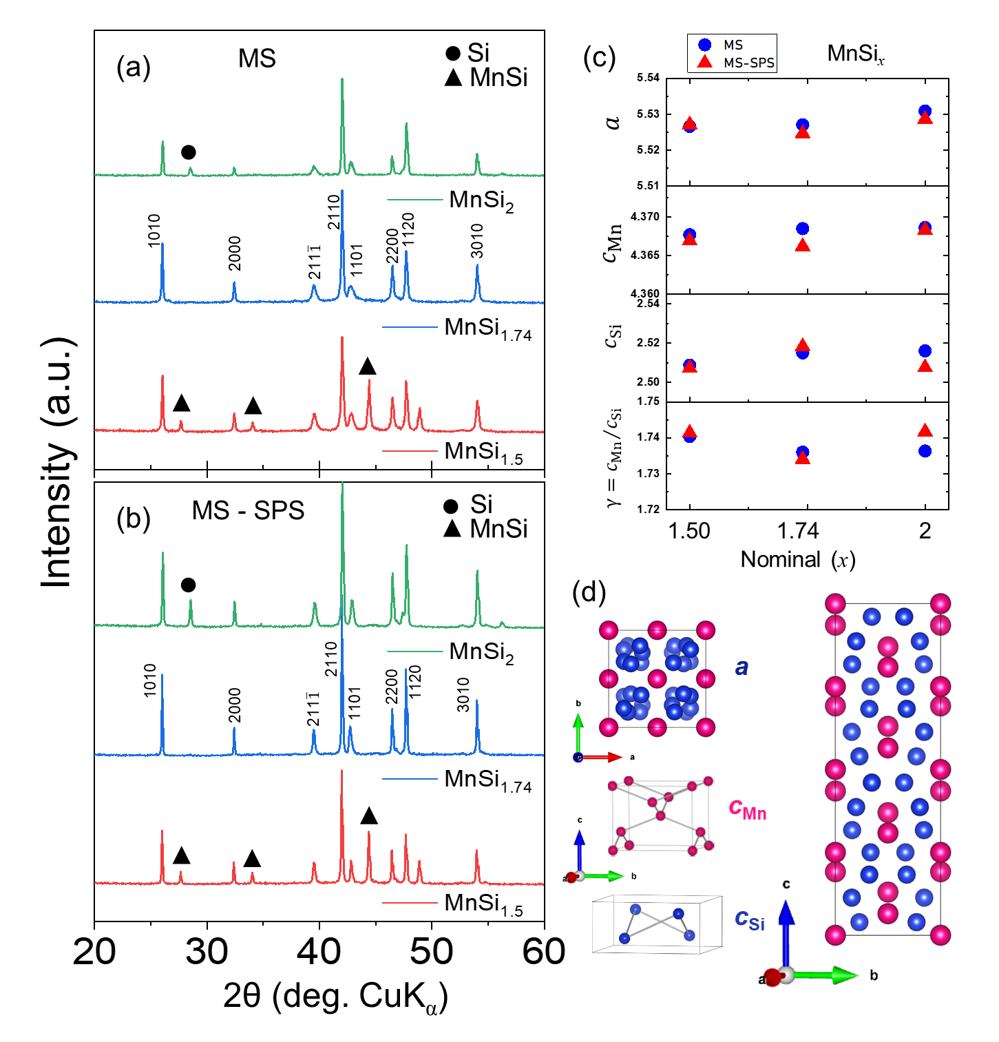

Figure 1. X-ray diffraction patterns of pulverized (a) melt-spun (MS) ribbons, and (b) sintered bulk (MS-SPS); (c) Refined lattice parameters a, $c_{Mn}$, $c_{Si}$ and γ for nominal MnSi_{x} (x =1.5, 1.74 and 2) polycrystals. (d) Crystal structure description of MnSi_{γ} showing the interpenetrating tetragonal Mn- and Si-subsystems with identical a- but different c-lattice parameters. The interaction between the two subsystems leads to a composite MnSi_{γ} unit-cell where γ = $c_{Mn}/c_{Si}$.

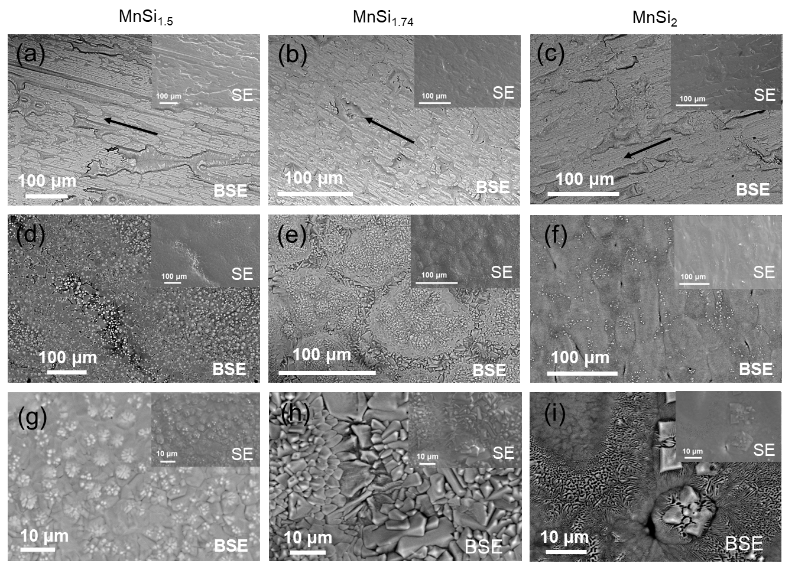
Figure 2. BSE electron micrographs showing (a - c) contact surface and (d - i) free surface at (a - f) low and (g - i) high magnification of melt-spun (MS) ribbon of (a, d, g) MnSi_{1.5}, (b, e, h) MnSi_{1.74}; and (c, f, i) MnSi₂ (MS-SPS) polycrystals. SE- electron micrograph shown in the inset. Arrows representing the tangential direction within the ribbon of wheel contact during the process of rapid consolidation via melt spinning.

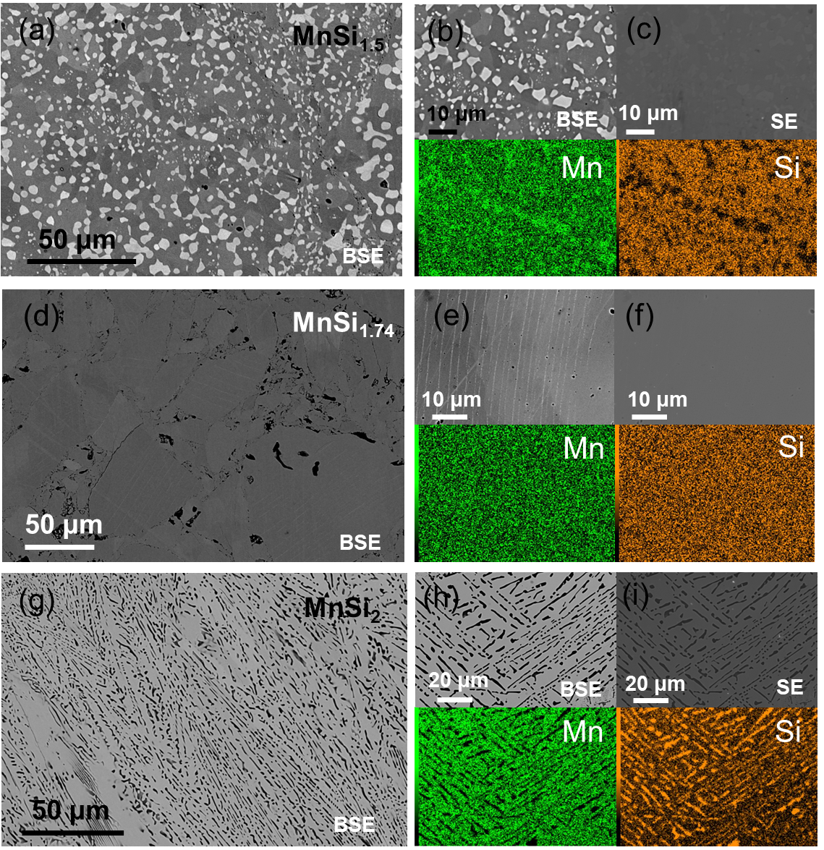

Figure 3. Secondary phases shown at (a, d, g) low, and (b, e, h) high magnification BSE-SEM image; and corresponding (c, f, i) SE-SEM image indicating high densification along with elemental mapping for (a, b, c) MnSi_{1.5} , (d, e, f) MnSi_{1.74} and (g, h, i) MnSi₂ polished sintered MS-SPS specimens.

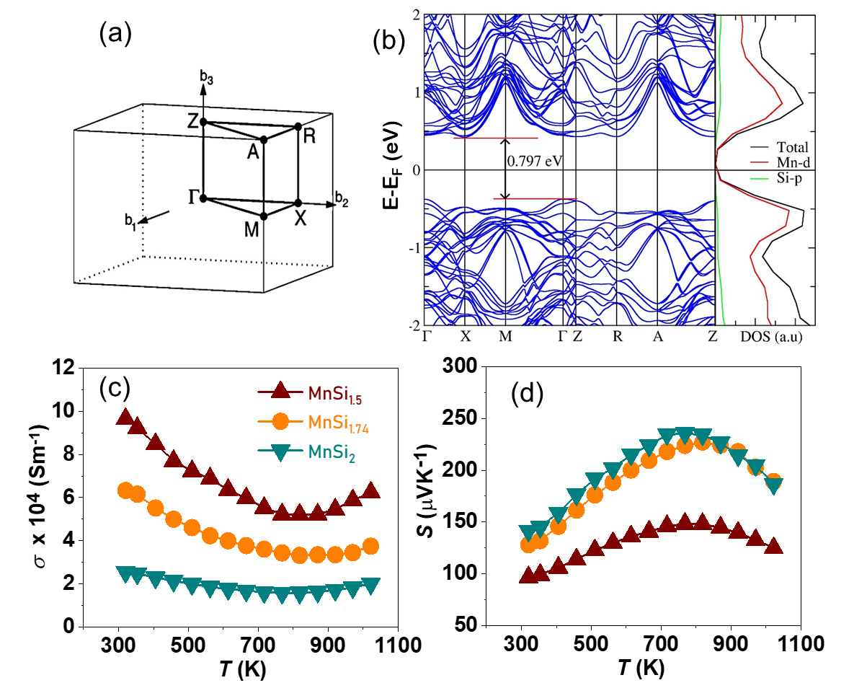
Figure 4. (a) High symmetry K-path of a tetragonal lattice, and (b) electronic band structure plotted along the high symmetry path. The orbital projected density of states of the individual elemental components are shown in the side panel. Temperature dependence of (c) electrical conductivity, and (d) Seebeck coefficient, of nominal MnSi_{x} (x =1.5, 1.74 and 2) MS-SPS polycrystals.
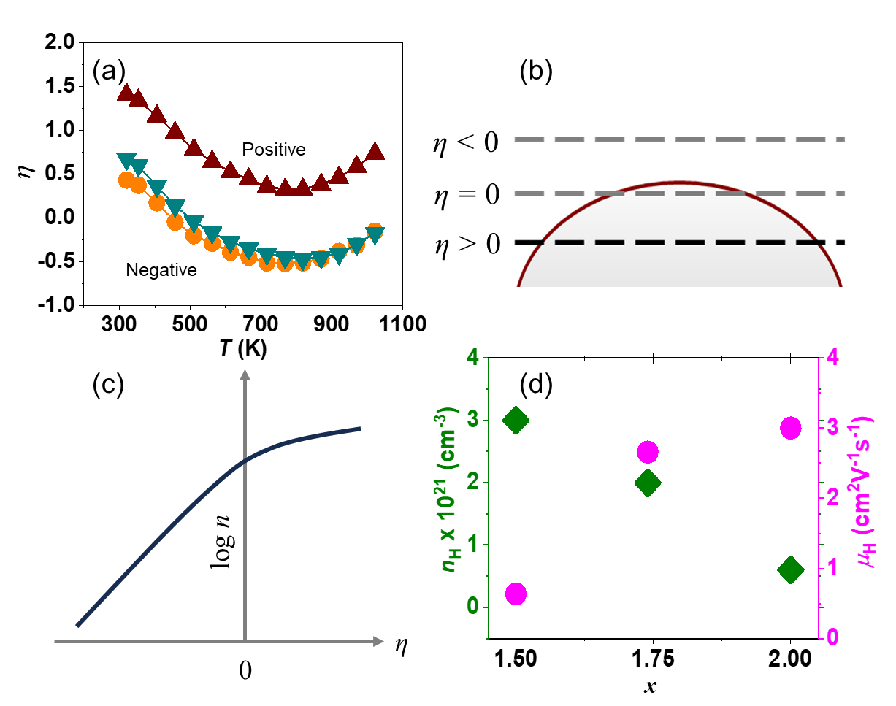
Figure 5. (a) Temperature dependent Reduced fermi level (η); Schematic illustration of (b) η variation on the valence band edge and (c) carrier concentration is a monotonically increasing function of η. (d) Carrier concentration and mobility of nominal MnSi_{x} (x =1.5, 1.74 and 2) MS-SPS polycrystals.

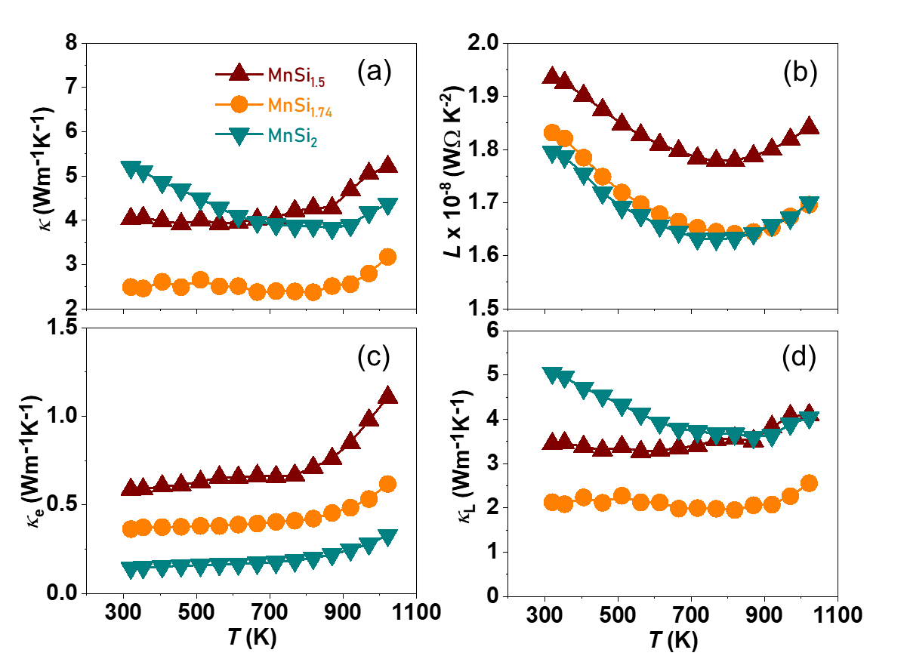
Figure 6. Temperature dependence of (a) total thermal conductivity, (b) Lorenz number, (c) electronic thermal conductivity and (d) lattice thermal conductivity of nominal MnSi_{x} (x =1.5, 1.74 and 2) MS-SPS polycrystals.

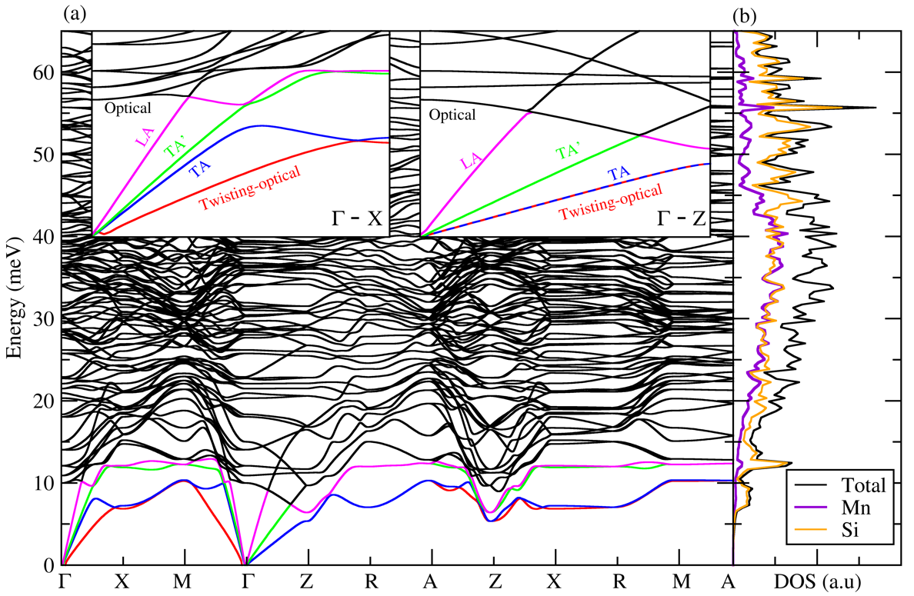
Figure 7. (a) Phonon dispersion along the high symmetry Q path of a tetragonal lattice (b) Total and partial phonon DOS of Mn₄Si_{7.} The insets in (a) show magnified plot of low energy phonon modes along Γ- X and Γ- Z directions i.e., the transverse acoustic modes (TA, TA′), longitudinal acoustic mode (LA) and twisting-optical mode.
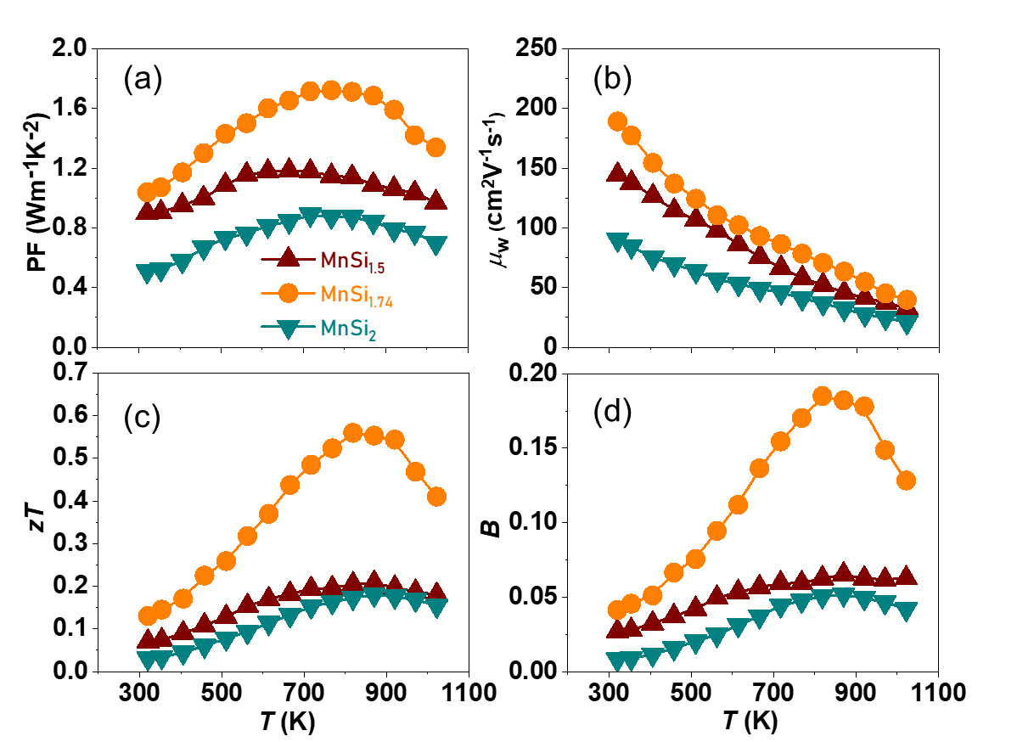
Figure 8. Temperature dependent (a) weighted mobility, (b) quality factor, and (c) thermoelectric figure-of-merit (zT) of nominal MnSi_{x} (x =1.5, 1.74 and 2) MS-SPS polycrystals.

References
(1) Reader, A. H.; Ommen, A. H. van; Weijs, P. J. W.; Wolters, R. A. M.; Oostra, D. J. Transition Metal Silicides in Silicon Technology. Rep. Prog. Phys. 1993, 56 (11), 1397–1467. https://doi.org/10.1088/0034-4885/56/11/002.
(2) Schmitt, A. L.; Higgins, J. M.; Szczech, J. R.; Jin, S. Synthesis and Applications of Metal Silicide Nanowires. J. Mater. Chem. 2010, 20 (2), 223–235. https://doi.org/10.1039/B910968D.
(3) Borisenko, V. E. Semiconducting Silicides; Springer Berlin Heidelberg: Berlin, Heidelberg, 2000.
(4) Opahle, I.; Parma, A.; McEniry, E. J.; Drautz, R.; Madsen, G. K. H. High-Throughput Study of the Structural Stability and Thermoelectric Properties of Transition Metal Silicides. New J. Phys. 2013, 15 (10), 105010. https://doi.org/10.1088/1367-2630/15/10/105010.
(5) Chen, X.; Liang, C. Transition Metal Silicides: Fundamentals, Preparation and Catalytic Applications. Catal. Sci. Technol. 2019, 9 (18), 4785–4820. https://doi.org/10.1039/C9CY00533A.
(6) Williams, H.; Wernick, J.; Sherwood, R.; Wertheim, G. Magnetic Properties of the Monosilicides of Some 3 d Transition Elements. J. Appl. Phys. (Melville, NY, U. S.) 1966, 37 (3), 1256–1256.
(7) Arora, P.; Chattopadhyay, M.; Roy, S. Magnetocaloric Effect in MnSi. Appl. Phys. Lett. 2007, 91 (6).
(8) Silva, M. R.; Brown, P.; Forsyth, J. Magnetic Moments and Magnetic Site Susceptibilities in Mn₅Si₃. J. Phys.: Condens.Matter 2002, 14 (37), 8707.
(9) Brown, P.; Forsyth, J. Antiferromagnetism in Mn5Si3: The Magnetic Structure of the AF2 Phase at 70 K. J. Phys.: Condens.Matter 1995, 7 (39), 7619.
(10) Miyazaki, Y. Higher Manganese Silicides. In Materials Aspect of Thermoelectricity; CRC Press, 2016; pp 434–454. https://doi.org/10.1201/9781315197029.
(11) Gottlieb, U.; Sulpice, A.; Lambert-Andron, B.; Laborde, O. Magnetic Properties of Single Crystalline Mn₄Si₇. J. Alloys Compd. 2003, 361 (1–2), 13–18. https://doi.org/10.1016/S0925-8388(03)00387-6.
(12) Karpinskii, O. G.; Evseev, B. A. Crystal Structure of the Compound Mn₄Si₇. In Chemical Bonds in Solids; Sirota, A. N. N., Ed.; 1972; pp 3–7. https://doi.org/10.1007/978-1-4684-8682-7_1.
(13) Schwomma, O.; Preisinger, A.; Nowotny, H.; Wittmann, A. Die Kristallstruktur von Mn₁₁Si₁₉ und deren Zusammenhang mit Disilicid-Typen. Monatshefte für Chemie 1964, 95 (6), 1527–1537. https://doi.org/10.1007/BF00901708.
(14) Knott, H. W.; Mueller, M. H.; Heaton, L. The Crystal Structure of Mn₁₅Si₂₆. Acta Cryst 1967, 23 (4), 549–555. https://doi.org/10.1107/S0365110X67003184.
(15) Zwilling, G.; Nowotny, H. Zur Struktur der Defekt-Mangansilicide Kristallstruktur von Mn₂₇Si₄₇. Monatshefte für Chemie 1973, 104 (3), 668–675. https://doi.org/10.1007/BF00910577.
(16) Miyazaki, Y. Higher Manganese Silicides. In Thermoelectric Energy Conversion; Woodhead Publishing Series in Electronic and Optical Materials; Elsevier, 2021; pp 375–387. https://doi.org/10.1016/B978-0-12-818535-3.00010-4.
(17) de Boor, J.; Dasgupta, T.; Müller, E. Thermoelectric Properties of Magnesium Silicide–Based Solid Solutions and Higher Manganese Silicides. In Materials Aspect of Thermoelectricity; CRC Press., 2016. https://doi.org/10.1201/9781315197029.
(18) Guo, Q.; Zhang, W.; Liu, Z.; Fu, X.; Le Tonquesse, S.; Sato, N.; Son, H.-W.; Shimamura, K.; Berthebaud, D.; Mori, T. Thermoelectric Performance of Cr Doped and Cr–Fe Double-Doped Higher Manganese Silicides with Adjusted Carrier Concentration and Significant Electron–Phonon Interaction. ACS Appl. Mater. Interfaces 2021, 13 (7), 8574–8583. https://doi.org/10.1021/acsami.0c21484.
(19) Le Tonquesse, S.; Joanny, L.; Guo, Q.; Elkaim, E.; Demange, V.; Berthebaud, D.; Mori, T.; Pasturel, M.; Prestipino, C. Influence of Stoichiometry and Aging at Operating Temperature on Thermoelectric Higher Manganese Silicides. Chem. Mater. 2020, 32 (24), 10601–10609. https://doi.org/10.1021/acs.chemmater.0c03714.
(20) Miyazaki, Y.; Kikuchi, Y. Higher Manganese Silicide, MnSi_{γ}. In Thermoelectric Nanomaterials; Koumoto, K., Mori, T., Eds.; Springer Berlin Heidelberg: Berlin, Heidelberg, 2013; Vol. 182, pp 141–156. https://doi.org/10.1007/978-3-642-37537-8_7.
(21) Miyazaki, Y.; Igarashi, D.; Hayashi, K.; Kajitani, T.; Yubuta, K. Modulated Crystal Structure of Chimney-Ladder Higher Manganese Silicides MnSi_{γ}( γ ∼ 1.74 ). Phys. Rev. B 2008, 78 (21), 214104. https://doi.org/10.1103/PhysRevB.78.214104.
(22) Yamamoto, A. Determination of Composite Crystal Structures and Superspace Groups. Acta Crystallogr., Sect. A: Found. Crystallogr. 1993, 49 (6), 831–846.
(23) Yamamoto, A. Unified Setting and Symbols of Superspace Groups for Composite Crystals. Acta Crystallogr., Sect. A: Found. Crystallogr. 1992, 48 (4), 476–483.
(24) Miyazaki, Y. Superspace Group Approach to the Crystal Structure of Thermoelectric Higher Manganese Silicides MnSi_{γ}. In Neutron Diffraction; Khidirov, I., Ed.; InTech, 2012. https://doi.org/10.5772/36666.
(25) Higgins, J. M.; Schmitt, A. L.; Guzei, I. A.; Jin, S. Higher Manganese Silicide Nanowires of Nowotny Chimney Ladder Phase. J. Am. Chem. Soc. 2008, 130 (47), 16086–16094. https://doi.org/10.1021/ja8065122.
(26) Chauhan, N. S.; Ono, I.; Hayashi, K.; Miyazaki, Y. Relevance of Solidification Kinetics for Enhanced Thermoelectric Performance in Al-Doped Higher Manganese Silicides. ACS Appl. Mater. Interfaces 2022, 14 (46), 51983–51993. https://doi.org/10.1021/acsami.2c16107.
(27) Migas, D. B.; Shaposhnikov, V. L.; Filonov, A. B.; Borisenko, V. E.; Dorozhkin, N. N. Ab Initio Study of the Band Structures of Different Phases of Higher Manganese Silicides. Phys. Rev. B 2008, 77 (7), 075205. https://doi.org/10.1103/PhysRevB.77.075205.
(28) Ham, M.-H.; Lee, J.-W.; Moon, K.-J.; Choi, J.-H.; Myoung, J.-M. Single-Crystalline Ferromagnetic Mn4Si7 Nanowires. J. Phys. Chem. C 2009, 113 (19), 8143–8146.
(29) Zevalkink, A.; Smiadak, D. M.; Blackburn, J. L.; Ferguson, A. J.; Chabinyc, M. L.; Delaire, O.; Wang, J.; Kovnir, K.; Martin, J.; Schelhas, L. T. A Practical Field Guide to Thermoelectrics: Fundamentals, Synthesis, and Characterization. Appl. Phys. Rev. 2018, 5 (2). https://doi.org/10.1063/1.5021094.
(30) Chen, X.; Weathers, A.; Carrete, J.; Mukhopadhyay, S.; Delaire, O.; Stewart, D. A.; Mingo, N.; Girard, S. N.; Ma, J.; Abernathy, D. L.; Yan, J.; Sheshka, R.; Sellan, D. P.; Meng, F.; Jin, S.; Zhou, J.; Shi, L. Twisting Phonons in Complex Crystals with Quasi-One-Dimensional Substructures. Nat. Commun. 2015, 6 (1), 6723. https://doi.org/10.1038/ncomms7723.
(31) Christensen, M.; Abrahamsen, A. B.; Christensen, N. B.; Juranyi, F.; Andersen, N. H.; Lefmann, K.; Andreasson, J.; Bahl, C. R.; Iversen, B. B. Avoided Crossing of Rattler Modes in Thermoelectric Materials. Nat. Mater. 2008, 7 (10), 811–815.
(32) Luo, Y.; Wang, J.; Li, Y.; Wang, J. Giant Phonon Anharmonicity and Anomalous Pressure Dependence of Lattice Thermal Conductivity in Y2Si2O7 Silicate. Sci. Rep. 2016, 6 (1), 29801.
(33) Pandey, T.; Polanco, C. A.; Lindsay, L.; Parker, D. S. Lattice Thermal Transport in La₃Cu₃X₄ Compounds (X= P, As, Sb, Bi): Interplay of Anharmonicity and Scattering Phase Space. Phys. Rev. B 2017, 95 (22), 224306.
(34) Delaire, O.; Ma, J.; Marty, K.; May, A. F.; McGuire, M. A.; Du, M.-H.; Singh, D. J.; Podlesnyak, A.; Ehlers, G.; Lumsden, M. Giant Anharmonic Phonon Scattering in PbTe. Nat. Mater. 2011, 10 (8), 614–619.
(35) Tadano, T.; Gohda, Y.; Tsuneyuki, S. Impact of Rattlers on Thermal Conductivity of a Thermoelectric Clathrate: A First-Principles Study. Phys. Rev. Lett 2015, 114 (9), 095501.
(36) Fredrickson, D. C.; Lee, S.; Hoffmann, R. The Nowotny Chimney Ladder Phases: Whence the 14 Electron Rule? Inorg. Chem. 2004, 43 (20), 6159–6167.
(37) Snyder, G. J.; Snyder, A. H.; Wood, M.; Gurunathan, R.; Snyder, B. H.; Niu, C. Weighted Mobility. Adv. Mater. 2020, 32 (25), 2001537. https://doi.org/10.1002/adma.202001537.
(38) Petříček, V.; Dušek, M.; Palatinus, L. Crystallographic Computing System JANA2006: General Features. Z. Kristallogr. Cryst. Mater 2014, 229 (5), 345–352.
(39) Kresse, G.; Furthmüller, J. Efficient Iterative Schemes for Ab Initio Total-Energy Calculations Using a Plane-Wave Basis Set. Phys. Rev. B 1996, 54 (16), 11169.
(40) Perdew, J. P.; Burke, K.; Ernzerhof, M. Generalized Gradient Approximation Made Simple. Phys. Rev. Lett 1996, 77 (18), 3865.
(41) Blöchl, P. E. Projector Augmented-Wave Method. Phys. Rev. B 1994, 50 (24), 17953.
(42) Momma, K.; Izumi, F. VESTA: A Three-Dimensional Visualization System for Electronic and Structural Analysis. J. Appl. Crystallogr. 2008, 41 (3), 653–658.
(43) Togo, A.; Tanaka, I. First Principles Phonon Calculations in Materials Science. Scr. Mater. 2015, 108, 1–5.
(44) Le Page, Y.; Saxe, P. Symmetry-General Least-Squares Extraction of Elastic Data for Strained Materials from Ab Initio Calculations of Stress. Phys. Rev. B 2002, 65 (10), 104104.

*Corresponding author: nagendra599@gmail.com;b_amrita@iitb.ac.in

