Phase-change Sn-Se thin films prepared via pulsed laser deposition
M. Kotrla¹, H. Segawa², T. Ohsawa², Y. Matsushita³, P. Janíček^{4,5}, J. Gutwirth¹, V. Nazabal^{6,1}, Č. Drašar^{4,5}, P. Němec^{1*}

1 Department of Graphic Arts and Photophysics, Faculty of Chemical Technology, University of Pardubice, Studentska 95, 53210 Pardubice, Czech Republic
2 Research Center for Electronic and Optical Materials, National Institute for Materials Science, Ibaraki 305-0044, Japan
3 Research Network and Facility Services Division, National Institute for Materials Science, 1-2-1 Sengen, Tsukuba, Ibaraki 305-0047, Japan
4 Institute of Applied Physics and Mathematics, Faculty of Chemical Technology, University of Pardubice, Studentská 95, 532 10 Pardubice, Czech Republic
5 Center of Materials and Nanotechnologies, Faculty of Chemical Technology, University of Pardubice, Studentská 95, 532 10 Pardubice, Czech Republic
6 University of Rennes, CNRS, ISCR (Institut des Sciences Chimiques de Rennes) – UMR 6226, F-35000 Rennes, France
* Corresponding author

Abstract
Sn-Se phase-change thin films with four different nominal compositions (Sn₄₀Se₆₀, Sn₃₇Se_{63,} Sn₃₃Se₆₇, Sn₃₀Se₇₀) were prepared by UV pulsed laser deposition. Fabricated films were investigated in the context of the structure, optical and electrical behaviour in both, as-deposited (amorphous) and annealed (crystalline) state. The samples exhibit good electrical contrast between amorphous and annealed state (∼3-6 orders of magnitude) and the optical contrast |Δn|+|Δk| for the wavelength 405 nm / 780 nm is about 0.84 / 1.75 respectively. The study of the Sn-Se films revealed that compositions are prone to undergo phase change into crystalline SnSe and SnSe₂ and display unusual electrical behaviour upon heating. This phenomenon may be characterized as the "localization of electrical charge" occurring very likely on the clusters of nanoparticles of either p-type or n-type crystallized phase.
Keywords
phase-change; Sn-Se; pulsed laser deposition; thin films; localization of electrical charge
Introduction
Tin selenides are materials undergoing the investigation in the context of various applications, including solar cells [1], optoelectronics [2], and electronic device applications such as batteries [3]. Moreover, stoichiometric tin selenides are studied for their thermoelectric properties, characterized by low thermal conductivity and high thermoelectric figure of merit [4,5], making them a promising candidate in energy conversion applications [6]. Another potential of tin selenides is their utilization in phase-change memory devices as reported for SnSe, SnSe₂ and Sn₂Se₃ [7,8]. These tin selenides show up to 5 orders of magnitude drop in the resistivity upon the phase-change (amorphous → crystalline) [7].
At atmospheric pressure, tin selenides exist in SnSe₂ and SnSe phases [9]. SnSe exhibits two crystallographic structures - orthorhombic [10] and cubic [11] while SnSe₂ adopts a hexagonal crystal structure [12]. These binary tin selenide compounds are semiconductors: SnSe presenting p-type [13] conductivity while SnSe₂ is of n-type conductivity [14].
The previous studies of tin selenide thin films are dated back to 2007, when Chandra et al. [15] focused on flash evaporated thin layers of Sn_{50±0.5}Se_{50±0.5} with the thickness of 300 nm deposited at different substrate temperatures (303, 453, 483 and 513 K). All as-deposited SnSe layers exhibited crystallization, phase separation into SnSe and SnSe₂ was observed for samples deposited at lower temperatures of the substrate (303–453 K). The optical bandgap E_{g} of SnSe (at substrate temperature of 513 K) was derived from the Tauc plot as 1.26 eV. In 2008 Chung et al. [7] prepared SnSe, SnSe₂ and Sn₂Se₃ thin films with thickness about 90 nm by molecular beam epitaxy and DC sputtering from single target to be investigated as a potential phase-change memory material. The paper mentions that only SnSe₂ was successfully as-deposited in amorphous state, while SnSe was crystalline and Sn₂Se₃ exhibited partial crystallization of SnSe. The annealed Sn₂Se₃ underwent phase separation to SnSe and SnSe₂. Temperatures of crystallization (T_{C}) for films prepared by molecular beam epitaxy measured with the heating rate of 5 K/min were 488, 493, and 436 K for SnSe, SnSe₂, and Sn₂Se₃. However, the T_{C} in case of sputtered films differed for SnSe₂ and Sn₂Se₃ films. Kumar et al. [16] focused on influence of the substrate temperature in the range of 350–550 K on the structural, optical, and electrical properties of tin selenide thin films deposited by thermal evaporation method. Authors describe the deposited layers as polycrystalline in nature with preferred orientation of grains along the 111 plane. The direct energy band gap values calculated from transmission data were in the range of 1.18-1.50 eV. Micoulaut et al. [8] performed an ab initio molecular dynamics study of liquid and crystalline SnSe₂. The reason to focus on such topic in the context of phase-change was the fact that SnSe₂ itself possess in some details phase-change characteristics similar to Ge-Sb-Te. On the other hand, SnSe₂ is also considered as isochemical compound to GeSe₂ which does not exhibit any interesting properties concerning phase-change.
The aim of our study is to fabricate novel films with different compositions/ratios of Sn:Se, to characterize them and to study their phase change behaviour with the focus on the changes in the electrical as well as optical properties between amorphous and crystalline layers. The motivation here is the combination of two materials with distinctly different nature of conductivity; as mentioned above, SnSe and SnSe₂ are naturally p- and n-type materials, respectively. The deposition method of choice is UV pulsed laser deposition (PLD), which seems to be advantageous due to high absorption of UV light in many materials as well as suitable flat-top energy distribution of the excimer laser beams which are typically used for UV PLD [17]. Furthermore, PLD is flexible, easily controllable technique, which often offers stoichiometric transfer of material to the thin films and fabrication of multi-layered structures [18-19].
Experimental
Polycrystalline samples with the nominal composition Sn₄₀Se₆₀, Sn₃₇Se₆₃, Sn₃₃Se₆₇, and Sn₃₀Se₇₀ were prepared by high-temperature reactions. Samples were synthesized from the stoichiometric mixtures of the 5 N elements (Sn and Se). Synthesis of the samples was done in evacuated quartz ampoules by heating the stoichiometric mixture (1.7 K/min) up to 1223 K. Ampoules were kept at this temperature for 6 h followed by free cooling to room temperature in the turned-off furnace. The resulting bulk materials were powdered in agate mortar and hot-pressed at pressure of 80 MPa and temperature of 693 K (except for the Sn₃₀Se₇₀ composition where temperature of 513 K was used instead) for 1 h in a graphite die. Compact disc-shaped samples (with diameter ~1 inch and thickness ∼4 mm) reaching 93-99% of the theoretical density were used as targets for PLD.
Subsequently, tin selenide thin films were deposited via PLD using multi-chamber system MPE600 (Plassys-Bestek, France) equipped with KrF excimer laser emitting at 248 nm. The output pulse energy was fixed at 140±3 mJ, with the pulse duration of 30 ns, and the repetition rate of 20 Hz. Laser energy density was set at ∼2 J/cm². The thin films were deposited in a vacuum chamber: the pressure during the deposition was (0.5-1.6)×10⁻⁵ Pa, while the background pressure was (4−5)×10⁻⁶ Pa. To obtain films with good thickness and composition uniformity, the off-axis PLD technique exploiting rotating substrates and targets was used. The rotational speeds of both targets and substrates were ∼5 rpm. Single-crystalline ⟨100⟩ oriented silicon wafers and microscope glass slides were utilized as substrates. They were positioned parallel to the target surface at target-to-substrate distance of 6 cm. Furthermore, the substrates were placed at constant distance from the axis of the rotation. The duration of the depositions was based on the desired film thickness of ∼170−210 nm.
The chemical composition of as-deposited and annealed films was verified by an electron microscope TM4000 (Hitachi, Japan) combined with an Energy-dispersive X-ray spectroscopy (EDX) analyzer XFlash 660H (Bruker, Germany). The optical properties were studied exploiting two variable angle spectroscopic ellipsometers VASE and IR-VASE (both J. A. Woollam, USA) in spectral range of 300 nm–12 μm. The first ellipsometer with automatic rotating analyzer was used for the UV-Vis-NIR region, measuring 100 revolutions with wavelength step of 20 nm at selected angles of incidence (50°, 60°, and 70°). The second ellipsometer with rotating compensator was employed for IR region at angles of incidence as above (50 scans, 15 spectra per revolution, resolution of 8 cm⁻¹) in both samples’ states – as deposited and annealed for samples deposited on glass substrate. The annealing of the samples for ellipsometry, EDX and Raman analysis purposes took place in Ar ambient and the annealing temperatures (T_{A}) were chosen to reach approximately 50 K above the T_{C}, specifically for Sn₄₀Se₆₀ T_{A} = 513 K, Sn₃₇Se₆₃ T_{A} = 493 K, Sn₃₃Se₆₇ T_{A} = 478 K, Sn₃₀Se₇₀ T_{A} = 453 K.
The resistivity and Hall effect measurements were performed on system Resitest 8300 (Toyo, Japan) with liquid nitrogen cryostat cell filled with helium with the temperature range up to 475 K. The data were collected each 5 K, from room temperature up to 475 K and the stability of the temperature was firmly regulated. The sheet resistance was measured using van der Pauw method [20]. Raman scattering spectra were recorded with inVia spectrometer (Renishaw, UK) with 532 nm excitation laser source. X-ray diffraction (XRD) measurements were performed at in-plane mode by SmartLab (Rigaku, Japan) with the detector D/teX Ultra 250, X-ray source Cu Kα, in 2θ scan mode, from 10° to 50° for as-deposited and 10° to 80° for annealed samples with step of 0.1°. Surface roughness was measured by AFM5100N (Hitachi, Japan) in dynamic force microscope measurement mode.
Results and discussion
The composition of as-deposited and annealed thin films determined by EDX is summarized in Table 1. The chemical composition of as-deposited thin films is in relatively good agreement with nominal one. However, one can notice a slight abundance of Sn amount in the prepared films comparing to the nominal/planned composition. The loss of selenium is probably caused by its higher volatility compared to tin. We note that annealing/phase change has negligible impact on the chemical composition of crystalline films/samples. It is worth to mention that chemical composition of the polycrystalline targets correspond to nominal composition within expected experimental error (±(1-2) at. %).
Table 1 Characterization of the Sn-Se thin films prepared via pulsed laser deposition: chemical composition (±(1-2) at. %) in as-deposited and annealed layers determined from EDX, temperatures of crystallization (±2 K) determined from R_{sqr} measurements, thickness of the films (±1 nm) and absolute values of optical contrast ⏐Δn⏐+⏐Δk⏐ at 405 and 780 nm (±0.04) determined from spectroscopic ellipsometry.
Sample | Nominal composition | Sn (at. %) /  Se (at. %)  as-deposited film | Sn (at. %) /  Se (at. %)  annealed film | T_{C} (K) | Thickness (nm) | |Δn|+|Δk|  (405 nm) | |Δn|+|Δk|  (780 nm)
1 | Sn₄₀Se₆₀ | 44 / 56 | 44 / 56 | 385 | 213 | 0.84 | 1.75
2 | Sn₃₇Se₆₃ | 41 / 59 | 41 / 59 | 394 | 186 | 0.39 | 1.56
3 | Sn₃₃Se₆₇ | 38 / 62 | 38 / 62 | 409 | 185 | 0.65 | 1.52
4 | Sn₃₀Se₇₀ | 35 / 65 | 37 / 63 | 443 | 171 | 0.83 | 1.33

Figure 1 Temperature-dependent sheet resistance (R_{sqr}) (left) and Hall concentration (right) of Sn-Se thin films deposited on the glass substrate (heating rate of 2 K/min). For chemical composition of the samples we refer to Table 1. Type of the electrical conductivity (n or p) is emphasized.
Figure 1 (left) shows the temperature dependence of the sheet resistance of measured samples with clear drop (∼3-6 orders of magnitude) corresponding to phase change from amorphous-to- crystalline state. With the increasing Se content temperature of crystallization (T_{C}) shifts to the higher temperatures. Obtained T_{C} summarized in Table 1 are lower than 488 K for SnSe, respectively 493 K for SnSe₂ reported by Chung et al. [7] which can by caused by different deposition method (pulsed laser deposition vs. molecular beam epitaxy) or different thickness of the layer. Based on the polarity of the Hall voltage, all samples are n-type semiconductors except for the sample 1 which is thin films with the highest content of SnSe phase (according to results XRD and Raman scattering spectroscopy results presented in Figure 2) being a p-type semiconductor. According to the literature, SnSe naturally exhibits p-type conductivity due to the presence of tin vacancies [13] and SnSe₂ n-type conductivity due to the presence of selenium vacancies [14]. The temperature dependence of the Hall concentration depicted in figure 1 (right) exhibits also abrupt change at T_{C} corresponding to phase change. Note that Hall concentration n, resp. p is calculated from Hall coefficient R_{H} using simplified assumption of single type of free carriers using equation R_{H} = 1/(n⋅e), resp. R_{H} = 1/(p⋅e) where e is elementary charge.
Figure 2 (left) Room temperature XRD patterns of Sn-Se annealed films and powder diffraction patterns of the SnSe and SnSe₂ from crystallographic database [21]. (right) Raman scattering spectra of Sn-Se annealed films. Annealing temperature is specified for each composition. For chemical composition of the samples we refer to Table 1.
Diffractograms measured for as-deposited thin films exhibit only broad amorphous band (not shown). The diffractograms for annealed thin films shown in Figure 2 (left) present diffraction peaks which can be related to orthorhombic SnSe (Pnma, PDF # 04-009-2257) and hexagonal SnSe₂ (R-3m, PDF # 04-003-4607). From the diffractogram of sample 4 (Figure 2 left, green data), it is evident that the peaks from SnSe either have very low intensity or they are completely absent. This makes it challenging to determine whether the broad peak at 2θ ∼ 29.1° is real 002 plane originated from SnSe₂ or it is a representation of the wide diffraction peak from SnSe 011 plane or if the overlapping of both occurs. In case of the sample 3 (Figure 2 left, blue data), there is probably a portion of SnSe represented by SnSe 011 peak. Overall, with higher content of Sn in samples’ composition the intensity of diffraction from orthorhombic SnSe (Pnma, PDF # 04-009-2257) phase increases.
Local structure of the annealed samples was analysed by Raman scattering spectroscopy and the results are depicted in Figure 2 (right). For the sample 4 (Figure 2 right, green curve) the only visible peak contribution is originating from SnSe₂ composition more specifically presence of E_{g} mode at ~ 118 cm⁻¹ and A_{1g} mode at ∼185 cm⁻¹ as mentioned by Li et al. [22]. For other samples there is one more peak at ~ 157 cm⁻¹ (the most prominent for sample 1 – Figure 2 right, black curve) which can be assigned probably to A_{g}³ mode of SnSe [23]. Raman spectra for as-deposited samples are not shown because they had tendency to crystallize during the measurement.
Based on the results presented in Figures 1-2 we propose mechanism of the phase change for Sn-Se thin films. In our opinion during annealing very likely both crystalline phases (SnSe as well as SnSe₂ visible in XRD) are created with the note that crystallization temperature of SnSe is lower than that of SnSe₂. However, we observe (Fig. 1) a distinct feature. Specifically, the significant drops of Hall concentration suggest a localization of free carriers at the very beginning of crystallization process. To our knowledge this has not been observed in any phase change material. With respect to the fact that crystals of SnSe are p-type while crystals of SnSe₂ are n-type we hypothesize that this charge localization is associated with a formation of very small (nano-) p-n junctions during annealing. We note that this process was observed in an earlier study of SnSe single crystals. Here, it was observed that SnSe₂ forms spontaneously in SnSe single crystals without any mechanical stress and hence deformation. The process is facilitated by the fact that both SnSe and SnSe₂ are layered van der Waals materials, thus with perfect interlayer matching (Figure 3 shows the in-situ formation of SnSe₂ domains in an equilibrium SnSe single crystal previously studied by K. Sraitrova et. al [24]). Moreover, such formation of nano p-n junctions is corroborated by the process of diffusion – during the crystallization SnSe-SnSe₂ pairs are formed – naturally one Se-rich and other Se-poor. Such a p-n junction must lead to localization of free carriers as long as percolation limit of that p-n junctions is reached. Then, transport mechanism is transformed from hopping into band-like transport of nano-crystalline (quasi-amorphous) solid composed of two materials. The electrical conductivity and carrier concentration increase with the increasing size of crystals. The change of the T_{C} of this process with composition (see dependence of sheet resistivity in Figure 1 left and Hall concentration in Figure 1 right) then might be connected with the SnSe/SnSe₂ ratio. On the other hand, neither from the Hall coefficient measurements nor from XRD or Raman measurement, the content of each phase cannot be unambiguously determined. In this case, however, it can be clearly stated that if the Hall coefficient shows an n-type conductivity, the n-type material (SnSe₂) dominates the volume and exceeds the percolation limit. Accordingly, the chemical analysis (Table 1) shows that sample 4, for example, contains approximately 90% SnSe₂ and 10% SnSe, hence n-type. Sample 1 contains about 64% SnSe, p-type. However, if none of the phases exceeds the percolation limit, the additivity of the properties is not guaranteed. Samples 2 and 3 (both n-type) contain 54% and 72% SnSe₂, indicating that SnSe₂ is the dominant component in terms of charge transport.
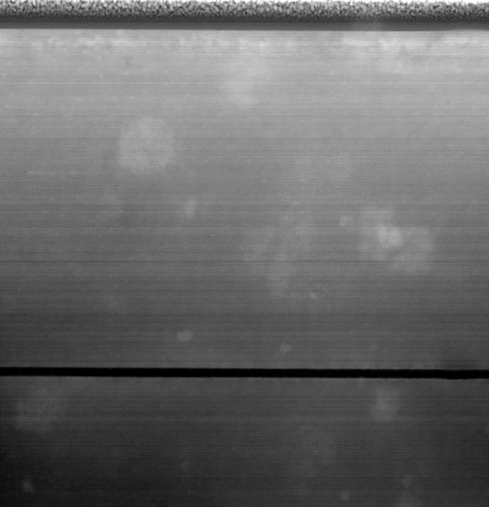 | 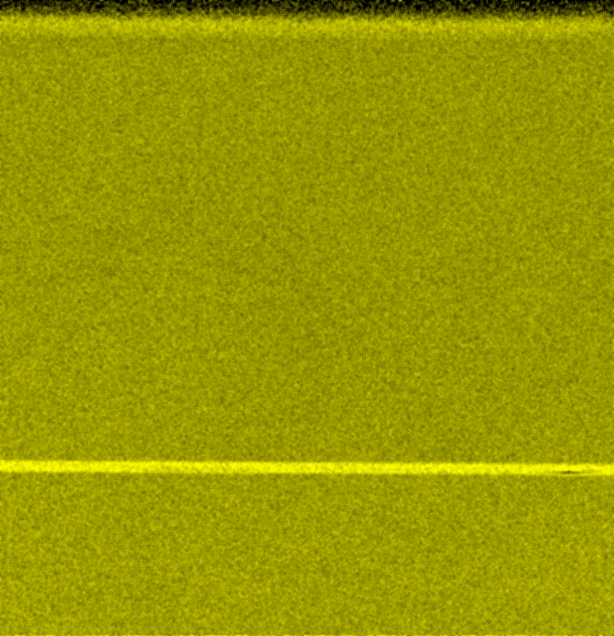
Figure 3 Cross sectional view of SnSe single crystal with dimensions ∼5x5 μm. (left) SEM image and (right) corresponding EDX mapping of Se showing in-situ formation of SnSe₂ domains within SnSe single crystal.
Figure 4 illustrates dependencies of the optical functions (refractive index n and extinction coefficient k) for both as-deposited (full curves) and annealed (dashed curves) Sn-Se thin films on photon energy obtained utilizing spectroscopic ellipsometry. Photon energies corresponding to wavelengths 405 nm and 780 nm used in Blue-ray disc and Compact discs (CD) respectively are also marked in Figure 4. Spectroscopic ellipsometry is an indirect optical characterization method, where the measured values ψ^{exp} and Δ^{exp} are compared to the values calculated from the model ψ^{mod} and Δ^{mod}. Two parameters, amplitude ratio, ψ, and phase shift, Δ, are defined by using the Fresnel reflection coefficients for p- (r_{p}) and s- (r_{s}) polarized light and express the change of the polarization state: r_{p}/r_{s} = tan(Ψ) •exp(iΔ). Fitting procedure is used with the aim to minimize Mean Square Error (MSE) [25,26]. For the analysis of as-deposited thin films' ellipsometric data, the Cody-Lorentz model, which includes the correct band edge function, a description of the weak Urbach absorption tail, as well as a Lorentz oscillator, was applied [27]. Increase of the refractive index and decrease of the energy bandgap with higher content of Sn in samples’ composition can be noted for as-deposited samples (sample 1 having the highest refractive index and the lowest energy bandgap – full black curve). For annealed/crystalline samples, parameterized semiconductor oscillator function [28-30] together with Drude-type contribution for free carriers [31] and another Lorentz oscillator for interband transitions for higher photon energies was utilized. Parameterized semiconductor oscillator function was utilized due to direct allowed transition bandgap of SnSe [15] and SnSe₂ [32].

Figure 4 Spectral dependence of refractive index (left) and extinction coefficient (right) of Sn-Se layers in both as-deposited (full curves) and annealed (dashed curves) state. For chemical composition of the samples we refer to Table 1.
Optical contrast was calculated as Δn+iΔk (n, k (annealed)-n, k (as-deposited)) and absolute values of optical contrast at 405 and 780 nm in terms of |Δn|+|Δk| can be found in Table 1. For 405 nm, the maximal optical contrast ∼ 0.84 found for sample 1 is lower in comparison with the value 2.25 [33] of commercial Ge₂Sb₂Te₅. It is worth to mention that optical contrast at 780 nm which is wavelength used in CD’s is particularly higher (∼ 1.33-1.75).
sample 1 | sample 2 | sample 3 | sample 4
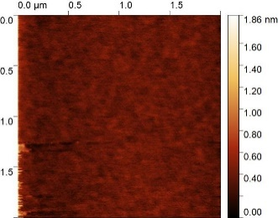  RMS = 0.1 nm | 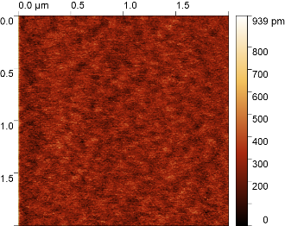  RMS = 0.1 nm | 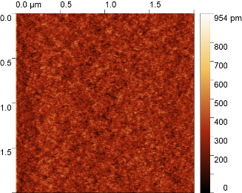  RMS = 0.1 nm | 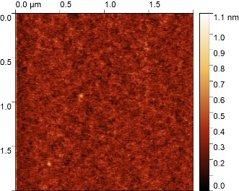  RMS = 0.1 nm
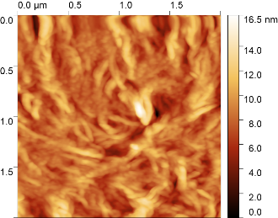  RMS = 1.8 nm | 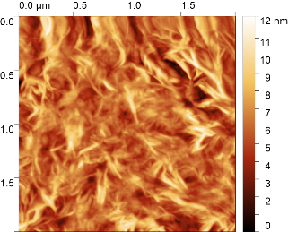  RMS = 1.8 nm | 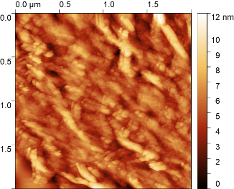  RMS = 2.4 nm |   RMS = 3.5 nm
Figure 5 AFM scans (2 × 2 μm) for as-deposited (top row) and annealed (bottom row) Sn-Se layers together with RMS values. For chemical composition of the samples we refer to Table 1.

AFM 2 μm × 2 μm scans depicted in Figure 5 shows smooth surface of all studied as-deposited Sn-Se thin films (top row) without the presence of any structures, crystals, or cracks with the root mean square (RMS) surface roughness about 0.1 nm. As-expected, for annealed Sn-Se thin films RMS surface roughness increases to ~ 1.8–3.5 nm due to presence of crystalline structure and corresponding features/structures (bottom row).
Conclusion
After the annealing the Sn-Se layers deposited by pulsed laser deposition undergo the phase-separation and crystallize into orthorhombic SnSe and hexagonal SnSe₂ which was confirmed by XRD and Raman spectroscopy. With increasing Se content temperature of crystallization T_{C} shifts to the higher temperatures. There is also clear change in the optical constants between amorphous and annealed samples. Although the samples exhibit good electrical contrast between amorphous and annealed state (∼3-6 orders of magnitude), the optical contrast |Δn|+|Δk| for the wavelength 405 nm / 780 nm is lower (∼ 0.84 / ∼ 1.75) than for commercially used Ge₂Sb₂Te₅ layers (∼ 2.25). We propose that during the annealing nano(subnano) crystalline plates of p-type SnSe and simultaneously nano(subnano) crystalline plates of n-type SnSe₂ are present in the layers leading to "localization of electrical charge" manifested by abrupt changes in the sheet resistance and Hall concentration. Depicted crystalline nano/micro clusters would benefit in potential high data density. Additionally, Sn-Se is cheaper than Ge₂Sb₂Te₅. Challenge for other researchers is whether presence of these nano(subnano) crystalline plates could be experimentally proven in this pair of materials or another pair of similar nature. We anticipate that the combination of two van der Waals layered materials with opposite conductivity types may lead to unexpected results, as shown in this paper.
Acknowledgements
The financial support from the Czech Science Foundation (GA ČR), project No. 22-07635S is highly appreciated. This work was also supported by the Ministry of Education, Youth, and Sports of the Czech Republic, grant number LM2023037. Authors are thankful to Dr. Jaroslav Barták for the EDX measurements and analysis and to Dr. Kateřina Čermák Šraitrová for preparation of polycrystalline samples used as targets for PLD deposition. Authors would like to acknowledge prof. J. Málek for establishment as well as support of internships of students between National Institute for Materials Science (Japan) and University of Pardubice (Czech Republic).
References
1. V. Reddy, S. Gedi, B. Pejjai, C. Park, Perspectives on SnSe-based thin film solar cells: a comprehensive review, J. Mater. Sci. Mater. Electron. 27 (2016) 5491-5508. https://doi.org/10.1007/s10854-016-4563-9.
2. T. Inoue, H. Hiramatsu, H. Hosono, T. Kamiya, Heteroepitaxial growth of SnSe films by pulsed laser deposition using Se-rich targets, J. Appl. Phys. 118 (2015) 205302. https://doi.org/10.1063/1.4936202.
3. D.-H. Lee, C.-M. Park, Tin Selenides with Layered Crystal Structures for Li-Ion Batteries: Interesting Phase Change Mechanisms and Outstanding Electrochemical Behaviors, ACS Appl. Mater. Interfaces 9 (2017) 15439- 15448. https://doi.org/10.1021/acsami.7b01829.
4. L.-D. Zhao, S.-H. Lo, Y. Zhang, H. Sun, G. Tan, C. Uher, C. Wolverton, V.P. Dravid, M.G. Kanatzidis, Ultralow thermal conductivity and high thermoelectric figure of merit in SnSe crystals, Nature 508 (2014) 373-377. https://doi.org/10.1038/nature13184.
5. P.-C. Wei, S. Bhattacharya, J. He, S. Neeleshwar, R. Podila, Y.Y. Chen, A.M. Rao, The intrinsic thermal conductivity of SnSe, Nature 539 (2016) E1-E2. https://doi.org/10.1038/nature19832.
6. V.Q. Nguyen, J. Kim, S. Cho, A Review of SnSe: Growth and Thermoelectric Properties, J. Korean Phys. Soc. 72 (2018) 841-857. https://doi.org/10.3938/jkps.72.841.
7. K.-M. Chung, D. Wamwangi, M. Woda, M. Wuttig, W. Bensch, Investigation of SnSe, SnSe₂, and Sn₂Se₃ alloys for phase change memory applications, J. Appl. Phys. 103 (2008) 083523. https://doi.org/10.1063/1.2894903.
8. M. Micoulaut, W. Wełnic, M. Wuttig, Structure of the liquid and the crystal of the phase-change material SnSe₂: First-principles molecular dynamics, Phys. Rev. B 78 (2008) 224209. https://doi.org/10.1103/PhysRevB.78.224209.
9. H. Okamoto, Se-Sn (Selenium-Tin), J. Phase Equilibria 19 (1998) 293-293. https://doi.org/10.1361/105497198770342544.
10. M. Taniguchi, R.L. Johnson, J. Ghijsen, M. Cardona, Core excitons and conduction-band structures in orthorhombic GeS, GeSe, SnS, and SnSe single crystals, Phys. Rev. B 42 (1990) 3634-3643. https://doi.org/10.1103/PhysRevB.42.3634.
11. R.E. Abutbul, E. Segev, S. Samuha, L. Zeiri, V. Ezersky, G. Makov, Y. Golan, A new nanocrystalline binary phase: synthesis and properties of cubic tin monoselenide, CrystEngComm 18 (2016) 1918-1923. https://doi.org/10.1039/C5CE02437D.
12. E.P. Mukhokosi, S.B. Krupanidhi, K.K. Nanda, Band Gap Engineering of Hexagonal SnSe₂ Nanostructured Thin Films for Infra-Red Photodetection, Sci. Rep. 7 (2017) 15215. https://doi.org/10.1038/s41598-017-15519-x.
13. B. Qin, W. He, L.-D. Zhao, Estimation of the potential performance in p-type SnSe crystals through evaluating weighted mobility and effective mass, J. Materiomics 6 (2020) 671-676. https://doi.org/10.1016/j.jmat.2020.06.003.
14. E. Barrios-Salgado, M.T.S. Nair, P.K. Nair, Thin films of n-type SnSe₂ produced from chemically deposited p-type SnSe, Thin Solid Films 598 (2016) 149-155. https://doi.org/10.1016/j.tsf.2015.11.075.
15. G.H. Chandra, J.N. Kumar, N.M. Rao, S. Uthanna, Preparation and characterization of flash evaporated tin selenide thin films, J. Cryst. Growth 1 (2007) 68-74. https://doi.org/10.1016/j.jcrysgro.2007.05.004.
16. N. Kumar, V. Sharma, N. Padha, N. Shah, M. Desai, C. Panchal, I. Protsenko, Influence of the substrate temperature on the structural, optical, and electrical properties of tin selenide thin films deposited by thermal evaporation method, Cryst. Res. Technol. 45 (2010) 53-58. https://doi.org/10.1002/crat.200900424.
17 L. Prokeš, M. Gorylová, K. Čermák Šraitrová, V. Nazabal, J. Havel, P. Němec, Arsenic-Doped SnSe Thin Films Prepared by Pulsed Laser Deposition, ACS Omega 6 (2021) 17483- 17491. https://doi.org/10.1021/acsomega.1c01892.
18 M. Bouška, S. Pechev, Q. Simon, R. Boidin, V. Nazabal, J. Gutwirth, E. Baudet, P. Němec, Pulsed laser deposited GeTe-rich GeTe-Sb₂Te₃ thin films, Sci. Rep. 6 (2016) 26552. https://doi.org/10.1038/srep26552.
19. P. Němec, V. Takats, A. Csik, S. Kokenyesi, GeSe/GeS nanomultilayers prepared by pulsed laser deposition, J. Non-Cryst. Solids 354 (2008) 5421-5424. https://doi.org/10.1016/j.jnoncrysol.2008.09.006
20. L. J. van der Pauw, A Method of Measuring Specific Resistivity and Hall Effect of Discs of Arbitrary Shape, Philips Res Rep 13 (1958) 1-9.
21. S. Gates-Rector, T. Blanton, The Powder Diffraction File: a quality materials characterization database, Powder Diffr. 34 (2019) 352-360. https://doi.org/10.1017/S0885715619000812.
22. Y. Li, J. Duan, Y. Berencén, R. Hübner, H.-S. Tsai, C.-N. Kuo, C. Shan Lue, M. Helm, S. Zhou, S. Prucnal, Formation of a vertical SnSe/SnSe₂ p–n heterojunction by NH₃ plasma-induced phase transformation, Nanoscale Adv. 5 (2023) 443-449. https://doi.org/10.1039/D2NA00434H.
23. H.R. Chandrasekhar, R.G. Humphreys, U. Zwick, M. Cardona, Infrared and Raman spectra of the IV-VI compounds SnS and SnSe, Phys. Rev. B 15 (1977) 2177-2183. https://doi.org/10.1103/PhysRevB.15.2177.
24. K. Sraitrova, J. Cizek, V. Holy, T. Plechacek, L. Benes, M. Jarosova, V. Kucek, C. Drasar, Vacancies in SnSe single crystals in a near-equilibrium state, Phys. Rev. B 99 (2019) 035306. https://doi.org/10.1103/PhysRevB.99.035306.
25. G.G. Politano, C. Versace, Spectroscopic ellipsometry: advancements, applications and future prospects in optical characterization, Spectroscopy J. 1 (2023) 163–181. https://doi.org/10.3390/spectroscj1030014.
26. J.A. Woollam, P.G. Snyder, M.C.Rost, Variable angle spectroscopic ellipsometry: a non-destructive characterization technique for ultrathin and multilayer materials, Thin Solid Films 166 (1988) 317–323. https://doi.org/10.1016/0040-6090(88)90393-8.
27. A.S. Ferlauto, G.M. Ferreira, J.M. Pearce, C.R. Wronski, R.W. Wronski, X. Deng, G. Ganguly, Analytical model for the optical functions of amorphous semiconductors from the near-infrared to ultraviolet: applications in thin film photovoltaics, J. Appl. Phys. 92 (2002) 2424–2436. https://doi.org/10.1063/1.1497462.
28. Guide to using WVASE32 Software for Spectroscopic Ellipsometry Data Acquisition and Analysis, in, J. A. Woollam Co. Inc., 2000.
29. Y.S. Ihn, T.J. Kim, T.H. Ghong, Y.D. Kim, D.E. Aspnes, J. Kossut, Parametric modeling of the dielectric functions of Cd_{1−x}Mg_{x}Te alloy films, Thin Solid Films 455 (2004) 222-227. https://doi.org/10.1016/j.tsf.2004.01.015.
30. B. Johs, C.M. Herzinger, J.H. Dinan, A. Cornfeld, J.D. Benson, Development of a parametric optical constant model for Hg_{1−x}Cd_{x}Te for control of composition by spectroscopic ellipsometry during MBE growth, Thin Solid Films 313-314 (1998) 137-142. https://doi.org/10.1016/S0040-6090(97)00800-6.
31. T.E. Tiwald, D.W. Thompson, J.A. Woollam, W. Paulson, R. Hance, Application of IR variable angle spectroscopic ellipsometry to the determination of free carrier concentration depth profiles, Thin Solid Films 313-314 (1998) 661-666. https://doi.org/10.1016/S0040-6090(97)00973-5.
32. G.A. Ermolaev, D.I. Yakubovsky, M.A. El-Sayed, M.K. Tatmyshevskiy, A.B. Mazitov, A.A. Popkova, I.M. Antropov, V.O. Bessonov, A.S. Slavich, G.I. Tselikov, I.A. Kruglov, S.M. Novikov, A.A. Vyshnevyy, A.A. Fedyanin, A.V. Arsenin, V.S. Volkov, Broadband Optical Constants and Nonlinear Properties of SnS₂ and SnSe₂, Nanomaterials 12 (2022) 141. https://doi.org/10.3390/nano12010141.
33. N. Yamada, Origin, secret, and application of the ideal phase-change material GeSbTe, Phys. Status Solidi B 249 (2012) 1837-1842. https://doi.org/10.1002/pssb.201200618.

