Supporting Information
Elevation and adhesion properties of injectable hydrogels based on catechol/boronic acid-modified Alaska pollock gelatin for endoscopic submucosal dissection

Kazuhiro Nagasaka^{1,2}, Hiyori Komatsu^{1,2}, Shima Ito^{1,2}, Debabrata Palai², Akihiro Nishiguchi², Tetsushi Taguchi^{1,2}*

¹Graduate School of Science and Technology, Degree Programs in Pure and Applied Sciences, University of Tsukuba, 1-1-1 Tennodai, Tsukuba, Ibaraki 305-8577, Japan

²Biomaterials Field, Research Center for Macromolecules and Biomaterials, National Institute for Materials Science, 1-1 Namiki, Tsukuba, Ibaraki 305-0044, Japan

*Corresponding author at: Biomaterials Field, Research Center for Macromolecules and Biomaterials, National Institute for Materials Science, 1-1 Namiki, Tsukuba, Ibaraki 305-0044, Japan
E-mail address: TAGUCHI.Tetsushi@nims.go.jp (T. Taguchi)
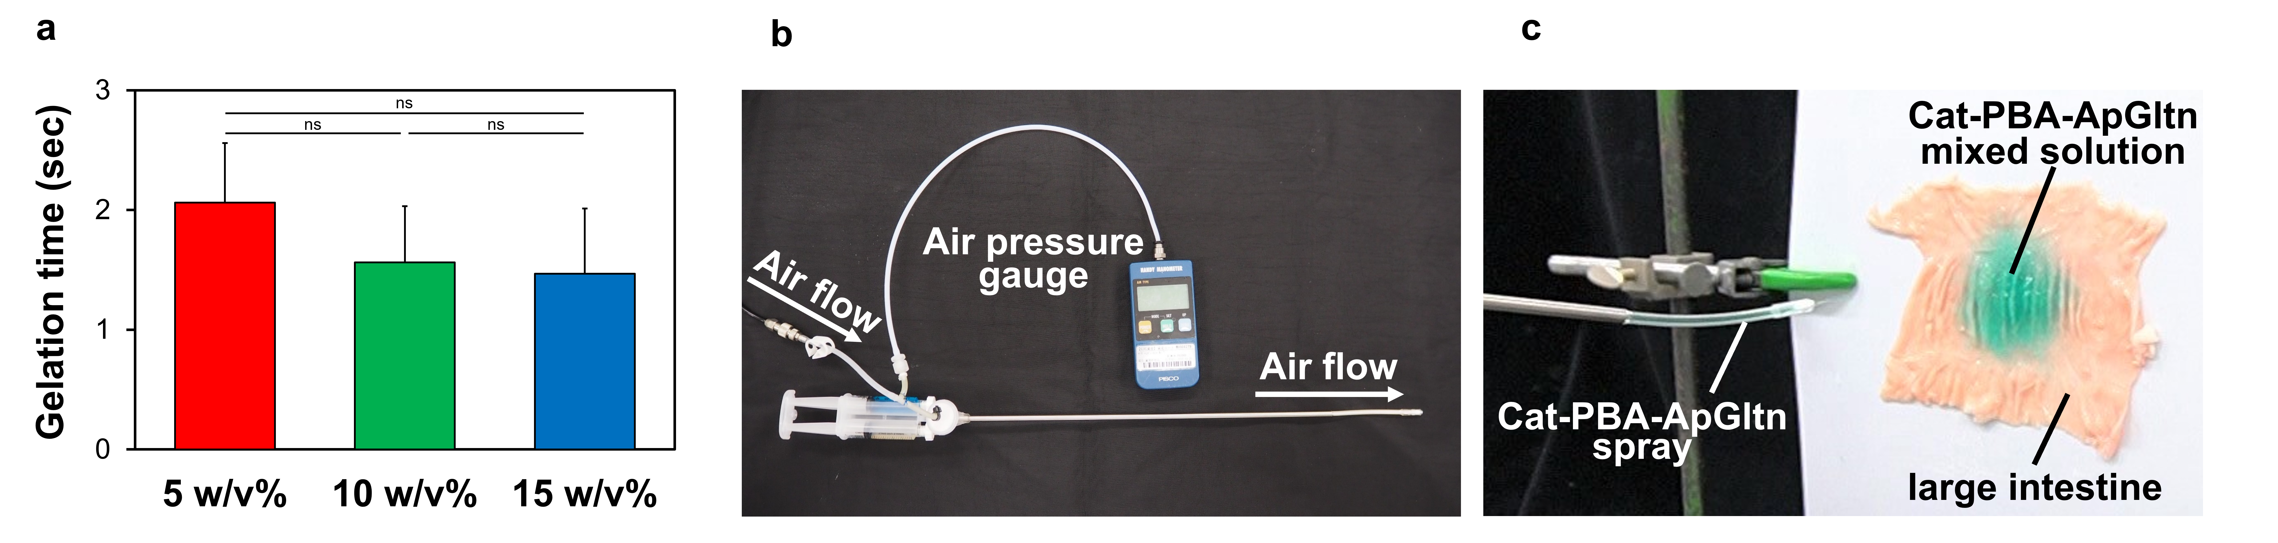
Fig. S1. Gelation time of the mixed Cat-PBA-ApGltn solutions. (a) Gelation time of the mixed Cat-PBA-ApGltn solutions of varying concentrations (n = 5). Data are presented as mean ± SD. Significant differences between groups were analyzed by Tukey's multiple comparisons test. ns = no significance. (b) Image of the spray device. (c) Image of the 10 w/v% Cat-PBA-ApGltn mixed solution being sprayed onto a vertical porcine large intestine.

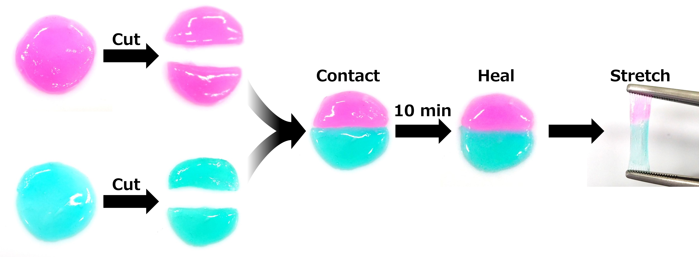
Fig. S2. Images of the macroscopic self-healing behavior of the 10 w/v% Cat-PBA-ApGltn hydrogel.

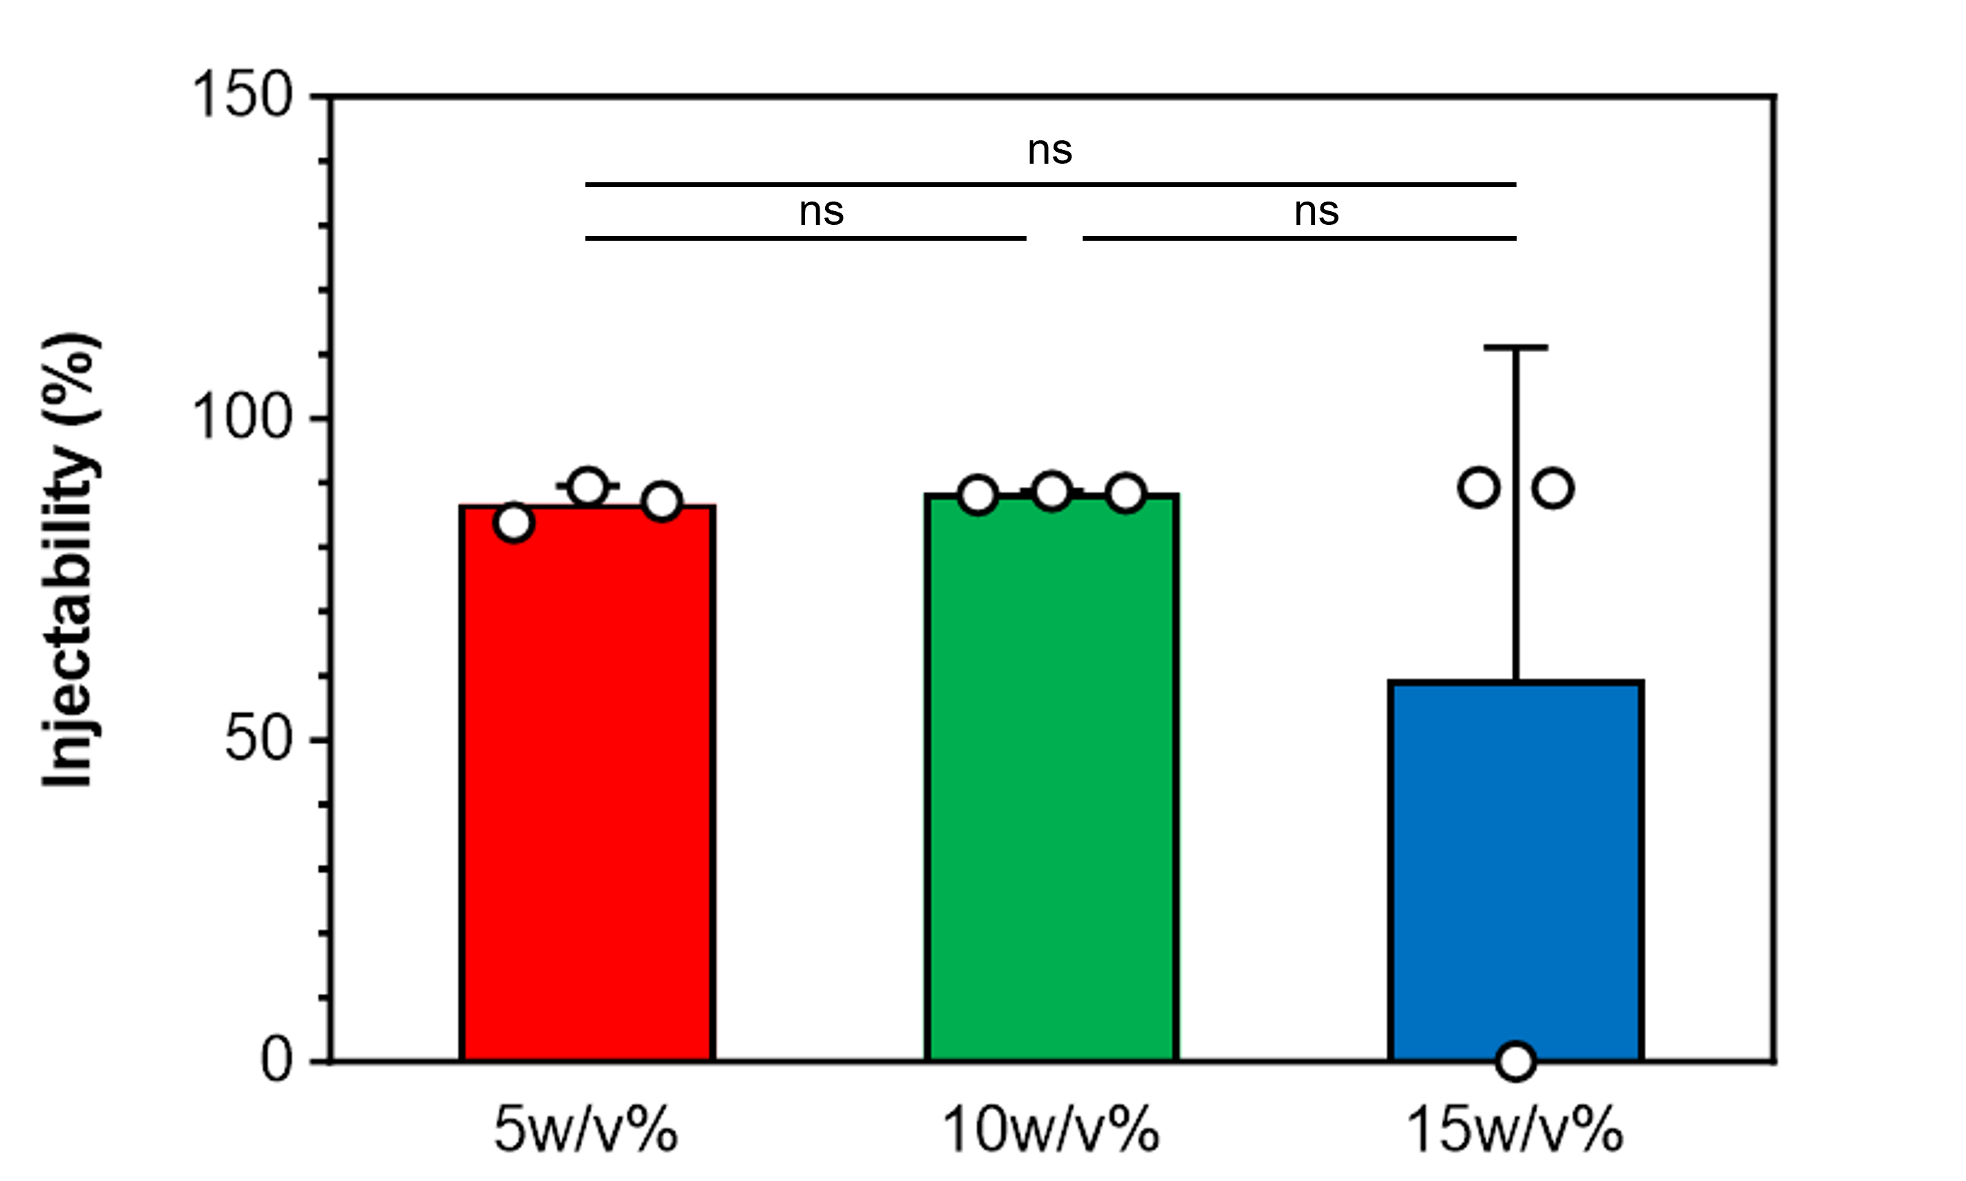
Fig. S3. Injectability of the Cat-PBA-ApGltn hydrogels with varying concentrations using an 18G needle (n = 3). Data are presented as mean ± SD. Significant differences between groups were analyzed by Tukey's multiple comparisons test. ns = no significance.

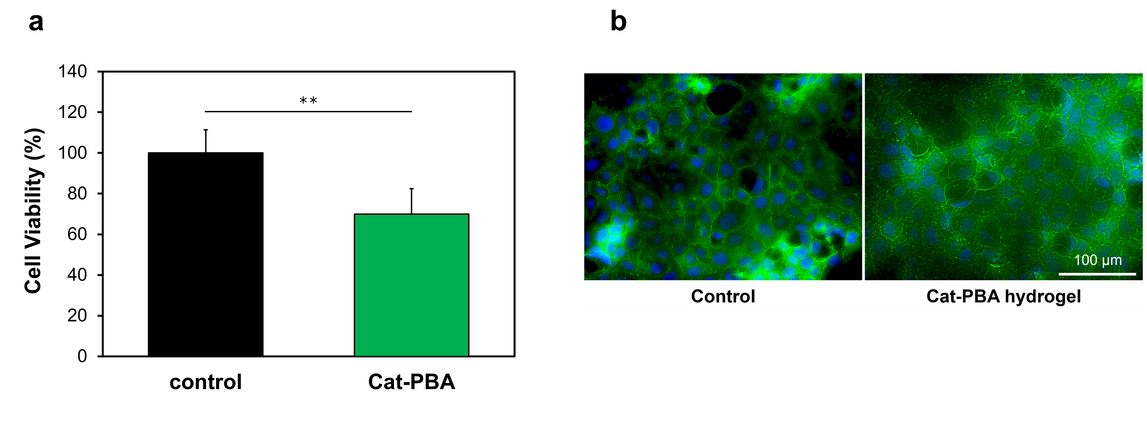
Fig. S4. Cytocompatibility of the 10 w/v% Cat-PBA-ApGltn hydrogels. (a) Viability (n = 6) and (b) cell morphology of Caco-2 cells exposed to the Cat-PBA-ApGltn hydrogel. Green: actin filament, blue: cell nucleus. Scale bar: 100 μm. Data are presented as mean ± SD. **p < 0.01, analyzed by Tukey's multiple comparisons test.

