Supporting Information
Observation of Fluctuation Spin Hall Effect in Low-resistive Antiferromagnet
Chi Fang^{1,2}, Caihua Wan^{1,7}, Xiaoyue Zhang^{3,5}, Satoshi Okamoto⁴, Tianyi Ma^{1,3}, Jianying Qin^{1,3}, Xiao Wang¹, Chenyang Guo¹, Jing Dong¹, Guoqiang Yu^{1,7}, Zhenchao Wen⁶, Ning Tang⁵, Stuart S. P. Parkin², Naoto Nagaosa⁹, Yuan Lu³, Xiufeng Han^{1,7,8}
¹Beijing National Laboratory for Condensed Matter Physics, Institute of Physics, University of Chinese Academy of Sciences, Chinese Academy of Sciences, Beijing 100190, China
²Max Planck Institute of Microstructure Physics, Halle (Saale) 06120, Germany
³Université de Lorraine, CNRS, Institut Jean Lamour, UMR 7198, campus ARTEM, 2 Allée André Guinier, 54011 Nancy, France
⁴Materials Science and Technology Division, Oak Ridge National Laboratory, Oak Ridge, TN 37831, USA
⁵State Key Laboratory of Artificial Microstructure and Mesoscopic Physics, School of Physics, Peking University, Beijing 100871, China
⁶National Institute for Materials Science NIMS, Tsukuba, Ibaraki 3050047, Japan
⁷Songshan Lake Materials Laboratory, Dongguan, Guangdong 523808, China
⁸Center of Materials Science and Optoelectronics Engineering, University of Chinese Academy of Sciences, Beijing 100049, China
⁹RIKEN Center for Emergent Matter Science (CEMS), Wako, 351-0198, Japan.
Content
I. Sample preparation and characterization
A. Sample Preparation
B. Magnetization Characterization
C. Resistivity determination of Cr
II. Transport data of spin Hall effects
A. ISHE and DSHE with in-plane field
B. ISHE and DSHE with out-of-plane magnetic field
C. ISHE with different thickness of Cr
D. ISHE with different current amplitude
E. Exaction of R_{ISHE} or R_{DSHE}
F. R_{ISHE} data from other devices
G. Shunting factor
H. Temperature dependence of spin Hall conductivity
III. Normalized Power Consumption
IV. Theoretical consideration on the SHE by AFM spin fluctuation
V. Fitting details of resistivity and spin Hall resistivity
Reference

I. Sample preparation and characterization
A. Samples Preparation
The growth details are following: Before deposition, the MgO(001) substrate was annealed at 700 °C for one hour to degas the surface, followed by depositing a 10 nm MgO seed layer at 450 °C to block the C impurity diffusion. The Cr layer was then deposited at 31 °C and followed by an in-situ post-annealing at 600 °C to obtain a flat Cr (001) surface. The temperature was maintained at 78 °C and 57 °C to deposit the MgO and Fe layers. A second post-annealing at 480 °C was performed to improve the crystalline quality of Fe. In the end, a 5 nm Au capping layer was deposited at 88 °C to prevent the surface oxidation. Surface structures of each stack were monitored by reflected high-energy electron diffraction (RHEED) throughout the growth process as shown in Fig. S1.
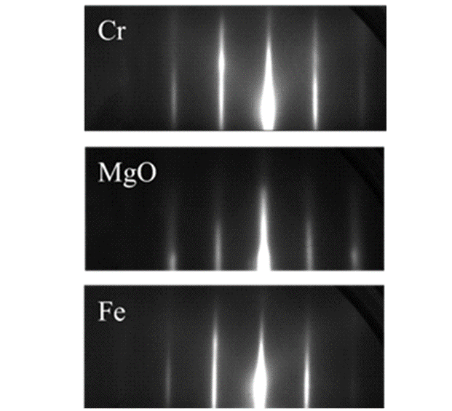
Figure S1. Typical RHEED pattern of MTJ film. RHEED pattern of the annealed Cr, MgO and Fe layers further confirmed the epitaxial growth mode. The sharp streaky patterns indicate a high-quality epitaxial growth character of our sample.
The 10 nm Cr for resistivity calibration is fabricated by etching the Fe/Au away monitored by in-situ HIDEN Analytical system installed in etching & depositing system (scia coat) and stoped at MgO layer. The AlO_{x} is in-situ deposited to prevent oxidization.
The high-resolution cross-sectional transmission electron microscope (HRXTEM) was used to check the MTJ structure (Figure 1b). The low-mag image validated uniform thickness for each layer well corresponding to the nominal one. The black field image (inset of Figure 1b) allows us to measure the lattice constant of each layer. The lattice constants of the bcc Cr and Fe near interfaces were determined as a_{Cr}=2.91 $Å$ and a_{Fe}=2.88 $Å$, close to their bulk values 2.88$Å$ and 2.87$Å$ ^{S1}. a_{MgO}=4.24 $Å$ reported in Ref. 32 was near $\sqrt{2}$a_{Cr}=4.11$Å$ and $\sqrt{2}$a_{Fe}=4.06$Å$, which implied the epitaxial relationship: (001)_{MgO}//(001)_{Cr/Fe} and [100]_{MgO}//[110]_{Cr/Fe} ³². The electron energy loss spectroscopy (EELS) was performed to map the elementary distributions (Fig. S2). There was negligible interdiffusion for the Cr, Fe, Mg and Au elements between neighboring layers.
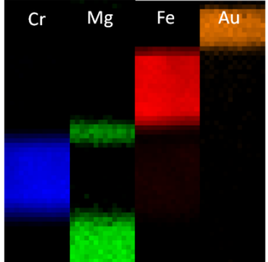
Figure S2. The electron energy loss spectroscopic (EELS) mapping of the Cr, Fe, Mg and Au elements.
B. Magnetization Characterization
Magnetization of stacks is determined by superconducting quantum interference device (SQUID, Quantum Design MPMS) at room temperature and low temperature as shown in Fig. S3. The Magnetic hysteresis loop in Fig. 1(d) is measured by vibrating sample magnetometer(VSM, Lakeshore) at room temperature.
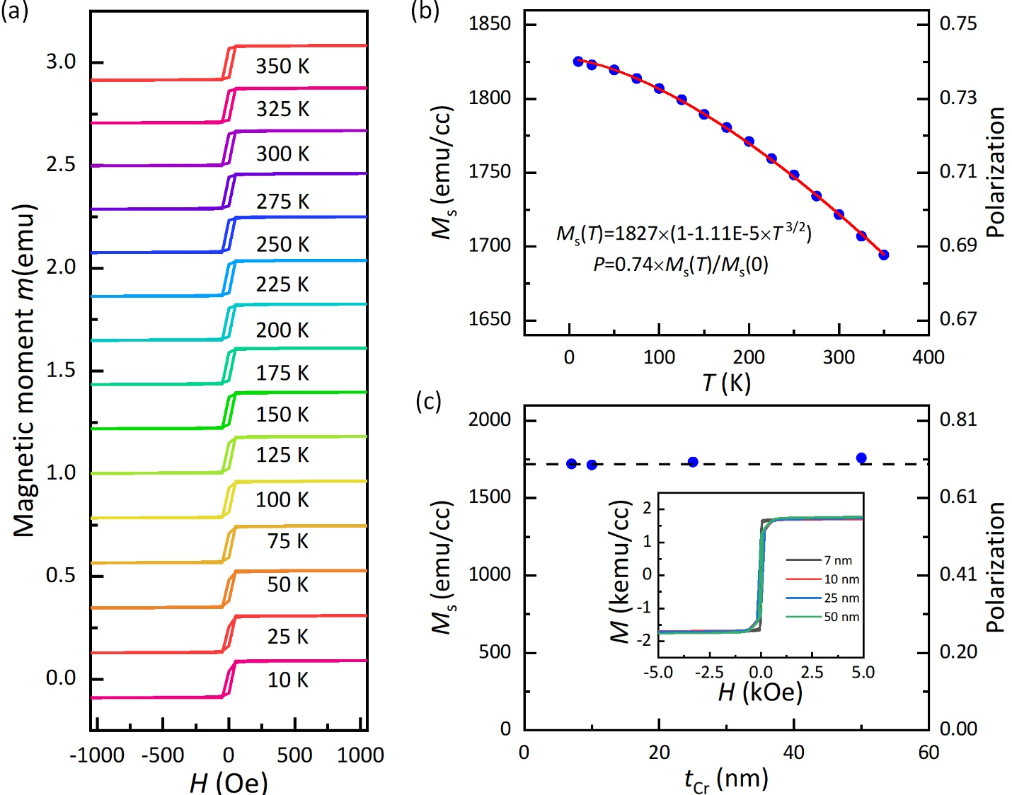
Figure S3. Magnetization in multilayer. (a) Magnetic hysteresis loop from 10 K to 350 K in Cr(25)/MgO(2)/Fe(10)/Au(5 nm) stack. (b) Temperature dependence of saturation magnetization M_{s} extracted from (a). The calculated spin polarization magnitude is shown by the right axis. (c) Cr thickness t_{Cr} dependence of M_{s} of stacks at 300 K. The M_{s} is irrelevant to the t_{Cr}.
As current is polarized in Fe layer, the spin polarization is assumed proportional to the saturation magnetization M_{s} of Fe^{S2,S3}. The M_{s} follows a T ^{3/2} law^{S1} as M_{s}(T)= M_{s}(0)(1-C$×$ T^{3/2}). Fitting the measured M_{s}-T gives M_{s}(0)=1827 emu/cc and C=1.11E-5. As P in single crystal Fe/MgO electrode is reported³⁹ as 0.74 at 0.25 K by superconducting tunnelling spectroscopy (STS) technique. The spin polarization P is determined as P(T)=0.74$×$ M_{s}(T)/M_{s}(0).
C. Resistivity determination of Cr
As the TEM Fig. S4 shows, the film maintains a well-defined single-crystal quality in large scale. So the contribution to resistivity in Cr from grain border is ignorable.
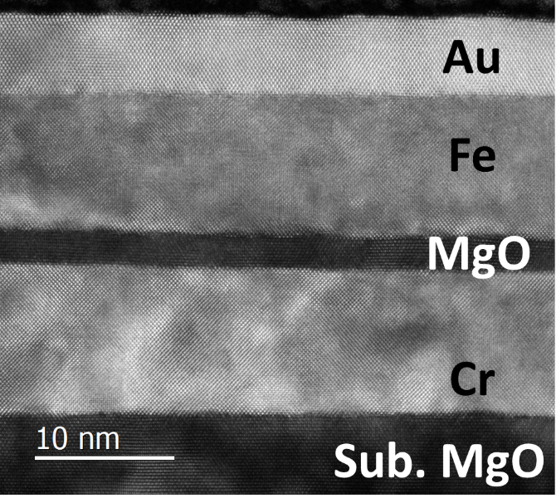
Figure S4. TEM picture of stacks for larger scale.
The main contribution to the resistivity in Cr with different thickness is the surface or interface in the stacks. In this case, we could follow Fuchs-Sondheimer’s theory to calibrate the resistivity of Cr layer^{S4,S5}.
Below the mean free path $λ$ of bulk material, the conductivity in thin films follow:
$σ=σ_{0}(1-\frac{3λ}{8t}(1-p))$ (R1)
where $σ_{0}$ is the bulk resistivity and p the a parameter describing the fraction of surface collisions. The $λ$ is derived as 15.2 nm in resistive Cr films^{S6}. The $λ$ vould be longer in single crystal Cr. We prepared 4-probe bar with length l=50 µm and width w=20 µm to measure the conductance of the full stacks. A t_{Cr}= 15 nm sample is added for the resistivity calibration. Based on the parallel circuit model, the conductance of full stack device is
$S_{total}=S_{Cr}+S_{MgO/Fe/Au}$ (R2)
where $S_{Cr}$ is the conductance of Cr layer depending on the Cr thickness as $σ_{Cr}wt_{Cr}/l$ and $S_{MgO/Fe/Au}$ is the conductance of the capping $MgO/Fe/Au$ staying the constant. Combing equation (R1) and (R2), we have
$$S_{total}=σ_{0}(1-3λ(1-p)/(8t_{Cr}))wt_{Cr}/l+S_{MgO/Fe/Au} =at_{Cr}+b$$
where $a= σ_{0}w/l$ and $b=-σ_{0}·3λ(1-p)/8·w/l+S_{MgO/Fe/Au}$. Fitting the $S_{total}-t_{Cr}$ relation linearly gives $σ_{0}=0.00281/0.4=0.007025$ as show in Fig. S5a.
To give the two terms of b respectively, we use the resistivity of single 10 nm Cr layer. The $ρ=48 μΩ cm$ gives a negative resistivity in 7 nm Cr. So the Cr could be oxidized partially at the surface. We further fabricate a 10 nm single Cr by etching the $Fe/Au$ capping layers away and depositing AlO_{x} capping layer on it to prevent oxidation. The etching process, as the tunnel junction fabrication, is monitored by HIDEN Analytical system and stopped in the middle of MgO layer. The $ρ=26.65 μΩ cm$ is determined in 10 nm Cr at 300 K. So the$σ=σ_{0}(1-4.66/t_{Cr})$ [µΩ⁻¹cm⁻¹] or $ρ=ρ_{0}(1-4.66/t_{Cr})$ [µΩ cm] where $ρ_{0}=14.23 µ cm$ is similar to bulk value of Cr 13 µΩ cm at room temperature^{S7}. $S_{MgO/Fe/Au}=0.03899 {}^{-1}$. By substracting $S_{MgO/Fe/Au}$ from $S_{total}$, the resistivity is determined as 17.59 µΩ cm in 25 nm Cr and 15.51 µΩ cm in 50 nm Cr as shown in Fig. S5b.

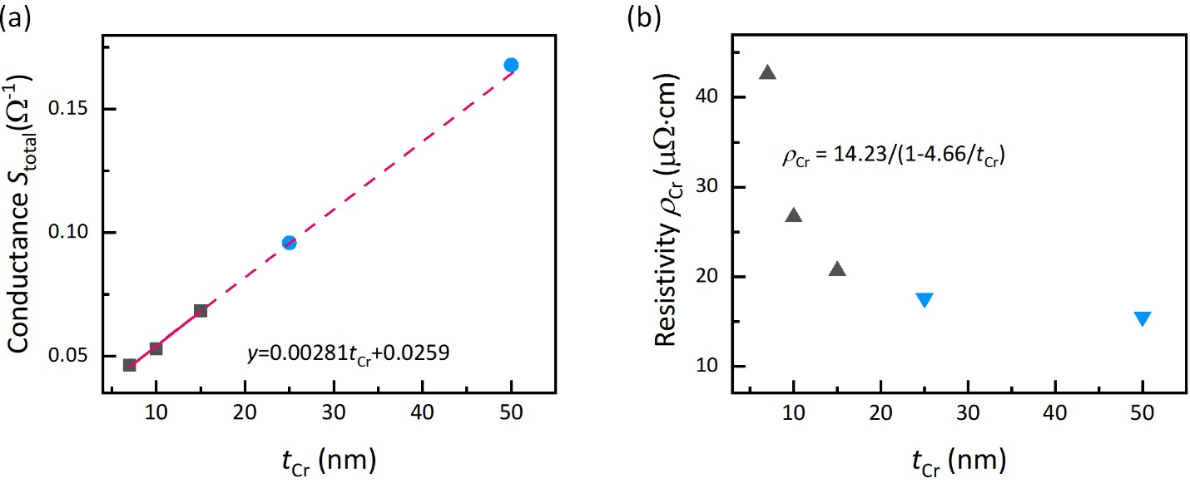
Figure S5. Calibration of Cr resistivity. (a) Thickness dependence of total conductance of Cr/MgO/Fe/Au stacks. (b) Estimated resistivity in Cr with different thicknesses.
II. Transport data of spin Hall effects
A. ISHE and DSHE with in-plane field
Original data of ISHE and DSHE is plotted in Fig. S6a and b. The magnetic field is applied in-plane along [110]_{MgO} direction as depicted in Fig. 2a. A random background resistance exists with each curve and is subtracted, which does not involve with the value of R_{ISHE(DSHE)}.
Figure S6. (a) ISHE and (b) DSHE in 10 nm Cr with in-plane magnetic field along MgO [110] at different temperatures. The R_{ISHE(DSHE)} values are extracted and plotted in Fig. 2d.

B. ISHE and DSHE with out-of-plane magnetic field
One could control the output voltage $V_{ISHE}$ or resistance ($dV_{ISHE}/dJ$) by M_{Fe} with an external field H. When H is applied out-of-plane along the film normal, $dV_{ISHE}/dJ$ vanishes because of the zero $\left(j_{s}×s\right)$ term.
Figure S7. Spin Hall signal with out-of-plane magnetic field H. (a) ISHE. (b) DSHE

C. ISHE with different thickness of Cr
Figure S8. ISHE resistance in Cr at 300 K with different thicknesses. The R_{ISHE(DSHE)} values of these data and ones of more sample are extracted and plotted in Fig. S11, whose average value is plotted in Fig. 2e.
D. ISHE with different current amplitude
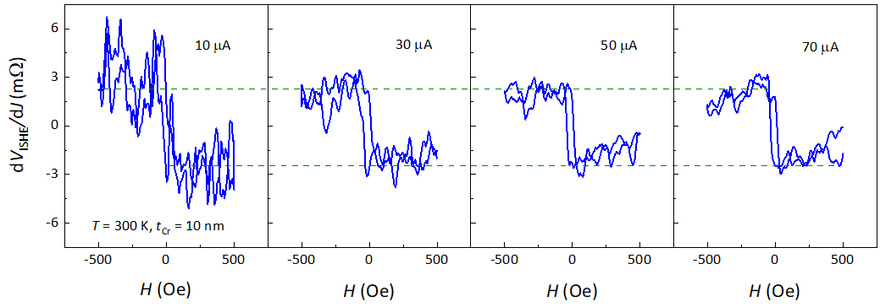
Figure S9. Spin Hall signal with different magnitude of injection current. dV_{ISHE}/dJ is irrelevant to the applied current as desired, indicating the signal results from the intrinsic properties of the Cr/MgO/Fe junction instead of any J-related artefacts such as heating.

E. Exaction of R_{ISHE} or R_{DSHE}
Following we show the procedure to extract the R_{ISHE} from data in Fig. 2b. By fitting the two resistance platform linearly, two intercept are given with their uncertainty, (0.00419 ± 1.00297E-4) $Ω$ and (-0.00351 ± 1.408E-4) $Ω$ as shown in Fig. S10. R_{ISHE} equals to the average of the two values (0.00419+0.00351)/2=0.00385 $Ω$, and its uncertainty is the sum of two uncertainty 1.00297E-4+1.408E-4 = 0.00024$Ω$, so the R_{ISHE} = (3.85 ± 0.24) m$Ω$. The uncertainty of spin Hall angle is given by equation (1) calculating with this R_{ISHE} value. R_{DSHE} is extracted in the same way.

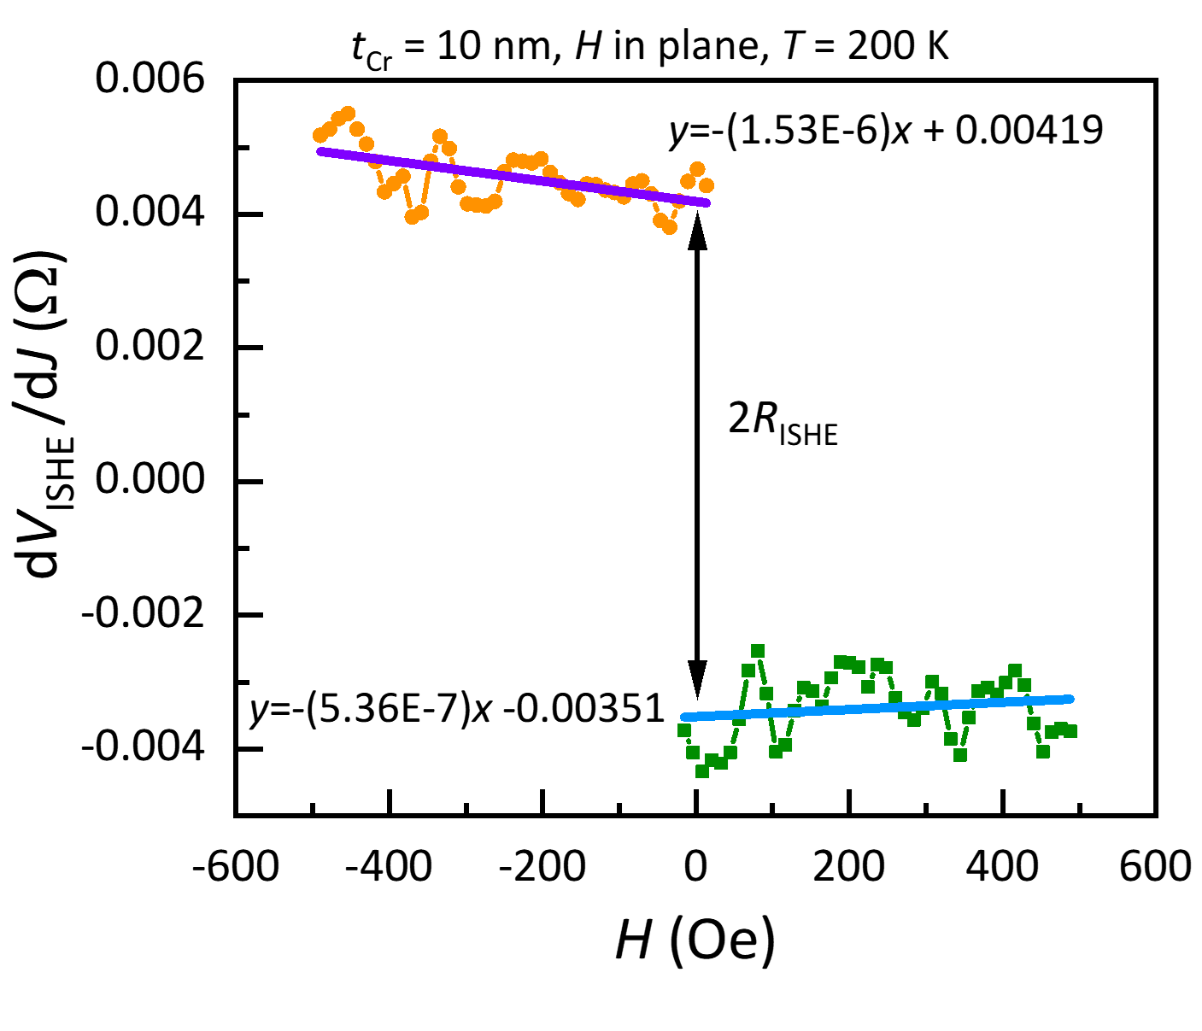
Figure S10. Fitting and extraction of R_{ISHE.}

F. R_{ISHE} data from other devices
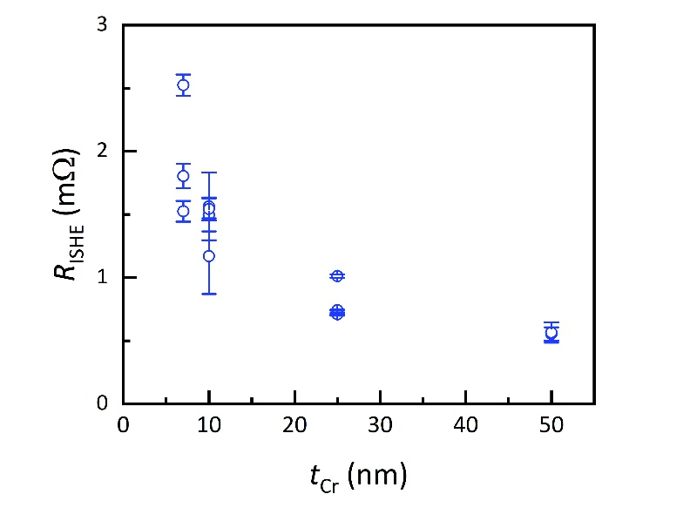
Figure S11. Inverse Spin Hall signal in Cr with different thickness.

Figure S12. Inverse Spin Hall signal in more samples. (a) Sample 2. (b) Sample 3.
G. Shunting factor
We measured at least two sample of each thickness of Cr at 300 K shown in Fig. S11 and fitting it to give $λ_{s}$=20.03±1.84 nm. We use the same value as the room temperature one. It is not reasonable enough to still use the equation(2) to fit the spin diffusion length near T_{N} or below it as the spin Hall angle in different thickness could have significant variation resulting from the domination of spin fluctuation. The spin fluctuation relates to the T_{N} which increases as the thickness increases in thin films so the $θ_{SH}$ could be different in Cr with different thickness even at the same temperature.
The $λ_{s}$ is reported monotonously increasing as the temperature decreases⁴⁷⁻⁴⁹, which could bring less than 2% variation of shunting factor $λ_{s}/t∙tanh⁡(t/(2λ_{s}))$ as it saturates to 0.5 as $λ_{\text{s}}$ increases as shown in Fig. S13, which could not explain the enhancement of $θ_{SH}$ over 100%. Keeping the same $λ_{\text{s}}$ will brings about at most 2% overestimation of $θ_{SH}$.
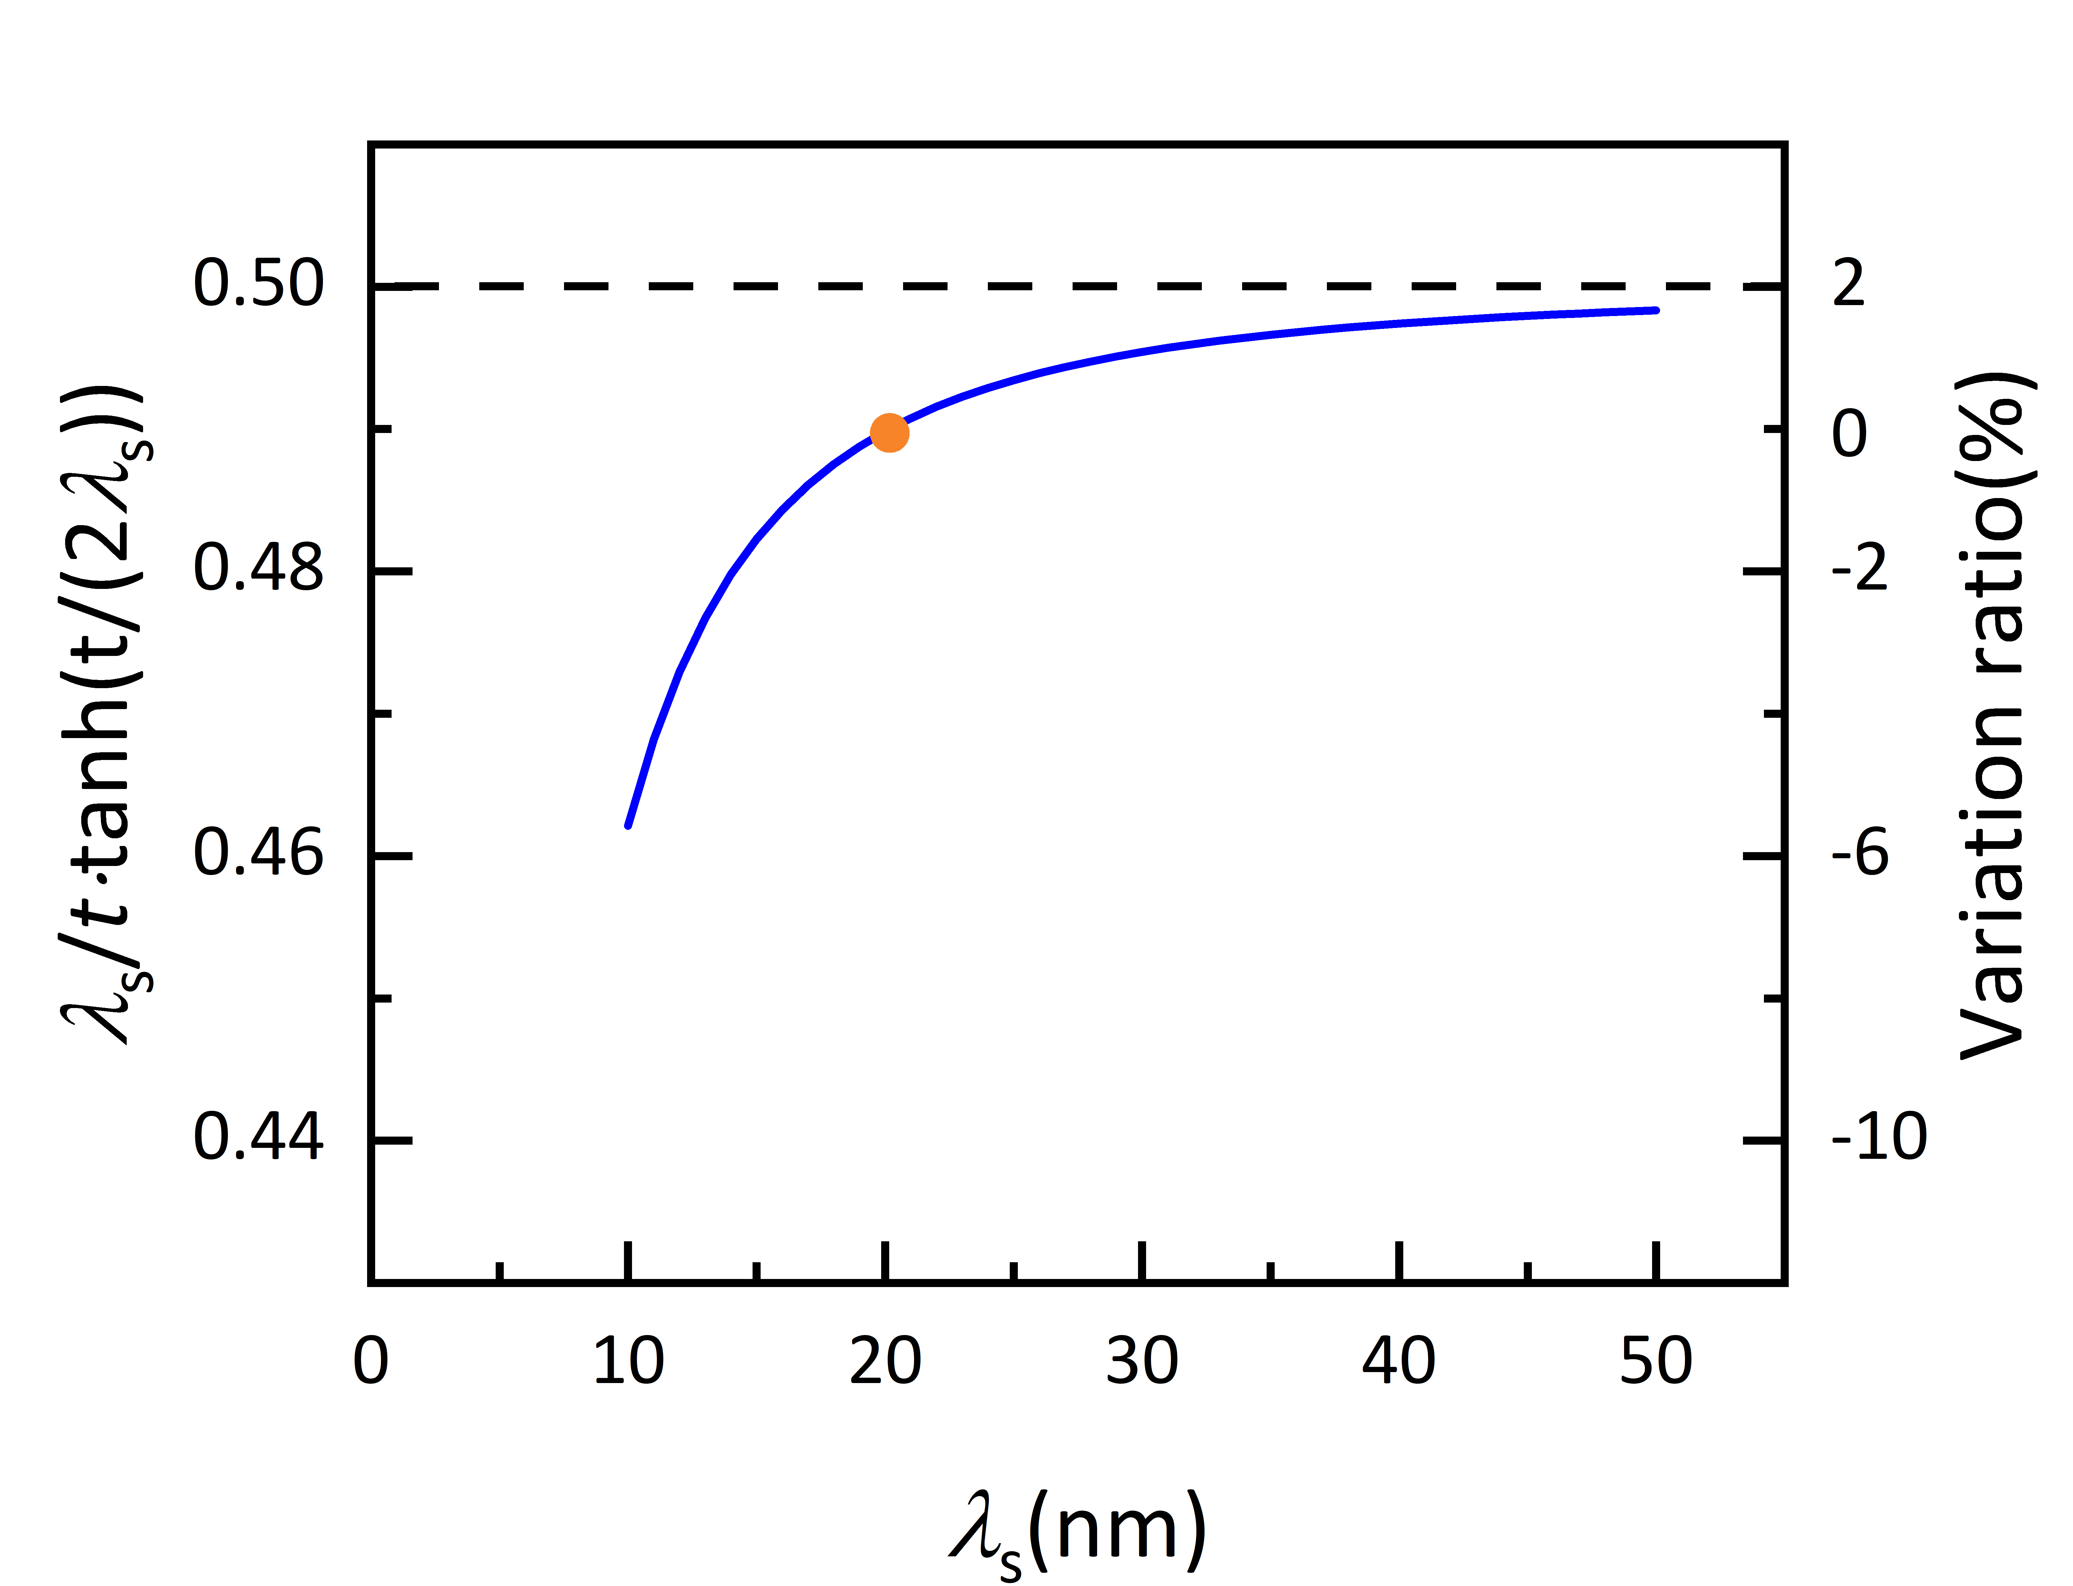
Figure S13. Spin diffusion length $λ_{\text{s}}$ dependence of shunting factor $λ_{s}/t∙tanh⁡(t/(2λ_{s}))$ in equation (1) for t=10 nm.

H. Temperature dependence of spin Hall conductivity
Figure S14. Temperature dependence of spin Hall conductivity in sample 1.
III. Normalized Power Consumption
If one ignores the possibility of current shunting through the magnet, P = ${I_{C}}^{2}R={(j_{C}wt)}^{2}∙ρl/(wt)={j_{C}}^{2}∙ρlwt$ where w, t and l is the dimensions of the device, $ρ$ is the resistivity of NM layer, $I_{C}$ is the critical current for spin-orbit torque (SOT) switching and $j_{C}$ is the critical current density. This is consistent with the understanding of reviewer. With normalizing the device dimensions, P$∝{j_{C}}^{2}ρ$. For a type Z switching (magnetization out-of-plane), $j_{C}$ is given by Ref. S8 and S9 as
$$j_{C}=\frac{2e}{ℏ}\frac{M_{s}t_{FM}}{θ_{SH}^{eff}}(\frac{H_{K}^{eff}}{2}-\frac{H_{x}}{\sqrt{2}})$$

in which e, ℏ, $M_{s}$ $t_{FM}$, $θ_{SH}^{eff}$, $H_{K}^{eff}$ and $H_{x}$ are the elementary charge, the reduced Planck constant, the saturation magnetization of FM layer, the thickness of FM layer, the effective spin Hall angle in NM layer, the effective anisotropy field and external magnetic field, respectively.
By normalizing, the FM layer paremeters $H_{K}^{eff}$, M_{s} ，device dimensions and external field H_{x} are kept the same. So$j_{C}∝1/θ_{SH}$ and $P_{N}∝{j_{C}}^{2}ρ∝ρ/θ_{SH}^{2}$. It worth mentioning this inference is based on the assumption that the thickness of NM stays below the spin diffusion length. Otherwise the effective $θ_{SH}$, i.e. $θ_{SH}^{eff}$, usually decreases as the thickness increases and results in larger power consumption.
The values are from the references list in the table and the reviews.
Table S1 Summary of the normalized power consumption of SOT materials
The P_{N} is calculated for different material categories with the magnitude of spin Hall angle or spin-orbit torque efficiency and resistivity. For a given $θ_{SH}$ or $ρ$ with a scale, the maximum $θ_{SH}$ and the minimum $ρ$ is adopted to give a low-estimation of P_{N}.
Structure (thickness in nm) | Method | SHA or SOT efficiency | Resistivity (⁠μΩ⋅ cm) | Normalized Power Consumption (μΩ·cm) | Reference
Non-magnetic metals(NM)
Ti(1) | MOKE | 0.074 | 21.2 | 3871.44 | S10
Pt | Second harmonic | 0.12 | 20 ∼ 100 | 1388.89 | S11
Pt(6) | Second harmonic | 0.09 | 36 | 4444.44 | S12
Pt(10) | SHTS | 0.04∼ 0.09 | 27 | 3333.33 | 35
Ta(6.2) | ST-FMR | -0.12 | 190 | 13194.44 | 10
Ta(3) | Second harmonic | -0.006 | 178.5 | 4958333 | 10
Ta(10) | SHTS | -0.05∼ 0.11 | 210 | 17355.37 | 35
W(5.2) | Critical current | -0.33 | 260 | 2387.51 | 15
W(6.2) | Critical current | -0.18 | 80 | 2469.14 | 15
W(5) | Critical current | -0.83 | 193 | 803.83 | S13
Hf(3.5) | Second harmonic | -0.02 | 199 | 497500 | S14
Pd(8) | Second harmonic | 0.033 | 30 | 27548.21 | S15
Ir | ST-FMR | 0.03 | 21.1 | 23444.44 | S16
Insert- or multi-layers
[Pt(0.75)/Ti(0.2)]_{n}/Pt(0.75) | Second harmonic | 0.35 | 90 | 734.69 | S17
Alloys
Au_{0.93}W_{0.07}(30) | ST-FMR | -0.1 | 57 | 5700 | S18
Au₂₅Pt₇₅(8) | Second harmonic | 0.35 | 80 | 653.06 | 7
PtAl(6) | Second harmonic | 0.14 | 75 | 3826.53 | S12
Pt₈₅Hf₁₅(6) | Second harmonic | 0.16 | 110 | 4296.88 | S12
Cu_{99.5}Bi_{0.5} | Lateral spin valve | -0.24 | 5.1 | 88.54 | S19
Cu_{1−x}Pt_{x}(6) | ST-FMR | 0.07 | 20∼ 70 | 4081.63 | S20
Cu₄₀Au₆₀(8) | Second harmonic | 0.097 | 29 | 3082.16 | S21
Ni₈₀Cu₂₀(>7nm) | Thermal spin injection | 52.7 | 0.11 | 4355.37 | 25
Ni₈₀Cu₂₀(<7nm) | Thermal spin injection | 52.7 | 0.46 | 249.05 | 25
Antiferromagnets
FeMn | Spin pumping | 0.008 | 167.7 | 2620313 | S22
PdMn | Spin pumping | 0.015 | 223 | 991111.1 | S22
IrMn | Spin pumping | 0.022 | 269.3 | 556405 | S22
PtMn | Spin pumping | 0.06 | 164 | 45555.56 | S22
PtMn | ST-FMR | 0.064∼ 0.081 | 164.5 | 25072.4 | S23
IrMn | ST-FMR | 0.053∼ 0.057 | 272.3 | 83810.4 | S23
PdMn | ST-FMR | 0.028∼ 0.049 | 220 | 91628.49 | S23
FeMn | ST-FMR | 0.022∼ 0.028 | 161.5 | 205994.9 | S23
Ir₂₂Mn₇₈ | ST-FMR | 0.057 | 278 | 85564.79 | S24
Ir₂₅Mn₇₅ | ST-FMR | 0.02 | 167∼ 278 | 417500 | S25
Ir₂₅Mn₇₅ | ST-FMR | 0.1 | 183 | 18300 | S16
Ir₂₅Mn₇₅ [111] | ST-FMR | 0.12 | 198 | 13750 | S16
Ir₂₅Mn₇₅ [100] | ST-FMR | 0.2 | 160 | 4000 | S16
Ir₂₅Mn₇₅ [100] annealed | ST-FMR | 0.35 | 160 | 1306.12 | S16
Mn₂Au | ST-FMR | 0.22 | 150 | 3099.17 | S26
Mn₃Sn | ST-FMR | 1 | 360 | 360 | S27
Mn₃Sn | Lateral spin valve | 0.053 | 1133 | 403346.39 | S28
RuO₂ [100] | ST-FMR | 0.0719 | 149 | 28822.29 | S29
RuO₂ [110] | ST-FMR | 0.0231 | 89 | 166788.48 | S29
Topological insulators
Bi₂Se₃(8) | ST-FMR | 3.5 | 1755 | 143.27 | 18
Bi₂Se₃(7.4) | Loop shift | 0.16 | 1060 | 41406.25 | 17
Bi₂Se₃ | Second harmonic | 0.08 | 667 | 104218.8 | 16
Bi₂Se₃ | SHTS | 0.8 | 700 | 1093.75 | S30
Bi_{x}Se_{1−x}(4) | Second harmonic | 18.62 | 12820 | 36.98 | S31
Bi_{0.9}Sb_{0.1}(10) | Coercivity | 52 | 400 | 0.15 | S32
(Bi,Sb)₂Te₃(8) | Loop shift | 0.4 | 4020 | 25125 | 17
(Bi,Sb)₂Te₃ | Second harmonic | 2.5 | 5464 | 874.24 | 16
SnTe | Second harmonic | 1.41 | 1835 | 922.99 | 16
Transition metal dichal-cogenides
WTe₂(5.5) | ST-FMR | 0.029 | 385 | 457788.3 | S33
WTe₂(19.6) | ST-FMR | 0.51 | 580 | 2229.91 | S34
PtTe₂ | ST-FMR | 0.05 | 33 | 13200 | S35
PtTe₂ | ST-FMR | 0.15 | 333 | 14800 | S35
MoTe₂ | ST-FMR | 0.032 | 550 | 537109.4 | S36
This work
Cr(10) at 200 K | SHTS | 0.35 | 20 | 163.3 | This work
Cr(10) at 300 K | SHTS | 0.14 | 27 | 1377.6 | This work

IV. Theoretical consideration on the SHE by AFM spin fluctuation
Here, we briefly discuss how the formalisms derived in Ref. 44 for the FM spin fluctuation should be modified when the AFM spin fluctuation is considered. The main difference from the FM fluctuation is that electrons at the Fermi surface are scattered by the AFM fluctuation with its spectral function given by
$$B_{q}\left(ω\right)=\frac{1}{π}\frac{ω/Γ}{{\left\{δ+A{\left(q-Q\right)}^{2}\right\}}^{2}+{\left(ω/Γ\right)}^{2}}.$$
Here, $δ$ measures the distance from the magnetic ordering as $δ∝T-T_{N}$ at $T>T_{N}$ and $δ∝M^{2}$ $T<T_{N}$ with $M$ being the ordered moment, which behaves as $M∝\sqrt{T_{N}-T}$ near T_{N}. A constant $A$ is introduced so that $A{\left(q-Q\right)}^{2}$ has the unit of energy, and $Γ$ is the Landau damping. In contrast to the similar expression in Ref. 44, (i) the momentum dependence is given by ${A\left(q-Q\right)}^{2}$ with $Q$ the magnetic wave vector characterizing the magnetic ordering, and (ii) the damping term $Γ$ is independent of momentum. Because of (i), electrons that contribute to the SHE have to satisfy the nesting condition, i.e., momenta $k$ and $k+Q$ have to be on the Fermi surface. This difference may lead to the following modified forms:
$$σ_{SH}^{ss}∝τ^{2} δ I^{2}\left(T,δ\right)$$
for the skew scattering contribution, and
$$σ_{SH}^{sj}∝τ \tilde{I}\left(T,δ\right)$$
for the side jump contribution. As in Ref. 44, $I\left(T,δ\right)$ is given by
$$I\left(T,δ\right)=\frac{1}{{\left(2π\right)}^{3}}\int{d^{3}p}\frac{1}{\sinh\left(ℏv_{F}∙p/T\right)}\frac{ℏv_{F}∙p/Γ}{{\left(δ+Ap^{2}\right)}^{2}+{\left(ℏv_{F}∙p/Γ\right)}^{2}},$$
where the momentum integral variable is changed from $q-Q$ to $p$ by measuring it from the magnetic wave vector $Q$, and $v_{F}$ is the Fermi velocity. $τ$ is the carrier lifetime, which is assumed to be independent of momentum that satisfies the nesting condition. $\tilde{I}\left(T,δ\right)$ appearing in the expression of $σ_{SH}^{sj}$ is given by
$$\tilde{I}\left(T,δ\right)=\frac{1}{{\left(2π\right)}^{3}}\int{d^{3}p}\int{dω} \frac{1}{\sinh\left(ω/T\right)}\frac{ω/Γ}{{\left(δ+Ap^{2}\right)}^{2}+{\left(ω/Γ\right)}^{2}}.$$
A similar expression is derived for the electron self-energy by the AFM spin fluctuation in Ref. S30. The detailed and comprehensive theoretical derivation can be referred to Ref. 50. Except for the vicinity of the magnetic transition temperature T_{N}, $I\left(T,δ\right)$ and $\tilde{I}\left(T,δ\right)$ behave as $I\left(T,δ\right)≈T^{3}/δ$ and $\tilde{I}\left(T,δ\right)≈T^{2}/\sqrt{δ}$, respectively. Thus, $σ_{SH}^{ss}$ and $σ_{SH}^{sj}$ behave as
$$σ_{SH}^{ss}∝τ^{2} T^{6}/δ$$
and
$$σ_{SH}^{sj}∝τ T^{2}/\sqrt{δ},$$
respectively. As shown in Fig. 1(b), the resistivity shows a smooth crossover behavior from $ρ\sim const. +αT^{2}$, where $α$ is a constant, at low temperatures (Fig. S8a) to $ρ∝T$ at high temperatures. Thus, the carrier lifetime is dominated by the impurity or disorder and the electron-electron interaction at low temperatures and by the phonon scattering at high temperatures. Assuming that $δ$ remains constant away from T_{N} and $τ∝σ\sim 1/ρ$, one finds
$$σ_{SH}^{ss}/σ^{2}∝ T^{6}$$
and
$$σ_{SH}^{sj}/σ^{2}∝ T^{2}+αT^{4}.$$
Moreover, there is no limitation for the above microscopic processes to take place above or below the ordering temperature, in contrast to ferromagnetically ordered systems where the pure SHE is expected to exist only above the transition temperature because below the transition temperature the anomalous Hall effect appears. Therefore, the AFM order is necessary to observe a pure spin-fluctuation-originated contribution to the SHE, i.e., FSHE, without involvement with the anomalous Hall effect.

V. Fitting details of resistivity and spin Hall resistivity
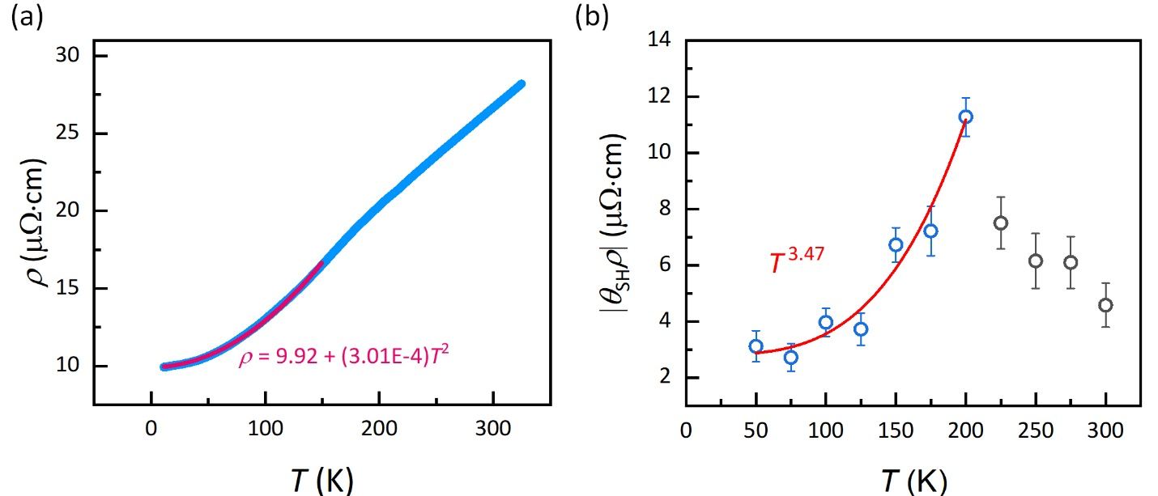
Figure S14. Fitting of T-dependence of resistivity and spin resistivity. (a), Resistivity fitting. Blue line is duplicated from Fig. 1b. Fitting $ρ\sim const. +αT^{2}$ gives the $α$. (b), Spin resistivity fitting. Data points with the circle shape are repeat of ones in Fig. 4c. Red line indicates a power-law fitting of the spin Hall resistivity at and below 200 K.

Reference
(S1) Kittel, C. Introduction to Solid State Physics; John Wiley & Sons, Inc., 1967.
(S2) Shang, C. H.; Nowak, J.; Jansen, R.; Moodera, J. S. Temperature dependence of magnetoresistance and surface magnetization in ferromagnetic tunnel junctions. Phys. Rev. B 1998, 58 (6), R2917-R2920
(S3) Hindmarch, A. T.; Marrows, C. H.; Hickey, B. J. Tunneling spin polarization in magnetic tunnel junctions near the Curie temperature. Phys. Rev. B 2005, 72 (10), 100401
(S4) Fuchs, K. The conductivity of thin metallic films according to the electron theory of metals. Mathematical Proceedings of the Cambridge Philosophical Society 1938, 34 (1), 100-108
(S5) Sondheimer, E. H. The mean free path of electrons in metals. Advances in Physics 1952, 1 (1), 1-42
(S6) Udachan, S. L.; Ayachit, N. H.; Udachan, L. A. Impact of substrates on the electrical properties of thin chromium films. Ingenieria y Universidad 2019, 23 (2), 1-17
(S7) Coey, J. M. D. Magnetism and Magnetic Materials; Cambridge University Press, 2010.
(S8) Lee, K.-S.; Lee, S.-W.; Min, B.-C.; Lee, K.-J. Threshold current for switching of a perpendicular magnetic layer induced by spin Hall effect. Appl. Phys. Lett. 2013, 102 (11), 112410
(S9) Fukami, S.; Anekawa, T.; Zhang, C.; Ohno, H. A spin-orbit torque switching scheme with collinear magnetic easy axis and current configuration. Nat. Nanotechnol. 2016, 11 (7), 621

(S10) Fan, X.; Celik, H.; Wu, J.; Ni, C. Y.; Lee, K. J.; Lorenz, V. O.; Xiao, J. Q. Quantifying interface and bulk contributions to spin-orbit torque in magnetic bilayers. Nat. Commun. 2014, 5, 3042
(S11) Nguyen, M. H.; Ralph, D. C.; Buhrman, R. A. Spin Torque Study of the Spin Hall Conductivity and Spin Diffusion Length in Platinum Thin Films with Varying Resistivity. Phys. Rev. Lett. 2016, 116 (12), 126601
(S12) Nguyen, M. H.; Zhao, M. N.; Ralph, D. C.; Buhrman, R. A. Enhanced spin Hall torque efficiency in Pt_{100-x}Al_{x} and Pt_{100-x}Hf_{x} alloys arising from the intrinsic spin Hall effect. Appl. Phys. Lett. 2016, 108 (24), 242407
(S13) Zhang, C.; Fukami, S.; Watanabe, K.; Ohkawara, A.; DuttaGupta, S.; Sato, H.; Matsukura, F.; Ohno, H. Critical role of W deposition condition on spin-orbit torque induced magnetization switching in nanoscale W/CoFeB/MgO. Appl. Phys. Lett. 2016, 109 (19), 192405
(S14) Torrejon, J.; Kim, J.; Sinha, J.; Mitani, S.; Hayashi, M.; Yamanouchi, M.; Ohno, H. Interface control of the magnetic chirality in CoFeB/MgO heterostructures with heavy-metal underlayers. Nat. Commun. 2014, 5, 4655
(S15) Ghosh, A.; Garello, K.; Avci, C. O.; Gabureac, M.; Gambardella, P. Interface-Enhanced Spin-Orbit Torques and Current-Induced Magnetization Switching of Pd/Co/AlOx Layers. Phys. Rev. Appl. 2017, 7 (1), 014004
(S16) Zhang, W.; Han, W.; Yang, S.-H.; Sun, Y.; Zhang, Y.; Yan, B.; Parkin, S. S. P. Giant facet-dependent spin-orbit torque and spin Hall conductivity in the triangular antiferromagnet IrMn₃. Sci. Adv. 2016, 2 (9), e1600759
(S17) Zhu, L. J.; Buhrman, R. A. Maximizing Spin-Orbit-Torque Efficiency of Pt/Ti Multilayers: Trade-Off Between Intrinsic Spin Hall Conductivity and Carrier Lifetime. Phys. Rev. Appl. 2019, 12 (5), 051002
(S18) Laczkowski, P.; Rojas-Sanchez, J. C.; Savero-Torres, W.; Jaffres, H.; Reyren, N.; Deranlot, C.; Notin, L.; Beigne, C.; Marty, A.; Attane, J. P.; et al. Experimental evidences of a large extrinsic spin Hall effect in AuW alloy. Appl. Phys. Lett. 2014, 104 (14), 142403
(S19) Niimi, Y.; Suzuki, H.; Kawanishi, Y.; Omori, Y.; Valet, T.; Fert, A.; Otani, Y. Extrinsic spin Hall effects measured with lateral spin valve structures. Phys. Rev. B 2014, 89 (5), 054401
(S20) Ramaswamy, R.; Wang, Y.; Elyasi, M.; Motapothula, M.; Venkatesan, T.; Qiu, X. P.; Yang, H. Extrinsic Spin Hall Effect in Cu_{1-x}Pt_{x}. Phys. Rev. Appl. 2017, 8 (2), 024034
(S21) Wen, Y.; Wu, J.; Li, P.; Zhang, Q.; Zhao, Y. L.; Manchon, A.; Xiao, J. Q.; Zhang, X. X. Temperature dependence of spin-orbit torques in Cu-Au alloys. Phys. Rev. B 2017, 95 (10), 104403
(S22) Zhang, W.; Jungfleisch, M. B.; Jiang, W. J.; Pearson, J. E.; Hoffmann, A.; Freimuth, F.; Mokrousov, Y. Spin Hall Effects in Metallic Antiferromagnets. Phys. Rev. Lett. 2014, 113 (19), 196602
(S23) Zhang, W.; Jungfleisch, M. B.; Freimuth, F.; Jiang, W.; Sklenar, J.; Pearson, J. E.; Ketterson, J. B.; Mokrousov, Y.; Hoffmann, A. All-electrical manipulation of magnetization dynamics in a ferromagnet by antiferromagnets with anisotropic spin Hall effects. Phys. Rev. B 2015, 92 (14), 144405
(S24) Wu, D.; Yu, G.; Chen, C.-T.; Razavi, S. A.; Shao, Q.; Li, X.; Zhao, B.; Wong, K. L.; He, C.; Zhang, Z.; et al. Spin-orbit torques in perpendicularly magnetized Ir₂₂Mn₇₈/Co₂₀Fe₆₀B₂₀/MgO multilayer. Appl. Phys. Lett. 2016, 109 (22), 222401
(S25) Soh, W. T.; Yeow, Y.; Zhong, X.; Ong, C. K. Inverse spin Hall effect of antiferromagnetic MnIr in exchange biased NiFe/MnIr films. Journal of Physics D: Applied Physics 2015, 48 (34), 345002
(S26) Singh, B. B.; Bedanta, S. Large Spin Hall Angle and Spin-Mixing Conductance in the Highly Resistive Antiferromagnet Mn₂Au. Phys. Rev. Appl. 2020, 13 (4), 044020
(S27) Kondou, K.; Chen, H.; Tomita, T.; Ikhlas, M.; Higo, T.; MacDonald, A. H.; Nakatsuji, S.; Otani, Y. Giant field-like torque by the out-of-plane magnetic spin Hall effect in a topological antiferromagnet. Nat. Commun. 2021, 12 (1), 6491
(S28) Muduli, P. K.; Higo, T.; Nishikawa, T.; Qu, D.; Isshiki, H.; Kondou, K.; Nishio-Hamane, D.; Nakatsuji, S.; Otani, Y. Evaluation of spin diffusion length and spin Hall angle of the antiferromagnetic Weyl semimetal Mn₃Sn. Phys. Rev. B 2019, 99 (18), 184425
(S29) Bai, H.; Han, L.; Feng, X. Y.; Zhou, Y. J.; Su, R. X.; Wang, Q.; Liao, L. Y.; Zhu, W. X.; Chen, X. Z.; Pan, F.; et al. Observation of Spin Splitting Torque in a Collinear Antiferromagnet RuO₂. Phys. Rev. Lett. 2022, 128 (19), 197202
(S30) Liu, L.; Richardella, A.; Garate, I.; Zhu, Y.; Samarth, N.; Chen, C.-T. Spin-polarized tunneling study of spin-momentum locking in topological insulators. Phys. Rev. B 2015, 91 (23), 235437
(S31) Mahendra, D. C.; Grassi, R.; Chen, J. Y.; Jamali, M.; Hickey, D. R.; Zhang, D. L.; Zhao, Z. Y.; Li, H. S.; Quarterman, P.; Lv, Y.; et al. Room-temperature high spin-orbit torque due to quantum confinement in sputtered Bi_{x}Se_{(1-x)} films. Nat. Mater. 2018, 17 (9), 800-807
(S32) Khang, N. H. D.; Ueda, Y.; Hai, P. N. A conductive topological insulator with large spin Hall effect for ultralow power spin-orbit torque switching. Nat. Mater. 2018, 17 (9), 808-813
(S33) MacNeill, D.; Stiehl, G. M.; Guimaraes, M. H. D.; Buhrman, R. A.; Park, J.; Ralph, D. C. Control of spin-orbit torques through crystal symmetry in WTe₂/ferromagnet bilayers. Nat. Phys. 2017, 13 (3), 300-305
(S34) Shi, S. Y.; Liang, S. H.; Zhu, Z. F.; Cai, K. M.; Pollard, S. D.; Wang, Y.; Wang, J. Y.; Wang, Q. S.; He, P.; Yu, J. W.; et al. All-electric magnetization switching and Dzyaloshinskii-Moriya interaction in WTe₂/ferromagnet heterostructures. Nat. Nanotechnol. 2019, 14 (10), 945-949
(S35) Xu, H. J.; Wei, J. W.; Zhou, H. G.; Feng, J. F.; Xu, T.; Du, H. F.; He, C. L.; Huang, Y.; Zhang, J. W.; Liu, Y. Z.; et al. High Spin Hall Conductivity in Large-Area Type-II Dirac Semimetal PtTe₂. Adv. Mater. 2020, 32 (17), 2000513
(S36) Stiehl, G. M.; Li, R. F.; Gupta, V.; El Baggari, I.; Jiang, S. W.; Xie, H. C.; Kourkoutis, L. F.; Mak, K. F.; Shan, J.; Buhrman, R. A.; et al. Layer-dependent spin-orbit torques generated by the centrosymmetric transition metal dichalcogenide beta-MoTe₂. Phys. Rev. B 2019, 100 (18), 184402

