High Responsivity of Zero-power-consumption Ultraviolet Photodetector using 2D-MoS₂/ i-GaN Vertical Heterojunction
Sushmitha Veeralingam^{1,2}, Liwen Sang^{2*}, Hong Pang,² Renzhi Ma,² and Sushmee Badhulika^{1*}
¹Department of Electrical Engineering, Indian Institute of Technology Hyderabad, Hyderabad, 502285, India
²International Center for Materials Nanoarchitectonics (MANA), National Institute for Materials Science,1-1 Namiki, Tsukuba, Ibaraki, Japan
*Corresponding author: E-mail: SANG.Liwen@nims.go.jp, sbadh@iith.ac.in

Abstract:
The wide bandgap semiconductor GaN has proved to be an excellent candidate for high-performance ultraviolet (UV) photodetectors owing to the direct bandgap, long lifetime, outstanding radiation hardness and high thermal and chemical stability. To ultimately reduce the power consumption, the self-powered operation is preferred. However, it is difficult to achieve a high responsivity when no external bias is applied for the reported self-powered Schottky, p-n junction or hybrid GaN-based photodetectors. In this study, we report a UV photodetector with an ultrahigh photoresponsivity and fast response speed under zero-power consumption by integrating GaN with transition metal dichalcogenides (TMDs) MoS₂ nanosheets through one-step hydrothermal and substrate compatible drop-casting method. Detailed characterization confirmed the formation of 2D-MoS₂/i-GaN vertical heterojunction with a few layers of hexagonal MoS₂ nanosheets on a high-crystalline-quality GaN film. The photoresponsivity as high as 610 A/W and external quantum efficiency exceeding 2000% were achieved at the wavelength of 370 nm under zero external bias without sacrificing the response speed (~ms). The specific detectivity was estimated to be 1.22×10¹⁴ Jones, and the UV/visible discrimination ratio was more than two orders of magnitude. The excellent performance of the 2D-MoS₂/GaN-based vertical heterojunction UV photodetector could be attributed to the optimized hetero-interface and the effective separation and transfer of photo-generated electron-hole pairs by the strong built-in electric field formed from the band alignment of the type-II heterojunction. This photodetector, with superior photoresponsivity at zero-power consumption, is promising for the practical applications in areas such as sensing, imaging, and communication.
Keywords: Gallium nitride, Molybdenum disulfide, photodetector, self-powered, vertical heterojunction, Ultraviolet detection
Introduction
Ultraviolet (UV) detection with wavelengths ranging from 10 nm to 400 nm is highly demanded in different applications, such as flame monitoring, gas detection, environmental monitoring, or medical inspections [1]. III-V nitride semiconductors have unique electronic and optical properties with a tunable direct bandgap (3.4 eV for GaN and 6.2 eV for AlN), good chemical and thermal stability, and radiation hardness, which are highly promising for UV photodetector applications. The wide bandgap of GaN makes it highly sensitive to the UV radiation, while its high electron mobility allows for the efficient collection of photo-generated carriers. Among the different structures, the self-powered photodetectors operate without an external power source, which makes them more energy-efficient and cost-effective than traditional photodetectors. To be effective, self-powered UV photodetectors must also meet the so-called “6S” requirements of high sensitivity, high speed, high signal-to-noise ratio, high stability, simplicity and arbitrary spectra selectivity [2]. The self-powered operations in GaN photodetectors can be achieved by the conventional Schottky/p-i-n type with metal contacts, asymmetrical pairs of Schottky contacts, or nanomaterial/GaN hybrid heterojunctions. Schottky-type photodetectors exhibit the merits of fast response speeds and low-level noises, while the surface states, which are usually resulted from the native oxides on GaN surfaces, lead to a low Schottky barrier height and high leakage current. P-i-n-type photodetectors offer lower dark currents, but as a result of the poor doping efficiency in p-GaN, the responsivity and external quantum efficiency (EQE) are usually very low [1]. Although the photodetectors fabricating on the free-standing GaN substrates could reduce the surface state and improve the doping efficiency of p-GaN, the responsivity was still poor if no external bias was applied [3,4].
To address these limitations, integrating specific nanomaterials on GaN is a promising approach to develop self-powered photodetectors. In particular, transition metal dichalcogenides (TMDs) on GaN has shown interesting results for UV photodetection [5]. TMDs are a family of two-dimensional materials that consist of a transition metal atom (e.g., molybdenum, tungsten) sandwiched between two chalcogen atoms (e.g., sulfur, selenium). MoS₂ is a typical two-dimensional TMD material, whose bandgap is tunable with thickness, allowing for the optimization of a specific spectrum absorption [6]. In addition, MoS₂ has a high carrier mobility, which enables the rapid transport of photo-generated carriers, thus, facilitating efficient charge separation and collection [7]. However, although the self-powered photoresponse can be achieved, the reported MoS₂/GaN photodetector working at zero bias still suffered from a low responsivity and slow response speed, which is less effective and limits their real applications [5,8].
In this work, an ultra-high photoresponsivity and rapid response speed for a UV photodetector working at zero-power consumption were achieved by integrating 2D MoS₂ to the GaN film with a one-step hydrothermal method followed by the probe sonication and optimized drop-coating technique. Detailed characterization revealed the formation of a few layers of 2D MoS₂ nanosheets with a hexagonal crystal phase on the high crystalline quality GaN epitaxial film. The 2D-MoS₂/GaN-based vertical heterojunction photodetector exhibit a low dark current and a significant increase in photocurrent upon UV light illumination. A photoresponsivity of 610 A/W and EQE of 2000% were achieved without any external bias at the wavelength of 370 nm. The UV/visible discrimination ratio was more than two orders of magnitude with a specific detectivity of 1.22×10¹⁴ Jones. The photodetection mechanism and the photocurrent gain under UV light illumination were further investigated with regard to the band diagram and the hetero-interface analysis.
Experimental details
Materials
Sodium molybdate (99.99%), Thiourea (99.9 %), was procured from Sigma Aldrich. N-methyl-2-pyrrolidone (NMP) and ethanol (99%) were procured from Mitsubishi Chemicals. DI water was obtained from the Millipore Q DI water-system.
Instrumentation
The structural analysis was performed using the high-resolution X-ray diffraction (Panalytical Xpert PRO XRD system) technique with Cu Kα (λ = 0.154 nm) radiation source, and surface morphology was evaluated by atomic force microscopy (AFM). Field emission scanning electron microscopy (FE-SEM) (Hitachi S-4800) was performed for morphological studies. Raman spectrometer was carried out in backscattering configuration using a laser with a wavelength of 532 nm (Photon Design Corporation, Japan). The optical properties of the nanostructure were evaluated by UV-vis absorption measurements using a UV-1800 Shimadzu spectrophotometer. Current-voltage (I-V) characteristics were measured with a Keithley 2635B source meter. The photodetector performance was evaluated from 200 to 1100 nm under both 30 W deuterium and 500 W xenon lamp (Bunkoukeiki X-250). The spectral response was carried out both in dc and ac mode using a standard lock-in detection technique, and calibrated by a standard Si photodetector.
Hydrothermal synthesis of MoS₂ nanoparticles
Hydrothermal synthesis was employed for the preparation of MoS₂ nanosheets owing to its simplicity, low cost, and high yield. This method involves the reaction of 0.3 g of sodium molybdate and 0.6 g of thiourea in an aqueous solution at 180°C temperature for 24 h in a Teflon-lined stainless-steel autoclave. During the reaction, the precursors undergo nucleation and growth to form MoS₂ nanoflowers with a high degree of crystallinity and uniformity in size and shape. The resulting MoS₂ nanoflowers were separated from the reaction solution by centrifugation followed by filtration. Further, the obtained nanoflowers were dried at 70°C for 5 h, as shown in Figure 1(a).
Exfoliation of MoS₂ nanoflowers to MoS₂ nanosheets using probe sonication
The probe sonication technique was used to exfoliate MoS₂ nanoflowers into nanosheets. In this method, MoS₂ nanoflowers are dispersed in NMP and subjected to high-intensity ultrasound for 0.5 hr, 1 hr, 2 hr and 3.5 hr using a sonication probe as shown in Figure 1(b). The ultrasound waves create high-frequency vibrations that create cavitation bubbles in the solution. The bubbles rapidly expand and collapse, generating shear forces and intense turbulence that can exfoliate the nanoflowers into nanosheets. The resulting MoS₂ nanosheets with high surface area and crystallinity were used for making heterojunction with GaN.
Epitaxial growth of i-GaN on Sapphire substrate by using metalorganic chemical vapor deposition
The GaN used in this study was epitaxially grown on c-plane sapphire substrate by metalorganic chemical vapor deposition (MOCVD). Trimethylgallium, and ammonia were used as the precursors, and nitrogen and hydrogen were used as carrier gases. Initially, the sapphire substrate was heated up to 1050°C for 20 min in hydrogen ambient, followed by the deposition of 25-nm-thick GaN buffer layer at 500°C. Then the temperature was raised to 1000°C and GaN epitaxial layer with the thickness of 3 μm was deposited.

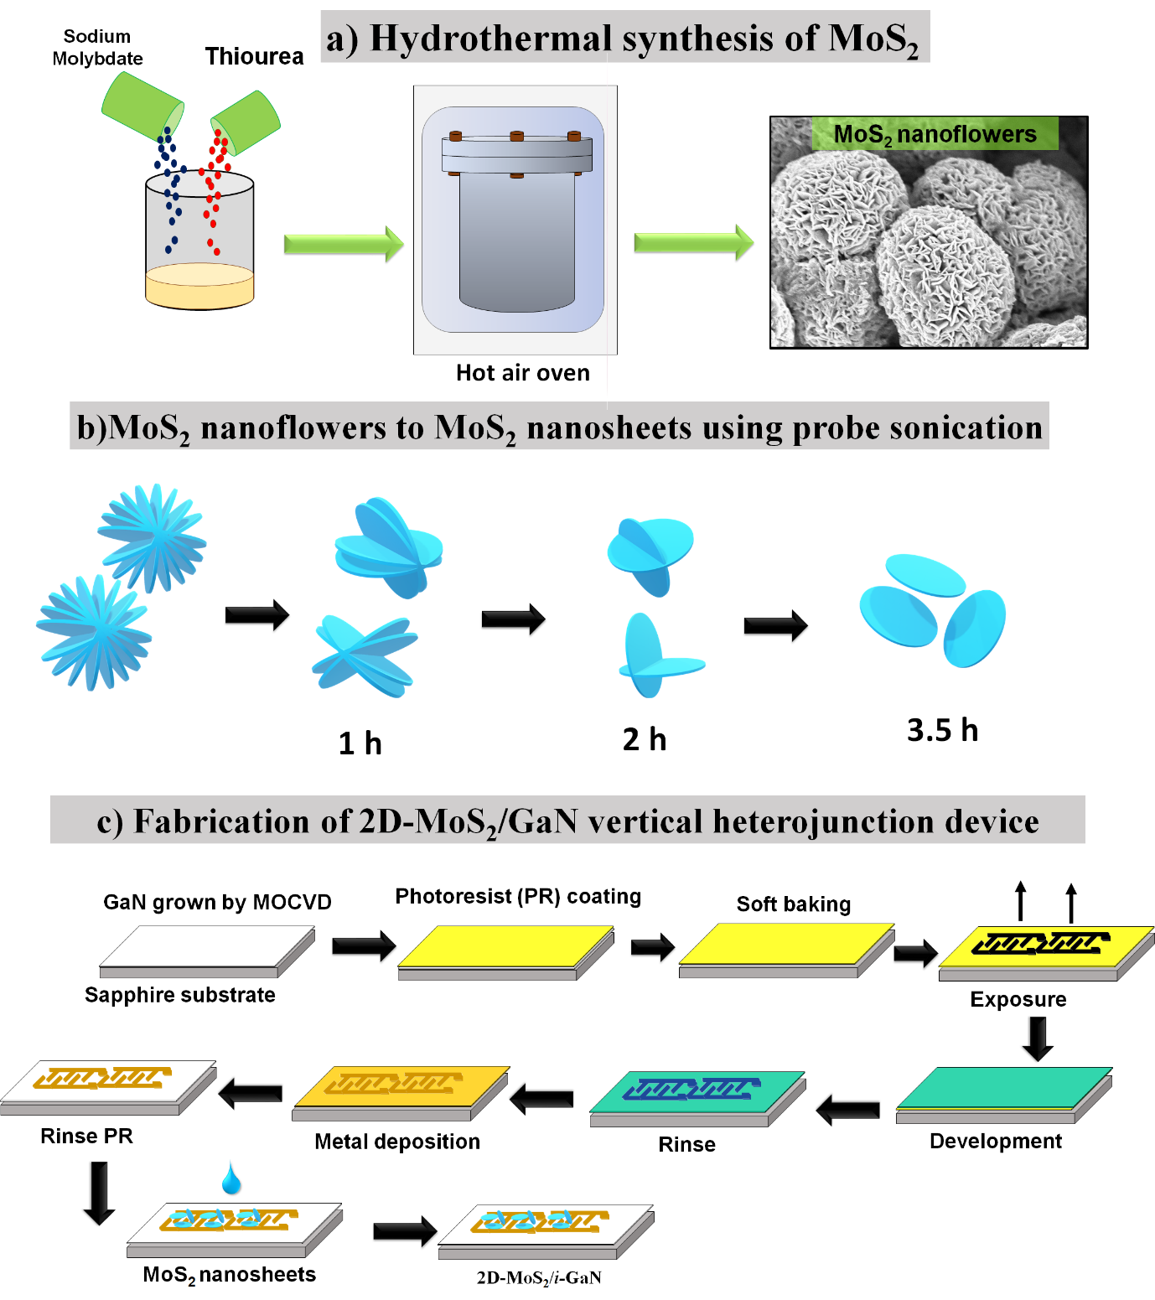
Figure 1. a) Hydrothermal synthesis of MoS₂ nanoparticles b) Exfoliation using probe-sonication c) Patterning using lithography and formation of vertical heterojunction.

Fabrication of 2D-MoS₂/GaN vertical heterojunction and photodetector device
First, the interdigital electrode contacts were fabricated on the GaN sample as metal-semiconductor-metal (MSM) photodetector using a standard laser lithography process. Ni (20 nm)/Au (20 nm) was deposited by an electron-beam evaporation followed by a lift-off process, as shown in Fig. 1(c). The resulting patterned metal layer forms the Schottky contacts suitable for the electrical measurements. Then, the optimized MoS₂ nanosheets after probe sonication of 3.5 h were taken for making 2D-MoS₂/GaN heterojunction. The GaN sample or MSM device were preheated at 60°C, and MoS₂ nanosheets were drop-casted onto the GaN, forming the vertical heterojunction interface between the two materials. Drop-casting is a simple and effective method for forming the heterojunction, allowing direct contact between the materials. The resulting heterojunction has a large interfacial area, which enhances the charge separation and transport properties of the device.
Results and discussion
Detailed characterization such as FESEM, XRD, RAMAN, UV-VIS spectroscopy, XPS spectra and PL spectroscopy were performed for both MoS₂ and GaN. Figure 2 (a) shows the FESEM images of MoS₂ nanoflowers, which exhibit a distinct morphology and structure with stacked petals resembling the tagetes erecta flower. The nanoflowers consist of multiple layers of MoS₂ petals arranged in a radial pattern around a central axis, forming a flower-like structure. The petals have smooth surfaces, which are thin and flat, and stacked on top of each other, creating a unique and intricate morphology. The formation of nanoflower-like structures can be attributed to the supersaturation of the precursor solution [9], which leads to the formation of nanocrystals, resulting in the self-assembly of these nanocrystals into larger flower-like structures. In addition, the stacking of individual MoS₂ layers can also be contributed to the formation of petal-like structures as each layer grows in a specific orientation [10]. Further, the exfoliation of MoS₂ nanoflowers into nanosheets was achieved using probe sonication for different periods of time. It is observed that as the sonication time increases from 0.5 to 3.5 hours, there is a corresponding increase in the number of exfoliated MoS₂ nanosheets. The FESEM images of MoS₂ nanoflowers before and after sonication at 0.5 hr, 1 hr, 2 hr and 3.5 hr are shown in Figs. 2(b), (c), (d) and (e), respectively. The images depict that the petals of the nanoflowers become more separated with increasing the sonication time, resulting in a greater number of individual nanosheets. At shorter sonication times of 0.5 hr and 1 hr, some larger flakes or clusters of flakes are observed to be still present due to incomplete exfoliation [11]. However, after a longer sonication of 3.5 hr., most of the MoS₂ material is exfoliated into individual nanosheets, as shown in Fig. 2(e).
AFM was used to investigate the surface morphology of GaN film grown on sapphire substrates. The AFM images revealed that the GaN film has an ultra-smooth surface with a root mean square (Rq) roughness of 0.514 nm, and an arithmetic average roughness (Ra) of 0.428 nm, for the surface area of 5×5 µm². A minimal difference of 0.0132% in the surface area of the projected image was obtained. The obtained results prove the superior property of GaN films to be used in photodetector applications [12].
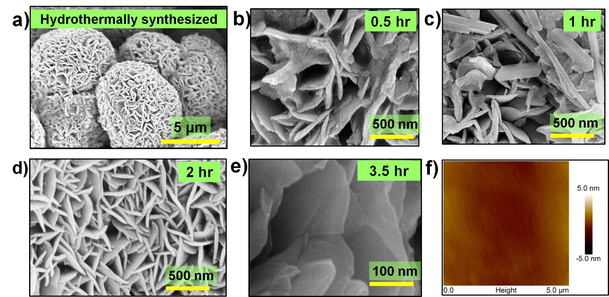
Figure 2. a) FESEM micrographs of the hydrothermally synthesized MoS₂ nanoflowers, Probe- sonicated MoS₂ nanosheets for b) 0.5 hr c) 1 hr d) 2 hr and e) 3.5 hr f) Typical 2D AFM images of the GaN film grown in sapphire substrate.

XRD analysis was performed to confirm the crystalline structure of the hydrothermally synthesized MoS₂ nanosheets. As shown in Fig. 3 (a), the XRD pattern shows clear diffraction peaks corresponding to the hexagonal phase of MoS₂. The most intense peak was observed at 2θ = 14.39°, corresponding to the (002) plane, followed by peaks at 2θ = 23.8°, 39.2°, 44.7°, and 62.4°, corresponding to (006), (103), (104), and (107) planes, respectively. The presence of these peaks confirms the highly crystalline nature of the MoS₂ nanosheets [13]. The observed peaks are consistent with the standard JCPDS card no. 002-0132, which further confirms the hexagonal crystal structure of MoS₂. To evaluate the crystalline quality of GaN epitaxial layer, XRD rocking curves around (002)- and (102)-planes were performed, as shown in Figs. 3(b) and 3(c). The full width at half maximum (FWHM) for (002)- and (102)-planes are 180 and 250 arcsec, respectively, indicating a high crystalline quality and a relatively low level of defects, which is desirable for optoelectronic applications [14].
Raman spectroscopy was used to study the structural and vibrational properties of MoS₂. The Raman spectrum of MoS₂ exhibits two prominent peaks at around 381 cm⁻¹ and 406 cm⁻¹, which correspond to the E_{1g} and A_{1g} modes, respectively. The E_{1g} mode arises from in-plane vibrations of the sulfur atoms, while the A_{1g} mode arises from out-of-plane vibrations of the sulfur and molybdenum atoms [15]. The energy difference of the two peaks indicates that the MoS₂ film consists of few-layered sheets. The UV-Vis spectra of MoS₂ show a strong absorption peak at around 250 nm, as shown in Fig. 3(e). This peak can be associated with an indirect transition due to the blue-shifted Z, C, and D excitonic peaks in MoS₂ [16]. Taucs’ plot was used to calculate the band gap energy of MoS₂ by plotting a graph between (αhν) ^ (1/n) versus photon energy (hν), where α is the optical absorption coefficient. A bandgap energy of 2.7 eV was obtained for the synthesized MoS₂ nanosheets. PL spectra of GaN films typically show a high-intensity peak at around 350-370 nm, corresponding to the band-edge emission. A much lower shoulder peaks at longer wavelengths, around 440 nm and 550 nm are also observed, which are typically attributed to defect-related emissions such as donor-acceptor pair (DAP) and yellow luminescence (YL) [17]. The XPS pattern for the as-synthesized MoS₂ nanoparticles and the deposited GaN films have been performed and given in SI section S2.
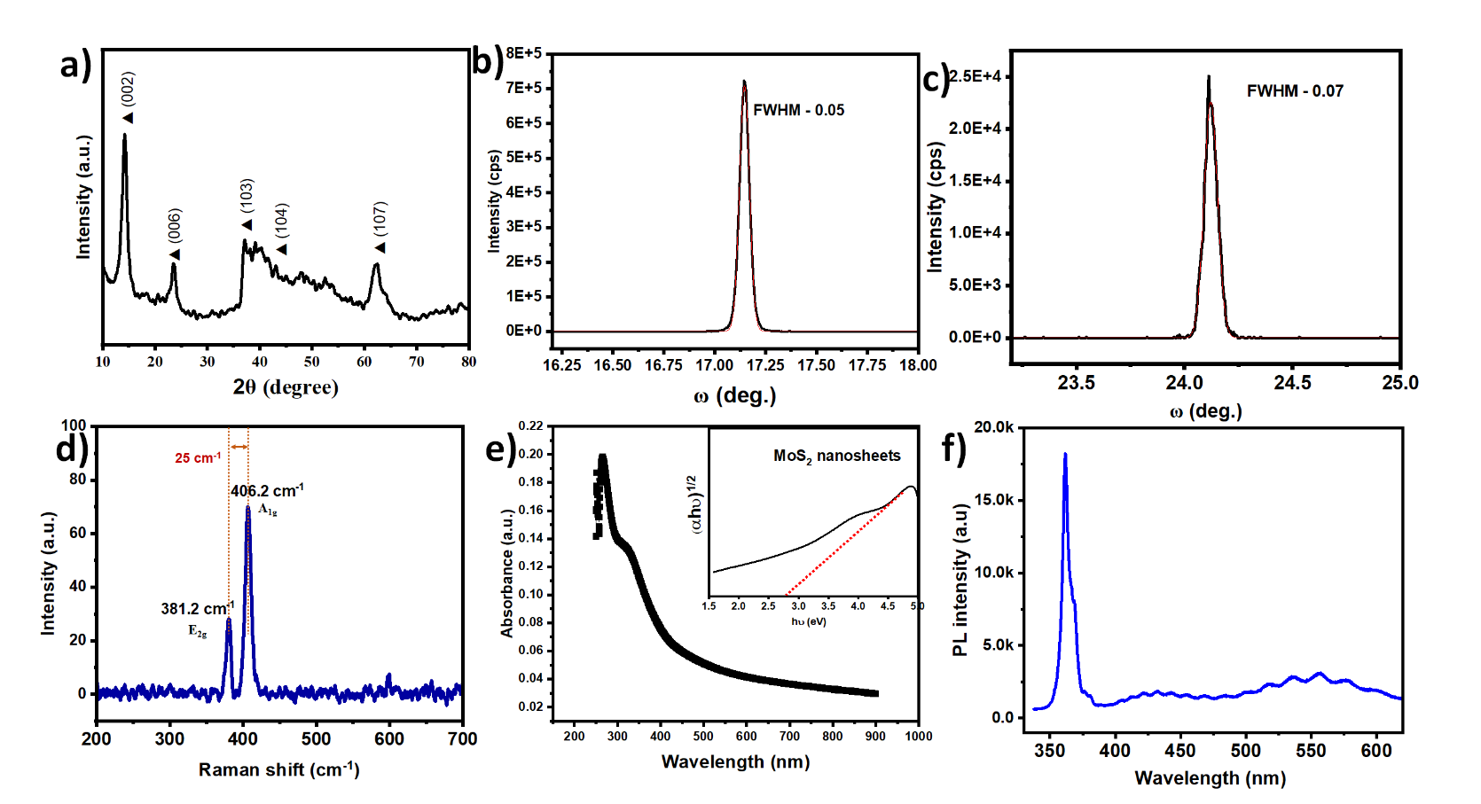

Figure 3. a) XRD pattern of the hydrothermally synthesized MoS₂ nanoparticles; b) XRD Rocking curves around (002)-plan of GaN; c) XRD Rocking curve of (102)-plane of GaN; d) Raman spectra of MoS₂ nanoparticles; e) UV-VIS spectra of MoS₂ inset: Tauc’s plot; f) PL spectra of GaN film

Photo response studies of the fabricated 2D- MoS₂/i-GaN photodetector
The performance of the 2D-MoS₂/i-GaN hybrid photodetector was investigated by electrical, optical, and photo response measurements. The MSM-type photodetectors fabricated on bare i-GaN were also characterized as references. The I-V curves of the i-GaN photodetector are given in Fig. 4(a). The dark current was found to be on the order of 10⁻¹¹A in the absence of external light at the applied voltage of 1V. Upon the illumination of UV light with the wavelengths of 350 and 370 nm, the photocurrents were found to be increased by up to two orders of magnitude at the applied voltage of 1 V. The incident light is typically absorbed by a depletion region within the GaN when the bias is applied, where the electric field is high and the carriers are separated [18,19]. The separated carriers are then collected by the electrodes, leading to the generation of photocurrents [20, 21]. The I-V characteristics of the 2D-MoS₂/i-GaN device are given in Fig.4(b). The dark current was increased compared to that of the i-GaN MSM photodetector but still maintained a low level on the order of 10⁻¹⁰A at 1 V. The hybrid heterojunction device displayed a unique photo response when the UV lights were illuminated. The photocurrent drastically increased to 6.2 x10⁻⁹ A when the incident wavelength was 250 nm at the applied voltage of -1 V. Judging from the UV-vis spectra and photocurrent spectra (Fig. 4 (c)), the photoresponse at 250 nm is generated from the 2D-MoS₂. When the incident wavelength was 270 nm, the photocurrent of the 2D-MoS₂/i-GaN hybrid junction device was reduced. While it increased again under the incident wavelength of 340nm-370nm, which is originated from the absorption of GaN. The spectra responsivity of the 2D-MoS₂/i-GaN heterojunction at 0V was measured from 200 to 1000 nm, as displayed in Fig. 4(c). The spectra responsivity of the i-GaN MSM device at 1 V is also displayed for reference. As can be seen, the response at 350-370 nm is drastically enhanced with the introduction of the 2D-MoS₂ to i-GaN even when no external bias is applied.
The photoresponsivity of the photodetector is calculated with regard to the efficiency to convert the incoming light into a measurable electrical signal. It is defined as the ratio of the output signal to the input optical power, as shown in eq. 1, where I_{λ} is the photocurrent generated by the photodetector, A is the area, and P_{λ} is the optical power incident on the photodetector. The EQE measures the number of electron-hole pairs a photodetector generates for each incoming photon. It is defined as the ratio of the number of collected charge carriers to the number of incident photons as shown in eq. 2, where h is Planck's constant, c is the speed of light, e is the elementary charge, R_{λ} is the responsivity. The detectivity (D) of the photodetector is described as the inverse of the noise equivalent power, as shown in eq. 3 below.
$R_{λ}=\frac{I_{λ}}{P_{λ}×A}$ [eq.1]
$EQE=hc×\frac{R_{λ}}{eλ}$ [eq.2]
$D^{*}=\frac{R}{{\left(2qJ_{d}\right)}^{0.5 }}$ [eq.3]
The MSM photodetector fabricated on bare i-GaN has a peak responsivity of 35 A/W at 370 nm when the applied voltage is 1 V. It is worth noting that, with the integration of 2D-MoS₂ to GaN, the hybrid photodetector exhibits a significantly enhanced response at ~370 nm. The maximum photoresponsivity is as high as 610 A/W with an EQE exceeding 2000% even when no external bias is applied. The photocurrent gain was further estimated using the following eq. 4.
Photocurrent Gain (G) = ΔI_{ph} / P_{opt} [eq.4]
where ΔI_{ph} is the change in photocurrent, and P_{opt} is the incident optical power. The photocurrent gain of 10³ was obtained for the fabricated heterojunction photodetector. The UV/Visible discrimination ratio, which calculates as the ratio of the absorbance in the UV region to the absorbance in the visible region, was estimated to be 141.8.
The temporal response of the fabricated 2D-MoS₂/GaN hybrid junction device illuminated at different wavelengths without external bias are shown in Figs. 4(d) and (e). The device was subjected to on/off illumination of different wavelengths. When the incident light is 250 nm, the photocurrent was ~6.2 ×10⁻⁹ A. While it was reduced and showed a slight stepwise increase upon the illuminations from 260 nm, 270 nm, and 280 nm. This behavior corresponds well with the UV-vis spectra and further confirms the absorption of MoS₂ layer at the deep UV region. As the wavelength increases towards 280 nm, the device exhibits a stepwise increase in the photocurrents, indicating the photoresponse from the absorption of the GaN layer. The highest photocurrent was at the 370 nm illumination, corresponding to the absorption from the GaN layer, as shown in Fig. 4(e). The device was subjected to on/off illumination cycles at five different wavelengths: 250 nm, 270 nm, 340 nm, 350 nm, and 370 nm, as shown in Supplementary Information (SI) Figure S1. The device showed excellent stability during the continuous on/off cycles, with little persistent photoconductivity effect [22]. The response time is further investigated under 350 nm pulse at zero bias, as shown in Fig. 4 (f). The measurement revealed a rise response time (T_{r}) of ~20 ms (the time for the photocurrent to reach 90% of its steady-state value), and a fall time (T_{f}) of ~ 18 ms (the time required for the photocurrent to decay to 10% of its steady-state value). We note that the response time was measured at weak UV intensity, upon which defects may play an important role. When a laser diode is employed, a much faster response time should be achieved [23].
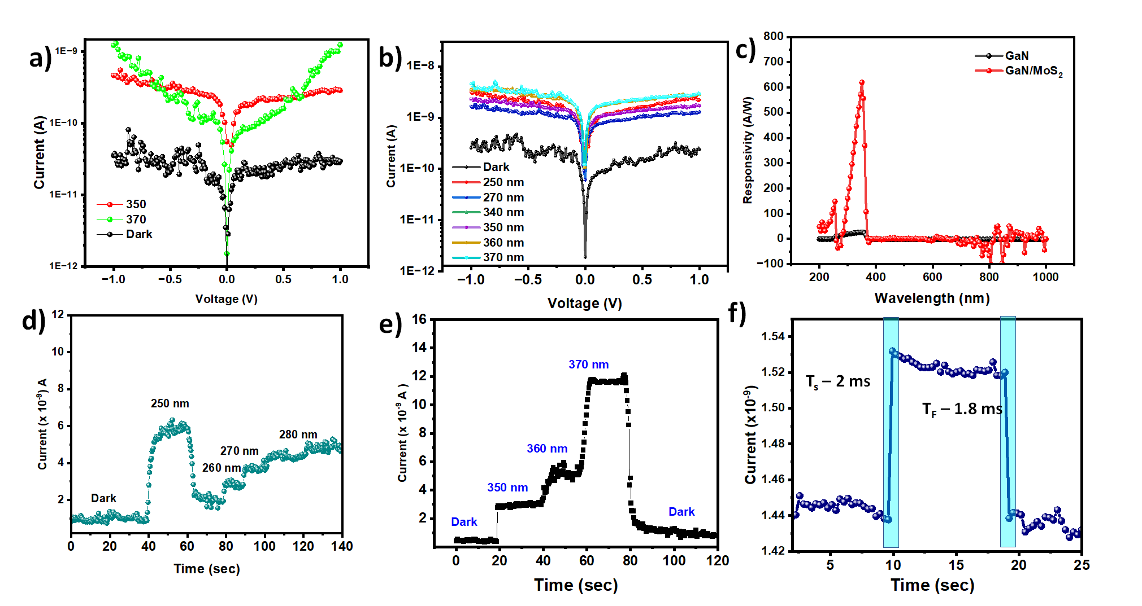
Figure 4. a) I-V characteristics of the fabricated GaN-based photodetector with and without UV light illuminations; b) I-V characteristics of the 2D-MoS₂/GaN-based photodetector with and without UV light illuminations; c) photoresponsivity plots of the i-GaN MSM photodetector under 1V and 2D-MoS₂/i-GaN photodetector without external bias; d) temporal response of the fabricated 2D-MoS₂/GaN-based photodetector in the range of 250 -280 nm at 1 V bias; e) Temporal response of the fabricated 2D-MoS₂/GaN-based photodetector in the range of 350– 370 nm; f) Rise time and fall time of the 2D-MoS₂/i-GaN photodetector

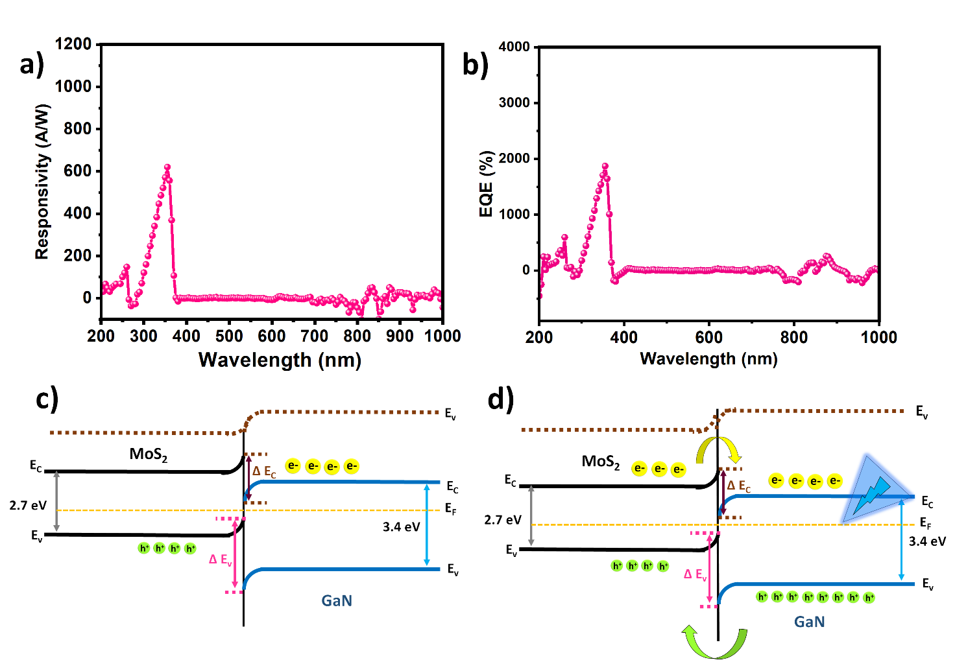
Figure 5. a) Responsivity spectrum of the fabricated photodetector b) EQE of the fabricated photodetector c) Band–diagram under equilibrium conditions d) Band-diagram upon illumination of UV light.

Photodetection Mechanism of the self-powered 2D-MoS₂/i-GaN hybrid photodetector
The mechanism of the fabricated self-powered photodetector can be explained with the help of the band diagram given in Figs. 5(c) and (d). The work function and electron affinity of the materials was calculated using the following equations:
Work function (Φ) = E_{vacuum} - E_{Fermi}
Electron affinity (χ) = E_{vacuum} - E_{conduction}
where E_{vacuum} is the energy of the vacuum level, E_{Fermi} is the Fermi energy level, and E_{conduction} is the energy level of the bottom of the conduction band. The energy levels of the bands were obtained from previous work [25]. The horizontal axis in the band diagram represents the position of the material, while the vertical axis represents the energy levels. The Fermi level is represented as a dashed line in the middle of the band gap. The band diagram shows the alignment of the energy levels of the two materials at the interface [26].
As the MoS₂ and GaN share the two Ni/Au electrodes, the fabricated device can be regarded as two MSM photodetectors connected in parallel. While as a difference in energy band structures and electron affinities between the two materials, a type II band heterojunction is formed between GaN and MoS₂. Due to the nanosheet morphology and free-dangling bonds of the surface of MoS₂, an excellent heterojunction can be formed beyond the restriction of lattice mismatching. Initially, under thermal equilibrium, electrons in the MoS₂ layer move toward the GaN end due to the decrease in conduction band energy, while the holes in GaN are transferred to MoS₂ due to the difference in the Fermi level [27]. The energy levels near GaN shows a downward bending, while those near MoS₂ bend upward until the Fermi levels of MoS₂ and GaN are aligned at the same position. This creates a built-in electric field at the heterojunction, resulting in a self-bias nature of the device.
When the UV light is illuminated on the device, a photon with energy greater than the band gap energy of GaN and MoS₂ is absorbed by the heterojunction. This absorption process creates an electron-hole pair within the heterojunction. Further, the absorbed photon creates an electron (e-) in the conduction band and leaves behind a hole (h+) in the valence band [28]. Due to the built-in electric field at the MoS₂/GaN interface, the generated electrons in the GaN layer are pushed towards the MoS₂ layer, and the holes are pushed in the opposite direction [29]. They are collected at the Ni/Au electrodes, thus a photocurrent is produced.
The significantly enhanced photo response at 370 nm by the integration of MoS₂ to GaN can be attributed to the following reasons: i) High carrier separation efficiency in the device due to the presence of the built-in electric field at the heterojunction interface. When 2D-MoS₂ formed heterojunction on the GaN, as a result of the energy band bending and the free-dangling bonds of the MoS₂ surface, a strong built-in electrical field will appear near the MoS₂/GaN interface. When the UV light is performed, the photo-generated electron-hole pairs will be quickly separated by the built-in electric field and driven to the GaN and MoS₂ layers, respectively. This leads to a high photoresponsivity and fast response speed, even at zero bias. ii) the unique properties of the MoS₂ layer. As a 2D material, MoS₂ has a high surface-to-volume ratio, which enhances its light absorption capabilities [20]. The layered structure, van-der-Waals bonding, and high carrier mobility of the MoS₂ layer also enables the efficient carrier separation. In addition, the illumination of the UV light further stimulated the trap states existing in the MoS₂ layer, contributing to the photocurrent gain. iii) The fabricated device can be regarded as two MSM photodetectors connected in parallel as the 2D MoS₂ and GaN share the same Ni/Au electrodes, which further contributes to the photocurrent gain.

Table 1. Comparison of the fabricated MoS₂/i-GaN photodetector with the recently reported photodetectors

Active material | Substrate | Method of fabrication | Responsivity | Self-powered | EQE (%) | Rise time (ms) | Operating temperature | References
MoS₂/GaN | AlN buffer layer on the Si(111) | Plasma-assisted molecular beam epitaxy of both GaN & MoS₂ | 37 mA/W | Yes | 126 | 33 | 250°C | [8]
MoS₂/GaN | Sapphire (0001) | Commercially procured | 10⁴ A/W @ 1V bias | No | 6.19 × 10⁶ | 300 | R. T | [31]
MoS₂ on p-GaN | sapphire | Metal oxide chemical vapor deposition of GaN  Electron beam evaporation of MoS₂ | 14.3 A/W | Yes | 1.5 x10³ | 97.1 | R. T | [32]
GaN/Nb-Doped MoS₂ | SiO₂ | Chemical Vapour Deposition of both MoS₂ & GaN | 172 A/W @1V bias | No | 23.7 | 110 | R. T | [33]
2D-MoS₂/i-GaN | Sapphire | MoS₂ – Hydrothermal and exfoliation  GaN – MOCVD | 610 A/W | YES | 2000 | 20 ms | R. T | This work

Table 1 provides a comparison of the recently reported MoS₂/GaN-based photodetectors with this work based on substrate, fabrication method, responsivity, self-powering capability, EQE, rise time, and operating temperature. As can be seen that only two of the previous works, i.e., MoS₂/GaN on Si (111) by Gupta et al. [31] and MoS₂ on p-GaN by Zhuo et al., [32] are working at zero-power consumption condition. However, their responsivities are very low and response speeds are high. In contrast, in this work, we obtained a true high-performance zero-power-consumption MoS₂/GaN UV photodetector with a peak responsivity of 610 A/W and EQE exceeding 2000%, which eliminates the need for an external bias and makes it easier to use in practical applications. The overall performances of the fabricated hybrid heterojunction device belong to the high level, such as the high sensitivity, high speed, high signal-to-noise ratio, high stability, simplicity and good spectra selectivity, satisfying the 6S requirements. The developed 2D-MoS₂/i-GaN self-powered UV photodetector with superior performance paves the way for the further research and development on the high-performance and zero-power consumption applications in optoelectronics.
Conclusion:
In summary, we successfully fabricated a high-performance zero-power-consumption 2D-MoS₂/i-GaN-based vertical heterojunction UV photodetector with superior responsivity and rapid response time. The one-step hydrothermal method followed by probe sonication was used to fabricate 2D-MoS_{2,} and then transferred to the GaN layer to form the hybrid heterojunction photodetectors. The device displayed a low dark current and a significant enhancement in photocurrent upon illumination of UV light of 370 nm, leading to a superior photoresponsivity of 610 A/W and EQE of 2000% under no external bias. The UV/visible discrimination ratio is more than two orders of magnitude, and the specific detectivity is estimated to be 1.22 × 10¹⁴ Jones. Although the photocurrent gain is high, the rapid photo-response with a rise/fall time of 20/18 ms is achieved. The advanced integration technology and the high-performance characteristics of this device pave the way for new and innovative applications in the field of optoelectronics with zero-power consumptions.
ACKNOWLEDGMENTS
This work was supported by the World Premier International Research Center Initiative (WPI) on Materials Nanoarchitectonics (MANA), Ministry of Education, Culture, Sports, Science & Technology (MEXT), JSPS KAKENHI (Grant No. 23H01359, and 23KF0081), and JST-PRESTO (Grant No. JPMJPR19I7) in Japan. SV would like to thank IITH and NIMS for the International Cooperative Graduate Program (ICGP) Fellowship.

Supporting Information
The Supporting Information is available free of charge.
- Figure of the time response with on/off illumination cycles at different wavelengths of the MoS₂/GaN device; XPS analysis of MoS₂ and GaN.

Reference:
(1) Sang, L.; Liao, M.; Sumiya, M. A Comprehensive Review of Semiconductor Ultraviolet Photodetectors: From Thin Film to One-Dimensional Nanostructures. Sensors (Switzerland). MDPI AG August 13, 2013, pp 10482–10518. https://doi.org/10.3390/s130810482.
(2) Sang, L.; Hu, J.; Zou, R.; Koide, Y.; Liao, M. Arbitrary Multicolor Photodetection by Hetero-Integrated Semiconductor Nanostructures. Sci Rep 2013, 3. https://doi.org/10.1038/srep02368.
(3) Sang, L.; Ren, B.; Endo, R.; Masuda, T.; Yasufuku, H.; Liao, M.; Nabatame, T.; Sumiya, M.; Koide, Y. Boosting the Doping Efficiency of Mg in p -GaN Grown on the Free-Standing GaN Substrates. Appl Phys Lett 2019, 115 (17). https://doi.org/10.1063/1.5124904.
(4) Ren, B.; Liao, M.; Sumiya, M.; Huang, J.; Wang, L.; Koide, Y.; Sang, L. Vertical-Type Ni/GaN UV Photodetectors Fabricated on Free-Standing GaN Substrates. Applied Sciences (Switzerland) 2019, 9 (14). https://doi.org/10.3390/app9142895.
(5) Zheng, Y.; Cao, B.; Tang, X.; Wu, Q.; Wang, W.; Li, G. Vertical 1D/2D Heterojunction Architectures for Self-Powered Photodetection Application: GaN Nanorods Grown on Transition Metal Dichalcogenides. ACS Nano 2022, 16 (2), 2798–2810. https://doi.org/10.1021/acsnano.1c09791.
(6) Veeralingam, S.; Badhulika, S. Ti@MoS2 Incorporated Polypropylene/Nylon Fabric-Based Porous, Breathable Triboelectric Nanogenerator as Respiration Sensor and Ammonia Gas Sensor Applications. Sens Actuators B Chem 2023, 380. https://doi.org/10.1016/j.snb.2023.133346.
(7) Wang, L.; Jie, J.; Shao, Z.; Zhang, Q.; Zhang, X.; Wang, Y.; Sun, Z.; Lee, S. T. MoS2/Si Heterojunction with Vertically Standing Layered Structure for Ultrafast, High-Detectivity, Self-Driven Visible-near Infrared Photodetectors. Adv Funct Mater 2015, 25 (19), 2910–2919. https://doi.org/10.1002/adfm.201500216.
(8) Vashishtha, P.; Prajapat, P.; Sharma, A.; Singh, P.; Walia, S.; Gupta, G. Self-Driven UVC-NIR Broadband Photodetector with High-Temperature Reliability Based on a Coco Palm-Like MoS2/GaN Heterostructure. ACS Appl Electron Mater 2023, 5 (3), 1891–1902. https://doi.org/10.1021/acsaelm.3c00156.
(9) Kadam, S. R.; Late, D. J.; Panmand, R. P.; Kulkarni, M. V.; Nikam, L. K.; Gosavi, S. W.; Park, C. J.; Kale, B. B. Nanostructured 2D MoS2 Honeycomb and Hierarchical 3D CdMoS4 Marigold Nanoflowers for Hydrogen Production under Solar Light. J Mater Chem A Mater 2015, 3 (42), 21233–21243. https://doi.org/10.1039/c5ta04617c.
(10) Yan, A.; Velasco, J.; Kahn, S.; Watanabe, K.; Taniguchi, T.; Wang, F.; Crommie, M. F.; Zettl, A. Direct Growth of Single- and Few-Layer MoS2 on h-BN with Preferred Relative Rotation Angles. Nano Lett 2015, 15 (10), 6324–6331. https://doi.org/10.1021/acs.nanolett.5b01311.
(11) Gopalakrishnan, D.; Damien, D.; Shaijumon, M. M. MoS2 Quantum Dot-Interspersed Exfoliated MoS2 Nanosheets. ACS Nano 2014, 8 (5), 5297–5303. https://doi.org/10.1021/nn501479e.
(12) Sang, L. Diamond as the Heat Spreader for the Thermal Dissipation of GaN-Based Electronic Devices. Functional Diamond 2021, 1 (1), 174–188. https://doi.org/10.1080/26941112.2021.1980356.
(13) Veeralingam, S.; Badhulika, S. X (Metal: Al, Cu, Sn, Ti)-Functionalized Tunable 2D-MoS2nanostructure Assembled Biosensor Arrays for Qualitative and Quantitative Analysis of Vital Neurological Drugs. Nanoscale 2020, 12 (28), 15336–15347. https://doi.org/10.1039/d0nr03427d.
(14) Heying, B.; Wu, X. H.; Keller, S.; Li, Y.; Kapolnek, D.; Keller, B. P.; Denbaars, S. P.; Speck, J. S. Role of Threading Dislocation Structure on the X-Ray Diffraction Peak Widths in Epitaxial GaN Films. Appl Phys Lett 1995, 643. https://doi.org/10.1063/1.116495.
(15) Muduli, S. P.; Veeralingam, S.; Badhulika, S. Interface Induced High-Performance Piezoelectric Nanogenerator Based on a Electrospun Three-Phase Composite Nanofiber for Wearable Applications. ACS Appl Energy Mater 2021, 4 (11), 12593–12603. https://doi.org/10.1021/acsaem.1c02371.
(16) Guo, Y.; Li, J. MoS2 Quantum Dots: Synthesis, Properties and Biological Applications. Materials Science and Engineering C. Elsevier Ltd April 1, 2020. https://doi.org/10.1016/j.msec.2019.110511.
(17) Ren, B.; Liao, M.; Sumiya, M.; Wang, L.; Koide, Y.; Sang, L. Nearly Ideal Vertical GaN Schottky Barrier Diodes with Ultralow Turn-on Voltage and on-Resistance. Applied Physics Express 2017, 10 (5). https://doi.org/10.7567/APEX.10.051001.
(18) Li, P.; Xiong, T.; Wang, L.; Sun, S.; Chen, C. Facile Au-Assisted Epitaxy of Nearly Strain-Free GaN Films on Sapphire Substrates. RSC Adv 2020, 10 (4), 2096–2103. https://doi.org/10.1039/c9ra09689b.
(19) Sha, R.; Vishnu, N.; Badhulika, S. MoS2 Based Ultra-Low-Cost, Flexible, Non-Enzymatic and Non-Invasive Electrochemical Sensor for Highly Selective Detection of Uric Acid in Human Urine Samples. Sens Actuators B Chem 2019, 279, 53–60. https://doi.org/10.1016/j.snb.2018.09.106.
(20) Xie, Y.; Zhang, B.; Wang, S.; Wang, D.; Wang, A.; Wang, Z.; Yu, H.; Zhang, H.; Chen, Y.; Zhao, M.; Huang, B.; Mei, L.; Wang, J. Ultrabroadband MoS2 Photodetector with Spectral Response from 445 to 2717 Nm. Advanced Materials 2017, 29 (17). https://doi.org/10.1002/adma.201605972.
(21) Liu, K.; Sakurai, M.; Aono, M.; Shen, D. Ultrahigh-Gain Single SnO2 Microrod Photoconductor on Flexible Substrate with Fast Recovery Speed. Adv Funct Mater 2015, 25 (21), 3157–3163. https://doi.org/10.1002/adfm.201500231.
(22) Liao, M.; Koide, Y. High-Performance Metal-Semiconductor-Metal Deep-Ultraviolet Photodetectors Based on Homoepitaxial Diamond Thin Film. Appl Phys Lett 2006, 89 (11). https://doi.org/10.1063/1.2349829.
(23) Liu, K.; Sakurai, M.; Aono, M.; Shen, D. Ultrahigh-Gain Single SnO2 Microrod Photoconductor on Flexible Substrate with Fast Recovery Speed. Adv Funct Mater 2015, 25 (21), 3157–3163. https://doi.org/10.1002/adfm.201500231.
(24) Veeralingam, S.; Badhulika, S. Enhanced Carrier Separation Assisted High-Performance Piezo-Phototronic Self-Powered Photodetector Based on Core-Shell ZnSnO3 @In2O3 Heterojunction. Nano Energy 2022, 98. https://doi.org/10.1016/j.nanoen.2022.107354.
(25) Takegahara, K.; Harima, H.; Kasuya, T. Band-Structure Calculation of MBe13 (M = La, Ce, Th and U); 1986; Vol. 16.
(26) Khan, F.; Idrees, M.; Nguyen, C.; Ahmad, I.; Amin, B. A First-Principles Study of Electronic Structure and Photocatalytic Performance of GaN-MX2(M = Mo, W; X= S, Se) van Der Waals Heterostructures. RSC Adv 2020, 10 (41), 24683–24690. https://doi.org/10.1039/d0ra04082g.
(27) Zhang, Y.; Zhu, T.; Zhang, N.; Li, Y.; Li, X.; Yan, M.; Tang, Y.; Zhang, J.; Jiang, M.; Xu, H. Air-Stable Violet Phosphorus/MoS2 van Der Waals Heterostructure for High-Responsivity and Gate-Tunable Photodetection. Small 2023. https://doi.org/10.1002/smll.202301463.
(28) Ermolaev, G. A.; Stebunov, Y. V.; Vyshnevyy, A. A.; Tatarkin, D. E.; Yakubovsky, D. I.; Novikov, S. M.; Baranov, D. G.; Shegai, T.; Nikitin, A. Y.; Arsenin, A. V.; Volkov, V. S. Broadband Optical Properties of Monolayer and Bulk MoS2. NPJ 2D Mater Appl 2020, 4 (1). https://doi.org/10.1038/s41699-020-0155-x.
(29) Jain, S. K.; Low, M. X.; Taylor, P. D.; Tawfik, S. A.; Spencer, M. J. S.; Kuriakose, S.; Arash, A.; Xu, C.; Sriram, S.; Gupta, G.; Bhaskaran, M.; Walia, S. 2D/3D Hybrid of MoS2/GaN for a High-Performance Broadband Photodetector. ACS Appl Electron Mater 2021, 3 (5), 2407–2414. https://doi.org/10.1021/acsaelm.1c00299.
(30) Singh, D. K.; Pant, R. K.; Nanda, K. K.; Krupanidhi, S. B. Pulsed Laser Deposition for Conformal Growth of MoS2 on GaN Nanorods for Highly Efficient Self-Powered Photodetection. Mater Adv 2022, 3 (15), 6343–6351. https://doi.org/10.1039/d2ma00577h.
(31) Tang, X.; Zheng, Y.; Cao, B.; Wu, Q.; Liang, J.; Wang, W.; Li, G. GaN Nanowire/Nb-Doped MoS2Nanoflake Heterostructures for Fast UV-Visible Photodetectors. ACS Appl Nano Mater 2022, 5 (3), 4515–4523. https://doi.org/10.1021/acsanm.2c00761.

High Responsivity of Zero-power-consumption Ultraviolet Photodetector using 2D-MoS₂/ i-GaN Vertical Heterojunction
Sushmitha Veeralingam^{1,2}, Liwen Sang^{2*}, Hong Pang,² Renzhi Ma,² and Sushmee Badhulika^{1*}
¹Department of Electrical Engineering, Indian Institute of Technology Hyderabad, Hyderabad, 502285, India
²International Center for Materials Nanoarchitectonics (MANA), National Institute for Materials Science,1-1 Namiki, Tsukuba, Ibaraki, Japan
*Corresponding author: E-mail: SANG.Liwen@nims.go.jp, sbadh@iith.ac.in

TOC GRAPHIC

For Table of Contents Only

