Magneto-thermal vibrations of single brain extracted microtubule in its super-non-conducting state

Satyajit Sahu, Subrata Ghosh, and Anirban Bandyopadhyay*

Advanced Key Technologies Division, National Institute for Materials Science, 1-2-1 Sengen, Tsukuba, Ibaraki, 305-0047 Japan

Quantum capacitance & quantum inductance, two well known signatures of quantum properties are used here to detect subtle changes in the resonance frequencies as instant quantum marker of cancerous mutation of tubulin proteins. A singular wave function is destroyed by measurement or environmental noise. Here we find that single brain extracted microtubule's spin quantum state is a collection of constituent wave functions, each wave function is made of elementary spin states. Such an unprecedented fractal packing of wave function enables self-survival of the wave function at the largest scale. As we image the three magnetic wave functions of a single brain extracted microtubule, packed one inside another in three layers, we find their geometric phase (Zak phase) rebuilds each other from nano-to-micro scale. Thus, in such protein structures, stored charge produces magnetic flux without flowing any current. Using the difference signal between magnetic and thermal nano-sensors located closely at the atomic edge of a probe, our interference based sensors mapped cancerous microtubule's local structural changes at the very onset of cancer even in the noisy environments.

Despite several attempts to safeguard information during measurement¹, it is still an open question whether it is at all possible to measure information without modifying or destroying natural weak vibrations. Since 1930s, routinely measured protein vibrations²⁻⁴ have failed to become a marker to detect the onset of a disease early, as subtle measurements flip a large number of its vibration modes. As protein vibrates at many different frequencies at a time²⁻⁴, no probe exists to read multiple energy domains at once, classical markers cannot instantly detect fractional changes in the resonance frequencies caused by mutation or virus attack. In the last 50 years all efforts to evade quantum demolition was optical^{1,5}, here, we found an electronic route, as three wave functions mutually clock each other, if one is destroyed, the other two rebuilds it. Instead of pumping an external energy to amplify enough to sense its response, we devised a new thermo-magneto differential⁶⁻⁸ sensor that is tuned to interfere & modulate the geometric phases of magnetic flux waves produced at the atomic scale to the micro scale. Instead of relying on the conventional electrical parameters like current or voltage, our three simultaneous recordings allow reading the rate of change of flux as a function of charge directly in a pure form to measure quantum capacitance⁹⁻¹¹ & quantum inductance¹²⁻¹⁵. These quantum markers⁹⁻¹⁵ of topological resonance^{6-8,16-20} of proteins are wavelike, originates purely from wave reflectance, transmittance & interference. So, a minute change in protein's local structural symmetry makes a significant change in phase. Earlier we reported significant changes in the resonance frequencies of microtubule¹⁷⁻²⁰ as it becomes cancerous¹⁷. Now, we read the same effect but quantum mechanically to enhance the detection resolution to 10⁻²¹eV, our new probe detects subtle changes in the internal degrees of freedom, yet momentum conservation yields Planks constant repeatedly. Measurement is self-fault tolerant hence fit to dip in a living cell²⁰ for the quantum detection of a disease at the very onset.

In 3.5 billion years, the diameter of a microtubule has varied 300% across the species. Its length rapidly changes 12000% to do essential cellular tasks.¹⁷ Its helical pitch changes 100% to precisely regulating the mechanics of the cells. This nanowire's length, diameter and pitch largely regulates life in our planet. We dropped a microtubule solution on the eight parallel electrodes of different gaps, selected microtubules of different lengths and diameters after reconstitution, and stretched it by pulling lengthwise to vary pitch. A device is shown Figure 1a. The measured capacitance & inductance of a microtubule oscillates with its length (l), pitch (p) and diameter (d); —this extreme insulator (10¹¹~10¹²Ω; Figures 1b, Figure S1) does not follow Ohm's law¹⁸; neither a classical capacitor (C≠ɛπd/l) nor a classical inductor (L≠μ₀ni). Period of oscillation is constant, varies linearly with l⁻¹, d⁻¹, and p⁻¹. This is signature of a quantum device operated by quasi particle interference causing geometric or topological resonance seen as standing wave mode.⁶⁻⁸

Microtubule is not a classical resonator, to check if its origin of resonance is quantum capacitor⁹⁻¹¹ and quantum inductor¹²⁻¹⁵ acting as a quantum resonator, we use Figure 1a device and measure C_{q} and L_{q} using standard bridge circuits, Figure 1c shows results. We found that if resonance frequency¹⁷⁻²⁰ is mixed with noise of a limited frequency range and amplitude (20μV<V<80μV), quantum features like periodicity⁶⁻⁸, and ripples in conductance like Tomasch oscillations⁶ seen in superconductors is more evident in microtubule. So, we determined fermi velocity of electrons⁸ v_{F} from conductance and l⁻¹ plot to find that noise reduces v_{F} from 10⁵m/s to 10⁻³m/s, i.e. microtubule becomes a super non-conductor (10¹⁵Ω) under suitable noise. So, we apply this noise to the Figure 1a set up mix with resonance frequencies (S/N~10²) as source to find that gating bias affects dos of microtubule changing its capacitance⁹⁻¹¹, which is also a function of frequency, we observe periodic ripples with gating in Figure 1c (top). So, it is obviously a quantum capacitor. Similarly, we measure quantum inductance¹²⁻¹⁵ as a function of frequency to find that each resonance frequency generates periodic oscillatory inductances (Figure 1c, bottom). Therefore, each resonance frequency of microtubule^{17,19-20} is originated from a pair of L_{q} and C_{q}. Thus far, minimizing scattering or collisions of electrons was key in electronics, here, super non-conductivity replaces the concept of resistance with strictly non-movable charge generating a magnetic flux (Figure 1d).

To find the nature of quasi particle wave that interferes to generate quantum properties we transform atom probe²⁰ as combined 0.1THz to 5THz thermal sensor²³ and a magnetic flux sensor²¹⁻²² (10⁻¹³T to 10⁻⁹T) as shown in Figure 2a (see methods & online texts for details). Differential signal between dual probes shows that THz emission and growth of magnetic ripple are in phase between two protein molecules on a microtubule surface when it exhibits a quantum effect. Noise induced rapid heating & cooling of dielectric transmits its phase by THz radiation through the protein junction, similar to the heat pipe effect.²⁴ Simultaneously, the probe records the formation of magnetic ripples, which is creation of microtubule's MHz resonance. By connecting L_{q} and C_{q} in parallel or series, it is not possible to fit this response, but, when we build a theory where L_{q} and C_{q} feed each other, we regenerate the entire magnetic ripple (see methods). So, microtubule resonance has a quantum origin, but, classical circuit often replicated as its quantum analogue does not work here.

Now, using this unique tip we scan electric and magnetic density of states of a single isolated monomer of tubulin protein, a single dimer and the microtubule by switching and holding to eight prominent conformer states or symmetries. Figure 2b images show that magnetic dos maps a condensed standing wave just like a superconductor, its scale free, while electronic dos profile is different for all components. So, the magnetic wave that forms at the monomer scales up to the microtubule. Its wavelength depends on lattice types or symmetry of dos. To find how exactly this scaling up happens, we put five atom probes at five different monomer locations on the magnetic condensed wave of 25μm long microtubule's surface (Figure 3a, top). The probes are synchronously clocked such that any change in phase is detected. Figure 3a (bottom) shows clearly how eight phase (Zak) ripples of a monomer integrates into a single phase of a dimer, and eight phase ripples of a dimer integrates into a single phase ripples of a microtubule. This is an interference pattern. In quantum interference two kinds of ripples superpose, while classical interference has only one kind of ripples. Here, three kinds of ripples are nested, if we try to apply a larger noise ~10⁻¹²watt (10⁹ times more power) one of three layers, even then phase plot is intact, Raman studies¹⁹ using laser & simultaneous phase quantization²⁰, confirmed this self-survival.

Such a way of packing phase inside a phase inside a phase is unprecedented. Therefore, we need to find basic quantum parameters experimentally, cross check the derivations by reproducing L_{q} and C_{q} values measured in Figure 1b. Then, we try to find the mechanism following which scale free fractal quantum behavior is generated. Since there is no electrical resistance, phase in a wave has to change by something, so we create a magnetic-charge analogue of Tomasch oscillations observed in superconductors.⁶⁻⁸ Instead of differential conductance (dV/dI) we measure differential magneto-charge variation (dψ/dQ) to find similar quantum ripples (Figure 3b) in monomer, dimer and microtubule, wherefrom we determined v_{F}~10⁻³m/s for all three components (see theory in the online text), which suggests that quasi charge dwell time in the quantum wells is 1μs in a monomer, 10μs in a dimer, 10ms in a microtubule. While the charge dwells for incredibly long times, the quasi charge moves with a phase velocity v_{ph}=λν~0.25×10⁸m/s~c/4; 25% the velocity of light c as we determine from Figure 2b, and Figure 3a. So, electrical resistance is infinity (~10¹⁵Ω), but quasi particle resistance for phase transmission is dψ/dQ~H~0.01~G⁻¹. Therefore, magneto-thermal ripples driven by quasi charge faces a similar resistance in a super non-conductor, like cooper pair faces in a super conductor (10⁻⁶Ω). We reported that at each resonance frequency microtubule rotates a polarized signal by nπ/4,²⁰ so, the value of quasi charge is e/4, quantum magnetic flux of Figure 2b is $Φ_{B}={4h}/e$. Instead of e²/h we get quantum phase conductance G_{o}=${16h}/{H^{2}e^{2}}$. To confirm G₀ is correct, we find C_{q} current phase, ahead by G₀C_{q}ω, and L_{q} current phase lags by G₀L_{q}ω from source, experiment & theories match. The magnetic wave wraps around microtubule, or tubulin, cross section σ of wave is πd²~10⁻¹⁸m². Quasi particles take τ_{i}~diameter/phase velocity~10⁻¹⁵ seconds only to resonate a monomer, dimer or microtubule.

When g_{v(r)} number of resonance frequencies are mixed with noise, monomer, dimer and microtubule break symmetry not randomly, but repeating a sequence like a clock, if we image Figure 2b continuously. Symmetry breaking is regulated by an internal mechanism, so, it affects the effective mass m* of the condensed magnetic wave. The ratio of cross sections of longest & shortest magnetic waves is the lattice limit factor $δ={(λ_{min}/λ_{max})}^{2}$~10⁻⁷, it increases L_{q}, decreases C_{q}, its value determines whether electric or magnetic effect would dominate for a given resonance frequency. L_{q} dominating resonance frequencies leaks a large dc current burst that was used earlier to detect resonance.¹⁸⁻²⁰ Using suitable frequencies $ΔE$ one could reversibly switch microtubule lattices i.e. their effective mass $m^{*}=ΔE/v_{Ph}^{2}δ$~10⁻²³kg. Microtubule lattice varies 8 ways triangular to hexagonal, hence lattice degeneracy ${0<g}_{v(a,b)}<8$; maximum magnetic wave degeneracy is $g_{v}=g_{v(r)}×g_{v(a,b)}$. Using all these values we calculate C_{q}= σδm*g_{v}e²/πћ² and L_{q}=g_{v}h/ΔQωδ. Using 5 tip set up of Figure 3a, we repeat Figure 1a experiment & derive C_{q} and L_{q} that varies linearly with m*, and with the degree of degeneracy g_{v} (Figure S2). We insert two additional atomic tips to directly pump noise to the water crystal core of microtubule. Microtubule validates the quantum expressions of C_{q} and L_{q} in two independent set ups. Even by using resonant tunneling diode models^{11,13,14} we could regenerate L_{q}~G⁻¹ τ_{i}~10⁻¹³H, and C_{q}~G τ_{i}~10⁻¹⁷F.

Figure 4a shows that a selection of 8 magnetic waves produced in the kHz-MHz resonance bands of cancerous¹⁷ & non-cancerous ($g_{v}>15$) microtubule follow a constituent relation $m^{*}σω=g_{v}h$, here a magnetic wave regulates its left part, the lattice tuning the charge dwell time edits the right part. This quantization is a magnetic analogue of mvr=nh is applicable to a single electron wave. The quantization argues that the electrons dwell times are edited statistically, but that dephasing is bridged by discretely placed quantum devices in the energy spectrum. Thus, $g_{v}$ accounts for buffer quantum bridges shown in Figure 4b, that ensures all local monomers charge dwell times constitute a dimer's dwell time. Dwell times of multiple dimers constitute quasi particles dwell time in a microtubule. We find here electrical resistance is infinity (10¹⁵Ω), resistance to condense a magnetic flux is nearly zero (10⁻³). Quantum capacitor does not store charge, quantum inductance generates magnetic flux without electron flow and these enables looking into the same electronic elements from an exactly opposite direction as illustrated in Figure 1c. Super non-conductivity is a new kind of super criticality, —combined with fractal integration of phase enable scale free quantum detection of protein mutation ($g_{v}$) even under noise.

Methods Summary:

Critical parameters for ultra-low power measurement: We reconstitute microtubule from the Porcine brain extracted tubulin protein.¹⁷⁻²⁰ 3-5nm water layer on microtubule/monomer/dimer surface is maintained²⁰ (thick water→10⁻⁶A ion flow masks protein current). We seal both the ends of microtubule with glycerine drops to protect its water crystal core. Note, we apply noise (μV, pA; ~10⁻¹⁸watt) to its water core, to see natural protein resonance 10⁻²¹watt (μV, fA; ). C_{q} and L_{q} were measured by capacitance & inductance bridges as practiced for decades.⁹⁻¹⁵

Measurement of ultra-low magnetic flux scan at 300K
10⁶ orders lower than earth’s magnetic field ~50×10⁻⁶T, is required to be measured, conventional fluxgate or SQUID fails here as at <150K noise freezes, δ→1, L_{q}→10⁻²¹H, C_{q}→10⁻¹⁰F. Our coaxial fluxgate systems (see details online) can reach <10⁻¹³T sensitivity. Change in ~1-80×10⁻¹³T in microtubule is detected by placing Figure 1a chip or entire set up inside multi-layered magnetic shields (details of Faraday cage building online). Differential Thermo-magneto spectroscopy (DTMS): Coaxial atom probe has two metal layers, Pt and Au, separated by a glass layer in the middle. We grow magnetic sensor CuInSe₂ on top, shorting the central Pt atom probe, then, a polymer PDDA layer isolating the inner probe. Finally, InP nanowire²³ is grown as a tip edge shorting the Au electrode. Three signals are taken out by independent hardware; magnetic, thermal and differential as ultra-low power outputs (Figure 2a). Thermal & magnetic signals are filtered by lock in, amplified & connected to Vector Network Analyzer (VNA) for S parameters, while differential signal passes through phase lock loop (PLL) amplifier, to get phase plotted in Figure 2a, Figure 3a. Central Au-magnetic tip is pumped with GHz stream of pulses to avoid magnetization saturation. The growth and decay rates of applied pulse stream is ~10-15ps, so magnetic flux ripples appear continuous. Magnetic Flux Microscopy (MXM, not Magnetic Force Microscopy, MFM): Fluxgate magnetic sensor (100pT to 0.1pT) is made by dropping 1nM helical nanowire solution²¹⁻²² of CuInSe₂ on Au end of Pt-glass-Au coaxial atom probe, it flows & covers the surface. The sensed magnetic induction current (1-10fA) for all nanowires is added & amplified through a preamplifier. For magnetic flux scan, 6 inch small RT-Ar(99%)-STM was used keeping inside a zero Gauss chamber; Pt tip was dipped in the InP nanowire solution for MXM with a feedback current loop. 1nm Pt tip edge adsorbs InP helical nanowire (helicity ~200nm, same as microtubule), a scan by switching off feedback loop at a constant height mode ~ 5nm above surface, records magnetic polarization induced transmission between oriented CuInSe₂ nanowires and HOPG substrate and is proportional to its magnetic flux.

A non-classical undefined wiring for quantum like resonance: As a charge passes through dos of one of eight quantum wells of a monomer, its dwell time $Δt$ is delayed at certain frequencies as if it stores a virtual charge $Q(t)=Q_{0}(1-exp⁡(-Δt/C_{q}\frac{∂ψ}{∂Q}))$; the reflected part from well grows as if an inductor is forming $L_{q}\left(t\right)=L_{q}(1-exp⁡(-Δt/C_{q}\frac{∂ψ}{∂Q}))$ the inductive phase grows $θ_{q(g)}=θ_{0}\left(1-\exp\left(-\frac{Δt\frac{∂ψ}{∂Q}}{L_{q}}\right)\right)=θ_{0}\left(1-\exp\left(-\frac{Δt\frac{∂ψ}{∂Q}}{L_{q}(1-exp⁡(-Δt/C_{q}\frac{∂ψ}{∂Q})) }\right)\right)$. Fitting Figures 2b, 3a we get Δt, as τ₁. As inductive waves phases between two neighbouring wells synchronizes, capacitive charging phase grows by decreasing $L_{q}$ phase as
$θ_{q(d)}=θ_{0}\left(\exp\left(-\frac{Δt}{{\frac{∂ψ}{∂Q}C}_{q}}\right)\right)=θ_{0}\left(\exp\left(-\frac{Δt\frac{∂ψ}{∂Q}}{C_{q}(1-exp⁡(-Δt\frac{∂ψ}{∂Q}/L_{q})) }\right)\right)$. Fitting Figures 2b, 3a we get Δt, as τ₂. A pair of quantum wells within a monomer creates a ripple with resonance frequency $f={(τ_{1}+τ_{2})}^{-1}\sim τ_{i}^{-1}$. $C_{q}$, $L_{q}$ contains h, produced wave is quantized ($ћω$), thus, classical series or parallel wiring of $C_{q}$, $L_{q}$ does not apply here as frequently practiced.¹⁰⁻¹⁵

Supplementary information

Supporting online text:
Experimental details

Supporting online figures:
Figure S1: Pitch and diameter variation of microtubule capacitance and inductance.
Figure S2: Variation of C_{q} and L_{q} as a function of g_{v} and m*.

Contributions: A.B. conceptualized the idea, S.S., S.G, A.B. did the experiment, A.B analyzed the data and wrote the paper.

Acknowledgements: We thank Dave Sonntag and Martin Timms for the independent test & verification of our device as part of patent US9019685B2. Authors acknowledge the Asian office of Aerospace R&D (AOARD) a part of United States Air Force (USAF) for the Grant no. FA2386-16-1-0003 (2016–2019) on the electromagnetic resonance based communication and intelligence of biomaterials.

Competing interests statement: The authors declare that they have no competing financial interest.

Correspondence and requests for materials should be addressed to A. B. anirban.bandyo@gmail.com and or anirban.bandyopadhyay@nims.go.jp

References:

1. V. Braginsky, Quantum Nondemolition Measurement. Science. 209 (4456): 547–557(1980).
2. F. Vollmer, D. Braun, and A. Libchaber; Protein detection by optical shift of a resonant microcavity; Appl. Phys. Lett. 80, 4057(2002).
3. Z. Zhai, C. Kusko, N. Hakim, S. Sridhar, A. Revcolevschi and A. Vietkine, Precision microwave dielectric and magnetic susceptibility measurements of correlated electronic materials using superconducting cavities, Review of Scientific Instruments 71 (2000), 3151–3160.)
4. S. M. Hanham, , C. Watts, W. J. Otter, S. Lucyszyn, and N. Klein; Dielectric measurements of nanoliter liquids with a photonic crystal resonator at terahertz frequencies; Appl. Phys. Lett. 107, 032903 (2015).
5. R. J. Sewell, M. Napolitano, N. Behbood, G. Colangelo & M. W. Mitchell, Certified quantum non-demolition measurement of a macroscopic material system, Nature Photonics 7, 517–520 (2013)
6. W. J. Tomasch, Geometrical resonance and boundary effects in tunneling from superconducting In, Phys. Rev. Lett. 16, 16-19 (1966).
7. G. I. Lykken, A. L. Geiger and E. N. Mitchell, Measurement of the Fermi Velocity in single crystal films of lead by electron tunneling, Phys. Rev. Lett. 25, 1578-1580(1970)
8. T. Wolfram, Tomasch oscillations in the density of states of superconducting films, Phys. Rev. 170, 481-490(1968). Reflections in the same directions.
9. S. Luryi Quantum capacitance devices. Appl. Phys. Lett. 52 (6) (1988).
10. S. Ilani, L. A. K. Donev, M. Kindermann and P. L. Mceuen, Measurement of quantum capacitance of interacting electrons in carbon nanotubes, Nature Physics, 2, 487-691 (2006)
11. E. R. Brown, C. D. Parker, and T. C. L. G. Solner, Effect of quasibound state life time on the oscillation power of resonant tunneling diodes, Appl. Phys. Lett. 54, 934-936(1989).
12. M. Begliarbekov, S. Strauf, C. P. Search, Quantum inductance and high frequency oscillators in graphene nanoribbons, Nanotechnology, 22, 165203-165210(2011).
13. K. Asakawa, M. Naoi, Y. Iki, M. Shinada, M. Suhara, Equivalent circuit modeling of triple barrier resonant tunneling diodes taking nonlinear quantum inductance and capacitance into account, Phys. Stat. Sol., C7(10), 2555-2558(2010).
14. H. C. Liu, Quantum inductance in resonant tunneling, J. Appl. Phys. 69(4) 2705-2707(1991)
15. J. Wang, B. Wang, H. Guo, Quantum inductance and negative electrochemical capacitance at finite frequency in a two-plate quantum capacitor, Phys. Rev. B, 75, 155336(2007).
16. Qian AR et al; Large gradient high magnetic field affects the association of MACF1 with actin and microtubule cytoskeleton; Bioelectromagnetics. 30(7), 545-55 (2009)
17. Sahu, S.; Ghosh, S.; Fujita, D.; Bandyopadhyay, A.; Live visualizations of single isolated tubulin protein self-assembly via tunneling current: effect of electromagnetic pumping during spontaneous growth of microtubule. Scientific Reports, 4, 7303 (2014)
18. Sahu, S. et al, Multi-level memory-switching properties of a single brain microtubule. Appl. Phys. Lett. 102, 123701 (2013).
19. Sahu, S. et al, Atomic water channel controlling remarkable properties of a single brain microtubule: Correlating single protein to its supramolecular assembly Biosensors and Bioelectronics 47,141–148 (2013).
20. Ghosh, S. et al, Inventing a co-axial atomic resolution patch clamp to study a single resonating protein complex and ultra-low power communication deep inside a living neuron cell; J. Int. Neuro.,15(4), 403-433 (2016).
21. Atanasova, V. and Dandoloff, R., Curvature-induced quantum behaviour on a helical nanotube. Physics Letters A 372, 6141-6144 (2008).
22. Shi, L. and Li, Q., Synthesis and formation mechanism of helical single-crystalline CuInSe2 nanowires; Cryst Eng Comm, 13, 7262-7266(2011).
23. K. Peng et al, Single nanowire photoconductive terahertz detectors; Nano Lett. 15, 206−210 (2015).
24. Y. Wang, M. Gundevia, Measurement of thermal conductivity and heat pipe effect in hydrophilic and hydrophobic carbon papers; Int. J. of Heat and Mass Transfer, 60, 134-142(2013)

Mithieux G, Chauvin F, Roux B, Rousset B. Association states of tubulin in the presence and absence of microtubule-associated proteins. Analysis by electric birefringence. Biophys Chem. 1985 Oct;22(4):307-16.

Figure Captions:

Figure 1. Quantum capacitance and Quantum inductance of a single microtubule: a. E1-E8 ~200nm Au electrodes on SiO₂/Si substrate, Microtubule is spray injected perpendicular to E1-E8. 10⁻¹⁸ watt noise mixed with resonance frequency is applied from source S. E2, E7 are ground to restrict leak current flow further (it enables sensitivity 1aF, 1fH, ~10⁻²¹ watt, each reading takes minutes to hours). E3, E6 measures voltage, E4, E5 measures current integral or charge. E3-E6 is used as four probe capacitance bridge ($C_{meas}=C_{ref}({∂V_{ref}}/∂V_{meas})$), & inductance bridge for all C_{q}, L_{q} measurements. Scale bar 300 nm. Below; STM image of microtubule (scale bar 6nm, 1pA, 40mV tip bias), tubulin dimer (scale bar 1.8nm, 3pA, 40mV), tubulin monomer (scale bar 0.2nm, 30pA, 80mV; R1-R8, rare observation of all tunneling diodes as dos clusters). To right, J1-J2 reservoirs are pair of junctions for tubulin monomer, dimer, and electrode E1-E2 for microtubule. b. Capacitance and inductance variation as a function of microtubule length L. Pitch & diameter variation, online Figure S1. c. Two panels. Top shows three plots at f₁~8.8MHz, f₂~16MHz, f₃~22.3MHz capacitance variation as a function of gate bias in panel a. Bottom shows quantized inductance change as a function of resonance frequencies. d. Schematic shows dψ/dQ is alternative to resistance leading to inverse of super conductivity, or super non-conductivity.

Figure 2. Imaging condensed magnetic waves of microtubule: Differential Thermal Magneto Spectroscopy (DTMS) and magnetic flux microscopy (MXM): a. Energy diagram & schematic of modified coaxial atom probe tip. Tip 1 (Δ1) and Tip 2 (Δ2) are connected to separate lock-in amplifiers. Tip 1 is THz sensor. Tip 2, Au-CuInSe helical nanowire system is connected to a pulse generator to de-magnetize the coils for continuous measurement. Δ1-Δ2 is sent to phase-lock loop differential amplifier. To the right, He-ion microscope (HIM) image of the tip, scale bar 1 μm. b. Two panels. Top, measuring circuit. Bottom, phase gap between phase ahead & phase lag wave is plotted as a function of time, simultaneously the magnetic flux is recorded, which shows quantized jumps. The wavelike variation (MHz) is a theoretical fit. c. Comparative electronic density of states (e-dos) and magnetic flux measurement (27 rectangular cells, black <0.1pT, brightest 80pT) using coaxial atom probe, for tubulin monomer (scale bar 0.2nm); tubulin dimer (scale bar 1.8 nm); microtubule (scale bar 6 nm) on HOPG substrate.

Figure 3. Fractal quantum bridging of wave functions: a. 5 electrodes (C1-C5) pinned inside proteins that maps magnetic wave on microtubule surface are wired as phase array (Figure 2b). Right, wiring of 5 electrodes. InP connected Pt is (Δ1 of Figure 2a) is used to sync clocking, ensuring a phase array response, CuInSe2 connected Au (Δ2 of Figure 2a) measures flux. The Δ1-Δ2 goes to phase locked loop differential amplifier, which measures differential phase gap plotted below as a function of time. Figure 3a is Figure 2b with a high resolution. One wave formed in a microtubule (τ_{i}~40-5ns), octave phases are nested from micro to atomic scale as dimer τ_{i}~40-5ps and monomer τ_{i} is estimated as 40-5fs (Figure 3b). Schematic of octave of octave ripples integrated into one is also shown. b. Tomasch quantum oscillations (9 ripples noted) when magnetic-charge differential measured directly by coaxial atom probe is plotted against magnetic flux. Inset shows Tomasch ripple periods for different lengths of microtubule (inverse length). Inset plot was used to calculate fermi velocity of charge (see SI text online).

Figure 4. Fractal phase quantization analogous to orbital electron: a. Product of effective mass, resonance frequency and cross sectional area of a microtubule for different degree of degeneracy generates the Plank constant (m*~10⁻²³kg×σ~10⁻¹⁸m²×2πν~10⁶Hz=h~10⁻³⁴kg.m²s⁻¹). Error is in m* estimation. b. Resonant tunneling diode model of Figure 1a is integrated in 24 (=3×8) devices, eight each for monomer, dimer and microtubule integrate as evidenced in Figure 2b and Figure 3a.

Figure 1.
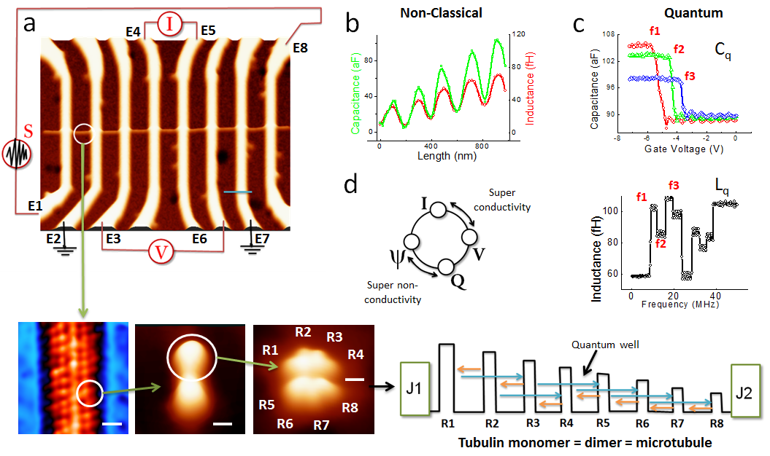

Figure 2
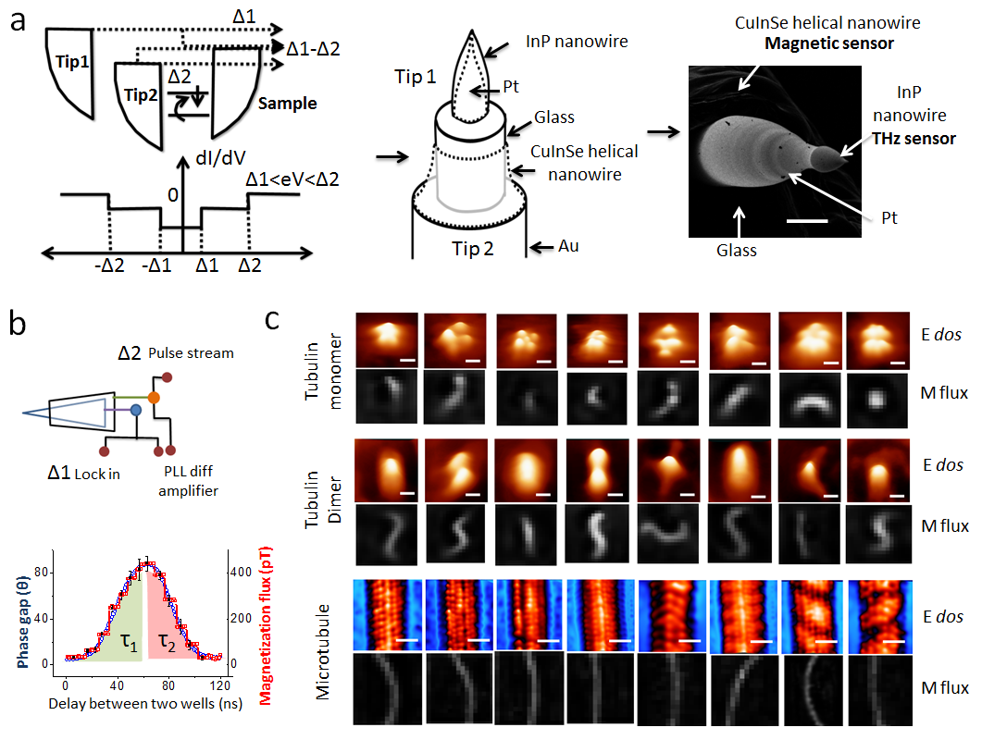

Figure 3.
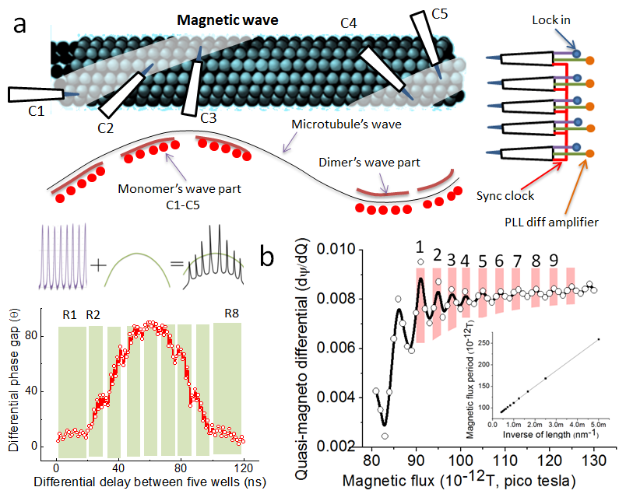

Figure 4.
