Quasi-1D edge contact to hBN-encapsulated multilayered graphene by SF₆ dry etch

Ryuichi Tsuchikawa¹, David Castro², Swastik Ballav², Michael S. Lodge¹, Kenji Watanabe³, Takashi Taniguchi⁴, Masa Ishigami², Robert E. Peale¹

Affiliations
- Truventic, LLC. 1209 W. Gore St. Orlando, FL 32805, U.S.A.
- Department of Physics and NanoScience Technology Center, University of Central Florida, Orlando, FL 32816, U.S.A.
- Research Center for Electronic and Optical Materials, National Institute for Materials Science, 1-1 Namiki, Tsukuba 305-0044, Japan
- Research Center for Materials Nanoarchitectonics, National Institute for Materials Science, 1-1 Namiki, Tsukuba 305-0044, Japan

Abstract
We investigate the contact resistance of twisted bilayer graphene devices encapsulated by hexagonal boron nitride (hBN). Encapsulation ensures an atomically flat interface that supports emerging new states in twistronics, but it also necessitates an etch step to expose the graphene for electrical contacts. The dry-etch process by sulfur hexafluoride (SF₆) etches hBN but stops on graphene. In our case, graphene only serves as an imperfect etch mask, resulting in a porous structure in graphene after the SF₆ etch, possibly due to inadvertent residual oxygen during the etch process. We investigate electrical contacts to graphene surfaces exposed by this process. Etched pores expose edges which participate in the contact, which combined with fluorination of the graphene surface, provide variables for optimizing contact resistance.

Introduction
Superconducting twisted-multilayer graphene has been proposed and used for highly sensitive photodetection devices [1–3]. Contact resistance between graphene and metal contacts affects device performance. Typically, twisted bilayer graphene is encapsulated by hBN, which must be etched to expose graphene for electrical contacts. Graphene can be contacted on its edge (1D) or on its surface (2D), though the latter is considered worse [4]. 1D contacts typically make better electrical contact to graphene due to the formation of covalent bonds between the metal and graphene, compared with the 2D contacts, which are formed by weak van der Waals bonds [5–8]. The first 1D contacts used CHF₃ gas to dry-etch the encapsulated stack [9]. A variety of etch recipes have been developed since to reduce 1D contact resistance [4,10]. In particular, graphene can act as an etch stop for SF₆ dry-etch if etch parameters are set properly and a plasma chamber is carefully conditioned by removing unwanted residual gases [10,11]. Furthermore, SF₆ etches hBN much faster than it does polymethyl methacrylate (PMMA) [10,11], which simplifies fabrication. A second step is usually an oxygen (O₂) plasma etch to square off the graphene flush with the etched hBN edge prior to depositing the metal that creates the 1D contact [10]. We eliminated the second step and deposited metal directly on the exposed graphene surface to create nominal 2D contacts. Our exposed 2D graphene is found to have nanometer-scale pores after SF₆ etch even after a careful conditioning of our plasma chamber, but we were still able to make electrical contacts on the porous graphene. We present in this report our study on the contact resistance of the devices in which electrical contacts are made on SF₆ etched porous graphene. Our work can open a path to continuously tuning the contact geometry of graphene from purely 2D to purely 1D, as a means of controlling contact resistance.
Materials and Methods
Figure 1 presents a schematic of the device fabrication process. Twisted bilayer graphene devices are fabricated by a polymer-stamp pick-up method using polycarbonate (PC) film [12,13]. Twisted bilayer graphene is encapsulated by top and bottom hBN flakes of 10 to 80 nm thickness. The stack is transferred onto a metal back gate on a 280-nm SiO₂ layer on silicon. The metal back gate is a long narrow stripe and has 2-10 nm Cr sticking layer and 40 nm Au top layer. After transfer, part of the encapsulated graphene hangs over the edges of the metal back gate, as depicted in Figure 1a. PMMA is spin-coated on the transferred stack to make a first etch mask for electron beam lithography (EBL). This etch mask is used to etch the stack into a smaller shape to clear up the space surrounding the graphene (Figure 1b and c). To etch the stack, we tailored the recipe of [10] to our reactive ion etcher (RIE). Prior to using this recipe, we run an O₂ plasma process to clean the plasma chamber. The top hBN is etched in SF₆ at 80 mTorr in Trion Minilock II RIE with a flow rate of 80 sccm, a RF power of 30 W, and no inductively-coupled plasma (ICP). The graphene layer is subsequently etched in O₂ at 70 mTorr with 50 sccm flow, 30 W RF power, and no ICP, followed by another SF₆ etch for the bottom hBN. Then, a second EBL step defines the pattern for electrical leads. The developed lead patterns expose a small part of the stack (Figure 1d), of which only the top hBN is etched in SF₆ with the same parameters as described above (Figure 1e). During this process, the etch is terminated at the graphene layer. We then deposit 10 nm Cr and 40-80 nm of Au to make electrical contacts to the exposed graphene (Figure 1f).

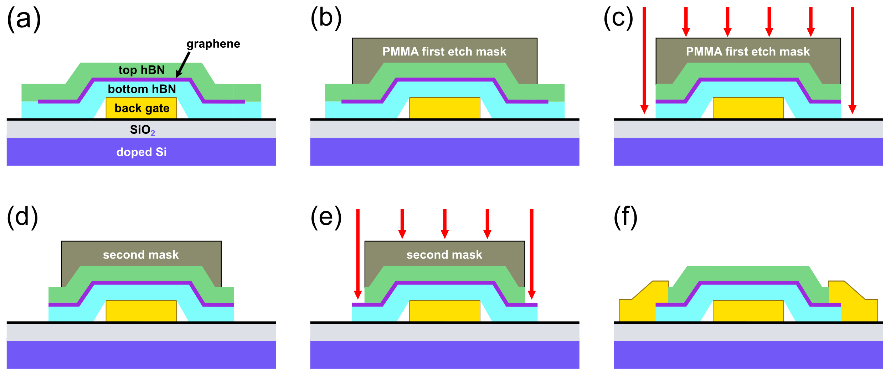
Fig. 1 Schematic of fabrication process. (a) hBN encapsulated graphene stack transferred onto a metal back gate. (b) Spin-coat PMMA and develop first etch mask. (c) SF₆ and O₂ RIE to trim hBN and graphene, respectively. (d) A second PMMA etch mask exposes a small part of the stack. (e) SF₆ RIE etches the top hBN, stopping on the graphene. (f) Metal deposition completes the electrical contact
Figure 2a presents an optical micrograph of one fabricated device. An image of the twisted bilayer graphene is overlaid. The vertical stripe in the middle is the back gate, and the prominent polygon is the small shape trimmed by the first etch. The source (S), drain (D), and two side leads (side 1 and side 2) are positioned away from the metal back gate to prevent shorts. The source lead contacts monolayer graphene (light pink), and the drain contacts Bernal-stacked bilayer graphene (dark orange), which was part of the original graphene flake used for the pick-up.
Figure 2b presents an electrical schematic for transport measurements. Current is passed through the device via S and D. The two-terminal voltage measurements are made between the same leads. Four-terminal voltage measurements use side 1 and 2 leads. Gate bias V_{g} is applied to the back gate to manipulate the Fermi level in the twisted bilayer graphene right above that metal (red oval in Figure 2b), where the bottom hBN serves as 11-nm-thick gate dielectric. The part of the encapsulated graphene outside back gate (two blue ovals in Figure 2b) is gated independently by applying a bias V_{Si} to the doped-silicon substrate. Contact resistance is estimated by the difference between the two- and four-terminal resistance values. Contact resistance is studied as a function of both V_{g} and V_{Si}.

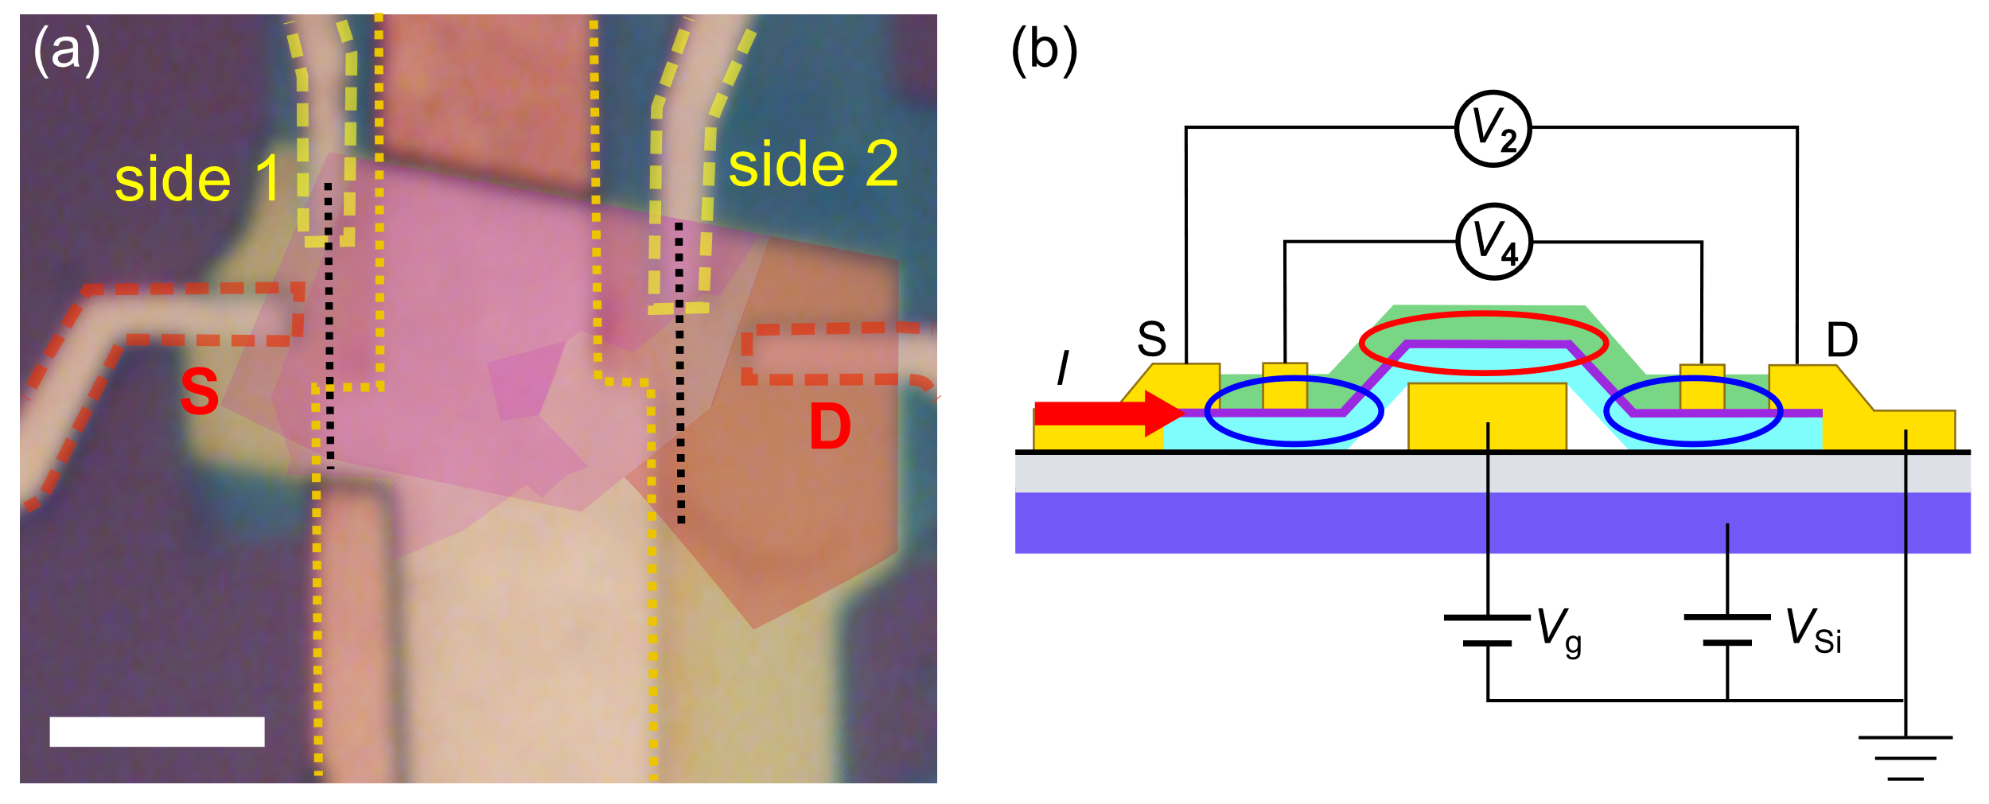
Fig. 2 (a) Optical microscope image of device. Twisted bilayer graphene shape is overlaid on the image. The light pink region is monolayer graphene, and the darker pink region is twisted bilayer graphene. The dark orange region is regular Bernal-stacked bilayer graphene. The metal back gate outline is traced with dotted yellow lines. Source (S) and drain (D) leads are traced with red dashed lines. The side leads (1 and 2) are traced with yellow dashed lines. The S and D leads have width W = 1.2 μm. The two dotted black lines bound the device area measured by the side leads. Scale bar: 5 μm. (b) Schematic of the device. V_{g} and V_{Si} apply bias to the metal back gate and the doped silicon back gate, respectively. The region of the twisted bilayer graphene gated by V_{g} (V_{Si}) is indicated by the red (blue) oval(s). V₂ (V₄) measures the voltage from the two- (four-) terminal measurement. A constant current of 100 nA (red arrow) is passed from S to D
Results and Discussion
Figure 3a presents an AFM image of graphene exposed via SF₆ etching. Some regions appear smooth with peak-to-peak roughness of less than 2 Angstroms, while other regions are much rougher with peak-to-peak roughness exceeding 2 nm. We reason the smooth areas are graphene, while in rough areas etched pores in graphene exposed the bottom hBN to etching. The hBN is chemically etched by SF₆, where fluorine radicals are the reactive etching agent [14]. It has been proposed that SF₆ selectively etches hBN because the etch process produces N₂ gas and volatile BF₃ gas, and these gases are pumped out, instead of being deposited on the etched surface [15]. Graphene is resistant to fluorine radicals because the reaction barrier to break a C-C bond is expected to be high for the planar hexagonal lattice, while graphene is easily etched with oxygen plasma due to a low reaction energy [16]. Though graphene can be used as an etch stop, etch parameters need to be tuned carefully, and in general, high chamber pressure and low RF power are preferred [14]. A harsh plasma condition will be likely to cause the fluorine radicals to etch graphene [16]. Agarwal et al. also emphasize the importance of preconditioning the etching chamber with SF₆ before running the actual etch recipe for hBN [14]. This indicates that even the slightest amount of residual oxygen in the etching chamber is detrimental to graphene. As such, it is likely that the pore formation in graphene is caused by (1) residual oxygen in the chamber due to imperfect preconditioning, (2) oxygen released from nearby SiO₂ substrate during the etch process, or (3) harsher-than-optimal SF₆ plasma conditions. The pore formation is not ideal for scanning probe studies, but if simply making electrical contacts to graphene underneath the top hBN is required, it is possible to make electrical contacts to porous graphene, and the very careful preconditioning and precise etch parameters are not required, as we will show below.

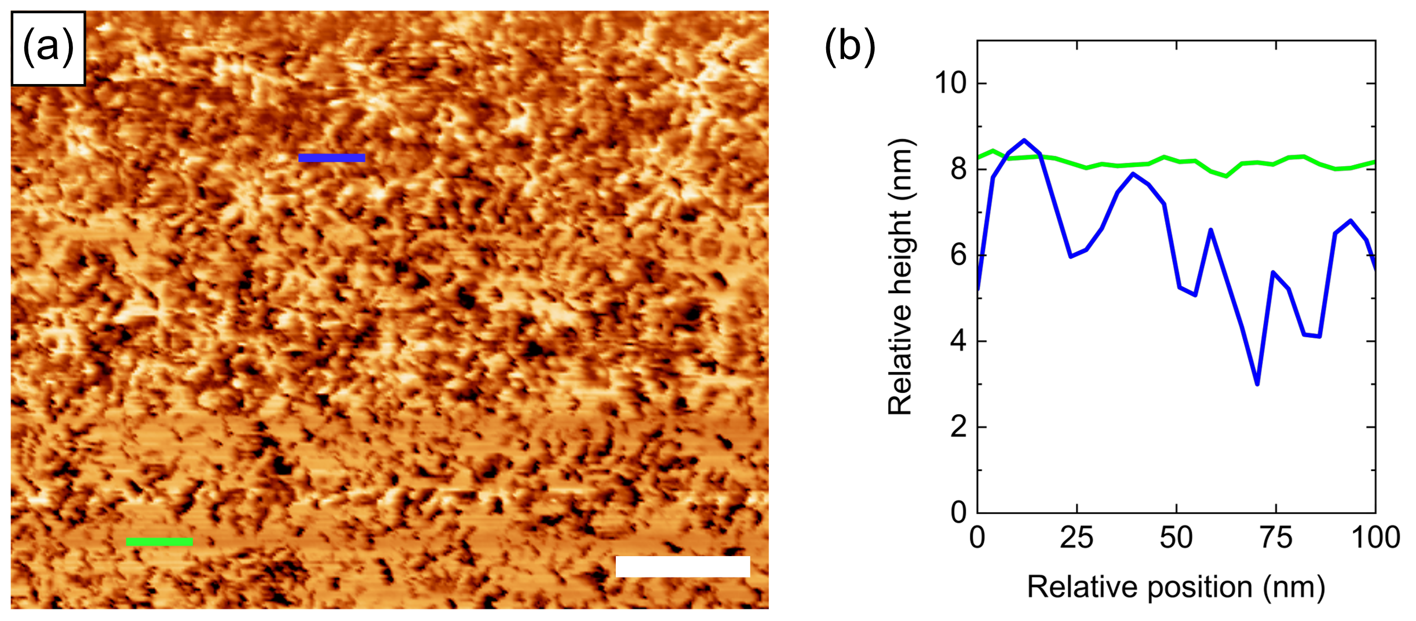
Fig. 3 (a) AFM image of exposed graphene following SF₆ etch of top hBN. Locations of height-profile scans are indicated by the green or blue lines, where surface morphology is smooth or rough, respectively. Scale bar (white): 200 nm. (b) AFM height profiles
Figure 4a presents plots of two- and four-terminal resistance measurements (R₂ and R₄) as a function of V_{g} in air at room temperature. The IV curves are linear at room temperature (Figure S1 in supplementary information), and for these measurements the source-drain current (I) is fixed at 100 nA for all V_{g} values. R₂ is the total device resistance (R_{total}), which includes the contact resistance (R_{c}), namely
R₂ = R_{total} = 2R_{c} + R₄ + R_{Si} (1)
where R_{Si} is the channel resistance between S and side 1 leads, and between side 2 and D leads. These two channels are gated by V_{Si}. The different colored curves in Figure 4 represent R-V_{g} curves at different fixed values of V_{Si}. The contact resistance is estimated by first subtracting R₄ from R₂. This results in
R₂ - R₄ = 2R_{c} + R_{Si} (2)
Since V_{Si} is fixed, R_{Si} should be negligibly affected by the V_{g} sweep and should have a fixed value. Then R₂ - R₄ would be independent of V_{g}. Figure 4b is the result of the subtraction. A small V_{g} dependence appears, though this variation is much smaller than the value of R₂ and R₄. This slight V_{g} dependence gating is due to the fringe fields from back-gate edges.
Now we estimate a constant value for R_{Si} to be used in Eq. (2). The average of R_{4,max} = 1.084 kΩ and R_{4,min} = 0.735 kΩ for V_{Si} = 0 V (black curve) gives R_{4,mid} = 0.909 kΩ. The length between the black dashed lines in Figure 2a is 8.8um, which is associated with R₄, so that the resistance per unit length is R₄/8.8. Multiplying this by 2.2 μm, the channel length outside the two side leads, gives the estimate of the resistance not measured by the four-terminal measurement, namely R_{Si} = R_{4,mid}·(2.2 /8.8) = 0.248 kΩ. Using Δ = |R_{4,max} - R_{4,mid}| = |R_{4,min} - R_{4,mid}| for the uncertainty, we find R_{Si} = (R_{4,mid} ± Δ)·(2.2/8.8) = 0.25 ± 0.06 kΩ. The range of the constant value R₂ - R₄ is estimated in the same way from the curve in Figure 4b, and it gives R₂ - R₄ = 2.055 ± 0.084 kΩ. From equation (2), R_{c} = 0.87 ± 0.06 kΩ for V_{Si} = 0 V. Using W = 1.2 μm of the width of the source and drain leads, the contact resistance in a unit of kΩ·μm is R_{c}·W = 1.0 ± 0.1 kΩ·μm. For V_{Si} = -8 V and +8 V, the same calculations give R_{c}·W = 0.99 ± 0.08 kΩ·μm and 0.92 ± 0.05 kΩ·μm, respectively.
The contact resistance shows only a slight dependence on V_{Si}, and it is ~1 kΩ·μm. In another twisted bilayer graphene device, we find R_{c}·W ~ 3 kΩ·μm (the AFM surface morphology image shown in Figure 3a corresponds to this device). We note that our contact resistance is a value around the charge neutrality point (CNP) since the range of V_{Si} we used is small and corresponds to ~0.6×10¹² cm⁻² of charge carrier density at V_{Si} = ±8 V. It has been shown that the contact resistance has gate dependence for both 1D and 2D contacts, and it can exceed 1 kΩ·μm at around the CNP [9,17]. Comparably small contact resistance as reported in literature [4] may be obtained in our devices by gating the contact region with a larger voltage.

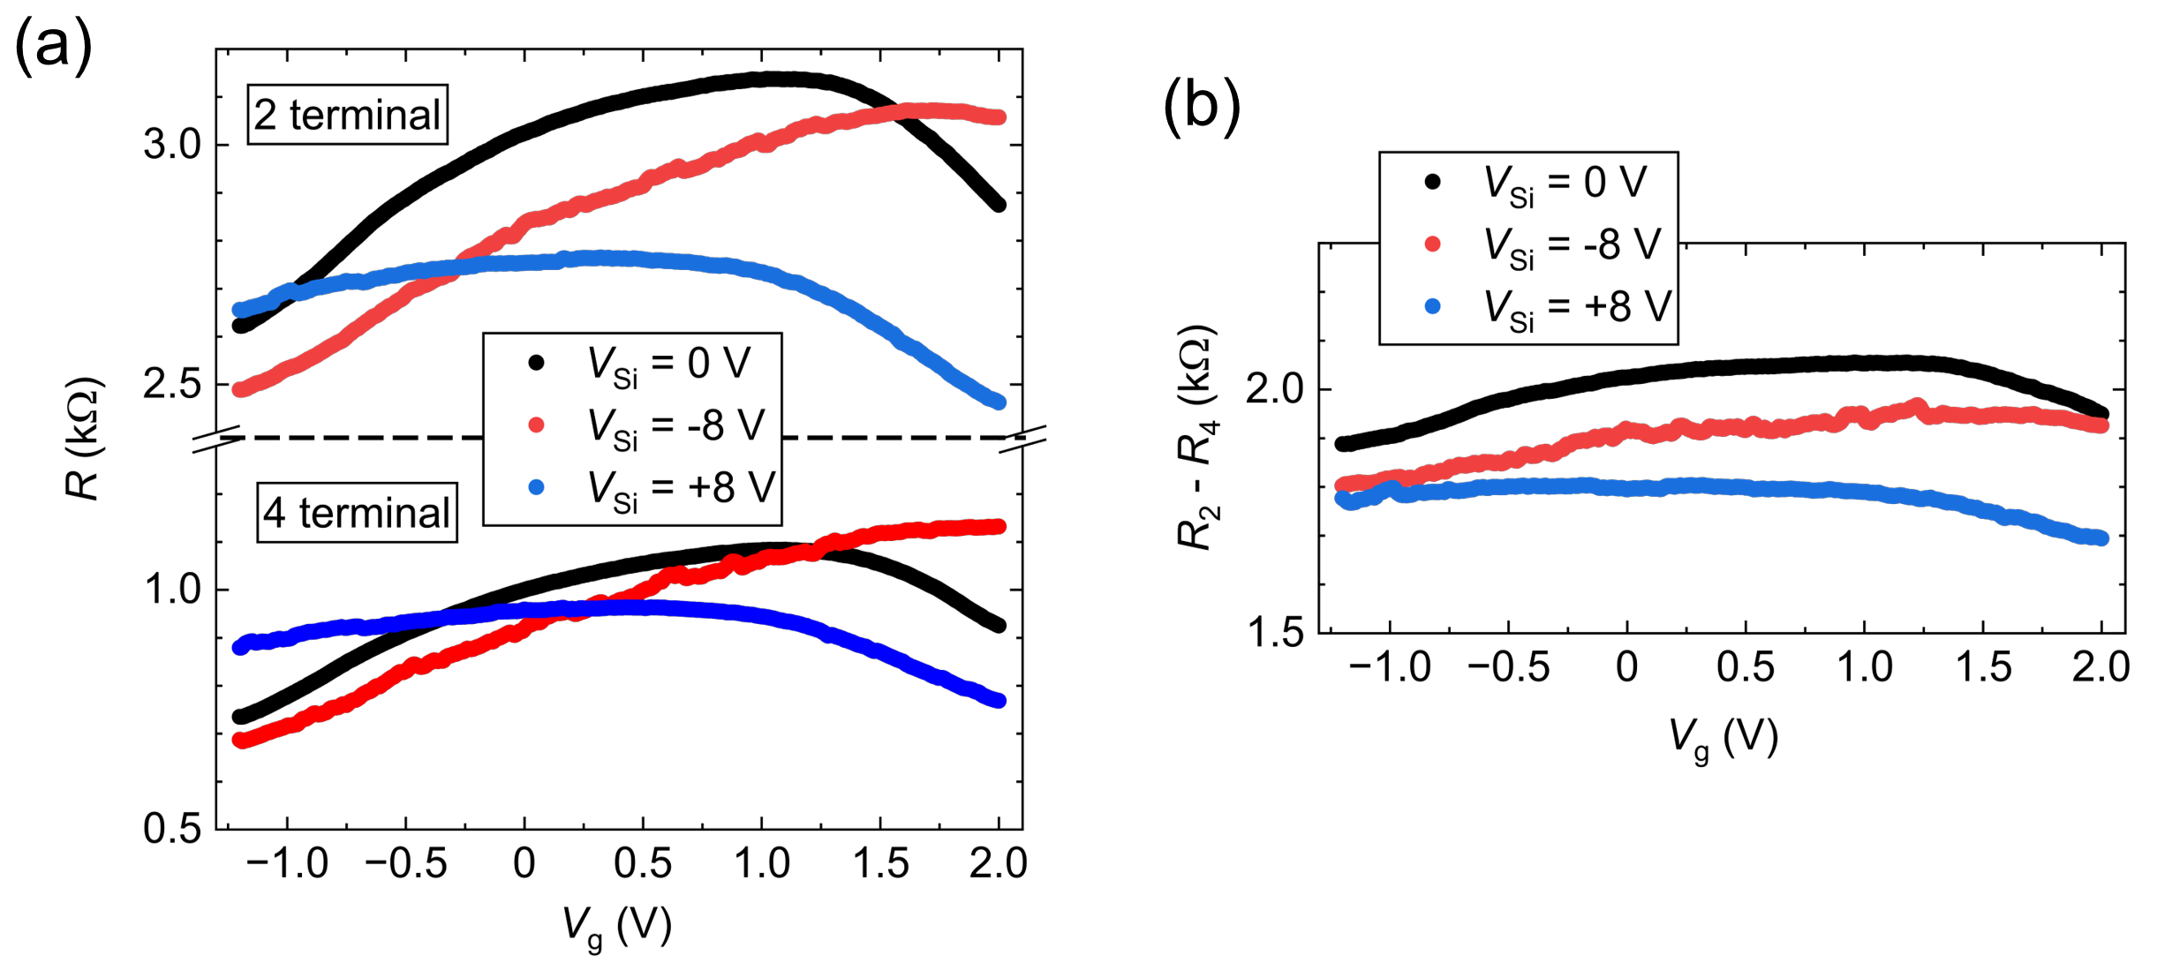
Fig. 4 (a) Two-terminal (upper half) and four-terminal (lower half) resistance as a function of V_{g} for different substrate bias V_{Si}. The vertical axis has a break in the middle. The scaling of the vertical axis is the same for the upper and lower plots (0.8 kΩ). Different colors correspond to fixed V_{Si} values (see legend). (b) R₂ - R₄ as a function of V_{g} for different fixed values of V_{Si}. The vertical scale is the same as for the upper or lower half of the plot in (a)
Parameters such as the contact area, choice of metal, and the functionalization of graphene surface or edge, can affect the contact resistance. Our results indicate the importance of the surface state of graphene being contacted. The edge and surface of the graphene exposed for contacts are likely fluorinated during SF₆ etching [10]. Fluorine termination at the graphene edge increases 1D contact resistance in comparison with bare carbon or oxygen-terminated edges [18]. Judging from AFM images, the device with ~ 3 kΩ·μm has a larger contact resistance because the graphene is etched into isolated islands whose edges cannot participate in transport. The result is a regular 1D contact to a fluorine-terminated edge. Interestingly, fluorination of the continuous graphene surface improves hybridization between graphene and Cr, reducing 2D contact resistance [6]. Therefore, it is expected that there is an optimal degree of porosity that provides the best contact resistance where increased number of edges and fluorinated surface work together to overpower the contact resistance increase due to fluorinated edges.
Conclusion
We have shown that the simple one-step etch process by SF₆ has the potential to engineer the contact resistance of twisted bilayer graphene devices. Our method from readily available two- and four-terminal measurement is comparable to other contact resistance determination methods [9,17,19,20] and provides a method to evaluate the contact resistance of the devices typical for graphene twistronics. This is especially important for twisted bilayer graphene based devices where methods such as the transfer length method are not easily implemented due to the size limitations of the twisted bilayer graphene and the lithography resolution limits. Since the fluorination can improve 2D contacts, there is a space for optimizing the contact resistance.
Acknowledgments
K.W. and T.T. acknowledge support from the JSPS KAKENHI (Grant Numbers 21H05233 and 23H02052), the CREST (JPMJCR24A5), JST and World Premier International Research Center Initiative, Ministry of Education, Culture, Sports, Science and Technology, Japan.
Data Availability
Truventic LLC holds data rights under its STTR contract, but the data is available from the authors upon reasonable request.
Conflict of Interest
Robert E. Peale has ownership in Truventic LLC and may benefit financially from the results of this research. Otherwise, all authors certify that they have no affiliations with or involvement in any organization or entity with any financial interest or non-financial interest in the subject matter or materials discussed in this manuscript.
References
1. P. Seifert, X. Lu, P. Stepanov, J.R. Durán Retamal, J.N. Moore, K.-C. Fong, A. Principi, D.K. Efetov, Nano Lett. (2020) https://doi.org/10.1021/acs.nanolett.0c00373
2. F.J. Gonzalez, M.S. Lodge, M. Ishigami, R.A. Klemm, A. Rathod, K.L. Lina, A.C. Bowman, F. Hernandez, C.J. Fredricksen, C. Cariker, R.E. Peale, MRS Adv. (2023) https://doi.org/10.1557/s43580-023-00546-w
3. G.D. Battista, K.C. Fong, A. Díez-Carlón, K. Watanabe, T. Taniguchi, D.K. Efetov, Sci. Adv. (2024) https://doi.org/10.1126/sciadv.adp3725
4. M.S. Choi, N. Ali, T.D. Ngo, H. Choi, B. Oh, H. Yang, W.J. Yoo, Adv. Mater. (2022) https://doi.org/10.1002/adma.202202408
5. X. Ji, J. Zhang, Y. Wang, H. Qian, Z. Yu, Phys. Chem. Chem. Phys. (2013) https://doi.org/10.1039/C3CP52589A
6. J. Son, J. Kwon, S. Kim, Y. Lv, J. Yu, J.-Y. Lee, H. Ryu, K. Watanabe, T. Taniguchi, R. Garrido-Menacho, N. Mason, E. Ertekin, P.Y. Huang, G.-H. Lee, A. M. van der Zande, Nat. Commun. (2018) https://doi.org/10.1038/s41467-018-06524-3
7. Y. Matsuda, W.-Q. Deng, W.A.I. Goddard, J. Phys. Chem. C (2010) https://doi.org/10.1021/jp806437y
8. S. Min Song, T. Yong Kim, O. Jae Sul, W. Cheol Shin, B. Jin Cho, Appl. Phys. Lett. (2014) https://doi.org/10.1063/1.4875709
9. L. Wang, I. Meric, P.Y. Huang, Q. Gao, Y. Gao, H. Tran, T. Taniguchi, K. Watanabe, L.M. Campos, D.A. Muller, J. Guo, P. Kim, J. Hone, K.L. Shepard, C.R. Dean, Science (2013) https://doi.org/10.1126/science.1244358
10. B.S. Jessen, L. Gammelgaard, M.R. Thomsen, D.M.A. Mackenzie, J.D. Thomsen, J.M. Caridad, E. Duegaard, K. Watanabe, T. Taniguchi, T.J. Booth, T.G. Pedersen, A.-P. Jauho, P. Bøggild, Nat. Nanotechnol. (2019) https://doi.org/10.1038/s41565-019-0376-3
11. D.R. Danielsen, A. Lyksborg-Andersen, K.E.S. Nielsen, B.S. Jessen, T.J. Booth, M.-H. Doan, Y. Zhou, P. Bøggild, L. Gammelgaard, ACS Appl. Mater. Interfaces (2021) https://doi.org/10.1021/acsami.1c09923
12. P.J. Zomer, M.H.D. Guimarães, J.C. Brant, N. Tombros, B.J. van Wees, Appl. Phys. Lett. (2014) https://doi.org/10.1063/1.4886096
13. D.G. Purdie, N.M. Pugno, T. Taniguchi, K. Watanabe, A.C. Ferrari, A. Lombardo, Nat. Commun. (2018) https://doi.org/10.1038/s41467-018-07558-3
14. H. Agarwal, A. Reserbat-Plantey, D.B. Ruiz, K. Soundarapandian, G. Li, V. Mkhitaryan, J. Osmond, H. Lozano, K. Watanabe, T. Taniguchi, P. Stepanov, F.H.L. Koppens, R.K. Kumar, arXiv (2025) https://doi.org/10.48550/arXiv.2503.14238
15. S. Grenadier, J. Li, J. Lin, H. Jiang, J. Vac. Sci. Technol. Vac. Surf. Films (2013) https://doi.org/10.1116/1.4826363
16. S.W. Kim, M. Seol, Y. Cho, K.W. Shin, D. Lee, S.-J. Jeong, H. Lee, J.G. Chung, H.-M. Kim, K.-B. Kim, S. Park, H.-J. Shin, ACS Appl. Nano Mater. (2020) https://doi.org/10.1021/acsanm.0c00658
17. F. Xia, V. Perebeinos, Y. Lin, Y. Wu, P. Avouris, Nat. Nanotechnol. (2011) https://doi.org/10.1038/nnano.2011.6
18. B. Kretz, C.S. Pedersen, D. Stradi, M. Brandbyge, A. Garcia-Lekue, Phys. Rev. Appl. (2018) https://doi.org/10.1103/PhysRevApplied.10.024016
19. J.H. Kim, S.-H. Kang, D. Yoon, H. Kim, J.-S. Kim, M.M. Haidari, D.J. Jang, J.-Y. Ko, Y.-W. Son, B.H. Park, J.S. Choi, NPG Asia Mater. (2024) https://doi.org/10.1038/s41427-024-00556-6
20. C. Li, S. Guéron, A. Chepelianskii, H. Bouchiat, Phys. Rev. B (2016) https://doi.org/10.1103/PhysRevB.94.115405
Authors Contributions
M.I. and R.P. conceptualized the research. R.T., D.C., S.B., and M.L. contributed to the device fabrication and data acquisition. R.T., M.I., and R.P. analyzed and discussed the data. K.W. and T.T. provided the hexagonal boron nitride crystals used for the devices. R.T. wrote the manuscript, and M.I. and R.P. reviewed and edited the manuscript.
Funding
This work was supported by Army OSD STTR contract #W911NF22P0026 and by matching funds from the Florida High Technology Corridor (I-4) Program.

