Supporting Information
Ionic Liquid Crystal–Polymer Composite Electromechanical Actuators: Design of Two-Dimensional Molecular Assemblies for Efficient Ion Transport and Effect of Electrodes on Actuator Performance

Chengyang Liu^{1,2} and Masafumi Yoshio*^{1,2,3}

¹ Research Center for Macromolecules & Biomaterials, National Institute for Materials Science, 1-2-1 Sengen, Tsukuba, Ibaraki 305-0047, Japan.
² Graduate School of Chemical Sciences and Engineering, Hokkaido University, Kita 13, Nishi 8, Kita-ku, Sapporo, Hokkaido 060-8628, Japan
³ Japan Science and Technology Agency, PRESTO, 4-1-8 Honcho, Kawaguchi, Saitama, 332-0012, Japan

Prof. Dr. M. Yoshio
E-mail: YOSHIO.Masafumi@nims.go.jp

1. DSC Analysis.

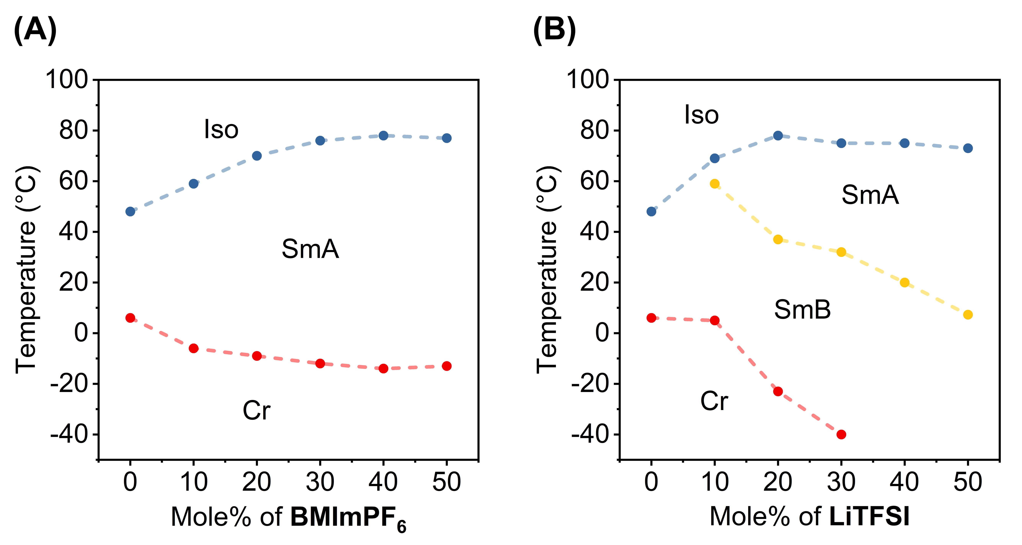

Figure S1. Phase transition temperatures of (A) the mixture of POMe and BMImPF₆ and (B) the mixture of POMe and LiTFSI.

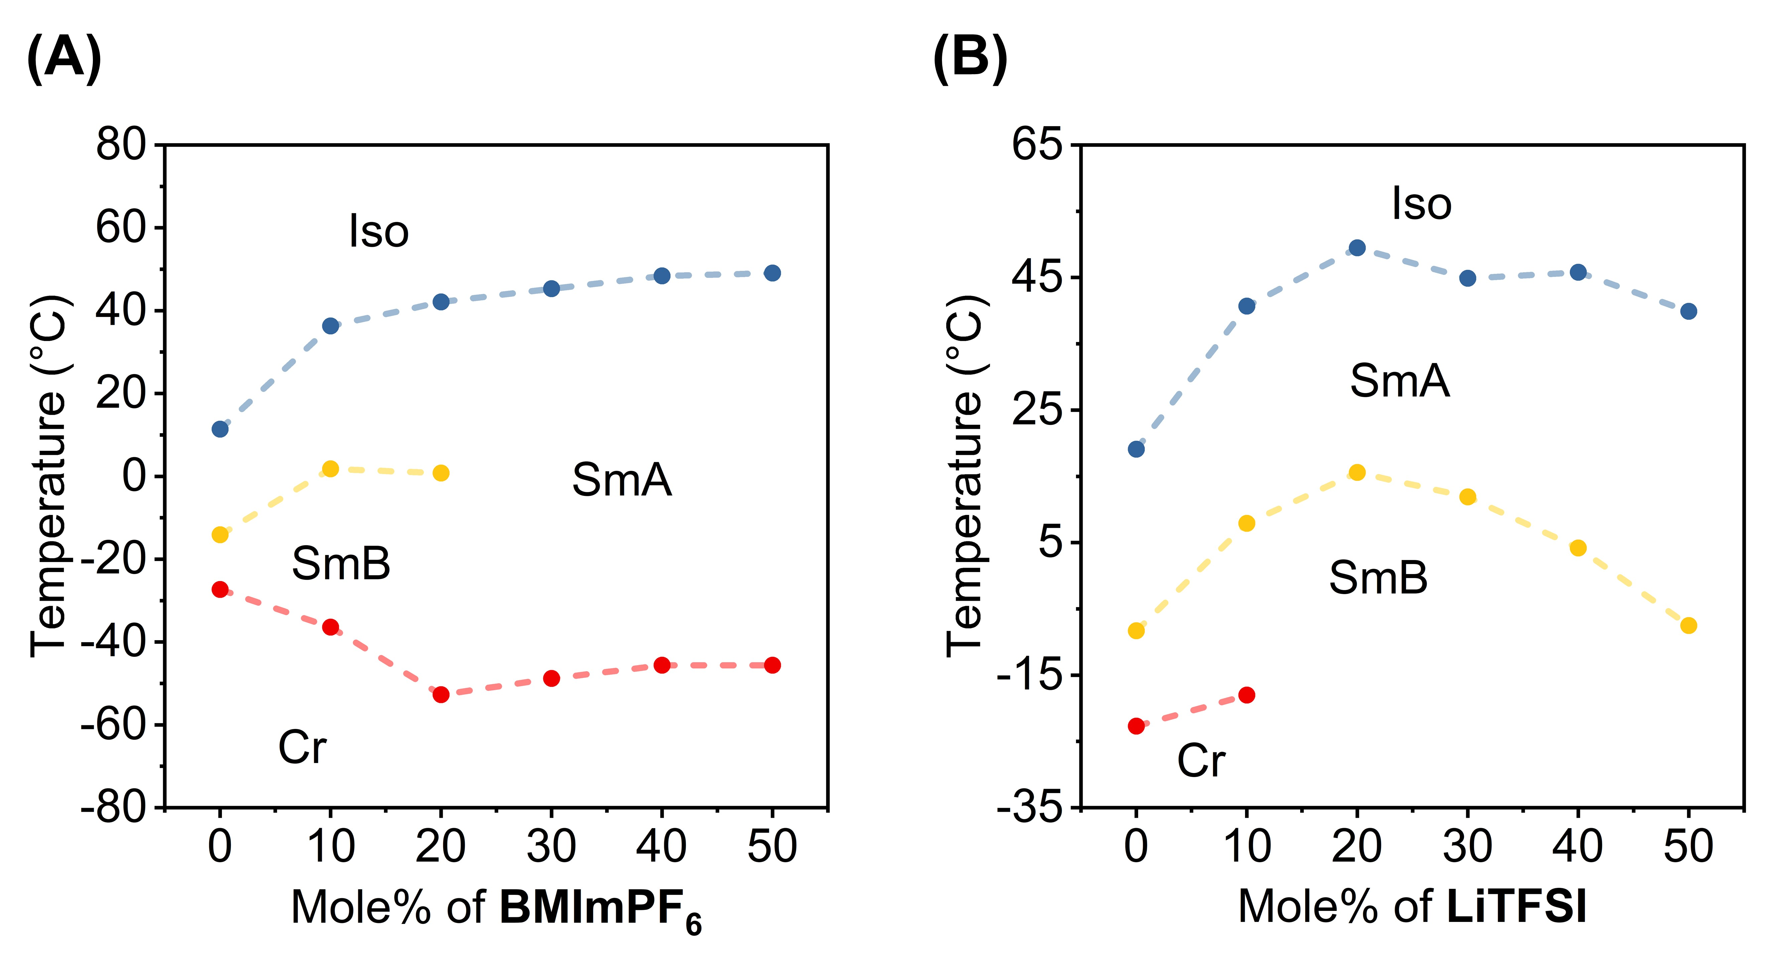

Figure S2. Phase transition temperatures of (A) the mixture of POEt and BMImPF₆ and (B) the mixture of POEt and LiTFSI.

Figure S3. DSC charts of the first cooling scan and 2nd heating scan for (A) POMe and the equimolar mixtures of salts and (B) POEt and the equimolar mixtures with salts.

2. Molecule Structure of POMe.
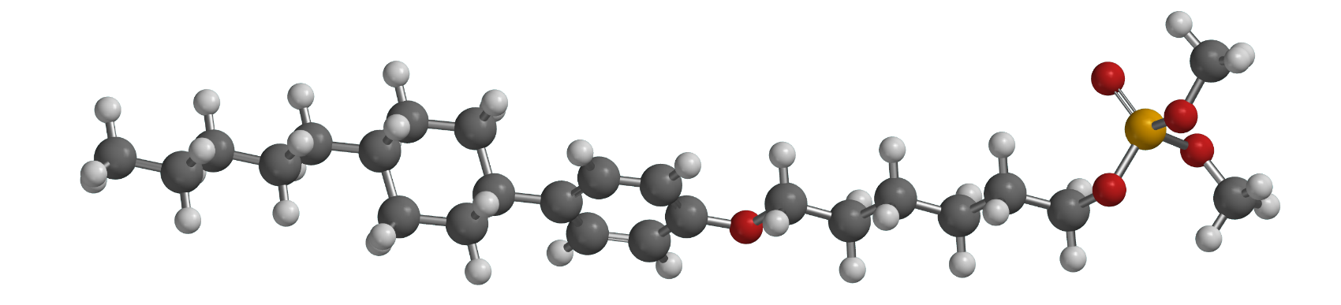
Figure S4. Molecule structure of POMe drawn using Spartan 18.

3. XRD Analysis.

Figure S5. The d-spacings of the d₀₀₁ peak determined from the XRD patterns for the mixtures of POMe or POEt with either BMImPF₆ or LiTFSI at ambient temperature.

4. FT-IR Analysis.
Figure S6. FT-IR Spectra of (A) POMe/LiTFSI, POEt/LiTFSI, POMe, POEt, LiTFSI and (B) and (C) POMe/BMImPF₆, POEt/BMImPF₆, POMe, POEt, BMImPF₆ at ambient temperature.

5. Characterization of Liquid Crystal–Polymer Composites.

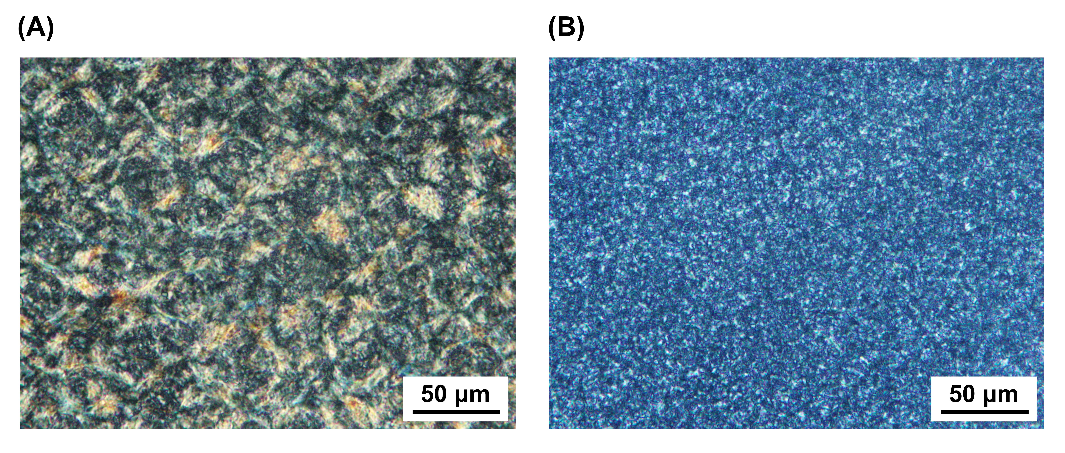

Figure S7. POM texture of liquid crystal–polymer composite electrolytes: (A) POMe/LiTFSI(50)–polymer; (B) POMe/BMImPF₆(50)–polymer.

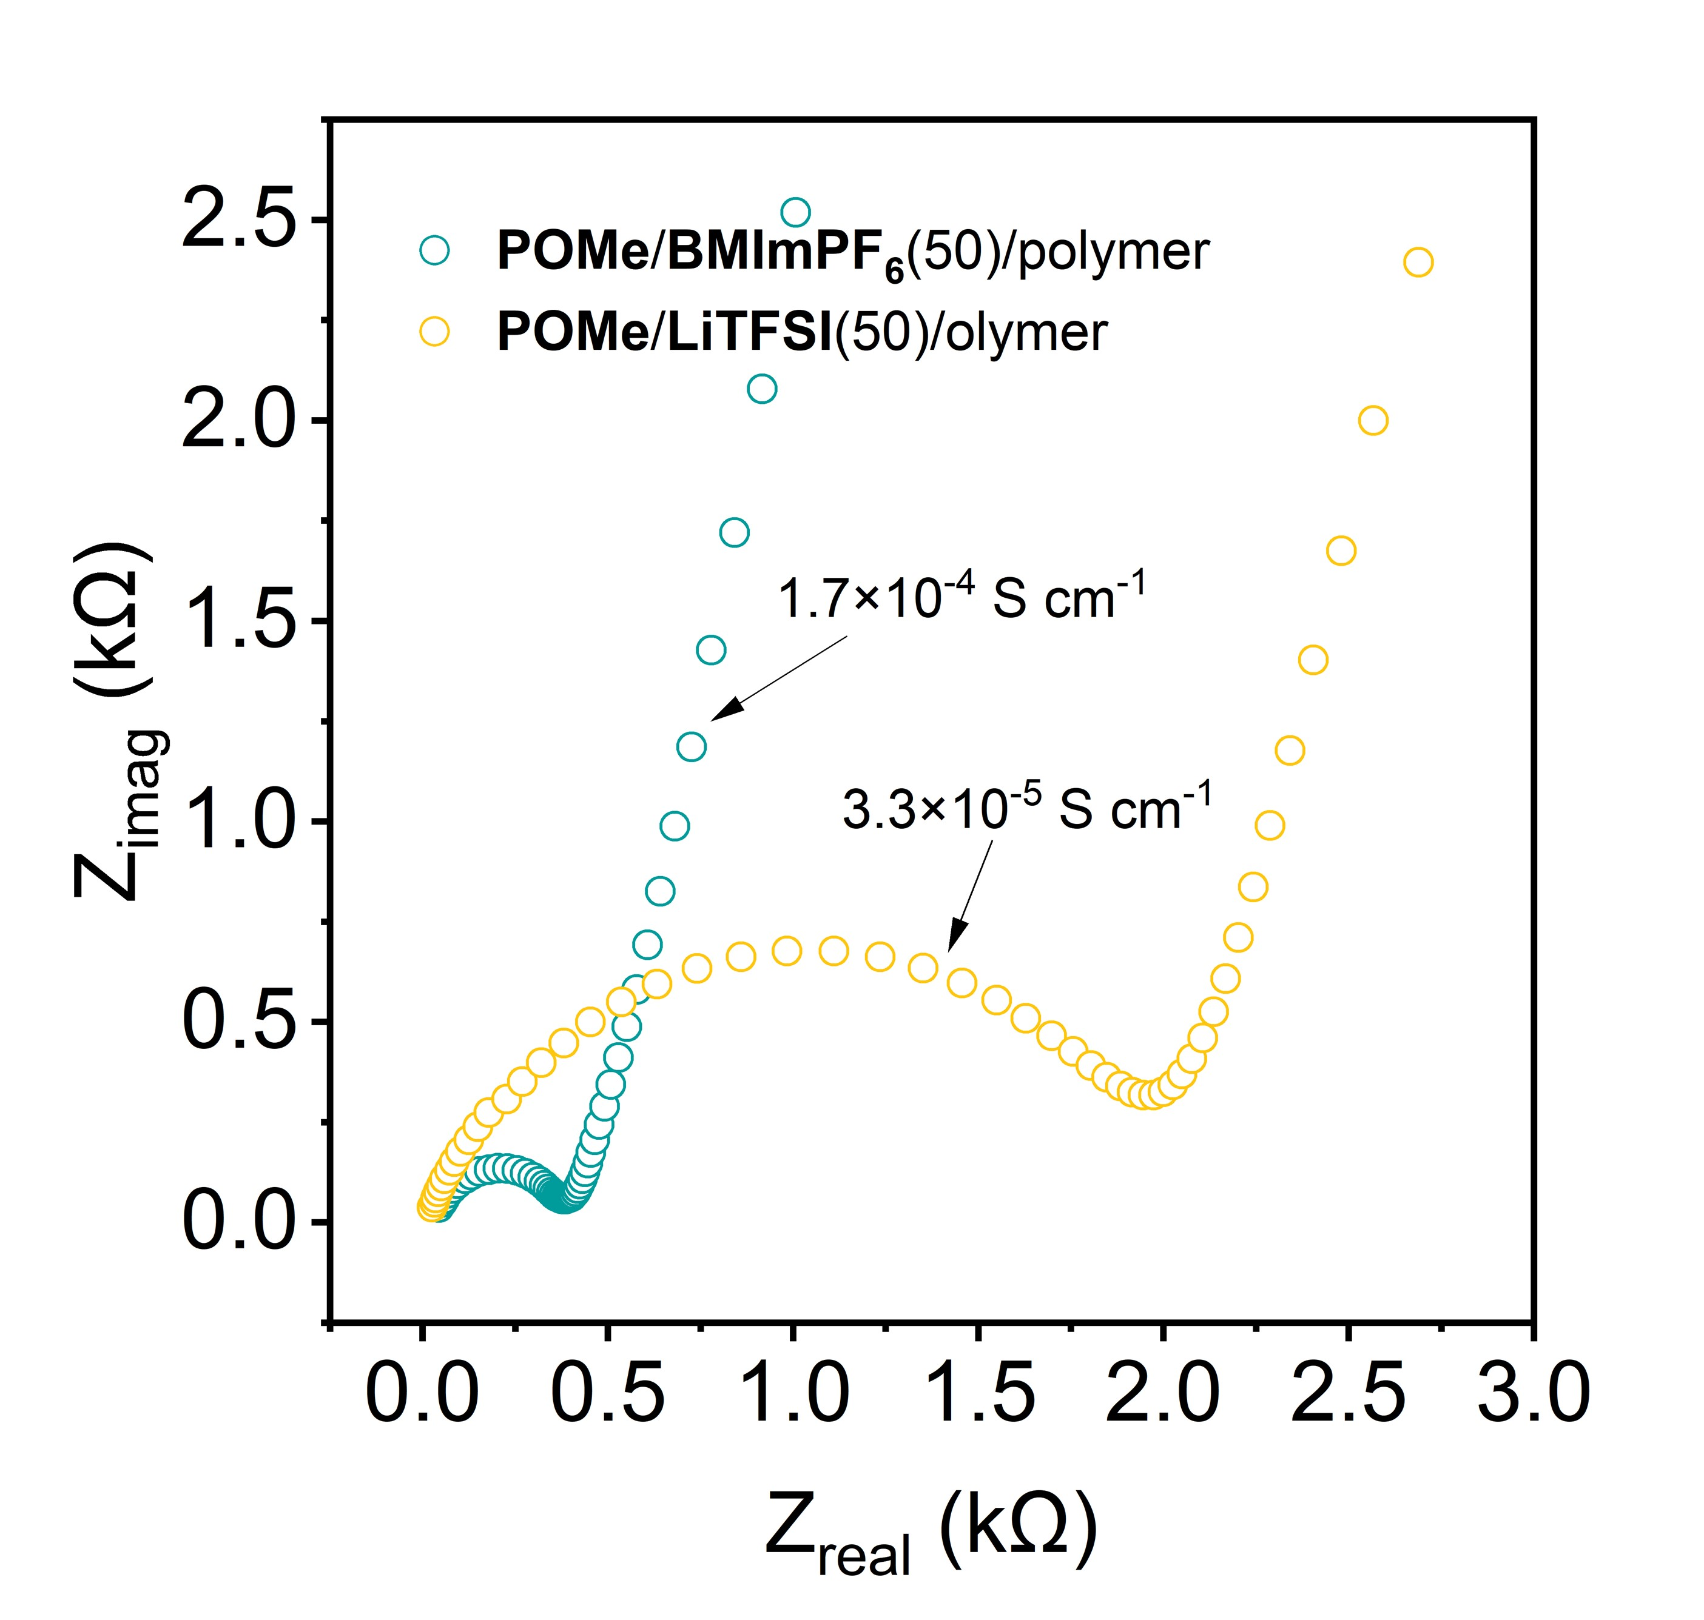
Figure S8. Ionic conductivities of POMe/BMImPF₆(50)/polymer composite membrane and POMe/LiTFSI(50)/polymer composite membrane.

6. Flammability Test of Ionic Liquid Crystal–Polymer Composites.
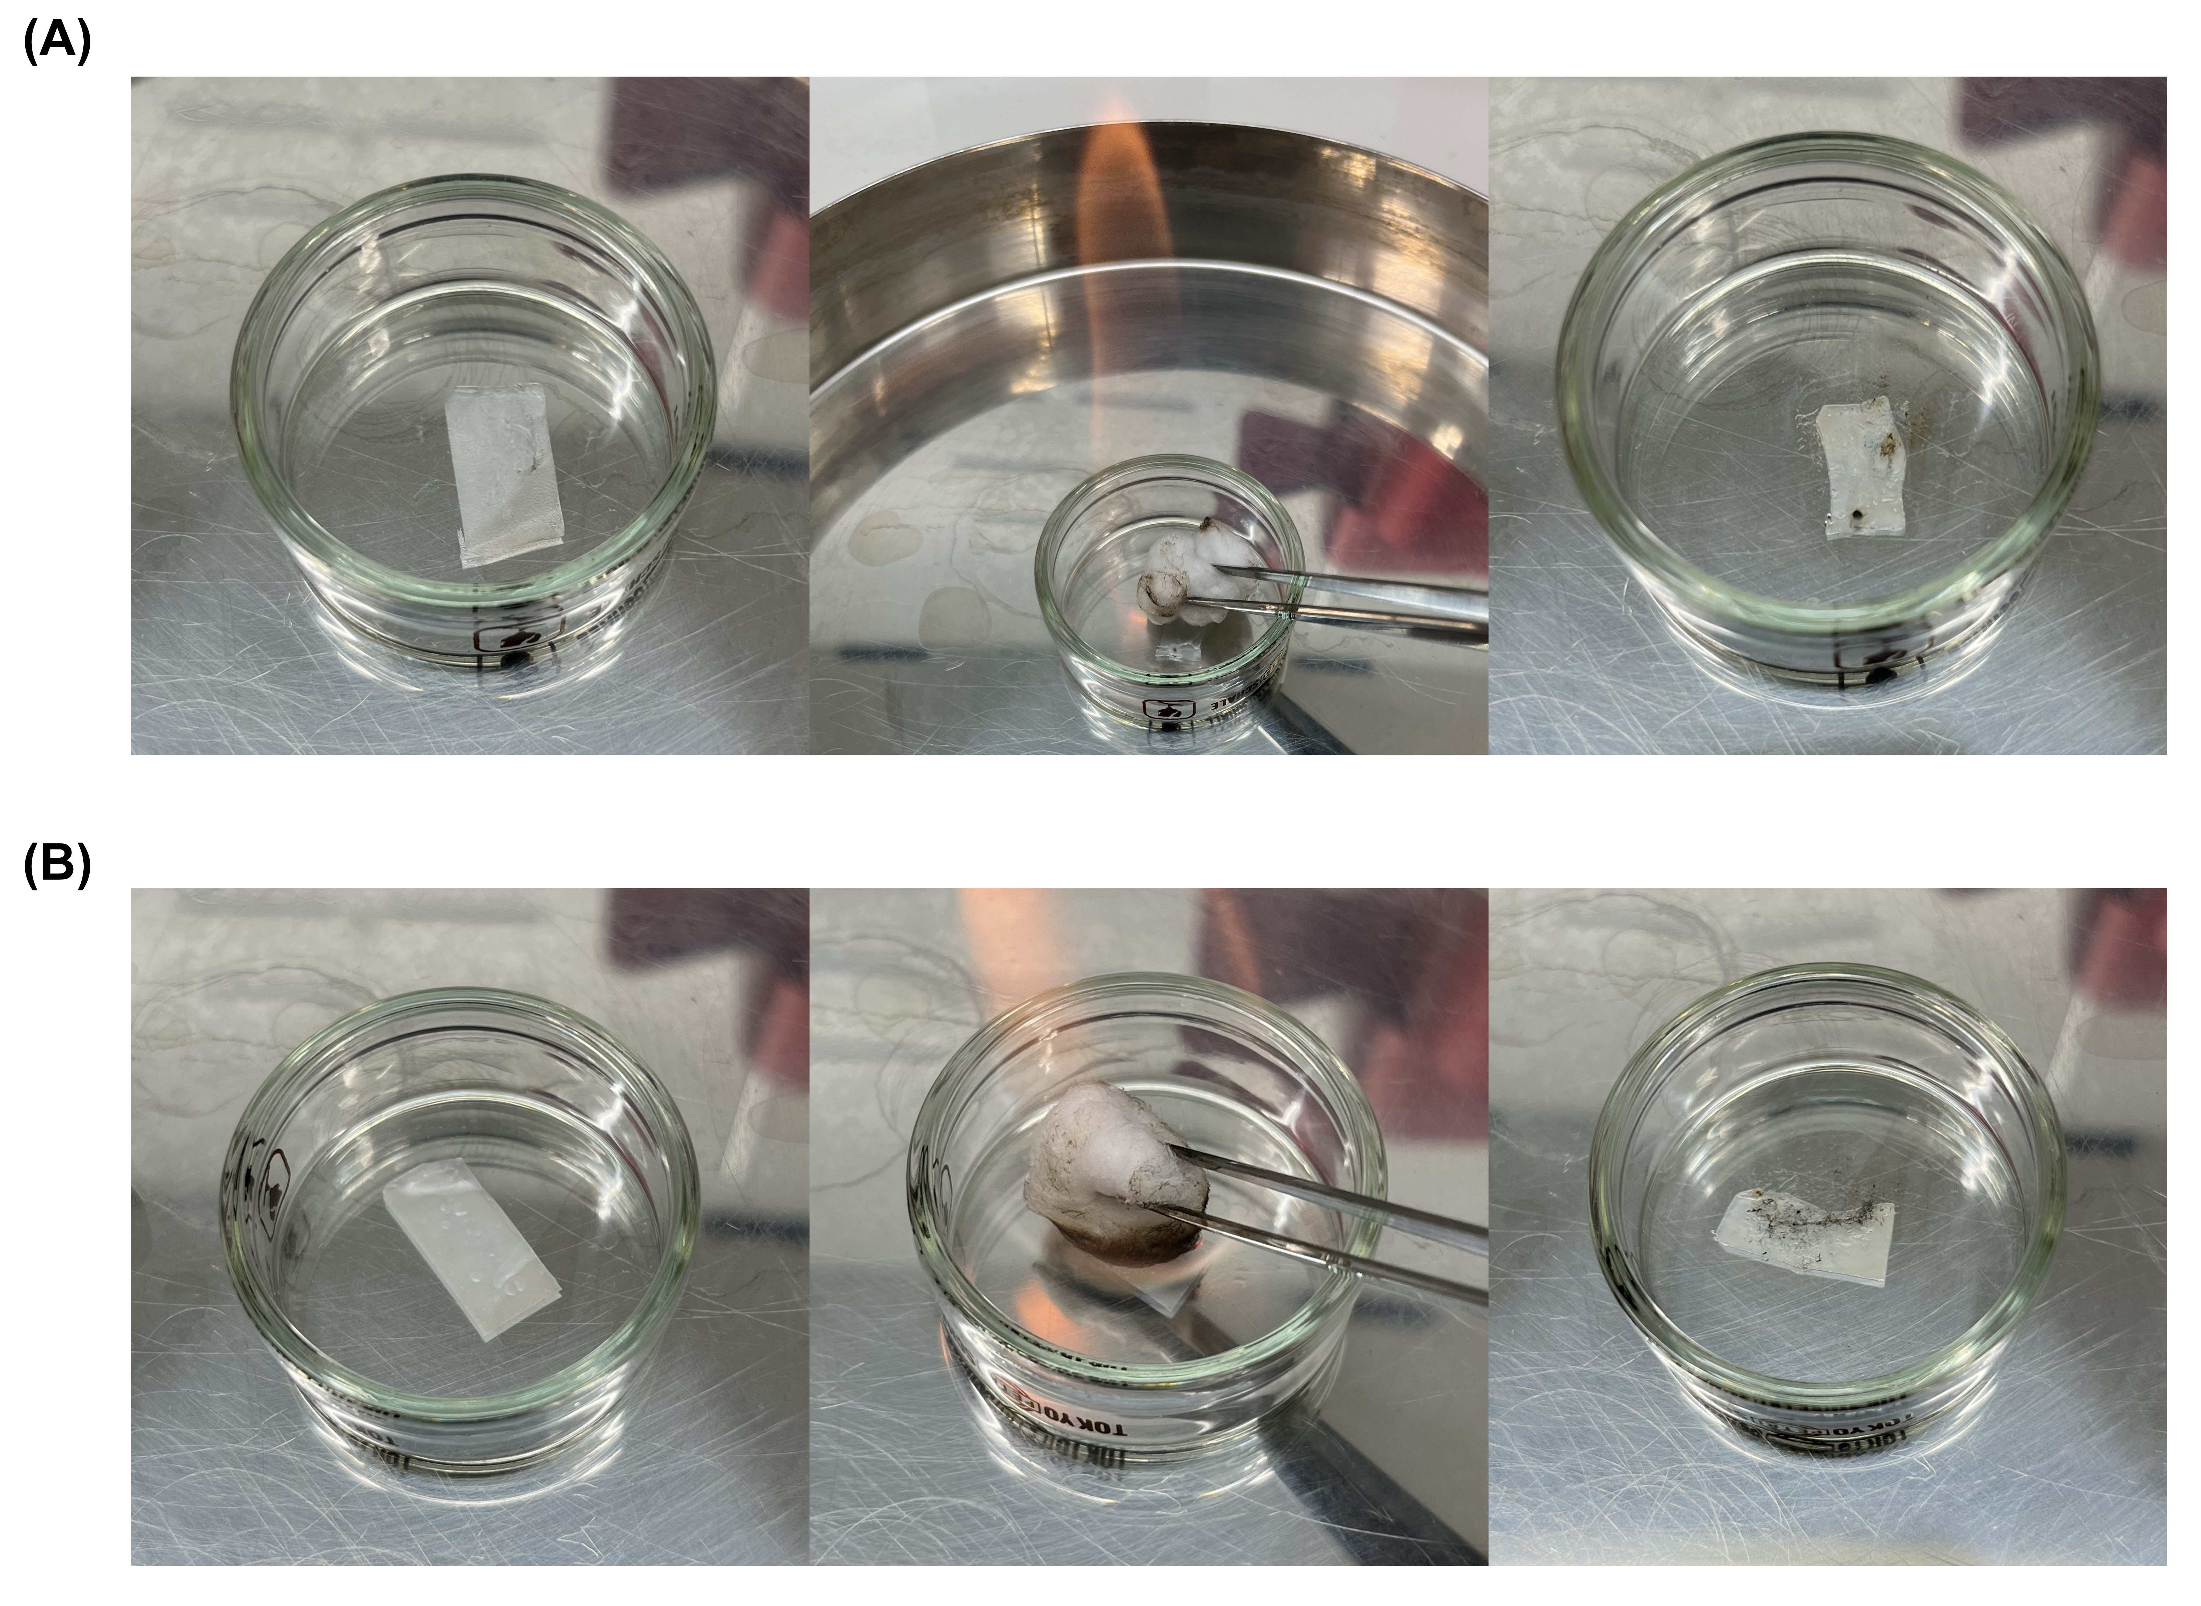
Figure S9. Photographs of (A) POMe/LiTFSI(50)–polymer composite membrane and (B) POMe/BMImPF₆(50)–polymer composite membrane before and after exposure to fire.

7. Actuation performances.
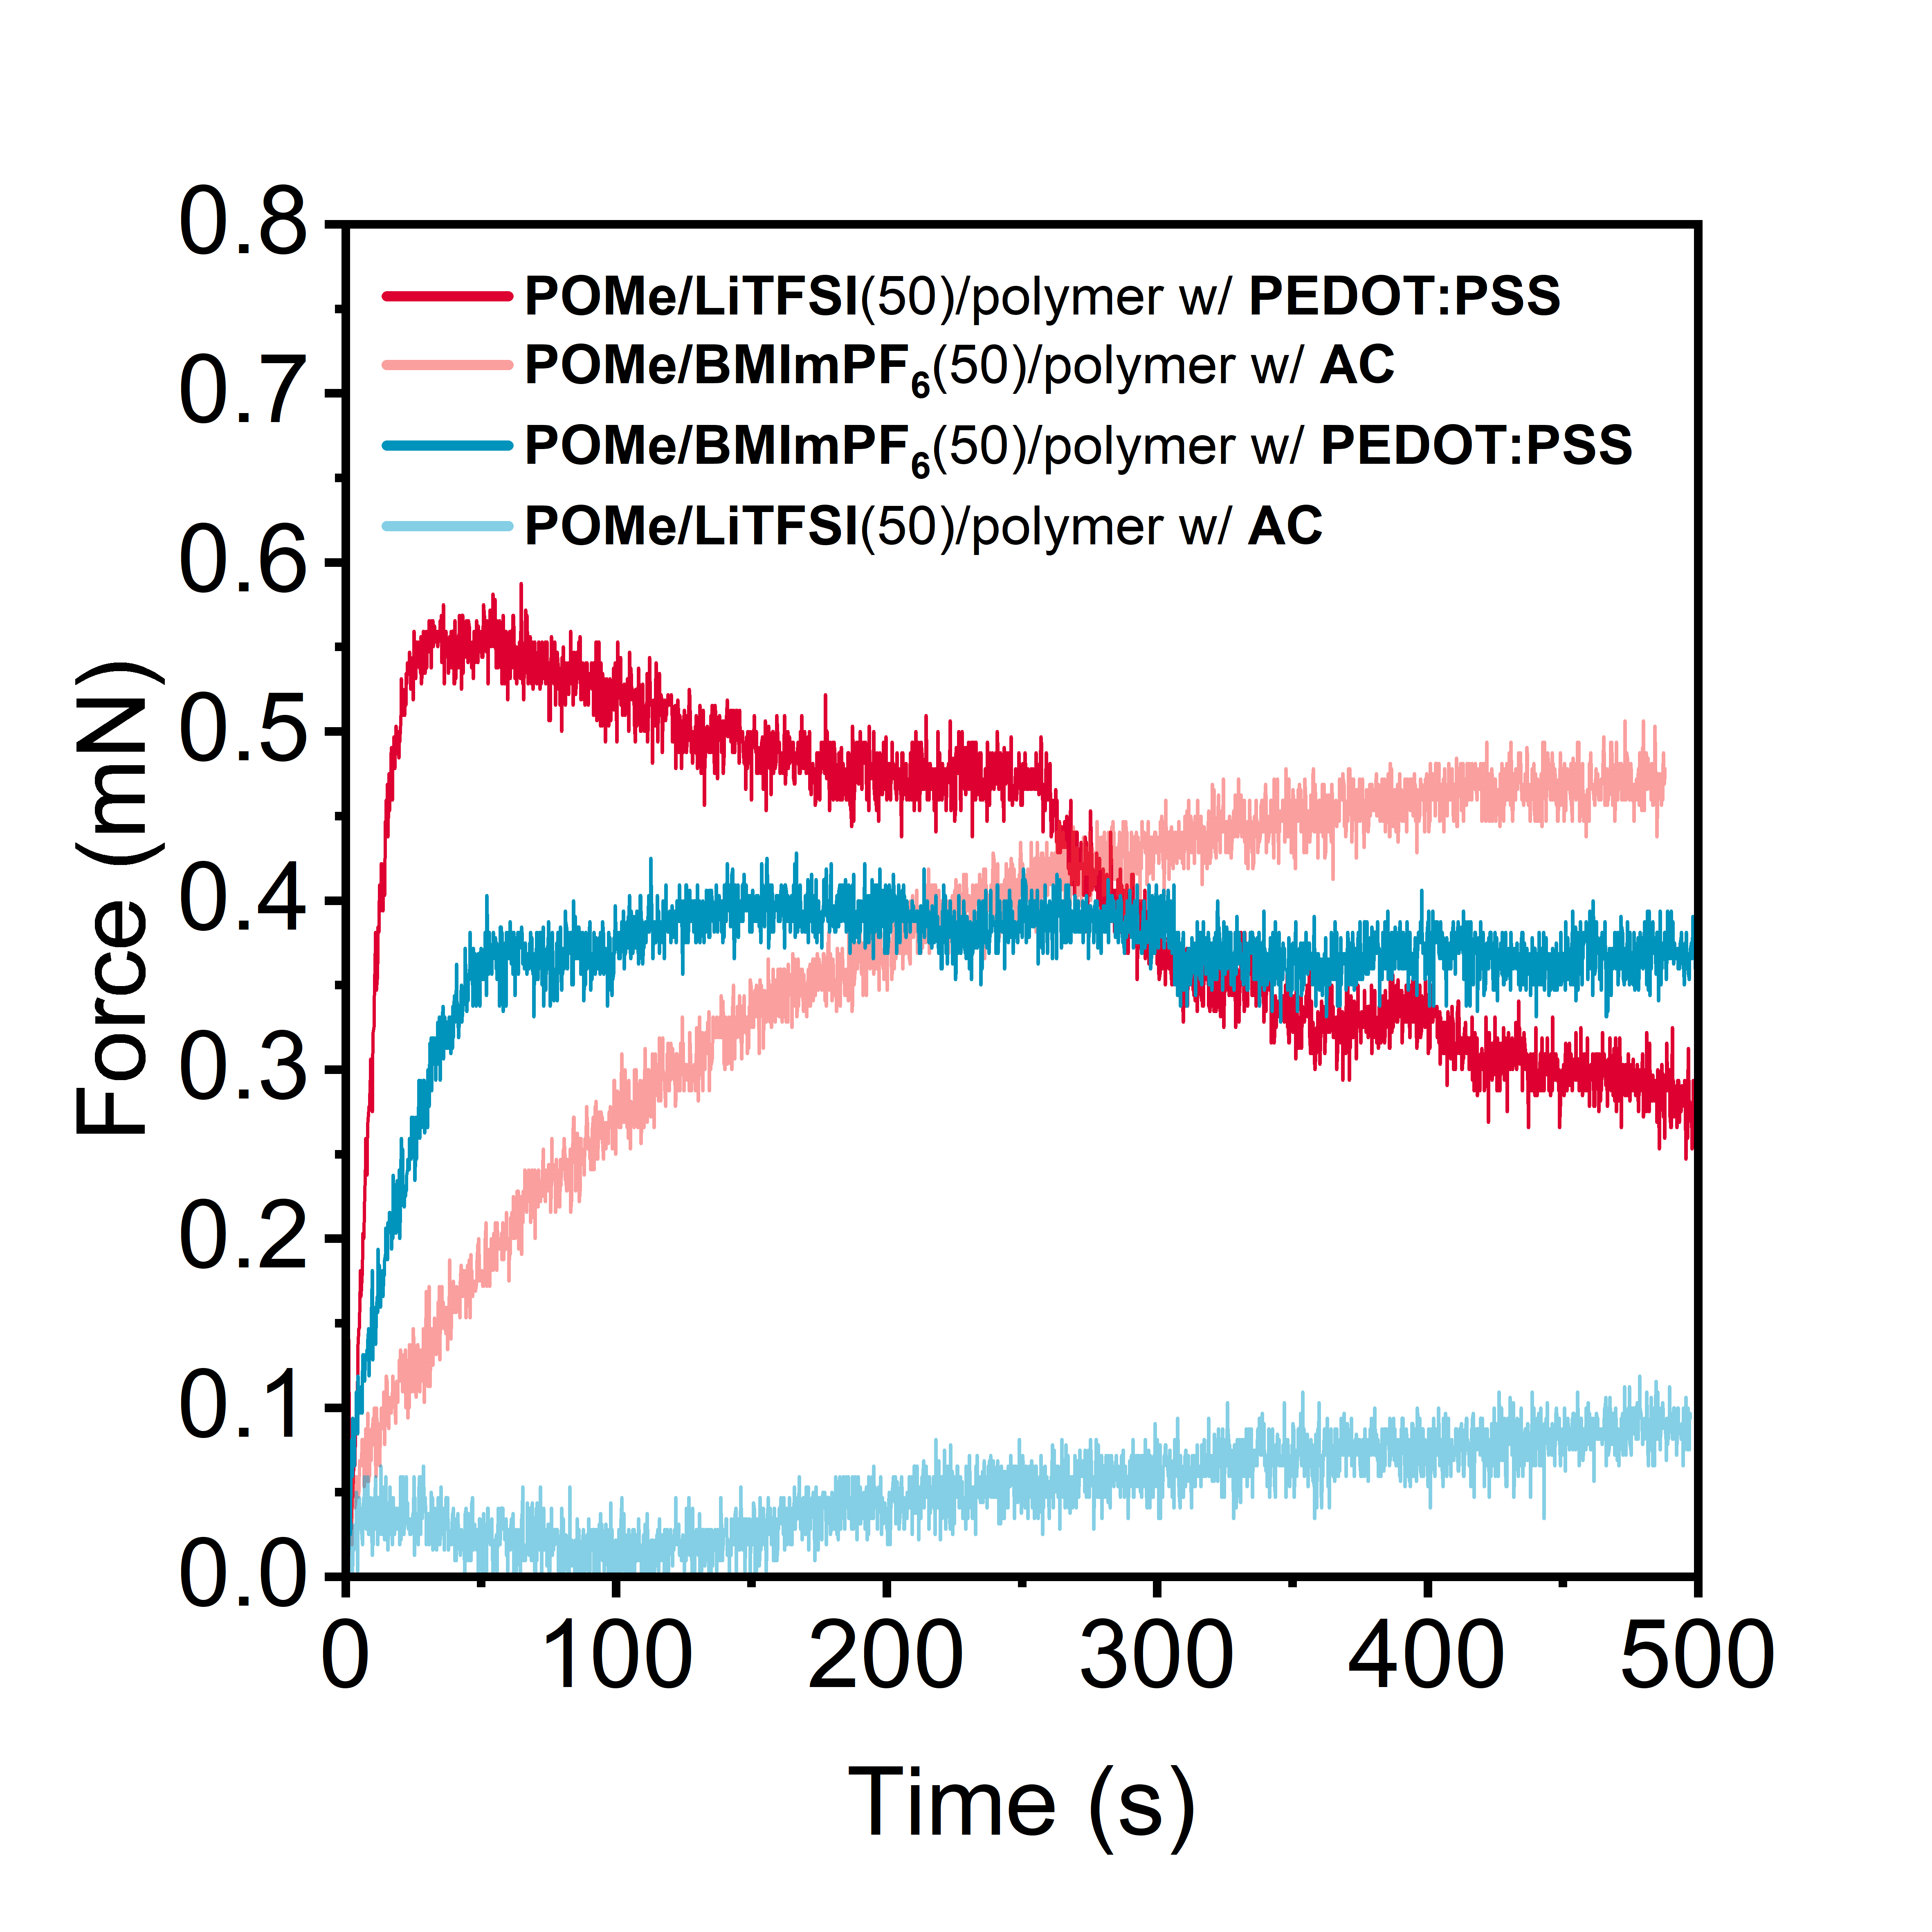
Figure S10. Blocking forces of POMe-based liquid crystal–polymer composite actuators with PEDOT:PSS and AC electrodes under applying a DC voltage of 2 V.

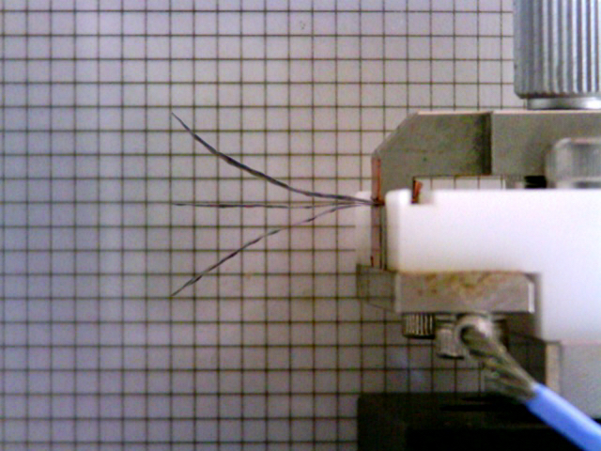

Figure S11. Photograph of the POMe/BMImPF₆(50)–polymer composite actuator with AC electrodes under ambient conditions, with ± 2 V DC voltages applied. The upper face of the actuator was connected to a working electrode, while the other face was attached to a counter electrode short-circuited with the reference electrode of the potentiostat.
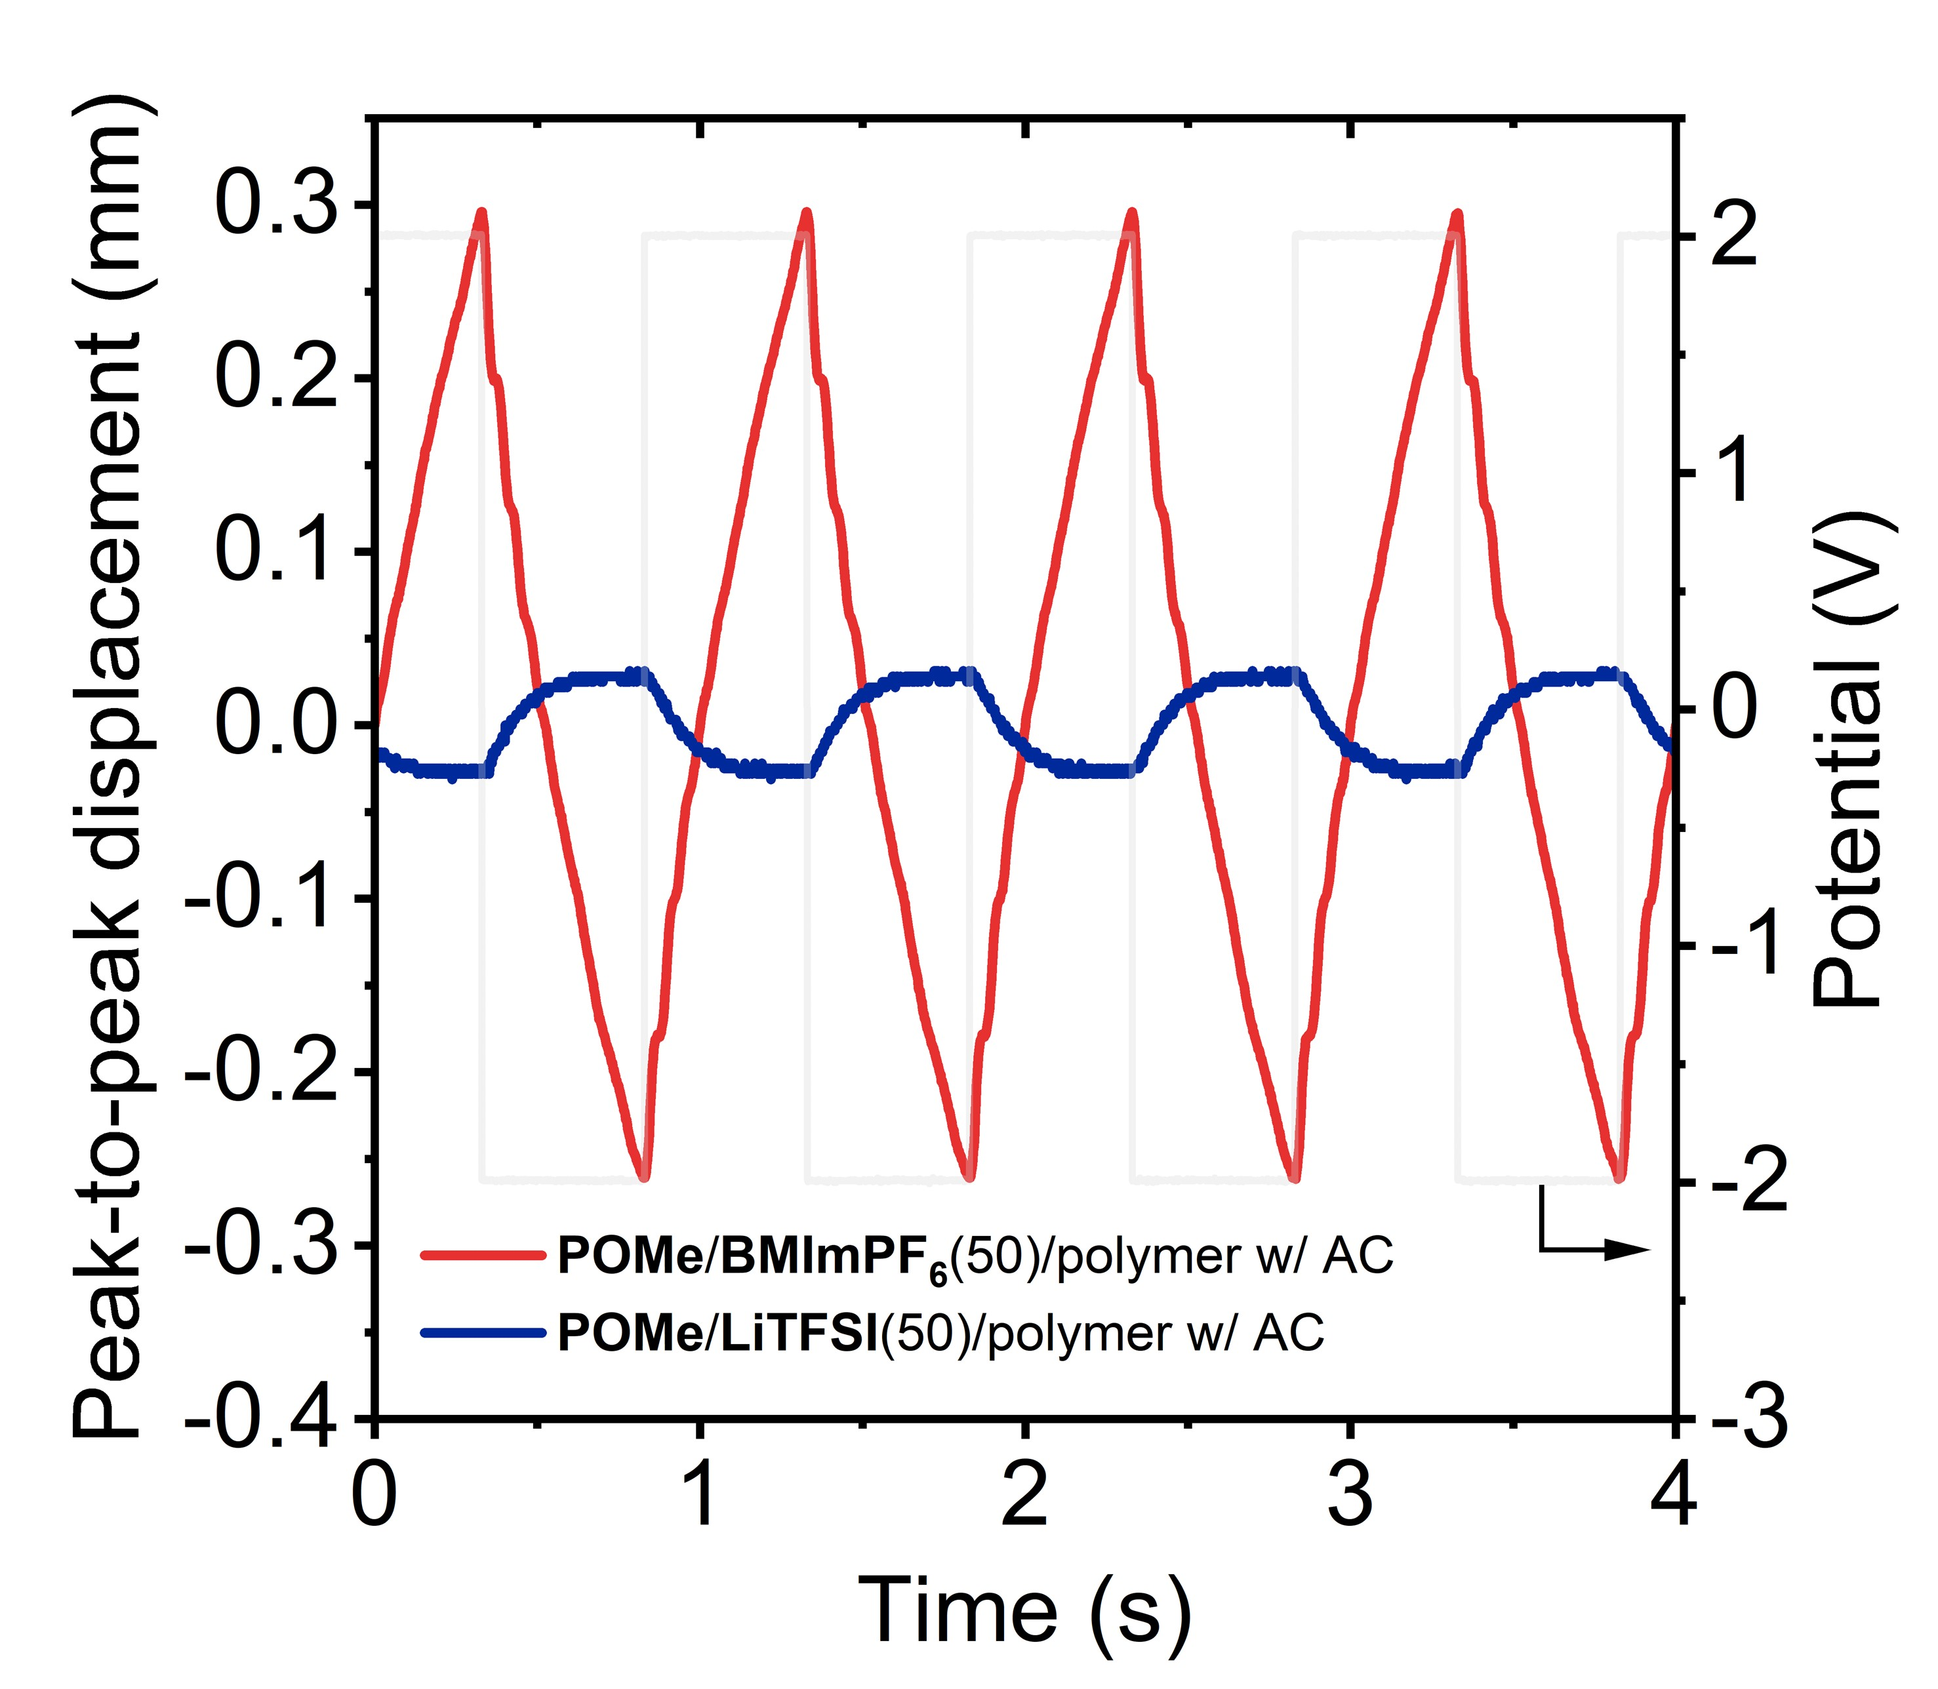
Figure S12. Bending displacements of AC electrode-based actuators incorporating the POMe/LiTFSI(50)–polymer and POMe/BMImPF₆(50)–polymer composite electrolytes under an alternating current square wave voltage of ±2V at 1Hz in ambient conditions. Displacements were measured at a distance of 12 mm from the clamped end of the actuator using a laser displacement meter.

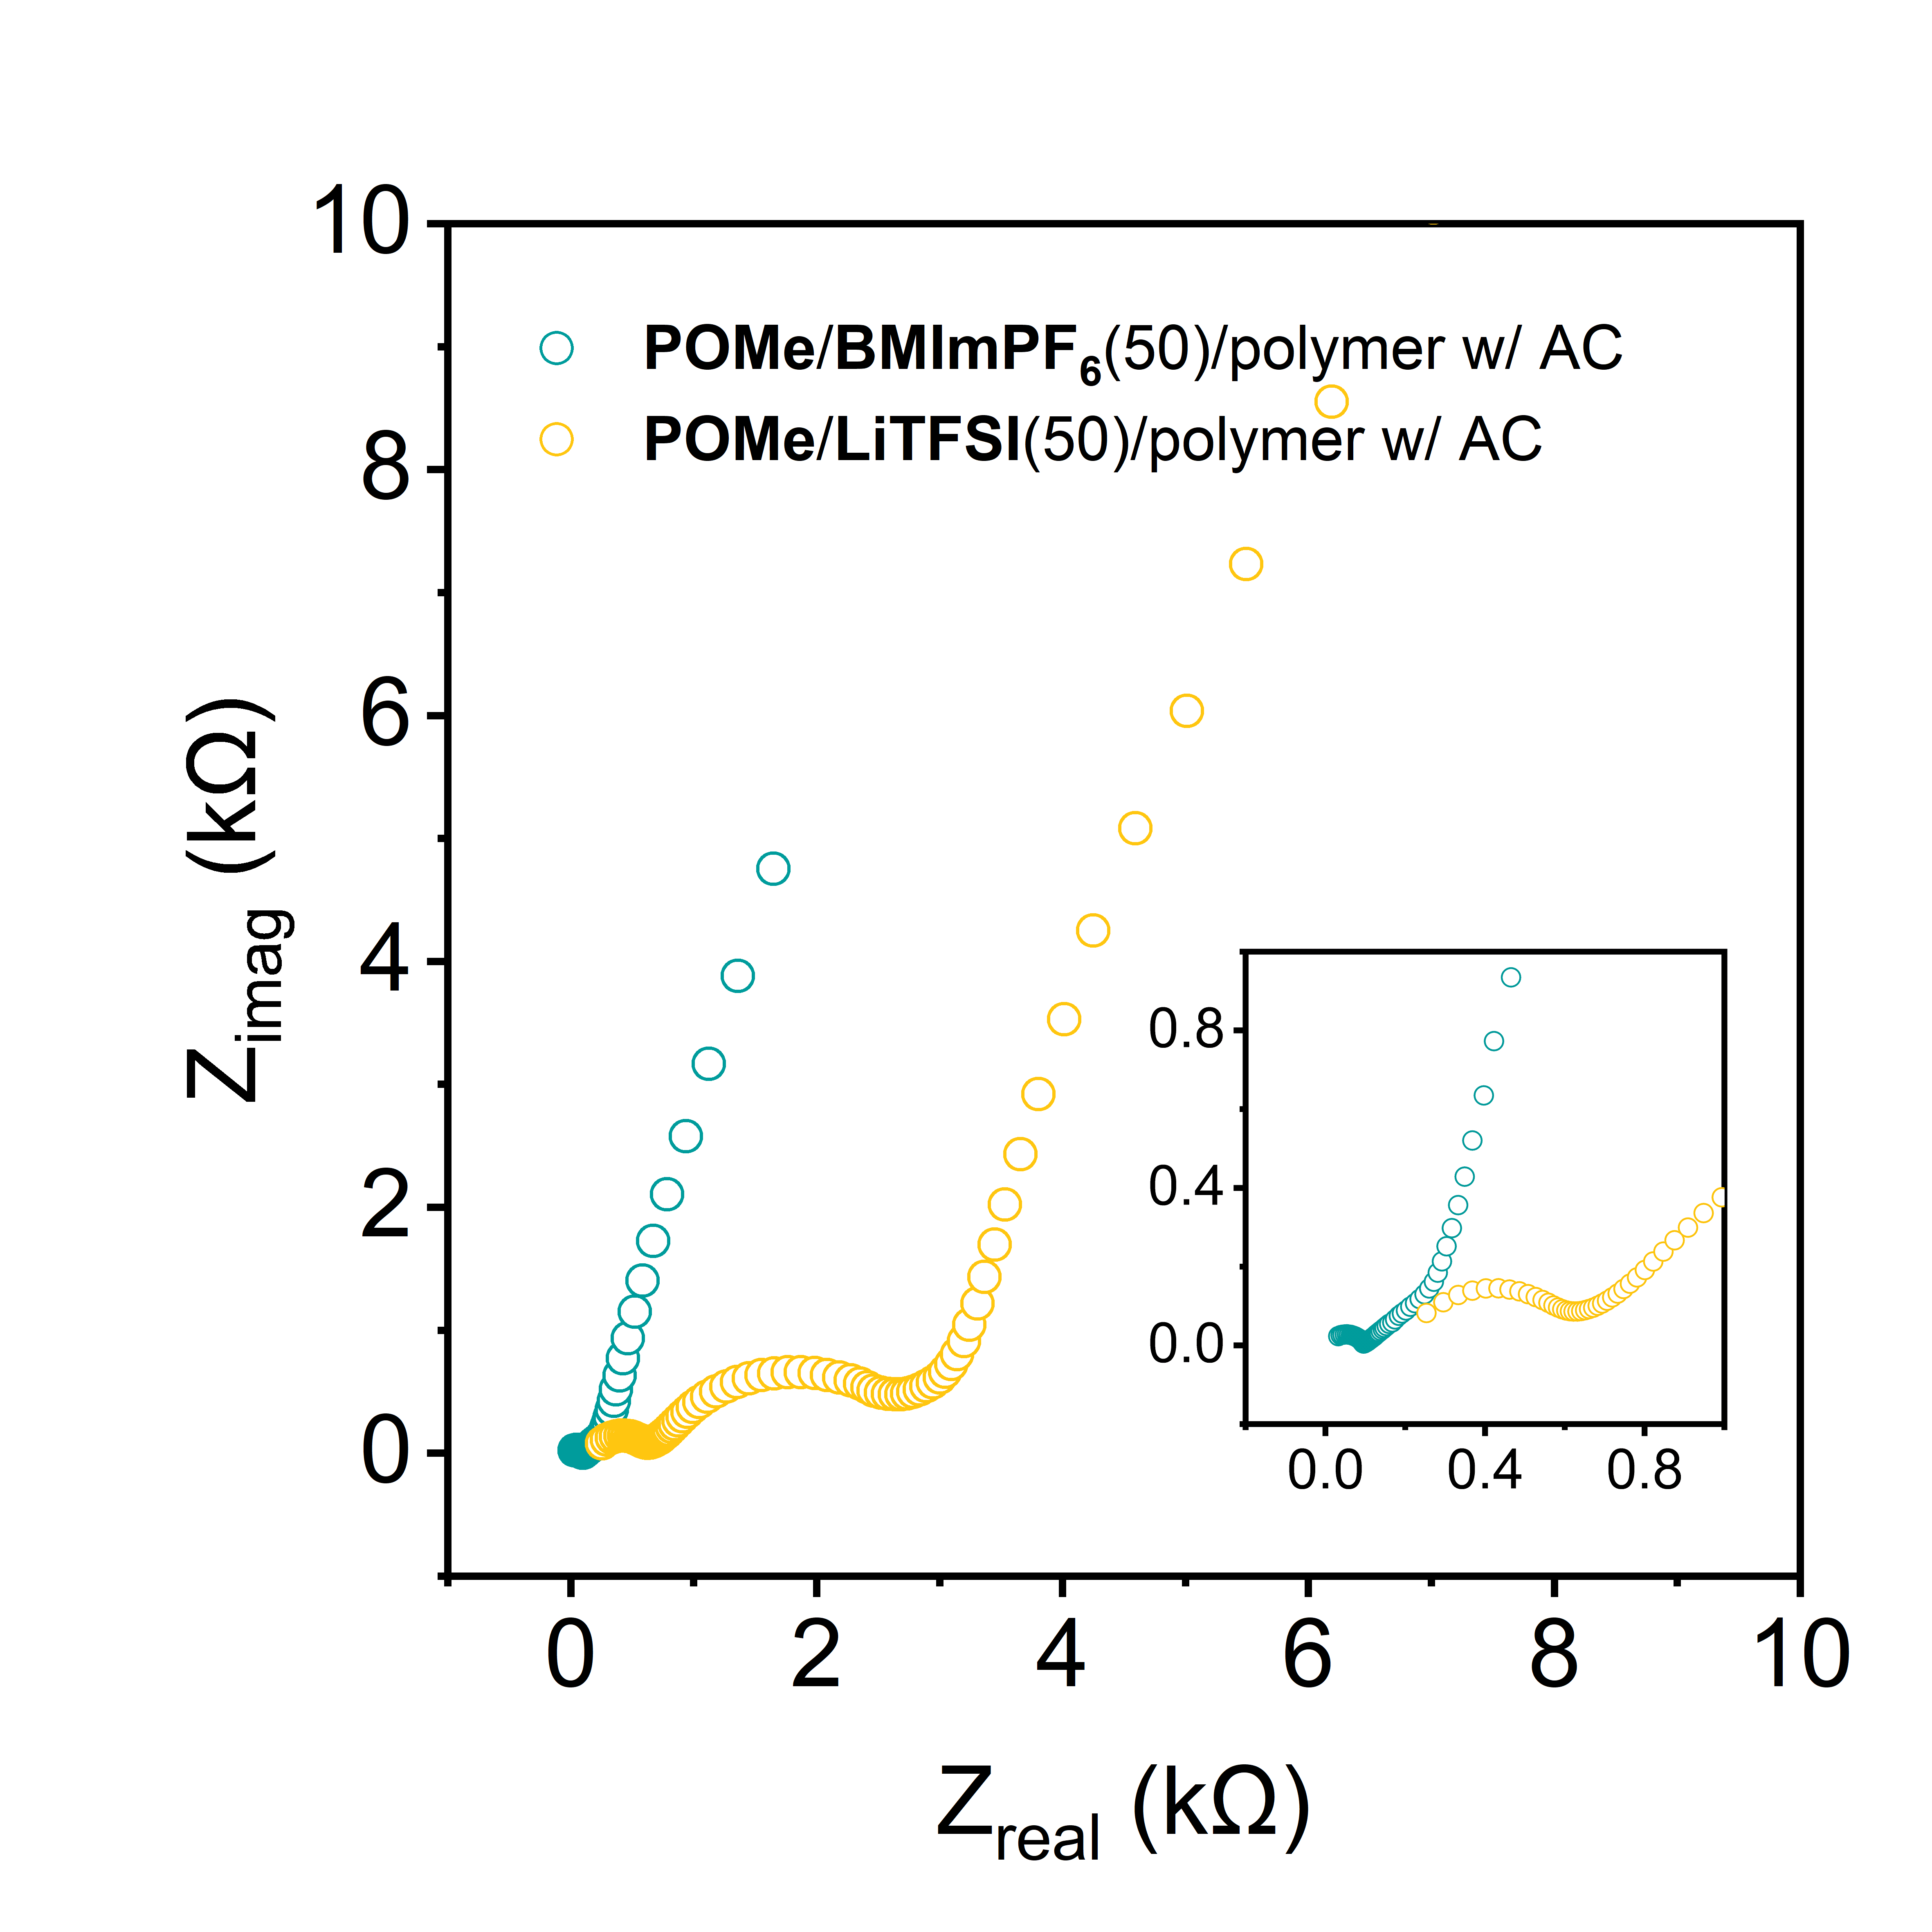
Figure S13. Nyquist plots of AC electrode-based actuators incorporating the POMe/LiTFSI(50)–polymer and POMe/BMImPF₆(50)–polymer composite electrolytes.

8. Comparison of iEAP actuators.
Table S1. Performances of actuators using PEDOT:PSS or composite electrode including PEDOT:PSS.
Electrode | Electrolyte | Input Voltage (V) | Maximum Frequency (Hz) | Strain (%) | Stability
pMoS2-nSNrGO/PEDOT:PSS¹ | Nafion/EMImBF₄ | 1.0 | 15 | 0.89 | 11000 cycles-96%
Th-SNG/PEDOT:PSS² | Li-SPBI-EMIMBF₄ | 1.0 | 10 | 0.36 | 18000 cycles-96% @ ±1 V, 1 Hz
3D GCN–NG/PEDOT:PSS³ | Nafion/EMImBF₄ | 0.5 | 0.1 | 0.52 | 5 h-93%  @ ±0.5 V 1 Hz
G-CNT-Ni/PEDOT:PSS⁴ | G-CNT-Ni/Nafion/EMImBF₄ | 1.0 | 10 | 0.52 | 4 h-93%  @ ±1 V 1 Hz
PEDOT:PSS/MWCNTs⁵ | TPU/EMIBF₄ | 2.5 | 10 | 0.64 | 100000 cycles-99.4%,  @ ±2.5 V, 1 Hz
Ti3C2Tx/PEDOT:PSS⁶ | Nafion/EMImBF₄ | 1.0 | 10 | 1.37 | 18000 cycles-97% @ ±1 V 1 Hz
CTF/PEDOT:PSS⁷ | Nafion/EMImBF₄ | 1.0 | 10 | 0.6 | 15000-99%  @ ±1 V, 1 Hz
NDC/PEDOT:PSS⁸ | TPU/EMITFSI | 3.0 | 5 | 0.2 | /
CoNC/PEDOT:PSS⁹ | TPU/EMITFSI | 3.0 | 5 | 0.28 | 6h -91%  @ ±2 V, 1 Hz
NSCOFs/PEDOT:PSS¹⁰ | Nafion/EMImBF₄ | 0.5 | 10 | 0.37 | 20000 cycles-98.75%  @ ±1 V, 1 Hz
BS-COF-Cs/PEDOT:PSS¹¹ | Nafion/EMImBF₄ | 0.5 | 10 | 0.62 | 6h-90%  @ ±0.5 V, 1 Hz
HPNC-900/PEDOT:PSS¹² | Nafion/EMImBF₄ | 0.5 | 10 | 0.53 | /
PEDOT:PSS¹³ | COF-DT-SO₃-Na | 0.5 | 20 | 0.39 | 23000 cycles-100%  @ ±0.5 V, 0.1 Hz
Our Previous Work  PEDOT:PSS  ¹⁴ | POEt/LiTFSI(50)–Polymer (PVC/PVDF-HFP) | 2.0 | 80 | 0.63 | 14400 cycles 100%  @ ±1 V, 1 Hz
This Work  PEDOT:PSS | POMe/LiTFSI(50)–Polymer (PVC/PVDF-HFP) | 2.0 | 110 | 0.68 | 14000 cycles 100%  @ ±1 V, 1 Hz
This Work  AC | POMe/BMImPF₆ (50)–Polymer (PVC/PVDF-HFP) | 2.0 | 50 | 0.34 | 14000 cycles 96%  @ ±1 V, 1 Hz
9. References.
(1) Manzoor, M. T.; Nguyen, V. H.; Umrao, S.; Kim, J.; Tabassian, R.; Kim, J.; Oh, I. Mutually Exclusive p‐Type and n‐Type Hybrid Electrode of MoS ₂ and Graphene for Artificial Soft Touch Fingers. Adv. Funct. Mater. 2019, 29 (48), 1905454. https://doi.org/10.1002/adfm.201905454.
(2) Kotal, M.; Kim, J.; Kim, K. J.; Oh, I.-K. Sulfur and Nitrogen Co-Doped Graphene Electrodes for High-Performance Ionic Artificial Muscles. Adv. Mater. 2016, 28 (8), 1610–1615. https://doi.org/10.1002/adma.201505243.
(3) Kotal, M.; Kim, J.; Tabassian, R.; Roy, S.; Nguyen, V. H.; Koratkar, N.; Oh, I.-K. Highly Bendable Ionic Soft Actuator Based on Nitrogen-Enriched 3D Hetero-Nanostructure Electrode. Adv. Funct. Mater. 2018, 28 (34), 1802464. https://doi.org/10.1002/adfm.201802464.
(4) Kim, J.; Bae, S.; Kotal, M.; Stalbaum, T.; Kim, K. J.; Oh, I. Soft but Powerful Artificial Muscles Based on 3D Graphene–CNT–Ni Heteronanostructures. Small 2017, 13 (31), 1701314. https://doi.org/10.1002/smll.201701314.
(5) Wang, D.; Lu, C.; Zhao, J.; Han, S.; Wu, M.; Chen, W. High Energy Conversion Efficiency Conducting Polymer Actuators Based on PEDOT:PSS/MWCNTs Composite Electrode. RSC Adv. 2017, 7 (50), 31264–31271. https://doi.org/10.1039/C7RA05469F.
(6) Umrao, S.; Tabassian, R.; Kim, J.; Nguyen, V. H.; Zhou, Q.; Nam, S.; Oh, I.-K. MXene Artificial Muscles Based on Ionically Cross-Linked Ti₃C₂T_{x} Electrode for Kinetic Soft Robotics. Sci. Robot. 2019, 4 (33), eaaw7797. https://doi.org/10.1126/scirobotics.aaw7797.
(7) Mahato, M.; Tabassian, R.; Nguyen, V. H.; Oh, S.; Nam, S.; Hwang, W.-J.; Oh, I.-K. CTF-Based Soft Touch Actuator for Playing Electronic Piano. Nat. Commun. 2020, 11 (1), 5358. https://doi.org/10.1038/s41467-020-19180-3.
(8) Lu, F.; Xiang, K.; Wang, Y.; Chen, T. Electrochemical Actuators Based on Nitrogen-Doped Carbons Derived from Zeolitic Imidazolate Frameworks. Mater. & Des. 2020, 187, 108405. https://doi.org/10.1016/j.matdes.2019.108405.
(9) Lu, F.; Chen, T.; Xiang, K.; Wang, Y. Ionic Electro-Active Polymer Actuator Based on Cobalt-Containing Nitrogen-Doped Carbon/Conducting Polymer Soft Electrode. Polym. Test. 2020, 84, 106413. https://doi.org/10.1016/j.polymertesting.2020.106413.
(10) Mahato, M.; Tabassian, R.; Nguyen, V. H.; Oh, S.; Nam, S.; Kim, K. J.; Oh, I. Sulfur‐ and Nitrogen‐Rich Porous π‐Conjugated COFs as Stable Electrode Materials for Electro‐Ionic Soft Actuators. Adv. Funct. Mater. 2020, 30 (46), 2003863. https://doi.org/10.1002/adfm.202003863.
(11) Roy, S.; Kim, J.; Kotal, M.; Tabassian, R.; Kim, K. J.; Oh, I. Collectively Exhaustive Electrodes Based on Covalent Organic Framework and Antagonistic Co‐Doping for Electroactive Ionic Artificial Muscles. Adv. Funct. Mater. 2019, 29 (17), 1900161. https://doi.org/10.1002/adfm.201900161.
(12) Roy, S.; Kim, J.; Kotal, M.; Kim, K. J.; Oh, I.-K. Electroionic Antagonistic Muscles Based on Nitrogen-Doped Carbons Derived from Poly(Triazine-Triptycene). Adv. Sci. 2017, 4 (12), 1700410. https://doi.org/10.1002/advs.201700410.
(13) Yu, F.; Ciou, J.-H.; Chen, S.; Poh, W. C.; Chen, J.; Chen, J.; Haruethai, K.; Lv, J.; Gao, D.; Lee, P. S. Ionic Covalent Organic Framework Based Electrolyte for Fast-Response Ultra-Low Voltage Electrochemical Actuators. Nat. Commun. 2022, 13 (1), 390. https://doi.org/10.1038/s41467-022-28023-2.
(14) Liu, C.; Cao, S.; Yoshio, M. Ion‐Conducting Non‐Flammable Liquid Crystal–Polymer Composites for High‐Frequency Soft Actuators. Adv. Funct. Mater. 2023, 33 (25), 2300538. https://doi.org/10.1002/adfm.202300538.

