Suulemetary data

Effect of strain-induced defects in GaN channel on two-dimensional carrier transport in AlGaN/GaN heterostructures

Masatomo Sumiya^{1,*} Yasutaka Imanaka², and Yoshitaka Nakano³
¹Electro-ceramics Group, National Institute for Materials Science, Tsukuba 305-0044, Japan
²High magnetic Field Group, National Institute for Materials Science, Tsukuba 305-0003, Japan
³Department of Electrical and Electronic Engineering, Chubu University, Kasugai, Aichi 487-8501, Japan
*Corresponding author’s E-mail address: SUMIYA.Masatomo@nims.go.jp

1. Integar quantum Hall effect of AlGaN/GaN grown by MOCVD
The quantum plateau of R_{xy} and the zero resistnce of R_{xx} were observed for the Sample A with the 2DEG carrier density of 1.2×10¹²cm⁻² as show in Fig. 1S. Since there were two carrier paths as indicated in the inset, the values of R_{xy} corresponding to the filling factor were lower. All samples evaluated in this manuscriptexhibited the SdH oscillation in high magnetic field up to 15 T at 1.8 K. The heterointrefces of samples we fabricated were good enough to discuss the carrier transport of 2DEG.

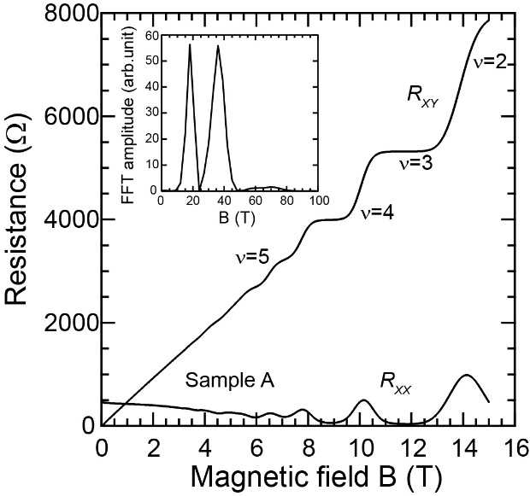

Fig. S1 Dependence of magnetoresistance and Hall resistance on magnetic field at 1.8 K for Al_{0.06}Ga_{0.094}N/GaN heterointerface (Sample A). Filling factors (ν) are indicated. The inset shows the FFT amplitude of 1/B.

2. SIMS analysis for Sample D and E
To consider the reasons why the defects were increased by AlN mol fraction in the barrier layer and why the defect distribution was markedly changed by inserting the AlN interlayer, the depth profile of composition of Samples D and E were evaluated by SIMS measurement. Figure 2S(a) shows the SIMS depth profile of Ga and Al for Samples D and E from the surface to a depth of 60 nm. The intensities of Al and Ga in the AlGaN barrier layer were constant. The increase in Al count was confirmed at the AlN interlayer at a depth of around 20 nm for Sample E, and the detected Al count decreased with increasing depth of the GaN channel layer. This profile was the same as that of Sample D. The Ga counts in the channel were constant for both samples. No marked compositional fluctuation^{1,2} was detected in the barrier and channel layers. In addition, the oxygen adsorbed on the AlGaN barrier layer did not diffuse into the AlGaN and GaN layers regardless of the presence or absence of the AlN interlayer. The concentrations of carbon, oxygen and Si impurities were as low as order of 10¹⁵ cm⁻³, close to the detection limits for both samples as shown in Figs. 2(b)-(d). It is difficult to explain the reduction of defect due to the AlN interlayer in terms of the compositional fluctuation and the incorporation of impurities.

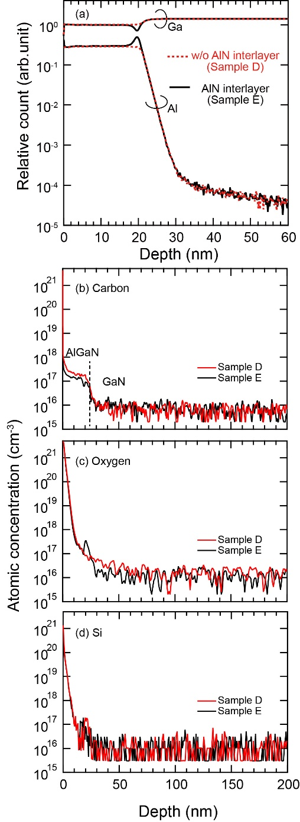
Fig. S2 (a) SIMS depth profiles of Ga and Al elements in the region near the surface and interface for Samples D (red) and E (black). The intensity of Ga was normalized to that of the AlGaN layer. Depth profiles of (b) carbon, (c) oxygen and (d) silicon in Sample D and E. The vertical dot line is guide for eye to show the interface between AlGaN and GaN rougly.

3. C-V measurement
Although the 2DEG carrier density measured by high magnetic field for both samples were same, the density of Sample D measured by the CV at the accumulated condition was lower than that of Sample E. Figure 3S shows the C–V characteristics measured for Samples D and E. We supposed that the electrons were partially moved between 2DEG and the strain-induced defect levels near the CBM during the C–V measurement, because the capacitance of Sample D in the accumulated condition was slightly lower than that of Sample E (Fig. 3S(a)), and the responsiveness of the 2DEG carriers in Sample D was deteriorated in the high-frequency range (Fig. 3S(b)).

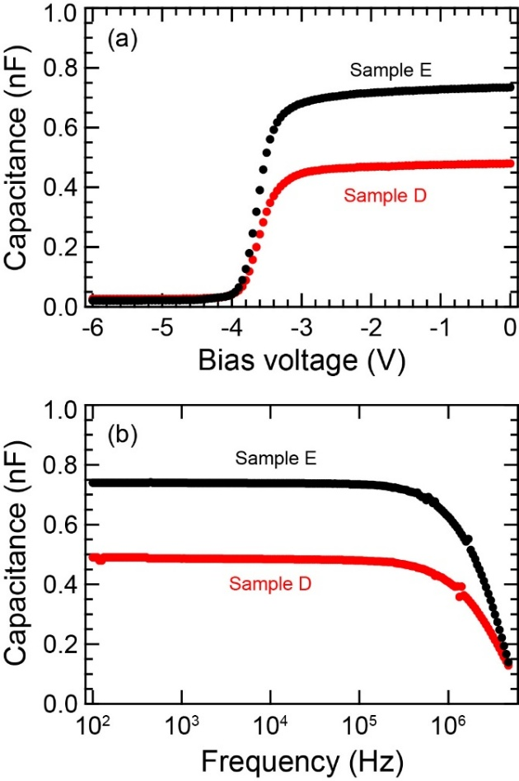

Fig. S3 (a) C–V characteristics @100 kHz and (b) frequency dependence of capacitance for Samples D (red) and E (black).

4. Surface morphology of AlN interlayer on GaN channel
We deposited the AlN interlayer on GaN channel, and observed the surface morphology. Figure 4S shows the AFM image of the AlN interlayer. The surface morphology of GaN exhibited the steps and terrace structure. Although the AlN interlayer had the step and terrace structure, the fine grain structure and the uncovered area were observed as shown in Fig. 4S. The value of root mean square was as low as 0.47 nm. We supposed that the room between grains must work like a cushion to prevent the propagation of the strain from the AlGaN barrier to GaN channel layer.

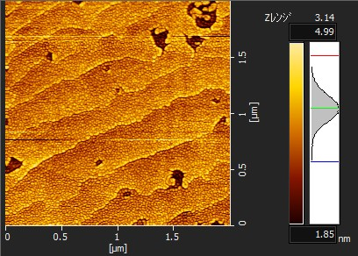

Fig. S4 Surface morphology of AlN interlayer grown for 7 s on GaN channel layer by MOCVD. The value of surface roughness (room mean square) was 0.47 nm.

5. R_{xx} and R_{xy} for Samples B and C
The carrier density and 2DEG mobility plotted in Fig. 6 for Samples B and C were obtained from the Fig. 5S. Both samples had the heterointerface good enough to exhibit the SdH oscillation. Sample B exhibited the IQHE.
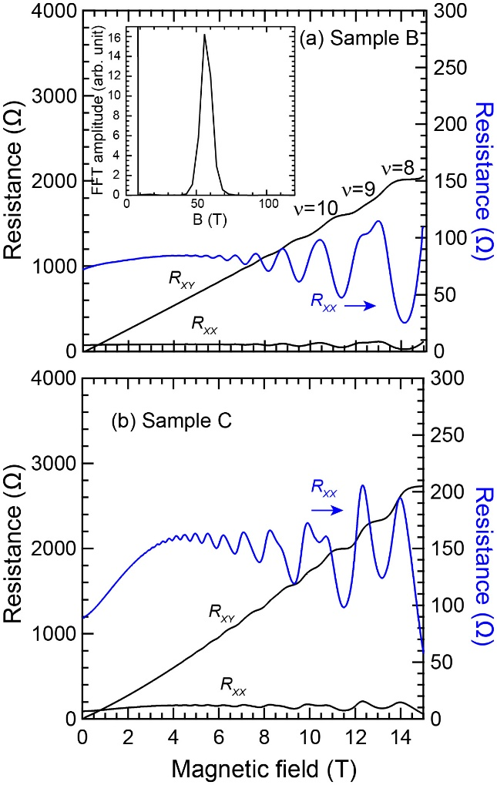

Fig. S5 (a) Dependence of magnetoresistance and Hall resistance on magnetic field at 1.8 K for Al_{0.05}Ga_{0.095}N/AlN/GaN heterointerface (Sample B). Filling factors (ν) are indicated. The right axis shows the expanded R_{xx}. The inset shows the results of FFT analysis to estimate the 2DEG carrier density. (b) R_{xx} and R_{xy} of Sample C, which had the same 2DEG carrier density as Sample B.

References
1 Birte-Julia Godejohann, Erdin Ture, Stefan Muller, Mario Prescher, Lutz Kirste, Rolf Aidam, Vladimir Polyakov, Peter Bruckner, Steffen Breuer, Klaus Kohler, Rudiger Quay, and Oliver Ambacher, ‘AlN/GaN HEMTs grown by MBE and MOCVD: Impact of Al distribution’, Phys. Status Solidi B 254, 1600715 (2017).
2 A. Papamichail; A. R. Persson; S. Richter; V. Stanishev; N. Armakavicius; P. Kühne; S. Guo; P. O. Å. Persson; P. P. Paskov; N. Rorsman; V. Darakchieva, ‘Impact of Al profile in high-Al content AlGaN/GaN HEMTs on the 2DEG properties’, Appl. Phys. Lett. 125, 123505 (2024)

