A machine learning approach for the prediction of electron inelastic mean free paths
Xun Liu^{1,2,3}, Lihao Yang^{1,2,3}, Zhufeng Hou⁴, Bo Da^{2,3*}, Kenji Nagata², Hideki Yoshikawa², Shigeo Tanuma³, Yang Sun⁵ and Zejun Ding^{1#}
¹Hefei National Laboratory for Physical Sciences at Microscale and Department of Physics, University of Science and Technology of China, Hefei, Anhui 230026, People’s Republic of China
²Research and Services Division of Materials Data and Integrated System, National Institute for Materials Science, 1-1 Namiki, Tsukuba, Ibaraki 305-0044, Japan
³Research Center for Advanced Measurement and Characterization, National Institute for Materials Science, 1-2-1 Sengen, Tsukuba, Ibaraki 305-0047, Japan
⁴State Key Laboratory of Structural Chemistry, Fujian Institute of Research on the Structure of Matter, Chinese Academy of Sciences, Fuzhou 350002, China
⁵Ames Laboratory, US Department of Energy, Ames, Iowa 50011, USA
*DA.Bo@nims.go.jp
#zjding@ustc.edu.cn

Abstract
The prediction of electron inelastic mean free paths (IMFPs) from simple material parameters is a challenging problem in studies using electron spectroscopy and microscopy. Herein, we propose a machine learning approach to predict IMFPs from some basic material property data. The machine learning model showed excellent performance based on the calculated IMFPs for a group of 41 elemental materials (Li, Be, C (graphite), C (diamond), C (glassy), Na, Mg, Al, Si, K, Sc, Ti, V, Cr, Fe, Co, Ni, Cu, Ge, Y, Nb, Mo, Ru, Rh, Pd, Ag, In, Sn, Cs, Gd, Tb, Dy, Hf, Ta, W, Re, Os, Ir, Pt, Au, Bi) from our previous work by Shinotsuka et al., which was comparable to that of the robust TPP-2M formula (by Tanuma, Powell and Penn). The developed machine learning model was then extended to materials that do not have reported IMFPs in the Shinotsuka et al. database. The IMFPs for 18 transition metals and lanthanide metals (Mn, Zn, Zr, Tc, Cd, La, Ce, Pr, Nd, Pm, Sm, Eu, Ho, Er, Tm, Yb, Lu, and Hg) were predicted by the machine learning model. In the comparison to FPA-calculated IMFPs through two newly-found experimental energy loss functions (ELFs), i.e. Mn and Zr, the GPR predicted IMFPs not only agreed well with those calculated using the TPP-2M formula in the energy range above 50 eV, but were also consistent with the trend of IMFPs calculated through experimental ELFs in the range of 2.7 to 50 eV, where the TPP-2M formula cannot be used. Our findings suggest that machine learning is very powerful and efficient and has great potential to complete a database of IMFPs for materials that can prove solutions closer to reality than empirical models on materials with similar physical and chemical properties and can be applied to other different situations for correlated information prediction.

Keywords: surface science, machine learning, inelastic mean free path, Gaussian Process regression (GPR)

- Introduction
The inelastic mean free path (IMFP), which describes the mean distance an electron travels through a solid before losing energy [1], is an essential parameter in determinations of surface sensitivity for surface electrons spectroscopies such as X-ray photoelectron spectroscopy (XPS) [2-4], Auger electron spectroscopy (AES) [2,5-7], reflection electron energy loss spectroscopy (REELS) [8,9] and for quantitative analyses with these techniques. Additionally, IMFP is one of the most important constants in Monte Carlo method [10], and some other important parameters can be successively obtained by the simulation of the physical process of the incident-electron scattering in materials to observe electron transport behaviors, represented by theoretically determined parameters of materials including the mean escape depth [11], backscattering factor [12,13], surface excitation parameters [14-16] and so on. Since the IMFP is fundamentally important for both experimental and theoretical studies, several methods, e.g. full-Penn algorithm (FPA)[17], Mermin algorithm[18] and ex-Mermin algorithm[19], have been established to calculate IMFPs at electron energies above 50 eV. As the most popular and reliable theoretical algorithms for the calculation of IMFPs, the difference between them is the usage of dielectric function. Firstly, the most well-accepted algorithm is the FPA, which is proposed by Penn [17]. In the calculation of FPA, Penn used Lindhard dielectric function to represent the probability for inelastic scattering, however, the finite lifetime broadening of the plasmon is neglected. Tanuma et al. frequently calculated IMFPs with FPA: 27 elemental materials [20,21], 15 inorganic compounds [22], and 14 organic compounds [23] in energy range from 50 to 2000 eV; 41 elemental materials [24] and 42 inorganic compounds [25] in energy range from 50 to 200 keV. Secondly, for higher accuracy, Mermin developed the Mermin model [18], which considered the finite lifetime broadening of the plasmon, using the so-called Mermin dielectric function in IMFPs calculation. Abril et al. also brought out series of IMFPs calculation [26] with the Mermin method. And recently, the latest brand-new extended Mermin method [19] is proposed by Da et al., they further improve the calculation accuracy of the Mermin method. However, all these methods are rely on accurate determination of the energy loss function (ELF), because they are built in the framework of the dielectric theory. Therefore, these theoretical approaches can only be applied to materials that have experimental optical constants available to provide the ELFs for fitting [27]. Unfortunately, until now, IMFPs for numerous materials, even for elemental materials are still cannot be calculated through these algorithms, due to the lack of reliable experimental data for their optical constants over a sufficiently wide energy range. Especially for lanthanide metals, for the preparation of lanthanide metal sample with a sufficiently clean surface requires quite high level of facilities and skills. In detail, in the polishing process of lanthanide metal sample, the surface is very susceptible to be contaminated. Although in recent years, many groups including our group successfully obtained ELFs from experimental REELS spectra [28-32], and successfully obtained ELFs of multiple materials [33-37], except for lanthanide metals. Until now, there are still numerous materials that lack reliable experimental data for their optical constants over a sufficiently wide energy range, because of the lack of sufficiently accurate REELS spectra. Therefore, it is critical to develop an alternative way to determine the unknown IMFPs based on lessons learned from those materials with well-established optical data.
Recently, several methods have been proposed to characterize parameters for electron scattering, which is the history of effective attenuation lengths (EALs) and IMFPs, based on those well-established material features. Details of some of the well-known empirical formulas for them are provided as follows.
- The universal formula:
(1)
where A and B are coefficients that are fitted according to the kinds of material being investigated, including element, inorganic compounds and organic compounds.
The starting point for the development of a predictive EAL formula is the work of Seah and Dench [38]. It must be stated that, at the time that the review was published, it was believed that inelastic mean free paths (IMFPs) and attenuation lengths (now known as effective attenuation lengths (EALs)) were the same quantity. More detailed information of IMFPs and EALs can be found in Ref. [39,40]. The universal formula developed in the Seah and Dench review is based on an analysis of what are now known as EALs, not IMFPs. Their universal formula result from a least squares analysis of the attenuation lengths in solids for energies less than 10 000 eV above the Fermi level. They considered solid materials included elements, inorganic compounds, organic compounds, and gas adsorbates. This work initiated an idea in attenuation lengths description, namely to seek a universal approach to describe the attenuation lengths by a simple formula suitable for all materials. However, the individual EAL measurements had large uncertainties [40].
- The Bethe equation:
(2)
where E_{p} is the free-electron plasmon energy and β and γ are coefficients.
A basic equation to calculate IMFPs is the Bethe equation, which is the starting point of robust TPP-2M equation [24]. The parameters used in the original Bethe equation [41] are microscopic quantities. Tanuma et al. [21] transformed the parameters used in the Bethe equation into macroscopic quantities, in other words, material-dependent parameters, and expanded the Bethe equation to low energies (<200 eV), thus making it an empirical formula. However, the Bethe equation is only valid for energies above 200 eV. Thus TPP-2M equation was developed [23] based on the Bethe equation and later expressed for relativistic electron energies [24].
- TPP-2M equation [24]:
(3)
where m_{e}c² is the electron rest energy (510998.9 eV), E_{p} is the free-electron plasmon energy (in eV), E_{g} is the bandgap energy for nonconductors (in eV), ρ is the bulk density (in g cm⁻³) and N_{v} is the number of valence electrons per atom or molecule.
- TPP-LASSO-S formula[42]
(4)
where m_{e}c² is the electron rest energy (510998.9 eV), E_{p} is the free-electron plasmon energy (in eV), E_{i} is the starting-point energy (in eV), E_{g} is the bandgap energy for nonconductors (in eV), ρ is the bulk density (in g cm⁻³) and N_{v} is the number of valence electrons per atom or molecule.
Additionally, an empirical formula includes energy region lower than 50eV is also proposed in Ref. [43]. Although the formula can describe electron IMFPs of low energy region (< 50eV), but according to Ref. [43], the fitting coefficients cannot be related to material-dependent parameters. In other word, for now, the formula need fitting according to IMFP curves for every certain material. The formula is actually different for each material, not to mention the predictive power it will has.
Recently, Shinotsuka et al. [24] developed a relativistic version of the TPP-2M equation based on the modified Bethe equation by introducing a data-driven concept. In the equation, the formulas for β and γ were confirmed since Ref. [23]. Through application of the TPP-2M equation to a variety of materials, the two correction terms C and D were also introduced into the denominator to adjust the prediction results for energies less than 200 eV since Ref. [23]. Last, a relativistic modification was added, which gave β_{r}, γ_{r}, C_{r}, D_{r}, and the modification term α(E), to provide the complete form of the TPP-2M equation, thus representing another step towards an accurate description of electron IMFPs using material-dependent parameters. Using the TPP-2M equation, IMFPs can be estimated for any material.
The TPP-2M formula [24], which is a modified form of the Bethe equation [41], shows a robust fitting of calculated IMFPs and can predict IMFPs using material properties, such as density and the number of electrons per atom, in the electron energy range above 50 eV. Tanuma and colleagues have worked on the TPP-2M formula from the initial work [20] to the most recent [24], expanded their original IMFP calculations (additional materials, expanded energy range, and improved calculation accuracy). In the development process of the TPP-2M, Tanuma and colleagues were using FPA-calculated IMFP data as a target. However, the FPA-calculated IMFPs have a relatively poorer accuracy for energies less than 50 eV and above 200 keV, due to the uncertainty of the exchange-correlation potential [21] and the neglect of the transverse differential cross section for inelastic scattering [24], respectively. Although the main motivation for the IMFP calculations of Tanuma et al. was to provide needed IMFP data for practical applications of AES and XPS, and there are few such applications in the very low energy (<50 eV) range, the fact that TPP-2M formula cannot be used in the very low energy (<50 eV) range is still a shortcoming in some special applications. And the TPP-LASSO-S formula [42] is a modified TPP-like formula derived by our team by machine learning (ML). Compared to TPP-2M formula, the TPP-LASSO-S formula has increased accuracy with the introduction of Z and the power of ML, but still has not overcome the inability of empirical formula for IMFPs in the very low energy (<50 eV) range.
In contemporary materials science, ML is playing an increasingly important role because it can provide promising models for problems when a reliable empirical formula is not available [44]. Recently, many studies using ML on datasets or spectra [45,46] have shown the advantages of ML in materials science, thus guiding the methodology for application of ML. Therefore, in this work, in order to overcome the unavailability of traditional empirical formulae on lower energies (<50eV) and for ease of application, we consider to use machine learning to provide a convenient way to calculate IMFPs. We established a robust database for IMFP, and predicted unknown IMFPs of 18 transition and lanthanide metals. We show that the proposed ML scheme fits known IMFP data with an accuracy similar to or even better than that of the TPP-2M formula. Although the FPA-calculated IMFP values are not very accurate in the very low energy (<50 eV) regime due to the FPA calculational model, the trained ML model of IMFPs can be extended to the range even below 10 eV, which can at least show illustrative trends. Moreover, we provide suitable descriptors for the training of the ML model over a broad energy range of the IMFP calculations, and the prediction ability of our algorithm is systematically discussed through leave one material out cross validation (LOOCV) and comparison to new FPA calculated IMFPs and experimental IMFPs. We also analysis the advantage and disadvantage of the used ML method and empirical formulae, since the ML method here show good prediction power on materials with similar physical and chemical properties, while the empirical formulae, e.g. TPP-2M formula, are effective on the prediction of unfamiliar material IMFPs. Finally, we discuss the possibility for directly extend the ML predicted elemental IMFPs to compounds, thus reveal the future direction for ML methods used on IMFPs prediction.
- Theoretical Method and Results
The performance of ML models strongly depends on the database and training algorithm [47]. Through decades of study, researchers have accumulated numerous IMFP results that can serve as a reliable database to build a ML model. Shinotsuka et al. [24] theoretically computed IMFPs for 41 different elements with complete optical constant data over a wide energy range with the FPA. Here, these IMFP data were used as an initial database for the ML model. In this work, the energy range and mesh are basically as same as the work in [24], because we used these data as training and testing set. The detailed energy mesh is now listed in the appendix of the manuscript in Table A1, together with the prediction result of transition metals and lanthanide metals. It must be stated that, Shinotsuka et al. did not publish their FPA-calculated IMFP values at very high (>200 keV) and very low (<50 eV) energies due to the limited accuracy in these energy regimes, as mentioned above, so data for these regions were communicated privately. That is, the information for 41 common elements were included in the ML model to quantitatively investigate the relationship between material parameters (Table I) and IMFPs [24]. For the consideration of both material and energy dependence of IMFP values, in the regression, there are 129 points depends on electron energies for each material, so totally there are 129×41=5289 data instances in the dataset. We noted that all the electron energy values are above Fermi energy in the database, as well as the calculations, tables and figures in our work.
Table I. Parameters used in ML, including atomic number (Z), atomic mass (M), density (ρ), number of valence electrons per atom (N_{v}), free-electron plasmon energy (E_{p}), bandgap energy (E_{g}), Fermi energy (E_{F}), and atomic radius (R)
Element | Z | M | ρ (g/cm³) | N_{v} | E_{p} (eV) | E_{g} (eV) | E_{F} (eV) | R (pm)
Li | 3 | 6.94 | 0.534 | 1 | 7.99 | 0 | 4.74 | 145
Be | 4 | 9.01 | 1.848 | 2 | 18.44 | 0 | 14.3 | 105
C (graphite) | 6 | 12.01 | 2.25 | 4 | 24.93 | 0 | 20.4 | 70
C (diamond) | 6 | 12.01 | 3.515 | 4 | 31.16 | 5.5 | 20.4 | 70
C (glassy) | 6 | 12.01 | 1.8 | 4 | 22.3 | 0 | 20.4 | 70
Na | 11 | 22.99 | 0.971 | 1 | 5.92 | 0 | 3.24 | 180
Mg | 12 | 24.31 | 1.738 | 2 | 10.89 | 0 | 7.1 | 150
Al | 13 | 26.98 | 2.7 | 3 | 15.78 | 0 | 11.2 | 125
Si | 14 | 28.09 | 2.33 | 4 | 16.59 | 1.1 | 12.5 | 110
K | 19 | 39.10 | 0.862 | 1 | 4.28 | 0 | 2.12 | 220
Sc | 21 | 44.96 | 2.989 | 3 | 12.86 | 0 | 5.8 | 160
Ti | 22 | 47.87 | 4.51 | 4 | 17.68 | 0 | 6 | 140
V | 23 | 50.94 | 6.11 | 5 | 22.3 | 0 | 6.4 | 135
Cr | 24 | 52.00 | 7.14 | 6 | 26.14 | 0 | 7.8 | 140
Fe | 26 | 55.85 | 7.874 | 8 | 30.59 | 0 | 8.9 | 140
Co | 27 | 58.93 | 8.9 | 9 | 33.58 | 0 | 10 | 135
Ni | 28 | 58.69 | 8.902 | 10 | 35.47 | 0 | 9.1 | 135
Cu | 29 | 63.55 | 8.96 | 11 | 35.87 | 0 | 8.7 | 135
Ge | 32 | 72.59 | 5.32 | 4 | 15.59 | 0.67 | 12.6 | 125
Y | 39 | 88.91 | 4.469 | 3 | 11.18 | 0 | 4.4 | 180
Nb | 41 | 92.91 | 8.57 | 5 | 19.56 | 0 | 5.3 | 145
Mo | 42 | 95.94 | 10.28 | 6 | 23.09 | 0 | 6.5 | 145
Ru | 44 | 101.07 | 12.41 | 8 | 28.54 | 0 | 6.9 | 130
Rh | 45 | 102.91 | 12.41 | 9 | 30 | 0 | 6.9 | 135
Pd | 46 | 106.42 | 12.02 | 10 | 30.61 | 0 | 6.2 | 140
Ag | 47 | 107.87 | 10.5 | 11 | 29.8 | 0 | 7.2 | 160
In | 49 | 114.82 | 7.31 | 3 | 12.59 | 0 | 4.82 | 155
Sn | 50 | 118.71 | 7.31 | 4 | 14.29 | 0 | 5.51 | 145
Cs | 55 | 132.91 | 1.88 | 1 | 3.43 | 0 | 1.73 | 260
Gd | 64 | 157.25 | 8.23 | 9 | 19.77 | 0 | 3.5 | 180
Tb | 65 | 158.93 | 8.25 | 9 | 19.69 | 0 | 4 | 175
Dy | 66 | 162.50 | 8.78 | 9 | 20.08 | 0 | 3.5 | 175
Hf | 72 | 178.49 | 13.31 | 4 | 15.73 | 0 | 7.9 | 155
Ta | 73 | 180.95 | 16.65 | 5 | 19.53 | 0 | 8.4 | 145
W | 74 | 183.85 | 19.3 | 6 | 22.86 | 0 | 10.1 | 135
Re | 75 | 186.21 | 21.02 | 7 | 25.6 | 0 | 10.7 | 135
Os | 76 | 190.23 | 22.61 | 8 | 28.08 | 0 | 11.4 | 130
Ir | 77 | 192.22 | 22.65 | 9 | 29.66 | 0 | 11.2 | 135
Pt | 78 | 195.08 | 21.45 | 10 | 30.2 | 0 | 10.6 | 135
Au | 79 | 196.97 | 19.32 | 11 | 29.92 | 0 | 9 | 135
Bi | 83 | 208.98 | 9.79 | 5 | 13.94 | 0 | 12.6 | 160
Another part of building the database for ML is to select proper input parameters; namely, the descriptors of the material parameters. Because the TPP-2M formula has achieved a good description of the IMFP, the parameters in the TPP-2M formula [24] were used, as listed in Table 1 of Ref. [24]. Furthermore, we found that the inclusion of the atomic number Z and atomic radius R in the descriptors markedly improved the accuracy of the ML model, together with the other parameters listed in Table I. To describe the correlation between these descriptors, we used the Pearson’s correlation coefficient r, which is defined as:
(5)
where $X_{i}$ and $Y_{i}$ are two descriptors and $\overline{X}$ and $\overline{Y}$ are the averaged values over n data points. According to Eq. (5), r = 1 indicates an exact linear correlation between X and Y, whereas r = 0 implies no correlation. Using the above parameter information and Eq. (5), the applicability of parameters to IMFP was analyzed as follows.
In this paper, the same descriptors, i.e., material-dependent physical parameters, were used as those employed in the TPP-2M equation. In Ref. [24], the TPP-2M equation included four material-dependent physical parameters to predict IMFPs; namely, atomic mass (M), density (ρ, in g cm⁻³), number of valence electrons per atom (N_{v}), and bandgap energy (E_{g}, in eV). Among these parameters, M and ρ are basic physical parameters and E_{g} as well as the Fermi energy (E_{F}, in eV), as basic material-dependent parameters, describe the basic model of the energy band. The descriptors E_{p} and N_{v} are responsible for the density of valence electrons in a material. N_{v} is usually associated with valence electrons but may include shallow core electrons in some materials. E_{p}, which is another parameter that is related to the IMFP, is related to N_{v} by E_{p}=28.8(N_{v}ρ/M)^{1/2} (eV), which represents the oscillator strength for electrons that strongly contribute to the inelastic scattering. Figure 1a) shows an obvious relationship between E_{F} and E_{p}. This relationship occurs because E_{F} and E_{p} are dependent on the electron number density for free-electron-like solids. But this is not suggesting that E_{F} is not necessary in this work, even if E_{F} is not appearing in the TPP-2M formula. In the theoretical model of calculating IMFP with optical constants, such as the FPA or Mermin method, E_{F} is a very important parameter. In the calculation of FPA, although E_{F} is not essential for predicting IMFPs at relatively high energies (above 50 eV), it is very important in low-energy IMFP calculations [48]. As is mentioned before, IMFP values are expressed as the energy above Fermi energy in this work, as same as the FPA-calculated database used here. In other word, electron energy (E') is from the bottom of conduction band in the FPA calculations for conductor, while the upper limit of the integration in FPA is E'-E_{F}, not E' [24], which is due to the Pauli exclusion principle. So the IMFP calculation with the FPA is associated with E_{F}. In the case of high energy region at least above 50eV, E_{F} can be ignored compared to the electron energy, so E_{F} do not apparently influence the calculation of the FPA. But inversely, the IMFPs in very low energies (<50 eV) is sensitive to the value of E_{F}. For the same reason, the TPP-2M formula does not contain E_{F} due to the fact that its application energy region is above 50 eV, while the ML model in this work is estimating IMFPs at very low energies (<50 eV). Therefore, in the ML model, we have to adopt E_{F} as a basic parameter here in ML model. Figure 1a) also reveals that the correlations among Z, M, and ρ are the highest: these descriptors are considered to be the most basic physical parameters when predicting IMFPs, which means that they cannot be considered as repeated features and must be retained. In addition, N_{v} changes periodically with increasing atomic number and has a weak correlation with the basic physical parameters R (in pm), Z, M, and ρ. E_{p} is correlated with N_{v}, ρ, and M. As for E_{F} and E_{g}, because they are parameters in band theory, they have no direct correlation with the other descriptors. These physical quantities have already been included in the TPP-2M formula or FPA and thus must also be included here. As shown in Fig. 1a), the descriptors used in the current work show weak correlations with each other. Therefore, because they are almost independent of each other, all are necessary for the ML model.
There are various training algorithms for the ML model with the ability to recognize patterns from a dataset and then use these patterns to make predictions for new data [49]. Here we compare the performance of three regression algorithms for the ML model of IMFPs: generalized linear regression (GLR), Gaussian process regression (GPR) [50] and support vector regression (SVR) [51].
- Generalized linear regression (GLR)
Linear regression is often performed using the least-squares method, producing a linear relationship between descriptors and a target. Generalized linear regression (GLR) is not like simple linear regression, which gives a response with a certain distribution; e.g., a Poisson distribution. The distribution can be seen as a function added between a simple linear regression and the final regression results.
- Gaussian process regression (GPR)
The GPR model is a probabilistic model belonging to a generic supervised learning method. The GPR model provides a probabilistic distribution of a new output value by the descriptors $P(y_{new}|y_{train},x_{train},x_{new})$ based on the training result for each step. In the step-by-step optimization, the joint distributions of the regressed function follow a Gaussian process:
(6)
where is the kernel function. This kernel function is related to the shape of the target, which is a radial basis function (RBF) in this work:
(7)
where $l$ is the length scale parameter and ${d(a,b)}^{2}$ is the mean square derivatives of a and b. For available distributions of the function and targets, the posterior distribution of the adjusted function is calculated through a Gaussian process.
- Support vector regression (SVR)
The essential thought of SVR is to transform a regression into a linear regression. SVR involves reflecting the descriptors into a high-dimensional feature space in which a high-dimensional linear regression can be performed. The kind of SVR used in this paper is ε-SVR, which allows a tolerance gap ε between the true target and the learning target. Within the gap, the result will be seen as an acceptable result. The actual optimization uses quadratic programing algorithms. The decision function is:
(8)
where $α_{i},{α_{i}}^{*}$ are Lagrange multipliers, and $k(x,x')$ is a kernel function, as shown in Eq. (7).
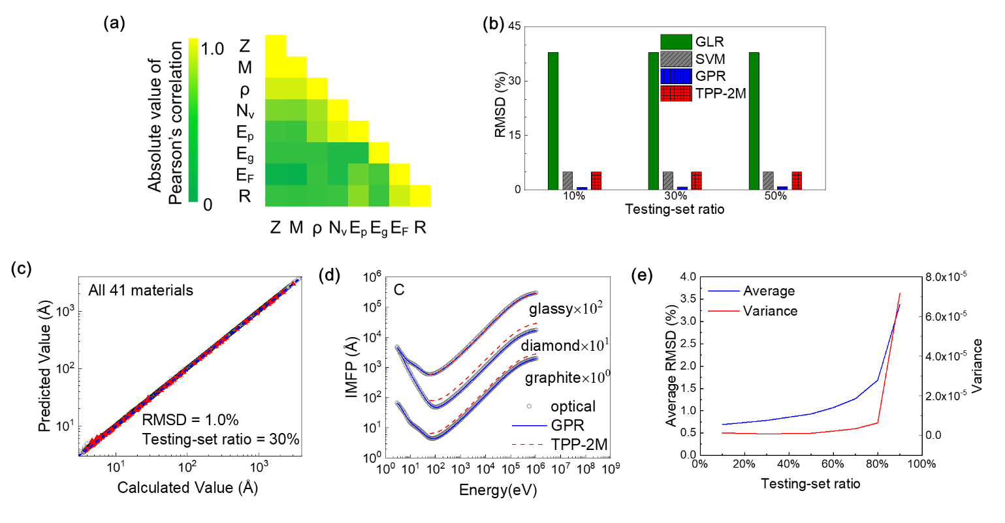
Fig. 1 a) Correlations between adopted descriptors: atomic number (Z), atomic mass (M), density (ρ), number of valence electrons per atom (N_{v}), free-electron plasmon energy (E_{p}), bandgap energy (E_{g}), Fermi energy (E_{F}), and atomic radius (R); b) the average root mean square deviation (RMSD) of different machine learning (ML) models. The models include Gaussian process regression (GPR), support vector regression (SVR), generalized linear regression (GLR), and the TPP-2M formula above 50 eV for comparison. Detailed RMSD values and variances are shown in Table II. To ensure fair comparison, the calculation of RMSD with the TPP-2M formula also used Eq. (9); c) Learning performance of IMFP for all materials. The x-axis is the IMFP calculated using the FPA in Ref. [24] and the y-axis is the IMFP predicted using GPR. The energy range covers all IMFPs in the data set. The blue line is a diagonal, which means agreement between predicted and calculated IMFPs, and the red triangles are predicted results; d) Comparison between the GPR model, TPP-2M formula, and calculations with optical data. The blue solid line is IMFPs predicted by the GPR model, the red dashed line is IMFPs predicted by the TPP-2M formula, and the black dots are IMFPs calculated with optical data. The results for three typical carbon allotropes are shown. The electron energies are expressed with respect to the Fermi level. e) The average RMSD and variance of trained GPR model. The model for each testing-set ratio is trained for 100 times separately by changing the random partition of training and testing sets.

To prepare the training data, the database was divided into a training dataset and testing dataset. The ML model was trained with the training set and then the accuracy of the model was calculated with the testing set. The testing set ratio was used to indicate the size ratio of the testing dataset over the total database. A larger testing set ratio indicates the model is trained with a smaller training dataset. Figure 1b) shows the performance of three ML algorithms for different datasets with three testing set ratios. Each ML algorithm are trained for 100 times by changing the random partition of training and testing sets in the sight of credibility. The performance of the TPP-2M formula for applicable energies (>50 eV) is included as a reference. The accuracy of the model was measured by the root mean square deviation (RMSD) as
(9)
where n is the total number of data points in the testing set, $E_{i}$ is the electron energy, $λ_{pred}\left(E_{i}\right)$ is the predicted IMFP, and $λ(E_{i})$ is the target value calculated by the FPA. The closer that the RMSD is to 0, the better the prediction. Figure 1b) reveals that the GLR has the worst performance in the different testing set ratios. The results of the GPR and SVR are much better and are close to the performance of the TPP-2M formula with the high-energy data. GPR showed the best performance of the three algorithms. Therefore, we used this algorithm to train the ML model. For testing-set ratio, we chose it as 30%, which is widely used in the ML community [52].This is also allowed with Fig. 1e). In this figure, we expand the ratio of testing set until 90% for GPR, and also trained every model for 100 times. For testing-set ratio higher than 30%, the average RMSD and its variance is rising. Above all, according to these evidence, our chosen testing-set ratio is 30%.

Table II. Detailed RMSD and its variance in for different ML models appeared in Fig. 2b).
ML Algorithms | Testing-set Ratio | Average RMSD | RMSD Variance
GLR | 10% | 37.98% | 1.22×10⁻⁴
SVM | 10% | 4.90% | 2.66×10⁻⁶
GPR | 10% | 0.69% | 1.31×10⁻⁶
GLR | 30% | 37.92% | 4.10×10⁻⁵
SVM | 30% | 4.92% | 9.98×10⁻⁷
GPR | 30% | 0.78% | 8.24×10⁻⁷
GLR | 50% | 37.87% | 2.34×10⁻⁵
SVM | 50% | 4.97% | 5.35×10⁻⁷
GPR | 50% | 0.93% | 1.15×10⁻⁶
TPP-2M |  | 4.98%

Figure 1c) presents the training results of IMFP with the GPR method determined above. There is good agreement between the GPR-predicted value and the standard values calculated by the FPA. Figure 1d) compares the IMFPs predicted with the GPR method to those obtained from the TPP-2M formula using optical data for three carbon allotropes. Our ML approach shows remarkable performance even if the predictions of carbons are typically poor among all 41 materials, whereas the TPP-2M equation cannot achieve a balanced description accuracy for three carbon allotropes, despite the isolated good agreement for glassy carbon. These results reveal that our ML method is much stronger than the TPP-2M equation in terms of IMFP data retrieval. Besides, during this procedure, the critical features mentioned above are selected. In fact, during the regression of GPR algorithm, the optimized value length scale l for each feature x appearing in Eq. (7) is also given by the program. According to Eq. (7), a larger length scale means a smaller deviation of kernel function, thus leads to a weaker impact to the target value. In other word, the value of length scale can reflect the relativity of each feature toward the target value. Through the attempts to different testing-set ratio, the features will be selected by checking the value of the optimized length scale. In the procedure of GPR, many other features including Z and R, for example, electrical and thermal conductivity have been tried, but their optimized length scale usually reach the upper bound of the optimization, in other word, show low impact to IMFPs. Optimized length scales of the features using in ML now are shown in Table III. In the features used now, the length scales are all comparable to the maximum value of each features, while the length scale of Z and ρ is relatively larger. In fact, this is caused by the introduction of Z and R. For Z, it has an obvious linear relationship with M, as shown in Fig. 1a); For R, it is related to atomic effective volume (~ R³), which is also linear with M/ρ. On one hand, M and ρ appeared in TPP-2M formula, which is already be used to describe IMFPs; on the other hand, we have proven the necessity of Z and R with data-driven idea, by regressing another powerful empirical formula with LASSO [42] in our previous work. Although these features are not independent to each other, which means the length scale of these parameters will inevitably include large values, but they are very easy to be obtained because they are all basic features (material dependent parameters) in periodic table. It is harmless to include them in the selection of features. Especially, TPP-2M formula does not include Z and R yet, we stated that they are necessary in GPR. Meanwhile, many other features are deleted from the candidates for their length scales are not reasonable, and finally the eight features used in this work are decided.

Table III. Length scales of parameters (electron energies excluded) used in ML optimized by GPR.
Element | Z | M | ρ (g/cm³) | N_{v} |  | E_{p} (eV) |  | E_{g} (eV) |  | E_{F} (eV) |  | R (pm)
Maximum value | 83 | 208.98 | 22.65 |  | 11 |  | 35.87 |  | 5.5 |  | 20.4 | 260
Length scale | 15970 | 103 | 1220 |  | 8.95 |  | 11.4 |  | 6.24 |  | 11.8 | 76.5

We now demonstrate the ability of the current ML model to predict IMFPs. In ML area, one of the algorithms to monitor and avoid overfitting is the cross validation (CV). In this work, we also introduced one of cross validation, e.g. leave one material out cross validation (LOOCV), which is also widely used to test the prediction performance of ML algorithms. In the LOOCV method, we trained the ML model with 40 of the 41 materials. The performance of the model was then tested on the 41st material. In other words, the information of the 41st material was the testing set and the data for the other 40 materials were the training set for the model. We repeated the process 41 times so that the prediction performance (characterized by RMSD) was obtained for all the materials in the current dataset. The LOOCV method was conducted as follows in this work. First, all the data for a single material were taken out as a testing set and then the data for the other 40 materials were used as a training set. Second, an ML process was run on the training set and then the learning result was tested using the testing set. This process was repeated 41 times (once for each material) to generate a total of 41 cross-validation learning results. Because each training cycle is equivalent to using the data of 40 materials to predict the remaining one material, this method can effectively test the ability of GPR to predict the IMFP of a new material.
Figure 2a) displays a color map of the RMSDs of the 41 materials determined from the LOOCV testing (Table IV). The total average RMSD was 6.9% and over 80% of the elemental solids had RMSDs within 10%. Careful examination of Fig. 2a) revealed that the predicted IMFPs of the transition metals and lanthanide metals showed very good accuracy with an average RMSD of only 3.5% for all the transition metals and lanthanide metals in the dataset. Figure 2b) shows three typical LOOCV results with different accuracies for the transition metals or lanthanide metals Ir (1.36%), Gd (4.49%), and Fe (7.88%). Even the LOOCV results for Fe in Fig. 2b) show satisfactory agreement with the results from optical data. The energy dependence of the RMSD values is presented in Fig. 2c). For the transition metals and lanthanide metals, the ML model shows slightly larger RMSDs in the lower energy range, especially in the region from approximately 10 to 100 eV, and then gradually decreased as the energy increases. Considering the information in Fig. 2b) and c), we can draw the conclusion that the predictive performance of the GPR for transition metals and lanthanide metals is consistent and superior to that for other materials. Figure 2c) also shows the typical RMSD distribution of transition metals and lanthanide metals with energy, which confirms the good prediction accuracy of the ML model for transition metals and lanthanide metals.
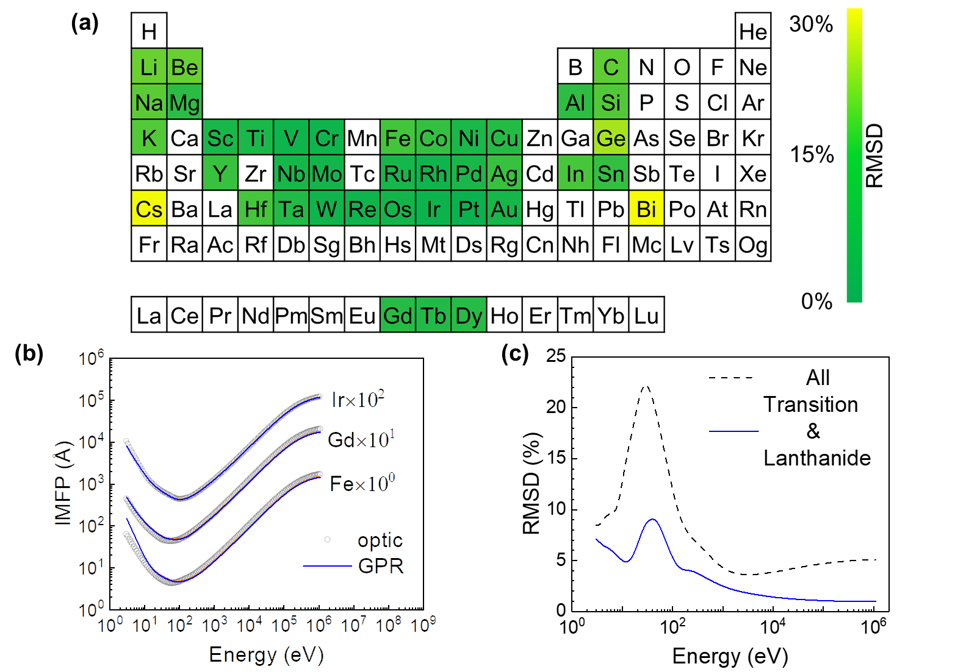
Fig. 2 a) Direct representation of RMSDs determined for the 41 investigated materials in the periodic table. The gradual color change from green to yellow corresponds to the RMSD value. A detailed RMSD value distribution is provided in Table IV; b) Some typical LOOCV results (Ir, Gd and Fe), the electron energies are expressed with respect to the Fermi level. The variances are also shown in the figure which is very small; c) RMSD as a function of energy for different kinds of materials. The black dashed line is the average RMSD for all of the materials. The blue solid line is for transition metals and lanthanide metals.

Table IV. RMSDs of LOOCV results.
Element | Li | Be | C(graphite) | C(diamond) | C(glassy) | Na | Mg
RMSD | 12.37% | 12.29% | 8.10% | 17.02% | 7.98% | 10.59% | 5.12%
Element | Al | Si | K | Sc | Ti | V | Cr
RMSD | 5.29% | 9.59% | 9.74% | 2.93% | 3.11% | 1.74% | 1.67%
Element | Fe | Co | Ni | Cu | Ge | Y | Nb
RMSD | 7.88% | 6.10% | 3.17% | 4.31% | 19.68% | 6.62% | 2.66%
Element | Mo | Ru | Rh | Pd | Ag | In | Sn
RMSD | 2.28% | 2.52% | 1.70% | 2.96% | 6.69% | 8.49% | 6.00%
Element | Cs | Gd | Tb | Dy | Hf | Ta | W
RMSD | 28.59% | 4.49% | 4.10% | 4.46% | 8.09% | 3.97% | 1.87%
Element | Re | Os | Ir | Pt | Au | Bi
RMSD | 1.71% | 2.27% | 1.36% | 1.10% | 2.57% | 28.89%

Figure 2a) reveals that the total RMSDs for three elements exceeded 20%; namely, Ge (20%), Cs (29%), and Bi (29%). These large prediction biases probably originated from the lack of training data, especially data for elements with similar physical properties. For example, Cs and Bi are quite isolated from the other elements in the training set on the periodic table, as shown in Fig. 2a). In addition, Ge has no neighboring elements in the periodic table that are in the training dataset. Another possible reason for the large prediction biases is that the current descriptors in the ML model may not be sufficient to describe Ge, Cs, and Bi well. Further investigations should be conducted to collect more training data and search for more universal descriptors for the IMFP data.
In Fig. 2c), the energy dependence of total RMSD for all materials showed a similar trend to that of the transition metals and lanthanide metals except that the absolute values were larger, especially in the very low energy (<50 eV) range. The highest RMSD was 22% at an energy of ~30 eV. While this prediction error is non-negligible, besides the inaccuracy of FPA in low energy region (<50 eV), namely our training set stated earlier, three points should be emphasized: (1) The large deviation in the very low energy (<50 eV) range mainly arose from the small number of elements in the dataset. For example, the RMSDs for the alkali metals and alkaline earth metals are much larger than those of the transition metals and lanthanide metals. This result occurs mainly because the difference of the physical properties between alkali metals and alkaline-earth metals is relatively large, whereas other materials, e.g. the transition metals and lanthanide metals are fairly similar to each other; (2) There are barely no empirical formula has prediction power for low energy IMFPs. On one hand, the TPP-2M formula was not intended for use of low energy region (<50eV); on the other hand, despite the empirical formula including the very low-energy (<50 eV) range has been achieved in Ref. [42], the limitation is explained earlier. In reality, when the energy is as low as 50 eV, there are few channels for electrons to lose energy, meanwhile the probabilities for inelastic scattering generally decrease for electron energies less than several times the excitation energy, simultaneously causes IMFP to increase in the very low energy (<50 eV) region. So, the calculation of FPA in the very low-energy (<50 eV) is not as accurate as intermediate energies (more than 50eV or less than 200keV), because of the neglect of many effects. The imprecise values of IMFPs in the very low-energy (<50 eV) as training set may mislead the prediction of ML, thus results a large peak in low energy region. Despite the training set, namely FPA-calculated IMFPs from Ref. [24] have less validity at extreme energies (less than 50eV or more than 200keV) than intermediate energy region and may cause lower reliability in our GPR prediction, but it is not a disadvantage of GPR. (3) Actually, from the IMFP calculation methods (e.g. FPA), we can see that the description of IMFP in low and high energy region rely on different material dependent parameters (features), respectively. However, in order to meet the need for all the energy regions in this work, the features are selected together. This may lead to a poor prediction for low energy region. In other sight, as is mentioned before, the IMFPs calculation using FPA is directly associated with ELF. And the shape of ELF is quite different in lower energies (< 100 eV) for each material. We noted that the used features, even for E_{p} and E_{g}, cannot completely show the characteristic of ELF in this energies. So in the sight of energy dependent degree, the GPR prediction ability in this energy region, especially from material dependent parameters, is inevitably poorer. Based on specified database, the current ML model covers both the low and high energy regions, which means that it is a reliable approach and can be applied to the prediction of IMFP.
Table V. Properties of transition metals and lanthanide metals used to predict IMFPs. Note that these are materials whose IMFPs cannot be calculated by physical theory (e.g., FPA) because of a lack of ELF or optical constants.
Element | Z | M | ρ (g/cm³) | N_{v} |  | E_{p} (eV) |  | E_{g} (eV) |  | E_{F} (eV) |  | R (pm)
Mn | 25 | 54.94 | 7.47 |  | 7 |  | 28.10 |  | 0 |  | 10.9 | 140
Zn | 30 | 65.38 | 7.14 |  | 12 |  | 32.97 |  | 0 |  | 9.47 | 135
Zr | 40 | 91.22 | 6.51 |  | 4 |  | 15.39 |  | 0 |  | 5.8 | 155
Tc | 43 | 98.00 | 11.50 |  | 7 |  | 26.10 |  | 0 |  | 7.1 | 135
Cd | 48 | 112.41 | 8.65 |  | 12 |  | 27.68 |  | 0 |  | 7.47 | 155
La | 57 | 138.91 | 6.15 |  | 9 |  | 18.17 |  | 0 |  | 3.7 | 195
Ce | 58 | 140.12 | 6.69 |  | 9 |  | 18.88 |  | 0 |  | 2.9 | 185
Pr | 59 | 140.91 | 6.64 |  | 9 |  | 18.76 |  | 0 |  | 3.8 | 185
Nd | 60 | 144.24 | 7.01 |  | 9 |  | 19.05 |  | 0 |  | 4 | 185
Pm | 61 | 145.00 | 7.26 |  | 9 |  | 19.34 |  | 0 |  | 4.2 | 185
Sm | 62 | 150.36 | 7.35 |  | 9 |  | 19.11 |  | 0 |  | 4.5 | 185
Eu | 63 | 151.96 | 5.24 |  | 9 |  | 16.05 |  | 0 |  | 4.2 | 185
Ho | 67 | 164.93 | 8.80 |  | 9 |  | 19.95 |  | 0 |  | 4.9 | 175
Er | 68 | 167.26 | 9.07 |  | 9 |  | 20.12 |  | 0 |  | 3.9 | 175
Tm | 69 | 168.93 | 9.32 |  | 9 |  | 20.30 |  | 0 |  | 4.1 | 175
Yb | 70 | 173.05 | 6.57 |  | 9 |  | 16.83 |  | 0 |  | 2.7 | 175
Lu | 71 | 174.97 | 9.84 |  | 9 |  | 20.49 |  | 0 |  | 6 | 175
Hg | 80 | 200.59 | 13.53 |  | 12 |  | 25.91 |  | 0 |  | 7.13 | 150

Figure 3 presents the comparison of the IMFPs determined by our ML method, the TPP-2M formula. Because of the robustness of our ML method, the trend predicted by the ML approach is consistent for the six materials, and the high energy region agrees well with the results from the TPP-2M formula. The most unagreed result in high energy region between our ML approach and the TPP-2M formula are material Zn and Hg. We notice that Zn and Hg are both have just one neighbor material on the degree of period table in training data (see Fig. 2a)), but other materials in Fig. 3 have both neighbors. Besides, Hg is the only liquid metal existed in simple materials and this fact may bring out some unique trends on IMFP curve. These trends may not seized by FPA-calculation as our training data, thus ML should has a larger deviated result. Considering that our training set includes the FPA-calculated IMFP data, and the TPP-2M formula is also derived from FPA-calculated IMFP data, the agreement between our ML data and TPP-2M formula is very reasonable. These results demonstrate that the ML method is very reliable, because it is only dependent on the reliability of the input data; it does not require any artificial or subjective factors that are often included in empirical formulas. More details of the ML prediction data used to determine the IMFPs of transition metals, including lanthanide metals (uncolored elements in Fig. 2a) are described in Appendix I (Table A1, Fig. A1).

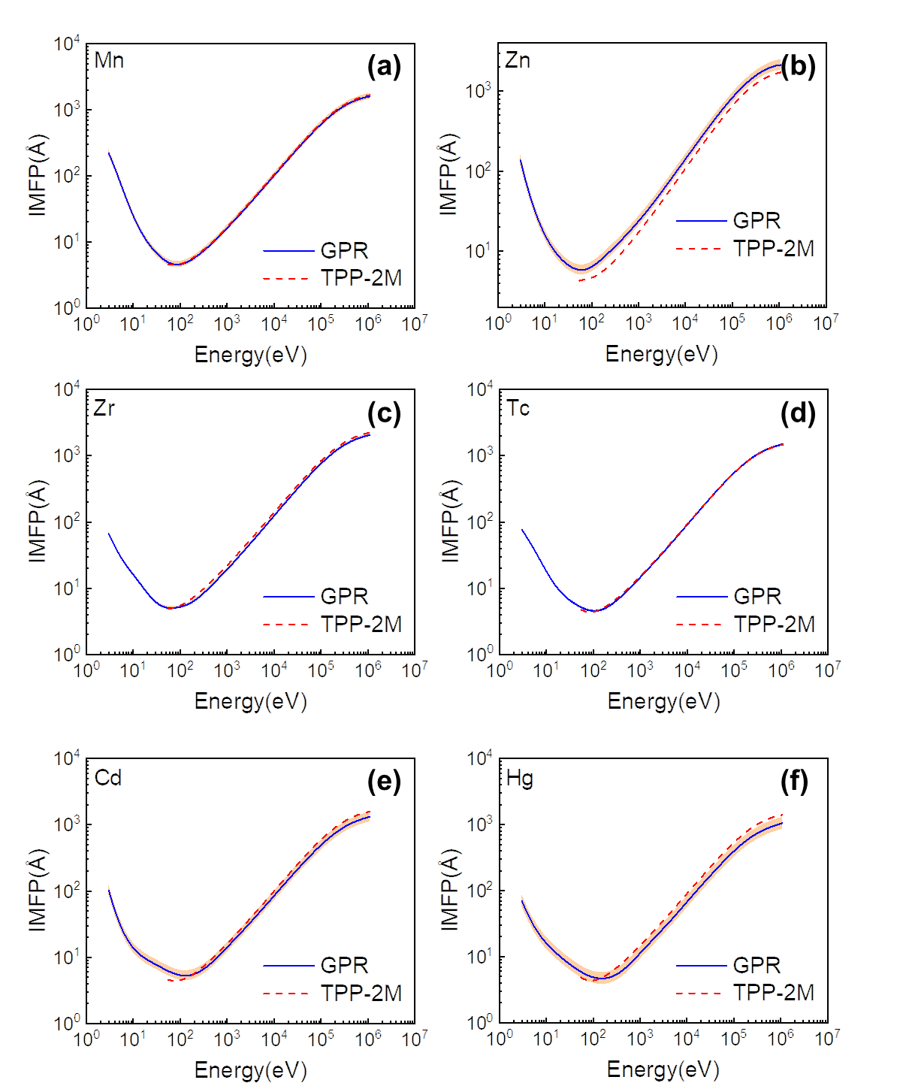
Fig. 3 Representative predictions for the transition metals Mn, Zn, Zr, Tc, Cd and Hg. Blue solid curves are IMFPs predicted by GPR, red dashed curves are IMFPs predicted by the TPP-2M formula. All the electron energies are expressed with respect to the Fermi level. The variances are also shown in the figure.

However, the only comparison with empirical formula is not pursuable. Here another series of FPA calculations for materials not included in Ref. [24], i.e. the training set of our ML approach is carried out for further comparison. The most sensitive factor in the FPA calculation is energy loss function (ELF). In fact, the reason why Shinotsuka et.al. did not include several materials in the FPA calculation [24] is that they could not find suitable ELFs at that time, for Mn and Zr etc. The suitable means their quality, namely two sum rules have large errors.
Two sum rules, i.e. the oscillator strength sum rule (f-sum rule) and the perfect screening sum rule (ps-sum rule) [53], were applied to check the accuracy of the ELFs of Mn and Zr used in this work. The f-sum rule is given by,
, (10)
where , is the number density of atoms, is the Avogadro’s number, is the mass density and is the atomic weight. The ps-sum rule can be obtained from the Kramers-Kronig relation as Ref. [53]:
, (11)
for conductors. The theoretical values of and are atomic number and unity, respectively, in the limit of . In this work, was 1 MeV.
After a lot of literature research, we validated amount of ELFs of many simple materials, and finally found two suitable ELFs, for two materials-Mn and Zr. The ELF of Mn used in the calculation of IMFP were taken from Adachi [54] in the photon energy range of 0.07 - 6.6 eV, from Wehenkel [55] in the range of 7.0 - 110 eV and from Henke [56] in the range of 110 eV-30 keV (see Fig. 1a)). The ELF of Zr were taken from Prieto [57] in the photon energy range of 0 - 80 eV and from Henke [56] in the range of 80 eV - 30 keV (see Fig. 1b)).The ELFs for energy losses between 30 keV and 1 MeV were calculated from atomic scattering factors [58]. The discontinuity of ELFs shown in Fig 4a) and Fig. 4b) is due to the fact that the ELFs are composed of multiple sets of experimental data, and the results of different experiments are different, including the connective energy points. Fig. 4c)- Fig. 4f) shows the f- and ps-sum rule checks of ELFs of Mn and Zr used in this work. Table VI lists the results of f- and ps-sum rules of ELFs of Mn and Zr. In the validation of sum rules for both materials, ps-sum rules show very small relative errors; f-sum rules show relatively larger error especially for Mn, but still acceptable comparing to other ELFs we found.

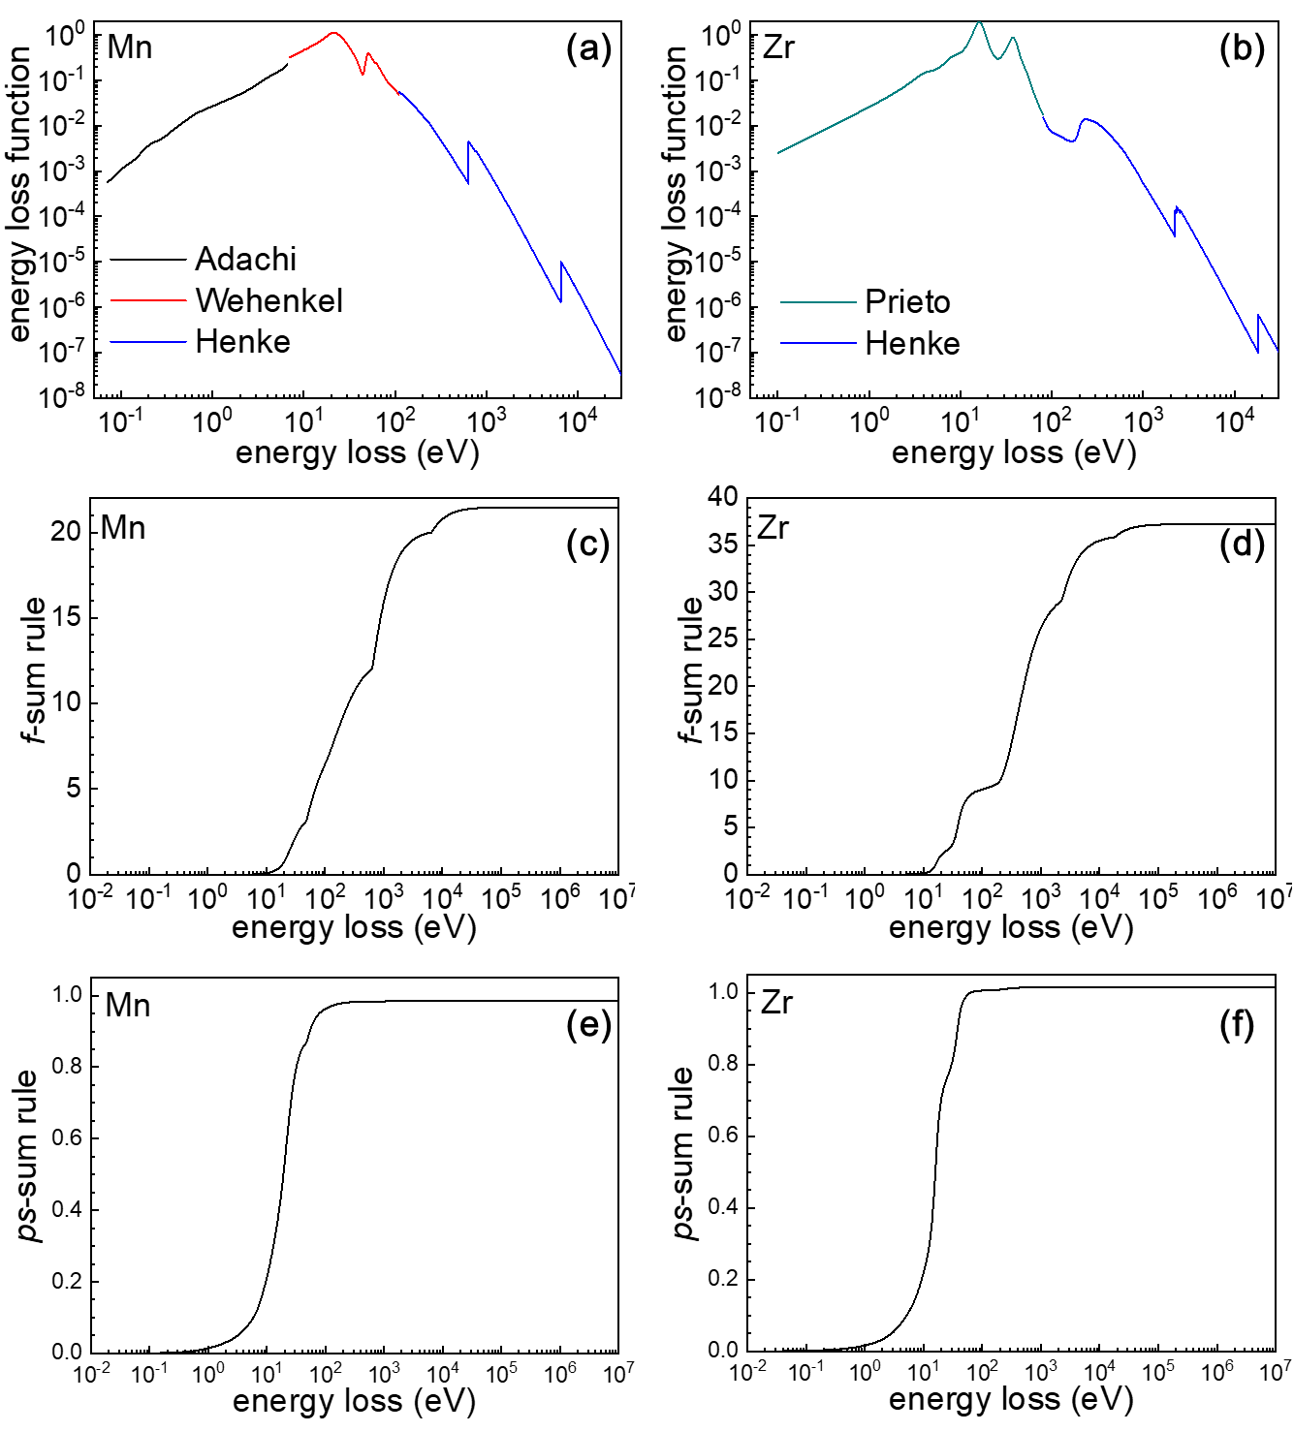
Fig. 4 ELFs and two sum rules for Mn and Zr.

Table VI. List of f-sum and ps-sum rule checks of ELFs of Mn and Zr.
 | f-sum rule | relative error | ps-sum rule | relative error
Mn | 21.47 | -14.1% | 0.984 | -1.6%
Zr | 37.24 | -6.9% | 1.016 | 1.6%
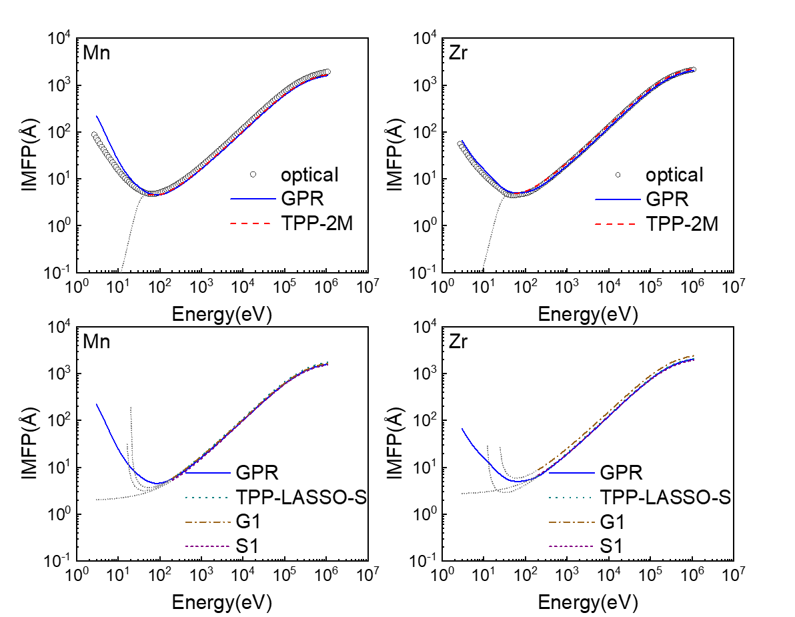
Fig. 5 Representative predictions for Mn and Zr. Blue solid curves are IMFPs predicted by GPR, red dashed curves are IMFPs predicted by the TPP-2M formula, the green dotted curves are IMFPs predicted by TPP-LASSO-S formula, the brown dash-dotted curves are IMFPs predicted by G1 formula, the purple short dashed curves are IMFPs predicted by S1 formula and black hollowed dots are IMFPs obtained from FPA calculation. Despite the applicable energies (above 50 eV for the TPP-2M formula, above 200eV for other formulae), the predicted IMFPs for these energies for each formulae are still shown in gray dots for comparison. For clarity, the comparison of each material is shown in two plots, respectively. All the electron energies are expressed with respect to the Fermi level.

Through the validated ELFs of Mn and Zr, IMFPs are calculated through FPA. Figure 5 shows the comparison of FPA-calculated, GPR-predicted IMFPs on Mn and Zr. On low energy region (< 100eV), the GPR-predicted IMFPs for Mn are larger than FPA result, but still illustrate the trend; on high energy region (>100eV), the GPR-predicted IMFPs are very similar to FPA results, but slightly lower. Meanwhile, for Zr, the relative position of curve for GPR and FPA are almost similar with the situation of Mn on whole energy region, but Zr has a better GPR result than Mn. The larger deviation of Mn is highly probable due to the underestimated ELF used in the FPA calculation. As shown in Fig. 4d) and Table VI, the f-sum rule of ELF for Mn has a relative error of -14.1%, representing the ELF of Mn used herein should has apparent error with the true value, especially for the high energy part. This result shows that in the future we are willing to use the GPR-predicted IMFP as a reference for splicing different experimental ELFs between different energy segments.
Moreover, in order to compare the predictive power of empirical formulae and GPR furthermore, we also plot the IMFPs predicted by various empirical formulae including the TPP-2M formula in Fig. 5 for whole energy region. The TPP-LASSO-S formula is the brand-new formula also developed by our group in Ref. [42], while S1 and G1 formulae are developed by Seah and Gries, details can be found in Ref. [59]. Although the applicable energies for the TPP-2M formula are above 50 eV and for TPP-LASSO-S, G1 and S1 formulae are above 200eV, the IMFPs predicted by each formula are shown in whole energy region. The shorted values in lower energy for each formula is because they give out negative IMFPs which cannot be shown in the figure. Firstly, it can be seen that the formulae and GPR show consistency with FPA-calculated data in high energies (>50eV). To quantify the error, the relative deviation between GPR predicted and FPA calculated IMFPs, as well as the most representative one among all formulae - the TPP-2M formula predicted and FPA calculated IMFPs are calculated in high energy region (> 50eV). For Mn, the RMSD (see Eq. (9)) of GPR and that of TPP-2M formula are 3.77% and 2.91%, respectively, while that of Zr are 2.28% and 3.89%. Meanwhile, for the situation of energy above 200eV, the RMSD for GPR, TPP-LASSO-S, G1 and S1 are 5.68%, 11.91%, 18.72% and 26.18% for Mn, while that of Zr are 5.91%, 12.43%, 19.58% and 27.46%, respectively. These relative deviations clearly indicate that at least in the situation of Mn and Zr, GPR has same predictive power compared to TPP-2M for electron energies above 50 eV , and generally better than the TPP-LASSO-S, G1 and S1 formulae for electron energies above 200 eV where researchers frequently concerned about. Besides, in lower energies (<50eV), even the trends of empirical formulae are not having certain reference value, while our GPR-predicted IMFPs is the most closed curve to FPA-calculated values. In fact, although there is no further experimental evidence for IMFPs of Zn, Tc and Cd, we believe that only for the cases discussed in this work, namely from the known IMFP database to predict the IMFPs unknown for sporadic transition metals in the database, GPR can give out reliable results in the degree of statistics.
Actually, GPR is different from traditional empirical formulae for the different focus points. GPR defaulted all the material features follow the Gaussian distribution, which means that the prediction of GPR focus on local information between similar materials in the prediction; but empirical formulae including TPP-2M formula must contain the information of all the materials including 14 organic compounds [23], 41 element materials [24] and 42 inorganic compounds [25], thus the IMFP descriptions for general materials must make sacrifice for materials with special properties, in order to contain all the material IMFPs. This characteristic can also be seen from Fig. 2a): transition metals and lanthanides show a better prediction (lower RMSD) while the RMSD for Bi and Cs is very large. Not only associated with atomic numbers, for the elementary materials far away in the periodic table, various physical and chemical properties may have large differences. Therefore, for GPR, the prediction of these materials with large differences in features will lack effective information, leading to poor learning effects of these materials, namely large RMSDs. So comparing to GPR, the TPP-2M empirical formula obtained by mass data analysis is more suitable for prediction of the material IMFPs with less correlation with the known-IMFP materials. Naturally, the “correlation” here means the feature values difference between materials (i.e. the correlation between physical and chemical properties). And the machine learning method e.g. GPR in this work has a stronger predictive ability when the known-IMFP materials is more relevant to the material whose IMFPs need to be predicted.
With our confidence in the current ML model established, especially for transition metals and lanthanide metals, we then made predictions of unknown IMFPs using the parameters listed in Table III. Figure 4 shows the predicted IMFP curves for Er, Tm, Pr, Nd, Lu, Yb and Ho as representative examples. For comparison, we also include the IMFPs predicted by the TPP-2M formula, which only works in the high energy region. Because TPP-2M is an empirical formula, it is appropriate to prove the accuracy of the prediction data with experiments in addition to the TPP-2M formula.
Figure 6 compares the ML results and those obtained from other calculations using the experimental data from Ref. [60], software ELSEPA developed in Ref. [61], and calculation method inspired by Refs. [62-65]. The effective attenuation length (EAL) $λ_{EAL}$ [64] is another important physical quantity in surface analysis [65]. From EAL data, an experimental IMFP value can be evaluated. EAL can be calculated as follows [62]:
(12)
for all the predicted materials. In Eq. (12), x is the surface layer thickness and$\frac{I^{S} }{I^{B}}$ is determined from the experimental data in Ref. [60]. EAL was then converted to IMFP to compare results. Using the software ELSEPA [61], the transport cross section σ_{tr} was obtained. A linear interpolation was used to fit the energies. According to Ref. [63]:
(13)
where M’ is the atomic density, $N_{0}$ is the Avogadro number, $A_{m}$ is atomic weight, and$ρ$ is density. Equation 10 allows σ_{tr} to be converted to transport mean free path (TMFP) $λ_{tr}$. As described in Ref. [65]:
(14)
Using the known TMFP, IMFP can be determined according to:
(15)
Therefore, Eq. (15) allows IMFP to be estimated from experimental data, and the resulting values can be compared with our ML predictions. It shall be noted that Eq. (15) is an empirical formula and this method allows us to do only a rough comparison because it has an unknown amount of error. In particular, the method in Ref. [62] is very approximate, especially for the value of x in Eq. (12). Actually, the x changes with the materials because of the related lattice relaxation and surface core level shift in materials. This means that the trend of the curve in Fig. 4 is more important than the absolute values.
Figure 6 presents the comparison of the IMFPs determined by our ML method, TPP-2M formula, and using Eq. (15). Because of the robustness of our ML method, the trend predicted by the ML approach is consistent for the seven materials, and the high energy region agrees well with the results of the TPP-2M formula. Considering that our training set includes the calculated data for optical constants, instead of experimental data, the agreement between our ML data and experimental data is very valuable. For most of the transition metals and lanthanide metals, the GPR result is close to the experimental data, even if the comparison is only for the lower energy region because of the lack of experimental data (obviously the results for the higher energy region will be even better). The largest inaccuracy is observed for the lanthanide metals. One reason for this is that there are only three lanthanide metals available for our training dataset. A complete series of data should improve the performance for this group of elements. These results demonstrate that the ML method is very reliable, which is because it is only dependent on the reliability of the input data; it does not require any artificial or subjective factors that are often included in empirical formulas. More details of the ML prediction data used to determine the IMFPs of transition metals and lanthanide metals (uncolored elements in Fig. 2a) are described in the Appendix.
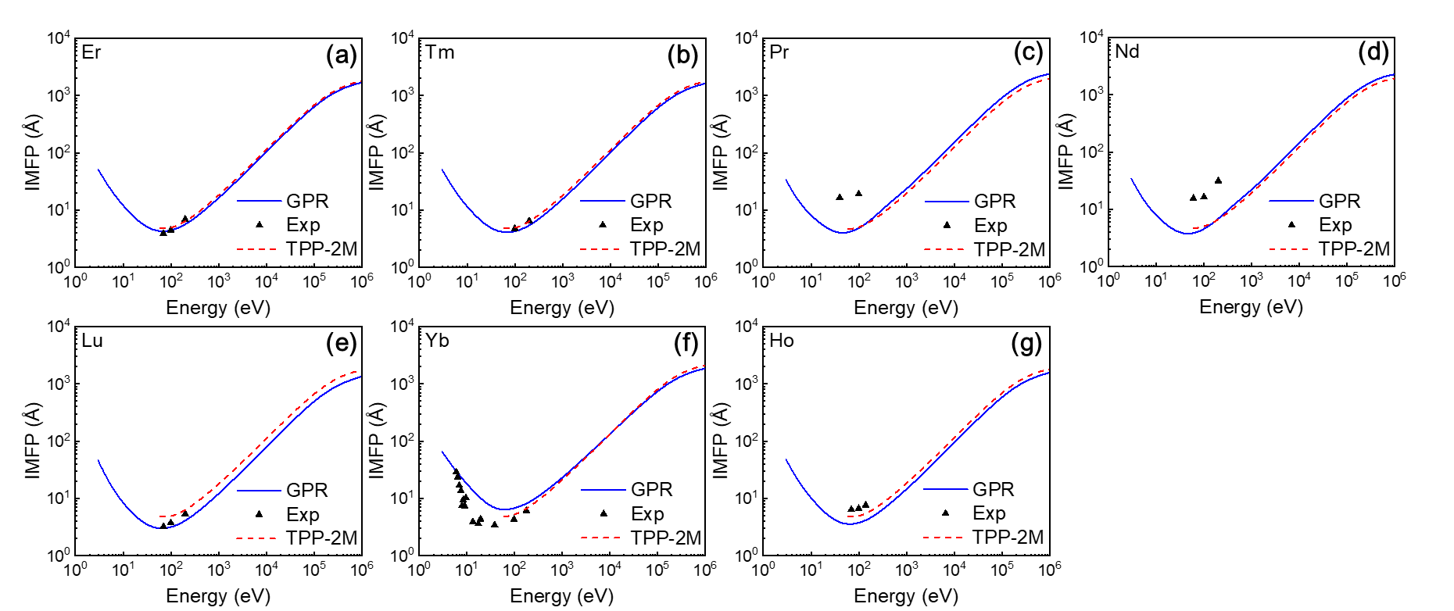
Fig. 6 Representative predictions for the transition metals and lanthanide metals Er, Tm, Pr, Nd, Lu, Yb, and Ho. Blue solid curves are IMFPs predicted by GPR, red dashed curves are IMFPs predicted by the TPP-2M formula, and black dots are IMFPs calculated from experimental data for comparison.

Finally, the error caused by ML and the training data must be considered. Shinotsuka et al. [24] calculated IMFP data using FPA with optical constants. Because of the lack of experimental data, the optical constants are not complete, which causes inaccuracy in the training data, especially in the very low energy (<50 eV) region, which is sensitive to these constants. And together with the reason of the FPA calculation model, it was pointed out by Shinotsuka et al. that the FPA-calculated IMFP data is relatively not reliable in the very low energy (<50 eV) region and very high energy (>200 keV) region. In addition, according to Ref. [66], N_{v} cannot be reliably evaluated in many cases, at least for the transition metals and lanthanide metals predicted in this work.
- Discussion
So far, the results shown above are limited to the most preliminary predictions and tests in the elemental material IMFPs. Therefore, not limited to elemental material IMFPs, in order to test the extension ability from elemental materials to compounds, our initial attempt is to use the virtual crystal approximation (VCA) [67] on the expand from elemental materials to compounds. VCA is a well-received simple approximation used on the first principles calculation, in which the compounds are treated as primitive-periodicity-styled crystals. However, the atoms in the composition of the compounds are assumed interpolate contributed to the compounds, namely “virtual” atoms. Similarly, a very natural idea is to apply the VCA directly on elemental IMFPs to predict compounds.
Supposing that for a compound A_{x}B_{y}, the IMFP can be calculated through the accumulation of cross sections of A and B like follow, using VCA:
(16)
where n’ is the number of following atoms in the compound in unit volume and σ is cross section. Then the IMFP of A_{x}B_{y} can be derived according to the following equation:
(17)
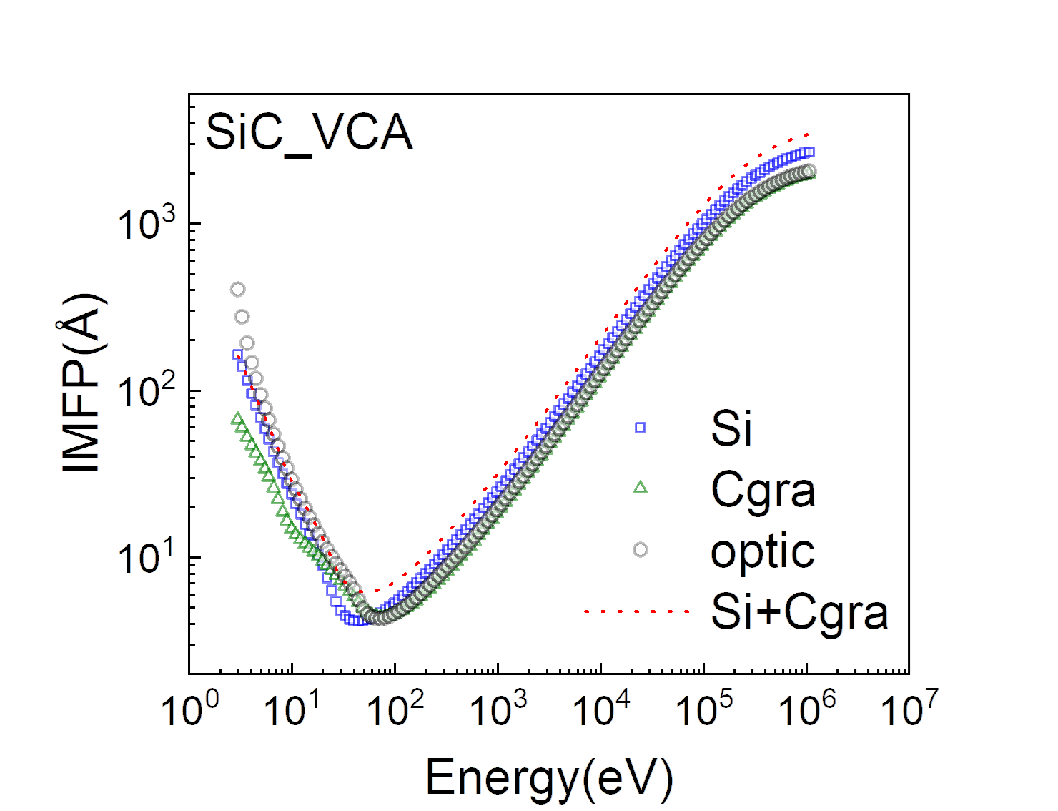
Fig. 7 Predictions for the SiC based on elemental materials using the virtual crystal approximation. Blue square dots are IMFPs of Si and green triangle dots are IMFPs of C (graphite) calculated from experimental data in Ref. [24], they are used for SiC IMFP calculation in this figure. Red dotted curve is IMFPs predicted by Si and C (graphite). Black dots are IMFPs calculated from experimental data in Ref. [68] for comparison.

But this is very limited, because the IMFPs are not always available for A or B, e.g. for the situation of oxides and halides. Anyhow, we try to predict the IMFPs of SiC using the IMFPs of silicon and graphite. The predictive result is shown in Fig. 7. The calculated IMFPs of SiC [68], Si and C (graphite) [24] based on experimental data are shown in dots for comparison. We noted that the curve of predicted values is not lying between the curves of Si and C (graphite) as usual, due to the fact that the SiC IMFPs prediction is a weighted harmonized average value of its components, according to Eq. (17). The predicted IMFPs of SiC are not agree with the FPA-calculated IMFPs with the RMSD of 14.16%, even the raw data of elemental graphite and silicon is closer than the prediction here, as shown in Fig. 7. Noted that the energy gap of SiC (2.31eV) is even larger than the energy gap of Si (1.1eV) and graphite (0), so the poor prediction here is probably due to the large energy gap of SiC. In fact, Table IV also indicates that the semiconductors always have very large RMSDs, for example C (diamond) and Ge. Semiconductors, together with insulators, have non-zero energy gaps, different from the most other materials in the training set, which led to slower learning rates and poor results, so the prediction results of semiconductors and insulators were not as accurate as those of metals. In a word, it seems not desirable using the VCA on IMFPs to predict compound IMFPs.
Alternatively, we now try to predict compound IMFPs with ML using the model trained with elemental material IMFPs. Obviously, some features of compounds should be estimated with VCA and used as the input features in ML, as shown in Table VII. With the comparison with the true values of compounds IMFP database, which is taken from Ref. [68] calculated by Shinotsuka et.al. for accuracy validation, the prediction RMSD results are shown in Table VIII.
Table VII. Properties of compounds used to predict IMFPs. Noted that the values of Z, M, N_{v} and R are estimated using the virtual crystal approximation.
Element | Z | M | ρ (g/cm³) | N_{v} | E_{p} (eV) | E_{g} (eV) | E_{F} (eV) | R (pm)
AgBr | 41 | 93.89 | 6.48 | 9 | 22.71 | 2.68 | 6.95 | 137.5
AgCl | 32 | 71.66 | 5.59 | 9 | 24.14 | 3.25 | 7.51 | 130
AgI | 50 | 117.39 | 5.72 | 9 | 19.08 | 2.92 | 6.15 | 150
Al₂O₃ | 10 | 20.39 | 3.97 | 4.8 | 27.86 | 8.63 | 16.63 | 86
AlAs | 23 | 50.95 | 3.73 | 4 | 15.59 | 2.16 | 7.43 | 120
AlN | 10 | 20.49 | 3.26 | 4 | 22.99 | 6 | 12.03 | 95
AlSb | 32 | 74.37 | 4.28 | 4 | 13.83 | 1.62 | 6.94 | 135
c-BN | 6 | 12.41 | 3.49 | 4 | 30.56 | 7.2 | 15.71 | 75
h-BN | 6 | 12.41 | 2.3 | 4 | 24.81 | 5 | 13.77 | 75
CdS | 32 | 72.24 | 4.8 | 9 | 22.28 | 2.46 | 6.88 | 127.5
CdSe | 41 | 95.69 | 5.66 | 9 | 21.03 | 1.7 | 6.23 | 135
CdTe | 50 | 120.01 | 5.85 | 9 | 19.09 | 1.51 | 6.13 | 147.5
GaAs | 32 | 72.32 | 5.32 | 4 | 15.63 | 1.47 | 8.54 | 122.5
GaN | 19 | 41.86 | 6.09 | 4 | 21.98 | 3.4 | 10.49 | 97.5
GaP | 23 | 50.35 | 4.13 | 4 | 16.51 | 2.26 | 8.93 | 115
GaSb | 41 | 95.74 | 5.61 | 4 | 13.95 | 0.73 | 7.75 | 137.5
GaSe | 32.5 | 74.34 | 5.07 | 4.5 | 15.96 | 1.98 | 9.71 | 122.5
InAs | 41 | 94.87 | 5.67 | 4 | 14.09 | 0.36 | 6.48 | 135
InP | 32 | 72.90 | 4.79 | 4 | 14.77 | 1.38 | 7.36 | 127.5
InSb | 50 | 118.29 | 5.78 | 4 | 12.74 | 0.18 | 6.36 | 150
KBr | 27 | 59.50 | 2.75 | 4 | 12.39 | 7.26 | 9.86 | 167.5
KCl | 18 | 37.27 | 1.98 | 4 | 13.28 | 7.4 | 10.1 | 160
MgF₂ | 10 | 20.77 | 3.177 | 5.33 | 26.03 | 10.95 | 16.45 | 83.33
MgO | 10 | 20.15 | 3.576 | 4 | 24.28 | 7.69 | 13.99 | 105
NaCl | 14 | 29.22 | 2.165 | 4 | 15.69 | 9 | 13.1 | 140
NbC_{0.712} | 26.44 | 59.26 | 7.746 | 4.58 | 22.31 | 0 | 7.4 | 113.81
NbC_{0.844} | 24.98 | 55.88 | 7.769 | 4.54 | 22.9 | 0 | 7.4 | 110.67
NbC_{0.93} | 24.13 | 53.93 | 7.781 | 4.52 | 23.27 | 0 | 7.4 | 108.86
PbS | 49 | 119.63 | 7.62 | 5 | 16.26 | 0.42 | 5.63 | 140
PbSe | 58 | 143.08 | 8.29 | 5 | 15.51 | 0.29 | 5.29 | 147.5
PbTe | 67 | 167.40 | 8.27 | 5 | 14.32 | 0.32 | 4.86 | 160
SiC | 10 | 20.05 | 3.22 | 4 | 23.1 | 2.31 | 9.26 | 90
SiO2 | 10 | 20.00 | 2.19 | 5.33 | 22.02 | 9.1 | 19.1 | 85
SnTe | 51 | 123.16 | 6.47 | 5 | 14.77 | 0.19 | 8.44 | 142.5
TiC_{0.7} | 15.41 | 33.11 | 4.627 | 4 | 21.54 | 0 | 5.7 | 111.18
TiC_{0.95} | 14.21 | 30.41 | 4.843 | 4 | 23 | 0 | 5.7 | 105.90
VC_{0.76} | 15.66 | 34.13 | 5.582 | 4.57 | 24.91 | 0 | 7.5 | 106.93
VC_{0.86} | 15.14 | 32.94 | 5.605 | 4.54 | 25.32 | 0 | 7.5 | 104.95
Y₃Al₅O₁₂ | 13.9 | 29.68 | 4.554 | 4.8 | 24.73 | 6.5 | 13 | 94.25
ZnS | 23 | 48.72 | 4.09 | 9 | 25.05 | 3.81 | 9.18 | 117.5
ZnSe | 32 | 72.17 | 5.26 | 9 | 23.34 | 2.68 | 8.1 | 125
ZnTe | 41 | 96.49 | 5.64 | 9 | 20.9 | 2.25 | 7.67 | 137.5

Table VIII. RMSDs of GPR predicted compound IMFP results using virtual crystal approximation.
Material | RMSD | Material | RMSD | Material | RMSD | Material | RMSD
AgBr | 6.93% | CdTe | 12.20% | MgF₂ | 24.35% | SnTe | 8.42%
AgCl | 4.87% | GaAs | 6.80% | MgO | 9.95% | TiC_{0.7} | 10.59%
AgI | 10.76% | GaN | 9.37% | NaCl | 24.72% | TiC_{0.95} | 12.86%
Al₂O₃ | 14.20% | GaP | 7.79% | NbC_{0.712} | 6.38% | VC_{0.76} | 7.15%
AlAs | 8.14% | GaSb | 2.05% | NbC_{0.844} | 7.25% | VC_{0.86} | 7.94%
AlN | 7.41% | GaSe | 5.69% | NbC_{0.93} | 7.69% | Y₃Al₅O₁₂ | 4.29%
AlSb | 6.00% | InAs | 3.31% | PbS | 11.82% | ZnS | 8.79%
c-BN | 9.99% | InP | 6.85% | PbSe | 15.14% | ZnSe | 7.88%
h-BN | 4.45% | InSb | 4.99% | PbTe | 16.21% | ZnTe | 11.22%
CdS | 7.32% | KBr | 21.35% | SiC | 9.83%
CdSe | 10.56% | KCl | 22.62% | SiO₂ | 18.38% | Average | 10.11%

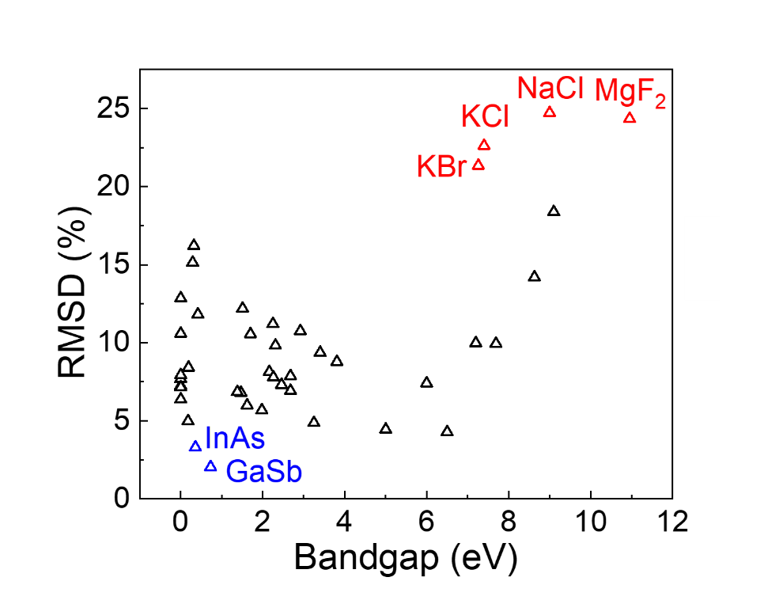
Fig. 8 The relationship between RMSDs of GPR predicted compound IMFP results using virtual crystal approximation and the bandgap of compounds.

As mentioned before, for a better discussion for the relationship between RMSDs and bandgap energies, Figure 8 shows a clearly positive correlation for them. There are some materials with extra-large errors at the right side of Fig. 8, e.g. KBr, KCl, MgF₂ and NaCl with red color. These materials are all halides with large bandgap energies, in which the atomics are combined with ionic bonds. In these compounds, the valence electrons are largely biased to halogen atoms in the compounds, so the physical and chemical properties of these materials are very different from the elemental materials included in our training set in its formation. Therefore, the predicted IMFPs of these compounds from the IMFPs of elemental materials have larger deviations. Meanwhile, there are also some materials with good predictions, such as GaSb and InAs with blue color at the left side of Fig. 8. These materials show strong metallic characteristics with relatively small bandgaps, in which the valence electrons show low bias between the atomics and can be predicted by the VCA of its formation elements. Moreover, the materials with small bandgaps are also better predicted in our model, which trained by elemental materials. And in the prediction of small bandgap compounds, these similarly well-predicted small bandgap elemental materials can have larger contribution due to their similar electron properties. Although for most of the compounds, the electron behaviors are very different with their component elements, leads to poor prediction, this ML model holds the potential to be used for predicting the IMFPs of alloys as a mixture of multiple elemental materials, whose electric properties often similar to that of its components. Thus the IMFPs of alloys will be easily predicted with only elemental materials.

- Conclusions
Based on the existing IMFP database, we developed an ML technique to determine IMFPs from simple material properties. The obtained ML model achieved a robust description of IMFPs over a wide energy range, overcoming the limitation of the TPP-2M formula in the very low energy (<50 eV) range. In the LOOCV testing, the ML model showed reliable performance in IMFP prediction. Based on the developed ML model, we predicted IMFPs for several transition metals and lanthanide metals that were not included in the existing database because of missing optical constants. Improved predictions of IMFPs were achieved by our ML method, proving its superiority to traditional empirical formula fitting methods. This study is only an initial example of using ML to complete the missing part of the IMFP database, and we will extend this method to the IMFP estimation of compounds and other materials in future work. And since the GPR method is more adept at using local information for prediction, we are going to use the GPR method to predict the IMFP of metal alloys. Importantly, this ML method is not limited to IMFP prediction; it can easily be extended to any other field to determine a small number of missing data values in a specified database.

DATA AVAILABILITY
All data generated and/or analyzed during this study are included in this article

AUTHOR INFORMATION
Competing interests
The authors declare no competing financial or non-financial interests.
Contributions
X.L. wrote the program, performed the analyzation of results, and wrote the initial manuscript. L.H.Y. had done some of the IMFP calculation, which is used in results validation. Z.F.H. and Y.S. gave crucial suggestions to the ML program and the initial manuscript. K.N. gave crucial algorithm used on controlling overfitting and optimizing hyper-parameter. B.D. and Z.J.D. supervised the research. H.Y. and S.T. gave physics picture and suggestions. All authors discussed and commented on the manuscript. All the authors developed the concepts together and participated the discussions of the work.

ACKNOWLEDGMENTS
This work was supported by Grant for Basic Science Research Projects from The Sumitomo Foundation, the National Key Research and Development Project (2019YFF0216404) and Education Ministry through “111 Project 2.0” (BP0719016). The calculations in this study were performed on Numerical Materials Simulator at NIMS. We also thank the Supercomputing Center of USTC for support with parallel computing.

REFERENCES
[1] ISO18115 Surface Chemical Analysis-Vocabulary-Part 1: General terms and terms used in spectroscopy (International Organisation for Standardisation, Geneva, 2010).
[2] J.D. Bourke and C.T. Chantler, Momentum-dependent lifetime broadening of electron energy loss spectra: A self-consistent coupled-plasmon model, J. Phys. Chem. Lett. 6, 314 (2015).
[3] C.T. Chantler and J.D. Bourke, X-ray spectroscopic measurement of photoelectron inelastic mean free paths in molybdenum, J. Phys. Chem. Lett. 1, 2422 (2010).
[4] C.J. Powell and A. Jablonski, Surface sensitivity of X-ray photoelectron spectroscopy, Nucl. Instrum. Meth. Phys. Res. A 601, 54 (2009).
[5] W.S.M. Werner, W. Smekal, H. Stori, H. Winter, G. Stefani, A. Ruocco, F. Offi, R. Gotter, A. Morgante and F. Tommasini, Emission-depth-selective Auger photoelectron coincidence spectroscopy, Phys. Rev. Lett. 94, 038302 (2005).
[6] Z.J. Ding, K. Salma, H.M. Li, Z.M. Zhang, K. Tokesi, D. Varga, J. Toth, K. Goto and R. Shimizu, Monte Carlo simulation study of electron interaction with solids and surfaces, Surf. Interface Anal. 38, 657 (2006).
[7] N. Cao, B. Da, Y. Ming, S.F. Mao, K. Goto and Z.J. Ding, Monte Carlo simulation of full energy spectrum of electrons emitted from silicon in Auger electron spectroscopy, Surf. Interface Anal. 47, 113 (2015).
[8] B. Da, Z.Y. Li, H.C. Chang, S.F. Mao and Z.J. Ding, A Monte Carlo study of reflection electron energy loss spectroscopy spectrum of a carbon contaminated surface, J. Appl. Phys. 116, 124307 (2014).
[9] B. Da, S.F. Mao, G.H. Zhang, X.P. Wang and Z.J. Ding, Monte Carlo modeling of surface excitation in reflection electron energy loss spectroscopy spectrum for rough surfaces, J. Appl. Phys. 112, 034310 (2012).
[10] Z.J. Ding and R. Shimizu, A Monte Carlo modeling of electron interaction with solids including cascade secondary electron production, Scanning 18, 92 (1996).
[11] Y.B. Zou, S.F. Mao, B. Da and Z.J. Ding, Surface sensitivity of secondary electrons emitted from amorphous solids: calculation of mean escape depth by a Monte Carlo method. J. Appl. Phys. 120, 235102 (2016).
[12] Z.J. Ding, W.S. Tan and Y.G. Li, Improved calculation of the backscattering factor for quantitative analysis by Auger electron spectroscopy, J. Appl. Phys. 99 084903 (2006).
[13] R.G. Zeng, Z.J. Ding, Y.G. Li and S.F. Mao, A calculation of backscattering factor database for quantitative analysis by Auger electron spectroscopy, J. Appl. Phys. 104 114909 (2008).
[14] B. Da, K. Salma, H. Ji, S.F. Mao, G.H. Zhang, X.P. Wang and Z.J. Ding, Surface excitation parameter for rough surfaces, Appl. Surf. Sci. 356, 142 (2015).
[15] B. Da, Y. Sun, S.F. Mao and Z.J. Ding, Systematic calculation of the surface excitation parameters for 22 materials, Surf. Interface Anal. 45, 773 (2013).
[16] Z. Zheng, B. Da, S.F. Mao and Z.J. Ding, Calculation of surface excitation parameters by a Monte Carlo method, Chin. J. Chem. Phys. 30, 83 (2017).
[17] D.R. Penn, Electron mean-free-path calculations using a model dielectric function, Phys. Rev. B 35, 482 (1987).
[18] N.D. Mermin, Lindhard dielectric function in the relaxation-time approximation, Phys. Rev. B 1, 2362 (1970).
[19] B. Da, H. Shinotsuka, H. Yoshikawa, Z. J. Ding and S. Tanuma, Extended Mermin method for calculating the electron inelastic mean free path, Phys. Rev. Lett. 113, 063201 (2014).
[20] S. Tanuma, C.J. Powell and D.R. Penn, Calculations of electron inelastic mean free paths for 31 materials, Surf. Interf. Anal. 11, 577 (1988).
[21] S. Tanuma, C. J. Powell and D. R. Penn, Calculations of electron inelastic mean free paths. II. Data for 27 elements over the 50–2000 eV range, Surf. Interface Anal. 17, 911 (1991).
[22] S. Tanuma, C. J. Powell and D. R. Penn, D. R. Calculations of electron inelastic mean free paths. III. Data for 15 inorganic compounds over the 50-2000 eV range, Surf. Interface Anal. 17, 927 (1991).
[23] S. Tanuma, C. J. Powell and D. R. Penn, Calculations of electron inelastic mean free paths. V. Data for 14 organic compounds over the 50–2000 eV range, Surf. Interface Anal. 21, 165 (1994).
[24] H. Shinotsuka, S. Tanuma, C.J. Powell and D.R. Penn, Calculations of electron inelastic mean free paths. X. Data for 41 elemental solids over the 50 eV to 200 keV range with the relativistic full Penn algorithm, Surf. Interface Anal. 47, 871 (2015); ibid, Surf. Interface Anal. 47, 1132 (2015).
[25] H. Shinotsuka, B. Da, S. Tanuma, H. Yoshikawa, C.J. Powell and D.R. Penn, Calculations of electron inelastic mean free paths. XII. Data for 42 inorganic compounds over the 50 eV to 200 keV range with the full Penn algorithm, Surf. Interface Anal. 51, 427 (2019).
[26] I. Abril, R. Garcia‐Molina, C.D. Denton, F.J. Pérez‐Pérez and N.R. Arista, Dielectric description of wakes and stopping powers in solids, Phys. Rev. A 58, 357 (1998).
[27] Y. Sun, H. Xu, B. Da, S.F. Mao and Z.J. Ding, Calculations of energy-loss function for 26 materials, Chin. J. Chem. Phys. 29, 663 (2016).
[28] B. Da, S.F. Mao, Y. Sun and Z.J. Ding, A new analytical method in surface electron spectroscopy: reverse Monte Carlo method, e-J. Surf. Sci. Nanotech. 10, 441 (2012).
[29] B. Da, Y. Sun, S.F. Mao, Z.M. Zhang, H. Jin, H. Yoshikawa, S. Tanuma, and Z.J. Ding A reverse Monte Carlo method for deriving optical constants of solids from reflection electron energy-loss spectroscopy spectra, J. Appl. Phys. 113, 214303 (2013).
[30] H. Xu, B. Da, J. Tóth, K. Tőkési, and Z.J. Ding, Absolute determination of optical constants by reflection electron energy loss spectroscopy, Phys. Rev. B 95, 195417 (2017).
[31] F. Yubero and S. Tougaard, Model for quantitative analysis of reflection-electron-energy-loss spectra. Phys. Rev. B 46, 2486 (1992).
[32] W.S.M. Werner, Simple algorithm for quantitative analysis of reflection electron energy loss spectra (REELS), Surf. Sci. 604, 290 (2010).
[33] H. Xu, L.H. Yang, J. Tóth, K. Tőkési, B. Da and Z.J. Ding, Absolute determination of optical constants of three transition metals using reflection electron energy loss spectroscopy, J. Appl. Phys. 123, 043306 (2018).
[34] L.H. Yang, M. Menyhard, A. Sulyok, K. Tőkési and Z.J. Ding, Optical properties and excitation energies of Iridium derived from reflection electron energy loss spectroscopy spectra, Appl. Surf. Sci. 456, 999 (2018).
[35] L.H. Yang, J. Tóth, K. Tőkési, B. Da and Z.J. Ding, Calculation of electron inelastic mean free path of three transition metals from reflection electron energy loss spectroscopy spectrum measurement data, Eur. Phys. J. D 73, 21 (2019).
[36] W.S.M. Werner, Analysis of reflection electron energy loss spectra (REELS) for determination of the dielectric function of solids: Fe, Co, Ni, Surf. Sci. 601, 2125 (2007).
[37] H. Jin, H. Shinotsuka, H. Yoshikawa, H. Iwai, S. Tanuma and S. Tougaard, Measurement of optical constants of Si and SiO₂ from reflection electron energy loss spectra using factor analysis method, J. Appl. Phys. 107, 083709 (2010).
[38] M.P. Seah and W.A. Dench, Quantitative electron spectroscopy of surfaces: A standard data base for electron inelastic mean free paths in solids, Surf. Interf. Anal. 1, 2 (1979).
[39] A. Jablonski and C.J. Powell, Relationships between electron inelastic mean free paths, effective attenuation lengths, and mean escape depths, J. Electron. Spectros. Relat. Phenomena. 100, 137 (1999).
[40] C.J. Powell, The quest for universal curves to describe the surface sensitivity of electron spectroscopies, J. Electron Spectrosc. Relat. Phenom. 47, 197 (1988).
[41] H. Bethe, Zur theorie des durchgangs schneller korpuskularstrahlen durch materie, Ann. Phys. 5, 325 (1930).
[42] X. Liu, Z.F. Hou, D.B. Lu, B. Da, H. Yoshikawa, S. Tanuma, Y. Sun and Z.J. Ding, Unveiling the principle descriptor for predicting the electron inelastic mean free path based on a machine learning framework, Sci. Technol. Adv. Mater. 20, 1090 (2019).
[43] B. Ziaja, R. A. London and J. Hajdu, Ionization by impact electrons in solids: Electron mean free path fitted over a wide energy range, J. Appl. Phys. 99, 033514 (2006).
[44] G. Montavon, M. Rupp, V. Gobre, A. Vazquez-Mayagoitia, K. Hansen, A. Tkatchenko, K.-R. Müller and O.A. von Lilienfeld, Machine learning of molecular electronic properties in chemical compound space. New J. Phys. 15, 095003 (2013).
[45] T. Ueno, H. Hino, A. Hashimoto, Y. Takeichi, M. Sawada and K. Ono, Adaptive design of an X-ray magnetic circular dichroism spectroscopy experiment with Gaussian process modelling, npj Comput. Mater. 4, 4 (2018).
[46] Y. K. Wakabayashi, T. Otsuka, Y. Taniyasu, H. Yamamoto and H. Sawada, Improved adaptive sampling method utilizing Gaussian process regression for prediction of spectral peak structures, Appl. Phys. Express 11, 112401 (2018).
[47] F. Pedregosa, G. Varoquaux, A. Gramfort, V. Michel, B. Thirion, O. Grisel, M. Blondel, P. Prettenhofer, R. Weiss, V. Dubourg, J. Vanderplas, A. Passos, D. Cournapeau, M. Brucher, M. Perrot and É. Duchesnay, Scikit-learn: Machine learning in Python, J. Mach. Learn. Res. 12, 2825 (2011).
[48] H. Shinotsuka, B. Da, S. Tanuma, H. Yoshikawa, C.J. Powell and D.R. Penn, Calculations of electron inelastic mean free paths. XI. Data for liquid water for energies from 50 eV to 30 keV, Surf. Interface Anal. 49, 238 (2017).
[49] I.H. Witten, E. Frank, M. A. Hall and C.J. Pal, Data Mining: Practical Machine Learning Tools and Techniques 2nd edition (Morgan Kaufmann Publishers, USA, 2016).
[50] C.E. Rasmussen and C.K.I. Williams, Gaussian Processes for Machine Learning (MIT Press, UK, 2006).
[51] C. Cortes and V. Vapnik, Support-vector networks, Machine Learning, 20, 273 (1995).
[52] Z.H. Zhou, Machine Learning (Tsinghua University Press, China, 2016).
[53] S. Tanuma, C. J. Powell and D.R. Penn, Use of sum rules on the energy-loss function for the evaluation of experimental optical data, J. Electron Spectrosc. Relat. Phenom. 62, 95 (1993).
[54] S. Adachi, The handbook on optical constants of metals: in tables and figures (World Scientific, Singapore, 2012).
[55] C. Wehenkel and B. Gauthé, Electron energy loss spectra and optical constants for the first transition series from 2 to 120 eV, Phys. Stat. Sol. 64, 515 (1974).
[56] B.L. Henke, E.M. Gullikson and J.C. Davis, X-ray interactions: photoabsorption, scattering, transmission, and reflection at E= 50-30,000 eV, Z= 1-92, At. Data Nucl. Data Tables 54, 181 (1993).
[57] P. Prieto, F. Yubero, E. Elizalde and J.M. Sanz, Dielectric properties of Zr, ZrN, Zr₃N₄, and ZrO₂ determined by quantitative analysis of electron energy loss spectra, J. Vac. Sci. Technol. 14, 3181 (1996).
[58] D.E. Cullen, J.H. Hubbell and L. Kissel, EPDL97: The evaluated data library, 1997 version, Lawrence Livermore National Lab. CA (United States), 1997.
[59] S.Tanuma, C.J. Powell, and D.R. Penn, Calculations of electron inelastic mean free paths (IMFPs) VI. analysis of the gries inelastic scattering model and predictive IMFP equation, Surf. Interface. Anal. 25, 25 (1997).
[60] F. Gerken, A.S. Flodström, J. Barth, L.I. Johansson and C. Kunz, Surface core level shifts of the lanthanide metals Ce58-Lu71: a comprehensive experimental study, Phys. Scr. 32, 43 (1985).
[61] F. Salvat, A. Jablonski and C.J. Powell, ELSEPA—Dirac partial-wave calculation of elastic scattering of electrons and positrons by atoms, positive ions and molecules, Comput. Phys. Commun. 162, 157 (2005).
[62] F. Offi, S.Iacobucci and L. Petaccia, The attenuation length of low energy electrons in Yb, J. Phys.: Condens. Matter 22, 305002 (2010).
[63] A. Jablonski, Universal quantification of elastic scattering effects in AES and XPS, Surf. Sci. 364, 380 (1996).
[64] C.J. Powell and A. Jablonski, Surface sensitivity of X-ray photoelectron spectroscopy, Nucl. Instrum. Meth. A 54, 601 (2009).
[65] A. Jablonski and C. J. Powell, Effective attenuation lengths for photoelectrons emitted by high-energy laboratory X-ray sources, J. Elect. Spectros. Relat. Phenom. 199, 27 (2015).
[66] S. Tanuma, C.J. Powell and D.R. Penn, Calculations of electron inelastic mean free paths (IMFPS). IV. Evaluation of calculated IMFPs and of the predictive IMFP formula TPP‐2 for electron energies between 50 and 2000 eV, Surf. Interface. Anal. 20, 77 (1993).
[67] L. Bellaiche and D. Vanderbilt, Virtual crystal approximation revisited: Application to dielectric and piezoelectric properties of perovskites, Phys. Rev. B, 61, 7877 (2000).
[68] H. Shinotsuka, S. Tanuma, C. J. Powell and D. R. Penn, Calculations of electron inelastic mean free paths. XII. Data for 42 inorganic compounds over the 50 eV to 200 keV range with the full Penn algorithm. Surf. Interface Anal. 51, 427 (2019).

Appendix I: GPR prediction result of transition metals and lanthanide metals

Table A1 Prediction result of transition metals and lanthanide metals
 | Inelastic mean free path(Å)
Energy(eV) | Mn | Zn | Zr | Tc | Cd | La | Ce
3.0 | 220.35 | 138.68 | 65.95 | 76.00 | 101.88 | 24.30 | 34.86
3.3 | 187.99 | 110.89 | 57.29 | 68.60 | 80.82 | 20.83 | 30.61
3.7 | 153.86 | 85.59 | 48.52 | 60.50 | 62.00 | 17.38 | 26.25
4.1 | 127.60 | 68.56 | 42.02 | 53.90 | 49.58 | 14.86 | 22.96
4.5 | 107.21 | 56.61 | 37.10 | 48.40 | 41.01 | 12.97 | 20.43
5.0 | 87.73 | 46.11 | 32.45 | 42.70 | 33.62 | 11.21 | 18.02
5.5 | 73.08 | 38.72 | 28.96 | 38.02 | 28.52 | 9.91 | 16.18
6.0 | 61.86 | 33.30 | 26.26 | 34.11 | 24.84 | 8.93 | 14.74
6.7 | 50.19 | 27.85 | 23.36 | 29.66 | 21.21 | 7.89 | 13.19
7.4 | 41.73 | 23.97 | 21.14 | 26.11 | 18.67 | 7.13 | 12.02
8.2 | 34.67 | 20.75 | 19.15 | 22.89 | 16.61 | 6.48 | 10.98
9.0 | 29.49 | 18.37 | 17.55 | 20.33 | 15.10 | 5.99 | 10.17
10.0 | 24.75 | 16.16 | 15.92 | 17.83 | 13.73 | 5.52 | 9.36
11.0 | 21.29 | 14.51 | 14.59 | 15.88 | 12.72 | 5.15 | 8.72
12.2 | 18.25 | 13.02 | 13.26 | 14.09 | 11.82 | 4.81 | 8.11
13.5 | 15.85 | 11.81 | 12.06 | 12.60 | 11.08 | 4.53 | 7.58
14.9 | 13.94 | 10.81 | 11.00 | 11.39 | 10.48 | 4.29 | 7.11
16.4 | 12.41 | 9.99 | 10.06 | 10.39 | 9.98 | 4.09 | 6.71
18.2 | 11.03 | 9.23 | 9.14 | 9.47 | 9.50 | 3.90 | 6.33
20.1 | 9.94 | 8.61 | 8.36 | 8.74 | 9.10 | 3.76 | 6.00
22.2 | 9.02 | 8.08 | 7.68 | 8.12 | 8.73 | 3.64 | 5.72
24.5 | 8.24 | 7.63 | 7.09 | 7.59 | 8.39 | 3.54 | 5.48
27.1 | 7.57 | 7.23 | 6.59 | 7.13 | 8.07 | 3.47 | 5.28
30.0 | 6.98 | 6.89 | 6.17 | 6.73 | 7.76 | 3.43 | 5.11
33.1 | 6.50 | 6.62 | 5.84 | 6.39 | 7.48 | 3.41 | 4.98
36.6 | 6.07 | 6.38 | 5.57 | 6.07 | 7.20 | 3.42 | 4.89
40.4 | 5.71 | 6.19 | 5.37 | 5.80 | 6.93 | 3.46 | 4.83
44.7 | 5.41 | 6.04 | 5.22 | 5.55 | 6.68 | 3.52 | 4.81
49.4 | 5.15 | 5.94 | 5.11 | 5.33 | 6.44 | 3.61 | 4.81
54.6 | 4.94 | 5.88 | 5.05 | 5.14 | 6.21 | 3.73 | 4.85
60.3 | 4.78 | 5.86 | 5.02 | 4.97 | 6.01 | 3.87 | 4.92
66.7 | 4.66 | 5.88 | 5.01 | 4.82 | 5.82 | 4.05 | 5.02
73.7 | 4.59 | 5.95 | 5.03 | 4.71 | 5.66 | 4.26 | 5.15
81.5 | 4.55 | 6.05 | 5.07 | 4.62 | 5.53 | 4.50 | 5.31
90.0 | 4.54 | 6.21 | 5.13 | 4.56 | 5.42 | 4.78 | 5.50
99.5 | 4.58 | 6.40 | 5.20 | 4.52 | 5.34 | 5.11 | 5.73
109.9 | 4.65 | 6.64 | 5.30 | 4.52 | 5.29 | 5.47 | 5.99
121.5 | 4.75 | 6.92 | 5.41 | 4.56 | 5.26 | 5.89 | 6.30
134.3 | 4.89 | 7.24 | 5.56 | 4.62 | 5.27 | 6.36 | 6.65
148.4 | 5.06 | 7.60 | 5.73 | 4.72 | 5.30 | 6.89 | 7.04
164.0 | 5.26 | 7.99 | 5.94 | 4.85 | 5.36 | 7.48 | 7.49
181.3 | 5.50 | 8.43 | 6.18 | 5.01 | 5.46 | 8.14 | 7.99
200.3 | 5.76 | 8.90 | 6.47 | 5.21 | 5.59 | 8.86 | 8.55
221.4 | 6.06 | 9.40 | 6.81 | 5.44 | 5.75 | 9.67 | 9.17
244.7 | 6.39 | 9.95 | 7.19 | 5.71 | 5.95 | 10.54 | 9.85
270.4 | 6.75 | 10.53 | 7.63 | 6.02 | 6.19 | 11.49 | 10.59
298.9 | 7.15 | 11.15 | 8.13 | 6.37 | 6.46 | 12.51 | 11.40
330.3 | 7.58 | 11.81 | 8.68 | 6.75 | 6.78 | 13.59 | 12.27
365.0 | 8.06 | 12.53 | 9.29 | 7.18 | 7.15 | 14.73 | 13.21
403.4 | 8.59 | 13.29 | 9.96 | 7.66 | 7.57 | 15.93 | 14.21
445.9 | 9.17 | 14.12 | 10.68 | 8.19 | 8.04 | 17.19 | 15.27
492.7 | 9.80 | 15.01 | 11.47 | 8.76 | 8.56 | 18.50 | 16.40
544.6 | 10.49 | 15.97 | 12.32 | 9.39 | 9.15 | 19.87 | 17.60
601.8 | 11.25 | 17.01 | 13.24 | 10.08 | 9.79 | 21.31 | 18.88
665.1 | 12.07 | 18.14 | 14.23 | 10.83 | 10.50 | 22.83 | 20.25
735.1 | 12.98 | 19.36 | 15.30 | 11.65 | 11.28 | 24.44 | 21.71
812.4 | 13.96 | 20.68 | 16.47 | 12.54 | 12.14 | 26.17 | 23.29
897.8 | 15.03 | 22.12 | 17.73 | 13.50 | 13.06 | 28.03 | 25.01
992.3 | 16.20 | 23.67 | 19.11 | 14.55 | 14.06 | 30.06 | 26.87
1096.6 | 17.46 | 25.36 | 20.61 | 15.69 | 15.15 | 32.29 | 28.90
1212.0 | 18.84 | 27.20 | 22.26 | 16.92 | 16.33 | 34.74 | 31.13
1339.4 | 20.33 | 29.21 | 24.05 | 18.25 | 17.60 | 37.45 | 33.57
1480.3 | 21.94 | 31.39 | 26.02 | 19.70 | 18.97 | 40.44 | 36.25
1636.0 | 23.69 | 33.77 | 28.16 | 21.26 | 20.45 | 43.75 | 39.20
1808.0 | 25.59 | 36.38 | 30.50 | 22.96 | 22.06 | 47.40 | 42.43
1998.2 | 27.66 | 39.23 | 33.04 | 24.80 | 23.80 | 51.43 | 45.97
2208.3 | 29.90 | 42.35 | 35.81 | 26.81 | 25.69 | 55.85 | 49.84
2440.6 | 32.34 | 45.75 | 38.81 | 28.99 | 27.74 | 60.69 | 54.06
2697.3 | 35.00 | 49.48 | 42.08 | 31.36 | 29.96 | 65.97 | 58.67
2981.0 | 37.89 | 53.54 | 45.63 | 33.95 | 32.38 | 71.71 | 63.67
3294.5 | 41.04 | 57.96 | 49.49 | 36.77 | 35.00 | 77.95 | 69.11
3641.0 | 44.47 | 62.78 | 53.69 | 39.84 | 37.85 | 84.70 | 75.00
4023.9 | 48.21 | 68.01 | 58.25 | 43.20 | 40.95 | 91.99 | 81.40
4447.1 | 52.28 | 73.70 | 63.23 | 46.85 | 44.32 | 99.87 | 88.32
4914.8 | 56.72 | 79.86 | 68.66 | 50.84 | 47.98 | 108.39 | 95.82
5431.7 | 61.54 | 86.55 | 74.58 | 55.18 | 51.96 | 117.57 | 103.94
6002.9 | 66.79 | 93.80 | 81.04 | 59.91 | 56.28 | 127.50 | 112.75
6634.2 | 72.49 | 101.66 | 88.07 | 65.05 | 60.97 | 138.24 | 122.30
7332.0 | 78.68 | 110.18 | 95.74 | 70.65 | 66.07 | 149.86 | 132.66
8103.1 | 85.41 | 119.42 | 104.08 | 76.74 | 71.62 | 162.44 | 143.91
8955.3 | 92.72 | 129.46 | 113.16 | 83.36 | 77.64 | 176.09 | 156.13
9897.1 | 100.65 | 140.35 | 123.02 | 90.55 | 84.17 | 190.90 | 169.39
10938.0 | 109.26 | 152.17 | 133.72 | 98.36 | 91.27 | 206.99 | 183.80
12088.4 | 118.59 | 165.01 | 145.33 | 106.84 | 98.96 | 224.45 | 199.45
13359.7 | 128.71 | 178.92 | 157.91 | 116.04 | 107.30 | 243.41 | 216.44
14764.8 | 139.68 | 194.01 | 171.56 | 126.01 | 116.33 | 264.00 | 234.88
16317.6 | 151.55 | 210.35 | 186.34 | 136.83 | 126.10 | 286.35 | 254.88
18033.7 | 164.41 | 228.03 | 202.35 | 148.53 | 136.64 | 310.57 | 276.54
19930.4 | 178.32 | 247.13 | 219.69 | 161.21 | 148.03 | 336.81 | 300.00
22026.5 | 193.35 | 267.74 | 238.46 | 174.91 | 160.31 | 365.22 | 325.37
24343.0 | 209.58 | 289.96 | 258.78 | 189.71 | 173.54 | 395.91 | 352.78
26903.2 | 227.10 | 313.88 | 280.74 | 205.69 | 187.78 | 429.04 | 382.36
29732.6 | 245.96 | 339.61 | 304.47 | 222.93 | 203.09 | 464.73 | 414.23
32859.6 | 266.26 | 367.23 | 330.07 | 241.48 | 219.55 | 503.12 | 448.51
36315.5 | 288.07 | 396.87 | 357.63 | 261.44 | 237.21 | 544.31 | 485.31
40134.8 | 311.46 | 428.61 | 387.24 | 282.87 | 256.15 | 588.45 | 524.77
44355.9 | 336.50 | 462.55 | 419.00 | 305.84 | 276.43 | 635.61 | 566.97
49020.8 | 363.26 | 498.80 | 452.96 | 330.42 | 298.10 | 685.88 | 612.01
54176.4 | 391.79 | 537.42 | 489.19 | 356.64 | 321.20 | 739.35 | 659.96
59874.1 | 422.12 | 578.48 | 527.74 | 384.56 | 345.79 | 796.07 | 710.89
66171.2 | 454.31 | 622.03 | 568.62 | 414.21 | 371.86 | 856.05 | 764.82
73130.4 | 488.37 | 668.10 | 611.87 | 445.59 | 399.44 | 919.33 | 821.81
80821.6 | 524.31 | 716.69 | 657.49 | 478.74 | 428.51 | 985.89 | 881.80
89321.7 | 562.13 | 767.77 | 705.46 | 513.61 | 459.05 | 1055.75 | 944.84
98715.8 | 601.81 | 821.32 | 755.74 | 550.17 | 491.00 | 1128.83 | 1010.86
109097.8 | 643.28 | 877.24 | 808.30 | 588.40 | 524.30 | 1205.09 | 1079.79
120571.7 | 686.47 | 935.45 | 863.02 | 628.19 | 558.87 | 1284.43 | 1151.54
133252.4 | 731.29 | 995.80 | 919.84 | 669.45 | 594.61 | 1366.72 | 1225.97
147266.6 | 777.59 | 1058.11 | 978.52 | 712.08 | 631.38 | 1451.81 | 1302.93
162754.8 | 825.18 | 1122.15 | 1038.92 | 755.91 | 669.07 | 1539.43 | 1382.20
179871.9 | 873.82 | 1187.68 | 1100.75 | 800.72 | 707.49 | 1629.33 | 1463.42
198789.2 | 923.25 | 1254.35 | 1163.70 | 846.31 | 746.45 | 1721.08 | 1546.32
219696.0 | 973.13 | 1321.84 | 1227.35 | 892.42 | 785.76 | 1814.22 | 1630.38
242801.6 | 1023.13 | 1389.73 | 1291.34 | 938.73 | 825.18 | 1908.18 | 1715.14
268337.3 | 1072.85 | 1457.54 | 1355.19 | 984.94 | 864.49 | 2002.30 | 1799.95
296558.6 | 1121.94 | 1524.79 | 1418.44 | 1030.67 | 903.46 | 2095.90 | 1884.21
327747.9 | 1170.01 | 1591.07 | 1480.64 | 1075.62 | 941.85 | 2188.11 | 1967.21
362217.4 | 1216.75 | 1655.81 | 1541.42 | 1119.49 | 979.47 | 2278.14 | 2048.24
400312.2 | 1261.89 | 1718.58 | 1600.33 | 1161.96 | 1016.16 | 2365.10 | 2126.52
442413.4 | 1305.18 | 1778.89 | 1657.18 | 1202.82 | 1051.82 | 2448.16 | 2201.41
488942.4 | 1346.54 | 1836.33 | 1711.71 | 1241.91 | 1086.33 | 2526.50 | 2272.22
540364.9 | 1385.89 | 1890.47 | 1763.88 | 1279.09 | 1119.70 | 2599.32 | 2338.30
597195.6 | 1423.21 | 1940.84 | 1813.55 | 1314.32 | 1151.86 | 2665.75 | 2399.00
660003.2 | 1458.45 | 1986.92 | 1860.72 | 1347.57 | 1182.85 | 2724.96 | 2453.81
729416.4 | 1491.59 | 2028.15 | 1905.24 | 1378.76 | 1212.61 | 2776.13 | 2501.90
806129.8 | 1522.44 | 2063.81 | 1946.93 | 1407.80 | 1240.97 | 2818.19 | 2542.55
890911.2 | 1550.71 | 2092.96 | 1985.41 | 1434.50 | 1267.74 | 2849.97 | 2574.78
984609.1 | 1575.98 | 2114.51 | 2019.99 | 1458.48 | 1292.50 | 2870.19 | 2597.53
1088161.4 | 1597.42 | 2127.11 | 2049.75 | 1479.18 | 1314.65 | 2877.27 | 2609.34
 | Inelastic mean free path(Å)
Energy(eV) | Pr | Nd | Pm | Sm | Eu | Ho | Er
3.0 | 33.47 | 34.22 | 34.35 | 34.82 | 34.16 | 47.87 | 51.25
3.3 | 29.03 | 29.56 | 29.56 | 29.84 | 29.69 | 41.35 | 44.92
3.7 | 24.56 | 24.88 | 24.77 | 24.87 | 25.15 | 34.78 | 38.40
4.1 | 21.24 | 21.42 | 21.25 | 21.23 | 21.77 | 29.91 | 33.44
4.5 | 18.73 | 18.80 | 18.59 | 18.49 | 19.21 | 26.20 | 29.60
5.0 | 16.36 | 16.34 | 16.09 | 15.92 | 16.78 | 22.69 | 25.88
5.5 | 14.57 | 14.49 | 14.22 | 14.00 | 14.96 | 20.03 | 23.03
6.0 | 13.20 | 13.06 | 12.78 | 12.53 | 13.56 | 17.96 | 20.77
6.7 | 11.73 | 11.54 | 11.26 | 10.97 | 12.06 | 15.74 | 18.32
7.4 | 10.63 | 10.40 | 10.11 | 9.81 | 10.92 | 14.05 | 16.44
8.2 | 9.66 | 9.40 | 9.12 | 8.80 | 9.93 | 12.56 | 14.76
9.0 | 8.91 | 8.63 | 8.35 | 8.01 | 9.15 | 11.40 | 13.43
10.0 | 8.17 | 7.87 | 7.59 | 7.25 | 8.38 | 10.25 | 12.12
11.0 | 7.58 | 7.27 | 7.00 | 6.66 | 7.76 | 9.35 | 11.08
12.2 | 7.02 | 6.70 | 6.44 | 6.10 | 7.17 | 8.49 | 10.08
13.5 | 6.54 | 6.22 | 5.97 | 5.63 | 6.65 | 7.74 | 9.22
14.9 | 6.12 | 5.80 | 5.56 | 5.22 | 6.20 | 7.11 | 8.47
16.4 | 5.75 | 5.44 | 5.21 | 4.87 | 5.80 | 6.56 | 7.83
18.2 | 5.40 | 5.09 | 4.87 | 4.55 | 5.42 | 6.03 | 7.22
20.1 | 5.11 | 4.81 | 4.60 | 4.28 | 5.10 | 5.59 | 6.71
22.2 | 4.85 | 4.56 | 4.36 | 4.05 | 4.82 | 5.21 | 6.26
24.5 | 4.64 | 4.35 | 4.16 | 3.86 | 4.59 | 4.88 | 5.88
27.1 | 4.45 | 4.18 | 3.99 | 3.70 | 4.39 | 4.60 | 5.54
30.0 | 4.30 | 4.03 | 3.85 | 3.57 | 4.24 | 4.35 | 5.25
33.1 | 4.19 | 3.93 | 3.75 | 3.47 | 4.13 | 4.15 | 5.01
36.6 | 4.10 | 3.85 | 3.68 | 3.40 | 4.05 | 3.98 | 4.81
40.4 | 4.05 | 3.80 | 3.63 | 3.36 | 4.01 | 3.85 | 4.65
44.7 | 4.03 | 3.78 | 3.61 | 3.35 | 4.01 | 3.74 | 4.52
49.4 | 4.04 | 3.79 | 3.62 | 3.35 | 4.04 | 3.67 | 4.42
54.6 | 4.07 | 3.82 | 3.65 | 3.39 | 4.10 | 3.62 | 4.35
60.3 | 4.13 | 3.88 | 3.70 | 3.44 | 4.19 | 3.59 | 4.31
66.7 | 4.22 | 3.96 | 3.78 | 3.52 | 4.31 | 3.58 | 4.30
73.7 | 4.33 | 4.07 | 3.88 | 3.62 | 4.47 | 3.60 | 4.30
81.5 | 4.48 | 4.21 | 4.01 | 3.75 | 4.66 | 3.63 | 4.33
90.0 | 4.65 | 4.37 | 4.16 | 3.90 | 4.87 | 3.69 | 4.38
99.5 | 4.86 | 4.56 | 4.34 | 4.07 | 5.12 | 3.76 | 4.46
109.9 | 5.09 | 4.78 | 4.55 | 4.27 | 5.40 | 3.86 | 4.55
121.5 | 5.37 | 5.03 | 4.79 | 4.50 | 5.72 | 3.98 | 4.67
134.3 | 5.68 | 5.32 | 5.06 | 4.76 | 6.09 | 4.11 | 4.81
148.4 | 6.03 | 5.65 | 5.37 | 5.06 | 6.49 | 4.28 | 4.98
164.0 | 6.43 | 6.02 | 5.72 | 5.39 | 6.94 | 4.46 | 5.18
181.3 | 6.88 | 6.44 | 6.11 | 5.75 | 7.44 | 4.67 | 5.41
200.3 | 7.37 | 6.89 | 6.55 | 6.16 | 7.99 | 4.91 | 5.66
221.4 | 7.92 | 7.40 | 7.03 | 6.62 | 8.60 | 5.19 | 5.96
244.7 | 8.53 | 7.96 | 7.55 | 7.11 | 9.26 | 5.49 | 6.29
270.4 | 9.19 | 8.57 | 8.13 | 7.65 | 9.98 | 5.82 | 6.65
298.9 | 9.91 | 9.24 | 8.76 | 8.24 | 10.76 | 6.20 | 7.06
330.3 | 10.68 | 9.95 | 9.43 | 8.88 | 11.59 | 6.60 | 7.51
365.0 | 11.50 | 10.72 | 10.16 | 9.56 | 12.47 | 7.05 | 8.00
403.4 | 12.38 | 11.53 | 10.94 | 10.29 | 13.41 | 7.54 | 8.54
445.9 | 13.32 | 12.41 | 11.77 | 11.07 | 14.41 | 8.08 | 9.14
492.7 | 14.31 | 13.34 | 12.65 | 11.90 | 15.46 | 8.66 | 9.78
544.6 | 15.37 | 14.32 | 13.59 | 12.78 | 16.57 | 9.29 | 10.49
601.8 | 16.49 | 15.38 | 14.59 | 13.72 | 17.75 | 9.98 | 11.25
665.1 | 17.69 | 16.50 | 15.66 | 14.74 | 19.00 | 10.72 | 12.08
735.1 | 18.98 | 17.71 | 16.82 | 15.83 | 20.34 | 11.53 | 12.99
812.4 | 20.37 | 19.02 | 18.06 | 17.00 | 21.79 | 12.41 | 13.97
897.8 | 21.88 | 20.43 | 19.41 | 18.28 | 23.36 | 13.37 | 15.04
992.3 | 23.52 | 21.98 | 20.88 | 19.67 | 25.07 | 14.42 | 16.20
1096.6 | 25.31 | 23.66 | 22.49 | 21.19 | 26.95 | 15.55 | 17.46
1212.0 | 27.28 | 25.51 | 24.26 | 22.85 | 29.01 | 16.80 | 18.84
1339.4 | 29.44 | 27.54 | 26.19 | 24.68 | 31.27 | 18.16 | 20.34
1480.3 | 31.81 | 29.78 | 28.32 | 26.70 | 33.77 | 19.64 | 21.97
1636.0 | 34.43 | 32.23 | 30.66 | 28.91 | 36.51 | 21.26 | 23.75
1808.0 | 37.30 | 34.93 | 33.23 | 31.34 | 39.52 | 23.02 | 25.69
1998.2 | 40.45 | 37.88 | 36.05 | 34.00 | 42.83 | 24.95 | 27.80
2208.3 | 43.90 | 41.12 | 39.14 | 36.92 | 46.44 | 27.05 | 30.11
2440.6 | 47.66 | 44.66 | 42.51 | 40.11 | 50.37 | 29.34 | 32.61
2697.3 | 51.77 | 48.51 | 46.19 | 43.59 | 54.65 | 31.84 | 35.34
2981.0 | 56.23 | 52.71 | 50.20 | 47.38 | 59.29 | 34.55 | 38.31
3294.5 | 61.08 | 57.28 | 54.56 | 51.49 | 64.31 | 37.51 | 41.55
3641.0 | 66.34 | 62.23 | 59.29 | 55.97 | 69.73 | 40.72 | 45.06
4023.9 | 72.04 | 67.60 | 64.42 | 60.82 | 75.59 | 44.22 | 48.89
4447.1 | 78.22 | 73.42 | 69.99 | 66.08 | 81.90 | 48.03 | 53.06
4914.8 | 84.91 | 79.73 | 76.03 | 71.78 | 88.73 | 52.17 | 57.59
5431.7 | 92.15 | 86.57 | 82.57 | 77.97 | 96.09 | 56.68 | 62.52
6002.9 | 100.00 | 93.98 | 89.67 | 84.67 | 104.05 | 61.58 | 67.89
6634.2 | 108.52 | 102.02 | 97.37 | 91.95 | 112.66 | 66.92 | 73.74
7332.0 | 117.75 | 110.75 | 105.73 | 99.86 | 121.98 | 72.73 | 80.10
8103.1 | 127.77 | 120.23 | 114.81 | 108.44 | 132.07 | 79.05 | 87.02
8955.3 | 138.65 | 130.53 | 124.68 | 117.77 | 143.01 | 85.93 | 94.55
9897.1 | 150.47 | 141.71 | 135.40 | 127.91 | 154.87 | 93.40 | 102.74
10938.0 | 163.30 | 153.87 | 147.04 | 138.92 | 167.73 | 101.53 | 111.63
12088.4 | 177.24 | 167.07 | 159.70 | 150.89 | 181.68 | 110.36 | 121.30
13359.7 | 192.38 | 181.41 | 173.45 | 163.90 | 196.79 | 119.95 | 131.79
14764.8 | 208.80 | 196.98 | 188.38 | 178.01 | 213.16 | 130.35 | 143.17
16317.6 | 226.63 | 213.87 | 204.58 | 193.33 | 230.88 | 141.63 | 155.50
18033.7 | 245.94 | 232.18 | 222.15 | 209.94 | 250.05 | 153.85 | 168.85
19930.4 | 266.86 | 252.02 | 241.18 | 227.94 | 270.77 | 167.09 | 183.29
22026.5 | 289.50 | 273.49 | 261.78 | 247.42 | 293.14 | 181.39 | 198.90
24343.0 | 313.96 | 296.70 | 284.05 | 268.47 | 317.28 | 196.86 | 215.75
26903.2 | 340.38 | 321.76 | 308.11 | 291.22 | 343.28 | 213.55 | 233.93
29732.6 | 368.85 | 348.79 | 334.06 | 315.75 | 371.26 | 231.55 | 253.52
32859.6 | 399.49 | 377.89 | 362.01 | 342.17 | 401.33 | 250.95 | 274.62
36315.5 | 432.43 | 409.18 | 392.07 | 370.59 | 433.58 | 271.83 | 297.29
40134.8 | 467.76 | 442.74 | 424.32 | 401.09 | 468.12 | 294.26 | 321.63
44355.9 | 505.57 | 478.69 | 458.87 | 433.76 | 505.03 | 318.32 | 347.73
49020.8 | 545.95 | 517.08 | 495.79 | 468.69 | 544.40 | 344.07 | 375.64
54176.4 | 588.97 | 558.02 | 535.16 | 505.95 | 586.27 | 371.59 | 405.43
59874.1 | 634.67 | 601.53 | 577.03 | 545.58 | 630.71 | 400.91 | 437.16
66171.2 | 683.09 | 647.68 | 621.43 | 587.62 | 677.74 | 432.08 | 470.88
73130.4 | 734.28 | 696.45 | 668.39 | 632.09 | 727.34 | 465.09 | 506.58
80821.6 | 788.19 | 747.86 | 717.89 | 678.98 | 779.51 | 499.98 | 544.30
89321.7 | 844.81 | 801.88 | 769.93 | 728.28 | 834.20 | 536.70 | 584.01
98715.8 | 904.11 | 858.48 | 824.44 | 779.92 | 891.33 | 575.20 | 625.68
109097.8 | 965.98 | 917.55 | 881.37 | 833.85 | 950.82 | 615.43 | 669.21
120571.7 | 1030.34 | 979.02 | 940.61 | 889.94 | 1012.49 | 657.28 | 714.55
133252.4 | 1097.03 | 1042.73 | 1002.01 | 948.07 | 1076.22 | 700.62 | 761.55
147266.6 | 1165.92 | 1108.54 | 1065.42 | 1008.07 | 1141.75 | 745.28 | 810.05
162754.8 | 1236.75 | 1176.17 | 1130.63 | 1069.70 | 1208.87 | 791.10 | 859.84
179871.9 | 1309.24 | 1245.43 | 1197.35 | 1132.71 | 1277.29 | 837.80 | 910.71
198789.2 | 1383.06 | 1315.92 | 1265.29 | 1196.80 | 1346.64 | 885.18 | 962.37
219696.0 | 1457.84 | 1387.30 | 1334.07 | 1261.60 | 1416.61 | 932.93 | 1014.47
242801.6 | 1533.13 | 1459.12 | 1403.27 | 1326.72 | 1486.76 | 980.75 | 1066.72
268337.3 | 1608.42 | 1530.95 | 1472.41 | 1391.78 | 1556.68 | 1028.35 | 1118.74
296558.6 | 1683.18 | 1602.25 | 1541.06 | 1456.30 | 1626.00 | 1075.45 | 1170.20
327747.9 | 1756.87 | 1672.48 | 1608.72 | 1519.88 | 1694.34 | 1121.81 | 1220.73
362217.4 | 1828.94 | 1741.21 | 1674.90 | 1582.12 | 1761.29 | 1167.21 | 1270.11
400312.2 | 1898.89 | 1807.92 | 1739.16 | 1642.67 | 1826.59 | 1211.55 | 1318.01
442413.4 | 1966.21 | 1872.19 | 1801.15 | 1701.26 | 1889.99 | 1254.70 | 1364.36
488942.4 | 2030.44 | 1933.66 | 1860.46 | 1757.56 | 1951.24 | 1296.70 | 1409.00
540364.9 | 2091.27 | 1991.96 | 1916.86 | 1811.42 | 2010.20 | 1337.58 | 1451.88
597195.6 | 2148.18 | 2046.82 | 1970.02 | 1862.69 | 2066.67 | 1377.46 | 1493.04
660003.2 | 2200.85 | 2097.83 | 2019.67 | 1911.13 | 2120.36 | 1416.41 | 1532.39
729416.4 | 2248.74 | 2144.67 | 2065.48 | 1956.50 | 2170.95 | 1454.45 | 1569.97
806129.8 | 2291.34 | 2186.70 | 2106.93 | 1998.39 | 2217.84 | 1491.49 | 1605.54
890911.2 | 2327.77 | 2223.31 | 2143.43 | 2036.20 | 2260.22 | 1527.29 | 1638.74
984609.1 | 2357.06 | 2253.51 | 2174.00 | 2069.09 | 2297.00 | 1561.35 | 1669.13
1088161.4 | 2377.83 | 2276.09 | 2197.51 | 2095.90 | 2326.64 | 1592.91 | 1695.78
 | Inelastic mean free path(Å)
Energy(eV) | Tm | Yb | Lu | Hg
3.0 | 50.79 | 65.78 | 45.84 | 70.19
3.3 | 44.36 | 58.97 | 38.91 | 59.85
3.7 | 37.76 | 51.61 | 32.09 | 49.83
4.1 | 32.77 | 45.78 | 27.14 | 42.66
4.5 | 28.91 | 41.11 | 23.43 | 37.34
5.0 | 25.21 | 36.48 | 19.98 | 32.43
5.5 | 22.36 | 32.82 | 17.42 | 28.79
6.0 | 20.13 | 29.88 | 15.46 | 26.00
6.7 | 17.70 | 26.62 | 13.38 | 23.06
7.4 | 15.85 | 24.07 | 11.84 | 20.86
8.2 | 14.20 | 21.75 | 10.50 | 18.94
9.0 | 12.91 | 19.89 | 9.46 | 17.45
10.0 | 11.63 | 18.01 | 8.46 | 16.00
11.0 | 10.62 | 16.50 | 7.68 | 14.86
12.2 | 9.65 | 15.03 | 6.95 | 13.77
13.5 | 8.82 | 13.74 | 6.34 | 12.83
14.9 | 8.11 | 12.61 | 5.81 | 12.01
16.4 | 7.50 | 11.63 | 5.36 | 11.29
18.2 | 6.92 | 10.69 | 4.94 | 10.58
20.1 | 6.43 | 9.90 | 4.59 | 9.96
22.2 | 6.00 | 9.21 | 4.29 | 9.39
24.5 | 5.63 | 8.61 | 4.03 | 8.87
27.1 | 5.31 | 8.09 | 3.80 | 8.38
30.0 | 5.03 | 7.65 | 3.61 | 7.93
33.1 | 4.81 | 7.30 | 3.45 | 7.52
36.6 | 4.62 | 7.02 | 3.32 | 7.14
40.4 | 4.46 | 6.80 | 3.22 | 6.79
44.7 | 4.34 | 6.63 | 3.14 | 6.47
49.4 | 4.25 | 6.51 | 3.08 | 6.17
54.6 | 4.18 | 6.44 | 3.04 | 5.91
60.3 | 4.14 | 6.42 | 3.02 | 5.68
66.7 | 4.13 | 6.43 | 3.02 | 5.47
73.7 | 4.13 | 6.47 | 3.03 | 5.28
81.5 | 4.16 | 6.55 | 3.06 | 5.13
90.0 | 4.21 | 6.65 | 3.11 | 4.99
99.5 | 4.27 | 6.79 | 3.17 | 4.88
109.9 | 4.36 | 6.95 | 3.25 | 4.80
121.5 | 4.48 | 7.14 | 3.34 | 4.74
134.3 | 4.61 | 7.36 | 3.46 | 4.70
148.4 | 4.78 | 7.62 | 3.59 | 4.68
164.0 | 4.96 | 7.90 | 3.74 | 4.68
181.3 | 5.18 | 8.23 | 3.92 | 4.71
200.3 | 5.43 | 8.60 | 4.11 | 4.77
221.4 | 5.70 | 9.02 | 4.33 | 4.85
244.7 | 6.02 | 9.48 | 4.58 | 4.96
270.4 | 6.37 | 9.99 | 4.86 | 5.11
298.9 | 6.76 | 10.56 | 5.16 | 5.28
330.3 | 7.19 | 11.18 | 5.50 | 5.50
365.0 | 7.66 | 11.87 | 5.86 | 5.76
403.4 | 8.18 | 12.61 | 6.27 | 6.06
445.9 | 8.75 | 13.42 | 6.71 | 6.40
492.7 | 9.37 | 14.30 | 7.20 | 6.80
544.6 | 10.04 | 15.25 | 7.72 | 7.25
601.8 | 10.78 | 16.28 | 8.30 | 7.76
665.1 | 11.58 | 17.40 | 8.92 | 8.33
735.1 | 12.44 | 18.60 | 9.61 | 8.96
812.4 | 13.39 | 19.91 | 10.35 | 9.65
897.8 | 14.41 | 21.33 | 11.16 | 10.40
992.3 | 15.53 | 22.87 | 12.04 | 11.22
1096.6 | 16.74 | 24.55 | 13.00 | 12.11
1212.0 | 18.07 | 26.37 | 14.04 | 13.06
1339.4 | 19.51 | 28.35 | 15.18 | 14.09
1480.3 | 21.08 | 30.51 | 16.43 | 15.19
1636.0 | 22.79 | 32.85 | 17.79 | 16.37
1808.0 | 24.65 | 35.40 | 19.27 | 17.64
1998.2 | 26.68 | 38.16 | 20.88 | 19.00
2208.3 | 28.89 | 41.16 | 22.64 | 20.48
2440.6 | 31.30 | 44.41 | 24.56 | 22.07
2697.3 | 33.93 | 47.92 | 26.65 | 23.79
2981.0 | 36.79 | 51.72 | 28.93 | 25.65
3294.5 | 39.90 | 55.84 | 31.41 | 27.69
3641.0 | 43.28 | 60.29 | 34.11 | 29.90
4023.9 | 46.96 | 65.10 | 37.05 | 32.31
4447.1 | 50.98 | 70.31 | 40.25 | 34.94
4914.8 | 55.34 | 75.95 | 43.74 | 37.81
5431.7 | 60.09 | 82.05 | 47.54 | 40.95
6002.9 | 65.27 | 88.67 | 51.67 | 44.37
6634.2 | 70.90 | 95.84 | 56.17 | 48.10
7332.0 | 77.03 | 103.61 | 61.06 | 52.17
8103.1 | 83.70 | 112.04 | 66.40 | 56.60
8955.3 | 90.96 | 121.18 | 72.20 | 61.42
9897.1 | 98.86 | 131.07 | 78.51 | 66.65
10938.0 | 107.44 | 141.78 | 85.37 | 72.34
12088.4 | 116.76 | 153.38 | 92.82 | 78.49
13359.7 | 126.88 | 165.92 | 100.92 | 85.15
14764.8 | 137.86 | 179.46 | 109.70 | 92.35
16317.6 | 149.75 | 194.08 | 119.22 | 100.13
18033.7 | 162.63 | 209.84 | 129.53 | 108.52
19930.4 | 176.57 | 226.82 | 140.70 | 117.55
22026.5 | 191.63 | 245.10 | 152.77 | 127.27
24343.0 | 207.90 | 264.76 | 165.81 | 137.74
26903.2 | 225.45 | 285.88 | 179.90 | 148.99
29732.6 | 244.37 | 308.54 | 195.09 | 161.08
32859.6 | 264.73 | 332.84 | 211.46 | 174.06
36315.5 | 286.62 | 358.84 | 229.07 | 188.01
40134.8 | 310.13 | 386.63 | 248.01 | 202.96
44355.9 | 335.34 | 416.30 | 268.33 | 218.98
49020.8 | 362.31 | 447.91 | 290.09 | 236.11
54176.4 | 391.10 | 481.50 | 313.36 | 254.42
59874.1 | 421.78 | 517.13 | 338.17 | 273.92
66171.2 | 454.37 | 554.82 | 364.54 | 294.66
73130.4 | 488.91 | 594.58 | 392.52 | 316.64
80821.6 | 525.40 | 636.39 | 422.09 | 339.85
89321.7 | 563.82 | 680.24 | 453.22 | 364.28
98715.8 | 604.13 | 726.04 | 485.88 | 389.90
109097.8 | 646.28 | 773.71 | 520.00 | 416.63
120571.7 | 690.16 | 823.17 | 555.48 | 444.39
133252.4 | 735.65 | 874.24 | 592.23 | 473.09
147266.6 | 782.60 | 926.72 | 630.06 | 502.60
162754.8 | 830.79 | 980.42 | 668.81 | 532.76
179871.9 | 880.01 | 1035.07 | 708.29 | 563.42
198789.2 | 929.99 | 1090.39 | 748.24 | 594.39
219696.0 | 980.39 | 1146.04 | 788.44 | 625.48
242801.6 | 1030.91 | 1201.71 | 828.63 | 656.49
268337.3 | 1081.21 | 1257.04 | 868.58 | 687.26
296558.6 | 1130.94 | 1311.69 | 908.07 | 717.58
327747.9 | 1179.78 | 1365.37 | 946.91 | 747.31
362217.4 | 1227.47 | 1417.75 | 985.01 | 776.37
400312.2 | 1273.80 | 1468.69 | 1022.26 | 804.67
442413.4 | 1318.62 | 1517.99 | 1058.72 | 832.20
488942.4 | 1361.85 | 1565.56 | 1094.46 | 858.99
540364.9 | 1403.49 | 1611.28 | 1129.64 | 885.10
597195.6 | 1443.51 | 1655.08 | 1164.39 | 910.60
660003.2 | 1481.94 | 1696.88 | 1198.92 | 935.53
729416.4 | 1518.76 | 1736.48 | 1233.36 | 959.98
806129.8 | 1553.82 | 1773.54 | 1267.71 | 983.83
890911.2 | 1586.83 | 1807.47 | 1301.82 | 1006.93
984609.1 | 1617.26 | 1837.60 | 1335.37 | 1029.01
1088161.4 | 1644.37 | 1862.73 | 1367.73 | 1049.54

Figure A1 Prediction result in Table A1 with variance
