Tuning magnetocaloric effect of Ho_{1-x}Gd_{x}Ni₂ and HoNi_{2-y}Co_{y} alloys around hydrogen liquefaction temperature
Jiawei Lai, Xin Tang, Hossein Sepehri-Amin*, Kazuhiro Hono
Research Center for Magnetic and Spintronic Materials, National Institute for Materials Science, 1-2-1 Sengen, Tsukuba, 305-0047, Japan

We show the giant magnetocaloric effect of HoNi₂ compound can be tuned around hydrogen liquefaction temperature by substituting Ho with Gd and Ni with Co in Ho_{1-x}Gd_{x}Ni_{2-y}Co_{y}. While the Curie temperature of Ho_{1-x}Gd_{x}Ni_{2-y}Co_{y} can be tuned from 15 to 32 K originating from the lattice expansion of the cubic structure, giant entropy change of 22.0 J/kgK is retained near the hydrogen liquefaction temperature. A table-like entropy change observed in a broad temperature range of 20 to 32 K makes them promising as magnetocaloric materials for cryogenic magnetic refrigeration utilizing an Ericsson cycle.

Keywords: Table-like magnetocaloric effect, HoNi₂ alloys, Curie temperature, Hydrogen liquefaction
* Corresponding author: H. Sepehri-Amin (Email address: h.sepehriamin@nims.go.jp ).

Cryogenic magnetic refrigeration (MR) using magnetocaloric materials with a giant magnetocaloric effect (MCE) is considered to be promising for a hydrogen liquefaction technology because of its high efficiency and environment friendly features [1, 2]. When applying a magnetic field, a large isothermal magnetic entropy change (|ΔS_{M}|) or adiabatic change of temperature (ΔT_{ad}) is induced in the magnetocaloric materials. Giant MCE at the cryogenic temperatures are mainly found in heavy rare-earth-based (RE) alloys such as Gd₅(Ge, Si)₄ [3], REAl₂(RE = Dy, Ho, Er) [4], and RENi₂ alloys [5, 6].
Among these, the HoNi₂ compound with the MgCu₂-type cubic structure shows a large value of |ΔS_{M}| of 26 J/kgK at 14 K due to the existence of crystalline electric field between the RE and 3d-metal [5]. A second order magnetic phase transition occurs in the HoNi₂ compound, which provides an advantage of no volume change and no hysteresis [7]. Moreover, rather low melting point (1558K) of HoNi₂ makes it feasible to manufacture in a large scale [8]. Hence, HoNi₂ alloy has a great potential to be used for magnetic refrigeration for hydrogen liquefaction. However, its ferromagnetic/paramagnetic phase transition temperature, i.e., Curie temperature (T_{C}), is lower than the hydrogen liquefaction temperature (20 K). Thus, tuning T_{C} to above 20 K while maintaining its giant MCE is needed for cryogenic magnetic refrigeration for hydrogen liquefaction.
The previous investigations on Fe-doping [9] and Co-doping [10] to HoNi₂ have shown the possibility of tuning T_{C} to higher than 20 K. However, the increase of T_{C} is accompanied by the large reduction of |ΔS_{M}| from 26 J/kgK for HoNi₂ to 18.9 J/kgK for HoNi_{1.75}Co_{0.25}, suggesting there is room for |ΔS_{M}| to be improved [10]. Hence, tuning T_{C} of the HoNi₂ compound to higher than 20 K with minimum reduction of |ΔS_{M}| is required. In addition, finding material that shows a table-like |ΔS_{M}| is of particular interest for cryogenic Ericsson cycle refrigeration, for which a constant change in magnetic entropy within the region of cooling is required [11, 12]. A table-like |ΔS_{M}| of 12 J/kgK from 20 to 30 K had been reported for Gd_{0.5}Er_{0.5}NiAl alloy [13]. Hence, the second aim is to obtain a table-like ΔS_{M} in a broad temperature range by tuning the chemical composition of the HoNi₂ compound. Herein, we systematically investigated the effect of Gd and Co in Ho_{1-x}Gd_{x}Ni_{2-y}Co_{y} with the main motivation of increasing T_{C} to above 20K while maintaining the giant MCE and the second motivation of achieving a table-like |ΔS_{M}|.
Polycrystalline Ho_{1-x}Gd_{x}Ni_{2-y}Co_{y} (x = 0, 0.1, 0.2, and 0.3; y = 0, 0.1, 0.2, and 0.3) alloys were prepared by arc melting. In order to compensate the evaporation of Ho during the melting process, 5 wt.% of excess Ho was added to the raw materials. The crushed ingots were sealed in quartz ampoules under 80 KPa of Ar. In the first batch, the Ho_{1-x}Gd_{x}Ni_{2-y}Co_{y} alloys were annealed at 1200 K for 3 days. According to the results of TG-DTA, we found that the samples with y = 0.2 and y = 0.3 needed a higher annealing temperature for homogenization. Thus, the samples y = 0.2 and 0.3 were annealed at 1273 K for 1 day. Microstructures were studied by a SEM using the Carl Zeiss CrossBeam1540EsB and a scanning transmission electron microscope (STEM) (Titan G2 80–200 System) with a probe aberration corrector. Specimens for STEM observations were prepared using a FEI Helios G4 dual beam machine using the standard lift-out process. Powder X-ray diffraction with Cr Kα radiation was conducted in the 0.6 kW Rigaku MiniFlex X-ray diffractometer. The temperature and magnetic field dependence of the magnetization was measured by a superconducting quantum interference device vibrating sample magnetometer, SQUID-VSM (Quantum Design MPMS SQUID VSM).
Magnetization as a function of temperature for HoNi_{2-y}Co_{y} alloys under 1 T is shown in figure 1 (a). The magnetization under 1 T at 5 K increases from 146.2 to 159.2 A/m²kg⁻¹ when increasing y from 0 to 0.3. An increase of magnetization is observed by Co substitution for Ni, indicating a ferromagnetic moment of Co between Ho is developed in the HoNi_{2-y}Co_{y} alloys. This result is in agreement with the report by Mudryk et al. on the effect of Co on RECo₂ (RE = Ho, Er, Gd) alloys [14].
Magnetization as a function of temperature for Ho_{1-x}Gd_{x}Ni₂ alloys under 1 T is shown in figure 1 (b). By substituting Gd for Ho in HoNi₂, the magnetization is increased, which is similar to the effect of Co. This is because the spin component of Ni 3d electrons couples antiparallel to that of Gd 4f electrons and it contributes to an angular momentum of 0.23 μB in the GdNi₂ alloy [15]. Thus, introducing Gd-Ni magnetic coupling in the HoNi₂ alloy is expected to increase the magnetization.
ZFC–FC curves and the corresponding dM/dT values as a function of temperature under 0.05 T for Ho_{1-x}Gd_{x}Ni_{2-y}Co_{y} alloys are shown in the figure 1 (c) and (d). The values of T_{C} in this work are determined by the maximum peak of dM/dT under 0.05 T, as shown in figure 1 (d). The values of T_{C} are listed in Table 1. By increasing Gd substitution x to 0.1 or Co substitution y to 0.2, T_{C} increases to above 20 K. The increase of T_{C} suggests that a stronger exchange interaction of magnetic atoms is developed in the Ho_{1-x}Gd_{x}Ni_{2-y}Co_{y} alloys. This agrees with the higher magnetization observed in the Gd contained and Co contained alloys, as shown in figures 1 (a) and (b).

Table 1: List of T_{C}, ∆S_{M} (J/kgK) at 2 and 5 T applied magnetic field, RC and ∆S_{M} (J/cm³K) at 5 T for the Ho_{1-x}Gd_{x}Ni₂ and HoNi_{2-y}Co_{y} alloys, and compared with that of ErZn/ErZn₂ [16] and ErFeSi [17].
Materials | T_{C}  (K) | ∆S_{M} (2T)  (J/kgK) | ∆S_{M} (5T)  (J/kgK) | RC (5T)  (J/kg) | ∆S_{M} (5T)  (J/cm³K) | Ref.
HoNi₂ | 15 | 14.5 | 25.9 | 402 | 0.27 | This work
HoCo_{0.1}Ni_{1.9} | 18 | 12.9 | 24.0 | 435 | 0.25 | This work
HoCo_{0.2}Ni_{1.8} | 22 | 10.5 | 20.6 | 453 | 0.21 | This work
HoCo_{0.3}Ni_{1.7} | 27 | 8.9 | 18.6 | 488 | 0.19 | This work
Ho_{0.9}Gd_{0.1}Ni₂ | 21 | 11.2 | 22.0 | 455 | 0.23 | This work
Ho_{0.8}Gd_{0.2}Ni₂ | 27 | 9.1 | 18.5 | 465 | 0.19 | This work
Ho_{0.7}Gd_{0.3}Ni₂ | 32 | 8.0 | 16.8 | 495 | 0.17 | This work
ErZn/ErZn₂ | 9/20 | 8.1 | 19.5 | 365 | 0.17 | [16]
ErFeSi | 22 | 14.2 | 22.5 | 362 | 0.18 | [17]

Figures 2 (a) and (b) show SEM-EDS maps and composition line profiles of constituent elements obtained from Ho_{0.7}Gd_{0.3}Ni₂ and HoNi_{1.7}Co_{0.3} samples, respectively. Microstructures show uniform distribution of Gd and Co in the HoNi₂ parent phase in both samples without any segregation. Small amount of HoNi and Ho₃Ni₂ impurity phases are also observed as indicated in figure 2 (b). Composition line profiles obtained from matrix phase show that Gd with an average content of 10 at. % is substituted for Ho in the Ho_{0.7}Gd_{0.3}Ni₂ sample. Co with an average content of ~11 at.% is substituted for Ni in the matrix phase. Fig. 2 (c) shows the high resolution high angle annular dark field (HAADF)-STEM image observed along $[\overline{1}01]$ zone axis of a HoNi_{1.7}Co_{0.3} grain. Higher magnification HAADF-STEM images and atomic resolution STEM-EDS maps of Ho (red), Co (blue) and Ni (green) atoms in the crystal are shown in Fig. 2 (c), confirming that Co atoms exist in the Ni atoms sites in the crystal. HoNi₂ show cubic C15 crystal structure and the Curie temperature depends on the interatomic distance in the crystal. Hence, substitution of Co for Ni and Gd for Ho can change the lattice parameter of the crystal and accordingly the interatomic exchange in HoNi₂ based phase.
Figure 3 (a) shows the XRD patterns obtained from Ho_{1-x}Gd_{x}Ni₂ samples. The main phase is found to be MgCu₂-type Laves phase (cubic with space group Fdm3) and a very minor impurity phases of HoNi (‎orthorhombic with space group Pnma) and Ho₃Ni₂ (‎monoclinic with space group C2/m) are also observed in the microstructure. Similar result is also obtained in the HoNi_{2-y}Co_{y} samples (data not shown). Based on the binary phase diagram of Ho-Ni [8], HoNi₂, HoNi and a liquid phase occur when cooling down from the stoichiometry composition. The HoNi phase will transform to the Ho₃Ni₂ phase at the temperature range of 1033 to 1233 K. Therefore, the phases shown in our XRD results are consistent with the reported binary phase diagram. The Rietveld refinements are calculated using Fullprof software, as shown in the figure 3 (b). The volume fraction of the main phase is 92.5, 92.2, 93.3, 95.4 % for y = 0, 0.1, 0.2, 0.3 of HoNi_{2-y}Co_{y} alloys annealed at 1273 K while it is 93.2, 93.3, 93.6, 92.8 % for x = 0, 0.1, 0.2, 0.3 of Ho_{1-x}Gd_{x}Ni₂ alloys annealed at 1200 K. Figure 3 (c) shows measured lattice constant a of the cubic MgCu₂-type phase from XRD results for Ho_{1-x}Gd_{x}Ni₂ and HoNi_{2-y}Co_{y} samples. By increasing Gd from 0 to 0.3, the value of a increases from 7.1407 to 7.1586 Å by 0.25%. When increasing Co from 0 to 0.3 in the HoNi_{2-y}Co_{y} alloys, the value of a increases from 7.1335 to 7.1471 Å by 0.19%. Replacing even smaller atoms of Gd and Co for Ho and Ni atoms increases the volume of the unit cell in the MgCu₂-type structure.
Isothermal magnetic entropy change, |ΔS_{M}|, is calculated by using Maxwell equation from the measured data of iso-field magnetizations as a function of cooling temperature under a magnetic field of 0.5-5.0 T by a field step of 0.5 T. |ΔS_{M}| measured under a magnetic field of 5 T is 25.9, 24.0, 20.6, and 18.6 J/kgK for HoNi_{2-y}Co_{y} (y = 0, 0.1, 0.2, 0.3) alloys, respectively. |ΔS_{M}| is measured as 22.0, 18.5 and 16.8 J/kgK for Ho_{1-x}Gd_{x}Ni₂ (x = 0.1, 0.2, 0.3) alloys, respectively. By tuning T_{C} to 20 K, we obtained a similar value of |ΔS_{M}| in the Ho_{0.9}Gd_{0.1}Ni₂ alloy (|ΔS_{M}|=22.0 J/kgK, T_{C} = 21 K) and the HoNi_{1.8}Co_{0.2} alloy (|ΔS_{M}|=20.6 J/kgK, T_{C} = 22 K). Obtained giant MCE close to 20K in these alloys shows that these materials are promising candidates for magnetic refrigeration application for H₂ liquefaction compared with the other existing alloys such as Er₅Pd₂ (|ΔS_{M}| = 13.5 J/kgK, T_{C} = 20 K) [18], ErFeSi (|ΔS_{M}|= 23.1 J/kgK, T_{C} = 20 K) [17] , and DyNi₂ (|ΔS_{M}| = 21.3 J/kgK, T_{C} = 20.3 K) [5, 6] as shown in figure 4 (c). It was found that in the Ho_{0.7}Gd_{0.3}Ni₂ alloy, the |ΔS_{M}| -T curves under 1 to 5 T show a rather broad peak at a similar height around T_{C} i.e. a table-like behavior of |ΔS_{M}|, as shown in the figure 4 (b). The table-like |ΔS_{M}| of 16.6 J/kgK from 23 to 32 K is obtained in the Ho_{0.7}Gd_{0.3}Ni₂ alloy. In addition, a table-like |ΔS_{M}| of 18.5 J/kgK from 20 to 25 K is also shown in the Ho_{0.8}Gd_{0.2}Ni₂ alloy, as plotted in the orange curve of figure 4 (a). Table-like |ΔS_{M}| was previously observed in the (Gd_{1-x}Er_{x})NiAl alloys, which possessed multiple transition from heat capacity measurement [13]. In the Gd_{(1-x)}Er_{x}NiAl system with multiple magnetic ordering process, the origin of table-like |ΔS_{M}| was attributed to the frustrated spin lattice in their hexagonal crystal structure and the competing effects of exchange and CEF interactions [13]. In this work, the underlying physics for the observed table-like behavior of |ΔS_{M}| in the cubic Ho_{1-x}Gd_{x}Ni₂ alloys is still an open question which needs to be clarified in future.
Since the gap generated by the superconducting magnets is limited, the density of material determines the total amount of materials that can be used in the MR system. Thus, |ΔS_{M}| values need to be compared in the unit of J/(cm³.K) for practical application in the cryogenic magnetic refrigeration systems. Figure 4 (d) shows |ΔS_{M}| values measured under 5 T in the unit of J/(cm³.K) for Ho_{1-x}Gd_{x}Ni_{2-y}Co_{y} alloys developed in this work and compared with the other promising candidates in the temperature range of 14 to 34 K. The density values are the theoretical densities obtained from the Pearson database: HoNi₂ (10.3 g/cm³), HoN (10.3 g/cm³) [19], ErZn₂/ErZn (8.6 g/cm³) [9], Er₅Pd₂ (10.0 g/cm³) [18], DyNi₂ (10.1 g/cm³) [5], ErFeSi (8.0 g/cm³) [17], GdCo₂B₂ (8.0 g/cm³) [20], DyCuAl (7.4 g/cm³) [21], HoAl₂ (6.1 g/cm³) [4]. The values of |ΔS_{M}| for Ho_{1-x}Gd_{x}Ni₂ and HoNi_{2-y}Co_{y} alloys are shown in table 1. Due to the high density of HoNi₂, the Ho_{1-x}Gd_{x}Ni₂ and HoNi_{2-y}Co_{y} alloys, a superior performance to the previously reported alloys in the range of 20 to 32 K is observed making these materials excellent candidates for the cryogenic MR of hydrogen liquefaction.
Another criterion to evaluate refrigeration efficiency is the refrigeration capacity (RC) [22] which represents the amount of heat transferred during one thermodynamic cycle. By introducing Gd and Co atoms in the HoNi₂ alloy, the value of |ΔS_{M}| is reduced while the sharpness of |ΔS_{M}| is broadened. Thus, it increases the value of RC and enhances the refrigeration efficiency. The value of RC here is calculated by integrating the |ΔS_{M}|-T curves between T_{hot} and T_{cold}, where T_{hot} and T_{cold} correspond to the temperature range at which the |ΔS_{M}| value is half of the peak value. The calculated values of RC at 5 T for Ho_{1-x}Gd_{x}Ni_{2-y}Co_{y} are shown in Table 1. The value of RC for HoNi₂ alloy is 405 J/kg. By 10 at% of Gd and Co substitution, the RC are enhanced to 495 and 488 J/kg by 23% and 20%, which are higher than ErFeSi (362 J/kg) [17] and Ho_{0.4}Er_{0.6}Ni (418 J/kg). [23]
In conclusion, T_{C} of the Ho_{1-x}Gd_{x}Ni_{2-y}Co_{y} alloys is successfully tuned to the temperatures above 20K by the substitution of Gd for Ho and the substitution of Co for Ni. The T_{C} increase is ascribed to an expansion of the lattice constant of the crystal originating from the substation of Gd atoms and Co atoms for Ho and Ni atoms, respectively, in the MgCu₂-type structure. A giant MCE of 22.0 J/kgK is obtained in the Ho_{0.9}Gd_{0.1}Ni₂ sample at 21 K and 20.6 J/kgK is obtained in the HoNi_{1.8}Co_{0.2} sample at 22 K, making them excellent candidates for the cryogenic MR of hydrogen liquefaction. The table-like |ΔS_{M}| of 18.5 and 16.8 J/kgK for the Ho_{0.8}Gd_{0.2}Ni₂ and Ho_{0.7}Gd_{0.3}Ni₂ alloys are another remarkable finding in this work raising the merits of these materials for cryogenic MR application utilizing an Ericsson cycle.
Acknowledgement
This work was supported by the JST-Mirai Program Grant Number JPMJMI18A3, Japan.

References
[1] V. Franco, J.S. Blázquez, J.J. Ipus, J.Y. Law, L.M. Moreno-Ramírez, A. Conde, Progress in Materials Science 93 (2018) 112-232.
[2] K.A. GschneidnerJr, V.K. Pecharsky, A.O. Tsokol, Reports on Progress in Physics 68(6) (2005) 1479-1539.
[3] A.O. Pecharsky, K.A. Gschneidner, V.K. Pecharsky, Journal of Magnetism and Magnetic Materials 267(1) (2003) 60-68.
[4] J.C.B. Monteiro, F.G. Gandra, Journal of Applied Physics 121(21) (2017) 213904.
[5] P.J. von Ranke, D.F. Grangeia, A. Caldas, N.A. de Oliveira, Journal of Applied Physics 93(7) (2003) 4055-4059.
[6] P.J. von Ranke, V.K. Pecharsky, K.A. Gschneidner, Physical Review B 58(18) (1998) 12110-12116.
[7] J. Ćwik, Y. Koshkid'ko, K. Nenkov, E.A. Tereshina, K. Rogacki, Journal of Alloys and Compounds 735 (2018) 1088-1095.
[8] Z. Huaiying, O. Xiangli, Z. Xiaping, Journal of Alloys and Compounds 177(1) (1991) 101-106.
[9] N.K. Singh, S. Agarwal, K.G. Suresh, R. Nirmala, A.K. Nigam, S.K. Malik, Physical Review B 72(1) (2005) 014452.
[10] R. Mondal, R. Nirmala, J. Arout Chelvane, S.K. Malik, Journal of Magnetism and Magnetic Materials 393 (2015) 376-379.
[11] J.W. Lai, Z.G. Zheng, X.C. Zhong, V. Franco, R. Montemayor, Z.W. Liu, D.C. Zeng, Journal of Magnetism and Magnetic Materials 390 (2015) 87-90.
[12] L. Li, C. Xu, Y. Yuan, S. Zhou, Materials Research Letters 6(8) (2018) 413-418.
[13] B.J. Korte, V.K. Pecharsky, K.A. Gschneidner, Journal of Applied Physics 84(10) (1998) 5677.
[14] Y. Mudryk, D. Paudyal, A.K. Pathak, V.K. Pecharsky, K.A. Gschneidner, Journal of Materials Chemistry C 4(20) (2016) 4521-4531.
[15] K. Yano, Y. Tanaka, I. Matsumoto, I. Umehara, K. Sato, H. Adachi, H. Kawata, Journal of Physics: Condensed Matter 18(29) (2006) 6891-6895.
[16] L. Li, Y. Yuan, Y. Qi, Q. Wang, S. Zhou, Materials Research Letters 6(1) (2018) 67-71.
[17] H. Zhang, B.G. Shen, Z.Y. Xu, J. Shen, F.X. Hu, J.R. Sun, Y. Long, Applied Physics Letters 102(9) (2013) 092401.
[18] M.K. Sharma, K. Yadav, K. Mukherjee, Journal of Physics: Condensed Matter 30(21) (2018) 215803.
[19] T.A. Yamamoto, T. Nakagawa, K. Sako, T. Arakawa, H. Nitani, Journal of Alloys and Compounds 376(1) (2004) 17-22.
[20] L. Li, K. Nishimura, H. Yamane, Applied Physics Letters 94(10) (2009) 102509.
[21] Q.Y. Dong, B.G. Shen, J. Chen, J. Shen, J.R. Sun, Journal of Applied Physics 105(11) (2009) 113902.
[22] M.E. Wood, W.H. Potter, Cryogenics 25(12) (1985) 667-683.
[23] X.Q. Zheng, B. Zhang, H. Wu, F.X. Hu, Q.Z. Huang, B.G. Shen, Journal of Applied Physics 120(16) (2016) 163907.

Figure 1: Magnetization as a function of temperature for (a) HoNi_{2-y}Co_{y} and (b) Ho_{1-x}Gd_{x}Ni₂ alloys under a magnetic field of 1 T; (c) Zero field cooling (ZFC) - field cooling (FC) and (d) dM/dT values as a function of temperature for Ho_{1-x}Gd_{x}Ni_{2-y}Co_{y} alloys under 0.05 T showing change of their Curie temperature.

Figure 2: SEM-EDS maps and composition line profiles of constituent elements obtained from matrix phase of (a) (Ho_{0.7}Gd_{0.3})Ni₂ and (b) Ho(Ni_{1.7}Co_{0.3}) alloys. (c) High resolution HAADF-STEM images and atomic resolution STEM-EDS maps of Ho (red), Co (blue), and Ni (green) obtained along $[\overline{1}01]$ zone axis in HoNi_{1.7}Co_{0.3} sample.

Figure 3 (a) XRD patterns Ho_{1-x}Gd_{x}Ni₂ alloys and (b) the refinement result for Ho_{0.7}Gd_{0.3}Ni₂; and (c) lattice parameter a of HoNi₂ phase in the Ho_{1-x}Gd_{x}Ni₂ and HoNi_{2-y}Co_{y} samples.

Figure 4: (a) Isothermal magnetic entropy change (∆S_{M}) as a function of temperature for the Ho_{1-x}Gd_{x}Ni₂ and HoNi_{2-y}Co_{y} alloys under a magnetic field of 5 T; (b) Table like ∆S_{M} as a function of temperature is observed for the Ho_{0.7}Gd_{0.3}Ni₂ alloy under 1 to 5 T applied magnetic field. (c) and (d) ∆S_{M} with different units of J/KgK and J/cm³K under 5 T applied magnetic field as a function of temperature for Ho_{1-x}Gd_{x}Ni₂ and HoNi_{2-y}Co_{y} alloys and comparison of the ∆S_{M} with the other promising candidates in the temperature range of 14 to 34 K [5-6, 17-18].

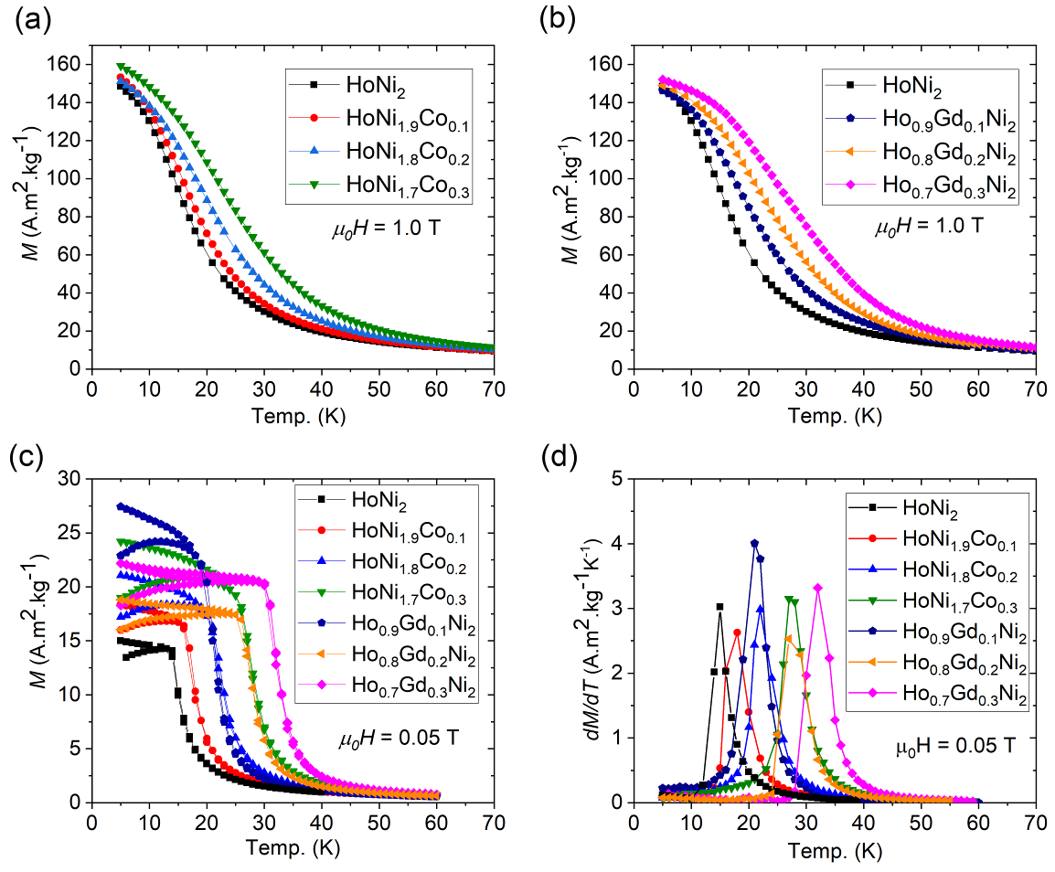
Figure 1

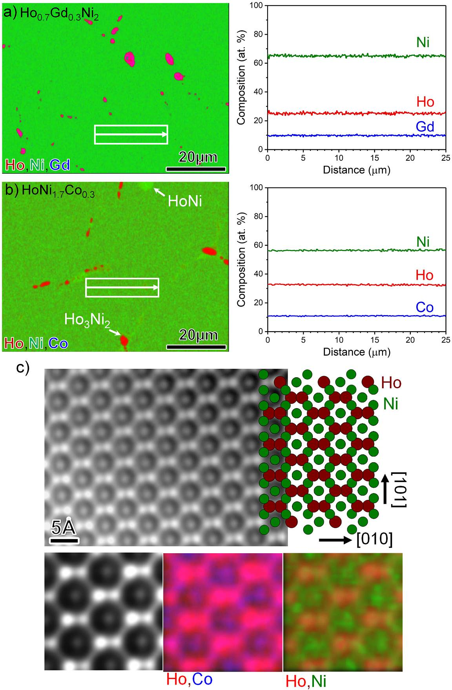
Figure 2

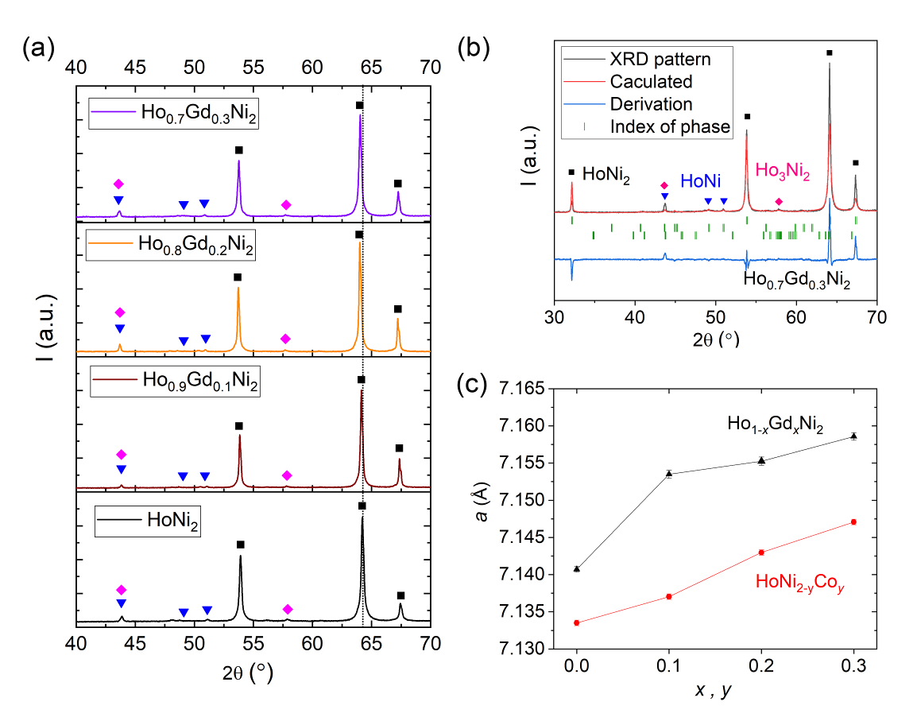
Figure 3
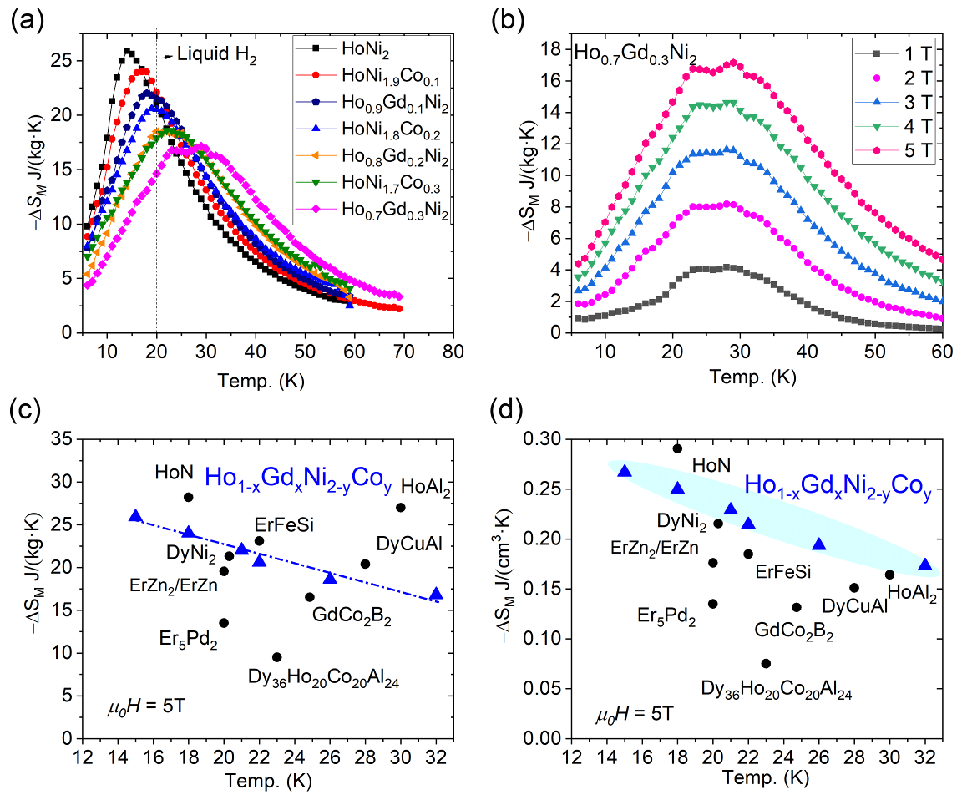
Figure 4

