Ultrathin CoPt Alloy Films with fcc (111) Orientation and Perpendicular Magnetic Anisotropy Fabricated by Electrodeposition
Daiki Araki ¹, Yoshiaki Sonobe ², Yukiko K. Takahashi ³, and Takayuki Homma ^{1, 2, *}
¹Department of Nano science and engineering, Waseda University, Shinjuku, Tokyo, 169-8555, Japan
²Research Organization for Nano and Life Innovation, Waseda University, Shinjuku, Tokyo, 162-0041, Japan
³National Institute for Materials Science, Tsukuba, Ibaraki, 305-0047, Japan
*Corresponding author. E-mail: t.homma@waseda.jp; Tel.: +81-3-5286-3209; Fax: +81-3-3205-2074

ABSTRACT
In this study, ultrathin CoPt alloy films oriented along face-centered cubic (fcc) (111) with perpendicular magnetic anisotropy (PMA) are fabricated by electrodeposition at room temperature and normal pressure without annealing. By increasing the concentration of Pt ions in the electrolytes, initial nucleation of CoPt becomes fine, forming epitaxial CoPt alloy films oriented along fcc (111) to the film planes with very smooth surfaces (Arithmetic average roughness Ra~0.43 nm). The deposited CoPt films show the lower saturation magnetization (M_{S}~620 emu･cm⁻³) compared to conventional CoPt films with hexagonal close-packed (hcp) structures. The CoPt film with a thickness of 5 nm exhibits large PMA (anisotropy constant K_{u}~4.3 Merg･cm⁻³), coercivity (H_{C}~2.4 kOe), and nucleation field (H_{n}~2.0 kOe). The fabricated CoPt films contribute to the development of magnetic tunnel junctions with enhanced tunnel magnetoresistance effects and a next-generation magnetic memory with ultrahigh recording density.
KEYWORDS
ultrathin films, CoPt alloy, fcc structure, electrodeposition, nucleation, perpendicular magnetic anisotropy

- Introduction
Recently, CoPt alloys have attracted attention as materials for magnetic random-access memories (MRAMs) [1] and vertical domain wall motion memory (V-DWMM) [2]. MRAMs consist of magnetic tunnel junctions (MTJs), where an oxide barrier layer sandwiched between ferromagnetic layers [1, 3]. If the ferromagnetic layers have perpendicular magnetic anisotropy (PMA), MARMs achieve high thermal stability, low critical current for magnetization switching and reduced error rate [1]. Additionally, when the ferromagnetic layers are CoPt alloys oriented along face-centered cubic (fcc) (111) to the film planes, the tunnel magnetoresistance (TMR) ratio in the MTJs exceeds 2000%, based on the first-principle calculations [1]. The TMR ratio of the (111)-oriented MTJs is more than 3 times greater than the maximum value 631% measured in (001)-oriented CoFe/MgO/CoFe MTJs [3]. Therefore, CoPt layers with PMA and fcc (111) orientation are required for future MRAMs. V-DWMM, which consists of multiple magnetic layers with PMA and low magnetic anisotropy, is a promising magnetic memory device with an ultrahigh recording density [2]. CoPt alloys are suitable for V-DWMM because their magnetic anisotropy can be tuned by varying the alloy composition [4]. To decrease the spin-polarized current density and power consumption of the V-DWMM, the saturation magnetization (M_{S}) of the CoPt layers must be reduced [5]. Since M_{S} decreases as the Pt composition in CoPt alloy film increases [4], CoPt layers with large Pt compositions and PMA are necessary for V-DWMM. Moreover, the thickness of the film should be a few nanometers to achieve an ultrahigh recording density, and the surface smooth for effective stacking of the CoPt layers. Thus, ultrathin Pt-rich CoPt alloy layers with PMA, fcc (111) orientation and smooth surfaces are required to develop future magnetic devices.
Electrodeposition is a low-cost deposition process and has high scalability, as it allows the size of substrates can be expanded into wafers or even larger sizes [6–8]. Additionally, ferromagnetic materials with high-aspect-ratio structures which are essential for V-DWMM can be grown perpendicularly to substrates by only electrodeposition with porous membranes [9–13]. In contrast, forming ferromagnetic materials into high-aspect-ratio structures vertically by reactive ion etching, which is commonly used in semiconductor manufacturing, is challenging due to the formation of nonvolatile products and corrosion [14]. Therefore, electrodeposition is an attractive method to fabricate magnetic devices. Many CoPt alloy thin films with PMA have been fabricated by electrodeposition; however, the Pt composition of these conventional films is less than 30 at%, and the crystal structure is hexagonal close-packed (hcp) [15–20]. In this study, ultrathin Pt-rich CoPt alloy films oriented along fcc (111) with PMA have been fabricated by electrodeposition at room temperature and normal pressure without annealing. To obtain the fcc structure in CoPt layers, the Pt composition in the layers should be increased to over 40 at% [21]. Hence, Pt composition in the deposited films is raised by increasing the concentration of Pt ions in the electrolyte. A higher concentration of Pt ions in the electrolyte can also decrease a composition gradient along a thickness direction, which is typically observed in electrodeposited CoPt films [18, 19]. During the initial phase of electrodeposition of CoPt alloys, Pt is preferentially deposited, and the deposited alloy composition becomes Pt-rich. Once diffusion limited conditions are reached, the Pt composition in the deposited films decreases as the diffusion current of the Pt deposition decreases, approaching the concentration ratio of Pt ions to the total metal ions in the electrolytes. If the concentration ratio of Pt ions is large, the alloy compositions in finally deposited parts of the CoPt films become close to those of initially deposited parts. These small composition differences prevent disorders of the crystal structure of the deposited CoPt films because the crystal structure of CoPt alloys varies with their alloy compositions. Thus, increasing the concentration of Pt ions in the electrolyte increases not only increases the Pt composition but also enhances uniformity of the crystal structure in the deposited CoPt films.
- Experimental section
CoPt films were deposited in electrolytes where the concentrations of Co and Pt salts were less than 1 mM, resulting in a reduction in the deposition rate to control the thickness of the ultrathin films. The concentration of cobalt sulfate (CoSO₄) was fixed at 1 mM, whereas that of hexachloroplatinic acid (H₂PtCl₆) was raised from 0.1 to 1 mM. Consequently, the concentration ratio of the Pt salt to that of the Co salt increased to 1:1, which was larger than the conventional ratio for the electrodeposition of CoPt thin films with PMA [15–20] i.e., 1:10. 0.1 M sodium sulfate (Na₂SO₄) was added to increase the conductivity of the electrolyte. The substrates were Pt (15 nm)/Ti (5 nm) films sputtered onto thermally oxidized Si wafers. The Pt layer was oriented in the fcc (111) direction relative to the film plane. These substrates were cut into 1.2 cm squares, treated with O₂ plasma and piranha solution (mixute of 96wt% H₂SO₄ and 30wt% H₂O₂ at a volume ration of 3:1) to remove organic pollutants on the surface, and then washed with hydrochloric acid to remove oxides. After cleaning, the substrates were placed in a holder, immersed in the electrolyte and connected to a potentiostat (HZ-7000, Meiden Hokuto). The counter and reference electrodes were a Pt mesh and an Ag/AgCl electrode with a saturated potassium chloride solution, respectively. Electrodepositions of CoPt films were conducted under a constant potential of -0.65 V vs. Ag/AgCl at room temperature and atmospheric pressure. The deposition time was varied from 70 to 500 s in the bath containing 0.1 mM H₂PtCl₆ (referred to as “0.1 mM bath”) and 5 to 600 s in the bath containing 1 mM H₂PtCl₆ (referred to as “1 mM bath”). The surface roughness of the deposited films was analyzed using atomic force microscopy (AFM, SPM-9700, Shimazu). The thicknesses, cross-sections, and crystal structures of the films were analyzed by transmission electron microscopy (TEM, Spectra Ultra, Thermo Fisher Scientific) and X-ray diffraction (XRD, SmartLab, Rigaku). The magnetic properties were characterized using a vibration sample magnetometer (VSM, BHV-3, 5 Series, Riken Denshi) and by the polar magneto-optic Kerr effect (PMOKE, BH-810CPC-WU, Neo Ark). Cross-sectional scanning transmission electron microscopy (STEM) was performed using a SpectraUltra S/TEM (Thermo Fisher Scientific). The cross-sectional TEM sample was fabricated using a focused ion beam (FIB) with scanning electron microscopy (SEM) dual-beam system Helios5UX (Thermo Fisher Scientific).
- Results and discussions
Figure 1 shows the three-dimensional (3D) images of the surface morphology of the deposited CoPt films. Figures 1(a) and (b) present the surface morphology of the films deposited in the 0.1 mM bath, and (c) and (d) show the corresponding images for the 1 mM bath. In the 0.1 mM bath deposition, large particles appear sporadically for 70 s. Subsequent depositions on the large and dispersed particles became bumpy by 500 s, with the thickness of the deposited layer reaching 7 nm. In the 1 mM bath deposition, small particles covered the surface, though some pits remained uncovered after 10 s. Subsequently, the particles perfectly covered the surface, and a smooth surface was obtained by 75 s, with the thickness of the deposited layer reaching 5 nm. Since the initial particles were grown from the nuclei, the size and number density of initial nuclei varied depending on the concentration of Pt salt. These differences arose owing to the supersaturation of metal adatoms on the cathode surface during electrodeposition. Adatoms are metal atoms reduced from ions and adsorbed on cathodes but not crystalized [22]. The critical nuclei diameter $r_{crit}$ and the rate of nucleation of $N$ particles during time $t$ can be described as a function of supersaturation ratio $S$, which is a ratio of the concentration of adatoms to the equilibrium ones, denoted by equations (1) and (2), respectively.
Here, $γ$ represents the surface energy between the nuclei and the solution, $ν$ is the volume where one atom occupies in nuclei, $k_{B}$ is Boltzmann’s constant, $T$ is the temperature, and $φ$ is a factor accounting for the differences in the properties when the material of the nuclei differs from that of the substrate [23]. Equations (1) and (2) suggest that as supersaturation increases, the nuclei size decreases, and nucleation occurs more frequently. Large supersaturation can be achieved by increasing the number of metal adatoms. The number of metal adatoms increases at a higher metal ion concentration under a sufficiently negative potential relative to the equilibrium potentials of the metal ions as more metal ions are reduced near the cathode surface. Since the deposition potential of -0.65 V vs. Ag/AgCl is much more negative than the equilibrium potential of Pt deposition from the chlorides used in this study (~0.5 V vs. Ag/AgCl [24]), a higher concentration of Pt ions increases the amount of Pt adatoms and the supersaturation. This makes the size of nuclei smaller and their number density higher. Additionally, since the ratio of Pt deposition to the deposition at the initial stage is greater compared to the subsequent stages [18, 19], changes in Pt ion concentration have a significant influence on the initial nucleation, although the concentration of Co salt is the same in both baths. Therefore, the surface gets smoothened by increasing the Pt salt concentration.
Figure 2 shows the cross-sectional high-angle annular dark-field scanning transmission electron microscope (HAADF-STEM) images of the smooth CoPt films deposited in a 1 mM bath for 75 s. Ni was deposited on the CoPt layer by sputtering just before preparing the TEM sample with FIB to protect the surface from damage by FIB. The thickness of the CoPt layer deposited in the 1 mM bath was approximately 5 nm. The surface of the CoPt layer is smooth, consistent with the surface roughness measured by AFM, as shown in Figure 1(b). Additionally, the deposited CoPt layer was dense and continuous. Figures 2 (b) and (c) show the high-resolution TEM images obtained from the regions highlighted in red in Figure 2(a). The Co and Pt atoms are stacked in an ABCABC arrangement, as shown in Figure 2(b), indicating that the CoPt layer is oriented in the fcc (111) direction perpendicular to the film plane. Figure 2(c) shows the interface between Pt and CoPt. This indicates that the fcc (111) orientation was seamlessly maintained from the Pt substrate to the deposited CoPt layer. Therefore, the CoPt layer grew epitaxially on the Pt substrate. Figure 3 shows the XRD result of the CoPt films deposited in a 1 mM bath for 75 s. The XRD also showed fcc (111) and (222) peaks; however, no peaks corresponding to the ordered CoPt alloy were observed, indicating that the deposited CoPt alloy is of the A1 disordered type. The composition of the CoPt layer deposited in the 1 mM bath analyzed by energy dispersive X-ray spectroscopy (EDS) was Co 47at% and Pt 53at%, which is more Pt-rich than the conventional CoPt films with PMA fabricated by electrodeposition [15–20].
Figure 4(a) shows the magnetization loops of the smooth CoPt film deposited in a 1 mM bath. The saturation magnetization M_{S} was 620 emu･cm⁻³, calculated with the deposited area (0.5 cm²) and thickness measured by cross-sectional TEM images (5 nm). This value is the same as M_{S} of Co₅₀Pt₅₀ films deposited by sputtering [25] and evaporation [4], which suggests the electrodeposited CoPt layer is as dense and little oxidized as the films deposited by the dry processes. The CoPt film deposited in a 1 mM bath showed PMA, with an anisotropy constant (K_{u}) of 4.3 Merg･cm⁻³. The anisotropy constant K_{u} was calculated using equation (3).
Here, K_{eff} is the effective anisotropy constant calculated from the area surrounded by the out-of-plane and in-plane magnetization curves in the first quadrant, and its value was found to be 1.9 Merg･cm⁻³. Figure 4(b) shows the magnetization loops of the CoPt film deposited for 600 s in the 1 mM bath. PMA apparently decreased as the deposition time increased. Since film thickness increased with deposition time, PMA was induced at initial thin layers of the deposited CoPt films and decreased as film thickness increased. The first possible origin of PMA in the initial layers is interface anisotropy between CoPt layers and Pt substrates. However, PMA derived from interface anisotropy is observed only when the thickness of a ferromagnetic layer is a few atomic monolayers [26]. Since the thickness of the deposited CoPt films was 5 nm (approximately 20 monolayers), interface anisotropy could not be the main reason for the PMA. The second possibility is magnetoelastic anisotropy induced by strains. There are tensile strains in CoPt layers on Pt substrates due to lattice misfit between CoPt and Pt, which causes magnetoelastic anisotropy. In previous research, Co₅₀Pt₅₀ films with a thickness of less than 4.5 nm deposited on MgO (111) exhibited PMA by strains derived from misfit between CoPt and MgO [27]. For another example, Ni layers sandwiched between amorphous Si layers showed PMA by thermal expansion-induced stress and maintained PMA even when the thickness of Ni layer was 28 nm [28]. Magnetoelastic anisotropy can persist when the film thickness is several tens of nanometers. However, the amount of anisotropy energy is approximately 10⁵ erg･cm⁻³ and an order of magnitude smaller than K_{eff} in the electrodeposited films. The third possibility is anisotropy induced by two dimensional Co clusters in CoPt layers. There are some reports that two-dimensional Co clusters were formed in CoPt films and interface anisotropy between the clusters and the surrounding Pt atoms [25, 29, 30]. The anisotropy constant n 20 nm-thick Co₃₀Pt₇₀ films was 3 Merg･cm⁻³, which is close to K_{eff} in the electrodeposited films [29]. Therefore, Co clusters could have formed in the initial thin part in the electrodeposited films. The coercivity (H_{C}) and nucleation field (H_{n}) of the CoPt film deposited in the 1 mM bath were 2.4 and 2.0 kOe, respectively. The coercivity is relatively smaller than that of conventional electrodeposited CoPt films with hcp structures and PMA (4–7 kOe) [15–20]. However, the H_{n} value of 2.0 kOe is the largest in electrodeposited CoPt films and helps to reduce thermal decay of magnetization [31]
Figure 5 shows the magnetization loops of the CoPt films with deposition times of 75 s or shorter, as measured by PMOKE. The magnetization of the samples when the deposition time was less than 75 s was too small for the VSM to detect, so the magnetization loops were measured using PMOKE. PMA loops with high squareness, close to 1, were observed when the deposition time was less than 75 s. The sample deposited for 40 s exhibited the highest H_{C} and H_{n}. H_{C} and H_{n}. disappeared when the deposition time was 5 s likely because the magnetizations of the tiny CoPt crystals deposited in such a short time were weakened by thermal fluctuations. The surfaces of these films were also smooth, especially the films deposited for 20 and 40 s, with the surface roughness (R_{a}) being 0.3 and 0.4 nm, respectively. Assuming thickness proportional to deposition time, the thicknesses of the films deposited for 20 and 40 s were 1.3 and 2.7 nm, respectively. Hence, ultrathin and smooth CoPt layers with a high PMA can be fabricated by electrodeposition in a 1 mM bath. Thus, the electrodeposited CoPt films in this study can be applied to (111)-oriented MTJs and V-DWMM in terms of structures and magnetic properties, although their thermal stability remains unclear. However, the deposited films are likely stable up to around 500 ℃ because crystal structure of Co₄₄Pt₅₆ films did not change at this temperature [32]. In addition to thermal stability, chemical stability against oxidation and corrosion is expected to be high due to the large composition of Pt, a noble metal.

- Conclusion
Ultrathin CoPt alloy films oriented in fcc (111) with PMA were fabricated by electrodeposition without annealing. By increasing the concentration of Pt salt in the diluted electrolyte, initial nucleation became fine, and very smooth surface was obtained. The Pt composition in the deposited CoPt films were larger than that of conventional CoPt films with hcp structure and PMA, which contributed lower saturation magnetization of the deposited films (620 emu･cm⁻³) compared to the conventional ones. The deposited CoPt film with a thickness of 5 nm showed high perpendicular magnetic anisotropy (anisotropy constant K_{u}~4.3 Merg･cm⁻³), coercivity (H_{C}~2.4 kOe), and nucleation field (H_{n}~2.0 kOe). Moreover, the CoPt films maintained perpendicular magnetic anisotropy when the film thickness was below 5 nm. The deposited CoPt alloy films contribute to the development of future magnetic memories such as MRAMs with (111)-oriented MTJs and V-DWMM.

AUTHOR INFORMATION
Corresponding Author
*Takayuki Homma.
t.homma@waseda.jp; Tel.: +81-3-5286-3209; Fax: +81-3-3205-2074

ACKNOWLEDGMENT
This study was supported in part by CREST (Grant number: JPMJCR21C1; Japan). Part of this work resulted from using research equipment (G1026) shared by the MEXT Project to promote the public utilization of advanced research infrastructure (JPMXS0440500024). We are grateful to Dr. Y. Takamura and Prof. S. Nakagawa, Science Tokyo, for their kind support with VSM measurements. We thank Yukie Mori for preparing the samples for cross-sectional TEM observations. A part of this study was supported by the Electron Microscopy Unit, National Institute for Materials Science (NIMS).

CRediT
Daiki Araki: Conceptualization, Methodology, Investigation, Writing – Original Draft. Yoshiaki Sonobe: Supervision. Yukiko K. Takahashi: Investigation. Takayuki Homma: Supervision, Writing – Review & Editing.

REFERENCES
[1] K. Masuda, H. Itoh, Y. Sonobe, H. Sukegawa, S. Mitani, Y. Miura, Interfacial giant tunnel magnetoresistance and bulk-induced large perpendicular magnetic anisotropy in (111)-oriented junctions with fcc ferromagnetic alloys: A first-principles study, Phys. Rev. B 103 (2021) 064427. https://doi.org/10.1103/PhysRevB.103.064427
[2] Y. M. Hung, T. Li, R. Hisatomi, Y. Shiota, T. Moriyama, T. Ono, Low Current Driven Vertical Domain Wall Motion Memory with an Artificial Ferromagnet, J. Magn. Soc. Jpn. 45 (2021) 6–11. https://doi.org/10.3379/msjmag.2011R002
[3] T. Scheike, Z. Wen, H. Sukegawa, S. Mitani, 631% room temperature tunnel magnetoresistance with large oscillation effect in CoFe/MgO/CoFe(001) junctions, Appl. Phys. Lett. 122 (2023) 112404. https://doi.org/10.1063/5.0145873
[4] D. Weller, H. Brändle, G. Gorman, C.-J. Lin, H. Notarys, Magnetic and magneto‐optical properties of cobalt‐platinum alloys with perpendicular magnetic anisotropy, Appl. Phys. Lett. 61 (1992) 2726–2728. https://doi.org/10.1063/1.108074
[5] S. Honda, Y. Sonobe, S. J. Greaves, Transforming domain motion for 3D racetrack memory with perpendicular magnetic anisotropy, J. Phys. D: Appl. Phys. 54 (2021) 135002. https://doi.org/10.1088/1361-6463/abd060
[6] L. T. Romankiw and S. Krongelb, The Path fromInvention to Product for the Magnetic Thin Film Head in Advances in Electrochemical Science and Engineering: Electrochemical Engineering Across Scales: from Molecules to Processes, John Wiley & Sons, Hoboken (2015) pp 7−58. https://doi.org/10.1002/9783527690633.ch2
[7] R. Zoberbier, B. Scheller, Dr. C. Ohde, Optimization of electrolytic plating processes for challenging fan-out panel level package designs, 2019 IEEE 69th ECTC (2019) 106–111. https://doi.org/ 10.1109/ECTC.2019.00024
[8] T. Jiang, H. Hu, Review of Evolution and Rising Significance of Wafer-Level Electroplating Equipment in Semiconductor Manufacturing, Electronics 14 (2025) 894. https://doi.org/10.3390/electronics14050894
[9] Y. H. Huang, H. Okumura, G. C. Hadjipanayis, D. Weller, CoPt and FePt nanowires by electrodeposition, J. Appl. Phys. 91 (2002) 6869–6871. https://doi.org/10.1063/1.1447524
[10] J.-R. Choi, S. J. Oh, H. Ju, J. Cheon, Massive Fabrication of Free-Standing One-Dimensional Co/Pt Nanostructures and Modulation of Ferromagnetism via a Programmable Barcode Layer Effect, Nano Lett. 5(11) (2005) 2179-2183. https://doi.org/10.1021/nl051190k
[11] K. E. Hnida, A. Zywczak, M. Gajewska, M. Marciszko, G. D. Sulka, M. Przybylski, Tuning the magnetic properties of multilayered CoPt-Pt nanowires via thickness of magnetic segments, Electrochim. Acta 205 (2016) 29–37. https://doi.org/10.1016/j.electacta.2016.04.076
[12] M. M. Hasan, T. Huang, M. Saito, Y. Takamura, D. Oshima, T. Kato, T. Homma, Preparation and characterization of high aspect ratio electrodeposited CoPt multilayered magnetic nanowires. 2023 IEEE International Magnetic Conference (INTERMAG), p.1-5. https://doi.org/10.1109/INTERMAG50591.2023.10265078
[13] N. Oguchi, M. Saito, T. Homma, T. Kato, T. Ono, M. Shima, K. Yamada, Optimizing preparation conditions and characterizing for CoxPt1-x alloy cylindrical nanowires fabricated by electrodeposition on nanoporous polycarbonate membranes, J. Magn. Magn. Mater. 601 (2024) 172159. https://doi.org/10.1016/j.jmmm.2024.172159
[14] J.-Y. Park, S.-K. Kang, M.-H. Jeon, M. S. Jhon, G.-Y. Yeoma, Etching of CoFeB Using CO/NH3 in an Inductively Coupled Plasma Etching System, J. Electrochem. Soc. 158(1) (2011) H1-H4. https://doi.org/10.1149/1.3505295
[15] S. Franz, M. Bestetti, M. Consonni, P. L. Cavallotti, Electrodeposition of micromagnets of CoPtW(P) alloys, Microelectron. Eng. 64 (2002) 487–494. https://doi.org/10.1016/S0167-9317(02)00825-0
[16] I. Zana, G. Zangari, Electrodeposition of Co-Pt Films with High Perpendicular Anisotropy, Electrochem. Solid-State Lett. 6 (2003) C153. https://doi.org/10.1149/1.1619648
[17] M. Ghidini, G. Zangari, I. L. Prejbeanu, G. Pattanaik, L. D. Buda-Prejbeanu, G. Asti, C. Pernechele, M. Solzi, Magnetization processes in hard Co-rich Co–Pt films with perpendicular anisotropy, J. Appl. Phys. 100 (2006) 103911. https://doi.org/10.1063/1.2357869
[18] S. Wodarz, T. Otani, H. Hagiwara, T. Homma, Characterization of Electrodeposited Co-Pt Nanodot Array at Initial Deposition Stage, ECS Trans. 64(45) (2015) 1-9. https://doi.org/10.1149/06445.0099ecst
[19] O. Dragos-Pinzaru, A. Ghemes, H. Chiriac, N. Lupu, M. Grigoras, S. Riemer, I. Tabakovic, Magnetic properties of CoPt thin films obtained by electrodeposition from hexachloroplatinate solution. Composition, thickness and substrate dependence, J. Alloy Compd. 718 (2017) 319-325. https://doi.org/10.1016/j.jallcom.2017.05.186
[20] T. Huang, Y. Takamura, M. Saito, M. M. Hasan, S. Kasai, Y. Sonobe, S. Nakagawa, Development of Ultra-Thin CoPt Films With Electrodeposition for 3-D Domain Wall Motion Memory, IEEE Trans. Magn. 59(11) (2023) 1301005. https://doi.org/10.1109/TMAG.2023.3298911
[21] A. S. Darling, Cobalt-Platinum Alloys A critical review of their constitution and properties, Plat. Metar. Rev. 7(3) (1963) 96-104.
[22] E. Budevski, G. Staikov, W. J. Lorenz, Fundamentals of Electrocrystallization of Metals in Electrochemical Phase Formation and Growth An Introduction to the Initial Stages of Metal Deposition, VCH Verlagsgesellschaft mbH, Weinheim (1996) pp. 1-7.
[23] N. T. K. Thanh, N. Maclean, S. Mahiddine, Mechanisms of Nucleation and Growth of Nanoparticles in Solution, Chem. Rev. 114 (2014) 7610-7630. https://doi.org/10.1021/cr400544s
[24] A. J. Bard, L. R. Faulkner, H. S. White, Appendix C in Electrochemical Methods: Fundamentals and Applications, 3rd ed., John Wiley & Sons, Hoboken, 2022, pp 1007−1014.
[25] J. Li, Q. Guo, T. Lin, Q. Zhang, H. Bai, S. Cheng, X. Zhan, L. Gu, T. Zhu, Field-free magnetization switching through large out-of-plane spin–orbit torque in the ferromagnetic CoPt single layers, Appl. Phys. Lett. 124 (2024) 212407. https://doi.org/10.1063/5.0191182
[26] C.-J. Lin, G. L. Gorman, C. H. Lee, R. F. C. Farrow, E. E. Marinero, H. V. Do, H. Notarys, C. J. Chien, Magnetic and structural properties of Co/Pt multilayers, J. Magn. Magn. Mater. 93 (1991) 194-206. https://doi.org/10.1016/0304-8853(91)90329-9
[27] C. Pan, T. Gao, N. Itogawa, T. Harumoto, Z. Zhang, Y. Nakamura, J. Shi, Large lattice mismatch induced perpendicular magnetic anisotropy and perpendicular exchange bias in CoPt/FeMn bilayer films, Sci. China. Tech. Sci. 62 (2019) 2009–2013. https://doi.org/10.1007/s11431-019-1433-0
[28] M. Tadić, M. Panjan, J. Kovač, M. Čekada, P. Panjan, Nickel films deposited between amorphous silicon layers: Effects of annealing, Ni/Si interface and magnetic properties, Appl. Surf. Sci. 686 (2025) 162122. https://doi.org/10.1016/j.apsusc.2024.162122
[29] T. A. Tyson, S. D. Conradson, Observation of internal interfaces in PtxCo12x (x~0.7) alloy films: A likely cause of perpendicular magnetic anisotropy, Phy. Rev. B 54(6) (1996) R3702. https://doi.org/10.1103/PhysRevB.54.R3702
[30] L. Liu, C. Zhou, T. Zhao, B. Yao, J. Zhou, X. Shu, S. Chen, S. Shi, S. Xi, D. Lan, W. Lin, Q. Xie, L. Ren, Z. Luo, C. Sun, P. Yang, E.-J. Guo, Z. Dong, A. Manchon, J. Chen, Current-induced self-switching of perpendicular magnetization in CoPt single layer, Nat. Commun. 13 (2022) 3539. https://doi.org/10.1038/s41467-022-31167-w
[31] Y. Sonobe, H. Muraoka, K. Miura, Y. Nakamura, K. Takano, A. Moser, H. Do, B. K. Yen, Y. Ikeda, N. Supper, W. Weresin, Thermally Stable CGC Perpendicular Recording Media With Pt-Rich CoPtCr and Thin Pt Layers, IEEE Trans. Magn. 38(5) (2002) 2006. https://doi.org/10.1109/INTMAG.2002.1001000
[32] Y. J. Zhang, Y. T. Yang, Y. Liu, Y. X. Wang, X. Y. Lia, D. D. Wang, J. Cao, N. N. Yang, J. Li, S. Y. Yang, Y. Q. Liu, M. B. Wei, J. H. Yang, Effects of annealing temperature, atomic composition, film thickness on structure and magnetic properties of CoPt composite films, J. Alloy. Compd. 509 (2011) 326. https://doi.org/10.1016/j.jallcom.2010.09.020

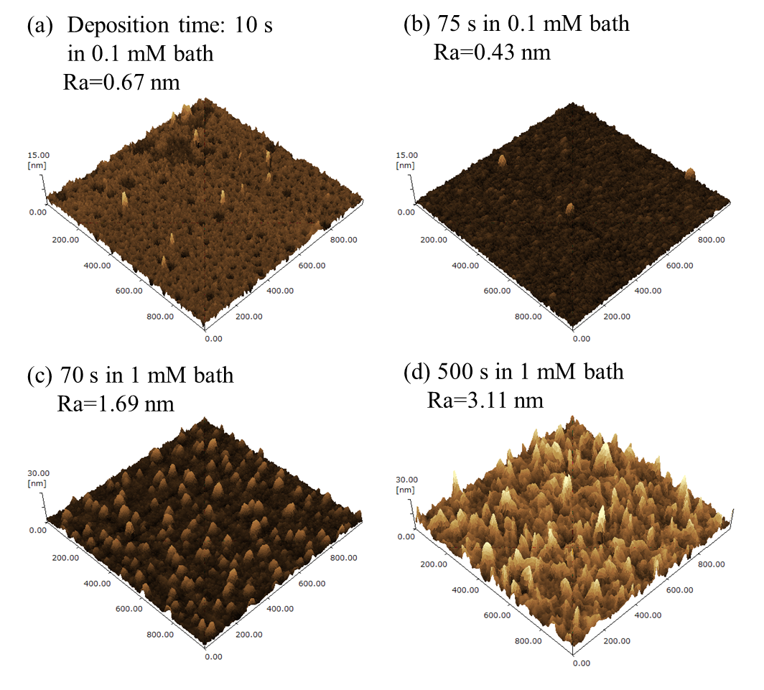
Figure 1. 3D surface images of the deposited CoPt films acquired by AFM. (a) and (b) show the images of the CoPt films deposited in the 1 mM bath for 10 and 75 s, respectively. (c) and (d) represent the ones deposited in the 0.1 mM bath for 70 and 500 s, respectively.

Math formulae
$$\begin{aligned}r_{crit}=\frac{2γv}{φk_{B}T lnS}\#\left(1\right)\end{aligned}$$
$$\begin{aligned}\frac{dN}{dt}=A\exp\left(-\frac{16πφγ^{3}v^{2}}{3k_{B}^{3}T^{3} {\left(lnS\right)}^{2}}\right)\#\left(2\right)\end{aligned}$$
$$\begin{aligned}K_{u}=K_{eff}+2πM_{S}^{2}\#\left(3\right)\end{aligned}$$

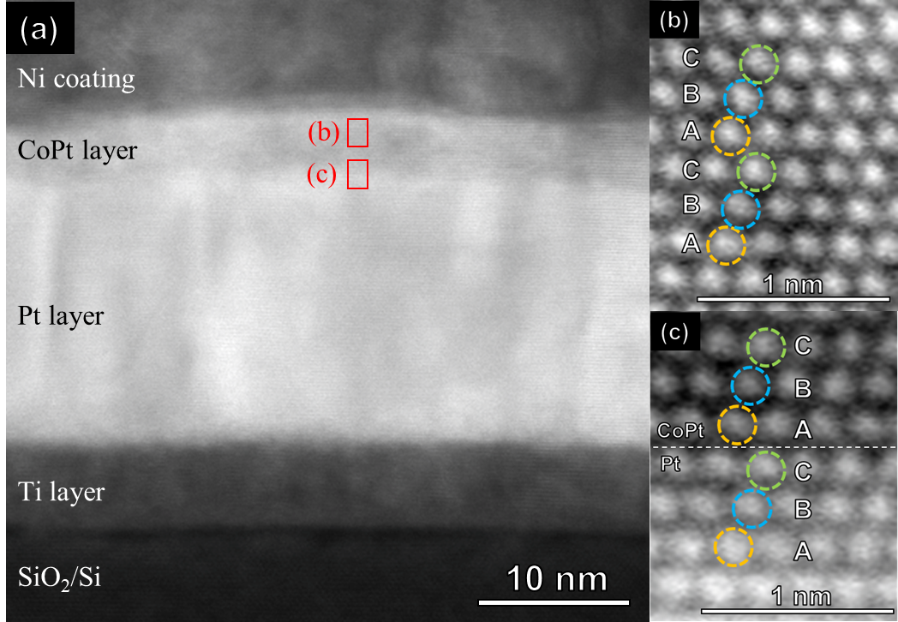
Figure 2. (a) Cross-sectional TEM image of CoPt films deposited in the 1 mM bath for 75 s. (b) and (c) show enlarged high resolution images of red frame areas in (a).
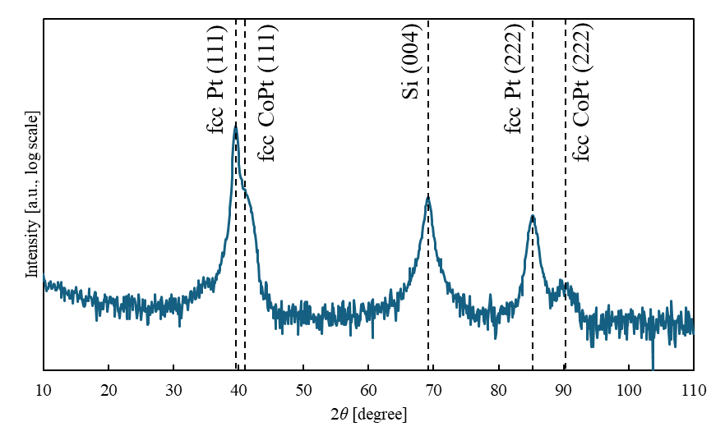
Figure 3. XRD pattern of the CoPt film deposited in the 1 mM Pt bath for 75 s.
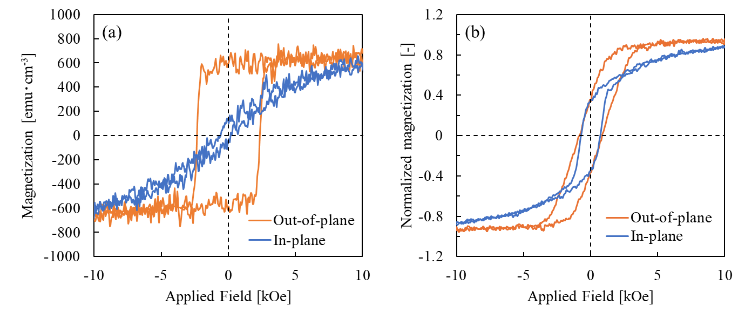
Figure 4. Magnetization curves of the deposited CoPt films deposited in 1 mM bath measured with VSM. (a) and (b) show the curves when deposition time was 75 s and 600 s, respectively. The orange and blue lines show the curves in out-of-plane and in-plane directions, respectively.
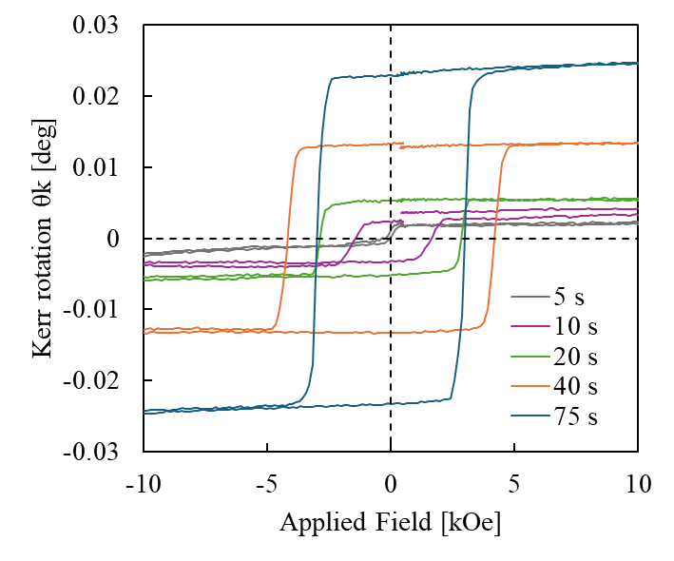
Figure 5. Magnetization curves of the CoPt films deposited in 1 mM bath for 5, 10, 20, 40, and 75 s with PMOKE. Gray, purple, green, orange, and blue lines show the curves of the films deposited for 5, 10, 20, 40, and 75 s, respectively.

