Zhongyunshen Zhu, Hridibrata Pal, Aditya Dev Varma, Masataka Imura, Hironori Okumura, and Tomás Palacios, Fellow IEEE
Zr-Based Contacts to n-Type AlN with Improved Performance for Power and High-Temperature Electronics
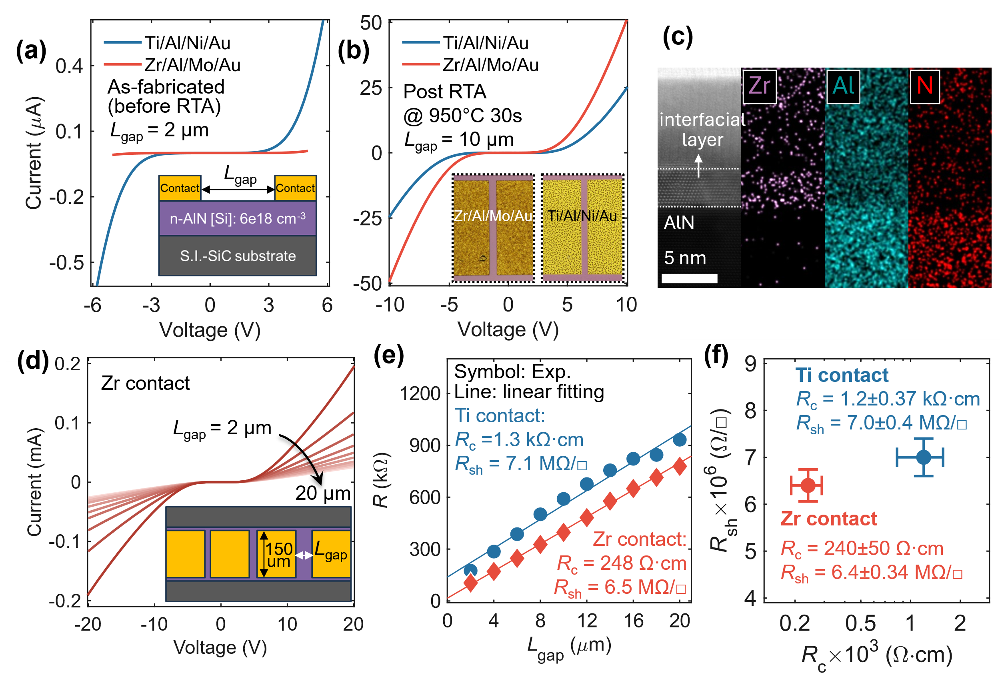
Fig. 1. Measured I-V characteristics of devices with two different contacts (a) before and (b) after RTA. The inset in (a) and (b) shows the device cross-section schematic and top-view microscope image of two contacts after RTA, respectively. (c) HAADF-STEM and EDS images at AlN/Zr contact interface after RTA. (d) I-V characteristics of TLM structure with Zr contact. (e) Total resistance vs. L_{gap} in two TLM devices with two different contacts. (f) Statistics of R_{c} and R_{sh} with the two contacts based on multiple TLM devices.

Abstract—This work reports improved ohmic contacts on n-type AlN using a Zr/Al/Mo/Au metal stack with contact resistivities of ~10⁻³ Ω⋅cm² at 25°C and ~10⁻⁵ Ω⋅cm² at 500°C, which are over one and two orders of magnitude lower than Ti-based contacts, respectively. Temperature-dependent current-voltage characteristics reveal thermionic-field emission-dominated transport at the Zr/AlN interface, leading to improved conductivity and ohmic behavior above 400°C. Record-low specific on-resistance (R_{on,sp}) is achieved in AlN Schottky barrier diodes using Zr-based cathode compared to previously reported values at comparable breakdown voltages. The devices reveal 10× enhanced Baliga Figure of Merit at 300°C and 500°C due to significantly lowered R_{on,sp} < 50 mΩ⋅cm².
Index Terms—AlN, Zr contact, high temperature, Schottky barrier diodes, high power

Introduction
A
luminum nitride (AlN) holds exceptional potential for next-generation power devices and high-temperature electronics owing to its ultrawide bandgap, superior critical field, and excellent thermal properties [1]–[4]. However, realizing high-performance AlN devices is challenged by high dopant ionization energy and self-compensation effects in metal-organic chemical vapor deposition (MOCVD) material [5], leading to a low carrier concentration <10¹⁶ cm⁻³ at room temperature (RT) even with doping level >10¹⁸ cm⁻³ [1],[6]. Low electron affinity and Fermi-level pinning at the metal/AlN interface further increase contact barriers, hindering formation of low-resistance ohmic contacts [1]. Although reverse-graded n-AlGaN layers mitigate contact resistance, their effectiveness is limited by low effective doping in high-Al-content AlGaN and a polarization-induced barrier at the AlGaN/AlN interface [7]. For direct contact to AlN, conventional Ti-based contacts widely used for GaN typically show specific contact resistivities (ρ_{c}) >10⁻² Ω·cm² [8]–[11]. While recent Ti/Al/Ti stacks have reduced ρ_{c} below 10⁻³ Ω·cm² [12], fully unlocking their potential for AlN-based power electronics requires comprehensive device-level validation alongside an in-depth analysis of the underlying carrier transport physics. Recently, Zr has demonstrated reduced ρ_{c} in Al_{x}Ga_{1-x}N with x up to 0.85 [13]–[17] by more effectively promoting N-extraction to generate N-vacancy donors compared to Ti [18],[19], thereby thinning the depletion region associated with the Schottky barrier. However, extending this to pure AlN alters the physical environment at the contact interface due to the significantly higher thermodynamic stability of the Al-N bond and much lower carrier density [20],[21]. As a result, the fundamental transport mechanisms of Zr contacts on pure AlN remain uninvestigated. Furthermore, as elevated temperatures effectively ionize dopants and increase carrier density in AlN [10],[11],[22], evaluating the high-temperature device performance of the contact is also critical.
Here, we demonstrate an improved contact on n-type MOCVD-grown AlN using a Zr-based electrode compared to conventional Ti/Al/Ni/Au. Temperature-dependent electrical characterization from 25°C to 800°C shows that the Zr contact approaches ohmic behavior above 400°C, with a minimum ρ_{c} of 5.7×10⁻⁵ Ω·cm² at 500°C. Schottky barrier diodes (SBDs) with Zr-based cathode exhibit the lowest specific on-resistance (R_{on,sp}) among all reported lateral AlN SBDs at comparable breakdown voltages (V_{BD}) at 25°C and a further enhanced Baliga Figure of Merit (BFOM) at elevated temperatures.
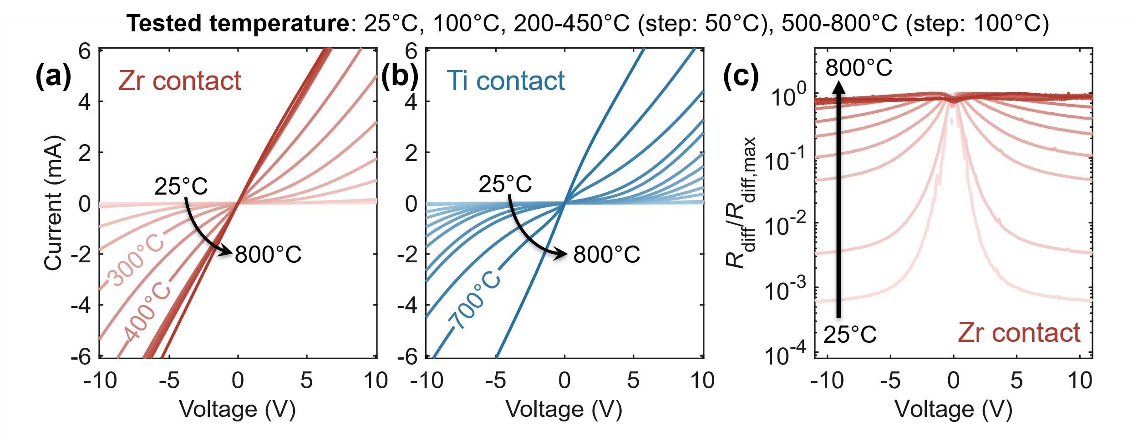
Fig. 2. Temperature-dependent I-V characteristics of (a) Zr-contact device and (b) Ti contact device with L_{gap} = 10 μm, width of 150 μm. (c) Temperature dependency of normalized differential resistance as a function of bias.
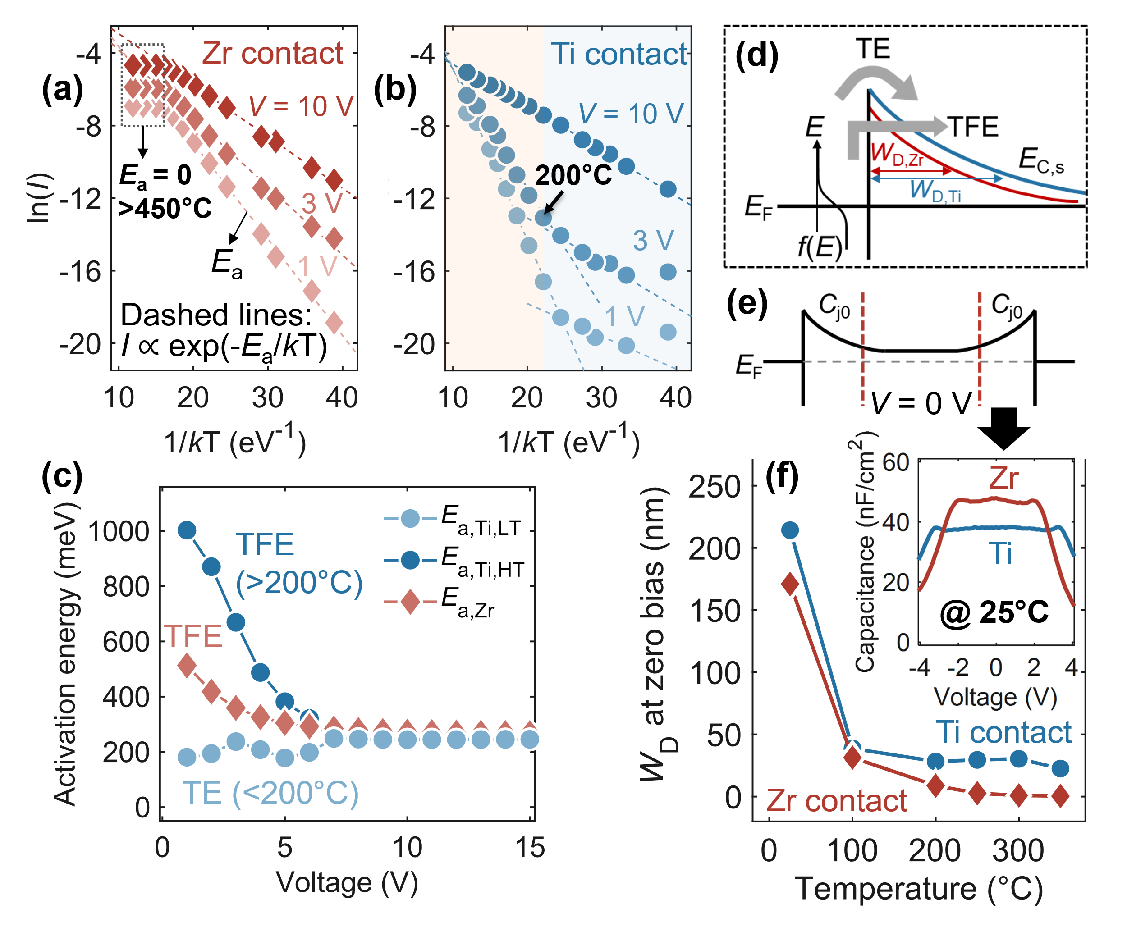
Fig. 3 (a-b) Arrhenius plot of measured I-V (points) at various bias with Zr and Ti contact device, respectively. Dashed lines: theoretical fitting with I ∝ exp(-E_{a}/kT) to extract E_{a}. (c) Extracted E_{a} vs. applied voltage. (d) Schematic of different emission mechanisms at the metal/AlN interface. (e) Equivalent model of the total capacitance at zero bias. (f) W_{D} at zero bias vs. temperature. Inset: C-V characteristics near zero bias for both contacts at RT.

Device Fabrication
A ~325-nm-thick Si-doped AlN layer was grown on a semi-insulating 4H-SiC substrate with 4°-off-axis by MOCVD. The growth was performed at 1120°C and 1.3×10⁴ Pa using trimethylaluminum (TMAl), NH₃ and tetramethylsilane (TMSi) as the precursors. The Si concentration was estimated as ~6×10¹⁸ cm⁻³ based on its gas flow of ~8×10⁻² μmol/min during the growth. The fabrication started with contact formation. Transfer-length method (TLM) structures were patterned via UV lithography, followed by native oxide removal using BOE 7:1. A 15/100/40/30 nm Zr/Al/Mo/Au metal stack (Mo acts as a diffusion barrier) was then deposited by electron-beam evaporation under a base pressure of 2×10⁻⁷ Torr, while 20/100/25/50 nm Ti/Al/Ni/Au stack was used as reference, both followed by a lift-off process (schematic in Fig. 1a inset). Rapid thermal annealing (RTA) at 950°C for 30 s in N₂ was then performed to improve the contact. This RTA condition is typically used for Ti-contacts for AlN [23],[24] and shown to be effective for Zr-based contacts on high-Al-content AlGaN [13],[14],[16],[17]. Device mesa isolation was achieved by Cl-based reactive-ion etching. The TLM device structure with electrode width of 150 μm is illustrated in cross-section (Fig. 1a inset) and top view (Fig. 1d inset), with the post-RTA surface morphology presented in Fig. 1b inset. The same ohmic contact formation was applied to SBD fabrication, employing Ni/Au Schottky anodes.

Electrical Characterization and Discussion
Temperature-dependent electrical characterization was performed in an Instec high-temperature probe station with a Keysight B1500A Semiconductor Analyzer, while RT breakdown tests employed a Tesla probe station with a Keysight B1505A Power Device Analyzer. As shown in Fig. 1a, the Ti contact exhibits lower total resistance than Zr before RTA, whereas after RTA, the Zr contact delivers nearly twice the current at 10 V compared to Ti (Fig. 1b). This suggests that the RTA treatment more effectively improves the Zr contact. TEM analysis in Fig. 1c reveals a thin Zr-Al-N interfacial layer after RTA, considerably thinner than the Al-N interlayers reported for Ti/Al/Ti/Au contacts [12], and is expected to reduce the effective contact barrier and improve carrier transport [18],[19]. Representative TLM I-V characteristics with Zr contact at 25°C are shown in Fig. 1d, with extracted contact (R_{c}) and sheet resistances (R_{sh}) at ±20 V summarized in Fig. 1e. Statistical results in Fig. 1f confirm that both contacts exhibit similar R_{sh}, while R_{c} is reduced by over fivefold with the Zr contact, indicating improved contact performance using the Zr/Al/Mo/Au metal stack.
Temperature-dependent I-V characteristics were performed for devices with the two contacts as shown in Fig. 2a-b. In both cases, the current increases with temperature due to enhanced Si dopant ionization and increased electron energy [10],[23]. The current tends to saturate for Zr contact after 450°C and reaches a similar value to Ti at 800°C. Moreover, the Zr contact shows increasingly linear I-V characteristics with temperature, achieving ohmic behavior at 400°C, in contrast to 700 °C for Ti. Fig. 2c shows that the change of the normalized differential resistance (R_{diff} = dV/dI, normalized to its maximum) near zero bias reduces with temperature and reaches a nearly constant above 400°C, confirming the transition to ohmic contact.
To investigate the origin of the differences between the two contacts, the activation energy (E_{a}) was extracted based on the slope of the Arrhenius plots of the I-V characteristics as shown in Fig. 3a-b. For Zr, excellent linear fitting ranging from 25°C-450°C with a single E_{a} is found at various bias conditions. E_{a} becomes 0 after 450°C due to the saturation in current improvement (Fig. 3a). In contrast, two distinct E_{a} are observed for Ti contact, with a transition temperature between them of ~200°C (Fig. 3b). Fig. 3c presents bias-dependent E_{a} for three cases: E_{a,Zr} for Zr contact; E_{a,Ti,LT} and E_{a,Ti,HT} for Ti contact at low and high temperature regimes, respectively. For Zr contact, E_{a,Zr} reduces as the bias increases, indicating that the carrier injection at the metal-AlN interface is dominated by thermionic-field emission (TFE). The Ti contact shows the same behavior at high temperatures, where E_{a,Ti,HT} decreases rapidly with bias. However, at low temperatures, E_{a,Ti,LT} is largely independent of bias, implying that thermionic emission (TE) dominates, consistent with a Schottky contact [25],[26]. At high bias, all cases converge to a constant E_{a} (~250 meV), indicating tunneling-dominated transport across the contact interface under strong electric fields. This phenomenon can be explained as illustrated in Fig. 3d. The Zr/AlN junction likely exhibits a narrower depletion width (W_{D}) than the Ti/AlN junction at low temperatures, allowing thermally assisted tunneling through the barrier (TFE process). Two factors may contribute to this difference: first, interfacial reactions between Zr and AlN during 950°C RTA [18],[19], which is expected to generates more nitrogen vacancies and lowers the local conduction band edge (E_{C,s}), thereby reducing W_{D}; secondly, the resulting Zr-Al-N interfacial layer (Fig. 1c) has lower band offset to AlN relative to Ti [27], further decreasing the Schottky barrier and narrowing the depletion region. The zero-bias W_{D} for both contacts was extracted from C-V measurements, where the capacitance at 0 V corresponds to two junction capacitors (C_{j0}) in series (Fig. 3e). The Zr contact exhibits a smaller W_{D} at low temperatures (Fig. 3f).
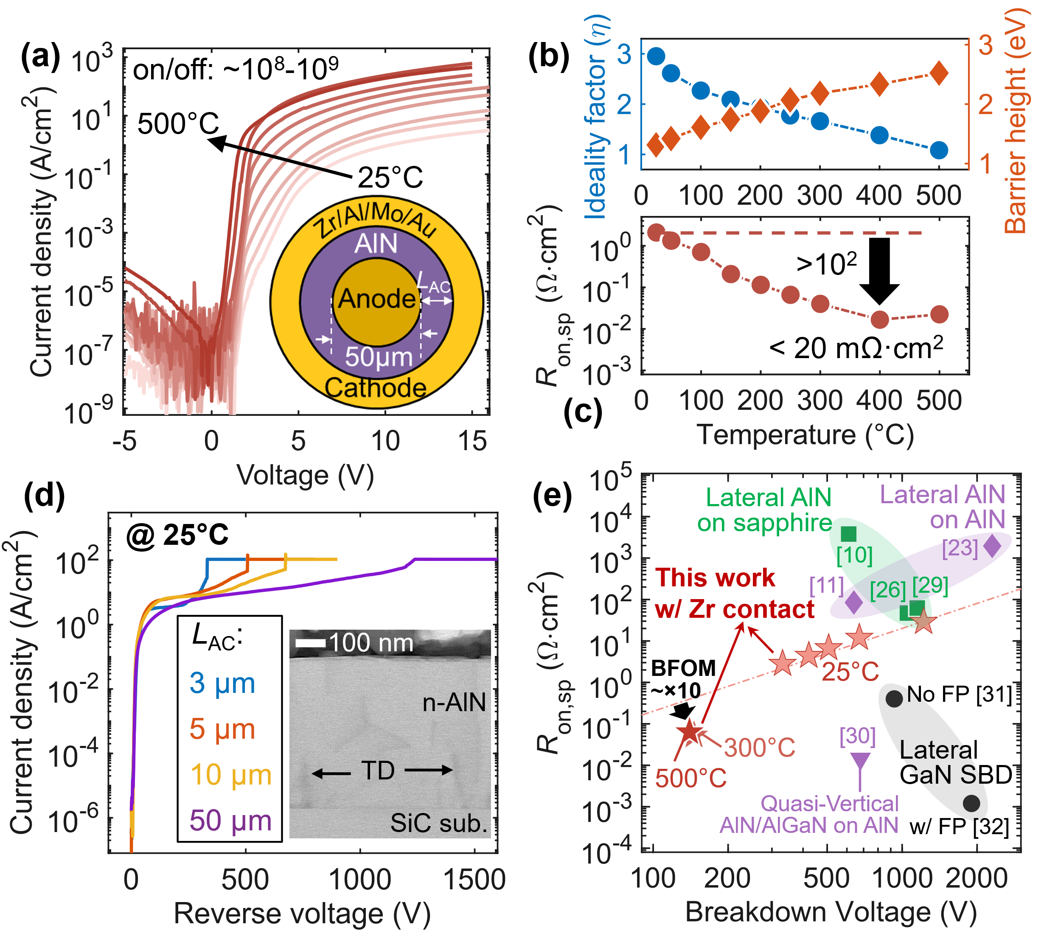
Fig. 5. (a) Temperature-dependent I-V characteristics of an SBD with Zr cathode. Inset: top-view schematic of the diode. (b) Ideality factor/barrier height and (c) R_{on,sp} (the slope of linear I-V region) as a function of temperature. (d) Breakdown characteristics at 25°C for various L_{AC}. Inset: TEM image of the heteroepitaxial AlN with threading dislocations (TDs) from the interface. (e) Benchmarking of this work against other AlN and GaN SBDs. Dashed line indicates the extracted BFOM for AlN SBDs at 25°C.
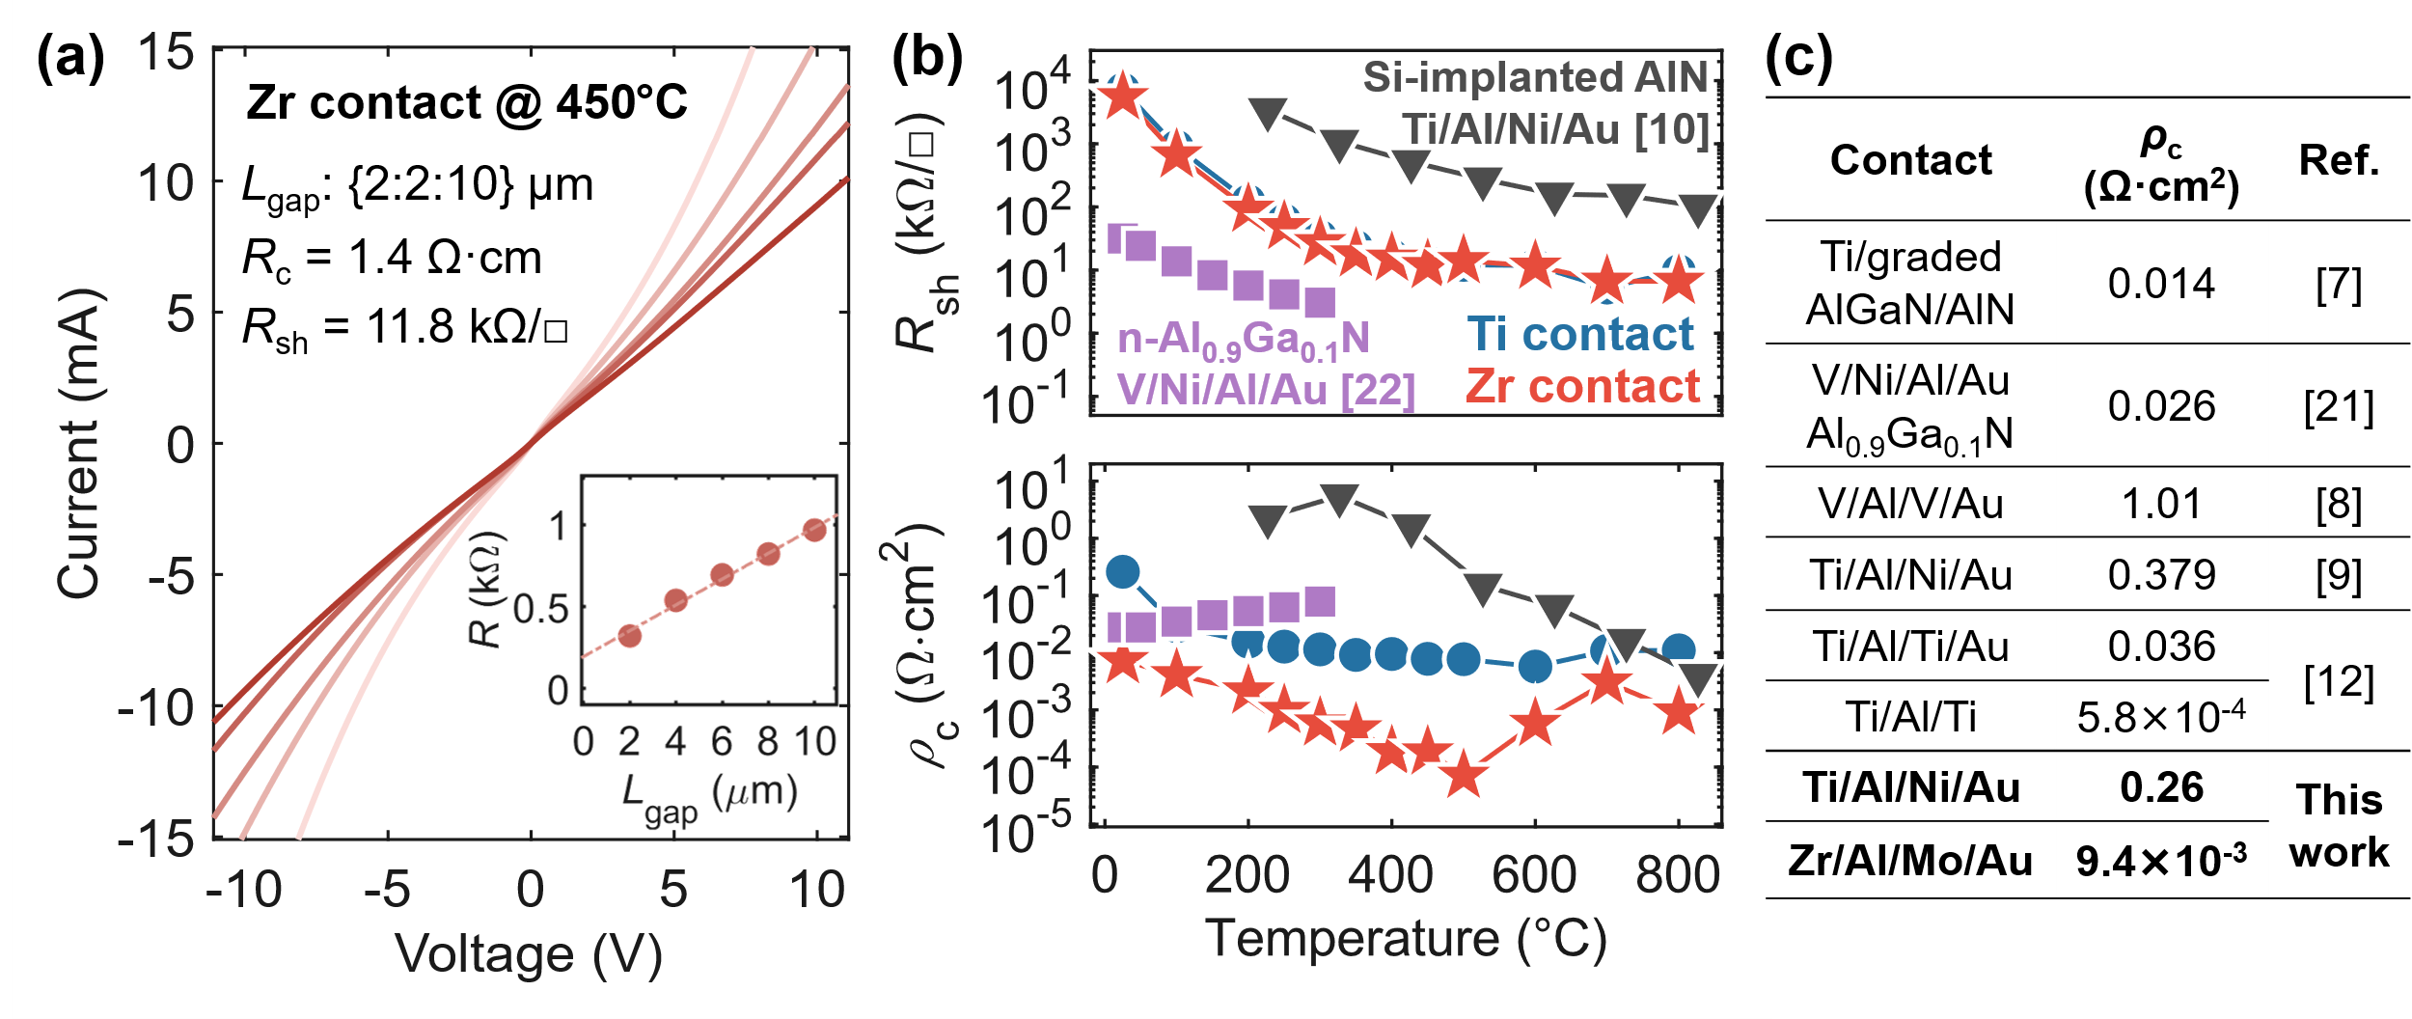
Fig. 4. (a) Measured TLM I-V characteristics of Zr-contact device at 450°C. The extracted (b) R_{sh} and (c) ρ_{c} as a function of temperature for the two contacts and literature with different configurations. (c) ρ_{c} comparison of different reported contacts to n-type AlN at RT.
Furthermore, temperature-dependent R_{sh} and ρ_{c} extracted from TLM are shown in Fig. 4b, with representative ohmic-like I-V curves for the Zr contact in Fig. 4a. R_{sh} values for both contacts overlap well across all temperatures, confirming the uniformity of the Si-doped AlN film. R_{sh} decreases rapidly below ~300°C due to dopant ionization dopants and increased carrier density, then saturates near 10 kΩ/◻︎ above 400°C as mobility degradation offsets further carrier increase. In contrast, ρ_{c} reduces over two orders of magnitude for the Zr contact, reaching 5.7×10⁻⁵ Ω·cm² at 500°C, whereas the Ti contact shows a ~30× reduction to 7.7×10⁻³ Ω·cm² at 600°C. Notably, a sharp rise in ρ_{c} occurs for the Zr contact above 500°C, while the Ti contact shows only a slight increase beyond 600°C. Compared to previous AlN contact studies [10],[22], our Zr-contact devices exhibit similar temperature dependency, with notably lower ρ_{c}. Among various AlN contact technologies listed in Fig. 4c, such as Ti on AlN [9],[12], V on Al_{0.9}Ga_{0.1}N [22] and using highly doped graded AlGaN as contact layer [7], the Zr contact reveals comparably low ρ_{c}.
To provide device-level validation, Zr contact was further implemented as the cathode for AlN SBDs. Fig. 5a shows the forward I-V characteristics of a lateral circular SBD (inset) with L_{AC} = 3 μm measured up to 500°C. The measured devices show high thermal stability and nearly a constant I-V characteristic for >10³ s. The on/off current ratio is ~10⁸ at RT, increasing to ~10⁹ at 300°C due to enhanced on-current, while higher temperatures cause off-current rise. The ideality factor (η) and apparent barrier height (ϕ_{B}) were extracted by fitting ln(J) ≈ qV/ηkT + ln(J₀) (Fig. 5b), where the slope and intercept yield η and J₀, respectively. The barrier height was then calculated using ϕ_{B} = (kT/q)⋅ln(A*T²/J₀), with A* = 38.4 A⋅cm⁻²K⁻² (electron effective mass of 0.32m₀) for AlN [28]. As temperature increases, η drops from 2.9 to 1.08, and ϕ_{B} increases to ~2.5 eV at 500°C. The relatively large η observed at RT is likely due to Schottky barrier inhomogeneity at the metal/AlN interface [26] together with defect-induced carrier transport [22], both of which introduce non-ideal current components beyond pure thermionic emission. Fig. 5c shows R_{on,sp} decreasing by over two orders of magnitude with temperature, reaching <20 mΩ·cm² at 400°C. RT breakdown measurements in Fluorinert FC-70 (Fig. 5d) reveal an average breakdown field >1 MV/cm for L_{AC} up to 5 µm, and V_{BD} >1.2 kV with 50-µm L_{AC}. The reverse leakage current may be attributed to conductive paths at the n-AlN/SiC interface (Fig. 5d inset), and introducing an undoped AlN interlayer is expected to suppress leakage by improving the interface and forming a back barrier. As summarized in Fig. 5e, our AlN SBDs with Zr contact exhibit the lowest R_{on,sp} among reported lateral AlN SBDs [10],[11],[23],[26],[29] despite still a higher value than quasi-vertical AlN [30] and GaN SBDs [31],[32]. Thanks to the significant reduction in R_{on,sp} with temperature, the BFOM (${\text{V}}_{\text{BD}}^{\text{2}}$/R_{on,sp}) improves by ~10 times at 300 and 500°C compared to RT, and exceeds reported Ga₂O₃ counterparts at the same temperature [33]. This highlights the strong potential for high-temperature electronics. The observed V_{BD} reduction at high temperatures is primarily attributed to measurements performed in air without Fluorinert passivation, and further improvement in high-temperature BFOM is expected with optimized passivation to avoid surface flashover.

Conclusion
We present a Zr-based metal stack for n-type AlN ohmic contact that achieves substantially lower contact resistivity than conventional Ti contacts from RT up to 800°C, enabled by the TFE-dominated carrier transport at the Zr/AlN contact interface. The resulting devices exhibit record-low R_{on,sp} among all reported lateral AlN SBDs with similar breakdown voltages and ~10× enhanced BFOM at 300 and 500°C compared to RT. These findings identify Zr as a promising contact metal for high-performance, high-temperature AlN power devices, paving the way toward practical ultrawide-bandgap electronics.

References
[1] W. A. Doolittle, C. M. Matthews, H. Ahmad, K. Motoki, S. Lee, A. Ghosh, E. N. Marshall, A. L. Tang, P. Manocha, and P. D. Yoder, “Prospectives for AlN electronics and optoelectronics and the important role of alternative synthesis,” Appl. Phys. Lett., vol. 123, no. 7, p. 070501, Aug. 2023 doi: 10.1063/5.0156691.
[2] J. Y. Tsao, S. Chowdhury, M. A. Hollis, D. Jena, N. M. Johnson, K. A. Jones, R. J. Kaplar, S. Rajan, C. G. Van de Walle, E. Bellotti, C. L. Chua, R. Collazo, M. E. Coltrin, J. A. Cooper, K. R. Evans, S. Graham, T. A. Grotjohn, E. R. Heller, M. Higashiwaki, M. S. Islam, P. W. Juodawlkis, M. A. Khan, A. D. Koehler, J. H. Leach, U. K. Mishra, R. J. Nemanich, R. C. N. Pilawa-Podgurski, J. B. Shealy, Z. Sitar, M. J. Tadjer, A. F. Witulski, M. Wraback, and J. A. Simmons, “Ultrawide-Bandgap Semiconductors: Research Opportunities and Challenges,” Adv. Electron. Mater., vol. 4, no. 1, p. 1600501, Jan. 2018 doi: 10.1002/aelm.201600501.
[3] M. Meneghini, C. De Santi, I. Abid, M. Buffolo, M. Cioni, R. A. Khadar, L. Nela, N. Zagni, A. Chini, F. Medjdoub, G. Meneghesso, G. Verzellesi, E. Zanoni, and E. Matioli, “GaN-based power devices: Physics, reliability, and perspectives,” J. Appl. Phys., vol. 130, no. 18, p. 181101, Nov. 2021 doi: 10.1063/5.0061354.
[4] Y. Zhang, D. Dong, Q. Li, R. Zhang, F. Udrea, and H. Wang, “Wide-bandgap semiconductors and power electronics as pathways to carbon neutrality,” Nat. Rev. Electr. Eng., vol. 2, no. 3, pp. 155–172, Mar. 2025 doi: 10.1038/s44287-024-00135-5.
[5] X. T. Trinh, D. Nilsson, I. G. Ivanov, E. Janzén, A. Kakanakova-Georgieva, and N. T. Son, “Stable and metastable Si negative-U centers in AlGaN and AlN,” Appl. Phys. Lett., vol. 105, no. 16, p. 162106, Oct. 2014 doi: 10.1063/1.4900409.
[6] P. Bagheri, C. Quiñones-Garcia, D. Khachariya, S. Rathkanthiwar, P. Reddy, R. Kirste, S. Mita, J. Tweedie, R. Collazo, and Z. Sitar, “High electron mobility in AlN:Si by point and extended defect management,” J. Appl. Phys., vol. 132, no. 18, p. 185703, Nov. 2022 doi: 10.1063/5.0124589.
[7] M. Hiroki and K. Kumakura, “Ohmic contact to AlN:Si using graded AlGaN contact layer,” Appl. Phys. Lett., vol. 115, no. 19, p. 192104, Nov. 2019 doi: 10.1063/1.5124936.
[8] R. France, T. Xu, P. Chen, R. Chandrasekaran, and T. D. Moustakas, “Vanadium-based Ohmic contacts to n-AlGaN in the entire alloy composition,” Appl. Phys. Lett., vol. 90, no. 6, p. 062115, Feb. 2007 doi: 10.1063/1.2458399.
[9] X. Li, J. Zhang, M. Sun, B. Ye, J. Huang, Z. Xu, W. Dong, J. Wang, and K. Xu, “Effect of annealing temperature on Ti/Al/Ni/Au ohmic contacts on undoped AlN films,” J. Semicond., vol. 38, no. 11, p. 116002, Nov. 2017 doi: 10.1088/1674-4926/38/11/116002.
[10] H. Okumura, Y. Watanabe, and T. Shibata, “Temperature dependence of electrical characteristics of Si-implanted AlN layers on sapphire substrates,” Appl. Phys. Express, vol. 16, no. 6, p. 064005, June 2023 doi: 10.35848/1882-0786/acdcde.
[11] D. Herath Mudiyanselage, D. Wang, B. Da, Z. He, and H. Fu, “Over 600 V Lateral AlN-on-AlN Schottky Barrier Diodes with Ultra-Low Ideality Factor,” Appl. Phys. Express, vol. 17, no. 7, p. 074001, July 2024 doi: 10.35848/1882-0786/ad5e5a.
[12] H. Cao, M. Nong, J. Li, X. Tang, T. Liu, Z. Liu, B. Sarkar, Z. Lai, Y. Wu, and X. Li, “Low contact resistivity at the 10−4 Ω cm2 level fabricated directly on n-type AlN,” Appl. Phys. Lett., vol. 125, no. 8, p. 081602, Aug. 2024 doi: 10.1063/5.0215744.
[13] N. Yafune, S. Hashimoto, K. Akita, Y. Yamamoto, H. Tokuda, and M. Kuzuhara, “AlN/AlGaN HEMTs on AlN substrate for stable high-temperature operation,” Electron. Lett., vol. 50, no. 3, pp. 211–212, Jan. 2014 doi: 10.1049/el.2013.2846.
[14] N. Yafune, S. Hashimoto, K. Akita, Y. Yamamoto, and M. Kuzuhara, “Low-Resistive Ohmic Contacts for AlGaN Channel High-Electron-Mobility Transistors Using Zr/Al/Mo/Au Metal Stack,” Jpn. J. Appl. Phys., vol. 50, no. 10R, p. 100202, Oct. 2011 doi: 10.1143/JJAP.50.100202.
[15] A. M. Armstrong, B. A. Klein, A. Colon, A. A. Allerman, E. A. Douglas, A. G. Baca, T. R. Fortune, V. M. Abate, S. Bajaj, and S. Rajan, “Ultra-wide band gap AlGaN polarization-doped field effect transistor,” Jpn. J. Appl. Phys., vol. 57, no. 7, p. 074103, June 2018 doi: 10.7567/JJAP.57.074103.
[16] X. Hu, S. Hwang, K. Hussain, R. Floyd, S. Mollah, F. Asif, G. Simin, and A. Khan, “Doped Barrier Al0.65Ga0.35N/Al0.40Ga0.60N MOSHFET With SiO2 Gate-Insulator and Zr-Based Ohmic Contacts,” IEEE Electron Device Lett., vol. 39, no. 10, pp. 1568–1571, Oct. 2018 doi: 10.1109/LED.2018.2866027.
[17] A. Mamun, K. Hussain, R. Floyd, M. D. Alam, M. Chandrashekhar, G. Simin, and A. Khan, “Al0.64Ga0.36N channel MOSHFET on single crystal bulk AlN substrate,” Appl. Phys. Express, vol. 16, no. 6, p. 061001, June 2023 doi: 10.35848/1882-0786/acd5a4.
[18] R. E. Loehman and A. P. Tomsia, “Reactions of Ti and Zr with AlN and Al2O3,” Proc. Int. Symp. Met.-Ceram. Interfaces, vol. 40, pp. S75–S83, Jan. 1992 doi: 10.1016/0956-7151(92)90266-H.
[19] R. A. Shishkin, V. S. Kudyakova, A. V. Chukin, and A. R. Beketov, “Study of ZrN-AlN formation solid-phase reaction in a nitrogen atmosphere during microwave heating,” IOP Conf. Ser. Mater. Sci. Eng., vol. 450, no. 3, p. 032045, Nov. 2018 doi: 10.1088/1757-899X/450/3/032045.
[20] B. Van Daele, G. Van Tendeloo, W. Ruythooren, J. Derluyn, M. R. Leys, and M. Germain, “The role of Al on Ohmic contact formation on n-type GaN and AlGaN∕GaN,” Appl. Phys. Lett., vol. 87, no. 6, p. 061905, Aug. 2005 doi: 10.1063/1.2008361.
[21] L. Sulmoni, F. Mehnke, A. Mogilatenko, M. Guttmann, T. Wernicke, and M. Kneissl, “Electrical properties and microstructure formation of V/Al-based n-contacts on high Al mole fraction n-AlGaN layers,” Photonics Res., vol. 8, no. 8, pp. 1381–1387, Aug. 2020 doi: 10.1364/PRJ.391075.
[22] T. Maeda, R. Page, K. Nomoto, M. Toita, H. G. Xing, and D. Jena, “AlN quasi-vertical Schottky barrier diode on AlN bulk substrate using Al0.9Ga0.1N current spreading layer,” Appl. Phys. Express, vol. 15, no. 6, p. 061007, May 2022 doi: 10.35848/1882-0786/ac702e.
[23] D. Herath Mudiyanselage, D. Wang, Z. He, B. Da, J. Xie, and H. Fu, “High-Temperature Electrical Characteristics of High-Voltage AlN Schottky Barrier Diodes on Single-Crystal AlN Substrates,” IEEE Trans. Electron Devices, vol. 72, no. 4, pp. 1637–1643, Apr. 2025 doi: 10.1109/TED.2025.3537073.
[24] D. Chettri, G. Mainali, H. Cao, J. H. Salcedo, M. Nong, M. Kumar, S. Yuvaraja, X. Tang, C. Liao, and X. Li, “Demonstration of aluminum nitride metal oxide semiconductor field effect transistor on sapphire substrate,” J. Phys. Appl. Phys., vol. 58, no. 3, p. 035104, Oct. 2024 doi: 10.1088/1361-6463/ad8759.
[25] S. Mukhopadhyay, L. A. M. Lyle, H. Pal, K. K. Das, L. M. Porter, and B. Sarkar, “Evidence of thermionic emission in forward biased β-Ga2O3 Schottky diodes at Boltzmann doping limit,” J. Appl. Phys., vol. 131, no. 2, p. 025702, Jan. 2022 doi: 10.1063/5.0068211.
[26] H. Fu, I. Baranowski, X. Huang, H. Chen, Z. Lu, J. Montes, X. Zhang, and Y. Zhao, “Demonstration of AlN Schottky Barrier Diodes With Blocking Voltage Over 1 kV,” IEEE Electron Device Lett., vol. 38, no. 9, pp. 1286–1289, Sept. 2017 doi: 10.1109/LED.2017.2723603.
[27] M. Kumar, S. Ishii, N. Umezawa, and T. Nagao, “Band engineering of ternary metal nitride system Ti1-x ZrxN for plasmonic applications,” Opt. Mater. Express, vol. 6, no. 1, pp. 29–38, Jan. 2016 doi: 10.1364/OME.6.000029.
[28] I. Vurgaftman, J. R. Meyer, and L. R. Ram-Mohan, “Band parameters for III–V compound semiconductors and their alloys,” J. Appl. Phys., vol. 89, no. 11, pp. 5815–5875, June 2001 doi: 10.1063/1.1368156.
[29] H. Cao, M. Nong, T. Liu, G. I. García, Z. Liu, X. Tang, M. Kumar, B. Sarkar, Y. Wu, and X. Li, “Performance Enhancement of n-Type AlN Schottky Barrier Diodes Using Oxygen-Rich Rapid Thermal Annealing Treatment,” IEEE Trans. Electron Devices, vol. 72, no. 3, pp. 1533–1536, Mar. 2025 doi: 10.1109/TED.2025.3532562.
[30] C. E. Quiñones, D. Khachariya, P. Reddy, S. Mita, J. Almeter, P. Bagheri, S. Rathkanthiwar, R. Kirste, S. Pavlidis, E. Kohn, R. Collazo, and Z. Sitar, “High-current, high-voltage AlN Schottky barrier diodes,” Appl. Phys. Express, vol. 17, no. 10, p. 101002, Oct. 2024 doi: 10.35848/1882-0786/ad81c9.
[31] Seung-Chul Lee, Min-Woo Ha, Jin-Cherl Her, Soo-Seong Kim, Ji-Yong Lim, Kwang-Seok Seo, and Min-Koo Han, “High breakdown voltage GaN Schottky barrier diode employing floating metal rings on AlGaN/GaN hetero-junction,” in Proceedings. ISPSD ’05. The 17th International Symposium on Power Semiconductor Devices and ICs, 2005., May 2005, pp. 247–250 doi: 10.1109/ISPSD.2005.1487997.
[32] M. Zhu, B. Song, M. Qi, Z. Hu, K. Nomoto, X. Yan, Y. Cao, W. Johnson, E. Kohn, D. Jena, and H. G. Xing, “1.9-kV AlGaN/GaN Lateral Schottky Barrier Diodes on Silicon,” IEEE Electron Device Lett., vol. 36, no. 4, pp. 375–377, Apr. 2015 doi: 10.1109/LED.2015.2404309.
[33] H. Ellis, W. Jia, I. Rahaman, A. Hillas, B. Li, M. A. Scarpulla, B. Sensale Rodriguez, and K. Fu, “Degradation of 2.4-kV Ga₂O₃ Schottky Barrier Diode at High Temperatures Up to 500°C,” IEEE Trans. Electron Devices, vol. 72, no. 10, pp. 5372–5378, Oct. 2025 doi: 10.1109/TED.2025.3601139.

This work is funded by the U. S. ARO/OSU grant (SPC-1000007046 | GR129057), the U. S. ARL and ARO grant (W911NF2320057), Wallenberg Foundation (KAW2023.0471), the AFOSR grant (FA9550-22-1-0367), and JSPS/KAKENHI (23K26556 and 25K01297). Z. Zhu, H. Pal, A. D. Varma, and T. Palacios are with the Microsystems Technology Laboratories, Massachusetts Institute of Technology, Cambridge 02139, MA, USA. (e-mail: zhuzhysh@mit.edu). M. Imura is with Research Center for Electronic and Optical Materials, National Institute for Materials Science, Tsukuba, Ibaraki 305-0044, Japan. H. Okumura is with Institute of Pure and Applied Sciences, University of Tsukuba, Tsukuba, Ibaraki 305-8573, Japan. This work was carried out in part through the use of MIT.nano's facilities.

