Origin of Intrinsic Operational Instability in Organic Field-Effect Transistors with Aligned High-Mobility Donor-Acceptor Copolymer Active Layers

Kenji Sakamoto,*,† Kirill Bulgarevich,†,‡,§ Takeshi Yasuda,† Takeo Minari,† and Masayuki Takeuchi†,‡

† National Institute for Materials Science (NIMS), 1-1 Namiki, Tsukuba, Ibaraki 305-0044, Japan
‡ Faculty of Pure and Applied Sciences, University of Tsukuba, 1-1-1 Tennodai, Tsukuba, Ibaraki 305-8571, Japan
§ Present address: Center for Emergent Matter Science (CEMS), RIKEN, 2-1 Hirosawa, Wako, Saitama, 351-0198, Japan
* E-mail: SAKAMOTO.Kenji@nims.go.jp

The origin of intrinsic operational instability in organic field-effect transistors (OFETs) is discussed by comparing bias stress effects of OFETs with unidirectionally aligned and unaligned active layers of two different semiconducting polymers under vacuum environment. By forming hydrophobic nano-groove structures on gate dielectric surfaces, a high-mobility donor-acceptor copolymer, poly[4-(4,4-dihexadecyl-4H-cyclopenta[1,2-b:5,4-b’]-dithiophen-2-yl)-alt-[1,2,5]thiadiazolo[3,4-c]pyridine] (PCDTPT) and a benchmark semicrystalline polymer, poly(2,5-bis(3-hexadecylthiophen-2-yl)thieno[3,2-b]thiophene) (PBTTT-C16), are successfully aligned. The mobilities of the PCDTPT-OFETs are higher than those of the PBTTT-OFETs, but the operational stabilities are lower. Moreover, for both semiconducting polymers, the aligned OFETs exhibit higher mobility but lower operational stability than the unaligned OFETs. These results indicate that an increase in mobility does not necessarily lead to an increase in operational stability. The interface trap density of states analysis reveals that the lower operational stability of PCDTPT-OFETs is not due to the tail state change but primarily due to the much larger turn-on voltage shift (ΔV_{on}). The major mechanism causing ΔV_{on} should be the charge carrier transfer from the channel to the gate dielectric. Since the energy barrier limiting the charge carrier transfer decreases with increasing ionization potential of the active layer, the lower operational stability of PCDTPT-OFETs is attributed to the higher ionization potential of PCDTPT.

KEYWORDS: polymer-based organic field-effect transistors; nano-grooves; bias-stress effects; charge carrier mobility; alignment control

1. Introduction
Polymer-based organic field-effect transistors (OFETs) have attracted much attention as promising active devices in large-area, low-cost, light-weight, flexible, and stretchable electronics because of good solution processability and superior mechanical properties of conjugated polymers. Improving field-effect charge carrier mobility is a central issue in this research field, because the cutoff frequency of OFETs is proportional to it. Since the report of polythiophene-OFETs in 1986 [], the field-effect mobility of polymer-based OFETs has been significantly improved from 10⁻⁵ to over 10 cm² V⁻¹ s⁻¹ [,]. First, continuous mobility improvement was achieved under a strategy of increasing long-range crystallinity and/or incorporating fused ring aromatic structures into the polymeric backbone structure to facilitate the charge transfer along the π-stacking direction through increasing π-π stacking overlap. As a result, semicrystalline polymers, such as regioregular poly(3-hexylthiophene-2.5-diyl) (RR-P3HT) [,] and poly(2,5-bis(3-alkylthiophen2-yl)thieno[3,2-b]thiophene) (PBTTT-Cn), were synthesized and utilized as active layer materials. The field-effect mobility equivalent to that of amorphous silicon (≈0.5 cm² V⁻¹ s⁻¹) was reported for spin-coated PBTTT films []. These polymers are still widely used as the benchmarks of polymeric organic semiconductors. By adopting the design concept of donor-acceptor (D-A) copolymers in which electron-donating and electron-accepting moieties alternate along the backbone structure, a breakthrough in the field-effect mobility was brought, and the field-effect mobility exceeded 1 cm² V⁻¹ s⁻¹ [-]. The D-A copolymer design enhances the intermolecular interaction through the attractive forces between the D and A moieties, shortening the intermolecular π-π stacking distance.
Among promising D-A copolymers, poly[4-(4,4-dihexadecyl-4H-cyclopenta[1,2-b:5,4-b’]-dithiophen-2-yl)-alt-[1,2,5]thiadiazolo[3,4-c]pyridine] (PCDTPT) received particular attention, because a very high field-effect hole mobility of 36.3 cm² V⁻¹ s⁻¹ was reported for the highly oriented films, which were formed by combined use of a hydrophobic nano-grooved surface and capillary action in a sandwich casting system []. Although an overestimation was pointed out for such a very high mobility afterward [,], the intrinsic mobility of the highly oriented PCDTPT films estimated by Okachi [] was still high, around 10 cm² V⁻¹ s⁻¹. Recently, a superior field-effect hole mobility of 72.94 ± 18.02 cm² V⁻¹ s⁻¹ was observed for single crystal PCDTPT nanowires prepared using a liquid-bridge-mediated nano-transfer molding method []. The fact that the field-effect hole mobility of spin-coated PCDTPT films (macroscopically random in-plane orientation) is about 0.5 cm² V⁻¹ s⁻¹ [] indicates that the macroscopic alignment of polymeric backbone structures is essential for such high field-effect mobilities [].
In addition to high field-effect mobility, the long-term operational stability must be achieved for commercialization; that is, the change in the electrical characteristics under continuous operation, bias-stress effect, must be minimized. Here, one might imagine that a positive correlation exists between field-effect mobility and operational stability, because efficient carrier transport (i.e., high field-effect mobility) may be favorable for high operational stability[,]. According to this, the following two questions arise. Does the adoption of high-mobility D-A copolymers improve the operational stability of OFETs? Does alignment of polymeric backbone structures improve not only mobility but also operational stability? To answer these questions and find the factors limiting the intrinsic operational stability, in this study the operational stability of PCDTPT-OFETs with unidirectionally aligned and unaligned (isotropic) active layers has been evaluated under vacuum environment and compared with that of the corresponding PBTTT-OFETs []. The evaluation under vacuum environment is essential, because extrinsic factors such as the atmospheric oxygen and moisture have a great influence on the operational stability of OFETs, masking the intrinsic relationship between field-effect mobility and operational stability and the origin of intrinsic operational instability. To minimize ambiguity in comparisons, PCDTPT-OFETs with almost the same device structures as PBTTT-OFETs were fabricated, and the bias-stress effects were evaluated under the same bias stress condition in the same measurement sequence. This careful comparison is also essential in this study. The sandwich casting combined with hydrophobic nano-grooved surfaces (alignment-inducing surfaces) is very effective at achieving a high degree of alignment, but it is a time-consuming process (6-8 h) and is not attractive from an application perspective. Thus, in this study hydrophobic nano-grooved surfaces were combined with spin-coating, which is a simple and fast solution coating technique.
The simple alignment technique worked well and the alignment-induced field-effect mobility enhancement was confirmed for both PCDTPT- and PBTTT-OFETs. The aligned OFETs exhibited higher mobility but lower operational stability than the unaligned OFETs for both semiconducting polymers. The PCDTPT-OFETs showed higher mobility but lower operational stability than the PBTTT-OFETs. From these results, it was found that there is no positive correlation between field-effect mobility and operational stability and also that increased surface roughness due to the formation of nano-grooves is unfavorable for the operational stability. These suggest the need to put an end to the molecular design and the development of alignment techniques that only pursue high mobility. To elucidate the origin of the lower operational stability of PCDTPT-OFETs, the interface trap density of states (DOS) analysis was performed. The major cause was found to be not the change in the tail states within the bandgap but much larger turn-on voltage shifts (ΔV_{on}) in the PCDTPT-OFETs than in the PBTTT-OFETs. The most likely mechanism causing ΔV_{on} is the charge carrier transfer from the channel to the gate dielectric. The energy barrier limiting the charge carrier (hole) transfer is the highest occupied molecular orbital (HOMO) level mismatch between the active layer and gate dielectric. Thus, the lower operational stability of PCDTPT-OFETs was attributed to the higher ionization potential of PCDTPT than that of PBTTT. We concluded that the charge carrier transfer from the channel to the gate dielectric is one of the origins determining the intrinsic operational instability in OFETs. This finding provides a useful strategy to realize p-type OFETs with high intrinsic operational stability.

2. Experimental Section
2.1 Materials
PCDTPT was purchased from 1-Material and used without further purification. The mass average molecular weight (polystyrene standard) and polydispersity reported in the certificate of analysis provided by the vendor were 76 kg mol⁻¹ and 2.5, respectively. Anhydrous chlorobenzene purchased from Sigma-Aldrich, electronics grade acetone and 2-propanol purchased from Kishida Chemical, toluene, dehydrated toluene, and electronics grade sulfuric acid and hydrogen peroxide purchased from Kanto Chemical, and octadecyltrichlorosilane (ODTS) provided by Acros Organics were used as received.
2.2 Preparation of Highly Hydrophobic Nano-Grooved Surfaces
Highly hydrophobic nano-grooved surfaces used as alignment-inducing surfaces were prepared following the same procedure described in ref.19, where the electrical properties and operational stability of OFETs with aligned and isotropic PBTTT-C16 active layers were already reported. Briefly, heavily doped n-type Si(100) substrates (20 × 20 mm²) with a thermally grown SiO₂ layer (≈100 nm thick) were cleaned sequentially with acetone and a piranha solution (a mixture of sulfuric acid and hydrogen peroxide). Then, nano-grooves were formed by scratching the SiO₂ surfaces using a homebuilt scratching machine with a diamond lapping film (3M 668X) whose nanoparticles size was 100 nm. Typical atomic force microscope (AFM) images of the scratched and unscratched SiO₂ surfaces are presented in Figure S1, Supporting Information. The root mean square surface roughness increased from 0.14 to 1.2 nm by forming nano-grooves. The substrates were cleaned again with acetone and a piranha solution in that order. Finally, the scratched SiO₂ surfaces were treated with ODTS vapor at 120 °C for 3 h to prevent charge trapping at the active layer/SiO₂ gate dielectric interface and increase the alignment ability of nano-grooved surfaces [19]. The resultant ODTS-treated surfaces exhibited water contact angles in excess of 110°.
2.3 Formation of Hydrophobic-Hydrophilic Patterned Surfaces
Coating such a highly hydrophobic gate dielectric surface with a semiconducting polymer film was difficult due to the repellent nature against organic solvents (lyophobicity). This difficulty could be solved by forming an appropriate hydrophobic-hydrophilic pattern on the highly hydrophobic gate dielectric surface [19-]. OFETs could be fabricated in the hydrophobic areas. Following the same procedure described in ref. 19, hydrophobic-hydrophilic patterns were formed on the SiO₂ surfaces with or without nano-grooves. Briefly, desired hydrophobic-hydrophilic (lyophobic-lyophilic) surface patterns were written by exposing the ODTS-treated surfaces to vacuum ultraviolet (VUV) light (wavelength 172 nm) through a photomask. The pattern of the photomask used for OFET array fabrication is shown in Figure 1a. The black and white regions are the blocking and transmissive areas, respectively. An excimer lamp irradiation unit (Ushio SUS06) was used as the light source. The VUV-light-exposed surface areas became hydrophilic (lyophilic).
2.4 Fabrication of PCDTPT-OFET Arrays
After forming hydrophobic-hydrophilic surface pattens, thin PCDTPT active layers were deposited on the SiO₂/n⁺-Si(100) substrates with or without nano-grooves by spin-coating with a 0.25 wt% solution of PCDTPT in chlorobenzene at room temperature in air. The rotation speed and duration of spin-coating were 1000 rpm and 180 s, respectively. The n⁺-Si substrate and ODTS-treated SiO₂ layer served as a common gate electrode and a gate dielectric, respectively. The spin-coated films were then annealed at 200 °C for 15 min in a nitrogen atmosphere following the previous reports [16,]. The PCDTPT film thickness estimated with a stylus type step profiler was ≈16 nm. To complete bottom-gate/top-contact (BG/TC)-type OFET arrays, source and drain (S/D) electrodes were formed on the annealed PCDTPT films by sequential thermal evaporation of MoO₃ (25 nm thick) and Au (63 nm thick) through a shadow mask in vacuum (base pressure < 6 × 10⁻⁴ Pa). The same shadow mask that was used for the fabrication of PBTTT-OFETs reported in ref. 19 was utilized, producing 12 × 5 arrays of OFETs with channel length (L)/width (W) of 50/300 μm in the hydrophobic gate dielectric surface areas. The channel direction of neighboring OFETs in the arrays was orthogonal to each other. Thus, parallel and perpendicular OFETs, 30 each, were formed on a single nano-grooved substrate, and 60 isotropic (unaligned) OFETs were fabricated on a single substrate without nano-grooves. Here, “parallel” and “perpendicular” specify the channel current direction with respect to the nano-groove direction. Figure 1b shows the optical microscope image of a BG/TC-type PCDTPT-OFET array with a nano-grooved gate dielectric surface, where the nano-grooves were formed along the vertical direction. The hydrophobic-hydrophilic (lyophobic-lyophilic) pattern can be seen as slight color difference due to interference effect.
2.5 Electrical Characterization
The electrical characteristics of OFETs were measured with a combined system of a vacuum probe station (VIC International, Inc. VMP-100) and a semiconductor parameter analyzer system composed of two source measure unit instruments (Keithley 2635B and 2636B) and a control software (Keithley ACS Basic Edition). Each OFET was isolated by removing the surrounding PCDTPT film with a tungsten needle in air. Then, an OFET array substrate was set in the vacuum probe station. After evacuation, the array was annealed at 200 °C for 15 min to remove residual oxygen and moisture in the PCDTPT active layer. First, the initial output and transfer characteristics of all OFETs were measured, and then the change in the transfer characteristics against on-state bias stress were measured for selected OFETs. The detailed conditions of the electrical measurements will be presented with the experimental data. All the above electrical measurements were performed at room temperature under vacuum conditions less than 10⁻⁴ Pa in the dark. The gate dielectric capacitance was measured with an LCR meter (HIOKI 3522-50).
2.6 Surface and Film Characterization
The contact angle measurements were performed with a Kyowa DM 500 contact angle meter, and the thickness of PCDTPT active layers and S/D electrodes were measured with a Kosaka ET200 stylus type step profiler. Optical microscope observation was performed with an Olympus BX51 optical microscope. AFM images were acquired with a system composed of Hitachi High-Tech AFM5100N and AFM5000II. Out-of-plane X-ray diffraction (XRD) measurements were performed with an RIGAKU SmartLab X-ray diffractometer. The thickness of PCDTPT and PBTTT-C16 films prepared for the XRD measurements were determined by an SII NanoTechnology L-Trace AFM.

3. Results and Discussion
3.1. Nano-Groove-Induced Alignment of PCDTPT
The alignment of PCDTPT backbone structures induced by nano-grooves was confirmed with polarizing optical microscope (POM). After annealing at 200°C, the POM images were captured in the reflection geometry of crossed Nicols at sample rotation angles of 0 and 45°. They are shown in Figures 1c and 1d, respectively. Here, the sample rotation angle is defined by the angle between the nano-groove direction and the transmission axis of the polarizer, which are indicated by the thin double-side arrow and the thick double-side arrow marked by “P”, respectively. From these two POM images, it is seen that the brightness oscillation by rotating the sample is observed only in the hydrophobic areas. This result indicates that the directional alignment of PCDTPT backbone structures was efficiently induced in hydrophobic areas, but little in the hydrophilic areas. The surface hydrophobicity is crucial for generating the alignment ability of nano-grooved surfaces.
3.2. Electrical Characterization of PCDTPT-OFET Arrays
The typical output characteristics of parallel, perpendicular, and isotropic PCDTPT-OFETs are presented in Figure 2a, Figures S2a, and S2b, Supporting Information, respectively. The transfer characteristics of the three OFETs are plotted together in Figure 2b. The transfer (output) characteristics were obtained by negatively increasing the gate-source voltage V_{gs} (drain-source voltage V_{ds}) down to -20 V as a forward sweep and immediately executing the reverse voltage sweep. In the transfer characteristic measurement, a constant V_{ds} of -20 V was applied, and in the output characteristic measurement, V_{gs} was varied from 0 to -20 V in increments of -4 V. Here, we should note that V_{ds} was limited to -20 V instead of -30 V, which was adopted for PBTTT-OFETs in our previous work [19]. As PCDTPT is a narrow band gap D-A copolymer [15], showing ambipolar characteristics, the minority carrier (electron) injection and trapping can easily occur under the off-state bias conditions, leading to the electrical device instability [] and the overestimation of field-effect mobility [13]. By carefully selecting bias conditions, the increase in off-current due to electron injection from the drain electrode was suppressed. As a result, no electron-trapping-induced double slope appeared in the |I_{d}|^{1/2}-V_{gs} characteristics. The three kinds of OFETs showed good p-channel transistor behavior with almost no drain current (I_{d}) hysteresis between the forward and reverse sweeps. The maximum current on/off ratio was greater than 10⁶ for the parallel and isotropic OFETs and 10⁵ for the perpendicular OFETs.
The field-effect hole mobility μ, threshold voltage V_{th}, and subthreshold swing SS were evaluated from the forward sweep transfer characteristics. The μ and V_{th} were derived using the equation describing I_{d} in the saturation regime under the gradual channel approximation:

$|I_{d}|=\frac{W}{2L}C_{i}μ{\left(V_{gs}-V_{th}\right)}^{2}$, (1)

where C_{i} is the gate dielectric capacitance per unit area: 34.1 nF cm⁻² for the parallel and perpendicular OFETs and 31.0 nF cm⁻² for the isotropic OFETs. The SS was determined from the partial transfer characteristics (not shown) separately measured at intervals of 0.05 V over the turn-on V_{gs} range. Figure 3a-c shows the histograms of μ, V_{th}, and SS, respectively, where the solid, open, and hatched bars are the data for the parallel, perpendicular, and isotropic OFETs, respectively. Their average values (A_{v}), standard deviations (σ), and relative standard deviations (σ/A_{v}) are listed in Table 1, together with the corresponding values for the OFET arrays with PBTTT-C16 active layers reported in our previous article [19]. The field-effect mobilities of the parallel, perpendicular, and isotropic PCDTPT-OFETs (μ//, μ⊥, and μ_{iso}) were 1.88 ± 0.05, 0.211 ± 0.007, and 0.501± 0.030 cm² V⁻¹ s⁻¹, respectively. The device-to-device variations of μ were very small (≈3%) for the parallel and perpendicular OFETs and relatively small (6%) for the isotropic OFETs. The μ// was significantly enhanced by a factor of ∼4 with respect to the μ_{iso}, whereas the μ⊥ was reduced by more than half. The charge transport anisotropy (μ///μ⊥) in the aligned PCDTPT active layer was ≈9. These results clearly show that the alignment-induced mobility enhancement (≈4) was realized by introducing nano-groove structures on the gate dielectric surface. The enhancement factor was much larger than that observed for PBTTT-OFETs, which was ≈2. The average values of V_{th} and SS were not so different with those for PBTTT-OFETs, but their distributions were relatively broader than those for PBTTT-OFETs.
3.3. Bias-Stress Effect of PCDTPT-OFETs
The operational stability of PCDTPT-OFETs in a vacuum environment was examined by evaluating the bias-stress effect under the same bias and measurement conditions that were adopted for PBTTT-OFETs in our previous work [19]. The bias-stress effect was measured by repeating cycles of constant prolonged gate-bias application and transfer curve acquisition in the linear regime. In particular, the initial transfer curve was acquired by sequentially sweeping V_{gs} between 2 and -30 V in the forward and reverse directions at V_{ds} = -1 V, and a constant prolonged on-state bias-stress (V_{gs} = -30 V and V_{ds} = -1 V) was applied 1 h after completing the initial transfer curve acquisition. The on-state bias stress application was interrupted at bias stress times of 5 × 10², 5 × 10³, and 2.5 × 10⁴ s, and immediately the linear transfer curves were acquired by sweeping V_{gs} between 0 and -30 V. Since the gate bias stress weakens during the transfer curve acquisitions, negatively-shifted V_{th} by the on-state bias stress application slightly shifts back in the positive direction. To minimize this unavoidable effect, the number of transfer curve acquisitions was reduced to three. Here, we should note that the injection of minority carriers (electrons) was not observed under the above bias stress and linear transfer curve acquisition conditions.
The linear transfer curves of the parallel, perpendicular, and isotropic PCDTPT-OFETs recorded at different bias stress times are shown in Figure 4a. All the OFETs showed apparent bias stress effect; that is, the transfer curves shifted in the negative voltage direction with increasing bias stress time. The field-effect mobility (μ^{lin}) and the threshold voltage (V_{th}^{lin}) in the linear regime were derived using the following equation:

$I_{d}=\frac{μ^{lin}WC_{i}}{L}V_{ds}\left(V_{gs}-V_{th}^{lin}-\frac{V_{ds}}{2}\right)$. (2)

Since the shape of the acquired transfer curves was not ideal (not straight line in the on-state V_{gs} region), we paid close attention to the derivation procedure using Equation (2). The slope of the transfer curve increased with increasing |V_{gs}| without saturating within the measurement range, but the transfer curve shape of each OFET in the high |I_{d}| region was almost identical during the prolong bias stress application: |I_{d}| > 2 μA, > 0.1 μA, and > 0.5 μA for the parallel, perpendicular, and isotropic OFETs, respectively. Thus, to achieve meaningful evaluation of μ^{lin} and V_{th}^{lin}, Equation (2) was applied to the I_{d}-V_{gs} data points around I_{d} equal to the maximum I_{d} of the transfer curve recorded at a bias stress time of 2.5 × 10⁴ s. The validity of this derivation can be confirmed from the good overlapping of all the transfer curves in the high |I_{d}| region after converting the horizontal axis from V_{gs} to V_{gs} - V_{th}^{lin} (see Figure S3, Supporting Information). The initial V_{th0}^{lin} and μ₀^{lin}, respectively, were -10.6 V and 2.31 cm² V⁻¹ s⁻¹ for the parallel OFET, -9.5 V and 0.268 cm² V⁻¹ s⁻¹ for the perpendicular OFET, and -9.7 V and 0.746 cm² V⁻¹ s⁻¹ for the isotropic OFET. Figure 4b shows the bias stress time dependences of the normalized V_{th}^{lin} shift and μ^{lin} defined by (V_{th}^{lin} - V_{th0}^{lin})/(V_{gs} - V_{th0}^{lin}) = ΔV_{th}^{lin}/(V_{gs} - V_{th0}^{lin}) and μ^{lin}/μ₀^{lin}, respectively. The normalized μ^{lin} of the three OFETs was almost unity throughout the whole bias stress period, which corresponds to no shape change of the transfer curves in the high |I_{d}| region with bias stress time as mentioned above. In the bias stress time dependences of the normalized ΔV_{th}^{lin}, a small difference can be seen between the parallel and perpendicular OFETs, but the small difference was within the device-to-device variation. See Table 2, in which the values of normalized ΔV_{th}^{lin} at 2.5 × 10⁴ s for the six OFETs examined (two devices for each parallel, perpendicular, and isotropic OFETs) are listed. Considering the device-to-device variation, here we can state only that the operational stability was slightly decreased by introducing nano-groove structures on the gate dielectric surfaces, regardless of whether the field-effect mobility was improved or reduced.
The operational stability was quantified by fitting the bias stress time dependence of ΔV_{th}^{lin} with a stretched exponential function:

$∆V_{th}^{lin}\left(t\right)=\left(V_{gs}-V_{th0}^{lin}\right)∙\left\{1-exp\left[-{\left(\frac{t}{τ}\right)}^{β}\right]\right\}$, (3)

where τ is the trapping time constant of carriers to fill trap levels and β (0 ≤ β ≤ 1) is a stretching factor representing the distribution of time constants [,]. The dotted curves in Figure 4b show the best fit results. τ and β of the six PCDTPT-OFETs examined in this study are listed in Table 2. All the six PCDTPT-OFETs showed β of around 0.33. In this case, the direct comparison of τ among the OFETs is meaningful, showing that introducing nano-groove structures onto the gate dielectric surfaces reduced the trapping time constant by half for PCDTPT-OFETs.
3.4. Comparison with PBTTT-OFETs
Now, we can compare the intrinsic operational stabilities of the PCDTPT- and PBTTT-OFETs with minimal ambiguity. This is because the device structures of both OFETs were almost the same and the bias stress effect was evaluated in a vacuum environment under the same bias stress condition in the same measurement sequence. The bias stress time dependences of the normalized ΔV_{th}^{lin} and μ^{lin} of PBTTT-OFETs [19] are shown in Figure 5. The normalized ΔV_{th}^{lin} at 2.5 × 10⁴ s, τ, and β of five PBTTT-OFETs (two parallel, a perpendicular, and two isotropic OFETs) are listed in Table 2. In Figure 6, the τ and β of all the OFETs examined were plotted on the horizontal and vertical axes, respectively.
Comparing Figures 4b and 5, it is seen that the normalized ΔV_{th}^{lin} in PCDTPT-OFETs increases faster with bias stress time than in PBTTT-OFETs, independent of the presence of nano-groove structures on the gate dielectric surfaces. This result explicitly shows that the operational stability of PCDTPT-OFETs is lower than that of PBTTT-OFETs. From Figure 6, the trapping time constants of the PCDTPT-OFETs are found to be at least an order of magnitude smaller than those of the PBTTT-OFETs. This relationship is opposite to that in the field-effect mobility; the field-effect mobilities of PCDTPT-OFETs are higher than those of PBTTT-OFETs as shown in Table 1. Moreover, the operational stability of both OFETs was degraded by introduction of nano-groove structure (alignment-inducing layer), whether the field-effect mobility was enhanced or reduced. (The degree of degradation was smaller in the PCDTPT-OFETs than in the PBTTT-OFETs. This is probably due to large paracrystalline disorder in the π-stacking direction of the PCDTPT active layers compared to that of the PBTTT ones as mentioned later; that is, large disorder should reduce the sensitivity to surface roughness.) From these results, it was found that there is no positive correlation between the field-effect mobility and operational stability; that is, the increase in mobility does not necessarily lead to the improvement of operational stability. In addition to this, it was suggested that alignment techniques that involve an increase in surface roughness should be avoided from the standpoint of operational stability.
3.5. Interface Trap DOS Analysis
In general, charge carrier mobility degradation and V_{th} shift occur simultaneously during bias stress application, where both shallow trap and deep tarp densities increase []. Charge carriers trapped in shallow trap sites are easily reactivated by heat, being able to contribute to channel current. Thus, the increase of shallow trap density results in decrease in charge carrier mobility through increase in the energetic disorder and activation energy for charge carrier hopping. On the other hand, charge carriers trapped in deep trap sites are immobilized and cannot contribute to channel current, acting as ionized scattering centers, which have little effect on the energetic disorder and activation energy []. Thus, increase in deep trap site density decreases mobile charge carrier density, resulting in V_{th} shift, but has little effect on charge carrier mobility. Therefore, the main traps that affect charge carrier mobility and V_{th} shift lie in different trapping energy range. Interestingly, both PCDTPT- and PBTTT-OFETs only experienced V_{th} shifts without charge carrier mobility degradation over the prolonged bias stress application, as shown in Figures 4b and 5. This suggests that shallow trap density changed little and deep trap site density increased.
To characterize the trap states created during bias stress application, the interface trap DOS was calculated from the transfer characteristics in the linear regime using Grünewald’s method [-]. Here, the same assumptions as in previous studies [,] were used; the flat-band voltage (V_{FB}) is equal to the turn-on voltage (V_{on}) in linear transfer characteristics; the quasi-Fermi level of the active layer coincides with the valence band edge (E_{v}) at the gate dielectric interface when the maximum value of the gate-source voltage above V_{FB}, which is defined by U_{gs} = |V_{gs} - V_{FB}|, is applied. Using the second assumption, the interface trap DOS can be plotted as a function of energy from E_{v}: that is, N(E - E_{v}). In these calculations, the literature value of 2.56 [] was used as the relative permittivity of PBTTT layers. That of PCDTPT layers was assumed to be 4.0, because the relative permittivity of organic semiconductor is generally between 3 and 4 [-]. The assumption of relative permittivity only affects the absolute value of the interface trap DOS. Specifically, as shown in Figure S5, Supporting Information, the absolute value of N(E - E_{v}) is inversely proportional to the relative permittivity used in calculation, but its profile is not affected. Thus, the assumption of relative permittivity is not problematic in the next discussion on the interface trap DOS profiles.
Figure 7a-c shows the interface trap DOS profiles before (thick curves) and after (thin curves) bias stress application (V_{gs} = -30 V and V_{ds} = -1 V for 2.5 × 10⁴ s) for the isotropic, parallel, and perpendicular PCDTPT-OFETs, respectively. Those for the corresponding PBTTT-OFETs are shown in Figure 7d-f. All the OFETs showed interface trap DOS profiles tailing into the band gap. The deeper tails were observed for PCDTPT-OFETs than for PBTTT-OFETs, regardless of whether the nano-groove structures exist on the gate dielectric surface. This can be clearly seen in Figure S6, Supporting Information. The deeper tails can be understood by larger paracrystalline disorder in the π-stacking direction of annealed PCDTPT films than that of terrace-phase PBTTT films. In high-molecular-weight (>50 monomer units) semicrystalline semiconducting polymers, pronounced disorder, probably due to chain folding, entanglement, and side-chain conformational disorder, exists in the π-stacking direction within lamellas, even though the lamella structures with high degree of edge-on orientation are formed along the normal to the substrate surface []. This is the case for annealed PCDTPT and terrace-phase PBTTT films. (The crystallinity evaluation of their lamella structures is described in Section S2, Supporting Information.) The dominant disorder in the π-stacking direction is paracrystalline disorder, which is a cumulative, static statistical fluctuation of local lattice spacing. It is quantified by the paracrystallinity (g), which can be accurately estimated from a single peak profile of XRD related to the π-stacking using the following equation [39, ]:

$g=\sqrt{\frac{∆_{q}}{2πq_{0}}}$, (4)

where q₀ and Δ_{q} are the center position and breadth of diffraction peak, respectively. The paracrystallinities of terrace-phase PBTTT-C12 and annealed PCDTPT films are estimated to be 7.3% and 11%, respectively, from the grazing incident X-ray diffraction (GIXD) data reported previously [23,]. (See Table S1, Supporting Information.) Unfortunately, the XRD peak profile related to the π-stacking was not reported for terrace-phase PBTTT-C16 films. However, both PBTTT-C12 and PBTTT-C16 show the same liquid crystalline phase at an elevated temperature [6,], and the both terrace-phase films are formed through the liquid crystalline phase. The lower g value for PBTTT-C12 is probably due to the nematic-like in-plane orientational order in the π-stacking direction []. Thus, it is appropriate to consider that both terrace-phase films exhibit approximately the same paracrystallinity. Considering that crystalline small-molecule semiconductors show: g < 1%, and amorphous semiconducting polymers: g = 10−20% [39], it is suggested that much larger paracrystalline disorder exists in annealed PCDTPT films than in terrace-phase PBTTT-C16 films. Paracrystalline disorder in the π-stacking direction creates deep tails of electronic states extending into the band gap with an energy spread that increases with increasing g []. Therefore, the deeper tail profiles are attributed to the larger paracrystalline disorder of the annealed PCDTPT films.
Now, we discuss the profile changes in the interface trap DOS (ΔN(E - E_{v})) with bias stress application (V_{gs} = -30 V and V_{ds} = -1 V for 2.5 × 10⁴ s). From Figure 7a-f, it is found that N(E - E_{v}) in the vicinity of E_{v} (E - E_{v} < ≈0.1 eV) is almost unchanged before and after the bias stress application for all OFETs. This corresponds to no change in the field-effect mobility during the bias stress application, as described above. To clearly show the profile change in the deep trap energy range, ΔN(E - E_{v}) of the PCDTPT- and PBTTT-OFETs were plotted on a linear vertical scale in Figures 7g and 7h, respectively. Here, it is noticed that the tail states of the parallel OFETs increase in a wide energy range (E - E_{v} > ≈0.1 eV) after the bias stress application, whereas those of the perpendicular OFETs increase only in the deeper energy range (E - E_{v} > 0.25 eV for PCDTPT and > 0.18 eV for PBTTT). For the isotropic OFETs, the profile change appears to be a combination of those for the parallel and perpendicular OFETs. The terrace-phase PBTTT (annealed PCDTPT) films are known to consist of highly ordered domains (aggregates) and spaghetti-like amorphous regions [39]. In the aligned OFETs, polymeric backbone structures are oriented on average parallel to the nano-groove direction. The fastest charge transport along the polymeric backbone structures can be efficiently used in the parallel OFETs, whereas cannot in the perpendicular OFETs. Thus, the number of interchain charge transfer events in the charge carrier transport from S to D electrodes should be much greater in the perpendicular OFETs than in the parallel OFETs. As efficient interchain charge transfer occurs in highly ordered regions with large π-orbital overlap, the contribution of highly ordered domains or aggregates to the channel current should be much larger in the perpendicular OFETs than in the parallel OFETs. Thus, ΔN(E - E_{v}) for the perpendicular OFETs might be mainly related to the interchain charge transfer in highly ordered domains or aggregates, while ΔN(E - E_{v}) for the parallel OFETs to the charge carrier transport along the polymeric backbone structures in both highly and less ordered regions. Along this line of thought, the combination characteristics in ΔN(E - E_{v}) for the isotropic OFETs can be understood. Moreover, from the inset of Figure 7g we can see that the increase in ΔN(E - E_{v}) for the perpendicular PCDTPT-OFETs is significantly smaller than that for the parallel PCDTPT-OFETs. This is probably due to the small volume ratio of highly ordered aggregates to less ordered regions. Since the tail states originate from the electronic states of polymeric semiconductor through paracrystalline disorder [39,44], a possible origin of the observed ΔN(E - E_{v}) is the increase in disorder caused by conformational change of polymers under gate bias stress application via the electrostrictive effect. Although this mechanism was proposed to explain the increase in shallow trap site density by Lee et al. [27], it is likely that deep trap site density increases as well. However, the origins of the observed ΔN(E - E_{v}) are still unclear.
In the Grünewald’s method, the effect of band bending of active layers in the absence of applied field is removed by using U_{gs} (= |V_{gs} - V_{FB}|) in the calculation of N(E- E_{v}) [30,32]; that is, the interface trap DOS only between E_{v} and the Fermi level can be obtained in this method. Charges trapped at the active layer/gate dielectric interface and/or in the gate dielectric with trap life-times on the order of hours [] or longer cause the band bending, changing V_{FB} and affect the value of V_{th}^{lin} [30,32]. Thus, in addition to ΔN(E - E_{v}), ΔV_{FB} (practically ΔV_{on}) during bias stress application must be considered to understand the operational stability. Figure 7i shows |ΔV_{on}| together with |ΔV_{th}^{lin}| and |ΔV_{th}^{lin} - ΔV_{on}| for all OFETs, where |ΔV_{th}^{lin} - ΔV_{on}| corresponds to the |ΔV_{th}^{lin}| component caused by ΔN(E - E_{v}) shown in Figure 7g,h. Multiplying the vertical axis of Figure 7i by C_{i}, which is almost the same (≈33 nF cm⁻²) for the six OFETs, gives the trapped charge density. Thus, Figure 7i allows a quantitative comparison of the trapped charge density between PCDTPT- and PBTTT-OFETs. A quick glance reveals that more than half of |ΔV_{th}^{lin}| was caused by |ΔV_{on}|. The contribution of |ΔV_{on}| to |ΔV_{th}^{lin}| was much higher in the PCDTPT-OFETs than in the PBTTT-OFETs, and interestingly almost 100% for the perpendicular PCDTPT-OFETs. On the other hand, the |ΔV_{th}^{lin} - ΔV_{on}| of the PCDTPT-OFETs was only slightly greater than that of the PBTTT-OFETs, except for the perpendicular OFETs. The |ΔV_{th}^{lin} - ΔV_{on}| of the perpendicular PCDTPT-OFET was almost zero. Thus, the major difference between the PCDTPT- and PBTTT-OFETs was in the amount of |ΔV_{on}|; the |ΔV_{on}| of the isotropic, parallel, and perpendicular PCDTPT-OFETs was about 4, 2, and 3 times greater than that of the corresponding PBTTT-OFETs, respectively. From these results, we found that the lower operational stability of PCDTPT-OFETs comes from the larger |ΔV_{on}|. In addition to this, the comparable |ΔV_{th}^{lin} - ΔV_{on}| for both PCDTPT- and PBTTT-OFETs may suggest that the two semiconducting polymers have similar resistance to bias stress application in terms of conformational changes.
3.6. Possible Mechanisms causing ΔV_{on}
The negative shift of V_{on} means an increase in the downward band bending near the gate dielectric/active layer interface. Considering that the evaluation of bias stress effects was performed under vacuum conditions to eliminate environmental effects and chemical degradation, two candidates would remain as possible mechanisms to explain this band bending []. One is the formation of bipolarons [27,], which are immobilized doubly charged states in the active layer. As the formation rate of bipolarons is proportional to the square of charge carrier density (N_{h}: holes in this study), it should be sensitive to the local density rather than the average one. For semicrystalline semiconducting polymers, an energy barrier exists between the highly and less ordered regions, because the HOMO-lowest unoccupied molecular orbital (LUMO) gap reduces with increasing conjugation length [39]. Thus, charge carriers would preferentially reside in the highly ordered regions (probably at the boundary). Since the size of highly ordered regions is smaller in annealed PCDTPT layers than in terrace-phase PBTTT layers (see L_{π-π} in Table S1, Supporting Information), the N_{h} of the PCDTPT active layer would become locally higher than that of the PBTTT one. Although the bipolaron formation rate is not determined solely by N_{h}, the larger |ΔV_{on}| of the PCDTPT-OFETs may be explained by the bipolaron formation.
The other is the charge carrier (hole) transfer from the channel to the gate dielectric under on-state (negative) gate bias application. The operational instability due to this charge transfer was reported by Kim et al. for pentacene-OFETs with 300 nm-thick SiO₂ gate dielectrics coated with 10 nm-thick layers of three different polymers [45]. The bias stress stability of the OFETs increased with increasing HOMO level mismatch between pentacene and the coating polymer. In this experiment, the HOMO level mismatch was varied from 1.54 to 3.35 eV. This result was explained by that the HOMO level mismatch acts as an energy barrier to limit the charge carrier transfer from the channel to the localized HOMO states of the polymer layer. We speculate that the same or similar charge carrier transfer process would occur for our OFETs with ODTS-treated SiO₂ gate dielectrics, although the HOMO level mismatch between the active layer and ODTS monolayer [] is very large (≈4.0 eV for PCDTPT [15] and ≈4.4 eV for PBTTT [-]) as shown in Figure 8a. Since the single monolayer thickness of ODTS is 2.65 nm [48], the charge carrier transfer from the channel to the localized states at the ODTS/SiO₂ interface by tunneling should be allowed. In this case, the HOMO level mismatch works as a tunneling barrier. The hydroxyl groups more or less remain due to imperfect passivation of hydrophilized SiO₂ surfaces with a long alkyl chain trichlorosilane (ODTS in this study) [,]. The remaining hydroxyl groups would act as the localized trap sites at the ODTS/SiO₂ interface. These two possible charge carrier transfer paths are shown in Figure 8b. Regardless of the details of the charge carrier transfer mechanism, the larger HOMO level mismatch, the more restricted the charge carrier transfer. Thus, the larger |ΔV_{on}| of PCDTPT-OFETs can be explained by the smaller HOMO level mismatch. Since the gate dielectrics are the same in this study, the lower intrinsic operational stability of PCDTPT-OFETs can be attributed to the higher ionization potential of PCDTPT.
We believe that the dominant mechanism causing ΔV_{on} is the charge carrier transfer, although the HOMO level mismatch is very large (4.0 - 4.4 eV). This is supported by a previous article, where Lee et al. [27] reported photo-induced charge transfer from channel to gate dielectric under gate bias application in RR-P3HT-OFETs with an ODTS-treated SiO₂ gate dielectric. As the ionization potential of P3HT is 4.89 eV [], the HOMO level mismatch against ODTS is ≈4.3 eV, close to the HOMO level mismatches between PCDTPT and ODTS (≈4.0 eV) and between PBTTT and ODTS (≈4.4 eV). In the photo-induced charge transfer experiments, to generate a high density of photocarriers (holes and electrons) near the P3HT/gate dielectric interface, the OFET channel was irradiated with monochromatic light with a wavelength of 500 nm (2.48 eV). Here, the important point is that the photon energy is greater than the band gap (≈1.95 eV [27]) of P3HT []. After irradiating the channel under a bias condition of non-zero negative (positive) V_{gs} and V_{ds} = 0 V, a negative (positive) ΔV_{on} was observed. The amount of ΔV_{on} can be controlled by varying V_{gs} and the duration and intensity of light irradiation [27,57]. Since the photon energy is much smaller than the HOMO level mismatch, it is inferred that the light irradiation is not essential for the charge transfer from the channel to the gate dielectric and utilized to induce a desired ΔV_{on} in an acceptable amount of time (on the order of minutes). Therefore, the results of photo-induced charge transfer strongly supports that the charge carriers (holes) transfer from the channel to the gate dielectric occurs under on-state (negative) gate bias application in our PCDTPT- and PBTTT-OFETs.
According to this mechanism, a general and valuable guideline to improve the intrinsic operational stability of p-type OFETs is to increase the HOMO level mismatch through decreasing the ionization potential of the active layer and/or increasing that of the gate dielectric. Unfortunately, there is the trade-off relationship between the intrinsic and environmental stabilities for p-type OFETs, because a low-lying HOMO level of the active layer is suitable for preventing oxidation (improving environmental operational stability) but unfavorable for the intrinsic operational stability. Therefore, synthesizing or finding gate dielectric materials and/or gate dielectric coating materials with high ionization potentials is the ideal strategy to increase the intrinsic and environmental operational stabilities of p-type OFETs. Otherwise, it is important to select or design and synthesize p-type semiconductor materials with appropriate ionization potentials, taking into account the balance between intrinsic and environmental stability.

4. Conclusion
To conclude, the intrinsic operational stability of aligned and isotropic PCDTPT-OFETs has been examined under vacuum condition and compared to that of the corresponding PBTTT-OFETs with minimal uncertainty. For both semiconducting polymers, the alignment-induced mobility enhancement by ODTS-treated nano-grooved SiO₂ gate dielectric surfaces was confirmed, but the operational stability of the parallel OFETs was lower than that of the isotropic OFETs. The field-effect hole mobilities of the parallel, perpendicular, and isotropic PCDTPT-OFETs were higher than those of the corresponding PBTTT-OFETs, while the operational stabilities were lower. From these results, we found that there is no positive correlation between the field-effect mobility and operational stability and also that alignment techniques that involve an increase in surface roughness should be avoided from the standpoint of operational stability. The interface trap DOS analysis revealed that the major cause for the lower operational stability of PCDTPT-OFETs was much larger |ΔV_{on}| in the PCDTPT-OFETs than in the PBTTT-OFETs. The most likely mechanism causing ΔV_{on} is the charge carrier transfer from the channel to the gate dielectric. The energy barrier limiting the charge carrier (hole) transfer is the HOMO level mismatch between the active layer and gate dielectric. As the gate dielectrics were the same for both OFETs, the lower intrinsic operational stability of PCDTPT-OFETs was attributed to the higher ionization potential of PCDTPT than that of PBTTT. The charge carrier transfer was concluded to be one of the origins determining the intrinsic operational instability in OFETs. The charge carrier transfer can be suppressed by increasing the HOMO level mismatch through decreasing the ionization potential of the active layer and/or increasing that of the gate dielectric. However, there is the trade-off relationship between the intrinsic and environmental stabilities, because a low-lying HOMO level of the active layer is suitable for preventing oxidation. Therefore, synthesizing or finding gate dielectric materials and/or gate dielectric coating materials with high ionization potentials is the ideal strategy to increase the intrinsic operational stability without lowering the environmental one. Finally, we would like to point out that close attention should be paid to the ionization potential from the perspective of not only environmental stability but also intrinsic stability, when novel p-type semiconducting materials are designed and synthesized.

Supporting Information.
Supporting Information is available from the Wiley Online Library or from the author.

Acknowledgements
The authors would like to thank Mr. Yasuji Masuda (NIMS) for the design and fabrication of the scratch machine used in this study and Dr. Takeshi Ogaki (NIMS) for training XRD measurements. A part of this work was supported by JSPS KAKENHI Grant No. 20K05310 and by “Advanced Research Infrastructure for Materials and Nanotechnology in Japan (ARIM)” of the Ministry of Education, Culture, Sports, Science and Technology (MEXT), Proposal Number JPMXP1223NM5185.

Conflict of Interest
The authors declare no conflict of interest.

Corresponding Author
*E-mail: SAKAMOTO.Kenji@nims.go.jp
Figures with captions

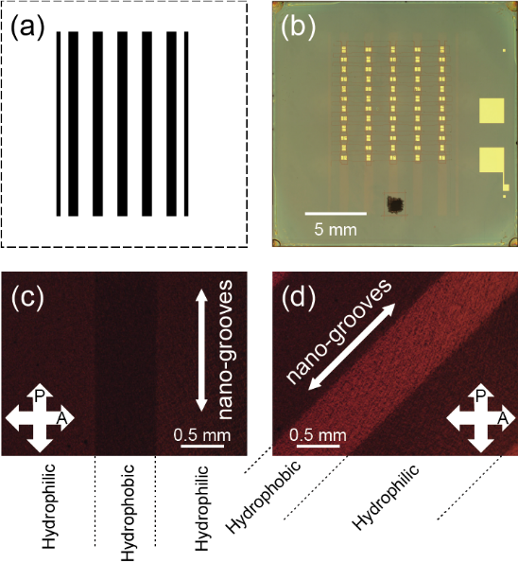
Figure 1. a) Photomask pattern used to fabricate PCDTPT-OFET arrays. The black and white areas are blocking and transmissive areas, respectively. b) Optical microscope image of a PCDTPT-OFET array with a hydrophobic nano-grooved SiO₂ gate dielectric. c,d) POM images of an annealed PCDTPT film formed on the nano-grooved SiO₂ gate dielectric surface with the hydrophobic-hydrophilic pattern, which were captured at sample rotation angles of 0 and 45°, respectively, in the reflection geometry of crossed Nicols. The sample rotation angle was defined by the angle between the nano-groove direction and the transmission axis of the polarizer, which are indicated by the thin double-side arrows and the thick double-side arrows marked by “P”, respectively.

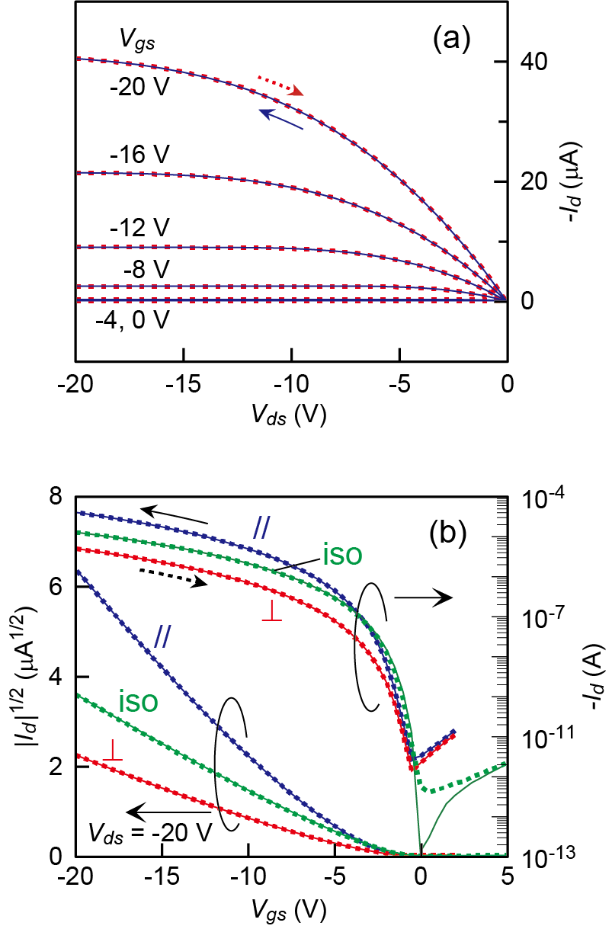
Figure 2. a) Typical output characteristics of parallel PCDTPT-OFETs. b) Typical transfer characteristics of parallel (//), perpendicular (⊥), and isotropic (iso) PCDTPT-OFETs. The data in the forward and reverse sweeps are shown by the solid and dotted curves, respectively.

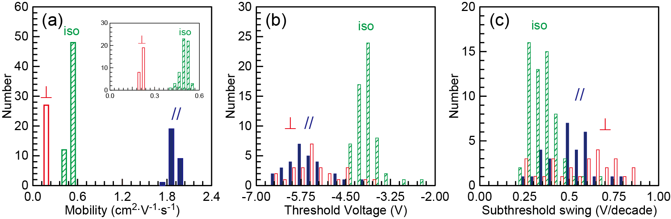
Figure 3. Histogram analysis of initial properties of PCDTPT-OFET arrays: a) field-effect mobility, b) threshold voltage, and c) subthreshold swing. The bin widths are: a) 0.12 cm² V⁻¹ s⁻¹ and inset: 0.03 cm² V⁻¹ s⁻¹, b) 0.25 V, and c) 0.05 V/decade. The solid, open, and hatched bars show the data for the parallel, perpendicular, and isotropic OFETs, respectively.

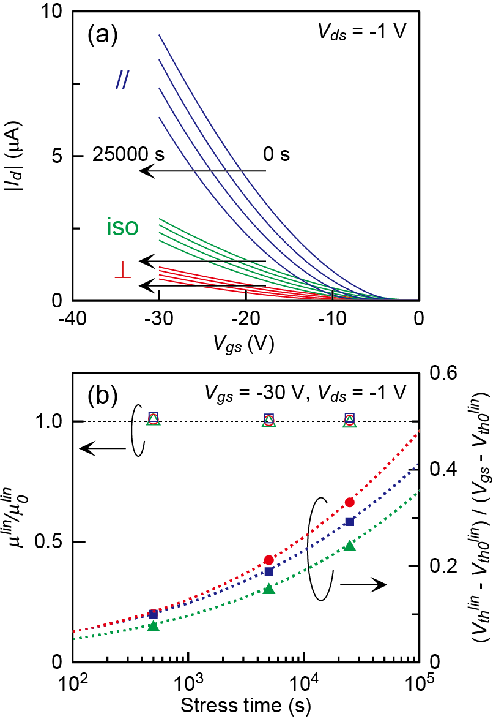
Figure 4. a) Transfer characteristics of the parallel (//), perpendicular (⊥), and isotropic (iso) PCDTPT-OFETs acquired in the linear regime at bias stress (V_{gs} = -30 V, V_{ds} = -1 V) times of 0, 5 × 10², 5 × 10³, and 2.5 × 10⁴ s. b) Bias stress time dependence of the normalized ΔV_{th}^{lin} and μ^{lin}. The data points for the normalized ΔV_{th}^{lin} and μ^{lin} are plotted by the filled and open symbols, respectively. The squares, circles, and triangles are the data points for the parallel, perpendicular, and isotropic PCDTPT-OFETs, respectively. The dotted curves are the fitting results with stretched exponential functions.

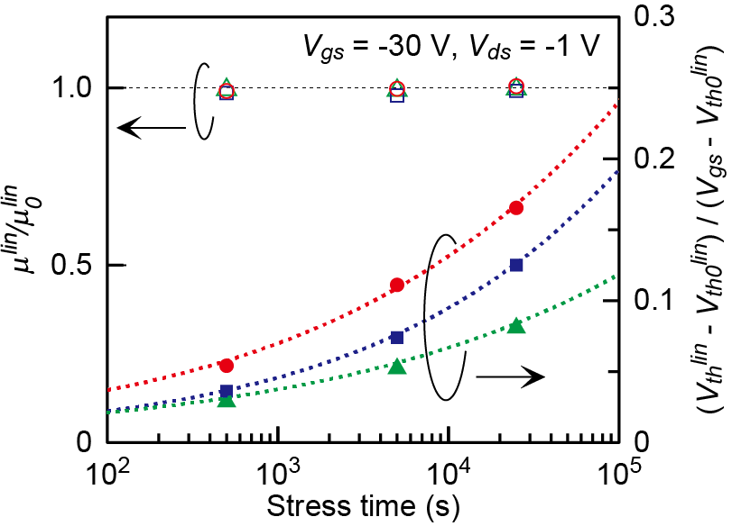
Figure 5. Bias stress time dependence of the normalized ΔV_{th}^{lin} and μ^{lin} of PBTTT-OFETs. The bias stress condition was V_{gs} = -30 V and V_{ds} = -1 V. The data points for the normalized ΔV_{th}^{lin} and μ^{lin} are plotted by the filled and open symbols, respectively. The squares, circles, and triangles are the data points for the parallel, perpendicular, and isotropic PBTTT-OFETs, respectively. These data were already reported in ref. [19], but the right vertical axis is replotted with the normalized ΔV_{th}^{lin} to facilitate comparison with Figure 4b.

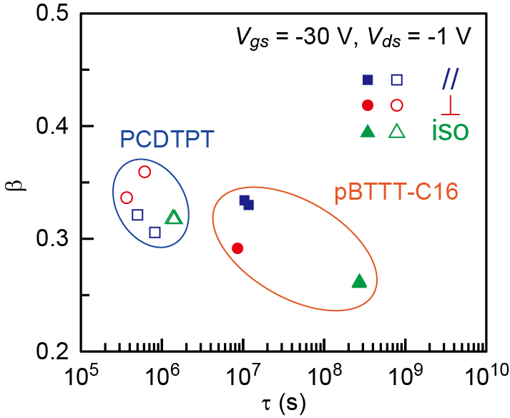
Figure 6. τ and β determined by fitting the bias stress time dependence of the ΔV_{th} with Equation (3). τ and β for PBTTT-OFETs reported in ref. [19] were plotted for comparison. The bias stress condition was V_{gs} = -30 V and V_{ds} = -1 V for both OFETs.

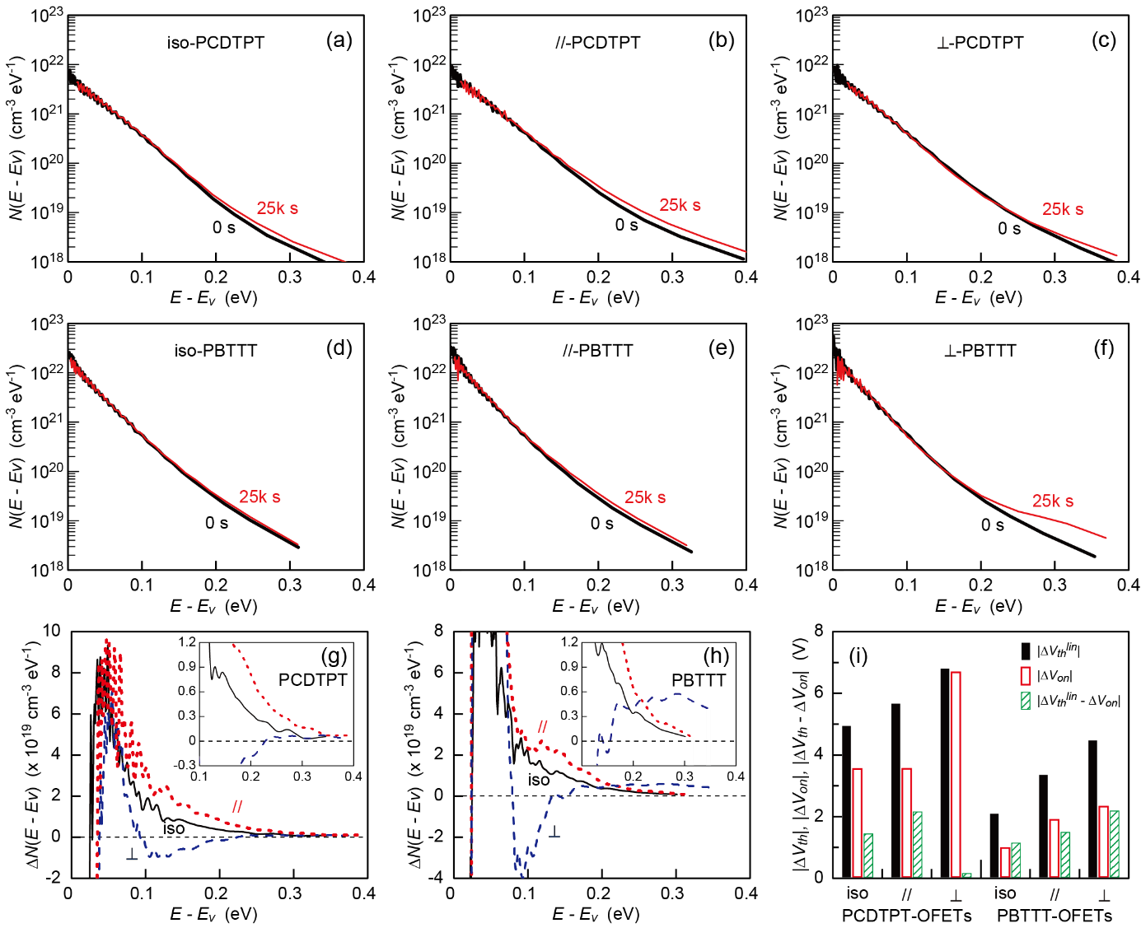
Figure 7. Interface trap DOS, N(E - E_{v}), calculated by the Grünewald’s method before (thick curves) and after (thin curves) bias stress application (V_{gs} = -30 V and V_{ds} = -1 V for 2.5 × 10⁴ s): a) isotropic, b) parallel, and c) perpendicular PCDTPT-OFETs and d) isotropic, e) parallel, and f) perpendicular PBTTT-OFETs. The relative permittivity was assumed to be 4.0 and 2.56 for PCDTPT and PBTTT, respectively. g,h) the difference of N(E - E_{v}) before and after the bias stress application for PCDTPT- and PBTTT-OFETs, respectively. The insets show the magnified ΔN(E - E_{v}) in the deep trap energy region. i) Absolute values of ΔV_{th}^{lin}, ΔV_{on}, and ΔV_{th}^{lin} - ΔV_{on} during the bias stress application for the six OFETs.

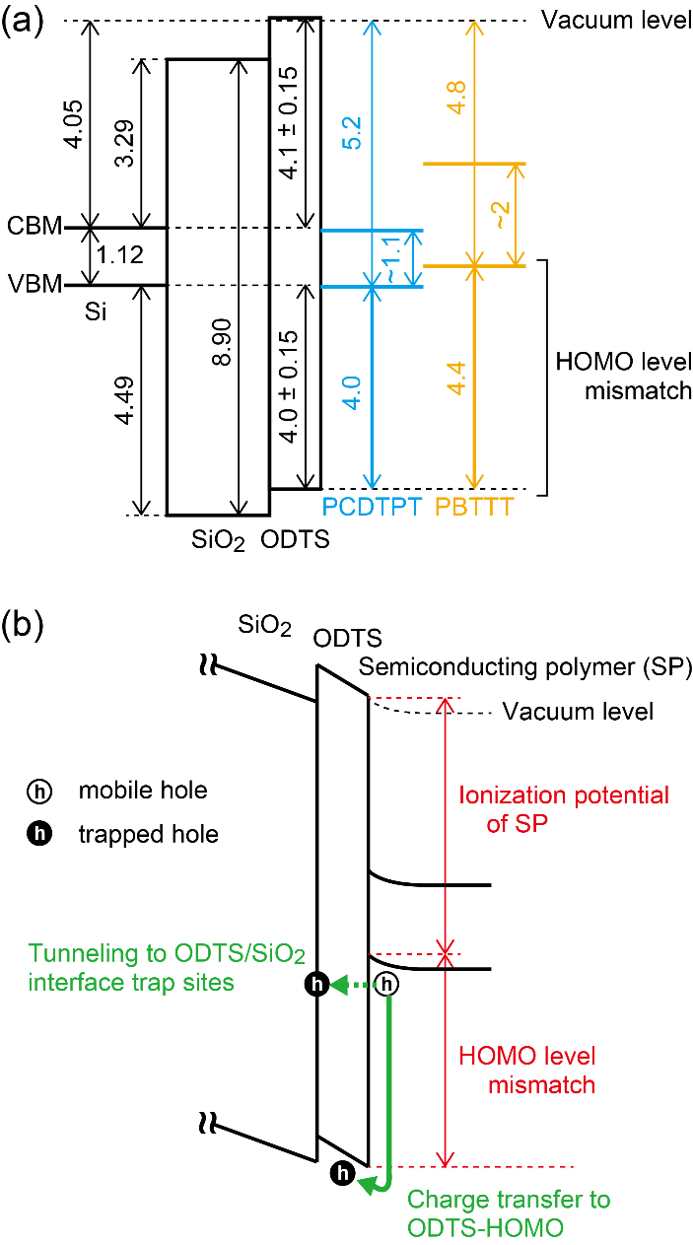

Figure 8. a) Band alignment of PCDTPT, PBTTT, ODTS, SiO₂, and Si relative to the vacuum level [15,48-53]. The unit is eV. b) Two possible charge carrier transfer paths (thick solid and dotted arrows) under on-state gate bias stress application.

Table 1. Summary of initial electrical properties (μ, V_{th}, and SS) of the parallel, perpendicular, and isotropic PCDTPT-OFETs, where A_{v} and σ are the average values and standard deviations, respectively. For comparison, those of PBTTT-OFETs previously reported in ref. [19] are also listed.
 | parallel OFETs |  |  |  | perpendicular OFETs |  |  |  | isotropic OFETs
 | A_{v} | σ | σ/A_{v} |  | A_{v} | σ | σ/A_{v} |  | A_{v} | σ | σ/A_{v}
 | PCDTPT (V_{ds} = -20 V)
μ (cm² V⁻¹ s⁻¹) | 1.88 | 0.05 | 2.7% |  | 0.211 | 0.007 | 3.3% |  | 0.501 | 0.030 | 6.0%
V_{th} (V) | -5.8 | 0.6 | ⎯ |  | -5.2 | 0.7 | ⎯ |  | -3.9 | 0.3 | ⎯
SS (V/decade) | 0.48 | 0.13 | ⎯ |  | 0.58 | 0.18 | ⎯ |  | 0.36 | 0.08 | ⎯
 | PBTTT-C16 ( V_{ds} = -30 V)
μ (cm² V⁻¹ s⁻¹) | 0.513 | 0.018 | 3.5% |  | 0.114 | 0.011 | 9.6% |  | 0.273 | 0.007 | 2.6%
V_{th} (V) | -5.7 | 0.2 | ⎯ |  | -5.1 | 0.4 | ⎯ |  | -6.0 | 0.2 | ⎯
SS (V/decade) | 0.41 | 0.08 | ⎯ |  | 0.48 | 0.07 | ⎯ |  | 0.45 | 0.07 | ⎯

Table 2 Summary of (V_{th}^{lin} – V_{th0}^{lin})/(V_{gs} – V_{th0}^{lin}) at 2.5 × 10⁴ s, τ, and β of PCDTPT- and PBTTT-OFETs.
Semiconductor | Gate-dielectric | $\frac{\left(V_{th}^{lin}-V_{th0}^{lin}\right)}{\left(V_{gs}-V_{th0}^{lin}\right)}$ at 25k s | τ [s] | β | Atmosphere | Ref.
PCDTPT | Nano-grooved ODTS-SiO₂ | 0.29 (//)  0.32 (//)  0.33 (⊥)  0.27 (⊥) | 8 × 10⁵ (//)  5 × 10⁵ (//)  4 × 10⁵ (⊥)  6 × 10⁵ (⊥) | 0.31 (//)  0.32 (//)  0.34 (⊥)  0.36 (⊥) | in vac. | this work
PCDTPT | ODTS-SiO₂ | 0.24  0.24 | 1 × 10⁶  1 × 10⁶ | 0.32  0.32 | in vac. | this work
pBTTT-C16 | Nano-grooved ODTS-SiO₂ | 0.13 (//)  0.12 (//)  0.17(⊥) | 1 × 10⁷ (//)  1 × 10⁷ (//)  9 × 10⁶ (⊥) | 0.33 (//)  0.33 (//)  0.29(⊥) | in vac. | [19]
pBTTT-C16 | ODTS-SiO₂ | 0.08  0.08 | 3 × 10⁸  3 × 10⁸ | 0.26  0.26 | in vac. | [19]

TOC/Abstract Graphic

Organic Field-Effect Transistors

K. Sakamoto,* K. Bulgarevich, T. Yasuda, T. Minari, M. Takeuchi

Origin of Operational Instability in Organic Field-Effect Transistors with Aligned High-Mobility Donor-Acceptor Copolymer Active Layers

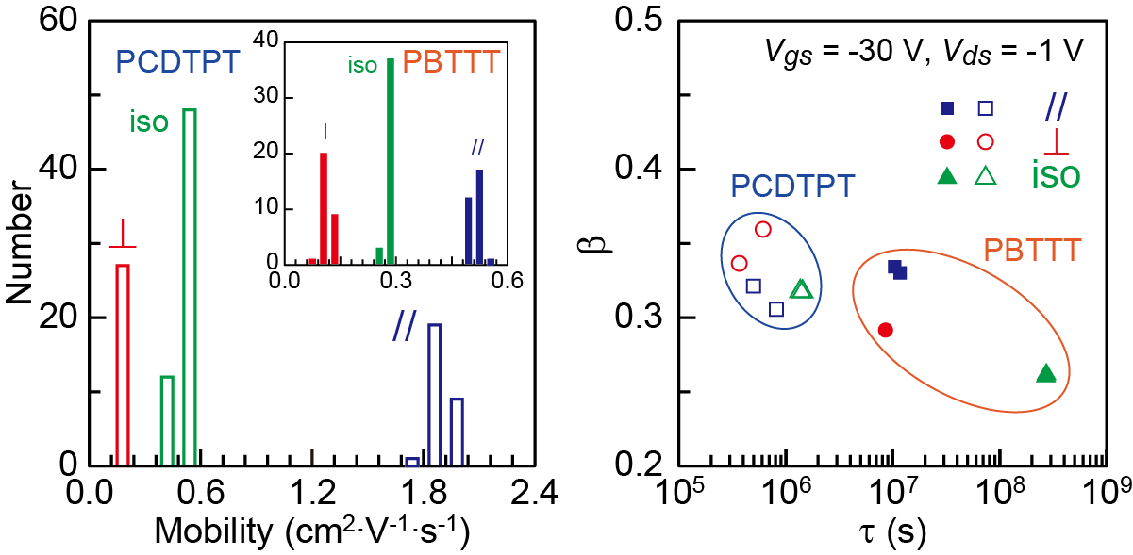
Organic field-effect transistors with aligned and unaligned active layers of a high mobility donor-acceptor copolymer (PCDTPT) showed lower operational stability than those with active layers of a benchmark semicrystalline polymer (PBTTT). This relationship was opposite to that in field-effect mobility. The main cause of lower operational stability was attributed to the ionization potential of PCDTPT higher than that of PBTTT.

References

[] Tsumura, A.; Koezuka, H.; Ando, T. Macromolecular electronic device: Field-effect transistor with a polythiophene thin film. Appl. Phys. Lett. 1986, 49, 1210-1212.
[] Khim, D.; Luzio, A.; Bonacchini, G. E.; Pace, G.; Lee, M.-J.; Noh, Y.-Y.; Caironi, M. Uniaxial Alignment of Conjugated Polymer Films for High-Performance Organic Field-Effect Transistors. Adv. Mater. 2018, 30, 1705463.
[] Dong, H.; Fu, X.; Liu, J.; Wang, Z.; Hu, W. 25th Anniversary Article: Key Points for High-Mobility Organic Field-Effect Transistors, Adv. Mater. 2013, 25, 6158–6183.
[] Richard D. McCullough, Renae D. Lowe, Manikandan Jayaraman, and Deborah L. Anderson, Design, synthesis, and control of conducting polymer architectures: structurally homogeneous poly(3-alkylthiophenes), J. Org. Chem. 1993, 58, 904–912.
[] Bao, Z.; Dodabalapur, A.; Lovinger, A. J. Soluble and processable regioregular poly(3-hexylthiophene) for thin film field-effect transistor applications with high mobility, Appl. Phys. Lett. 1996, 69, 4108-4110.
[] McCulloch, I.; Heeney, M.; Bailey, C.; Genevicius, K.; MacDonald, I.; Shkunov, M.; Sparrowe, D.; Tierney, S.; Wagner, R.; Zhang, W.; Chabinyc, M. L.; Kline, R. J.; McGehee, M. D.; Toney, M. F. Liquid-Crystalline Semiconducting Polymers with High Charge-Carrier Mobility. Nat. Mater. 2006, 5, 328-333.
[] Zhang, X.; Bronstein, H.; Kronemeijer, A. J.; Smith, J.; Kim, Y.; Kline, R. J.; Richter, L. J.; Anthopoulos, T. D.; Sirringhaus, H.; Song, K.; Heeney, M.; Zhang, W.; McCulloch, I.; DeLongchamp, D. M. Molecular Origin of High Field-Effect Mobility in an Indacenodithiophene–Benzothiadiazole Copolymer. Nat. Commun. 2013, 4, 2238.
[] Nielsen, C. B.; Turbiez, M.; McCulloch, I. Recent Advances in the Development of Semiconducting DPP-Containing Polymers for Transistor Applications. Adv. Mater. 2013, 25, 1859-1880.
[] Venkateshvaran, D.; Nikolka, M.; Sadhanala, A.; Lemaur, V.; Zelazny, M.; Kepa, M.; Hurhangee, M.; Kronemeijer, A. J.; Pecunia, V.; Nasrallah, I.; Romanov, I.; Broch, K.; McCulloch, I.; Emin, D.; Olivier, Y.; Cornil, J.; Beljonne, D.; Sirringhaus, H. Approaching Disorder-Free Transport in High-Mobility Conjugated Polymers. Nature 2014, 515, 384-388.
[] Luo, C.; Kyaw, A. K. K.; Perez, L. A.; Patel, S.; Wang, M.; Grimm, B.; Bazan, G. C.; Kramer, E. J.; Heeger, A. J. General Strategy for Self-Assembly of Highly Oriented Nanocrystalline Semiconducting Polymers with High Mobility. Nano Lett. 2014, 14, 2764-2771.
[] Bittle, E. G.; Basham, J. I.; Jackson, T. N.; Jurchescu, O. D.; Gundlach, D. J. Mobility overestimation due to gated contacts in organic field-effect transistors. Nat. Commun. 2016, 7, 10908.
[] McCulloch, I.; Salleo, A.; Chabinyc, M. Avoid the kinks when measuring mobility, Science 2016, 352, 1521-1522.
[] Okachi, T. Mobility overestimation due to minority carrier injection and trapping in organic field-effect transistors, Org. Electron. 2018, 57, 34-44.
[] Park, Y.; Jung, J. W.; Kang, H.; Seth, J.; Kang, Y.; Sung, M. M. Single-Crystal Poly[4-(4,4-dihexadecyl-4H-cyclopenta[1,2-b:5,4-b′]dithiophen-2-yl)-alt-[1,2,5]thiadiazolo[3,4-c]pyridine] Nanowires with Ultrahigh Mobility. Nano Lett. 2019, 19, 1028-1032.
[] Ying, L.; Hsu, B. B. Y.; Zhan, H.; Welch, G. C.; Zalar, P.; Perez, L. A.; Kramer, E. J.; Nguyen, T.-Q.; Heeger, A. J.; Wong, W.-Y.; Bazan, G. C. Regioregular Pyridal[2,1,3]thiadiazole π-Conjugated Copolymers. J. Am. Chem. Soc. 2011, 133, 18538-18541.
[] Tseng, H.-R.; Phan, H.; Luo, C.; Wang, M.; Perez, L. A.; Patel, S. N.; Ying, L.; Kramer, E. J.; Nguyen, T.-Q.; Bazan, G. C.; Heeger, A. J. High-Mobility Field-Effect Transistors Fabricated with Macroscopic Aligned Semiconducting Polymers. Adv. Mater. 2014, 26, 2993-2998.
[] Kim, D. H.; Lee, B. -L.; Moon, H.; Kang, H. M.; Jeong, E. J.; Park, J. -I.; Han, K. -M.; Lee, S.; Yoo, B. W.; Koo, B. W.; Kim, J. Y.; Lee, W. H.; Cho, K.; Becerril, H. A.; Bao, Z. Liquid-Crystalline Semiconducting Copolymers with Intramolecular Donor−Acceptor Building Blocks for High-Stability Polymer Transistors. J. Am. Chem. Soc. 2009, 131, 6124-6132.
[] Kim, B. J.; Lee, H. -S.; Lee, J. S.; Cho, S.; Kim, H.; Son, H. J.; Kim, H.; Ko, M. J.; Park, S.; Kang, M. S.; Oh, S. Y.; Kim, B. S.; Cho J. H. Correlation between Crystallinity, Charge Transport, and Electrical Stability in an Ambipolar Polymer Field-Effect Transistor Based on Poly(naphthalene-alt-diketopyrrolopyrrole). J. Phys. Chem. C 2013, 117, 11479-11486.
[] Bulgarevich, K.; Sakamoto, K.; Minari, T.; Yasuda, T.; Miki, K.; Takeuchi, M. Polymer-Based Organic Field-Effect Transistors with Active Layers Aligned by Highly Hydrophobic Nanogrooved Surfaces. Adv. Funct. Mater. 2019, 29, 1905365.
[] Horii, Y.; Sakaguchi, K.; Chikamatsu, M.; Azumi, R.; Yase, K.; Kitagawa, M.; Konishi, H. High-Performance Solution-Processed n-Channel Organic Thin-Film Transistors Based on a Long Chain Alkyl-Substituted C₆₀ Derivative. Appl. Phys. Express 2010, 3, 101601.
[] Bulgarevich, K.; Sakamoto, K.; Minari, T.; Yasuda, T.; Miki, K. Spatially Uniform Thin-Film Formation of Polymeric Organic Semiconductors on Lyophobic Gate Insulator Surfaces by Self-Assisted Flow-Coating. ACS Appl. Mater. Interfaces 2017, 9, 6237-6245.
[] Bulgarevich, K.; Sakamoto, K.; Yasuda, T.; Minari, T.; Takeuchi, M. Operational Stability Enhancement of Polymeric Organic Field-Effect Transistors by Amorphous Perfluoropolymers Chemically Anchored to Gate Dielectric Surfaces. Adv. Electron. Mater. 2020, 6, 2000161.
[] Wu, D.; Kaplan, M.; Ro, H. W.; Engmann, S.; Fischer, D. A.; DeLongchamp,D. M.; Richter, L. J.; Gann, E.; Thomsen, L.; McNeill, C. R.; Zhang, X. Blade Coating Aligned, High-Performance, Semiconducting-Polymer Transistors. Chem. Mater. 2018, 30, 1924-1936.
[] Phan, H,; Wang, M.; Bazan, G. C.; Nguyen, T. -Q. Electrical Instability Induced by Electron Trapping in Low-Bandgap Donor–Acceptor Polymer Field-Effect Transistors. Adv. Mater. 2015, 27, 7004-7009.
[] Kunii, M.; Iino, H.; Hanna, J. Bias-Stress Characterization of Solution-Processed Organic Field-Effect Transistor Based on Highly Ordered Liquid Crystals. Appl. Phys. Lett. 2017, 110, 243301.
[] Lee, W. H.; Choi, H. H.; Kim, D. H.; Cho, K. 25th Anniversary Article: Microstructure Dependent Bias Stability of Organic Transistors. Adv. Mater. 2014, 26, 1660-1680.
[] Lee, H.; Moon, B.; Son, S. Y.; Park, T.; Kang, B.; Cho, K. Charge Trapping in a Low-Crystalline High-Mobility Conjugated Polymer and Its Effects on the Operational Stability of Organic Field-Effect Transistors. ACS Appl. Mater. Interfaces 2021, 13, 16722–16731.
[] Li, C.; Duan, L.; Li, H.; Qiu, Y. Universal Trap Effect in Carrier Transport of Disordered Organic Semiconductors: Transition from Shallow Trapping to Deep Trapping. J. Phys. Chem. C 2014, 118, 10651-10660.
[] Grünewald, M.; Thomas, P.; Würtz, D. A Simple Scheme for Evaluating Field Effect Data, Phys. Status Solidi 1980, 100, K139–K143.
[] Weber, K.; Grünewald, M.; Fuhs, W.; Thomas, P. Field Effect in a-Si:H Films. Influence of Annealing and Light Exposure. Phys. Status Solidi B 1982, 110, 133-142.
[] Kalb, W. L.; Batlogg, B. Calculating the trap density of states in organic field-effect transistors from experiment: A comparison of different methods. Phys. Rev. B 2010, 81, 035327.
[] Kalb, W. L.; Meier, F.; Mattenberger, K.; Batlogg, B. Defect healing at room temperature in pentacene thin films and improved transistor performance. Phys. Rev. B 2007, 76, 184112.
[] Haneef, H. F.; Zeidell, A. M.; Jurchescu, O. D. Charge carrier traps in organic semiconductors: a review on the underlying physics and impact on electronic devices. J. Mater. Chem. C 2020, 8, 759-787.
[] Iqbal, H. F.; Ai, Q.; Thorley, K. J.; Chen, H.; McCulloch, I.; Risko, C.; Anthony, J. E.; Jurchescu, O. D. Suppressing bias stress degradation in high performance solution processed organic transistors operating in air. Nat. Commun. 2021, 12, 2352.
[] Kiefer, D.; Kroon, R.; Hofmann, A. I.; Sun, H.; Liu, X.; Giovannitti, A.; Stegerer, D.; Cano, A.; Hynynen, J.; Yu, L.; Zhang, Y.; Nai, D.; Harrelson, T. F.; Sommer, M.; Moulé, A. J.; Kemerink, M.; Marder, S. R.; McCulloch, I.; Fahlman, M.; Fabiano, S.; Müller, C. Double doping of conjugated polymers with monomer molecular dopants. Nat. Mater. 2019, 18, 149–155.
[] Armin, A.; Stoltzfus, D. M.; Donaghey, J. E.; Clulow, A. J.; Nagiri, R. C. R.; Burn, P. L.; Gentle, I. R.; Meredith, P. Engineering dielectric constants in organic semiconductors. J. Mater. Chem. C 2017, 5, 3736-3747.
[] Brebels, J.; Douvogianni, E.; Devisscher, D.; Eachambadi, R. T.; Manca, J.; Lutsen, L.; Vanderzande, D.; Hummelen, J. C.; Maes, W. An effective strategy to enhance the dielectric constant of organic semiconductors – CPDTTPD-based low bandgap polymers bearing oligo(ethylene glycol) side chains. J. Mater. Chem. C, 2018, 6, 500-511.
[] Wang, C.; Zhang, Z.; Pejić, S.; Li, R.; Fukuto, M.; Zhu, L.; Sauvé, G. High Dielectric Constant Semiconducting Poly(3-alkylthiophene)s from Side Chain Modification with Polar Sulfinyl and Sulfonyl Groups. Macromolecules 2018, 51, 9368-9381.
[] Noriega, R.; Rivnay, J.; Vandewal, K,; Koch, F. P. V.; Stingelin, N,; Smith, P.; Toney, M. F.; Salleo, A. A general relationship between disorder, aggregation and charge transport in conjugated polymers. Nat. Mater. 2013, 12, 1038-1044.
[] Rivnay, J.; Noriega, R.; Kline, R. J.; Salleo, A.; Toney, M. F. Quantitative analysis of lattice disorder and crystallite size in organic semiconductor thin films. Phys. Rev. B 2011, 84, 045203.
[] Chabinyc, M. L.; Toney, M. F.; Kline,R. J.; McCulloch,I,; Heeney, M. X-ray Scattering Study of Thin Films of Poly(2,5-bis(3-alkylthiophen-2-yl)thieno[3,2-b]thiophene). J. Am. Chem. Soc. 2007, 129, 11, 3226-3237.
[] Umeda, T.; Tokito, S.; Kumaki, D. High-Mobility and Air-Stable Organic Thin-Film Transistors with Highly Ordered Semiconducting Polymer Films. J. Appl. Phys. 2007, 101, 054517.
[] Zhang, X.; Hudson, S. D.; DeLongchamp, D. M.; Gundlach, D. J.; Heeney, M.; McCulloch, I. In-Plane Liquid Crystalline Texture of High-Performance Thienothiophene Copolymer Thin Films. Adv. Funct. Mater. 2010, 20, 4098-4106.
[] Rivnay, J.; Noriega, R.; Northrup, J. E.; Kline, R. J.; Toney, M. F.; Salleo, A. Structural origin of gap states in semicrystalline polymers and the implications for charge transport. Phys. Rev. B 2011, 83, 121306.
[] Kim, J.; Jang, J.; Kim, K.; Kim, H.; Kim, S. H.; Park, C. E. The Origin of Excellent Gate-Bias Stress Stability in Organic Field-Effect Transistors Employing Fluorinated-Polymer Gate Dielectrics. Adv. Mater. 2014, 26, 7241-7246.
[] Park, S.; Kim, S. H.; Choi, H. H.; Kang, B.; Cho, K. Recent Advances in the Bias Stress Stability of Organic Transistors. Adv. Funct. Mater. 2020, 30, 1904590
[] Street, R. A.; Salleo, A.; Chabinyc, M. L. Bipolaron Mechanism for Bias-Stress Effects in Polymer Transistors. Phys. Rev. B 2003, 68, 085316.
[] Boulas, C.; Davidovits, J. V.; Rondelez, F.; Vuillaume, D. Suppression of Charge Carrier Tunneling through Organic Self-Assembled Monolayers. Phys. Rev. Lett. 1996, 76, 4797-4800.
[] Zhuo, J. -M.; Zhao, L. -H.; Png, R. -Q.; Wong, L. -Y.; Chia, P. -J.; Tang, J. -C.; Sivaramakrishnan, S.; Zhou, M.; Ou, E. C. -W.; Chua, S. -J.; Sim, W. -S.; Chua, L. -L.; Ho, P. K. -H. Direct Spectroscopic Evidence for a Photodoping Mechanism in Polythiophene and Poly(bithiophene-alt-thienothiophene) Organic Semiconductor Thin Films Involving Oxygen and Sorbed Moisture. Adv. Mater. 2009, 21, 4747-4752.
[] Zhao, L. -H.; Png, R. -Q.; Chiam, C. C. H.; Guo, H.; Zhuo, J. -M.; Chua, L. -L.; Wee, A. T. S.; Ho, P. K. H. Polarization effects on energy-level alignment at the interfaces of polymer organic semiconductor films. Appl. Phys. Lett. 2012, 101, 053304.
[] Yamashita, Y.; Tsurumi, J.; Ohno, M.; Fujimoto, R.; Kumagai, S.: Kurosawa, T.; Okamoto, T.; Takeya, J.; Watanabe, S. Efficient molecular doping of polymeric semiconductors driven by anion exchange. Nature 2019, 572, 634-638.
[] Alay, J. L.; Hirose, M. The valence band alignment at ultrathin SiO2/Si interfaces. J. Appl. Phys. 1997, 81, 1606-1608.
[] S. M. Sze, "Physics of Semiconductor Devices (second edition)", Wiley, NY 1981.
[] Roh, J.; Kang, C. -m.; Kwak, J.; Lee, C.; Jung, B. J. Overcoming tradeoff between mobility and bias stability in organic field-effect transistors according to the self-assembled monolayer chain lengths. Appl. Phys. Lett. 2014, 104, 173301.
[] Lei, Y.; Wu, B.; Chan, W. -K. E.; Zhu, F.; Ong, B. S. Engineering gate dielectric surface properties for enhanced polymer field-effect transistor performance. J. Mater. Chem. C 2015, 3, 12267.
[] Lyon, J. E.; Cascio, A. J.; Beerbom, M. M.; Schlaf, R.; Zhu, Y.; Jenekhe, S. A. Photoemission study of the poly(3-hexylthiophene)/Au interface. Appl. Phys. Lett. 2006, 88, 222109.
[] Podzorov, V.; Gershenson, M. E. Photoinduced Charge Transfer across the Interface between Organic Molecular Crystals and Polymers. Phys. Rev. Lett. 2005, 95, 016602.

