Development of novel Ni-Co base P/M disk superalloy
by redesigning based on turbine blade alloy, TM-47

Toshio Osada^{1*}, Makoto Osawa¹, Yuhi Mori¹, Ayako Ikeda¹, Hiroshi Harada¹,
Takuma Kohata¹, Kyoko Kawagishi¹

- National Institute for Materials Science (NIMS), 1-2-1 Sengen, Tsukuba, Ibaraki 305-0047, Japan
*Corresponding author: OSADA.Toshio@nims.go.jp (T. Osada)

Keywords: Ni-Co base superalloys, Powder Metallurgy, Disk, Creep

Abstract
The temperature capability of current state-of-the-art high-pressure disk superalloys is around 700°C. To further improve their temperature capabilities, new disk alloy design approaches with a focus on blade alloy compositions, which was designed for applications at temperatures of above 900°C or higher, may be effective. In this study, novel Ni-Co base disk superalloys were designed based on a combination of Ni-base blade superalloy TM-47 and Co-12.5wt.% Ti, both of which possess a γ-γʹ two-phase structure. First screen results using single crystal casts revealed TM-47 to be a potentially promising candidate as a base alloy for Ni-Co base disk superalloy, while additions of Co-12.5 wt.% Ti to TM-47 was found to improve creep strength of the alloy. A later investigation using P/M alloys revealed that limited additions of Co-12.5wt.% Ti to the base alloy also improves powder manufacturability, phase stability, and high temperature proof stress. Thus, TM-47 M2 (20 wt.% addition of Co-12.5wt.% Ti to TM-47) was selected as a candidate alloy for subscale manufacturing trial. Creep tests at 760 °C/630MPa demonstrated that the selected TM-47 M2 provides superior creep properties compared to other conventional disk superalloys, especially for the 0.2 % creep time, which is a critical property for high pressure turbine disks.

Introduction
Polycrystalline Ni-base superalloys manufactured using the powder metallurgy (P/M) route [1] are widely employed in recent aeroengines as a high-pressure (HP) turbine disk, greatly contributing to the recent improvements in engine efficiency. A new advanced Ni-base superalloy, ME501 [2], has a reported temperature capability (temperature for 100 hours 0.2 % creep time at 630MPa) of 749 ℃, which is estimated from experimental times to 0.2 % creep under three tested conditions (704 ℃/ 690MPa, 760℃/500 MPa, and 815 ℃/ 345 MPa [2]). This implies that powder metallurgy manufacturing using gas atomized powder may allow for increased levels of strengthening elements such as Ta, Hf, and Nb, without forming solidification defects and macro-segregation, a potential risk during conventional casting of highly-alloyed superalloys.
Meanwhile, the National Institute for Materials Science (NIMS) has proposed a novel Ni-Co base superalloy design concept based on the combination of a Ni-base superalloy and a Co-base alloy (Co-Co₃Ti) that led to the creation of cast-and-wrought TMW-4M3 [3-4] and P/M TMP-5002 (HGN200). [5] When manufactured by the powder metallurgy (P/M) route, Co additions improve formability and phase stability while Ti additions increase the amount of γʹ precipitates which contributes to improved mechanical properties. Co also decreases the stacking fault energy contributing to additional strengthening through microtwinning deformation [6] which has been reported to improve the 0.2% creep time of an alloy. This creep property is more important than creep rupture life when designing HP disks as the part would be considered to fail after small increases in creep strain have been reached.
The purpose of this study is to design a new powder superalloy composition for disk applications with a targeted operating temperature of 800 ℃. For this, 4 different Ni-Co base SC superalloys, TM-47 M1, M2, M3 and M4 (TM-47 MX series) based on the Ni-base superalloy, TM-47 [7], an established Ni base superalloy for conventional casting (CC) blades, mixed with Co-12.5wt.% Ti alloy were tested. Further, the manufacturability via P/M route including atomized powder preparations and sintering process were evaluated for TM-47 MX series. Meanwhile, phase stability and high-temperature 0.2% proof stress of alloys manufactured via P/M route (gas atomization, Hot Isostatic Pressing (HIP) and heat-treatment) were evaluated. Based on the results of the first two studies, TM-47 M2 was down selected for the next step - subscale manufacturing. Finally, we evaluated the tensile creep properties of subscale sized bar sample for TM-47 M2 prepared by the ‘C&W’ route instead of the P/M route.

Experimental procedure
We designed 4 types of Ni-Co base superalloys based on the Ni-base superalloy, TM-47 [7], an established Ni-base superalloy for conventional casting (CC) blades, for disk applications. Here, the two-step alloy design/screening approach consisted of first using single crystal (SC) model alloys, followed by using P/M alloys, as shown in following sections are applied.

Alloy design and first screening using single crystal model alloys
For the first screening of new alloy compositions, single crystal (SC) model alloys having nominal compositions listed in Table 1 were cast by using a directional solidification furnace. After casting, all alloys were homogenized and aged at 870 ℃ for 20 h. The Ni-base CC superalloy, TM-47 was selected as a foundational candidate material as it satisfies the following three criteria [8] among the various NIMS proposed superalloys for turbine blade applications:
(i) alloys showing both creep property and corrosion resistance,
(ii) alloys having > 10 wt.% Cr content for formation of stable carbide precipitation, and
(iii) alloys with density of ≤ 8.5 g/cm³.
Here, TM-47 SC model alloy was modified by removing grain boundary strengthening elements such as C, B and Zr. In addition, 4 types of Ni-Co base SC superalloys, TM-47 M1, M2, M3 and M4 (MX series) were designed by mixing 10, 20, 30 and 40 wt.% of Co-12.5wt.% Ti alloy into TM-47 SC alloy, respectively. Here, the composition Co-12.5wt.% Ti was selected as it contained the same γʹ volume fraction (V_{f}) as TM-47 SC alloy at 800 ℃. For comparison, single crystal samples of U720Li [9], TMW-4M3 [4], TMP-5002 (HGN200) [5], ME3 [10], and ME501 [2] were also cast. As shown in Table 1, compared to these alloys, the TM-47 MX series has a higher amount of W and no Nb nor Hf, last two elements usually added to P/M alloys for strengthening purpose. Meanwhile, the V_{f} calculated at 800 ℃ using the Alloy Design Program (ADP) [11] is around 55 % for TM-47 MX series SC alloy. It is also worth noting that the density of the TM-47 MX alloys slightly decreases with the amount Co-12.5wt.% Ti added.
Tensile creep specimens with a diameter of 4 mm and gauge length of 22 mm were machined from aged single crystal (SC) model alloys. Constant load tensile creep tests were then performed at 800 ℃ to simulate the targeted operating temperature with an initial applied stress of 735 MPa.

Table 1 – Nominal alloy compositions of SC model alloy for screening and TM-47 CC alloy (Ni: Bal.).
Alloy name | Process |  | wt.% |  |  |  |  |  |  |  |  |  |  |  | Density | Volume fraction of γʹ calculated at 800 ºC by ADP, %
Alloy name | Process |  | Co | Cr | Mo | W | Al | Ti | Nb | Ta | Hf | C | B | Zr | g/cm³ | Volume fraction of γʹ calculated at 800 ºC by ADP, %
TM-47 | CC | Nominal | 9.50 | 12.80 | - | 8.70 | 3.70 | 3.90 | - | 2.60 | - | 0.11 | 0.01 | 0.05 | - | -
TM-47 | SC | Nominal | 9.50 | 12.80 | - | 8.70 | 3.70 | 3.90 | - | 2.60 | - | - | - | - | 8.51 | 55
TM-47 M1 | SC | Nominal | 17.30 | 11.52 | - | 7.83 | 3.33 | 4.76 | - | 2.34 | - | - | - | - | 8.48 | 54
TM-47 M2 | SC | Nominal | 25.10 | 10.24 | - | 6.96 | 2.96 | 5.62 | - | 2.08 | - | - | - | - | 8.45 | 53
TM-47 M3 | SC | Nominal | 32.90 | 8.96 | - | 6.09 | 2.59 | 6.48 | - | 1.82 | - | - | - | - | 8.43 | 53
TM-47 M4 | SC | Nominal | 40.70 | 7.68 | - | 5.22 | 2.22 | 7.34 | - | 1.56 | - | - | - | - | 8.40 | 55
U720Li | SC | Nominal | 15.0 | 16.0 | 3.0 | 1.25 | 2.5 | 5.0 | - | - | - | - | - | - | 8.14 | 38
TMW-4M3 | SC | Nominal | 25.0 | 13.5 | 2.8 | 1.2 | 2.3 | 6.2 | - | - | - | - | - | - | 8.14 | 42
TMP-5002 | SC | Nominal | 27.0 | 11.7 | 3.4 | 1.9 | 3.2 | 4.4 | 0.5 | 2.2 | 0.35 | - | - | - | 8.29 | 56
ME3 | SC | Nominal | 20.60 | 13.00 | 3.80 | 2.10 | 3.50 | 3.40 | 0.90 | 2.40 | - | - | - | - | 8.29 | -
ME501 | SC | Nominal | 18.00 | 12.00 | 2.90 | 3.00 | 3.00 | 3.00 | 1.50 | 4.80 | 0.40 | - | - | - | 8.53 | 53

Alloy design and second screening using P/M alloys
For the second screen of these new alloy compositions, samples having the compositions listed in Table 2 were manufactured via P/M route (gas atomization, HIP, and heat-treatment). P/M samples of ME3 [10] and ME501[2] were also produced for comparison to TM-47 MX alloy series. It should be noted that these compositions all include C, B, and Zr when the SC versions did not. All the alloy powders were prepared by a confined gas atomizer (VF-RQP1K, MAKABE Technical Research Co., Ltd., Japan) having a special nozzle [13-14] with the conditions at melt temperature of 1650 ℃ and at Ar gas pressure of 8.0 MPa [14]. The actual compositions for the atomized powders classified < 53 μm were also listed in Table 2. Classified powders < 53 μm were packed into stainless steel cylindrical cans (φ54 × L100 mm) in vacuum and sintered by Hot Isostatic Pressing (HIP) at 1120 ℃ for 4 h at 98 MPa resulting in high relative density > 99% of the consolidated material. All the Hot Isostatic Pressed (HIPed) samples were then heat-treated at γʹ supersolvus temperature of 1220 ℃ for 4 h and aged for two step conditions at 650 ℃ / 24 h / AC + 760 ℃ / 16 h / AC. The compression test samples (φ 6 × L9 mm) were cut from HIPed and heat-treated samples by Electrical Discharge Machining (EDM) and then polished. The compression tests were carried out at 725 ℃ and 800 ℃ with a strain rate of 10⁻⁵ s⁻¹.

Table 2 – Nominal alloy compositions of tested P/M alloys (Ni: Bal.)
Alloy name | Process |  | wt.%
Alloy name | Process |  | Co | Cr | Mo | W | Al | Ti | Nb | Ta | Hf | C | B | Zr
TM-47 | P/M | Nominal | 9.50 | 12.80 | - | 8.70 | 3.70 | 3.90 | - | 2.60 | - | 0.02 | 0.02 | 0.03
TM-47 | P/M | Actual (powder) | 9.60 | 13.20 | - | 8.85 | 3.69 | 3.89 | - | 2.69 | - | 0.03 | 0.02 | 0.03
TM-47 M1 | P/M | Nominal | 17.30 | 11.52 | - | 7.83 | 3.33 | 4.76 | - | 2.34 | - | 0.02 | 0.02 | 0.03
TM-47 M1 | P/M | Actual (powder) | 17.30 | 11.80 | - | 7.96 | 3.32 | 4.81 | - | 2.42 | - | 0.02 | 0.02 | 0.02
TM-47 M2 | P/M | Nominal | 25.10 | 10.24 | - | 6.96 | 2.96 | 5.62 | - | 2.08 | - | 0.02 | 0.02 | 0.03
TM-47 M2 | P/M | Actual (powder) | 25.40 | 10.40 | - | 7.07 | 2.93 | 5.82 | - | 2.10 | - | 0.023 | 0.02 | 0.03
TM-47 M3 | P/M | Nominal | 32.90 | 8.96 | - | 6.09 | 2.59 | 6.48 | - | 1.82 | - | 0.02 | 0.02 | 0.03
TM-47 M3 | P/M | Actual (powder) | 32.90 | 9.30 | - | 6.46 | 2.48 | 6.45 | - | 1.90 | - | 0.02 | 0.02 | 0.02
TM-47 M4 | P/M | Nominal | 40.70 | 7.68 | - | 5.22 | 2.22 | 7.34 | - | 1.56 | - | 0.02 | 0.02 | 0.03
TM-47 M4 | P/M | Actual (powder) | 41.10 | 7.90 | - | 5.38 | 2.19 | 7.33 | - | 1.61 | - | 0.02 | 0.02 | 0.02
ME3 | P/M | Nominal | 20.60 | 13.00 | 3.80 | 2.10 | 3.50 | 3.40 | 0.90 | 2.40 | - | 0.02 | 0.02 | 0.03
ME3 | P/M | Actual (powder) | 20.60 | 13.40 | 3.84 | 2.15 | 3.55 | 3.39 | 0.86 | 2.43 | - | 0.02 | 0.02 | 0.01
ME501 | P/M | Nominal | 18.00 | 12.00 | 2.90 | 3.00 | 3.00 | 3.00 | 1.50 | 4.80 | 0.40 | 0.05 | 0.03 | 0.05
ME501 | P/M | Actual (powder) | 18.00 | 12.40 | 2.93 | 2.97 | 3.01 | 2.96 | 1.45 | 4.86 | 0.33 | 0.06 | 0.02 | 0.05

Evaluation of microstructure and phase stability
Microstructures were analyzed using field-emission scanning electron microscopy (FESEM, ZEISS Gemini SEM300, Germany) with electron backscatter diffraction (EBSD). The EBSD scans were carried out in a FE-SEM using the TSL OIM data collection program. The average grain size was measured from EBSD data using OIM analysis program. Further, the γʹ volume fraction and size were measured from SEM images using ImageJ software. To evaluate phase constitutions and phase stability, all aged HIPed alloys were sealed into glasses with Ar and were long-term aged at 850℃, 750 ℃ and 650 ℃ for 3000 hours. The phase stability was investigated by Field-emission electron probe micro-analyzer (FE-EPMA, Shimazu EPMA-8050G) with a field-emission gun operating at 15 kV.

Preparation of subscale bar using the ‘C&W’ route
Finally, we evaluated the tensile creep properties. When manufacturing P/M disks, the HIPed sample must always go through an extrusion and isothermal forging at high temperatures to break the prior powder boundary (PPB). A subscale sized bar of TM-47 M2 was prepared using the ‘C&W’ route instead of the P/M route, as there is no large extrusion facility capable of manufacturing subscale bars from which tensile creep tests can be taken. For comparison, a billet of TMW-4M3, a typical C&W alloy, was also prepared using the C&W route. The subscale samples both of TM-47 M2 and TMW-4M3 were cast by 5kg Vacuum Induction Melting (VIM). The ingot of TM-47 M2 was then homogenized at a maximum temperature of 1220 ℃ for 25 h. The ingot, preheated at 1100 °C, was rolled and swaged into a bar sample (φ 20 mm × L300 mm). The bar samples of TM-47 M2 and TMW-4M3 were heat treated at γʹ sub-solvus temperatures of 1160 ℃ and 1100 ℃ for 4 h, respectively, to obtain the same grain size and volume fraction of primary γʹ precipitates, and then aged at 650 ℃ / 24 h / AC followed by 760 ℃ / 16 h / AC. The tensile creep specimen with a diameter of 4 mm and gauge length of 22 mm were machined from subscale sized bar sample. A constant load tensile creep test was then performed at 725 ℃ under 630MPa.

Results and Discussion

Creep behaviors of single crystal model Ni-Co base alloys
Figure 1 shows the creep curves of single crystal model alloys having compositions of (a) typical disk alloy and TM-47 SC, and (b) Ni-Co base superalloys (TM-47 MX series) tested at 800 ℃ and 735 MPa. As shown in Figure 1 (a), the TM-47 SC shows superior creep strength compared to other reported disk alloys. The result implies the TM-47 SC is a good candidate as a base alloy for future Ni-Co base disk superalloy. As shown in Figure 1 (b), the creep rupture life (t_{R}) significantly increases with increasing Co-12.5wt.% Ti addition with the longest life found to be from TM-47 M3 SC. Surprisingly, the t_{R} on TM-47 M3 SC was the almost similar to 2nd generation SC superalloy, CMSX-4 [12], which contains 6 wt.% Re and possesses a higher γʹ volume fraction than TM-47 M3 SC. However, when the additions of Co-12.5wt.% Ti increased beyond that in TM-47 M3 SC, the t_{R} began to decrease significantly as shown in the creep curve of TM-47 M4 SC.
However, it is worth noting that TM-47 M2 SC provided the longest 0.2 % creep time among TM-47 MX alloy series, and even longer than ME501 and CMSX-4 as shown in Figure 1 (c) and (d). The order of the 0.2 % creep time was TM-47 M2 SC >> TMP-5002 SC > TM-47 M1 SC > TM-47 M3 SC > TM-47 SC ~ TMW-4M3 SC ~ CMSX-4 > ME501>ME3. Notably, all tested Ni-Co base SC alloys exhibited longer 0.2 % creep time than CMSX-4, ME501 and ME3. This clearly shows that addition of Co-12.5 wt.% Ti to Ni base superalloys can effectively improve the 0.2 % creep time.
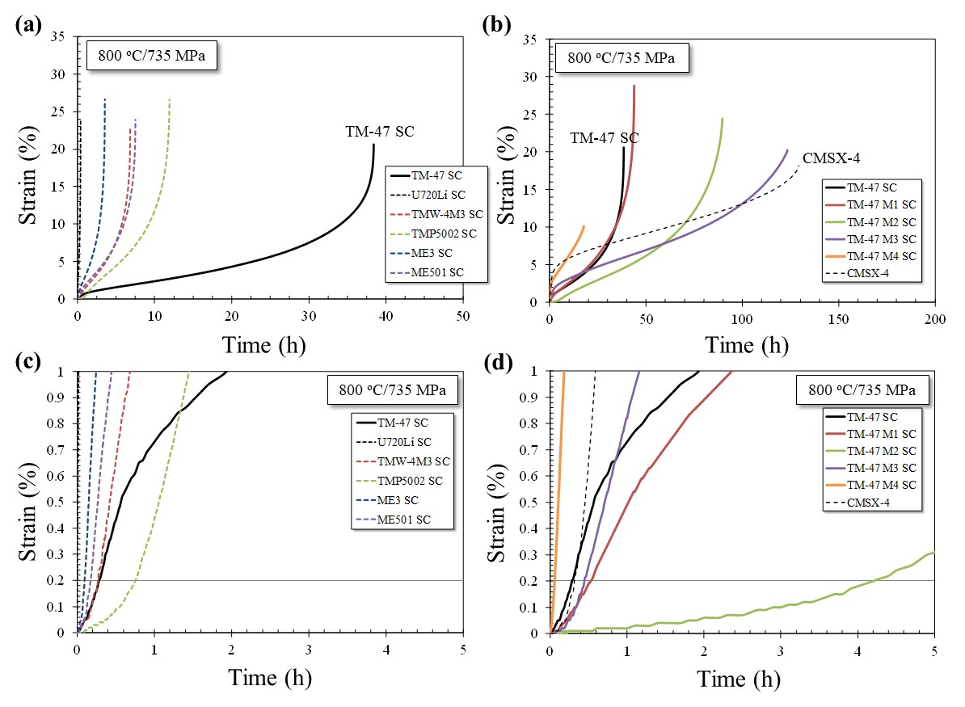
Figure 1 – Creep curves of (a) single crystal model alloys having compositions of typical disk alloy and TM-47; (b) TM-47 MX series SC tested at 800 ℃ and 735 MPa compared to CMSX-4; (c) early stage of creep curve of (a); and (d) early stage of creep curve of (b).

Feature of gas atomized powder for Ni-Co base alloys
Figure 2 shows the cumulative weight percent of size for gas atomized raw powders of TM-47 MX series, ME3, and ME501. As shown in figure 2 (a), for TM-47 MX series alloys, size of atomized powders decreased with Co-12.5wt.% Ti addition. The atomized powder features together with microstructure and phase stability were summarized in table 3. As an example, TM-47 M2 powder could achieve a higher yield of 76.0 % (size: < 53 μm) compared to the 63.2 % yield for ME3 alloy. Further, as shown in figure 2 (b), the powders were fine and showed a high circularity. The yield increment here significantly contributes less cost of raw powder for disk applications, since atomized powder is usually sieved to < 53 μm before canning for removing the ceramics inclusions acting as fatigue crack initiation sites [1]. Thus, it was concluded that the Ni-Co base superalloys design based on TM-47 SC possess excellent powder manufacturability.
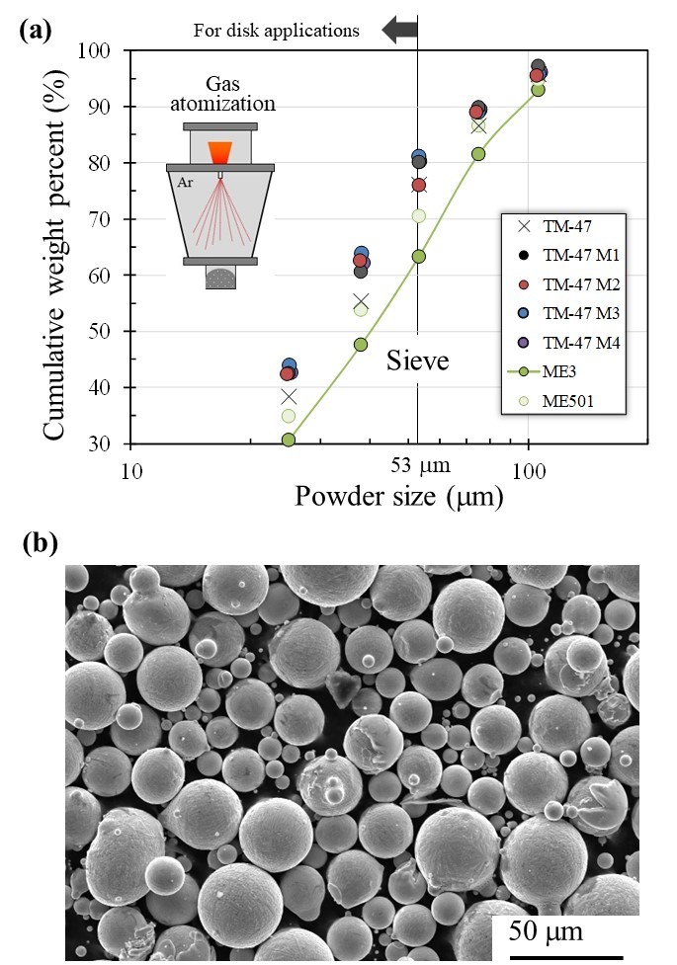
Figure 2 – Gas atomized powder characteristics: (a) Cumulative weight percent of size of gas atomized raw powder of TM-47 series, ME3, and ME501; (b) SEM image of TM-47 M2 powder classified to < 53 μm.

Table 3 – Atomized powder, initial microstructural features, phase stability at 650°C/750°C/850°C for 3000 hours, and mechanical property for tested P/M alloys
Alloy name | Process | Atomized powder | Microstructure features |  | Phase stability | Mechanical property
Alloy name | Process | Yield of < 53 mm powder [%] | Grain size  (mm) | Total γ’ volume fraction (%) | TCP phase #  by long term aging | Proof stress at 725 ℃/800℃  (MPa)
TM-47 | P/M | 76.1 | 34.3±16.1 | 55.5 | XXX | 985/778
TM-47 M1 | P/M | 80 | 29.1±14.9 | 58.8 | 0 | 1102/928
TM-47 M2 | P/M | 76 | 33.5±22.0 | 60.1 | 0 | 1080/891
TM-47 M3 | P/M | 81.1 | 28.8±15.2 | 62.9 | 0 | 995/797
TM-47 M4 | P/M | 80.3 | 34.1±13.9 | 61.5 | X | 950/749
ME3 | P/M | 63.2 | 37.4±18.2 | 54.4 | X | 1019/820
ME501 | P/M | 70.5 | 70.4±24.4 | 54.7 | XX | 1119/943
# Formation of TCP phase (σ, η, μ): No TCP phase (0), low (x), medium (xx), and large amounts (xxx) of TCP phase.

Initial microstructure and phase stability
Figure 3 shows the microstructure of the P/M TM-47 MX series alloys after aging. The grain size measured by EBSD, and the total amount of secondary and tertiary γʹ precipitates V_{f} measured by SEM images are summarized in Table 3. The average grain size is around 30 μm for the TM-47 MX series and the ME3 alloys, and 70.4 μm for the ME501 alloy. The measured V_{f} of γʹ on the alloy aged at 760 °C increases from 55.5 % to 61.5 % with additions of Co-12.5wt.% Ti, although TM-47 MX series alloys were designed with almost same V_{f} at 800 °C by ADP. Further, the measured V_{f} is slightly larger than that of ME501 and ME3.
Figure 4 shows the typical microstructures of TM-47 MX series, ME3, and ME501 exposed at 850 ℃, 750 ℃, and 650 ℃ for 3000 hours. In the base alloy, TM-47, significant TCP phases (white color phase in figure) can be observed especially after the 850 ℃ aging. From EPMA analysis, it was confirmed that the TCP phases comprise of μ and η phases, which are mainly composed of (Cr, W, Ta) and (Ni, Ta, Al, Ti), respectively. These TCP phases (white color) appear to not precipitate within grains of TM-47 M1, M2, and M3 compositions which contain lower amount of Cr, W, and Ta. Meanwhile, small amounts of TCP phase (σ phase) possibly composed of (Cr, Ni, Co) was detected in TM-47 M3 and TM-47 M4 by EPMA. The presence of σ phase in TM-47 M3/4 is most likely due to the increased Co content. Further the carbides composed of (Ti, Zr, C) can be observed as a large black phase especially in TM-47 M3 and M4 exposed at 650 ℃, although the smaller black spots are either oxides or pores. Some TCP formation of η phase composed of (Ni, Ta, Al, Ti) and σ phase composed of (Ni, Cr, Co, Mo, W) was detected in ME3. With respect to ME501, some σ phase and many M₂B borides composed of (Cr, Mo, W, B) were observed. The results clearly show that TM-47 M1-M3, containing no Mo, realized improved phase stability for long term exposure compared to disk alloys, ME3 and ME501.

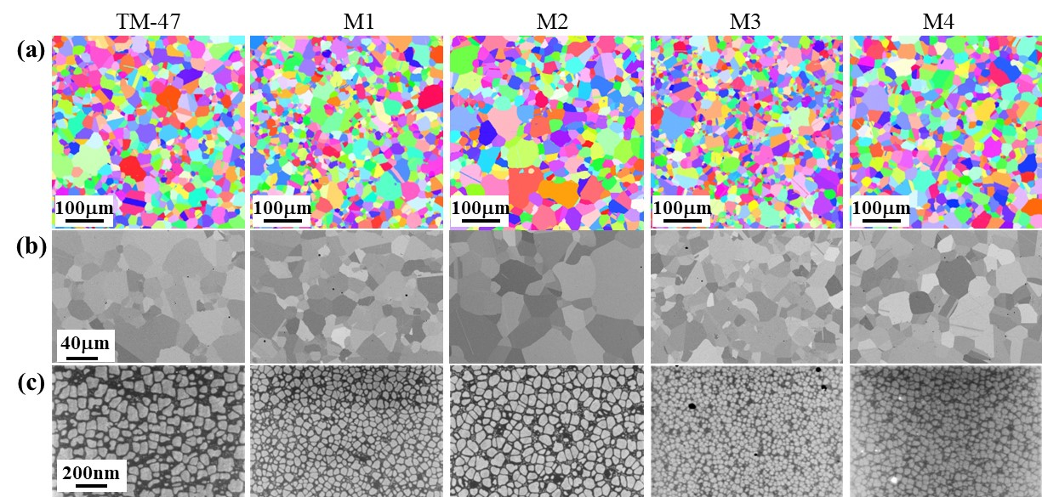
Figure 3 –(a) Inverse pole figure obtained by EBSD, (b) SEM image showing grains and pores, and (c) secondary and tertiary γʹ precipitates within grain for aged TM-47 MX series alloys (P/M).
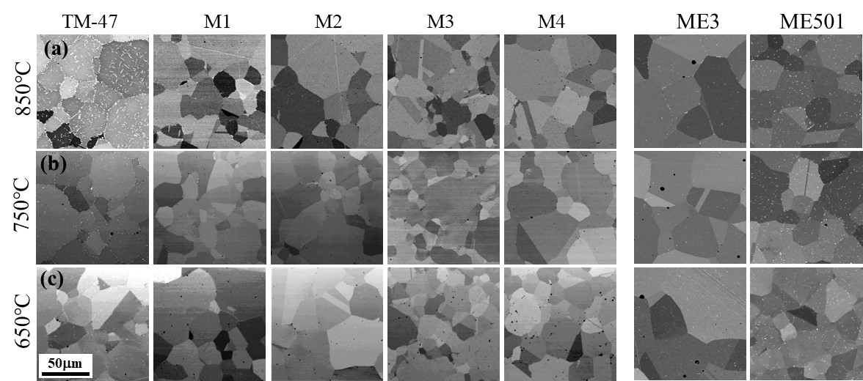
Figure 4 –Typical microstructure of TM-47 MX series, ME3 and ME501 exposed at (a) 850 ℃, (b) 750 ℃, and (c) 650 ℃ for 3000 hours.

High temperature strength
Figure 5 shows the compressive 0.2 % proof stress at 725 °C and 800 °C for aged TM-47 MX series alloys (P/M). As shown in the figure, the 0.2 % proof stress at both 725 °C and 800 °C increased significantly with increasing Co-12.5wt.% Ti addition, indicating the peak value at ranging around 10-20 wt.% addition (M1 and M2). Although further deformation analysis is still required, the increment to peak values could be caused by improving γʹ precipitation strengthening by Ti addition and additional strengthening through micro twinning deformation by Co addition [6] similar to other types of Ni-Co base superalloys, while the decrease in proof stress above 20 wt.% addition could be caused by a decrease in the overall amount of the solid solution strengthening elements W and Ta. Further, the 0.2 % proof stress of TM-47 M2 and M3 were higher than values of ME3 and slightly lower than that of ME501.
In summary, limited additions of Co-12.5wt.% Ti to the TM-47 base alloy improved powder manufacturability, phase stability, and the high temperature proof stress. Thus, based on the results in figures 2 through 5, TM-47 M2 was down-selected for the next step - subscale manufacturing.

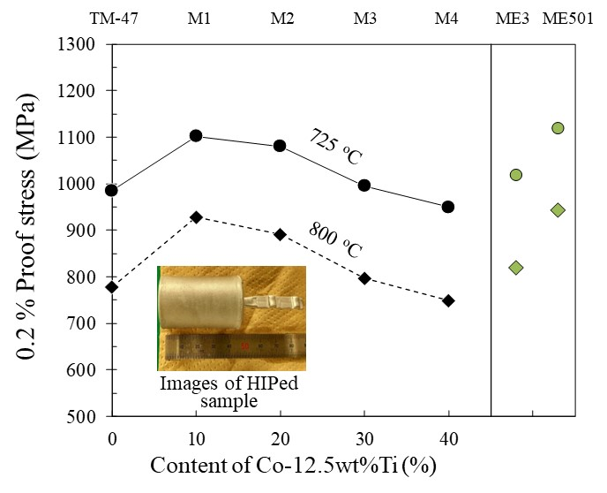
Figure 5 Compressive 0.2 % proof stress of TM-47 series alloys, ME3, and ME501.

Microstructure and creep behavior of TM-47 M2 (C&W)
Finally, we evaluated the tensile creep properties of TM-47 M2 (C&W). Here, we note again that subscale sized bar sample for TM-47 M2 was prepared by the ‘C&W’ route instead of the P/M route, as we have no large extrusion facility capable of manufacturing subscale bars from which tensile creep test specimen can be taken. The creep data will be important in determining whether the TM-47 M2 is promising as a P/M alloy for HP-disk applications, although the creep property of C&W alloy cannot be directly compared to that of other P/M alloys. Figure 6 (a) shows the subscale sized bar of TM-47 M2 (C&W) that was produced for this study. Figure 6 (b) and 6 (c) reveal the typical microstructure found in TM-47 M2 (C&W) and TMW-4M3 (C&W). The microstructure of TM-47 M2 (C&W) comprised of grains, annealing twins, and primary, secondary, and tertiary γʹ precipitates similar to those found in TMW-4M3. Furthermore, the grain microstructure of TM-47 M2 (C&W) was sufficiently uniform and fine. This observation suggests that TM-47 M2 may be suitable for typical P/M processing, including high-temperature extrusion and isothermal forging. In addition, no band structure with mixed large and fine grains caused by heterogeneous dendritic element segregation before hot working was observed. Therefore, a Hf and Nb free TM-47 M2 composition may also be amenable for C&W processing, although a small cast ingot was manufactured in this study rather than a more common ton-class ingot which is usually produced in commercial C&W process.
Figure 7 (a) and (b) show the creep curves for TM-47 M2 (C&W) and TMW-4M3 tested at 725 ℃ under 630 MPa. The creep rupture life of TM-47 M2 (C&W) was 2116.5 h, which is about 9 times longer compared to TMW-4M3 (t_{R}=234 h). The increment in temperature capability based on the rupture life and 0.2 % creep time as estimated from Larson-Miller Parameter (C=20) were +41℃ and +39℃, respectively.
Figure 7 (c) shows the temperature capability estimated based on 0.2 % creep time at 630 MPa by using the experimental creep curve of TM-47 M2 (C&W) at these conditions. The temperature capabilities for alloys prepared by P/M route, U720Li [5], RR1000 [15], ME3 [10], ME501[2], TMP-5002 (HGN200) [5], and C&W alloy, TMW-4M3 [4], were also summarized in figure 7. Despite TM-47 M2 possessing slightly lower 0.2 % proof stress compared to ME501 at 725°C and 800 °C, TM-47 M2 (C&W) provides a higher temperature capability than ME501 [2]. Additionally, the temperature capability of TM-47 M2 (C&W) (766°C) was found to be the highest among the reported disk alloys as shown in Figure 7 (c) [2,4,5,10,15]. This result suggests that improving γʹ precipitation strengthening through Ti addition could be effective towards improving the 0.2 % creep time of future disk superalloys.

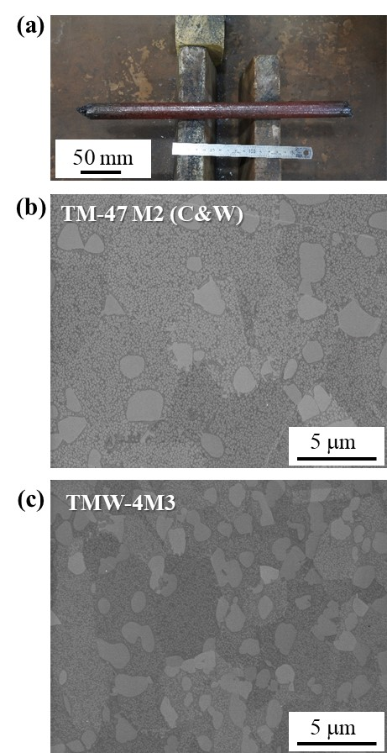
Figure 6 (a) Subscale sized bar prepared via ‘C&W’ route, and typical microstructures for (b) TM-47 M2 and (c) TMW-4M3 prepared for comparison.

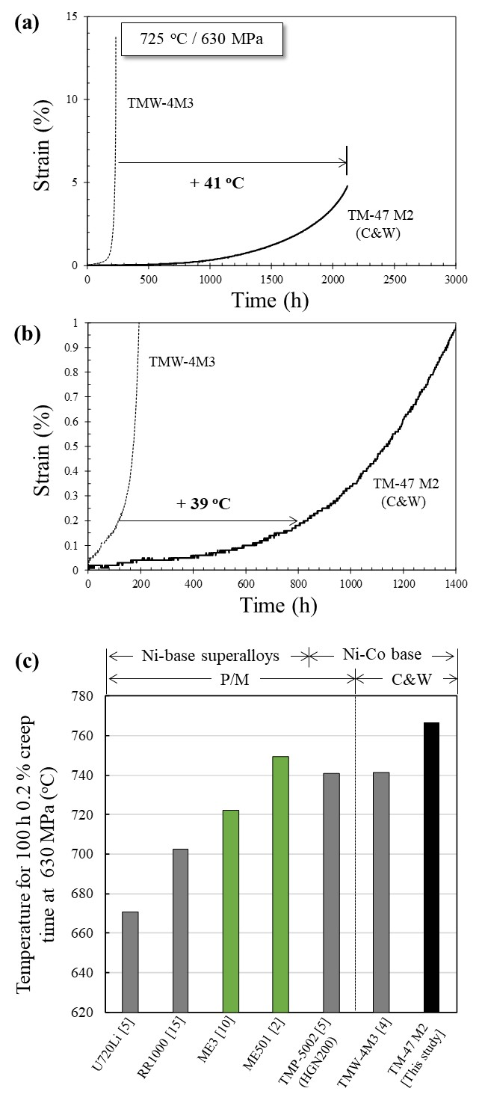
Figure 7 – (a) Creep curves for TM-47 M2 (C&W) and TMW-4M3 tested at 725℃ / 630 MPa (b) enlarged creep curves ; (c) temperature capability (estimated based on 0.2% creep time at 630 MPa) for TM-47 M2 manufactured by C&W route and typical P/M alloys.

Conclusions
In this study, several new Ni-Co base disk superalloys (TM-47 MX series) based on Ni-base CC superalloy, TM-47, where developed and tested. Using a P/M processing route, we demonstrated that the limited additions of Co-12.5wt.% Ti to the TM-47 base alloy improved powder manufacturability, phase stability, and the high temperature proof stress. Furthermore, it was demonstrated that the selected alloy, TM-47 M2 (C&W), provided superior creep properties and temperature capability compared to current state-of-the-art disk superalloys. Future work will explore the high temperature mechanical properties of the down-selected TM-47 M2 produced using P/M.

Acknowledgements
This work was supported by Innovative Science and Technology Initiative for Security, ATLA, Japan (Principal Research Institution: IHI Corporation). We would also like to thank Dr. Kazumi Minagawa and Mr. Masashi Hirosawa for their supports in powder preparations, Mr. Yuji Takata for single crystal casting, Dr. Michinari Yuyama for creep test, and Mr. Takaaki Hibaru, Mr. Masaki Kobayashi and Mr. Kazuhiko Iida for accosting with material preparations.

References
- D. Rice, P. Kantzos, B. Hann, J. Neumann, R. Helmink in Superalloys 2008, Seven Springs, Champion, PA, USA, p. 139-147.
- A. Powell, K. Bain, A. Wessman, D. Wei, T. Hanlon, D. Mourer, in Superalloys 2016, Seven Springs, Champion, PA, USA, p. 189-197.
- Y.F. Gu, H. Harada, C. Cui, D. Ping, A. Sato, J. Fujioka, Scripta Materialia, 55 (2006) 815-818.
- J. Fujioka, Y.F. Gu, T. Osada, C. Cui, T. Yokokawa, T. Kobayashi, H. Harada, T. Fukuda, A. Mitsuhashi, Proceedings of International Gas Turbine Congress 2015 Tokyo, (2015) 333-338.
- Y.F. Gu, T. Osada, T. Yokokawa, H. Harada, J. Fujioka, D. Nagahama, M. Okuno in Superalloys 2016, Seven Springs, Champion, PA, USA, p. 209-216.
- Y. Yuan, Y.F. Gu, T. Osada, Z.H. Zhong, T. Yokokawa, H. Harada, Scripta Materialia, 66 (2012) 884-889
- H. Harada, M. Yamazaki, Tetsu-to-Hagane, 65 (1979) 1059-1068.
- Y. Mori, K. Kawagishi, T. Osada, H. Harada, M. Yuyama, Y. Takata, M. Osawa, A. Ikeda, Metallurgical and Materials Transactions A, 51 (2020) 2020-2035.
- L. Wu, T. Osada, T. Yokokawa, Y. Chang, K. Kawagishi, Journal of Alloys and Compounds, 931 (2023) 167508.
- T.P. Gabb, P.T. Kantzos, K. O’Connor, Report NASA/TM 2002-211796, NASA Glenn Research Center, (2002)
- T. Yokokawa, H. Harada, Y. Mori, K. Kawagishi, Y. Koizumi, T.Kobayashi, M.Yuyama, S. Suzuki, in Superalloys 2016, Seven Springs, Champion, PA, USA, p. 123-130.
- K. Kawagishi, T. Yokokawa, T. Kobayashi, Y. Koizumi, M Sakamoto, Michinari Yuyama, H. Harada, I. Okuda, M. Taneike, H. Oguma in Superalloys 2016, Seven Springs, Champion, PA, USA, p. 115-122.
- S. Imano, T. Osada, T. Shibayama, A. Ota, H. Nishikawa, K. Kawagishi, Journal of the Gas Turbine Society of Japan, 50 (2022) 301-306.
- R. Tamura, T. Osada, K. Minagawa, T. Kohata, M. Hirosawa, K. Tsukada, K. Kawagishi, Materials & Design 198 (2021) 109290.
- A. Encinas-Oropesa et al. in Superalloys 2008, Seven Springs, Champion, PA, USA, p. 609-618.

