Improved Hydration Property of Tissue Adhesive/Hemostatic Microparticle based on Hydrophobically-modified Alaska Pollock Gelatin

Shima Ito^{a,b}, Kazuhiro Nagasaka^{a,b}, Hiyori Komatsu^{a,b}, Debabrata Palaiª, Akihiro Nishiguchiª, Tetsushi Taguchi^{a,b}*
ªBiomaterials field, Research Center for Macromolecules and Biomaterials, National Institute for Materials Science, 1-1 Namiki, Tsukuba, Ibaraki 305-0044, Japan
^{b}Graduate School of Science and Technology, Degree Programs in Pure and Applied Sciences, University of Tsukuba, 1-1-1 Tennodai, Tsukuba, Ibaraki 305-8577, Japan

Correspondence and requests for materials should be addressed to T.T. (email: TAGUCHI.Tetsushi@nims.go.jp)

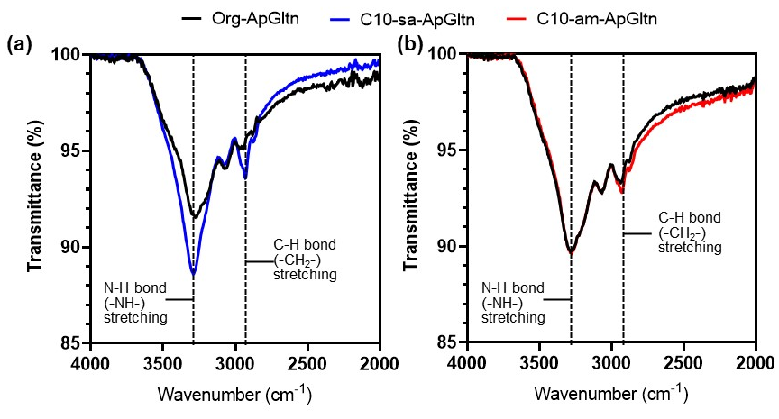
Fig. S1. Characterization of C10-sa-ApGltn (a) and C10-am-ApGltn (b). FT-IR spectra for C10-sa-ApGltn revealed an increase in the secondary amine stretching peak at 3,295 cm⁻¹. Both spectra exhibited sp³ CH symmetric stretching peaks for the decyl group at 2,927 cm⁻¹.

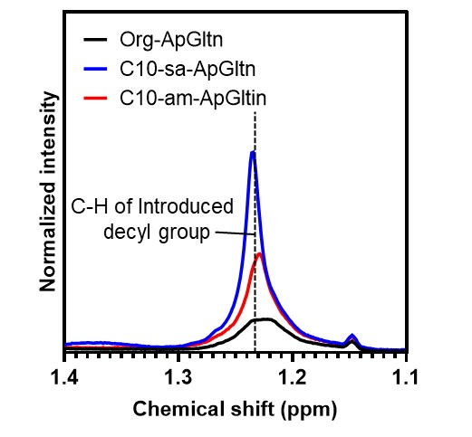
Fig. S2. ¹H-NMR spectra revealed an increased intensity for the CH₂ proton at 1.24 ppm. DMSO containing 0.05% 3-(trimethylsilyl) propionic 2, 2, 3, 3-d₄ acid sodium was used as the solvent for Org-, C10-sa-, and C10-am-ApGltn for ¹H-NMR measurements.

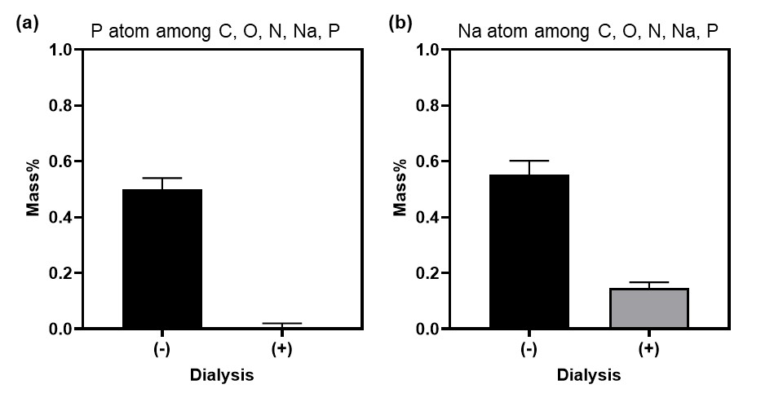
Fig. S3. EDX analysis of C10-am-ApGltn. (a) Mass composition of phosphorus atoms in relation to the total composition of P, C, O, and Na, with and without dialysis. (b) Mass composition of sodium atoms in relation to the total composition of P, C, O, and Na, with and without dialysis.

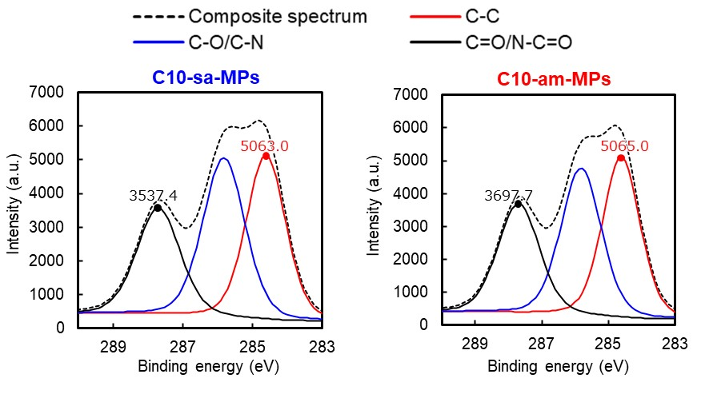
Fig. S4. XPS analysis of C10-sa-MPs and C10-am-MPs. There is an enhanced C=O/N–C=O peak in C10-am-MPs compared to C10-sa-MPs, indicating a higher quantity of amide structures.

