Materials Innovation and Electronics Engineering in X-ray Detection
Bo Hou¹, Qiushui Chen², Luying Yi¹, Paul Sellin³, Hong-Tao Sun⁴, Liang Jie Wong⁵ & Xiaogang Liu^{1*}
¹Department of Chemistry, National University of Singapore, Singapore 117543, Singapore. ²MOE Key Laboratory for Analytical Science of Food Safety and Biology, State Key Laboratory of Photocatalysis on Energy and Environment, College of Chemistry, Fuzhou University, Fuzhou 350207, China. ³Department of Physics, University of Surrey, Guildford GU2 7XH, UK. ⁴Research Center for Materials Nanoarchitectonics (MANA), National Institute for Materials Science (NIMS), 1-2-1 Sengen, Tsukuba 305-0047, Japan. ⁵School of Electrical and Electronic Engineering, Nanyang Technological University, 50 Nanyang Avenue, Singapore 639798, Singapore.

*Corresponding author. E-mail: chmlx@nus.edu.sg (X.L.)

X-ray detection is critical for numerous modern applications, including medical diagnosis, industrial inspection, security checks, scientific inquiry, and space exploration. Recent advances in materials science, electronics, manufacturing, and artificial intelligence have greatly propelled this field forward. This review examines fundamental principles and recent breakthroughs in X-ray detection and imaging technologies, with a focus on the interplay between electrical engineering techniques and X-ray-responsive materials. Two primary approaches are highlighted: semiconductor-based direct detection and scintillator-based indirect detection. These discussions encompass innovations such as photon counting detectors and heterojunction phototransistors. A key emphasis lies in elucidating the critical contributions of electrical engineering in the development of these cutting-edge detectors. This involves considerations such as chemical engineering, circuit optimization, and the implementation of image processing algorithms. Subsequent sections provide an overview of significant applications, ranging from biomedical imaging to resonant X-ray techniques for material analysis, and even nanometer-resolution circuit imaging. This review also underscores future research directions, which encompass 3D and 4D X-ray imaging sensors, multispectral X-ray imaging and artificial intelligence-assisted medical image diagnosis.

Introduction
The discovery of X-rays in 1895 by Wilhelm Conrad Roentgen was a defining moment in science and technology. This breakthrough unveiled a new form of electromagnetic radiation capable of penetrating materials to reveal their hidden structures and properties¹⁻³. From its inception as a scientific curiosity, X-ray technology has rapidly evolved into a fundamental tool in modern detection and imaging, revolutionizing fields such as medicine, industry, and scientific research⁴⁻⁶. X-ray imaging hinges on the interaction between X-ray photons (with wavelengths ranging from 10 nm to 0.001 nm) and matter⁷⁻⁹. The ability of X-rays to traverse various substances, experiencing varying levels of attenuation interaction, forms the basis for their non-invasive imaging applications.

X-ray detectors are designed to convert the intricate structures of objects carried by X-ray photons into measurable electronic signals. This conversion can be achieved either directly or through conversion into intermediate photons¹⁰⁻¹³. Key factors influencing the performance of X-ray detectors include energy conversion materials and circuit development and optimization. These factors impact crucial parameters such as minimum detectable dose rate, signal-to-noise ratio, dynamic range, and sampling speed. Specific parameters of importance encompass the generation of photons or charge carriers within the material under X-ray excitation, as well as carrier mobility and lifetime. On the other hand, circuit development has emerged as a primary means to influence carrier detection efficiency and compensate for material deficiencies. The synergy between materials science and electronics has led to the development of highly efficient electron detection schemes. These include techniques such as chemical interface engineering to control dark current in semiconductor materials, self-powered photon-counting detectors, and heterojunction phototransistors. Moreover, several exciting X-ray detection and imaging schemes have emerged in tandem with rapid advances in other engineering technologies and artificial intelligence. These include multi-spectral X-ray imaging, ingestible X-ray dosimeters, and phase-contrast X-ray imaging sensors. This review examines these intriguing physical mechanisms, novel materials, and engineering approaches to detection, along with innovative use cases. It also delves into challenges in the field and proposes future research directions.

X-ray detection mechanism and methods
X-rays, a high-energy form of electromagnetic radiation, are generated by directing high-energy electrons at a target material, typically heavy metals such as tungsten or molybdenum¹⁴. When these high-energy electrons collide with the target atoms, they induce the emission of X-ray photons in various directions. X-rays are generated by two mechanisms: bremsstrahlung, which results in broadband radiation emitted as electrons decelerate in matter, and characteristic radiation, which produces narrowband radiation when electrons eject electrons from the inner shell of atoms, allowing bound electrons of higher energy to relax through spontaneous emission. Moreover, coherent X-rays can be generated when high-energy electrons impinge on crystalline solids, utilizing mechanisms such as parametric X-ray radiation and coherent bremsstrahlung^{15, 16}. As X-rays pass through objects, they interact with the materials along their path, leading to variations in the absorption, scattering, or diffraction of the X-rays. These differences are captured by an X-ray detector, which records the X-rays that have passed through or reflected off the object. This process provides a non-invasive and non-destructive method to visualize the internal structures of the object.
A typical X-ray detection device comprises an X-ray-sensitive material layer (either semiconductor or scintillator), a pixelated detection array, and control logic circuits (Fig. 1a). X-ray detection and imaging configurations can be broadly divided into two methods: semiconductor-based direct X-ray detection and scintillator-mediated indirect X-ray detection (Fig. 1b)^{17, 18}. In an indirect detector, a layer of scintillator materials generates high-energy electron-hole pairs upon X-ray excitation. These pairs are then converted into visible photons, typically in the wavelength range of 400-700 nm. Below the scintillator, a visible photodiode detector or an array of detectors interprets the signals emitted from the detector and ultimately produces high-resolution X-ray images via densely populated pixels.
In the case of direct detectors based on semiconductor materials, the photodiode is constructed from a layer of X-ray-responsive semiconductor materials. This design allows incoming X-ray photons to be directly converted into charges collected by specially designed electrodes¹⁹⁻²¹. In both direct and indirect X-ray imaging, typically, a thin-film transistor (TFT) pixel array is used to connect each pixel to the corresponding read-out integrated circuit (ROIC) channel, facilitating the conversion of the charge into a digital output. These TFTs are controlled by gate drivers that enable sequential readout of one row of pixels at a time. Thus, the captured X-ray image can be read from the flat panel detector using a rolling shutter mechanism²²⁻²⁴.
The core component of X-ray detection is the charge detection circuitry. The key difference between direct and indirect detection hinges on where the converted charge originates (Fig. 1c and d). Direct flat-panel detectors typically offer higher spatial resolution and produce clearer images than indirect detectors. This is because direct detectors do not generate visible light, which can cause lateral light dispersion and affect spatial resolution. In contrast, indirect detectors have advantages such as lower cost, larger coverage, and greater detection flexibility.

Direct X-ray detection
In recent years, direct detection configurations have garnered considerable recognition due to their impressive attributes, including robust X-ray absorption, high detection sensitivity, swift response, and excellent spatial and energy resolution. These direct detectors rely on X-ray-sensitive semiconductor materials, readout circuits, and control circuits. We assess the significant contributions of advanced circuit engineering and high-performance semiconductor materials in this domain.

Semiconductor-based electrical detection. The semiconductor-based detection process typically involves configurations as depicted in Figure 2a−c and Figure 2d−f. In standard capacitor mode, each single-pixel structure essentially corresponds to a storage capacitor (C_{ij}). This capacitor collects and stores charges generated by the X-rays absorbed in the semiconductor layer above the pixel (i, j) (Fig. 2a and Fig. 2d). When a control signal is applied to this pixel, it activates a switch that transfers the charge Q_{ij} on the capacitor to the data line. This charge is then converted into a voltage signal (V_{out} = Q_{ij}/C_{f}) by a charge amplifier and rapidly processed by a ROIC^{3, 25}. Semiconductor materials such as a-Se, CdTe and CdZnTe are normally used in this mode for direct X-ray detection. The a-Se-based prototype for direct X-ray detection was initially introduced by Rowlands et al.²⁶⁻²⁸. Subsequent studies focused on enhancing a-Se X-ray detectors by leveraging a-Se’s inherent properties, designing innovative detector structures, and integrating a-Se with other materials to overcome its limitations¹⁹.
In current mode, the application of a bias voltage to the semiconductor material triggers the motion of charge carriers, generating a current signal. This mode is analogous to photoresistors, where varying X-ray intensities exhibit disparate current responses under the same voltage (Fig. 2b and Fig. 2e). Park, Tang, and their co-workers have achieved low detection limits in X-ray detection by implementing dark current control through thermal annealing, surface treatment, and conformal interface processing of perovskite-based semiconductor materials^{10, 29}. In voltage mode, the integration of a hole transport layer (HTL) and an electron transport layer (ETL) facilitates charge collection, resulting in a voltage drop across the material³⁰. X-ray data are acquired by detecting the accumulated charge or voltage drop (Fig. 2c and Fig. 2f). Huang, Liu, and their co-workers have achieved low-power, high-sensitivity X-ray detection and single-photon counting at zero bias voltage through innovative device design and material integration^{31, 32}.

Material selection. A variety of semiconductor materials are employed for direct X-ray detection, (Table 1, Fig. 2g), including silicon (Si), cadmium zinc telluride (CdZnTe or CZT), gallium arsenide (GaAs), amorphous selenium (a-Se), and lead halide perovskites. The efficiency of X-ray detection in semiconductor materials is largely determined by their average atomic number. For example, the average atomic number of CdZnTe is 50, compared to the atomic number of Si at 14, leading to significantly higher detection efficiency in CdZnTe detectors. A 1-mm thick CdZnTe crystal can achieve a photoelectric detection efficiency of 97.4% for 60 keV radiation. In contrast, a 1-mm Si detector has a photoelectric detection efficiency of less than 10% for the same radiation energy. In addition, the electrons and holes generated by ionizing radiation in semiconductors must have excellent mobility and long lifetime to be separated and detected by an electric field before recombination occurs. The corresponding parameters are the product μτ of the carrier mobility μ and the average carrier lifetime τ, commonly referred to as the carrier drift length. Due to the typically much larger thickness of the material layer in X-ray detectors compared to common visible light detectors, the parameter μτ significantly limits the sensitivity of the detector as it affects the efficiency of charge collection.
In addition, sensitive material layer must be of high quality, meaning that they should have few defects. After absorption and conversion of X-ray photons into electrons and holes, drift and subsequent collection of these charge carriers occur. However, if holes are lost due to deep trapping during the drift phase, they cannot escape in time (Fig. 2h). This has two immediate consequences. First, the charge collected by the corresponding pixel diminishes, reducing the detector's sensitivity. This effect is known as limited charge collection efficiency ³³⁻³⁵. Second, the trapped holes induce negative charges on adjacent pixels, leading to a loss of resolution.
The large-scale fabrication of semiconductor materials for X-ray detection, such as CZT, HgI₂, PbI₂ and PbO, is critical³. However, challenges include grain boundary effects that limit charge transfer and the need for high annealing temperatures, which may be incompatible with the temperature sensitivity of backend circuits³⁶. Zhao et al³⁷. recently created a flexible, large perovskite film of 400 cm², demonstrating high X-ray sensitivity (8,696 mC Gy_{air}⁻¹ cm⁻²).

Key parameters. The sensitivity of X-ray detection is a key measure that indicates how efficiently X-rays are converted. It is represented by the formula S = hQ_{total}, where S stands for sensitivity, h is determined by charge collection efficiency, and Q_{total} is related to ionization energy²⁵. The efficiency of charge collection, influenced by the quality and purity of the material layer, plays a vital role in sensitivity. A high mobility lifetime (μt) of the materials enhances charge collection efficiency, even under low electric fields. Vapor-deposited polycrystalline HgI₂ layers exhibit maximum μt values of 10⁻³ cm²/V for electrons and 10⁻⁵ cm²/V for holes³⁸. Lead halide perovskites show large μt values (ranging from 10⁻⁴ to 10⁻² cm²/V), similar to CdTe and much larger than those found in a-Se^{39, 40}. These perovskites, with a broad range of ionization energies (4.65 to 6.3 eV) and high conversion efficiency (215 to 159 electrons/keV), achieve an ultra-high detection sensitivity of over 1,000 mCGy_{air}⁻¹ cm⁻².
The dark current or called leakage current, which refers to the existence of a tiny population of mobile electrons and holes within the detector, even under conditions without ionizing radiation. The dark current depends mainly on the imperfections of the semiconductor material and has a significant effect on the detection threshold in X-ray detection. In a typical a-Se-based detector with a pixel size of 200 × 200 μm², a static capacitance of 10 pF, and an integration time of 30 ms, a very low dark current density, specifically around 10⁻¹⁰ A cm⁻², is required to detect a single X-ray photon of 20 keV⁴¹. Kim et al. managed to significantly reduce the dark current in perovskite-based detectors to 80 ± 20 pA mm⁻² by using a combination of polyimide (PI)-MAPbBr₃ as a hole-blocking layer and PI-MAPbI₃ as a hole-transporting layer²⁹. The detection limit of these detectors is determined with a signal-to-noise ratio (SNR) of three⁴². SNR is calculated as I_{s}/I_{n}, where I_{s} is the signal current density and I_{n} is the noise current density. For semiconductor-based X-ray detectors, the noise current density is influenced by several factors, including thermal noise, 1/f noise, and shot noise.

Circuitry development. The development of circuits for direct X-ray detection involves a semiconductor material that can effectively convert X-ray photons into electron-hole pairs and generate an electric field to separate and collect these pairs. However, the interaction between X-ray photons and semiconductor materials typically results in a relatively low number of electron-hole pairs being generated. This poses a significant challenge for readout circuitry, especially in high-density detector arrays. Often, charge-sensitive preamplifiers or voltage amplifiers are required to produce measurable signals²². In the TFT readout circuit, each pixel typically operates in capacitor mode. The TFT gate is linked to a shared row gate signal line, and a scanning clock generator orchestrates the addressing of all the rows. Specifically, the clock generator activates a single row of TFT switches through the gate line. Once the data from one row has been extracted, the system proceeds to acquire charges from the next row in sequence (Fig. 2i).
To achieve optimal detection results, advanced technologies are applied to balance typical electric parameters effectively, including response speed, bias voltage, SNR, etc. For instance, increasing the bias voltage enhances the electrical signal gain, leading to improved sensitivity and reduced pixel size. Moreover, the implementation of filtering techniques enhances signal clarity, while strategies for reducing electric noise bolster the SNR by eliminating unwanted noise. Within the sensor, each pixel is connected to a channel of readout electronics on the chip. This setup enables precise modulation, control, and detection of the electrical signal from each pixel. Typical readout circuits introduced above are based on an integrating mode, which involves converting charge information into a digital signal over time. However, there are readout chip that operate in photon counting mode, such as Pilatus and Medipix. These chips measure the total number of events by counting charge pulses. This approach to photon counting has significantly enhanced the fields of X-ray detection, imaging, and spectroscopy⁴³. They count X-ray photons that strike each pixel during the acquisition^{44, 45}. This approach effectively achieves “noise-free” X-ray detection, primarily limited by photon statistics, even over long acquisition periods. Combined with high readout speed, this approach substantially improves measurement speed and sensitivity. The ROIC must be optimized for specific purposes, particularly with regard to energy resolution and photon counting rates. For enhanced photon counting rates, chips like TIMEPIX and PILATUS are preferred. Conversely, for better energy resolution, chips like IDEF-X and HEXITEC are more suitable. Dosimeters and imaging flat-panels are versatile and can function in both photon counting and integrating modes. However, most flat-panel detectors typically operate in integrating mode, where they accumulate charge over time to form an image. Spectrometry, on the other hand, requires the photon counting mode to measure the total charge or pulse amplitude of each absorbed photon accurately, which is important for detailed spectral analysis⁴⁶.

Indirect X-ray detection
An indirect X-ray detection and imaging system is extensively investigated due to its advantages, including a large imaging area, wide dynamic range, cost-effectiveness, and versatility. Scintillators with high conversion efficiency and photosensors with high sensitivity are critical components of indirect detection flat panels, influencing their performance significantly. In this review, we discuss the complexities surrounding advanced scintillator materials and explore a wide array of engineering approaches aimed at enhancing detection capabilities. These encompass a broad range of techniques, ranging from the application of electrical engineering principles to the art of efficient light harvesting.

Key attributes of conventional scintillators. Scintillator materials are luminescent substances that emit visible, ultraviolet, or infrared light when exposed to ionizing radiation such as X-rays, gamma rays, and charged particles (Fig. 3a)^{47, 48}. Excellent X-ray scintillators must have high density, a large effective atomic number, emission wavelength matching the photodetector's response, fast luminescent delay, high light yield, radiation resistance, and stable chemical properties. In general, scintillators are categorized as organic and inorganic scintillators (Table 2)⁴⁹⁻⁵¹, with inorganic scintillators being favored in X-ray detection due to their superior characteristics. Common inorganic scintillators include CsI:Tl single-crystal, Gd₂O₂S:Tb powder, LYSO crystal, and YAG:Ce single-crystal. New scintillators such as metal-halide perovskite scintillators with high light yield, fast decay, and tunable luminescent properties have been introduced (Fig. 3b)⁵². Glass scintillators are also promising, particularly in high-doping, large-size preparation, and optical fiber applications⁵³. Various materials engineering strategies, including doping, single-crystal growth, wavelength shifting, can enhance scintillator performance⁵⁴⁻⁵⁶. Particularly, the utilization of rare-earth elements as dopants in various scintillators has significantly expanded, including Ce-doped rare-earth halides (LaBr₃:Ce), Eu-doped perovskites (e.g., Cs₄SrI₆: Eu and CsSrBrI₂: Eu), and ceramic scintillators doped with Ce, Pr, and F (Gd₂O₂S:Ce,Pr,F)⁵⁷. These advancements improve scintillator efficiency and reliability in radiation detection and imaging applications.

Material characteristics. Important parameters of scintillators are their light yield and afterglow. The light yield (LY), which influences a detector's sensitivity and SNR, is usually calculated using a three-part formula: $LY=\left(\frac{{10}^{6}}{βE_{g}}\right)SQ$, where $E_{g}$ is the crystal band gap in electron volts, S is the efficiency of transferring hot-electron energy, Q is the photoluminescence quantum yield, and β is a constant related to the host structure. In many cases, the values of S and Q are close to 1 (ref ⁵⁸). However, the theoretical light yield is often higher than what is actually achieved due to self-absorption, non-radiative recombination, and nonunity light extraction efficiency. For example, while the calculated light yield of CsPbBr₃ nanocrystals and GOS scintillators are 177,000 and 66,000 photons/MeV, respectively, the actual light yield of CsPbBr₃ is far below its theoretical value⁵⁵. Furthermore, it is important to optimize the emission wavelength of the scintillator to match the peak responsivity of the photodiode, as this can maximize the light yield. We have summarized the light yields of some current scintillators in Table 2 for reference.
Afterglow refers to the residual light emitted by a scintillator after the X-ray exposure has stopped. This can cause image artifacts in radiography due to overlapping signals from consecutive exposures. In computed tomography (CT), where quick image capture is essential, scintillators with minimal afterglow are preferred. Common choices include CsI-Tl (0.5–5%@6ms), BGO (0.005%@3ms), CWO (0.005%@3ms), and Gd₂O₂S:Pr,Ce,F (0.01%@3ms)⁵⁸. Of these, CsI-Tl may not be suitable for modern fast CT scanners. Recent reports on perovskite scintillators, such as Cs₅Cu₃Cl₆I₂ and Cs₂Ag_{0.6}Na_{0.4}In_{0.85}Bi_{0.15}Cl₆, show lower afterglows (0.1%@10ms and 0.1%@0.016ms, respectively)^{59, 60}. Moreover, perovskite single crystals and quantum dots have negligible delay times, making them promise for dynamic imaging^{61, 62}.
Radiation hardness in scintillators is also important, especially for X-ray detectors in high energy physics. This involves assessing changes in scintillation efficiency under various radiation types, doses, and rates. This factor often links to crystal transparency and luminescence deterioration from radiation damage. BaF₂, CeF₃, BGO, LYSO, and PWO are commonly used for high-energy settings and CsI(Tl) for medium-energy applications⁵⁸. For these scintillators, it is crucial that they suffer little damage when irradiated with γ-ray sources, such as ⁶⁰Co and ¹³⁷Cs γ-ray sources. For example, pure CsI maintains good radiation hardness below 100 krad, while BaF₂, BGO and LYSO remain effective beyond 1 Mrad⁶³. CsPbBr₃ nanoscintillators exhibit exceptional radiation hardness even at 1 MGy doses (⁶⁰Co), with fluorination after synthesis boosting their efficiency by over 500%⁶⁴. Halide perovskite semiconductors also exhibit better tolerance to radiation damage. They maintain their high performance even at an accumulated dose of 2.3 Mrad (¹³⁷Cs), in contrast to CZT detectors, which degrade severely after 30 kGy of γ-ray exposure^{65, 66}.

Engineering scintillator detection efficiency. Achieving desired performance in indirect X-ray detectors involves not only the implementation of efficient light harvesting strategies but also the meticulous consideration of material geometry and surface characteristics, which can considerably enhance light capture efficiency. Various coupling methods exist between scintillator layers and image sensors, including direct coupling, optical lens coupling, and optical fiber coupling (Fig. 3c-e). Direct coupling involves adhesive bonding for cost-efficiency, but may result in light loss and reduced resolution. While direct coupling is primarily used in medical diagnostics, it necessitates image sensors with large pixel sizes (typically 50~200 μm), trading spatial resolution for a relatively large image area. For instance, commercial GOS-based detectors typically offer spatial resolution in the range of 4 - 8 lp/mm. CsPbBr₃ perovskite nanocrystal-based X-ray detectors exhibit an improved spatial resolution of ~10 lp/mm⁵⁵. Optical lens coupling, which consists of scintillator layers, optical lenses, and image sensors, offers advantages, particularly in terms of spatial resolution. Recent advances include scintillators based on thermally activated delayed fluorescence molecules, enabling X-ray imaging with a resolution of 16.6 lp/mm⁶⁷. The utilization of solution-processed rare-earth-doped nanoscintillators has allowed for ultra-long-lifetime 3D X-ray imaging with spatial resolution exceeding 20 lp/mm⁶⁸. Optical fiber coupling boasts high optical transmission efficiency, minimal coupling loss, and clear image transmission, with coupling efficiency often exceeding 70%^{69, 70}.
The performance of indirect X-ray detectors has seen significant enhancement through the careful geometric design of the scintillator film itself. For example, scintillator films composed of thallium-doped cesium iodide (CsI:Tl) needles have been developed to enhance resolutions up to 10~15 lp/mm, dependent on the scintillator layer’s thickness⁷¹. Phase-separated scintillator fibers that mimic optical fibers have achieved spatial resolutions better than 10 lp/mm⁷². Another strategy involves embedding scintillators into anodic alumina, resulting in higher resolution (10.4 lp/mm) and better stability (only 19% degradation after 250 h of continuous operation)^{70, 73}. By embedding perovskite nanocrystals in double-tapered fiber substrates, high-resolution X-ray imaging can be achieved with a spatial resolution of up to 22 lp/mm⁶⁹.

Advances in circuitry. Electrical circuits designed for indirect detectors primarily convert visible photons into electrical signals. Two commonly used circuits for indirect X-ray detection in photodetectors are photon counting and photoelectric integration (Fig. 3f and g)^{12, 24, 74}. Most photodetectors in indirect X-ray detectors operate as photoelectric integration devices and primarily use PN junction photodiodes. In these devices, the diodes exhibit a linear increase in current with light intensity when reverse-biased. For imaging purposes, typical readout circuits include charge-coupled devices (CCDs) and complementary metal-oxide semiconductor (CMOS) systems⁷⁵. For the detection of low-intensity light signals generated by scintillators, photomultiplier tubes (PMTs) and avalanche photodiodes (APDs) are the most commonly used. PMTs can amplify the signal by up to a factor of 10⁶, while APDs typically provide a gain from 50 to 200 times⁵⁷.
In recent years, silicon photomultipliers (SiPMs) or multi-pixel photon counters (MPPCs), which operate in photon counting mode, are commonly used in indirect X-ray detection⁴³. These devices consist of many parallel micro-units, each comprising a single-photon avalanche diode (SPAD, a type of APD operating in Geiger-mode) and associated front-end circuitry. The amplitude of the MPPC output pulses is proportional to the number of photons. MPPCs offer several advantages, including insensitivity to magnetic fields, compactness, and high signal gain of up to one million levels. However, the dynamic range of MPPCs is often constrained by the number of Geiger-mode APD pixels within the device. In addition, multi-channel MPPCs used for imaging tend to have a limited number of channels, resulting in relatively lower image resolution⁷⁶. For instance, Hamamatsu has introduced various MPPC products since 2008, but they typically have 8×8 or 16×16 channels.
In the photosensitive materials of photodetectors used in indirect detection, a-Si remains the preferred material for static and large-scale dynamic flat-panel detectors due to their favorable semiconductor properties, high quantum efficiency in the green spectrum, radiation hardness, and cost efficiency. The low electron mobility of a-Si requires the use of larger TFTs, which in turn reduces the SNR. In contrast, indium gallium zinc oxide (IGZO) TFTs offer over 10 times higher electron mobility than a-Si, enabling the use of smaller TFTs. This leads to faster pixel discharge, thereby enhancing the detector’s readout speed and SNR. However, IGZO also has its own drawbacks, such as shorter lifespan and high sensitivity to water and oxygen. On the other hand, low-temperature polycrystalline silicon has electron mobility that is 200-300 times faster than a-Si, which also contributes to higher readout speed and improved SNR⁷⁷. As of now, each of these three technologies ⎯ a-Si, IGZO, and low-temperature polycrystalline silicon ⎯ has distinct advantages, and there is no single technology that completely dominates the market.

Innovative approaches and enhancement strategies in X-ray detection
The development of electronic engineering has led to a plethora of high-performance X-ray detectors and imaging panels. Concurrently, significant progress in materials science, engineering technology, and artificial intelligence has given rise to numerous novel approaches and enhanced capabilities in X-ray detection. These include dual-energy X-ray imaging, phase-contrast X-ray imaging, and 3D X-ray imaging^{11, 60, 68}, all of which are augmented by the integration of artificial intelligence for improved performance and autonomation. As technology continues to advance, we anticipate further innovative and groundbreaking developments in this field.
Phase-contrast X-ray imaging. This technique quantifies phase changes in X-rays as they pass through objects, enabling the creation of high-contrast images, particularly for objects with minute absorption contrast. Utilizing synchrotron sources, phase-contrast imaging based on X-ray speckle tracking and the interference of interface-reflected X-rays can detect 0.6-nm-high molecular steps⁷⁸. However, their applications are limited by the cost and accessibility of synchrotron sources. Angle-based phase-contrast imaging, encompassing methods such as Hartmann wavefront sensing and, multiple transmission gratings, has made quantitative differential phase-contrast images using conventional X-ray tubes⁷⁹. Recent advances include the utilization of multicolor nanoscintillator arrays that convert incident X-ray angles into pixelized color output with 0.0018 degree resolution⁸⁰.
Multispectral X-ray imaging. Conventional black-and-white X-ray imaging lacks the spectral information of X-ray photons. Hyperspectral X-ray imaging systems, which capture a broader range of energy levels and provide rich spectral information, have found applications in materials analysis and biomedical research. These systems often rely on photon-counting detectors, with CZT (CdZnTe) crystals being a promising choice. Emerging multispectral X-ray imaging systems utilize multilayer stacked scintillators with varying X-ray absorptivity and scintillation spectra to discriminate X-ray energies⁸¹.
Artificial intelligence-assisted X-ray imaging. Artificial intelligence has great utility in automating object detection and classification in X-ray images, enhancing image quality, and automatically interpreting medical images⁸²⁻⁸⁴. Noninvasive X-ray imaging of 3D objects, such as integrated circuits, typically requires scanning from multiple angles and signal acquisition. Machine learning has the potential to reduce scanning requirements and acquisition time. In addition, X-ray micro-computed tomography (μCT) can use machine learning to automatically segment and quantitatively analyze μCT datasets of lithium batteries to detect lithium structures⁸⁵. Notably, machine learning models have demonstrated impressive performance in various medical imaging tasks, such as automated diagnosis of chest X-ray images, sometimes surpassing even clinical experts⁸⁶. Overall, artificial intelligence has bolstered the capabilities of X-ray imaging in terms of imaging systems, image processing, and applications.

Applications of X-ray detection and imaging
X-ray detection and imaging plays a central role across a wide spectrum of applications, including biomedical healthcare, industrial inspection, and scientific research, as well as in the field of space exploration. In this section, we provide an overview of the primary applications of X-ray detection and imaging, along with an outline of the diverse engineering and material requirements for different X-ray detector applications.

Medical imaging and radiotherapy monitoring. X-ray detection is pivotal in medical imaging and radiotherapy monitoring, where it aids in the diagnosis of medical conditions and treatment of diseases^{4, 87}. Various modalities of X-ray medical imaging exist, including digital radiography, full-field mammography, fluoroscopy, and multi-slice computed tomography (CT, Fig. 4a). Commercial indirect imaging panel commonly use CsI:Tl and GOS scintillators paired with a-Si photodiodes and TFT readout circuits, while α-Se semiconductor-based direct flat panels, known for their high imaging resolution, are mainly employed in X-ray mammography. Alternatives to α-Se have been proposed, with materials like TlBr, CdTe/CdZnTe, HgI₂, PbI₂, PbO, and perovskite single crystals being considered due to their high atomic numbers, densities, and superior μt⁸⁸. Pixel sizes of flat-panel in medical imaging typically range from 50-200 μm, covering an energy range of 20-150 keV. Mammography applications necessitate higher pixel resolutions of approximately 50-100 μm, with a slightly lower energy range of around 20-50 keV⁸⁹. CT scanners come with various detector row numbers, from 2 to 320, and typical pixel sizes are 1×1 mm², resulting in a spatial resolution of approximately 0.5×0.5 mm². The typical configuration involves assembling multiple independent detector modules into segments, forming a ring-like detector structure opposite the X-ray tube. Both fluoroscopy, in which images are recorded at high frame rates (15-60 images per second), and 3D CT, in which even faster frame rates are required, require materials with short afterglow periods and circuits that enable fast readout. Materials like CdWO₄, Bi₄Ge₃O₁₂, and doped Gd₂O₂S have been explored for these applications due to their quick response characteristics. The significant afterglow of CsI-Tl limits its suitability for use in modern rapid CT scans, as it can lead to image lag⁵⁷. In contrast, radiography does not require high frame rates but relies on longer, high-dose X-ray pulses (e.g., >3 s) to achieve the required X-ray exposure. This makes circuit optimization critical in radiography to avoid image artifacts and excessive noise⁸⁹.
In addition to medical imaging, X-rays find utility in radiotherapy to treat certain cancers with precision, minimizing damage to surrounding healthy tissues. In radiotherapy, linear accelerators typically operate with a peak energy of 6 MeV and a dose rate of 600 cGy/min. This specification presents challenges for detectors used in this setting, particularly in terms of their maximum energy limitation and radiation hardness⁸⁸. Specialized X-ray detectors and treatment planning systems, such as implantable metal oxide semiconductor field-effect transistors and thermoluminescent sensors, enabled the controlled delivery of X-ray doses to tumors⁹⁰. Moreover, developments in dosimetry have led to the creation of multifunctional capsule dosimeters using NaLuF₄:Tb scintillators⁸⁷. These capsule dosimeters are designed to be ingestible, allowing them to enter the gastrointestinal tract. Once inside the body, they can monitor and accurately measure the radiation dose at the site of the lesion. Innovations in X-ray detection technologies have substantially improved medical imaging and radiotherapy, enhancing diagnostic accuracy and the effectiveness of cancer treatments.

Electronics industry and security. X-ray detection provides a non-destructive and efficient means of inspecting internal structures, making it valuable in quality control, failure analysis, and component inspection within the electronics industry and security inspections (Fig. 4b). In electronics industry, as electronic devices and components become increasingly intricate and miniaturized, 3D X-ray imaging at various scales, from millimeters to nanometers, is indispensable⁹¹⁻⁹³. By combining solution-processable NaLuF₄:Tb nanoscintillators with conventional CCD cameras, for example, it is possible to obtain clear images of chip interiors. This method is effective even for small structures such as standard bonding wires, which typically have a diameter of 12.7 μm⁶⁸. Furthermore, for 3D imaging of entire chips, a ptychographic X-ray laminography system has been developed. This system employs a PILATUS photon-counting detector, which consists of silicon with a thickness of 320 μm and a pixel size of 172 μm. It produces high-resolution images of specific subregions with a resolution of 18.9 nm⁹². In modern security screening devices, there is a growing trend towards using semiconductor detectors such as high purity germanium (HPGe), CdTe, and CZT. While HPGe detectors need to be cooled with liquid nitrogen, both CdTe and CZT operate efficiently at room temperature. Two common types of X-ray detectors used in airport security imaging systems are the CdTe edge-on array detector (for 10–180 keV with XrM15c readout ASICs) and the CZT imaging diffraction detector (for 5–200 keV with IDeF-X/ALIGASPECT readout ASICs)⁴³.
The electronics industry and safety inspections place rigorous demands on X-ray detectors within the keV to MeV energy range. However, creating large-scale array detectors for MeV-range radiation with superior penetration capabilities in industrial applications presents significant challenges and costs. This difficulty arises from the sharp decline in photoelectric absorption coefficient of materials as radiation energy increases. Feasible solutions have been proposed, incorporating advanced electronic engineering and high-performance materials. For instance, scintillator films embedded with high-efficiency, double-tapered optical fibers enable radioluminescence to penetrate thick scintillator layers and be detected by conventional CCD or CMOS detectors, suitable for MeV-range radiation detection with an energy resolution of 8.9% FWHM at 662 keV⁶⁹. Lanthanide halide scintillators such as LaBr₃(Ce) and LaCl₃(Ce) with good stopping power and high energy resolution (3-4% FWHM at 662 keV) have also been investigated for MeV detection⁷⁵. High-energy radiation up to MeV energy levels is detected using semiconducting lead halide perovskites. These materials are characterized by their large carrier diffusion length and low charge trap density. They are grown as single crystals, usually measuring between 0.3 to 1 cm, and used directly for radiation detection. In terms of performance, they typically exhibit an overall photon-to-current conversion efficiency of ∼19% at 0.96 MeV and an optimized energy resolution of 1.4% FWHM at 662 keV^{94, 95}.

Materials science. X-ray detection offers insights into the structure, composition, and properties of various materials, spanning metals and ceramics to polymers and composites (Fig. 4c). Within this domain, popular analytical systems are X-ray diffraction (XRD) and X-ray reflection (XRR). A critical requirement for these systems is the precise counting of photons by X-ray detectors. These detectors must have high sensitivity, excellent energy resolution, and rapid response across a broad dynamic range. As a result, semiconductors are increasingly preferred over traditional scintillators such as NaI(Tl) in modern X-ray detection systems. Presently, silicon or CdTe are the most commonly used materials in XRD systems, while HPGe is less common. CZT detectors show significant promise, particularly for their high-count rates at energies up to 200 keV. They offer approximately 20 times the efficiency of NaI and surpass the energy limits of silicon^{43, 96}. Various readout integrated circuits are used, including TIMEPIX, PILATUS, and HEXITEC. An example of advanced technology in this area is the XRDynamic 500 (Anton Paar), which features silicon or CdTe detectors and utilizes a Timepix3 chip. This setup achieves a total count rate of 6.8 × 10¹⁰ counts per second.
Excellent X-ray detectors and sources enable many new X-ray detection technology and applications. X-ray diffraction has been used to identify different material phases, reveal atomic arrangements in lattices, measure strain properties in nanocrystalline materials, and investigate nanoscale dynamics with spatial and temporal resolutions at the nanometer and picosecond scales⁹⁷⁻¹⁰⁰. X-ray reflectivity and grazing incidence X-ray diffraction offer insights into the topography, element distribution, and ion distribution in thin films and at material interfaces. For instance, X-ray area detectors (e.g., PILATUS-100K) are employed in conjunction with synchrotron light sources. This combination creates a high-speed, in situ X-ray diffraction/scattering system. The speed and efficiency of this system are remarkable, allowing for the continuous monitoring of structural parameters such as alternating step dynamics or crystal polarization during the crystal growth process^{101, 102}. The development of advanced X-ray angle measurements and phase-contrast imaging systems has also provided robust tools for materials characterization. Emerging techniques, such as resonant anomalous X-ray reflectivity and X-ray resonant magnetic scattering, leverage resonant scattering near an element's X-ray absorption edge energy to unveil element coverage and location¹⁰³⁻¹⁰⁵. Synchrotron X-rays are utilized to induce quantum tunneling processes, enabling the distinctive identification of a single atom¹⁰⁶. This advancement facilitates the concurrent characterization of elemental and chemical attributes at the single-atom scale.

Aerospace. The challenging space environment, characterized by a wide spectrum of radiation energy and intensity along with long mission durations, poses significant hurdles for X-ray detectors. These challenges include radiation hardness, energy resolution, dynamic range, and long-term reliability. In space, X-ray systems are crucial for tasks such as high-throughput spectroscopy, directional localization, and high-resolution imaging (Fig. 4d). Semiconductors such as TlBr, epitaxial GaAs, CdTe, and CZT, operating in the keV to several hundred keV range, are preferred for their high energy resolution and low energy thresholds^{96, 107}. For example, CdTe, with a density of ~5.85 g/cm³ and an average atomic number of 50, can interact with 63% of 100 keV photons within a thickness of 1 mm, requiring only moderate cooling to operate at room temperature. CdTe and CZT semiconductors have been deployed in satellites such as Swift (CZT, working at 20 °C, -200 V bias, 15 keV lower limit, 3.3 keV FWHM at 59.6 keV), NuSTAR (CZT, 900 eV FWHM at 68 keV, 3 keV threshold, at 5 °C and -400 V bias), and AstroSat (CZT, 20-150 keV range, 7.2 keV FWHM at 60 keV, at 10 °C)^{75, 96, 108}. However, in the MeV gamma-ray range, semiconductors are less suitable due to their low carrier mobility. While HPGe offers high efficiency, the need for liquid nitrogen cooling and vulnerability to radiation damage are drawbacks. Although LaBr₃(Ce) and LaCl₃(Ce) scintillators show potential for MeV gamma-ray detection due to their good stopping power and high energy resolution,¹⁰⁹ their stability remains a concern. For the 1-10 keV energy range, silicon (∼10 μm thick, over 50% efficiency in the 0.4–4 keV range) and CZT (~400 eV resolution at 1.7 keV) are promising, offering substantial efficiency and resolution^{107, 110}.
Despite advances in semiconductor and scintillator materials such as the reported CsPbBr₃ perovskite semiconductor (1.4% FWHM at 662 keV, at 20 °C and 500V or -1,600 V bias), challenges in long-term stability, robustness, tolerance to varied radiation quanta, and the ability to withstand the extreme conditions must be overcome for their continued deployment in space exploration. X-rays emitted by celestial bodies such as pulsars pervade space and can be harnessed for deep space navigation and converted into electrical energy to power space vehicles¹¹¹.

Challenges and future perspectives
The collaboration between electrical engineering, process technology, materials science, and information processing has significantly advanced the development and application of X-ray detectors and imaging devices across various fields. However, these technologies face challenges and demand continuous improvement. One of the biggest challenges is finding a balance between radiation risks and optimal X-ray imaging performance, particularly in medical imaging. Minimizing radiation dose is essential for patient safety, but the reduced radiation reaching the detector may not produce enough signal. High-sensitivity detector arrays with dense pixel layouts, such as photomultiplier tube arrays or multipixel photon counters, are necessary but complex and costly solutions.
Another challenge is the trade-off between image resolution and sensitivity of X-ray detectors. Higher image resolution is crucial for better diagnostics, but dose safety, limited material efficiency, and inherent noise often necessitate compromises in spatial resolution. Advanced CMOS based on single-crystal silicon with high electron mobility, have been utilized to enhance image resolution. However, these sensors are expensive and suitable for smaller image areas. An alternative is offered by direct detectors that collect charge by applying a voltage, allowing high sensitivity without sacrificing spatial resolution. However, this approach requires high voltages, often several kilovolts, for materials with approximately 250 μm thick (for mammography) or 1000 μm thick (for general radiography). As a result, careful design is essential to protect the TFTs from damage due to high voltages.
The increasing diversity of application needs extends beyond grayscale images and requires X-ray detectors or imaging devices with broad energy measurement ranges (several hundred eV to MeV or even GeV) and faster multispectral imaging sensors. Economically portable 3D and 4D X-ray imaging sensors remains a challenge, and the lack of compact, fully integrated devices hinders wearable devices and mobile applications. With advances in imaging technology, complex algorithms and processing techniques are essential for data interpretation.
Future research should prioritize optimizing X-ray detectors by advancing electrical engineering, materials science, manufacturing processes, and artificial intelligence. Developing high-sensitivity materials is critical for improved spatial resolution, faster imaging, and reduced dosage. Recent advances in semiconductors and scintillator materials are promising but require further improvements in sensitivity, stability, and robustness. Engineering techniques can improve X-ray detection performance, such as the use of nanophotonic structures, photoconductive structures, and electrical enhancements to reduce bias voltage. Photonic crystals, for example, have been used for impedance matching¹¹²⁻¹¹⁴ and to enhance light yield through the Purcell effect ¹¹⁵⁻¹¹⁷. Recent developments include the improvement of ultrafast perovskite scintillators by nanoplasmonics.
In electrical engineering, key improvements include the development of low-noise readout electronics to lower dose limits, increasing the optical fill factor of the photodiode through TFT stacking, employing high-resolution ADCs for greater accuracy, and addressing power consumption concerns. Equally important is the need for improving the performance of photon counting X-ray detectors based on Si, IGZO, and CZT technologies. This may include the use of tiling technology for large-area planar detectors and cost-effective manufacturing techniques. Since counting ASICs are relatively small, large-area detectors require electrical connections to peripheral electronics in three dimensions (e.g., through silicon vias). Moreover, direct integration of network algorithms into detector chips has the potential to improve image reconstruction efficiency and speed. The ongoing progress in circuit optimization, engineering techniques, materials science, and advanced algorithms will drive the next generation of robust X-ray detectors with enhanced performance.

References
1. Lai, P.T. et al. All-Vacuum-Deposited Perovskite X-ray Detector with a Record-High Self-Powered Sensitivity of 1.2 C Gy⁻¹ cm⁻³. ACS Appl. Mater. Interfaces 14, 19795-19805 (2022).
2. Nicholson, A.P. et al. Te/CdTe and Al/CdTe Interfacial Energy Band Alignment by Atomistic Modeling. ACS Appl. Mater. Interfaces 14, 29412-29421 (2022).
3. Kasap, S. et al. Amorphous and polycrystalline photoconductors for direct conversion flat panel X-ray image sensors. Sensors 11, 5112-5157 (2011).
4. Hoheisel, M. Review of medical imaging with emphasis on X-ray detectors. Nucl. Instrum. Methods Phys. Res. Sect. A. 563, 215-224 (2006).
5. Du, X. et al. Chemical Potential Diagram Guided Rational Tuning of Electrical Properties: A Case Study of CsPbBr₃ for X-ray Detection. Adv. Mater. 34, e2110252 (2022).
6. Ghosh, J. et al. Surfactant-Dependent Bulk Scale Mechanochemical Synthesis of CsPbBr₃ Nanocrystals for Plastic Scintillator-Based X-ray Imaging. ACS Appl. Nano Mater. 6, 14980-14990 (2023).
7. Jana, A. et al. Perovskite: scintillators, direct detectors, and X-ray imagers. Mater. Today 55, 110-136 (2022).
8. Li, Z. et al. Halide perovskites for high-performance X-ray detector. Mater. Today 48, 155-175 (2021).
9. Wu, H., Ge, Y., Niu, G. & Tang, J. Metal halide perovskites for X-ray detection and imaging. Matter 4, 144-163 (2021).
10. Pan, W. et al. Cs₂AgBiBr₆ single-crystal X-ray detectors with a low detection limit. Nat. Photonics 11, 726-732 (2017).
11. Pang, J. et al. Vertical matrix perovskite X-ray detector for effective multi-energy discrimination. Light. Sci. Appl. 11, 105 (2022).
12. Ren, L., Zheng, B. & Liu, H. Tutorial on X-ray photon counting detector characterization. J. Xray Sci. Technol. 26, 1-28 (2018).
13. He, Y., Hadar, I. & Kanatzidis, M.G. Detecting ionizing radiation using halide perovskite semiconductors processed through solution and alternative methods. Nat. Photonics 16, 14-26 (2021).
14. Huang, S. et al. Quantum recoil in free-electron interactions with atomic lattices. Nat. Photonics 17, 224-230 (2023).
15. Huang, S. et al. Enhanced Versatility of Table-Top X-Rays from Van der Waals Structures. Adv. Sci. 9, e2105401 (2022).
16. Feranchuk, I.D., Ulyanenkov, A., Harada, J. & Spence, J. Parametric x-ray radiation and coherent bremsstrahlung from nonrelativistic electrons in crystals. Physical Review E 62, 4225 (2000).
17. Zhang, Z. et al. Highly Sensitive Direct Conversion Vacuum Flat Panel X‐Ray Detectors Formed by Ga₂O₃‐ZnO Heterojunction Cold Cathode and ZnS Target and their Photoelectron Multiplication Mechanism. Adv. Mater. Interfaces 9, 2102268 (2022).
18. Rowlands, J.A. Material change for X-ray detectors. Nature 550, 47-48 (2017).
19. Huang, H. & Abbaszadeh, S. Recent developments of amorphous selenium-based X-ray detectors: A Review. IEEE Sensors Journal 20, 1694-1704 (2020).
20. Ding, W. et al. Highly sensitive InGaAs/InAlAs X-ray avalanche photodiodes with fast time response. IEEE Transactions on Nuclear Science 70, 76-81 (2023).
21. Guo, L. et al. Fabrication and Performance of Micron Thick CsI(Tl) Films for X-Ray Imaging Application. IEEE Transactions on Nuclear Science 63, 1827-1831 (2016).
22. Bahubalindruni, P.G. et al. Rail-to-Rail timing signals generation using InGaZnO TFTs for flexible X-ray detector. IEEE Journal of the Electron Devices Society 8, 157-162 (2020).
23. Li, Y.Z. et al. A monolithic amorphous-Selenium/CMOS visible-light imager with sub-9-μm pixel pitch and extended full-well capacity. IEEE Sensors Journal 21, 339-346 (2021).
24. El-Falou, A., Camlica, A., Mohammadi, R., Levine, P.M. & Karim, K.S. A monolithic amorphous-Selenium/CMOS single-photon-counting X-ray detector. IEEE Transactions on Electron Devices 68, 1746-1752 (2021).
25. Kasap, S. X-ray sensitivity of photoconductors: application to stabilized a-Se. J. Phys. D: Applied physics 33, 2853 (2000).
26. Zhao, W. & Rowlands, J.A. X‐ray imaging using amorphous selenium: Feasibility of a flat panel self‐scanned detector for digital radiology. Med. Phys. 22, 1595-1604 (1995).
27. Rowlands, J.A., Zhao, W., Blevis, I.M., Waechter, D.F. & Huang, Z. Flat-panel digital radiology with amorphous selenium and active-matrix readout. RadioGraphics 17, 753-760 (1997).
28. Yaffe, M. & Rowlands, J. X-ray detectors for digital radiography. Phys. Med. Biol. 42, 1 (1997).
29. Kim, Y.C. et al. Printable organometallic perovskite enables large-area, low-dose X-ray imaging. Nature 550, 87-91 (2017).
30. Afzal, A.M. et al. Highly efficient self-powered perovskite photodiode with an electron-blocking hole-transport NiO(x) layer. Sci. Rep. 11, 169 (2021).
31. Zhao, H. et al. Flexible Perovskite X‐Ray Detectors through Interfacial Modification with Perylene Diimide. Adv. Opt. Mater. 11, 2202668 (2023).
32. Zhou, Y. et al. Self-powered perovskite photon-counting detectors. Nature 616, 712-718 (2023).
33. Kabir, M.Z., and S. O. Kasap. Charge collection and absorption-limited sensitivity of x-ray photoconductors: Applications to a-Se and HgI₂. Appl. Phys. Lett. 80, 1-4 (2002).
34. Kim, H.K. Analytical model for incomplete signal generation in semiconductor detectors. Appl. Phys. Lett. 88, 1-4 (2006).
35. Nemirovsky, Y. Statistical modeling of charge collection in semiconductor gamma-ray spectrometers. Journal of Applied Physics 85, 8-15 (1999).
36. Schieber, M. et al. Thick films of X-ray polycrystalline mercuric iodide detectors. Journal of Crystal Growth 225, 118-123 (2001).
37. Zhao, J. et al. Perovskite-filled membranes for flexible and large-area direct-conversion X-ray detector arrays. Nat. Photonics 14, 612-617 (2020).
38. Schieber, M. & Zuck, A. Advances in physical vapor deposited polycrystalline-HgI2 x-ray imaging detectors. J. Optoelectron. Adv. Mater 5, 1299-1303 (2003).
39. Sellin, P.J., Davies, A.W., Lohstroh, A., Ozsan, M.E. & Parkin, J. Drift mobility and mobility-lifetime products in CdTe:Cl grown by the travelling heater method. IEEE Transactions on Nuclear Science 52, 3074-3078 (2005).
40. Kargar, A., Ariesanti, E. & McGregor, D.S. A Comparison Between Spectroscopic Performance of HgI2and CdZnTe Frisch Collar Detectors. Nuclear Technology 175, 131-137 (2017).
41. Kasap, S.O. & Rowlands, J.A. Photoconductor selection for digital flat panel x-ray image detectors based on the dark current. Journal of Vacuum Science & Technology A: Vacuum, Surfaces, and Films 18, 615-620 (2000).
42. Zhuang, R. et al. Highly sensitive X-ray detector made of layered perovskite-like (NH₄)₃Bi₂I₉ single crystal with anisotropic response. Nat. Photonics 13, 602-608 (2019).
43. Greenberg, J. X-ray diffraction imaging: technology and applications. (CRC Press, 2018).
44. https://www.dectris.com/detectors/x-ray-detectors/pilatus3/ Pilatus 3.
45. https://medipix.web.cern.ch/medipix4 Medipix 4.
46. Yu, H., Chen, T., Han, Z., Fan, J. & Pei, Q. Liquid Scintillators Loaded with up to 40 Weight Percent Cesium Lead Bromide Quantum Dots for Gamma Scintillation. ACS Appl. Nano Mater. 5, 14572-14581 (2022).
47. Hou, B. et al. An interactive mouthguard based on mechanoluminescence-powered optical fibre sensors for bite-controlled device operation. Nat. Electron. 5, 682-693 (2022).
48. Liang, L. et al. Controlling persistent luminescence in nanocrystalline phosphors. Nat. Mater. 22, 289-304 (2023).
49. Wang, X. et al. Organic phosphors with bright triplet excitons for efficient X-ray-excited luminescence. Nat. Photonics 15, 187-192 (2021).
50. Liu, J. et al. Flexible, Printable Soft-X-Ray Detectors Based on All-Inorganic Perovskite Quantum Dots. Adv. Mater. 31, e1901644 (2019).
51. Hong, Z., Chen, Z., Chen, Q. & Yang, H. Advancing X-ray Luminescence for Imaging, Biosensing, and Theragnostics. Acc. Chem. Res. 56, 37-51 (2023).
52. Zeng, Z. et al. Multimodal Luminescent Yb³⁺ /Er³⁺ /Bi³⁺ -Doped Perovskite Single Crystals for X-ray Detection and Anti-Counterfeiting. Adv. Mater. 32, e2004506 (2020).
53. Chen, S. et al. Intense broadband radioluminescence from an Mn2+-doped aluminoborate glass scintillator. J. Mater. Chem. C 10, 10382-10388 (2022).
54. Badel, X. et al. Performance of scintillating waveguides for CCD-based X-ray detectors. IEEE Transactions on Nuclear Science 53, 3-8 (2006).
55. Heo, J.H. et al. High-Performance Next-Generation Perovskite Nanocrystal Scintillator for Nondestructive X-Ray Imaging. Adv. Mater., e1801743 (2018).
56. Zhou, F. et al. Halide Perovskite, a Potential Scintillator for X‐Ray Detection. Small Methods 4, 2000506 (2020).
57. Ljungberg, M. Handbook of Nuclear Medicine and Molecular Imaging for Physicists: Radiopharmaceuticals and Clinical Applications, Volume III. (CRC Press, 2022).
58. Gektin, A. & Korzhik, M. Inorganic scintillators for detector systems. (Springer, 2017).
59. Wu, H. et al. One-dimensional scintillator film with benign grain boundaries for high-resolution and fast x-ray imaging. Sci. Adv. 9, eadh1789 (2023).
60. Zhu, W. et al. Low-dose real-time X-ray imaging with nontoxic double perovskite scintillators. Light. Sci. Appl. 9, 112 (2020).
61. Wu, H.Y., Kuan, Y.H., Yu, G., Sun, Y.S. & Hsu, J.C. Photoluminescence of Cesium-Doped Sodium Iodide Films Irradiated by UV LED. Nanomaterials 13, 2747 (2023).
62. Kumar, V. & Luo, Z. A Review on X-ray Excited Emission Decay Dynamics in Inorganic Scintillator Materials. Photonics 8, 1-27 (2021).
63. Yang, F., Zhang, L. & Zhu, R.-Y. Gamma-Ray Induced Radiation Damage Up to 340 Mrad in Various Scintillation Crystals. IEEE Transactions on Nuclear Science 63, 612-619 (2016).
64. Zaffalon, M.L. et al. Extreme γ-ray radiation hardness and high scintillation yield in perovskite nanocrystals. Nat. Photonics 16, 860-868 (2022).
65. Wei, H. & Huang, J. Halide lead perovskites for ionizing radiation detection. Nat. Commun. 10, 1066 (2019).
66. Yang, S. et al. Organohalide Lead Perovskites: More Stable than Glass under Gamma-Ray Radiation. Adv. Mater. 31, e1805547 (2019).
67. Ma, W. et al. Thermally activated delayed fluorescence (TADF) organic molecules for efficient X-ray scintillation and imaging. Nat. Mater. 21, 210-216 (2022).
68. Ou, X. et al. High-resolution X-ray luminescence extension imaging. Nature 590, 410-415 (2021).
69. Yi, L., Hou, B., Zhao, H., Tan, H.Q. & Liu, X. A double-tapered fibre array for pixel-dense gamma-ray imaging. Nat. Photonics 17, 494-500 (2023).
70. Lin, C.-H. et al. Designed growth and patterning of perovskite nanowires for lasing and wide color gamut phosphors with long-term stability. Nano Energy 73 (2020).
71. Svenonius, O., Sahlholm, A., Wiklund, P. & Linnros, J. Performance of an X-ray imaging detector based on a structured scintillator. Nucl. Instrum. Methods Phys. Res. Sect. A. 607, 138-140 (2009).
72. Ohashi, Y., Yasui, N., Yokota, Y., Yoshikawa, A. & Den, T. Submicron-diameter phase-separated scintillator fibers for high-resolution X-ray imaging. Appl. Phys. Lett. 102, 1-5 (2013).
73. Zhao, X. et al. Embedding Cs3Cu2I5 Scintillators into Anodic Aluminum Oxide Matrix for High‐Resolution X‐Ray Imaging. Adv. Opt. Mater. 9, 2101194 (2021).
74. Pan, L., He, Y., Klepov, V.V., De Siena, M.C. & Kanatzidis, M.G. Perovskite CsPbBr₃ single crystal detector for high flux X-Ray photon counting. IEEE Trans. Med. Imaging 41, 3053-3061 (2022).
75. Huber, M.C., Pauluhn, A. & Timothy, J.G. in Observing Photons in Space: A Guide to Experimental Space Astronomy 1-19 (Springer, 2013).
76. Kataoka, J. et al. Recent progress of MPPC-based scintillation detectors in high precision X-ray and gamma-ray imaging. Nucl. Instrum. Methods Phys. Res. Sect. A. 784, 248-254 (2015).
77. Chen, C. et al. Integrating Poly-Silicon and InGaZnO Thin-Film Transistors for CMOS Inverters. IEEE Transactions on Electron Devices 64, 3668-3671 (2017).
78. Fenter, P., Park, C., Zhang, Z. & Wang, S. Observation of subnanometre-high surface topography with X-ray reflection phase-contrast microscopy. Nat. Phys. 2, 700-704 (2006).
79. Pfeiffer, F., Weitkamp, T., Bunk, O. & David, C. Phase retrieval and differential phase-contrast imaging with low-brilliance X-ray sources. Nat. Phys. 2, 258-261 (2006).
80. Yi, L., Hou, B., Zhao, H. & Liu, X. X-ray-to-visible light-field detection through pixelated colour conversion. Nature 618, 281-286 (2023).
81. Ran, P. et al. Multispectral Large-Panel X-ray Imaging Enabled by Stacked Metal Halide Scintillators. Adv. Mater. 34, e2205458 (2022).
82. Kang, I. et al. Attentional Ptycho-Tomography (APT) for three-dimensional nanoscale X-ray imaging with minimal data acquisition and computation time. Light. Sci. Appl. 12, 131 (2023).
83. Azizi, S. et al. Robust and data-efficient generalization of self-supervised machine learning for diagnostic imaging. Nat. Biomed. Eng. 7, 756-779 (2023).
84. Gao, C. et al. Synthetic data accelerates the development of generalizable learning-based algorithms for X-ray image analysis. Nat. Mach. Intell. 5, 294-308 (2023).
85. Huang, Y. et al. Detecting lithium plating dynamics in a solid-state battery with operando X-ray computed tomography using machine learning. npj Computational Materials 9 (2023).
86. Wang, G. et al. A deep-learning pipeline for the diagnosis and discrimination of viral, non-viral and COVID-19 pneumonia from chest X-ray images. Nat. Biomed. Eng. 5, 509-521 (2021).
87. Hou, B. et al. A swallowable X-ray dosimeter for the real-time monitoring of radiotherapy. Nat. Biomed. Eng. (2023).
88. Abbene, L. & Iniewski, K.K. High-Z Materials for X-ray Detection: Material Properties and Characterization Techniques. (Springer Nature, 2023).
89. Granfors, P.R. & Albagli, D. Scintillator‐based flat‐panel x‐ray imaging detectors. Journal of the Society for Information Display 17, 535-542 (2012).
90. Beyer, G.P. et al. An Implantable MOSFET Dosimeter for the Measurement of Radiation Dose in Tissue During Cancer Therapy. IEEE Sensors Journal 8, 38-51 (2008).
91. Whiteley, S.J., Heremans, F.J., Wolfowicz, G., Awschalom, D.D. & Holt, M.V. Correlating dynamic strain and photoluminescence of solid-state defects with stroboscopic x-ray diffraction microscopy. Nat. Commun. 10, 3386 (2019).
92. Holler, M. et al. Three-dimensional imaging of integrated circuits with macro- to nanoscale zoom. Nat. Electron. 2, 464-470 (2019).
93. Ziesche, R.F. et al. 4D imaging of lithium-batteries using correlative neutron and X-ray tomography with a virtual unrolling technique. Nat. Commun. 11, 777 (2020).
94. He, Y. et al. CsPbBr₃ perovskite detectors with 1.4% energy resolution for high-energy γ-rays. Nat. Photonics 15, 36-42 (2020).
95. Yakunin, S. et al. Detection of gamma photons using solution-grown single crystals of hybrid lead halide perovskites. Nat. Photonics 10, 585-589 (2016).
96. Iniewski, K.K. Advanced X-ray Detector Technologies. (Springer, 2022).
97. Nyby, C. et al. Visualizing Energy Transfer at Buried Interfaces in Layered Materials Using Picosecond X‐Rays. Adv. Funct. Mater. 30, 2002282 (2020).
98. Bein, B. et al. In situ X-ray diffraction and the evolution of polarization during the growth of ferroelectric superlattices. Nat. Commun. 6, 10136 (2015).
99. Jiang, Z., Strzalka, J.W., Walko, D.A. & Wang, J. Reconstruction of evolving nanostructures in ultrathin films with X-ray waveguide fluorescence holography. Nat. Commun. 11, 3197 (2020).
100. Barty, A. et al. Ultrafast single-shot diffraction imaging of nanoscale dynamics. Nat. Photonics 2, 415-419 (2008).
101. Ju, G. et al. In situ microbeam surface X-ray scattering reveals alternating step kinetics during crystal growth. Nat. Commun. 12, 1721 (2021).
102. Hejral, U., Muller, P., Balmes, O., Pontoni, D. & Stierle, A. Tracking the shape-dependent sintering of platinum-rhodium model catalysts under operando conditions. Nat. Commun. 7, 10964 (2016).
103. Leveille, C. et al. Ultrafast time-evolution of chiral Neel magnetic domain walls probed by circular dichroism in x-ray resonant magnetic scattering. Nat. Commun. 13, 1412 (2022).
104. Ong, B.L. et al. Anomalous Ferromagnetism of quasiparticle doped holes in cuprate heterostructures revealed using resonant soft X-ray magnetic scattering. Nat. Commun. 13, 4639 (2022).
105. Carr, A.J. Resonant anomalous X-ray reflectivity for revealing ion distributions near electrodes. Nat. Rev. Phys. 4, 743-743 (2022).
106. Ajayi, T.M. et al. Characterization of just one atom using synchrotron X-rays. Nature 618, 69-73 (2023).
107. Bavdaz, M., Peacock, A. & Owens, A. Future space applications of compound semiconductor X-ray detectors. Nucl. Instrum. Methods Phys. Res. Sect. A. 458, 123-131 (2001).
108. Kalemci, E. Summary of the past, present and future of the X-ray astronomy. The European Physical Journal Plus 133, 407 (2018).
109. Hansson, C.C.T., Owens, A. & Biezen, J.v.d. X-ray, γ-ray and neutron detector development for future space instrumentation. Acta Astronautica 93, 121-128 (2014).
110. Ogino, N. et al. Performance verification of next-generation Si CMOS soft X-ray detector for space applications. Nucl. Instrum. Methods Phys. Res. Sect. A. 987, 164843 (2021).
111. Tu, Y. et al. Perovskite Solar Cells for Space Applications: Progress and Challenges. Adv. Mater. 33, e2006545 (2021).
112. Zhu, Z. et al. Improved light extraction of LYSO scintillator by the photonic structure from a layer of anodized aluminum oxide. Nucl. Instrum. Methods Phys. Res. Sect. A. 786, 1-4 (2015).
113. Iltis, A. et al. Impact on timing and light extraction of a photonic crystal as measured on a half patterned LYSO crystal: implications for time of flight PET imaging. Journal of Instrumentation 14, P06036-P06036 (2019).
114. Pots, R.H. et al. Improving light output and coincidence time resolution of scintillating crystals using nanoimprinted photonic crystal slabs. Nucl. Instrum. Methods Phys. Res. Sect. A. 940, 254-261 (2019).
115. Kurman, Y., Shultzman, A., Segal, O., Pick, A. & Kaminer, I. Photonic-Crystal Scintillators: Molding the Flow of Light to Enhance X-Ray and gamma-Ray Detection. Phys Rev Lett 125, 040801 (2020).
116. Ye, W., Bizarri, G., Birowosuto, M.D. & Wong, L.J. Enhancing Large-Area Scintillator Detection with Photonic Crystal Cavities. ACS Photonics 9, 3917-3925 (2022).
117. Shultzman, A., Segal, O., Kurman, Y., Roques‐Carmes, C. & Kaminer, I. Enhanced Imaging Using Inverse Design of Nanophotonic Scintillators. Adv. Opt. Mater. 11, 2202318 (2023).
118. Torrisi, L. et al. Single crystal silicon carbide detector of emitted ions and soft x rays from power laser-generated plasmas. Journal of Applied Physics 105, 1-8 (2009).
119. Luo, Z., Moch, J.G., Johnson, S.S. & Chen, C.C. A review on X-ray detection using nanomaterials. Current Nanoscience 13, 364-372 (2017).
120. Guo, J. et al. Morphology of X-ray detector Cs₂TeI₆ perovskite thick films grown by electrospray method. J. Mater. Chem. C 7, 8712-8719 (2019).
121. Kauppinen, M. et al. Characterization of Seamless CdTe Photon Counting X-Ray Detector. IEEE Transactions on Instrumentation and Measurement 70, 1-11 (2021).
122. Ivanov, Y.M. et al. The possibilities of using semi‐insulating CdTe crystals as detecting material for X‐ray imaging radiography. physica status solidi 3, 840-844 (2003).
123. Mirzaei, A., Huh, J.-S., Kim, S.S. & Kim, H.W. Room Temperature Hard Radiation Detectors Based on Solid State Compound Semiconductors: An Overview. Electronic Materials Letters 14, 261-287 (2018).
124. Wu, S. et al. A Photoconductive X-ray Detector with a High Figure of Merit Based on an Open-Framework Chalcogenide Semiconductor. Angew. Chem. Int. Ed. Engl. 59, 18605-18610 (2020).
125. Thirimanne, H.M. et al. High sensitivity organic inorganic hybrid X-ray detectors with direct transduction and broadband response. Nat. Commun. 9, 2926 (2018).
126. Matt, G.J. et al. Sensitive Direct Converting X‐Ray Detectors Utilizing Crystalline CsPbBr₃ Perovskite Films Fabricated via Scalable Melt Processing. Adv. Mater. Interfaces 7, 1901575 (2020).
127. Almora, O. et al. Surface versus Bulk Currents and Ionic Space-Charge Effects in CsPbBr₃ Single Crystals. J. Phys. Chem. Lett. 13, 3824-3830 (2022).
128. Xu, Q. et al. CsPbBr₃ Single Crystal X-ray Detector with Schottky Barrier for X-ray Imaging Application. ACS Appl. Electron. Mater. 2, 879-884 (2020).
129. Gou, Z. et al. Self‐Powered X‐Ray Detector Based on All‐Inorganic Perovskite Thick Film with High Sensitivity Under Low Dose Rate. Phys. Status Solidi Rapid Res. Lett. 13, 1900094 (2019).
130. Zhang, B.B. et al. High-Performance X-ray Detection Based on One-Dimensional Inorganic Halide Perovskite CsPbI₃. J. Phys. Chem. Lett. 11, 432-437 (2020).
131. Yin, L. et al. Controlled Cooling for Synthesis of Cs₂AgBiBr₆ Single Crystals and Its Application for X‐Ray Detection. Adv. Opt. Mater. 7, 1900491 (2019).
132. Xia, M. et al. Unveiling the Structural Descriptor of A₃B₂X₉ Perovskite Derivatives toward X‐Ray Detectors with Low Detection Limit and High Stability. Adv. Funct. Mater. 30, 1910648 (2020).
133. Tie, S. et al. Robust Fabrication of Hybrid Lead-Free Perovskite Pellets for Stable X-ray Detectors with Low Detection Limit. Adv. Mater. 32, e2001981 (2020).
134. Gao, Y. et al. Ultrathin and ultrasensitive direct X-ray detector based on heterojunction phototransistors. Adv. Mater. 33, e2101717 (2021).
135. Temino, I. et al. Morphology and mobility as tools to control and unprecedentedly enhance X-ray sensitivity in organic thin-films. Nat. Commun. 11, 2136 (2020).
136. Wang, Y. et al. Direct radiation detection by a semiconductive metal-organic framework. J. Am. Chem. Soc. 141, 8030-8034 (2019).
137. He, Y. et al. Controlling the Vapor Transport Crystal Growth of Hg₃Se₂I₂ Hard Radiation Detector Using Organic Polymer. Cryst. Growth Des. 19, 2074-2080 (2019).
138. Moszynski, M., Kapusta, M., Mayhugh, M., Wolski, D. & Flyckt, S. Absolute light output of scintillators. IEEE Transactions on Nuclear Science 44, 1052-1061 (1997).
139. Miyata, E., Miki, M., Tawa, N. & Miyaguchi, K. X-Ray Responsivities of Direct-Scintillator-Deposited Charge-Coupled Device. Japanese Journal of Applied Physics 44, 1476 (2005).
140. Auffray, E. et al. Irradiation effects on Gd₃Al₂Ga₃O₁₂ scintillators prospective for application in harsh irradiation environments. Radiat. Phys. Chem. 164, 108365 (2019).
141. Li, W. et al. Preparation and characterization of multilayer Gd₂O₂S:Tb hosphor screen for X‐ray detection application. International Journal of Applied Ceramic Technology 17, 1440-1444 (2019).
142. Moszyński, M., Ludziejewski, T., Wolski, D., Klamra, W. & Norlin, L. Properties of the YAG: Ce scintillator. Nucl. Instrum. Methods Phys. Res. Sect. A. 345, 461-467 (1994).
143. Drozdowski, W. et al. CeBr₃ Scintillator Development for Possible Use in Space Missions. IEEE Transactions on Nuclear Science 55, 1391-1396 (2008).
144. Li, Y. et al. Scintillation Properties of Perovskite Single Crystals. J. Phys. Chem. C 123, 17449-17453 (2019).
145. Xu, Q. et al. Bulk Organic-Inorganic Methylammonium Lead Halide Perovskite Single Crystals for Indirect Gamma Ray Detection. ACS Appl. Mater. Interfaces 11, 47485-47490 (2019).
146. Zhang, Y. et al. Metal Halide Perovskite Nanosheet for X-ray High-Resolution Scintillation Imaging Screens. ACS Nano 13, 2520-2525 (2019).
147. Yang, B. et al. Lead-Free Halide Rb₂CuBr₃ as Sensitive X-Ray Scintillator. Adv. Mater. 31, e1904711 (2019).
148. Yang, K., Zhuravleva, M. & Melcher, C.L. Crystal growth and characterization of CsSr_{1-x}Eu_{x}I₃ high light yield scintillators. Phys. Status Solidi Rapid Res. Lett. 5, 43-45 (2011).
149. Stand, L. et al. Characterization of mixed halide scintillators: CsSrBrI₂:Eu, CsCaBrI₂:Eu and CsSrClBr₂:Eu. Journal of Luminescence 207, 70-77 (2019).
150. Rutstrom, D., Stand, L., Koschan, M., Melcher, C.L. & Zhuravleva, M. Europium concentration effects on the scintillation properties of Cs₄SrI₆:Eu and Cs₄CaI₆:Eu single crystals for use in gamma spectroscopy. Journal of Luminescence 216, 116740 (2019).
151. Loyd, M. et al. Crystal structure and thermal expansion of CsCaI₃:Eu and CsSrBr₃:Eu scintillators. Journal of Crystal Growth 481, 35-39 (2018).
152. Lü, Z.-W. et al. New flexible CsPbBr₃-based scintillator for X-ray tomography. Nuclear Science and Techniques 33, 1-11 (2022).
153. Chen, Q. et al. All-inorganic perovskite nanocrystal scintillators. Nature 561, 88-93 (2018).
154. Rossi, C. et al. Exploiting the Transformative Features of Metal Halides for the Synthesis of CsPbBr₃@SiO₂ Core–Shell Nanocrystals. Chem. Mater. 34, 405-413 (2021).
155. Cao, F. et al. Shining Emitter in a Stable Host: Design of Halide Perovskite Scintillators for X-ray Imaging from Commercial Concept. ACS Nano 14, 5183-5193 (2020).
156. Lian, L. et al. Efficient and Reabsorption-Free Radioluminescence in Cs₃Cu₂I₅ Nanocrystals with Self-Trapped Excitons. Adv. Sci. 7, 2000195 (2020).
157. Gan, N. et al. Organic phosphorescent scintillation from copolymers by X-ray irradiation. Nat. Commun. 13, 3995 (2022).
158. Fecková, M. et al. Structural tailoring of p-terphenyl scaffold: Towards advanced plastic scintillator. Dyes and Pigments 219, 111593 (2023).
159. Yanagida, T., Watanabe, K. & Fujimoto, Y. Comparative study of neutron and gamma-ray pulse shape discrimination of anthracene, stilbene, and p-terphenyl. Nucl. Instrum. Methods Phys. Res. Sect. A. 784, 111-114 (2015).
160. Cameron, R.J. et al. Fogging in Polyvinyl Toluene Scintillators. IEEE Transactions on Nuclear Science 62, 368-371 (2015).
161. Chuirazzi, W.C. et al. Evaluation of polyvinyl toluene scintillators for fast neutron imaging. Journal of Radioanalytical and Nuclear Chemistry 318, 543-551 (2018).

Highlighted references
9. Wu, H., Ge, Y., Niu, G. & Tang, J. Metal halide perovskites for X-ray detection and imaging. Matter 4, 144-163 (2021).
This article reviews the latest advancements in metal halide perovskite-based X-ray detection, with a focus on fundamental and performance metrics of both direct and indirect X-ray detection.

32. Zhou, Y. et al. Self-powered perovskite photon-counting detectors. Nature 616, 712-718 (2023).
This article demonstrates a self-powered polycrystalline perovskite X-ray detector that utilizes the unique defect properties of perovskites for photon counting.

43. Greenberg, J. X-ray diffraction imaging: technology and applications. (CRC Press, 2018).
This book provides a comprehensive discussion of the fundamental physics, architectures, and applications of X-ray diffraction imaging, suitable for both beginners and experts.

58. Gektin, A. & Korzhik, M. Inorganic scintillators for detector systems. (Springer, 2017).
This book describes significant advancements in both traditional and novel engineering and production of scintillation materials, including ceramics and nanocrystals.

75. Huber, M.C., Pauluhn, A. & Timothy, J.G. in Observing Photons in Space: A Guide to Experimental Space Astronomy 1-19 (Springer, 2013).
This book discusses the requirements and examples of X-ray and gamma-ray detectors in astronomical space instruments related to the space environment.

80. Yi, L., Hou, B., Zhao, H. & Liu, X. X-ray-to-visible light-field detection through pixelated colour conversion. Nature 618, 281-286 (2023).
This article uses an array of multicolor nanoscintillators, the incident X-ray angles are converted into pixelated color output with a resolution of 0.0018 degrees.

88. Abbene, L. & Iniewski, K.K. High-Z Materials for X-ray Detection: Material Properties and Characterization Techniques. (Springer Nature, 2023).
This book covers a wide range of topics, including in-depth analysis of the development and utilization of high-Z materials, as well as their applications in X-ray detection.

96. Iniewski, K.K. Advanced X-ray Detector Technologies. (Springer, 2022).
This book offers in-depth analysis of X-ray detection and related electronic devices, along with a wide range of applications.

101. Ju, G. et al. In situ microbeam surface X-ray scattering reveals alternating step kinetics during crystal growth. Nat. Commun. 12, 1721 (2021).
This article demonstrates an in situ X-ray scattering system that can determine whether A or B steps exhibit faster kinetics under specific growth conditions.

Acknowledgments This work was supported by the Agency for Science, Technology and Research grant no. A1983c0038); the National Research Foundation, the Prime Minister’s Office of Singapore under its Investigatorship Programme (award no. NRF-NRFI05-2019-0003). L.J.W. acknowledges support from the Ministry of Education, Singapore, under its AcRF Tier 2 Programme (Award No. MOE-T2EP50222-0012). JSPS KAKENHI (grant no. 21H01743).

Author contributions B.H. and L.Y. contemplated the topic and the overall structure of the Review. X.L., L.J.W., Q.C., P.S., and H.S. participated in deliberations regarding the content and collectively contributed to the writing and editing of the manuscript.

Competing interests The authors declare no competing interests.

Key points box
- X-ray detection is critical for numerous modern applications and recent advances in materials science, electronics, manufacturing, and artificial intelligence have greatly propelled this field forward.
- The characteristics of semiconductor materials on carrier collection efficiency, dark current, ionization energy, X-Ray damage and easy for large area fabrication are the key points for direct X-ray detection.
- Scintillators with high conversion efficiency and photosensors with high sensitivity are critical components of indirect detection flat panels, influencing their performance significantly.
- X-ray detection and imaging plays a central role across a wide spectrum of applications, including biomedical healthcare, industrial inspection, and scientific research, as well as in the field of space exploration.

Short summary
This review examines fundamental principles and recent breakthroughs in X-ray detection and imaging technologies, with a focus on the interplay between electrical engineering techniques and X-ray-responsive materials.
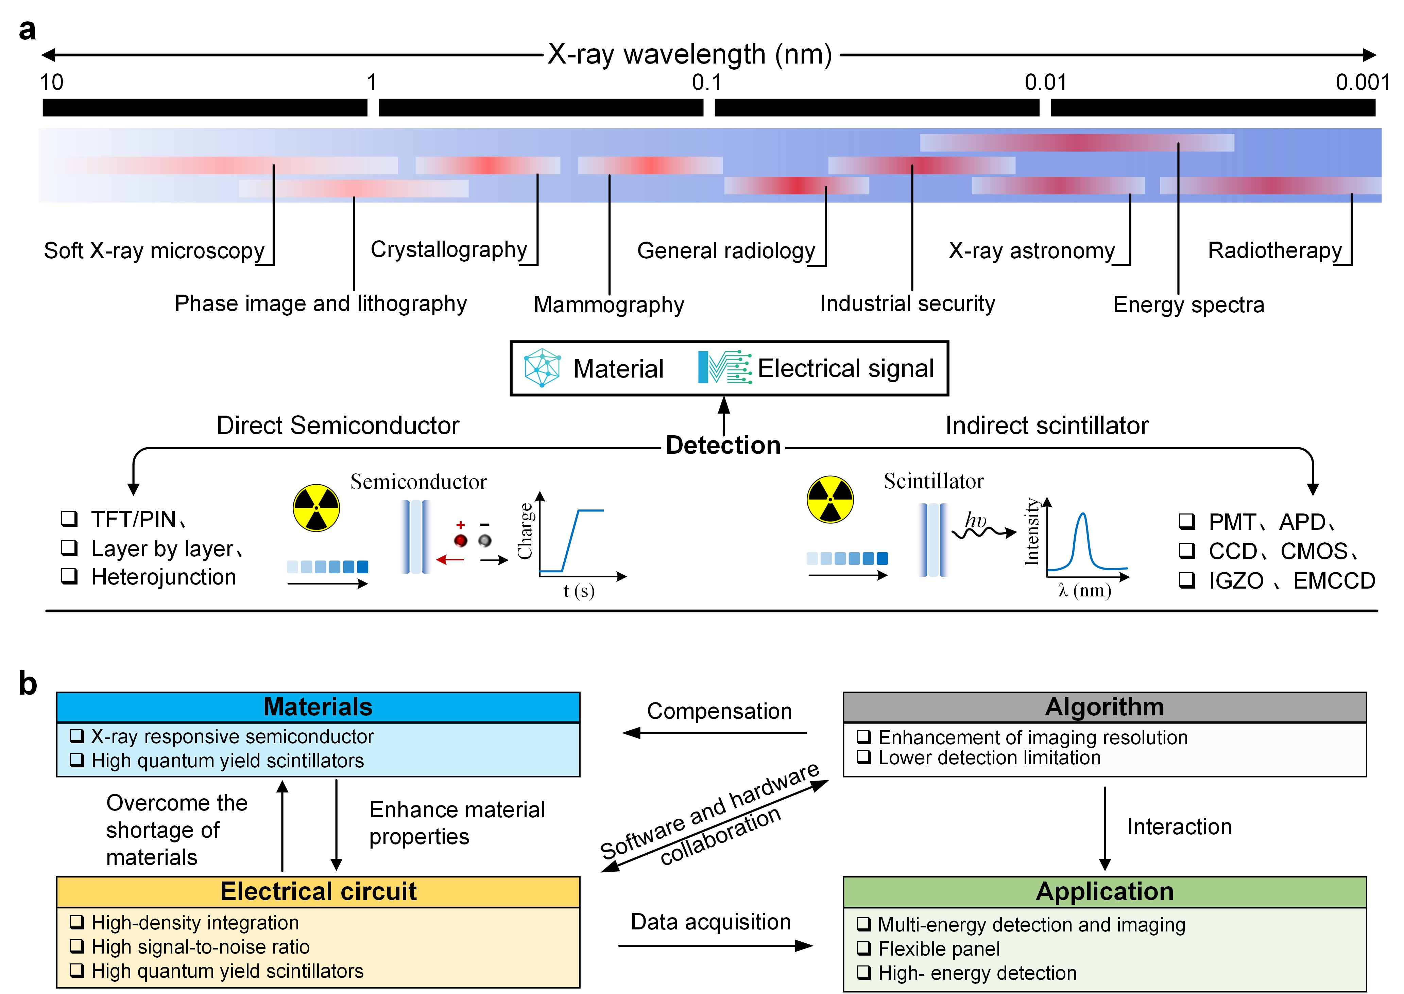
Box 1. Characteristics and challenges in X-ray detection

The energy spectrum of X-ray photons spans from 10 nm to 0.001 nm, rendering them applicable in numerous fields such as industry, security inspection, medicine, scientific research, and among others (Box 1a). Presently, X-ray detection methods are broadly divided into two categories — indirect signal transmission using photons as intermediaries and direct conversion of X-rays into charge. Key performance parameters for X-ray detectors encompass minimum detection dose rate, imaging spatial resolution, response uniformity, signal-to-noise ratio, dynamic range, and sampling speed. Electrical engineering and material properties are the main factors that affect the improvement of these key parameters. Focusing on detection materials is crucial to enhance X-ray detection performance. Furthermore, electronic engineering has emerged as a primary means to compensate for material shortcomings and improve detection capabilities (Box 1b). The main challenges currently encountered in X-ray detection are as follows:

Material Challenges:
    - X-ray semiconductor materials with minimal dark current for optimal performance.
    - Prolonged carrier diffusion to enable accurate detection.
    - High efficiency in radiation-induced electron-hole generation to enhance sensitivity.
Circuit Challenges:
    - Implementation of highly sensitive single-photon counting circuits for accurate measurement.
    - Development of dense-pixel, extensive area detection arrays to broaden the scope of detection.
    - Circuit designs with an elevated signal-to-noise ratio to improved accuracy.
Additional Challenges:
    - Creation of flexible, high-sensitivity photodetection circuits to enable versatile applications.
    - Addressing concerns related to material encapsulation to ensure durability and reliability.
    - Leveraging artificial intelligence (AI) algorithms to enhance X-ray detection capabilities.
    - Developing customized radiation detectors tailored for a diverse range of applications.
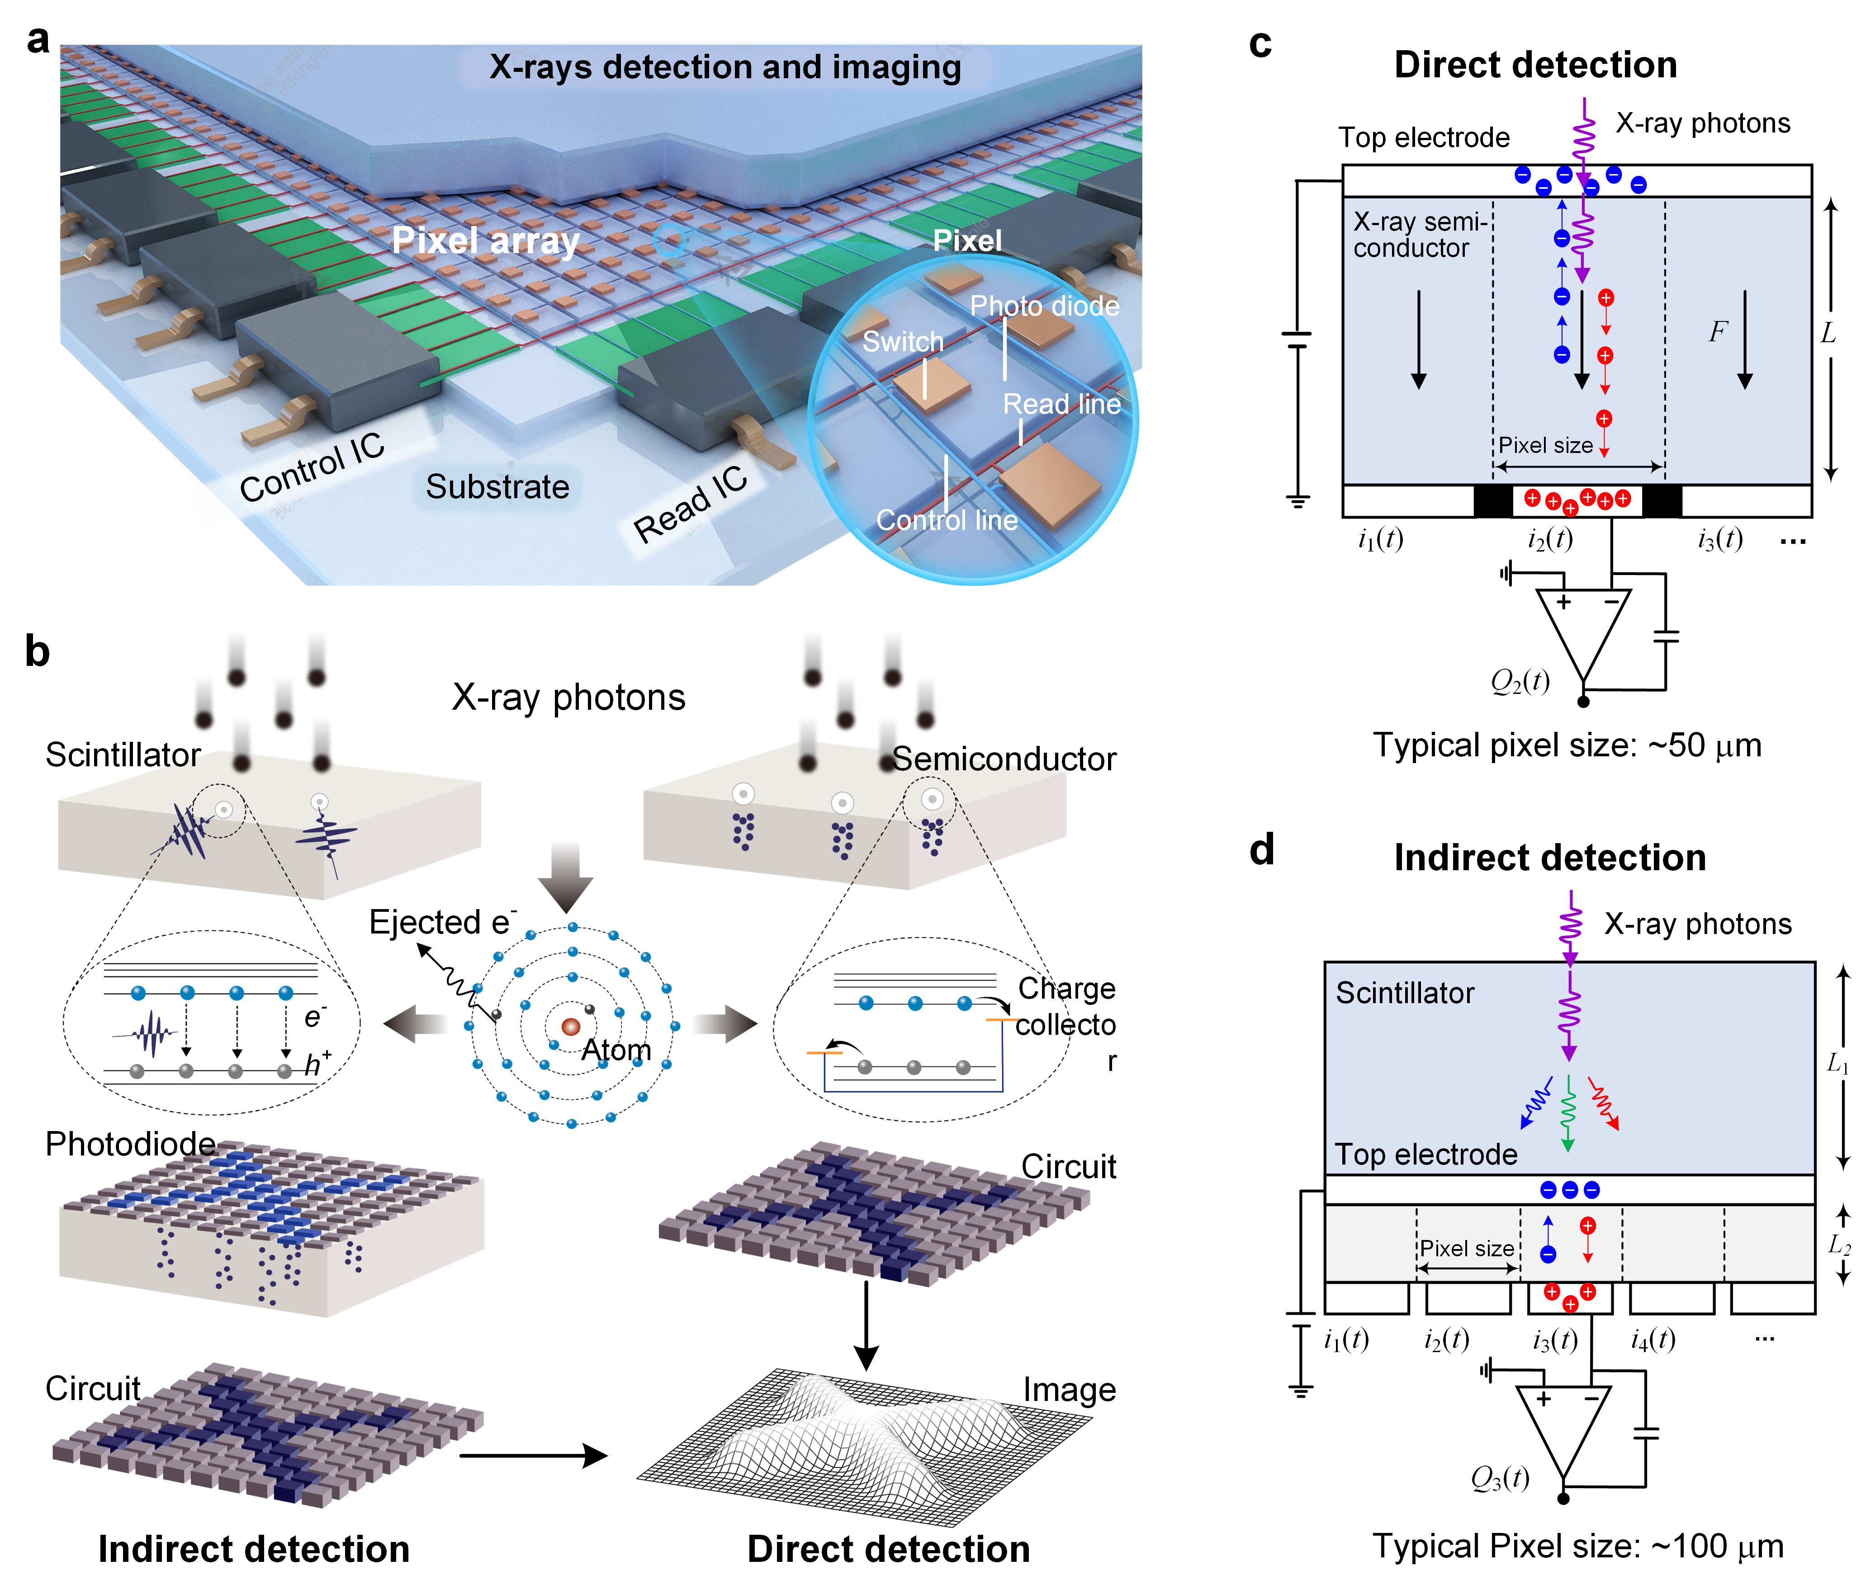

Fig. 1 | Mechanism and equivalent electronic circuitry for typical X-ray detection methods. a, Schematic of a standard pixelated array used in X-ray detection. b, Schematic of an indirect scintillator-based X-ray detector and a direct semiconductor-based X-ray detector, along with the interaction mechanism between X-ray photons and matter. Upon absorption of X-ray photons, high-energy electron-hole pairs are generated. In indirect detection, these electron-hole pairs are first converted into fluorescence signals, then detected by a photodiode, and ultimately transformed into electrical signals. In direct detection, the electron-hole pairs are directly converted into measurable electrical signals. c and d, Equivalent circuit diagrams for direct and indirect X-ray detection. In direct detection, typical pixel dimensions are approximately 50 μm, with semiconductor layer thickness ranging from 10 nm to 3 mm. In indirect detection, pixel size can be around 100 μm, and the scintillator thickness varies from 20 μm to 200 μm.

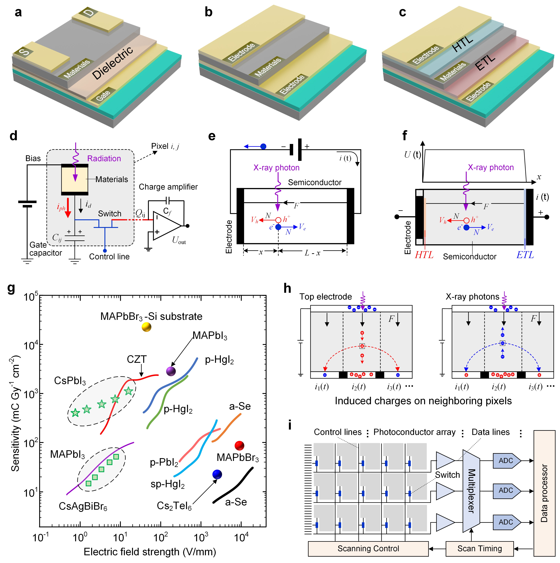

Fig. 2 | Electric models and signal transduction strategies in direct X-ray detection. a-c, Schematic layout of typical indirect X-ray detection strategies. a, A simplified cross-sectional view of traditional capacitor mode. b, A simplified cross-sectional view of an X-ray photoconductor. c, A direct detector featuring an integrated hole transport layer (HTL) and an electron transport layer (ETL). d, Simplified equivalent circuit of a phototransistor. e and f, Model illustrating electron-hole motion within X-ray-responsive semiconductors. e, Generation of electron-hole pairs and dose detection through current measurement. f, Hole and carrier collection through HTL and ETL, leading to charge accumulation on both sides of the semiconductor. g, Summary of X-ray detection sensitivity in state-of-the-art and recently developed detectors. h, Effects of charge trapping on resolution, dependent on the type of trapped charge carriers and their direction toward the top or bottom electrode. i₂ represents the central pixel, while i₁ and i₃ denote the neighboring left and right pixels. Transient currents into these pixels are integrated to determine the collected charges in neighboring pixels. i, Digital signal chain diagram illustrating the operation of a pixelated X-ray detector array.

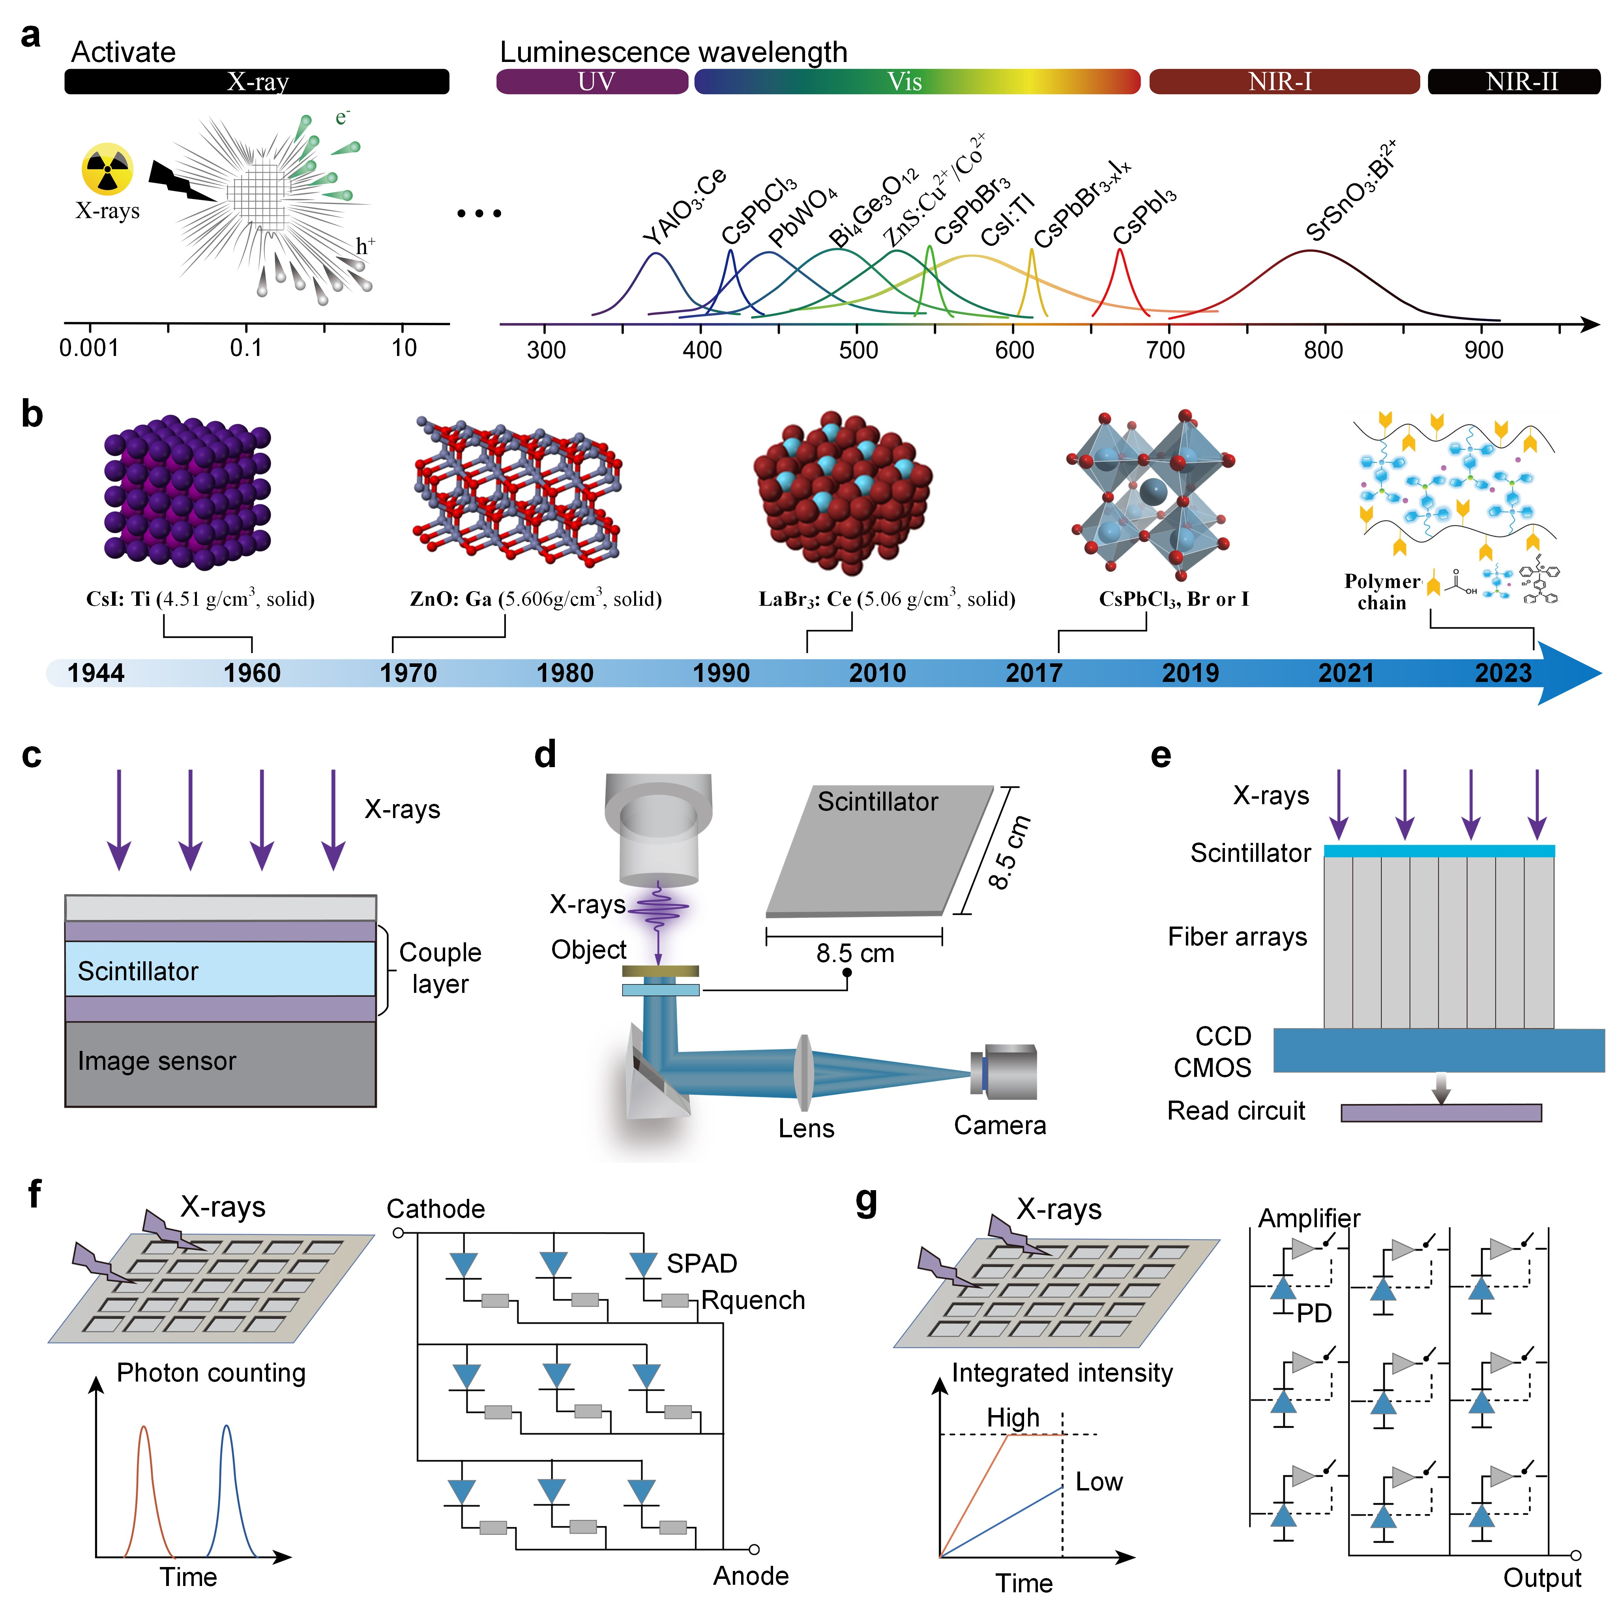

Fig. 3 | Indirect X-ray detection: materials, engineering technology and electrical engineering. a, Emission wavelength tuning from UV to NIR in X-ray-excited scintillators. b, Crystal structures of representative scintillators and a historical timeline, including traditional and newly reported inorganic and organic scintillators. c-e. Various methods for coupling scintillator layers with optical sensors, including direct coupling (c), optical lens coupling (d), and fiber coupling (e). Direct coupling combines adhesive bonding for cost efficiency with direct deposition to enhance resolution. Optical lens coupling primarily consists of the scintillator layer, optical lens, and imaging sensor, resulting in notable improvements in spatial resolution. The fiber coupling method offers benefits such as minimal scattering and high imaging resolution. f and g, Two common detection circuits: photon counting (f) and photoelectric integration (g). Photon counting consists of many parallel micro-units, each micro-unit comprising a single-photon avalanche diode (SPAD) and its associated front-end circuitry. These diodes are operated in Geiger mode, resulting in output pulses whose amplitude correlates directly with the number of photons detected. In contrast, photoelectric integration relies on PN junction photodiodes (PD). When these diodes are reverse-biased, the current increases linearly with light intensity.
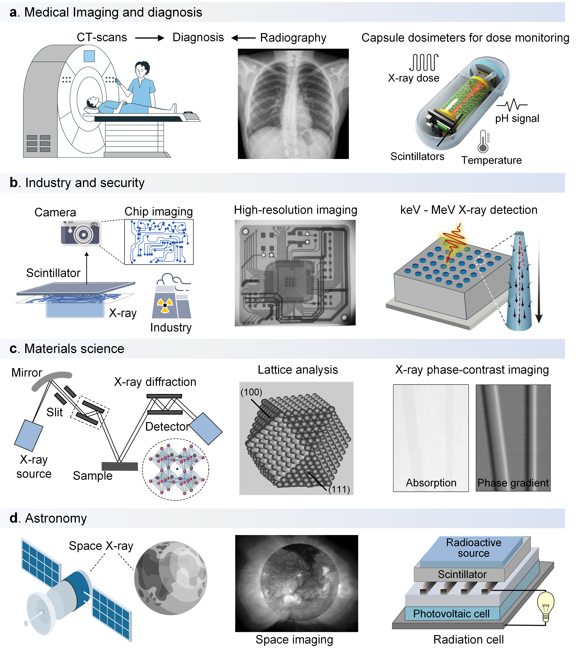
Fig. 4 | Versatile applications of X-ray detection and imaging. a, Medical imaging and diagnosis: a non-invasive and invaluable tool for diagnosing a wide range of medical conditions (left to right: CT scan imaging, chest radiography, a capsule dosimeter specially designed for dose monitoring during radiotherapy)⁸⁷. Copyright 2023 Springer Nature. b, Industry and security applications: a crucial technology that enables high-resolution imaging of semiconductor chips and integrated circuits, dose monitoring of nuclear power plants, and high-sensitivity detection of ionizing radiation (left to right: camera-based indirect X-ray imaging, high-resolution X-ray imaging of an integrated circuit, optical fiber coupling for improved energy harvesting in the keV to MeV range⁶⁹. Copyright 2023 Springer Nature. c, Materials science research: X-ray diffraction aids crystal studies while X-ray phase-contrast imaging explores material surface topology (left to right: X-ray diffraction setup, crystal lattice analysis, X-ray phase-contrast imaging compared to conventional X-ray absorption contrast imaging). d, Astronomy applications: a specialized technique used to capture high-energy X-rays emitted by cosmic sources and unveil hidden aspects of the universe (left to right: space dose monitoring, space, cosmic X-ray imaging, scintillator-based nuclear battery).

Table 1. Performances and electrical parameters of some typical semiconductor materials for direct X-ray detection.

Semiconductor material | μτ product  (cm² V⁻¹) | Electric field  (V/μm) | Lowest detection dose | Spectrum response range | Sensitive structure | Detection circuit | Stability | Ref
Si | >1 | 0.01-0.1 | <10 nGy/h | 28 keV @320 μm | Si-PIN(Positive-Intrinsic-Negative) | Single photon-counting with 20 bits. | High | ^{118, 119}
a-Se | 10⁻⁷ | 10 | 5.5 μGy/s | 100 keV @100 μm | Se-PIN(Positive-Intrinsic-Negative) | Single photon-counting. | High | ²⁵
Cs₂TeI₆ | 5.2×10⁻⁵ | 0.25 | <10 nGy/h | 40 keV | FTO/TiO₂/Cs₂TeI₆/PTAA/Au | Source Measure Unit | High | ¹²⁰
CdTe | 3×10⁻³ | 0.5 | <10 nGy/s | 150 keV | Au/CdTe/Au  single crystal | CV+ASIC | High | ^{121, 122}
CdZnTe | 10⁻³–10⁻² | 0.1 - 0.5 | 50 nGy/s | ~10 keV- 600 keV | Au/CdTe/Au  single crystal | CV+ASIC | High | ¹²³
InSe | ~10⁻³ | 0.1 - 1 | 6.35 μGy/s | 80 keV | Ag/InSe/Ag | Single photon-counting. | High | ¹²⁴
Bi₂O₃ | ~10⁻² | 0.1 - 1 | ~ 10 μGy/s | ~50 keV - 15 MeV | ITO/PEDOT: PSS/P3HT/  PC70BM/Bi₂O₃/BCP/Al | Source Measure Unit | High | ¹²⁵
CsPbBr₃ | 10⁻³–10⁻⁴ | 1.2 | 500 nGy/s | 70 keV | Ga/CsPbBr₃/Au | Source Measure Unit | Medium | ^{126, 127}
CsPbBr₃ | 10⁻³–10⁻⁴ | 0.11 | 53 nGy/s | 35 keV | Au/CsPbBr₃/ITO | Source Measure Unit | Medium | ^{128, 129}
CsPbI₃ | 10⁻³–10⁻⁴ | 31.25 | 220 nGy/s | 80 keV | Au/CsPbI₃/Au | Source Measure Unit | Medium | ¹³⁰
MAPbBr₃ | 10⁻² | 14.3 | 22.1 μGy/s | 50 keV | Al/MAPbBr₃/Au | Source Measure Unit | Medium | ⁷⁻⁹
Cs₂AgBiBr₆ | 10⁻³ | 0.05 | 45.7 nGy/s | 50 keV | Au/Cs₂AgBiBr₆/Au | Source Measure Unit | Medium | ¹³¹
Rb₃Bi₂I₉ | 2.51 × 10⁻³ | 0.3 | 8.3 nGy/s | 50 keV | Au/Rb₃Bi₂I₉/Au | Source Measure Unit | Medium | ¹³²
MA₃Bi₂I₉ | 4.6 × 10⁻⁵ | 0.21 | 9.3 nGy/s | 45 keV | Au/MA₃Bi₂I₉/Au | Source Measure Unit | Medium | ¹³³
CsPbBrI₂ | 10 ⁻³–10⁻⁴ | 300 | < 1 nGy/s | 20 keV  @50 nm | Heterojunction Au/PDPP-BTT/CsPbBrI₂/Au | Source-meter B2900A | Medium | ¹³⁴
TIPS | 1.7 × 10⁻² | V_{SG} = –20 V  V_{SD} = –15 V | 35 μGy/s | 140 keV | Field-effect transistors | Keithley 2614 Source Meter | Medium | ¹³⁵
SCU-12 | NA | 0.3-0.4 | 0.71 μGy s⁻¹ | 80 keV | Au/SCU-12/Au | Keithley 6517B electrometer | Medium | ¹³⁶
Hg₃Se₂I₂ | 10⁻⁵ | 0.2-0.6 | Resolution  ∼8.1% | 5.5 MeV | Au/Hg₃Se₂I₂/Au | Multichannel Analyzer | High | ¹³⁷
CsPbBr₃ | 8 × 10⁻³ | 0.1-0.1 | Resolution  ∼1.4% | 662 keV | EGaIn/CsPbBr3/Au | Multichannel Analyzer | Medium | ⁹⁴
CV, charge to voltage. ASIC, application-specific integrated circuit.
Table 2. Performance of recently reported scintillators.

Type | Material | Light yield  (ph/MeV) | Emission wavelength (nm) | Decay time | Stability | Ref
Traditional scintillators | BGO (Bi₄Ge₃O₁₂) | 8500 | 480 | ~300 ns | High | ¹³⁸
Traditional scintillators | CsI: Ti | 65000 | 540-550 | ~30 ns | High | ¹³⁹
Traditional scintillators | LYSO: Ce | 2900 | 400 | ~20 μs | High | ¹⁴⁰
Traditional scintillators | Gd₂O₂S: Tb | 30000-50000 | 430-450, 530-550 | ~ 1.2 μs | High | ¹⁴¹
Traditional scintillators | YAG: Ce | 16400 | 550 | 1 μs-10 ms | High | ¹⁴²
Traditional scintillators | CeBr₃ | 57000-66000 | 380-390 | 20 ns - 270 ns | High | ¹⁴³
Perovskite single crystals | CH₃NH₃PbCl₃ | ~20000 | 438 | 5.85 ns | High | ¹⁴⁴
Perovskite single crystals | MAPbBr_{x}Cl_{3-x} | 18000 | 410-600 | 0.14 ns | Medium | ¹⁴⁵
Perovskite single crystals | CsPbBr₃ | 21000 | 525 | 8.09 ns | High | ¹⁴⁶
Perovskite single crystals | CsEuI₃ | 24000 | 460 | 3400 ns | High | ^{147, 148}
Lanthanide-doped perovskites and metal halides | CsSrBrI₂: Eu | 65300 | 452 | 1800 ns | High | ¹⁴⁹
Lanthanide-doped perovskites and metal halides | CsSrClBr₂: Eu | 35100 | 445 | 3500 ns | High | ¹⁴⁹
Lanthanide-doped perovskites and metal halides | CsCaBrI₂: Eu | 51800 | 462 | 2100 ns | High | ¹⁴⁹
Lanthanide-doped perovskites and metal halides | CsCaI₃: Eu | 40000 | 460 | 2100 ns | High | ¹⁵⁰
Lanthanide-doped perovskites and metal halides | Cs₄SrI₆: Eu | 71000 | 460 | 3900 ns | High | ¹⁵¹
Perovskite and metal halide QDs | CsPbBr₃ | 17700 | 550 | 2.87 ns | Medium | ¹⁵²
Perovskite and metal halide QDs | CsPbCl₃ | 10000 | 420 | ~4 ns | Low | ¹⁵³
Perovskite and metal halide QDs | CsPbBr₃@SiO₂ | 16000 | 550 | ~3 ns | High | ¹⁵⁴
Perovskite and metal halide QDs | CsPbBr₃@Cs₄PbBr₆ | 6000 | 518 | 3 ns | High | ¹⁵⁵
Perovskite and metal halide QDs | Cs₃Cu₂I₅ | 79000 | 445 | 1920 ns | Medium | ¹⁵⁶
Organic scintillators | ITC | - | 520-535 | ~10 ms | Medium | ⁴⁹
Organic scintillators | Anthracene | ~37% | 420-430 | 30-40 ns | Medium | ¹⁵⁷
Organic scintillators | P-terphenyl | 65-70% | 340-360 | 1.5-3 ns | Medium | ^{158, 159}
Organic scintillators | Polyvinyl toluene | 1-2% | 410-430 | 2-4 ns | High | ^{160, 161}
Persistent luminescent materials | NaLuF₄:Tb@NaYF₄ | - | 489 / 543 | >10 h | High | ⁶⁸
Persistent luminescent materials | SrAl₂O₄:Eu²⁺/Dy³⁺ | - | 510-520 | >10 h | High | ⁶⁸
Persistent luminescent materials | ZnS:Cu²⁺/Co²⁺ | - | 510-530 | ~1s - ~10 h | High | ⁶⁸
Persistent luminescent materials | ZnGa_{1.995}O₄: Cr_{0.005} | - | 700 | ~1min - ~10 h | High | ⁶⁸
QDs, quantum dots.

