Multifunctional Oxadiazole-Based Polycatenars: A Pathway to Polar Columnar Phases

Yu Cao,^{1,2} Tejal Nirgude,³ Jonathan Jende,³ Alexander Jarosik,⁴ Alexey Eremin,⁴ Feng Liu,^{1,2} Masafumi Yoshio,^{5,6} Mohamed Alaasar,*^{3,7}
¹ Shaanxi International Research Center for Soft Matter, State Key Laboratory for Mechanical Behavior of Materials, Xi’an Jiaotong University, Xi’an 710049, P. R. China
² Institute of New Concept Sensors and Molecular Materials, Shaanxi Key Laboratory of New Concept Sensors and Molecular Materials, Xi’an Jiaotong University, Xi’an, P. R. China
³ Department of Chemistry, Martin-Luther University Halle-Wittenberg, Halle (Saale), Germany
⁴ Department of Nonlinear Phenomena, Institute for Physics Otto Von Guericke University Magdeburg, Magdeburg, Germany
⁵ Research Center for Macromolecules and Biomaterials, National Institute for Materials Science, 1-2-1 Sengen, Tsukuba, Ibaraki Japan
⁶ Japan Science and Technology Agency, PRESTO, Kawaguchi, Saitama, Japan
⁷ Department of Chemistry, Faculty of Science, Cairo University, Giza, Egypt

Abstract
Polar columnar liquid crystals (LCs) offer a promising pathway to nanostructured architectures for next-generation ferroelectric devices. Here, we represent a robust design strategy for producing polar columnar LCs based on nonsymmetric π-conjugated 1,3,4-oxadiazole derived bent-core polycatenars. The materials feature three alkoxy chains at one end and a single chain at the other, with the latter incorporating an azobenzene moiety that is either nonfluorinated or fluorinated to varying degrees. Increasing the degree of fluorination directs the molecular aggregation into novel modes of self-assembled columnar structures, leading to polar columnar phases. All phases could be perfectly aligned under an electric field due to the induced dielectric polarization from the oxadiazole ring. Notably, while nonfluorinated materials fail to form gels in organic solvents at low concentrations, their fluorinated counterparts exhibit exceptional gelation capabilities at concentrations below 1% weight, classifying them as supergelators. This behavior is due to enhanced π-π interactions and directed aggregation facilitated by aromatic core fluorination. Additionally, all materials exhibit reversible trans-cis photoisomerization upon light irradiation, both in the bulk state and in solution. These findings establish a versatile approach for designing multifunctional polar columnar phases through controlled molecular aggregation, which can be of interest for technological applications.

1. Introduction
The self-assembly of π-conjugated polyaromatic hydrocarbons into well-defined aggregates provides critical building blocks for a wide range of organic optoelectronic devices., Their unique electronic and optical properties, stemming from the delocalized π-electron systems, make these materials highly suitable for applications in organic field-effect transistors (OFETs), organic light-emitting diodes (OLEDs), and organic photovoltaic devices (OPVs)., These organic materials are typically composed of abundant elements like carbon and hydrogen, making them more sustainable and environmentally friendly compared to inorganic materials, which often rely on rare or toxic elements.
Liquid crystals (LCs) have long been at the forefront of materials science due to their unique combination of fluidity and molecular order, which makes them indispensable for applications in displays, sensors, and photonic devices. Columnar LCs, have garnered significant attention due to their anisotropic charge transport properties, making them promising candidates for applications in organic electronics.,, As a result of strong π-stackings between the conjugated building blocks the molecules segregate in columnar arrangement and thus provide one-dimensional conduction pathway., Integrating polarity into the columnar LCs generates a new class of functional materials with fast response and well-designed conductivity, promising for sensors and organic photovoltaics. The development of polar columnar LCs is still in its early stages. The first report for polar columnar LC was in 1993 by Swager using vanadyl salicylaldehyde Schiff base. Later, it was reported for other type of materials including cone-shaped,, bowl-shaped,, taper-shaped,,, sulfone-based materials, triphenylphosphine oxide LCs, and umbrella-shaped subphthalocyanine LCs., For columnar LC phases to be viable for applications in organic photovoltaics, two critical conditions must be met. First, the clearing temperature of the LC phase should be as low as possible. Second, the phase structure must facilitate complete and facile homeotropic alignment upon the application of a direct current (DC) electric field.,
Polycatenar LCs–molecules with multiple terminal flexible chains attached to a rigid core–are known for their ability to aggregate into complex mesophases, including columnar, cubic, and lamellar structures.,,,,,, These materials bridge the gap between conventional calamitic (rod-like) and discotic (disc-like) LCs, offering tunable optical and electronic properties that are highly desirable for advanced functional materials.^{21,,,,,} The integration of azobenzene moieties into the LC system represents a promising strategy to impart photo-responsive behavior, enabling precise control over molecular alignment and phase transitions through light irradiation., These properties make azobenzene derivatives ideal for applications in optical data storage, light-driven actuators, and smart surfaces.,,, In addition to mesophase formation, polycatenar LCs can form gels in organic solvents through aggregation into fibrous or network-like structures. These gels combine the mechanical robustness of solids with the dynamic responsiveness of LCs, making them attractive for applications in soft robotics, drug delivery, optoelectronics, and fluorescent sensors.,, Gel formation is governed by weak intermolecular interactions such as hydrogen bonding, van der Waals interactions, and π–π interactions, and can therefore be finely tuned by modifying the molecular structure, including the rigid core and the flexible terminal chains. More interestingly, the incorporation of external stimulus-sensitive units into such systems introduces an additional layer of control. For example, an azo unit can trigger gel-sol transitions or alter the mechanical properties of the gel. Such photo-responsive gelation opens new avenues for the development of adaptive and stimuli-responsive materials.,,
To date, only a few examples of bent-core hockey stick nonsymmetric polycatenars are reported to approach the polar columnar phase. Using a central bent-core unit connected to side wings of variable lengths with an unequal distribution of the terminal alkoxy chains, suh as hockey stick polycatenars are promising for integrating polarity into self-assembly hebavior. Four bent-core units were used to design such hockey stick polycatenars, including 4-cyanoresorcinol,, 2,5-disubstituted thiophene, 4-bromoresorcinol,⁵³ and 1,3,4-oxadiazole.³⁵ The latter plays a critical role in the molecular engineering of LCs, owing to its distinctive electronic properties. As an electron-deficient heterocycle, it enhances charge transport capabilities and promotes strong intermolecular interactions, such as π-π stacking and dipole-dipole coupling, which are essential for stabilizing ordered mesophases.^{54–56} Its rigid, bent-core geometry introduces molecular asymmetry, a key factor in inducing polar order and enabling the aggregation into complex nanostructured LC phases.^{57–59} Furthermore, the thermal and chemical stability of the 1,3,4-oxadiazole unit ensures the robustness of the resulting materials under operational conditions.⁵⁴ These features make it an ideal central unit for designing LCs with tailored functionalities, especially for organic semiconductors.^{61,62}
Herein, we present the design, synthesis, and characterization of a new family of multifunctional azobenzene-derived 1,3,4-oxadiazole-based nonsymmetric polycatenar LCs (compounds An, An/mF₃ and An/mF₂₃, Scheme 1). We employ a dual strategy of alkyl chain engineering and aromatic core fluorination to design new stimuli-responsive materials that aggregate into diverse columnar LC phases, including a new, unreported structure. The molecular self-assembly was investigated via differential scanning calorimetry (DSC), polarized optical microscopy (POM), small angle X-ray scattering (SAXS), and electrooptic investigations. These materials exhibit photochromic properties and, depending on the degree of fluorination, can form gels in organic solvents at concentrations below 1%, classifying them as supergelators. Notably, they possess low clearing temperatures, and most of the columnar phases exhibit polar order, enabling facile homeotropic alignment under a DC electric field. The combination of photo-responsivity, gelation ability, and a capacity for polar aggregation makes these multifunctional systems highly promising for advanced optoelectronic applications.

2. Results and discussion
2.1. Synthesis
The synthesis of the target polycatenars was performed as shown in Scheme 1. It was started with the synthesis of the ester-based side arm 4/n by first an esterification reaction between the 3,4,5-tris(alkoxy)benzoic acid 1/n,, and 4-hydroxybenzaldehyde 2, resulting in the formation of 4-formylphenyl-3,4,5-tris(alkoxy)benzoate 3/n. The obtained aldehydes were then oxidized to the corresponding benzoic acid derivatives 4/n using Pinnick oxidation.,, To synthesize the phenols having both the oxadiazole ring and the azobenzene unit (10/mH, 10/mF₃ and 10/mF₂₃) the azobenzene-based benzoic acids (5/mH, 5/mF₃ and 5/mF₂₃)^{64,,} underwent an esterification step with 2,3,4,5,6-pentafluorophenol 6, to get the substituted esters (7/mH, 7/mF₃ and 7/mF₂₃). These esters were reacted with 4-hydroxybenzohydrazide 8 to get the corresponding benzohydrazide derivatives (9/mH, 9/mF₃ and 9/mF₃). In a subsequent step, along with thionyl chloride, they form the substituted 1,3,4-oxadiazol-containing phenols (10/mH, 10/mF₃ and 10/mF₂₃). In the final step, the benzoic acid derivatives 4/n were converted to their corresponding acid chlorides using thionyl chloride and used in an acylation reaction of the phenols (10/mH, 10/mF₃ and 10/mF₂₃) in presence of equivalent amount of triethyl amine (TEA) and pyridine as a catalyst to get the final polycatenars (An, An/mF₃ and An/mF₂₃ ). All synthesis details as well as the analytical data are reported in Supporting Information (SI).

2.1. Thermotropic behavior:
The phase behavior of the synthesized materials was investigated by DSC, POM, and SAXS investigations. The combined results are summarized in Table 1 and Table 2.

Scheme 1: Synthesis of the target polycatenars. Reagents and conditions: i. DCC, DMAP, DCM, stirring at RT, 24 h; ii. resorcinol, NaClO₂, NaH₂PO₄, stirring at RT, 18 h; iii. THF, DMF, stirring at RT under argon, 12 h; iv. SOCl₂, pyridine, reflux under argon for 6 h; v. SOCl₂, DMF, pyridine, TEA, DCM, reflux under argon for 6 h.

2.1.1. Nonfluorinated polycatenars
In the first series of materials, designated as An, no fluorine substitution was introduced. These compounds feature a fixed alkyl chain of 12 carbon atoms at the monosubstituted end, while the length of the terminal chains at the trisubstituted end was systematically varied (n = 4, 6, 12, and 16). As summarized in Table 1, this group exhibits a diverse range of LC phases. The shortest homologue (A4) forms a three-dimensional cubic phase, while the longer derivatives (A12 and A16) exhibit various columnar phases. This structural variation highlights the significant influence of terminal chain volume on the self-assembly and phase behavior of these materials.

Table 1. Phase transition temperatures (T/°C), mesophase types, and transition enthalpies [ΔH (kJ/mol)] of An compounds.
Cpd. | n | Transition temperatures (°C) and enthalpies [kJ/mol]ª
A4 | 4 | H: Cr 106 [26.4] Cub_{bi}/Ia$\overline{3}$d 126 [1.1] Iso  C: Iso 124 [< 0.1]^{b} Cub_{bi}/Ia$\overline{3}$d 97 [7.1] Cr
A6 | 6 | H: Cr 133 [28.6] Iso  C: Iso 108 [27.2] Cr
A12 | 12 | H: Cr1 68 [30.9] Cr2 85 [3.3] Hex/P6₃/mmc+Cub_{bi}/Ia$\overline{3}$d 100 [0.5] p6mm 129 [0.6] Iso  C: Iso 125 [0.6] p6mm 82 [4.1] Cub_{bi}/Ia$\overline{3}$d 49 [11.1] Cr
A16 | 16 | H: Cr 86 [46.7] p6mm 131 [0.7] Iso  C: Iso 128 [0.7] p6mm 81 [3.8] P6/mmm 61 [29.5] Cr
a Peak temperature as determined from 2nd heating (H) and 2nd cooling (C) DSC scans with rate 10 K min⁻¹; b this transition cannot be detected by DSC; abbreviations: Cr = crystalline solid; Cub_{bi}/Ia$\overline{3}$d = bicontinuous cubic phase with Ia$\overline{3}$d symmetry; P6mm = hexagonal columnar phase with P6mm symmetry; Hex/P6₃/mmc = 3D hexagonal columnar phase with P6₃/mmc symmetry; Iso = isotropic liquid.

Upon cooling the shortest homologue, A4, from the isotropic liquid state in a sandwiched glass cell under crossed polarizers, a highly viscous state is observed, characterized by its isotropic appearance (Figure 1a). The formation of this phase is accompanied by a distinct transition peak in the DSC heating curve, with an enthalpy change (ΔH) of approximately 1.1 kJ/mol and a thermal hysteresis of 2 °C (see Table 1 and Figure S31 for DSC traces). Rotating one of the analyzers from the crossed position with a small angle reveals no dark or bright domains, which is characteristic of an achiral double gyroid bicontinuous cubic phase with Ia$\overline{3}$d symmetry (Cub_{bi}/Ia$\overline{3}$d). This phase assignment was further corroborated by X-ray diffraction (XRD) studies, as will be discussed later.

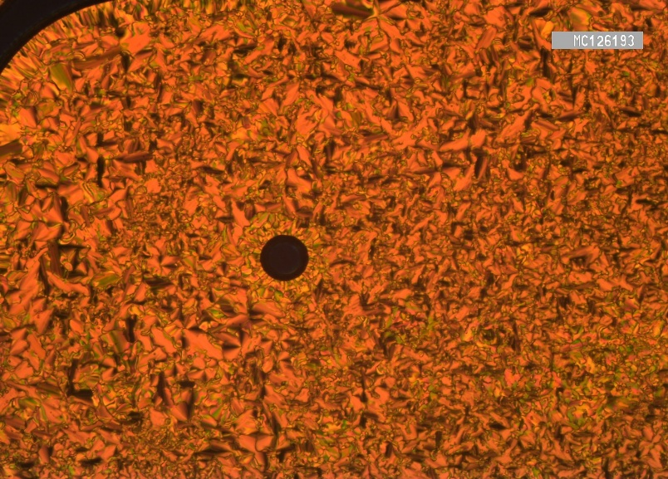
a)
b)

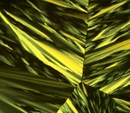


Figure 1. POM textures of a) the Cub_{bi}/Ia$\overline{3}$d phase of A4 at @ °C and b) the columnar p6mm phase of A12 at 115 °C in a sandwiched glass cell. The direction of the polarizers, identical in all cases, is shown in a). The insets show the corresponding textures in a polyimide (PI)-coated ITO cell with a 6 µm gap.
Increasing the chain length from n = 4 to 6 in the next homologue (A6) results in a non-mesomorphic material, as evidenced by the direct transition from the crystalline state to the isotropic liquid upon heating, with no LC phases observed during cooling (see Table 1 and Figure S32). On the other hand, the next derivative with n = 12 exhibits entirely different phase behavior. The DSC heating cycle reveals two additional measurable transitions following melting and Cr1-Cr2 transitions, confirming the presence of two distinct LC phases for A12, which are also observable during the cooling cycle (Figure S35). These phases are further corroborated by POM observations (Figure 1). Upon cooling from the isotropic liquid state, a confocal fan-shaped texture appears at ~ 125 °C (Figure 1b), which changes at the next transition near 82 °C to a completely dark texture similar to that observed for A4 indicating the presence of Cub_{bi}/Ia$\overline{3}$d phase before starting of crystallization at ~ 49 °C (Figure S33).
The SAXS investigations reveal that depending on the temperature A12 exhibits different types of LC phases. Upon heating, a complex phase sequence with three LC phases competing with each other is recorded (Figure 2a). At high temperature, the LC phase is the conventional hexagonal columnar phase with p6mm space group. The SAXS pattern exhibits three sharp peaks in ratio of $1:\sqrt{3}:2$. The reconstructed electron density map suggests a hexagonal lattice with lattice parameter as 4.98 nm at 101ºC (Figure 2b). The high electron density region is close to the length of aromatic core (~3.5 nm), shown in thick white line in ED map. Calculated from both volume increment method, columns are composed by molecular rafts of about 4 individual molecules. Due to the lack of constrain between neighbouring columns, the rafts adopt free rotation in each column, leading to the uniform circular high electron density region. At relatively lower temperature, there is a range of coexisting p6mm and Ia$\overline{3}$d phases. By annealing at 92 °C, the Ia$\overline{3}$d phase could be dominating, and the reconstructed ED map suggested a bicontinuous cubic phase with two interwoven networks connected by three-way junctions (Figure 2c). The lattice parameter can be determined as 11.29 nm, suggesting a cubic lattice containing about 668 molecules. Assuming the intermolecular distance is 0.45 nm, which is typical from the molten alkyl chains, about 3 molecules form rafts and align perpendicular to the network. The transition from columnar phase to network phase upon cooling is common, which is a result of decreasing interfacial curvature between incompatible aromatic core and aliphatic tail due to volume shrinkage upon cooling. Such transition, combined with the solely Ia$\overline{3}$d phase of A4, suggests that A12 is at the boundary of phase transition between network phase and columnar phase.
At even lower temperature, a novel phase becomes dominating, indexed as a 3D hexagonal lattice with P6₃/mmc space group, one of the hexagonal space group with highest symmetry (Figure 2d). The lattice parameter of this phase is a = 18.22 nm and c = 10.25 nm. Interestingly, the reconstructed ED map suggests a structure combining both column and network in one lattice (Figure 2e). The network is connected by three-way junctions in ab plane, which is same as Ia$\overline{3}$d phase. Meanwhile, the columns along c direction form smaller hexagonal lattice by three red columns and one blue column as in Figure 2f. The lattice formed by columns exhibits a parameter of 5.26 nm, very close to the high temperature hexagonal phase. The formation of such 3D hexagonal lattice is a result of optimal space filling. The fully extended length of A12 is ~6.5 nm, which is definitely insufficient to fill the hexagonal network in the 3D phase. Instead, by inserting the columns in the middle of each hexagon, the interior of the network can be properly filled. Besides, this is also a practical way to tune the interfacial curvature of the phase.
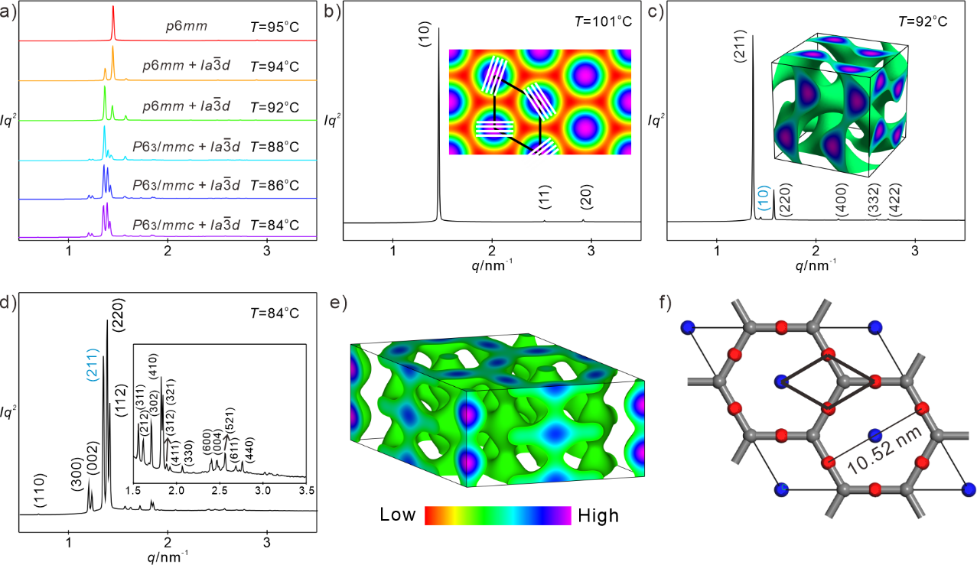
Figure 2. a) Temperature-dependent XRD patterns of A12 upon heating; b) XRD profile of the p6mm phase of A12 at 101 °C with an inset showing the reconstructed ED map; c) XRD profile of the Ia$\overline{3}$d phase of A12 at 92 °C, where the blue (10) peak originates from the p6mm phase, with the reconstructed ED map shown as an inset; d) diffractogram of the P6₃/mmc phase of A12 at 84 °C, where the blue (211) peak originates from the Ia$\overline{3}$d phase; e) reconstructed ED map of the P6₃/mmc phase; f) projection of the P6₃/mmc phase onto the ab plane.
By comparing compound A12 with recently reported hockey stick polycatenars derived from the 1,3,4-oxadiazole heterocycle,³⁵ which have the same number of aromatic rings and similar chain volumes at both ends of the rigid aromatic core, it becomes evident that the position of the oxadiazole ring plays a critical role in determining the type of LC phases and their temperature ranges. In the previously reported compound, the oxadiazole ring was linked to two benzene rings with ester groups. In contrast, in the newly reported materials, the ester groups are positioned on the same side, along with an electron-donating triple-alkylated terminal benzene ring. This careful molecular design results in a higher dipole moment for the entire molecule, which in turn leads to a wider mesophase range of ~ 61 K and a more complex phase structure including a new LC phase (3D hexagonal phase with P6₃/mmc space group). In comparison, the previously reported material exhibited only a Col_{hex} phase over a narrower temperature range of ~ 35 K.
For the longest homologue A16 (n = 16), the extended alkyl chain volume suppresses the cubic network phase formation. Instead, only a single columnar phase with a hexagonal lattice p6mm is observed on the heating cycle (Figure 3a,d). With a lattice parameter of 5.18 nm, each molecular raft contains about 4 molecules, in line with A12. Upon cooling, however, an additional monotropic 3D hexagonal phase P6/mmm appears as a metastable phase prior to crystallization at ~ 61 °C (Figures 3b,c,e,f and S34). The columnar hexagonal framework is retained, but cooling introduces extra order along the c direction, transforming the 2D columnar phase into a 3D phase with P6/mmm space group and lattice parameters a = 6.24 nm and c = 3.88 nm. Notably, this phase transition does not change the cross-section of the columns in the ab plane (Figure 3e), indicating that the overall column orientation remains random within the 3D lattice. Instead, due to denser packing upon cooling, each molecular raft accommodates about 6 molecules.

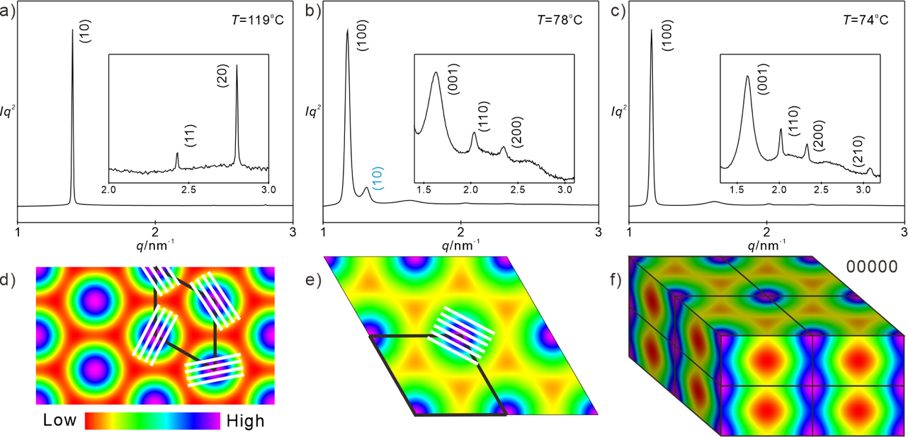
Figure 3. a-c) SAXS diffractograms of A16 upon cooling at the indicated temperatures, showning the p6mm phase, a mixed phase, and the P6/mmm phase; d) reconstructed ED map of the p6mm phase; e,f) top view and projection view of the P6/mmm phase with the 2×2×2 lattice indicated by solid black lines.
When an electric field of up to 200 Vpp was applied to any of the LC phases observed for An homologues, no polarization peak could be recorded, indicating that all of them are nonpolar. These results are consistent with the self-assembled LC phases of the non-fluorinated compounds. In all cases, the phases consist of molecular rafts containing an even number of molecules, which reduces the net polarity. Besides, the structures are either randomly packed columnar phases or 3D continuous networks, both of which are inherently difficult to align under an external electric field.
2.1.2. Fluorinated polycatenars
Building on our recent findings that aromatic core fluorination can induce polar order in the Col_{hex} phase,³⁵ we synthesized an additional series of fluorinated materials. We explored the influence of single fluorine substitution on the development of polar order in columnar phases by synthesizing two selected derivatives: A16/12F₃ and A12/12F₃ with medium and longest chain. Then we focused on structural modification of the compounds with n = 12 in relation to the neat compound A12 or to the monofluorinated one A12/12F₃, which both exhibit different columnar Col phases. Therefore, we synthesized a complete series of polycatenars having two fluorine atoms at ortho and meta positions with respect to the terminal alkoxy chain at the monosubstituted end (compounds A12/mF₂₃, Table 2). Finally, we have also tested the effect of double core fluorination in case of the longest derivative from series An i.e. A16 by synthesizing its related analogue A16/12F₂₃ (Table 2). These structural variations allowed us to compare the effects of single versus double fluorine substitution on the stabilization of polar order in the columnar phases.

Table 2. Phase transition temperatures (T/°C), mesophase types, and transition enthalpies [ΔH (kJ/mol)] of compounds from An/mF₃ and An/mF₂₃.
Cpd. | n | m | X | Y | Transition temperatures (°C) and enthalpies [kJ/mol]ª
A12/12F₃ | 12 | 12 | F | H | H: Cr 96 [15.9] p2 104 [<0.1] p6mm 147 [1.1] Iso  C: Iso 144 [1.1] p6mm 102 [<0.1] p2 88 [26.2] Cr
A16/12F₃ | 16 | 12 | F | H | H: Cr 96 [41.1] p6mm 144 [1.1] Iso  C: Iso 141 [0.9] p6mm 94 [0.3] p2 82 [32.4] Cr
A12/8F₂₃ | 12 | 8 | F | F | H: Cr1 100 [49.3] Cr2 135 [10.0] p6mm 146 [1.4] Iso  C: Iso 143 [-1.2] p6mm 132 [-10.7] Cr2 89 [-37.9] Cr1
A12/10F₂₃ | 12 | 10 | F | F | H: Cr 82 [22.70] Cr₁ 100 [10.90] Cr2 132 [12.27] p6mm 150 [1.92] Iso  C: Iso 148 [-1.82] p6mm 129 [-11.80] Cr2 78 [-28.44] Cr1
A12/12F₂₃ | 12 | 12 | F | F | H: Cr 104 [18.3] p2 122 [1.1] p2 125 [5.2] p6mm 152 [1.2] Iso  C: Iso 149 [1.3] p6mm 122 [2.7] p2 114 [1.1] p2 86 [20.7] Cr
A12/14F₂₃ | 12 | 14 | F | F | H: Cr 94 [19.9] p2 109 [2.3] p2 124 [3.9] p6mm 152 [1.9] Iso  C: Iso 149 [-2.5] p6mm 122 [-4.2] p2 98 [-1.8] p2 72 °C [-14.6] Cr
A12/16F₂₃ | 12 | 16 | F | F | H: Cr 97 [24.1] p2 128 [3.6] p6mm 159 [3.1] Iso  C: Iso 156 [-3.3] p6mm 124 [-4.1] p2 64 [-25.6] Cr
A16/12F₂₃ | 16 | 12 | F | F | H: Cr 107 [32.0] p2 117 [0.7] p2 128 [1.7] p6mm 152 [1.0] Iso  C: Iso 147 [1.0] p6mm 123 [1.9] p2 105 [< 0.1] p2 90 [30.5] Cr
a Peak temperature as determined from 2nd heating (H) and 2nd cooling (C) DSC scans with rate 10 K min⁻¹; abbreviations: p2 = columnar phase with p2 symmetry; for remaining abbreviations see Table 1.

Single core fluorination. The first compound investigated was A12/12F₃ with n and m = 12 (Table 2). Compared to its non-fluorinated related analogue A12 (Table 1), monofluorine substitution results in higher melting and crystallization temperatures, attributable to stronger core-core interactions facilitated by aromatic core fluorination. Additionally, only two columnar phases are observed during the DSC heating and cooling cycles of A12/12F₃ (see Fig. S35). During POM investigations in a sandwiched glass cell under crossed polarizers, a change in birefringence is observed at the transition from the higher temperature phase to the lower temperature one (Figure 4a,b), both on heating and cooling. This confirms the enantiotropic nature of the LC phases. When an electric field of up to 200 Vpp was applied in a polyimide (PI)-coated ITO cell containing A12/12F₃, no current response was detected in the higher temperature phase (Figure. 4c). In contrast, at the transition to the lower temperature LC phase, a clear polarization peak appeared (Figure. 4d), indicating its ferroelectric nature. This ferroelectricity arises from aromatic core fluorination, as no polarization current response was observed in any of the LC phases of the non-fluorinated compound A12.
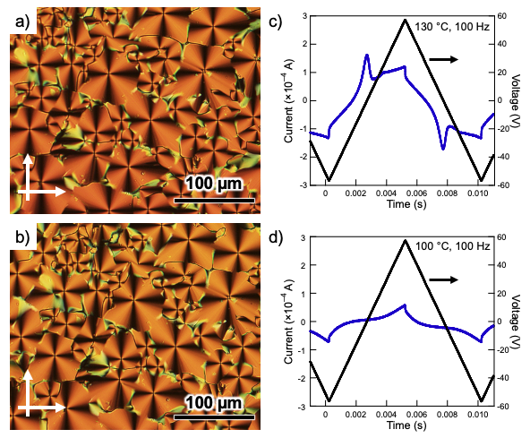

Figure 4. POM textures of A12/12F₃ in a sandwiched glass cell with insets showing textures in a PI-coated ITO cell with a 6 µm gap without applied electric field (left), and the corresponding polarization current response curves (right) recorded in the PI-coated ITO cell. Panels a,c) show the p6mm phase at 140 °C, while panels b,d) display the p2 phase at 97 °C. 10 V shown in c,d) should be deleted.

Monofluorination of the longest compound A16, yields A16/12F₃. Like the observations made for A12/12F₃, the transition temperatures of A16/12F₃ are significantly affected. However, polar order remains observable in the lower temperature monotropic phase (see Figure S36 for DSC and Figure S44 in the SI). To understand the origin of such polarity, the self-assembled structures of A16/12F₃ were investigated in more detail with SAXS and reconstructed ED maps. The high-temperature columnar phase is a conventional p6mm 2D phase as found in non-fluorinated compounds (Figure 5a, b). The lattice parameter is 5.21 nm, nearly identical to that of A16 (5.18 nm). Upon cooling, however, this phase transforms into a second columnar phase with very low symmetry as p2 phase, replacing the 3D P6/mmm hexagonal phase found in A16. This p2 columnar phase is characterized by lattice parameters of a = 11.88 nm, b = 6.25 nm, and γ = 85.0º (Figure 5c, d).

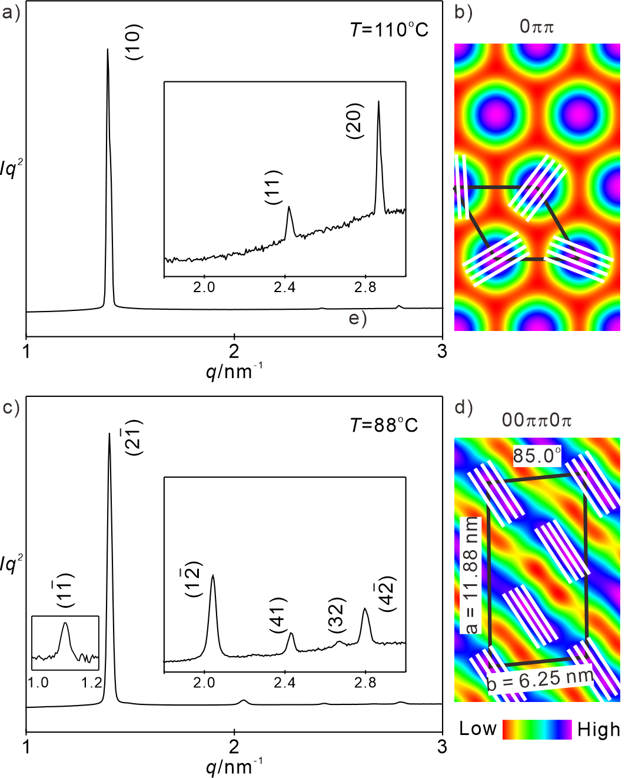
Figure 5. SAXS Investigations of A16/12F₃: a,b) SAXS diffractograms and reconstructed ED map of the higher temperature p6mm phase; c,d) SAXS diffractograms and reconstructed ED map of the lower temperature p2 phase.

Interestingly, the number of molecules per raft is quite close between two phases, 4.26 in p6mm phase vs 4.45 in p2 phase, which explains the very small enthalpy change upon phase transition. From ED map of p2 phase, it’s clear that high ED region deforms upon phase transition, from circular to layer-like. Such change indicates that molecules are aligned in each column, which enhances the polarity as in B2 phase of bent-core LCs. Such alignment can be resulted from the stronger polarity from fluorination. Besides, the extra fluorine atom at the peripheral of aromatic core enhances the π−π interaction, leading to the more ordered and aligned molecular packing upon cooling.

Double core fluorination. Using double fluorine substitution instead of monofluorination turned out to be more effective toward induction of more complex LC phases as well as toward the development of polar order (Table 2). We have synthesized a complete series of these materials having a fixed n = 12 at the crowded end and a variable chain length at the monosubstituted end with m = 8–16 (compounds A12/mF₂₃, Table 2). The first two homologous with m = 8 and 10 display very similar phase behavior (Table 2), therefore we focus here on the shortest homologue A12/8F₂₃ as an example. The DSC heating cycle of A12/8F₂₃ shows two transition peaks corresponding to Cr-Cr transitions followed by one peak for an LC phase to the isotropic liquid transition, indicating the presence of one enantiotropic LC phase (Figure S37). No additional monotropic LC is detected during the cooling cycle. Under POM this LC phase exhibits a spherulitic texture, indicating a Col phase (Figure 6a). Upon cooling this Col phase and at ~ 130 °C shortly before the onset of crystallization another characteristic texture with circular domains and reduced birefringence is observed (Fig. 6b). At the transition to this texture, the development of polar order begins, evidenced by the appearance of two distinct polarization current peaks under an applied electric field (Fig. 6e), indicating an antiferroelectric LC state. To the best of our knowledge, this represents the first reported example of an antiferroelectric columnar phase for polycatenar LCs. Upon further cooling and at the onset of crystallization, the two polarization peaks merge into a single, very broad peak, which rapidly vanished after entering the crystalline state. The textural changes are also easily recognized in a PI-coated ITO cell (the insets in Fig. 6a,b). Interestingly, applying an electric field to the LC phase leads to the disappearance of the birefringent texture, replaced by a completely dark texture. This observation is also recorded in the whole range of the LC phase. This indicates perfect alignment of the columnar structure under the electric field, a property of significant interest for potential applications. It should be noted here that the alignmnet of all Col phases exhibited by all synthesized materials from Table 1 and 2 was possible under an applied electric field.

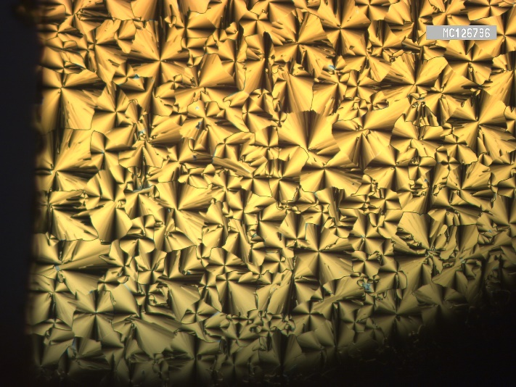
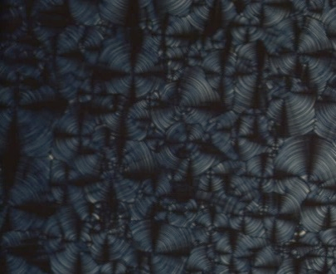
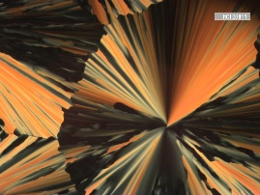
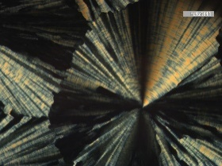
a)
c)
a)
b)

b)
d)

Figure 6. POM textures of A12/8F₂₃ in the p6mm phase: a) at 141 °C and b) at 130 °C in a sandwiched glass cell (left), with insets showing textures in a PI-coated ITO cell with a 6 µm gap without applied field. The polarizer directions are indicated by arrows in b). Corresponding polarization current response curves (right) recorded in the PI-coated ITO cell: c) at 141 °C and d) at 130 °C.

Upon further chain elongation the phase behavior becomes more complicated (Table 2). The two derivatives with m = 12 and14 exhibit the same phase sequence of p2-p2-p6mm on heating and cooling cycles (Table 2). Therefore, we will discuss here in details compound A12/12F₂₃ as a reprsentative example. As can be seen from the DSC traces (Fig. S39) all phase transitions are detcteable with measureable change of enthalpy. The transition from one phase to another could be also observed under POM, where on cooling from the isotropic liquid state a highly bireferengt texture is observed in the p6mm phase (Figure 7a). This texture becomes less birefrengence at the transition to the p2 on further cooling (Fig. 7b). At the transition to this p2 phase, the development of polar order begins, evidenced by the appearance of two polarization current peaks (Fig. 7e). One of these peaks is intense and higher than the other one, which might indicate also an antiferrolelectric switching as that observed for the shorter derivative A12/8F₂₃. However, in case of A12/12F₂₃ the two peaks cannot be separated and are not equivalent in height, which can be attributed to the higher viscosity of the LC phase resulting from the presence of longer chains compared to A12/8F₂₃.
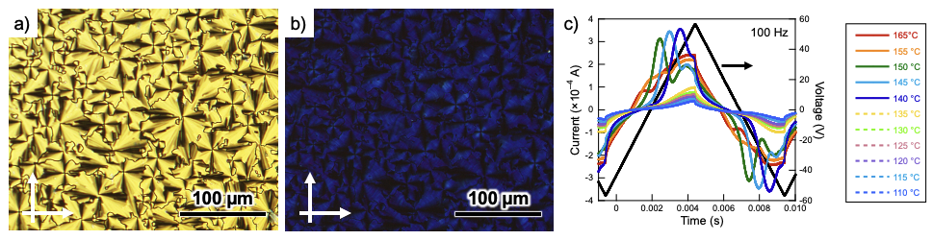
Figure 7. POM textures of A12/12F₂₃in a sandwiched glass cell (left), with insets showing textures in a PI-coated ITO cell with a 6 µm gap without applied electric field, and corresponding polarization current response curves (right): a,d) p6mm phase at 135 °C; b,e) p2 phase at 123 °C, c,f) p2 phase at 112 °C. The polarizer directions are indicated by arrows in c).

The two p2 phases of A12/12F₂₃ at different temperatures can be properly indexed into columnar phases formed by molecular rafts of four molecules (Figure 8a,e). To ensure the phase, assignment, sample at different temperature was sheared and tested as grazing-incident small-angle X-ray scattering (GISAXS). Due to the low symmetry of p2 plane group, there’re multiple orienations of the aligned sample, resuting in scattering patterns of arcs instead of scattering points (Figure 8b,c,f). However, the GISAXS patterns can still prove that the assignments of columnar phases are correct. With such phase, the reconstructed ED maps suggest again layer-like structure with highly orientaed molecular rafts (Figure 8d,g).
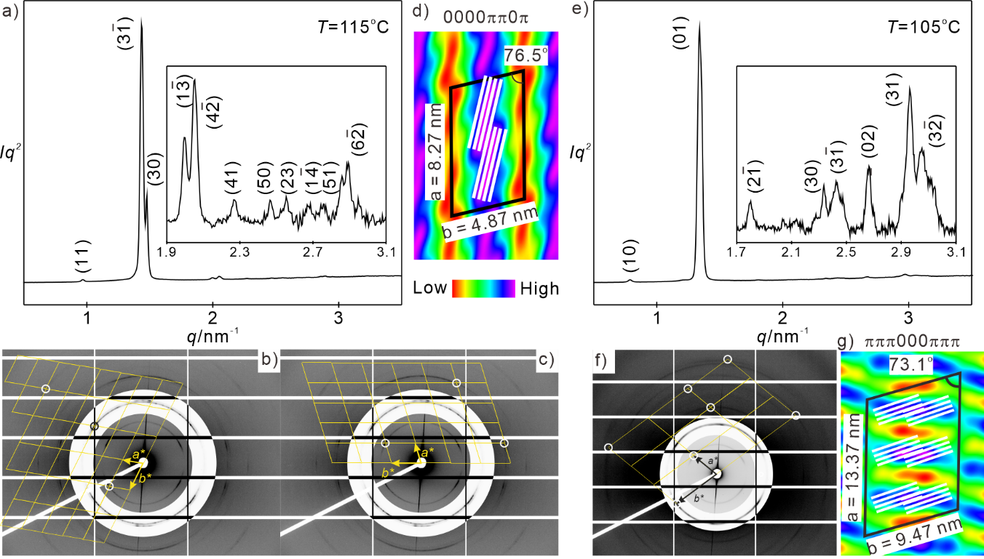
Figure 8. a) SAXS diffractograms; b,c) GISAXS pattern d) ED map of the p2 phase at 115 °C of A12/12F₂₃; e) SAXS diffractograms; f) GISAXS pattern g) ED map of the p2 phase at 105 °C of A12/12F₂₃.

The longest double fluorinated compound A12/16F₂₃ exhibit also the phase sequence p2-p6mm as indicated from DSC (Fig. S41) and optical investiagtions (Fig. S46). However, compared to the shorter derivatives with m = 12 and 14 only one p2 phase could be recorded forA12/16F₂₃.
To study the effect of double core fluorination in case of compound with the largest chain volume (m = 16) comapred to their related analogues either without fluorine (A16, Table 1) or with one fluorine atom (A16/12F₃), we have also synthesized A16/12F₂₃ (Table 2). As can be seen from Table 1 and 2, in all three compounds the p6mm was observed as the highest temperature LC phase. However, the non-fluorinated material A16 displays the additional new 3D p6/mmm, while the fluorinated materials exhibit p2 phases. The main difference between A16/12F₃ and A16/12F₂₃ is that the additional F atom induce an additional p2 phase (Figure S42) instead of only one type observed in case of the monofluorinated compound. This further confirms the effectiveness of aromatic core fluorination in tailoring the LC behaviour of the reported materials. This was proved by detailed SAXS investigation…..(Yu).
2.2. SHG Investigations
The series of A12/mF_{23,} m = 8 - 16, exhibited a distinct field-induced second harmonic generation (SHG). Although no SHG signal was observed in the field-free state, application of an electric field induced SHG. Simultaneously, the current response was observed due to the polarisation switching, suggesting an antiferroelectric character of the investigated phases. The length of the terminal alkoxy chain at the monosubstituted end strongly affects the character of the response. Short-chained compounds exhibit SHG activity at high temperatures up to the transition into the isotropic phase (Fig. 9a,b). Induced SHG signals could be detected even above the clearing point. This suggests that molecules form polar clusters which persist above the clearing point. At the same time, the low entropic contribution of the short chains results in closer packing and suppression of the switching behaviour. With increasing chain length, added conformational entropy suppresses high-temperature clustering and loosens low-temperature packing, yielding a strong, mid-range maximum in SHG intensity and a rapid decline toward both high and low temperatures (Fig. 9c,d).
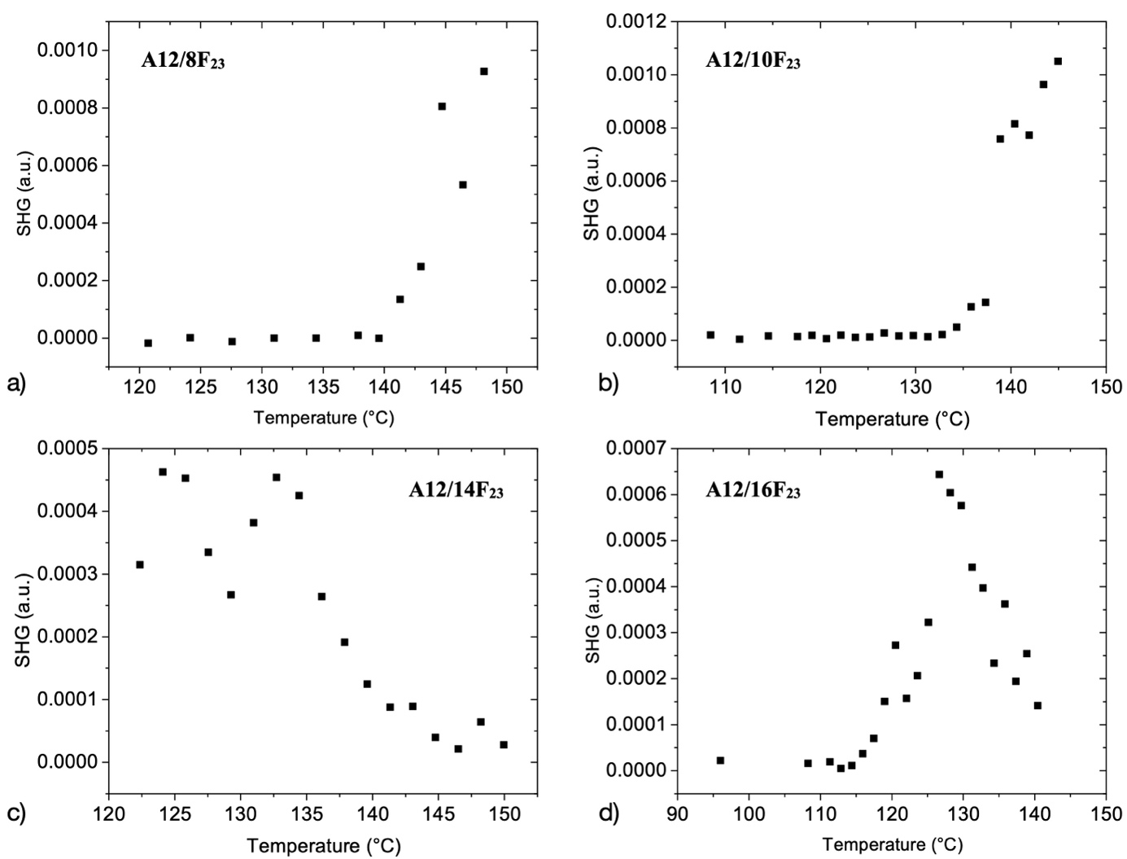
Figure 9. Temperature dependence of the induced SHG signal observed in an AC field E_{pp}=7.5 Vµm⁻¹ and the frequency f=15 Hz (cell thickness 10 µm): a) A12/8F₂₃, b) A12/10F₂₃, c) A12/14F₂₃, d) A12/16F₂₃.
2.3. Gelation studies
To study the ability of the synthesized materials to aggregate in solutions we selected three examples: A16 (non-fluorinated), A16/12F₃ (monofluorinated), and A16/12F₂₃ (difluorinated). The aggregation properties of these materials were studied in various solvents, including n-hexane, n-dodecane, toluene, benzene, m-xylene, dichloromethane, chloroform, tetrahydrofuran, n-butanol, ethanol, and dimethylsulfoxide. All compounds were found to form stable gel, but with different critical gelation concentrations (wt%) in n-hexane and n-dodecane, as confirmed by the inversion of the glass vial (Fig. 47 and Table S1-S3 in the SI). The compounds precipitated in ethanol and n-butanol, were soluble in benzene, toluene, m-xylene, chloroform, dichloromethane and tetrahydrofuran, and insoluble in DMSO. Both fluorinated compounds, A16/12F₃ and A16/12F₂₃, stabilized the gel formation in n-hexane and dodecane at very low critical gelation concentration of 0.57 and 0.53 wt%, respectively. In contrast, the non-fluorinated A16 formed stable gels only at a concentration > 1 wt% in the same solvents. Previous studies classify molecules capable of gelation at concentrations lower than 1 wt% as supergelators.^{43,,} Therefore compounds A16/12F₃ and A16/12F₂₃ are identified as supergelators, while A16 is not.
Several factors influence molecular aggregation, including hydrogen bonding, the number and position of terminal flexible chains (leading to weak forces such as van der Waals interactions), and π–π interactions. In our case, hydrogen bonding is absent in the molecular structures of the materials, and other factors remain consistent across the three compounds. The key differentiating factor is the strength of π–π interactions, which play a crucial role in gel formation. These interactions are enhanced by increasing the degree of aromatic core fluorination, explaining why A16/12F₃ and A16/12F₂₃ act as supergelators, while the non-fluorinated A16 does not.

2.4. Photo-isomerization
Azobenzene-based LCs are well-known for their reversible trans-cis photoisomerization capabilities, which can be triggered by light irradiation at specific wavelengths.^{35,} This photochromic behavior is particularly valuable for applications in optical data storage, photomechanical actuators, and stimuli-responsive materials.^{40,41,42} The photoisomerization properties of the new oxadiazole-based polycatenar LCs were investigated, examining how structural modifications—particularly fluorination—influence their photoresponsive behavior in both mesophases and solution.
2.4.1. Photoisomerization in Mesophases
The photoisomerization behavior was studied in the different LC phases by exposing the samples to UV light (350 nm) and monitoring the resulting textural changes under POM. We have selected three different compounds for such investigation A12, A12/12F₃, and A12/12F₂₃. The materials have the same chain lengths at both ends of the aromatic core but with different degrees of fluorination. Figure 10 illustrates the textural changes observed for the non-fluorinated compound A12 at different temperatures during heating. Upon UV irradiation of A12 in the p6₃/mmm phase at 95 °C (Fig. 10a), the texture transforms to another one with a reduced birefringence (Fig. 10b), indicating a photoinduced p6₃/mmm – p6mm phase transition. When the temperature increases to 125 °C, UV exposure induces a complete transition from the p6mm phase to the isotropic liquid state (Fig. 10c,d), evidenced by the disappearance of birefringence and loss of ordered molecular arrangement. Both transitions are reversible as confirmed by relaxing back to the original texture in both cases after switching off the light source. The process of back relaxation takes place in less than three seconds.
b) p6mm
a) p6₃/mmm
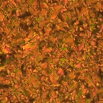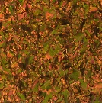
d) Iso
c) p6mm
Light on
Light off
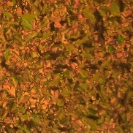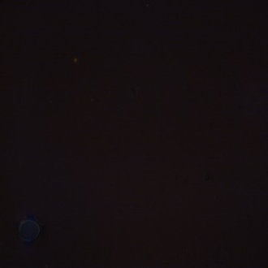
Light on
Light off
Figure 10. Textural changes of A12 observed at a,b) at 95 °C and c,d) at 125 °C upon heating, before (left) and after (right) irradiation with UV light.

The mono-fluorinated derivative A12/12F₃ demonstrates comparable photoresponsive behavior but with distinct characteristics related to its phase sequence. As shown in Figure S48, at 140 °C, UV irradiation triggers a p6mm to Iso phase transition (Fig. S48a,b), characterized by a complete loss of birefringence and high fluidity of the dark texture as typically observed for normal liquids. At lower temperatures (89 °C), exposure to UV light induces transitions between the two different columnar phases (P2 and p6mm, Fig. S48c,d), evidenced by changes in texture and birefringence patterns.
Similar observations were also observed for the di-fluorinated compound A12/12F₂₃, which exhibits more complex phase sequence with three different columnar phases (Figure S49). Like A12 and A12/12F₃ UV irradiation can easily induces the p6mm-Iso, P2-p6mm and P2-P2 transitions. All phase transitions for the three compounds are reversible as detected by restoring the initial LC texture before irradiation after switching off the light source.
The photoisomerization behavior observed in mesophases can be rationalized by considering the molecular structure of the oxadiazole-based polycatenars. The azobenzene unit undergoes a significant conformational change during trans-cis isomerization, transitioning from a planar, extended configuration to a bent, compact form. This molecular-level transformation disrupts the π-π stacking interactions and alters the packing geometry within the columnar assemblies, leading to the observed phase transitions.

2.4.2. Photoisomerization in Solution
UV-Vis Spectroscopy was also employed to monitor the trans-cis photoisomerization of the same selected three materials in chloroform solution. Figure S50 shows the absorption spectra of A12, A12/12F₃, and A12/12F₂₃ in chloroform (10⁻⁵ M) before and after UV irradiation. The initial spectrum in all cases exhibits a strong absorption band at approximately 370 nm, characteristic of the π-π* transition of the trans-azobenzene configuration. Upon irradiation with UV light (350 nm), this band decreases in intensity while a new absorption band appears around 450 nm, corresponding to the n-π* transition of the cis-azobenzene isomer. The photoisomerization kinetics were investigated by monitoring the absorbance changes at 370 nm as a function of irradiation time. The results reveal that fluorination significantly enhances the photoisomerization efficiency, with the di-fluorinated derivative (A12/12F₂₃, Fig. S50c) exhibiting the fastest conversion rate. This trend can be attributed to the electron-withdrawing effect of fluorine atoms, which stabilizes the cis isomer and lowers the activation energy for the trans-cis conversion. The isothermal back-relaxation from cis to trans configuration was also studied by monitoring the recovery of the absorption band at 370 nm after storing the solution in dark overnight. All materials show isothermal back relaxation at room temperature, indicating the reversible cis to trans photoisomerization.

3. Summary and conclusions
A novel family of multifunctional 1,3,4-oxadiazole-based nonsymmetric polycatenar LCs incorporating an azobenzene moiety has been designed, synthesized, and characterized. Through systematic structural modifications—specifically alkyl chain engineering and aromatic core fluorination—we have demonstrated the ability to precisely control self-assembly behavior, induce polar order, enhance gelation capabilities, and enable photoresponsive properties. These findings establish a versatile approach for developing advanced functional materials with potential applications in optoelectronics, sensors, and memory devices.
The nonfluorinated compounds (An) exhibit diverse mesophase behavior depending on the terminal chain length at the trisubstituted end. The shortest homologue (A4) forms a three-dimensional cubic phase with Ia$\overline{3}$d symmetry, while longer derivatives (A12 and A16) display various columnar phases, including conventional hexagonal and novel 3D hexagonal columnar mesophases. This structural diversity highlights the significant influence of terminal chain volume on self-assembly and phase behavior.
Introduction of fluorine atoms to the aromatic core dramatically alters the self-assembly properties of these materials. Monofluorinated derivatives (An/mF₃) exhibit enhanced core-core interactions, leading to higher melting and crystallization temperatures compared to their nonfluorinated counterparts. More significantly, these compounds display ferroelectric behavior in their lower-temperature columnar phases, as evidenced by the appearance of single polarization current peaks under applied electric fields. SAXS studies and reconstructed electron density maps reveal that this polar order arises from the alignment of molecules within columns, facilitated by the enhanced dipole moment resulting from fluorination.
The difluorinated compounds (An/mF₂₃) demonstrate even more complex phase behavior. Notably, some of these materials exhibit antiferroelectric properties, characterized by the appearance of two distinct polarization current peaks under applied electric fields. The polar order for these materials was also proved by SHG measurements. This represents the first reported example of antiferroelectric columnar phases in polycatenar liquid crystals. The enhanced polar order in these materials enables facile homeotropic alignment under DC electric fields, a critical requirement for applications in organic photovoltaics and other optoelectronic devices. A particularly remarkable feature of the fluorinated derivatives is their exceptional gelation capability in organic solvents. While nonfluorinated compounds fail to form gels at low concentration, their fluorinated counterparts can induce gelation at concentrations below 1% by weight, classifying them as supergelators. This behavior is attributed to enhanced π-π interactions facilitated by aromatic core fluorination, which promotes the formation of one-dimensional fibrillar networks.
All synthesized compounds demonstrate efficient trans-cis photoisomerization upon exposure to UV light, both in solution and in the LC state. In mesophases, photoisomerization induces phase transitions between adjacent LC phases, as observed under POM. The extent and nature of these photo responses are influenced by the degree of fluorination, with difluorinated derivatives exhibiting the most pronounced effects as proved from UV-Vis spectroscopy studies in chloroform solution.
The integration of multiple functional properties, including polar columnar self-assembly, gelation capability, and photo responsiveness in a single molecular platform represents a significant advancement in the field of LCs. The structure-property relationships established in this study provide valuable insights for the rational design of next-generation multifunctional materials. The ability to control molecular organization through external stimuli such as electric fields and light irradiation makes these materials particularly promising for applications such as organic electronics, optical data storage, sensors and actuators. Future work will focus on further optimizing these materials for specific applications, exploring additional structural modifications to enhance their functional properties, and investigating their performance in prototype devices.

4. References

F. J. Martin-Martinez , K. Jin , D. López Barreiro and M. J. Buehler , ACS Nano, 2018, 12 , 7425–7433.
T. Q. Nguyen, R. Martel, M. Bushey, P. Avouris, A. Carlsen, C. Nuckolls, and L. Brus, Phys. Chem. Chem. Phys., 2007, 9, 1515–1532.
H. Iino, T. Usui, J. Hanna, Liquid crystals for organic thin-film transistors. Nat. Commun. 2015, 6, 6828.
M. Funahashi, J. Mater. Chem. C, 2014, 2, 7451−7459.
T. Kato, J. Uchida, T. Ichikawa, and T. Sakamoto, Angew. Chem., Int. Ed., 2018, 57, 4355.
M. L. Nguyen and B.-K. Cho, Chem.–Eur. J., 2020, 26 , 6964–6975.
K. Kishikawa , S. Nakahara , Y. Nishikawa , S. Kohmoto, and M. Yamamoto, J. Am. Chem. Soc., 2005, 127, 2565–2571.
A. Concellón, R.-Q. Lu, K. Yoshinaga, H.-F. Hsu, and T. M. Swager, J. Am. Chem. Soc., 2021, 143 , 9260–9266.
S. Kumar, Chem. Soc. Rev. 2006, 35, 83–109.
H. Detert, M. Lehmann, H. Meier, Materials, 2010, 3, 3218–3330.
A. G. Serrette and T. M. Swager, J. Am. Chem. Soc., 1993, 115 , 8879–8880
M. Sawamura, K. Kawai, Y. Matsuo, K. Kanie, T. Kato, and E. Nakamura, Nature, 2002, 419, 702–705.
D. Kilian, D. Knawby, M. A. Athanassopoulou, S. T. Trzaska, T. M. Swager, S. Wróbel, and W. Haase, Liq. Cryst., 2000, 27, 509–521.
S. Furukawa, J. Wu, M. Koyama, K. Hayashi, N. Hoshino, T. Takeda, Y. Suzuki, J. Kawamata, M. Saito, and T. Akutagawa, Nat. Commun., 2021, 12, 768–776.
Y. Matsuo, A. Muramatsu, R. Hamasaki, N. Mizoshita, T. Kato, and E. Nakamura, J. Am. Chem. Soc., 2004, 126, 432–433.
H. Shimura, M. Yoshio, A. Hamasaki, T. Mukai, H. Ohno, and T. Kato, Adv. Mater., 2009, 21, 1591–1594.
T. Kato, T. Yasuda, Y. Kamikawa, and M. Yoshio, Chem. Commun., 2009, 729–739.
D. Miyajima, F. Araoka, H. Takezoe, J. Kim, K. Kato, M. Takata, and T. Aida, Angew. Chem., Int. Ed., 2011, 50, 7865–7869.
M. Yoshio, R. Konishi, T. Sakamoto, and T. Kato, New J. Chem., 2013, 37, 143–147.
J. Bi, J. Uchida, and T. Kato, New J. Chem., 2025, 49, 3708–3714.
M. Lehmann, M. Baumann, M. Lambov, and A. Eremin, Adv. Funct. Mater., 2021, 31, 2104217.
A. Murad, E. Baron, M. Feneberg, M. Baumann, M. Lehmann, and Alexey Eremin, ACS App. Mater. Interfaces, 2024, 16, 25025–25032.
J. Guilleme, J. Aragó, E. Ortí, E. Cavero, T. Sierra, J. Ortega, C. L. Folcia, J. Etxebarria, D. González-Rodríguez, and T. Torres, J. Mater. Chem. C, 2015, 3, 985–989.
C. Zhang, K. Nakano, M. Nakamura, F. Araoka, K. Tajima, D. Miyajima, J. Am. Chem. Soc. 2020, 142, 3326–3330.
C. Dressel , F. Liu , M. Prehm , X. B. Zeng , G. Ungar, and C. Tschierske , Angew. Chem., Int. Ed., 2014, 53, 13115–13120.
T. Reppe, S. Poppe, X. Cai, Y. Cao, F. Liu, and C. Tschierske, Chem. Sci., 2020, 11, 5902–5908.
M. Alaasar, A. F. Darweesh, X. Cai, Y. Cao, F. Liu, and C. Tschierske, Chem.–Eur. J., 2021, 27, 14921–14930.
M. Alaasar, S. Poppe, Y. Cao, C. Chen, F. Liu, C. Zhu, and C. Tschierske, J. Mater. Chem. C, 2020, 8, 12902–12916.
Y. Cao, Y. Zhao, T. Tan, F. Liu, M. Alaasar, Chem.–Eur. J., 2025, 31, e202403586.
Y. Cao , M. Alaasar , L. Zhang , C. Zhu , C. Tschierske and F. Liu , J. Am. Chem. Soc., 2022, 144 , 6936–6945.
Yuantang Duan, Haixia Wu, Fen Wang, Zilong Guo, Yu Yang, and Xiaohong Cheng, Chem. Eur. J. 2025, e202404734.
O. Kwon, X. Cai, W. Qu, F. Liu, J. Szydlowska, E. Gorecka, M. J. Han, D. K. Yoon, S. Poppe, and C. Tschierske, Adv. Funct. Mater., 2021, 31 , 2102271.
M. Alaasar, Y. Cao, T. Neumann, T. Tan, F. Liu, and M. Giese, Mater. Adv., 2024, 5, 8505–8514.
A. Murad, M. Alaasar, A. F. Darweesh, A. Eremin. Mater. Adv., 2024, 5, 6205–6209.
M. Alaasar, A. F. Darweesh, Y. Cao, K. Iakoubovskii, and M. Yoshio, J. Mater. Chem. C, 2024, 12 (4), 1523–1532.
M. Alaasar, A. F. Darweesh, C. Anders, K. Iakoubovskii, and M. Yoshio, Mater. Adv., 2025, 5(2), 561–569.
A. Natansohn and P. Rochon , Chem. Rev., 2002, 102 , 4139–4175.
H. M. D. Bandara and S. C. Burdette, Chem. Soc. Rev., 2012, 41, 1809–1825.
M. Saccone, M. Spengler, M. Pfletscher, K. Kuntze, M. Virkki, C. Wölper, R. Gehrke, G. Jansen, P. Metrangolo, A. Priimagi, and M. Giese, Chem. Mater., 2019, 31, 462–470.
R. S. Zola, H. K. Bisoyi, H. Wang, A. M. Urbas, T. J. Bunning, and Q. Li, Adv. Mater. 2018, 31, 1806172.
H. Yu, T. Ikeda, Adv. Mater., 2011, 19, 2149–2180.
H. K. Bisoyi and Q. Li, Chem. Rev., 2016, 116, 15089–15166.
S. K. Pathak, B. Pradhan, R. K. Gupta, M. Gupta, S. K. Pal, and A. S. Achalkumar. J. Mater. Chem. C, 2016, 4, 6546–6561.
S. Diring, F. Camerel, B. Donnio, T. Dintzer, S. Toffanin, R. Capelli, M. Muccini, and R. Ziessel, J. Am. Chem. Soc., 2009, 131, 18177–18185.
S. S. Babu, S. Prasanthkumar, and A. Ajayaghosh, Angew. Chem. Int. Ed., 2012, 51, 1766–1776.
C. Wang, Q. Chen, F. Sun, D. Zhang, G. Zhang, Y. Huang, R. Zhao, and D. Zhu, J. Am. Chem. Soc., 2010, 132, 3092–3096.
K. Ichimura, Chem. Rev., 2000, 100(5), 1847–1874.
A. R. Hirst, B. Escuder, J. F. Miravet, and D. K. Smith, Angew. Chem. Inter. Ed., 2008, 47(42), 8002–8018.
T. Ikeda, J. Mater. Chem., 2003, 13(9), 2037–2057.
M. Alaasar and S. Poppe, J. Mol. Liq., 2022, 351, 118613
M. Alaasar, X. Cai, Y. Cao, and F. Liu, New J. Chem., 2022, 46, 15871–15881.
J. Matraszek, D. Pociecha, N. Vaupotič, M. Salamończyk, M. Vogrin, and E. Gorecka, Soft Matter, 2020, 16, 3882–3885.
J. Hu, Y. Xiao, Q. Chang, H. Gao, and X. Cheng, J. Mol. Liq., 2019, 286, 110844.
G. Das, S. Cherumukkil, A. Padmakumar, V. B. Banakar, V. K. Praveen, and A. Ajayaghosh, Angew. Chem. Int. Ed., 2021, 60, 7851–7859.
A. S. Achalkumar, U. S. Hiremath, D. S. S. Rao, S. K. Prasad, and C. V. Yelamaggad, J. Org. Chem., 2013, 78, 527–544.
M. Alaasar, M. Prehm, M. Brautzsch, and C. Tschierske, J. Mater. Chem. C, 2014, 2, 5487–5501.
M. Poppe, M. Alaasar, A. Lehmann, S. Poppe, M. G. Tamba, M. Kurachkina, A. Eremin, M. Nagaraj, J. K. Vij, X. Cai, F. Liu, and C. Tschierske, J. Mater. Chem. C, 2020, 8, 3316–3336.
A. Lehmann, M. Alaasar, M. Poppe, S. Poppe, M. Prehm, M. Nagaraj, S. P. Sreenilayam, Y. P. Panarin, J. K. Vij, and C. Tschierske, Chem.–Eur. J., 2020, 26, 4714–4733.
M. Alaasar, M. Prehm, and C. Tschierske, Chem. Commun., 2013, 49, 11062–11064.
M. Alaasar, M. Prehm, M. Brautzsch, and C. Tschierske, Soft Matter, 2014, 10, 7285–7296.
Y. Cao, M. Alaasar, A. Nallapaneni, M. Salamończyk, P. Marinko, E. Gorecka, C. Tschierske, F. Liu, N. Vaupotič, and C. Zhu, Phys. Rev. Lett., 2020, 125, 027801
R. A. Reddy and C. Tschierske, J. Mater. Chem., 2006, 16, 907.
R. Yoshida, Adv. Mater., 2010, 22, 3463.
K. Yuichiro, T. Yoshinori, H. Akihito, Y. Hiroyasu, and H. Akira, Sci. Rep., 2013, 3, 1243.
M. Alaasar, T. Nirgude, and C. Anders. J. Mol. Liq., 2024, 414, 126174.

