Electrolyte Design for High Power Dual-ion Battery with Graphite Cathode for Low Temperature Applications
Yu Zhaoª, Hekang Zhuª, Lidan Xing^{b}, Denis Y. W. Yu^{a,c*}

ªSchool of Energy and Environment, City University of Hong Kong, 83 Tat Chee Avenue, Kowloon, Hong Kong S.A.R., P. R. China.
^{b} National and Local Joint Engineering Research Center of MPTES in High Energy and Safety LIBs, Engineering Research Center of MTEES (Ministry of Education), Research Center of BMET (Guangdong Province), and Key Lab. of ETESPG(GHEI), South China Normal University, Guangzhou 510006, China
^{c}Research Center for Energy and Environmental Materials (GREEN), National Institute for Materials Science, Tsukuba, Ibaraki 305-0044, Japan.

Tel: +81-29-8604168, E-mail addresses: yu.denis@nims.go.jp (Denis Y.W. Yu)

Abstract
The design of electrolyte suitable for low-temperature use is of great significance to expand the applications of energy storage devices. Dual-ion battery (DIB) with fast ion transport kinetics is expected to be a nascent battery system that can deliver high power density both at room temperature and low temperatures. In this work, we design a 4.8 M lithium bis(fluorosulfonyl)imide in 2,2,2-trifluoroethyl acetate/dimethyl carbonate (LiFSI FEA/DMC) + 1% LiPF₆ electrolyte with a low melting point of about -93 °C, enabling graphite cathode in a DIB to achieve excellent fast charge/discharge capability with a high capacity of about 108 mAh g⁻¹ and 80 mAh g⁻¹ at 10 C at 25 °C and 0 °C, respectively. Even at -30 °C, the graphite cathode can still give 69.2 mAh g⁻¹ at 0.5 C. The graphite||Li DIB with 4.8 M LiFSI FEA/DMC + 1% LiPF₆ electrolyte also exhibits a stable cycle life with a capacity retention of 91.5% at 5 C after 2000 cycles at 25 °C. The electrolyte forms a uniform cathode electrolyte interface film on the graphite surface, as confirmed by transmission electron microscopy and X-ray photoelectron spectroscopy, which enables the outstanding electrochemical performance of the graphite cathode in a wide working temperature range from -30 °C to 25 °C.

Keywords: Dual-ion battery; graphite cathode; electrolyte; electrode-electrolyte interphase; low temperature
Introduction
Rechargeable batteries capable of operating in low temperatures are highly desirable for places located at middle/high latitudes or altitudes where ambient temperature can drop to subzero degrees in the wintertime. Currently, the optimal operating temperature of lithium-ion batteries (LIB) is from 5 °C to 30 °C, but the overall battery capacity and power are reduced tremendously when the temperature drops below 0 °C.[1, 2] This makes it difficult to apply LIBs to electric vehicles (EV) and smart grids in places with cold climates, such as Harbin, a city in northern China where the average temperature in winter can reach -30 °C. If EV were to be used in these places, external heating will be required to warm up the battery, which will decrease the available capacity and efficiency of the battery. On the other hand, lead-acid batteries which are capable of operating at lower temperatures have much lower energy density and are not environmentally friendly because of the use of toxic lead.
The poor low-temperature performance and corresponding rate capability of LIB is due to the “rocking chair” configuration of the battery, where Li ions have to move back and forth between the cathode and the anode during charging and discharging, and the redox reactions at the two electrodes and the transport of Li ions through the electrolyte are rate-limiting. To improve the kinetics within a battery, it is possible to decouple the reactions at the two electrodes and reduce the diffusion length of the ions in the electrolyte by constructing a dual-ion battery (DIB), where both the cations and anions that are stored in the electrolyte serve as the charge carriers. At the anode and cathode sides, the cations (e.g. Li⁺, Na⁺, K⁺) and anions (e.g. BF₄⁻, PF₆⁻, bis(fluorosulfonyl)imide FSI⁻, bis(trifluoromethanesulfonyl)imide TFSI⁻) can be inserted and extracted, respectively, from the active materials such as graphite with the following reactions, for example:[3]
Anode: C + x Li⁺ + x e⁻ ↔ Li_{x}C (1)
Cathode: C + x FSI⁻ ↔ FSI_{x}C + x e⁻ (2)
Wang et al. have previously demonstrated that DIB half-cell with graphite||Li and full cell with graphite||graphite can give excellent rate performance at room temperature, with 88.8% and 82.9% capacity retention at 40 C, respectively.[4] The electrolyte used in their case was 3 M LiPF₆ + 0.5% lithium difluoro(oxalato)borate (LiDFOB) in ethyl methyl carbonate (EMC). Liu et al. showed a DIB full-cell with graphite cathode using 7.5 M LiFSI in EC/DMC (ethylene carbonate/dimethyl carbonate) with a capacity utilization of 72.4% at 5 C at room temperature.[5] However, conventional carbonated solvents have high melting points and are expected to have problems at subzero temperatures.
Advancements were previously made to improve the performance of DIBs at low temperatures, such as designing alternative anode/cathode materials[6-8], developing reliable electrolyte formulation[9-12], and constructing stable electrode-electrolyte interphase (EES)[13]. Though, whether a battery works in extreme conditions or not will depend on the nature of the electrolyte. Electrolytes used at sub-zero temperature should meet the requirements of good ionic conductivity, low melting point, fast ion transport rate, and electrochemically stable within the working voltage range of the battery.
Among different solvents, ethyl acetate (EA), a kind of carboxylate ester, has been reported for low-temperature LIB applications because of its unique physical properties such as low melting point and non-toxicity.[14] These inherent characteristics make it ideal for low-temperature DIB and can effectively solve the critical problems of carbonate solvents such as EMC and DMC. However, carboxylate esters with a short carbon-chain length show poor electrochemical stability at a high potential above 5.0 V and cannot form a compact and effective cathode electrolyte interface (CEI) layer to protect graphite electrode from side reactions.[15] To enhance the interfacial stability of the graphite cathode, fluorination of the electrolyte is one of the strategies. The decomposition of fluorinated solvents forms a CEI layer with rich LiF or F-containing composites, thus improving mechanical and chemical stability of the graphite.[16-18] Therefore, we studied the use of 2,2,2-trifluoroethyl acetate (FEA) instead of EA, where the three H atoms in the original functional group are replaced by fluorine atoms, forming -CF₃. However, FEA has lower lithium salt solubility compared to EA with the additional of F atoms, which will increase the voltage polarization and decrease the de-intercalation capacity of the battery. To overcome the issue, DMC that can enable a high anion de-intercalation capacity is used as co-solvent in this work.
As is well known, LiPF₆ is a popular commercial lithium salt used in the industry. LiPF₆-based electrolytes exhibit unique advantages in terms of Al current collector stability, low cost, and high-rate performance (Figure 1a).[19-21] However, most batteries using LiPF₆-based electrolyte can only be cycled at room temperature.[22-24] This is because LiPF₆ is sensitive towards temperature, water, and humidity, releasing HF and further harmful species, which decreases battery lifespan. Therefore, LiFSI salt is used as the main salt in this study because of its better low temperature performance.
In this work, we designed a novel 4.8 M LiFSI FEA/DMC + 1% LiPF₆ electrolyte and studied its effects on the electrochemical performances of dual-ion half-cells with graphite cathode and lithium anode in a wide temperature range from -30 °C to 25 °C. We found that this electrolyte shows a low melting point of about -93 °C, as measured by differential scanning calorimetry (DSC) and forms an effective protection layer on the Al current collector. The graphite||Li cells with 4.8 M LiFSI FEA/DMC + 1% LiPF₆ electrolyte show excellent fast charge capability both at room temperature and low temperature, with a high capacity of about 108 mAh g⁻¹ with 99.8 % capacity utilization at 10 C compared to 2 C at 25 °C, and 80 mAh g⁻¹ capacity at 10 C at 0 °C, which is superior to that in LiPF₆-based electrolyte. Our results are among the best low-temperature performance for DIB to date.[1] The 4.8 M LiFSI FEA/DMC + 1% LiPF₆ electrolyte can also ensure the long-term stability of the battery with a capacity of 96.1 mAh g⁻¹ (91.5 % capacity retention) at 5 C after 2000 cycles at 25 °C because the electrolyte is stable up to 5.1 V (vs. Li/Li⁺) and has good compatibility with aluminum current collector and graphite cathode, compared with 4.8 M LiFSI FEA/DMC, 4.8 M LiFSI FEA + 1% LiPF₆, and 4.8 M LiFSI DMC + 1% LiPF₆ electrolytes, as shown by X-ray photoelectron spectroscopy (XPS) and transmission electron microscopy (TEM).
It is noted that the deposition of metallic lithium on the graphite or lithium anode is another problem during fast charging and also operation at low temperatures, which needs to be solved in the future in other works. In this study, we focus on studying the electrolyte and reaction mechanisms to enable fast charge-discharge of the graphite cathode in DIBs.

2. Results and discussion
2.1 Characteristics of the electrolytes
Battery performance is typically affected by the melting point of the electrolyte inside it. If the operating temperature of the battery is lower than the melting point of the electrolyte, the battery cannot function because the electrolyte will be frozen. Therefore, the melting point of an electrolyte is an indicator of whether the corresponding battery will work or not for low-temperature applications. The melting point of solvents and electrolytes were explored by differential scanning calorimetry (DSC) in this study (Figure 1b and c, Table 1). The melting point of DMC solvent that is commonly used in LIB is about 6 °C. Addition of salt into DMC can lower the melting point (4.8 M LiFSI DMC + 1% LiPF₆) to -31 °C, but may not be sufficient for low temperature applications. To further reduce the melting point of the electrolyte, we decided to add FEA solvent (m.p. -82 °C) into the electrolyte, forming 4.8 M LiFSI FEA/DMC = 8:2 + 1% LiPF₆ with a melting point of about -93 °C. For comparison, we also prepared 4.8 M LiFSI FEA/DMC = 8:2 and 4.8 M LiFSI FEA+1% LiPF₆ in this study to investigate the effect of LiPF₆ and DMC additions. Further, the physical properties (e.g., ionic conductivity, viscosity) of different electrolytes are measured, as shown in Table 1. 4.8 M LiFSI FEA/DMC + 1% LiPF₆ shows ionic conductivity of about 2.1 and 0.9 mS cm⁻¹ at 25 °C and -30 °C, respectively, which is enough to guarantee the ion transport in the electrolyte within the wide temperature range. The viscosity of 4.8 M LiFSI FEA/DMC + 1% LiPF₆ is about 120 mPa s at 25 °C. It should be noted that even though the viscosity of the electrolyte is large due to the high salt concentration, the corresponding battery still functions well due to the good wettability (low contact angle) of the PVdF separator with the electrolyte (Figure S1, Supporting Information) and the low impedance of the graphite||Li cell with the 4.8 M LiFSI FEA/DMC + 1% LiPF₆ electrolytes compared to other electrolytes (Figure S2, Supporting Information).
High-voltage tolerance is an essential criterion for DIB battery electrolyte design due to the high working potential of DIB. Firstly, oxidative stability of the four electrolytes is measured by linear sweep voltammetry (LSV) with titanium as the working electrode and lithium as the counter electrode in coin cells, as shown in Figure 1d. Notedly, 4.8 M LiFSI FEA + 1% LiPF₆ electrolyte starts to decompose at 4.75 V, which is below the intercalation plateau of FSI⁻ into graphite. This suggests that FEA cannot be used as the only solvent for DIBs. Instead, the stability of the electrolyte can be improved by the addition of DMC solvent, as 4.8 M LiFSI FEA/DMC + 1% LiPF₆, 4.8 M LiFSI FEA/DMC, and 4.8 M LiFSI DMC + 1% LiPF₆ electrolytes show good anti-oxidation ability, with minimal amount of current when the voltage is raised up to 5.1 V vs. Li/Li⁺.

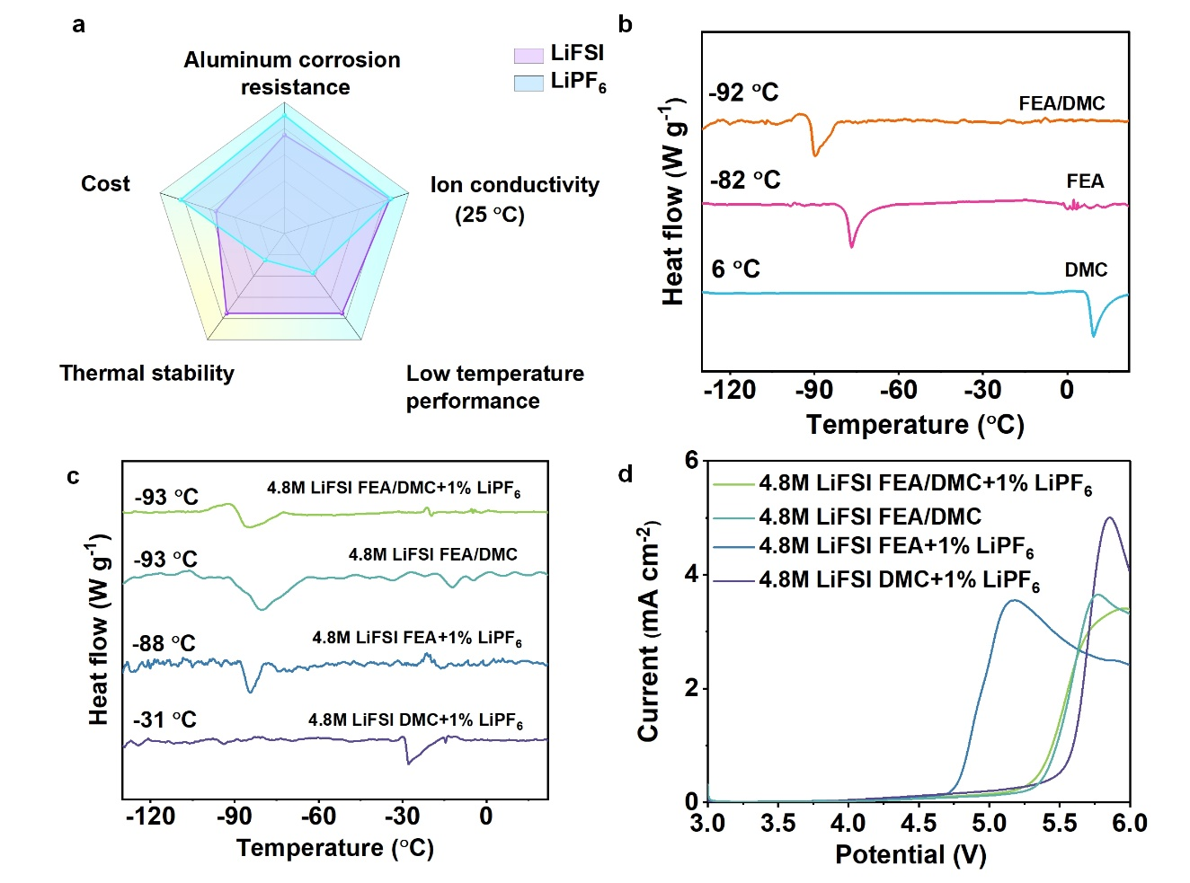

Figure 1. (a) Radar chart comparing key characteristics of LiFSI and LiPF₆ salts; the DSC profiles of different (b) solvents and (c) electrolytes; (d) the LSV scan curves of different electrolytes with a scan rate of 5 mV s⁻¹.

Table 1. Melting point, ionic conductivity and viscosity of various electrolytes.
Electrolyte | Melting point (°C) | Ionic conductivity  (mS cm⁻¹) |  | Viscosity  (mPa s)  at 25 °C
Electrolyte | Melting point (°C) | at 25 °C | at -30 °C | Viscosity  (mPa s)  at 25 °C
4.8 M LiFSI  FEA/DMC + 1% LiPF₆ | -93 | 2.07 | 0.89 | 120
4.8 M LiFSI  FEA/DMC | -93 | 1.99 | 0.89 | 107
4.8 M LiFSI  FEA + 1% LiPF₆ | -88 | 2.29 | 0.93 | 106
4.8 M LiFSI  DMC + 1% LiPF₆ | -31 | 2.63 | 0.62 | 111

In an electrolyte, the dissolved salt interacts with the surrounding solvent molecules, forming various solvation complexes. The nature and strength of this interaction will influence many properties of the electrolyte and affect the electrochemical performances of the battery with it. To study the solvation structure of the electrolytes, Raman spectroscopy was conducted as shown in Figure 2a-f. Compared with FEA and DMC solvent, all the electrolytes with LiFSI salt show one new peak at around 750 cm⁻¹ due to the vibration of the FSI⁻ anions (Figure 2b). It can be seen that the FSI⁻-peak of all the electrolytes move to a higher position compared with free FSI⁻, which is located at around 726 cm⁻¹,[25] indicating that FSI⁻ anions interact with the solvent molecules, forming contact ion pairs (CIPs) and ion aggregates (AGGs). Similarly, the DMC-peak and FEA-peak in 4.8 M LiFSI FEA/DMC + 1% LiPF₆, 4.8 M LiFSI FEA/DMC, 4.8 M LiFSI FEA + 1% LiPF₆, and 4.8 M LiFSI DMC + 1% LiPF₆ electrolytes all exhibit different degrees of positive shift compared with DMC and FEA pure solvents (Figure 2c-f), showing that DMC and FEA are involved in the solvation shell of FSI⁻. Especially, the peaks of the coordinated-DMC are shifted more than those of the coordinated-FEA with respect to the corresponding DMC and FEA solvent molecules (Table 2), suggesting DMC is in the inner solvation shell and interacts strongly with the ions. Note that the FSI⁻, FEA and DMC-related peaks of 4.8 M LiFSI FEA/DMC + 1% LiPF₆ and 4.8 M LiFSI FEA/DMC are located at almost the same positions (Table 2), indicating that the addition of 1% LiPF₆ does not change the solvation structure of the electrolyte.
The molecular orbital levels of different solvation complexes are calculated by density functional theory (DFT) (Figure 2g) to better understand the electrochemical stability of the electrolytes based on the solvation structure. The results show that FEA is more prone to be oxidized than DMC as the HOMO energy level of FEA is less negative than that of DMC, which is consistent with the LSV tests of the DMC and FEA solvents (Figure S3, Supporting Information). The addition of FSI⁻ anions to the solvents (FSI⁻- solvent) worsens the oxidative stability of the solvents, for example, the HOMO levels of FSI⁻-DMC and FSI⁻-FEA are higher than pure DMC and FEA. On the other hand, CIPs and AGGs with a Li⁺-FSI⁻-solvent structure can enhance the oxidative stability of the solvent molecules, as the HOMO energy levels of Li⁺-FSI⁻-DMC and Li⁺-FSI⁻-FEA are lower than that of DMC and FEA, respectively. The results support our observation that the highly concentrated electrolyte with CIPs and AGGs complexes in the electrolyte increases the electrochemical stability of the electrolyte.
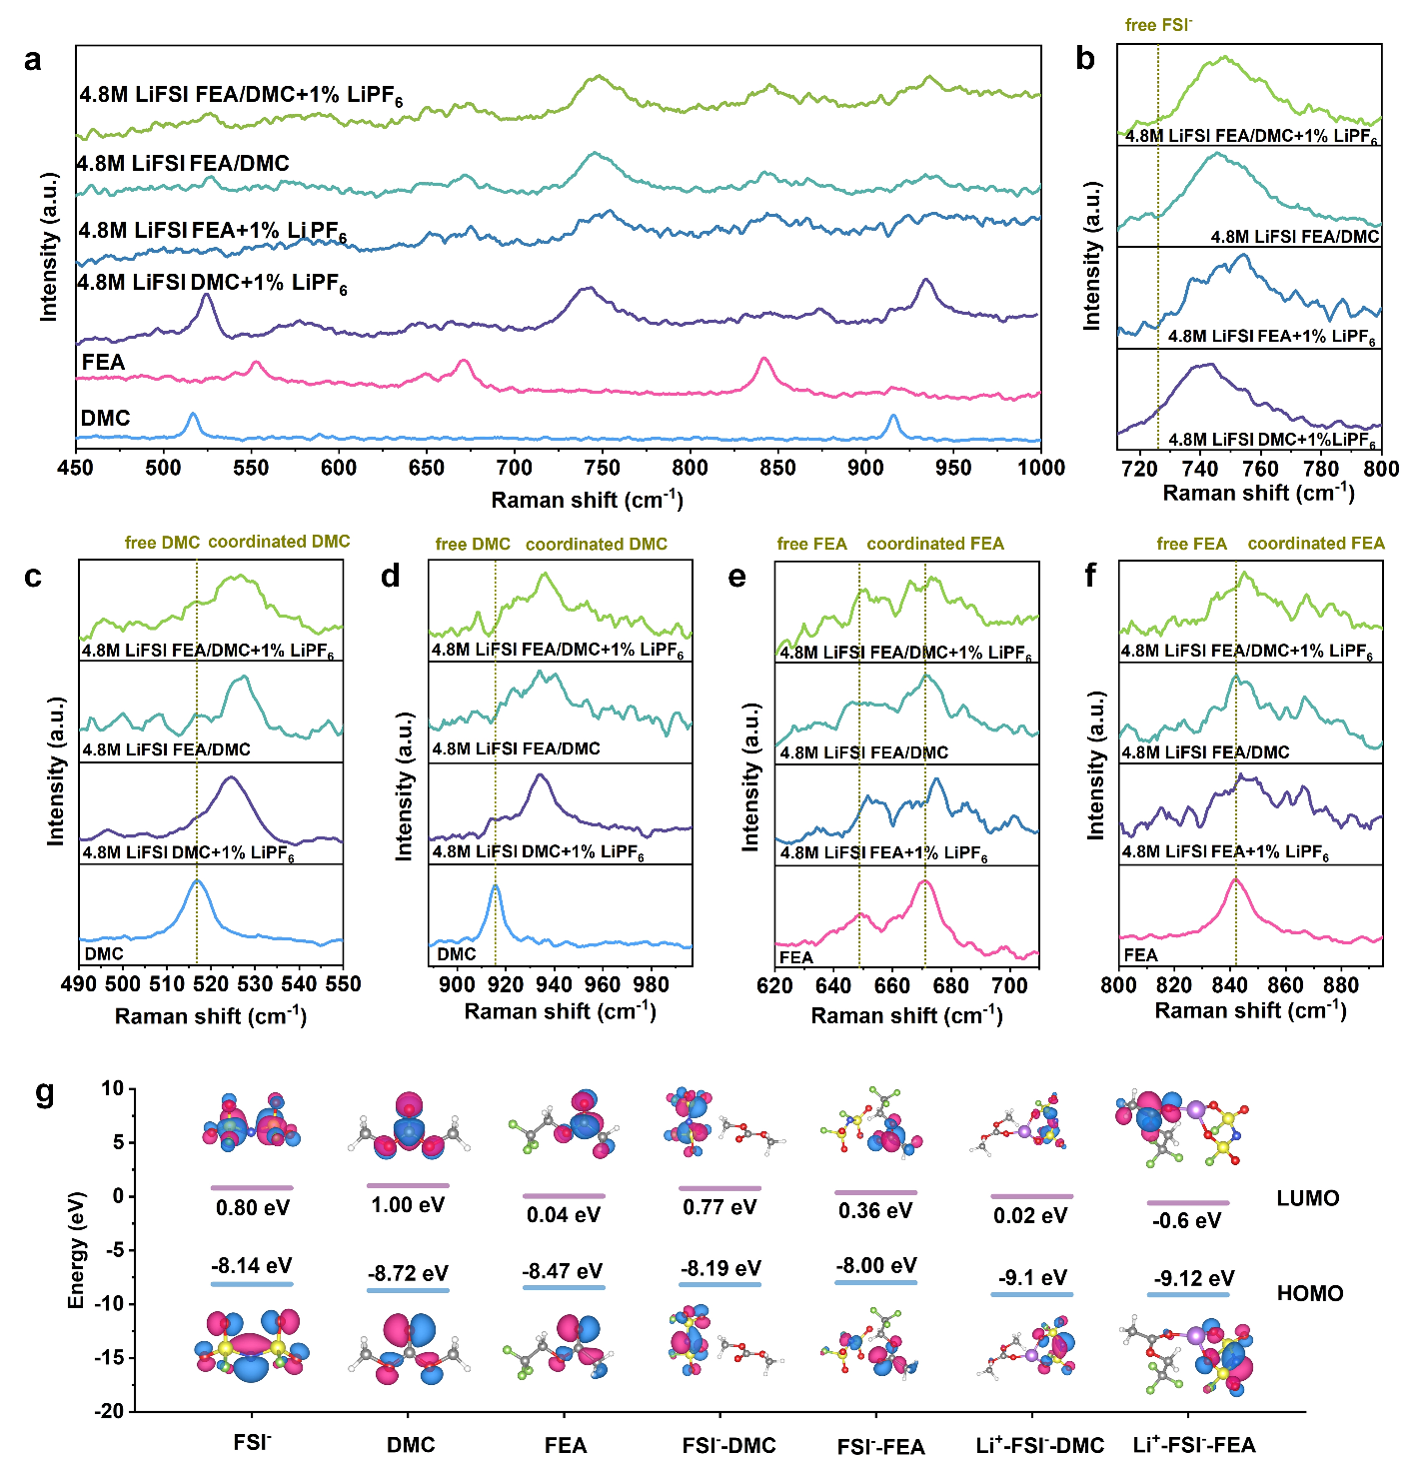

Figure 2. (a) The full Raman spectra of 4.8 M LiFSI FEA/DMC + 1% LiPF₆, 4.8 M LiFSI FEA/DMC, 4.8 M LiFSI FEA + 1% LiPF₆, and 4.8 M LiFSI DMC + 1% LiPF₆ electrolytes. The enlarged area corresponding to the Raman shift of (b) FSI⁻, (c-d) DMC and (e-f) FEA; (g) frontier molecular orbital energy levels (HOMO and LUMO) of FSI⁻, different solvents, FSI⁻-solvent, Li⁺-FSI⁻-solvent complexes (Insets are the simulation snapshots of the HOMO and LUMO).

Table 2. Summary of corresponding Raman peaks of electrolytes and solvents.
Electrolyte/Solvent | FSI⁻  (cm⁻¹) | DMC-1 (cm⁻¹) | DMC-2 (cm⁻¹) | FEA-1  (cm⁻¹) | FEA-2  (cm⁻¹) | FEA-3  (cm⁻¹)
4.8 M LiFSI FEA/DMC + 1% LiPF₆ | 747.3 | 526.2 | 936.5 | 648.6 | 673.4 | 845.5
4.8 M LiFSI FEA/DMC | 746.2 | 526.7 | 936.9 | 649.2 | 672.7 | 846.0
4.8 M LiFSI  FEA + 1% LiPF₆ | 751.7 | - | - | 653.9 | 676.3 | 847.15
4.8 M LiFSI  DMC + 1% LiPF₆ | 741.3 | 524.7 | 934.2 | - | - | -
DMC | - | 517.4 | 915.9 | - | - | -
FEA | - | - | - | 648.2 | 669.8 | 841.2

2.2 The stability of aluminum current collector in electrolytes
Aluminum (Al) foil is commonly used as current collector for the cathode electrode in the DIB system. Though, the lifetime of the battery can be limited if it corrodes under a high potential. Here, Al current collector stability, a key indicator of how well the Al foil can withstand the corrosion from the electrolyte, is measured by constant voltage measurements at room temperature. The Al foils were kept at 5.1 V for 100 h in aluminum||lithium half-cells. Figure S4 (Supporting Information) show the measured current over time of the Al foils in different electrolytes. It can be seen that the reaction current from Al is the largest for 4.8 M LiFSI in DMC + 1% LiPF₆ and the addition of 1% LiPF₆ is not enough to passivate the Al foil in this case. Instead, adding FEA into the electrolyte (4.8 M LiFSI FEA/DMC) reduces the reaction current. Al corrosion can be suppressed further with 4.8 M LiFSI FEA/DMC + 1% LiPF₆ and 4.8 M LiFSI FEA + 1% LiPF₆ electrolytes.
Figure 3a-d shows the optical photographs and scanning electron microscopy (SEM) images of Al foils after corrosion reaction with different electrolytes. It can be observed visually that the Al foils were well maintained with a bright silver color in 4.8 M LiFSI FEA/DMC + 1% LiPF₆ and 4.8 M LiFSI FEA + 1% LiPF₆ electrolytes (Figure 3a and 3c). In contrast, many corrosion pits appear on the Al foil in 4.8 M LiFSI FEA/DMC electrolyte (Figure 3b). On the other hand, the Al foil turns dull gray after 100 hours in 4.8 M LiFSI DMC + 1% LiPF₆ electrolyte (Figure 3d), where the surface is severely roughened. These results suggest that Al is not passivated with LiFSI in DMC even with the addition of LiPF₆, while the addition of FEA can stabilize the Al foil against corrosion.
To further verify the effect of the electrolytes, the surface compositions of the Al foils after constant voltage measurements are studied by XPS. Figure 3e-h and Figure 3i-l are the Al 2p and F 1s XPS spectra of the Al foils tested surface in 4.8 M LiFSI FEA/DMC + 1% LiPF₆, 4.8 M LiFSI FEA/DMC, 4.8 M LiFSI FEA + 1% LiPF₆, and 4.8 M LiFSI DMC + 1% LiPF₆ electrolytes, respectively. The Al 2p profiles can be deconvoluted into 3 peaks centered at 72.3, 74.9 and 75.5 eV, corresponding to metallic Al, Al-O and Al-F, respectively. [26-28] On the other hand, the F 1s profiles can be fitted with 3 peaks at 685.2, 686.5 and 687.2 eV, assigned to the Li-F, Al-F and F-S components, respectively.[29-31] The Al-O peak is ascribed to Al₂O₃ on the surface of the Al foils, which may be generated when the sample was exposed to air during the XPS test, while the Al-F and F-S signals are attributed to AlF₃ and Al(FSI)₃, respectively. AlF₃ is an effective passivation layer on the surface of Al foil that can protect the current collector from continuous corrosion, whereas Al(FSI)₃ is soluble in the electrolyte.[32] If more Al(FSI)₃ is formed, the combined film of AlF₃ and Al(FSI)₃ is not robust enough to protect the Al foil, and the Al foil will be corroded at a high potential.
As it can be seen from Figure 3h and 3l, Al foil tested in 4.8 M LiFSI DMC + 1% LiPF₆ shows the smallest amount of Al-F with the largest amount of F-S[32, 33], which suggests there is less AlF₃ and more Al(FSI)₃ on the surface, which is consistent with the larger amount of corrosion as observed from the constant voltage test and SEM observation. By adding FEA as co-solvent (4.8 M LiFSI FEA/DMC), the amount of Al-F is increased while that from F-S is decreased (Figure 3f and 3j), and the corrosion of Al is reduced. Addition of LiPF₆ (4.8 M LiFSI FEA/DMC + 1% LiPF₆) further increases the amount of Al-F, passivating the surface (Figure 3e and 3i), as the decomposition of PF₆⁻ (PF₆⁻ → PF₅⁻ + F⁻) will provides extra F⁻ to form a AlF₃ layer on the surface of Al. At the same time, an obvious metallic Al signal is detected on the surface of Al, suggesting that the passivation layer with 4.8 M LiFSI FEA/DMC + 1% LiPF₆ is thin. Note that for the Al foil tested in 4.8 M LiFSI FEA + 1% LiPF₆ without DMC (Figure 3g and 3k), an extra peak corresponding to Li-F is observed. This is possibly from the decomposition of LiFSI, which is consistent with the poor oxidation stability of the 4.8 M LiFSI FEA + 1% LiPF₆ electrolyte at high voltage as observed from the LSV results (Figure 1d).

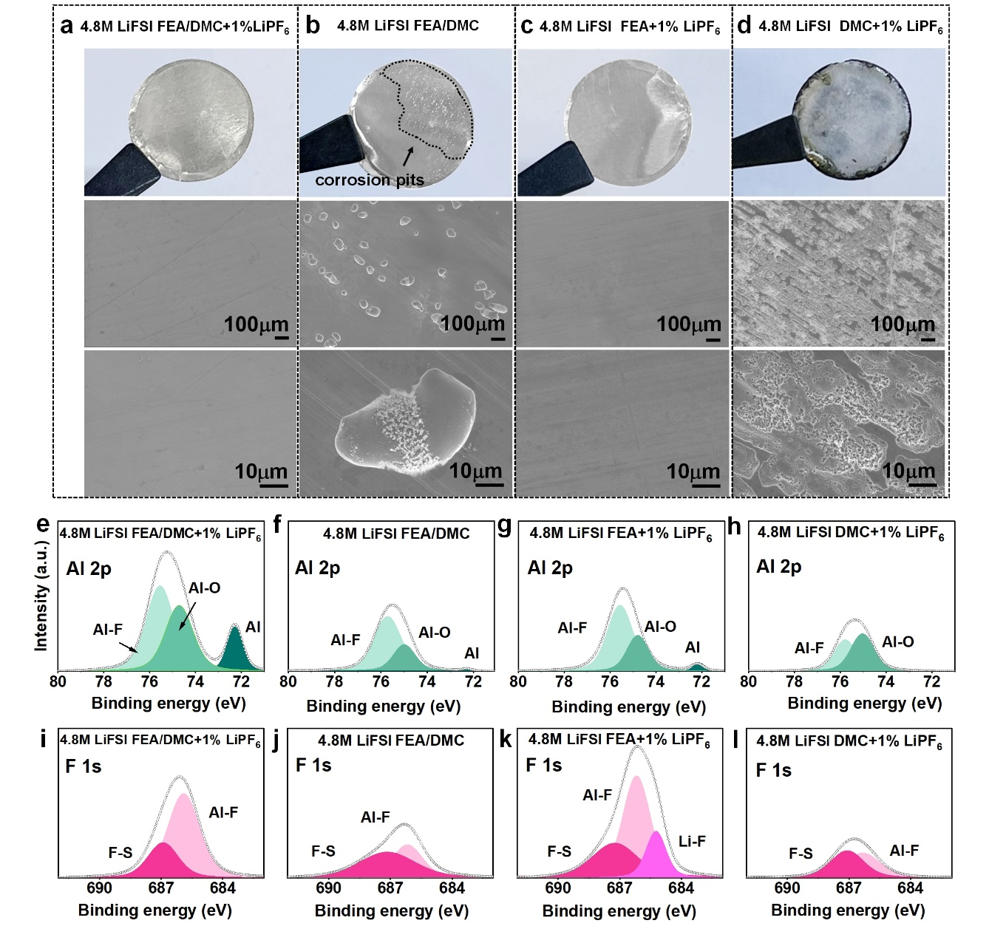

Figure 3. (a-d) Optical photographs and the corresponding SEM images of Al foils after 100 h at 5.1 V in different electrolytes; (e-h) Al 2p and (i-l) F 1s XPS spectra of the Al surface after 100 h at 5.1 V in 4.8 M LiFSI FEA/DMC + 1% LiPF₆, 4.8 M LiFSI FEA/DMC, 4.8 M LiFSI FEA + 1% LiPF₆, and 4.8 M LiFSI DMC + 1% LiPF₆ electrolytes.

2.3 Electrochemical performances of dual-ion graphite||Li battery at room temperature
Initially, a series of experiments were conducted to choose the appropriate solvent ratio, salt concentration and amount of LiPF₆ additive for further studies. Specifically, graphite cathodes were first tested in 4.8 M LiFSI FEA/DMC electrolytes with 10:0, 8:2, 5:5, 2:8 and 0:10 ratios at a 5 C current rate (1 C = 100 mA g⁻¹). As seen in Figure S5 (Supporting Information), the graphite in 4.8 M LiFSI FEA/DMC = 8:2 shows the highest available capacity and also the best cycle stability. Therefore, the FEA/DMC ratio of 8:2 is chosen. Next, graphite electrodes were compared with 4.8 M LiFSI and 6 M LiFSI FEA/DMC = 8:2. The results indicate that the electrode in 6 M LiFSI shows smaller capacity with larger voltage polarization (Figure S6, Supporting Information). Thus, the LiFSI salt concentration is fixed at 4.8 M. Lastly, the effect of the amount of LiPF₆ additive was investigated with 4.8 M LiFSI FEA/DMC = 8:2 electrolyte with 1% and 2% LiPF₆. The result in Figure S7 (Supporting Information) shows that 1% LiPF₆ is sufficient to stabilize the graphite cathode, while maintaining a high rate capability. Thus, the 4.8 M LiFSI FEA/DMC = 8:2 + 1% LiPF₆ electrolyte was selected for further tests.
To study the role of FEA, DMC and LiPF₆ to the electrochemical performances of graphite cathode, three more control electrolytes, namely 4.8 M LiFSI FEA/DMC, 4.8 M LiFSI FEA + 1% LiPF₆, and 4.8 M LiFSI DMC + 1% LiPF_{6,} were compared. The first cycle charge-discharge curves of the graphite cathodes in the four electrolytes at room temperature (25 °C) at a current density of 5 C are shown in Figure 4a and the initial Coulombic efficiency (ICE) are summarized in Figure 4b. While graphite electrode tested in 4.8 M LiFSI DMC + 1% LiPF₆ gives the highest initial discharge capacity of 90.8 ± 3.0 mAh g⁻¹, its ICE is only 53%, which is attributed to the parasitic reaction on the Al current collector and also the formation of a poor cathode electrolyte interface (CEI), which will be discussed in a later section. FEA electrolyte alone (4.8 M LiFSI FEA + 1% LiPF₆) however increases the voltage polarization of the cell and also reduces the available capacity, which is attributed to a more resistive CEI layer on the surface of graphite. An electrolyte with a mixture of FEA and DMC (4.8 M LiFSI FEA/DMC) can increase ICE while maintaining the high capacity. The ICE is further improved with the addition of LiPF₆ (4.8 M LiFSI FEA/DMC + 1% LiPF₆) by suppressing Al corrosion, though voltage polarization is slightly increased with LiPF₆.
The cycle performances of the graphite electrodes at 5 C rate are shown in Figure 4c and the charge-discharge curves at different cycles are shown in (Figure S8, Supporting Information). Even though the cell with 4.8 M LiFSI DMC + 1% LiPF₆ delivers a high initial discharge capacity, the capacity decays quickly within fifty cycles due to the formation of a poor CEI on the surface of graphite, as the CE keeps on decreasing with cycle. FEA can allow a stable intercalation and deintercalation of FSI⁻ into graphite with 93 % capacity retention after 2000 cycles, but the available capacity is only about 50 mAh g⁻¹. The combination of FEA and DMC can maintain the high capacity of 99 mAh g⁻¹ while improving the cycle performance because of the formation of a robust surface layer. The average CE for graphite during the 2000 cycles in 4.8 M LiFSI FEA/DMC is however only 92.8 ± 1.9 %, indicating there are some parasitic side reactions. The average CE can be improved to 97.6 ± 1.8 % with the addition of 1% LiPF₆ into the electrolyte, which is attributed to the suppression of Al corrosion, and the discharge capacity remains 96.1 mAh g⁻¹ after 2000 cycles, corresponding to a capacity retention of about 91.5 % of the maximum capacity (~105 mAh g⁻¹). The corresponding charge/discharge profiles of graphite electrodes in different electrolytes are shown in Figure S8c-f (Supporting Information).
The rate capabilities of graphite||Li cells in different electrolytes are further investigated (Figure 4d). For cells tested with 4.8 M LiFSI FEA/DMC + 1% LiPF₆ electrolyte, the discharge capacity can be maintained at about 102.0 mAh g⁻¹ with 94.8 % capacity utilization even at 30 C, with small polarization at high current rates (Figure S9, Supporting Information). In comparison, battery with 4.8 M LiFSI FEA/DMC shows larger volage polarization while that with 4.8 M LiFSI FEA + 1% LiPF₆ shows lower discharge capacity. These results indicate that the 4.8 M LiFSI FEA/DMC + 1% LiPF₆ electrolyte can enable ultrafast and reversible FSI⁻ intercalation/de-intercalation into and out of graphite cathodes in a DIB.
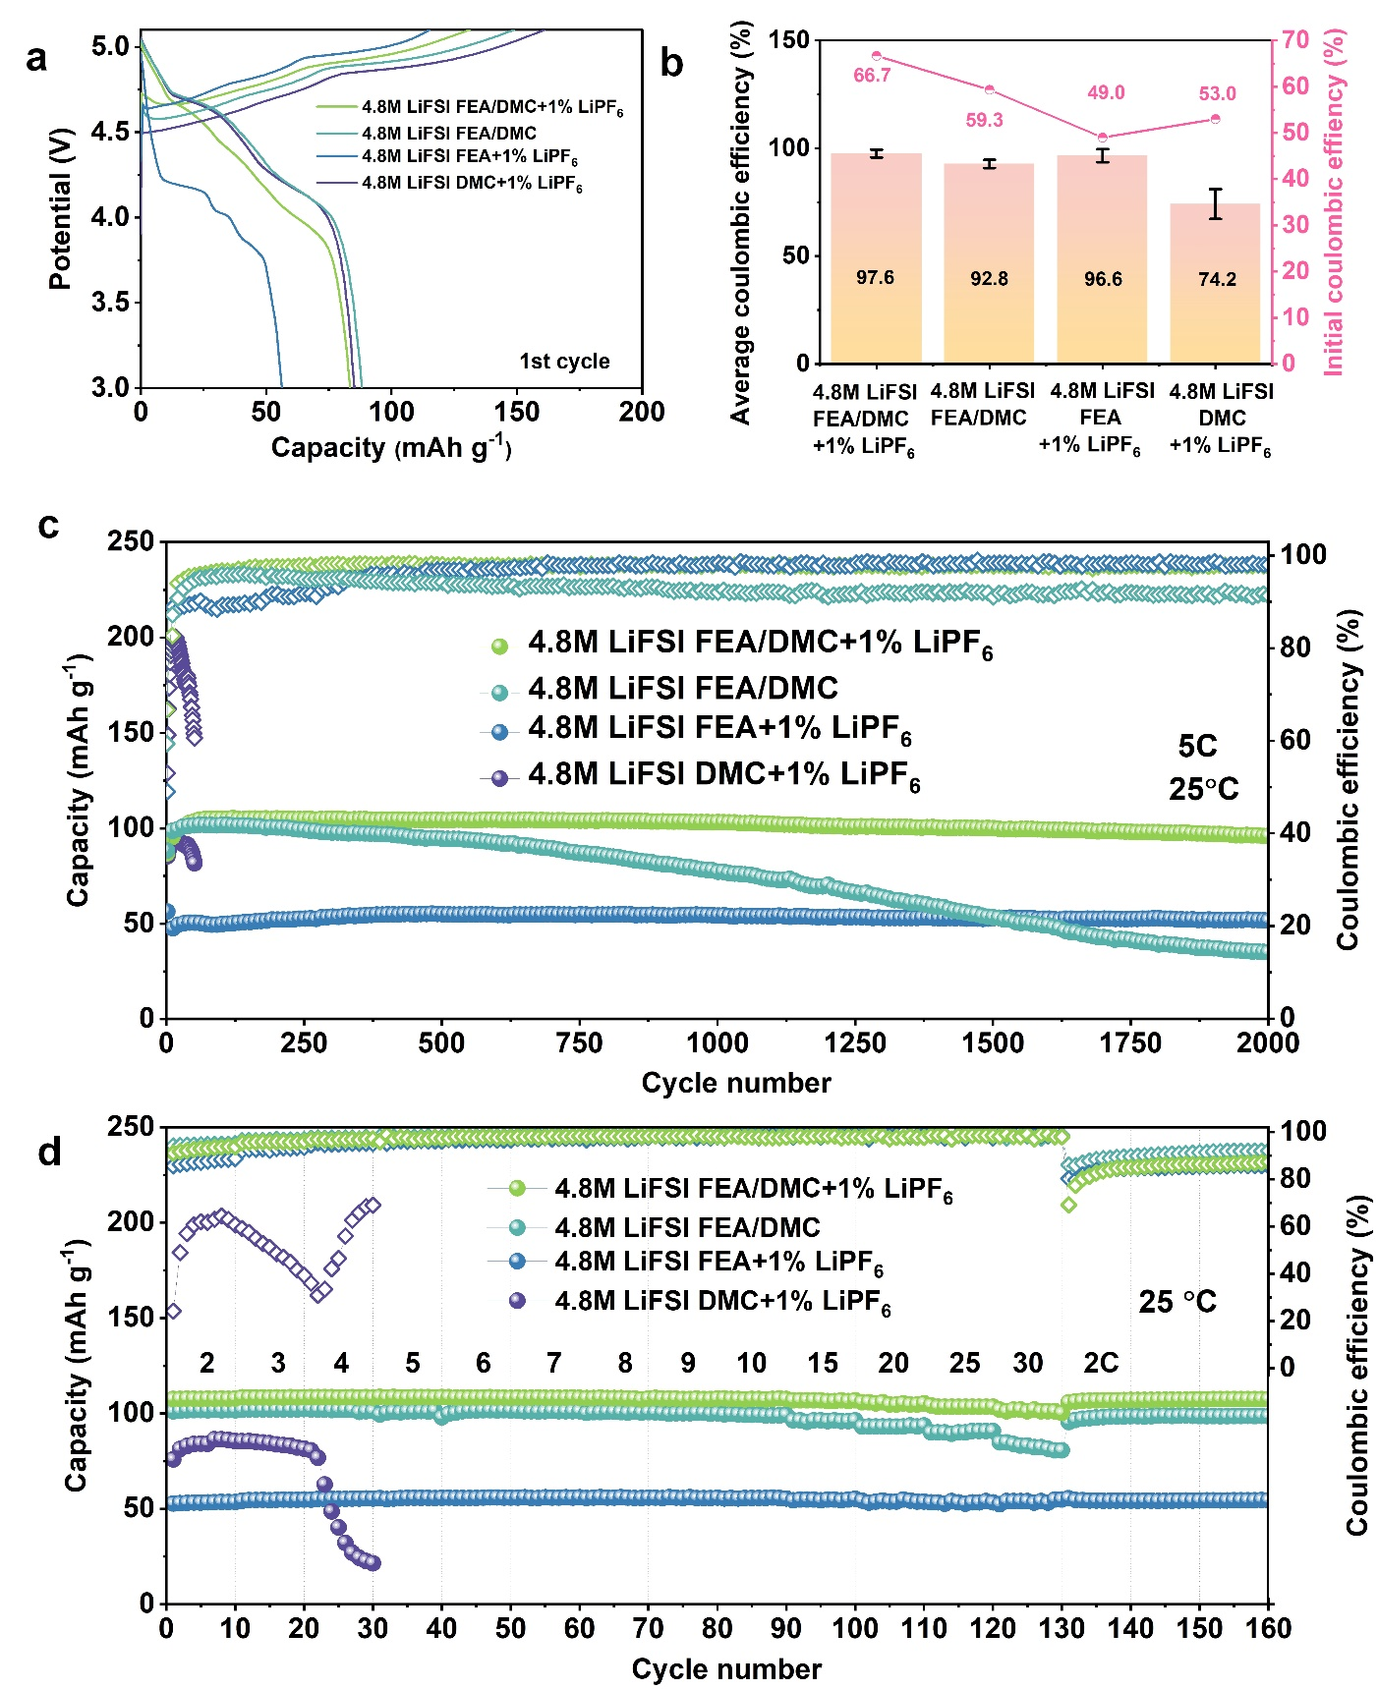

Figure 4. The electrochemical performances of graphite||lithium DIBs with different electrolytes at room temperature. (a) The first cycle charge and discharge curves; (b) the average Coulombic efficiency (with error bar) and initial Coulombic efficiency; (c) long-term cycle stability at a current density of 5C; (d) rate capability of graphite cathode under various charge/discharge rates.

2.4 Effect of electrolyte on graphite cathode
As suggested before, the difference in stability of the graphite electrodes with the four different 4.8 M LiFSI-based electrolytes are likely due to the different CEI formed on the surface. High-resolution transmission electron microscopy (HRTEM) was conducted to study the thickness of the CEI films after cycling at a current density of 5 C for 100 cycles with different electrolytes. It can be seen from Figure 5d that CEI layer of graphite with 4.8 M LiFSI DMC + 1% LiPF₆ electrolyte is non-uniform with thick areas and thin areas along the surface. This indicates that the CEI layer formed with DMC is not able to protect the graphite surface, leading to poor cycle stability. The addition of FEA is beneficial for forming an intact CEI. Though, due to the poor oxidative stability of the 4.8 M LiFSI FEA + 1% LiPF₆ electrolyte, the CEI formed on graphite surface is as thick as 17.3 nm (Figure 5c). An electrolyte with a combination of DMC and FEA can decrease the thickness of the CEI to about 10.1 nm (Figure 5b). Meanwhile, the addition of 1% LiPF₆ can further strengthen the CEI layer and reduce its thickness to about 5.4 nm (Figure 5a).
The chemical composition of the CEI film on graphite cathode surface is further analyzed by XPS measurements. Fluorine (F), oxygen (O), nitrogen (N), carbon (C), and sulfur (S) elements can be detected on all the electrode (Figure S10a-d, Supporting Information). The N and S signals would have to be originated from the LiFSI salt in the electrolyte, as there are no other source of N and S (Figure S10e-l, Supporting Information). Phosphorus (P) is only observed from graphite surfaces with LiPF₆-containing electrolytes, which is from reactions with LiPF₆ (Figure 5e).[34] Figure 5f shows the C 1s spectra of graphite cathodes in different electrolytes. All the electrolytes show similar oxygenated organic groups (C-O, C=O species)[35], which is caused by the decomposition of the solvents. Meanwhile, the lower C-C peak at 284.8 eV from the electrode tested in 4.8 M LiFSI DMC + 1% LiPF₆ is likely due to the thicker CEI formed overall on the graphite surface. By comparing the F 1s spectra (Figure 5g), the graphite electrode tested in 4.8 M LiFSI FEA/DMC + 1% LiPF₆ shows a larger amount of C-F and smaller amount of LiF. The ratios of the different elements observed on the surface are shown in Figure 5h and Table S1 (Supporting Information). Since LiF is electron-insulating, the lower amount on graphite in the 4.8 M LiFSI FEA/DMC + 1% LiPF₆ is favorable for superior rate performance and fast ion transport.[36] In contrast, O-containing organics prevailing on the surfaces of graphite in 4.8 M LiFSI FEA + 1% LiPF₆ and 4.8 M LiFSI DMC + 1% LiPF₆ electrolytes indicate more electrolyte decomposition with more organic byproducts and thicker CEI.

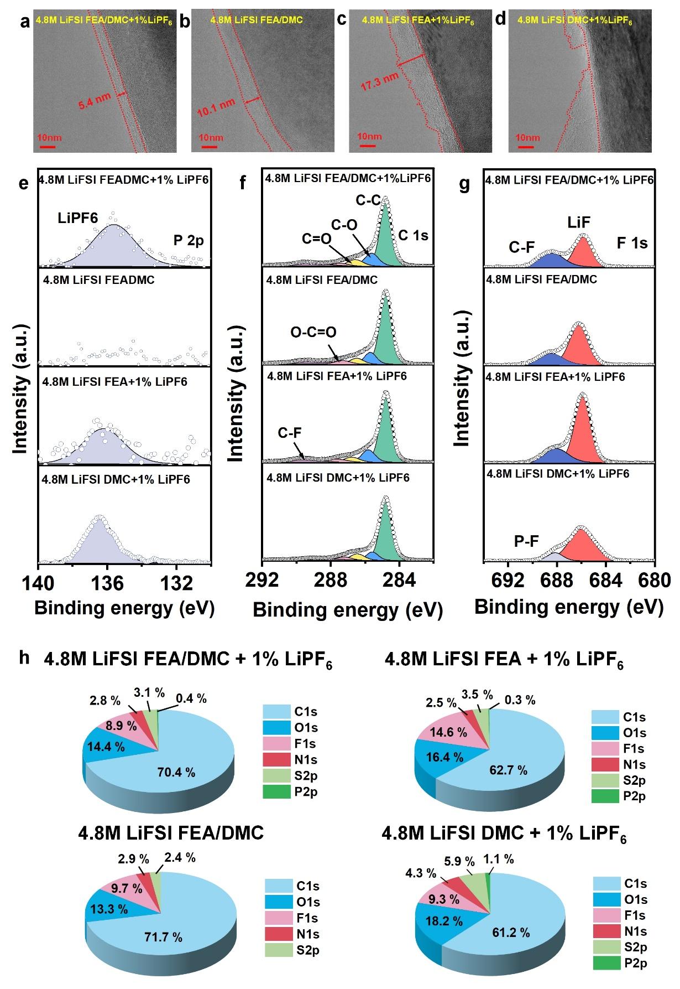

Figure 5. (a-d) HRTEM images of the graphite electrodes after cycling in different electrolytes. High-resolution XPS spectra of (e) P 2p, (f) C 1s, (g) F 1s, and (h) surface composition (pie chart) of the CEI layer formed on the graphite cathode surface using different electrolytes.

2.5 Application of electrolytes in DIB at sub-zero temperatures
As DIBs with 4.8 M LiFSI FEA/DMC + 1% LiPF₆ electrolyte can give high power capability at room temperature, we test here the capability of the graphite cathode at low temperatures in the range of 0 °C to -30 °C from 3.0 V to 5.0 V at a current density of 0.5 C. For comparison, graphite electrodes in 3.7 M LiPF₆ FEA/DMC = 8:2 was also tested to show the distinctive advantages of LiFSI over LiPF₆. Note that due to the lower solubility of LiPF₆ in organic electrolytes, 3.7 M is the maximum concentration of LiPF₆ that can be dissolved in FEA/DMC solvents. It can be seen from Figure 6a that the 4.8 M LiFSI FEA/DMC + 1% LiPF₆ electrolyte is still in a liquid state at -30 °C (melting point of -93 °C as indicated from DSC test) while the melting point of the 3.7 M LiPF₆ FEA/DMC = 8:2 electrolyte is -18 °C (Figure S11, Supporting Information). The discharge capacity and Coulombic efficiency of graphite at different temperatures in 4.8 M LiFSI FEA/DMC + 1% LiPF₆ and 3.7 M LiPF₆ FEA/DMC = 8:2 electrolytes are shown in Figure 6b-d. Overall, the cells with 3.7 M LiPF₆ FEA/DMC electrolyte can normally work with the capacity of about 86.0 mAh g⁻¹ at 25 °C at 0.5 C. However, the capacity utilization sharply decreases with large polarization when the temperature is reduced. Specifically, the available capacity is only 14.9 mAh g⁻¹ at -20 °C. In contrast, graphite in 4.8 M LiFSI FEA/DMC + 1% LiPF₆ electrolyte gives high available capacity and Coulombic efficiency, with a discharge capacity of 94.4, 84.1, 79.2, and 69.2 mAh g⁻¹ at 0.5 C with capacity utilization of 95%, 85%, 80%, and 70% at 0, -10, -20, -30 °C, respectively, compared with the room-temperature capacity (Figure 6c), which is a remarkable achievement for DIB to date (Table S2, Supporting Information).
The long cycle stability of graphite||Li dual-ion half-cell with 4.8 M LiFSI FEA/DMC + 1% LiPF₆ electrolytes is also tested at 2 C with the voltage ranging from 3.0 V to 5.1 V at 0 °C, showing a discharge capacity of about 88.0 mAh g⁻¹ with 86.3 % capacity retention after 500 cycles (Figure 6e). Even if the temperature is as low as -20 °C, the battery can still cycle steadily for 100 cycles at 0.5 C with almost no capacity decay (Figure S12, Supporting Information). These results show that 4.8 M LiFSI FEA/DMC + 1% LiPF₆ electrolyte is favorable for graphite||Li dual-ion half-cells working within a wide temperature range from -30 °C to 25 °C.
The high-rate charging/discharge capabilities of graphite||Li dual-ion half cells with LiFSI and LiPF₆ salts in FEA/DMC-based solvent system were further studied at 0 °C (Figure 6f). Graphite can realize fast FSI⁻-intercalation/de-intercalation process in 4.8 M LiFSI FEA/DMC + 1% LiPF₆ electrolyte at 0 °C. Even when the current is increased to 10 C, a capacity of about 80.3 mAh g⁻¹ is sustained, corresponding to a charge-discharge cycle of 12 minutes and 74.1% capacity utilization compared with the attainted capacity (108 mAh g⁻¹) at 10 C at room temperature. However, for graphite in 3.7 M LiPF₆ FEA/DMC, capacity utilization is reduced significantly with the increase of current density (Figure S13, Supporting Information).

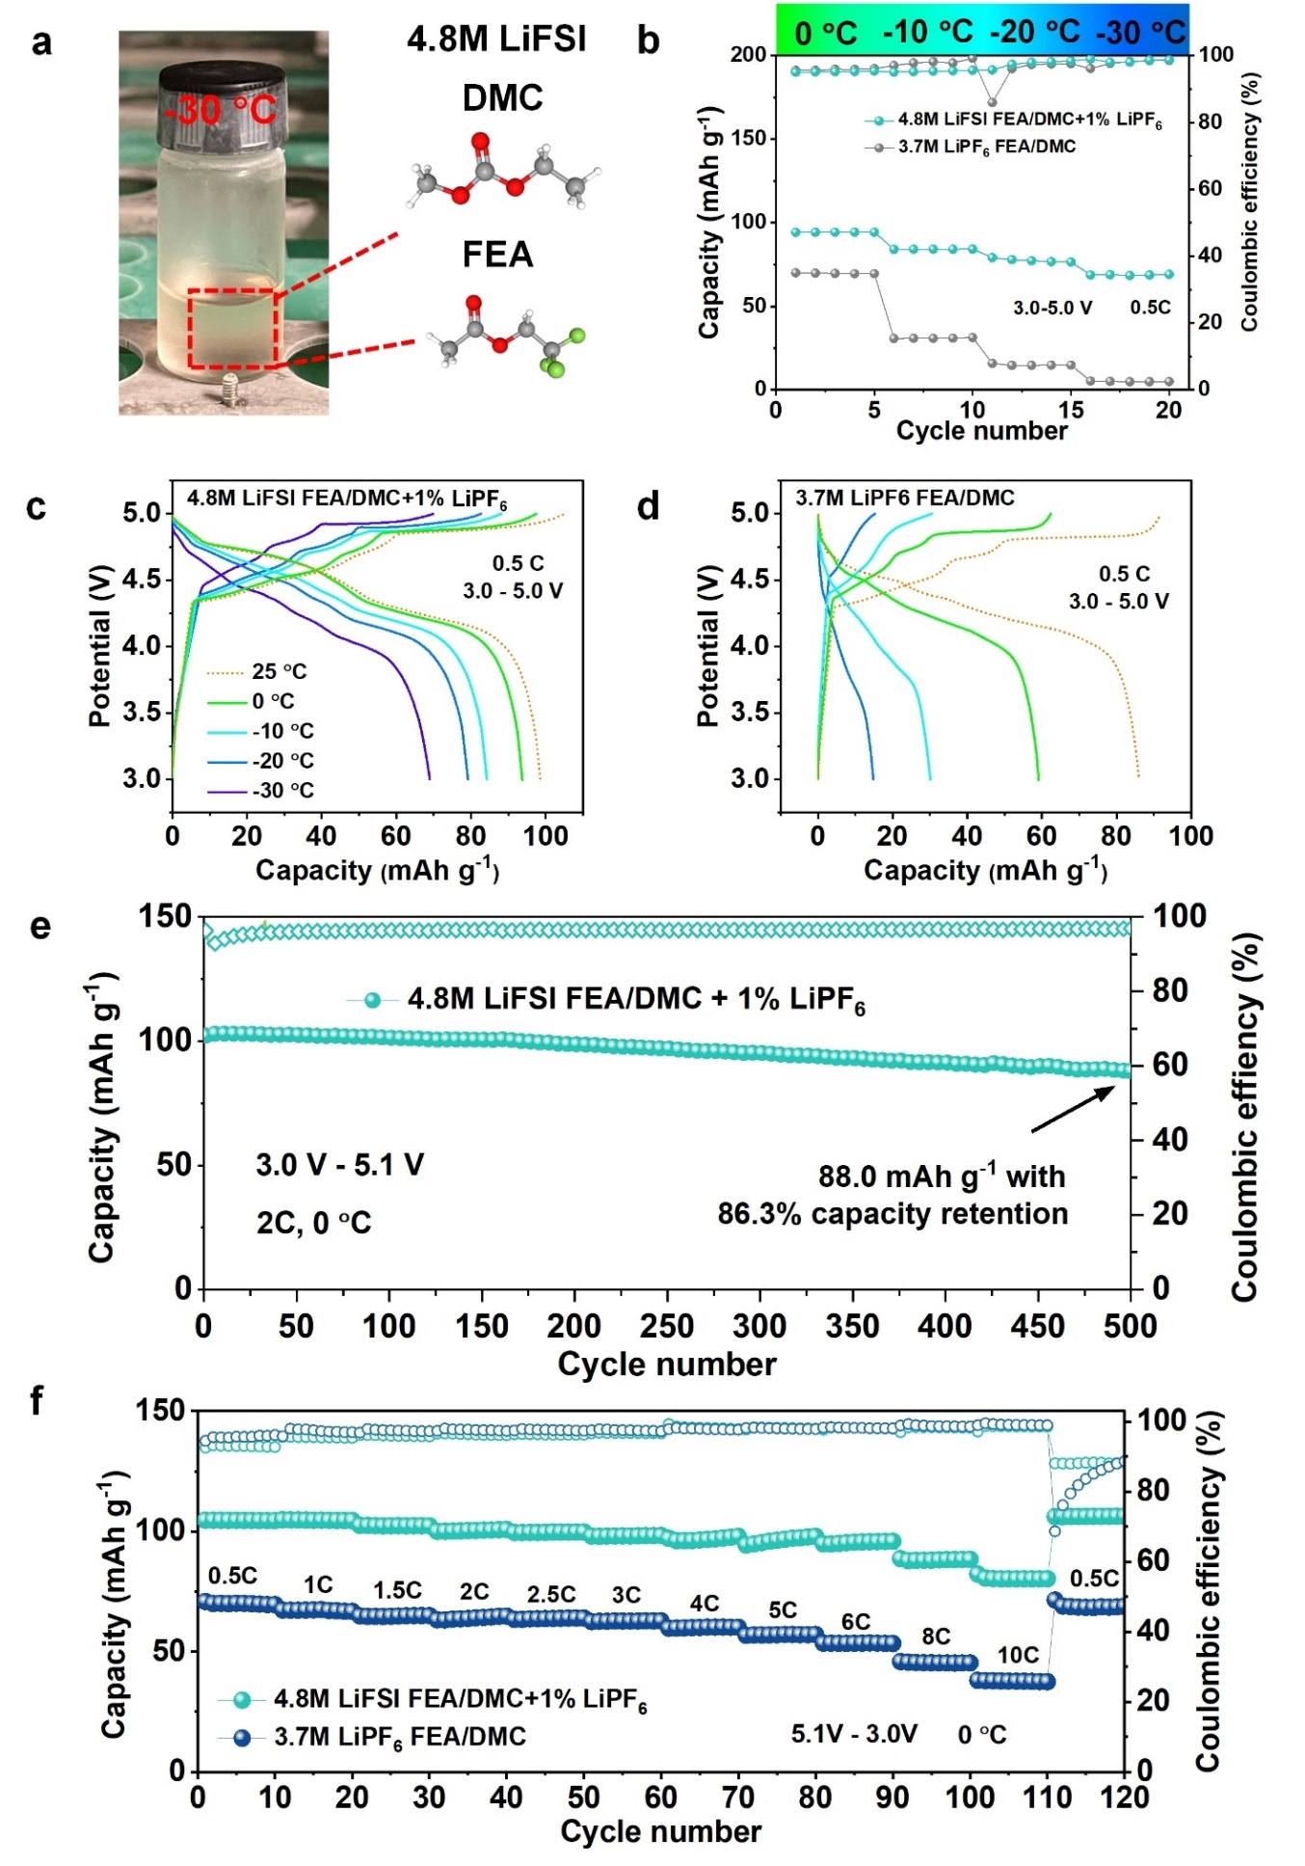
Figure 6. (a) Optical photograph of 4.8 M LiFSI FEA/DMC + 1% LiPF₆ electrolyte at -30 °C; (b) capacity of graphite||Li cells with different electrolytes at 0, -10, -20, -30 °C at a current density of 0.5 C; charge/discharge profiles of graphite||Li cells with (c) 4.8 M LiFSI FEA/DMC + 1% LiPF₆ and (d) 3.7 M LiPF₆ FEA/DMC electrolyte at various temperatures; (e) long-term cycle performance of cells with electrolyte at 0 °C at a current density of 2 C; (f) rate capability of cells with different electrolytes at 0 °C.

When the surrounding ambient temperature is lowered, the interface resistance increases and the kinetic transport becomes sluggish, making it harder for a battery to be charged and discharged rapidly.[37-39] To further analyze the kinetics of anion (i.e. FSI⁻ and PF₆⁻) intercalation and deintercalation during charge and discharge, respectively, we study how the cyclic voltammetry (CV) profiles change with temperature (Figure 7a and b). The voltage of the main redox peak (oxidation peak at ~ 4.95 V, reduction peak at ~ 4.60 V) with respect to that at 20°C follows an Arrhenius behaviour, and the activation energies of intercalation and deintercalation for FSI⁻ and PF₆⁻ corresponding to charge and discharge process are determined to be 116, 526 J mol⁻¹ and 81, 524 J mol⁻¹, respectively (Figure 7c and d). The result shows that more energy is consumed to overcome the energy barrier when PF₆⁻ anions are intercalated and de-intercalated into and out of graphite layer. In contrast, graphite cathode shows lower activation energy in 4.8 M LiFSI FEA/DMC + 1% LiPF₆ electrolyte, which is consistent with the better rate capability.
Electrochemical impedance spectra (EIS) of graphite||Li cells tested at 0 °C and 25 °C were conducted after different number of cycles to further track the interfacial resistance with various electrolytes and demonstrate the benefit of LiFSI salt (Figure 7e and f, Figure S14, Supporting Information). The Nyquist plots usually include two overlapping semicircles and a sloping tail. The intercept on the real part of the Nyquist plots corresponds to the R_{ohm} of cells, which is mainly derived from the contact resistance of the bulk electrolyte. The semicircle at high frequency corresponds to the CEI-layer resistance (R_{CEI}) and the semicircle at low frequency is attributed to the charge transfer resistance (R_{ct}) (the employed equivalent circuits are shown in the inset of Figure 7k and l). [40] Graphite electrode tested in 4.8 M LiFSI FEA/DMC + 1% LiPF₆ electrolyte shows lower R_{ohm}, R_{CEI} and R_{ct} both at 0 °C (Figure 7k) and 25 °C (Figure S14a, Table S3, Supporting Information) compared to that tested in 3.7 M LiPF₆ FEA/DMC (Figure 7f and S14b). This indicates that the transport of FSI⁻ is more facile compared to PF₆⁻. In addition, graphite electrode in LiFSI electrolyte shows small increase in impedance with cycling, compared to that in LiPF₆ (Figure S14b, Supporting Information). This suggests that the CEI formed with LiFSI is more stable, while that with LiPF₆ continues to grow. These results show that LiFSI-based electrolyte has a better low-temperature performance over LiPF₆-based electrolyte and can better realize the rapid insertion and removal of anions in graphite cathode at low temperatures (Figure 8).
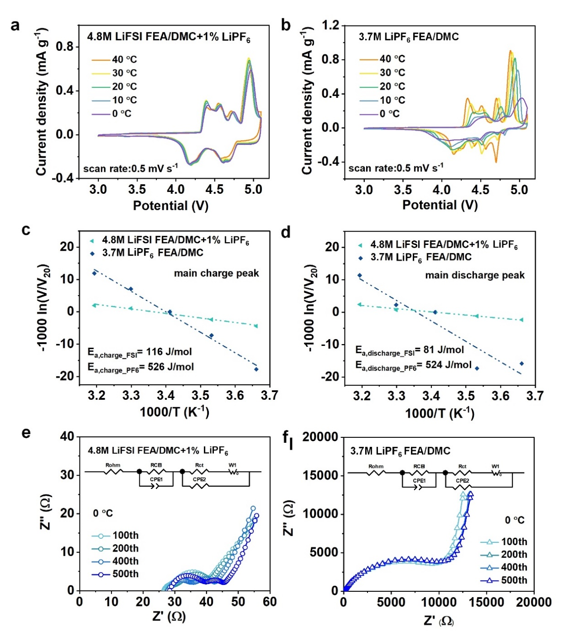
Figure 7. (a)-(b) CV curves of different electrolytes at various temperatures; Arrhenius plots and calculated activation energy of (c) charge process and (d) discharge process; Nyquist plots of cells with (e) 4.8 M LiFSI FEA/DMC + 1% LiPF₆ electrolyte and (f) 3.7 M LiPF₆ FEA/DMC electrolyte at 0°C at discharged state after different number of cycles.

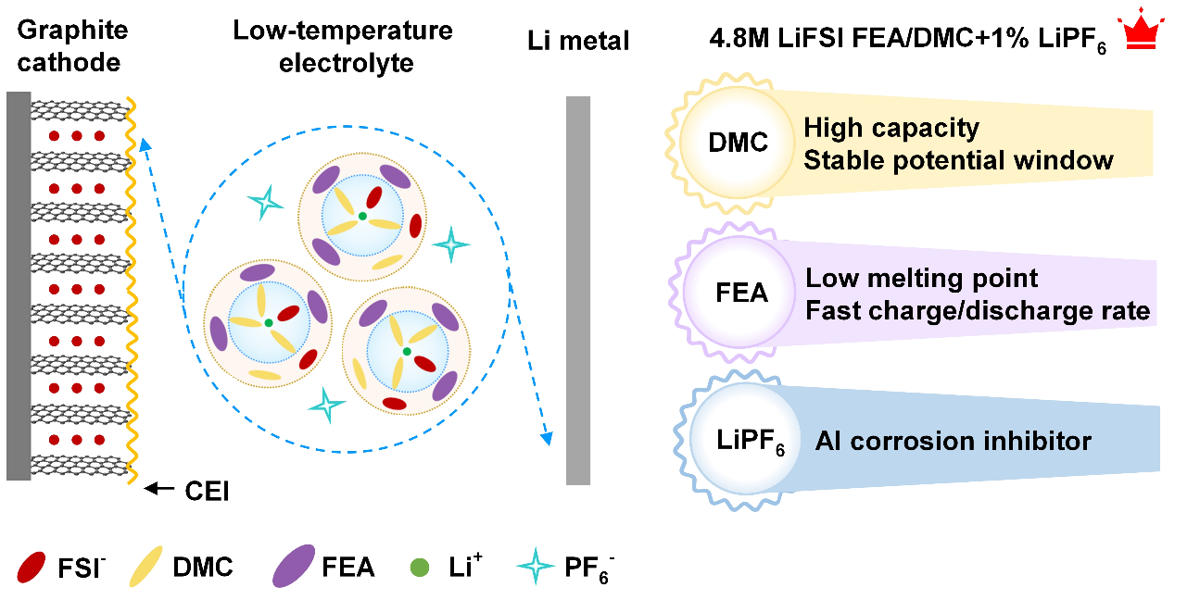

Figure 8. The schematic diagram illustrating the functions of each solvent and salt of the 4.8 M LiFSI FEA/DMC + 1% LiPF₆ electrolyte.

3. Conclusion
To extend electrification of cold climate regions and reduce dependence on fossil fuel, batteries that can be cycled at a low temperature are needed. Electrolytes with low melting point, fast ion transport dynamics and good stability are essential. In this paper, we developed a dual-ion battery with high power even at low temperature with LiFSI as the main salt. FEA with a low melting point is first adopted as the main solvent in the electrolyte. DMC is added as the co-solvent to improve capacity and enlarge the potential window of the electrolyte. LiPF₆ is further added as additive to reduce Al corrosion. Specifically, the optimal formulation, 4.8 M LiFSI FEA/DMC + 1% LiPF₆ electrolyte shows a low melting point of -93 °C with good stability up to 5.1 V, allowing graphite electrode to operate down to -30 °C. Benefiting from fast FSI⁻ transport kinetic, small interphase resistance, and good wettability of the separator by the electrolyte, the graphite cathode can be fast-charged and discharged at high rates at both room temperature and low temperatures. This work highlights the importance of electrolyte design to develop fast charging and low-temperature DIB systems, and more electrolyte formulations can be explored in the future.

4. Experimental Section
Electrolyte preparation: LiFSI (DoDoChem), LiPF₆ (DoDoChem), FEA (Shangfluoro Technology) and DMC (Shanshan Technology) were purchased and used as they are. 4.8 M LiFSI and 1 wt% LiPF₆ (with respect to the electrolyte) were added to FEA/DMC (8:2 by volume), FEA, and DMC to yield 4.8 M LiFSI FEA/DMC + 1% LiPF₆, 4.8 M LiFSI FEA + 1% LiPF₆, and 4.8 M LiFSI DMC + 1% LiPF₆ electrolytes, respectively. 4.8 M LiFSI FEA/DMC electrolyte was made with a similar procedure without adding LiPF₆. All the electrolytes were fabricated in an argon-filled glove box with H₂O < 0.1 ppm and O₂ < 0.1 ppm.
Electrode preparation and cell fabrication: Graphite powder (MTI SAG-R) was first mixed with acetylene black (AB) and polyacrylic acid binder (PAA, Sigma Aldrich, MW450,000) using N-methyl-2-pyrrolidinone (NMP) as solvent in a weight ratio of 85:5:10 to form a slurry, which was then coated onto aluminum foils to form the graphite electrode. The coated electrodes were dried at 110 °C overnight in a vacuum oven. Electrodes were punched into discs with diameter of 16 mm with a packing density of about 1.2 g cm⁻³ and an average mass loading of ~2.0 mg cm⁻². The graphite electrodes were coupled with Li metal as counter electrode, PVdF separator and assembled into a 2032-coin cell in an Ar-filled glove box. The amount of electrolyte used in half-cells is approximately 160 μL.
Electrochemical test: The room-temperature electrochemical tests were measured by a Neware battery test system. The voltage window for graphite||Li dual-ion half-cells using LiFSI-electrolyte and LiPF₆-electrolyte are 3.0-5.1 V and 3.0-5.2 V, respectively. Because of the limitation of the upper cut-off voltage of the battery charger, the low-temperature (-30 °C to 0 °C) tests were conducted in a voltage range of 3.0 V-5.0 V. Long cycle and rate performance tests of cells at 0 °C were conducted with a BASYTEC charge-discharge system between 3.0 V and 5.1 V. LSV with the scan rate of 5 mV s⁻¹ and CV were both tested with a Bio-Logic potentiostat (VMP3). Impedance measurements were also measured with the Bio-Logic potentiostat (VMP3) by applying a 10 mV AC potential amplitude within the frequency range from 100 kHz to 10 mHz. Graphite||Li cells with different electrolytes were first activated at room temperature for 50 cycles to obtain a stable Coulombic efficiency and were then tested for their low-temperature electrochemical performances.
Material characterizations: Raman spectroscopy (Alpha300R, WITec) was conducted to explore the solvation structure of electrolytes by using a 532 nm excitation wavelength. The morphology of aluminum surface after corrosion test was observed by SEM (ZEISS EVO MA10). To characterize the chemical composition of the CEI layer, XPS (ESCALAB 250Xi, Thermo Scientific) was conducted with graphite cathode cycled after 100 cycles at 5 C. A vacuum transfer apparatus was used to transfer the sample electrodes from an Ar-filled glovebox to the XPS. The CEI layer after 100 cycles at 5 C was observed by TEM (FEI Talos F200X G2). To prepare the TEM samples, cycled graphite electrodes were first extracted from coin cells and washed twice with DMC solvent and dried in an Ar-filled glove box. Then, the electrode powder was removed from the current collector and dispersed in ethanol with an ultrasound sonicator for 5 mins. The suspended sample was then dropped onto a Cu grid and dried by an infrared lamp which was then transferred onto the TEM sample stage.
DSC was used to investigate the melting point of the electrolytes with DSC-60A Plus, Shimadzu. 5 μL electrolyte was sealed in a stainless-steel pan inside a glovebox, then first cooled down to -150 °C and held isothermally for 10 min by a liquid nitrogen cooling system. The temperature is then increased from -150 °C to 25 °C with a 5 °C min⁻¹ heating rate. The melting point of the electrolyte is determined as the onset temperature of the endothermic peak during the DSC scan.
DFT Calculation: Gaussian 16 software with PBE0 functional was used for the calculations. Specifically, the def2-SVP basis set was used to optimize the geometry for each compound. A larger def2-TZVP basis set was adopted for the singlet point energy calculations.[41] To further improve the accuracy of the calculation, DFT-D3 dispersion correction with BJ-damping[42] was applied to correct the weak interaction. The solvation effect was accounted for with the SMD implicit solvation model,[43] while the Multiwfn software was used to analyze the orbital energy level[44]. The visualization of the orbitals for FSI⁻, different solvents, FSI⁻-solvent, Li⁺-FSI⁻-solvent complexes were achieved using VESTA software.

Supporting Information
Supporting Information is available from the Wiley Online Library or from the author.

Acknowledgements
This study was supported by a Research Matching Grant Scheme (PJ9229008) by the government of Hong Kong Special Administrative Region.

Conflict of Interest
The authors declare no conflict of interest.

Reference
[1] D. Yu, K. Li, G. Ma, F. Ru, X. Zhang, W. Luo, P. Hu, D. Chen, H. Wang, Advances in Low-Temperature Dual-Ion Batteries, ChemSusChem, 16 (2023) e202201595, https://doi.org/10.1002/cssc.202201595.
[2] C.B. Jin, N. Yao, Y. Xiao, J. Xie, Z. Li, X. Chen, B.Q. Li, X.Q. Zhang, J.Q. Huang, Q. Zhang, Taming Solvent-Solute Interaction Accelerates Interfacial Kinetics in Low-Temperature Lithium-Metal Batteries, Adv Mater, 35 (2023) e2208340, https://doi.org/10.1002/adma.202208340.
[3] J. Hao, X. Li, X. Song, Z. Guo, Recent progress and perspectives on dual-ion batteries, EnergyChem, 1 (2019) 100004, https://doi.org/10.1016/j.enchem.2019.100004.
[4] Y. Wang, Y. Zhang, S. Wang, S. Dong, C. Dang, W. Hu, D.Y.W. Yu , Ultrafast Charging and Stable Cycling Dual‐Ion Batteries Enabled via an Artificial Cathode-Electrolyte Interface, Advanced Functional Materials, 31 (2021) 2102360, https://doi.org/10.1002/adfm.202102360.
[5] L. Xiang, X. Ou, X. Wang, Z. Zhou, X. Li, Y. Tang, Highly Concentrated Electrolyte towards Enhanced Energy Density and Cycling Life of Dual-Ion Battery, Angewandte Chemie International Edition, 59 (2020) 17924-17930, https://doi.org/10.1002/anie.202006595.
[6] J. Chen, Y. Peng, Y. Yin, Z. Fang, Y. Cao, Y. Wang, X. Dong, Y. Xia, A Desolvation-Free Sodium Dual-Ion Chemistry for High Power Density and Extremely Low Temperature, Angewandte Chemie International Edition, 60 (2021) 23858-23862, https://doi.org/10.1002/anie.202110501.
[7] X. Dong, Y. Yang, P. Li, Z. Fang, Y. Wang, Y. Xia, A High-Rate and Long-Life Rechargeable Battery Operated at -75 °C, Batteries & Supercaps, 3 (2020) 1016-1020, https://doi.org/10.1002/batt.202000117.
[8] F. Chen, J. Wang, J. Liao, S. Wang, Z. Wen, C. Chen, A hydrogel-enabled free-standing polypyrrole cathode film for potassium ion batteries with high mass loading and low-temperature stability, Journal of Materials Chemistry A, 9 (2021) 15045-15050, https://doi.org/10.1039/D1TA02209A.
[9] Y. Wang, Y. Zhang, S. Dong, W. Zhou, P.K. Lee, Z. Peng, C. Dang, P.H.L. Sit, J. Guo, D.Y.W. Yu, An All‐Fluorinated Electrolyte Toward High Voltage and Long Cycle Performance Dual‐Ion Batteries, Advanced Energy Materials, (2022) 2103360, https://doi.org/10.1002/aenm.202103360.
[10] J. Qin, Q. Lan, N. Liu, F. Men, X. Wang, Z. Song, H. Zhan, A Metal-free Battery with Pure Ionic Liquid Electrolyte, iScience, 15 (2019) 16-27, https://doi.org/10.1016/j.isci.2019.04.010.
[11] H. Fan, L. Qi, H. Wang, Hexafluorophosphate anion intercalation into graphite electrode from methyl propionate, Solid State Ionics, 300 (2017) 169-174, https://doi.org/10.1016/j.ssi.2016.12.032.
[12] Y. Sun, H. Ma, X. Zhang, B. Liu, L. Liu, X. Zhang, J. Feng, Q. Zhang, Y. Ding, B. Yang, L. Qu, X. Yan, Salty Ice Electrolyte with Superior Ionic Conductivity Towards Low-Temperature Aqueous Zinc Ion Hybrid Capacitors, Advanced Functional Materials, 31 (2021) 2101277, https://doi.org/10.1002/adfm.202101277.
[13] W.H. Li, Y.M. Li, X.F. Liu, Z.Y. Gu, H.J. Liang, X.X. Zhao, J.Z. Guo, X.L. Wu, All-Climate and Ultrastable Dual-Ion Batteries with Long Life Achieved via Synergistic Enhancement of Cathode and Anode Interfaces, Advanced Functional Materials, 32 (2022) 2201038, https://doi.org/10.1002/adfm.202201038.
[14] J. Zhang, J. Zhang, T. Liu, H. Wu, S. Tian, L. Zhou, B. Zhang, G. Cui, Toward Low-Temperature Lithium Batteries: Advances and Prospects of Unconventional Electrolytes, Advanced Energy and Sustainability Research, 2 (2021) 2100039, https://doi.org/10.1002/aesr.202100039.
[15] L. Zhang, H. Fan, H. Wang, Methyl acetate-based solutions for dual-ion batteries, Electrochimica Acta, 342 (2020) 135992, https://doi.org/10.1016/j.electacta.2020.135992.
[16] Y. Wang, Z. Li, Y. Hou, Z. Hao, Q. Zhang, Y. Ni, Y. Lu, Z. Yan, K. Zhang, Q. Zhao, F. Li, J. Chen, Emerging electrolytes with fluorinated solvents for rechargeable lithium-based batteries, Chemical Society Reviews, 52 (2023) 2713-2763, https://doi.org/10.1039/D2CS00873D.
[17] X. Ren, P. Gao, L. Zou, S. Jiao, X. Cao, X. Zhang, H. Jia, M.H. Engelhard, B.E. Matthews, H. Wu, H. Lee, C. Niu, C. Wang, B.W. Arey, J. Xiao, J. Liu, J.G. Zhang, W. Xu, Role of inner solvation sheath within salt-solvent complexes in tailoring electrode/electrolyte interphases for lithium metal batteries, Proc Natl Acad Sci U S A, 117 (2020) 28603-28613, https://doi.org/10.1073/pnas.2010852117.
[18] N. von Aspern, G.V. Röschenthaler, M. Winter, I. Cekic-Laskovic, Fluorine and Lithium: Ideal Partners for High-Performance Rechargeable Battery Electrolytes, Angewandte Chemie International Edition, 58 (2019) 15978-16000, https://doi.org/10.1002/anie.201901381.
[19] G.G. Eshetu, S. Grugeon, G. Gachot, D. Mathiron, M. Armand, S. Laruelle, LiFSI vs. LiPF₆ electrolytes in contact with lithiated graphite: Comparing thermal stabilities and identification of specific SEI-reinforcing additives, Electrochimica Acta, 102 (2013) 133-141, https://doi.org/10.1016/j.electacta.2013.03.171.
[20] F. Kita, A. Kawakami, J. Nie, T. Sonoda, H. Kobayashi, On the characteristics of electrolytes with new lithium imide salts, Journal of Power Sources, 68 (1997) 307-310, https://doi.org/10.1016/S0378-7753(97)02528-7.
[21] M. Dahbi, F. Ghamouss, F. Tran-Van, D. Lemordant, M. Anouti, Comparative study of EC/DMC LiTFSI and LiPF₆ electrolytes for electrochemical storage, Journal of Power Sources, 196 (2011) 9743-9750, https://doi.org/10.1016/j.jpowsour.2011.07.071.
[22] M. Qin, Z. Zeng, S. Cheng, J. Xie, Challenges and strategies of formulating low-temperature electrolytes in lithium-ion batteries, Interdisciplinary Materials, 2 (2023) 308-336, https://doi.org/10.1002/idm2.12077.
[23] C.B. Jin, N. Yao, Y. Xiao, J. Xie, Z. Li, X. Chen, B.Q. Li, X.Q. Zhang, J.Q. Huang, Q. Zhang, Taming Solvent-Solute Interaction Accelerates Interfacial Kinetics in Low-Temperature Lithium-Metal Batteries, Advanced Materials, 35 (2023) 2208340, https://doi.org/10.1002/adma.202208340.
[24] G. Song, Z. Yi, F. Su, L. Xie, Z. Wang, X.X. Wei, G. Xu, C.M. Chen, Boosting the Low-Temperature Performance for Li-Ion Batteries in LiPF₆-Based Local High-Concentration Electrolyte, ACS Energy Letters, 8 (2023) 1336-1343, https://doi.org/10.1021/acsenergylett.2c02903.
[25] L.L. Jiang, C. Yan, Y.X. Yao, W. Cai, J.Q. Huang, Q. Zhang, Inhibiting Solvent Co-Intercalation in a Graphite Anode by a Localized High-Concentration Electrolyte in Fast-Charging Batteries, Angewandte Chemie International Edition, 60 (2021) 3402-3406, https://doi.org/10.1002/anie.202009738.
[26] G. Yan, X. Li, Z. Wang, H. Guo, W. Peng, Q. Hu, Lithium difluoro(oxalato)borate as an additive to suppress the aluminum corrosion in lithium bis(fluorosulfony)imide-based nonaqueous carbonate electrolyte, Journal of Solid State Electrochemistry, 20 (2016) 507-516, https://doi.org/10.1007/s10008-015-3069-3.
[27] B. Philippe, R. Dedryvère, M. Gorgoi, H. Rensmo, D. Gonbeau, K. Edström, Improved performances of nanosilicon electrodes using the salt LiFSI: a photoelectron spectroscopy study, J Am Chem Soc, 135 (2013) 9829-9842, https://doi.org/10.1021/ja403082s.
[28] M. Abbas, S.F.B. Haque, Y. Tian, J.P. Ferraris, K.J. Balkus Jr, Organic-Inorganic Nanohybrids in Supercapacitors, in: Hybrid Nanomaterials: Biomedical, Environmental and Energy Applications, Springer, 2022, pp. 359-383.
[29] K. Matsumoto, K. Inoue, K. Nakahara, R. Yuge, T. Noguchi, K. Utsugi, Suppression of aluminum corrosion by using high concentration LiTFSI electrolyte, Journal of Power Sources, 231 (2013) 234-238, https://doi.org/10.1016/j.jpowsour.2012.12.028.
[30] J. Xie, A.D. Sendek, E.D. Cubuk, X. Zhang, Z. Lu, Y. Gong, T. Wu, F. Shi, W. Liu, E.J. Reed, Y. Cui, Atomic Layer Deposition of Stable LiAlF₄ Lithium Ion Conductive Interfacial Layer for Stable Cathode Cycling, ACS Nano, 11 (2017) 7019-7027, https://doi.org/10.1021/acsnano.7b02561.
[31] M. Abbas, A.M. Maceda, H.R. Firouzi, Z. Xiao, H.D. Arman, Y. Shi, H.C. Zhou, K.J. Balkus, Fluorine extraction from organofluorine molecules to make fluorinated clusters in yttrium MOFs, Chemical Science, 13 (2022) 14285-14291, https://doi.org/10.1039/D2SC05143E.
[32] C.l. Li, S.W. Zeng, P. Wang, Z.j. Li, L. Yang, D.n. Zhao, J. Wang, H.n. Liu, S.Y. Li, Mechanism of aluminum corrosion in LiFSI-based electrolyte at elevated temperatures, Transactions of Nonferrous Metals Society of China, 31 (2021) 1439-1451, https://doi.org/10.1016/S1003-6326(21)65588-7.
[33] Y. Zhao, K. Xue, D.Y.W. Yu, Tuning Electrolyte Solvation Structure and CEI Film to Enable Long Lasting FSI⁻-Based Dual-Ion Battery, Advanced Functional Materials, 33 (2023) 2300305, https://doi.org/10.1002/adfm.202300305.
[34] W. Yu, Z. Yu, Y. Cui, Z. Bao, Degradation and Speciation of Li Salts during XPS Analysis for Battery Research, ACS Energy Letters, 7 (2022) 3270-3275, https://doi.org/10.1021/acsenergylett.2c01587.
[35] S.F.B. Haque, Y. Tian, D.W. Tague, K.J. Balkus, J.P. Ferraris, Carbon fiber composite electrodes derived from Metal Organic Polyhedra-18 and Matrimid for hybrid supercapacitors, Energy Advances, (2024), https://doi.org/10.1039/D3YA00537B.
[36] Y. Wang, Y. Zhang, Q. Duan, P. K. Lee, S. Wang, D.Y.W.Yu, Engineering cathode-electrolyte interface of graphite to enable ultra long-cycle and high-power dual-ion batteries, Journal of Power Sources, 471 (2020) 228466, https://doi.org/10.1016/j.jpowsour.2020.228466.
[37] Q. Li, G. Liu, H. Cheng, Q. Sun, J. Zhang, J. Ming, Low-Temperature Electrolyte Design for Lithium-Ion Batteries: Prospect and Challenges, Chemistry - A European Journal, 27 (2021) 15842-15865, https://doi.org/10.1002/chem.202101407.
[38] S.S. Zhang, K. Xu, T.R. Jow, The low temperature performance of Li-ion batteries, Journal of Power Sources, 115 (2003) 137-140, https://doi.org/10.1016/S0378-7753(02)00618-3.
[39] S. Zhang, K. Xu, T. Jow, Low-temperature performance of Li-ion cells with a LiBF₄-based electrolyte, Journal of Solid State Electrochemistry, 7 (2003) 147-151, https://doi.org/10.1007/s10008-002-0300-9.
[40] Y. Guo, J. Cai, Y. Liao, J. Hu, X. Zhou, Insight into fast charging/discharging aging mechanism and degradation-safety analytics of 18650 lithium-ion batteries, Journal of Energy Storage, 72 (2023) 108331, https://doi.org/10.1016/j.est.2023.108331.
[41] F. Weigend, Accurate Coulomb-fitting basis sets for H to Rn, Phys Chem Chem Phys, 8 (2006) 1057-1065, https://doi.org/10.1039/b515623h.
[42] S. Grimme, S. Ehrlich, L. Goerigk, Effect of the damping function in dispersion corrected density functional theory, J Comput Chem, 32 (2011) 1456-1465, https://doi.org/10.1002/jcc.21759.
[43] A.V. Marenich, C.J. Cramer, D.G. Truhlar, Universal solvation model based on solute electron density and on a continuum model of the solvent defined by the bulk dielectric constant and atomic surface tensions, J Phys Chem B, 113 (2009) 6378-6396, https://doi.org/10.1021/jp810292n.
[44] T. Lu, F. Chen, Multiwfn: A multifunctional wavefunction analyzer, Journal of Computational Chemistry, 33 (2012) 580-592, https://doi.org/10.1002/jcc.22885.

