Supplementary Material

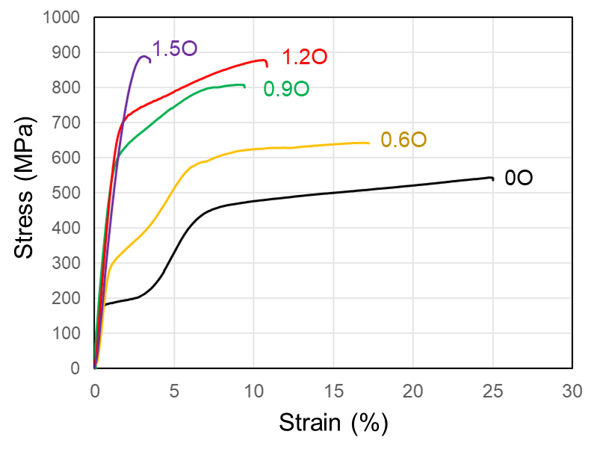
Fig. S1. Tensile stress–strain curves of the Ti–12Zr–6Nb–2Mo–2Sn– xO (x = 0, 0.6, 0.9, 1.2 and 1.5) alloys annealed at 1173 K for 1.8 ks.

Table 1: Tensile properties of the Ti–12Zr–6Nb–2Mo–2Sn–xO (x = 0, 0.6, 0.9, 1.2 and 1.5) alloys annealed at 1173 K for 1.8 ks.
Alloy | Young’s Modulus (GPa) | UTS (MPa) | Elongation (%)
0O | 36.3 ± 1.4 | 542 ± 13 | 24.5 ± 1.9
0.6O | 49.9 ± 2.8 | 650 ± 7 | 15.1 ± 1.1
0.9O | 52.0 ± 1.0 | 817 ± 7 | 9.2 ± 0.9
1.2O | 58.0 ± 4.1 | 860 ± 11 | 10.7 ± 0.5
1.5O | 49.3 ± 2.7 | 905 ± 9 | 3.4 ± 0.1

