Activation of non <a> type dislocation in near <0001>-oriented Mg by Sc addition
Elango Chandiran*, Yukiko Ogawa, Rintaro Ueji, Alok Singh, Hidetoshi Somekawa, and Takahito Ohmura
National Institute for Materials Science, 1-2-1 Sengen, Tsukuba, Ibaraki 305-0047, Japan
* Corresponding author. E-mail address: CHANDIRAN.elango@nims.go.jp

Abstract
This study investigates the effect of Sc addition on the deformation behaviour of near-<0001>-oriented Mg via micropillar compression. The Sc addition significantly increases the yield stress and promotes activation of non-<a> dislocation while suppressing <a> dislocation.

Keywords: micropillar compression, Mg, Mg-Sc, mechanical property, deformation mechanism

1. Introduction
The excellent strength-to-weight ratio of magnesium (Mg) alloys makes them desirable for structural applications in the automotive and aerospace industries [1]. However, the poor room temperature formability of wrought-form Mg alloys limits their wider applicability [1,2]. The poor formability is attributed to their hexagonal-closed-packed (HCP) crystal structure, because basal slips are dominant owing to the lower critical resolved shear stress (CRSS) over the prismatic and pyramidal planes. Thus, there are not enough independent slip systems to meet the Von Mises criterion for ductility [2-5].
Addition of rare earth (RE) elements to Mg is known to reduce the difference in CRSS between the basal and non-basal planes [6] and promote activation of non-basal slips, resulting in improved room temperature ductility [3,4]. Sandlöbes et al [7] suggested that higher activation of the non-basal deformation in Mg–Y alloys is due to a reduction in the I₁ stacking fault energy (SFE) by Y. This is because the I₁ stacking faults that form are reported to be sites for activation of non-basal dislocations [8]. Scandium (Sc) is one of these RE elements, and its alloying in Mg has been shown to improve properties such as creep strength [9], strength [10], ductility [10], and biocompatibility [11]. Ogawa et al [12] recently showed the presence of non-basal slips in a fractured Mg–Sc alloy that possesses a good combination of strength and ductility. Nevertheless, it remains unknown how Sc addition affects the deformation mechanisms of Mg, particularly in the early stages of deformation. As a result, this study investigates the impact of Sc addition to Mg on deformation behaviour with near-<0001>-oriented grains during micropillar compression at room temperature.

2. Materials and methods
Mg (99.96% purity) and Mg–Sc (20 at.%) alloy were used in this study. The as-received Mg was extruded into a plate shape with a reduction ratio of 18:1 at 543 K [13], and a small sample Mg extruded plate was cut and annealed for 48 hours at 748 K [14] to obtain Mg specimens. The Mg–Sc alloy sheets were produced by cold-rolling an as-cast billet, as previously reported [12]. A small sample Mg–Sc sheet was cut and annealed for 144 hours at 773 K to obtain Mg–Sc with HCP structure (hereafter referred to as Mg–Sc) [14]. The exact composition of the Mg–Sc alloy was determined to be Mg-19.7 at.% Sc using an electron probe micro analyser [14]. The microstructures of the samples were imaged from the RD–ND plane surface using a scanning electron microscope (SEM) (JEOL 7000F) coupled with an electron backscatter diffraction (EBSD) detector (EDAX-TSL). For imaging, the sample surfaces were mechanically polished and then etched with a 6% aqueous solution of hydrochloric acid. The crystallographic orientation of grains was determined from EBSD data using orientation imaging microscopy software from TexSEM Laboratories. <0001>-oriented grains large enough for micropillar fabrication were identified.
Cylindrical micropillars with a diameter of 5 µm and height of 10 µm were fabricated using focused ion beam (FIB) milling (ZEISS Crossbeam 550). The compression axis was kept parallel to the <0001> direction of the grains. Following fabrication, the micropillars were subjected to compression using a nano-indenter (Hysitron Triboindenter TI950) with a flat punch under displacement-rate-controlled conditions at a strain rate of 1 × 10⁻³ s⁻¹ at room temperature. The compression test was conducted until there was approximately a 10% decrease in height or an interruption prior to that. The engineering stress–strain curves were obtained from the experimental load–displacement data using the original cross-sectional area (with the top diameter) and micropillar height during compression.
The Sneddon correction model [4] was used to subtract the elastic deflection of Mg and Mg–Sc from beneath the micropillars, resulting in an accurate measurement of the actual micropillar displacement. The CRSSs of different dislocation slips were calculated from the yield stresses using the Schmid factors. The Schmid factor for each dislocation slip was calculated from the Euler angles (average crystallographic orientation) of the grain. To ensure reproducibility, at least five micropillars were compressed for subsequent analysis of the given materials. For selected sample conditions, TEM observations were conducted from the midplane parallel to the compression axis. TEM samples were fabricated using FIB lift-out. TEM observations were made using a JEOL 2800 microscope equipped with a scanning TEM (STEM).

3. Results and discussion
3.1 Microstructure and compression behaviour
The inverse pole figure maps shown in Fig. 1 represent the initial microstructure of the processed samples. These maps show that the microstructure consists of fully equiaxed grains because they do not contain deformed structures such as shear bands or twins, indicating they were fully recrystallized during annealing. The grains identified as G1 (in Fig. 1a), G2, and G3 (in Fig. 1b), whose crystallographic orientations are approximately 6–7° from <0001>, were used for micropillar fabrication.
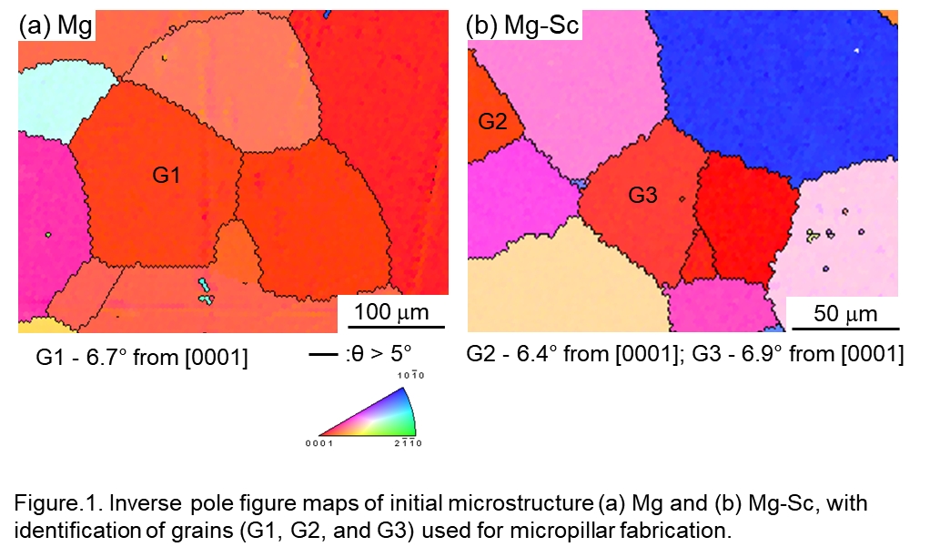Stress–strain curves of the Mg and Mg–Sc micropillars are shown in Fig. 2a and b. The stress–strain curves are initially linear until a drop in stress leads to a noticeable change in the shape of the curve, which is more frequently observed in Mg (Fig. 2a) than in Mg–Sc (Fig. 2b). The drop in stress is often interpreted as a consequence of avalanche-like collective motion of dislocations during compression of micrometre-sized crystalline specimens [15]. The 0.2% proof stress is considered as the yield stress in this study. The yield stresses for Mg and Mg–Sc are 37±4 MPa and 530±26 MPa, respectively. The CRSS for the basal <a> dislocation slip is 4±0.5 MPa for Mg and 61±3 MPa for Mg–Sc. Similarly, the CRSS for the pyramidal <c+a> dislocation slip is 17±2 MPa in Mg and 239±12 MPa in Mg–Sc. Note that, as shown later in Fig. 3, both the <a> and <c+a> dislocations are activated. The initial slope of the stress–strain curve, which is a measure of the Young modulus, is higher in Mg–Sc than in Mg, which is consistent with previous studies [16,17].
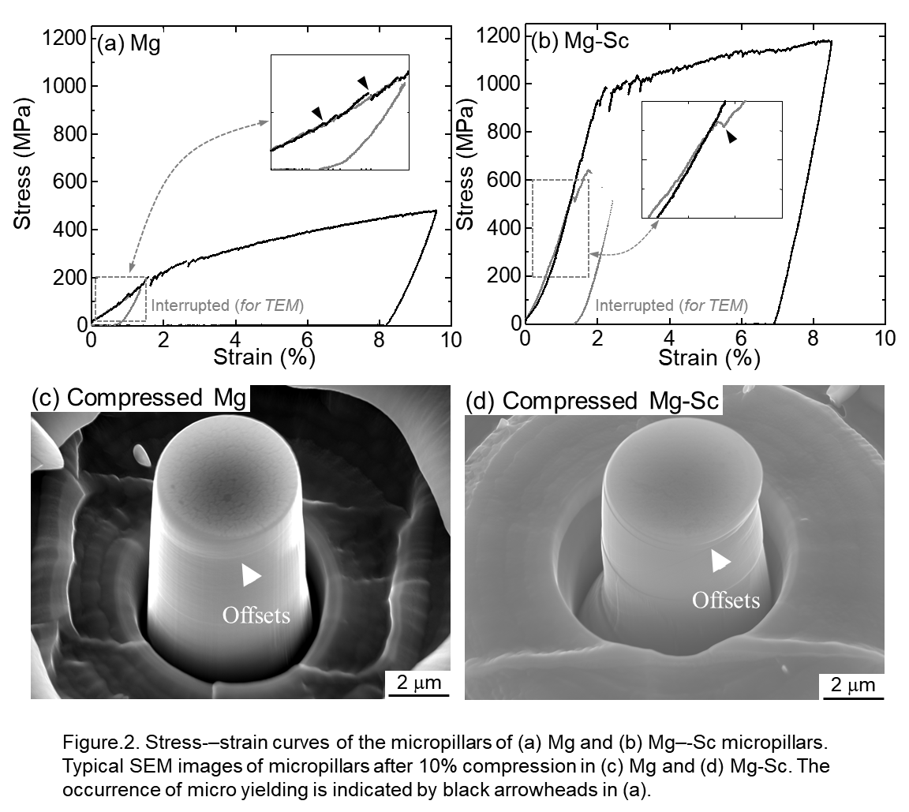
Figure 2c and d show SEM images of the 10% compressed micropillars of Mg and Mg–Sc, respectively. In Mg (Fig. 2c), fine slip traces are observed on the surface of the pillar, and the offset of these slip traces is lower, which indicates the deformation is largely homogenous along the pillar axis. Compared with Mg, the Mg–Sc micropillar has a significant amount of slip offset (Fig. 2d), whereby a section of the pillar is displaced outwardly from the original pillar axis. This suggests that the deformation is less homogenous along the pillar axis in Mg–Sc than in Mg. The compression tests of some micropillars were stopped just after the first instance of a drop in stress over 15 MPa (shown in Fig. 2a and b as “interrupted for TEM”) to examine the deformation mechanism involved during compression.
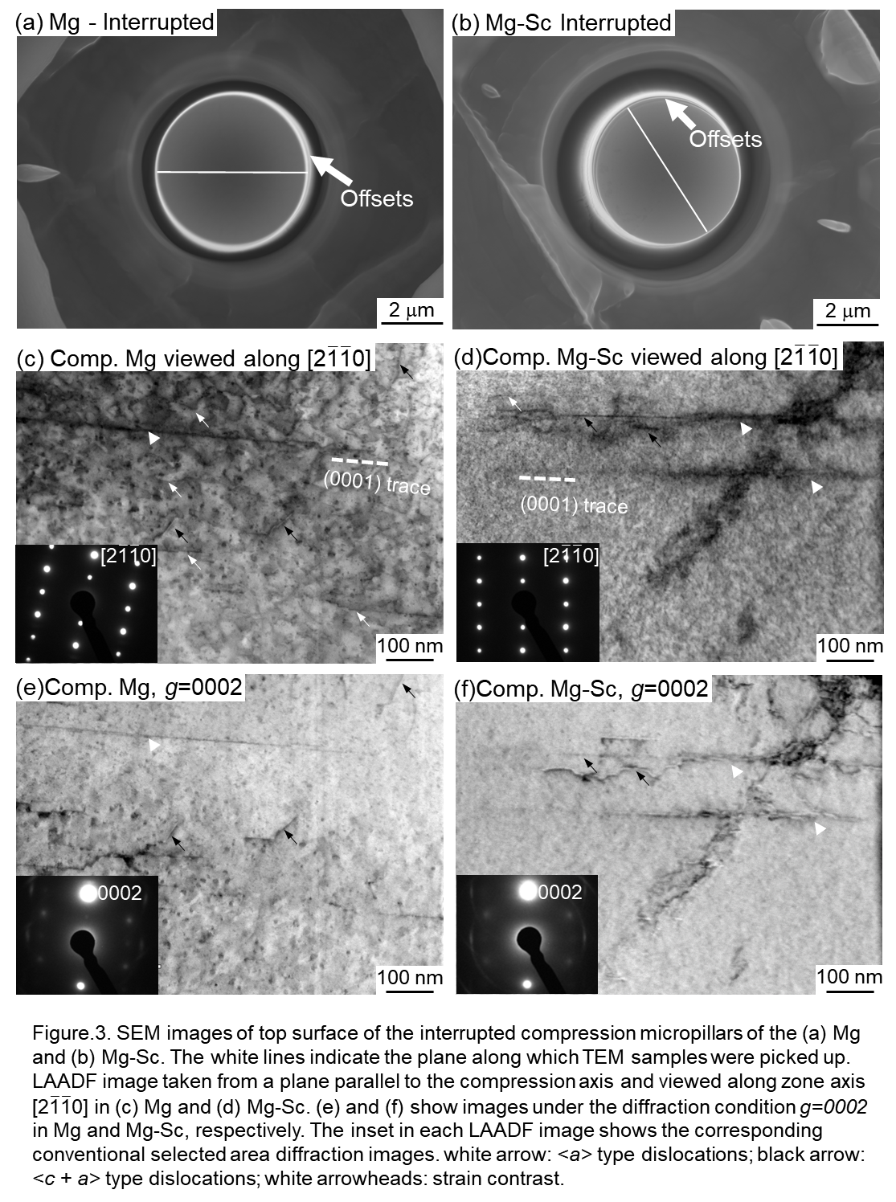
Figure 3a and b show the top surface of the interrupted compression micropillars of the Mg and Mg–Sc samples. The presence of offset on micropillar surfaces confirm slip activation during interrupted compression. TEM samples were prepared on the sections indicated by the white lines. In the conventional TEM mode, the diffraction conditions were chosen, and bright field and weak beam images were captured. Under the same tilting conditions, low-angle annular dark-field (LAADF) images were then captured in STEM mode. The LAADF images are presented in Fig. 3c–f, and the inset in each image shows the corresponding conventional selected area diffraction images. Figure 3c and d show a typical dislocation structure observed in deformed samples viewed along the [2$\overline{\text{1}}\overline{\text{1}}$0] zone axis. In Mg (Fig. 3c), a larger number of dislocations (white and black arrows) is observed, and these are observed in a large area along the column of the micropillars (Fig. S1a). Some strain contrast/distinct lines (white arrowheads) are observed parallel to the top surface of the micropillar (i.e., the basal plane). In Mg–Sc, dislocations are hardly observed but strain contrast/distinct lines are found both parallel to the basal plane and about 45 degrees from the top surface of the micropillar (Figs. 3d and S1b). To examine the nature of the strain contrast/distinct lines, imaging was done under the diffraction condition g=0002, as shown in Fig. 3e and f. The line contrasts are still visible. Some line segments are observed to be in the basal plane, some perpendicular to it (prismatic), and some inclined to it by approximately 75 or 55 degrees to the basal plane (pyramidal) (Fig. 3e). Some of these dislocations are also observed in Fig. 3c, as indicated by the black arrows. These can be assumed to be of the <c+a> type. This is because on the basis of the visibility criterion g•b ≠ 0, all <c+a> and <c> dislocations are visible under the diffraction condition g=0002. Furthermore, fewer dislocations are visible in Mg for g=0002 (Fig. 3c) than when viewed along the [2$\overline{\text{1}}\overline{\text{1}}$0] zone axis (Fig. S1a), suggesting that most of the dislocations observed in Mg are of the <a> type. In the case of Mg–Sc (Fig. 3f), we can say the observed line contrasts are dislocations with a strong c component and are of the <c> and <c+a> types. These dislocation types are observed in larger numbers in Mg–Sc. No twin formation is observed in either sample under any diffraction conditions via the TEM. These results imply dislocation slip is the active deformation mechanism in both Mg and Mg–Sc samples with near-<0001> orientation during micropillar compression. More importantly, the addition of Sc to Mg promotes activation of non-<a> dislocations and significantly suppresses <a> dislocation formation. These experimental observations agree well with atomic simulations in Mg with RE alloys [18].

3.2 Solid solution strengthening by Sc
The yield stress is determined by micropillar compression from single grains, so grain boundaries should have negligible effect. Furthermore, because these grains were fully recrystallized as a result of annealing (Fig. 1), the contribution of the dislocations to the measured yield stress is assumed to be negligible. As a result, we focused on the increase in yield stress observed in Mg–Sc due to the solution strengthening by Sc addition. The solid solution strengthening in Mg–Sc was estimated using the Fleischer model [19], which includes a concentration term related to the geometry of solute spacing in the matrix:
$$\text{Δ}{\text{σ}}_{\text{YS}}\text{ = αGM}{\text{ε}}^{\text{3/2}}{\text{C}}^{\text{1/2}} \text{,}\text{ (1)}$$
where $\text{Δ}{\text{σ}}_{\text{YS}}$is the yield stress increment due to solid solution strengthening caused by Sc addition, α is a constant (=1/550 in Mg [20]), G is the shear modulus of pure Mg (=16.7 GPa [21]), M is the Taylor factor (=3 [22]), ε is the misfit strain, and C is the concentration. The misfit strain ε is calculated as
$\text{ε=}\left|\frac{{\text{ε}}_{\text{G}}}{\text{1+0.5}\left|{\text{ε}}_{\text{G}}\right|}\text{-β}{\text{ε}}_{\text{a}}\right| \text{,}\text{ (2)}$
where $β$ is a constant (=3 [19]), $ε_{G}$is the modulus mismatch parameter, $ε_{a}$ is the atomic size factor, and d_{Sc} is the atomic radius of Sc (= 166 pm [21]). The parameter $ε_{G}$ is approximated as 0.566 using 2(G_{Sc}−G)/ G_{Sc} +G [23], where G_{Sc} =29.7 GPa is the shear modulus of Sc [21], and $ε_{a}$ is approximated as 0.0375 using (d_{Mg}−d_{Sc})/d_{Mg}, where d_{Mg} is the atomic radius of Mg (=160 pm [21]).
The solid solution strengthening estimated from Eqs. (1) and (2) is 76 MPa, which is nearly sixfold less than the experimentally observed value of 493 MPa. The model’s underestimation of solid solution strengthening is likely due to the fact that it only considers the combined effect of atomic size misfit and modulus mismatch. However, studies demonstrate that the strong interaction of substitutional atoms with dislocations also plays a significant role in Mg strengthening [24-26]. Tsuru et al. [24] showed that strong interaction of Y atoms with the basal dislocation core contributes to Mg strengthening. Furthermore, Fang et al. [25] proposed that Sc atoms tend to reduce the energy of basal dislocation cores similarly to Y and other REs like Er and Gd, indicating strong binding between the basal dislocation cores and the Sc atoms, which eventually contributes to the Mg strengthening.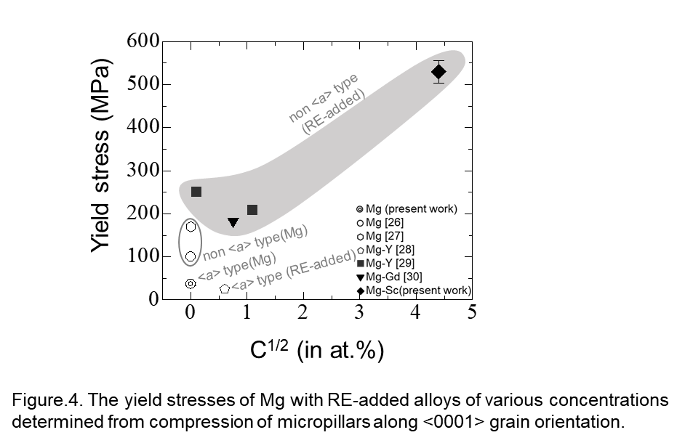
Figure 4 shows the yield stresses of Mg with RE-added alloys of various concentrations [27-30]. These values were obtained from micropillars with diameters of 5 to 10 µm, compressed along the <0001> grain orientation. It is noteworthy that the yield stress of Mg in this study is lower than the previously reported values [26,27]. This is presumably because of the dominant activation of the <a> dislocation slip rather than the <c+a> dislocation slip [26, 27], as shown in Figs. 3c and S1a, which requires less stress [20,23]. The Sc addition considerably enhanced the Mg yield stress compared with Y [29] and Gd [30] additions because the concentration of Sc is much higher than that of other alloying elements. Wu et.al [28] showed that for deformation of Mg-0.7 at.% Y at elevated temperatures, activation of pyramidal dislocation slips contributed to an increase in yield stress, whereas for room temperature deformation, activation of basal dislocation slips resulted in a lower yield stress. The other Mg alloys with RE additions such as Mg–Y [29], Mg–Gd [30], and Mg–Sc exhibited higher yield stresses, showing the predominance of non-<a> dislocation slips. These behaviors are consistent with those observed in Mg. Thus, these findings suggest that the strengthening effect in Mg is significant when there is a combination of RE addition and a propensity for non-<a> dislocation slip activation.

4. Summary
Addition of Sc to near-<0001>-oriented Mg during micropillar compression leads to significant increases in both yield strength and CRSS for a basal slip. Sc addition promotes formation of a <c+a> dislocation slip while <a> dislocation slip formation is scarcely observed. This shows that Sc addition to Mg is effective in improving ductility owing to higher activation of non-<a> dislocation.

Acknowledgments
This study was supported in part by the Japan Society for the Promotion of Science (JSPS) KAKENHI Grant No. 17J10094, 18K14032, and 22H01835. The authors gratefully acknowledge the assistance of Ms Eri Nagakawa of the Mechanical Properties Group at NIMS in the fabrication and compression of the micropillars. The authors also thank Ms Akiko Nakamura of the Microstructure Analysis Group at NIMS for TEM sample preparation.

Data availability
The datasets generated during the current study are not publicly available because the research is still ongoing but is available from the corresponding author upon reasonable request.

Originality statement
The authors confirm that the manuscript is currently not submitted for peer review or accepted for publication in another journal.

Supplementary
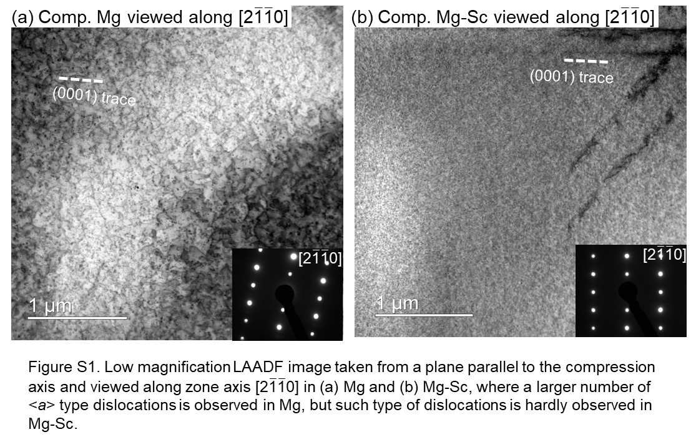

References
- H. Friedrich, S. Schumann, Research for a new age of magnesium in the automotive industry,J. Mater. Process. Technol., 117 (2001), pp. 276-281.
- P.G. Partridge, The crystallography and deformation modes of hexagonal close-packed metals, Metallurg. Rev., 12 (1) (1967), pp. 169-194.
- D. Griffiths, Explaining texture weakening and improved formability in magnesium rare earth alloys, Mater. Sci. Technol., 31 (2015), pp. 10-24.
- C. Moosbrugger, Engineering Properties of Magnesium Alloys, ASM International (2017).
- S.L. Couling, J.F. Pashak, L. Sturkey, Unique deformation and aging characteristics of certain magnesium-based alloys, Trans ASM, 51 (1959), pp. 94-107.
- T. Tsuru, Y. Udagawa, M. Yamaguchi, M. Itakura, H. Kaburaki, Y. Kaji, Solute softening in magnesium alloys: the effect of solid solutions on the dislocation core structure and nonbasal slip, J. Phys. Cond. Mater., 25 (2013) 022202.
- S. Sandlöbes, M. Friák, S. Zaefferer, A. Dick, S. Yi, D. Letzig, et al., The relation between ductility and stacking fault energies in Mg and Mg–Y alloys, Acta Mater., 60 (2012), pp. 3011-3021.
- M.H. Yoo, J.R. Morris, K.M. Ho, S.R. Agnew, Nonbasal deformation modes of HCP metals and alloys: Role of dislocation source and mobility, Metall Mater Trans A, 33 (2002), pp. 813-822.
- B.L. Mordike, I. Stulıkova, B. Smola, Mechanisms of creep deformation in Mg-Sc-based alloys, Metall. Mater. Trans., A36 (2005), pp. 1729-1736.
- C.J. Silva, A. Kula, R.K. Mishra, M. Niewczas, The effect of Sc on plastic deformation of Mg–Sc binary alloys under tension, J. Alloy. Compd., 761 (2018), pp. 58-70.
- J. Liu, Y. Lin, D. Bian, M. Wang, Z. Lin, X. Chu, W. Li, Y. Liu, Z. Shen, Y. Liu, Y. Tong, Z. Xu, Y. Zhang, Y. Zheng, In vitro and in vivo studies of Mg-30Sc alloys with different phase structure for potential usage within bone, Acta Biomater., 98 (2019), pp. 50-66.
- Y. Ogawa, A. Singh, H. Somekawa, Activation of non-basal <c+a> slip in coarse-grained Mg-Sc alloy, Scripta Mater, 218 (2022), Article 114830.
- H. Somekawa, C.A. Schuh, Effect of solid solution elements on nanoindentation hardness, rate dependence, and incipient plasticity in fine grained magnesium alloys, Acta Mater., 59 (2011), pp. 7554-7563.
- E. Chandiran, Y. Ogawa, R. Ueji, A. Singh, H. Somekawa, Enhancement of damping capacity by deformation-induced martensitic transformation in Mg–Sc alloy, Mater. Sci. Eng., A, 880 (2023) 145198.
- F.F. Csikor, C. Motz, D. Weygand, M. Zaiser, S. Zapperi, Dislocation avalanches, strain bursts, and the problem of plastic forming at the micrometer scale, Science, 318 (5848) (2007), pp. 251-254.
- Ş. Uğur, N. Arikan, F. Soyalp, G. Uğur, Phonon and elastic properties of AlSc and MgSc from first-principles calculations, Comput. Mater. Sci., 48 (2010), pp. 866-870.
- X.M. Tao, Y.F. Ouyang, H.H. Liu, Y.P. Feng, Yong Du, Z.P. Jin, Elastic constants of B2-MgRE (RE = Sc, Y, La–Lu) calculated with first-principle, Solid State Commun., 148 (2008), pp. 314–318.
- S. Sandlöbes, Z. Pei, M. Friák, L.F. Zhu, F. Wang, S. Zaefferer, D. Raabe, J. Neugebauer, Ductility improvement of Mg alloys by solid solution: ab initio modeling, synthesis and mechanical properties, Acta Mater., 70 (2014), pp. 92-104.
- R.L. Fleischer, Substitutional solution hardening, Acta Metall., 11 (1963), pp. 203-209.
- A. Akhtar, E. Teghtsoonian, Substitutional solution hardening of magnesium single crystals, Philosoph. Mag. J. Theor. Exp. Appl. Phys., 25 (1972), pp. 897-916.
- W. Martienssen, H. Warlimont (Eds.)., Springer handbook of condensed mater and materials data, (2006).
- L.J. Slutsky, C. Garland, Elastic constants of magnesium from 4.2 K to 300 K, Phys Rev, 107 (1957), pp. 972-976.
- H.E. Friedrich, B.L. Mordike (Eds.)., Magnesium Technology: Metallurgy, Design Data, Applications, Springer-Verlag, Berlin (2006).
- T. Tsuru, D.C. Chrzan, Effect of solute atoms on dislocation motion in Mg: an electronic structure perspective, Sci. Rep., 5 (2015), pp. 8793.
- C. Fang, J. Zhang, F. Pan, First-principles study on solute-basal dislocation interaction in Mg alloys
J. Alloys Compd., 785 (2019), pp. 911-917.
- Z. Pei, M. Friák, S. Sandlöbes, R. Nazarov, B. Svendsen, D. Raabe, J. Neugebauer, Rapid theory-guided prototyping of ductile Mg alloys: from binary to multi-component material, New J. Phys., 15 (2013), p. 043020
- E. Lilleodden, Microcompression study of Mg (0001) single crystal, Scr. Mater., 62 (2010), pp. 532-535.
- C.M. Byer, B. Li, B. Cao, K.T. Ramesh, Microcompression of single-crystal magnesium, Scr. Mater., 62 (2010), pp. 536-539
- J. Wu, S. Si, K. Takagi, T. Li, Y. Mine, K. Takashima, Y.L. Chiu, Study of basal < a > and pyramidal < c + a > slips in Mg-Y alloys using micro-pillar compression,Philos. Mag., 100 (2020), pp. 1454-1475
- H. Ovri, J. Markmann, J. Barthel, M. Kruth, H. Dieringa, E.T. Lilleodden, Mechanistic origin of the enhanced strength and ductility in Mg-rare earth alloys, Acta Mater., 244 (2023), Article 118550

Captions
Figure 1 | Inverse pole figure maps of initial microstructure (a) Mg and (b) Mg-Sc, with identification of grains (G1, G2, and G3) used for micropillar fabrication.
Figure 2 | Stress-–strain curves of the micropillars of (a) Mg and (b) Mg–-Sc micropillars. Typical SEM images of micropillars after 10% compression in (c) Mg and (d) Mg-Sc. The occurrence of micro yielding is indicated by black arrowheads in (a).
Figure 3 | SEM images of top surface of the interrupted compression micropillars of the (a) Mg and (b) Mg-Sc. The white lines indicate the plane along which TEM samples were picked up. LAADF image taken from a plane parallel to the compression axis and viewed along zone axis [2$\overline{\text{1}}\overline{\text{1}}$0] in (c) Mg and (d) Mg-Sc. (e) and (f) show images under the diffraction condition g=0002 in Mg and Mg-Sc, respectively. The inset in each LAADF image shows the corresponding conventional selected area diffraction images. white arrow: <a> type dislocations; black arrow: <c+a> type dislocations; white arrowheads: strain contrast.
Figure 4 | The yield stresses of Mg with RE-added alloys of various concentrations determined from compression of micropillars along <0001> grain orientation.
Figure S1 | Low magnification LAADF image taken from a plane parallel to the compression axis and viewed along zone axis [2$\overline{\text{1}}\overline{\text{1}}$0] in (a) Mg and (b) Mg-Sc, where a larger number of <a> type dislocations is observed in Mg, but such type of dislocations is hardly observed in Mg-Sc.

