Strain-Sensitive On-Surface Ladderization via Non-Dehydrogenative Heterocyclization
Yujing Ma,^{[a]} Kazuma Sugawara,^{[b]} Yusuke Ishigaki,^{[b]} Kewei Sun,^{[a]} Takanori Suzuki,*^{[b]} Shigeki Kawai*^{[c]}

[a] Dr. Y. Ma, Dr. K. Sun
Research Center for Advanced Measurement and Characterization
National Institute for Materials Science
Sengen 1-2-1, Tsukuba, Ibaraki 305-0047, Japan
[b] Dr. K. Sugawara, Prof. Dr. Y. Ishigaki, Prof. Dr. T. Suzuki
Department of Chemistry, Faculty of Science, Hokkaido University
Sapporo, Hokkaido 060-0810, Japan
E-mail: tak@sci.hokudai.ac.jp
[c] Prof. Dr. S. Kawai
Research Center for Advanced Measurement and Characterization, National Institute for Materials Science
1-2-1 Sengen, Tsukuba, Ibaraki 305-0047, Japan
Graduate School of Pure and Applied Sciences, University of Tsukuba
Tsukuba 305-8571, Japan
E-mail: KAWAI.Shigeki@nims.go.jp

Abstract: On-surface cyclodehydrogenation recently became an important reaction to planarize π-conjugated molecules and oligomers. However, the high-activation barrier to cleave the C-H bond often requires high-temperature annealing, consequently restricting structures of precursor molecules and/or leading to random fusion at their edges. Here, we present a synthesis of pyrrolopyrrole-bridged ladder oligomers from 11,11,12,12-tetrabromo-1,4,5,8-tetraaza-9,10-anthraquinodimethane molecules on Ag(111) with bond-resolved scanning tunnelling microscopy. This non-dehydrogenative cyclization between pyrazine and ethynylene/cumulene groups has a low-activation barrier, with forming intermediary dimeric oligomer containing dipyrazinopyrrolopyrrolopyrazine units, thus giving new insight into the strain-sensitive in ladder-oligomer formation.

Conjugated polymers have emerged as appealing molecular electronics in the applications for field effect transistors^{[1]} and light-emitting diodes^{[2]} as well as photovoltaic solar cells,^{[3]} due to the unique optoelectronic properties. Since delocalized π-electrons along polymeric chains give rise to intriguing electric and optical properties, these systems are bearing great promise and potentials as functional organic materials. Notably, π-conjugated ladder oligomers, whose units are rigidly linked by fused rings, exhibit extraordinary thermal, chemical, and mechanical stabilities.^{[4]}
On-surface reaction has become a powerful tool to synthesize extended π-conjugated system since the designer structure can be formed by linking small precursor molecules on catalytic surfaces.^{[5]} This bottom-up technique is free from the solubility issue, which is usually present in wet chemistry. Among various on-surface reactions, cyclodehydrogenation has been widely used for syntheses of polycyclic aromatic hydrocarbons.^{[6]} Particularly, this reaction became well-recognized as a principal method for planarization of small molecules and oligomers since the first systematic synthesis of graphene nanoribbons (GNRs)^{[7]} was demonstrated by combining the Ullmann-type reaction.^{[8]} While various GNRs with different edges^{[9]} and heteroatoms-incorporations^{[10]} have already been obtained, the thermally induced process usually relies on the high reaction barriers for the C-H bond cleavage in cyclodehydrogenation. The barrier height is strongly changed by the molecular structure and/or the underlying metal substrates.^{[11]} It is well-known that in a synthesis of GNRs, the steric hinderance in between the conjugated anthracene units caused by the strong adsorption to the metal substrate reduces the reaction temperature.^{[12]} Paradoxically, the cyclodehydrogenation may not be universally induced if the reactant is completely planar which has no assistance of the steric hindrance, and/or has a low thermal stability on surface. Remarkably, Fisher et al., recently found a low activation barrier of the cyclodehydrogenation in a heterocyclic π-system, leading to a C-N bond formation at 100 °C on Au(111) or Ag(111).^{[13]} In light of their work, one can expect that simple cyclization without any dehydrogenation can be caused at even lower temperatures and can further be applied for ladderization. In fact, Sánchez-Grande et al., very recently demonstrated an on-surface synthesis of nitrogen-containing ladder oligomers with tetraazapentacene on Au(111) and Ag(111) through the reaction between acetylene and azaacene groups at 100 °C and 200 °C, respectively.^{[14]} The higher reaction temperature on a Ag(111) surface, which is more reactive than a Au(111) surface, was attributed as the silver-directed N···Ag···N bond stabilization between the tetraazapentacene units. One can expect that this effect reduces if a shorter unit as tetraazaanthracene is used.
Here we report the on-surface synthesis of 1,4-pyrrolopyrrole-bridged ladder oligomers with 11,11,12,12-tetrabromo-1,4,5,8-tetraaza-9,10-anthraquinodimethane 1 on Ag(111) with high-resolution scanning tunneling microscopy (STM). Via a systematic investigation of the stepwise and periodic cyclization of the linear oligomer, we found the dimeric oligomer as the stable intermediate arising from a low activation barrier of the cyclization between pyrazine and ethynylene/cumulene groups, which was finally converted to the fully aromatic ladder oligomer. It should be noted that, in the first cyclization to the intermediate, 14-p tetraazaanthracene unit is converted into 18-p pyrazinopyrrolopyrrolopyrazine skeleton, which is an unprecedented aromatic skeleton (Scheme 1). According to the calculation of the harmonic oscillator model of aromaticity (HOMA), the electronic nature of newly formed 6-5-5-6 fused ring system is far different from that of antiaromatic dibenzopentalene with 16-p electrons (Figure S1).
Following the recent on-surface synthesis of ethynylene-bridged anthracene oligomers demonstrated by Sánchez-Grande et al.,^{[15]} we utilize 1 to obtain ladder oligomers on Ag(111) (Scheme 2). Firstly, ethynylene/cumulene-linked oligomers 2 are synthesized by the Ullmann-type reaction. Subsequent annealing of the sample induces the skeletal isomerization via cyclization between pyrazine and ethynylene/cumulene groups, forming 1,4-pyrrolopyrrole-bridged ladder oligomers 3. The linear structure is composed of a series of left (L)- or right (R)-tilted enantiomers, and this trans-isomerization shortens the total length along the longitudinal oligomer axis. The cis isomer unit does not compose the main chain of 3, appearing only at the kink site between the two trans oligomers, since the cis isomer formation should be accompanied by positional rearrangement of C_{sp} carbons. We discovered the dimeric oligomer as the stable intermediate, which demonstrates that the ladder oligomerization of 1 does not proceed from one end of the linear polymer with expand gradually. Thus, non-dehydrogenative cyclization in a periodic manner proceed preferably with forming 18-p stable aromatic system, which then undergoes further cyclization to furnish the ladder oligomer (Scheme 3).
Scheme1. Formation of hitherto unknown heterocyclic skeleton of pyrazino[1'',2'':1',5']pyrrolo[2',3':4,5]pyrrolo[1,2-a]pyrazine

Scheme2. On-surface reaction scheme for two different π-conjugated oligomers. As-deposited 1 transforms to conjugated linear oligomers 2 on Ag (111) at RT and subsequently to ladder-type oligomers 3 by annealing.

Scheme3. Stable intermediate of dimeric oligomer during the ladder oligomerization forms linear oligomer.

Upon deposition of 1 on a clean Ag(111) surface kept at room temperature, the debromination took place,^{[16]} leaving large amount of dissociated Br atoms on the terrace (Figures 1a and S2). The surface was also covered with extended linear structures and their strands, running along three crystallographic directions of the underlying Ag(111) substrate. The close-up view taken around the area indicated by an arrow in figure 1a shows that one-dimensional structure is composed of linearly linked aza-anthracene units, which locate in parallel with each other (Figure 1b). The units, having three distinct protrusions, are separated by 730 pm as indicated by a double arrow. The short unit distance indicates the desired building block of 1. Moreover, a failure of the tip-induced lateral manipulation indicates the robust and rigid bonding nature of the linear system (not shown here). The corresponding bond-resolved image taken with a CO terminated tip^{[17]} reveals the detailed structures of the unit and its linkers (Figure 1c). For a better view of the bond feature, the Laplace filter was applied (Figure S3). In between the units, we find the dark line bridges, which is comparable with that seen in non-substituted anthracene-based oligomers.^{[15]} Hence, it can be concluded that the ethynylene/cumulene-bridged 1,4,5,8,-tetraaza-anthracene oligomer 2 was synthesized by the Ullmann-type reaction. Besides the dark line bridge, we found two bright spots between the units, which we tentatively regard them silver adatoms, connecting to pyrazine moieties. Noticeably, the distinct contrast between the pyrazine moiety and the central benzene is quite discernable in the dI/dV image. The nature of the contrast is ambiguous at the moment but may relate to different aromaticity in the heteroatom π system.^{[18]} Nevertheless, this feature is quite helpful in determination on the chemical structure of the cyclized oligomers obtained in the subsequent reaction. We also observed bright dots at the rims of the tetraazaanthracene units, which may relate to the orbital distribution of HOMO (Figure S4).

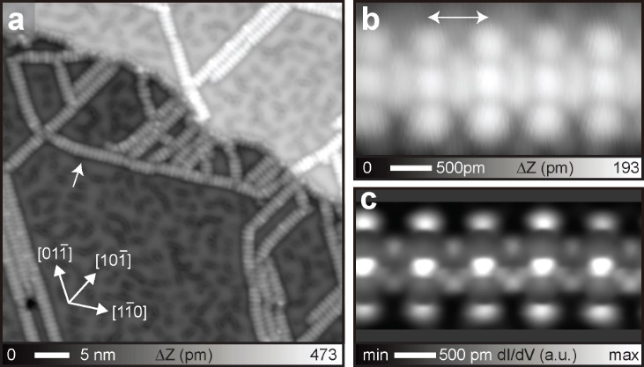
Figure 1. Formation of linear conjugated oligomers. a) Large-scale STM topography of as-deposited 1 on Ag(111) at room temperature. b) Close-up view around the area indicated by an arrow in (a), and c) the corresponding high-resolution constant-height dI/dV map obtained with a CO-functionalized tip. Measurement parameters: bias voltage V = 200 mV and tunneling current I = 10 pA in (a), V = 100 mV and I = 100 pA in (b), and V = 1 mV in (c).

After annealing the sample at 120 °C, two more types of oligomers, as zigzag- and straight-shaped structures, appeared on the surface and were labeled as α and β oligomers in figure 2a, respectively. α oligomer is composed of repeated small segments while β oligomer has a long planar segment. Since both segments no longer ran along the [1-10] and its equivalent directions, the adsorption site of the molecular unit on Ag(111) was changed. We also found no significant bond scission of 2 after the reaction while several branch points appeared. The close-up view of α oligomer shows that two units are connected at their longer edges and the resultant dimers are also linked each other (Figure 2b). The bond-resolved image of the comparable product reveals that the linker of the dimer corresponds to two C_{sp} carbons (Figure 2c). The distinct contrast at the central ring of the tetraazaanthracene unit allowed an unambiguous structural analysis of the product. We found the formation of a pyrrolopyrrole moiety in the dimer unit, indicating that the system has gone through the cyclization process in a well-ordered periodic manner. Apparently, the annealing process at 120 °C induced the skeletal isomerization in the two units of 2 and led to the synthesis of the pyrazinopyrrolopyrrolopyrazine skeletons for the first time, which were still connected with each other via the ethynylene/cumulene unit. This temperature, much lower than typical temperatures for cyclodehydrogenation, indicates a low activation barrier of the non-dehydrogenative cyclization. Although the newly formed pyrazino[1'',2'':1',5']pyrrolo[2',3':4,5]pyrrolo[1,2-a]pyrazine is the unprecedented aromatic skeleton, the DFT calculation [B3LYP/6-31g(d)] indicates the planar geometry with sufficient bond delocalization (Figure S5). Since the majority of the species on the surface was the dimer, the reaction barrier to form the trimer and higher oligomers seems to be much higher than that of the dimer. We also found that the straight-shaped oligomers β simply corresponds to the trans oligomer with a same chirality (Figure 2c). The bond-resolved image shows the successful synthesis of the pyrrolopyrrole-bridged ladder oligomer (Figure 2e), which is the product in this reaction. The calculations on the model compounds including pyrazinopyrrolopyrrolopyrazine units as well as its condensed forms (Figure S6) indicate that the dimer (α oligomer) is not energetically most stable and the further ladderization (β oligomer) is more favorable. However, the α oligomer accounts for a large portion of the products on surface. This inconsistency between the experiment and the calculation indicates that the isomerization was strongly affected by the reaction pathway.
Through the ladderization, the unit was rotated by approximately 25 degrees with respect to the longitudinal axis of the 2 unit in both the clock- and anti-clockwise directions, leading to the formation of R- and L-types trans isomers, respectively (Scheme 2). Consequently, the total length became 14 % shorter than that of 2. The cis isomerization produces the kink site in the ladder oligomer (Figure S7), yet only a few events were identified as indicated by red arrows in figure 2a. The selective formation of trans isomer should be related to the internal tension along the oligomer axis because (i) positional rearrangement of C_{sp} carbons is necessary (ii) the length of the cis isomer is approximately 6 % shorter than that of the trans isomer, and (iii) the growth directions of the connected ladder oligomers have to be changed by the formation of the cis isomer. Such the local tension along the longitudinal axis of the ethynylene/cumulene linker should drastically increase the activation barrier^{[19]} as we observed remaining 2 even after further annealing at 200 °C (Figure S8). We also found that once the trans dimers were separated by the ethynylene/cumulene linker, the chiral switch of the trans isomer frequently occurred, that is α oligomer. The growth direction of α oligomer is almost the same as that of 2, which also indicates that changing the growth direction by formation of the cis isomer is energetically less favorable.
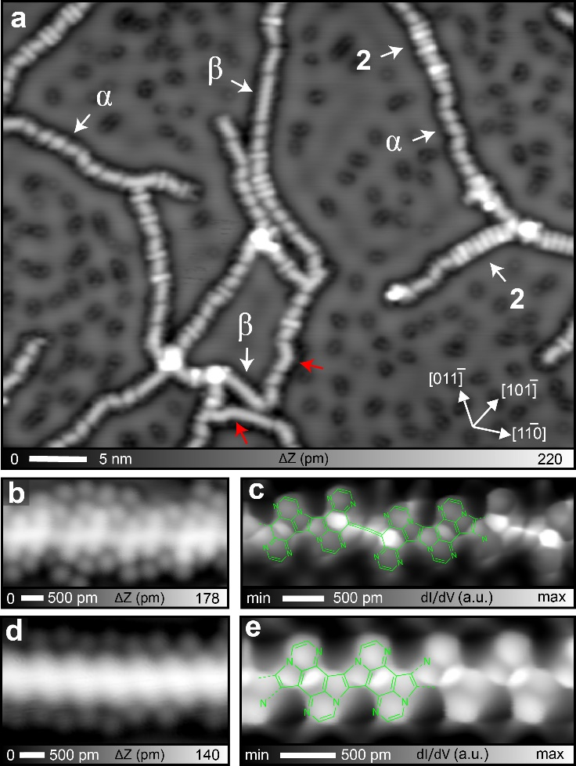
Figure 2. Formation of the ladder oligomers. (a) Large-scale STM topography taken after annealing at 120 °C. (b) Close-up view of the zig-zag shaped structure and (c) the corresponding high-resolution dI/dV map. (d) Close-up view of the straight-shaped structure and (e) the corresponding high-resolution dI/dV map. Measurement parameters: V = 130 mV and I = 30 pA in (a), and V = 100 mV and I = 100 pA in (b) and (d), and V = 1 mV in (c) and (e).

We found that the ladderization is quite sensitive to the thermodynamics. In fact, we observed small segments of the ladder oligomer around the termini of 2 just after as-deposited 1 on Ag(111) at approximately 40 °C (Figure S9), indicating that this non-dehydrogenative cyclization has a very low activation barrier unless any significant tension is induced in the ethynylene/cumulene group (Figure S10). In other words, the length of the straight ladder oligomer can be limited if long 2 is formed before the cyclization (Figure S8). To confirm the stability of the dimerized oligomer, we deposited 1 on Ag(111) kept at 150 °C with an extremely low sublimation rate (<0.1 Å/min) for 60 min. Since the Ullmann-type homo-coupling and cyclization are simultaneously induced in this condition, we expected that the effect of the undesirable tension during the cyclization would reduce. However, it turned out that most of the products were still emerged as α oligomer (Figure 3a). Apparently, the reaction rate of the Ullmann-type homo-coupling was much higher than that of the cyclization even under the temperature, consequently forming relatively long 2 before ladderization. Therefore, we next increased the substrate temperature to 200 °C during the deposition and found the absence of 2 and rather the formation of the extended ladder oligomers (Figure 3b). Apparently, the increased reaction rate of cyclization led to the situation, in which the cyclization was caused immediately after 1 was linked to the terminus of an existing ladder oligomer. However, several ethynylene/cumulene groups between the ladder oligomers still remained. Finally, we deposited 1 on Ag(111) kept at 250 °C (Figure 3c), and found the formation of the long pyrrolopyrrole-bridged ladder oligomers, having a small number of the kink sites (Figure S11 and S12). Note that formation of the kink site was strongly affected by the corrugation of the substrate, such as the herringbone structure of the Au(111) substrate (Figure S13).
To analyze the temperature dependence of the ladderization, we conducted statistics analyses on the length distributions, measured within a same chirality under the three conditions. When the substrate temperature was held at 150 °C during the deposition, the populated trans dimers resulted in a shortest length distribution in the histogram (Figure 3d). Elevating the sample temperature to 200 °C, the extended ladder oligomer with a length of above 5 nm appeared. Finally, the hot deposition at 250 °C gave rise to significant upward shifts in the distribution. In short, increasing the substrate temperature during the deposition helps to elongate the ladder oligomer and so that the influence of the tension to the mechano-sensitive isomerization was unambiguously reduced (Figure S14). If the sample was annealed at a higher temperature of 400 °C, heterocyclic ring-opening by the cleavage of the C-N bond^{[20]} was observed at the kink site (Figure S15). We also attempted to reduce the reaction rate of the Ullmann-type coupling by the steric hindrance with four extra-phenyl groups introduced to the 2, 3, 6, and 7-positions of 1 (tp-1). However, it turned out that the overhanging group completely prevented the Ullmann-type homo-coupling, leading to the formation of the disordered clusters (Figure S16).
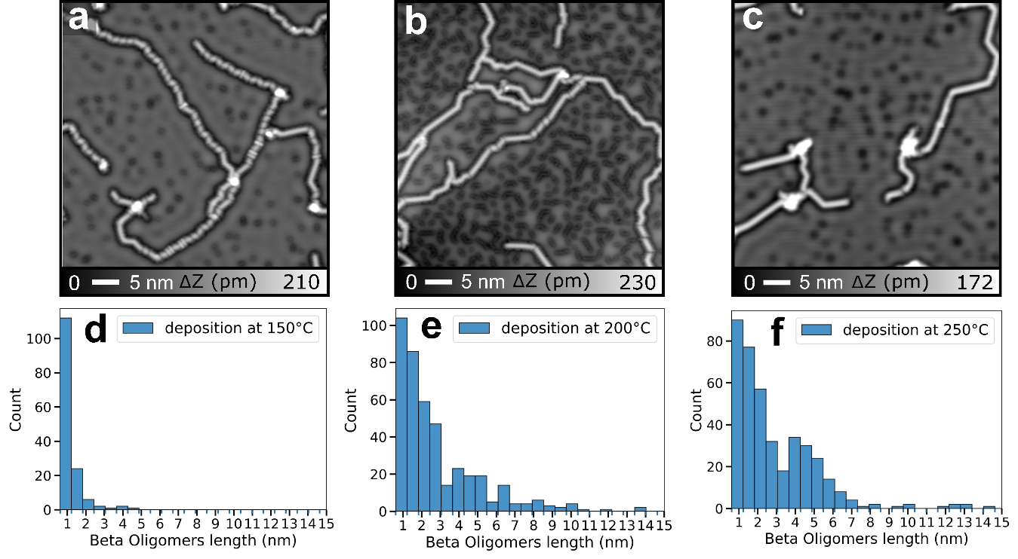
Figure 3. Different substrate temperatures during deposition of molecules in the syntheses of the ladder oligomers. (a) Deposition of 1 on Ag(111) kept at 150°C, (b) at 200°C, and (c) at 250 °C. (d)-(f) Statistical analyses of the length distributions. Measurement parameters: V = 100 mV and I = 20 pA in (a), and V = 100 mV and I = 10 pA in (b, c)

As mentioned above, Sánchez-Grande et al., demonstrated a similar surface-assisted synthesis of nitrogen-containing conjugated polymer with tetraazapentacene on the Ag(111), Ag(100) and Au(111) substates.^{[14]} Among them, the mechanism of our non-dehydrogenative reaction between tetraazaanthracene units should be identical with that between tetraazapetacene units on Ag(111). However, their long tetraazapentacene units somehow pinned the Ag adatoms in the N···Ag···N coordination, leading to significant increase of the ladderization temperature (200 °C). Furthermore, 22p-tetraazapentacene is unstable since its dihydro derivative with 24p-electron has been known as stable dye.^{[21]} Thus, the ladder oligomer has uncontrolled hydrogenation in the product. Besides the difference of the aromaticity (Figure S1), the extra benzene rings would give rise to the steric repulsion with the adjacent units, which may increase the reaction temperature.
In contrast, we found that the resulting cyclization proceeds with keeping the aromaticity of the units and the segment of the ladder oligomer is relatively small (Figure S9). The cyclization of 2 can cause at approximately 40 °C, which is much lower than that of the previous work.^{[14]} This result indicates that the long structure of tetraazapentacene seems to be responsible for the high temperature ladderization. Nevertheless, our 11,11,12,12-tetrabromo-1,4,5,8,tetraaza-9,10-anthraquinodimethane molecule allowed investigation of the mechanism for the ladder oligomer formation from the linear oligomer with demonstrating the intermediacy of the dimer-oligomer, thanks to the stability of the newly generated aromatic heterocycles. We also emphasize that the on-synthesis with our precursor molecules realized nitrogen containing ladder oligomers with an unprecedented high ratio of nitrogen and carbon of 1:4. To the best of our knowledge, such highly N-doped oligomers have not yet been synthesized by on-surface reaction.
In summary, we demonstrated non-dehydrogenative cyclization between pyrazine and ethynylene/cumulene group on Ag(111), leading to the formation of pyrrolopyrrole-bridged ladder oligomer, having a high ratio of nitrogen and carbon of 1:4. The reaction barrier of the ladderization is sufficiently low as the small segment of the ladder units already appeared after as-deposited precursors on the substrate kept at 40 °C, offering investigation of the detailed pathway to the fully aromatic condensed ladder oligomer with demonstrating the intermediacy of the dimerized oligomer and mechano-sensitive skeletal isomerization. We found that formation of cis and trans isomer units of the ladder oligomer from the linear oligomer induces the local tension and consequently increases the reaction barrier as the ethynylene/cumulene-bridged 1,4,5,8,-tetraazaanthracene oligomer segment remained even after annealing at 200 °C. Simultaneous reactions of Ullmann-coupling and ladderization by depositing molecules on the Ag(111) substrate kept at 250 °C lead to significant elongation of the pyrrolopyrrole-bridged ladder oligomer in length. We believe that the use of mechano-sensitive reactant in on-surface chemistry helps to advance the understanding of detailed synthesis pathways of oligomers.
Acknowledgements
This work was supported in part by Japan Society for the Promotion of Science (JSPS) KAKENHI Grant Number 21K18885, 21F21058 and22H00285 to SK, 20H02719 and 20K21184 to TS, and 21H01912 and 21H05468 to YI.

Conflict of interest
The authors declare no conflict of interest.

Keywords: bond-resolved scanning tunnelling microscopy • on-surface skeletal isomerization • π-conjugation • pyrazinopyrrolopyrrolopyrazine • hetero-atoms

References
[1] H. Sirringhaus, P. J. Brown, R. H. Friend, M. M. Nielsen, K. Bechgaard, B. M. W. Langeveld-Voss, A. J. H. Spiering, R. A. J. Janssen, E. W. Meijer, P. Herwig, D. M. de Leeuw, Nature 1999, 401, 685−688.
[2] H. Burroughes, D. D. C. Bradley, A. R. Brown, R. N. Marks, K. Mackay, R. H. Friend, P. L. Burns, A. B. Holmes, Nature 1990, 347, 539−541.
[3] G. Yu, J. Gao, J. C. Hummelen, F. Wudl, A. J. Heeger, Science 1995, 270, 1789−1791.
[4] a) J. Lee, A. J. Kalin, T. Yuan, M. Al-Hashimi, L. Fang, Chem. Sci. 2017, 8, 2503–2521. b) Y. C. Teo, H. W. H. Lai, Y. Xia, Chem. – A Eur. J. 2017, 23, 14101–14112. c) Z. Cai, M. A. Awais, N. Zhang, L. Yu, Chem 2018, 4, 2538–2570.
[5] L. Grill, H. Stefan, Nat. Chem. 2020, 12, 115-130.
[6] a) G. Otero, G. Biddau, C. Sánchez-Sánchez, R. Caillard, M. F. López, C. Rogero, F. J. Palomares, N. Cabello, M. A. Basanta, J. Ortega, J. Méndez, A. M. Echavarren, R. Pérez, B. Gómez-Lor. J. A. Martín-Gago, Nature 2008, 454, 865–868. b) M. Treier, C. A. Pignedoli, T. Laino, R. Rieger, K. Müllen, D. Passerone. R. Fasel, Nat. Chem. 2011, 3, 61-67. c) D. G. de Oteyza, P. Gorman, Y. Chen, S. Wickenburg, A. Riss, D. J. Mowbray, G. Etkin, Z. Pedramrazi, H. Tsai, A. Rubio, M. F. Crommie, F. R. Fischer, Science 2013, 340, 1434−1437. d) S. Kawai, V. Haapasilta, B. D. Lindner, K. Tahara, P. Spijker, J. A. Buitendijk, R. Pawlak, T. Meier, Y. Tobe, A. S. Foster, E. Meyer, Nat. Commun. 2016, 7, 12711.
[7] J. Cai, P. Ruffieux, R. Jaafar, M. Bieri, T. Braun, S. Blankenburg, M. Muoth, A. P. Seitsonen, M. Saleh, X. Feng, K. Müllen, R. Fasel, Nature 2010, 466, 470–473.
[8] L. Grill, M. Dyer, L. Lafferentz, M. Persson, M. V. Peters, S. Hecht, Nat. Nanotechnol. 2007, 2, 687−691.
[9] a) P. Ruffieux, S. Wang, B. Yang, C. Sánchez-Sánchez, J. Liu, T. Dienel, L. Talirz, P. Shinde, C. A. Pignedoli, D. Passerone, T. Dumslaff, X. Feng, K. Müllen, R. Fasel, Nature 2016, 531, 489-192. b) D. J. Rizzo, G. Veber, T. Cao, C. Bronner, T. Chen, F. Zhao, H. Rodriguez, S. G. Louie, M. F. Crommie, F. R. Fischer, Nature 2018, 560, 204-206. c) O. Gröning, S. Wang, X. Yao, C. A. Pignedoli, G. Borin Barin, C. Daniels, A. Cupo, V. Meunier, X. Feng, A. Narita, K. Müllen, P. Ruffieux, R. Fasel, Nature 2018, 560, 209–213. d) C. Moreno, M. Vilas-Varela, B. Kretz, A. Garcia-Lekue, M.V. Costache, M. Paradinas, M. Panighel, G. Ceballos, S.O. Valenzuela, D. Peña, A. Mugarza, Science 2018, 360, 199 - 203. e) D. J. Rizzo, G. Veber, J. Jiang, R. McCurdy, T. Cao, C. Bronner, T. Chen, S. G. Louie, F. R. Fischer, M. F. Crommie, Science 2020, 369, 1597-1603.
[10] a) J. Cai, C. A. Pignedoli, L. Talirz, P. Ruffieux, H. Söde, L. Liang, V. Meunier, R. Berger, R. Li, X. Feng, K. Müllen, R. Fasel, Nat. Nanotechnol. 2014, 9, 896–900. b) S. Kawai, S. Saito, S. Osumi, S. Yamaguchi, A. S. Foster, P. Spijker, E. Meyer, Nat. Commun. 2015, 6. 8098. c) G. D. Nguyen, H.-Z. Tsai, A. A. Omrani, T. Marangoni, M. Wu, D. J. Rizzo, G. F. Rodgers, R. R. Cloke, R. A. Durr, Y. Sakai, F. Liou, A. S. Aikawa, J. R. Chelikowsky, S. G. Louie, F. R. Fischer, M. F. Crommie, Nat. Nanotechnol. 2017, 12, 1077–1082. d) S. Kawai, S. Nakatsuka, T. Hatakeyama, R. Pawlak, T, Meier, J. Tracey, E. Meyer, A. S. Foster. Sci. Adv. 2018, 4, eaar7181.
[11] Q. Zhong, Y. Hu, K. Niu, H. Zhang, B. Yang, D. Ebeling, J. Tschakert, T. Cheng, A. Schirmeisen, A. Narita, K. Müllen, L. Chi, J. Am. Chem. Soc. 2019, 141, 7399-7406.
[12] a) S. Blankenburg, J. Cai, P. Ruffieux, R. Jaafar, D. Passerone, X. Feng, K. Müllen, R. Fasel, C. A. Pignedoli, ACS Nano 2012, 6, 2020–2025. b) J. Björk, S. Stafström, F. Hanke, J. Am. Chem. Soc. 2011, 133, 14884–14887.
[13] I. Piskun, R. Blackwell, J. Jornet-Somoza, F. Zhao, A. Rubio, S. G. Louie, F. R. Fischer, J. Am. Chem. Soc. 2020, 142, 3696–3700.
[14] A. Sánchez-Grande, J. I. Urgel, I. García-Benito, J. Santos, K. Biswas, K. Lauwaet, J. M. Gallego, J. Rosen, R. Miranda, J. Björk, N. Martín, D. Écija, Adv. Sci. 2022, 9, 2200407.
[15] A. Sánchez-Grande, B. de la Torre, J. Santos, B. Cirera, K. Lauwaet, T. Chutora, S. Edalatmanesh, P. Mutombo, J. Rosen, R. Zbořil, R. Miranda, J. Björk, P. Jelínek, N. Martín, D. Écija, Angew. Chemie Int. Ed. 2019, 58, 6559–6563.
[16]S. Kawai, A. Sadeghi, T. Okamoto, C. Mitsui, R. Pawlak, T. Meier, J. Takeya, S. Goedecker, E. Meyer, Small 2016 12, 5303-5311.
[17] a) L.; Gross, F. Mohn, N. Moll, P. Liljeroth, G. Meyer, Science 2009, 325, 1110−1114. b) R. Temirov, S. Soubatch, O. Neucheva, A. C. Lassise, F. S. Tautz, New J Phys. 2008, 10, 053012. c) P. Hapala, G. Kichin, C. Wagner, F. S. Tautz, R. Temirov, Phys. Rev. B 2014, 90, 085421.
[18] a) T. Dienel, S. Kawai, H. Söde, X. Feng, K. Müllen, P. Ruffieux, R. Fasel, O. Gröning, Nano Lett. 2015, 15, 5185-5190. b) R. Pawlak, X. Liu, S. Ninova, P. D’Astolfo, C. Drechsel, S. Sangtarash, R. Häner, S. Decurtins, H. Sadeghi, C. J. Lambert, U. Aschauer, S.-X. Liu, E. Meyer, J. Am. Chem. Soc. 2020, 142, 12568–12573.
[19] a) N. Willis-Fox, E. Rognin, T. A. Aljohani, R. Daly, Chem 2018,4 2499-2537. b) Y. Chen, G. Mellot, D. van Luijk, C. Creton, R. O. Sijbesma, Chem. Soc. Rev. 2021, 50, 4100-4140.
[20] K. Sun, K. Sugawara, A. Lyalin, Y. Ishigaki, K. Uosaki, T. Taketsugu, T. Suzuki, S. Kawai, Angew. Chem. Int. Ed. 2021, 60, 9427-9432.
[21] a) J. Armand, L. Boulares, Can. J. Chem. 1987, 65, 1619-1623. b) T. Lelaidier, T. Leoni, P. Arumugam, A. Ranguis, C. Becker, O. Siri, Langmuir 2014, 30, 5700−5704
Entry for the Table of Contents
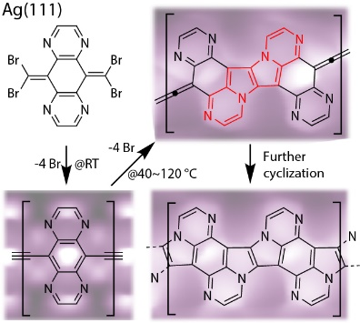

TEXT for TOC.
On-surface non-dehydrogenative cyclization leads to low-temperature formation of pyrrolopyrrole-bridged ladder oligomer with an unprecedented high ratio of nitrogen and carbon of 1:4.

