Supporting Information

Synthesis of Conjugated Polymers with Controlled Terminal Structures by Direct Arylation Polycondensation and Correlation between Terminal Structures and Emission Properties

Ziwei Hu,ª Takeshi Yasuda,^{b} Takaki Kanbara, ª* Junpei Kuwabara ^{a,c}*

Scheme S1. Synthesis of the Pd(II) catalyst precursor.

Scheme S2. Polycondensation and terminal modification by the Pd(II) catalyst precursor.

Table S1. Results of polycondensation

Entry | TPD : Br₂-DOF | Yield ^{a)} | M_{n} (M_{w}/M_{n}) | Theoretical M_{n} ^{b)}
1 | 1 : 1.05 | 73% | 120 000 (2.6) | 24 600
2 | 1 : 1.33 | 77% | 16 900 (1.8) | 4 900
^{a)} Yields of the CHCl₃-soluble and hexane-insoluble parts. ^{b)} Calculated by the Carothers equation.

Figure S1. MALDI-TOF-MS of the polymer (Table 1, Entry 1).

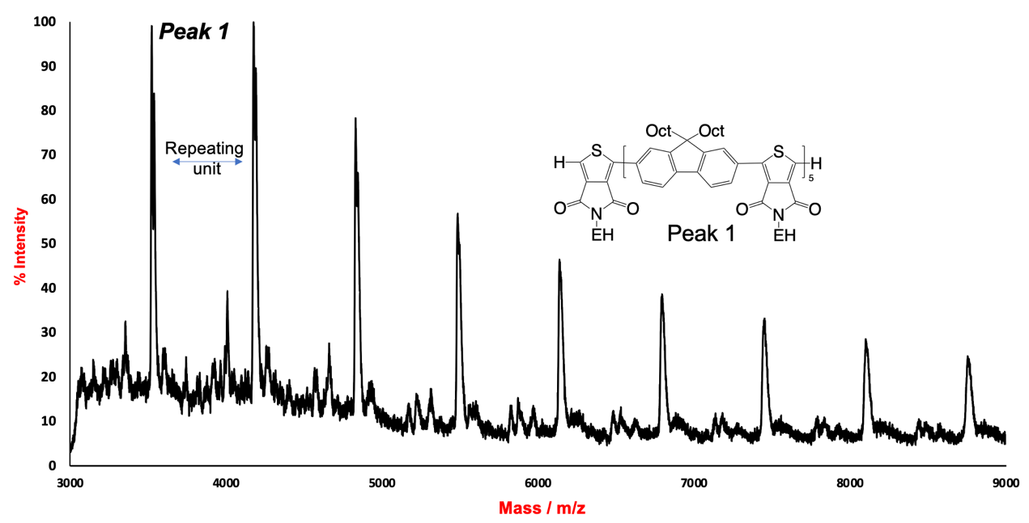
Figure S2. MALDI-TOF-MS of the polymer (Table 1, Entry 2).

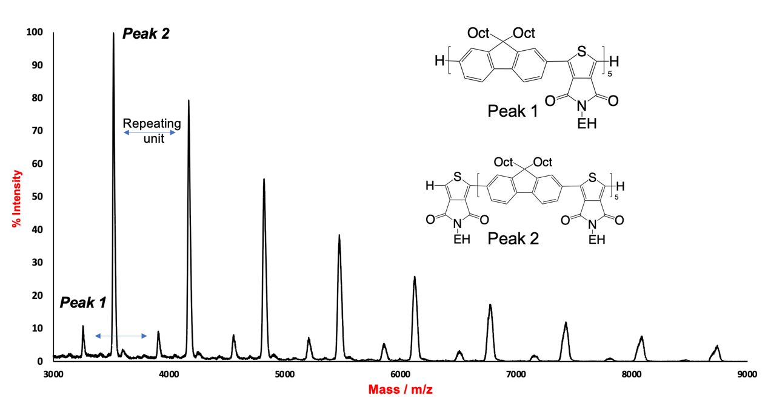
Figure S3. MALDI-TOF-MS of the polymer (Table 1, Entry 3).

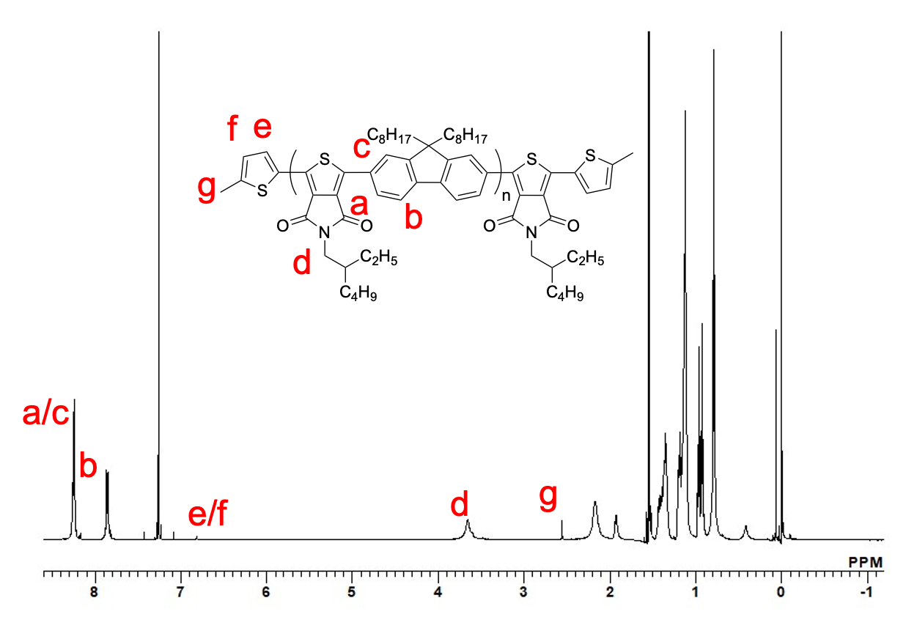
Figure S4. ¹H NMR Spectrum of the terminal modified polymer (600 MHz, CDCl₃, r.t.).

Figure S5. MALDI-TOF-MS tracking the terminal modification process using Pd(PCy₃)₂.

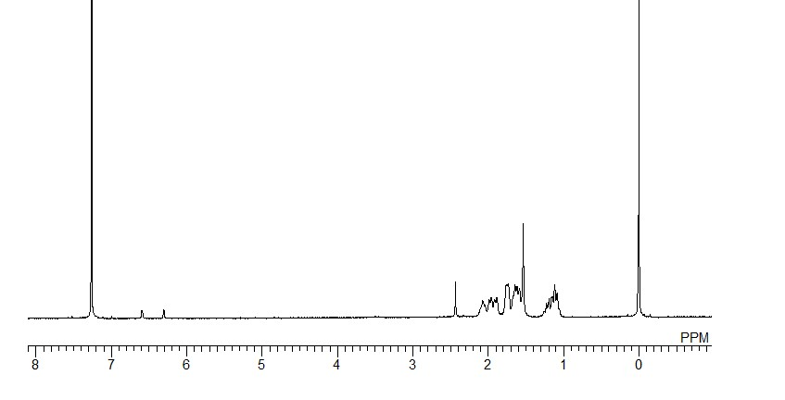
Figure S6. ¹H NMR spectrum of the Pd(II) catalyst precursor. (400 MHz, CDCl₃).

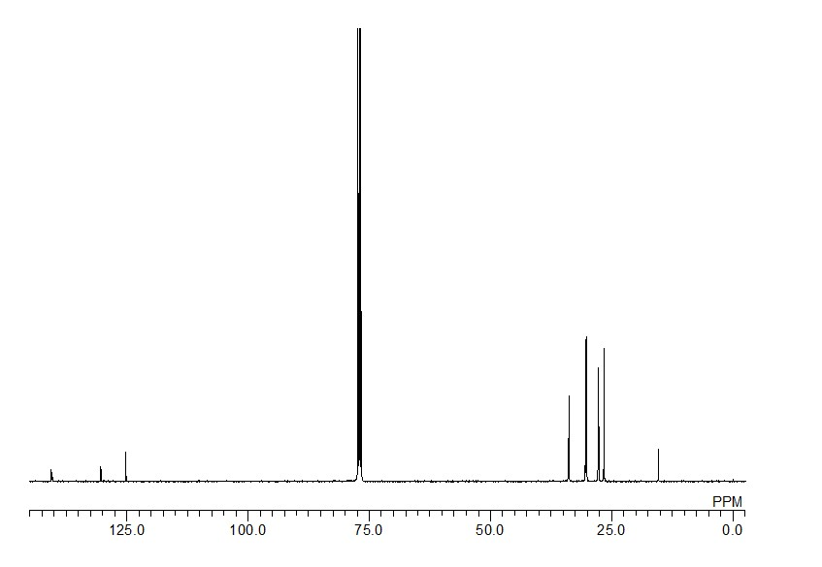
Figure S7. ¹³C{¹H} NMR spectrum of the Pd(II) catalyst precursor (100 MHz, CDCl₃).

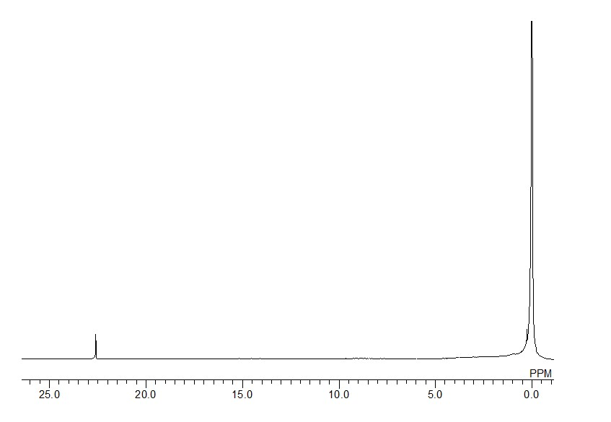
Figure S8. ³¹P NMR spectrum of the Pd(II) catalyst precursor (162 MHz, CDCl₃).

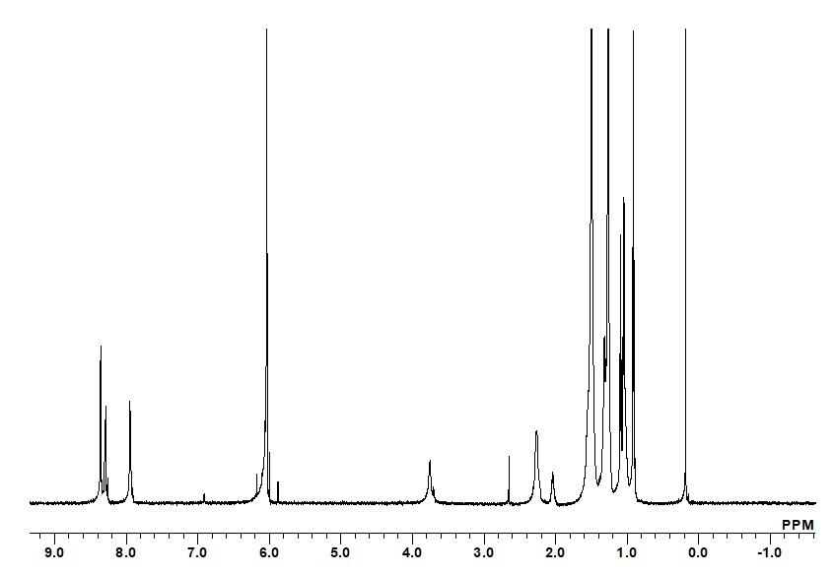
Figure S9. ¹H NMR spectrum of P-Th (600 MHz, C₂D₂Cl₄, 373 K).

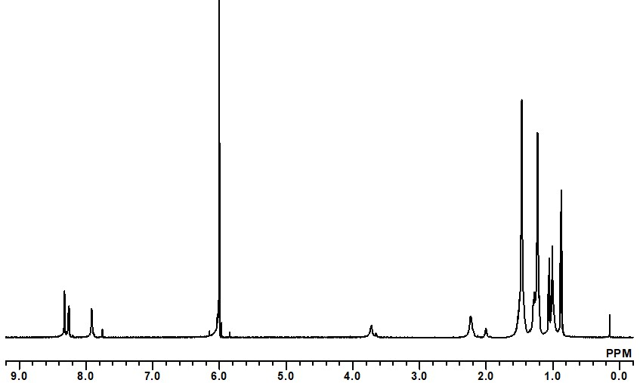

Figure S10. ¹H NMR spectrum of P-TPD (600 MHz, C₂D₂Cl₄, 373 K).

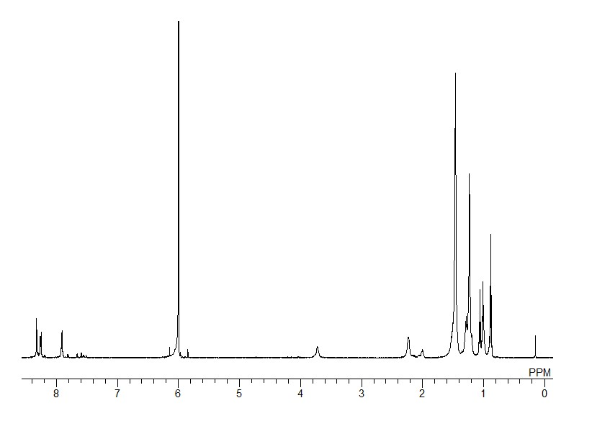
Figure S11. ¹H NMR spectrum of P-Br (600 MHz, C₂D₂Cl₄, 373 K).

Figure S12. UV-Vis absorption spectra (a) in the solution (CHCl₃, 5 μM) and (b) thin-film states.

Figure S13. Voltage (V) – Luminance (L) characteristics of the OLEDs.

Figure S14. Normalized EL spectrum of the OLED with P-TPD and PL spectrum in thin-film state.

