Uniform formation of Ti-based conversion coatings on aluminum alloy surfaces by alkaline-acid etch treatment to improve organic coating properties

N. Banjo ^{a, b}, T.T. Sasaki ^{c}, K. Hono ^{a, c}
ª Graduate School of Science and Technology, University of Tsukuba, Tsukuba 305-8577, Japan
^{b} Profile Technology Manufacturing Headquarters, YKK AP Inc., Kurobe 938-8611, Japan
^{c} National Institute for Materials Science, Tsukuba 305-0047, Japan
Corresponding author: SASAKI.Taisuke@nims.go.jp

Abstract
Environmentally friendly chromium-free Ti-/Zr-based conversion coatings are used as a pretreatment for organic coatings applied to aluminum alloys to replace conventional chromate conversion coatings. It is known that chemical cleaning of alloy surfaces with alkalis and acids prior to conversion treatment improves the corrosion resistance and adhesion of organic coatings. In recent years, there have been many attempts to optimize acid treatment, for example, by adding HF to the acid to improve the etching performance. In this study, the microstructure formed during acid treatment with and without HF was analyzed in detail to investigate its effect on the adhesion property of organic coatings. Ti-based conversion coatings were formed on A3003 alloy after chemical cleaning with NaOH followed by H₂SO₄ or HF-containing H₂SO₄. Cleaning with HF-containing H₂SO₄ resulted in the formation of an F-rich layer on the alloy surface and the reprecipitation of dealloyed Cu. Subsequent Ti-based conversion treatment enriched the F-rich layer and formed Cu-containing Ti-oxide aggregates, which reduced the adhesion of organic coatings. Impact adhesion and salt spray corrosion resistance were comparable to those of chromate conversion coatings when Ti-based conversion coatings were formed uniformly under optimum conditions after acid treatment without HF.
Keywords: A3003 aluminum alloy; Chromium-free; Ti-based conversion coatings; Chemical cleaning; Acid etching; Hydrogen fluoride

- Introduction
Chromium-free Ti-/Zr-based conversion coatings are being applied to aluminum alloy components in the automotive and construction industries as an alternative to chromate conversion coatings (CrCC) containing hexavalent chromium in response to strong demands for the reduction of harmful substances due to environmental considerations. However, since the corrosion resistance and adhesion of organic coatings applied to the Ti-/Zr-based conversion coated surface are inferior to those to conventional CrCC, optimizing the processing conditions for Ti-/Zr-based conversion coatings could be an effective approach to further improve the organic coating properties [1,2]. Chemical cleaning process with alkalis and/or acids prior to conversion treatment is beneficial to improve organic coating properties such as corrosion resistance and adhesion [3,4]. Chemical cleaning utilizes the corrosive and etching action of alkalis and acids on metal surfaces to dissolve and remove contaminants, oxide films, and heterogeneous structures, thereby activating aluminum alloy surfaces to a state suitable for forming conversion coatings [5–12]. Recently, a two-step cleaning process of alkaline etching followed by acid pickling/etching has been introduced as a cleaning process suitable for Ti-/Zr-based conversion coatings on aluminum alloys used as exterior building materials. The two-step alkaline-acid treatment can effectively dissolve and activate alloy surfaces due to the combined effects of different etching actions [13,14]. To reduce the environmental impact of the chemical cleaning process, there is a growing interest in the use of weak alkaline solutions or processes limited to acid treatment only to reduce the waste sludge generated by strong alkaline etching. To realize these processes, it is necessary to optimize the acid treatment, such as by adding HF to improve the acid etching performance to compensate for the weak alkaline etching. However, the formation of Ti-/Zr-based conversion coatings is affected by the acid treatment [13], which requires the establishment of the chemical cleaning process based on the understanding of the acid treatment, for the widespread use of the chromium-free Ti/Zr-based conversion coatings [14].
Many studies have reported that a two-step treatment consisting of strong alkaline NaOH etching followed by acid pickling/etching is effective in successfully depositing conversion coatings such as Ti-/Zr-based, Ce-based, and trivalent chromium and improving their corrosion and adhesion properties [3,9,13–15]. This is probably because the combination of stable dissolution by the strong alkali and smut removal by the acid effectively activates the alloy surfaces. Single or mixed solutions of H₂SO₄, HNO₃, and HF have been examined for acid treatment, but these solutions have different effects on smut removal, dissolution, and oxidizing power [16,17]. Among these solutions, acid solutions containing HF aggressively etch the alloy surface to preferentially dissolve intermetallic particles (IMPs) and IMP/matrix interface, resulting in an uneven alloy surface. Recent studies have observed IMP passivation [14,18], IMP shedding due to local dissolution of the boundary phase [6,19,20], and Cu dealloying and redeposition [17,21,22] during acid treatment with HF and/or HNO₃, and reported that these surface microstructural changes affect the electrochemical properties and corrosion behavior of the conversion coatings [13,18,23]. However, such microstructural changes occur over a wide range from micro- to nanoscales, and multiple microstructural changes occur simultaneously [17,20]. This has made it difficult to assess the relationship between the microstructural changes associated with acid treatment and the deposition behavior of the conversion coatings and their effect on the corrosion and adhesion properties.
The aim of this study is to understand the effects of the chemical cleaning, particularly the role of HF in acid, on the corrosion resistance and adhesion of organic coatings through analyzing the microstructure of alkaline-acid treated alloy surfaces and subsequently formed Ti-based conversion coatings (TiCC), using scanning electron microscopy (SEM) and scanning transmission electron microscopy (STEM). In this study, A3003 alloy rolled sheets, which are widely used as exterior building materials, were treated with NaOH followed by H₂SO₄ (for acid pickling) or HF-containing H₂SO₄ (for acid etching). The results revealed the requirements for the acid treatment necessary for the uniform formation of TiCC to achieve salt spray corrosion resistance and impact adhesion of organic coatings comparable to CrCC.

- Materials and Methods
We received commercial H24-tempered A3003 alloy sheets with the size of 100 × 300 mm² and thickness of 3.0 mm, cut from sheets produced by continuous casting and rolling process. The chemical composition of the material is listed in Table 1. TiCC was formed using the immersion method according to the procedure summarized in Table 2. Three different chemical cleaning treatments were applied to the materials prior to the conversion-coat treatment, as shown in Fig. 1. Industrial-grade chemical solutions were used for each treatment, and the treatment conditions were similar to those used on the production line. In the following, the treatment process with acid degreasing only is denoted as Non-Etching (steps 1 through 2 in Table 2), and the one with acid degreasing followed by alkaline etching and acid pickling is denoted as NaOH-H₂SO₄ (steps 1 through 6). In the NaOH-H₂SO₄ treatment, the process in which 15 g/L of a commercial HF additive (Henkel, C-IC 120WN (containing 30% HF)) for acid etching was added to the H₂SO₄ solution is denoted as NaOH-H₂SO₄/HF (steps 1 through 6). It is estimated that thicknesses equivalent to approximately 4 μm, 0.2 μm, and 1.5 μm were dissolved and removed from the alloy surface during alkaline etching (NaOH), acid pickling (H₂SO₄), and acid etching (H₂SO₄/HF) treatments, respectively, based on the change in weight of the materials before and after each treatment. A fluorotitanic acid (H₂TiF₆) base solution (Henkel, Alodine 5200, containing HF, Zr-based compounds, and organic polymers) was used for the conversion treatment of TiCC. The concentration, pH, and temperature of the conversion bath and the immersion time of the conversion treatment were determined within the manufacturer's recommendations. Samples without conversion treatment (w/o CC) and with conventional CrCC treatment were prepared for comparison. CrCC was treated under the standard conditions as described in previous study [24]. Organic coatings were then applied using a spray gun and cured at 200 °C for 15 min. The organic coatings were thermosetting polyester resin powder coatings (Tiger Drylac, Series 58) with a thickness of approximately 90 μm.
Table 1: Chemical composition of substrates in wt.%.
Material | Si | Fe | Mg | Mn | Cu | Zn | Ti | Cr | Al
A3003 | 0.17 | 0.48 | 0.00 | 1.27 | 0.07 | 0.01 | 0.04 | 0.00 | balance
Table 2: Procedure for TiCC deposition.
Step | Treatment (Solution) | Concentration | Temp (°C) | Time (min)
1 | Acid degrease (H₂SO₄ base) | 1.0% | 50 | 5
2 | Rinse (Industrial water) |  | 25 | 1
3 | Alkaline etching (NaOH) | 50 g/L | 40 | 5
4 | Rinse (Industrial water) |  | 25 | 2
5 | Acid pickling (H₂SO₄)  or Acid etching (H₂SO₄/HF) | 200 g/L  (add 15 g/L*) | 25 | 5
6 | Rinse (Industrial water) |  | 25 | 2
7 | Rinse (Deionized water) |  | 25 | 1
8 | Conversion coat (H₂TiF₆ base) | 1.0%, pH 3.5 | 35 | 1
9 | Rinse (Deionized water) |  | 25 | 1
10 | Rinse (Deionized water) |  | 25 | 1
11 | Dry | - | 80 | 60
* An HF-based additive containing 30% HF is added 15 g/L to H₂SO₄ solution.
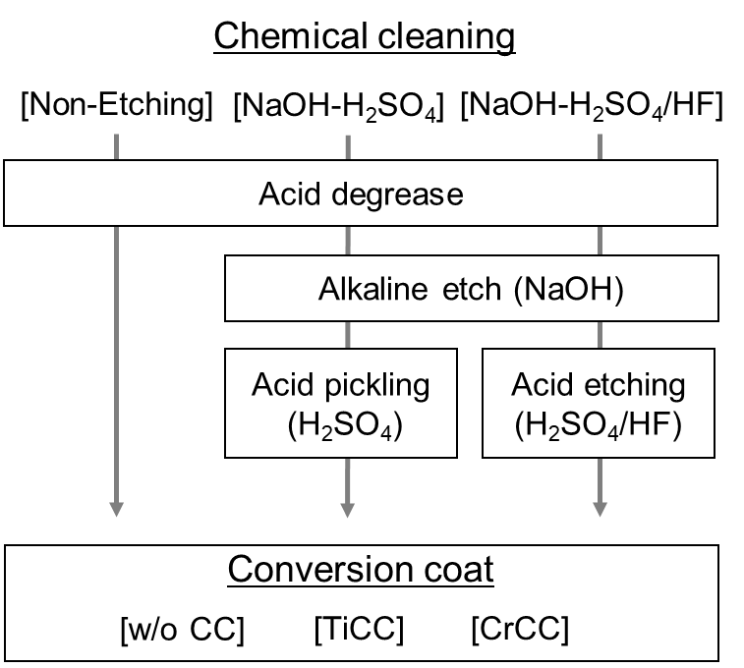
Fig. 1. A schematic flow diagram of the combination of chemical cleaning and conversion treatments used in this study.
The organic coated samples with the size of 100 × 50 mm² were used for the corrosion and adhesion tests, and these tests were performed three times for each treatment combination, Fig. 1. Copper-accelerated acetic acid salt spray (CASS) corrosion tests were performed according to ASTM B117 to evaluate the corrosion resistance of the organic coated samples. The coating surface, with a cross incision reaching the substrate, was continuously sprayed with a corrosive solution (5% NaCl, 0.26 g/L copper chloride, adjusted to pH = 3 with acetic acid, 50 °C) for 1000 h and the blister area of organic coatings was evaluated. Impact adhesion tests were performed in accordance with ASTM D2794 to assess the adhesion property of organic coatings. The fraction of delamination area of the organic coatings that occurred after the adhesive tape was attached and then removed was evaluated for the specimens after applying an impact to a 3 mm deformation on the opposite side of the coating surface. The impact test was conducted on the specimens after boiling water treatment for 5 h to assess the durability of the adhesion.
The surfaces of chemically cleaned samples were analyzed by X-ray photoelectron spectroscopy (XPS) in PHI Quantera II using a monochromatic Al Kα source (hν = 1486.6 eV) with a diameter of 100 μm and a take-off angle of 45°. The microstructures of chemically cleaned surfaces and conversion coatings were analyzed using SEM and STEM. The sample surface was observed using a field emission (FE)-SEM (JEOL, JSM-IT500HR) at an acceleration voltage of 15 kV. The specimens for cross-section were sputter coated with an Al layer for surface protection, then cross-sections were prepared using a focused ion beam (FIB), and observed at 2 kV using FE-SEM (Carl Zeiss, Crossbeam 1540EsB and Crossbeam 550 laser). STEM observations were performed at 200 kV using FEI Titan G2 80-200; thin films for STEM observations were prepared by standard lift-out methods using FIB/SEM (FEI Helios G4).

- Results
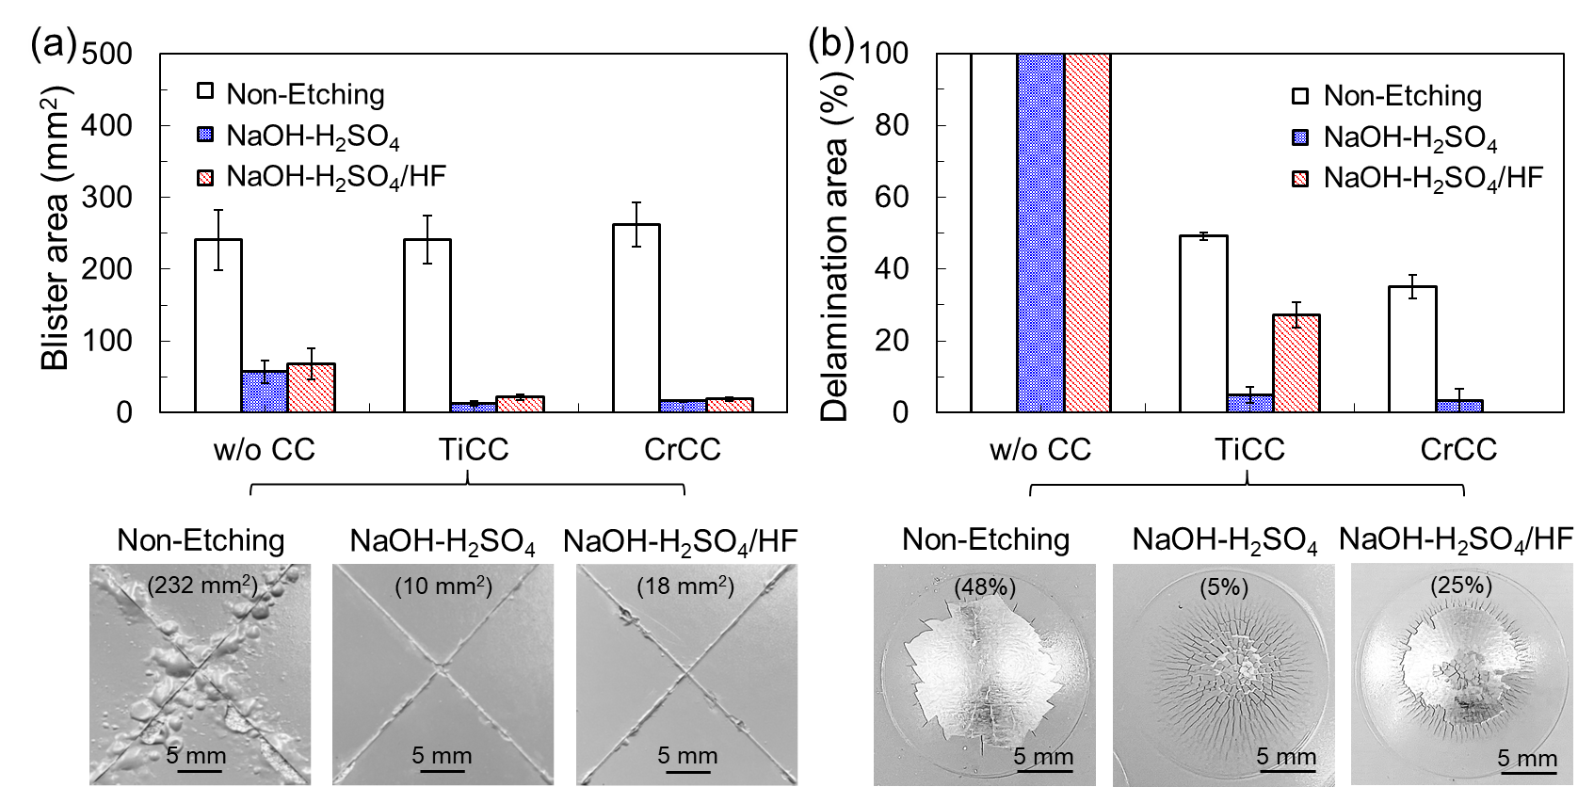
Fig. 2. Effect of chemical cleaning treatment on (a) the blister area for the organic coated samples after the CASS corrosion test for 1000 h and (b) the fraction of delamination area of organic coatings assessed by the impact adhesion test for the boiling water treated samples. The organic coatings were applied on w/o CC, TiCC, and CrCC formed after different chemical cleaning treatments. Surface snapshots of the TiCC samples after testing are shown as a reference in (a) and (b).
Fig. 2(a) shows the blister area of the organic coatings after the corrosion test for the samples with organic coatings on TiCC formed after different chemical cleaning treatments, along with those without conversion coatings (w/o CC) and with CrCC. Etching treatment with NaOH-H₂SO₄ or NaOH-H₂SO₄/HF plays an important role in improving the corrosion resistance. The blister area is ~250 mm² for the w/o CC sample without etching (Non-Etching), but the etching treatment with NaOH-H₂SO₄ or NaOH-H₂SO₄/HF significantly reduces the blister area to <100 mm². The formation of conversion coatings after etching treatment further improves the corrosion resistance. The blister area, which exceeds 200 mm² for the Non-Etching sample, is significantly reduced to only <25 mm² by NaOH-H₂SO₄ or NaOH-H₂SO₄/HF treatment for both TiCC and CrCC samples. As shown in the snapshots after the CASS test (Fig. 2(a)), the TiCC samples after NaOH-H₂SO₄ and NaOH-H₂SO₄/HF treatment exhibit a blister width of <1 mm, which is comparable to the excellent corrosion resistance achieved in CrCC.
Fig. 2(b) shows the fraction of delamination area of organic coatings assessed by the impact test for the samples after boiling water treatment. In contrast to corrosion resistance, the formation of conversion coatings is more critical than etching treatments for improving the adhesion of organic coatings. While all the organic coatings on the w/o CC samples fully delaminate even after the chemical cleaning treatment, the conversion treatment significantly improves the adhesion of organic coatings to reduce the delaminated area. While the organic coatings delaminate by ~50% for the TiCC sample without etching treatment (Non-Etching), the one after NaOH-H₂SO₄ treatment significantly reduces the delaminated area to ~5%. However, TiCC after NaOH-H₂SO₄/HF treatment has a delamination area of ~25%, showing that the addition of HF to the H₂SO₄ solution degrades the adhesion. The snapshots of the TiCC samples after the impact test (Fig. 2(b)) show an obvious difference in the adhesion of the organic coatings when treated with NaOH-H₂SO₄ and NaOH-H₂SO₄/HF. However, the CrCC samples show no significant difference in adhesion whether the samples are treated with NaOH-H₂SO₄ or NaOH-H₂SO₄/HF; both samples exhibit excellent adhesion with <5% delamination area.
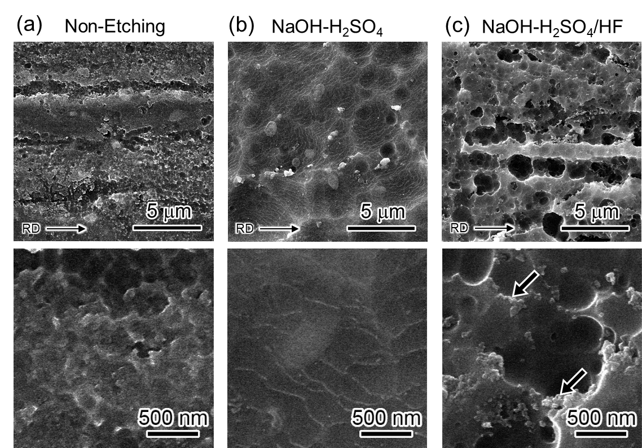
Fig. 3. Low- and high-magnification secondary electron (SE)-SEM images obtained from the A3003 surface after (a) Non-Etching, (b) NaOH-H₂SO₄, and (c) NaOH-H₂SO₄/HF treatments. The arrows in the low-magnification images indicate the rolling direction (RD). The samples were not treated with conversion coatings.
Fig. 3 shows the secondary electron (SE)-SEM images of the surface of chemically cleaned A3003. The surface characteristics of the Non-Etching sample (Fig. 3(a)) are typical of as-rolled sheet, such as microscale grooves along the rolling direction (RD), which remain on the surface after degreasing. In addition, microscopic irregularities are also observed in the high-magnification SEM image (Fig. 3(a)). In the NaOH-H₂SO₄ treated sample, such alloy surface structures disappear, and a microscopically smooth surface appears by alkaline etching and acid pickling (Fig. 3(b)). Second-phase particles with a diameter of ~0.5 μm are observed, which are expected to be Al–(Mn,Fe) IMPs typically seen in A3003 alloy [25]. NaOH-H₂SO₄/HF treatment causes an increase in the alloy surface roughness due to the formation of etch pits and the associated dissolution and shedding of IMPs (Fig. 3(c)). Compared to Fig. 3(b), the relatively large hemispherical concavity is formed as a result of IMP shedding by selective dissolution of IMPs and their surroundings due to the reaction with HF, as similar surface morphology has been reported in previous studies [6,13,22]. As indicated by the arrows in the high-magnification SE-SEM image in Fig. 3(c), nanoscale fine particles were present on the surface after NaOH-H₂SO₄/HF treatment. Note that these particles are identified as Cu-rich particles as mentioned in Fig. 5(a).
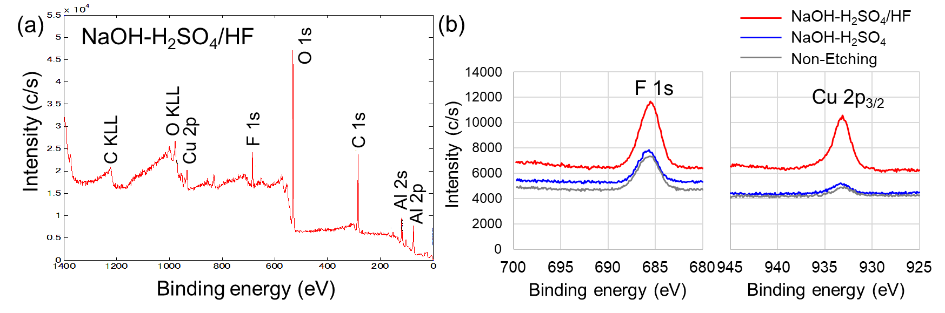
Fig. 4. (a) XPS survey spectrum of the A3003 surface after NaOH-H₂SO₄/HF treatment. (b) High-resolution spectra of F 1s and Cu 2p_{3/2} obtained from the sample surfaces after different chemical cleaning treatments. These were obtained from the samples without conversion coatings.
Fig. 4(a) shows the typical XPS spectrum of the NaOH-H₂SO₄/HF treated sample. Trace amounts of F and Cu are detected on the sample surface, in addition to Al, O, and C from the surface oxide layer and impurities. Comparison of the Non-Etching samples and the samples treated with NaOH-H₂SO₄ and NaOH-H₂SO₄/HF shows no significant difference in the detected elements (data not shown). However, the high-resolution spectra of F 1s and Cu 2p_{3/2} (Fig. 4(b)) show that the peak intensities of F 1s and Cu 2p_{3/2} increase after the NaOH-H₂SO₄/HF treatment, indicating that the reaction between HF-containing H₂SO₄ and A3003 alloy surface resulted in the formation of F- and Cu-containing substances on the surface [11]. Weak F 1s peaks unexpectedly detected on the surface on the Non-Etching sample and the sample treated with NaOH-H₂SO₄ could be because the trace F is contained as impurities in the industrial water used in the final rinse step, i.e., step 6 in Table 2.
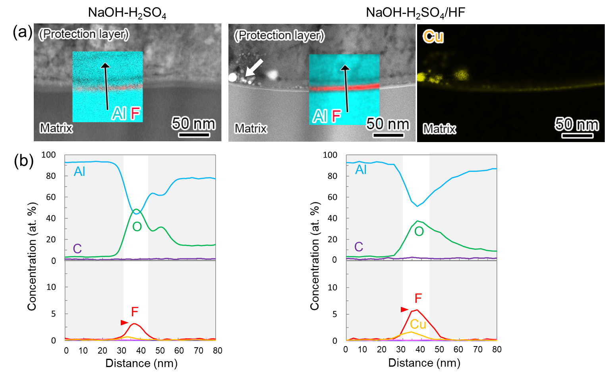
Fig. 5. (a) Cross-sectional HAADF-STEM images of different chemically cleaned samples (no conversion treatment) and EDS elemental maps of Cu corresponding to the HAADF-STEM image of the sample treated with NaOH-H₂SO₄/HF. The superimposed images in (a) are corresponding composite EDS elemental maps of Al and F. (b) Line composition profiles analyzed along black arrows in (a).
Figs. 5(a) and (b) show the typical cross-sectional high-angle annular dark-field STEM (HAADF-STEM) images with corresponding EDS elemental maps, and the EDS line composition profiles acquired from the chemically cleaned samples, respectively. The protective layer on the specimen surface is sputter-coated pure Al before the cross-sectional STEM observation. Consistent with the results obtained by XPS analysis in Fig. 4, Al, O, and F are detected on the surface of the aluminum matrix after NaOH-H₂SO₄ treatment, while higher amounts of F (~6%) with trace amounts of Cu are detected on the matrix after NaOH-H₂SO₄/HF treatment, as shown in Figs. 5(a) and (b). As shown in the EDS elemental map corresponding to the HAADF-STEM image of the NaOH-H₂SO₄/HF treated sample, Cu is enriched in the brightly imaged particles indicated by the white arrow in the HAADF-STEM image (Fig. 5(a)), which are the nanoscale fine particles observed in Fig. 3(c). Such Cu-rich particles are redeposited Cu that has been dealloyed from the A3003 alloy during the chemical cleaning process, because the chemical cleaning solutions do not contain Cu.
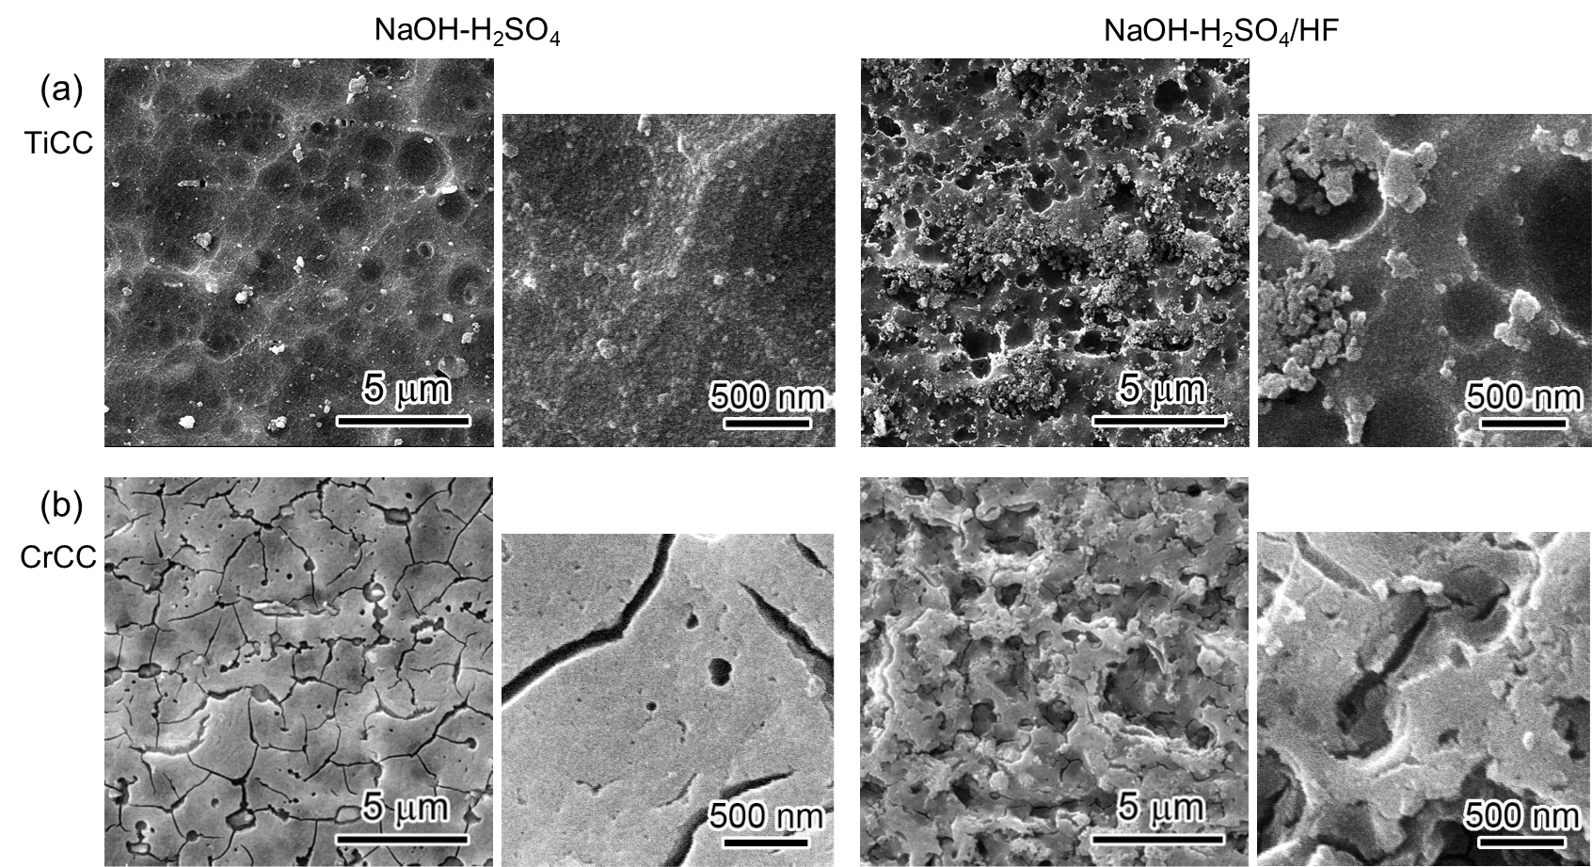
Fig. 6. (a) Low- and high-magnification SE-SEM images obtained from the surface of TiCC after NaOH-H₂SO₄ or NaOH-H₂SO₄/HF treatment. (b) Surface SE-SEM images of the CrCC samples for comparison.
Fig. 6(a) shows the SE-SEM images of the surface of TiCC formed after NaOH-H₂SO₄ or NaOH-H₂SO₄/HF treatment. TiCC is formed in different morphologies depending on the surface microstructure of A3003. The surface of the NaOH-H₂SO₄ treated sample does not change significantly before and after TiCC formation (Figs. 3(b) and 6(a)). The high-magnification image shows that the fine particles are continuously deposited to cover the entire surface (Fig. 6(a)). In contrast, particles of different sizes are heterogeneously deposited on the surface of the NaOH-H₂SO₄/HF treated sample. Aggregates of the particles with a size of several hundred nm are also observed in the high-magnification image (Fig. 6(a)). For comparison, the surface SE-SEM images of the CrCC samples are shown in Fig. 6(b). The surface roughness of CrCC after NaOH-H₂SO₄/HF treatment is greater than that after NaOH-H₂SO₄ treatment, possibly depending on the surface roughness of the NaOH-H₂SO₄/HF treated sample. Both NaOH-H₂SO₄ and NaOH-H₂SO₄/HF treated samples show thick CrCC formed over the entire surface. The high-magnification images show that the CrCC sample after NaOH-H₂SO₄/HF treatment has an uneven surface, reflecting the surface of the as-chemically etched sample, whereas the CrCC sample after NaOH-H₂SO₄ treatment has a smooth surface.
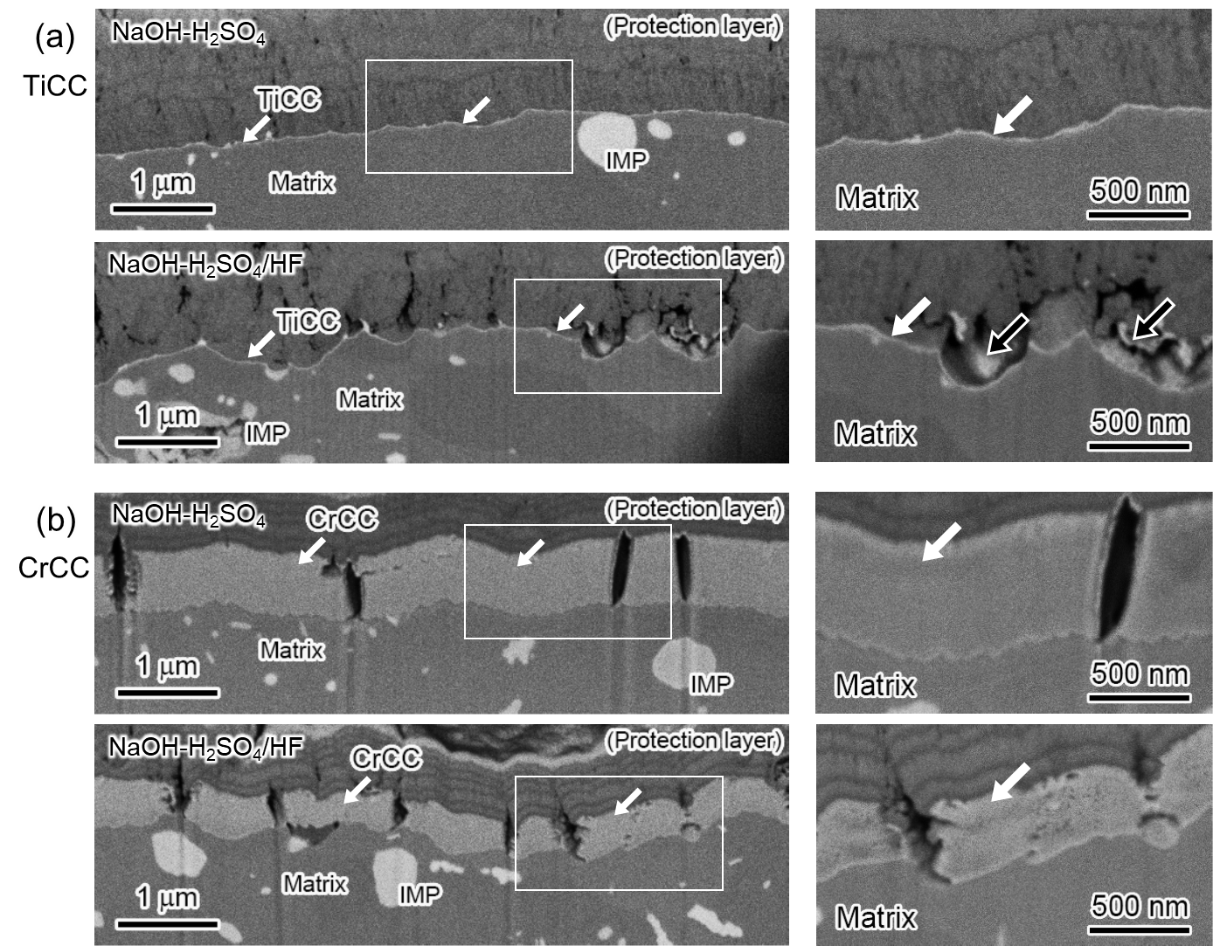
Fig. 7. (a) Cross-sectional backscattered electron (BSE)-SEM images of the TiCC sample after NaOH-H₂SO₄ or NaOH-H₂SO₄/HF treatment, and magnified BSE-SEM images of the area surrounded by the white line. (b) Cross-sectional BSE-SEM images of the CrCC samples for comparison.
Fig. 7(a) shows the cross-sectional BSE-SEM images of TiCC formed after NaOH-H₂SO₄ or NaOH-H₂SO₄/HF treatment; the magnified images are taken from the area surrounded by the white line. As indicated by the white arrows in Fig. 7(a), TiCC with the bright imaging contrast is observed on the aluminum matrix. After NaOH-H₂SO₄ treatment, a thin TiCC layer of uniform thickness is continuously formed on the smooth matrix surface. Even in the sample with uneven surface after NaOH-H₂SO₄/HF treatment, a thin TiCC layer is continuously formed on the matrix surface. As indicated by the black arrows in the magnified image in Fig. 7(a), particles with the size of ~several hundred nm are present above TiCC on the matrix after NaOH-H₂SO₄/HF treatment, as observed in the surface SE-SEM image in Fig. 6(a). In the CrCC samples after NaOH-H₂SO₄ and NaOH-H₂SO₄/HF treatments, Fig. 7(b), a layer with a thickness of >300 nm, which is more than ten times thicker than TiCC, is formed over the entire surface with a surface roughness similar to that of the alloy surface. The magnified image shows that part of the CrCC surface after NaOH-H₂SO₄/HF treatment is microscopically uneven, but no particle aggregates are observed as seen in the TiCC sample.
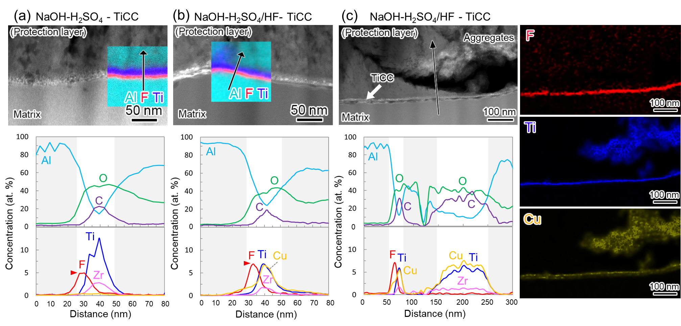
Fig. 8. Cross-sectional HAADF-STEM images and line composition profiles of the samples deposited with TiCC after (a) NaOH-H₂SO₄ and (b) NaOH-H₂SO₄/HF treatments. The superimposed images in HAADF-STEM images are corresponding composite EDS elemental maps of Al, F, and Ti. (c) HAADF-STEM image and EDS elemental maps of F, Ti, and Cu showing TiCC with particle aggregates deposited after NaOH-H₂SO₄/HF treatment. Line composition profile acquired along the black arrow through the matrix interface and the aggregates above it in the HAADF-STEM image.
Figs. 8(a) and (b) show the cross-sectional HAADF-STEM images and the line composition profiles acquired from the TiCC-deposited samples after different chemical cleaning treatment. The composite EDS elemental map of Al, F, and Ti is superimposed on the HAADF-STEM images. TiCC consists of a Ti-rich and a thin F-rich layer, with a total thickness of ~20 nm, independent of the HF addition. The EDS line profiles show a clear difference in TiCC composition between the NaOH-H₂SO₄ and NaOH-H₂SO₄/HF treated samples. TiCC deposited after NaOH-H₂SO₄ treatment consists of a Ti-rich layer containing Ti, O, C, and a trace of Zr on an F-rich layer (5–10 nm thick) containing Al, O, and F (~5%). The Ti-rich layer contains titanium oxides deposited from fluorotitanic acid and carbon derived from organic polymers in the conversion solution [24,25]. In contrast, the F-rich layer in TiCC after NaOH-H₂SO₄/HF treatment contains more F (~7.5%), and the Ti-rich layer contains almost as much Cu as Ti. Fig. 8(c) shows the HAADF-STEM image and EDS elemental maps of F, Ti, and Cu, showing TiCC with a region containing particle aggregates formed after NaOH-H₂SO₄/HF treatment. There is a void between the TiCC on the matrix and the particle aggregates when the cross-sectional lamella was prepared for STEM observation. The particle aggregates grow independently of TiCC on the matrix, suggesting that they are not sufficiently adhered to TiCC on the matrix. The EDS elemental maps suggest that Ti and Cu are homogeneously distributed within these particles. The line composition profile, analyzed along the black arrow through the TiCC layer and the particle aggregates, shows that the composition of the particle aggregates is similar to the Ti-rich layer on the matrix, i.e., their Cu content is identical to that of Ti, and they contain significant amounts of O and C along with the trace amounts of Zr.
Figs. 9(a) and (b) show the surface SE-SEM and cross-sectional BSE-SEM images obtained from the delaminated area of the organic coatings after the impact adhesion test for the organic-coated TiCC samples after NaOH-H₂SO₄ and NaOH-H₂SO₄/HF treatments, respectively. As shown in Fig. 9(a), the delamination area of the organic coatings is small (5%) on the TiCC sample after NaOH-H₂SO₄ treatment, and the surface and cross-sectional SEM images show that TiCC remains on the matrix of the delaminated area, i.e., sufficient adhesion is maintained both at the interface between TiCC and organic coatings and at the interface between TiCC and matrix. In contrast, in the NaOH-H₂SO₄/HF treated sample with a larger delamination area of 25%, the aluminum matrix appears in the delaminated area, Fig. 9(b), indicating that the increase in delamination area is due to the low adhesion at the TiCC-matrix interface. There are no particle aggregates on the remaining TiCC surface, so these particle aggregates may have facilitated the delamination. Fig. 9(c) shows the cross-sectional HAADF-STEM image and corresponding EDS maps obtained from the delaminated area in Fig. 9(b), showing that an F-rich layer remains on the matrix where the Ti-rich layer has delaminated. These results suggest that delamination of organic coatings increases after NaOH-H₂SO₄/HF treatment because the interface between the F-rich and Ti-rich layers initiates delamination in addition to the particle aggregates.
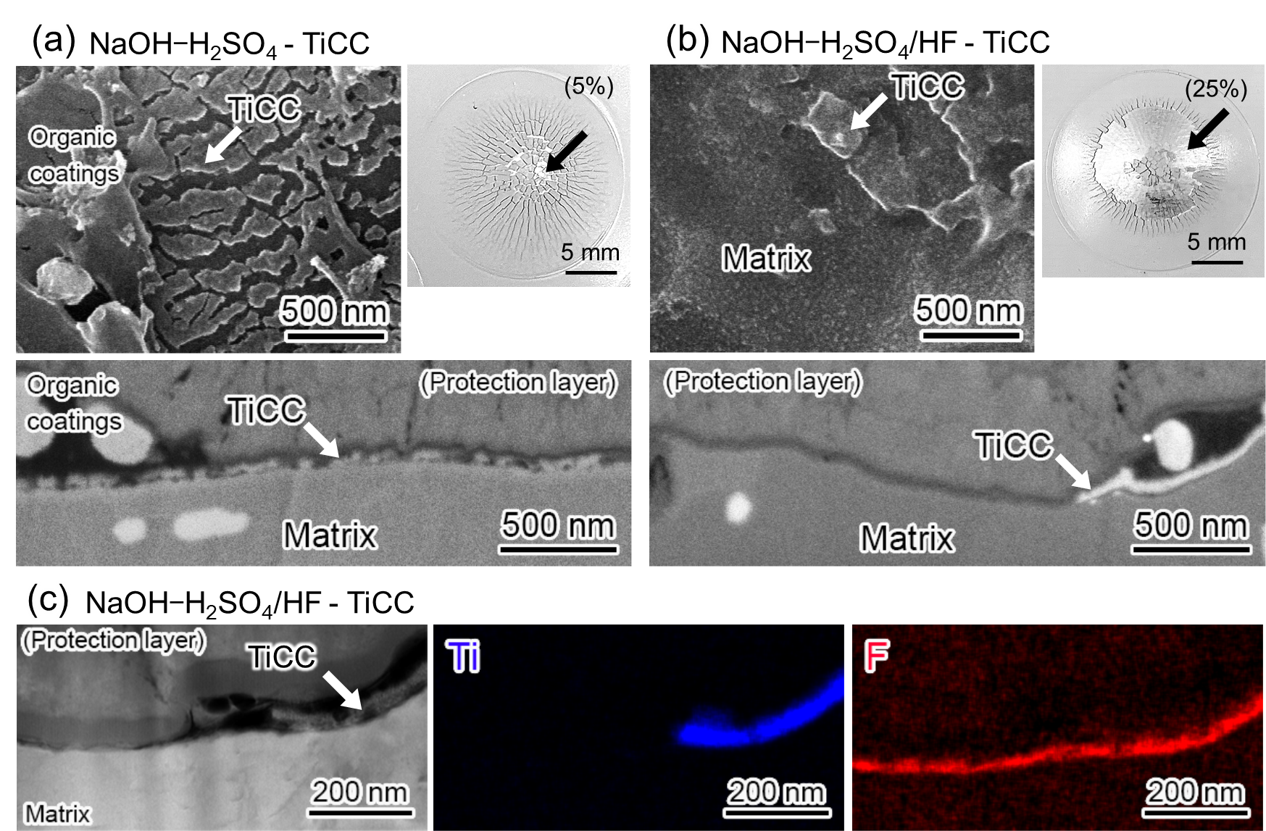
Fig. 9. Surface SE-SEM images and cross-sectional BSE-SEM images obtained from the delaminated area of organic coatings after impact adhesion test for the TiCC samples after (a) NaOH-H₂SO₄ and (b) NaOH-H₂SO₄/HF treatment. The snapshots in (a) and (b) show the organic coating surface after the impact test, with black arrows indicating the delaminated region. (c) HAADF-STEM image of a cross section obtained from the delamination area in (b) and corresponding EDS elemental maps of Ti and F.

- Discussion
This study demonstrated the importance of optimizing the alkaline-acid treatment to achieve the corrosion resistance and adhesion of organic coatings comparable to CrCC-treated samples on chromium-free TiCC-treated samples. Microstructural analysis using SEM and STEM showed the effect of acid treatment on the microstructure of TiCC, which revealed the requirements for improved corrosion and adhesion properties.
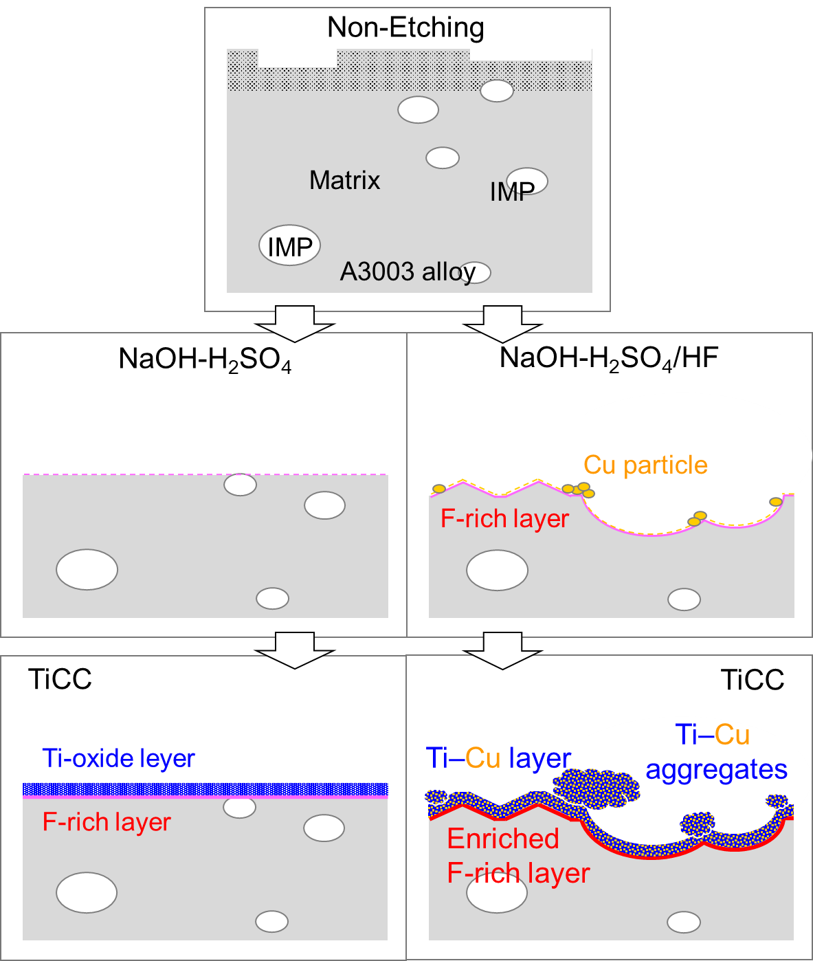
Fig. 10. Schematic of surface microstructure changes during alkaline-acid treatment and subsequent TiCC deposition on A3003 alloy.
Fig. 10 shows a schematic of the cross-section of the alloy surface showing the microstructural evolution during the alkaline-acid treatment and subsequent TiCC deposition process. While the alkaline-acid treatment resulted in dissolution and removal of the alloy surface, regardless of whether the acid contained HF or not, NaOH-H₂SO₄/HF treatment resulted in IMP shedding and a concomitant increase in surface roughness (Fig. 3), as reported in the previous studies [6,13,19]. NaOH-H₂SO₄/HF treatment also increased the F and Cu concentrations of the F-rich layer on the matrix surface (Figs. 4 and 5) because of the active reaction of HF with the alloy surface to form a fluoride layer, such as Al–O–F and AlF_{3,} and the reprecipitation of dealloyed Cu [11,23], as shown in Fig. 5. In the subsequent conversion coating process, a thin TiCC was formed continuously even on the uneven matrix surface (Fig. 7(a)). The thickness of TiCC deposited after NaOH-H₂SO₄/HF treatment is ~20 nm, which is similar to that after NaOH-H₂SO₄ treatment (Fig. 8(a)). However, the F content of the F-rich layer is enriched by a factor of about 1.5 compared to that treated with NaOH-H₂SO₄, and the Ti-oxide layer contains a substantial amount of Cu (Fig. 8(b)). In addition, the Cu particles redeposited on the alloy surface formed Cu-containing Ti-oxide aggregates with a size of ~several hundred nm through the TiCC deposition (Figs. 6(a), 7(a), and 8(c)). Therefore, the characteristic phenomena in TiCC after acid treatment with HF are the increase in F concentration in the F-rich layer, the formation of Cu-containing Ti-oxide layer, and the aggregates of Cu-containing Ti-oxide particles. Further study is needed to clarify the mechanism by which the redeposited Cu is homogeneously distributed within the Ti-oxide layer and aggregates [21,23,26].
The Non-Etching samples exhibit poor corrosion resistance regardless of whether or not conversion coatings are formed (Fig. 2(a)). Since a previous study reported that such poor corrosion resistance is due to the retention of the surface microstructure induced during the thermomechanical process [5], it is essential to remove the top surface structure and smut by alkaline-acid treatment prior to the conversion treatment (Fig. 3). In the NaOH-H₂SO₄ and NaOH-H₂SO₄/HF treated samples, the blister area was further reduced by the formation of TiCC, resulting in corrosion resistance comparable to that of the CrCC-treated samples (Fig. 2(a)). This is because the continuously formed TiCC on the alloy surface, Figs. 6(a) and 7(a), provided a sufficient barrier effect to inhibit the progression of metal corrosion of the substrate under the organic coatings initiated from the cross incision, as reported in our previous studies [24,25]. Therefore, in order to achieve salt spray corrosion resistance comparable to that of the sample with CrCC, TiCC must be continuously formed on the alloy after removing the surface structure induced during the thermomechanical process. This work showed that IMP shedding and Cu reprecipitation did not affect corrosion resistance. However, further studies are needed to clarify whether or not these features affect the corrosion property, as their cathodicity may affect the corrosion susceptibility of the alloy surfaces [23,27,28].
The adhesion test showed that the organic coatings on the w/o CC samples were fully delaminated (Fig. 2(b)), confirming the necessity of forming conversion coatings to obtain sufficient impact adhesion after boiling water treatment, as reported in our previous work [25]. The organic coatings on the CrCC samples showed excellent adhesion (Fig. 2(b)), whether or not the acid contains HF, suggesting that the formation of CrCC is less affected by the acid treatment (Figs. 6(b) and 7(b)). In contrast, when TiCC is used as a conversion coating, HF in the acid has a significant effect on adhesion. While NaOH-H₂SO₄/HF treatment resulted in a slight improvement of the adhesion of organic coatings, i.e., ~25 % in a delamination area, NaOH-H₂SO₄ treatment resulted in a substantial improvement of the adhesion to a delamination area of only ~5%, which is comparable to CrCC (Fig. 2(b)). The microstructure of the delaminated area showed that delamination mainly occurred at the interface between F-rich and Ti-oxide layers in the TiCC sample after NaOH-H₂SO₄/HF treatment (Figs. 9(b) and (c)), suggesting that the reduced adhesion at the interface is due to the higher F concentration in the F-rich layer and the higher Cu content in the Ti-oxide layer compared to those after NaOH-H₂SO₄ treatment (Figs. 8(a) and (b)). The increase in alloy surface roughness did not contribute significantly to the adhesion, suggesting that adhesion at the TiCC-matrix interface is dominant in the delamination of organic coatings. Cu-containing aggregates are another factor preventing adhesion improvement, as they do not intrinsically adhere to the TiCC on the matrix and may have induced delamination at the TiCC-organic coating interface (Figs. 7(a), 8(c), and 9(b)). TiCC after NaOH-H₂SO₄ treatment without HF formed a uniform Ti-oxide layer on an F-rich layer with low F concentration (Figs. 7(a) and 8(a)), resulting in sufficient adhesion with the organic coatings and the matrix (Fig. 9(a)). Therefore, the key to simultaneously improving the corrosion resistance and adhesion of organic coatings is to form a uniform TiCC without a high F concentration of F-rich layer and Cu-containing layers/aggregates, which requires controlling the alloy surface during acid treatment to suppress the formation of an F-rich layer and the reprecipitation of dealloyed Cu.
This study showed that optimization of the acid treatment condition is critical for the samples using chromium-free TiCC to achieve organic coating properties equivalent to those of conventional CrCC. Such excellent properties were achieved by uniform TiCC formation while suppressing the increase in F and Cu concentrations on the alloy surface during acid treatment. The F-rich layer with high F content and Cu aggregates, which degrade the organic coating properties, are formed when the sample containing only 0.07% Cu is treated with acid containing trace HF of <1%. Therefore, when HF additives are used to expect high etching performance, such as in acid treatment following weak alkaline etching or in processes limited to acid treatment only, the HF content and acid treatment conditions must be carefully controlled to simultaneously achieve corrosion resistance and adhesion of organic coatings.

- Conclusions
This study revealed the role of acid treatment in improving the organic coating properties with chromium-free TiCC from the perspective of surface microstructure. By uniformly forming TiCC on the alloy surface under optimum conditions after acid treatment, we achieved salt spray corrosion resistance and impact adhesion of organic coatings comparable to CrCC with TiCC. TiCC formed on A3003 alloy after NaOH-H₂SO₄ or NaOH-H₂SO₄/HF treatment improved the corrosion resistance and adhesion of organic coatings, but the adhesion improvement is limited after the treatment with acid containing HF. The corrosion resistance of the samples with TiCC deposited on the NaOH-H₂SO₄/HF treated surface was comparable to that of CrCC, because TiCC was formed as a continuous layer even on the uneven matrix surfaces caused by the HF-containing acid treatment. The addition of HF to the acid facilitated the formation of an F-rich layer and the reprecipitation of dealloyed Cu on the alloy surface. The deposition of TiCC on the NaOH-H₂SO₄/HF treated surface was accompanied by an increased F concentration in the F-rich layer and the formation of a Cu-containing Ti-oxide layer and Cu-containing aggregates. Such microstructures reduced the impact adhesion after boiling treatment, resulting in delamination at the TiCC-matrix interface. On the other hand, the matrix surface after NaOH-H₂SO₄ treatment without HF was smooth, with low concentrations of F and Cu, resulting in TiCC forming uniformly over the entire surface with a thickness of ~20 nm, which sufficiently improved the corrosion resistance and adhesion of organic coatings. Therefore, in the sample with TiCC, it is necessary to suppress the formation of the F-rich layer and the reprecipitation of Cu during acid treatment to achieve corrosion and adhesion properties equivalent to those of CrCC.

Acknowledgements
The authors would like to thank Mr. Y. Tomioka (Technology and Innovation Center, YKK Corp.) for the surface analysis using XPS.

References
[1] L. Fedrizzi, F. Deflorian, P.L. Bonora, Corrosion behaviour of fluotitanate pretreated and painted aluminium sheets, Electrochim. Acta. 42 (1997) 969–978. https://doi.org/10.1016/S0013-4686(96)00274-5.
[2] I. Milošev, G.S. Frankel, Review—Conversion coatings based on zirconium and/or titanium, J. Electrochem. Soc. 165 (2018) C127–C144. https://doi.org/10.1149/2.0371803jes.
[3] L. Fedrizzi, A. Bianchi, F. Deflorian, S. Rossi, P.L. Bonora, Effect of chemical cleaning on the corrosion behaviour of painted aluminium alloys, Electrochim. Acta. 47 (2002) 2159–2168. https://doi.org/10.1016/S0013-4686(02)00092-0.
[4] J.M.C. Mol, J. Van De Langkruis, J.H.W. De Wit, S. Van Der Zwaag, An integrated study on the effect of pre- and post-extrusion heat treatments and surface treatment on the filiform corrosion properties of an aluminium extrusion alloy, Corros. Sci. 47 (2005) 2711–2730. https://doi.org/10.1016/j.corsci.2004.11.003.
[5] H. Leth-Olsen, J.H. Nordlien, K. Nisancioglu, Filiform corrosion of aluminium sheet. III. Microstructure of reactive surfaces, Corros. Sci. 40 (1998) 2051–2063. https://doi.org/10.1016/S0010-938X(98)00094-8.
[6] K.J.H. Nelson, A.E. Hughes, R.J. Taylor, B.R.W. Hinton, L. Wilson, M. Henderson, Characterisation of aluminium alloys after HNO₃/HF-NaOH-HNO₃/HF pretreatment, Mater. Sci. Technol. 17 (2001) 1211–1221. https://doi.org/10.1179/026708301101509287.
[7] C.E. Moffitt, D.M. Wieliczka, H.K. Yasuda, An XPS study of the elemental enrichment on aluminum alloy surfaces from chemical cleaning, Surf. Coatings Technol. 137 (2001) 188–196. https://doi.org/10.1016/S0257-8972(00)01121-X.
[8] A. Decroly, J.P. Petitjean, Study of the deposition of cerium oxide by conversion on to aluminium alloys, Surf. Coatings Technol. 194 (2005) 1–9. https://doi.org/10.1016/j.surfcoat.2004.05.012.
[9] C.M. Rangel, T.I. Paiva, P.P. da Luz, Conversion coating growth on 2024-T3 Al alloy. The effect of pre-treatments, Surf. Coatings Technol. 202 (2008) 3396–3402. https://doi.org/10.1016/j.surfcoat.2007.12.017.
[10] S. Joshi, W.G. Fahrenholtz, M.J. OKeefe, Effect of alkaline cleaning and activation on aluminum alloy 7075-T6, Appl. Surf. Sci. 257 (2011) 1859–1863. https://doi.org/10.1016/j.apsusc.2010.08.126.
[11] R. Viroulaud, J. Światowska, A. Seyeux, S. Zanna, J. Tardelli, P. Marcus, Influence of surface pretreatments on the quality of trivalent chromium process coatings on aluminum alloy, Appl. Surf. Sci. 423 (2017) 927–938. https://doi.org/10.1016/j.apsusc.2017.06.246.
[12] R. Saillard, B. Viguier, G. Odemer, A. Pugliara, B. Fori, C. Blanc, Influence of the microstructure on the corrosion behaviour of 2024 aluminium alloy coated with a trivalent chromium conversion layer, Corros. Sci. 142 (2018) 119–132. https://doi.org/10.1016/j.corsci.2018.07.007.
[13] P. Zhou, Y. Liu, L. Liu, B. Yu, T. Zhang, F. Wang, Critical role of pretreatment on the corrosion resistance of Zr conversion coating on 6061 aluminum alloy: The combined effect of surface topography and potential difference between different phases, Surf. Coatings Technol. 377 (2019). https://doi.org/10.1016/j.surfcoat.2019.124904.
[14] S. Sainis, C. Zanella, A localized study on the influence of surface preparation on the reactivity of cast Al-7Si-1Fe and Al-7Si-2Cu-1Fe alloys and their effect on cerium conversion coating deposition, Appl. Surf. Sci. 585 (2022) 152730. https://doi.org/10.1016/j.apsusc.2022.152730.
[15] S. Sharifi Golru, M.M. Attar, B. Ramezanzadeh, Effects of different surface cleaning procedures on the superficial morphology and the adhesive strength of epoxy coating on aluminium alloy 1050, Prog. Org. Coatings. 87 (2015) 52–60. https://doi.org/10.1016/j.porgcoat.2015.05.005.
[16] S.K. Toh, A.E. Hughes, D.G. McCulloch, J. Duplessis, A. Stonham, Characterization of non-Cr-based deoxidizers on Al alloy 7475-T7651, Surf. Interface Anal. 36 (2004) 1523–1532. https://doi.org/10.1002/sia.1938.
[17] C. Trinidad, J. Światowska, S. Zanna, A. Seyeux, D. Mercier, R. Viroulaud, P. Marcus, Effect of surface preparation treatments on copper enrichment on 2024 aluminium alloy surface, Appl. Surf. Sci. 560 (2021). https://doi.org/10.1016/j.apsusc.2021.149991.
[18] U. Tiringer, J. Kovač, I. Milošev, Effects of mechanical and chemical pre-treatments on the morphology and composition of surfaces of aluminium alloys 7075-T6 and 2024-T3, Corros. Sci. 119 (2017) 46–59. https://doi.org/10.1016/j.corsci.2017.02.018.
[19] J.J.A. Galvín, L.G. Rovira, M. Bethencourt, F.J. Botana, J.M.S. Amaya, Influence of aerospace standard surface pretreatment on the intermetallic phases and CeCC of 2024-T3 Al-Cu alloy, Metals (Basel). 9 (2019). https://doi.org/10.3390/met9030320.
[20] C.F. Glover, M.L.C. Lim, J.R. Scully, Increased filiform corrosion resistance utilizing a zirconium-based conversion coating on an Al-Zn-Mg-Cu (AA7075-T6) alloy as well as selected surface treatments, Corrosion. 77 (2021) 40–52. https://doi.org/10.5006/3510.
[21] J. Cerezo, I. Vandendael, R. Posner, J.H.W. De Wit, J.M.C. Mol, H. Terryn, The effect of surface pre-conditioning treatments on the local composition of Zr-based conversion coatings formed on aluminium alloys, Appl. Surf. Sci. 366 (2016) 339–347. https://doi.org/10.1016/j.apsusc.2016.01.106.
[22] O. Gharbi, N. Birbilis, K. Ogle, In-situ monitoring of alloy dissolution and residual film formation during the pretreatment of Al-alloy AA2024-T3, J. Electrochem. Soc. 163 (2016) C240–C251. https://doi.org/10.1149/2.1121605jes.
[23] P. Campestrini, H. Terryn, A. Hovestad, J.H.W. de Wit, Formation of a cerium-based conversion coating on AA2024: Relationship with the microstructure, Surf. Coatings Technol. 176 (2004) 365–381. https://doi.org/10.1016/S0257-8972(03)00743-6.
[24] N. Banjo, T.T. Sasaki, K. Hono, Microstructural origin of adhesion and corrosion properties of Ti-based conversion coatings on A6063 alloy, Appl. Surf. Sci. 604 (2022) 154411. https://doi.org/10.1016/j.apsusc.2022.154411.
[25] N. Banjo, T.T. Sasaki, K. Hono, Microstructure control of Ti-based conversion coatings for optimizing organic coating properties in A6063 and A3003 alloys, Surf. Coatings Technol. 468 (2023) 129735. https://doi.org/10.1016/j.surfcoat.2023.129735.
[26] A. Sarfraz, R. Posner, M.M. Lange, K. Lill, A. Erbe, Role of intermetallics and copper in the deposition of ZrO₂ conversion coatings on AA6014 , J. Electrochem. Soc. 161 (2014) C509–C516. https://doi.org/10.1149/2.0121412jes.
[27] R.G. Buchheit, A compilation of corrosion potentials reported for intermetallic phases in aluminum alloys, J. Electrochem. Soc. 142 (1995) 3994–3996. https://doi.org/10.1149/1.2048447.
[28] R.G. Buchheit, R.P. Grant, P.F. Hlava, B. Mckenzie, G.L. Zender, Local dissolution phenomena associated with S phase ( Al₂CuMg ) particles in aluminum alloy 2024‐T3, J. Electrochem. Soc. 144 (1997) 2621–2628. https://doi.org/10.1149/1.1837874.

