No-Insulation BSCCO Coils Impregnated with Low-Melting Point Metal

S. Matsunaga, G. Nishijima, Y. Narushima, K. Natsume, N. Yanagi, and K. Kamiya

Fig. 1. Photographs of coils: (a) dry-wound and (b) impregnated coil #P, (c) dry-wound and (d) impregnated coil #A, (e) polyimide sheet inserted between layers of coil #A-PI, and (f) impregnated coil #A-PI. Bobbin and casing materials were polycarbonate for #P and aluminum alloy for coil #A and coil #A-PI, respectively.

Abstract—This paper presents the experimental results of the (Bi,Pb)₂Sr₂Ca₂Cu₃O₁₀ (BSCCO) coils impregnated with low-melting point metal, whose melting point is 60 °C. The coils were layer-wound without turn-to-turn insulation, i.e., no-insulation (NI). We fabricated the coils with polycarbonate bobbin and casing and the coils with aluminum alloy bobbins and casing. The coils with polycarbonate bobbin and casings showed severe degradation after impregnation. The coils with aluminum alloy ones showed less degradation. A long decay time of the magnetic field during a sudden discharge was measured. The decay time was shortened to be 1/39 by an inter-layer insulation with polyimide sheet. Partial insulation, i.e., electrical insulation between adjacent layers, was effective in reducing this long time constant, even for a BSCCO NI coil.

Index Terms— BSCCO, High-temperature superconducting coil, impregnation, no-insulation, and partial-insulation.

I. INTRODUCTION
D
IFFICULTIES of quench protection for high-temperature superconducting (HTS) magnets have hindered their practical magnet application. The no-insulation (NI) winding has introduced the self-protection mode and achieved some success in quench protection [1], [2], [3], [4]. However, in high magnetic fields, NI coils are subjected to unbalanced electromagnetic forces. This can cause deformation of the coil winding, resulting in mechanical failure [2], [3], [4], [5], [6], [7], [8].
Appropriate impregnation can suppress the deformation of a coil winding and degradation caused by thermal stress and/or Lorentz forces in an NI coil [9], [10]. It also affects on the coil stability, especially when the coil is conduction cooled [10], [11], [12], [13].
The test coil impregnated with electrically conductive epoxy resin demonstrated that the coil can be protected from quenching under a conduction cooling condition [13]. HTS windings of the toroidal field model coils were vacuum-impregnated with low-temperature solder on the SPARC project [14].
Since coated conductors easily delaminate because of their multilayer thin-film structure, it is difficult to adjust the impregnation conditions without degrading the conductor [15], [16]. To find appropriate materials for NI coils composed of coated conductors, ice, low-melting point metal, liquid metal have been tried [17], [18], [19]. We have tried to impregnate a layer-wound REBCO coil with a low-melting point metal. However, the coil deteriorated during thermal cycles [18].
With respect to delamination strength, a (Bi,Pb)₂Sr₂Ca₂Cu₃O₁₀ (BSCCO) tape is expected to exhibit better properties than a coated conductor because of its sheathed conductor structure: Silver matrix in BSCCO tape deforms without transferring the thermal stress to Bi-2223 filaments [20].
Several NI coils using BSCCO tapes were fabricated to investigate the applicability to various applications [1], [21], [22], [23], [24], [25], [26]. Their winding method are dry or impregnated with epoxy resin. Since the layer-winding is effective in reducing the number of conductor joints and locating the joints outside the coil [27], [28], we fabricated and tested layer-wound NI BSCCO coils impregnated with low-melting point metal to verify the applicability.
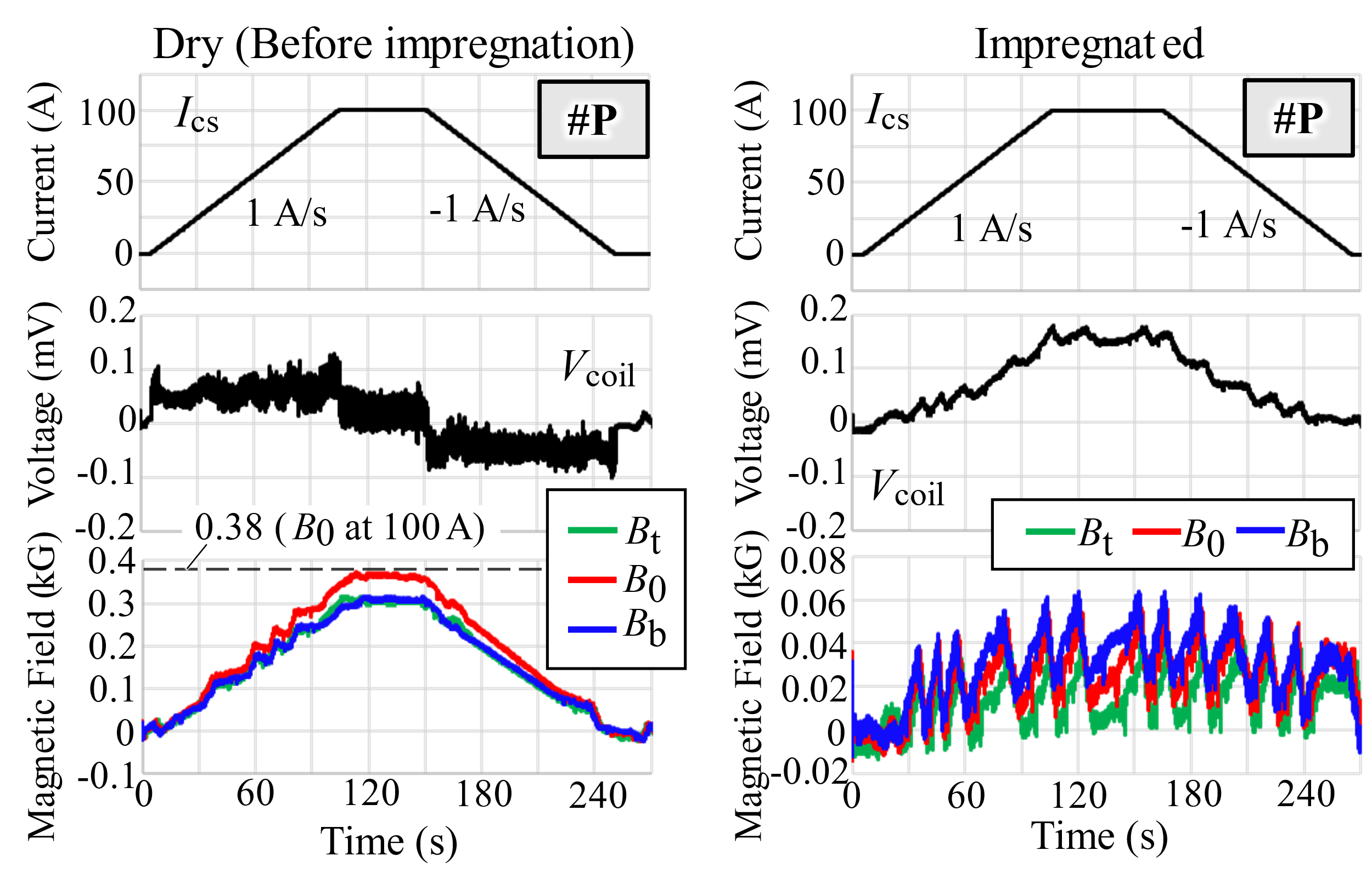
Fig. 3. Charging test results on coils with polycarbonate bobbin and casing #P

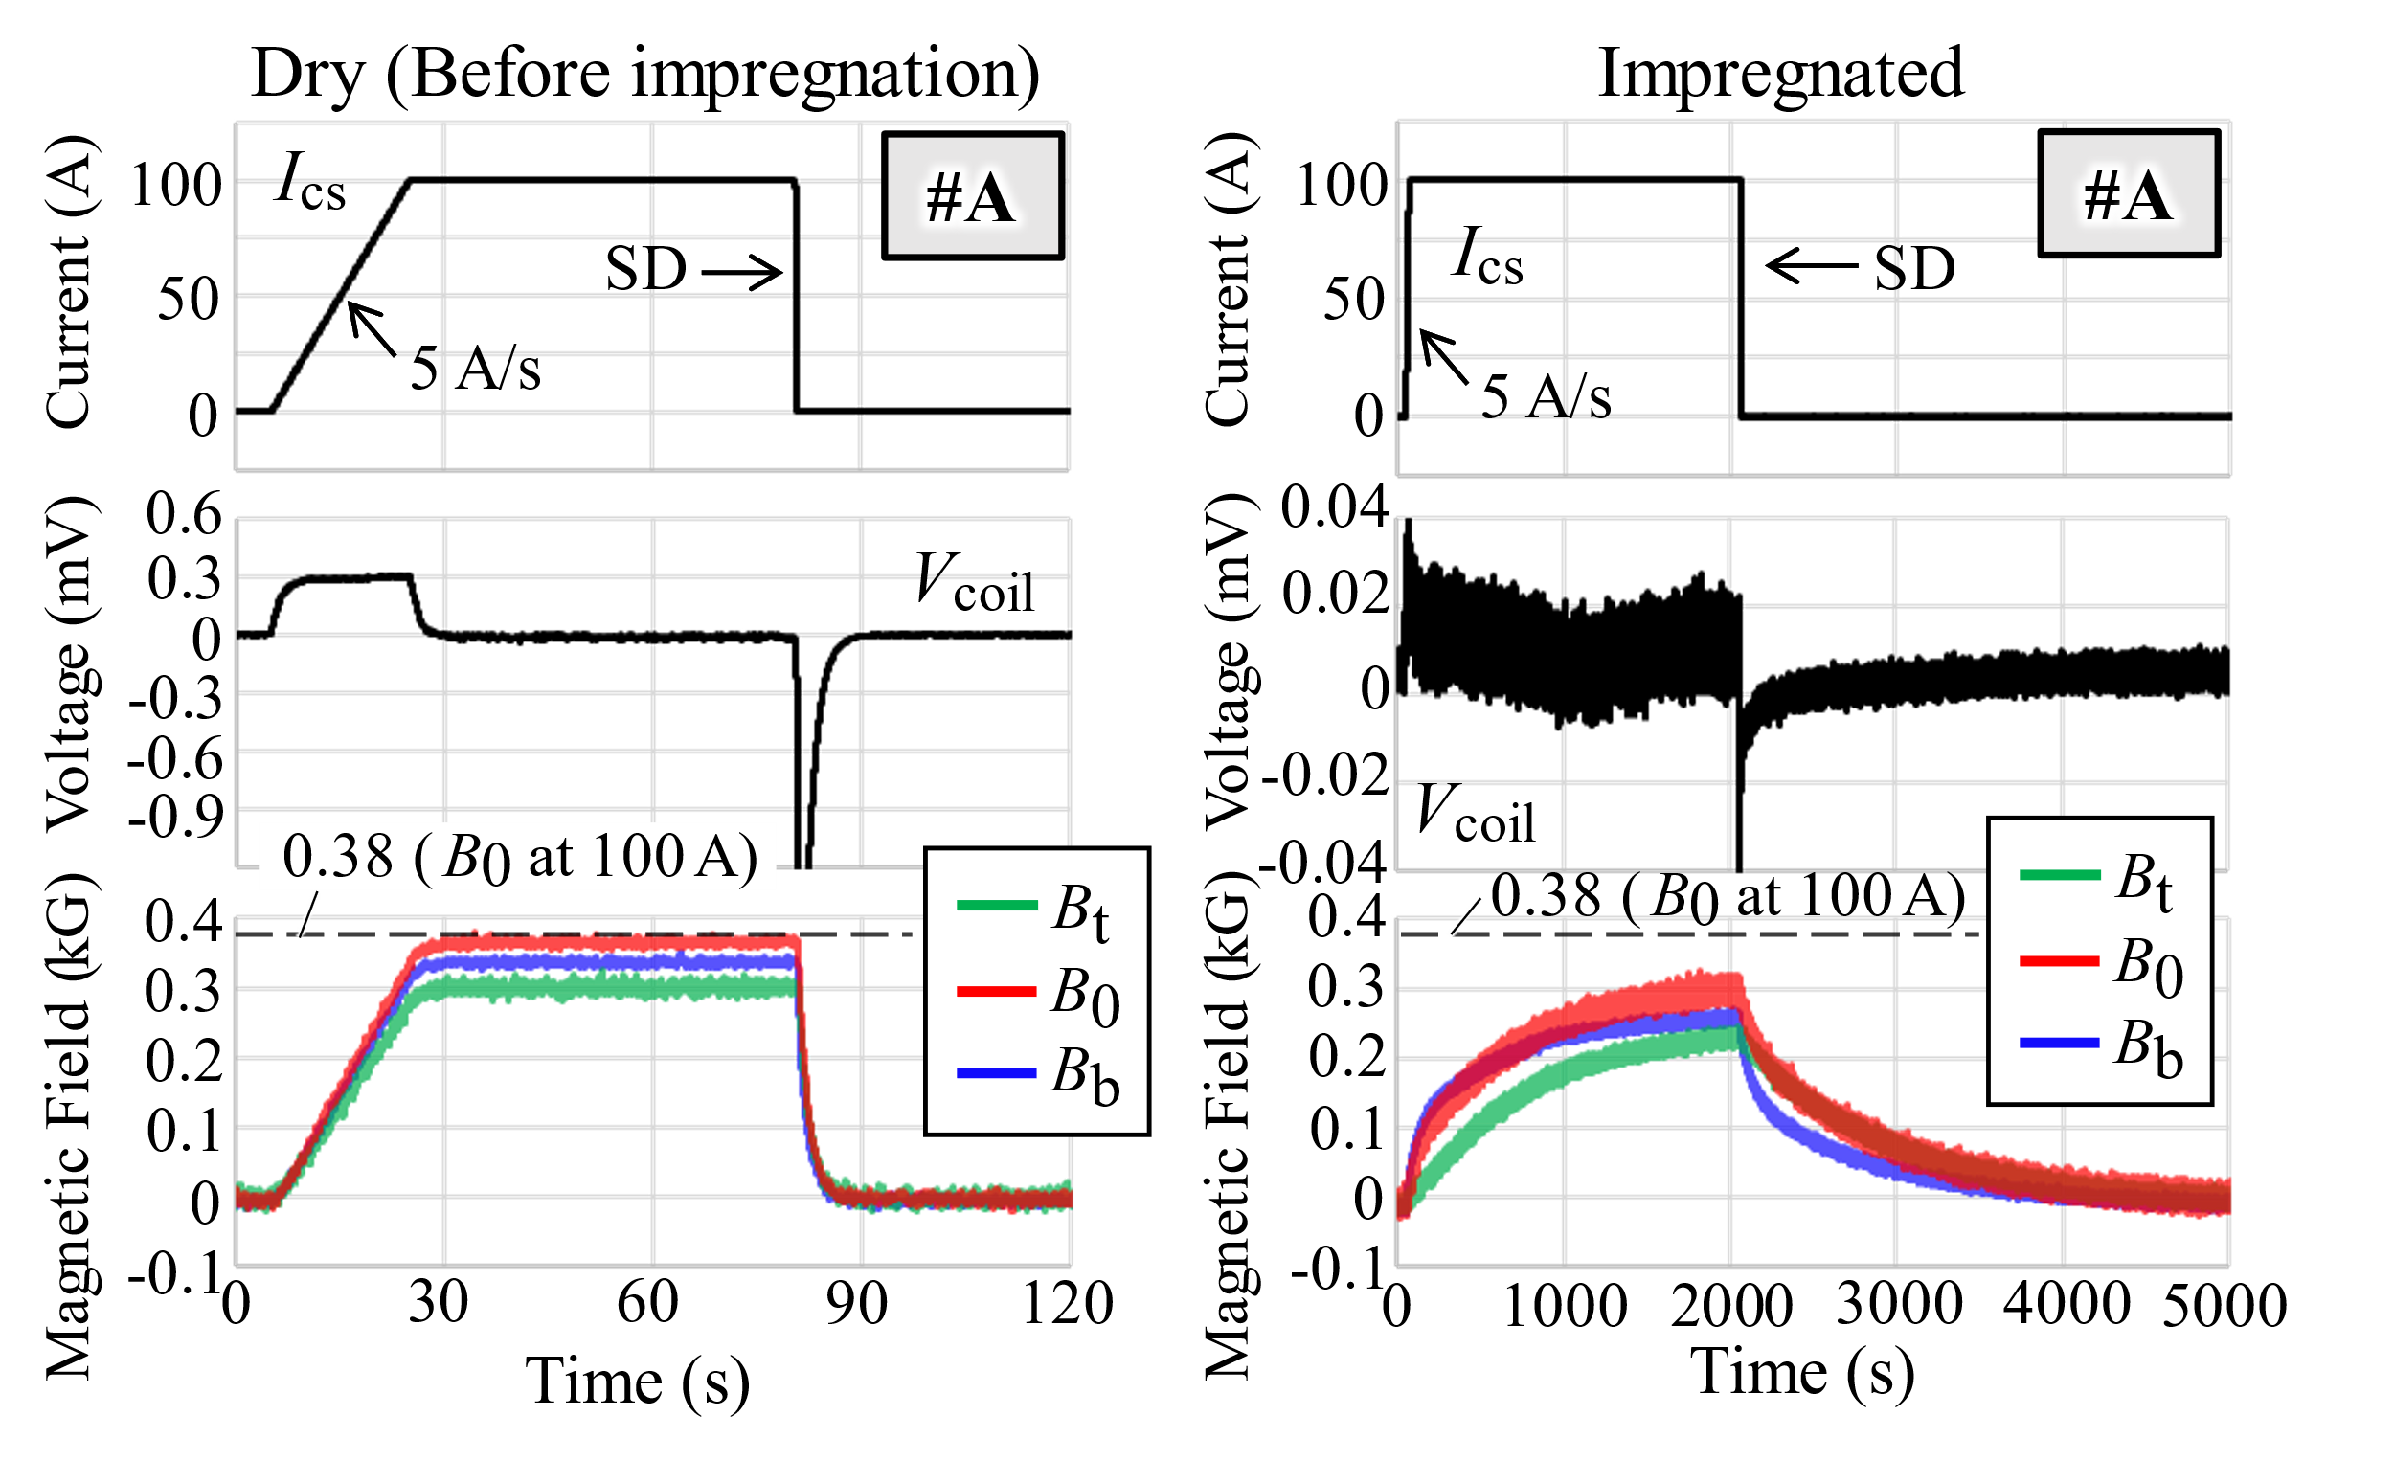
(a)
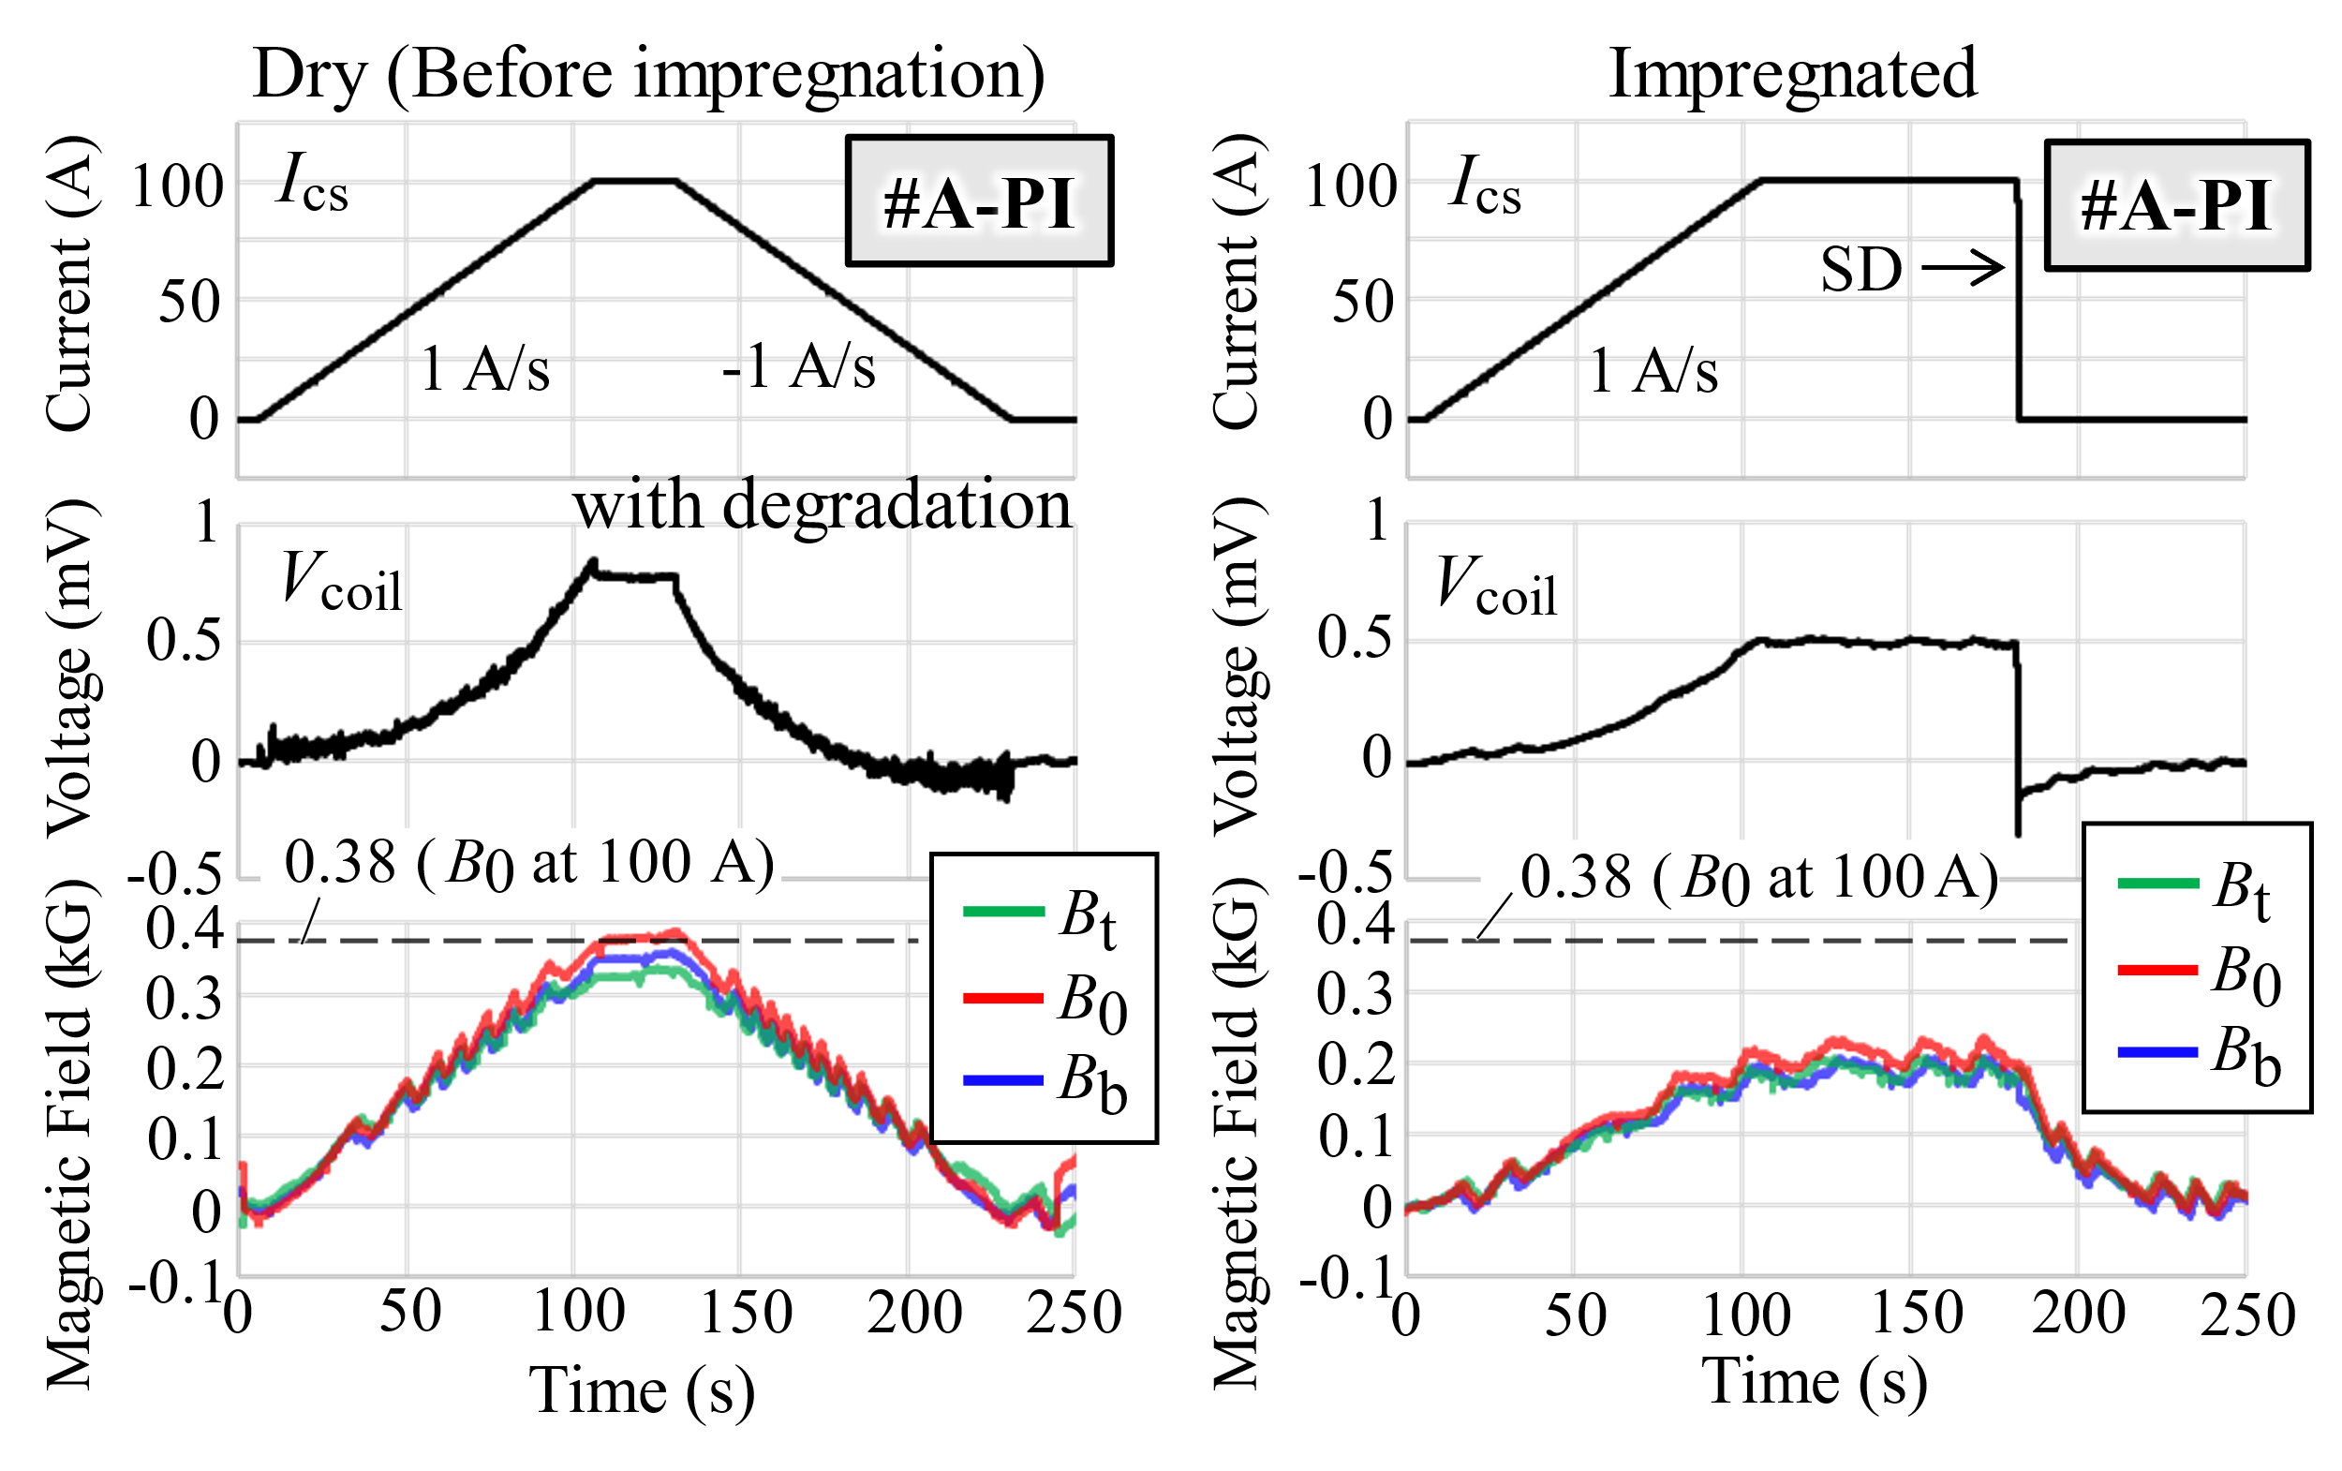
(b)
Fig. 4. Charging test results on coils with aluminum alloy bobbin and casing (a) #A and (b) #A-PI.

Fig. 1. Photographs of coils: (a) dry and (b) after impregnation of coil #P, (c) dry and (d) after impregnation of coil #A, (c) polyimide sheet inserted between layers of coil #A-PI, and (d) after impregnation of #A-PI. Bobbin and casing materials were polycarbonate for #P and aluminum alloy for #A and #A-PI.

Fig. 2. Schematic drawing of the experimental setup.

Fig. 3. Charging test results on coils with polycarbonate bobbin and casing #P

(a)
(b)
Fig. 4. Charging test results on coils with aluminum alloy bobbin and casing (a) #A and (b) #A-PI.

Fig. 1. Photographs of coils: (a) dry and (b) after impregnation of coil #P, (c) dry and (d) after impregnation of coil #A, (c) polyimide sheet inserted between layers of coil #A-PI, and (d) after impregnation of #A-PI. Bobbin and casing materials were polycarbonate for #P and aluminum alloy for #A and #A-PI.

II. Coil Fabrication and Experimental Setup

A. Coil Fabrication
The employed HTS conductor was DI-BSCCO® type H manufactured by Sumitomo Electric Industries, Ltd. The width and thickness are 4.2 mm and 0.22 mm, respectively. The critical current (I_{c}) at 77 K in self-field was measured to be 185 A at an electric field criterion of 1 µV/cm. The n-value obtained by fitting the voltage-current data to the power-law model was 22. In-Bi-Sn eutectic alloy was used as the impregnation material. The composition of In, Bi, and Sn is 51, 32.5, and 16.5wt%, respectively. The melting point is 60 °C.
The procedure to fabricate the coils is as follows:
1. Wind the BSCCO tape in two layers on the bobbin.
2. Assemble the casing with the wound coil.
3. Heat the assembled coil to 90 °C for impregnation.
4. Pour the melted low-melting point metal between the casing and the bobbin.
5. Cool the impregnated coil down to room temperature.
We produced three coils, i.e., #P, #A, and #A-PI. The photographs are shown in Fig.1. The bobbin and the casing for #P was made of polycarbonate and was 3-D printed. They can be handled at the impregnation temperature of 90 °C, since the softening point of polycarbonate is about 120 °C. The material of bobbin and the casing for #A and #A-PI were aluminum alloy (A6063: Japanese industrial standards). For #A-PI, a polyimide sheet was inserted between layers as shown in Fig. 1(e). Each coil has an inner diameter of 80 mm and a length of 63 mm. The coils are layer-wound with 30 turns in two layers. The inductance is calculated to be 50 µH.

B. Experimental Setup
Fig. 2 shows a schematic drawing of the experimental setup. Voltage taps were soldered to the BSCCO tape to monitor the coil voltage as shown in Fig 1(d). The coil was charged by a current source. The applied current was monitored using a shunt resistor. Three Hall sensors were installed in the bore to measure the magnetic field distribution along the central axis of the coil. One of them was placed in the center of the bore and measured the central magnetic field, B₀. Others (B_{b} and B_{t}) were placed 20 mm below and above the center, respectively. All tests were performed in a liquid nitrogen bath at a temperature of 77 K.

III. Experimental Results and Discussion
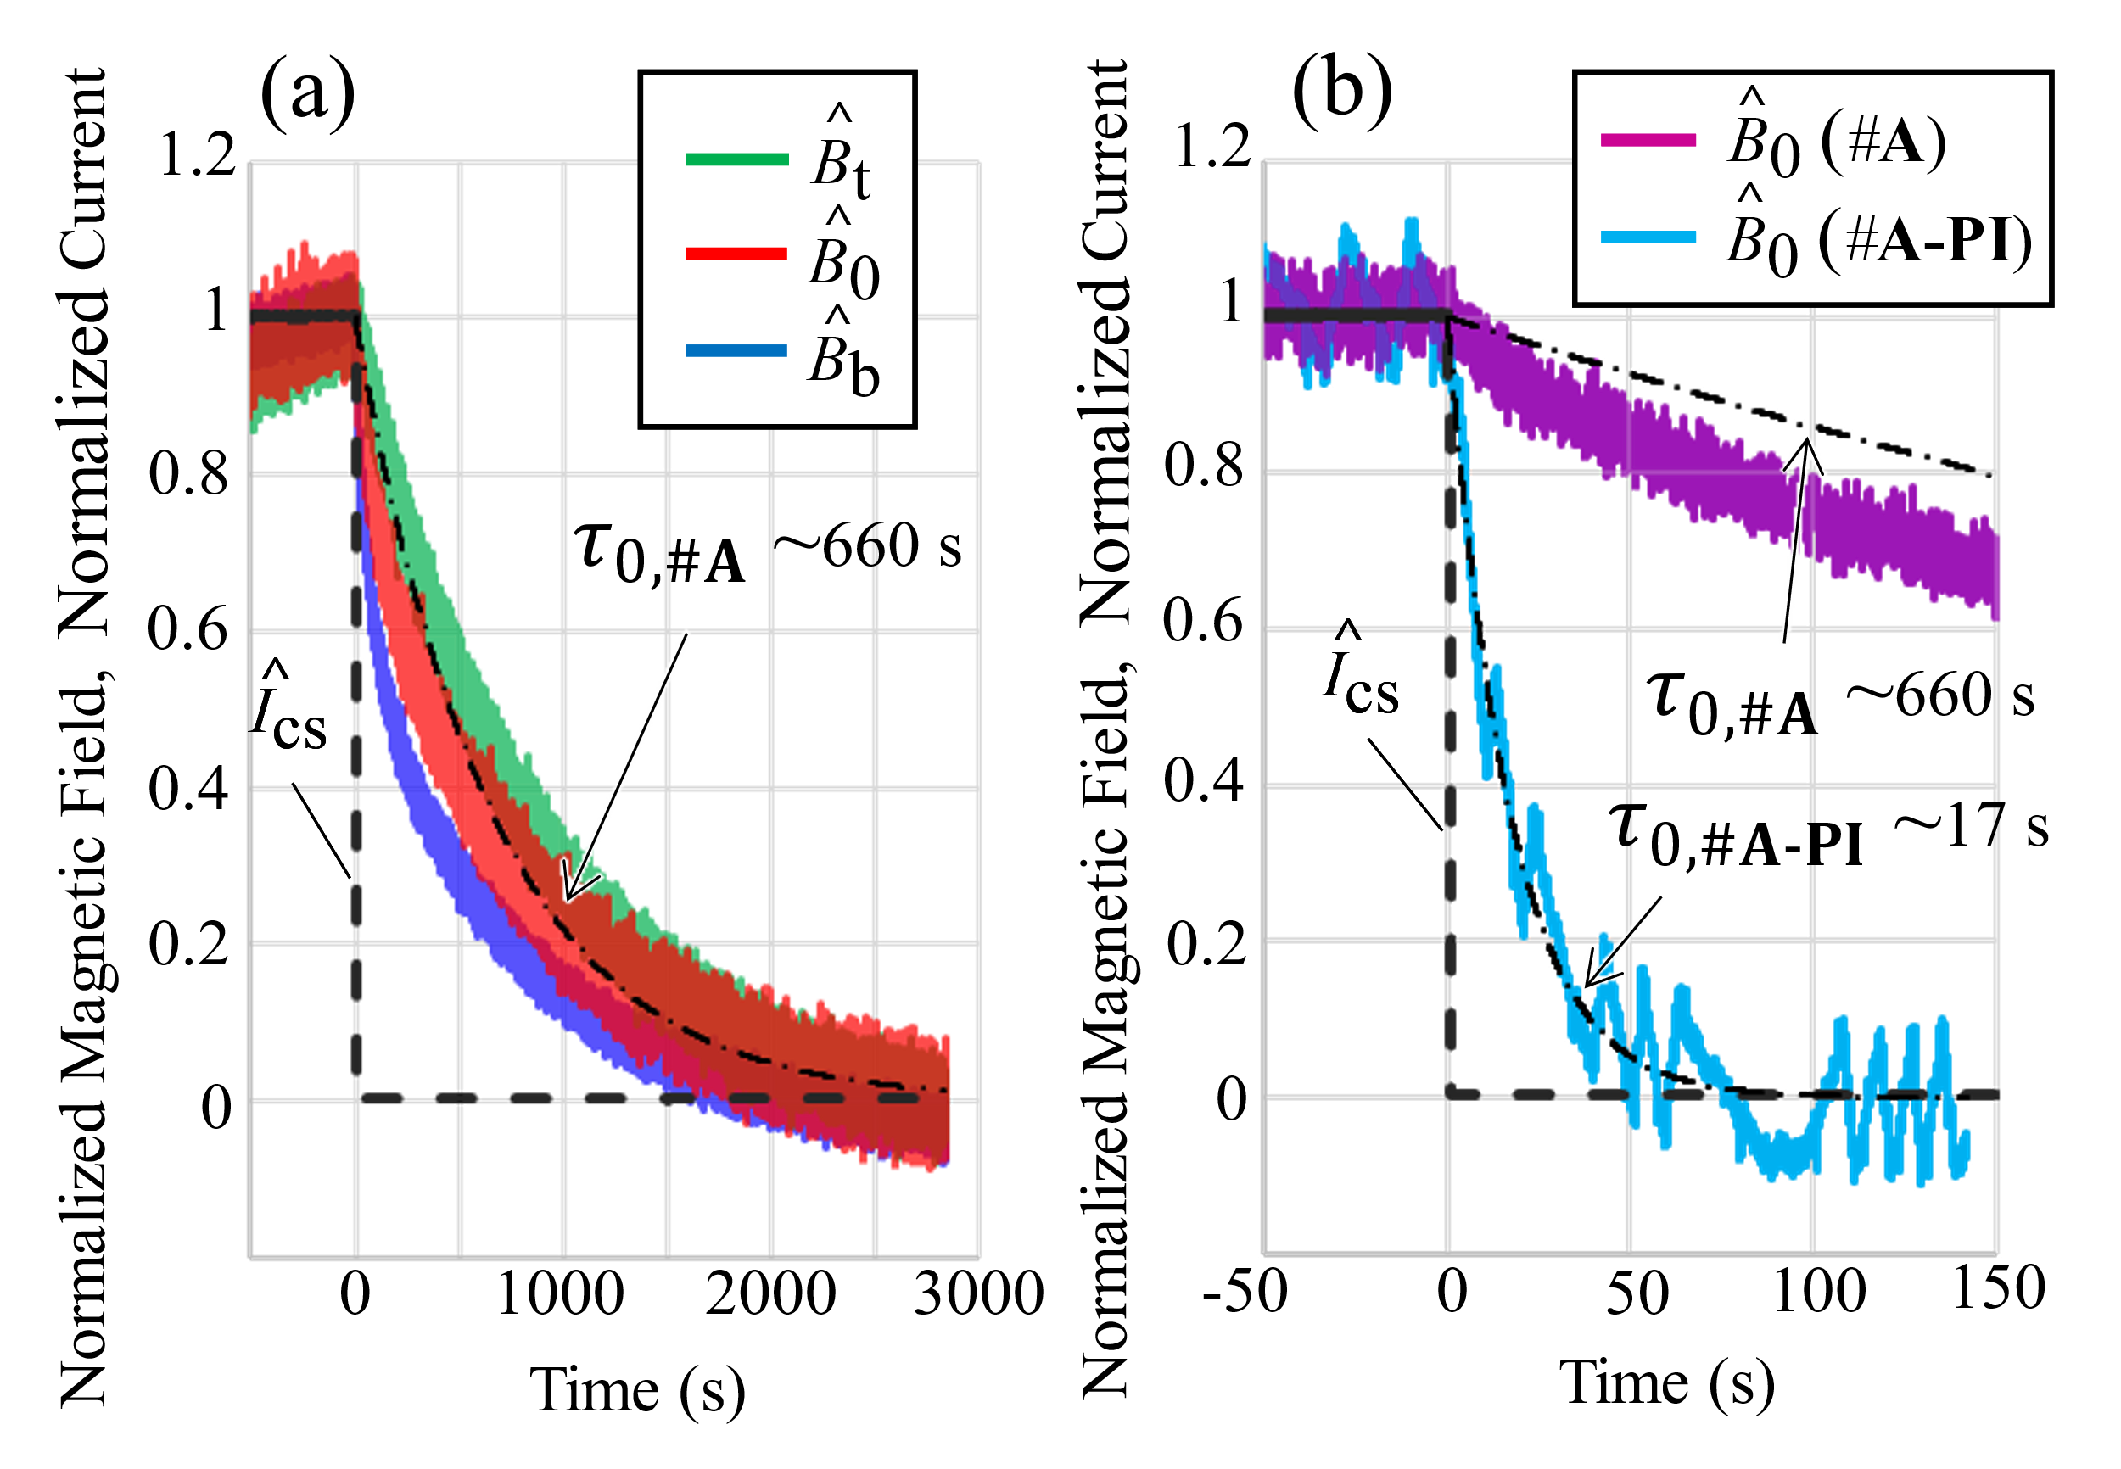

Fig. 5. (a) Magnetic field decay at sudden discharging (SD) for coil #A. (b) Comparison of magnetic field decay at coil center for #A and #A-PI.

Fig. 3 shows the applied current, coil voltage, and measured magnetic fields as a function of time on coils #P before and after impregnation. In the coil #P before impregnation, the measured magnetic field at the coil center (B₀) at 100 A flat-top agreed with the calculated value. Voltages induced by the current ramp also agreed with designed values and were not eliminated from the voltage signals shown in Fig. 3 and Fig. 4. These results indicate that the dry coil was fabricated as designed.
After impregnation, the induced voltages of #P were not measured. The measured magnetic fields decreased to 0.02 kG corresponding to a coil of 1–2 turns. The ohmic voltages of #P at 100 A provides resistance values of 1.5 µΩ. The BSCCO tapes seemed to be seriously damaged in #P. Other coil with impregnated terminals also severely deteriorated. The impregnation boundary is not the cause of the degradation.
The coils #A and #A-PI that used aluminum alloy for the bobbin and the casing generated magnetic field after impregnation (Fig. 4). These results indicate that #A and #A-PI did not deteriorate as seriously as #P. #A-PI exhibited sufficient resistive, resulting in the observation of a voltage signal corresponding to I_{cs}. After impregnation, the values of generated magnetic field at 100 A were 80% of the value impregnation in #A. 20% of the ied current did not seem to flow into the coil. This implies that the BSCCO tape deteriorated for some reasons. The overcurrent for the BSCCO tape bypassed through low-melting point metal, the bobbin, and the casing.
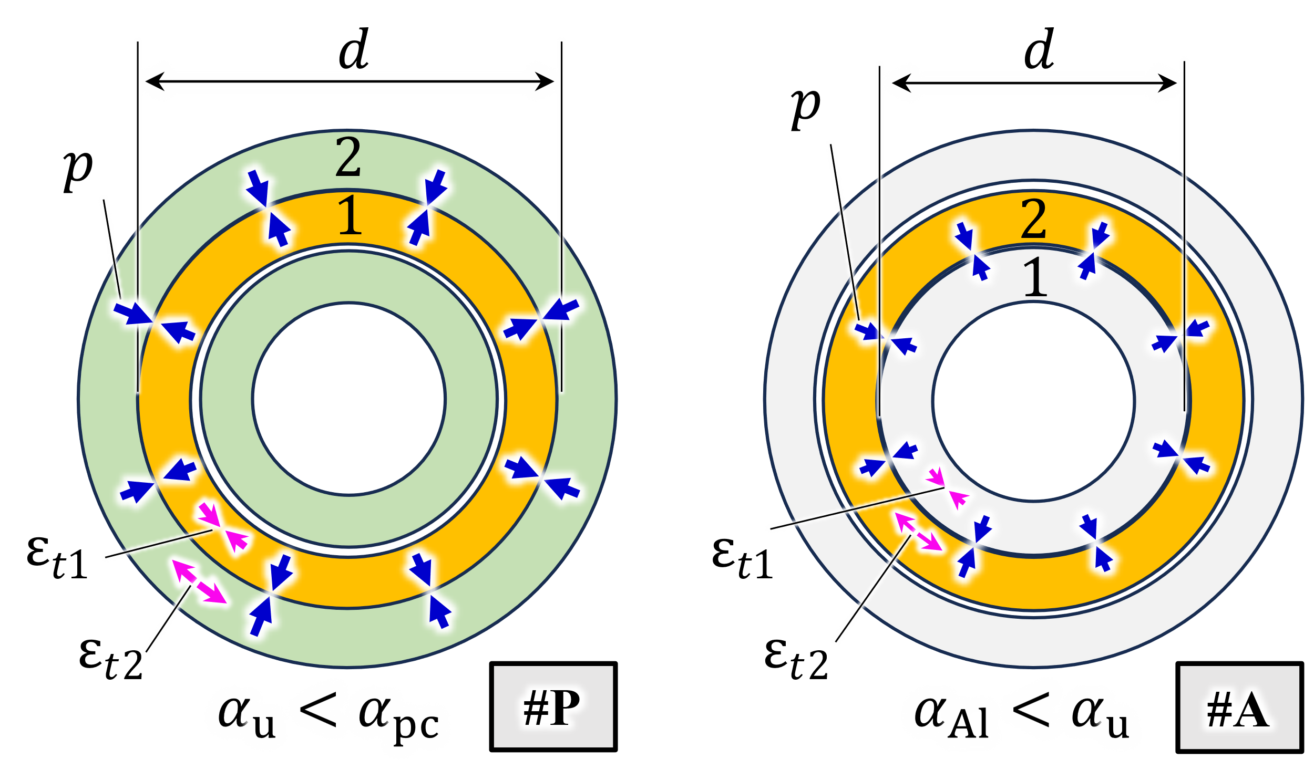

Fig. 6. Schematic illustration of thin cylinders models for (a) #P (the impregnated winding is circumferentially compressed) and (b) #A (the impregnated winding is subjected to tension).
In the coil #A, so-called magnetic field delay was observed. The measured magnetic fields did not increase linearly with increasing current linearly. The delay behavior of the etic field measured at three points was different each other. The delay behavior at the top side of the coil (B_{t}) is longer than that at B₀ and B_{b}. In a layer-wound NI coil without degradation, an azimuthal current is charged to increase from the coil terminal side [29]. Since the terminals are located at the top of the coil, the delay of B_{t} should be shorter than that of B₀ and B_{b}. This discrepancy implies that turn-to-turn resistance may be distributed and/or that the bottom part of the coil may be deteriorated.
Fig. 5(a) shows time variation of magnetic fields during a sudden discharging (SD) of the coil #A. The values of magnetic field were normalized by the measured values at t = 0. The decay time constant was about 660 s at the coil center (B₀). This corresponds to the characteristic resistance of 76 nΩ. The small characteristic resistance implies that it was affected by low-melting point metal and the bobbin.
Fig. 5(b) compares the magnetic field decay of the coils #A and #A-PI. The time constant of #A-PI was 17 s, which is 1/39 of that of #A. The inner and outer layers of #A-PI are insulated by a polyimide sheet as shown in Fig. 1(d). This result indicates that partial insulation is also effective in reducing the decay time constant of the magnetic field, even in a layer-wound NI BSCCO coil. Co-winding of metallic tapes could be also promising to shorten the time constant [30].
A resistance between the inner and outer layers was estimated to be 76 nΩ from the characteristic resistance of #A. Assuming the contact area of 300 cm² between the inner and outer layers, the estimated contact resistivity is 23 µΩcm². This small contact resistivity probably affected the long time constant.
Before impregnation of #A, the time constant was about 2 s. The increase of the time constant, i.e., the decrease of the characteristic resistance, due to the impregnation is probably caused by the increase of the pressure between the inner and the outer layers. The contact resistivity of BSCCO tapes decreases from 100 µΩcm² in the absence of surface pressure to 25-50 µΩcm² at pressures exceeding 1 MPa [31]. The estimated small contact resistivity of 23 µΩcm² implies the appearance of the surface pressure larger than 1 MPa.
For the three coils, the terminals were at the top of the coils. if the two terminals are placed at the top and bottom of the coil, the current could bypass the damaged area.
Although we used low-melting point metal as impregnation material, other materials, e.g., solder, ice, electrically conductive epoxy resin, etc. should be attempted in future. However, tin pest should be concern if pure tin or tin-based alloys are used [32], [33], [34].
TABLE I
Estimated Strain and Surface Pressure
(a) #P | 1: impregnated winding | 2: polycarbonate casing
$t$, mm | 8.0 | 2.0
$\int_{77 K}^{300 K}{α}dT$, % | -0.48 [35] | -1.3 [34]
$E(77 K)$, MPa | 6.0 x 10³ [35] | 3.4 x 10³ [37]
$ε_{t}$, % | -0.10 | 0.73
$|p|$, MPa | 1.0

(b) #A | 1: aluminum alloy bobbin | 2: impregnated winding
$t$, mm | 5.0 | 5.0
$\int_{77 K}^{300 K}{α}dT$, % | -0.39 [36] | -0.48 [35]
$E(77 K)$, MPa | 7.5 x 10⁴ [38] | 6.0 x 10³ [35]
$ε_{t}$, % | -0.0067 | 0.084
$|p|$, MPa | 0.56

IV. Strain Estimation using Thin Cylinders Model
The coil with polycarbonate bobbin and casing #P showed serious degradation, while the coils with aluminum alloy bobbin and casing, #A and #A-PI, did not. To discuss this result, the thermal strain and the surface pressure were estimated using thin cylinders model.
Fig 6 illustrates the thin cylinders models for #P and #A. Thermal contraction of polycarbonate is larger than that of metals in cool-down from 300 K to 77 K. The impregnated winding will be circumferentially compressed by the casing for #P. On the other hand, the impregnated winding will be subjected to circumferential tension for #A, because thermal contraction of low-melting point metal is larger than that of aluminum alloy [34], [35], [36].
For the thin cylinders model, deformation condition is
$0=p_{1}+p_{2}=\frac{2t_{1}E_{1}ε_{t1}}{d}+\frac{2t_{2}E_{2}ε_{t2}}{d}$ (1)
and constraint condition is
$δ=d\int_{T_{L}}^{T_{0}}{\left(α_{1}-α_{2}\right)}dT=-d\left(ε_{t1}-ε_{t2}\right)$ (2)
where $ε_{t}$ is circumferential strain, $p$ is surface pressure, $t$ is thickness of the cylinders, $E$ is Young's modulus, $δ$ is difference in the diameters, $d$ is diameter of contacting surface, $α$ is coefficient of thermal expansion (CTE), $T_{0}$ is initial temperature, and $T_{L}$ is temperature in cooled condition. The subscripts 1 and 2 indicate the inner and outer cylinders, respectively. Solving for $ε_{t1}$ and $ε_{t2}$ from (1) and (2), we obtain
$ε_{t1}=-\frac{\int_{T_{L}}^{T_{0}}{\left(α_{1}-α_{2}\right)}dT}{1+\frac{t_{1}E_{1}}{t_{2}E_{2}}}$ (3)
and
${ ε}_{t2}=\frac{\int_{T_{L}}^{T_{0}}{\left(α_{1}-α_{2}\right)}dT}{1+\frac{t_{2}E_{2}}{t_{1}E_{1}}}.$ (4)
The estimated strain and surface pressure values were shown in Table I. It resulted in 0.1% circumferential compressive strain and 0.08% tensile strain in the impregnated windings. The 0.1% longitudinal strain does not degrade BSCCO tape significantly [39]. The surface pressures were estimated to be 1.0 MPa and 0.56 MPa for #P and #A, respectively. These values were sufficiently smaller than the transverse compressive stress of 50 MPa that causes degradation in a BSCCO tape [40]. The estimated strains and surface pressures were not large enough to degrade a BSCCO tape.
In the case of #P, the bobbin contracts more than the low-melting point metal, suggesting that the surface pressure would not appear. Assuming that the winding is in the innermost of the low-melting point metal, the peeling stress is unlikely to be the cause of degradation, because the winding was not bonded to the bobbin.
The combination of the longitudinal (circumferential) compression and transverse (radial) compression may need to be considered.
The charging test results showed that the impregnated coils deteriorated. Among them, ones with the polycarbonate bobbin and casing deteriorated particularly severely. Assuming that the deterioration is caused by the bobbin and casing, removing them after impregnation (before cool-down) may reduce the thermal stresses in the winding during cooing down. In any case, a future task is to identify the deteriorated areas of the BSCCO tape unwound from the coils.
V. Summary
This study presents the manufacturing method and experimental results of a layer-would NI BSCCO coil impregnated with low-melting-point metal (In-Bi-Sn eutectic alloy).
In the charging tests of the coils, the difference in material of bobbin and casing yielded the different results. The coils wound on the polycarbonate bobbin and covered with the polycarbonate casings showed severe degradation after impregnation. The coil using aluminum alloy instead of polycarbonate showed less degradation.
The degradation could not be explained by the thermal strain estimations with a simple model that accounts for differences in thermal contraction between the constituent materials. The deteriorated coil should be unwound and identify the location of the damage to further discuss the reasons of the degradation.
The impregnated NI coil showed a long decay time of the magnetic field during a sudden discharge. We endeavored partial insulation, specifically electrical insulation between adjacent layers. The efficiency of such insulation to decrease the long decay time was also demonstrated in the layer-would NI coil impregnated with low-melting point metal.

Acknowledgment
The authors would like to thank the staff of Tsukuba Magnet Laboratory at NIMS for their help.

References
- S. Hahn et al., “HTS Pancake Coils Without Turn-to-Turn Insulation,” IEEE Trans. Appl. Supercond., vol. 21, issue. 3, pp. 1592-1595, December 2010, doi: 10.1109/TASC.2010.2093492
- S. Hahn et al., “45.5-tesla direct-current magnetic field generated with a high-temperature superconducting magnet,” Nature, vol. 570, pp. 496-499, June 2019, doi: 10.1038/s41586-019-1293-1
- P. Fazilleau, X. Chaud, F. Debray, T. Lécrevisse, and J. Song, “38 mm diameter cold bore metal-as-insulation HTS insert reached 32.5 T in a background magnetic field generated by resistive magnet,” Cryogenics, vol. 106, no. 103053, March 2020, doi: 10.1016/j.cryogenics.2020.103053
- T. Lécrevisse et al., “Metal-as-insulation variant of no-insulation HTS winding technique: pancake tests under high background magnetic field and high current at 4.2 K,” Superconductor Science and Technology, vol. 31, no. 055008, April 2018, doi: 10.1088/1361-6668/aab4ec
- P. C. Michael et al., “Assembly and Test of a 3-Nested-Coil 800-MHz REBCO Insert (H800) for the MIT 1.3 GHz LTS/HTS NMR Magnet,” IEEE Trans. Appl. Supercond., vol. 29, issue. 5, no. 4300706, February 2019, doi: 10.1109/TASC.2019.2901246
- S. Noguch et al., “Quench Analyses of the MIT 1.3-GHz LTS/HTS NMR Magnet,” IEEE Trans. Appl. Supercond., vol. 29, issue. 5, no. 4301005, March 2019, doi: 10.1109/TASC.2019.2903268
- J.-B. Song et al., “Metal-as-Insulation HTS Insert for Very-High-Field Magnet: A Test Report After Repair,” IEEE Trans. Appl. Supercond., vol. 32, issue. 6, no. 4300206, February 2022, doi: 10.1109/TASC.2022.3150622
- M. Ahn et al., “Quenching of a no-insulation high-temperature superconducting magnet,” Review of Scientific Instruments., vol. 94, no. 083309, August 2023, doi: 10.1063/5.0133172
- H.-J. Shin et al., “Effects of Impregnating Materials on Thermal and Electrical Stabilities of the HTS Racetrack Pancake Coils Without Turn-to-Turn Insulation,” IEEE Trans. Appl. Supercond., vol. 23, issue. 3, no. 7700404, June 2013, doi: 10.1109/TASC.2012.2234179
- H. Miyazaki et al., “Study on a Stacked REBCO Coil Composed of Six Single Pancakes With Electrically Conductive Epoxy Resin,” IEEE Trans. Appl. Supercond., vol. 30, issue. 4, no. 4704105, May 2020, doi: 10.1109/TASC.2020.2991260
- H. Park et al., “Mechanical and electric characteristics of vacuum impregnated no-insulation HTS coil,” Physica C: Superconductivity and its Applications, vol. 504, pp. 138-143, September 2014, doi: 10.1016/j.physc.2014.04.010
- Y. J. Hwang, J. Y. Jang, S. Song, J. M. Kim, and S. G. Lee et al., “Feasibility Study of the Impregnation of a No-Insulation HTS Coil Using an Electrically Conductive Epoxy,” IEEE Trans. Appl. Supercond., vol. 27, issue. 4, no. 4603405, June 2017, doi: 10.1109/TASC.2017.2668064
- H. Miyazaki et al., “Over-Current Test of REBCO Pancake Coils Impregnated With Electrically Conductive Epoxy Resin Under Conduction-Cooled Conditions,” IEEE Trans. Appl. Supercond., vol. 29, issue. 5, no. 4602805, August 2019, doi: 10.1109/TASC.2019.2909795
- Z. Hartwig et al., “The SPARC toroidal field model coil,” Proc. 27th Int. Conf. Magnet Technol., November 2021
- I. Kesgin, Q. Hasse, Y. Ivanyushenkov, and U. Welp, “Performance of 2G-HTS REBCO Undulator Coils Impregnated Epoxies Mixed With Different Fillers,” IEEE Trans. Appl. Supercond., vol. 27, issue. 4, no. 4100104, June 2017, doi: 10.1109/TASC.2016.2638431
- N. Bagrets, S. Otten, K. Weiss, A. Kario, and W, Goldacker, “Thermal and mechanical properties of advanced impregnation materials for HTS cables and coils,” IOP Conference Series: Materials Science and Engineering, vol. 102, no. 012021, 2015, doi: 10.1088/1757-899X/102/1/012021
- G. Wang et al., “A new method for avoiding critical current degradation of YBCO coils using ice impregnation,” Superconductor Science and Technology, vol. 32, no. 105011, September 2019, doi: 10.1088/1361-6668/ab347f
- S. Matsunaga et al., “HTS-WISE Conductor and Magnet Impregnated With Low-Melting Point Metal,” IEEE Trans. Appl. Supercond. vol. 12, no. 4601405, June 2020, doi: 10.1109/TASC.2020.2969613
- L. Liu et al., “Transient Electrical Characteristics of No-Insulation REBCO Coil Impregnated With GaInSn Liquid Metal,” IEEE Trans. Appl. Supercond., vol. 32, issue. 9, no. 8800306, December 2022, doi: 10.1109/TASC.2022.3211836
- C. Senatore et al., “Progresses and challenges in the development of high-field solenoidal magnets based on RE123 coated conductors,” Superconductor Science and Technology, vol. 27, no. 103001, September 2014, doi: 10.1088/0953-2048/27/10/103001
- A. Musso et al., “Electrical Characteristics of HTS Coils With and Without Insulation in a Layer-Wound Configuration,” IEEE Trans. Appl. Supercond. vol. 31, no 5, 4900605, August 2021, doi: 10.1109/TASC.2021.3059971
- P. K. Nayak et al., “I–V characteristics and magnetic field profile studies in high T_{c} BSCCO based Helmholtz coil,” Physica C: Superconductivity and its Applications, vol. 469, issues 5–6, pp. 211-215, March 2009, doi: 10.1016/j.physc.2009.01.013
- H.-W. Kim et al., “Study of Magnetomotive Force Control Type Superconducting Magnet Using BSCCO HTS Wire,” IEEE Trans. Appl. Supercond. vol. 25, issue 3, 4600804, October 2014, doi: 10.1109/TASC.2014.2365549
- H.-W. Kim et al., “Determining the Operating Current of No-Insulation Field Coils in HTS Generators,” IEEE Trans. Magnetics, vol. 51, issue 11, 9000404, June 2015, doi: 10.1109/TMAG.2015.2435800
- Y. Zhang, Y. Tang, C. Zhang, Z. Xia, L. Ren, “Performance and Analysis of No-Insulation HTS Toroidal Magnet,” IEEE Trans. Appl. Supercond. vol. 27, issue 4, 4201305, January 2017, doi: 10.1109/TASC.2017.2660582
- U. Prasad et al., “Fabrication and Characterization of BSCCO-2223 Tape Compact Coils,” IEEE Trans. Appl. Supercond. vol. 32, issue 6, 4605505, June 2022, doi: 10.1109/TASC.2022.3180307
- M. Xu et al., “Experimental Layer-Wound Mock-Up Coil for HTS MRI Magnet Using BSCCO Tape,” IEEE Trans. Appl. Supercond., vol. 19, issue. 3, pp. 2309-2312, June 2009, doi: 10.1109/TASC.2009.2018107
- D. Uglietti, S. Choi, and T. Kiyoshi, “Design and fabrication of layer-wound YBCO solenoids,” Physica C, vol. 470, issue 20, pp. 1749-1751, November 2010, doi: 10.1016/j.physc.2010.05.199
- Y. Suetomi et al., “Mechanism of notable difference in the field delay times of no-insulation layer-wound and pancake-wound REBCO coils,” Superconductor Science and Technology, vol. 29, no. 105002, August 2016, doi: 10.1088/0953-2048/29/10/105002
- M.-H. Sohn et al., “Controllability of the Contact Resistance of 2G HTS Coil With Metal Insulation,” IEEE Trans. Appl. Supercond., vol. 28, issue. 3, no. 4602705, February 2018, doi: 10.1109/TASC.2018.2804354
- H.-S. Shin, J. R. C. Dizon, S.-S. Oh, and R. F. Bonifacio, “Bending Strain Characteristics of the Transport Property in Lap-Jointed Coated Conductor Tapes,” IEEE Trans. Appl. Supercond. vol. 19, pp. 2991-2994, June 2009, doi: 10.1109/TASC.2009.2019580
- W. J. Plumbridge, “Tin pest issues in lead-free electronic solders,” Journal of Materials Science: Materials in Electronics, vol. 18, pp. 307-318, September 2006, doi: 10.1007/s10854-006-9025-3
- W. J. Plumbridge, “Recent Observations on Tin Pest Formation in Solder Alloys,” Journal of Electronic Materials, vol. 37, pp. 218–223, October 2007, doi: 10.1007/s11664-007-0165-x
- G. Schwarz, “Thermal expansion of polymers from 4.2 K to room temperature,” Cryogenics, vol. 28, no. 4, pp. 248-254, April 1988, doi: 10.1016/0011-2275(88)90009-4
- M. Plötner, B. Donat, and A. Benke, “Deformation properties of indium-based solders at 294 and 77 K,” Cryogenics, vol. 31, issue 3, pp. 159-162, March 1991, doi: 10.1016/0011-2275(91)90169-W
- A. F. Clark, “Low temperature thermal expansion of some metallic alloys,” Cryogenics, vol. 8, issue 5, pp. 282-289, October 1968, doi: 10.1016/S0011-2275(68)80003-7
- A. Oliver, A. L. Mbaruku, and J. Schwartz, “Mechanical Properties of Carbon Nanotube Reinforced Polycarbonate at Cryogenic Temperature,” MRS Online Proceedings Library, vol. 1018, no. 1024, November 2007
- S. Saji and S. Hori, “Mechanical properties of aluminum alloys at very low Temperature,” Journal of the Japan Institute of Metals and Materials, vol. 39, no. 8, pp. 574-583, 1989
- P. Sunwong, J. S. Higgins, and D. P. Hampshire, “Angular, Temperature, and Strain Dependencies of the Critical Current of DI-BSCCO Tapes in High Magnetic Fields,” IEEE Trans. Appl. Supercond., vol. 21, issue. 3, pp. 2840 - 2844, January 2011, doi: 10.1109/TASC.2010.2097573
- K. Kasaba et al., “Stress/strain dependence of critical current in DI-BSCCO tape,” Annual Report of High Field Laboratory for Superconducting Materials in Tohoku University, 2008J. U. Duncombe, “Infrared navigation—Part I: An assessment of feasibility,” IEEE Trans. Electron Devices, vol. ED-11, no. 1, pp. 34–39, Jan. 1959, doi: 10.1109/TED.2016.2628402

Submitted for review October 6, 2023. Submitted for revision January 23, 2024. This work was supported by JST-Mirai Program Grant Number JPMJMI18A3, Japan. S. Matsunaga, G. Nishijima, K. Natsume, and K. Kamiya are with National Institute for Materials Science, 3-13 Sakura, Tsukuba, Ibaraki, 305-0003 Japan (e-mail: matsunaga.shinnosuke@nims.go.jp). Y. Narushima and N. Yanagi are with National Institute for Fusion Science, 322-6 Oroshi-cho, Toki, Gifu, 509-5292 Japan.Second B. Author Jr. was with Rice University, Houston, TX 77005 USA. He is now with the Department of Physics, Colorado State University, Fort Collins, CO 80523 USA (e-mail: author@lamar.colostate.edu).

