Tungsten-based Solar Absorber with a Strip-Combined Starfish Structure with High Photothermal Conversion Efficiency and Low Radiative Heat Loss
Chih-Chung Wang,^{a c} Jia-Han Li * ^{a c d} and Tadaaki Nagao * ^{a b}

- International Center for Materials Nanoarchitectonics (WPI-MANA), National Institute for Materials Science (NIMS), 1-1 Namiki, Tsukuba, Ibaraki 305-0044, Japan.
E-mail: NAGAO.Tadaaki@nims.go.jp
- Department of Condensed Matter Physics Graduate School of Science, Hokkaido University, Kita-10 Nishi-8 Kita-ku, Sapporo 060-0810, Japan.
- Department of Engineering Science and Ocean Engineering, National Taiwan University, No. 1, Sec. 4, Roosevelt Rd., Taipei 106319, Taiwan.
E-mail: jiahan@ntu.edu.tw
- NTU Radiation Application and Hardness Technology Research Center, National Taiwan University, No. 1, Sec. 4, Roosevelt Rd., Taipei 106319, Taiwan.,

We propose a tungsten-based broadband resonator capable of achieving near-perfect solar absorption with suppressed radiative heat loss. Across the entire solar radiation spectrum, the absorber exhibits a spectrally integrated total solar absorptance of 95%. Taking into account the thermal emission under an operating temperature of 100°C, the photothermal conversion efficiency remains as high as 92%-93%. Using the Particle Swarm Optimization, the initial square-based structure is transformed into the adjacent and closely packed strip structures with multiple lengths to achieve enhanced solar absorption. The analysis uses finite-difference time-domain simulations, considering light polarization, incident angle, and structural defects. We proposed a new metamaterial structure with multiple strips that are more efficient, and has simpler geometric structures, such as compared to multilayer films, pyramids, or cone structures, which mostly exhibit substantial radiative heat losses. The structure is composed of a W/SiO₂/W (Metal-Insulator-Metal) configuration, with a surface nanostructure pattern composed of low-emissivity tungsten, with fabrication error-tolerant computational design.
1. Introduction
In the last century, the rapid increase in energy consumption in human society has led to the excessive reliance on fossil fuels, resulting in air pollution and global warming, which have seriously altered and deteriorated the natural environment. Utilizing new and renewable energy sources is urgently required to achieve environmental sustainability. Compared to traditional energy sources, renewable energy is more environmentally friendly and is increasingly regarded as a promising solution for sustainable social development.^{1,2} Among various renewable energy technologies, solar photothermal heat conversion has gained significant global attention due to its abundance, sustainability, and environmental benefits.¹ Additionally, its cost is not much compared to other renewable energy sources, making it a viable option for the future. ^{1,2}
In solar-heat absorber applications, selecting refractory materials is crucial for maintaining device stability and extending operational lifespan. These materials are defined by their ability to retain chemical stability at temperatures exceeding 2000°C and have been widely utilized in industrial furnaces, aerospace thermal protection systems, and semiconductor technologies.³ While metals have been explored for plasmonic applications, conventional noble metals suffer from high optical losses and low thermal stability, significantly limiting their effectiveness. As an alternative, refractory materials such as tungsten, molybdenum, and titanium nitride, conductive oxides exhibit plasmonic resonance in the visible to near-infrared range. Additionally, refractory hexaborides (LaB₆, CeB₆) and the intermetallic NiAl can serve as alternative refractory materials in high-temperature absorber stacks.²⁷⁻²⁹ Compared to conventional base metals, these materials demonstrate superior mechanical and chemical stability under high-temperature conditions.^{3,27-29} For plasmonic applications, the combination of metals and dielectrics is a commonly used material design approach, often incorporating nanoscale periodic structures in the metallic layer.^{4-9,11-17} One of the recently studied configurations involves tungsten (W) and silicon dioxide (SiO₂).^{4-7,9,10,15}
Many studies have focused on improving solar absorption efficiency, primarily through periodic structure designs in the tungsten layer. For example, square periodic structures have been shown to achieve high absorption in the visible to near-infrared (NIR) range⁴ ; square-ring and cross-shaped structures offer near-perfect absorption in the visible range but perform poorly in the NIR.⁵ Other designs, such as square holes filled with SiO₂, also show excellent performance⁶ , and circular or elliptical structures enhance further absorption. ⁷ Additionally, applying titanium nitride (TiN) and aluminum oxide (Al₂O₃) in square structures has proven more effective than triangular or disk-shaped designs.⁸ Multilayer metal/dielectric combinations can also enhance plasmonic resonance and further boost absorption. ^{9–13} Conical structures enable effective broadband absorption by allowing different wavelengths to interact with gradually scaled features^{14–15}, and combining them with multilayer films can further enhance more absorption.^{16–17} Another study used metal particle configurations to design solar absorbers, which are easier to fabricate and outperform conventional nanostructures. This improvement results from the interaction between light and metal nanoparticles, where intense polarization occurs when the particle size is smaller than the skin depth.³⁰
However, most of these previous works have not addressed low radiative heat loss or the low emissivity (Low-E) in longer wavelengths, which can lead to energy loss by heat reradiation. In this work, we incorporate these considerations and propose a new design strategy to suppress such losses and improve overall absorber performance. Here, we choose tungsten as the primary metal. The design approach was developed from a basic MIM-trilayer metamaterial structure with a square periodic pattern.⁴ This structure is then divided into strip-like segments with randomly varied lengths to serve as optimization parameters. As a result, the energy absorption of solar radiation for the optimized structure is significantly improved compared to the initial structure, such as a square periodic pattern. The finite-difference time-domain (FDTD) simulation results show that the optimized metamaterial absorbers can achieve a total solar absorptance as high as 95% while maintaining a low total thermal emittance of 3% and the photothermal conversion efficiency of 92%-93%.

2. Design and structural parameters of solar absorber
This study aims to enhance the absorption of solar radiation. Therefore, defining and analyzing the spectral range of solar radiation is essential. Solar light travels unobstructed in space, and it interacts with atmospheric components such as air molecules (CO₂, water vapor, etc.) and dust upon entering Earth's atmosphere. These interactions cause a gradual reduction in energy as the sunlight reaches the Earth's surface. To quantify this effect, the concept of air mass (AM) is introduced. The air mass represents the relative thickness of the atmosphere that sunlight must traverse. A higher air mass value indicates a longer optical path and greater attenuation of solar radiation. The air mass is mathematically defined as AM = secθ, where θ is the solar zenith angle. When θ = 48.2°, the air mass is approximately 1.5, as illustrated in Fig. 1. In this study, we adopt the ASTM G-173 solar spectrum from the American Society for Testing and Materials (ASTM)¹⁸, as shown in Fig. 2. It can be observed that both AM0 and AM1.5G spectra predominantly fall within the 300–2500 nm wavelength range. Specifically, AM1.5G (Air Mass 1.5 Global) is widely used as a standard reference spectrum for evaluating terrestrial solar energy conversion systems. It represents the solar radiation received on a horizontal surface at the Earth's surface when the sun is positioned 48.2° from the zenith, corresponding to an air mass of 1.5. The “G” denotes that it includes both direct and diffuse sunlight, making it suitable for characterizing devices under typical outdoor conditions. Therefore, the solar spectrum used in this study is based on AM1.5G. However, in the mid-infrared region, the thermal emission due to blackbody radiation at 100°C becomes significant beyond 2500 nm. Consequently, the solar absorber targeted in this study corresponds to the dashed spectrum shown in Fig. 2. Therefore, we aim to optimize solar absorption within the 300–2500 nm wavelength range to the greatest extent possible. We subsequently evaluate the impact of thermal emission for wavelengths longer than 2500 nm.

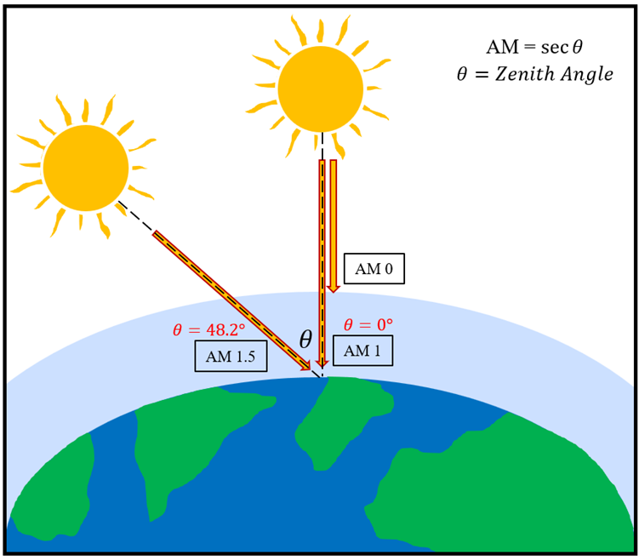
Fig. 1 Schematic diagram of air mass.

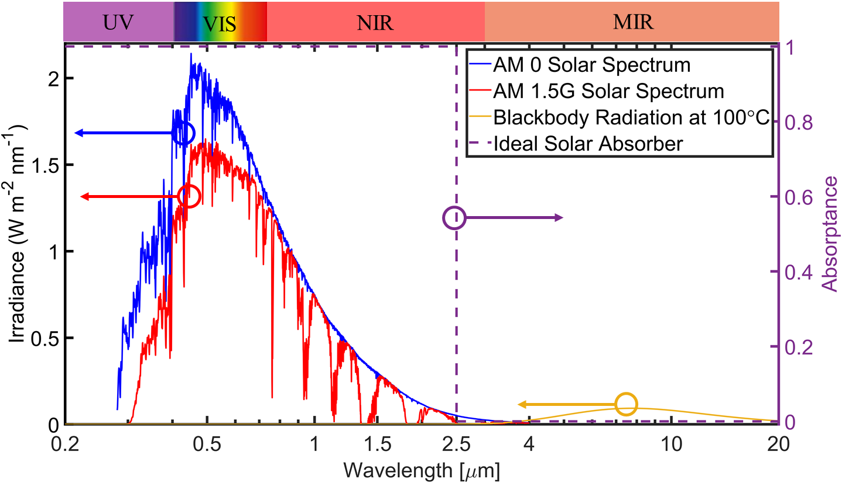
Fig. 2 Solar spectrum diagram.

Next, we select the metallic material for optimizing solar absorption within the 300–2500 nm wavelength range. To evaluate the optical performance of various candidates, we adopt Fresnel reflectance as the main selection criterion, following the approach demonstrated in previous work¹⁹. This method describes surface reflection loss based on the material’s refractive index$\tilde{n}$ ($\tilde{n}=n+ik)$, which is the key factor governing light–matter interaction. Under normal incidence, the Fresnel reflectance $R$ can be approximated as:

$R = 1 - \frac{4n}{{\left(n+1\right)}^{2}+k^{2}}$ (1)
Here, $n$ and $k$ are the real and imaginary parts of the complex refractive index $\tilde{n}=n+ik$. According to Eq. (1), these parameters jointly determine optical reflectance. While a moderate $n$ helps reduce surface reflection, a higher $k$ generally suggests a stronger material loss. However, in some noble metals like Au, despite large $k$ values, their low $n$ leads to high reflectance and low actual absorption. Therefore, the balance between $n$ and $k$ must be considered together when evaluating solar absorber performance. Figure 3(a) and 3(b) show the Fresnel reflectance spectra of selected metals, calculated using experimentally reported optical constants from literature. In the solar spectrum region (0.3–2.5 μm), tungsten (W) exhibits the lowest reflectance among the compared materials. In the longer wavelength range of 2.5–20 μm, although the differences in reflectance become less pronounced, W still maintains a relatively low reflectance level. Considering its broadband absorption potential and its excellent thermal stability as a refractory plasmonic material³, W is selected as the prototype absorber material in this study.

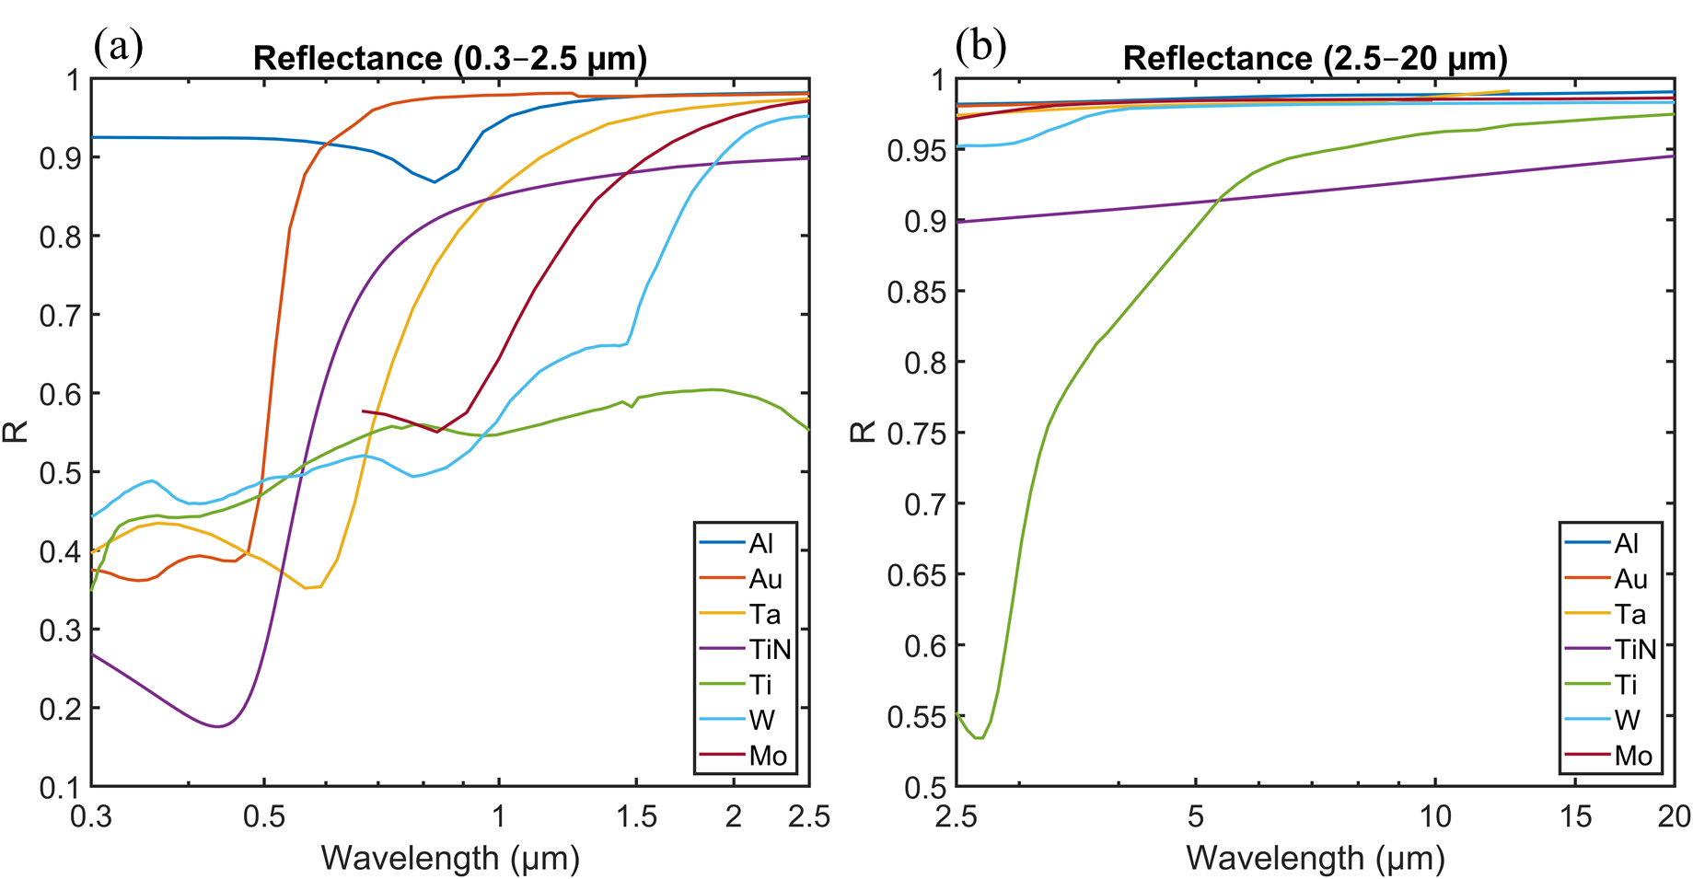
Fig. 3 Fresnel reflectance spectra of selected metals. (a) Solar-active region (0.3–2.5 μm); (b) Mid-infrared region (2.5–20 μm). Reflectance is calculated using the Fresnel formula (Eq. 1) based on experimentally reported optical constants from literature. Data sources: W, Al, Au, Ti – Palik ²⁰; TiN – Beliaev et al. ²¹; Ta – Weaver et al. ²²; Mo – Ordal et al. ²³. Among these materials, W exhibits relatively low reflectance across both wavelength regions.

Based on the preceding analysis, tungsten (W) was selected as the metallic material used in the simulations. Fig. 4 presents the simulated results of three conceptual structural designs, where the blue solid line represents the solar spectrum (AM1.5G), the blue dashed line corresponds to blackbody radiation at 100 °C, and the orange solid line indicates the simulated absorptance. The absorptance 𝐴 was obtained from finite-difference time-domain (FDTD) simulations using the relation 𝐴 = 1 – 𝑅 − 𝑇, where 𝑅 and 𝑇 denote reflectance and transmittance, respectively. Fig. 4(a) shows a multilayer cone structure that combines tapered geometry with stacked multilayers. The simulation results indicate that this structure achieves nearly perfect absorption within the solar spectral range (300–2500 nm). However, it also exhibits significant absorption in the mid-infrared (MIR) region (2500–20000 nm), which may lead to additional thermal radiation loss. Moreover, this structure is a tall, three-dimensional design with a complex morphology, which poses fabrication challenges, requiring precise process control and advanced three-dimensional lithography/etching techniques (e.g., focused-ion-beam milling and colloidal-nanosphere lithography).¹⁵,¹⁶ Fig. 4(b) illustrates a random strip structure based on a metal–insulator–metal (MIM) configuration, where randomly arranged metallic strips are distributed over a two-dimensional plane. The simulation results show that although the solar absorptance is slightly lower than that of structure (a), the MIR absorption is significantly suppressed, effectively reducing undesirable thermal emission. More importantly, this structure represents a planar two-dimensional design concept that is relatively easy to fabricate and offers good manufacturability and scalability. Fig. 4(c) represents the conceptual goal structure, aiming to achieve ultra-high absorption within the solar spectral range (300–2500 nm) while maintaining minimal absorption or low emission (low-E) in the MIR region (2500–20000 nm), resembling the characteristics of the flat W film, thereby enabling efficient solar energy harvesting with suppressed thermal radiation. Based on the above comparison, this study adopts a design strategy inspired by structure (b), aiming to identify a structure with random two-dimensional geometric features that is also easy to fabricate. This approach not only balances optical absorption performance and practical manufacturability, but also provides a coherent framework that links the simulation analysis to experimental realization, ultimately achieving the desired objective of high solar absorptance (300–2500 nm) and low MIR absorptance (2500–20000 nm).

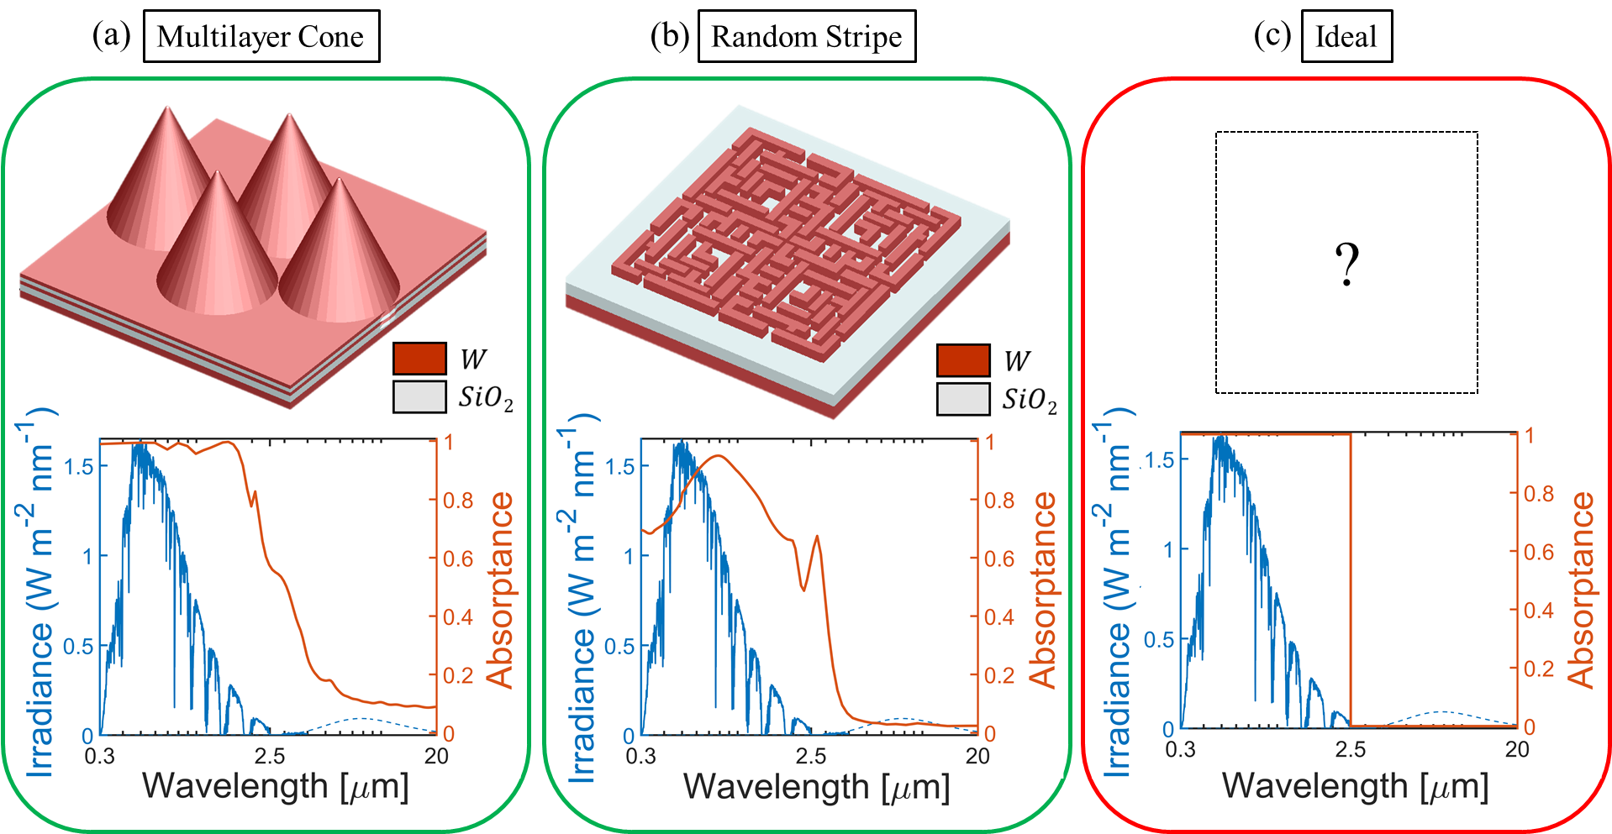
Fig. 4 Simulated absorptance of three structure ideas. Blue: AM1.5G spectrum (solid) and 100 °C blackbody (dashed). Orange: absorptance.
(a) Multilayer cone—high solar, high MIR absorption; (b) Random strip—low MIR, low solar absorption; (c) Ideal—high solar (300–2500 nm), low MIR (2500–20000 nm).

This study adopts a tungsten-based absorber targeting the 300–2500 nm spectrum, utilizing a metal-dielectric-metal (MIM) stacked structure as the initial design. This concept has been discussed in the literature review.⁴ As shown in Fig. 5, the design consists of a metal ground plane, a dielectric layer, and a resonant metallic nanostructure identical in material to the ground plane. The structural dimensions are P = 500 nm, b = 250 nm, h = 150 nm, and t = 60 nm. Silicon dioxide (SiO₂) is selected as the dielectric layer due to its low-loss and stable permittivity in the optical range, as well as its high melting point, which enhances thermal stability for absorber design.⁵

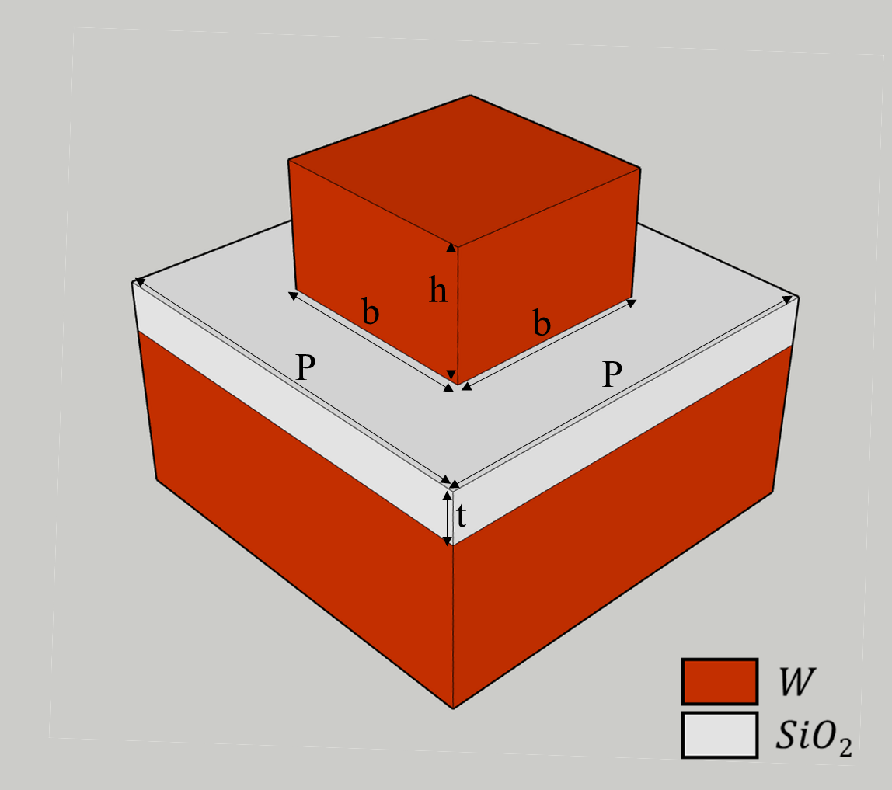
Fig. 5 Metal-dielectric-metal (MIM) periodic square surface structure.

Following the aforementioned square structure, the objective is to optimize the initial design shown in Fig. 6(a) into the structure presented in Fig. 6(b) in a three-dimensional (3D) schematic representation. Similarly, in a two-dimensional (2D) projection, this transformation is illustrated from Fig. 6(c) to Fig. 6(d). The starfish-like configuration was deliberately chosen because it combines geometric symmetry, which supports broadband absorption, with irregular edge features that can be systematically optimized. Compared with purely random or fractal patterns, the starfish design offers a balance between structural complexity and controllability, making it particularly suitable for PSO-based optimization. A closer examination of Fig. 6(c) reveals that the initial geometric configuration is first divided along one of the symmetry axes of the surface square structure. This division results in three adjacent strip-like segments. Each of these initial strip structures has a length of 125 nm and a width of 50 nm, with the lowest strip positioned precisely on the symmetry axis. While the width of each strip remains fixed at 50 nm, their respective lengths are redefined as optimization variables: w₁, w₂, and w₃. These three adjacent strips are rotated by 90 degrees around the central symmetry axis of the square unit, forming the newly optimized surface pattern. The optimization objective function is to maximize the total solar absorption, defined as $α_{total}$, which represents the total solar irradiance absorbed by the structure :

$α_{total}=\frac{\int_{0.3μm}^{2.5μm}{α_{λ}{ I}_{AM1.5G}\left(λ\right)dλ}}{\int_{0.3μm}^{2.5μm}{{ I}_{AM1.5G}\left(λ\right)dλ}}$ (2)
Here, $α_{λ}$​ represents the absorptance at wavelength $λ$, while ${ I}_{AM1.5G}\left(λ\right)$ denotes the AM1.5G solar irradiance intensity corresponding to wavelength $λ$. It allows us to identify an optimized structure that more closely aligns with the design of an ideal solar absorber. The optimization method employed in this study is Particle Swarm Optimization (PSO), a population-based stochastic optimization technique. In our implementation, the swarm size was set to 5 with a fixed budget of 1000 iterations; no early stopping or convergence tolerance was applied, and the optimizer ran for all 1000 iterations to assess convergence. PSO has been widely used in various fields, including nanophotonic design, where it has been applied to optimize structures for enhanced performance.²⁴⁻²⁶

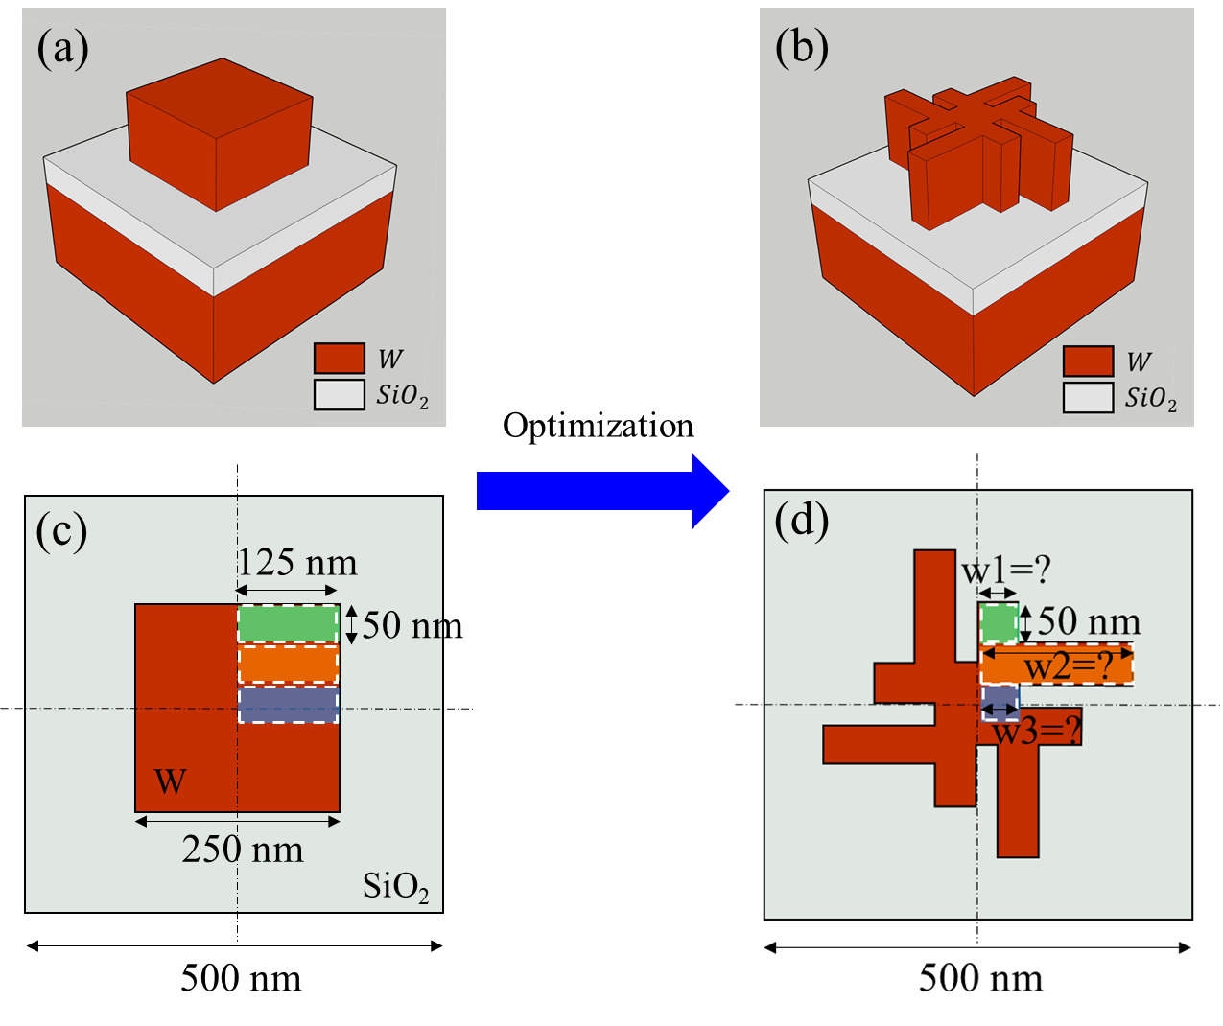
Fig. 6 Transformation of the original square structure into a Strip-Combined Structure through optimization.

3. Results and discussion
Numerical simulations were performed using the finite-difference time-domain (FDTD) method (Lumerical FDTD Solutions, Ansys). The FDTD method was chosen because it can accurately capture broadband responses and complex periodic geometries. While RCWA is a standard tool for periodic gratings, it often requires a very large number of Fourier harmonics to converge for lossy metallic nanostructures with sharp edges, making FDTD a more efficient and reliable approach for our study. Perfectly matched layer (PML) boundaries were applied in all directions. A normally incident, linearly polarized plane-wave source was employed. An auto non-uniform mesh with a minimum step size of 2.5 nm was used in the nanostructure region to ensure convergence. Reflection and transmission spectra were recorded by frequency-domain power monitors, and absorptance was calculated as A=1−R−T. Optical constants of W and SiO₂ were taken from Palik’s experimental datasets.²⁰ Subsequently, the optimized variables w1, w2, and w3 are converged into 50 nm, 186 nm, and 50 nm, respectively. Fig. 7(a) illustrates the solar absorption performance of the initial square structure. It demonstrates a relatively high performance, achieving an overall total solar absorption ($α_{total}$) of 90.5%. However, there is still a noticeable lack of absorption in the wavelength ranges of 500–600 nm and 2000–2500 nm. After optimization, as shown in Figure 6(b), absorption in these wavelength regions is significantly improved, resulting in an enhanced total solar absorption ($α_{total}$) of 95%.
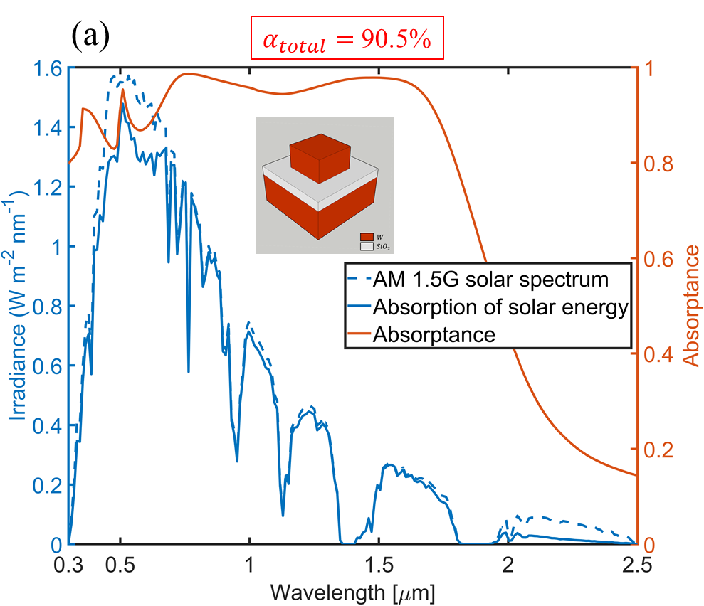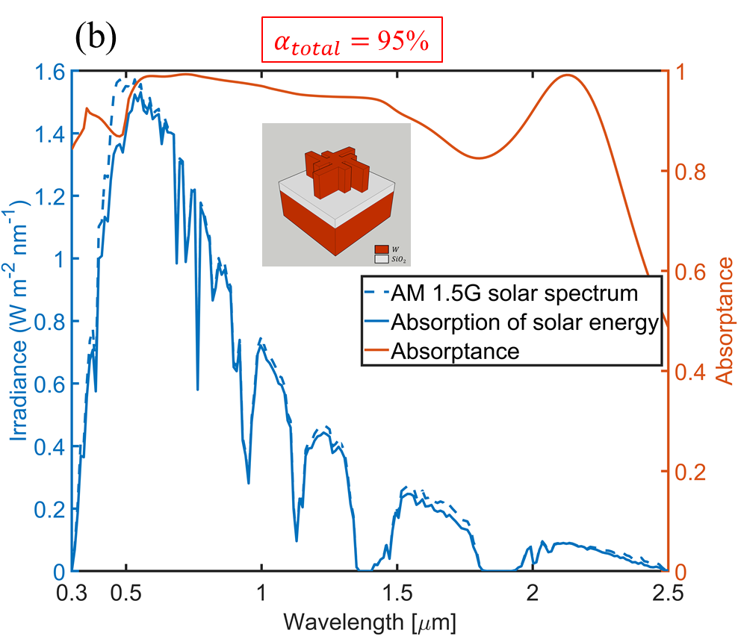

Fig. 7 Solar energy absorption performance before (a) and after (b) optimization. The blue dashed line represents the AM1.5G solar spectrum, the blue solid line represents the actual absorbed solar spectrum after considering the absorption rate, and the orange solid line represents the absorption rate spectrum.

To analyze the absorption variations of solar radiation in the wavelength ranges of 500–600 nm and 2000–2500 nm, we present the electric field distributions at two representative wavelengths: λ = 576 nm, where the solar irradiance is strong and the optimized structure achieves substantially higher energy absorption, and λ = 2124 nm, which also contributes to the solar spectrum and where the optimized structure shows improved solar energy absorption compared to the unoptimized case. According to the electric field distributions before and after optimization in Figs. 8 and 9, it is evident that the optimized structure significantly enhances the electric field intensity. Notably, in addition to the strong electric field at the outermost tips, the fine trenches surrounding the central region of the pattern also play a crucial role in enhancing the electric field intensity.

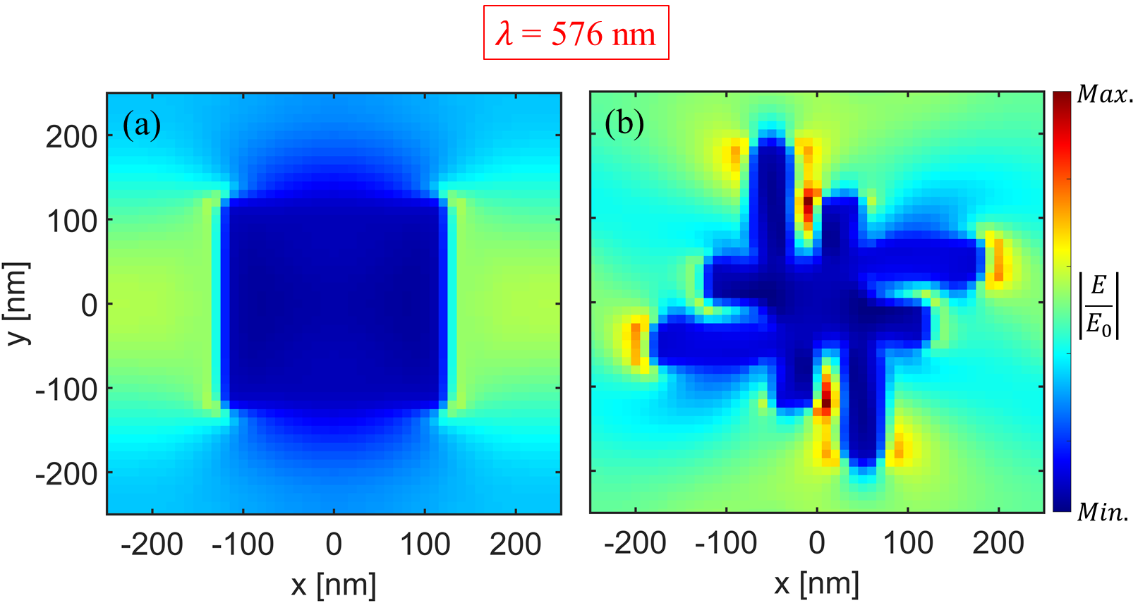
Fig. 8 Electric field distributions were obtained from FDTD simulations using near-field monitors under normally incident plane-wave excitation. Electric field distribution before (a) and after (b) optimization at a wavelength of 𝜆 = 576 nm, with the polarization direction of the simulated light parallel to the x-axis.
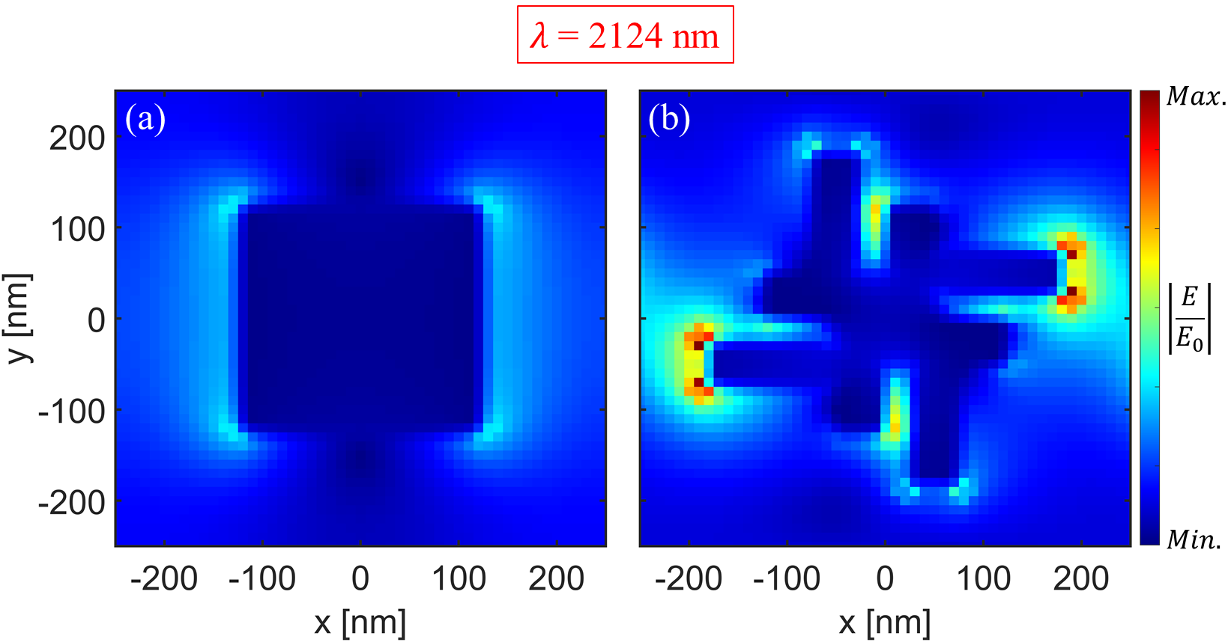
Fig. 9 Electric field distributions were obtained from FDTD simulations using near-field monitors under normally incident plane-wave excitation. Electric field distribution before (a) and after (b) optimization at a wavelength of 𝜆 = 2124 nm, with the polarization direction of the simulated light parallel to the x-axis.

We also conducted a discussion on the simulation of incident light angles. The absorption simulations mentioned earlier were all based on the assumption of normal incidence, meaning the incident angle was set to 0 degrees. As shown in Fig. 10, we simulated the variation of the α value for the optimized structure with incident angles ranging from 0 to 75 degrees. It can be observed that for incident angles between 0 and 30 degrees, the α value remains around 95%. When the incident angle increases to 45–60 degrees, the α value decreases to approximately 90%. Finally, at an incident angle of 75 degrees, the α value drops to around 75%.

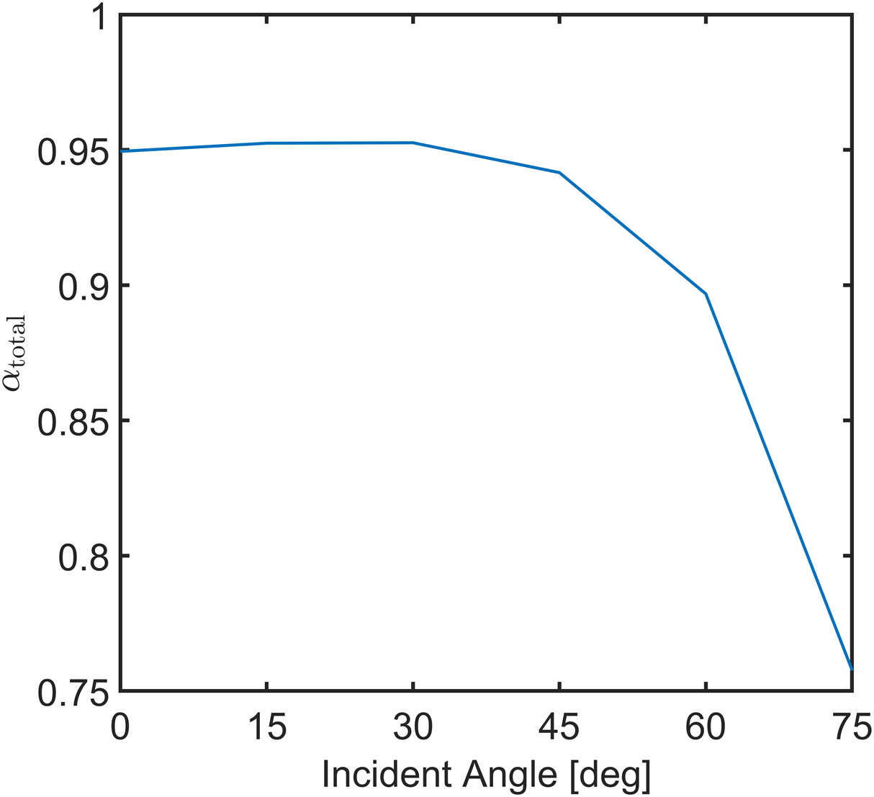
Fig. 10 Variation of the $α_{total}$ value with respect to different incident light angles for the optimized structure.

As shown in Fig. 11, the solar absorption simulation is based on an optimized structure replicated with the same dimensions using freehand drawing. This approach considers potential edge roughness caused by fabrication processes. The simulation results show that the α value is 94.8%, which is only slightly lower than the original 95%, suggesting that edge roughness has minimal impact on absorption performance.

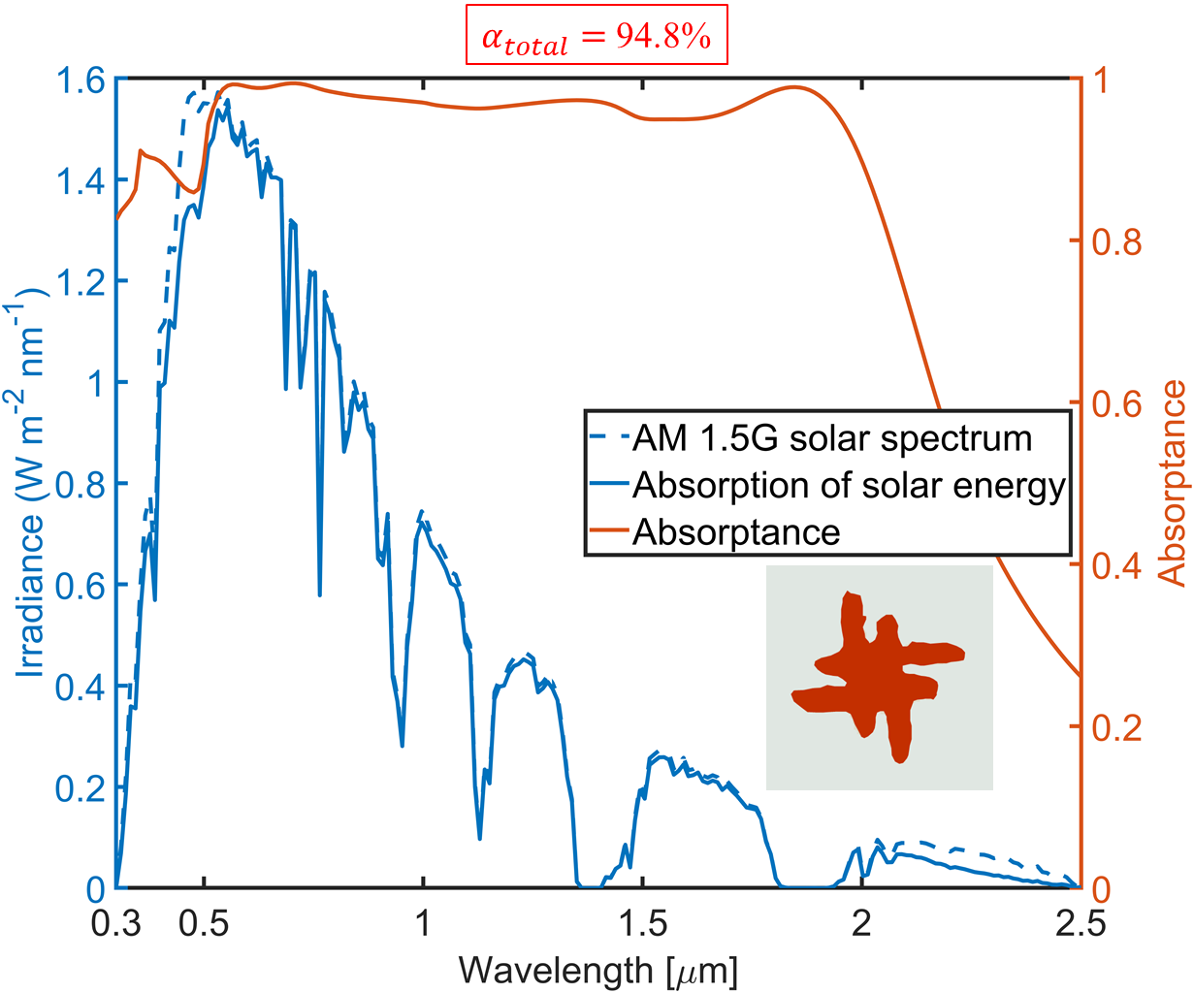
Fig. 11 Solar absorption simulation of an optimized structure replicated with the same dimensions using freehand drawing.

Fig. 12 presents the influence of the vertical shape size of the optimized structure on the α value. Given the optimized structural proportions, an edge angle of 81 degrees just reaches the formation of a sharp tip. Therefore, the investigation ranges from the original vertical 90-degree angle to an 81-degree angle. Notably, a slightly tilted 89-degree angle results in a marginally higher α value than the vertical 90-degree angle. However, as the angle decreases from 89 degrees to 81 degrees, the α value gradually declines, reaching approximately 93%. This indicates that the impact of fabrication-induced corner variations on the α value is relatively limited, which means that our absorber design is also fabrication error-tolerant. Moreover, fabrication can follow a standard microfabrication route, comprising thin-film deposition to form the metal/dielectric stack, ultraviolet (UV) lithography to define the photoresist mask, and reactive-ion etching (RIE) to transfer the pattern into the top functional layer.⁸

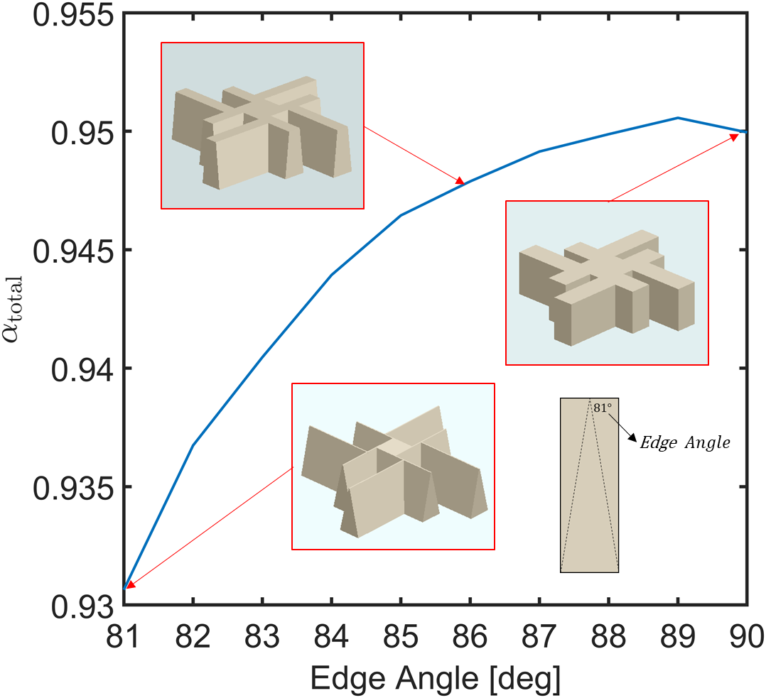
Fig. 12 Influence of the vertical shape size of the optimized structure on the $α_{total}$ value.

Next, we evaluate the effects of thermal emission. Assuming that our device operates at a steady temperature of 100°C under one-sun illumination (without special focusing), its optimized thermal emission performance is shown in Fig. 13. First, we observe that at 100°C, blackbody radiation primarily spans the wavelength range of approximately 2.5 to 20 μm. According to Kirchhoff’s law of thermal radiation, the emissivity at a given wavelength is equal to the absorptivity at the same wavelength. From this, we can see that the absorptance in the 2.5–20 μm range remains around 5%. Consequently, the actual thermal emission is nearly negligible when multiplying this absorptance by the blackbody radiation at 100°C.

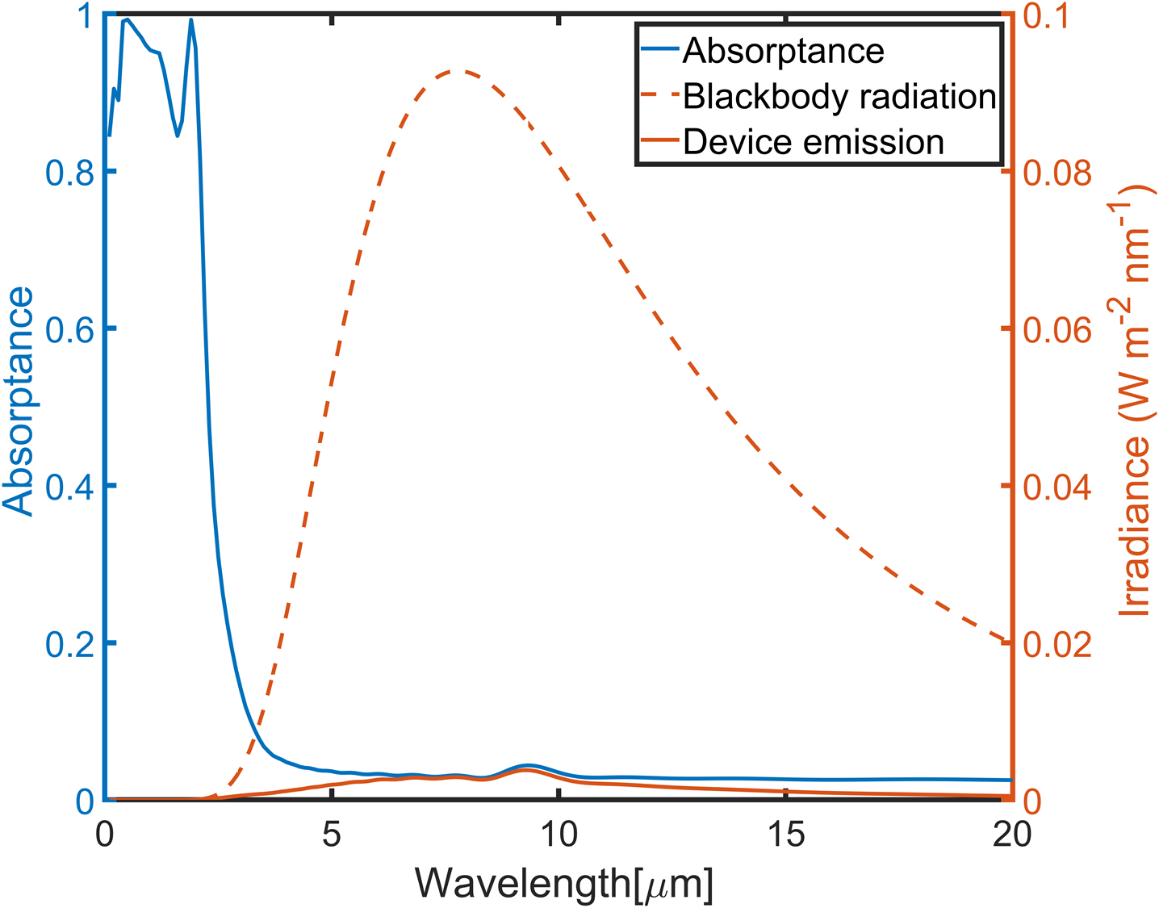
Fig. 13 Thermal emission performance of the optimized structure.

Finally, we calculate the photothermal conversion efficiency discussed in this study. This efficiency, denoted as 𝜂, is defined as the fraction of the total incident solar radiation energy (within the 0.3–2.5 μm wavelength range) that is absorbed (within the same wavelength range), minus the thermal emission loss caused by blackbody radiation (within the 0.3–20 μm wavelength range):

$η= \frac{\int_{0.3μm}^{2.5μm}{α_{λ}{ I}_{AM1.5}\left(λ\right)dλ}-\int_{0.3μm}^{20μm}{ε_{λ}{ I}_{B}\left(T_{abs}, λ\right)dλ}}{\int_{0.3μm}^{2.5μm}{{ I}_{AM1.5G}\left(λ\right)dλ}}$ (3)

where $α_{λ}$​ is the absorptance at wavelength λ, and ${ I}_{AM1.5G}\left(λ\right)$ represents the AM1.5G solar irradiance at wavelength λ. The emissivity $ε_{λ}$ follows Kirchhoff’s law of thermal radiation, which states that $ε_{λ}=α_{λ}$. The term ${ I}_{B}\left(T_{abs}, λ\right)$ denotes the blackbody radiation at the device’s operating temperature $T_{abs}$​ and wavelength λ. We also can define the total thermal emittance term as $ε_{total}$ :

$ε_{total} = \frac{\int_{0.3μm}^{20μm}{ε_{λ}{ I}_{B}\left(T_{abs}, λ\right)dλ}}{\int_{0.3μm}^{20μm}{{ I}_{B}\left(T_{abs} ,λ\right)dλ}}$(4)

Table 1 compares the results of this study with other solar absorbers reported in recent years. Overall, the $α_{total}$,$ε_{total}$, and $η$ values obtained in this study are competitive with, or in some cases comparable to, those reported previously. It should be noted that Ref. 30 achieved even higher experimental photothermal conversion efficiency, partly due to its nanoparticle-on-mirror design based on noble metal silver, which is inherently different from the starfish-type structure studied here based on refractory tungsten. While our approach is based on a relatively simple W/SiO2/W configuration optimized through PSO, many of the other studies in Table 1 adopt multilayer or more complex structures. Thus, the performance of our optimized structure remains notable considering its simplicity and distinct design principle.

Table 1 Comparison of solar absorbers
*: indicates values extracted from the cited reference and recalculated using Eq. (3) of this work for comparison.
Type | $$T_{abs}$$ | $$α_{total}$$ | $$ε_{total}$$ | $$η$$ | Ref.
W-palik/SiO2-palik/W-palik  Random struct  (Sim.) | $$100℃$$ | 0.9500 | 0.0317 | 0.9207 | This study
W/SiO₂/W  Square structure  (Sim.) | $$100℃$$ | 0.8872 | 0.0297 | 0.8601* | 4
(SiO₂/W)*15  Multilayer structure  (Sim.) | $$100℃$$ | 0.989 | - | - | 9
SiO2/Al₂O₃/W/Al₂O₃/W  Multilayer structure  (Exp.) | $$100℃$$ | 0.8719 | 0.0713 | 0.8072* | 10
W/Al₂O₃/W/Al₂O₃/W  Square ring + Multilayer  (Sim.) | $$100℃$$ | 0.9626 | - | - | 12
Si₃N₄/TiN/Si₃N₄/Ti/Si₃N₄/Ti  Ti and TiN multilayer ring structure  (Sim.) | $$102℃$$ | 0.9896 | 0.138 | 0.8608* | 13
SiO₂/TiN NPs/Ag  Multilayer structure  (Exp.) | $$100℃$$ | 0.94 | 0.02 | 0.92 | 30

Conclusions
This study presents simulation results of a solar absorber optimized using a combined strip structure with multiple lengths. We demonstrate that this starfish-like structure achieves better absorption performance for solar radiation and low heat re-radiation than the conventional designs. The optimized geometry enhances the electric field intensity, which improves the absorption effect of the nanostructure. Additionally, we performed simulations to predict the impact of practical fabrication processes and fabrication errors on the absorber's performance. Overall, the optimized design shows notable and competitive performance compared to other solar absorbers reported in recent studies.
Author contributions
We strongly encourage authors to include author contributions and recommend using CRediT for standardised contribution descriptions. Please refer to our general author guidelines for more information about authorship.
Conflicts of interest
In accordance with our policy on Conflicts of interest please ensure that a conflicts of interest statement is included in your manuscript here. Please note that this statement is required for all submitted manuscripts. If no conflicts exist, please state that “There are no conflicts to declare”.
Data availability
A data availability statement (DAS) is required to be submitted alongside all articles. Please read our full guidance on data availability statements for more details and examples of suitable statements you can use.
Acknowledgements
We acknowledge Dr. K. Shinozaki for sharing the needs and motivation of this OSA project, as well as for fruitful discussions and budgetary support from JAXA. We also thank Dr. T. D. Ngo and Dr. Yamada for the helpful discussions related to the random broadband structures and the potential effects of experimental errors on the MIM devices in general. This research was partially supported by the Dragon Gate Project under grant numbers NSTC 112-2926-I-002-510-G and 114-2926-I-002-505-G.
References
- Liangyao Chen, ed. Optical properties of solar absorber materials and structures. Springer, 2021.
- M. Imtiaz Hussain, Christophe Ménézo, and Jun-Tae Kim., Advances in solar thermal harvesting technology based on surface solar absorption collectors: A review, Solar Energy Materials and Solar Cells, 2018, 187, 123-139.
- U. Guler, A. Boltasseva, and V. M. Shalaev, Refractory plasmonics, Science, 2014, 344(6181), 263-264.
- H. Wang and L. Wang, Perfect selective metamaterial solar absorbers, Optics Express, 2013, 21(S6), A1078-A1093.
- A. S. Rana, et al., Tungsten-based ultrathin absorber for visible regime, Scientific Reports, 2018, 8(1), 2443.
- Q. Liang, et al., Perfect spectrally selective solar absorber with dielectric filled fishnet tungsten grating for solar energy harvesting, Solar Energy Materials and Solar Cells, 2020, 215, 110664.
- J. Li, et al., Broadband solar energy absorber based on monolayer molybdenum disulfide using tungsten elliptical arrays, Materials Today Energy, 2020, 16, 100390.
- P. Zeng, et al., Nanostructures/TiN layer/Al₂O₃ layer/TiN substrate configuration-based high-performance refractory metasurface solar absorber, Scientific Reports, 2024, 14(1), 25827.
- D. Wu, et al., Numerical study of a wide-angle polarization-independent ultra-broadband efficient selective metamaterial absorber for near-ideal solar thermal energy conversion, RSC Adv., 2018, 8(38), 21054-21064.
- Y. Tian, et al., Scalable-manufactured metal–insulator–metal based selective solar absorbers with excellent high-temperature insensitivity, Appl. Energy, 2021, 281, 116055.
- S. K. Patel, et al., Multi-layered Ti–Si solar absorber design based on tungsten material for solar thermal energy conversion, Int. J. Therm. Sci., 2023, 192, 108419.
- B. Qi, et al., A near-perfect metamaterial selective absorber for high-efficiency solar photothermal conversion, Int. J. Therm. Sci., 2023, 194, 108580.
- P. Wu, et al., Design of ultra-high absorptivity solar absorber based on Ti and TiN multilayer ring structure, Int. J. Therm. Sci., 2023, 183, 107890.
- J. Wang, et al., Large-scale broadband absorber based on metallic tungsten nanocone structure, Appl. Phys. Lett., 2017, 111(25).
- S. R. Mirnaziry, M. A. Shameli, and M. Danaeifar, Thermo-optical analysis of a nanocone based solar absorber for thermophotovoltaic applications, J. Phys. D: Appl. Phys., 2024, 58(4), 045505.
- M. Karimi Habil, M. Ghahremani, and C. J. Zapata–Rodríguez, Multi-octave metasurface-based refractory superabsorber enhanced by a tapered unit-cell structure, Sci. Rep., 2022, 12(1), 17066.
- F. Wu, et al., Spectrally selective ultra‐broadband solar absorber based on pyramidal structure, Adv. Photon. Res., 2024, 5(3), 2300305.
- A. Marzo, et al., Comparison of Atacama Desert solar spectra vs. ASTM G173-03 reference spectra for solar energy application, International Energy Society, Conference Proceedings, 2016.
- K. Zhang, R. Deng, L. Song, T. Zhang, Broadband near-infrared absorber based on all metallic metasurface, Materials, 2019, 12(21), 3568.
- E. D. Palik, Handbook of Optical Constants of Solids I–III, Academic Press, 1985–1998.
- L. Yu. Beliaev, E. Shkondin, A. V. Lavrinenko, and O. Takayama, Optical properties of plasmonic titanium nitride thin films from ultraviolet to mid-infrared wavelengths deposited by pulsed-DC sputtering, thermal and plasma-enhanced atomic layer deposition, Opt. Mater., 2023, 143, 114237.
- J. H. Weaver, D. W. Lynch, and G. D. Olson, Optical properties of metals, Phys. Rev. B, 1973, 10, 501.
- M. A. Ordal, R. J. Bell, R. W. Alexander, L. A. Newquist, and M. R. Querry, Optical properties of Al, Fe, Ti, Ta, W, and Mo at submillimeter wavelengths, Appl. Opt., 1988, 27, 1203–1209.
- J. G. Mutitu, et al., Thin film silicon solar cell design based on photonic crystal and diffractive grating structures, Opt. Express, 2008, 16, 5238.
- M. Shokooh-Saremi and R. Magnusson, Leaky-mode resonant reflectors with extreme bandwidths, Opt. Lett., 2010, 35, 1121.
- R. Magnusson, M. Shokooh-Saremi, and E. G. Johnson, Guided-mode resonant wave plates, Opt. Lett., 2010, 35, 2472.
- P. T. Tran, et al., Metal-insulator-metal strip spectroscopic infrared photothermal absorber based on uniaxially oriented plasmonic lanthanum hexaboride films, Opt. Express, 2022, 30, 38630–38642.
- A. Ruiz-Perona, et al., Optimizing the optical response of uniaxial cerium hexaboride films for high-temperature plasmonic applications, ACS Appl. Electron. Mater., 2025, 7, 2093–2101.
- T. D. Ngo, et al., Infrared thermophotonics: theoretical benchmarking of Ni–Al superalloys, Adv. Photon. Res., 2025, 6, 2400093.
- Y. Li, et al., Nanoparticle-on-mirror metamaterials for full-spectrum selective solar energy harvesting, Nano Letters, 2022, 22(14), 5659-5666.

