Partially oriented MgB₂ superconducting bulks with addition of B₄C and cubic BN obtained by slip casting under high magnetic field and spark plasma sintering

M. A. Grigoroscuta¹, G. Aldica¹, I. Pasuk¹, M. Burdusel¹, V. Sandu¹, A. Kuncser¹, T.S. Suzuki, O. Vasylkiv², P. Badica^{1*}

¹ National Institute of Materials Physics, Street Atomistilor 405A, 077125 Magurele, Romania
² National Institute for Materials Science, 1-2-1 Sengen, 305-0047 Tsukuba, Ibaraki, Japan

Corresponding author:
P. Badica
National Institute of Materials Physics, Atomistilor 405A, Magurele, Ilfov, 077125, Romania
email: badica2003@yahoo.com
fax: +40-213690177
ph: +40-21-3690185

Submitted to J. Eur. Ceram. Soc.
Partially oriented MgB₂ superconducting bulks with addition of B₄C and cubic BN obtained by slip casting under high magnetic field and spark plasma sintering

M. A. Grigoroscuta¹, G. Aldica¹, I. Pasuk¹, M. Burdusel¹, V. Sandu¹, A. Kuncser¹, T.S. Suzuki, O. Vasylkiv², P. Badica^{1*}

¹ National Institute of Materials Physics, Street Atomistilor 405A, 077125 Magurele, Romania
² National Institute for Materials Science, 1-2-1 Sengen, 305-0047 Tsukuba, Ibaraki, Japan

Abstract

Dense discs with starting compositions (MgB₂)_{0.99}(B₄C)_{0.01} and (MgB₂)_{0.99}(c-BN)_{0.01} were fabricated by slip casting under a magnetic field H₀ (perpendicular on the surface of the disc) of 12 T and subsequent spark plasma sintering. As-processed bulk material shows (00l) partial orientation of the MgB₂. The degree of orientation is about 13 and 9 % when using B₄C and c-BN additives. From magnetic measurements with magnetic field H parallel and perpendicular to H₀, superconducting parameters were extracted and they present anisotropy. The maximum values of high field critical current density J_{c} and irreversibility field µ₀H_{irr} are for H//H₀ and these values are higher or similar than for randomly oriented samples. For the same orientation the critical temperature at midpoint T_{c, mid} of transition is slightly lower and suggests an anisotropic influence of carbon substituting for boron in MgB₂. The volume pinning force F_{p, max} and T_{c, mid} are lower in the partially than in randomly oriented samples. The pinning-force-related parameters depend on the additive and orientation and establishing the major pinning mechanism based on them within scaling and percolation models is not reliable. A method to scale the normalized volume pinning force vs. reduced magnetic pinning force is proposed by involving a Gauss function: for the randomly oriented samples a single Gauss function works well, while for partially oriented samples (regardless H//H₀ or H⊥H₀) a double Gauss function was necessary since in these samples a second maximum in F_{p} occurs.

Keywords: MgB₂, B₄C and c-BN additions, critical current density, pinning force, c-axis texture
1. Introduction

Superconducting properties of MgB₂ are widely investigated in relation with additions, microstructures, and processing technologies. It is noteworthy that indicated factors are not independent and one has to pay attention to their synergetic and complex nature. In general, a high density and nanostructured material is necessary to achieve enhancement of the flux pinning, of the critical current J_{c}, and of the irreversibility field µ₀H_{irr}. Higher J_{c} and µ₀H_{irr} values can boost applications of MgB₂ with significant commercial impact.
In our work, we have prepared high density bulk samples of MgB₂ by spark plasma sintering (SPS) [noi Phys C primul]. The route we apply is defined in literature as ex situ, i.e. the raw material is the powder of the MgB₂ compound. In the in situ routes, two powders that contain separately Mg and B are the raw materials and MgB₂ forms by chemical reaction between Mg and B. We tested different additions [noi carte 2017]. For our technology, among the most efficient for improvement of the superconducting parameters were B₄C [noi Mater Res Bull] and cubic BN (c-BN) [noi SUST].
Recently, we successfully fabricated partially c-axis oriented pristine MgB₂ bulk samples [noi SUST orient1]. The texture of MgB₂ was obtained by combining slip casting under a high magnetic field of 12 T and further SPS processing. Our promising results enable continuation of the studies targeting improvement of the superconducting functional parameters such as J_{c} and H_{irr} by taking advantage of the anisotropic nature of MgB₂. The details of pinning in textured MgB₂ bulk also deserves attention. Hence, fabrication and characterization of partially textured MgB₂ bulks with additives is the next natural course of investigation and this is the aim of this work. The criteria for selection of the additives, B₄C and c-BN, are not only their positive influence on pinning, J_{c}, and µ₀H_{irr} as already mentioned in the previous paragraph, but also the fact that B₄C is anisotropic (rhombohedral) and it was demonstrated that it can be aligned by magnetic slip casting [?? de cautat], while c-BN is isotropic (cubic).

2. Experimental

Raw powders were MgB₂ (Alfa Aesar, 99.5%, metals basis purity), B₄C (Sinopharm, ?? Oleg/Mihai) and c-BN (???Oleg/Mihai). They were mixed and composition was (MgB₂)_{0.99}(A)_{0.01}, where A denotes the additive B₄C or c-BN. The starting composition was set based on our previous studies: (MgB₂)_{0.99}(A)_{0.01}, A = B₄C or c-BN is the optimum composition to maximize J_{c} and µ₀H_{irr} [noi B4C, c-BN]. Powder mixtures were processed by magnetic (H₀ = 12 T) slip casting and details are presented in ref. [17 din noi SUST orient1]. In the slip casting process, as a dispersing agent, the polyethyleneimine (PEI) (molecular weight = 10000, Wako Pure Chemical Industries Ltd., Japan) was used. The as-fabricated green bodies were loaded into a graphite mold system and SPSed by using a FCT Systeme GmbH – HP D5 (Germany) furnace. The SPS temperature was 1150 °C for a dwell time of 30 min. The heating rate was 110 °C/min. The maximum uniaxial pressure applied on the sample was P = 95 MPa. The direction of P coincides with direction of H₀ used in magnetic slip casting processing. Discs of ~20 mm in diameter and 4 mm thickness were obtained. Reference samples (‘b’ and ‘d’ in Table 1), randomly oriented and with composition (MgB₂)_{0.99}(A)_{0.01}, A = B₄C or c-BN, were prepared by SPS for 3 min. These samples were not subject of high field slip casting (HFSC).
The apparent densities ρa^{SPS} (Table 1) of sintered discs were measured by Archimedes method. The theoretical densities ρt^{SPS} of the composites were determined [18 din noi SUST orient1] considering the X-ray diffraction (XRD) patterns and the weight fraction (Table 1) of MgB₂ (2.63 g/cm²), MgO (3.58 g/cm²), and MgB₄ (2.49 g/cm³) phases obtained from Rietveld simulations (MAUD 2.31 [19 din noi SUST orient1]). The c-BN additive does not react with MgB₂ [noi SUST], while B₄C reacts with MgB₂ during SPS processing. [noi Mater Res Bull]. Phases c-BN and residual unreacted B₄C (<1.3 wt. %) were not included in Rietveld analysis and in calculation of the theoretical density. The relative densities R^{SPS} (%) were estimated with formula: R^{SPS}=ρa^{SPS} / ρt^{SPS} x 100 (Table 1).
XRD patterns were measured with Bruker AXS D8 Advance diffractometer (CuK_{α} radiation). The a and c lattice parameters of MgB₂, the crystallite size for different phases, and the residual micro strain were determined by Rietveld analysis (Table 1). The shape of crystallite in estimation of the crystallite size is considered spherical. The amount of carbon z substituting for boron in the crystal lattice of MgB₂ (Mg(B_{1-z}C_{z})₂) depends on the lattice parameter a (nm). Considering results from refs. [21-23], the dependence is: z = -21.9 a + 6.76 [20]. Orientation of MgB₂ was assessed by using the March Dolase orientation factor r [33, 34 din noi SUST orient1], the degree of orientation η [33, 34 din noi SUST orient1], the orientation angle ϕ [34 din noi SUST orient1 si noi SUST1], and the Lotgering factor LF [35 din noi SUST orient1] (Table 1).
A PPMS-14T (Quantum Design) equipment was used to measure the magnetization curves with temperature m(T) and hysteresis loops m(H) at different temperatures. Samples were cubic, cut from the center of the discs with the size of 1 × 1 × 1 mm³. The critical current density J_{c} (in A⋅cm⁻²) was calculated with the Bean formula for a cubic geometry [36 din noi SUST orient1]:
$J_{c}=30\left|m↑-m↓\right|/l^{4}$ (1)
where m is the magnetic moment in emu for the increasing m↑ and decreasing m↓ magnetic field, and l is the side of the cube in cm. The irreversibility ﬁeld H_{irr} was determined with the criterion J_{c}(H_{irr}) = 10² A/cm².

3. Results and Discussion

3.1. Bulk density and structural details

Samples prepared by SPS have high relative densities, above 94 % (Table 1). The relative density is higher for the partially oriented samples ‘c’ (99 %) and ‘e’ (98%) than for randomly oriented samples ‘b’ (94.7 %) and ‘d’ (97.7 %). The authors of refs. [noi Phys. C primul si din Phys C primul SUST englezii??] found that the influence of relative density on critical current density, when above 90 %, is small. This observation is taken as the background that enables a comparative analysis of the superconducting properties among the randomly and partially oriented samples from this work (see Section 3.2).
Samples present also other differences and the reasons are related to different SPS dwell times at 1150 °C, namely 3 min for randomly oriented samples ‘b’ and ‘d’ and 30 min for partially oriented samples ‘c’ and ‘e’, and to the use of PEI during processing of the partially oriented samples ‘c’ and ‘e’. Although partially oriented samples ‘c’ and ‘e’ have higher relative densities as mentioned, they contain a lower weight fraction of MgB₂ phase: 70 / 74 wt. % in samples ‘c’ / ’e’ versus 78.9 / 81.4 wt. % in samples ‘b’ / ‘d’. Due to PEI presence during processing, partially oriented samples ‘c’ / ’e’ show higher z-values (0.0192 / 0.146) of carbon substituting into the crystal lattice of MgB₂ than for randomly oriented samples ‘b’ / ’d’ (0.0102 / 0.0083). One also observes that z in samples ‘b’ / ‘c’ (0.0102 / 0.0192) added with B₄C is higher while the weight
fraction of MgB₂ is lower (78.9/70 wt.%) than for the corresponding samples ‘d’ / ’e’ (0.0083 / 0.0146 and 81.4 /7 4 wt. %). As expected, B₄C reacts with MgB₂ [noi Mater Res Bull] and supplies

Table 1. March-Dollase orientation factor (r), Lotgering factor (LF), degree of preferred orientation (η), orientation angle ϕ, lattice parameters of MgB₂, amount of carbon (z) in Mg(B_{1-z}C_{z})₂ lattice, crystallite size, residual micro strain, and relative density R^{SPS} and midpoint critical temperature T_{c,mid}.

Sample* |  | r | LF[%]  /η [%]  (ϕ) [°] | Lattice parameters of MgB₂ |  | z | Phase content [wt. %] / Crystallite size [nm] |  |  | Micro  strain in MgB₂ [%] | R^{SPS} [%] | T_{c, mid}  [K]
 |  | r | LF[%]  /η [%]  (ϕ) [°] | a [Å] | c [Å] | z | MgB₂ | MgB₄(Mg) | MgO | Micro  strain in MgB₂ [%] | R^{SPS} [%] | T_{c, mid}  [K]
‘a’ | MgB₂ raw powder | - | 0 / - | 3.0876 | 3.5248 | 0.002 | 88.0 / 113 | 4.6(0.3) / 100(91) | 7.1 /  31 | 0.09 | - | -
‘b’ | SPS  MBBC randomly oriented | - | 0 / - | 3.0821 | 3.5277 | 0.0102 | 78.9/ 170 | 13.3 /  72 | 7.8 /  85 | 0.175 | 94.7 | 37.48
‘c’ | HFSC+ SPS MBBC;  S_{top} | 0.796 | 14 / 13 / (50°) | 3.0780 | 3.5246 | 0.0192 | 70 / 186 | 20 /  91 | 10 /  93 | 0.15 | 99 | 37.42
‘c’ | HFSC + SPS MBBC; S_{lateral} | - | - | - | - | - | 70 / 232 | 19 /  101 | 11 /  103 | 0.12 | - | 37.02
‘d’ | SPS  MBBN  randomly oriented | - | 0 / - | 3.0835 | 3.5292 | 0.0083 | 81.4 / 160 | 10.9 /  54 | 7.7 / 116 | 0.142 | 97.7 | 37.98
‘e’ | HFSC+ SPS MBBN; S_{top} | 0.847 | 9 / 9.4 / (51°) | 3.0801 | 3.5247 | 0.0146 | 74 / 174 | 15 /  80 | 11 /  78 | 0.14 | 98 | 37.88
‘e’ | HFSC + SPS MBBN; S_{lateral} | - | - | - | - | - | 75 / 228 | 14 /  93 | 11 /  88 | 0.11 | - | 37.85
Note: * Notations are: HFSC=high field slip casting; MBBC = MgB₂ added with B₄C; MBBN = MgB₂ added with cubic BN; XRD was performed on S_{top}= top surface of the disc and on S_{lateral} = surface perpendicular to S_{top} and parallel to the thickness of the disc.

carbon, thus, contributing to enhancement of z. Another source of carbon is the graphite mold used during SPS. The raw powder of MgB₂ has the lowest z-value (0.002).
In general, a higher z is accompanied by larger values of the micro strain in MgB₂. This is valid if we compare randomly oriented samples ‘b’ and ‘d’ or partially oriented samples ‘c’ and ‘e’. Situation changes when samples ‘b’, ‘c’ with B₄C and ‘d’, ‘e’ with c-BN are compared: the dependence between z and micro strain is reversed (Table 1). It is also noteworthy that micro strain presents anisotropy in the partially oriented samples ‘c’ and ‘e’. The micro strain is smaller when XRD is measured on the surface S_{lateral} of the sintered disc (Table 1) than for the surface S_{top}. This can be understood in the view of differential directional coarsening of MgB₂ during SPS, this process being influenced by the MgB₂ orientation. The crystallite size of MgB₂ in partially oriented samples ‘c’ and ‘e’ when measured on S_{top} and S_{lateral} show different values, namely for S_{top} (186, 174 nm) is smaller than for S_{lateral} (232, 228 nm). This tendency is observed also for the phases MgB₄ and MgO. The crystallite size of the randomly oriented samples ‘b’ and ‘d’ for phases MgB₂ (170 / 160 nm), MgB₄ (72 / 54 nm) and MgO (85 / 116 nm) are in general lower than for partially oriented samples ‘c’ and ‘e’ (186 and 232 / 174 and 228 nm for MgB₂, 91 and 101 / 80 and 93 nm for MgB₄, 93 and 103 / 78 and 88 nm for MgO). An exception is the relatively high value of MgO crystallite size in sample ‘d’. Results suggest that orientation promotes crystallite size enhancement and this is in agreement with our previous findings for partially oriented pristine MgB₂ bulk [noi SUST orient 1]. However, the statement needs careful consideration because additives may contribute to different processes including MgB₂ orientation and further to crystallite size evolution. Although the influence of the additive on crystallite size is not significant, we note that samples ‘d’ and ‘e’ with an inert c-BN addition show mostly lower crystallite size values (exception is large value for MgO in sample ‘d’) than for samples ‘b’ and ‘c’ with a reactive B₄C additive (Table 1). The orientation factors LF and η are higher (March Dollase orientation factor r is smaller) in the sample ‘c’ with B₄C (∼ 13 %) than in sample ‘e’ with inert c-BN (∼ 9 %) for a similar value of the orientation angle ϕ (∼ 50 °). The difference may come from the fact that Mg and C form a low temperature Mg-C eutectic (4?? °C) [?? Vezi noi Mater Res Bull cu B4C] and this can aid orientation formation during SPS. Noteworthy is also that partially oriented samples with additives from this work present a lower degree of MgB₂ orientation than for the pristine sample from ref. [??noi SUST orient1] (∼ 23 %).
This Section indicates on the different influence of the additives when samples are randomly oriented or partially oriented: parameters such as degree of MgB₂ orientation, crystallite size, z-carbon, micro strain and phase assembly show changes with different amplitudes. Some tendencies in the partially oriented samples such as carbon behavior and anisotropy of the micro strain require further research.

3.2 Temperature dependence of magnetization and magnetic susceptibility

The temperature dependence of magnetization and of magnetic susceptibility is shown in Fig.1. Zero-field-cooling (ZFC) magnetization was normalized to its value at 35 K, while susceptibility data were normalized to susceptibility of an ideal superconductor χ_{id} = 1/4π and corrected for demagnetization effects with demagnetization factor N. Measurements were performed in a field of 100 Oe, lower than lower critical field, H_{c1} (??? [poate Buzea/Yamashita SUST???]) to avoid the effects of vorticity at low temperatures so that the volume fraction of superconductor can be estimated.

(a) | 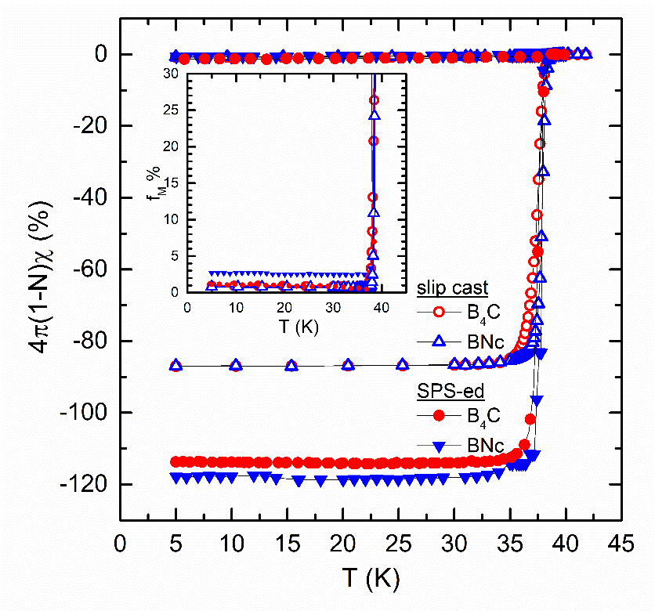  (b)
Fig. 1 (a) - Reduced magnetization curves vs. temperature for MBBC and MBBN, oriented and randomly oriented) samples ‘b’-‘e’; (b) - Temperature dependence of the normalized magnetic susceptibility χ for samples ‘b’-‘e’ (for partially oriented samples ‘c’ and ‘e’ applied magnetic field H is parallel to H₀). Inset shows the temperature dependence of the Meissner fraction f_{M}.

The critical temperature of the samples taken as the onset of transition T_{c, onset} is about 39-39.2 K, i.e. it is considered constant. The shape of the reduced magnetization curves m(T) / m(35 K) versus temperature is different. To compare samples we determined the midpoint critical temperature T_{c, mid} for m(T) / m(35 K) = 0.5. Values of T_{c, mid} are gathered in Table 1. Due to a higher z-carbon, in partially oriented samples ‘b’ and ‘d’ the values of T_{c, mid} are lower and transitions are larger than in randomly oriented ones ‘c’ and ‘e’. Moreover, for sample ‘c’ added with a reactive additive, B₄C, the difference in T_{c, mid} values for the two measurements with applied magnetic field H perpendicular and parallel with S_{top} is significant, of 0.4 K. One order of magnitude smaller difference (0.03) is encountered for sample ‘e’ (0.03 K) added with an inert additive, c-BN. This result suggests that in the oriented samples, the influence of carbon (especially of the carbon supplied by B₄C in sample ‘c’) on T_{c, mid} is anisotropic. The layered structure of MgB₂ with alternating planes of Mg and B provides the background for a different influence of a defect or local strain (e.g. induced by the substitution of B by C) on the electromagnetic properties of the MgB₂ crystal in the ab-plane and out-of-plane.
The shielding volume fraction, as obtained from the low temperature data of susceptibility at 5 K (Fig. 1b) is very high in partially oriented samples ‘c’ and ‘e’, of about 87 %. At that temperature, the applied field H is smaller than H_{c1} and the sample is expected to be in the Meissner state, i.e., the induced currents would screen the sample from the applied field and sample behaves close to an ideal diamagnetic sample. Therefore, the shielding volume fraction is larger than the real superconducting volume fraction: indeed as addressed in Section 3.1, SPSed samples contain substantial amounts of non-superconducting MgO and MgB₄ phases. The ratio between FC (field-cooling) and ZFC susceptibility χ_{FC} and χ_{ZFC} ($f_{M}=\frac{χ_{FC}}{χ_{ZFC}}$), i.e. the Meissner fraction [A. M. Campbell, F. J. Blunt, J. D. Johnson, and P. A. Freeman, Cryogenics 31, 732 (1991)] at temperatures T_{c1} where the lower critical field H_{c1} is equal to the measuring field H = 100 Oe, gives information on the strength of the pinning γ_{c1} at that temperature [J. R. Clem, Z. Hao, Phys. Rev. B 48 13774 (1993)]. Specifically, f_{M} = f(1-γ_{c1}/2n), where f < 1 is a dimensionless factor and 1 ≤ n ≤ 3 depicts the temperature decrease of the critical current density. The Meissner fraction for the two samples partially oriented samples ‘c’ and ‘e’ is small, f_{M} = 0.9 % and f_{M} = 0.79 %, respectively. It indicates that pinning is rather strong in both samples with a slight improvement for the sample ‘e’ with c-BN. The comparison with the randomly oriented samples show a decrease of the Meissner fraction f_{M} and an enhancement of the pinning strength γ_{c1}: f_{M} is 1.1 and 0.9 % for samples ‘b’ and ‘c’ added with B₄C and it has a more consistent decrease from 2.7 to 0.79 % for samples ‘d’ and ‘e’ added with c-BN.
In summary, Section 3.2 indicates on the non-trivial electromagnetic behavior of the samples depending on orientation and additives. For a deeper insight, in the next Section 3.3 the details of critical current density, irreversibility field, and pinning force aspects are addressed.

3.3. Critical current density, irreversibility field, and pinning force

Magnetic critical current densities at 5 and 20 K are presented in Fig. 2 a, b. In partially oriented samples ‘c’ and ‘e’, J_{c} at high magnetic fields for an applied magnetic field H // H₀ is higher than for H ⊥ H₀ and it is similar or even higher than for the corresponding randomly oriented

(a) | (b)
(c) | 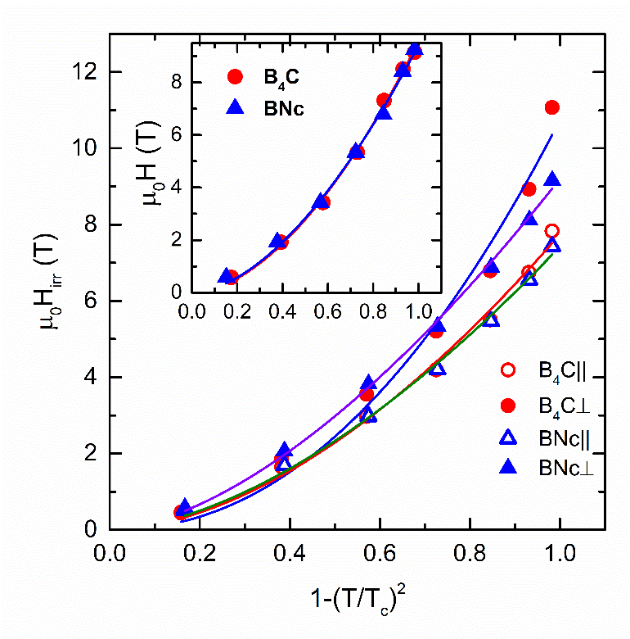  (d)
(e) | (f)
Fig. 2 Critical current density curves J_{c}(μ₀H) at 5 K (a) and 20 K (b); Irreversibility field curves µ₀H_{irr}(T) (c); Irreversibility field µ₀H_{irr} as a function of reduced temperature 1- (T/T_{c})² for partially oriented samples (d) and for randomly oriented samples (inset): lines are fits with eq. (2); Zero-field critical current density curves J_{c0}(T) (e); (J_{c0} x μ₀H_{irr}) vs. temperature (g).

samples ‘b’ and ‘d’. This result is also reflected by the curves of irreversibility field H_{irr} with temperature from Fig. 2c. The largest values of H_{irr} are for sample ‘c’ when H // H₀. This result is remarkable since we have seen that the weight fraction of MgB₂ is smaller and the crystallite size is larger in the partially oriented samples than in the corresponding randomy oriented ones. A larger crystallite size leads to a lower density of grain boundaries. The grain boundaries are recognized as effective pinning centers in MgB₂. A higher density of grain boundaries and better conectivity for less non-superconducting phases are the ingredients for enhancement of J_{c} and H_{irr}, but this is the specific situation for the randomly oriented samples with lower J_{c} and H_{irr}. Our results enable further enhancement of J_{c} and H_{irr} through additives and orientation, and promotes new practical developments.
The irreversibility field (Fig. 2d) roughly obeys the law:
$H_{irr}=H_{irr}\left(0\right){\left[1-{\left(\frac{T}{T_{c}}\right)}^{2}\right]}^{β}$, (2)
The exponent β takes close values for partially oriented sample ‘e’ added with BN, β = 1.67 ± 00.08 (H ⊥ H₀) and β = 1.62 ± 0.05 (H // H₀). For sample ‘c’ added with B₄C, the difference between the exponents is rather consistent, β =1.76 ± 0.11 (H ⊥ H₀) and β = 2.13 ± 0.22 (H // H₀). Randomly oriented samples, ‘b’ and ‘d’, follow the same temperature dependence (Fig. 2d inset): despite different additives, β -values are not much different, i.e. β = 1.78 ± 0.06 and β = 1.73±0.0.07, respectively. This paragraph confirms results from the previous one, namely that orientation has a considerable effect on the samples added with B₄C.
When the amount of carbon in the samples is higher, H_{irr} is enhanced, but, in general, the zero-field critical current density J_{c0} decreases. This tendency can be observed for our samples, although variation among samples ‘b’-‘e’ is within a relatively small range (0.58 – 0.72 MA/cm² at 5 K). The highest H_{irr} (as-observed in partially oriented samples ‘c’ and ‘e’ for H // H₀) is accompanied by the lowest J_{c0} (Fig. 2e). This correlates also with assumed anisotropic influence of the carbon expected from the stronger decrease of T_{c, mid} for H // H₀ than for H ⊥ H₀, presented in Section 3.2. The relatively more significant variation of H_{irr} than of J_{c0} mostly controls the quality product J_{c0}⋅µ₀H_{irr}. The lowest values of the product (Fig. 2f) as well as of H_{irr} (Fig. 2 c) are in the partially oriented samples when H ⊥ H₀, while for all the other situations the product shows almost similar values. The quality product has no theoretical or practical meaning and it is only used to compare samples from the viewpoint of the balance between the low and high field functional superconducting characteristics of the samples.
The dependence of the pinning force, F_{p} = J_{c}B, normalized by its maximum value, F_{p,max} with reduced field h = H/H_{irr} is shown for 20 K in Fig. 3a and for all temperatures in Fig. 1 Supplementary Material. The dependence of F_{p,max} with temperature is shown in Fig. 3 b. Higher values of F_{p,max} are for the randomly oriented samples than for partially oriented ones. For the oriented samples ‘c’ and ‘e’ the values of F_{p,max} when H ⊥ H₀ and H // H₀ are not much different. This situation is not special since the values of J_{c} are not much different at low and intermediate fields where F_{p} is maximum.

(a) | (b)
(c) | (d)

Fig. 3 (a) - Normalized pinning force f_{p} as a function of reduced magnetic field h at 20 K; (b) - maximum pinning force as a function of temperature; (c), (d) – pinning force parameters h₀ and k_{n} as a function of temperature.

Dew-Hughes [Dew-Hughes D 1974 Philos. Mag. 30 293] proposed the following relationship
f_{p} = A⋅h^{p}(1-h)^{q} (3)
and defined h₀ = 0.2, p = 0.5, q = 2 for surface (grain boundary) pinning (GBP) and h₀=0.33, p = 1, q = 2 for pinning on point defects (PP). The pinning force parameter h₀ is h at f_{p} = 1. Considering the percolation aspects, Eisterer [??], introduced the pinning force parameter k_{n}=h₀/h₁ where h₁ = h(f_{p} = 0.5). For PP and GBP it takes the value 0.34 and for GBP 0.47. The dependencies of h₀ and k_{n} with temperature are presented in Fig. 3 c and d. In the partially oriented samples ‘c’ and ‘e’ for H // H₀, h₀ takes unusually low values, around 0.1 at 5 K and 0.18 at 30 K (Fig. 3c). The h₀₋values for H ⊥ H₀ are closer to theoretical values and they are similar or lower than for randomly oriented samples. This distribution remains valid for k_{n}, but separation among the curves is larger and k_{n}(‘d’)> k_{n}(‘b’)> k_{n}(‘e’, H ⊥ H₀)> k_{n}(‘c’, H ⊥ H₀). When one compares curves of h₀(T) and k_{n}(T), the k_{n}(T) curve for sample ‘c’, H ⊥ H₀ is located at very low k_{n}-values, even below those for sample ‘e’, H // H₀. Another observation of interest is that, although both h₀ and k_{n} are increasing with temperature, i.e. the share of GBP is stronger at low than at high temperatures, the values of k_{n} are above 0.33 and this suggests that the major pinning mechanism is of PP type. As mentioned, h₀ takes low values, between 0.1 and 0.3, and it would correspond to a major GBP mechanism. Encounted differences in the behavior of h₀(T) and k_{n}(T) indicate that the two pinning force parameters are sensitive in a different manner to sample’s specifics. Therefore, k_{n} is not a direct rescaled measure of h₀, it is more sensitive than h₀, and its physical meaning requires refinement. Presented situation also indicates that different pinning mechanisms are active in our samples and they are depending on the additive and MgB₂ orientation.
According to eq. (3), the plot of $\frac{d\text{ln}\left(f_{p}\right)}{d\text{ln}\left(h\right)}$ vs. x = h/(1-h) is supposed to be linear given that p and q exponents are acceptable. However, the plots provide unphysical high exponents for low fields (p ~2, q ~ 10) and more moderate at higher fields (p ~2.5, q ~ 4.5), but also hard to find a correct physical interpretation. Following the analyses of Wordenweber et al. [R Wordenweber, K Heinemann, G V S SastryS and H C Freyhardt 1989 Supercond. Sci. Technol. 2 207] and Eisterer et al. [M. Eisterer, M. Zehetmayer, and H.W.Weber 2003 Phys. Rev. Lett. 90 247002] we searched for a more general relationship:
f_{p} = h^{1/2}(1-h)²g(h) (4)
which reduces the question of the functional dependence to that of finding the function
g(h) = f_{p}h^{-1/2}(1-h)⁻². (5)
We assume that GBP is the major pinning mechanism for all our MgB₂ samples. The analysis with eq. (5) of our experimental data suggests that g(h) is peaked? (neclar: adica atinge bine maximul lui fp(h), sau? Viorel) and fits well with a distribution function. The right function depends on each sample. In the case of partially oriented samples ‘c’ and ‘e’ (Fig. 1 a-d, Supplementary Material), which show a shoulder in the f_{p} vs. h dependence, regardless the additive and the orientation of the applied field in the magnetic measurement we needed two Gauss functions. That fact is not valid in the case of the randomly oriented samples ‘b’ and ‘d’ for which g(h) is a single Gauss function (Fig. 1 e. f, Supplementary Material). The occurrence of the second peak in f_{p}(h) was considered to be primary the consequence of changing connectivity [Koblischka, noi cartea 2020] strongly influenced e.g. by additives distribution in the SPSed superconductor [noi cartea 2020]. For the samples from this work, the presence of the second peak in pinning force only in partially oriented samples ‘c’ and ‘e’ and a better distinguished peak for H // H₀ than for H ⊥ H₀ indicate that MgB₂ orientation has to be considered, as well. We have presented in Section 3.2 that pinning in the samples is different depending on orientation. The influence of pinning on the second peak of the volume pinning force remains open for further studies.
The first consequence of the proposed functional dependence is that the position of the peak is no more related only to the p and q exponents, which remains the same for all temperatures but also to the parameters of the Gauss function which change with temperature.
A second consequence is related to the field dependence of J_{c}. Instead of the complex dependences previously used and accompanied with a plethora of crossover fields, now, we have a single dependence (Fig. 2 Supplementary Material):
$J_{c}∝H^{-\frac{1}{2}}{\left(1-\frac{H}{H_{irr}}\right)}^{2}g\left(\frac{H}{H_{irr}}\right)$ (6)
This dependence also explain the field dependence of ln(J_{c})/dH vs. H which previously was interpreted as a change in the nature of pining [SUST noi Ref lucrare trecuta].

4. Conclusion

Partially oriented dense discs with a degree of orientation of 13 and 9 % were obtained in added samples with starting compositions (MgB₂)_{0.99}(B₄C)_{0.01} and (MgB₂)_{0.99}(c-BN)_{0.01}. Samples were fabricated by slip casting under a magnetic field H₀ (perpendicular on the surface of the disc) of 12 T and spark plasma sintering. These samples are compared with randomly oriented samples with similar starting compositions obtained by spark plasma sintering.
Structural and magnetic characterization indicate that partially oriented samples present anisotropic properties.
Structural details (phase amount, crystallite size, residual micro strain, z-carbon) bring evidence that orientation and addition have a synergistic effect on the evolution of the microstructure.
In partially oriented samples, the maximum values of high field critical current density J_{c} and irreversibility field µ₀H_{irr} are attained for H//H₀. These values are higher or similar than for randomly oriented samples. The result enables new possibilities for further MgB₂ improvement and application in superconducting devices. Moreover, for H//H₀ the critical temperature at midpoint T_{c, mid} of transition decreases only slightly (up to ∼0.4 K). This result suggests an anisotropic influence of carbon substituting for boron in MgB₂.
The volume pinning force F_{p, max} and T_{c, mid} are lower in the partially than in the randomly oriented samples.
The pinning-force-related parameters h₀ and k_{n} depend on the additive and orientation. Their values in the partially oriented samples versus the theoretical ones within Dew-Hughes and percolation models point on a major GBP and PP mechanism, respectively. This contradiction questions the reliability of pinning mechanism assessment based on these parameters. Other different details of their behavior leads to idea that k_{n} is not a direct rescaling of h₀ and it needs further studies for the refinement of its physical meaning.
It is proposed to scale the normalized volume pinning force vs. reduced magnetic pinning force by involving a Gauss function according to eq. (5) assuming that GBP is the major pinning mechanism. For the randomly oriented samples a single Gauss function works well, while for partially oriented samples (regardless H//H₀ or H⊥H₀) a double Gauss function was necessary since in these samples a second maximum in F_{p} occurs. Although the nature of the second peak in the pinning force confirms that it is mainly rooted in connectivity changes influenced by the additive and orientation, our results also point on the pinning contribution. More research is required in this direction.

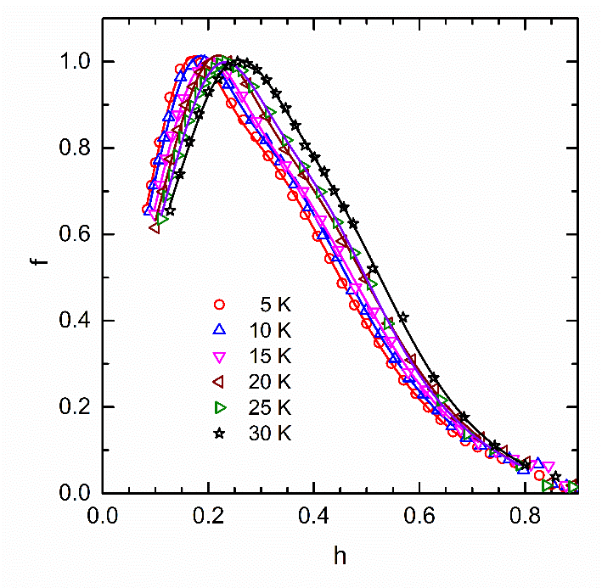  (a) | 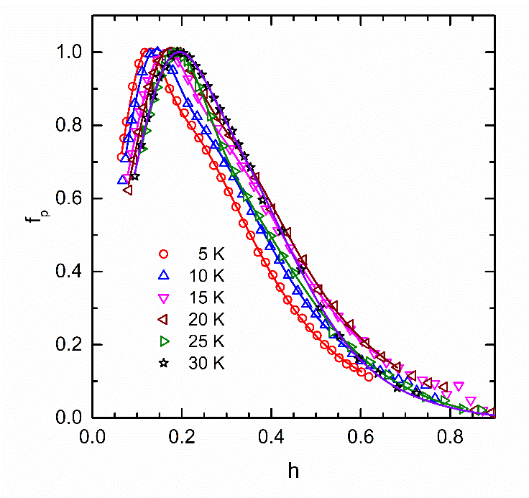  (b)
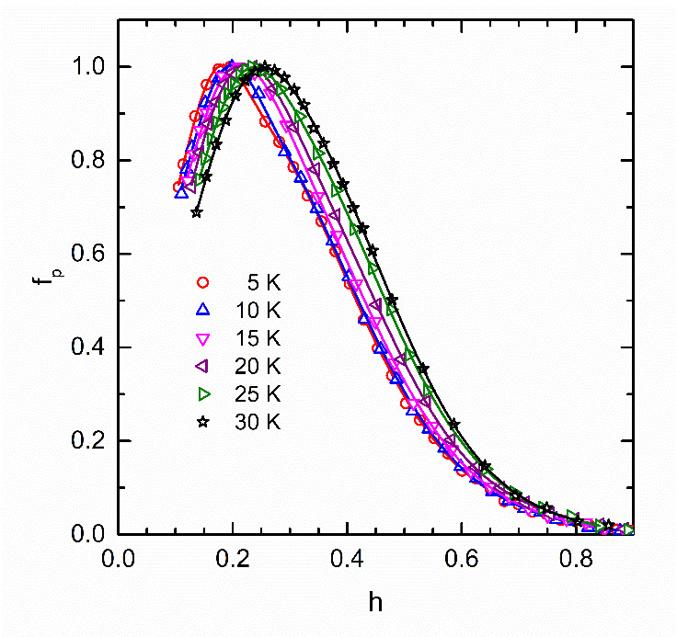  (c) | 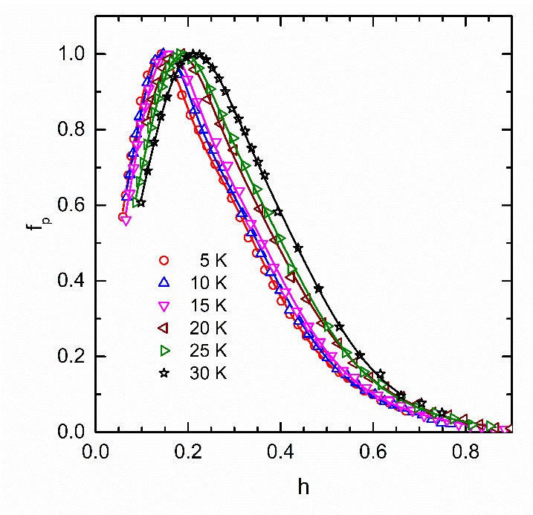  (d)
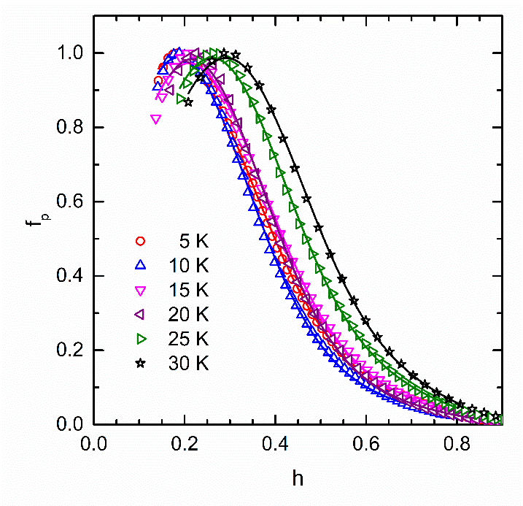  (e) | 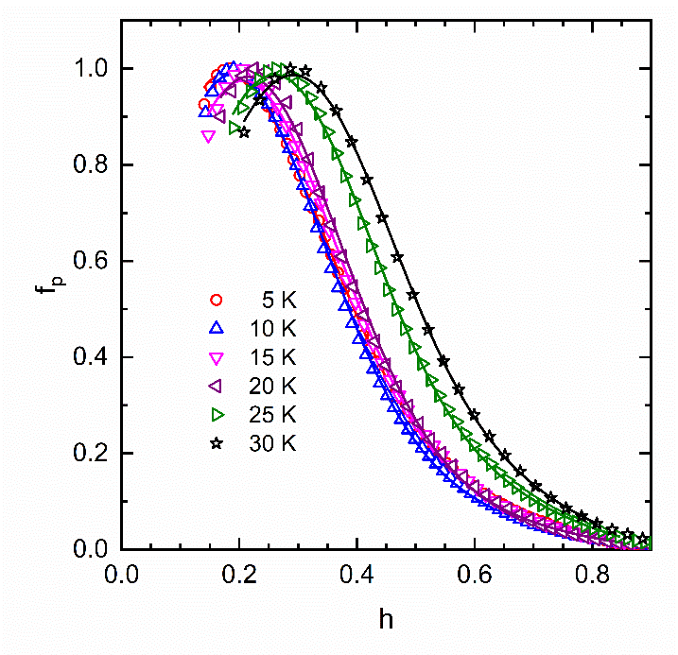  (f)

Fig. 1 (Supplementary Material) Normalized pinning force f_{p} at different temperatures as a function of reduced magnetic field h for: (a) - sample ‘c’ with B₄C, H ⊥ H₀; (b) - sample ‘c’ with B₄C, H // H₀; (c) - sample ‘e’ with c-BN, H ⊥ H₀; (d) - sample ‘e’ with c-BN, H // H₀. Continuous lines are fits with Eq. 5 where g(h) is a double Gauss function in (a)-(d) and a simple one in (e) and (f).
Observatie: (e) si (f) par identice in afara de curba violet !!!! DE VERIFICAT (Viorel)

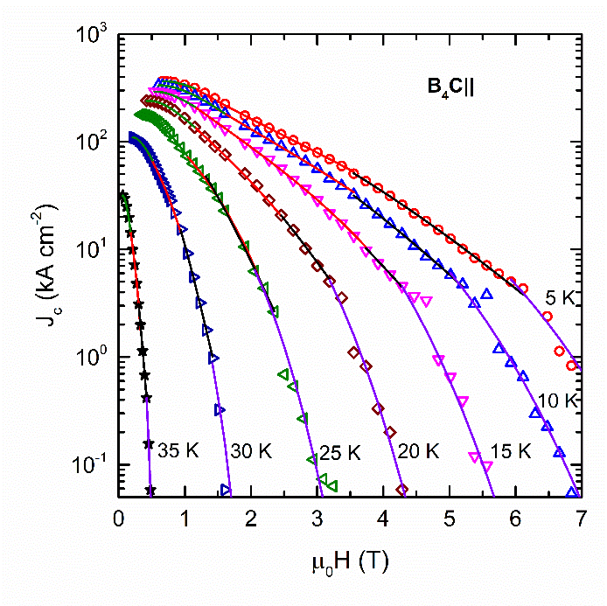  (a) | 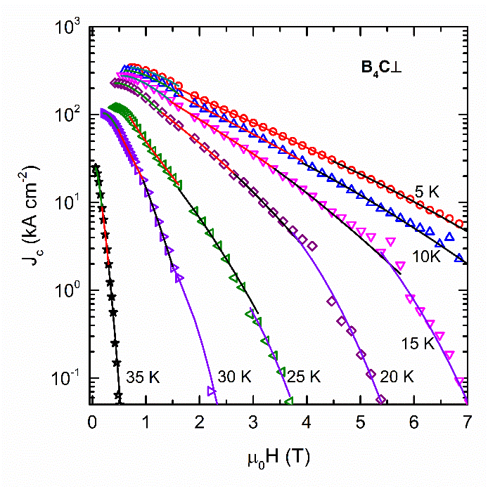  (b)
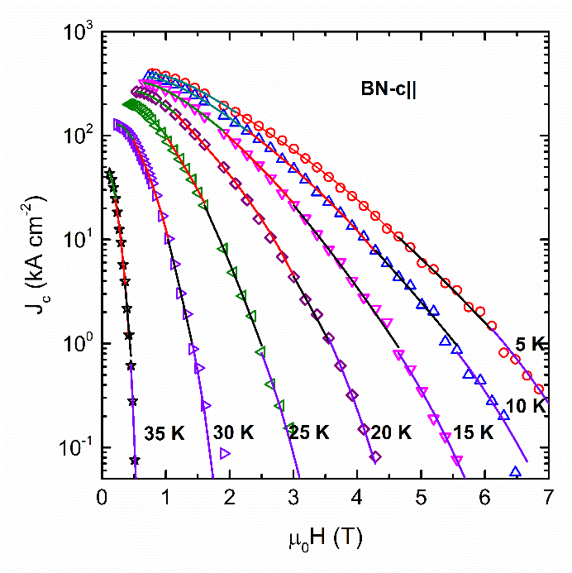  (b) | (d)

Fig. 2 (Supplementary Material) Critical current density J_{c} at different temperatures as a function of applied magnetic field µ₀H for: (a) - sample ‘c’ with B₄C, H ⊥ H₀; (b) - sample ‘c’ with B₄C, H // H₀; (c) - sample ‘e’ with c-BN, H ⊥ H₀; (d) - sample ‘e’ with c-BN, H // H₀; (e) - sample ‘b’ with B₄C; (f) - sample ‘d’ with c-BN. Continuous lines are fits with eq. (6) where g(h) is a double Gauss function.

Acknowledgements
Authors gratefully acknowledge financial support from MCI-UEFISCDI Romania through Core Program PN19-03 (contract no. 21 N/08.02.2019), project POC 37_697 no. 28/01.09.2016 REBMAT, and ERA-M BIOMB 74/2017 (tb pusa toata formula….). Mihai??

References
[1] G. Aldica, S. Popa, M. Enculescu, D. Batalu, L. Miu, M. Ferbinteanu, P. Badica. Addition of Ho₂O₃ of different types to MgB₂ in the ex-situ Spark Plasma Sintering: Simultaneous control of the critical current density at low and high magnetic fields, Materials Chemistry and Physics, 2014, vol. 146, no. 3, p. 313-323.
[2] S.X. Dou, W.K. Yeoh, J. Horvat, and M. Ionescu, Effect of carbon nanotube doping on critical current density of MgB₂ superconductor, Appl. Phys. Lett. 83 (2003) 4996.
[3] P. Badica, G. Aldica, A.M. Ionescu, M. Burdusel, and D. Batalu, The Influence of Different Additives on MgB₂ Superconductor Obtained by Ex Situ Spark Plasma Sintering: Pinning Force Aspects, Correlated Functional Oxides Ch.4 (2017) 75 ISBN 978-3-319-43777-4.
[4] S.A. Ishmael, S. Rogers, F. Hunte, G. Naderi, C. Roach, W. Straka, J. Schwartz, Current density and quench behavior of MgB₂/Ga composite wires, IEEE Appl. Supercond. 25(6) 6200908 (2015).
[5] K. Yoon, J. H. Ahn, Properties of MgB₂/Ga composites prepared by mechanical alloying, Arch. Metal. Mater. 60(2) 1271-1274 (2015).
[6] O.V. Shcherbakova, D.J. Santos, S.X. Dou, Effect of Mg-Ga powder addition on the superconducting properties of MgB₂ samples, Physica C, 460 (part 1) 583-584 (2007).
[7] J. C. Grivel, Attempts at doping indium in MgB2, Physica C, 531 (67-71) 2016.
[8] H. Kitaguchi, T. Nakane, H. Kumakura, Fabrication of ex-situ MgB₂/Al tapes and the effects of In and SiC addition, IEEE Appl. Supercond., 17(2) 2802-2805 (2007).
[9] K. Katagiri, A. Iwamoto, Y. Shoji, K. Tachikawa, Y. Yamada, K. Watanabe, T. Mito, Stress/strain characteristics of PIT MgB₂ tapes with nickel sheath-effect of indium addition to the core, Physica C 397(3-4) 95-98 (2003).
[10] Y.S. Han, J.K.F. Yau, G.Q. Yuan, X.N. Xu, D.W. Lu, L. J. Shen, X. Jin, Pinning effects and current density broadening of resistance on MgB₂, Physica C, 386 626-630 (2003).
[11] W.A. Fietz and W.W. Webb, Hysteresis in superconducting alloys—temperature and field dependence of dislocation pinning in niobium alloys, Phys. Rev. B 178 (1969) 657.
[12] D. Dew-Hughes, Flux pinning mechanisms in type II superconductors, The Philos. Mag.: A Journal of Theoretical Experimental and Applied Physics 3 (1974) 293.
[13] D. Batalu, G. Aldica, S. Popa, L. Miu, M. Enculescu, R.F. Negrea, I. Pasuk, and P. Badica, High magnetic field enhancement of the critical current density by Ge, GeO₂ and Ge₂C₆H₁₀O₇ additions to MgB₂, Scripta Mater. vol. 82, 2014, 61-64.
[14] D. Batalu, G. Aldica, and P. Badica, Ge₂C₆H₁₀O₇-added MgB₂ Superconductor Obtained by Ex-Situ Spark Plasma Sintering, IEEE T. Appl. Supercond. vol. 26, 2016, 1-4.
[15] D. Batalu, T. Nakamura, M. Enculescu, S. Popa, I. Pasuk, G. Aldica, A.M. Ionescu, P. Badica, A Comparative Study of Ge-Based Organometallic Additions to MgB₂, IEEE TRANSACTIONS ON APPLIED SUPERCONDUCTIVITY, vol. 28, no. 4, # 7000205.
[16] G. Aldica, C. Matei, A. Paun, D. Batalu, M. Ferbinteanu, P. Badica, Petre, Thermal analysis on C₆H₁₀Ge₂O₇-doped MgB₂ JOURNAL OF THERMAL ANALYSIS AND CALORIMETRY, vol. 127, no. 1, 173-179.
[17] G. Aldica, D. Batalu, S. Popa, I. Ivan, P. Nita, Y. Sakka, O. Vasylkiv, L. Miu, I. Pasuk, and P. Badica, Spark plasma sintering of MgB₂ in the two-temperature route, Physica C 477 (2012) 43.
[18] G.W. Marks and L.A. Monson, Effect of certain group IV oxides on dielectric constant and dissipation factor of barium titanate. Ind. Eng. Chem. 47 (1955) 1611.
[19] L. Lutterotti, Total pattern fitting for the combined size-strain-stress-texture determination in thin film diffraction, Nuclear Inst. Methods Phys. Res. B 268, 334-340 (2010).
[20] G. Aldica, S. Popa, M. Enculescu, I. Pasuk, A. M. Ionescu, and P. Badica, Dwell Time Influence on Spark Plasma-Sintered MgB₂, J. Supercond. Nov. Mag. 31 (2018) 317.
[21] Avdeev, M., Jorgensen, J.D., Ribeiro, R.A., Bud’ko, S.L., Canfield, P.C.: Physica C 387, 301–306 (2003).
[22] Lee, S., Masui, T., Yamamoto, A., Uchiyama, H., Tajima, S.: Physica C 412–414, 31–35 (2004).
[23] Dou, S.X., Shcherbakova, O., Yoeh, W.K., Kim, J.H., Soltanian, S., Wang, X.L., Senatore, C., Flukiger, R., Dhalle, M., Husnjak, O., Babic, E.: Phys. Rev. Lett. 98, 097002(2007).
[24] C.P. Bean, Magnetization of hard superconductors. Phys. Rev. Lett. 8 (1962) 250.
[25] L. Miu, G. Aldica, P. Badica, I. Ivan, D. Miu, and G. Jakob, Improvement of the critical current density of spark plasma sintered MgB₂ by C₆₀ addition. Supercond. Sci. Technol. 23 (2010) 095002.
[26] N. C. Halder, C. N. J. Wagner, Acta Crystallogr. 1 22-31 (1966).
[27] N. C. Halder, C. N. J. Wagner, Adv. X-ray Anal. 9 91-102 (1966).
[28] M. A. Susner, S. D. Bohnenstiehl, S. A. Dregia, M. D. Sumption, Y. Yang, J. J. Donovan, and E. W. Collings, Homogeneous carbon doping of magnesium diboride by high-temperature high-pressure synthesis, Appl. Phys. Lett. 104 (2014) 162603.

Se pot sterge daca nu mai facem referire la ele in text!

[13] B. Birajdar and O. Eibl, Microstructure critical current density model for MgB₂ wires and tapes, J. Appl. Phys. 105 (2009) 033903.
[14] J.C. Loudon, S. Yazdi, T. Kasama, N.D. Zhigadlo, and J. Karpinski, Measurement of the penetration depth and coherence length of MgB₂ in all directions using transmission electron microscopy, Physical Review B (2015) 91054505(5).
[15] J.H Kim, S. Oh, Y.-U. Heo, S. Hata, H. Kumakura, A. Matsumoto, M. Mitsuhara, S. Choi, Y. Shimada, M. Maeda, J.L. MacManus-Driscol, and S.X. Dou, Microscopic role of carbon on MgB₂ wire for critical current density comparable to NbTi, NPG Asia Mater. 4 (2012) e3.
[16] M. A. Susner, S. D. Bohnenstiehl, S. A. Dregia, M. D. Sumption, Y. Yang, J. J. Donovan, and E. W. Collings, Homogeneous carbon doping of magnesium diboride by high-temperature high-pressure synthesis, Appl. Phys. Lett. 104 (2014) 162603.
[17] H. Yamasaki, K. Endo, S. Kosaka, M. Umeda, S. Yoshida and K. Kajimura, Scaling of the flux pinning force in epitaxial Bi₂Sr₂Ca₂Cu₃O_{x} thin films, Phys. Rev. Lett. 70 (1993) 3331.
[18] P. Fabbricatore, C. Priano, A. Sciutti, G. Gemme, R. Musenich, R. Parodi, F. Gömöry and J. R. Thompson, Flux pinning in Bi-2212/Ag-based wires and coils, Phys. Rev. B 54 (1996) 12543.
[19] J.S. Satchell, R.G. Humphreys, N.G. Chow, J.A. Edwards and M.J. Kane, High-magnetic-field critical currents in thin films of YBa₂Cu₃O₇, Nature 334 (1988) 331.
[20] L. Civale, M.W. McElfresh, A.D. Marwick, F. Holtzberg, C. Feild, J.R. Thompson and D.K. Christen, Scaling of the hysteretic magnetic behavior in YBa₂Cu₃O₇ single crystals, Phys. Rev. B 43 (1991) 13732.
[21] L. Klein, E.R. Yacoby, Y. Yeshurun, A. Erb, G. Müller-Vogt, V. Breit and H. Wühl, Peak effect and scaling of irreversible properties in untwinned Y-Ba-Cu-O crystals, Phys. Rev. B 49 (1994) 4403.
[22 – noi cu J Mater Sci] M. Burdusel, G. Aldica, S. Popa, M. Enculescu, P. Badica, MgB2 with addition of Sb2O3 obtained by spark plasma sintering technique. J. Mat. Sci. 47 (2012) 3828.
[23] Dongliang Wang, Haitao Zhang, Xianping Zhang, Shaopu Tang, Yanwei Ma, Hidetoshi Oguro, Satoshi Awaji, and Kazuo Watanabe, Effects of three different homemade nanocarbons doping on the superconducting properties of MgB₂ tapes, Physica C 508 (2015) 49.
[24] Zongqing Ma, Yongchang Liu, Wenping Hu, Zhiming Gao, Liming Yu, Zhizhong Dong, The enhancement of J_{c} in nano SiC-doped MgB₂ superconductors rapidly synthesized by activated sintering at low-temperature, Scripta Mater. 61 (2009) 836.
[25] Lucas B. S. Da Silva, Durval Rodrigues Jr., German D. Serrano, Vivian C. V. Metzner, Maria T. Malachevsky, and Adriana Serquis, MgB₂ Superconductors With Addition of Other Diborides and SiC, IEEE Trans. Appl. Supercond. 21 (2011) 2639.
[26] E. Martínez, P. Mikheenko, M. Martínez-López, A. Millán, A. Bevan, and J. S. Abell, Flux pinning force in bulk MgB₂ with variable grain size, Phys. Rev. B 75 (2007) 134515(8).
[27] Kh. A. Ziq, P. C. Canfield, J. E. Ostenson, and D. K. Finnemore, Scaling of flux pinning with the thermodynamic critical field, Phys. Rev. B 60 (1999) 3603.
[28] A. F. Salem, K. A. Ziq, A.A. Bahgat, Scaling Behavior in Aluminum Doped MgB₂ Superconductor, J. Supercond. Novel Magn. 26 (2013) 1517.
[29] Qi Cai, Yongchang Liu, Zongqing Ma, Huijun Li, and Liming Yu, Variation of pinning mechanism and enhancement of critical current density in MgB₂ bulk containing self-generated coherent MgB₄ impurity, Appl. Phys. Lett. 103 (2013) 132601(4).
[30] Qi Cai, Yongchang Liu, Zongqing Ma, and Liming Yu, Significant enhancement of critical current density in Gly-doped MgB₂ bulk by tailoring the formation of MgO, Scripta Mater. 67 (2012) 92.

Din 10 Mihai

