Supplementary Information
Metal-Free, Single-Component White-Light Emission and Visible–Near-Infrared Whispering Gallery Mode Micro-Emitter
Barun Kumar Barman^{* 1, 2}, Keisuke Watanabe¹, Vijayakumar Balakrishnan,² Keiko Okano¹, Kenzo Deguchi⁴, Shinobu Ohki⁴, Kenjiro Hashi⁵, Atsushi Goto⁵, Tadaaki Nagao^{* 1, 3}
¹Research Center for Materials Nanoarchitectonics (MANA), National Institute for Materials Science (NIMS), Tsukuba, Ibaraki 305-0044, Japan
²Centre for Interdisciplinary Research (CIDR), SRM University - AP, Amaravati, Andhra Pradesh 522240, India
³Department of Condensed Matter Physics, Graduate School of Science, Hokkaido University Sapporo, Hokkaido 060-0810, Japan
⁴Advanced Engineering and Services Division, National Institute for Materials Science (NIMS), Tsukuba, Ibaraki 305-0003, Japan
⁵Center for Basic Research on Materials, National Institute for Materials Science (NIMS), Tsukuba, Ibaraki 305-0003, Japan
Email: barunkumar.b@srmap.edu.in, NAGAO.Tadaaki@nims.go.jp

Figure S1. The low and high magnification SEM images of WCPM-OPD2 microstructures.
Figure S2. SEM images of YCPM microstructures.
Figure S3. Solid-state NMR characterization
Figure S4. CIE chromaticity coordinates of WCPM-OPD microbeads.
Figure S5. Linear dependence between λ²/Δλ and microbead diameter.
Figure S6. Photostability of the individual microbeads under 785 nm laser irradiation.
Figure S7: FDTD simulated TE mode separation spectra.
Figure S8. FSR of the microbeads in the NIR spectral region.

Numerical simulation
To simulate the resonance spectra and mode profiles of WCPM-OPD microbeads, a commercial finite-difference time-domain (FDTD) solver (Ansys Lumerical) was used. Emission characteristics of microbead were modeled as a dipole source positioned in the vicinity of the edge of the sphere. Optical power emitted by the dipole was monitored using a transmission box enclosing the dipole. Perfectly matched layers in the x and y directions served as absorbing boundary conditions. Microcavity were placed in air (n = 1, k = 0), and optical constants of these spheres were set to n = 1.439, k = 0.003, giving a good agreement with experimental spectra.

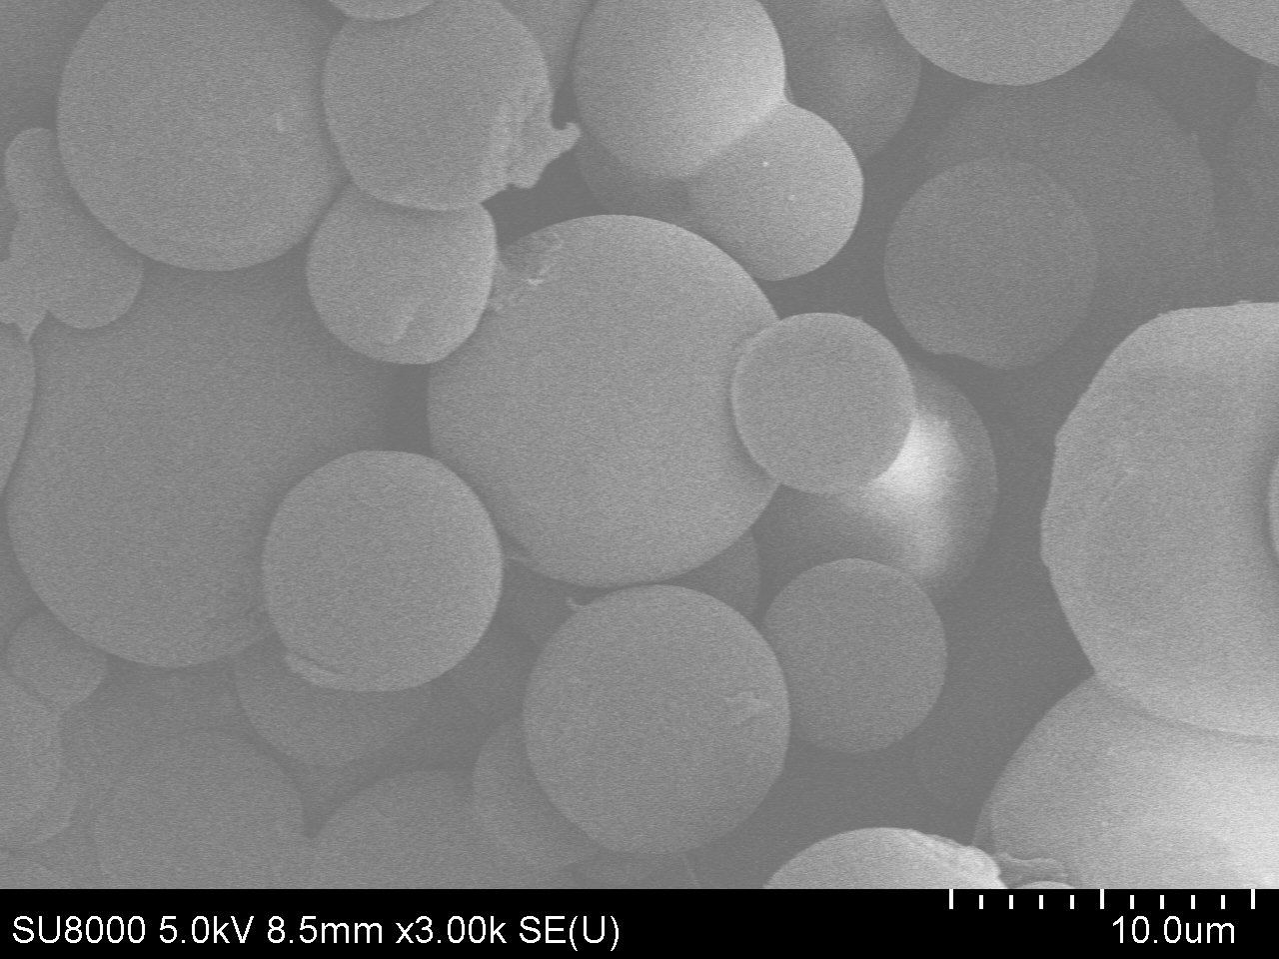
(a)

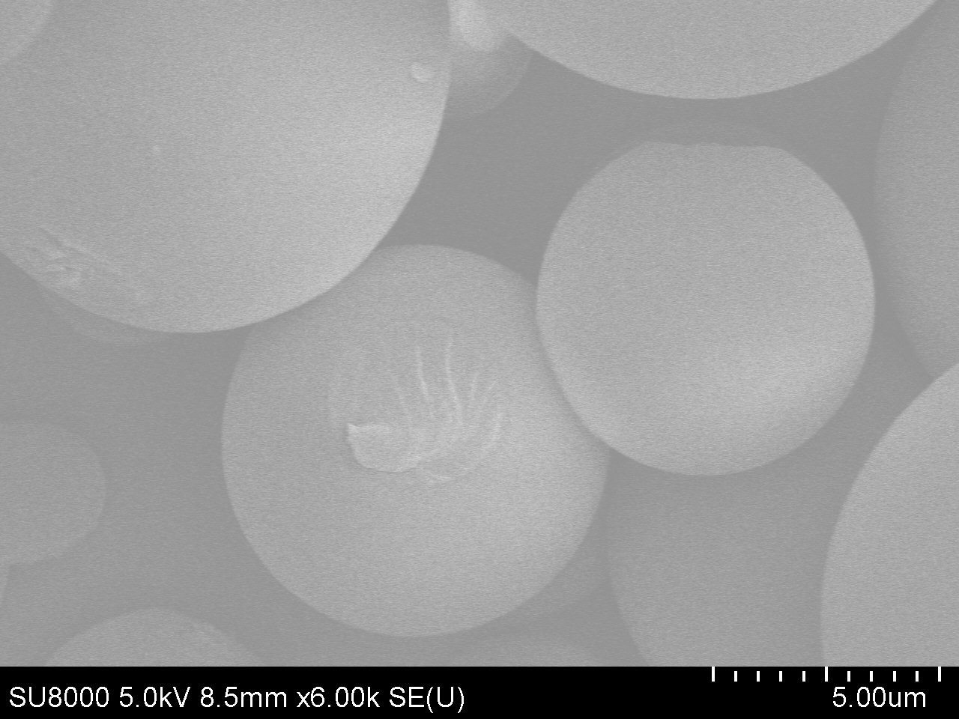
(b)

Figure S1. (a, b) low and high magnification SEM images of WCPM-OPD2

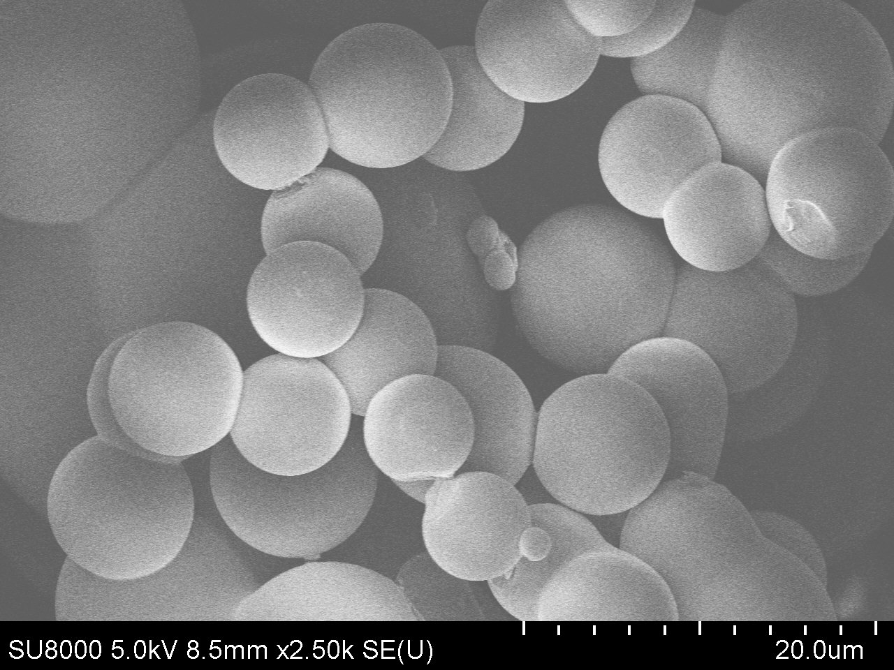
(a)
(b)

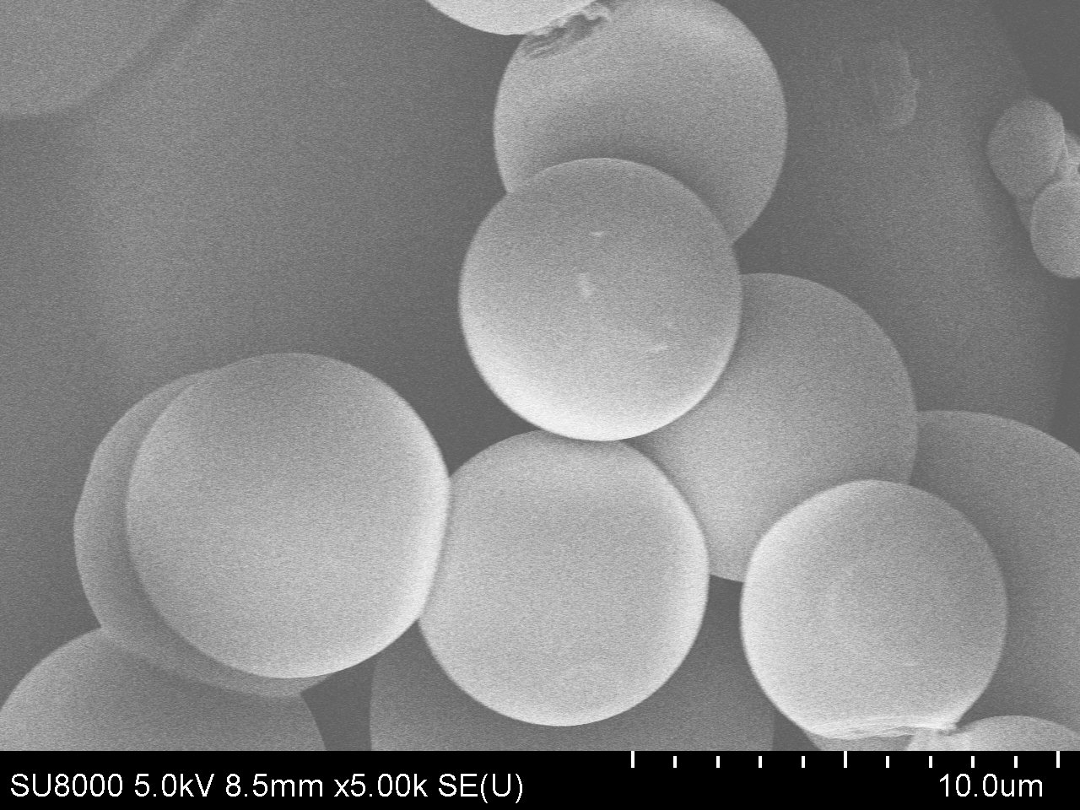

Figure S2. (a-b) High and low magnified SEM images of YCPM microbead structure.

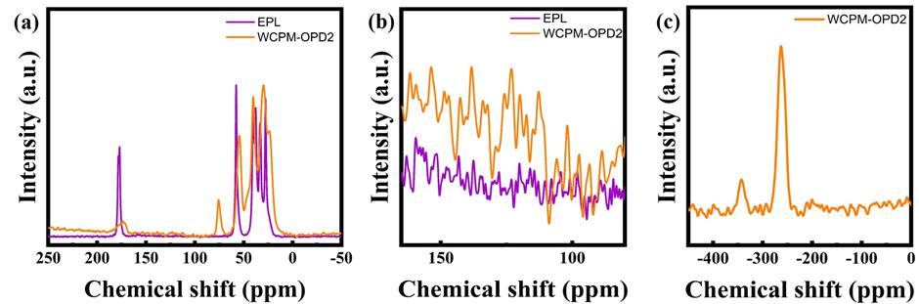
Figure S3. Solid-state NMR characterization of WCPM-OPD2: (a) ¹³C CP/MAS ssNMR spectra of EPL and WCPM-OPD2, (b) expanded view of the aromatic/sp² carbon region of the ¹³C CP/MAS ssNMR spectra, and (c) ¹⁵N ssNMR spectrum of WCPM-OPD2.

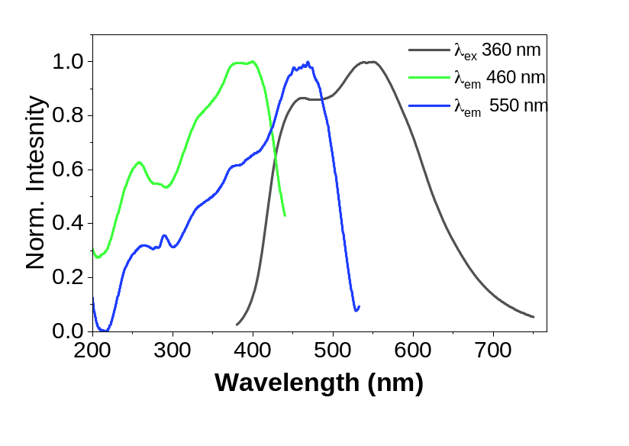

Figure S3. PL and PLE spectra of the WCPM-OPD1 microstructures.
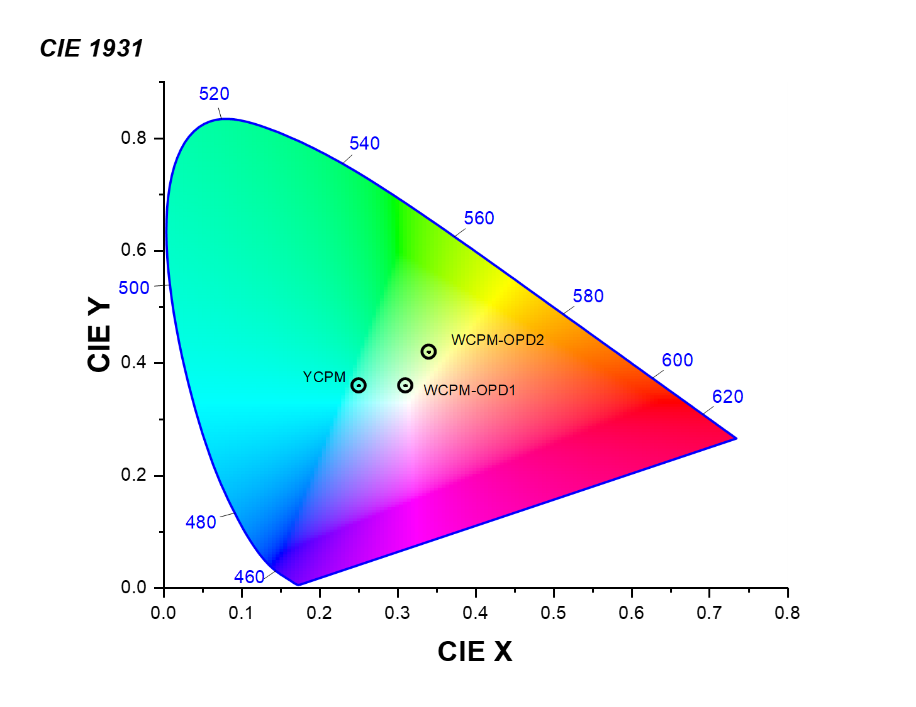
Figure S4. CIE chromaticity coordinates of YCPM and WCPM-OPD1, 2 microbeads.
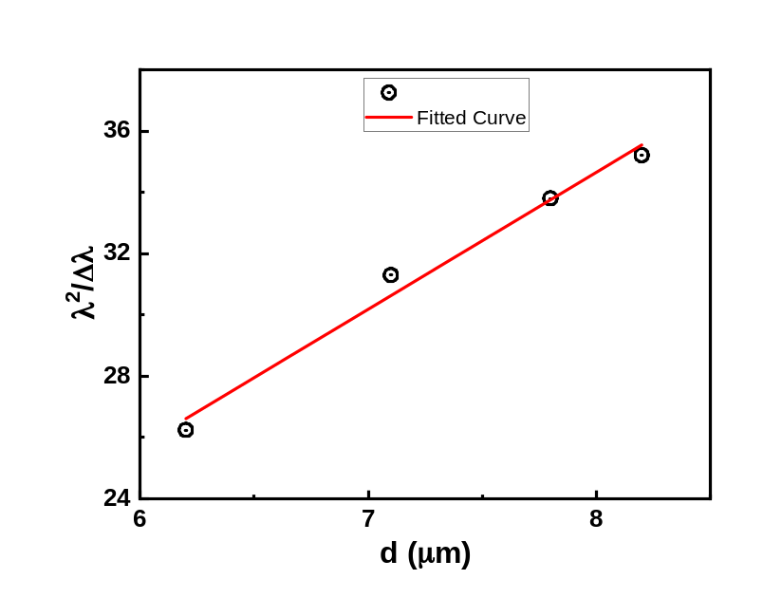

Figure S5. Linear dependence between λ²/Δλ and microbead diameter. The simplest expression for WGM resonance positions is written as mλ = n_{eff}πd, which corresponds to the first-order term of the asymptotic expansion of the Mie solution (Airy function approximation). Here, m is an integer, λ is the resonant wavelength, n_{eff} is the effective refractive index of the resonant mode, and d is the microcavity diameter. With a fitted slope of n_{eff}π = 4.46. Thus, the effective refractive index n_{eff} is approximately 1.42.

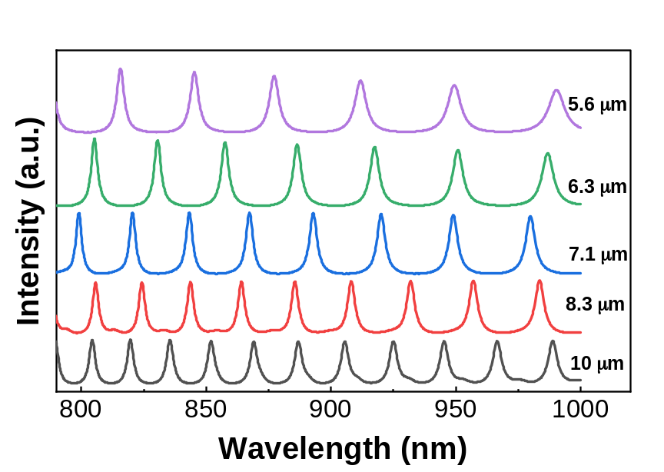
Figure S6. FDTD simulated TE mode separation of different diameter microcavity at NIR spectral region.
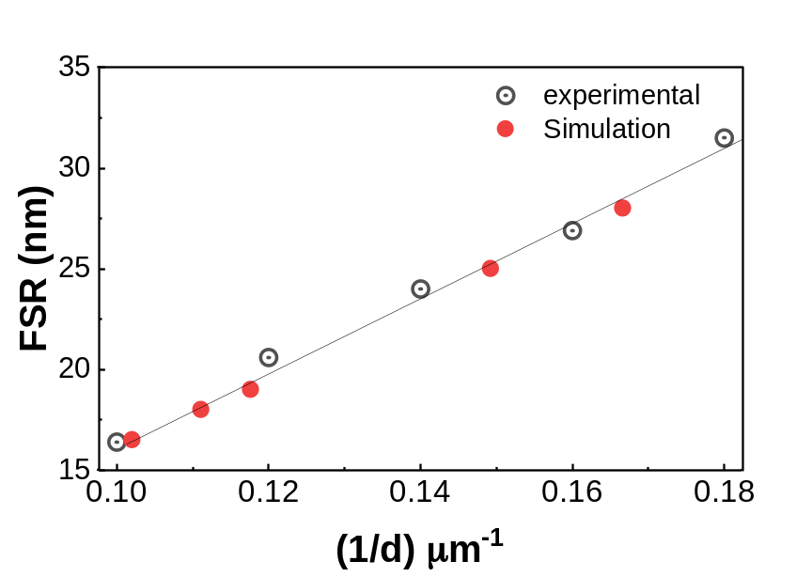
Figure S7. The experimental and simulated free spectral range (FSR) of the different diameter microbeads in the NIR spectral region (~850 nm) exhibits a linear relationship with d⁻¹, where the experimental FSR variation flows the simulated FRS.

