Ultra-high elevated temperature strength of TiB₂-based ceramics consolidated by spark plasma sintering
Dmytro Demirskyi (a), Hanna Borodianska (b), Yoshio Sakka (b), and Oleg Vasylkiv (a,b).
(a) Nanyang Technological University, 50 Nanyang Avenue, 639798 Singapore
(b) National Institute for Materials Science, 1-2-1 Sengen, Tsukuba, Ibaraki 305-0047, Japan

Corresponding Authors:
Dmytro Demirskyi, Nanyang Technological University, 50 Nanyang Avenue, 639798 Singapore, phone: +65-93415641, dmytro.demirskyi@ntu.edu.sg.
Oleg Vasylkiv, National Institute for Materials Science, 1-2-1 Sengen, Tsukuba, Ibaraki 305-0047, Japan, phone: +81-(0)80-41444747, oleg.vasylkiv@nims.go.jp.

Abstract
Spark plasma sintering of TiB₂ – boron ceramics using commercially available raw powders is reported. The B₄C phase developed during reaction-driven consolidation at 1900 °C. The newly formed grains were located at the grain junctions and the triple point of TiB₂ grains, forming a covalent and stiff skeleton of B₄C. The flexural strength of the TiB₂ – 10 wt.% boron ceramic composites reached 910 MPa at room temperature and 1105 MPa at 1600 °С. Which is the highest strength reported for non-oxide ceramics at 1600 °C. This was followed by a rapid decrease at 1800 °C to 480–620 MPa, which was confirmed by increased number of cavitated titanium diboride grains observed after flexural strength tests.
Keywords: spark plasma sintering; titanium diboride; amorphous boron; high-temperature strength.
1. Introduction
Titanium diboride (TiB₂) is an important ceramic material which is extensively used as a cutting tool material, wear components and lightweight armour for ballistic protection. High elastic modulus and good strength at room temperature is often reported for monolithic TiB₂ and TiB₂-based ceramic composites [1–6]. In view of its refractory nature, high temperature applications are also within reach. In the latter case the significant decrease of strength after 1400 °C is expected due to activation of the high-temperature plastic deformation mechanisms such as grain-boundary sliding and creep [6].
An obvious solution to this problem is the consolidation of composites [6–14]. TiB₂–TaC composites have demonstrated a flexural strength of 480 MPa at 1600 °C, which is twice of that for monolithic TiB₂ ceramics [6]. It was summarized that even in TiB₂–TaC case a decrease in strength is expected at higher temperatures owing to electro-covalent nature of bonding in titanium diboride. Therefore in order to reach higher strength values TiB₂-based ceramics armored with covalent compounds is proposed.
This class of TiB₂-based composites is naturally restricted to TiB₂–AlN [8,9], TiB₂–SiC [10,11] and TiB₂–B₄C [12–17] ceramic composites, which show high room-temperature strength and toughness. High-temperature performance of these TiB₂-based composite is scarcely reported and is limited to the TiB₂–B₄C eutectic composites [14–17].
The latter composites are known to have a complex preparation route, and have a certain size limitation. This study suggests a simple route for manufacturing TiB₂–B₄C composites by the reaction spark plasma sintering [18–20] of commercially available powders of TiB₂ and amorphous boron. This approach allows homogeneous distribution of secondary phase mimicking that for eutectic composites. Moreover, the 90 wt.% of TiB₂ in original powder mixture of TiB₂ and amorphous boron, is far above than of 77 B₄C – 23 TiB₂ vol.% (60/40 wt.%) eutectic composition [17], hence, the results of the present study demonstrate the high-temperature flexural strength limit of ceramics with TiB₂ as a matrix.

2. Materials and Methods
Commercially available TiB₂ (d_{av} = 1.0–2.4 µm) and amorphous boron (d_{av} = 0.1–1.0 µm) (Wako Pure Chemicals, Osaka, Japan) powders were used as starting materials. A powder mix of TiB₂ + 10 wt.% aB was prepared by wet-chemical mixing in alcohol with low temperature drying (~100 °C) to remove moisture. The resultant powder was screened through a 60 and 400 mesh screens.
The SPS experiments were performed using the ‘Dr. Sinter’ machine produced by Sumitomo, Japan. Initially, a pressure of 20 MPa was applied to ensure the proper electric contact between the powder tablet and the graphite die and then pressure was increased to 40 MPa at 800 °C. A dwell time of 1 min at 800 °C was adopted for setting up the pyrometer. The heating rate was 140 °C·min⁻¹ from room temperature up to 800 °C followed by a heating rate of 50 °C·min⁻¹ up to sintering temperatures of 1900 °C, with a dwell time of 15 min. SPS was performed in argon gas medium with a flow rate of 2 L·min⁻¹.
Sintered specimens were first surface-ground flat with #600-800-1000-grit SiC paper, followed by diamond disks of up to 0.5 µm. The three-point flexural strength was determined using rectangular blocks (2 × 2.5 × 20 mm³) cut from specimens with diameters of 30 mm using electric discharge machining. Their lateral surfaces were grounded and polished using diamond pastes. Three-point flexural strength tests were conducted at room temperature and at high-temperature up to 1800 °С in argon flow using a Shimadzu AG-X plus (Shimadzu, Japan). Testing of specimens was performed in the direction parallel to the pressing directions in SPS. The loading speed was 0.5 mm·min⁻¹. Six samples were tested at each temperature, and the measurement accuracy was taken as the standard deviation. For the tests at 1800 °С, only three samples were tested. For the high-temperature flexural tests, the following heating schedule was used: room temperature to 200 °С in 10 min and from 200 °С to testing temperature at a speed of 18 °С·min⁻¹. A dwell time of 5 min was employed before the flexural test at a testing temperature. After testing, cooling from the testing temperature to room temperature was performed at a rate of 20 °С·min⁻¹.
Microstructural observations and analyses were carried out on the fracture surfaces by scanning electron microscopy (SEM) SU 8000 (Hitachi, Japan) in secondary electrons, using low-angle back scattered electrons filter for specimens tested at room temperature and at 600 °C.

3. Results and Discussion
TiB₂ – boron ceramics show good flexural strength at room temperature (σ_{25 °C}) ranging from 740 to 910 MPa, with a mean value among six tested specimens of 820 MPa, (Fig. 1) [3–6,12–14,21,22]. Figure 1 shows data for three point (open figures) and four point (closed figures) configurations obtained for TiB₂, B₄C and TiB₂-based composites at room and elevated temperatures. Among TiB₂-based ceramics the results of the present study are one of the best values reported so far. Only Huang et al. [13] for TiB₂–B₄C (60/40 vol.%) showed higher mean value of 867 MPa at room temperature.
There are two possible reasons for such high values: (i) a complex composite structure with even distribution of newly formed secondary boron carbide phase (Fig. 2); and (ii) interfacial microcracking [23] as result of large difference in the linear thermal expansion between TiB₂ matrix and B₄C inclusion. Finally, (iii) small value of the grain size, which corresponds to the initial particle size of raw TiB₂ powder (i.e. 2–5 µm). Recent analysis in [6] showed that strength of monolithic titanium diboride ceramic have a peak in strength for a grain size between 3 and 5 µm. This shows a good correlation with data obtained in the present study.
In case of composites, there is no obvious interdependence between the TiB₂ grain size in TiB₂–B₄C ceramic composites, since in the majority of these ceramic composites titanium diboride was added as the reinforcement phase, while in the present study it serves as a matrix. One noticeable observation is that microcracking [23] was observed after room temperature and in part at 600 °C flexural strength test.
This situation may be attributed to the residual stresses formed during the cooling process. In case of TiB₂-B₄C system consolidated at temperature of 1900 °C, the mismatch in the coefficients of thermal expansion (CTE) between TiB₂ and B₄C will result in formation of the residual stresses in the bulk ceramic composite [23,24]. Using the Taya’s [24] model and data of [12] one may evaluate that residual stresses on the diboride matrix σ_{m} and boron carbide σ_{i} are 348 MPa and -1165 MPa, respectively. Negative value of the residual stress at matrix indicates compression, while positive value of the residual stress at matrix suggests tension.
Finite elements calculations of residual stresses formed upon cooling in B₄C-TiB₂ were presented in [25]. An average compressive stress of 424 MPa was found has a good agreement with the results of B₄C-TaB₂ eutectics prepared by SPS (336 MPa with ΔT of 2000 °C or 391 MPa with ΔT of 2325 °C) [26].
One may see that the main difference between eutectic composite of B₄C-MeB₂ and that in the present case is that the TiB₂-boron ceramics after reactive SPS consolidation, constrains TiB₂ matrix in tension, while stiffer boron carbide inclusions are in tension. This may cause the different toughness behavior of these composites: since the crack will be deflected around boron carbide inclusions, using more energy for fracture of the TiB₂/B₄C bonds. Hence, observed increase in flexural strength may be also accompanied only by slight decrease in toughness (increase of stress intensity factor ΔK_{I} = 0.58 MPa m^{1/2} was evaluated). Further investigation of this behavior is necessary.
It is well known that the thin film of oxygen-rich layer consisting from TiO₂ or B₂O₃ that is on the surface of TiB₂ powders also affects effects titanium diboride densification [27]. In the present study, the addition of amorphous boron allowed solving this problem during the densification process. Furthermore, B₄C grains were formed during the reactive SPS consolidation. These were usually located in the triple points and in between relatively large size titanium diboride grains and are clearly viewed in Fig. 2. The fracture of newly formed B₄C phase largely affected the flexural behavior of TiB₂-boron ceramics at different temperatures, these are highlighted as solid arrows in Fig. 3.
An intergranular fracture of B₄C grains was noticed at room temperature and at 600 °C, generally suggesting a brittle fracture at the TiB₂/B₄C interface. The voids resulted by intergranular fracture of B₄C grains were seldom observed with increase in the flexural strength test temperature, however it was noted that majority of the fine boron carbide grains remains in the triple points or in the inter-TiB₂ grains space preserving the general structure of titanium diboride composite.
Titanium diboride grains were fractured intergranularly, some transgranular fracture was observed at low testing temperatures. Above 1400 °C two general trends were noted (a) thermal argon etching of the grain surfaces and as result the mate color of thereof, and (b) cavitation of titanium diboride grains which indicate higher contribution of creep mechanisms with increase in temperature (see open arrows in Fig. 3). It is believed that cavitation of the TiB₂ grains is the main reason for the fall in strength at 1800 °C, however it should stressed that the number of such cavitated TiB₂ grains observed at 1800 °C was a minor, but higher than that observed at 1400 or 1600 °C.
The strength above 1400 °C is controlled by the number of the titanium diboride grains affected by the stress and temperature induced cavitation. Bellow the certain ratio between non-cavitated and cavitated TiB₂ grains, there is a minor contribution of these phenomena to the decrease in fracture energy or flexural strength, hence an additional deformation mechanism such as grain-boundary sliding is operating. However, above a critical ratio between non-cavitated and cavitated TiB₂ grains the rapid strength decrease is observed. Without a doubt a further increase of flexural strength test temperature will lead to further increase in number of cavitated TiB₂ grains and ultimately will lead the strength to the level observed for monolithic MeB₂ ceramics [6,28].
A special notice should be addressed strength behavior of pure B₄C [21,22,29] or B₄C–TiB₂ eutectic composites [14–17]. For the high-density polycrystalline bulk samples of B₄C at temperatures of 900–1500 °C, the flexural strength was found to be constant or decrease slightly with increasing temperature [21,28]. This increase was attributed to the increase in contribution of plastic deformation to the fracture stress above 1500 K, which could be one of the reasons of the observed increase in strength for 1400 and 1600 °C, which is similar to the recent study on bulk boron carbide [22].
Furthermore, the flexural strength obtained in the present study is the highest among non-oxide ceramics at 1600 °C, which suggests that further increase in strength of other metal diborides by forming a similar type of composites is anticipated. The grain size in the consolidated ceramic specimens should be identical to that for initial powder size of metal diboride. Hence the described method should result in bulk ceramic originated from metal diboride with even relatively ‘coarser’ particle size (up to 10 µm). Moreover, due to the even character of distribution of secondary B₄C phase should be beneficial to the elastic properties as well as thermal conductivity.

4. Conclusions
Reactive spark plasma sintering of the TiB₂–boron ceramics enabled consolidation of high-strength ceramics. TiB₂ –10 wt.% boron ceramics composites had high room temperature strength ranging from 740 to 910 MPa have been attributed to the formation of a fine boron carbide and titanium diboride grains that were located in the triple points and intergrains voids of the original powder system. The development of these phases during SPS consolidation resulted in the formation of ceramics with grain sizes equal to those of the initial powders. This yielded higher the strength twice higher than that reported for monolithic TiB₂. Increase in flexural test temperature up to 1600 °C resulted in almost linear increase in the flexural strength of TiB₂ – boron specimens to the values of 850–1100 MPa, which followed by a rapid decrease at 1800 °C to 480–620 MPa. This is explained by a plastic deformation active in this temperature range, which is confirmed by the presence of creep-induced cavities at the TiB₂ grains above 1400 °C. We anticipate that the composites of Me^{IV–V}B₂ with amorphous boron will be beneficial in strength increase in composites with other important metal diboride improving both room and high-temperature performance.

Acknowledgments
This study was partially supported by with financial support from the Grant-in-Aid for Scientific Research B from Japan Society for the Promotion of Science (JSPS). The authors acknowledge Dr. Toshiyuki Nishimura (NIMS, Japan) for providing access to the high-temperature strength measurement facility.

References
[1]. R.G.Munro, Material Properties of Titanium Diboride, J. Res. Natl. Inst. Stand. Technol., 105, 709–720 (2000).
[2]. B. Basu, G.B. Raju, A.K. Suri, Processing and Properties of Monolithic TiB₂-Based Materials, Int. Mater. Rev., 51, 352–374 (2006).
[3]. H.R. Baumgartner, R.A. Steiger, Sintering and Properties of Titanium Diboride Made from Powder Synthesized in a Plasma-Arc Heater, J. Am. Ceram. Soc., 67, 207–212 (1984).
[4]. J. Matsushita, T. Suzuki, A. Sano, High Temperature Strength of TiB2 Ceramics, J. Ceram. Soc. Jap., 101 [9] 1074–1077 (1993).
[5]. G.B. Raju, B. Basu, N.H. Tak, S.J. Cho, Temperature dependent hardness and strength properties of TiB2 with TiSi2 sinter-aid, J. Eur. Ceram. Soc., 29, 2119–2128 (2009).
[6]. D. Demirskyi, T. Nishimura, Y. Sakka, O. Vasylkiv, High-strength TiB2–TaC ceramic composites prepared using reactive spark plasma consolidation, Ceram. Int., 42, 1298-1306 (2016).
[7]. D. Demirskyi, Y. Sakka, O. Vasylkiv, High-Temperature Reactive Spark Plasma Consolidation of TiB2–NbC Ceramic Composites, Ceram. Int., 41, 10828–10834 (2015).
[8]. T. Sano, G. Gilde, J. Campbell, Characterization and Evaluation of TiB2-AlN Composites for Armor Applications, ARL-TR-6568.
[9]. L-H.Li, H-E. Kim, E.S. Kang, Sintering and Mechanical Properties of Titanium Diboride With Aluminum Nitride as a Sintering Aid, J. Eur. Ceram. Soc., 22, 973–977 (2002).
[10]. Z. Degui, L. Shikai, Y. Xiandong, Y. Liu, X. Chuanchun, Z. Haoming, Z. Jianyong, In-situ HIP synthesis of TiB2/SiC ceramic composites, Journal of Materials Processing Technology, 89–90, 457–461 (1999).
[11]. M.-J. Pan, P.A. Hoffman, D.J. Green, J.R. Hellmann, Elastic Properties and Microcracking Behavior of Particulate Titanium Diboride–Silicon Carbide Composites, J. Am. Ceram. Soc., 80, 692–698 (1997).
[12]. V. Skorokhod Jr., V. D. Krstic, High strength-high toughness B4C-TiB2 composites, J. Mater. Sci. Lett., 19, 237–239 (2000).
[13]. S.G. Huang, K. Vanmeensel, O.J.A. Malek, O. Van der Biest, J. Vleugels, Microstructure and mechanical properties of pulsed electric current sintered B4C–TiB2 composites, Mater. Sci. Eng. A, 528, 1302–1309 (2011).
[14]. I. Bogomol, H. Borodianska, T. Zhao, T. Nishimura, Y. Sakka, P. Loboda and O. Vasylkiv, Dense and Tough (B₄C-TiB₂)-B₄C ‘Composite Within a Composite’ Produced by Spark Plasma Sintering, Scr. Mater., 71, 17–20 (2014).
[15]. I. Bogomol, S. Grasso, T. Nishimura, Y. Sakka, P. Loboda, O. Vasylkiv, Hard Polycrystalline Eutectic Composite Prepared by Spark Plasma Sintering, Ceram. Int., 38, 3947–3953 (2012).
[16]. I. Bogomol, T. Nishimura, O. Vasylkiv, Y. Sakka and P. Loboda, Microstructure and High-temperature Strength of B₄C–TiB₂ Composite Prepared by a Crucible Less Zone Melting Method, J. Alloys Compd., 485, 677–681 (2009).
[17]. I. Bogomol, P. Badica, Y.Q. Shen, T. Nishimura, P. Loboda, O. Vasylkiv, Room and High Temperature Toughening in Directionally Solidified B₄C-TiB₂ Eutectic Composites by Si Doping, J. Alloys Comp., 570, 94–99 (2013).
[18]. J. R. Groza, A. Zavaliangos, Sintering Activation by External Electrical Field, Mater. Sci. Eng. A, 287, 171–177 (2000).
[19]. I. Solodkyi, H. Borodianska, T. Zhao, Y. Sakka, P. Badica, O. Vasylkiv, B₆O Ceramic by in-situ Reactive Spark Plasma Sintering of B₂O₃ and B Powder Mixture, J. Ceram. Soc. Jap., 122, 336–340 (2014).
[20]. O. Vasylkiv, H. Borodianska, P. Badica, S. Grasso, Y. Sakka, A. Tok, L.T. Su, M. Bosman and J. Ma, High Hardness B_{a}C_{b}-(B_{x}O_{y}/BN) Composites with 3D Mesh-like Fine Grain-boundary Structure by Reactive Spark Plasma Sintering, J. Nanosci. Nanotechnol., 12, 959–965 (2012).
[21]. Yu. G. Tkachenko, D. Z. Yurchenko, V. K. Sulzhenko, G. S. Oleinik and V. M. Vereshchaka, Temperature Effect on Bending Strength of Hot-pressed Boron Carbide Materials, Powder Metall. Met. Ceram., 46, 254–260 (2007).
[22] O. Vasylkiv, D. Demirskyi, P. Badica, T. Nishimura, A.I.Y. Tok, Y. Sakka, H. Borodianska, “Room and high temperature flexural failure of spark plasma sintered boron carbide,” Ceram. Int., 42, 7001–7013 (2016).
[23]. L.S. Sigl, H.-J. Kleebe, Microcracking in B4C–TiB2 composites, J. Am. Ceram. Soc., 78, 2374–2380 (1995).
[24] M. Taya, S. Hayashi, A.S. Kobayashi, H.S. Yoon, “Toughening of a Particulate-Reinforced Ceramic-Matrix Composite by Thermal Residual Stress,” J. Am. Ceram. Soc. 73 [5] 1382­1391 (1990).
[25] R.M. White, E.C. Dickey, “The Effects of Residual Stress Distributions on Indentation-induced Microcracking in B4C–TiB2 Eutectic Ceramic Composites,” J. Am. Ceram. Soc. 94 [11] 4032-4039 (2011).
[26] D. Demirskyi, Y. Sakka, O. Vasylkiv, High-strength B4C-TaB2 eutectic composites obtained via in situ by spark plasma sintering, Journal of American Ceramic Society, (accepted, 10.1111/jace.14235).
[27]. S. Baik, P.F. Becher, Effect of oxygen contamination on densification of TiB2, J. Am. Ceram. Soc., 70, 527–530 (1987).
[28]. E.W. Neuman, G.E. Hilmas, W.G. Fahrenholtz, Mechanical behavior of zirconium diboride-silicon carbide-boron carbide ceramics up to 2200 C, J. Eur. Ceram. Soc., 35, 463–476 (2015).
[29]. G. de With, High Temperature Fracture of Boron Carbide: Experiments and Simple Theoretical Models, J. Mat. Sci., 19, 457–466 (1984).
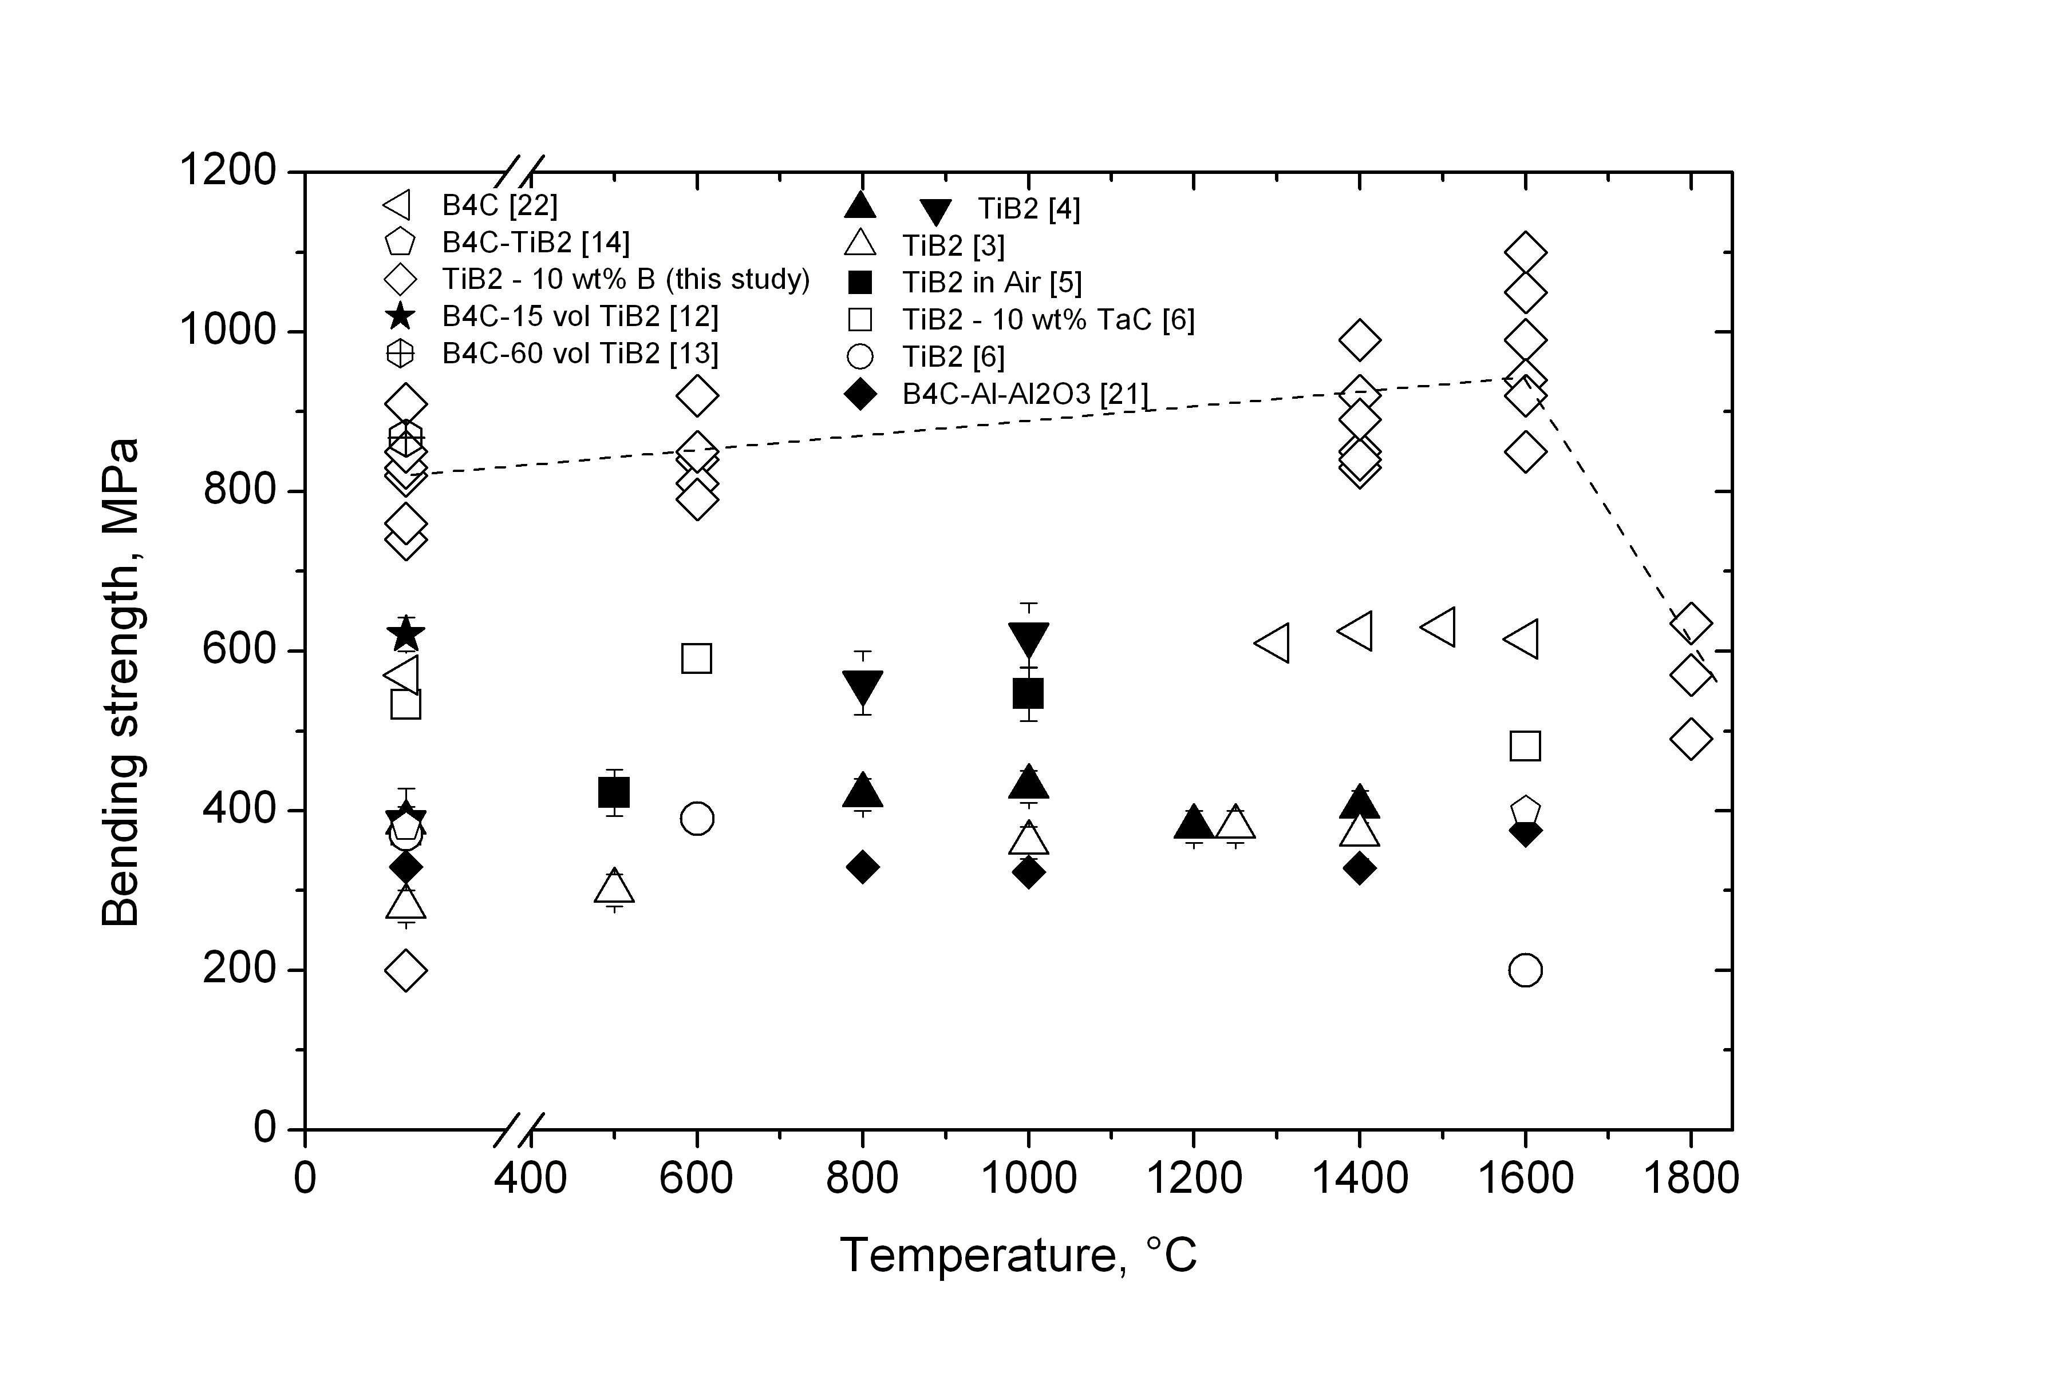
Figure 1. Temperature dependence of strength for TiB₂–boron ceramic composites consolidated by SPS and data on high-temperature flexural behavior of TiB₂ [3–6], B₄C [21,22] and TiB₂–B₄C [12–14] ceramics. Closed figures indicate that four point flexural strength test was performed, while open figures are for three-point strength tests.

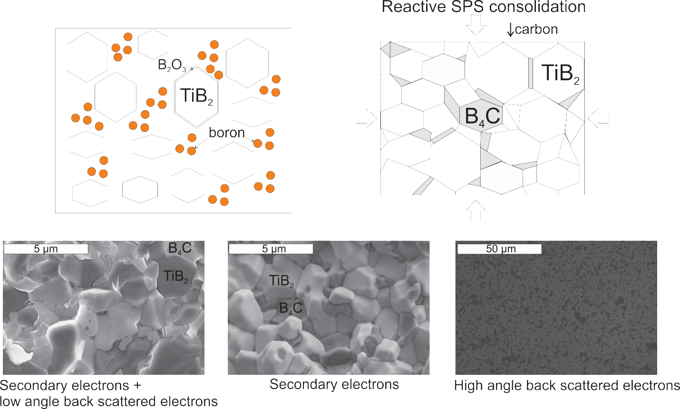
Figure 2. Structure formation during reactive SPS consolidation of TiB₂ – boron ceramics. Lower images show structure of the bulk composite obtained using SEM in different observation modes.

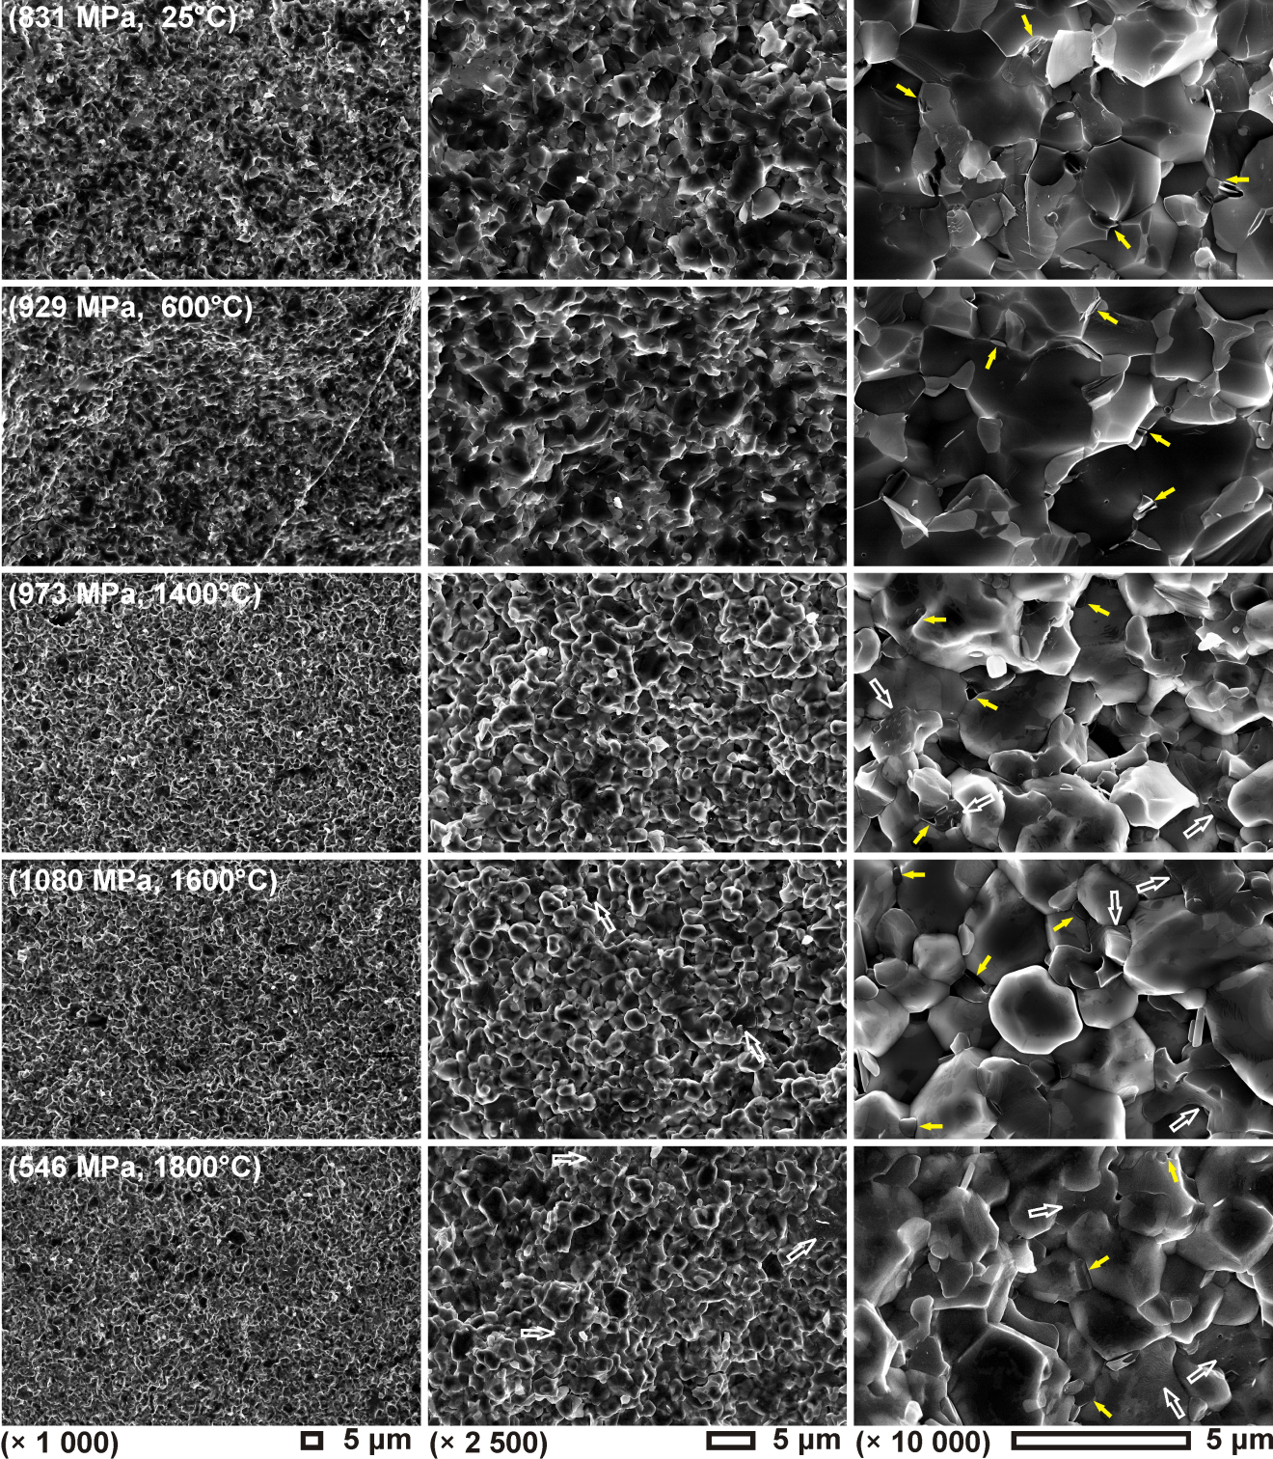

Figure 3. SEM images of TiB₂–boron ceramic composites after the three-point flexural strength test at different temperatures, the value of the flexural strength for observed sample is provided alongside with the flexural strength test temperature. Open arrows indicate places of plastic deformation. Closed arrows show effect of B₄C phase formed during reaction SPS.

