Received 00th January 20xx,
- Department of Chemistry, Graduate School of Science, Kyoto university, Kitashirakawa Oiwake-cho, Sakyoku, Kyoto, 606-8502, Japan.
- Materials and Structures Laboratory, Institute of Integrated Research, Institute of Science Tokyo, 4259 Nagatsuta-cho, Midori-ku, Yokohama, Kanagawa, 226-8501, Japan.
- Laboratory for Chemistry and Life Science, Institute of Innovative Research, Institute of Science Tokyo, 4259 Nagatsuta-cho, Midori-ku, Yokohama, Kanagawa 226-8501, Japan.
- Research Center for Autonomous Systems Materialogy (ASMat), Institute of Integrated Research, Institute of Science Tokyo, 4259 Nagatsuta-cho, Midori-ku, Yokohama, Kanagawa, 226-8501, Japan.
- Department of Electrical & Computer Engineering, University of Victoria, 3800 Finnerty Road, Victoria, British Columbia V8P 5C2, Canada.
- Kanagawa Institute of Industrial Science and Technology, 705-1 Shimoimaizumi, Ebina 243-0435, Japan.
† Footnotes relating to the title and/or authors should appear here.
Supplementary Information available: [details of any supplementary information available should be included here]. See DOI: 10.1039/x0xx00000x
Accepted 00th January 20xx
DOI: 10.1039/x0xx00000x

Tunable Optical Properties in (110)_{p}-oriented Layered Halide Perovskite FA₄Pb₂I_{7.5}(SCN)_{0.5} by Br Substitution
Koki Matsushima^{a,b}, Takuya Ohmi^{b}, Wataru Taniguchi^{b}, Shoya Nagano^{b}, Tomoya Fukui^{c}, Takanori Fukushima^{c,e}, Muhammmad Awais^{d}, Makhsud Saidaminov^{d}, Masaki Azuma^{b,e,f}, and Takafumi Yamamoto ^{*a,b}
Organic–inorganic hybrid halide perovskites have been explored extensively for optoelectronic functional materials. Here, we report (110)_{p}-oriented layered halide perovskite thin films with nominal compositions of FA₄Pb₂(Br_{x}I_{1-x})_{7.5}(SCN)_{0.5} (x = 0, 0.25, 0.5, 0.75, and 1). X-ray diffraction measurements and UV-visible diffuse reflectance measurements demonstrate the successful formation of a solid solution between iodide and bromide. The band gap gradually changes from 2.18 eV to 2.81 eV with increasing Br content, and PL emission of 750 nm was observed for the x = 0 film. We also report a single crystal sample of x = 1.
Introduction
Mixed-anion compounds have attracted much attention as emerging inorganic functional materials.^{1–3} The combination of multiple anions with distinct bonding properties, charges, and ionic radii allows unique crystal structures and properties that cannot be achieved with single-anion compounds. Representative examples are oxynitride photocatalysts. Since nitrogen is less electronegative than oxygen, substituting nitride ions for oxide ions narrows the band gaps, leading to a suitable band gap for visible light absorption.^{4–7}. Oxychloride Ca₃ReO₅Cl₂ shows a unique pleochroism due to the mixed anion environment around Re⁺⁶.⁸ Oxyhydride SrVO₂H with trans-coordinated VO₄H₂ octahedra exhibits quasi-2D electronic structure due to the different bonding nature between O^{2‒} and H‒.^{9,10}
Organic-inorganic hybrid perovskites, as represented by CH₃NH₃PbI₃ (CH₃NH₃⁺ = Methylammonium ion, MA⁺), have been widely explored as promising semiconductors for optoelectronic applications. In this material group, the conduction band is composed of the Pb 6s and 6p orbitals, while the valence band is the halide p orbitals,¹¹ suggesting the band gap can be tuned by the substitution of halide anion.^{12–14} The molecular cations in organic-inorganic hybrid perovskites contribute to the modulation of the crystal structure utilizing their diverse shapes and wide range of the ionic size.^{15–20} Using molecular cations with chain-like structure as spacers (e.g. n-alkylammonium), the original three-dimensional (3D) perovskite structure changes to a two-dimensional (2D) perovskite structure.²¹ The dimensional reduction of the inorganic framework by spacer cations induces a quantum-well structure, enhancing photoluminescence emission.²²
Thiocyanate ion (SCN⁻) can act as a capping agent for the bonds of an inorganic framework, owing to its anisotropic bonding nature.^{23,24} The selective bond formation of Pb-S causes the disconnection of the PbI₆ octahedral network, leading to low-dimensional structures.²¹ Reflecting this feature, (MA)₂PbI₂(SCN)₂ adopts a Rudddlesden-Popper-type structure, where N-terminate in SCN⁻ directs to the interlayer space.^{25,26} (MA)₂PbI₂(SCN)₂ tolerate 80% of Br⁻ substitution into I⁻, leading band gap narrowing.^{27,28}
We recently discovered a novel homologous family of defect-ordered hybrid perovskite materials, (CH(NH₂)₂)_{n+1}Pb_{n−1}I_{3n−1.5}(SCN)_{0.5} (n = 3, 5, ∞; (CH(NH₂)₂⁺ = formamidinium ion, FA⁺)), with SCN⁻ as a defect generator.²⁴ Here, n value corresponds to the inverse of the PbI columnar defect concentration. Accordingly, FAPbI₃ (n = ∞) has a primitive perovskite structure without defects. FA₆Pb₄I_{13.5}(SCN)_{0.5} (n = 5) has a three-dimensional perovskite framework with one-fifth of the ordered-columnar-defects, forming √5a_{p} × √5a_{p} × a_{p} superstructure (a_{p}: cell parameter of primitive perovskite cell). In FA₄Pb₂I_{7.5}(SCN)_{0.5} (n = 3), the one-third columnar defects are aggregated in a layered manner, forming (110)_{p}-oriented layered perovskite structure (Figure 1, Figure S1). The powder sample of this compound exhibits red photoluminescence emission, which is a feature of layered perovskites with a quantum-well structure.²⁹ However, all these compounds were reported in powder or single crystal forms. In view of potential applications, thin film fabrication is desired to investigate their functionality further. Here, we synthesized Br-substitution in FA₄Pb₂I_{7.5}(SCN)_{0.5} to control the optical properties, especially in a thin film form. First, we clarify that the bromide counterpart has the same structure type as the iodide by a single crystal analysis (Figure S2). Then, we fabricated the nominal composition FA₄Pb₂(Br_{x}I_{1-x})_{7.5}(SCN)_{0.5} (x = 0, 0.25, 0.5, 0.75, 1) thin films by spin-coating method. X-ray diffraction (XRD) measurements revealed that the lattice parameter linearly changes, reflected by the size of the halide ions. Notably, the body color, i.e., the band gap, of the films gradually changed by changing the anion ratio. We also demonstrate the photoluminescence (PL) property of the x = 0 film.
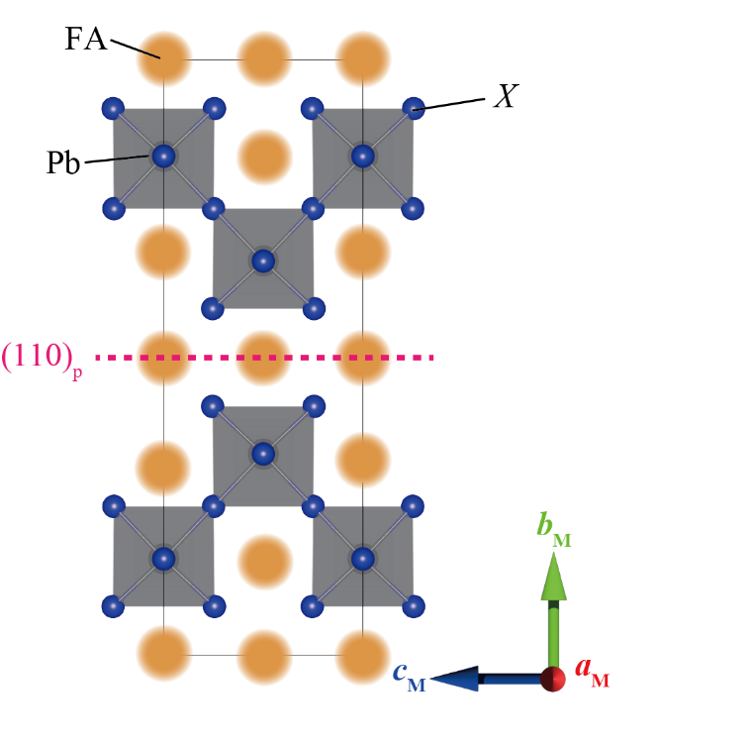
Figure 1. The schematic structure of FA₄Pb₂(Br_{x}I_{1-x})_{7.5}(SCN)_{0.5}. The dotted pink line represents the (110)_{p} defect plane. SCN partially occupies the X sites facing the (110)_{p} plane. The details of the structures for x = 0 (Cmmm) and x = 1 (P2₁/c) are shown in Figure S1 and Figure S2, respectively. a_{M}, b_{M}, and c_{M} represent the cell parameters for the monoclinic setting for P2₁/c, The crystal structures are visualized with VESTA3³⁰.

Experiments
Materials
Formamidine hydroiodide (FAI, >98.0%) and lead(Ⅱ) thiocyanate (Pb(SCN)₂, >99.5%) was purchased from Sigma-Aldrich Co. LLC. Formamidine hydrobromide (FABr, >99.0%), lead(Ⅱ) bromide (PbBr₂, >98.0%), and lead(Ⅱ) iodide (PbI₂, >98.0%) were purchased from Tokyo Chemical Industry Co., LTD. The solvents, N, N-dimethylformamide (DMF, 99.5%, dehydrated), dimethyl sulfoxide (DMSO, >99.0%, super dehydrated), and diethyl ether (DEE, 99.5%) were purchased from Kanto Chemical Co., INC. All other chemicals were of reagent grade and were used without further purification.
Synthesis of single crystals for x = 1
Single crystals for x = 1 were synthesized by a solid-state method. FABr and Pb(SCN)₂ at molar ratio 3:1 were pelletized respectively. These pellets were in a glass tube, which was flame-sealed under vacuum. The sealed sample was heated to 373 K in 1 h and hold for 24 hours in a furnace. The melted sample was slowly cooled to room temperature in 5 hours. Then, the colorless crystals with green
photoluminescence properties were obtained in the glass tube (Figure S3, S4).

Single crystal X-ray diffraction for FA₄Pb₂(Br, SCN)₈
A crystal sample was coated with Fluorolube® oil and mounted on the MiTeGen® microloop. The measurement was performed at 100 K with N₂ gas flow. Frames were collected with ω and φ scans using a Rigaku XtaLAB PRO diffractometer equipped with a PILATUS 200 K hybrid pixel array detector and a microfocus Mo Kα radiation (MicroMax007HF, 50 kV, 24 mA). The crystal-to-detector distance was set to 35 mm. The data were analyzed using the CrysAlisPro program (Rigaku Oxford Diffraction) and corrected for Lorentz polarization and absorption effects.

Preparation of precursor solutions for thin films
Solutions of FA₄Pb₂(Br_{x}I_{1-x})_{7.5}(SCN)_{0.5} (x = 0, 0.25, 0.5, 0.75, 1) were prepared by mixing stoichiometric ratio of FA₄Pb₂I_{7.5}(SCN)_{0.5} (x = 0) and FA₄Pb₂Br_{7.5}(SCN)_{0.5} (x = 1) solutions. The precursor solution for x = 0 was prepared by dissolving 0.8599 g of FAI, 1.0085 g of PbI₂, and 0.1011 g of Pb(SCN)₂ in 2.5 mL mixture of DMF and DMSO (4:1, v/v). The precursor solution for x = 1 was prepared by dissolving 0.6249 g of FABr, 0.8028 g of PbBr₂, and 0.1011 g of Pb(SCN)₂ in 2.5 mL mixture of DMF and DMSO (4:1, v/v). These solutions were filtered by PTFE.

Thin film fabrication
The thin films of the nominal composition FA₄Pb₂(Br_{x}I_{1-x})_{7.5}(SCN)_{0.5} (x = 0, 0.25, 0.5, 0.75, 1) were prepared by spin-coating method in a N₂ gas-filled glove box. Polished glass substrates of 10×10 mm² were spin-coated for absolute PL quantum yields measurements. The films were pre-treated by ultrasonic cleaning using soapy water, deionized water, acetone, and isopropanol for 5 minutes each in order, followed by UV-ozone treatment for 30 minutes to improve substrate hydrophilicity. A 40 μL of the precursor solution was dropped onto the substrate and then spined at 1000 rpm for 10 seconds, followed by 3500 rpm for 15 seconds. During the second step, 300 μL of DEE was dropped onto the spinning substrate. After that, the deposited thin film was annealed at 353 K for 15 minutes. These fabricated thin films were stored in a vacuum desiccator.
Other films using polished glasses substrate of 20×25 mm² were spin-coated for UV-vis diffuse reflectance measurements. Substrate treatment was same as 10×10 mm² substrates. An 80 μL of the precursor solution was dropped onto the substrate and spined at 1000 rpm for 10 seconds, then 2000 rpm for 15 seconds. During second step, 600 μL of DEE was dropped onto spinning substrate. After that, deposited thin film was annealed at 353 K for 15 minutes. These fabricated thin films were stored in a vacuum desiccator.

X-ray diffraction measurement for thin films
The fabricated films were evaluated in a setup for powder XRD measurements. CuKα was used as the light source for the measurements. The measured data were subjected to Le Bail analysis using TOPAS v5 software (Bruker AXS, Germany) to calculate lattice parameters³¹.

Scanning electron Microscopy (SEM) and Energy Dispersion X-ray Spectroscopy (EDX)
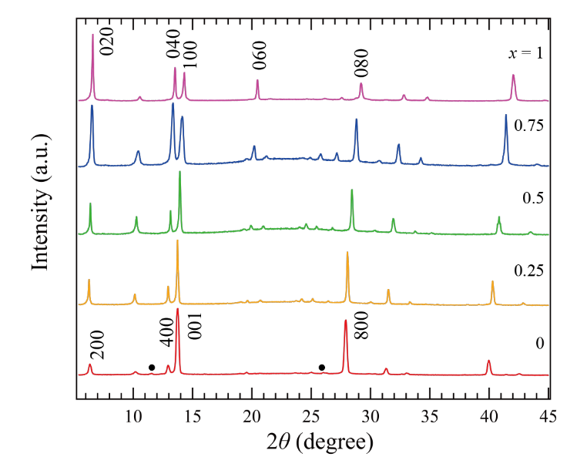
EDX was carried out on thin films (x = 0.25, 0.5 and 0.75) fabricated on 10×10 mm² ITO glass substrate by SEM (HIHACH, S-3500H) equipped with EDX detector at the accelerating voltage of 15 kV. Element analysis was performed on EDX data using EDS2008 software.
Diffuse reflectance
Diffuse reflectance spectra of thin film samples fabricated on 20×25 mm² glass were measured from λ = 200 to 800 nm using a JASCO model V-670 UV/Vis spectrometer equipped with a JASCO model ISN-723 integrating sphere at room temperature under air.

Absolute PL quantum yields
PL spectra and their absolute PL quantum yields of thin film samples fabricated on 10×10 mm² glass were measured from λ = 195 to 957 nm using a Hamamatsu model C9920-03 with an excitation wavelength of 365 nm at room temperature under air.
Results and Discussion
Characterization of Br-substituted FA₄Pb₂I_{7.5}(SCN)_{0.5} thin film
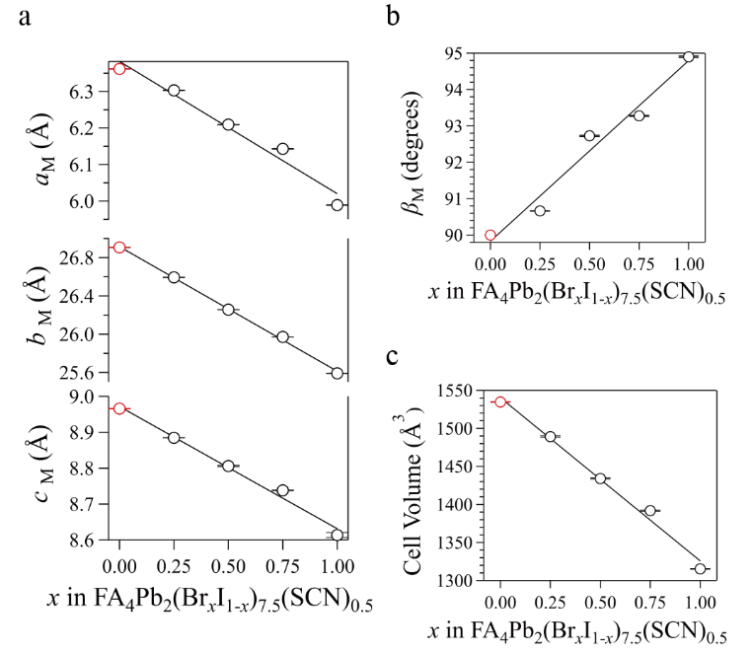
The XRD patterns of nominal composition FA₄Pb₂(Br_{x}I_{1-x})_{7.5}(SCN)_{0.5} (x = 0, 0.25, 0.5, 0.75, 1) thin films are shown in Figure 2. The XRD pattern for FA₄Pb₂I_{7.5}(SCN)_{0.5} (x = 0) can be indexed by Cmmm as reported in the result of single crystal XRD, although a small amount of impurity δ-FAPbI₃ exists.²⁹ Le Bail fitting (Figure S5) shows the lattice parameters of a = 26.908(18) Å, b = 8.9659(4) Å, and c = 6.3615(6) Å, which is consistent with the single crystal XRD data (a = 26.8694(13) Å, b = 8.9848(5) Å, and c = 6.3653(6) Å).²⁹ Similarly, the XRD pattern for FA₄Pb₂Br_{7.5}(SCN)_{0.5} (x = 1) can be indexed by P2₁/c as reported in the result of single crystal structure analysis, which shows that crystal structure of x = 1 is a (110)_{p}–oriented layered perovskite structure (Figure 1). The lattice parameters obtained by Le Bail analysis are a = 25.5907(14) Å, b = 8.61357(7) Å, c = 5.9891(6) Å and α = 94.9(2)°, which is also consistent with the single crystal result of a = 6.0118(4) Å, b = 25.534(2) Å, c = 8.5793(7) Å, and β = 94.869(5). The XRD patterns of the compositions between x = 0 and 1 is similar to those of x = 0 and 1, and the peak positions gradually change, suggesting the formation of a solid solution. Although we could not confirm that these solid solutions belong to Cmmm or P2₁/c due to the data resolution, we calculated the lattice parameters using P2₁/c by Le Bail refinement (Figure S5-9). Figure 3 shows the lattice parameters against x. All the parameters follow Vegard’s law, suggesting the formation of the solid solution. We note that the SCN⁻ amount in the lattices may change depending on x since it is different in x = 0 and 1 in the single crystal structure analysis.
From the result of SEM, microparticles of approximately 20 μm grew on the substrate was observed (Figure S10-15). The EDX measurement revealed that the composition ratio of lead to halogen in each thin film was 1:4, which matches the composition ratio of the target substance. In addition, the ratio of Br to I for each thin film also matched the composition ratio in the prepared solution almost exactly (Table S1-3). These results support the formation of the target compound within the particles and are consistent with the results obtained from XRD.
We note that these thin films appear to be stable ap to 500 K because of the previously reported DSC measurement result for powder FA₄Pb₂I_{7.5}(SCN)_{0.5} sample,²⁹ and remain stable for at least 10 days in ambient atmosphere.

Optical properties of FA₄Pb₂(Br_{x}I_{1-x})_{7.5}(SCN)_{0.5} thin films
Figure 2. XRD pattern for x = 0, 0.25, 0.5, 0.75 and 1. Black dots on x = 0 pattern presents impurity of δ-FAPbI₃. The indexes for x = 0 and 1 are indexed by Cmmm and P2₁/c, respectively.
Figure 3. Lattice parameters ((a), (b)) and volume (c) of the thin films with nominal composition of FA₄Pb₂(Br_{x}I_{1-x})_{7.5}(SCN)_{0.5} as a function of x. x = 0 film was refined with Cmmm (red plots) and others with P2₁/c (black plots). a_{M}, b_{M}, and c_{M} represent the cell parameters for monoclinic setting for P2₁/c, where the parameters for x = 0 with Cmmm correspond to c, a, and b, respectively. Horizontal lines to the plots show error bar of Le Bail refinement result. Lines are guides for the eye.

The appearance of thin films gradually changed from red to yellow as increasing Br content from x = 0 to 1, and the film of x = 1 appears to be almost colorless (Figure 4a). UV-visible diffuse reflectance spectra are shown in Figure 4b. The maximum absorption at 510 nm at x = 0 corresponds to the band edge of δ–FAPbI₃, which is included as an impurity.³² Compared with the powder sample (x = 0) reported previously (broad reflection was seen in between 500 – 700 nm),²⁹ the edge becomes drastically steeper,²⁷ which may be derived from different crystallinity, homogeneity or defect conditions. The absorption edges gradually shift to lower wavelength with increasing Br content: 580, 570, 520, 490, and 450 nm for x = 0, 0.25, 0.5, 0.75, and 1, respectively (Figure 4b). The blue shift of the band gap is consistent with Br substitution for I. The optical gaps calculated from the Tauc’s plot assumed as the direct bandgap shifted from 2.18 to 2.81 eV (Figure 4c, Figures S16-S20) for x = 0 to 1, consistent with the color changing of the films.²⁸
Thin film of FA₄Pb₂I_{7.5}(SCN)_{0.5} (x = 0) shows PL emission of 750 nm (λ_{ex} = 395 nm) (Figure 5). Compared to the powder samples (620 nm for the maximum),²⁹ the emission wavelength shifts to lower energy, which may be derived from different defect conditions. It is possible that the large amounts of defect formed in the thin film sample by rapid crystallization of the casting method, which functioned as luminescent centers.^{33,34} We note that the luminescence intensity, i.e., luminescence quantum yield, varied in different batches, while the peak position was the same (Figure S21). This indicates the change in the amounts of defects in each sample preparation.
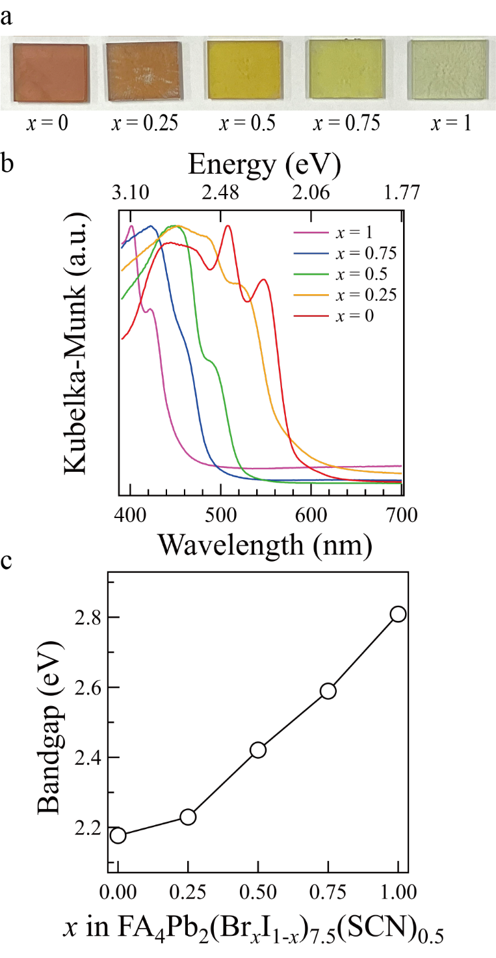
Figure 4. (a) Appearance of spin-coated thin film on 20×25 mm² glass substrate with increasing Br content from left to right. (b) Diffuse reflectance spectra and (c) optical gap energy of FA₄Pb₂(Br_{x}I_{1-x})_{7.5}(SCN)_{0.5}. The optical gaps in (c) are determined by the intersection of linear fitting curves of the baseline and onset region of the data.
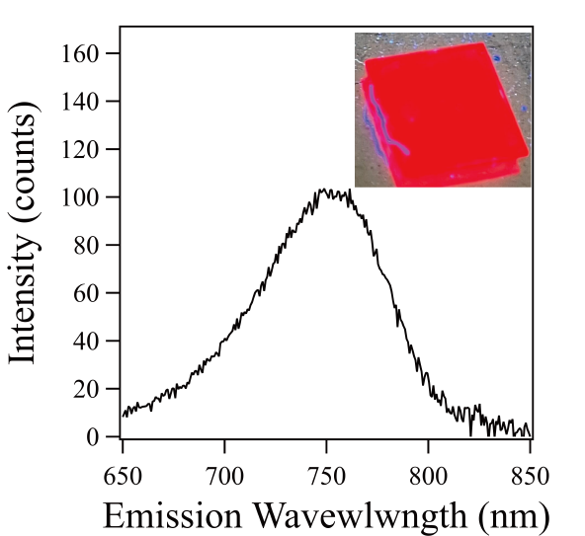
Figure 5. PL spectra of x = 1 film on 10×10 mm² glass substrate. Inset shows the photograph of the film under UV irradiation.

Conclusions
We reported a novel compound FA₄Pb₂Br_{7.74(3)}(SCN)_{0.26(3)} with (110)_{p}-oriented layered perovskite structure as a single crystal. We also reported the thin films of the (110)_{p}-oriented layered perovskites with nominal compositions of FA₄Pb₂(Br_{x}I_{1-x})_{7.5}(SCN)_{0.5} (x = 0, 0.25, 0.5, 0.75, and 1). Structural and optical characterizations revealed the successful formation of a solid solution. The optical properties can be tuned by anion content. The optical band gap changes from 2.17 eV to 2.8 eV with a changing anion ratio. This study uses a mixed-anion strategy to provide new layered halide perovskite with controllable PL property.
Author contributions
All the authors discussed the results. K. M. and T. Y. wrote the manuscript, with comments from all the authors.
Conflicts of interest
There are no conflicts to declare.
Data availability
The data supporting this article have been included as part of the ESI. †
Acknowledgements
This work was supported by Grant-in-Aid for Transformative Research Areas (A) “Supra-ceramics” (JSPS KAKENHI Grant Number JP22H05147). Takuya Ohmi was supported by the Japan Society for the Promotion of Science for Young Scientists (JP22J20672) and Overseas Challenge Program for Young Researchers.
Notes and references
Crystallographic data of FA₄Pb₂Br_{7.74(3)}(SCN)_{0.26(3)} (CCDC 2442705).

1 K. Maeda, F. Takeiri, G. Kobayashi, S. Matsuishi, H. Ogino, S. Ida, T. Mori, Y. Uchimoto, S. Tanabe, T. Hasegawa, N. Imanaka and H. Kageyama, Bull Chem Soc Jpn, 2022, 95, 26–37.
2 H. Kageyama, K. Hayashi, K. Maeda, J. P. Attfield, Z. Hiroi, J. M. Rondinelli and K. R. Poeppelmeier, Nat Commun, 2018, 9, 772.
3 J. K. Harada, N. Charles, K. R. Poeppelmeier and J. M. Rondinelli, Advanced Materials, 2019, 31, 1805295.
4 H. Mogi, K. Kato, S. Yasuda, T. Kanazawa, A. Miyoshi, S. Nishioka, T. Oshima, Y. Tang, T. Yokoi, S. Nozawa, A. Yamakata and K. Maeda, Chemistry of Materials, 2021, 33, 6443–6452.
5 Y. Bao, S. Du, Y. Qi, G. Li, P. Zhang, G. Shao and F. Zhang, Advanced Materials, 2021, 33, 2101883.
6 T. Oshima, T. Ichibha, K. S. Qin, K. Muraoka, J. J. M. Vequizo, K. Hibino, R. Kuriki, S. Yamashita, K. Hongo, T. Uchiyama, K. Fujii, D. Lu, R. Maezono, A. Yamakata, H. Kato, K. Kimoto, M. Yashima, Y. Uchimoto, M. Kakihana, O. Ishitani, H. Kageyama and K. Maeda, Angewandte Chemie International Edition, 2018, 57, 8154–8158.
7 T. Takata, C. Pan and K. Domen, ChemElectroChem, 2016, 3, 31–37.
8 D. Hirai, T. Yajima, D. Nishio-Hamane, C. Kim, H. Akiyama, M. Kawamura, T. Misawa, N. Abe, T. H. Arima and Z. Hiroi, J Am Chem Soc, 2017, 139, 10784–10789.
9 J. Bang, S. Matsuishi, H. Hiraka, F. Fujisaki, T. Otomo, S. Maki, J. I. Yamaura, R. Kumai, Y. Murakami and H. Hosono, J Am Chem Soc, 2014, 136, 7221–7224.
10 T. Yamamoto, D. Zeng, T. Kawakami, V. Arcisauskaite, K. Yata, M. A. Patino, N. Izumo, J. E. McGrady, H. Kageyama and M. A. Hayward, Nat Commun, 2017, 8, 1217.
11 X. Jiang, Z. Zang, Y. Zhou, H. Li, Q. Wei and Z. Ning, Acc Mater Res, 2021, 2, 210–219.
12 L. Protesescu, S. Yakunin, M. I. Bodnarchuk, F. Krieg, R. Caputo, C. H. Hendon, R. X. Yang, A. Walsh and M. V. Kovalenko, Nano Lett, 2015, 15, 3692–3696.
13 I. Levchuk, A. Osvet, X. Tang, M. Brandl, J. D. Perea, F. Hoegl, G. J. Matt, R. Hock, M. Batentschuk and C. J. Brabec, Nano Lett, 2017, 17, 2765–2770.
14 Y. Zhang, Y. Liu, Y. Li, Z. Yang and S. Liu, J Mater Chem C Mater, 2016, 4, 9172–9178.
15 X. Li, W. Ke, B. Traoré, P. Guo, I. Hadar, M. Kepenekian, J. Even, C. Katan, C. C. Stoumpos, R. D. Schaller and M. G. Kanatzidis, J Am Chem Soc, 2019, 141, 12880–12890.
16 S. Dimitrovska-Lazova, M. Bukleski, P. Tzvetkov, S. Aleksovska and D. Kovacheva, J Alloys Compd, 2021, 864, 158104.
17 H. Wei, Y. Yang, S. Chen and H. J. Xiang, Nat Commun, 2021, 12, 637.
18 J. Tian, D. B. Cordes, A. M. Z. Slawin, E. Zysman-Colman and F. D. Morrison, Inorg Chem, 2021, 60, 12247–12254.
19 R. Panetta, G. Righini, M. Colapietro, L. Barba, D. Tedeschi, A. Polimeni, A. Ciccioli and A. Latini, J Mater Chem A Mater, 2018, 6, 10135–10148.
20 C. C. Stoumpos, C. D. Malliakas and M. G. Kanatzidis, Inorg Chem, 2013, 52, 9019–9038.
21 C. C. Stoumpos, D. H. Cao, D. J. Clark, J. Young, J. M. Rondinelli, J. I. Jang, J. T. Hupp and M. G. Kanatzidis, Chemistry of Materials, 2016, 28, 2852–2867.
22 Y. Han, X. Cheng and B. Bin Cui, Mater Adv, 2023, 4, 355–373.
23 K. Maeda, T. Motohashi, R. Ohtani, K. Sugimoto, Y. Tsuji, A. Kuwabara and S. Horike, Sci Technol Adv Mater, 2024, 25, 2416384.
24 T. Ohmi, I. W. H. Oswald, J. R. Neilson, N. Roth, S. Nishioka, K. Maeda, K. Fujii, M. Yashima, M. Azuma and T. Yamamoto, J Am Chem Soc, 2023, 145, 19759–19767.
25 M. Daub and H. Hillebrecht, Angewandte Chemie International Edition, 2015, 54, 11016–11017.
26 D. Umeyama, Y. Lin and H. I. Karunadasa, Chemistry of Materials, 2016, 28, 3241–3244.
27 T. Yamamoto, I. W. H. Oswald, C. N. Savory, T. Ohmi, A. A. Koegel, D. O. Scanlon, H. Kageyama and J. R. Neilson, Inorg Chem, 2020, 59, 17379–17384.
28 T. Ohmi, T. Miura, K. Shigematsu, A. A. Koegel, B. S. Newell, J. R. Neilson, T. Ikoma, M. Azuma and T. Yamamoto, CrystEngComm, 2022, 24, 5428–5434.
29 T. Ohmi, J. R. Neilson, W. Taniguchi, T. Fukui, T. Nagase, Y. Haruta, M. I. Saidaminov, T. Fukushima, M. Azuma and T. Yamamoto, ACS Mater Lett, 2024, 6, 1913–1919.
30 K. Momma and F. Izumi, J Appl Crystallogr, 2011, 44, 1272–1276.
31 A. A. Coelho, J Appl Crystallogr, 2018, 51, 210–218.
32 F. Ma, J. Li, W. Li, N. Lin, L. Wang and J. Qiao, Chem Sci, 2017, 8, 800–805.
33 S. Kahmann, E.K. Tekelenburg, H. Duim, M. E. Kamminga and M. A. Loi, Nat Commun, 2020, 11, 2344.
34 M. C. Gélvez-Rueda, S. Peeters, P.-C. Wang, K. M. Felter and F. C. Grozema, Helv Chim Acta, 2020, 103, e2000121.

