Received 00th January 20xx,
- Department of Materials Science and Engineering, School of Materials and Chemical Technology, Institute of Science Tokyo, 2-12-1 Ookayama, Meguro-ku, Tokyo 152-8552, Japan. E-mail: mmiyauchi@ceram.titech.ac.jp
- National Institute for Materials Science, 1-1 Namiki, Tsukuba, Ibaraki 305-0044, Japan.
- Graduate School of Advanced Science and Technology, Japan Advanced Institute of Science and Technology, 1-1 Asahidai, Nomi, Ishikawa 923-1292, Japan.
- National Institute for Materials Science, 1-2-1 Sengen, Tsukuba, Ibaraki 305-0047, Japan.
†Electronic Supplementary Information (ESI) available.
See DOI: https://doi.org/10.1039/x0xx00000x
Accepted 00th January 20xx
DOI: 10.1039/x0xx00000x

Overcoming thermodynamic incompatibilities with photons: multi-carbon hydrocarbons from methane and carbon dioxide via a hybrid photocatalytic dry reforming/Fischer–Tropsch process
Hiroaki Kaneko,ª Shusaku Shoji,^{b} Yohei Cho,^{a,c} Tomotaka Sugimura,ª Ayako Hashimoto,^{d} Hideki Abe,^{b} Akira Yamaguchi ª and Masahiro Miyauchi ^{*a}
Combining methane dry reforming (DRM) and Fischer–Tropsch synthesis (FTS) enables the conversion of greenhouse gases into valuable hydrocarbons via syngas. However, DRM and FTS have contradictory thermodynamic conditions. This study demonstrates that a photocatalyst can reconcile DRM and FTS at an identical temperature and pressure (280 °C, 2.0 MPa). This achievement offers a new perspective on using photocatalysts to promote coupling reactions under high-pressure gas-phase conditions.
Green foundation
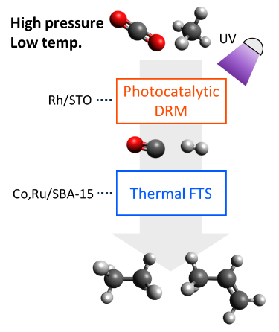
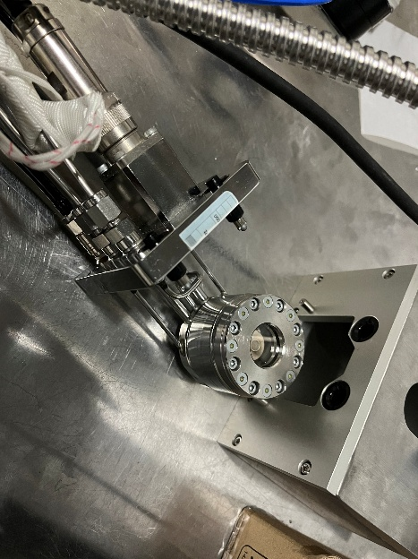
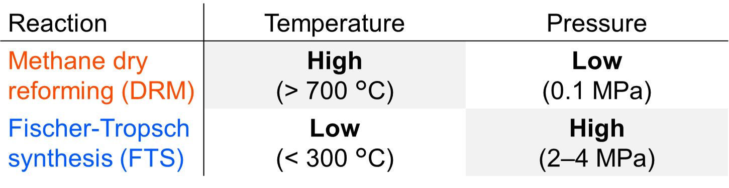
1. High-pressure photocatalysis enables innovative gas-to-liquid (GTL) process that combines CH₄ reforming and FTS reactions, overcoming the complexity of conventional GTL processes. The present concept is further emphasised by its scalability and potential for C1 chemistry applications, such as olefine and methanol production.
Table 1 Contradictory thermodynamic conditions for DRM and FTS reactions.

Scheme 1 (a) Schematic diagram of photocatalytic reconciliation of DRM and FTS and (b) photograph of high-pressure durable gas flow chamber with a light transmission window.
(a)
(b)
2. The photogenerated electron–hole pairs effectively drive DRM at low temperature, as opposed to the energy-intensive thermal process.
3. Future work will focus on utilising solar light and designing catalysts composed of earth-abundant elements to enhance sustainability.
Introduction
Methane dry reforming^{1,2} (DRM: CO₂ + CH₄ → 2CO + 2H₂) is a promising reaction for converting the two major greenhouse gases (CO₂ and CH₄) into syngas (a mixture of H₂ and CO).³ Conversely, the Fischer–Tropsch synthesis ^{4–6} (FTS: nCO + (2n + 1)H₂ → C_{n}H_{2n+2} + nH₂O, nCO + 2nH₂ → C_{n}H_{2n} + nH₂O) is used in industry for producing fuel, as it can convert syngas into hydrocarbons. Numerous studies have been conducted on combining methane reforming with FTS to convert greenhouse gases into sustainable fuels. Some of these studies have explored the integration feasibilities using two-step reactors in experimental⁷ or virtual modelling^{8,9} contexts. Others have focused on achieving simultaneous methane reforming and FTS within a single reactor using local furnace heating¹⁰ and photothermal effects¹¹ to form temperature distributions and plasma process^{12,13} to generate ionized gas. However, none of these studies attempt to fundamentally resolve the thermodynamic equilibrium dilemma between the two reactions. (See Table S1 (ESI †) for more details.) Table 1 shows the contradictory thermodynamic conditions for DRM and FTS reactions. DRM is a highly endothermic reaction with an increasing entropy, favouring high temperatures and low pressures¹⁴, whereas FTS is an exothermic reaction with a decreasing entropy, favouring low temperatures and high pressures ¹⁵. In practice, DRM typically requires high-temperature furnaces above 700 °C to proceed efficiently at ambient pressure. In contrast, FTS generally operates below 300 °C at 2–4 MPa to maintain high selectivity towards hydrocarbons. Therefore, these two reactions cannot occur simultaneously, and conventional gas-to-liquid (GTL) process requires multiple reactor systems that are operated under widely different conditions.
In semiconductor-type photocatalysts, electron–hole pairs generated by photoexcitation serve as the driving force, enabling DRM to occur under low-temperature conditions, such as room temperature, and overcoming thermodynamic equilibrium constraints^{16–20}. Furthermore, photocatalytic DRM has been found to exhibit high selectivity independent of the partial pressure ratio of the reaction gases.²¹ This suggests that sufficient DRM activity can be maintained even under high-pressure conditions.
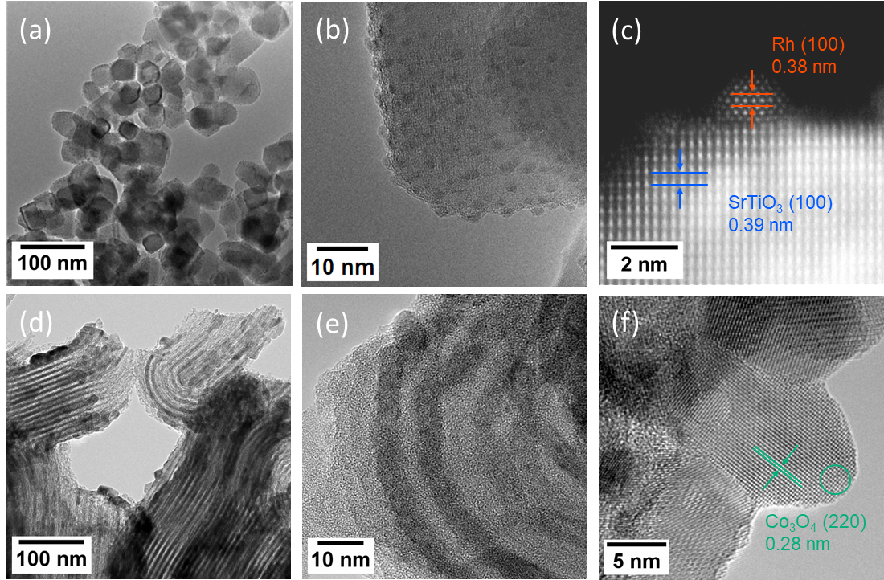
Herein, we demonstrate that combining a photocatalyst for DRM and a thermal catalyst for FTS enables the generation of hydrocarbons from greenhouse gases under low-temperature and high-pressure conditions (Scheme 1(a)). Leveraging the characteristics of photocatalysts enabled us to induce the desired reaction beyond the constraints of thermodynamic equilibrium. This research was made possible by the development of a novel reaction chamber that is capable of both high-pressure gas flow and light irradiation (Scheme 1(b), Fig. S1 (ESI †)). Furthermore, this achievement provides a new strategy for using photocatalysts under high-pressure gas-phase conditions and opens up a new area of application for photocatalysts in various coupling reactions, as opposed to the mainstream use of photocatalysts in decomposition reactions (e.g. water splitting, pollutant removal) under atmospheric pressure.
Fig. 1 TEM images of (a,b) Rh/STO and (d-f) Co,Ru/SBA-15. (c) ADF-STEM image of a Rh nanoparticle on the STO surface. The EDS analysis results for the circle area marked in (f) are shown in Fig. S2.
Results and Discussion
Rh-loaded SrTiO₃ (Rh/STO) and Co- and Ru-loaded mesoporous silica, SBA-15 (Co,Ru/SBA-15) catalysts were synthesised for photocatalytic DRM and thermal FTS, respectively, using a wet impregnation method as described in the electronic supplementary information (Note 1 (ESI †)). Rh/STO^{16,19} was previously reported as a highly efficient photocatalyst because of its appropriate band positions for CO₂ reduction and CH₄ oxidation and robust durability owing to its suppression of Rh particle aggregation and anti-coking property. Co,Ru/SBA-15 catalyst^{6,22} has good property of C–C chain growth activity and high metal dispersion provided by the ordered porous structure. Figure 1 (a,b) shows transmission electron microscopy (TEM) images, and Fig. 1 (c) shows annular dark-field (ADF) scanning TEM (STEM) images of the Rh/STO catalysts. The STO particle size is approximately 50 nm, and the Rh nanoparticles are loaded at an average size of 2.6 nm (Fig. 1 (a,b)). The average interlayer spacings of Rh (100) and STO (100) faces are 0.38 nm and 0.39 nm, respectively, consistent with those in the JCPDS cards (00-005-0685 and 00-035-0734) (Fig. 1 (c)). Fig. 1 (d–f) show TEM images of the Co,Ru/SBA-15 catalysts. The mesoporous structure of SBA-15, with a pore diameter of 8 nm, is observed (Fig. 1 (d)). Co and Ru are either loaded inside the pores of SBA-15 or onto its surface. The average interlayer spacing of the Co₃O₄ (220) faces is 0.28 nm, consistent with that of the JCPDS card (01-074-2120) (Fig. 1 (e,f)). Energy-dispersive X-ray spectroscopy (EDS) point analysis reveals that Co and Ru coexist within a single nanoparticle (Fig. S2 (ESI †)). Scanning electron microscopy (SEM) and EDS mapping reveal that the Rh or Co, Ru nanoparticles are dispersed on the surface of STO or SBA-15 (Fig. S3,4 ((ESI †)).
The X-ray diffraction (XRD) patterns of the Rh/STO, Co,Ru/SBA-15 powders are shown in Fig. S5 (ESI †). In Fig. S5 (a), the characteristic peaks of SrTiO₃ (JCPDS, 00-035-0734) are observed. However, no metallic Rh peaks are observed because of their small size or low loading. Fig. S5 (b) shows the characteristic peaks of Co₃O₄ (JCPDS, 01-074-2120). Similar to Rh/STO, no Ru oxide peaks are observed because of its small size or low loading. Co and Ru oxides were reduced with 5% H₂ in Ar gas flow at 400 °C for 1 h prior to the reaction evaluation. The quantity of Rh introduced into the impregnation process was 2.0 wt% versus SrTiO₃, and the actual loaded quantity of Rh was 1.8 wt%, as confirmed by X-ray fluorescence (XRF) analysis. Also, the quantity of Co and Ru introduced into the impregnation process was 20 wt% and 1.0 wt% versus SBA-15; however, the actual loaded quantities of Co and Ru were 37 wt% and 1.0 wt%, respectively.
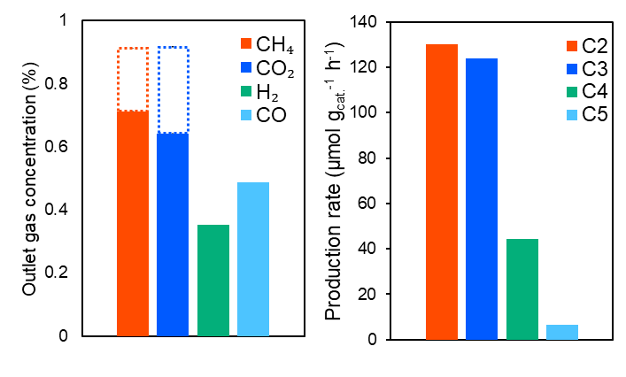
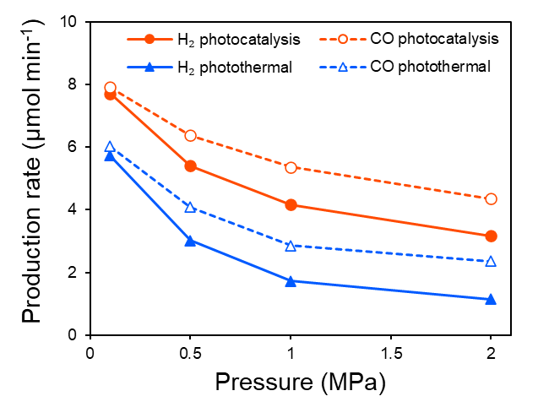
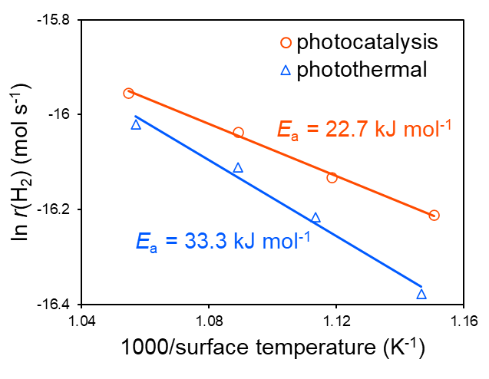
Ultraviolet–visible diffuse reflectance spectroscopy (UV–vis DRS) was used to investigate the optical properties of the catalysts. Rh/STO and STO exhibit strong light absorption at wavelengths below 380 nm (Fig. S6 (ESI †)). Rh/STO exhibits broad absorption in the visible light range owing to the presence of metallic rhodium. This is attributed to the interaction between the metal and the oxides support, which is consistent with previous literature²³. N₂ adsorption–desorption measurements were performed on SBA-15 and Co,Ru/SBA-15. The Brunauer–Emmett–Teller (BET) specific surface areas are 431.6 m² g⁻¹ and 255.1 m² g⁻¹, respectively. Figure S7 (ESI †) shows the N₂ adsorption isotherms of SBA-15 and Co,Ru/SBA-15, both of which are of type IV. Co,Ru/SBA-15 maintains its mesoporous structure even after impregnation, as evidenced by the TEM images (Fig. 1 (d)).
Fig. 3 Performance of the successive DRM and FTS reactions. (a) Outlet gas concentration during the reactions. The dotted area shows the net decrease in CH₄ and CO₂ concentrations. (b) Production rates of hydrocarbons. Sample: 5 mg Rh/STO and 3mg Co,Ru/SBA-15, heater set temperature: 280 °C, reactant gas composition: CH₄:CO₂:Ar = 0.9:0.9:98.2 (volume ratio), and standard gas flow rate: 15 mL min⁻¹, respectively.
(a)
(b)
Fig. 2 (a) Pressure dependence and (b) Arrhenius plots of the DRM activity in photocatalytic (2.7 W cm⁻² Hg–Xe lamp) and photothermal (5.3 W cm⁻² Xe lamp, > 400 nm) reactions. Sample: 5 mg Rh/STO, heater set temperature: (a) 280 °C and (b) 120–280 °C, pressure: (a) 0.1–2.0 MPa and (b) 0.1 MPa, reactant gas composition: CH₄:CO₂:Ar = 0.9:0.9:98.2 (volume ratio), and standard gas flow rate: 15 mL min⁻¹, respectively.
(a)
(b)
Figure 2 (a) shows the pressure dependence of photocatalytic and photothermal DRM using Rh/STO under a flow of 0.9% CH₄ and 0.9% CO₂ in Ar. In photocatalytic DRM, electron–hole pairs were generated by bandgap excitation of STO using a Hg–Xe lamp. In photothermal DRM, a Xe lamp was used to raise the surface temperature to the same level as that under photocatalytic conditions but without generating electron–hole pairs (Fig. S8,9 (ESI †)). Under both photocatalytic and photothermal conditions, the H₂ and CO production rates decreased as the pressure increased, in accordance with Le Chatelier's principle and thermodynamic equilibrium (Fig. S10 (ESI †)). The H₂/CO ratio was below 1 because of the reverse water gas shift reaction (RWGS: CO₂ + H₂ → CO + H₂O). It is noteworthy that photocatalysis retained more activity than photothermal catalysis, demonstrating an internal quantum efficiency of 5.5% even under 2.0 MPa. Arrhenius plots were used to evaluate the apparent activation energy (E_{a}) of the DRM reaction at 0.1 MPa (Fig. 2 (b)). The apparent activation energies were confirmed to be 22.7 and 33.3 kJ mol⁻¹ in the photocatalytic and photothermal conditions, respectively. The reduction of the apparent activation energy strongly suggests that photogenerated electron–hole pairs effectively promote the rate determining steps of the DRM reaction, such as CO₂ dissociation, CH₄ dehydrogenation, and CH* +O* → CHO*.²⁴ The previously reported action spectrum of Rh/STO also indicates that the bandgap excitation plays a dominant role to drive the efficient DRM reaction.¹⁶
To investigate the intermediates of the photocatalytic and photothermal DRM reactions, in situ diffuse reflectance infrared Fourier transform spectroscopy (in situ DRIFTS) was performed (Fig. S11 (ESI †)). Several characteristic peaks emerged under UV and visible light irradiation, including those of linearly adsorbed *CO (2025 cm⁻¹) ^{20,25,26} and bridged carbonyls (1880 cm⁻¹),²⁶ as well as *CHO (1717 cm⁻¹),²⁰ *OCO (1557 cm⁻¹ and 1517 cm⁻¹)²⁰, and *HCOO (1450 cm⁻¹).²⁷ These intermediates suggest that the Rh/STO catalyst rearranges the chemical bonds between CO₂ and CH₄ using UV and visible light as energy sources.
Figure S12 (ESI †) shows the thermal FTS activity of the Co,Ru/SBA-15 catalyst in the FTS gas atmosphere under a flow of 2.4% H₂ and 2.4% CO in Ar at 2.0 MPa. The conversion rate of syngas (H₂/CO = 1) was highest at 280 °C, approximately 10% on a carbon basis. The hydrocarbons produced were C1–C6 alkanes and alkenes. As the temperature increased, a large quantity of CO₂ was produced as a byproduct. Finally, the photocatalytic DRM and the thermal FTS were successively performed under identical temperature and pressure conditions (280 °C, 2.0 MPa). Figure 3 (a) shows the outlet gas concentrations during the reaction. Almost equal amounts of CH₄ and CO₂ were consumed (boxes with dashed lines), and H₂ and CO were produced by the DRM process. The FTS process then proceeded, converting some of the generated syngas into C2–C5 hydrocarbons (Fig. 3 (b)). It was assumed that there were no residual products containing C (such as C6+ hydrocarbons) on the catalyst surface because the carbon balance remained consistent throughout the reactions. The yield of C2+ hydrocarbons was limited (0.34% on a carbon basis), compared with other related reports (Table S1 (ESI †)). This was primarily due to the high flow rate (GHSV = 5500 mL g⁻¹_{cat} h⁻¹), low H₂/CO ratio (< 1), and low reaction rate of the FTS catalyst. Therefore, improving the yield would require changing the gas flow system to a batch process, adding H₂ or H₂O to the reactant gas to maintain an ideal H₂/CO ratio of 2 (for FTS) and optimising the FTS catalyst. For future scale-up, utilizing of sunlight sources and designing catalysts composed earth-abundant elements is more attractive for enhancing sustainability. Considerable effort is being expended on constructing visible-light-responsive^{17,28} and noble-metal-free^{29,30} catalyst for photocatalytic DRM. These catalysts have the potential to make our systems more environmentally friendly. In summary, two catalysts, Rh/STO and Co,Ru/SBA-15, successfully converted greenhouse gas into hydrocarbons through photocatalytic DRM and thermal FTS. This was attributed to the realisation of DRM under low-temperature and high-pressure conditions using a photocatalyst.
Conclusions
Rh/STO and Co,Ru/SBA-15 catalysts were successfully synthesised for photocatalytic DRM and thermal FTS, respectively. The photocatalytic performance of Rh/STO revealed that electron–hole pairs could effectively drive DRM, even under low-temperature and high-pressure conditions (280 °C, 2.0 MPa). By taking advantage of these unique properties of photocatalysts, it was possible to overcome the contradictions in the reaction and achieve both DRM and FTS at the same temperature and pressure. These findings provide a new perspective on photocatalytic coupling reactions under high pressure. While most previously reported photocatalysis reactions involve splitting or decomposition with increasing entropy, such as water splitting and air/water purification, this study shows one example of a coupling reaction driven by high-pressure photocatalysis. Furthermore, this concept can be extended to other valuable reactions, such as olefine and methanol production from CO₂, in addition to the present DRM + FTS reaction.
Author contributions
H.K. conducted experiments and wrote the manuscript. T.S. and A.Y. provided insights into the experimental design. S.S. provided the conceptual idea for this research, and Y.C. constructed a high-pressure durable gas flow chamber system. A.H. contributed to the high-magnification TEM observations. H.A. provided insight into the chemical reaction mechanism. M.M. supervised the project and wrote the manuscript. All the authors discussed the results and commented on the manuscript.
Conflicts of interest
There are no conflicts to declare.
Data availability
The data supporting this article have been included as part of the ESI.†
Acknowledgements
This study was partially supported by JSPS KAKENHI (grant numbers 23H02042, 23K26735, 23K17953, and 25KJ1275) and JST-CREST (No. JPMJCR15P1), the New Energy and Industrial Technology Development Organization (NEDO, No. 23810887), and JST SPRING (JPMJSP2180). One of the authors, Dr. Ayako Hashimoto, appreciates ATLA Innovative Science and Technology Initiative for Security (grant no. JPJ004596). This work was the result of using research equipment shared in MEXT Project for promoting public utilisation of advanced research infrastructure (a program for supporting the construction of core facilities), grant nos. JPMXS0440200025. We also thank Research Infrastructure Management Center Materials Analysis Division Core Facility Center, for TEM observations and Editage (http://www.editage.com) for English language editing.
Notes and references
1 D. Pakhare and J. Spivey, Chem. Soc. Rev., 2014, 43, 7813–7837.
2 C. He, S. Wu, L. Wang and J. Zhang, J. Photochem. Photobiol. C Photochem. Rev., 2022, 51, 100468.
3 S. R. Foit, I. C. Vinke, L. G. J. de Haart and R.-A. Eichel, Angew. Chem. Int. Ed., 2017, 56, 5402–5411.
4 O. O. James, B. Chowdhury, M. Adediran Mesubi and S. Maity, RSC Adv., 2012, 2, 7347–7366.
5 A. Y. Khodakov, W. Chu and P. Fongarland, Chem. Rev., 2007, 107, 1692–1744.
6 M. A. Coronel-García, A. I. Reyes de la Torre, J. A. Melo-Banda, A. L. Martínez-Salazar, R. Silva Rodrigo, N. P. Díaz Zavala, B. Portales Martínez and J. M. Domínguez, Int. J. Hydrog. Energy, 2015, 40, 17264–17271.
7 X. Zhao, A. Naqi, D. M. Walker, T. Roberge, M. Kastelic, B. Joseph and J. N. Kuhn, Sustain. Energy Fuels, 2019, 3, 539–549.
8 A. Ghareghashi, F. Shahraki, K. Razzaghi, S. Ghader and M. A. Torangi, Korean J. Chem. Eng., 2017, 34, 87–99.
9 M. Bakhtiari, M. Binazadeh, M. Farsi, S. M. Mousavi, R. H. Althomali and M. M. Rahman, Renew. Energy, 2024, 237, 121794.
10 O. Johnson, Y. He, B. Joseph and J. N. Kuhn, Energy Fuels, 2025, 39, 7815–7829.
11 H. A. El-Naggar, H. Asanuma, H. Yoshida and A. Yamamoto, Sol. RRL, 2025, 9, 2500021.
12 L. Wang, Y. Yi, C. Wu, H. Guo and X. Tu, Angew. Chem. Int. Ed., 2017, 56, 13679–13683.
13 D. Li, V. Rohani, F. Fabry, A. Parakkulam Ramaswamy, M. Sennour and L. Fulcheri, Appl. Catal. B Environ., 2020, 261, 118228.
14 R. Y. Chein, Y. C. Chen, C. T. Yu and J. N. Chung, J. Nat. Gas Sci. Eng., 2015, 26, 617–629.
15 J. Chen and C. Yang, ACS Omega, 2019, 4, 22237–22244.
16 S. Shoji, X. Peng, A. Yamaguchi, R. Watanabe, C. Fukuhara, Y. Cho, T. Yamamoto, S. Matsumura, M.-W. Yu, S. Ishii, T. Fujita, H. Abe and M. Miyauchi, Nat. Catal., 2020, 3, 148–153.
17 Y. Cho, S. Shoji, A. Yamaguchi, T. Hoshina, T. Fujita, H. Abe and M. Miyauchi, Chem. Commun., 2020, 56, 4611–4614.
18 M. Kushida, A. Yamaguchi and M. Miyauchi, J. Energy Chem., 2022, 71, 562–571.
19 H. Xiong, Y. Dong, C. Hu, Y. Chen, H. Liu, R. Long, T. Kong and Y. Xiong, J. Am. Chem. Soc., 2024, 146, 9465–9475.
20 C. He, S. Wu, Q. Li, M. Li, J. Li, L. Wang and J. Zhang, Chem, 2023, 9, 3224–3244.
21 H. Kaneko, Y. Cho, T. Sugimura, A. Hashimoto, A. Yamaguchi and M. Miyauchi, Chem. Commun., 2024, 60, 10406–10409.
22 N. C. Shiba, X. Liu, H. Mao, X. Qian, D. Hildebrandt and Y. Yao, Fuel, 2022, 320, 123939.
23 Q. T. Trinh, T. Le Van, T. T. N. Phan, K. P. Ong, H. Kosslick, P. N. Amaniampong, M. B. Sullivan, H.-S. Chu, H. An, T.-K. Nguyen, J. Zhang, J. Zhang, P. T. Huyen and N.-T. Nguyen, J. Alloys Compd., 2024, 1002, 175322.
24 B. Wang, S. Chen, J. Zhang, S. Li and B. Yang, J. Phys. Chem. C, 2019, 123, 30389–30397.
25 J. D. Jiménez, L. E. Betancourt, M. Danielis, H. Zhang, F. Zhang, I. Orozco, W. Xu, J. Llorca, P. Liu, A. Trovarelli, J. A. Rodríguez, S. Colussi and S. D. Senanayake, ACS Catal., 2022, 12, 12809–12822.
26 D. Panayotov, M. Mihaylov, D. Nihtianova, T. Spassov and K. Hadjiivanov, Phys. Chem. Chem. Phys., 2014, 16, 13136–13144.
27 Z.-Y. Zhang, T. Zhang, R.-K. Wang, B. Yu, Z.-Y. Tang, H.-Y. Zheng, D. He, T. Xie and Z. Hu, J. Catal., 2022, 413, 829–842.
28 B. Han, W. Wei, L. Chang, P. Cheng and Y. H. Hu, ACS Catal., 2016, 6, 494–497.
29 J. Zhao, X. Guo, R. Shi, G. I. N. Waterhouse, X. Zhang, Q. Dai and T. Zhang, Adv. Funct. Mater., 2022, 32, 2204056.
30 Z. He, K. Gong, Y. Wei, Y. Dai, L. Zhu, K. Gao, Y. Yang, Q. Niu, T. Lin and L. Zhong, Chem Catal., 2024, 4, 101040.

