Mass Enhancement and Lone-Pair-Driven Structural Distortion in PbCu₃V₄O₁₂
Ruifeng Tian¹, Jie Chen¹*, Zhiyan Shao¹*, Feng Wu^{1,2}, Jiayi Guan^{1,3}, Wei Wu², Wanli He¹, Yuanzhe Li¹, Yuemei Li¹, Jin-Ming Chen⁴, Zhiwei Hu⁵, Pengda Ye^{1,6}, Yuxiang Chen¹, Hua Zhang², Baoshan Song¹, Alexei A. Belik⁷, Yanfeng Guo⁸, Meiling Jin¹*, Jiabin Qiao¹*, Fan Yang¹, and Xiang Li¹*

¹Key Lab of Advanced Optoelectronic Quantum Architecture and Measurement (MOE) and School of Physics, Beijing Institute of Technology, Beijing 100081, P. R. China
²Institute of physics, Chinese Academy of Sciences, Beijing 100091, P. R. China
³Center for High Pressure Science and Technology Advanced Research (HPSTAR), Shanghai 201203, P. R. China
⁴Department of Electrophysics, National Yang Ming Chiao Tung University (NYCU), Hsinchu 300, Taiwan
⁵Max-Planck-Institute for Chemical Physics of Solids, Dresden 01187, Germany
⁶Key Laboratory of Biomimetic Robots and Systems, Ministry of Education, State Key Laboratory of Intelligent Control and Decision of Complex System, and School of Mechatronical Engineering, Beijing Institute of Technology, Beijing 100081, China.
⁷Research Center for Materials Nanoarchitectonics (MANA), National Institute for Materials Science (NIMS), Namiki 1-1, Tsukuba, Ibaraki 305-0044, Japan
⁸State Key Laboratory of Quantum Functional Materials, School of Physical Science and Technology and ShanghaiTech Laboratory for Topological Physics, ShanghaiTech University, Shanghai 201210, China

Abstract
A-site-ordered perovskites (AA’₃B₄O₁₂) provide a structurally robust platform for exploring correlated-electron behavior, offering unusual opportunities to disentangle the roles of orbital degree of freedom, bonding interaction, and local structural distortions. In this work, we synthesize a new A-site-ordered perovskite PbCu₃V₄O₁₂ under high-pressure and high-temperature conditions and perform comprehensive structural and physical characterizations. PbCu₃V₄O₁₂ crystallizes in the cubic Im-3 structure, yet its structural parameters deviate markedly from the established ionic-radius trend in the ACu₃V₄O₁₂ (A = Mn, Cu, Ca) series. This deviation reveals local structural modifications driven by the Pb²⁺ lone-pair electrons. The compound exhibits metallic behavior down to at least 8 K and shows a moderately enhanced Sommerfeld coefficient, with density-functional calculations confirming the associated mass enhancement. Comparison of the experimental and theoretical magnetic susceptibilities further indicates an additional contribution from Stoner mechanism. These results identify PbCu₃V₄O₁₂ as a rare example of a 3d-electron metallic vanadate with moderate electronic correlations, demonstrating how A-site chemistry and lone-pair-induced local distortions can be used to engineer correlated electronic states in perovskite-related materials.

1. Introduction
The exploration of perovskite-type oxides (ABO₃) continues to draw considerable interest due to the broad range of physical phenomena they host. Achieving wider tunability of electronic and magnetic properties, or improving functional performance, requires the discovery of new compounds and strategies for systematic materials design. One route involves replacing the B-site cation with different transition metal ions arranged in ordered configurations, forming double or triple perovskites [1,2]. Another route is to introduce cation ordering at the A-site, giving rise to the A-site-ordered perovskite family. In the AA’₃B₄O₁₂ structure, the A’-site is typically occupied by smaller cations such as Cu²⁺ or Mn²⁺, while the A-site accommodates alkali, alkaline-earth, or transition-metal ions [3,4].
Substitution at either the A- or B- site in AA’₃B₄O₁₂ provides an effective means to tune a wide range of physical properties. Reported transport behavior ranges from metallic to semiconducting or insulating, including metal-insulator transitions such as that observed in CaCu₃Fe₄O₁₂ [5]. The magnetic properties likewise vary, spanning paramagnetic, antiferromagnetic, ferrimagnetic, and ferromagnetic regimes [6-8]. Despite this diversity, most members retain a robust cubic Im-3 structure that is largely insensitive to specific A- or B-site chemistries, in clear contrast with simple or double perovskite. This structural stability offers a rare platform for disentangling the roles of orbitals degrees of freedom, bonding interactions, and subtle local distortions in determining the macroscopic physical properties.
The metallic compound CaCu₃Ru₄O₁₂ is one of the most extensively studied A-site-ordered perovskite owing to its Kondo-like behavior and heavy-fermion characteristics. The origin of its mass enhancement remains under debate [9-12]. Notably, its Sommerfeld coefficient (γ) is enhanced by a factor of 20- 30 relative to conventional metals, an unusual feature for systems without 4f electrons [13]. Similar enhanced γ value has been reported across several A-site-ordered perovskites, including ACu₃Ru₄O₁₂ (A = Na, La), ACu₃Ir₄O₁₂ (A = Ca, La), ACu₃V₄O₁₂ (A = Mn, Cu), and CaCu₃Co₄O₁₂, with γ values spanning 75- 336 mJ/(mol K²) [5,9,13-25]. The widespread enhancement underscores the importance of the unique A-site-ordered crystal structure in governing the correlated-electron behavior of this family.
In this study, we synthesized a new A-site-ordered perovskite, PbCu₃V₄O₁₂, under high-pressure and high-temperature conditions and carried out detailed structural and physical characterizations. PbCu₃V₄O₁₂ preserves the cubic Im-3 (No. 204) symmetry typical of this class, yet its lattice parameter, bond lengths, and bond angles deviate markedly from the trends established in ACu₃V₄O₁₂ (A = Cu, Mn, Ca) when plotted against A-site ionic radius. This deviation indicates local structural modifications introduced by Pb²⁺, highlighting the influence of the Pb²⁺ lone-pair electrons on subtle local distortions. PbCu₃V₄O₁₂ exhibits metallic conductivity down to at least 8 K and shows an enhanced Sommerfeld coefficient, with density-functional (DFT) calculations confirming a corresponding mass enhancement. Moreover, comparison between experimental magnetic susceptibility and theoretical estimates suggests an additional contribution from the Stoner mechanism.
Finally, we summarize and compare the structural and physical properties of reported metallic A-site-ordered perovskites to place PbCu₃V₄O₁₂ within the broader context of this compound family. These insights provide guidance for future materials design based on A-site ordering and lone-pair-induced local structural modifications.
2. Experimental
Synthesis: Polycrystalline PbCu₃V₄O₁₂ was synthesized under a high-pressure condition by solid- state reaction from powders of PbO (99.999%, Aladdin, Shanghai, China), CuO (99.9%, Aladdin, Shanghai, China), VO₂ (99.99%, Aladdin, Shanghai, China). Initial synthesis of PbCu₃V₄O₁₂ using a starting molar ratio of PbO: CuO: VO₂ = 1:3:4 resulted in the presence of a PbVO₃ impurity phase. Systematic optimization of the starting composition showed that a molar ratio of PbO: CuO: VO₂ = 1: 3.75: 4.75 yields the lowest impurity level (Figure S1 [26]). This optimized ratio was used for the preparation of all samples investigated in this study. PbCu₃V₄O₁₂ was synthesized at 10 GPa and 850℃ with a Walker-type multi-anvil high-pressure apparatus (LPR-1000, Max Voggenreiter Germany). The samples were kept at the target pressure and temperature for 30 minutes during high-pressure synthesis, then quenched to room temperature before the pressure was released.
Crystal Structure Determination: Polycrystalline samples obtained from high-pressure synthesis were characterized by laboratory X-ray diffraction (XRD) using a Bruker D2 Phaser diffractometer with Cu K_{α} radiation, as well as by synchrotron XRD at beamline BL02B2 at SPring-8 (λ = 0.41306 Å). Rietveld refinements were performed using the RIETAN-FP and VESTA software [27,28].
Valence State Determination: Cu K-edge X-ray absorption spectroscopy (XAS) measurements were performed at beamline BL17B1 of the Shanghai Synchrotron Radiation Facility. Pb L₃-edge XAS data were obtained at beamline BL12B2 of SPring-8, Japan.
Grain size Determination: Morphological characterization of the pristine polycrystalline sample was performed using a Jeol JSM-IT700HR scanning electron microscope (SEM).
Measurements of Transport Properties: The temperature dependence of electrical resistivity was measured using an Oxford TeslatronPT 14 T with a Stanford SR830 Lock-in amplifier. Resistivity was measured using the four-probe method in the van der Pauw configuration in the range 1.8 ≤ T ≤ 300 K. Owing to the moderate density and poor interparticle connectivity of the polycrystalline pellet, electron-transport measurements were challenging. The measurements were therefore performed by sealing a piece of the sample in a diamond anvil cell (DAC; culet diameter 200 µm), using platinum wires as electrical leads and NaCl as the pressure-transmitting medium. The DAC was used to hold the sample. As confirmed by ruby fluorescence measurements, the pressure during the measurement was 0.4 GPa. The temperature dependence of specific heat and thermoelectric power was measured using a Physical Property Measurement System (PPMS, Quantum Design Inc.). Specific heat measurements were performed using Apiezon-N grease for thermal contact between a pellet of polycrystalline sample and the sample stage in the range 1.8 ≤ T_≤ 300 K.
Measurements of Magnetic Properties: The field-cooling (FC) and zero-field-cooling (ZFC) of the samples were performed using a Magnetic Properties Measurement System (MPMS, Quantum Design Inc.), over the temperature range 1.8 ≤ T_≤ 300 K under an applied field of 1 kOe. The isothermal magnetization (M-H) curves were obtained by sweeping the field from -70 kOe to +70 kOe at 2, 50 and 200 K.
Density Functional Theory (DFT) calculations: DFT$+U$ calculations were performed using the Vienna ab inito Simulation Package (VASP). The projector augmented wave (PAW) was employed as the pseudopotentials [29-31]. The electronic correlations were considered by the generalized gradient approximation (GGA) with the Perdew-Burke-Ernzerhof (PBE) exchange potential [32]. The plane-wave cutoff energy is $550 eV$. A $k$-point grid $10×10×10$ is adopted. The onsite Coulomb interaction strength is set to be $U=4.0 eV$ for the $3d$ orbital of Cu and $U=3.0 eV$ for the $3d$ orbital of V. In the structure used for our calculations, the Pb atom was fixed at the ideal position $(0,0,0)$. Magnetic ordering was not included in the calculations.
3. Results and discussion
For detailed structural characterization, synchrotron XRD measurements were performed with an incident wavelength of λ = 0.41306 Å. We examined the crystal structure using an A-site-ordered perovskite model with space group Im-3 (No. 204), which has been previously reported for other A-site-ordered perovskites CaCu₃B₄O₁₂, (B = Ti, V, Cr, Mn, Co, Ru, and Ir). The final refined pattern is shown in Figure S2(a) [26], yielding refinement qualities of R_{wp} = 7.96 % and R_{p} = 5.88 %, where all site occupancies were fixed to 1. The thermal displacement parameter of Pb site (U_{iso} = 0.00979(9) Å²) is much larger than those of Cu (U_{iso} = 0.00226(9) Å²) and V (U_{iso} = 0.00215(9) Å²) sites. This is counterintuitive because, as a heavy element, Pb is generally expected to exhibit a smaller thermal displacement than lighter elements. Such an anomalously large U may originate from static disorder, prompting a closer examination of possible A-site deficiencies. Upon refining the cation-site occupancies, the Cu and V atoms at the 6b (0, 1/2, 1/2) and 8c (1/4, 1/4, 1/4) sites were found to be nearly fully occupied, whereas the Pb occupancy at the 2a (0, 0, 0) site converges to 0.886(1). Incorporation of this Pb deficiency leads to a reduced thermal displacement of Pb (U_{iso} = 0.00715(7) Å²), although the value remains larger than those of Cu (U_{iso} = 0.00453(8) Å²) and V (U_{iso} = 0.00376(7) Å²). The refinement quality also improves to R_{wp} = 6.20 % and R_{p} = 4.63 %. The refined pattern is presented in Figure S2(b) [26], and the corresponding structural parameters are summarized in Table S1 [26].
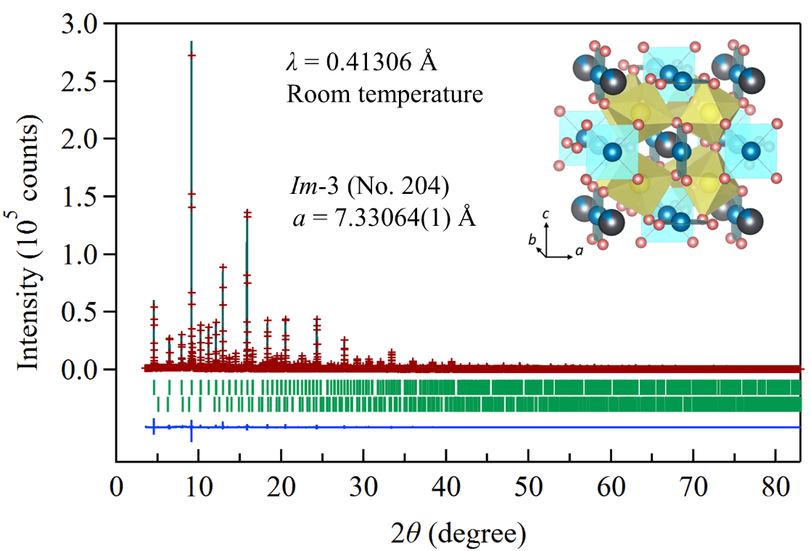
Figure. 1 Rietveld refinement of the synchrotron XRD profile (λ = 0.41306 Å) collected at room temperature for polycrystalline PbCu₃V₄O₁₂. A cubic (Im-3) model was used in the analysis. The crosses and solid lines show the observed and calculated patterns, respectively, with their differences shown at the bottom. The expected Bragg reflections are marked by ticks for the Im-3 structure (top; 99.01 wt.%) and PbVO₃ (bottom; 0.99 wt.%). The crystal structure image of the cubic PbCu₃V₄O₁₂ is shown in the inset, in which octahedral VO₆ and square CuO₄ are drawn in yellow and blue, respectively. The Pb atom position at the A-site is drawn as a grey sphere.
Unusually large U_{iso} values at the A-site in AA’₃B₄O₁₂, have been reported for CuCu₃V₄O₁₂ and MnCu₃V₄O₁₂, with room-temperature values of 0.0446 and 0.0222 Å² respectively [15,16]. Owning to the smaller ionic radii of Cu²⁺ and Mn²⁺, thermal oscillations at the A-site are considerably enhanced. These loosely bound A-site ions were shown to rattle within the oversized icosahedral cages, as demonstrated for Cu²⁺ and Mn²⁺. The rattling of Cu²⁺ at the A-site was further supported by heat-capacity measurements that revealed Einstein-like vibrational modes at low temperatures. Such behavior, however, has not been reported for the isostructural compound CaCu₃V₄O₁₂. Considering that Pb²⁺ has an even larger ionic radius than Ca²⁺, the rattling of A-site Pb²⁺ is unlikely to account for the observed large thermal displacement. Therefore, another possibility involving displacive disorder was considered, in which the A-site cation may shift from the ideal 2a position to more general sites.
An A-site-ordered perovskite BiMn₇O₁₂ (also written as BiMn₃Mn₄O₁₂) was previously reported to crystallize in a structure featuring a Bi-site splitting model, in which the lone electron pair of Bi³⁺ was proposed to drive to a displacement from the ideal 2a (0, 0, 0) to the 16f (x, x, x) site with an occupancy of 0.125 [33]. Considering that Pb²⁺ also possesses a lone electron pair as Bi³⁺, a similar splitting model was examined for Pb in the present compound. Rietveld refinement was performed using the Im-3 (No. 204) structural model, where Pb was placed at the 16f (x, x, x) site with an initial occupancy of 0.125, while all other atomic positions were kept unchanged. Note that the number of atoms per formula unit (n) is calculated as n = (m × occ.)/Z, where m is the Wyckoff multiplicity, occ. is the site occupancy, and Z is the number of formula units per unit cell. The definition of occ. depends on the refinement program, the occ. values reported here follow the convention implemented in the RIETAN-FP software. Within this model, the refined displacement parameter for Pb is reduced to U_{iso} = 0.00630(7) Å², compared with U_{iso} (Cu) = 0.00452(8) Å² and U_{iso} (V) = 0.00375(7) Å². The refined Pb position shows a clear deviation from the ideal 2a (0, 0, 0) site, yielding x = 0.040(2). The Pb-site deficiency is retained in this model, resulting in a refined chemical composition of Pb_{0.886}Cu₃V₄O₁₂. Although the Pb-site splitting model leads to a reduced U_{iso} value for Pb, it does not fully account for the comparatively large Pb displacement parameter. Moreover, the refinement quality is not improved, as indicated by unchanged R values.
Furthermore, considering that CuCu₃V₄O₁₂ can be stabilized under high-pressure and high-temperature conditions, this suggests that Cu can be accommodated at the A site of AA’₃B₄O₁₂. Therefore, we examined a structure refinement based on a structure model in which the A site is simultaneously occupied by Pb and Cu atoms in a disordered manner. The refinement yields A-site occupancies of 0.823 for Pb and 0.177 for Cu, corresponding to a chemical composition of Pb_{0.823}Cu_{0.177}Cu₃V₄O₁₂. Within this model, the displacement parameter at the A site remains slightly larger than those of the lighter-atom sites, as listed in Table 1. A comparison of the R values does not allow a definitive conclusion as to which structural model is superior. However, considering the elemental ratios of the starting materials described in the synthesis section, the refined composition of Pb_{0.823}Cu_{0.177}Cu₃V₄O₁₂ is very close to the nominal Pb: Cu: V ratio used for synthesis. This consistency supports the validity of the A-site disorder model, in which Pb and Cu coexist at the A site, for describing the compound synthesized in this work. As described in the Experimental section, systematic optimization of the starting composition shows that a molar ratio of PbO: CuO: VO₂ = 1: 3.75: 4.75 yields the lowest impurity level. A comparison of samples prepared with different starting ratios is presented in Figure S1 [26]. These results imply that there is an intrinsic tendency that prevents the A site from being fully occupied by Pb atoms.
Cation-site deficiency has been widely reported in A-site-ordered perovskites, such as Ln_{2/3}Cu₃Ti₄O₁₂ (Ln = lanthanide), CaCu₃Ti₄O₁₂, LaCu₃Pt_{3.75}O₁₂, and La₃Ru₄O₁₂ [34-37]. The ability to accommodate a substantial concentration of vacancies reflects the structural robustness of A-site-ordered perovskites. In the literature, (Dy_{δ}Mn_{1-δ})Mn₃Mn₄O₁₂ has also been reported to exhibit a comparable degree of A-site disorder to that observed in Pb_{0.823}Cu_{0.176}Cu₃V₄O₁₂, in which the A site is occupied by 91.1% Dy and 8.9% Mn [38]. Elucidating the physical origin of A-site disorder in Pb_{0.823}Cu_{0.176}Cu₃V₄O₁₂ will likely require further investigation of the local chemical coordination environment, for example, by pair distribution function (PDF) analysis.
Based on the high-resolution synchrotron XRD data presented in this work and a comparison of different structural models, we conclude that the A-site disorder model yielding Pb_{0.823}Cu_{0.177}Cu₃V₄O₁₂ provides the most reasonable description of the compound synthesized under the present conditions. Moreover, consistently large displacement parameters are obtained for Pb site across the different structural models, indicating that this feature is intrinsic to the Pb atoms rather than an artifact of a particular structural model. The stereochemical activity of the Pb²⁺ lone pair is a plausible origin of this behavior; a similar phenomenon has also been observed in Bi-based compounds [39]. The Rietveld refinement results for A-site disorder model are shown in Figure 1 and Table 1. It is worth noting that the structural parameters including lattice parameters, bond lengths, and bond angles, obtained from the different structural models are nearly identical. These are summarized in Table S3 [26] of the Supplemental Information. For simplicity, the nominal formula PbCu₃V₄O₁₂ is adopted in the following discussion.
Table 1 Atomic coordinates and equivalent isotropic displacement parameters (U_{iso}, 10⁻³Å²) for a cubic PbCu₃V₄O₁₂ as measured by the synchrotron X-ray diffraction at room temperature
Site | WP | Occ. | x | y | z | U_{iso}
Pb | 2a | 0.823(2) | 0.0 | 0.0 | 0.0 | 6.68(7)
Cu1 | 2a | 0.176 | 0.0 | 0.0 | 0.0 | 6.68
Cu2 | 6b | 1 | 0 | 0.5 | 0.5 | 4.59(8)
V | 8c | 1 | 0.25 | 0.25 | 0.25 | 3.84(7)
O | 24g | 1 | 0 | 0.3065(2) | 0.1866(2) | 4.3(3)
WP: Wyckoff position. Space group: Im-3 (Cubic; No.204); lattice constants a = 7.33064(1) Å; cell volume = 393.9367(11) Å³; d_{cal} = 6.476 g cm⁻³; Chemical formula sum: Pb_{0.823}Cu_{0.177}Cu₃V₄O₁₂ (Z = 2); and the final R values are 6.20 % (R_{wp}), 4.63 % (R_{p}), 3.10 % (R_{B}), and 1.75 % (R_{F}).
To confirm valence states, the polycrystalline sample was examined by XAS, as shown in Figure 2. The valence states of Pb and Cu were identified as 2+ by comparison with reference samples. The Pb-O, Cu-O, and V-O bond lengths obtained from Rietveld refinement are summarized in Table S3 [26]. The refined V-O bond length of 1.935 Å yields a bond-valence sum (BVS) of +3.99, supporting the tetravalent state of vanadium in PbCu₃V₄O₁₂.
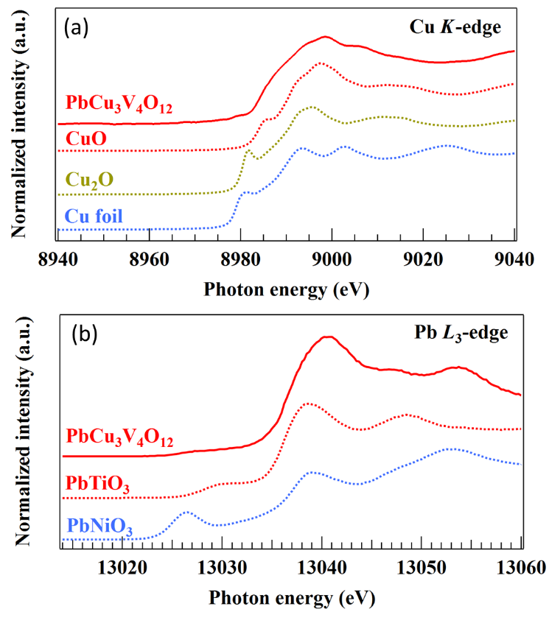
Figure 2 The XAS spectra of PbCu₃V₄O₁₂ at the (a) Cu-K edge and (b) Pb-L₃ edge.
The temperature dependence of resistivity ρ(T), shown in Figure 3(a), indicates that PbCu₃V₄O₁₂ remains metallic down to at least 8 K. The estimated residual-resistivity ratio (RRR) between 300 K and 8 K is merely 1.27, which is comparable to those reported for proposed semimetals [40,41]. The small RRR is likely associated with the presence of the grain-boundary effect in the main phase and insulating PbVO₃ impurity. The pristine sample obtained from high-pressure and high-temperature synthesis forms a moderately dense pellet, which may enhance grain-boundary scattering and result in a reduced RRR. For comparison, the estimated RRR for polycrystalline ACu₃V₄O₁₂ compounds are summarized in Table 2. All vanadate compounds in this family, ACu₃V₄O₁₂ (A = Na, Ca, Mn, Cu, Y, Pb), exhibit RRR values in the range of 1-2, indicating that a low RRR is a common characteristic of this compound family. Similar to PbCu₃V₄O₁₂, resistivity measurements for CuCu₃V₄O₁₂ have been reported to be challenging due to poor interparticle connectivity, contact resistance, or grain-boundary resistance; therefore, ρ(T) was measured using a DAC [16,42]. Such grain-boundary-dominated transport behavior is therefore likely to play an important role in determining the overall transport properties of this compound family.
The magnitude and temperature dependence of the thermoelectric power (S), shown in Figure 3(b), further confirm the metallic nature of this compound. The Seebeck coefficient increases upon cooling from 300 K and begins to decrease below approximately 15 K, approaching zero at the lowest measured temperature (= 2 K). The S(T) changes sign from negative to positive upon cooling through ~40 K, which may be indicative of temperature-driven band crossing. The S(T) is highly sensitive to the asymmetry of the electronic density of states near the Fermi energy (E_{F}) [43]. Although the electrical resistivity is less sensitive to such electronic asymmetry than the Seebeck coefficient, it may still exhibit related signatures, since resistivity depends on carrier mobility and the density of states at E_{F}. As shown in Figure 3(a), the slope of ρ(T) exhibits a subtle change around 40 K. This feature becomes more discernible in the temperature derivative $\frac{dρ}{dT}$ (Figure S3 [26]), where a minimum in $\frac{dρ}{dT}$ appears near 40 K, as indicated by the dashed line. As discussed above, resistivity is inherently less sensitive to such band-structure changes than the Seebeck coefficient; therefore, only a modest variation is observed in $\frac{dρ}{dT}$ compared with the more pronounced feature in the S(T). To further elucidate the temperature-driven band crossing, theoretical simulations beyond DFT calculations are required, as standard DFT provides the band structure at 0 K. This issue remains to be investigated in future work.
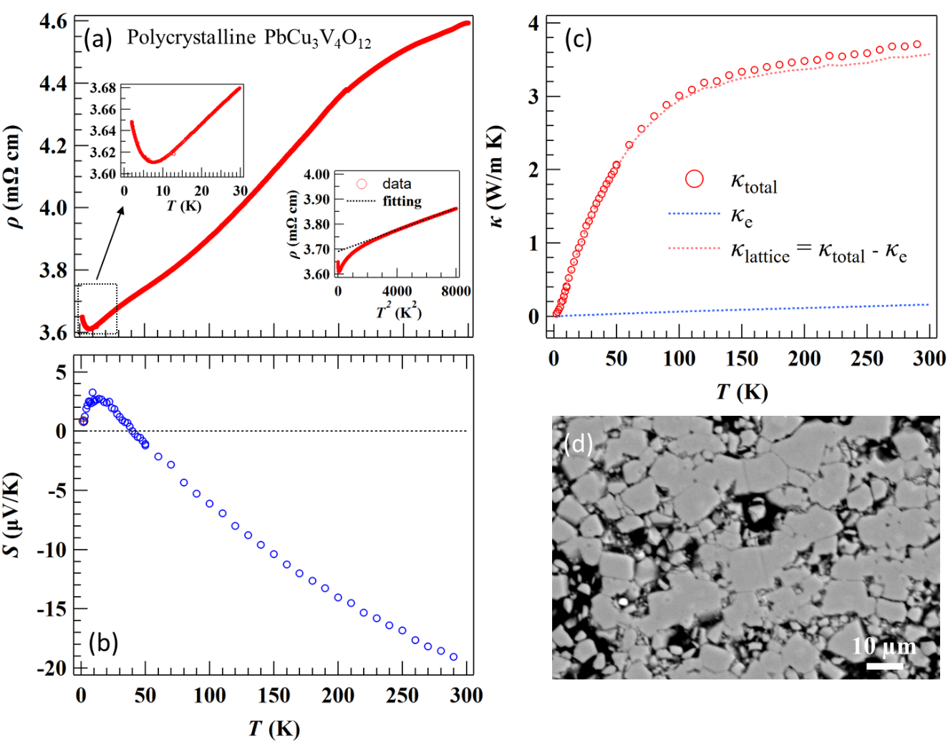
Figure 3 Temperature dependence of (a) resistivity ρ(T) with ρ(T²) shown in the inset, (b) thermopower S(T), (c) thermal conductivity κ(T), and (d) an SEM image of a polished surface of pristine polycrystalline PbCu₃V₄O₁₂.
A slight upturn of resistivity below 8 K may originate from the small amount of PbVO₃ impurity (0.99 wt. %, as obtained from Rietveld refinement). Pure PbVO₃ is insulating, and its resistivity increases from ~10 Ω cm at 300 K to 10³ Ω cm below 50 K [44]. Thus, the overall resistivity of the PbCu₃V₄O₁₂ sample may contain a minor insulating contribution from PbVO₃, leading to the observed upturn below 8 K. Nevertheless, the conducting behavior of PbCu₃V₄O₁₂ remains robust. The resistivity of PbCu₃V₄O₁₂ deviates from a T² dependence below ~60 K, as shown in the inset of Figure 3(a), whereas CaCu₃V₄O₁₂ begins to deviate from Fermi-liquid behavior below about 15 K. Downward deviations from Fermi-liquid behavior have also been reported for NaCu₃V₄O₁₂ and YCu₃V₄O₁₂ at low temperatures [14]. The low-temperature resistivity of PbCu₃V₄O₁₂ does not exhibit a clear T² dependence expected for a conventional Fermi liquid. This behavior is likely associated with disorder-related scattering effects. The polycrystalline PbCu₃V₄O₁₂ sample forms a moderately dense pellet, in which grain-boundary scattering and intergranular effects can lead to deviations from the intrinsic Fermi-liquid-like behavior.
The thermal conductivity (κ) of PbCu₃V₄O₁₂, shown in Figure 3(c), exhibits glass-like behavior similar to that reported for CaCu₃Ir₄O₁₂ and PbCu₃Ru₄O₁₂ [24,45]. To estimate the electronic contribution, the Wiedemann-Franz law, κ_{e} = LσT (where L is Lorenz number), was applied. The calculated κ_{e} is negligible compared with the total thermal conductivity (κ_{total}). The average grain size of the pristine sample, revealed by the SEM image in Figure 3(d), is approximately 5- 10 µm, which is much larger than the phonon mean free path. This rules out grain-boundary scattering as the origin of the glass-like behavior. It should be noted that the surface was obtained by polishing a moderately dense pellet of the pristine sample. The relatively low density of the pellet, together with the polishing process, leads to the pores observed in the SEM image.
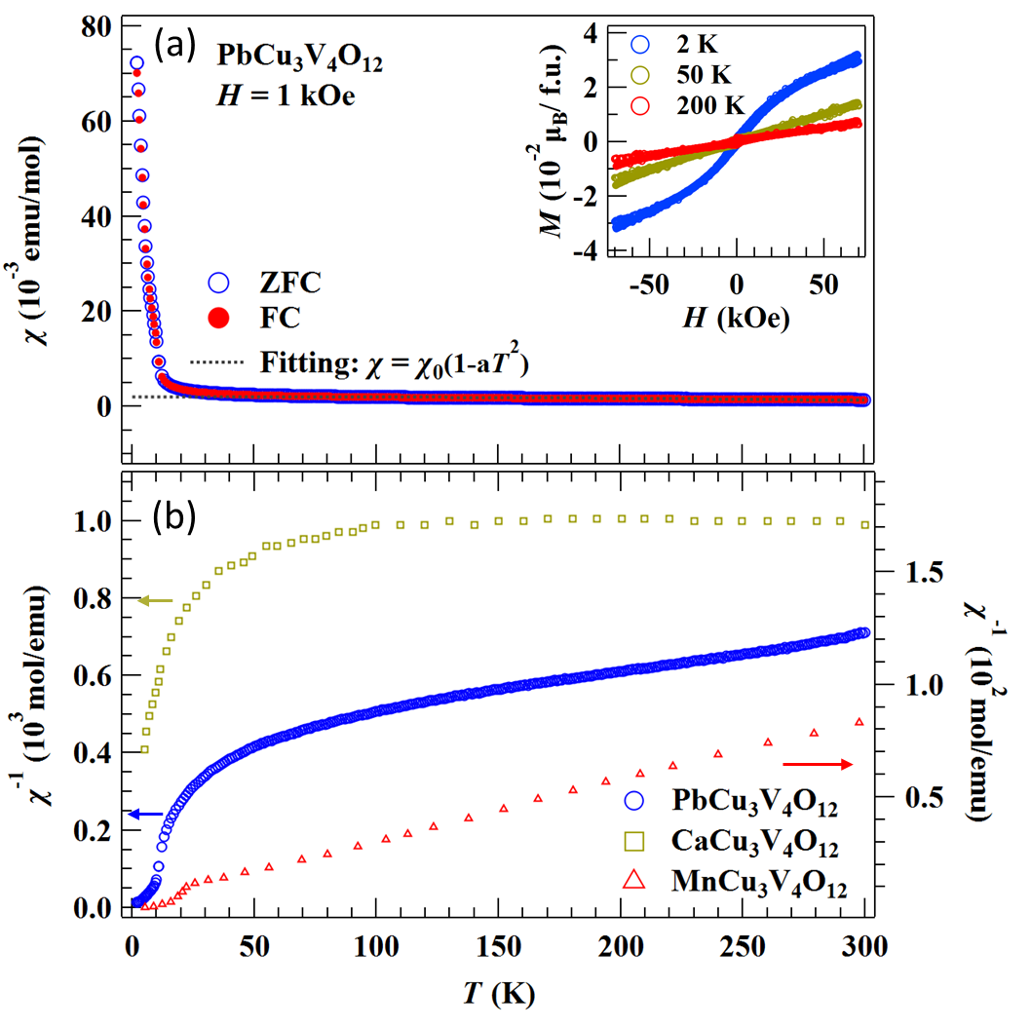
Figure 4 (a) Temperature dependence of χ of polycrystalline PbCu₃V₄O₁₂, measured in a field of 1 kOe. The dashed line is the fitting by the function of χ = χ₀ (1-aT²). Isothermal magnetizations at 2, 50, and 200 K are shown in the inset. (b) Alternative plot of the χ - T data, compared with those of CaCu₃V₄O₁₂ and MnCu₃V₄O₁₂ [14,15].
The temperature-dependence of magnetic susceptibility (χ-T) is shown in Figure 4(a). The paramagnetic susceptibility for a metal can generally be described by χ = χ₀(1-aT²) [43]. The χ-T data are well fitted by this expression between 100 and 300 K, yielding χ₀ = 2.05(1)×10⁻³ emu/mol and a = 4.2(1)×10⁻⁶ K⁻². The low-temperature upturn of χ-T below 10 K can be roughly fitted using the Curie-Weiss law, 1/χ = (T–θ_{W})/C, where θ_{W} is the Weiss temperature and C is the Curie constant. The fitted parameters are are θ_{W} = 0.7(3) K and C = 0.20(1) emu mol⁻¹ K, corresponding to an effective magnetic moment μ_{eff} = 1.265 μ_{B}. This value is much smaller than the theoretical spin-only moment expected for PbCu₃V₄O₁₂ with three localized Cu²⁺ (3d ⁹) and four V⁴⁺ (3d ¹). Thus, the paramagnetic-like component most likely arises from a minor magnetic impurity, although it is difficult to identify such an impurity solely from the structural analysis. Similar Curie-like upturns at low temperatures have been reported in ACu₃V₄O₁₂ (A = Na, Ca, Y) [14].
No significant difference is observed between the ZFC and FC curves. The χ⁻¹ - T plot is shown in Figure 4(b), together with those of CaCu₃V₄O₁₂ and MnCu₃V₄O₁₂ reproduced from the literature [14,15]. It is evident that χ⁻¹ (T) for PbCu₃V₄O₁₂ and CaCu₃V₄O₁₂ deviates from Curie-Weiss behavior at high temperatures (above ~20 K), whereas MnCu₃V₄O₁₂ exhibits a linear χ⁻¹ - T relation. The localized 3d electrons of Mn²⁺ are believed to contribute to the Curie-Weiss behavior in MnCu₃V₄O₁₂ [15]. In contrast, Ca²⁺ and Pb²⁺ at the A-site do not provide d electrons for magnetic interactions. The isothermal magnetization measured at various temperatures is shown in the inset of Figure 4(a). A linear field dependence starts to be observed from 50 K, whereas a slight deviation from linearity appears at 2 K, likely due to a minor magnetic impurity such as PbVO₃ [46]. The overall magnetization is very small, consistent with the magnetic susceptibility data, indicating the absence of long-range magnetic ordering in PbCu₃V₄O₁₂.
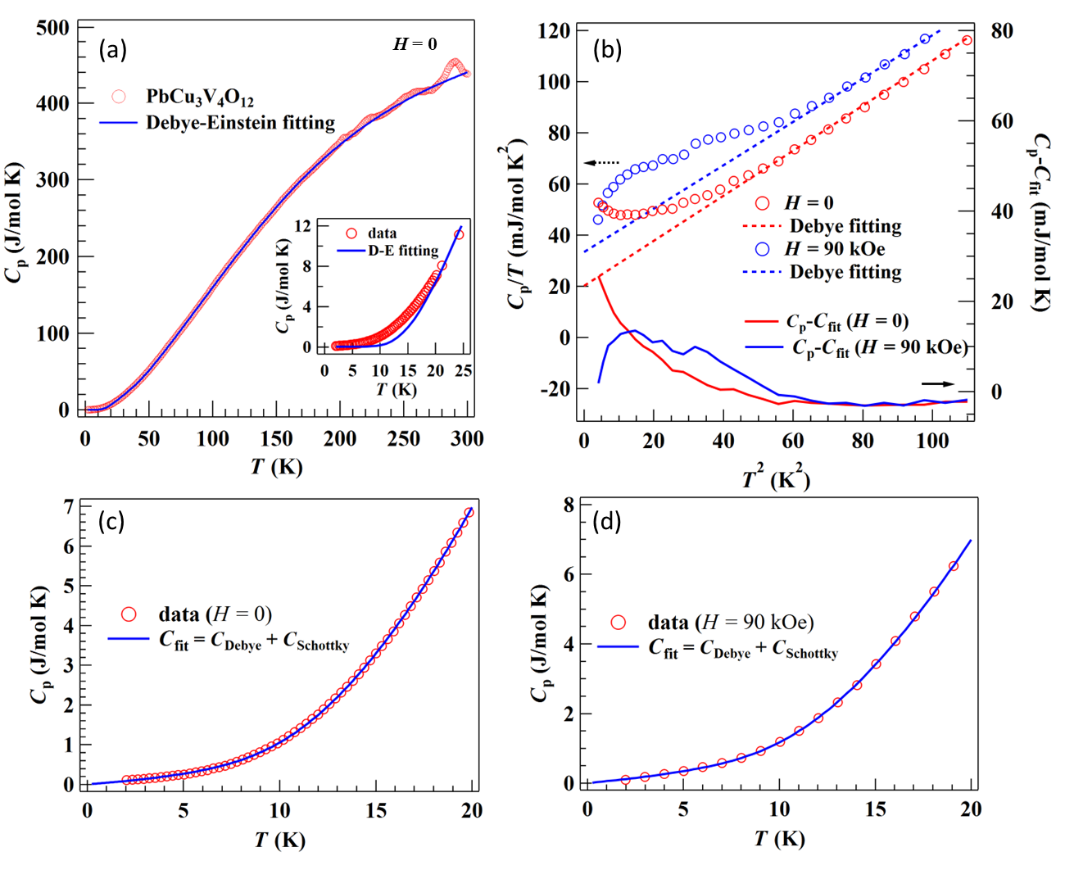
Figure 5 (a) Specific heat C_{p} vs. T curve of PbCu₃V₄O₁₂ measured in zero field. The inset shows an expanded view of the low-temperature region. (b) An approximate Debye fit to the C_{p}/T vs. T² data near the low-temperature limit. The difference between the experimental C_{p} and the Debye fitting result (C_{fit}) is plotted as solid lines, with values shown on the right axis. (c, d) Low-temperature C_{p} vs. T data fitted using C_{p} = C_{Debye} + C_{Schottky} function for measurements collected at (c) H = 0 and (d) H = 90 kOe.
In Figure 5(a), the temperature dependence of specific heat (C_{p}-T) is measured in zero magnetic field. Fitting the low-temperature data using an approximated Debye model, C_{p}/T = γ + β₀T², yields a Sommerfeld coefficient γ = 21.8(7) mJ/(mol K²) (equivalent to 5.45 mJ/(vanadium K²)), which is comparable to that of CaCu₃V₄O₁₂ (= 30 mJ/(mol K²) or 7.5 mJ/(vanadium K²)) [14]. The γ values fall within the range typical of moderately correlated metallic perovskite oxides, such as CaVO₃ and SrVO₃ (γ = 8-9 mJ/(mol K²)) [47]. In contrast, typical weakly correlated metallic perovskites, for examples, Nb-doped SrTiO₃ exhibits γ value below 2 mJ/(mol K²) [48]. On the other hand, several 3d transition-metal perovskite oxides, such as La_{1-x}Sr_{x}TiO₃ and Y_{1-x}Ca_{x}TiO₃, display significantly enhanced γ value, with their large effective carrier masses attributed to proximity to a metal-insulator transition [49,50]. In comparison, PbCu₃V₄O₁₂ exhibits a moderate mass enhancement.
The mass enhancement is further clarified by comparing the experimental γ value with the theoretical γ (DFT) value. Our DFT calculations, shown in Figure 6, yield N(E_{F}) = 2.305 states/eV/f.u./spin. Using $γ=\frac{π^{2}}{3}k_{B}^{2}N(E_{F})$, the theoretical γ (DFT) is estimated to be 5.43 mJ/(mol K²). The experimental γ is enhanced by a factor of four relative to γ (DFT), comparable to the enhancement reported for the nickelate perovskite LaNiO₃ [43]. The temperature-independent susceptibility χ₀ can also be estimated from N(E_{F}) using $χ_{0}=μ_{B}^{2}N(E_{F})$, giving χ₀ (DFT) = 7.45×10⁻⁵ emu/mol. Interestingly, the ratio $χ_{0}/χ_{0}(DFT)$ is significantly larger than $γ/γ(DFT)$, with values of 28 and 4, respectively. This indicates the presence of an additional mechanism that specifically enhances the magnetic susceptibility, rather than a renormalization arising solely from the effective mass enhancement. Electronic correlations may further amplify χ₀ through the Stoner mechanism, as previously observed in the narrow-band system LaNiO₃ [43]. Note that conventional DFT-based evaluations of magnetic order are essentially mean-field in nature and therefore have limitations in estimating magnetic ordering tendencies in systems with strong Coulomb interactions. A more reliable assessment of possible magnetic order in strongly correlated systems would require a beyond-DFT treatment that explicitly accounts for electronic correlations, which is left for future study.
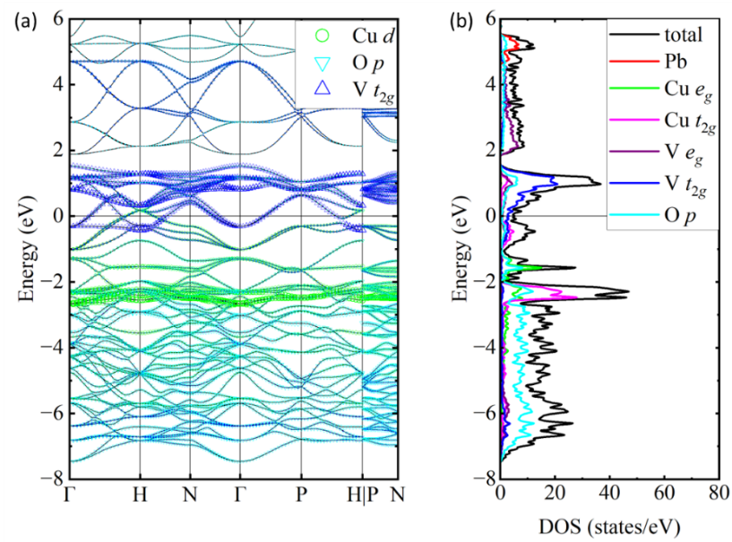
Figure 6 The band structure (a) and DOS (b) for PbCu₃V₄O₁₂.
The upturn of C_{p}/T below 6 K in zero field and the emergence of a broad hump under a magnetic field of 90 kOe, as shown in Figure 5(b), are reminiscent of a Schottky-like anomaly similar to those reported in oxides such as Sr₃Cr₂O₈, Sr₂YIrO₆, and CaRuO₃ [51-53].The upturn of C_{p}/T in zero field is likely the high-temperature tail of such a Schottky-like contribution, while the broad peak observed under 90 kOe shifts upward in temperature, reaching a maximum near 3.5 K. This field-dependent shift can be identified more clearly by subtracting the Debye component, C_{Debye} = γT + β₀T ³, from the experimental C_{p}, as shown in Figure 5(b). The resulting C_{p} – C_{Debye} curves demonstrate that the broad peak moves to higher temperature with the application of a 90 kOe magnetic field. Furthermore, the low-temperature C_{p} data collected at 90 kOe are well reproduced by including a two-level Schottky contribution (C_{Sch}) [54]:
$$C_{Sch}=\frac{R(\frac{Δ_{g}}{k_{B}T})^{2}\exp{(}\frac{Δ_{g}}{k_{B}T})}{[1+\exp{(}\frac{Δ_{g}}{k_{B}T})]^{2}}$$
The fitting results are shown in Figure 5(c) and 5(d). The presence of this Schottky-like anomaly is likely associated with a small amount of paramagnetic impurities, consistent with previous reports [51,52]. Paramagnetic centers are widely observed in oxide systems and may originate from paramagnetic impurities or intrinsic defects in the main phase of the sample. The latter may arise from deficiencies, chemical disorder, off-stoichiometry, and related effects.
The family of A-site-ordered perovskite AA’₃B₄O₁₂ has expanded significantly in recent decades, largely owing to advances in high-pressure and high-temperature synthesis. Although the physical properties vary widely, most members retain a robust cubic Im-3 structure independent of the specific A- or B-site compositions, providing an ideal platform to study property evolution. Table 2 summarizes the reported metallic members of this family and compares their synthesis conditions, resistivity (ρ) at 300 K, RRR, magnetic properties, Sommerfeld coefficients, and structural parameters.
Table 2 Comparison of synthesis pressure, resistivity (ρ) at 300 K, estimated RRR for metallic compounds, magnetic susceptibility (χ) at 300 K, Sommerfeld coefficient (γ), and bond-valence sum (BVS) for metallic A-site-ordered perovskite oxides. All compounds listed in the table crystalize into cubic structure (Im-3) at room temperature.
Compound | P_{synthesis}  (GPa) | Lattice parameter (Å) | ρ at 300K (mΩ cm) | RRR  value | χ at 300 K  (10⁻³ emu/mol) | γ  (mJ/(mol K²)) | BVS at A-site | Refs.
PbCu₃V₄O₁₂ | 8 | 7.33064(1) | 4.95 | 1.27 | 1.4 | 21.8(7) | 3.08 | This work
NaCu₃V₄O₁₂ | 9 | 7.25332(1) | 35.15 | 1.98 | 1.1 | \ | 1.52 | [14]
CaCu₃V₄O₁₂ | 9 | 7.28094(1) | 30.21 | 1.55 | 1.0 | 30 | 2.31 | [14]
MnCu₃V₄O₁₂ | 12 | 7.2668(1) | 1.75 | 1.43 | 12.1 | \ | 1.47 | [15]
CuCu₃V₄O₁₂ª | 15 | 7.2483(1) | 72.03 | 1.85 | 1.2 | 127(2) | 1.09 | [16]
YCu₃V₄O₁₂ | 9 | 7.2879(1) | 1.17 | 1.86 | 1.1 | \ | 2.38 | [14]
CaCu₃Cr₄O₁₂ | 6 | 7.253(3) | 0.98 | 2.58 | \ | \ | 2.35 | [17]
BiCu₃Cr₄O₁₂ | 7.7 | 7.3028(1) | 8 | \ | FIM ^{b} | \ | 3.11 | [18]
CaCu₃Fe₄O₁₂ | 15 | 7.29692(5) | MIT ^{c} | \ | FIM ^{b} | \ | 2.21 | [5]
CaCu₃Co₄O₁₂ | 9 | 7.12260(5) | 13 | 2.04 | 6.1 | 157.5(7) | 2.65 | [19]
NaCu₃Ru₄O₁₂ | AP ^{d} | 7.386(1) | 0.45 | 5.55 | 2.9 | 75 | 1.24 | [9,20,21]
CaCu₃Ru₄O₁₂ | AP ^{d} | 7.4098(8) | 0.35 | 5.20 | 4.8 | 92 | 2.06 | [13,22,23]
LaCu₃Ru₄O₁₂ | AP ^{d} | 7.477(1) | 0.57 | 2.47 | 4.5 | 136 | 3.53 | [9,20]
PbCu₃Ru₄O₁₂ | 12 | 7.47222(7) | 15.56 | 5.82 | 4.3 | 98 | 2.75 | [45]
CaCu₃Ir₄O₁₂ | 9 | 7.47380(6) | 4.61 | 4.48 | 4.2 | 173 | 2.11 | [24]
LaCu₃Ir₄O₁₂ | 9 | 7.524183(3) | 670 | 1.41 | 5.5 | 336 | 3.31 | [25]
a BiCu₃Cr₄O₁₂ and CaCu₃Fe₄O₁₂ exhibit ferrimagnetic (FIM) transition at 190 K and 90 K, respectively.
b CaCu₃Fe₄O₁₂ exhibits metal-semiconductor transition at 90 K.
c Ambient pressure (AP).
In simple vanadate perovskite AVO₃ (A = Ca, Sr, Pb), the crystal symmetry changes from the centrosymmetric structure (Pbnm or Pm-3m) for Ca and Sr to the noncentrosymmetric tetragonal P4mm for Pb due to the lone-pair electrons of Pb²⁺ [55-57]. This symmetry change accompanies marked differences in physical properties: CaVO₃ and SrVO₃ are metallic and no long-range magnetic ordering, whereas PbVO₃ is insulating and exhibits two-dimensional antiferromagnetism. The lone pair of Pb²⁺ can narrow the π* bandwidth through Pb-O covalency competing with V-O bonding [58]. However, introducing Pb²⁺ at the A-site in AA’₃B₄O₁₂ does not reduce the conductivity of PbCu₃V₄O₁₂; its resistivity is nearly an order of magnitude lower than that of CaCu₃V₄O₁₂ [14].
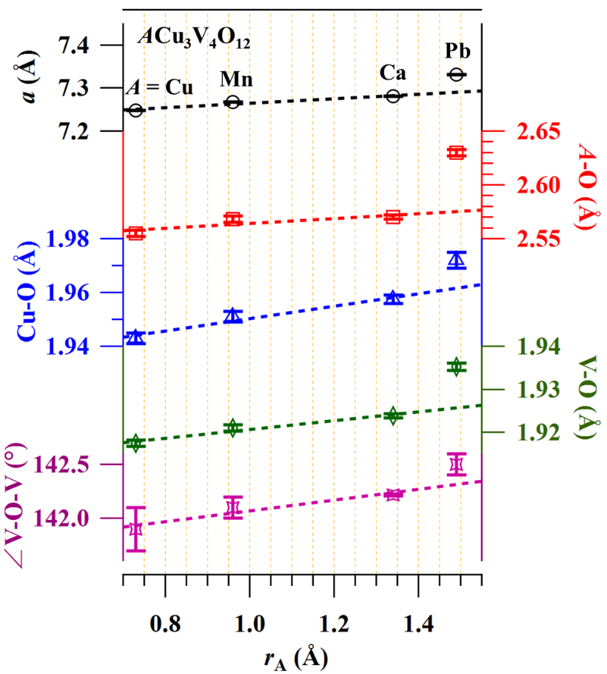
Figure 7 Evolution of lattice parameter, bond lengths, and bond angles in ACu₃V₄O₁₂ (A = Cu, Mn, Ca, Pb) as a function of A-site ionic radius.
Unlike the simple perovskite ABO₃, replacing the A-site with Pb in AA’₃B₄O₁₂ does not break cubic symmetry. Although ACu₃V₄O₁₂ (A = Cu, Mn, Ca, Pb) all remain cubic, the lattice parameter of PbCu₃V₄O₁₂ deviates from the expected ionic-radius trend and is larger than anticipated, as shown in Figure 7. This suggests that lattice expansion is not caused solely by the larger ion occupied at A-site, but also by local structural modifications. The A-O bond length is indeed enlarged by Pb²⁺ and exceeds the expected value, leading to an unusually high BVS (= 3.08). Surprisingly, the Cu-O bond is also significantly elongated in PbCu₃V₄O₁₂, and correspondingly, V-O bond lengths deviate from the trend observed in other ACu₃V₄O₁₂ compounds. Meanwhile, the V-O-V bond angle in PbCu₃V₄O₁₂ is less bent than in its analogues. The effect of Pb²⁺ substitution on the crystal structure has been investigated through a comparison between Sr_{1-x}Pb_{x}RuO₃ and Sr_{1-x}Ba_{x}RuO₃ [59]. It was found that although Pb and Ba substitution increase the average ionic radius, they induce distinctly different trends in the lattice parameters. This indicates that the structural effect of Pb²⁺ substitution cannot be explained solely by a simple steric effect. The structural behavior observed in PbCu₃V₄O₁₂ is consistent with this finding reported for ruthenate perovskite systems.
Metallic vanadate perovskites CaVO₃ and SrVO₃ exhibit moderate enhanced Sommerfeld coefficients (γ = 8-9 mJ/(mol K²)) [47], smaller than those of strongly correlated systems such as CaRuO₃ and SrRuO₃ (γ =30- 90 mJ/(mol K²)) [60,61] but clearly larger than weakly correlated metals like sodium (~1 mJ/(mol K²)). The A-site-ordered vanadates ACu₃V₄O₁₂ (A = Cu, Ca, Pb) display γ values comparable to those of AVO₃. CaCu₃Ru₄O₁₂, one of the most studied A-site-ordered perovskites, is known for its heavy-fermion behavior arising from hybridization between localized Cu²⁺ (3d⁹) moments and itinerant Ru-4d electrons [13,62,63]. By analogy, the moderately enhanced γ in PbCu₃V₄O₁₂ may reflect hybridization between localized Cu-3d moments and itinerant V-3d electrons. Because V⁴⁺ has only one 3d electron and the 3d orbitals are more localized than Ru-4d, the interaction is weaker. Nevertheless, γ values as large as 20-30 mJ/(mol K²) remain rare among 3d transition-metal oxides.
4. Conclusion
In conclusion, the A-site-ordered perovskite PbCu₃V₄O₁₂ was successfully synthesized under high-pressure and high-temperature conditions and confirmed to crystallize in a cubic Im-3 structure based on high-resolution synchrotron XRD. Its lattice parameter, A-O, Cu-O, V-O bond lengths, and V-O-V bond angle clearly deviate from the ionic-radius trend in the ACu₃V₄O₁₂ series, indicating local structural modifications associated with the Pb²⁺ lone-pair electrons. Transport, thermoelectric, and magnetic measurements reveal conducting behavior without long-range magnetic ordering, while specific-heat and DFT analyses show moderate mass enhancement and an unusually amplified magnetic susceptibility, pointing to correlation effects beyond simple mass renormalization. These results identify PbCu₃V₄O₁₂ as a rare 3d-electron metallic vanadate with moderate correlations and highlight the role of Pb-induced local structural distortions as a potential design strategy in perovskite-related materials.

ASSOCIATED CONTENT
Supporting Information
Figures and Tables showing XRD patterns for samples synthesized using different starting material ratios, additional structure refinement results of synchrotron XRD, first derivative of ρ(T) as a function of temperature and SEM-EDS elemental mapping of PbCu₃V₄O₁₂ powder sample.
AUTHOR INFORMATION
Corresponding Author
* Jie Chen
E-mail: jiechen.phy@bit.edu.cn
Zhiyan Shao
E-mail: 3120225763@bit.edu.cn
Meiling Jin
E-mail: jinml@bit.edu.cn
Jiabin Qiao
E-mail: jiabinqiao@bit.edu.cn
Xiang Li
Email: xiangli@bit.edu.cn
Notes
The authors declare no competing financial interests.
Author Contributions
The manuscript was written through contributions from all the authors. All authors have given their approval for the final version of the manuscript.
ACKNOWLEDGMENTS
This work was supported in part by the National Key R&D Program of China (Grant Nos. 2023YFA1406002, 2020YFA0308801), the National Natural Science Foundation of China (NSFC) (Grant Nos. 12174025, 12321004, 12204045), and the CAS Superconducting Research Project (Grant No. SCZX-0101). X. L. was supported by the Beijing Institute of Technology Research Fund Program (Grant No. 2023CX01027). J. C. and J. Q. were supported by the Beijing Institute of Technology Research Fund Program for Young Scholars. M. J. was supported by the Beijing Institute of Technology Laboratory Research Project (Grant No. 2023BITSYB07). F.Y. was supported by the National Natural Science Foundation of China (NSFC) (Grant Nos.12574141, 12234016, 12074031). Synchrotron radiation experiments were conducted at the powder diffraction beamline BL02B2 at SPring-8 with the permission from the Japan Synchrotron Radiation Research Institute (Proposal Number: 2024B1825). We thank Dr. S. Kobayashi and Dr. Y. Mori for their help at BL02B2 of SPring-8. The Analysis & Testing Center in the Beijing Institute of Technology and the Synergetic Extreme Condition User Facility (SECUF, https://cstr.cn/31123.02.SECUF) are also acknowledged.

References
[1] G. King and P. M. Woodward, Cation ordering in perovskites, Journal of Materials Chemistry 20, 5785 (2010).
[2] L. T. Nguyen and R. J. Cava, Hexagonal perovskites as quantum materials, Chemical Reviews 121, 2935 (2021).
[3] Y. Shimakawa, A-site-ordered perovskites with intriguing physical properties, Inorganic Chemistry 47, 8562 (2008).
[4] A. A. Belik, Rise of A-site columnar-ordered A₂A’A’’B₄O₁₂ quadruple perovskites with intrinsic triple order, Dalton Transactions 47, 3209 (2018).
[5] Y. Shimakawa, Crystal and magnetic structures of CaCu₃Fe₄O₁₂ and LaCu₃Fe4O₁₂: distinct charge transitions of unusual high valence Fe, Journal of Physics D: Applied Physics 48 (2015).
[6] Z. Zeng, M. Greenblatt, M. A. Subramanian, and M. Croft, Large Low-field magnetoresistance in perovskite-type CaCu₃Mn₄O₁₂ without double exchange, Physical Review Letters 82, 3164 (1999).
[7] H. Shiraki, T. Saito, T. Yamada, M. Tsujimoto, M. Azuma, H. Kurata, S. Isoda, M. Takano, and Y. Shimakawa, Ferromagnetic cuprates CaCu₃Ge₄O₁₂ and CaCu₃Sn₄O₁₂ with A-site ordered perovskite structure, Physical Review B 76, 140403 (2007).
[8] Y. J. Kim, S. Wakimoto, S. M. Shapiro, P. M. Gehring, and A. P. Ramirez, Neutron scattering study of antiferromagnetic order in CaCu₃Ti₄O₁₂, Solid State Communications 121, 625 (2002).
[9] S. Tanaka, N. Shimazui, H. Takatsu, S. Yonezawa, and Y. Maeno, Heavy-mass behavior of ordered perovskites ACu₃Ru₄O₁₂ (A = Na, Ca, La), Journal of the Physical Society of Japan 78, 024706 (2009).
[10] M. Mizumaki, T. Mizokawa, A. Agui, S. Tanaka, H. Takatsu, S. Yonezawa, and Y. Maeno, Oxygen hole state in A-site ordered perovskite ACu₃Ru₄O₁₂ (A = Na, Ca, and La) probed by resonant X-ray emission spectroscopy, Journal of the Physical Society of Japan 82, 204709 (2013).
[11] D. Takegami, C. Y. Kuo, K. Sakebayashi, J. G. Kim, C. F. Chang, C. E. Liu, C. N. Wu, D. Kasinathan, S. G. Altendorf, K. Hoefer, et al., CaCu₃Ru₄O₁₂: A high-Kondo-temperature transition-metal oxide, Physical Review X 12, 011017 (2022).
[12] H. Kato, T. Tsuruta, M. Matsumura, T. Nishioka, H. Sakai, Y. Tokunaga, S. Kambe, and R. E. Walstedt, Temperature-induced change in the magnitude of the effective density of states: A NQR/NMR study of the A-site-ordered perovskite system CaCu₃Ru₄O₁₂, Journal of the Physical Society of Japan 78, 054707 (2009).
[13] W. Kobayashi, I. Terasaki, J.-i. Takeya, I. Tsukada, and Y. Ando, A Novel Heavy-Fermion State in CaCu₃Ru₄O₁₂, Journal of the Physical Society of Japan 73, 2373 (2004).
[14] H. Shiraki, T. Saito, M. Azuma, and Y. Shimakawa, Metallic behavior in A-site-ordered perovskites ACu₃V₄O₁₂ with A =Na⁺,Ca²⁺, and Y³⁺, Journal of the Physical Society of Japan 77, 064705 (2008).
[15] Y. Akizuki, I. Yamada, K. Fujita, N. Nishiyama, T. Irifune, T. Yajima, H. Kageyama, and K. Tanaka, A‑site-ordered perovskite MnCu₃V₄O₁₂ with a 12-coordinated manganese(II), Inorganic Chemistry 52, 11538 (2013).
[16] Y. Akizuki, I. Yamada, K. Fujita, K. Taga, T. Kawakami, M. Mizumaki, and K. Tanaka, Rattling in the quadruple perovskite CuCu₃V₄O₁₂, Angewandte Chemie International Edition 54, 10870 (2015).
[17] M. A. Subramanian, W. J. Marshall, T. G. Calvarese, and A. W. Sleight, Valence degeneracy in CaCu₃Cr₄O₁₂, Journal of Physics and Chemistry of Solids 64, 1569 (2003).
[18] M. Etter, M. Isobe, H. Sakurai, A. Yaresko, R. E. Dinnebier, and H. Takagi, Charge disproportionation of mixed-valent Cr triggered by Bi lone-pair effect in the A-site-ordered perovskite BiCu₃Cr₄O₁₂, Physical Review B 97, 195111 (2018).
[19] I. Yamada, S. Ishiwata, I. Terasaki, M. Azuma, Y. Shimakawa, and M. Takano, Synthesis, structure, and physical properties of A-site ordered perovskites ACu₃Co₄O₁₂ (A = Ca and Y), Chemistry of Materials 22, 5328 (2010).
[20] S. Hébert, R. Daou, and A. Maignan, Thermopower in the quadruple perovskite ruthenates, Physical Review B 91, 045106 (2015).
[21] S. G. Ebbinghaus, A. Weidenkaff, and R. J. Cava, Structural investigations of ACu₃Ru₄O₁₂ (A = Na, Ca, Sr, La, Nd) — a comparison between XRD-Rietveld and EXAFS Results, Journal of Solid State Chemistry 167, 126 (2002).
[22] T.-H. Kao, H. Sakurai, S. Yu, H. Kato, N. Tsujii, and H.-D. Yang, Electronic phase transition between localized and itinerant states in the solid-solution system CaCu₃Ti_{4−x}Ru_{x}O₁₂, Physical Review B 96, 195141 (2017).
[23] A. Krimmel, A. Günther, W. Kraetschmer, H. Dekinger, N. Büttgen, A. Loidl, S. G. Ebbinghaus, E. W. Scheidt, and W. Scherer, Non-Fermi-liquid behavior in CaCu₃Ru₄O₁₂, Physical Review B 78, 165126 (2008).
[24] J. G. Cheng, J. S. Zhou, Y. F. Yang, H. D. Zhou, K. Matsubayashi, Y. Uwatoko, A. MacDonald, and J. B. Goodenough, Possible Kondo Physics near a Metal-Insulator Crossover in the A-Site Ordered Perovskite CaCu₃Ir₄O₁₂, Physical Review Letters 111, 176403 (2013).
[25] M. R. Li, M. Retuerto, Z. Deng, T. Sarkar, J. Sánchez-Benítez, M. C. Croft, T. S. Dasgupta, T. Das, T. A. Tyson, D. Walker, et al., Strong Electron Hybridization and Fermi-to-Non-Fermi Liquid Transition in LaCu₃Ir₄O₁₂, Chemistry of Materials 27, 211 (2015).
[26] See Supplemental Material [url] for Figures and tables showing XRD patterns for samples synthesized using different starting material ratios, additional structure refinement results of synchrotron XRD, first derivative of ρ(T) as a function of temperature and SEM-EDS elemental mapping of PbCu₃V₄O₁₂ powder sample.
[27] F. Izumi and T. Ikeda, A rietveld-analysis program RIETAN-98 and its applications to zeolites, Materials Science Forum 321-324, 198 (2000).
[28] K. Momma and F. Izumi, VESTA 3 for three-dimensional visualization of crystal, volumetric and morphology data, Journal of Applied Crystallography 44, 1272 (2011).
[29] G. Kresse and J. Hafner, Ab. initio molecular dynamics for liquid metals, Physical Review B 47, 558 (1993).
[30] G. Kresse and J. Furthmüller, Efficient iterative schemes for ab initio total-energy calculations using a plane-wave basis set, Physical Review B 54, 11169 (1996).
[31] P. E. Blöchl, Projector augmented-wave method, Physical Review B 50, 17953 (1994).
[32] J. P. Perdew, K. Burke, and M. Ernzerhof, Generalized gradient approximation made simple, Physical Review Letters 77, 3865 (1996).
[33] A. A. Belik, Y. Matsushita, Y. Kumagai, Y. Katsuya, M. Tanaka, S. Y. Stefanovich, B. I. Lazoryak, F. Oba, and K. Yamaura, Complex structural behavior of BiMn₇O₁₂ quadruple perovskite, Inorganic Chemistry 56, 12272 (2017).
[34] A. Dittl, S. Krohns, J. Sebald, F. Schrettle, M. Hemida, H. A. Krug von Nidda, S. Riegg, A. Reller, S. G. Ebbinghaus and A. Loidl, On the magnetism of Ln_{2/3}Cu₃Ti₄O₁₂ (Ln = lanthanide), The European Physical Journal B 79, 391 (2011).
[35] R. Schmidt, S. Pandey, P. Fiorenza, and D. C. Sinclair, Non-stoichiometry in ‘‘CaCu₃Ti₄O₁₂’’ (CCTO) ceramics, RSC Advances 3, 14580 (2013).
[36] M. Ochi, I. Yamada, K. Ohgushi, Y. Kusano, M. Mizumaki, R. Takahashi, S. Yagi, N. Nishiyama, T. Inoue and T. Irifune, B‑Site deficiencies in A‑site-Ordered perovskite LaCu₃Pt_{3.75}O₁₂, Inorganic Chemistry 52, 3985 (2013).
[37] T.-H. Kao, H. Sakurai, H. Kato, N. Tsujii, and H.-D. Yang, Nonstoichiometry and Magnetic Susceptibility of LaCu₃Ru₄O₁₂, Journal of the Physical Society of Japan 85, 025001 (2016).
[38] R. D. Johnson, D. D. Khalyavin, P. Manuel, L. Zhang, K. Yamaura, and A. A. Belik, Emergence of a Magnetostructural Dipolar Glass in the Quadruple Perovskite Dy_{1−δ}Mn_{7+δ}O₁₂, Physical Review Letters 125, 097601 (2020).
[39] D. D. Khalyavin, R. D. Johnson, F. Orlandi, P. G. Radaelli, P. Manuel, and A. A. Belik, Emergent helical texture of electric dipoles, Science 369, 680 (2020).
[40] R. D. Shannon, Synthesis and proterties of two new members of the rutile family RhO₂ and PtO₂, Solid State Communications 6, 139 (1968).
[41] J. Chen, Y. Matsushita, T. Kolodiazhnyi, A. A. Belik, Y. Tsujimoto, Y. Katsuya, M. Tanaka, Y. Su and Y. Shi., High-pressure synthesis, crystal structure, and semimetallic properties of HgPbO₃, Inorganic Chemistry 57, 7601 (2018).
[42] J. Guo, S. Wang, W. Li, D. Lu, X. Ye, Z. Liu, S. Qin, X. Wang, Z. Hu, H. J. Lin, et al., A-site Mn²⁺ tuned magnetism and electrical transport properties in the transition-metal-only perovskite oxide MnCu₃Mn₄O₁₂, Physical Review B 105, 054409 (2022).
[43] J. S. Zhou, L. G. Marshall, and J. B. Goodenough, Mass enhancement versus Stoner enhancement in strongly correlated metallic perovskites: LaNiO₃ and LaCuO₃, Physical Review B 89, 245138 (2014).
[44] R. V. Shpanchenko, V. V. Chernaya, A. A. Tsirlin, P. S. Chizhov, D. E. Sklovsky, E. V. Antipov, E. P. Khlybov, V. Pomjakushin, A. M. Balagurov, J. E. Medvedeva, et al., Synthesis, Structure, and Properties of New Perovskite PbVO₃, Chemistry of Materials 16, 3267 (2004).
[45] R. Tian, J. Chen, F. Wu, J. Guan, Z. Shao, W. Wu, M. Ma, Z. Hu, H. Zheng, P. Ye, et al., Evolution from a heavy-fermion metal to an antiferromagnetic insulator in the A-site ordered perovskite PbCu₃Ru_{4-x}Ti_{x}O₁₂, Physical Review B 113, 085117 (2026)
[46] K. Oka, I. Yamada, M. Azuma, S. Takeshita, K. H. Satoh, A. Koda, R. Kadono, M. Takano, and Y. Shimakawa, Magnetic ground-state of perovskite PbVO₃ with large tetragonal distortion, Inorganic Chemistry 47, 7355 (2008).
[47] I. H. Inoue, O. Goto, H. Makino, N. E. Hussey, and M. Ishikawa, Bandwidth control in a perovskite-type 3d¹-correlated metal Ca_{1-x}Sr_{x}VO₃. I. Evolution of the electronic properties and effective mass , Physical Review B 58, 4372 (1998).
[48] E. McCalla, M. N. Gastiasoro, G. Cassuto, R. M. Fernandes, and C. Leighton, Low-temperature specific heat of doped SrTiO₃: Doping dependence of the effective mass and Kadowaki-Woods scaling violation, Physical Review Materials 3, 022001 (2019).
[49] K. Kumagai, T. Suzuki, Y. Taguchi, Y. Okada, Y. Fujishima, and Y. Tokura, Metal-insulator transition in La_{1-x}Sr_{x}TiO₃ and Y_{1-x}Ca_{x}TiO₃ investigated by specific-heat measurements, Physical Review B 48, 7636 (1993).
[50] J. Rossat-Mignod, P. Bourges, F. Onufrieva, L. P. Regnault, J. Y. Henry, P. Burlet, and C. Vettier, Spin dynamics in the high-T_{c} system YBa₂Cu₃O_{6+x}: the heavily doped regime, Physica B: Condensed Matter 199-200, 281 (1994).
[51] Y. Singh and D. C. Johnston, Singlet ground state in the spin-1/2 dimer compound Sr₃Cr₂O₈, Physical Review B 76, 012407 (2007).
[52] L. T. Corredor, G. Aslan-Cansever, M. Sturza, K. Manna, A. Maljuk, S. Gass, T. Dey, A. U. B. Wolter, O. Kataeva, A. Zimmermann, et al., Iridium double perovskite Sr2YIrO6: A combined structural and specific heat study, Physical Review B 95, 064418 (2017).
[53] G. Cao, O. Korneta, S. Chikara, L. E. DeLong, and P. Schlottmann, Non-Fermi-liquid behavior in single-crystal CaRuO₃: Comparison to ferromagnetic SrRuO₃, Solid State Communications 148, 305 (2008).
[54] J. G. Cheng, Y. Sui, Z. N. Qian, Z. G. Liu, J. P. Miao, X. Q. Huang, Z. Lu, Y. Li, X. J. Wang and W. H. Su, Schottky-like anomaly in the low-temperature specific heat of single-crystal NdMnO₃, Solid State Communications 134, 381 (2005).
[55] H. Falcón, J. A. Alonso, M. T. Casais, M. J. Martı́nez-Lope, and J. Sánchez-Benı́tez, Neutron diffraction study, magnetism and magnetotransport of stoichiometric CaVO₃ perovskite with positive magnetoresistance, Journal of Solid State Chemistry 177, 3099 (2004).
[56] Y. C. Lan, X. L. Chen, and M. He, S tructure, magnetic susceptibility and resistivity properties of SrVO₃, Journal of Alloys and Compounds 354, 95 (2003).
[57] A. A. Belik, M. Azuma, T. Saito, Y. Shimakawa, and M. Takano, Crystallographic features and tetragonal phase stability of PbVO₃, a new member of PbTiO₃ family, Chemistry of Materials 17, 269 (2004).
[58] J. B. Goodenough and J. Zhou, Varied roles of Pb in transition-metal PbMO₃ perovskites (M = Ti, V, Cr, Mn, Fe, Ni, Ru), Science and Technology of Advanced Materials 16, 036003 (2016).
[59] J. G. Cheng, J. S. Zhou, and J. B. Goodenough, Evolution of ferromagnetism in orthorhombic perovskites Sr_{1−x}Pb_{x}RuO₃, Physical Review B 81, 134412 (2010).
[60] T. Kiyama, K. Yoshimura, K. Kosuge, H. Michor, and a. Gerfried Hilscher, Specific heat of (Sr-Ca)RuO₃, Journal of the Physical Society of Japan 67, 307 (1998).
[61] P. B. Allen, H. Berger, O. Chauvet, L. Forro, T. Jarlborg, A. Junod, B. Revaz, and G. Santi, Transport properties, thermodynamic properties, and electronic structure of SrRuO₃, Physical Review B 53, 4393 (1996).
[62] J. Oitmaa, W. Zheng, and D. Tompsett, Hard-core bosons on the triangular lattice at zero temperature: A series expansion study, Physical Review B 73, 172401 (2006).
[63] B. Q. Lv, H. M. Weng, B. B. Fu, X. P. Wang, H. Miao, J. Ma, P. Richard, X. C. Huang, L. X. Zhao, G. F. Chen, et al., Experimental Discovery of Weyl Semimetal TaAs, Physical Review X 5, 031013 (2015).

