Zn_{0.5}Cd_{0.5}S photocatalysts with loaded Cu²⁺ and Ni²⁺ dual active sites for promoted syngas production †
Wuqing Luo,‡ª Yuhao Yi,‡ª Lian Duan,ª Ruiling Du,ª Gen Chen,ª Min Liu,^{b} Xiaohe Liu,^{c} Renzhi Ma,^{d} and Ning Zhang ^{a,}*

- School of Materials Science and Engineering, Central South University, Changsha 410083, China. Email: nzhang@csu.edu.cn
- School of Physics and Electronics, Central South University, Changsha 410083, China
- School of Chemical Engineering, Zhengzhou University, Zhengzhou 450001, China
- Research Center for Materials Nanoarchitectonics (MANA), National Institute for Materials Science (NIMS), Tsukuba, Ibaraki 305-0044, Japan.

‡ These authors contributed equally to this work.

The Zn_{0.5}Cd_{0.5}S semiconductor is widely recognized as a promising photocatalyst due to its strong light absorption capability and high conduction band potential, enabling the conversion of CO₂ and H₂O into syngas (CO and H₂). However, its catalytic efficiency is significantly limited by the lack of active sites, restricting the simultaneous evolution of CO and H₂. In this study, Cu²⁺ and Ni²⁺ are co-introduced into Zn_{0.5}Cd_{0.5}S nanoparticles as active sites to selectively promote the evolution of CO and H₂, respectively, thereby synergistically enhancing the photocatalytic activity for overall syngas production. The Zn_{0.5}Cd_{0.5}S photocatalysts incorporating Cu²⁺ and Ni²⁺ dual active sites were synthesized via a simple precipitation method. Experimental results demonstrate that Cu²⁺ active sites significantly enhance CO yield, whereas Ni²⁺ active sites improve H₂ production. Theoretical calculations reveal that Cu²⁺ and Ni²⁺ play distinct roles in the reaction mechanisms: Cu²⁺ acts as the active site for CO₂ reduction, markedly reducing the Gibbs free energy barrier for intermediate adsorption, while Ni²⁺ serves as the active site for hydrogen evolution in water splitting, facilitating H* adsorption. The synergistic effect of Cu²⁺ and Ni²⁺ significantly enhances the photocatalytic performance of Zn_{0.5}Cd_{0.5}S in syngas production. This study provides a facile strategy for active site modulation to tailor photocatalytic behaviour, offering insights into the rational design and synthesis of highly efficient photocatalysts for syngas production.

Introduction
Artificial photocatalysis offers the potential to convert carbon dioxide and water into high-value chemicals, making it an ideal technology for addressing the excessive emission of CO₂ and energy crisis.^{1, 2} Syngas, usually composed of hydrogen (H₂) and carbon monoxide (CO), is considered one of the most important photocatalytic products for industrial chemical synthesis.³ The development of efficient photocatalysts is crucial for the artificial production of syngas.^{4, 5} In the design of photocatalytic materials, it is essential not only to ensure an adequately negative conduction band and an appropriate band gap, but also to optimize the surface active sites, as these are critical factors for tailoring photocatalytic reaction behaviours. ^{6, 7}
In recent years, metal sulfides semiconductors, such as CdS, Zn_{0.5}Cd_{0.5}S, and CuZnGaS₂, have garnered significant utilization for photocatalytic CO₂ reduction reactions.⁸⁻¹⁰ This interest arises from the sufficiently negative conduction band minimum (CBM) and an appropriate band gap (Eₓ), fulfilling the thermodynamic requirements for CO₂ reduction under solar irradiation.^{11, 12} Notably, Zn_{0.5}Cd_{0.5}S materials, with a band gap ranging from 2.3 to 2.6 eV and a CBM of approximately -0.6 V (vs. RHE, pH = 0), have been explored as efficient photocatalysts under visible light due to their favourable electronic band structures and simple chemical composition.^{13, 14} Recent studies have focused on optimizing the active sites of Zn_{0.5}Cd_{0.5}S materials. For instance, Guo et al. enhanced the photocatalytic hydrogen production performance of Zn_{0.5}Cd_{0.5}S by introducing Ni²⁺ sites onto its surface.¹⁵ Tang et al. utilized Co²⁺ to improve the CO₂ reduction ability of Zn_{0.5}Cd_{0.5}S.¹⁶ However, these studies on Zn_{0.5}Cd_{0.5}S materials have focused on optimizing energy band structure and tailoring individual photocatalytic reaction, such as hydrogen evolution or CO₂ reduction reaction.¹⁷ Rational regulating both H₂ evolution and CO₂ reduction reactions to simultaneously improve overall syngas is seldom concerned.
From the view of CO₂ reduction reactions, metals such as Zn and Ti are effective in selectively converting CO₂ into CO, while Bi, Sn, Cd, Pd, and In facilitate the formation of formic acid.^{18, 19} For water splitting, the metals such as Ni, Pt, and Fe are favourable for the H₂ evolutions.^{20, 21} Especially, owing to its unique electronic structure, Cu are favourable to stabilize intermediates of CO in CO₂ reduction reactions.²²⁻²⁴ For example, Guo et al. enhanced the selectivity for carbon products by photodepositing Cu onto Zn_{x}Cd_{1-x}S.²⁵ Otherwise, the Ni have excellent hydrogen adsorption and desorption capabilities, is frequently employed in water-splitting reactions for hydrogen production. For instance, By doping Ni into the Zn_{0.2}Cd_{0.8}S/TiO₂ heterojunction, both photocatalytic hydrogen production and imine yield were simultaneously enhanced.²⁶ Inspired by these characteristics, combining Cu and Ni into a single photocatalyst system, enabling a dual-functional cocatalyst efficiently activate both CO₂ reduction and water splitting to produce H₂ and CO, which will greatly enhance the overall efficiency of solar energy utilization. Unfortunately, the introduction of two distinct metals to create active sites that selectively tailor the hydrogen evolution and CO₂ reduction reactions to enhance the yields of CO and H₂ has been scarcely explored.
In this study, Cu²⁺ and Ni²⁺ were co-introduced into Zn_{0.5}Cd_{0.5}S nanoparticles as active sites to selectively enhance the evolution of CO and H₂, respectively, thereby synergistically improving the photocatalytic activity for overall syngas production. The Zn_{0.5}Cd_{0.5}S photocatalysts incorporating dual Cu²⁺ and Ni²⁺ active sites were synthesized via a facile precipitation method. Comprehensive structural and spectroscopic characterizations revealed that the incorporation of Cu²⁺ and Ni²⁺ effectively modulates the band structure and photoelectronic properties of Zn_{0.5}Cd_{0.5}S. The introduction of Cu²⁺ alone resulted in an 8.3-fold increase in CO production, while H₂ evolution remained largely unchanged. Conversely, the incorporation of Ni²⁺ exclusively led to a 2.9-fold enhancement in H₂ production, with no significant impact on CO evolution. Notably, the simultaneous introduction of both Cu²⁺ and Ni²⁺ yielded a 10.6-fold increase in CO production and a 3.1-fold enhancement in H₂ evolution, highlighting a pronounced synergistic effect. Theoretical calculations further elucidate the mechanistic roles of Cu²⁺ and Ni²⁺ in the photocatalytic process. Cu²⁺ functions as an active site for CO₂ reduction by significantly lowering the Gibbs free energy barrier for intermediate adsorption, thereby facilitating CO evolution. In contrast, Ni²⁺ acts as an active site for hydrogen evolution in water splitting, effectively reducing the adsorption energy of H*, thereby promoting H₂ production. This study demonstrates a rational and effective strategy for enhancing photocatalytic syngas production through the precise modulation of dual active sites. These findings provide valuable insights into the design and development of highly efficient photocatalysts for sustainable fuel generation.
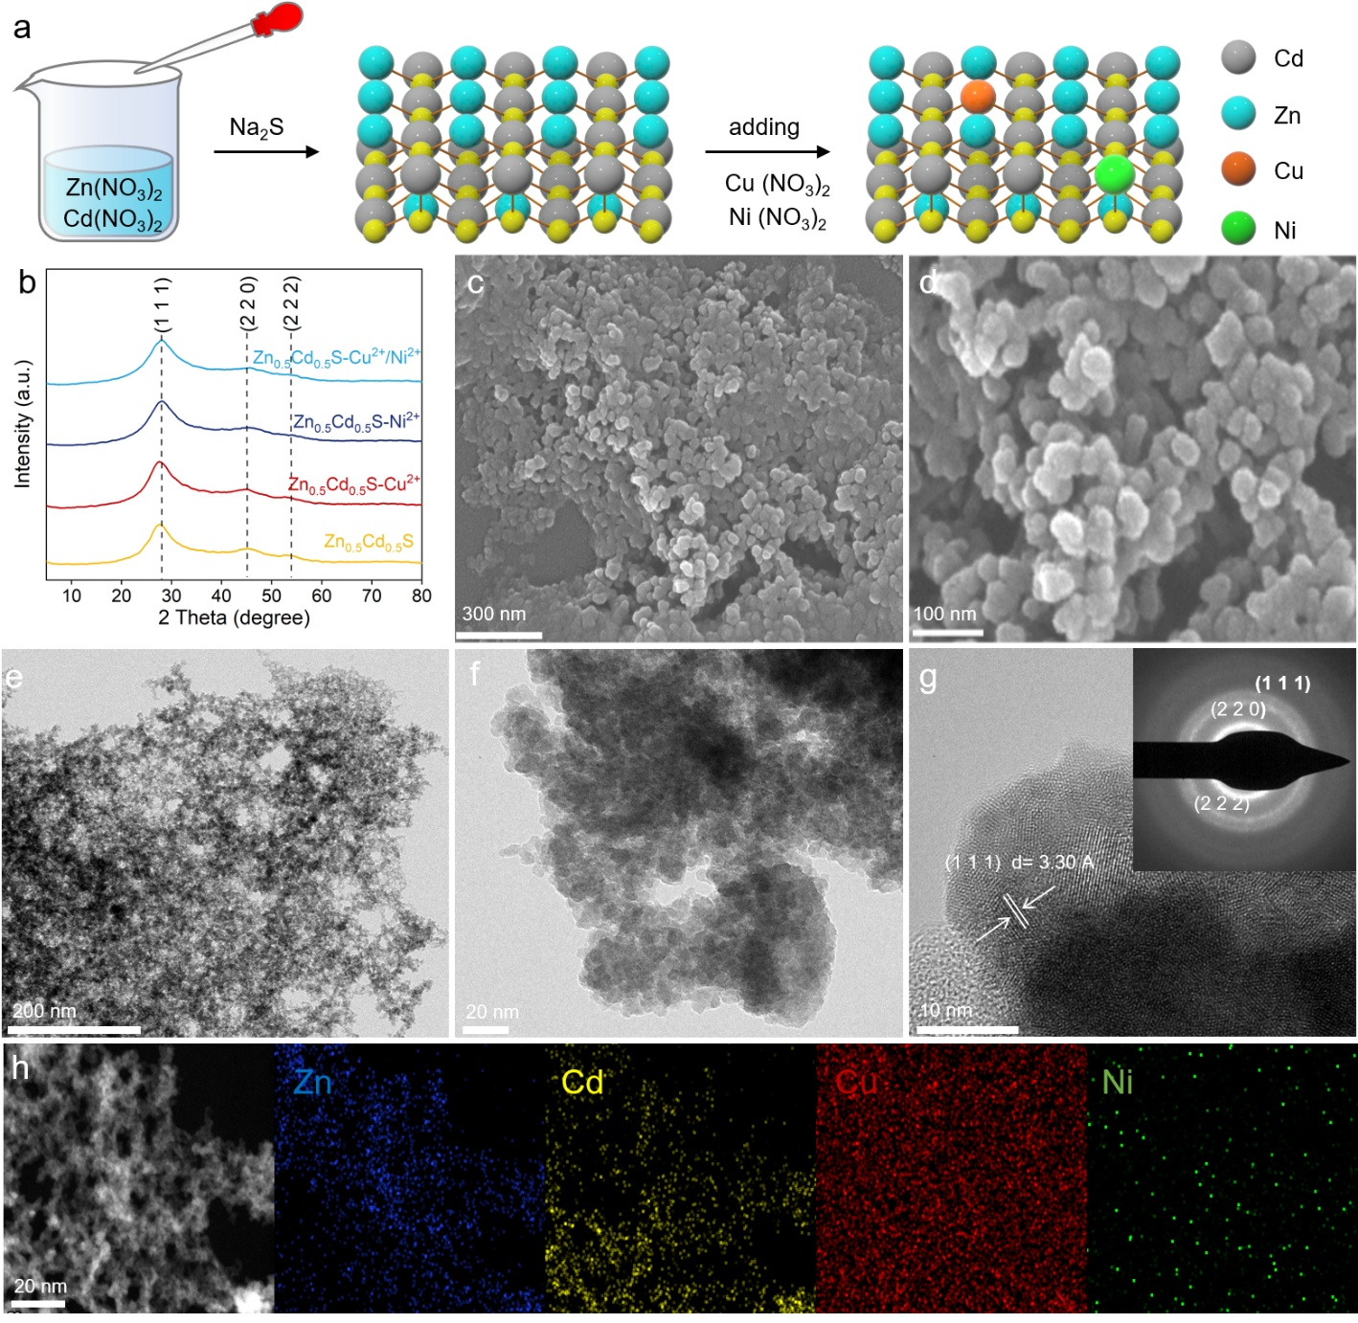
Fig. 1 (a)The scheme of synthetic process from Zn_{0.5}Cd_{0.5}S to Zn_{0.5}Cd_{0.5}S-Cu²⁺/Ni²⁺.(b) XRD patterns of prepared Zn_{0.5}Cd_{0.5}S products, (c) and (d) SEM image of Zn_{0.5}Cd_{0.5}S-Cu²⁺/Ni²⁺,(e and f) bright-field TEM image, (g) HRTEM image, and SAED pattern (inset of panel (g)) of Zn_{0.5}Cd_{0.5}S-Cu²⁺/Ni²⁺ and (h) TEM EDS and elemental mapping of Zn, Cd, Cu and Ni in -Cu²⁺/Ni²⁺.
2. Results and discussion
2.1 Structure of materials
Doped Zn_{0.5}Cd_{0.5}S materials were synthesized via the ion exchange method. The material doped with 0.2% Cu²⁺ is designated as Zn_{0.5}Cd_{0.5}S-Cu²⁺, while the material with 0.1% Ni²⁺ doping is referred to as Zn_{0.5}Cd_{0.5}S-Ni²⁺. The co-doped material with 0.2% Cu²⁺ and 0.1% Ni²⁺ is labelled as Zn_{0.5}Cd_{0.5}S-Cu²⁺/Ni²⁺. According to the inductively coupled plasma optical emission spectrometry (ICP-OES, Table S1) results, the atomic content of Cu ions in Zn_{0.5}Cd_{0.5}S-Cu²⁺/Ni²⁺ is approximately 0.2%, and the atomic content of Ni ions is approximately 0.1%. Additionally, it is observed that the Cd content remained essentially unchanged, while the Zn content exhibited a slight decrease, suggesting partial substitution of Zn atoms while maintaining a stable Cd composition. Fig. 1a presents the XRD patterns of the synthesized materials, which retain the cubic phase.^{27, 28} Notably, the doping process did not introduce significant changes to the crystal structure. The synthesized materials display only two broad peaks, suggesting relatively poor crystallinity of the materials. Fig. 1b and c provide the scanning electron microscope (SEM) images of Zn_{0.5}Cd_{0.5}S-Cu²⁺/Ni²⁺. The modified material consists of interconnected nanoparticles, approximately 10-50 nm in size. Compared with the pristine Zn_{0.5}Cd_{0.5}S product as shown in Fig. S1, the morphology of the material remains unchanged after doping with Cu and Ni. The energy-dispersive X-ray (EDX) mapping images demonstrate that both Cu and Ni elements were successfully incorporated into Zn_{0.5}Cd_{0.5}S and are uniformly distributed throughout the material. Fig 1d, 1e and S2 display the TEM images of Zn_{0.5}Cd_{0.5}S-Cu²⁺/Ni²⁺. The absence of distinct grain boundaries in these images suggests that the material retained its amorphous state after freeze-drying. High-resolution transmission electron microscopy (HRTEM) further reveals a disordered atomic arrangement with only a minimal presence of lattice fringes, confirming that the material is predominantly amorphous. The selected area electron diffraction (SAED) patterns exhibit broad diffuse rings, providing additional confirmation of the material's amorphous nature. X-ray photoelectron spectroscopy (XPS) was employed to analyze the elemental states of Zn_{0.5}Cd_{0.5}S and the doped Zn_{0.5}Cd_{0.5}S materials. As shown in Fig. 2a, elements such as Zn, Cd, and S were detected in the Zn_{0.5}Cd_{0.5}S sample. Notably, Cu was identified in the Zn_{0.5}Cd_{0.5}S-Cu²⁺ sample, Ni was detected in the Zn_{0.5}Cd_{0.5}S-Cu²⁺/Ni²⁺ sample, and both Cu and Ni were found in the Zn_{0.5}Cd_{0.5}S-Cu²⁺/Ni²⁺ sample. Fig. 2b and c present the high-resolution XPS spectra for Cu 2p and Ni 2p. The peaks of Cu 2p were observed at 952.2 eV and 932.3 eV in both Zn_{0.5}Cd_{0.5}S-Cu²⁺ and Zn_{0.5}Cd_{0.5}S-Cu²⁺/Ni²⁺. The high-resolution XPS spectrum of Ni 2p displays two main peaks; however, the signal is relatively weak, likely due to the low doping concentration. As shown in Fig. 2f, the high-resolution XPS spectrum of the S element reveals that the S 2p spectrum can be deconvoluted into two peaks, which are attributed to sulfide ions. The S 2p peaks of Zn_{0.5}Cd_{0.5}S are located at 161.2 eV and 162.4 eV, while the S peaks in the doped Zn_{0.5}Cd_{0.5}S samples exhibit varying degrees of positive shifts.^{29, 30} This indicates a reduction in the electron cloud density around the S atoms due to doping. Fig. 2d presents the high-resolution XPS spectrum of Zn. The Zn 2p 2/3 and Zn 2p 1/2 of Zn_{0.5}Cd_{0.5}S are positioned at 1022.4 eV and 1045.6 eV. In the doped Zn_{0.5}Cd_{0.5}S materials, the Zn peaks show varying degrees of negative shifts, suggesting an increase in the electron cloud density around the Zn atoms due to doping. In Zn_{0.5}Cd_{0.5}S-Cu²⁺/Ni²⁺, the binding energy of Zn 2p 2/3 and Zn 2p 1/2 exhibited the most substantial negative shift, with a displacement of approximately 0.4 eV. For the Cd element, as shown in Fig. 2e the Cd 3d 5/2 and Cd 3d 3/2 peaks of Zn_{0.5}Cd_{0.5}S are located at 411.7 eV and 404.8 eV, and no significant shift is observed in the doped Zn_{0.5}Cd_{0.5}S samples. The changes in the binding energies of Zn and S in the XPS spectra are associated with slight polarization of Zn and S, which could be attributed to lattice distortion, possibly due to the elongation of Zn-S bond.³¹⁻³³
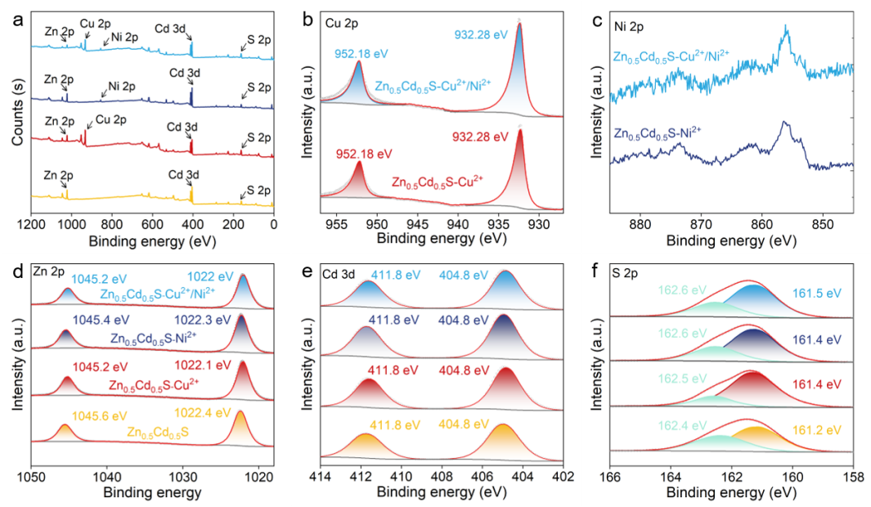
Fig. 2 (a) XPS survey spectrum. High-resolution XPS spectra of (b) Cu 2p, (c) Ni 2p, (d) Zn 2p, (e) Cd 3d and (f) S 2p for Zn_{0.5}Cd_{0.5}S and modified Zn_{0.5}Cd_{0.5}S. (From bottom to top are Zn_{0.5}Cd_{0.5}S, Zn_{0.5}Cd_{0.5}S-Cu²⁺, Zn_{0.5}Cd_{0.5}S-Ni²⁺ and Zn_{0.5}Cd_{0.5}S-Cu²⁺/Ni²⁺)

2.2. Electronic Energy Band Structure
To investigate the potential factors influencing the photocatalytic performance of Zn_{0.5}Cd_{0.5}S, the optical absorption and electronic band structure of the synthesized Zn_{0.5}Cd_{0.5}S were collected. The UV-Vis absorption spectra of the products are shown in Fig. 3a. From the Tauc plots, derived from the equation (αhν)^{1/n} = A(hν−E_{g}) (where α, ν, A, Eg, and n represent the absorption coefficient, incident light frequency, constant, band gap, and an integer), the band gaps of the four materials are calculated by using the Kubelka-Munk method (Fig. 3b). Given that Zn_{0.5}Cd_{0.5}S is a direct bandgap semiconductor, the value of n in the equation is 1/2. The calculated band gaps (E_{g}) for Zn_{0.5}Cd_{0.5}S, Zn_{0.5}Cd_{0.5}S-Cu²⁺, Zn_{0.5}Cd_{0.5}S-Ni²⁺ and Zn_{0.5}Cd_{0.5}S-Cu²⁺/Ni²⁺ are 2.51 eV, 2.45 eV, 2.45 eV, and 2.44 eV. The similarity in band gaps among the four products indicates that doping does not significantly alter the Eg. The valence band maximum (VBM) was determined using valence band XPS spectra (Fig. 3c). The VBM positions for Zn_{0.5}Cd_{0.5}S, Zn_{0.5}Cd_{0.5}S-Cu²⁺, Zn_{0.5}Cd_{0.5}S-Ni²⁺ and Zn_{0.5}Cd_{0.5}S-Cu²⁺/Ni²⁺ were estimated to be 1.78 eV, 1.68 eV, 1.77 eV, and 1.73 eV below the Fermi level. Using the equation E_{NHE} = φ + E_{VB} − 4.44 (E_{NHE}: represents the normal hydrogen electrode potential, φ is the work function of the analyzer, taken as 4.5 eV)^{34, 35}, the contact potential difference between the instrument and the sample was corrected. The VBM values for Zn_{0.5}Cd_{0.5}S, Zn_{0.5}Cd_{0.5}S-Cu²⁺, Zn_{0.5}Cd_{0.5}S-Ni²⁺ and Zn_{0.5}Cd_{0.5}S-Cu²⁺/Ni²⁺ were calculated to be 1.84 eV, 1.83 eV, and 1.79 eV. Based on the equation E_{VB} = E_{CB} + E_{g}, the conduction band minimums (CBM) for Zn_{0.5}Cd_{0.5}S, Zn_{0.5}Cd_{0.5}S-Cu²⁺, Zn_{0.5}Cd_{0.5}S-Ni²⁺ and Zn_{0.5}Cd_{0.5}S-Cu²⁺/Ni²⁺ were estimated to be -0.67 eV, -0.71 eV, -0.62 eV, and -0.65 eV. The flat band potentials for Zn_{0.5}Cd_{0.5}S, Zn_{0.5}Cd_{0.5}S-Cu²⁺, Zn_{0.5}Cd_{0.5}S-Ni²⁺ and Zn_{0.5}Cd_{0.5}S-Cu²⁺/Ni²⁺ were approximately -0.64 eV, -0.67 eV, -0.58 eV, and -0.59 eV (relative to Ag/AgCl). As calculated from the Mott-Schottky plots shown in Fig 3d. The positive slope of the Mott-Schottky curves for the four samples indicates a typical n-type semiconductor. Typically, the conduction band edge (E_{CB}) of an n-type semiconductor exhibits a value that is approximately -0.1 to -0.2 V more negative than its flat band potential, and this finding is in accordance with our calculated values. Based on this analysis, the relative positions of the VBM and CBM for Zn_{0.5}Cd_{0.5}S and modified Zn_{0.5}Cd_{0.5}S are illustrated in Fig. 3e.
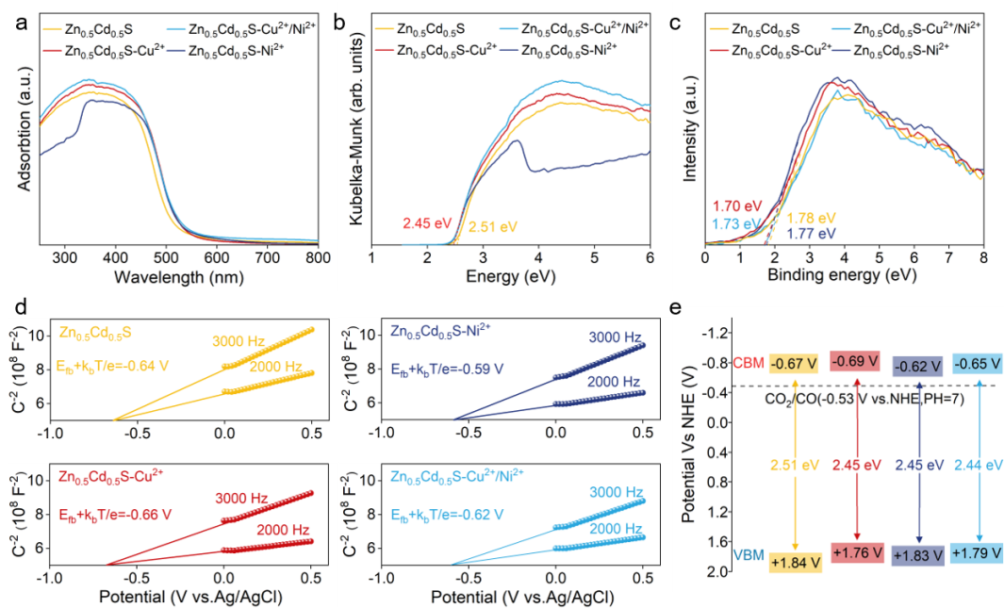
Fig. 3 (a) UV–vis adsorption spectra, (b) Eg calculation diagram, (c) XPS-VB spectra, (d and e) Mott-schottky curves of pristine Zn_{0.5}Cd_{0.5}S and modified Zn_{0.5}Cd_{0.5}S and (e) Schematic band diagram of pristine Zn_{0.5}Cd_{0.5}S and modified Zn_{0.5}Cd_{0.5}S (V vs. NHE, pH = 0).

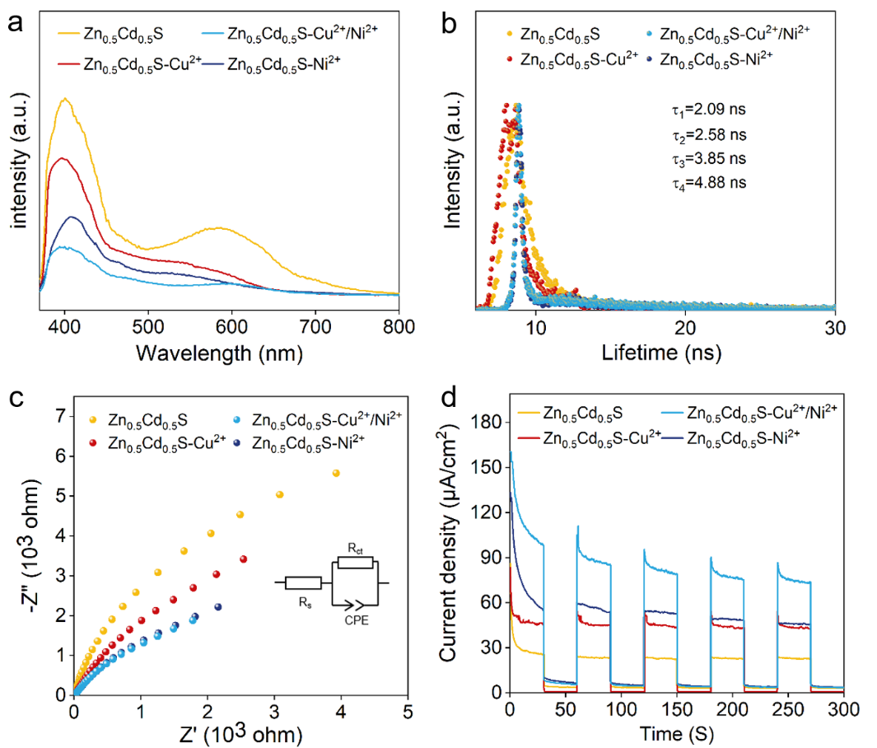
Fig. 4 (a) Photoluminescence spectra (λ_{ex} = 320 nm), (b) TRPL decay spectra, (c) photocurrent density−time curves measured at 1.05 V vs RHE under illumination with 30 s light on/off cycles, and (d) electrochemical impedance spectroscopy of Zn_{0.5}Cd_{0.5}S and modified Zn_{0.5}Cd_{0.5}S.

During the photocatalytic process, some photogenerated electrons participate in the reduction reactions, while others unfortunately recombine with holes. The radiative recombination processes in Zn_{0.5}Cd_{0.5}S and doped Zn_{0.5}Cd_{0.5}S were investigated using photoluminescence (PL) spectroscopy. As illustrated in Fig. 4a, when excited at a wavelength of 320 nm, Zn_{0.5}Cd_{0.5}S exhibits the highest emission intensity, followed by Zn_{0.5}Cd_{0.5}S-Cu²⁺, with Zn_{0.5}Cd_{0.5}S-Cu²⁺/Ni²⁺ showing the lowest emission intensity. Zn_{0.5}Cd_{0.5}S exhibits a broad PL peak around 600 nm, corresponding to the recombination of defect states. After the incorporation of Cu²⁺ and Ni²⁺ into Zn_{0.5}Cd_{0.5}S, the Cu-S and Ni-S bonds can passivate surface defects and inhibit defect recombination. The observed PL quenching can be attributed to the doping of Cu²⁺ and Ni²⁺, which effectively suppresses charge recombination. To elucidate the properties of carrier migration and separation in the prepared Zn_{0.5}Cd_{0.5}S materials, time-resolved photoluminescence spectroscopy (TRPL) was employed to investigate the lifetime of photogenerated carriers. The fitting function used was 𝑦 = 𝐴₁ exp(−𝑥/𝜏₁) + 𝐴₂ exp(−𝑥/𝜏₂) + 𝑦₀, as shown in Fig. 4b and Table S2. The carrier lifetimes for Zn_{0.5}Cd_{0.5}S, Zn_{0.5}Cd_{0.5}S-Cu²⁺, Zn_{0.5}Cd_{0.5}S-Ni²⁺ and Zn_{0.5}Cd_{0.5}S-Cu²⁺/Ni²⁺ were found to be 2.09 ns, 2.58 ns, 3.85 ns, and 4.88 ns, indicating that doping effectively enhances carrier transport efficiency. To further explore the charge transfer characteristics between Zn_{0.5}Cd_{0.5}S and modified Zn_{0.5}Cd_{0.5}S, photoelectrochemical characterization was conducted. Fig. 4c shows the light response of the samples under UV illumination at 1.05 V vs Ag/AgCl. The photocurrent of all four photoelectrodes increased rapidly when the light was turned on and decreased to nearly zero upon turning off the light, demonstrating high sensitivity and quick response to illumination. Among the photoelectrodes, Zn_{0.5}Cd_{0.5}S-Cu²⁺/Ni²⁺ exhibited the highest photocurrent density, followed by Zn_{0.5}Cd_{0.5}S-Ni²⁺ and Zn_{0.5}Cd_{0.5}S-Cu²⁺, with the pristine Zn_{0.5}Cd_{0.5}S showing the lowest photocurrent density. This suggests that the doped Zn_{0.5}Cd_{0.5}S materials possess higher photocatalytic charge separation and transfer efficiency. Furthermore, the Nyquist plots of electrochemical impedance spectroscopy (EIS) reveal that the doped Zn_{0.5}Cd_{0.5}S exhibits a smaller electrochemical resistance compared to the pristine Zn_{0.5}Cd_{0.5}S (Fig. 4d and Table S3), indicating that the doped Zn_{0.5}Cd_{0.5}S materials facilitate more efficient charge transfer. consequently, the enhanced charge separation and transfer processes result in superior overall photocatalytic activity for the doped Zn_{0.5}Cd_{0.5}S materials.
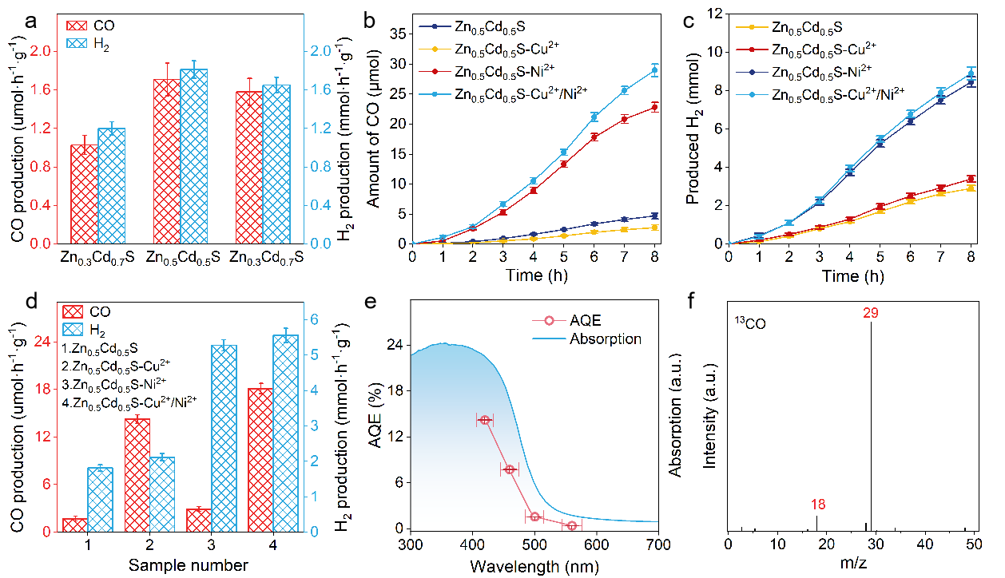
Fig. 5 (a) CO and H₂ evolution rates of the as-prepared Zn_{x}Cd_{1-x}S samples with different ratio of Zn to Cd (b) CO evolution vs irradiation time, (c) H₂ evolution vs irradiation time, and (d) CO and H₂ evolution rate over the Zn_{0.5}Cd_{0.5}S and modified Zn_{0.5}Cd_{0.5}S, (e) Wavelength-dependent Apparent Quantum Efficiency (AQE) (f) Representative GC–MS spectrum of ¹³CO after photocatalytic CO₂ reduction using isotope ¹³CO₂ over Zn_{0.5}Cd_{0.5}S-Cu²⁺/Ni²⁺ nanocrystals.
2.3 Photocatalytic performance
The photocatalytic CO₂ reduction reaction was conducted in a sealed gas circulation system saturated with CO₂, using a K₂SO₃/KHCO₃ solution under visible light irradiation (λ > 420 nm). The irradiation spectrum is shown in Fig. S4. In this setup, K₂SO₃ serves as a sacrificial agent by consuming photogenerated holes. The concentrations of gaseous products, CO and H₂, generated during the photocatalytic reaction were measured using gas chromatography, while the liquid phase was analysed through nuclear magnetic resonance (NMR) spectrum. In this study, the primary products were H₂ produced from H₂O and CO generated from CO₂ reduction. No significant liquid phase products were detected (Fig. S4). Fig 5b and c illustrate the kinetic curves of CO and H₂ evolution for Zn_{0.5}Cd_{0.5}S and doped Zn_{0.5}Cd_{0.5}S samples. It was observed that all four samples underwent an activation period of approximately two hours, followed by a linear evolution of gases between 2 to 6 hours, and the reaction rate decreases after 6 hours. Fig. 5d presents the average production rates after 8 hours of visible light irradiation. The pristine Zn_{0.5}Cd_{0.5}S exhibited average CO and H₂ production rates of 1.71 μmol·h⁻¹·g⁻¹ and 1.81 mmol·h⁻¹·g⁻¹, respectively. The Zn_{0.5}Cd_{0.5}S-Cu²⁺ demonstrated an average CO production rate that was 8.33 times higher than that of the pristine Zn_{0.5}Cd_{0.5}S, while the average H₂ production rate increased by only 16%. This indicates that Cu doping significantly enhances the CO production rate of the material. The average CO production rate for Zn_{0.5}Cd_{0.5}S-Ni²⁺ was 2.93 μmol·h⁻¹·g⁻¹, only slightly higher than that of the pristine Zn_{0.5}Cd_{0.5}S by a factor of 1.22 μmol·h⁻¹·g⁻¹, but the average H₂ production rate showed a substantial increase, reaching 2.91 times that of the pristine Zn_{0.5}Cd_{0.5}S, a growth of 3.46 mmol·h⁻¹·g⁻¹. Further experiments on Ni doping revealed that even at a higher concentration of 1%, Ni²⁺ doping continued to significantly enhance the average H₂ production rate, although it reduced the average CO production rate (Fig. S7). In the case of Cu and Ni co-doped Zn_{0.5}Cd_{0.5}S, both CO and H₂ average production rates were significantly increased, reaching 10.59 times and 3.06 times those of the pristine Zn_{0.5}Cd_{0.5}S. This yield is competitive among similar materials (Table S4). As shown in Fig. 5e, the apparent quantum efficiency (AQE) was tested under monochromatic wavelengths, with details and calculation formulas provided in supporting information. Under irradiation with monochromatic light at 420 nm (λ_{1/2}=19.10 nm), Zn_{0.5}Cd_{0.5}S-Cu²⁺/Ni²⁺ exhibited the highest quantum efficiency of 14.21%. In aqueous-phase photocatalytic systems, the low selectivity towards CO can be ascribed to the hydrogen evolution reaction resulting from water splitting, and this reaction generally tends to predominate. To assess the photocatalytic stability of the material, a long-term photocatalytic reaction of Zn_{0.5}Cd_{0.5}S-Cu²⁺/Ni²⁺ was conducted, as illustrated in Fig. S5. After 24 hours of photocatalytic cycling tests, the catalyst retained 79% of its initial 8-hour activity, indicating good photocatalytic stability. Furthermore, the SEM images of Zn_{0.5}Cd_{0.5}S before and after the photocatalytic reaction, as shown in Fig. S9, reveal that the material's structure did not undergo significant change post-reaction, further demonstrating its commendable stability.
To verify that the CO generated is indeed derived from the CO₂ involved in the CO₂ reduction reaction, we carried out control experiments under various photocatalytic CO₂ reduction conditions. When Ar gas was substituted for CO₂ while KHCO₃ was still present, the rate of the CO production was 3.13 μmol·h⁻¹·g⁻¹, significantly lower than the 18.12 μmol·h⁻¹·g⁻¹ observed under standard conditions with CO₂ and KHCO₃ (as shown in Fig. S8). Additionally, in the absence of both KHCO₃ and CO₂, the CO production was nearly undetectable. This indicates that the evolved CO predominantly originates from CO₂.To further confirm that CO is originated from CO₂, we utilized the isotope ¹³CO. As depicted in Fig. 5f, the characteristic GC-MS spectrum clearly reveals the presence of ¹³CO, indicating that the carbon source is ¹³CO₂. Hence, the released CO is indeed the product of the photocatalytic CO₂ reduction reaction.
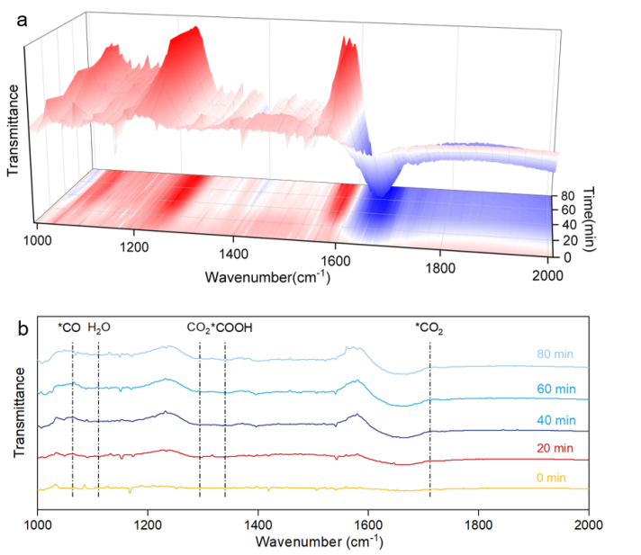
Fig. 6 (a) Time-dependent in situ ATR-IR spectra of Zn_{0.5}Cd_{0.5}S-Cu²⁺/Ni²⁺ under photoirradiation in the CO₂ and H₂O atmosphere, (b) In situ diffuse reflection infrared Fourier transform spectroscopy of Zn_{0.5}Cd_{0.5}S-Cu²⁺/Ni²⁺ (0, 20-, 40-, 60-, and 80-minutes light irradiation).
To investigate the possible reaction pathway for the transformation of CO₂ into CO, in situ diffuse reflectance infrared Fourier transform spectroscopy (DRIFTS) was applied to track the adsorption and conversion of CO₂ on the synthesized Zn_{0.5}Cd_{0.5}S-Cu²⁺/Ni²⁺ material. Fig. 6 illustrates the spectral changes observed during illumination from 0 to 80 minutes. In the absence of light, only adsorbed H₂O, CO₂, and carbonate species were detected on the surface, reflected in the peaks at 1113 and 1291 cm⁻¹.³⁶ Upon illumination, peaks appeared at 1744, 1341, and 1062 cm⁻¹, corresponding to ν(C=O), ν(COO), and ν(C–O) modes, respectively. As the irradiation time extended to 80 minutes, the intensity of these peaks increased, indicating the formation of *COOH species.^{37, 38} The *COOH species can act as a key intermediate in the conversion of CO₂ to CO. According to the in-situ FT-IR spectra and the reaction pathways reported previously, the photocatalytic conversion of CO₂ over the Zn_{0.5}Cd_{0.5}S-Cu²⁺/Ni²⁺ catalyst can occur through a multi-electron reduction process as follows: CO₂ → *CO₂ → *COOH → *CO → CO.³⁹⁻⁴¹
2.4. DFT calculations
DFT calculations were further employed to analyse the electronic structures and explore the mechanisms underlying the photocatalytic behaviours. The calculated model, exposing the (111) plane, consisted of five atomic layers comprising 20 Zn atoms, 20 Cd atoms, and 40 S atoms. The Zn_{0.5}Cd_{0.5}S-Cu²⁺/Ni²⁺ model was developed by replacing surface Zn atoms with Cu and Ni atoms. Fig. 7a and b respectively present the atomic slabs of Zn_{0.5}Cd_{0.5}S and Zn_{0.5}Cd_{0.5}S-Cu²⁺/Ni²⁺ on the (111) surface, as well as the corresponding deformation charge density maps. In the Cu²⁺ and Ni²⁺ decorated Zn_{0.5}Cd_{0.5}S model, one Cu atom and one Ni atom were substituted for Zn atoms on the Zn_{0.5}Cd_{0.5}S surface. The results reveal that, in Zn_{0.5}Cd_{0.5}S, the charge is predominantly concentrated on the S atoms and dispersed across the Zn and Cd atoms. In Zn_{0.5}Cd_{0.5}S- Cu²⁺/Ni²⁺, the charge is similarly concentrated on the S atoms but also dispersed across the Zn, Cd, Cu, and Ni atoms. Subsequently, Bader charge analysis were used to calculate the electron transfer numbers. Table S5 details the charges on the surface Zn, Cd, and S atoms. The results indicate that, in Zn_{0.5}Cd_{0.5}S, the Zn atom transfers 0.86 electrons to the S atom, while the Cd atom transfers 0.79 electrons to the S atom. Notably, compared to Zn_{0.5}Cd_{0.5}S, the surface charge distribution in Zn_{0.5}Cd_{0.5}S- Cu²⁺/Ni²⁺ is slightly altered, with the Zn atom losing more electrons, whereas the introduction of Cu and Ni atoms does not significantly affect the electron transfer of Cd atoms. Specifically, Cu loses 0.78 electrons, and Ni loses 0.76 electrons.
Based on these atomic models, the subsequent studies utilized DFT calculations to determine the Gibbs free energies (ΔG) of intermediates involved in the CO₂ reduction and H₂ evolution reaction/4`ns. The calculated free energy profiles for *CO₂, *COOH, *CO, and H* intermediates are illustrated in Fig. 7c and d. The adsorption models are depicted in Fig. S12, 15 and 17. In Zn_{0.5}Cd_{0.5}S, the calculations indicate that Zn acts as the active site for CO₂ reduction, while Cd serves as the active site for hydrogen evolution (Fig. S13 and 14). The Gibbs free energy calculations shown in Fig. 7c reveal that, on the Zn atom in Zn_{0.5}Cd_{0.5}S, the adsorption of *CO₂, *COOH, and *CO intermediates require 0.19, 0.88, 0.84, and 0.72 eV. Step 2 (CO₂* to COOH*) exhibits the highest free energy barrier (ΔGmax = 0.68 eV), indicating that this step involves overcoming a significant thermodynamic energy barrier, making it the rate-determining step of the reaction. On the Cd atom, the free energy required for H⁺ adsorption is -0.14 eV. Subsequently, in Zn_{0.5}Cd_{0.5}S-Cu²⁺/Ni²⁺, the Gibbs free energy changes for the CO₂ reduction intermediates on Cu, Ni, and Zn atoms were calculated and analyzed. As shown in Fig. S15, the ΔGmax for the conversion of *CO₂ to *COOH is 0.37 eV, lower than those for Zn and Ni, indicating that Cu is a more favourable active site for CO₂ reduction, successfully lowering the reaction barrier for intermediates. Additionally, the Gibbs free energies of intermediates in the hydrogen evolution reaction on Zn_{0.5}Cd_{0.5}S-Cu²⁺/Ni²⁺ were also investigated. The H⁺ adsorption and desorption models for the material were depicted in Fig. S12 and S17. The specific coupling reactions consist of two steps: H⁺→*H and *H→1/2 H₂. The Gibbs free energy (ΔG) for the Ni atom is -0.32 eV, which is lower than that of Cu, Zn, and Cd. This indicates that Ni is a more effective active site for hydrogen evolution compared to Zn, Cd, and Cu.
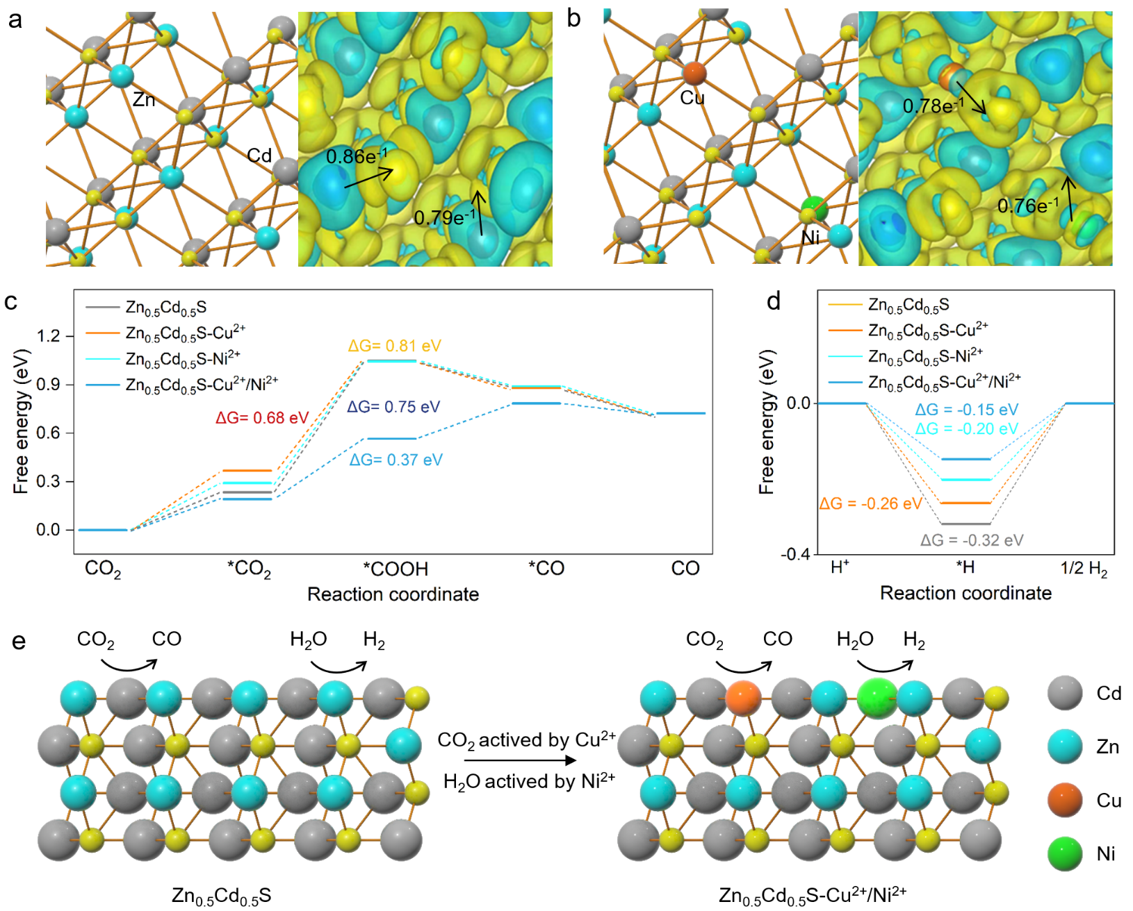
Fig. 7 (a) Atomic structure and calculated charge density distribution over (111) surface for Zn_{0.5}Cd_{0.5}S and (b) (111) surface for Zn_{0.5}Cd_{0.5}S-Cu²⁺/Ni²⁺. (c) Gibbs free energy diagram for the pathways of CO₂ conversion into CO over Zn_{0.5}Cd_{0.5}S, Zn_{0.5}Cd_{0.5}S-Cu²⁺, Zn_{0.5}Cd_{0.5}S:Ni, Zn_{0.5}Cd_{0.5}S-Cu²⁺/Ni²⁺ and (d) H⁺ conversion into H₂ over Zn_{0.5}Cd_{0.5}S, Zn_{0.5}Cd_{0.5}S-Cu²⁺, Zn_{0.5}Cd_{0.5}S-Ni²⁺, Zn_{0.5}Cd_{0.5}S-Cu²⁺/Ni²⁺. (e) Schematic Diagram of Active Site Transformation in Zn_{0.5}Cd_{0.5}S and Zn_{0.5}Cd_{0.5}S-Cu²⁺/Ni²⁺ for CO₂ reduction and water splitting for hydrogen production.
The Gibbs free energy changes (ΔG) for CO₂ reduction and water-splitting hydrogen evolution reactions at different atomic sites in Zn_{0.5}Cd_{0.5}S-Cu²⁺ and Zn_{0.5}Cd_{0.5}S-Ni²⁺ are based on the specific computational models shown in Fig. S14. The results indicate that, in Zn_{0.5}Cd_{0.5}S-Cu²⁺, the Cu atom serves as the optimal active site for CO₂ reduction, while the Cd atom is the optimal active site for hydrogen evolution. In Zn_{0.5}Cd_{0.5}S-Ni²⁺, the Zn atom is identified as the most favourable active site for CO₂ reduction, whereas the Ni atom is the most effective active site for hydrogen evolution. Fig. 7c and d present the Gibbs free energy profiles for CO₂ reduction and water-splitting hydrogen evolution reactions, respectively, at the optimal active sites of the Zn_{0.5}Cd_{0.5}S material and its modified counterparts. The findings demonstrate that the introduction of Cu and Ni successfully regulates the active sites for CO₂ reduction and hydrogen evolution reactions. Specifically, the active site for CO₂ reduction shifts from Zn to Cu, while the active site for hydrogen evolution shifts from Cd to Ni. The incorporation of Cu and Ni enhances the adsorption of intermediates in both CO₂ reduction and hydrogen evolution reactions, reduces reaction energy barriers, and thereby promotes the photocatalytic production of syngas.
3. Conclusion
In this study, Cu²⁺and Ni²⁺ are introduced Zn_{0.5}Cd_{0.5}S material to simultaneously enhancing the photocatalytic syngas (CO and H₂) production performance. The Zn_{0.5}Cd_{0.5}S-Cu²⁺/Ni²⁺ materials are achieved by a co-precipitation method, which exhibits a modulated bandgap of 2.44 eV. The photocatalytic performance is markedly improved, with CO and H₂ evolution rates reaching 18.1 μmol·h⁻¹·g⁻¹ and 5.6 mmol·h⁻¹·g⁻¹, respectively. Upon doping Zn_{0.5}Cd_{0.5}S with either Cu²⁺ or Ni²⁺ individually, Cu²⁺ doping led to an 8.3-fold increase in CO yield with minimal impact on hydrogen production. In contrast, Ni²⁺ doping significantly enhanced hydrogen evolution while only slightly affecting CO production. When both Cu²⁺ and Ni²⁺ are introduced, the production of CO and H₂ increased by 10.6 times and 3.1 times, respectively. FT-IR spectroscopy elucidates the reduction pathways of CO₂ and H₂O over Zn_{0.5}Cd_{0.5}S-Cu²⁺/Ni²⁺. Theoretical calculations confirm that Cu²⁺ and Ni²⁺ act as active sites that affect reaction rates and product distribution. Moreover, Cu²⁺ and Ni²⁺ play distinct roles in the reactions: Cu²⁺ serves as an active site for CO₂ reduction, significantly lowering the Gibbs free energy for intermediate adsorption, while Ni²⁺ acts as an active site for hydrogen evolution in water splitting, reducing the adsorption energy of H*. This study shows that incorporating active sites can effectively modulate photocatalytic behaviour, providing a promising strategy for designing efficient photocatalysts for syngas production.
Experimental method
Preparation of Zn_{0.5}Cd_{0.5}S-Cu²⁺/Ni²⁺
All chemicals were reagent grade and used as received. Using Na₂S as S source, the photocatalysts were synthesized by a simple co-precipitation method. The colloidal Zn_{0.5}Cd_{0.5}S with different doping molar ratios can be instantly obtained by injecting the freshly prepared Na₂S (20 ml, 2.052 mmol) solution into a solution containing Zn²⁺ (1.026 mmol), Cd²⁺ (1.026 mmol) at a rate of 4 ml/min using a micro-infusion pump under vigorous stirring at room temperature. Then, Cu(NO₃)₂ (0.004 mmol, 0.2%) and Ni(NO₃)₂ (0.002 mmol, 0.1%) were added, and the mixture was stirred at room temperature for six hours to ensure the reaction proceeded thoroughly. The reaction was proceeded for 30 min under the ambient condition. The resulting yellow suspension was centrifuged, washed several times with DI water and then dried in freezer dryer for 24 h.
Photocatalytic Reduction of CO₂
In a typical experiment, 0.1 M K₂SO₃ and 0.5 M KHCO₃ were added to an aqueous suspension containing Zn_{0.5}Cd_{0.5}S (200 mg), and the volume of the reaction mixture was adjusted to 200 mL by adding fresh deionized water. The reaction system was then evacuated, and high-purity CO₂ (99.999%) was repeatedly introduced until the final pressure, as indicated by the barometer, reached atmospheric levels (101-102 kPa). The reactor was illuminated using a 300 W xenon lamp (Microsolar 300, Beijing Perfectlight Technology Co., Ltd) equipped with a 420 nm cut-off filter (L42, HOYA) at a constant temperature of 25°C. The CO generated in the reaction system was collected and quantified using a gas chromatograph (GC-2014, Shimadzu, N₂ as carrier gas) with a flame ionization detector (FID). Additionally, an online gas chromatograph (GC-2014C, Shimadzu, Ar as carrier gas) and a thermal conductivity detector (TCD) were employed to measure the H₂ content. The apparent quantum efficiency (AQE) was determined using a 300 W xenon lamp with a 420 nm band-pass filter (HOYA), and the number of incident photons was measured with a radiometer (Ushio Spectroradiometer, USR-40). The AQE was calculated using the following formula:
AQE _{(H2)} = N_{(H2)}×2/N_{(Photons)} × 100% (1)
AQE _{(H2)} = N_{(CO)}×2/N_{(Photons}) × 100% (2)
Among them, N (H₂), N (CO) and N (Photons) respectively represent the number of H₂, CO and incident photons generated per unit time.
The characterizations, photocatalytic measurements, and DFT calculation methods are described in electronic supplementary information.
Author contributions
Wuqing Luo: conceptualization, data curation, formal analysis, investigation, methodology. Yuhao Yi: writing – original draft, writing – review and editing. Lian duan: formal analysis. Xiaohe Liu: validation – support. Min Liu: validation – support. Gen Chen: validation – support. Renzhi Ma: review and editing. Ning Zhang: funding acquisition, project administration, resources, supervision, validation, writing – review and editing.
Conflicts of interest
There are no conflicts to declare.
Data availability
All relevant data are available from the authors on reasonable request and/or are included within the article and the electronic supplementary information.
Acknowledgments
This work received financial support from the National Natural Science Foundation of China (22072183) and the Natural Science Foundation of Hunan Province, China (2022JJ30690). This work was supported in part by the High Performance Computing Center of Central South University.
Notes and references

1 H. Tong, S. Ouyang, Y. Bi, N. Umezawa, M. Oshikiri and J. Ye, Adv. Mater., 2012, 24, 229-251.
2 Z. Mao, G. Wei, L. Liu, T. Hao, X. Wang and S. Tang, J. Colloid Interface Sci., 2025, 679, 860-867.
3 A. Mora Rollo, A. Rollo and C. Mora, Nat. Rev. Earth Environ., 2020, 1, 332-332.
4 Y. Guo, L. Mao, Y. Tang, Q. Shang, X. Cai, J. Zhang, H. Hu, X. Tan, L. Liu, H. Wang, T. Yu and J. Ye, Nano Energy, 2022, 95, 107028.
5 S. N. Habisreutinger, L. Schmidt-Mende and J. K. Stolarczyk, Angew. Chem. Int. Ed., 2013, 52, 7372-7408.
6 W. Tu, Y. Zhou and Z. Zou, Adv. Mater., 2014, 26, 4607-4626.
7 J. Ran, M. Jaroniec and S.-Z. Qiao, Adv. Mater., 2018, 30, 1704649.
8 S. Wu, H. Pang, W. Zhou, B. Yang, X. Meng, X. Qiu, G. Chen, L. Zhang, S. Wang, X. Liu, R. Ma, J. Ye and N. Zhang, Nanoscale, 2020, 12, 8693-8700.
9 Q. Xu, L. Zhang, B. Cheng, J. Fan and J. Yu, Chem, 2020, 6, 1543-1559.
10 S. Gao, B. Gu, X. Jiao, Y. Sun, X. Zu, F. Yang, W. Zhu, C. Wang, Z. Feng, B. Ye and Y. Xie, J. Am. Chem. Soc., 2017, 139, 3438-3445.
11 S. Gao, Y. Lin, X. Jiao, Y. Sun, Q. Luo, W. Zhang, D. Li, J. Yang and Y. Xie, Nature, 2016, 529, 68-71.
12 X. Jiao, Z. Chen, X. Li, Y. Sun, S. Gao, W. Yan, C. Wang, Q. Zhang, Y. Lin, Y. Luo and Y. Xie, J. Am. Chem. Soc., 2017, 139, 7586-7594.
13 R. Zeng, T. Liu, M. Qiu, H. Tan, Y. Gu, N. Ye, Z. Dong, L. Li, F. Lin, Q. Sun, Q. Zhang, L. Gu, M. Luo, D. Tang and S. Guo, J. Am. Chem. Soc., 2024, 146, 9721-9727.
14 X. Wang, B. Liu, S. Ma, Y. Zhang, L. Wang, G. Zhu, W. Huang and S. Wang, Nat. Commun, 2024, 15, 2600.
15 M. Liu, Y. Chen, J. Su, J. Shi, X. Wang and L. Guo, Nat. Mater, 2016, 1, 16151.
16 C. Tang, T. Bao, S. Li, X. Li, H. Rao, P. She and J.-s. Qin, Adv. Funct. Mater., 2025, 35, 2415280.
17 H. Zhao, L. Guo, C. Xing, H. Liu and X. Li, J. Mater. Chem. A, 2020, 8, 1955-1965.
18 X. Chang, T. Wang and J. Gong, Energy Environ. Sci., 2016, 9, 2177-2196.
19 W. Zhang, A. R. Mohamed and W.-J. Ong, Angew. Chem. Int. Ed., 2020, 59, 22894-22915.
20 J. Jiao, Y. Ma, X. Han, A. Ergu, C. Zhang, P. Chen, W. Liu, Q. Luo, Z. Shi, H. Xu, C. Chen, Y. Li and T. Lu, Nat. Commun, 2025, 16, 857.
21 Y. Si, S. Cao, Z. Wu, Y. Ji, Y. Mi, X. Wu, X. Liu and L. Piao, Nano Energy, 2017, 41, 488-493.
22 M. B. Gawande, A. Goswami, F.-X. Felpin, T. Asefa, X. Huang, R. Silva, X. Zou, R. Zboril and R. S. Varma, Chem. Rev., 2016, 116, 3722-3811.
23 J. Graciani, K. Mudiyanselage, F. Xu, A. E. Baber, J. Evans, S. D. Senanayake, D. J. Stacchiola, P. Liu, J. Hrbek, J. F. Sanz and J. A. Rodriguez, Science, 2014, 345, 546-550.
24 R. Jana, T. P. Pathak and M. S. Sigman, Chem. Rev., 2011, 111, 1417-1492.
25 S. Bai, H. Qiu, M. Song, G. He, F. Wang, Y. Liu and L. Guo, eScience, 2022, 2, 428-437.
26 B. He, P. Xiao, S. Wan, J. Zhang, T. Chen, L. Zhang and J. Yu, Angew. Chem. Int. Ed., 2023, 62, e202313172.
27 W. Wang, I. Germanenko and M. S. El-Shall, Chem. Mater., 2002, 14, 3028-3033.
28 J. Chen, J. Chen and Y. Li, J. Mater. Chem. A, 2017, 5, 24116-24125.
29 M. H. Boratto, A. A. Linhares, M. Congiu, A. Batagin-Neto, C. C. Pla-Cid, A. A. Pasa and C. F. O. Graeff, Appl. Surf. Sci., 2021, 537, 147921.
30 X. Gao, J. Yang, D. Zeng, G. He, C. Dai, Y. Bao and Y. Wei, J. Alloys Compd., 2021, 871, 159460.
31 Z. Wang, L. L. Daemen, Y. Zhao, C. S. Zha, R. T. Downs, X. Wang, Z. L. Wang and R. J. Hemley, Nat. Mater, 2005, 4, 922-927.
32 F. A. La Porta, J. Andrés, M. S. Li, J. R. Sambrano, J. A. Varela and E. Longo, Phys. Chem. Chem. Phys, 2014, 16, 20127-20137.
33 Y. Kim and D.-J. Jang, CrystEngComm, 2014, 16, 6989-6995.
34 C.-C. Lin, T.-R. Liu, S.-R. Lin, K. M. Boopathi, C.-H. Chiang, W.-Y. Tzeng, W.-H. C. Chien, H.-S. Hsu, C.-W. Luo, H.-Y. Tsai, H.-A. Chen, P.-C. Kuo, J. Shiue, J.-W. Chiou, W.-F. Pong, C.-C. Chen and C.-W. Chen, J. Am. Chem. Soc., 2022, 144, 15718-15726.
35 Y. Chen, S. Zhao, X. Wang, Q. Peng, R. Lin, Y. Wang, R. Shen, X. Cao, L. Zhang, G. Zhou, J. Li, A. Xia and Y. Li, J. Am. Chem. Soc., 2016, 138, 4286-4289.
36 Z. Yang, Y. Zhang, H. Zhang, J. Zhao, H. Shi, M. Zhang, H. Yang, Z. Zheng and P. Yang, J. Catal., 2022, 409, 12-23.
37 S. Wang, B. Y. Guan and X. W. D. Lou, J. Am. Chem. Soc., 2018, 140, 5037-5040.
38 N. Meng, C. Liu, Y. Liu, Y. Yu and B. Zhang, Angew. Chem. Int. Ed., 2019, 58, 18908-18912.
39 Z. Fu, C. Shu, X. Wang, L. Chen, X. Wang, L. Liu, K. Wang, R. Clowes, S. Y. Chong, X. Wu and A. I. Cooper, CCS Chem., 2023, 5, 2290-2300.
40 F. Wang, T. Hou, X. Zhao, W. Yao, R. Fang, K. Shen and Y. Li, Adv. Mater., 2021, 33, 2102690.
41 X. Chi, Z.-A. Lan, Q. Chen, X. Zhang, X. Chen, G. Zhang and X. Wang, Angew. Chem. Int. Ed., 2023, 62, e202303785.

