Microstructural study of YBCO thin films with stripe-patterned substrates for ultra-fine multi-filaments

Akiyoshi Matsumoto, Minoru Tachiki, and Shuuichi Ooi, Ryo Teranishi, Masayoshi Inoue

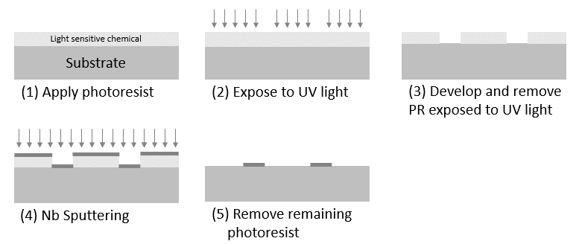
Fig. 1. Patterning method on the STO substrate through photolithography. (1) A photoresist was applied on the STO substrate by using a spin coater. (2) The patterned substrate was exposed to UV light. (3) The patterned substrate was developed by tetramethyl ammonium hydroxide, and the region exposed to UV was removed. (4) Nb was deposited on the patterned substrate. (5) The remaining photoresist was removed.

Abstract— Rare-earth barium copper oxide (REBCO) superconductors can be applied to superconducting magnets in low-temperature and high-magnetic-field and electric power equipment. Currently available superconducting wires supplied by many companies are tape-shaped, and a thin REBCO film is formed by depositing multiple buffer layers on a thin metal substrate. Coated conductors fabricated on such a flat substrate have a structure close to a single crystal and have high critical current density properties. In contrast, reducing the screening current is an important issue for practical applications such as high-field superconducting coils. In this study, we proposed a patterned multifilamentary thin film with a stripe pattern, fabricated on a substrate via photolithography. YBa₂Cu₃O_{x} was deposited onto stripe with Nb metal. Any stripe material can be used to separate superconducting and non-superconducting wires based on magneto-optical observations. Based on TEM/STEM-EDX observations, impurity phases such as NbBaO were formed on the STO/Nb strip. These results suggested that the use of a substrate with a stripe pattern is useful for fabricating multifilamentary coated conductors.

Index Terms— Coated conductors, Multifilamentary superconductors, Photolithography, YBa₂Cu₃O_{x}

I. INTRODUCTION
I
n recent years, the performance and accessibility of high-temperature superconducting coated conductor (HTS-CC) tape wires have been remarkably enhanced, as evidenced by numerous studies [1-10]. These studies focused on exploring the potential applications of HTS-CC tapes [11-17]. Nevertheless, the application of high-temperature superconductors (HTS) is limited in terms of multifilamentary structure and stabilization technologies, which are readily available for low-temperature superconducting wires and are crucial for screening the current of a high-field magnet system using HTS.
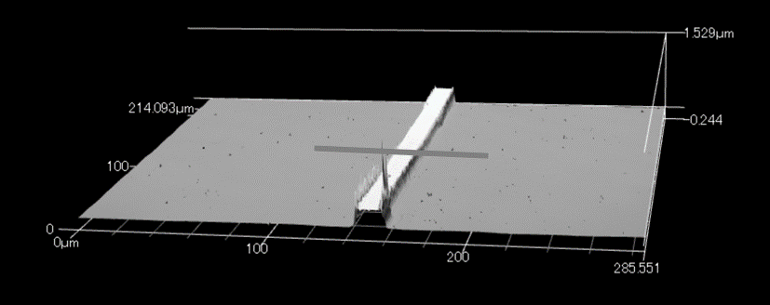
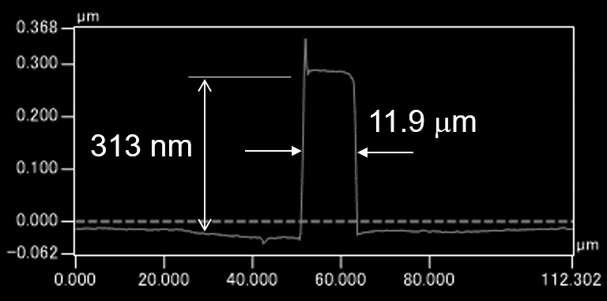
Fig. 2. Laser microscope image after making Nb-stripes. The measurement results below indicate the height measurements of the area indicated by the upper line.
In general, rare earth barium copper oxide (REBCO) CC tapes are manufactured through a process involving a layer of insulating films, known as buffer layers, onto a high-strength metal plate material after undergoing orientation treatment (utilizing methods such as IBAD or RABITS) [2-3,5]. This process is employed to fabricate highly oriented thin film substrates with a high critical current density (J_{c}) [18]. However, REBCO CC tapes exhibit an unusually high J_{c} and aspect ratio, relative to their shape. Consequently, the presence of shielding current-induced magnetic fields and AC losses limits their utilization in high-field magnets and electric power equipment. It has been theoretically shown that the tape shape of the CC causes magnetization loss, which is proportional to the square of the strip width[19,20]. Furthermore, if the width of the strip is small, the shielding current itself can be reduced, so that the hoop stress caused by the shielding current can be reduced. For these reasons, making the filament as small as possible will help reduce magnetization loss and reduce the complex hoop stress.
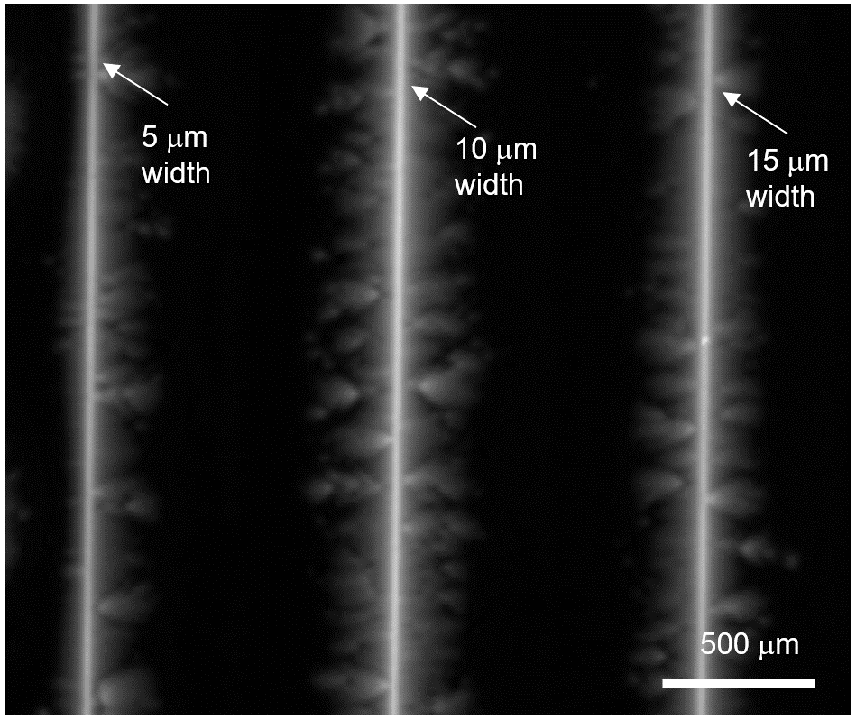
Fig. 4. MO images at 200 Oe with the magnetic field increasing up to 420 Oe before decreasing to 0 Oe at 50 K. The field ramped to 420 Oe and back to zero. The images obtained in the upward ramp. The white regions represent non-superconducting regions formed by Nb stripes with widths of 5, 10, and 15 μm, respectively.
These challenges can be effectively addressed through the application of multifilamentary technology, a methodology commonly employed in high-temperature superconducting wires [21]. In recent years, a plethora of investigations has aimed at mitigating screening current effects in superconducting magnets, particularly by segmenting the fabricated CC tape material using various techniques [22-27]. Among these methods, the scribing approach, which harnesses laser ablation, is considered as the most reliable and precision-oriented technique [22-24].
Notably, Wulff et al. introduced a novel two-level undercut profile substrate strategy employing chemical etching and polishing directly on a metal substrate to generate intricate 3D shaping profiles before the deposition of CC stacks [25]. Additionally, a method involving material scratching prior to stacking has emerged [26].
In the context of multifilamentary technology employed in magnet applications, it is essential to note that insulation between filaments may not always be a requisite. Moreover, there is a compelling report suggesting that establishing an electrical contact can enhance the stability [28,29]. These methodologies are eminently applicable considering their alignment with the principles of thinning stabilization observed in Nb-Ti and Nb₃Sn materials.
Recently, we proposed a multifilamentary YBa₂Cu₃O_{x} (YBCO) thin film fabricated by depositing YBCO on a substrate with elevated Zr stripes patterned by using photolithography. While the thin film exhibited superconductivity, the crystal grain orientation was disturbed above the stripe, which locally inhibited superconducting current flow. The results of this study indicate that a continuous YBCO film can be divided into separate superconducting filaments by locally suppressing the good grain alignment required for a high intergrain J_{c} with Zr stripes between the STO substrate and the YBCO film [27]. In addition, it is important to identify the types of gaps that can be formed in materials other than Zr. In this study, we discuss the superconducting properties and microstructural formation mechanism of the Nb stripes. At REBCO thin film, research on artificial pinning center using NBO and ZBO was progressing[30,31]. These impurities rarely significantly reduce the J_{c} properties. For this reason, we thought that there would be no problem even if some Zr and Nb were diffused into the YBCO itself. The results showed that Nb stripes form a structure that is completely different from that of Zr. In particular, detailed transition electron microscopy (TEM)/scanning transition electron microscopy (STEM) observations have revealed that YBCO is not formed on Nb, but many impurity phases are formed because of reactions with Nb.
Fig. 3. SEM image of the surface of the YBCO film on Nb-stripe-patterned substrate. The width of the Nb-stripe was 5 μm. YBCO is formed up to both ends.

II. Experimental
Photolithography, a versatile method employed in the fabrication of semiconductor devices, has been utilized in the production of a multi-core thin-film superconducting wires [27]. The photolithography technique process is shown in Figure 1. Initially, (1) a photoresist (OFPR700LB, Tokyo Ohka Kogyo Co., Ltd.) was applied to the 5 mm × 5 mm STO (100) substrate. Subsequently, (2) the photoresist was patterned by using a maskless lithography tool (Nano System Solutions Corporation, DL-1000). (3) Following the development of the thin film with tetramethyl ammonium hydroxide, the region exposed to ultraviolet light was removed. (4) A thin film of Nb was deposited on the substrate at approximately 25°C using a DC magnetron sputtering device (CFD-4EP-LL (4G), manufactured by Shibaura Mechatronics Co., Ltd.). (5) Next, a Nb stripe was created in the longitudinal direction on the substrate by dissolving the photoresist in a solvent. Subsequently, the YBCO thin film was deposited onto the STO substrate using pulsed laser deposition employing a KrF excimer laser. The target was prepared as follows. Y₂O₃, BaCO₃, and CuO powders were mixed with a nominal composition of Y:Ba:Cu = 1:2:3 and subjected to pre-baking at 850°C for 10 h. After pressing, YBCO target was heated at 900°C for 10 h. PLD deposition was performed for 1 h. while the substrate temperature was maintained at 650°C. Afterward, the substrate was cooled to 500°C and placed in an oxygen-rich chamber for 20min.
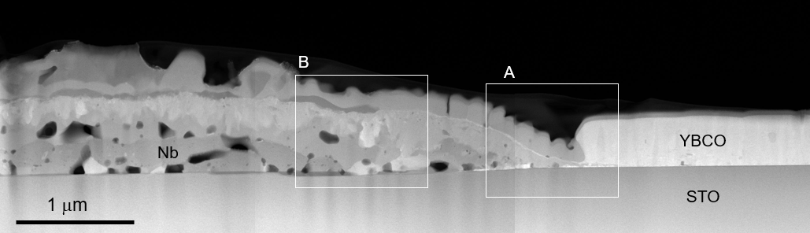Fig. 5. HAADF-STEM images of the cross section of the area near the Nb strip.
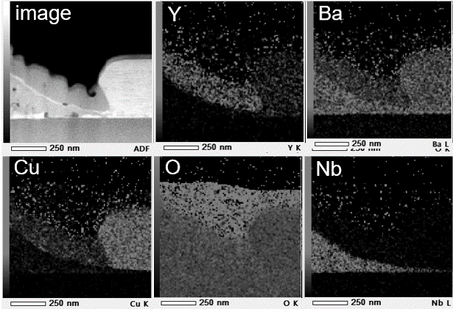
Fig. 6. HAADF-STEM images of the cross-section of the area near the edge of Nb strip (A position from Fig. 5) and elemental mapping by STEM-EDX images.
Microstructural observations were carried out using various techniques, including magneto-optical (MO) imaging to check the superconductivity of the patterned film, optical microscopy (KEYENCE, VHX-1000), scanning electron microscopy (SEM, Hitachi High-Tech, SU-70), and laser microscopy (KEYENCE, VK-X1100). In addition, TEM and STEM were performed using a JEOL-ARM to evaluate the microstructure in the vicinity of the strip region.

III. RESULTS AND DISCUSSION
Fig. 2 presents the results of measurements conducted on a portion of the Nb stripes after pattern deposition using a la-ser microscope. In this study, we used patterns with four different widths: 2, 5, 10, and 15 μm. In particular, measurements were taken on the 10-μm-width pattern, revealing a width of 11.9 μm and a height of 313 nm. In addition, these stripes were formed with a length of 5 mm.
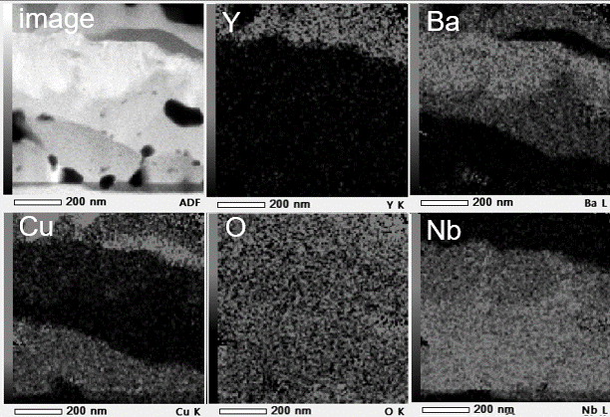
Fig.7. HAADF-STEM images of the cross-section of the area near the middle of the Nb strip (B position from Fig. 5) and elemental mapping by STEM-EDX images.
Fig. 3 shows the SEM image of the surface after YBCO deposition on the patterns shown in Fig. 2. Consequently, granular precipitates were evident within the Nb stripes, whereas YBCO crystals formed smoothly at both ends. Moreover, the edges were clearly demarcated and measured 5 μm in width.
Fig. 4 presents an MO image of regions separated by slits with widths of 5, 10, and 15 μm. The image was obtained under a magnetic field of 420 Oe at 50 K. The white regions indicate non-superconducting areas, whereas the black regions indicate superconducting states throughout. As illustrated in the figure, three vertical stripes are discernible, even in the case of the 5-μm-wide stripe, where non-superconducting regions are evident. Thus, at this stage, non-superconducting regions with a width of 5 μm can be formed.
However, the 2-μm-wide stripe could not be distinctly separated because of their suboptimal resist properties. In the future, further optimization of the process is necessary to achieve clear separation. Accurate measurement of non-superconducting regions is difficult due to insufficient resolution in MO observations. In the future, detailed studies using a combination of microstructures and electromagnetic measurements are required.
Fig. 5 shows HAADF-STEM images obtained through micro-sampling at the interface between the Nb and YBCO regions. Within the Nb region, the areas appearing black correspond to voids, and the contrast reveals a complex intermingling of the structures. Conversely, the formation of epitaxially grown YBCO is evident in the YBCO region situated on the STO substrate.
Furthermore, we conducted STEM observations and EDX analysis at the interface vicinity and central portion of Nb, and the results are illustrated in Fig. 6 and 7. Initially, Nb formed relatively tall walls of approximately 300 nm (Fig. 2). However, as observed in the elemental mapping of Nb pre-sented in Fig. 6, it appears to have gradually spread. In addition, Y and Cu were present on top of Nb and on the STO substrate, respectively. In contrast, Ba exists in regions overlapping with Nb but outside the same area as the vapor. The interaction between Nb and Ba suggests the formation of NbBaO₃. Furthermore, the observation results in the central region of Nb away from the STO are presented in Fig. 7. In the STEM image, regions with different contrasts are intricately formed on top of the STO. From these results, it is possible that reactions occur through different mechanisms at the edge and center regions. It is thought that as the substrate temperature rises, Nb takes on a gentle hill-like shape toward the STO. When YBCO accumulated by PLD, there were a difference in reaction between areas with less Nb (edges) and areas with more Nb (center). In other words, the reaction of NbCuBa occurs from the edge, and when Cu penetrates into the inside of Nb and crystallizes, voids were also formed. On the other hand, Ba remained at the edge area without diffusing into the Nb. A complex reaction occurs only where Nb was present, and that YBCO was formed on STO where Nb was not diffused.
Almost no reaction with Zr was observed on Zr, and the crystal orientation of YBCO on Zr was only random[27]. By changing the material in this way, the microstructures on the stripes also changes, so it is necessary to study electrical resistance etc. in detail to understand the mechanism of conductivity. If this technique can be further developed on metal substrates, it has the potential to contribute to the production of wires with reduced shielding currents.

IV. Conclusion
In this study, we fabricated a YBCO film by depositing strip-shaped nonaligned metal Nb on an oriented substrate using photolithography. Based on the MO images and microstructural observations, we found that the YBCO regions were distinguishable because of the impurity phases of Nb-Ba-Cu and other phases. We believe that this technology can be applied to multifilamentary technologies to reduce the screening current of superconducting magnets.

References
- C. Senatore, C. Barth, M. Bonura, M. Kulich and G. Mondonico, Field and temperature scaling of the critical current density in commercial REBCO coated conductors Supercond. Sci. Technol. 29(2015), 014002.
- Y. Iijima, N. Tanabe, O. Kohno, and Y keno, In-plane aligned YBa₂Cu₃O_{7−x} thin films deposited on polycrystalline metallic substrates Appl. Phys. Lett. 60(1992), 769.
- A. Goyal, D. P. Norton, J. D. Budai, M. Paranthaman, E. D. Specht, D. M. Kroeger, D. K. Christen, Q. He, B affian, F. A. List, D. F. Lee, P. M. Martin, C. E. Klabunde, E. Hartfield, and V. K. Sikka, High critical current density superconducting tapes by epitaxial deposition of YBa₂Cu₃O_{x} thick films on biaxially textured metals. Appl. Phys. Lett. 69,(1996) 1795
- D. Uglietti, A review of commercial high temperature superconducting materials for karge scale magnets: from wiews and tapes to cables and conductors, Supercond. Sci. Technol. 32(2019), 053001
- A. Usokin, U. Bets, J. Gnilson, S. Noll-Baumann, K. Schlenga, Long-Length YBCO coated consuctors for ultra-high fielsapplications: gaining engineering current density viapulsed lase deposition/alternating beam-assisted deposition route, Supercond. Sci. Technol. 32(2019), 094005
- B. Ma, U. Balachandran, Prospects for the fabrication of low aspect ratio coated conductors by inclined substrate deposition, Supercond. Sci. Technol. 19(2006), 497.
- W. Prusseit, M. Bauer, V. Große, R. Semerad, G. Sigl, M. Dürrschnabel, Z. Aabdin and O. Eibl, Working around HTS thickness limitations-towards 1000+A cm-1 -Class Coated Conductors, Phys. Proc. 36(2012), 1417–22
- A. Sundaram, Y. Zhang, A. R. Knoll, D. Abraimov, P. Brownsey, M. Kasahara, G. M. Carota, R. Nakasaki, J. B. Cameron, G. Schwab, L. V. Hope, R. M. Schmidt, H. Kuraseko, T. Fukushima and D. W. Hazelton, 2G HTS wires made on 30μm thick Hastelloy substrate, Supercond. Sci. Technol. 29(2016), 104007
- J.-H. Lee, H. Lee, J.-W. Lee, S.-M. Choi, S.-I. Yoo and S.-H. Moon, RCE-DR, a novel process for coated conductor fabrication with high performance, Supercond. Sci. Technol. 27 (2014) 044018.
- Y. Zhao, J.-M. Zhu, G.-Y. Jiang, C.-S. Chen, W. Wu, Z.-W. Zhang, S. K. Chen, Y. M. Hong, Z.-Y. Hong, Z.-J. Jin and Y. Yamada, Progress in fabrication of second generation high temperature superconducting tape at Shanghai Superconductor Technology, Supercond. Sci. Technol. 32(2019), 044004.
- M. Yagi, S. Mukoyama, A. Ishiyama, X. Wang, Y. Aoki, T. Saito, T. Ohkuma, O. Maruyama, Progress of 275 kV-3 kA YBCO HTS cable, Physica C471 (2011), 1274.
- O. Maruyama, T. Ohkuma, T. Masuda, Y. Ashibe, S. Mukoyama, M. Yagi, T. Saitoh, T. Hasegawa, N. Amemiya, A. Ishiyama, N. Hayakawa, Development of 66 kV and 275 kV Class REBCO HTS Power Cables, IEEE Trans. Appl. Supercond. 23(2013), 5401405.
- M. Iwakuma, H. Hayashi, H. Okamoto, A. Tomioka, M. Konno, T. Saito, Y. Iijima, Y. Suzuki, S. Yoshida, Y. Yamada, T. Izumi, Y. Shiohara, Development of REBCO superconducting power transformers in Japan, Physica C. 469(2009), 1726.
- W. D. Markiewicz, D. C. Larbalestier, H. W. Weijers, A. J. Voran, K. W. Pickard, W. R. Sheppard, J. Jaroszynski, A. Xu, J. Lu, A. V. Gavrilin, P. D. Noyes, Design of a Superconducting 32 T Magnet with REBCO High Field Coils, IEEE Trans. Appl. Supercond. 22(2012), 4300704
- J. Bascunan, S. Hahn, D. K. Park, Y. Kim, Y. Iwasa, On the 600 MHz HTS Insert for a 1.3 GHz NMR Magnet, IEEE Trans. Appl. Supercond. 22(2012), 4302104
- L. Rossi, A. Badel, M. Bajko, A. Ballarino, L. Bottura, M. M. J. Dhallé, M. Durante, Ph. Fazillea, J. Fleiter, W. Goldacker, E. Härö, A. Kario, G. Kirby, C. Lorin, J. van Nugteren, G. de Rijk, T. Salmi, C. Senatore, A. Stenvall, P. Tixador, A. Usoskin, G. Volpini, Y. Yang, N. Zangenberg, The EuCARD-2 Future Magnets European Collaboration for Accelerator-Quality HTS Magnets, IEEE Trans. Appl. Supercond. 25(2015), 4001007
- P. V. Gade, C. Barth, C. Bayer, W. H. Fietz, F. Franza, R. Heller, K. Hesch, K.-P. Weiss, Conceptual Design of a Toroidal Field Coil for a Fusion Power Plant Using High Temperature Superconductors, IEEE Trans. Appl. Supercond. 24(2014), 4202705
- D. Dimos, P. Chaudhari, J. Mannhart, and F. K. LeGoues, Orientation Dependence of Grain-Boundary Critical Currents in YBa2Cu3O7-δ Bicrystals, Phys. Rev. Lett. 61(1988), 219.
- E. H. Brandt and M. Indenbom, Type-II-superconductor strip with current in a perpendicular magnetic field, Phys. Rev. B 48(1993) 12893.
- E Zedov, J. R. Clem, M. McElfresh and M. Darwin, Magnetization and transport currents ithin superconducting films, Phys. Rev. B 49(1994) 9802.
- F. Grilli, A. Kario, How filaments can reduce AC losses in HTS coated conductors: a review, Supercond. Sci. Technol. 29(2016), 083002
- S. Terzieva, M. Vojenciak, F. Grilli, R. Nast, J. Souc, W. Goldacker, A. Jung, A. Kudymow, A. Kling, Investigation of the effect of striated strands on the AC losses of 2G Roebel cables Supercond. Sci. Tecnol. 24 (2011), 045001
- M. D. Sumption, E. W. Collings, P. N. Barnes, AC loss in striped (filamentary) YBCO coated conductors leading to designs for high frequencies and field-sweep amplitudes. Supercond. Sci. Technol. 18 (2005), 122
- T. Machi, K. Nakao, T. Kato, T. Hirayama, K. Tanabe, Reliable fabrication process for long-length multi-filamentary coated conductors by a laser scribing method for reduction of AC loss Supercond. Sci. Tecnol. 26 (2013), 105016
- A. C. Wulff, M. Solovyov, F. Gomory, A. B. Abrahamsen, O. V. Mishin, A. Usoskin, A. Rutt, J. H. Lundeman, K. Thyden, J. B. Hansen, J.-C. Grivel, Two level undercut-profile substrate for filamentary YBa₂Cu₃O₇ coated conductors Supercond. Sci. Technol. 28 (2015), 072001
- S. Fujita, S. Muto, C. Kurihara, H. Sato, W. Hirata, N. Nakamura, M. Igarashi, S. Hanyu, M. Daibo, Y. Iijima, K. Naoe, M. Iwakuma, T. Kiss, Characterization of Multifilamentary REBCO Coated Conductor Coil Fabricated by Using the Process of Scratching the IBAD-MgO Layer. IEEE Trans. Appl. Supercond. 27 (2017), 6600504.
- A. Matsumoto, M. Tachiki, S. Ooi, Development of YBCO patterned Multi-Filamentary Film Using Photolithography Method, IEEE Trans. Appl. Supercond. 33(2023), 7500404.
- Y. Sogabe, Y. Mizobata, and N. Amemiya, “Coupling time constants and ac loss characteristics of spiral copper-plated striated coatedconductor cables (SCSC cables),” Supercond. Sci. Technol., vol. 33, 2020, Art. no. 055008.
- N. Amemiya et al., “Effective reduction of magnetization losses in copperplated multifilament coated conductors using spiral geometry,” Supercond. Sci. Technol., vol. 35, 2022, Art. no. 025003.
- J. L. MacManus-Driscoll, S. R. Foltyn, Q. X. Jia, H. Wang, A. Serquis, L. Civale, B. Maiorov, M. E. Hawley, M. P. Maley & D. E. Peterson, Strongly enhanced current densities in superconducting coated conductors of YBa₂Cu₃O_{7–x} + BaZrO₃, Nat. Mat. 3(2004), 439.
- S. H. Wee, A. Goyal, Y. L. Zuev, C. Cantoni, V. Selvamanickam and E. D. Specht, Formation of Self-Assembled, Double-Perovskite, Ba₂YNbO₆ Nanocolumns and Their Contribution to Flux-Pinning and J_{c} in Nb-Doped YBa₂Cu₃O_{7-δ} Films, Appl. Phys. Express 3(2010) 023101.

Manuscript received 25 September 2023; This work was supported in part by Japan IKETANIZAIDAN. (Corresponding author: Akiyoshi Matsumoto) Akiyoshi Matsumoto is with the National Institute for Materials Science, Tsukuba, Ibaraki 3050047, Japan (e-mail:matsumoto.akiyoshi@nims.go.jp). Shuichi Ooi is with the Research Center for Materials Nanoarchitectonics (MANA), National Institute for Materials Science(NIMS), Tsukuba, Ibaraki 3050047, Japan (e-mail:ooi.shuuichi@nims.go.jp). Minoru Tachiki is with the National Institute for Materials Science, Tsukuba, Ibaraki 3050047, Japan (e-mail:tachiki.minoru@nims.go.jp). Ryo Teranishi is with the Department of Materials, Kyushu University, 744 Motooka, Nishi-ku, Fukuoka 8190395, Japan (e-mail: teranishi@zaiko.kyushu-u.ac.jp) Masayoshi Inoue is with the Faculty of Engineering, Electrical Engineering Fukuoka Institute of Technology, Higashi-ku, Fukuoka 8110295, Japan (e-mail: ms-inoue@fit.ac.jp)

