Syntheses of Water-soluble Silver(II)-Phthalocyanines toward Optical Sensing for Thiol Detection
Hiroaki Isago*¹, Harumi Fujita¹, Suzuko Nakai², and Tamotsu Sugimori³
¹National Institute for Materials Science, 1-2-1, Sengen, Tsukuba, Ibaraki, 305-0047, Japan
²Ochanomizu University, 2-1-1 Ohtsuka, Bunkyo-ku, Tokyo 112-8610, Japan
³University of Toyama, 2630 Sugitani, Toyama-shi, Toyama 930-0194, Japan

KEYWORDS. phthalocyanine, water-soluble, silver, high valence, thiol, chemical probe

ABSTRACT: Water-soluble silver(II)-phthalocyanine complexes (AgPcs), tetrakis{4-(N-alkylpyridinium)thio}phthalocyaninato silver(II) tetrafluoroborate, [Ag(tRpySpc)](BF₄)₄, (R = Me and Et), have been synthesized for the first time by quaternization of pyridyl groups of tetrakis(4-pyridylthio)phthalocyaninato silver(II) by using Meerwein reagents and characterized by ESI-MS, elemental analyses, and optical absorption spectroscopy. Although they strongly aggregate in water, the presence of appropriate surfactants, such as polyethyleneglycol-monooleyl ether (n = approximately 50; PEG50) and sodium dodecyl sulfate (SDS), effectively disaggregates them to monomeric species. Spectral properties of the AgPcs and their aggregates in aqueous and non-aqueous solutions have been investigated by optical absorption, emission, and magnetic circular dichroism spectroscopy. These AgPcs rapidly react with thiols such as cysteine, glutathione, homocysteine, and sodium 2-sulfanylethanesulfonate (even on the order of 0.01 mM) in aqueous PEG50 solutions at room temperature to liberate the corresponding macrocyclic ligand, H₂Pc, whereas not with the other amino-acid analogs without sulfhydryl groups. The molar ratio of thiol to AgPc has been determined to be 1:1. Since AgPcs are essentially non-fluorescent at room temperature, while H₂Pcs emit intense red fluorescence, AgPcs can be a potent thiol-sensor toward bioimaging.

Introduction
Selective, sensitive, and rapid sensing of thiols has attracted considerable attention in various fields ranging from the petrochemical industry^{1,2} to medicine.^{3,4} Intracellular thiols include cysteine (Cys; Chart 1), glutathione (GSH), and homocysteine (Hcys) which play a vital role in maintaining redox homeostasis through the equilibrium between reduced thiols (RSH) and oxidized disulfides (RSSR).^{5,6} They behave as free radical scavengers, radioprotective agents, cancer indicators, antitoxin, and antioxidants as well. ⁷ A wealth of investigations over the decades have revealed that imbalance in the redox buffering systems caused by oxidative stress has been linked to a number of diseases, including cancer, chronic neurodegenerative diseases (e.g., Alzheimer’s), and cardiovascular disease.⁸⁻¹⁰
CHART 1. Water-soluble thiols studied in this work.
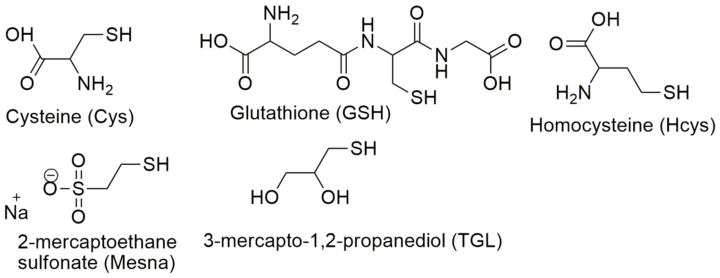

A considerable number of research works have been published on the determination of thiols.^{3, 4, 7} Typically, the intracellular thiol concentrations are on the order of 0.03–0.2 mM, and hence determination of such low absolute concentrations of thiols needs the use of analytical methods with high inherent sensitivity. In particular, optical sensing of thiols is of significant interest for biological scientists.^{3,4} Chemical probes with emission in the range of 650 – 900 nm (deep red or near-infrared; so-called as an "imaging window") are ideal for biological imaging because of decreased light scattering, good tissue penetration,¹¹ reduced autofluorescence (from endogenous fluorophores, such as melanin, proteins, hemoglobin, and related molecules), ^{12, 13} and greater photo-stability of tissues at these wavelengths.¹¹ In other words, such bioimaging requires organic fluorophores to have sufficiently high brightness (defined as the product of molar extinction coefficient and fluorescence quantum yield). From this viewpoint, phthalocyanines (hereafter Pcs) and their analogs are quite promising fluorophores because of their remarkable brightness in this window.¹⁴⁻¹⁹
Quite recently, we have reported silver(II)-Pc complexes (AgPcs).²⁰ While silver ions are generally considered the most stable in the +1 oxidation state, their higher oxidation states (+2/+3) are stabilized in multi-dentate N-donor ligands, such as porphyrins, corroles, and cyclam²¹⁻²⁶ as well as in Pcs. ²⁷⁻²⁹ The potential oxidizing power and high affinity against sulfur of the central metal ion can make AgPcs excellent chemical probes for the above-mentioned biothiols. Although those AgPcs were capable of oxidizing weak electron donors such as iodide in common organic solvents, but not thiols. This is probably because thiols in organic solvents are present mostly in a protonated form but not as thiolates that play a crucial role in the oxidation of thiols catalyzed by metal-Pc complexes (MPcs).³⁰ This speculation inspired us to study if AgPcs can react with deprotonated sulfhydryl group in aqueous solutions. Furthermore, the reduction of essentially non-fluorescent AgPcs (due to the paramagnetism of silver(II)) causes rapid demetallation and generates a corresponding more fluorescent metal-free macrocyclic ligand.²⁰ This work has been undertaken to investigate if water-soluble AgPcs can react with amino acids containing sulfhydryl groups in aqueous media and work as optical sensors for biothiols.

Experimental Section

Materials.
The synthesis of the starting material, {tetrakis(4-pyridylthio)phthalocyaninato}silver(II) monohydrate; [Ag(tpySpc)]•H₂O²⁰ and its precursor, H₂tpySpc, ³¹ are described elsewhere. Alkylation of peripheral pyridyl groups in the metal-free was carried out according to the earlier work reported by Kobayashi and coworkers.³¹ Aqueous solutions of polyethyleneglycol-monooleyl ether (n = approximately 50, 20, and 10 purchased from TCI; hereafter abbreviated as PEG50, PEG20, and PEG10, respectively) were prepared by dissolving it into distilled water at least a night before their use because it takes a long time. The other chemicals were of reagent grade and used as received without further purification.

Tetrakis{4-(N-methylpyridinium)thio}phthalocyaninato silver(II) tetrafluoroborate, [Ag(tMepySpc)](BF₄)₄.
Approximately 400 mg (2.7 mmol) of trimethyloxonium tetrafluoroborate (TCI) was suspended in dry chloroform (40 ml), to which was added a chloroform solution (16 ml) containing [Ag(tpySpc)]•H₂O (40 mg; 0.037 mmol) in an ice bath with vigorous stirring for 30 min under an argon atmosphere. Blue solids precipitated and the supernatant turned essentially colorless. A small amount (ca. 0.05 ml) of triethylamine was added to the reaction mixture to deactivate a large excess amount of the unreacted trimethyloxonium. The reaction mixture was allowed to be warmed to room temperature and then 180 ml of EtOH was added to the mixture. Blue fine solids were collected by filtration and washed with 10 ml of EtOH (5 × 2 ml) and then with 10 ml of dichloromethane (5 ×2 ml) until the washings turned colorless and dried at 60 °C under vacuum overnight. This crude product was dissolved into 6 ml of cold DMA and the solution was quickly poured into 200 ml of EtOH. Fine blue solids precipitated and were collected by filtration and were washed with 10 ml of EtOH (5 × 2 ml) and then with 10 ml of dichloromethane (5 × 2 ml) and dried at 60 °C under vacuum for 2 h. A 47 mg of the desired compound was obtained as a blue powder in this way (47 mg; 0.032 mmol. Yield; 86% vs. [Ag(tpySpc)]•H₂O. Anal calcd. (%) for C₅₆H₄₀N₁₂S₄AgB₄F₁₆: C, 45.93; H, 2.75; N, 11.48; found C, 46.08; H, 3.18; N, 11.53. MS(ESI) m/z; 278.7858 [M/4] (C₅₆H₄₀N₁₂S₄¹⁰⁷Ag⁴⁺ requires 1115/4 = 278.75), 279.2855 [(M+2)/4] (C₅₆H₄₀N₁₂S₄¹⁰⁹Ag⁴⁺ requires 1117/4 = 279.25).

Tetrakis{4-(N-ethylpyridinium)thio}phthalocyaninato silver(II) tetrafluoroborate, [Ag(tEtpySpc)](BF₄)₄.
Approximately 1.3 g (6.8 mmol) of triethyl oxonium tetrafluoroborate (Sigma-Aldrich) was suspended in dry chloroform (30 ml), to which was added a chloroform solution (30 ml) containing [Ag(tpySpc)]•H₂O (15.3 mg; 0.014 mmol) in an ice bath with vigorous stirring for 10 min under an argon atmosphere. Blue solids precipitated and the supernatant turned essentially colorless. A small amount (ca. 3 ml) of triethylamine was added to the reaction mixture to deactivate a large excess amount of the unreacted oxonium. The reaction mixture was allowed to be warmed to room temperature and then 240 ml of EtOH was added to the mixture. Blue fine solids were collected by filtration and washed with 10 ml of EtOH (5 × 2 ml) and then with 10 ml of dichloromethane (5 ×2 ml) until the washings turned colorless and dried at 60 °C under vacuum for 3 h. This crude product (15.6 mg) was dissolved into 1.5 ml of cold nitromethane and the solution was quickly poured into 80 ml of ice-cold chloroform, which the solution was kept cold for 30 min. Fine blue solids precipitated and were collected by filtration and washed with 10 ml of chloroform (5 × 2 ml) and then with 10 ml of dichloromethane (5 × 2 ml) and dried at 60 °C under vacuum for 2 h. A 10.8 mg of the desired compound was obtained as a blue powder in this way (10.8 mg; 0.0071 mmol). Yield; 51% vs. [Ag(tpySpc)]•H₂O). Anal calcd. (%) for C₆₀H₄₈N₁₂S₄AgB₄F₁₆: C, 47.40; H, 3.18; N, 11.05; found C, 47.22; H, 3.48; N, 11.00. MS(ESI) m/z; 292.8013 [M/4] (C₆₀H₄₈N₁₂S₄¹⁰⁷Ag⁴⁺ requires 1171/4 = 282.75), 293.3011 [(M+2)/4] (C₆₀H₄₈N₁₂S₄¹⁰⁹Ag⁴⁺ requires 1173/4 = 293.25).

Measurements.
The measurements of optical absorption spectra were performed with a Shimadzu UV-1800 spectrophotometer. Magnetic circular dichroism (MCD) spectra were recorded on a JASCO J-720 spectropolarimeter equipped with a JASCO MCD-104 electromagnet (accumulated 4 times), which is capable to generate magnetic fields of up to 0.8 T. A constant field of a magnitude of 0.65 T was applied to sample solutions during the measurements. Emission spectra were measured by using a Hitachi F-7000 fluorescence spectrophotometer. ESI mass spectra were recorded on a Thermo Scientific LTQ Orbitrap XL ETD mass spectrometer operating in the positive ion mode.

Results and Discussion

Synthesis
The first water-soluble AgPcs ([Ag(tEtpySpc)] and [Ag(tMepySpc)]; hereafter their counter anion, BF₄⁻, and the positive charge will be omitted for clarity) have successfully been synthesized through quaternization of pyridyl groups in their precursor, [Ag(tpySpc)], by using Meerwine alkylation reagents (Scheme 1). Both the elemental analytical and ESI-MS data are in good agreement with the theoretical values based on their chemical formula. In particular, as silver has two stable isotopes with comparable ratios (¹⁰⁷Ag:¹⁰⁹Ag = ca. 0.52:0.48), the isotope patterns around their molecular ion peak envelope play a crucial role in their characterization as fingerprints as exhibited in Fig.1. Besides, the interval values of one-quarter of the atomic mass unit, which are observed in the isotope patterns, indicate that this species is tetracation in line with their formula. Both the two AgPcs are moderately soluble in polar solvents, such as pyridine (slightly), acetonitrile, nitrobenzene (moderately), nitromethane, DMA, DMSO, as well as water (although strongly aggregated therein) while insoluble in common organic solvents, such as toluene, hexane, acetone, ethanol, dichloromethane, and chloroform. The use of more common quarternizing reagents like alkyl iodide was unsuccessful as expected because iodide as the byproduct should reduce the silver(II) to silver(I) and finally result in demetallation.²⁰ For example, the use of methyl iodide in place of trimethyloxonium tetrafluoroborate yielded metal-free tetrakis{4-(N-methyl pyridinium)thio}phthalocyanine as the main product. Attempts to use alkyl bromides in place of iodides gave rise to the same results. Methyl trifluoromethanesulfonate is also unsuitable for this purpose because the use of this reagent gave rise to demetallation. This is probably because AgPcs are unstable under acidic conditions²⁰ and this reagent seems contaminated by a small amount of free acid. It should also be noted that our attempts to synthesize an anionic water-soluble AgPc by sulfonating a tetra-phenoxy-substituted precursor²⁰ according to our previous work³² was unsuccessful because silver ion was withdrawn from the cavity of the macrocyclic ligand.
Scheme 1. The syntheses of water-soluble AgPcs studied in this work (R = Et and Me; isolated as BF₄⁻ salts).
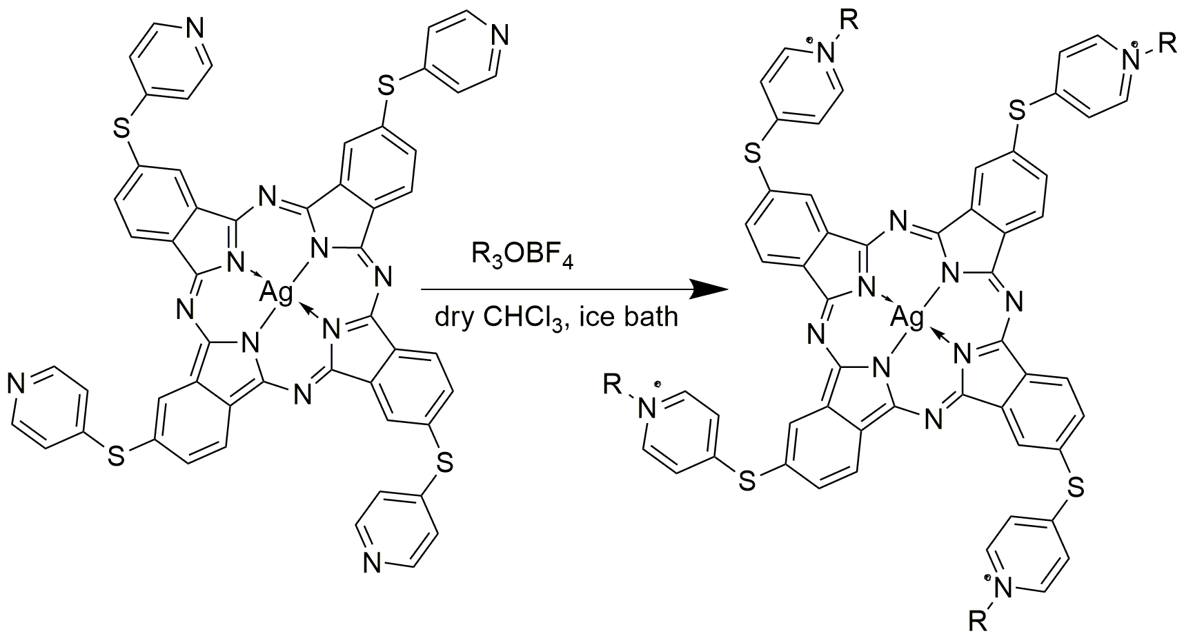
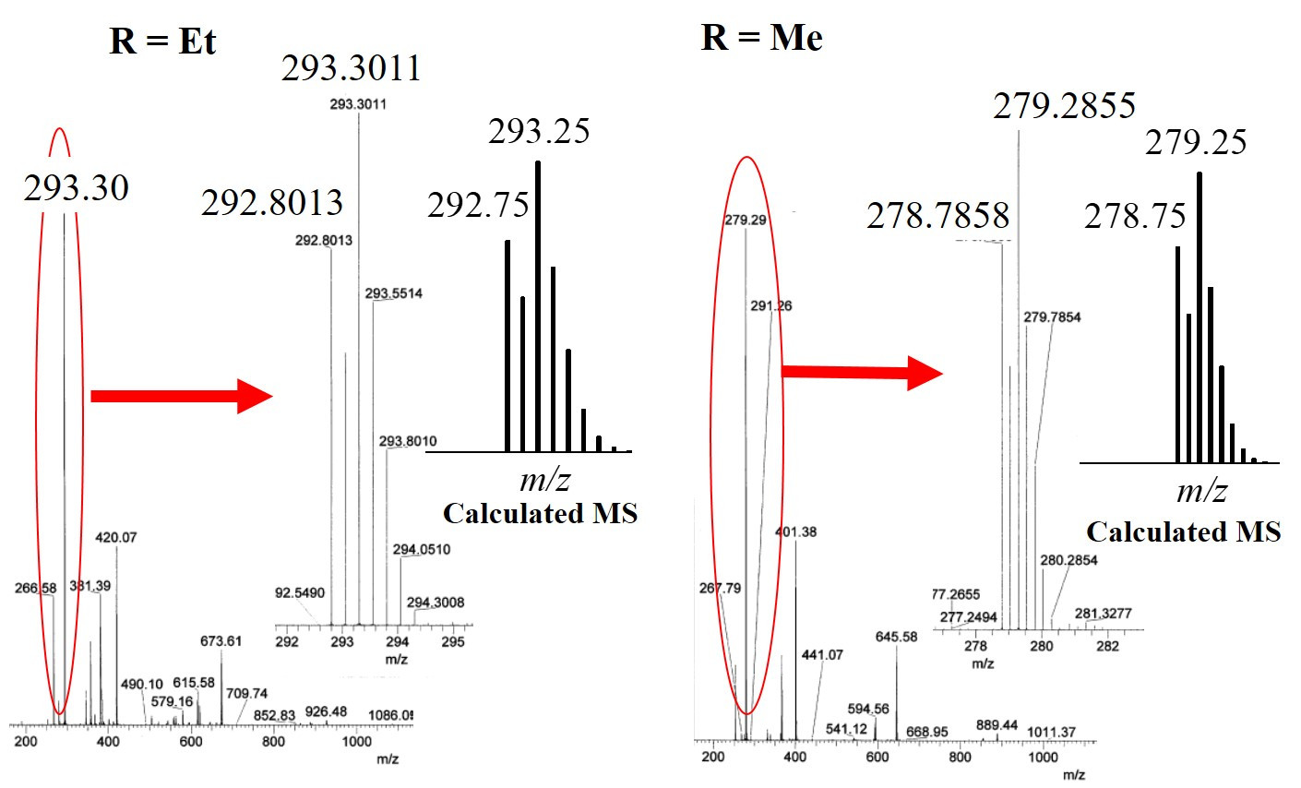
Fig. 1 Experimental and theoretical ESI-MS for [Ag(tRpySpc)] in aqueous solutions (a) R = Et and (b) Me.

Spectral properties
Optical absorption spectra of [Ag(tEtpySpc)] and [Ag(tMepySpc)] in non-aqueous solutions are quite similar to each other as well as to that of their precursor, [Ag(tpySpc)] (Fig.2a top). The most prominent absorption band in 670―690 nm, which is characteristic of monomeric MPcs and is generally called the Q-band of Pcs.^{31, 33―35} The Q-band has been assigned as an electronic transition from non-degenerate HOMO to doubly degenerate LUMO of the macrocyclic ligand. This assignment has further been evidenced by the appearance of a distinct sigmoid curve in the respective MCD spectrum with its center at the absorption peak wavelength (i.e., a Faraday A-term) [Fig. 2a bottom]. It should be noted that neither of the AgPcs studied in this work was fluorescent at room temperature (although some solutions can emit very weak fluorescence around 700 nm under some conditions, their excitation spectra have assigned the emission as from a trace amount of the corresponding H₂Pc).
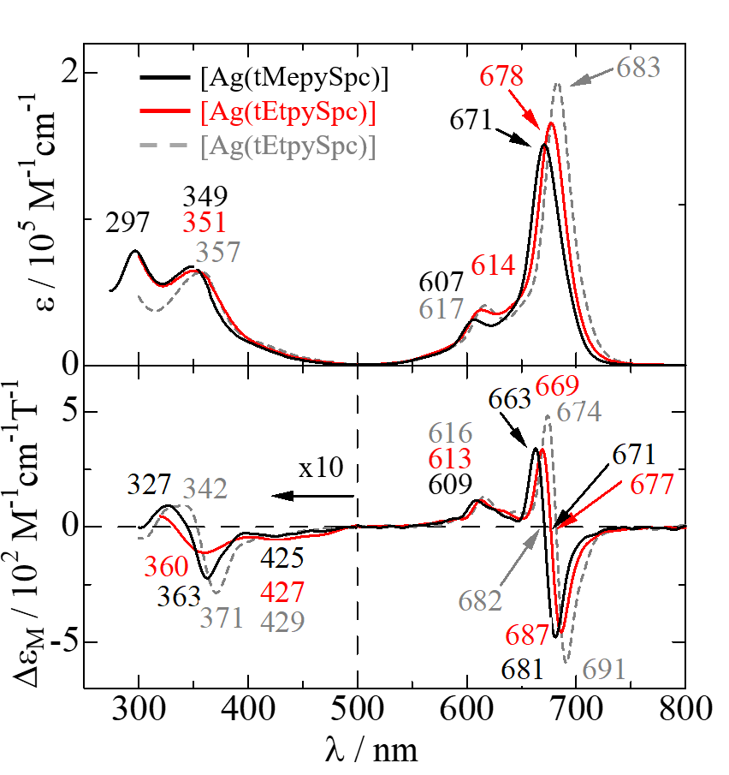
Fig.2 Optical absorption (top) and MCD (bottom) spectra of water-soluble AgPcs in non-aqueous solutions. The red solid and black solid lines represent spectra of Me- (in DMA; 3.92 × 10⁻⁶ M) and Et- derivatives (in acetonitrile; 3.86 × 10⁻⁶ M), respectively. The gray dashed lines exhibit those of [Ag(tpySpc)] in 1,2-dichlorobenzene (containing 2% triethylamine; 3.24 × 10⁻⁶ M) for comparison.
On the other hand, both the absorption spectra of [Ag(tEtpySpc)] and [Ag(tMepySpc)] show a broad absorption band around the Q-band envelope (Fig.3). The spectra are typical of strongly aggregated Pcs in aqueous solutions.^{31, 33―36} From the viewpoint of application of Pcs as a fluorescent chemical probe, molecular aggregation phenomena are quite unfavorable firstly because aggregated molecules can be deactivated due to steric hindrance and secondly because aggregated Pc molecules are much less fluorescent than monomers^{19, 38} even though they can react with the desired substrates in aggregated forms. Therefore, the effects of aggregation need to be minimized. In general, some common surfactants, such as sodium dodecyl sulfate (SDS), sodium dodecyl sulfonate, methyl trioctylammonium chloride, Triton X-100, and Tween 20 are capable of disaggregating Pcs in water.^{31, 36―41} Nevertheless, apart from SDS, they little or only insufficiently contribute to disaggregation of AgPc molecules in water. SDS exhibits excellent disaggregating performance (Fig. 3): with an increase in SDS concentration, the spectra around the Q-band envelope turned better isolated and, at [SDS] = ca. 90 mM, show essentially the same absorption and MCD spectra as those of AgPc monomer in nonaqueous solutions (Fig. S1). However, of note, the presence of SDS significantly inhibited the reactions of AgPcs and thiols/iodide as discussed later. Although not so common as the above-mentioned surfactants or not so effectively promoting disaggregation as SDS, PEG50 has been found much more suitable for our purposes; it moderately promotes disaggregation while allows AgPcs to react with thiols (as discussed below). Effects of PEG50 on the disaggregation of [Ag(tEtpySpc)] are shown in Fig. 4a (as PEG50 has considerable absorption in the UV region, only the Q-band envelope is shown). With an increase in [PEG50], the absorption band around 670 nm attributable to AgPc monomer grew (little change was detected above 7.72 mM). Unlike the monomer spectra observed in SDS solutions, a week absorption band appeared at the blue flank (around 630 nm) of the monomer band even at [PEG50] = 7.72 mM. This band is readily attributable to dimer Q-band based on the following experimental evidence. Fig. 4b shows absorption spectra of aqueous solutions containing various concentrations of [Ag(tEtpySpc)] with [PEG50] kept constant. A similar spectral change was observed where a sharp isosbestic point appeared at around 654 nm, indicating monomeric and aggregated molecules are in equilibrium. Therefore, we may assume that the aggregated species should be a dimer. The appearance of the dimer band only at the blue flank of the monomer band but not at the red flank is indicative of the formation of cofacial dimer according to Kasha’s exciton coupling theory.⁴² This has been further supported by the appearance of a sigmoid curve with its center at the peak wavelength in the MCD spectrum of [Ag(tEtpySpc)] at a higher concentration (i.e., Faraday A-term; Fig. 5) because the dimer Q-band must be also doubly degenerate in cofacial dimer.^{20,31,33,36,37} The methyl-substituted analog behaves essentially in the same manner (Fig.S2). It seems that the disaggregation-promoting performance of polyethyleneglycol ethers (PEG) depends on the length of the PEG chain and their performance is in the following order; PEG50 >> PEG20 > PEG10. This may probably be because a longer PEG chain more effectively isolates AgPc molecules from each other. Hereafter experimental results using only PEG50 will be described unless otherwise noted. Kobayashi and his coworkers have reported that cyclodextrins are capable of disaggregating Pcs of the same macrocyclic ligand.³¹ However, the addition of β-cyclodextrin induced little effect on the aggregation/disaggregation of our compounds.
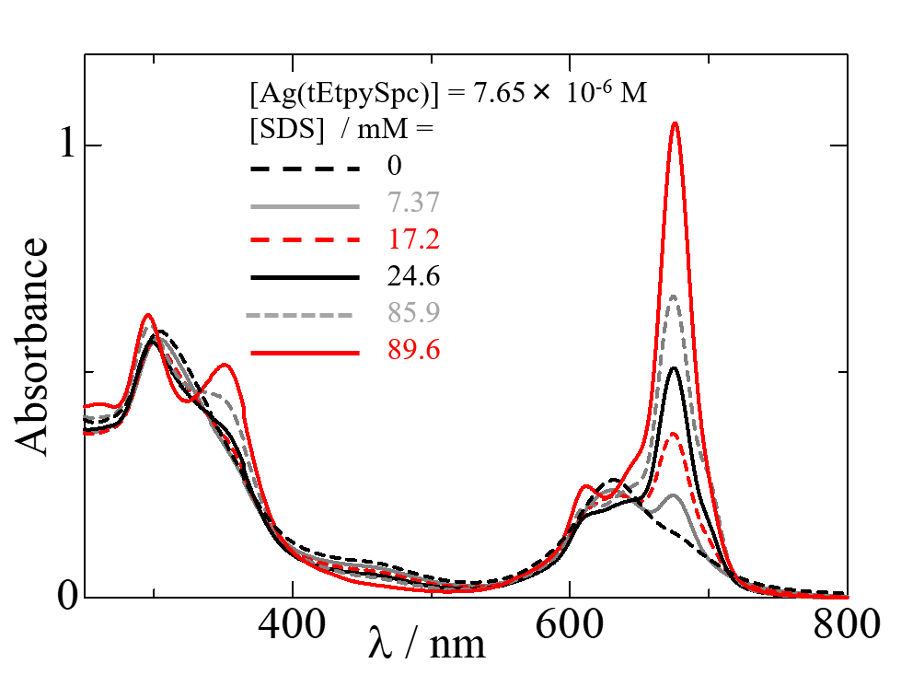
Fig.3 Optical absorption spectra of [Ag(tEtpySpc)] with its concentration kept constant (7.65 × 10⁻⁶ M) in aqueous solutions containing various concentration of SDS.
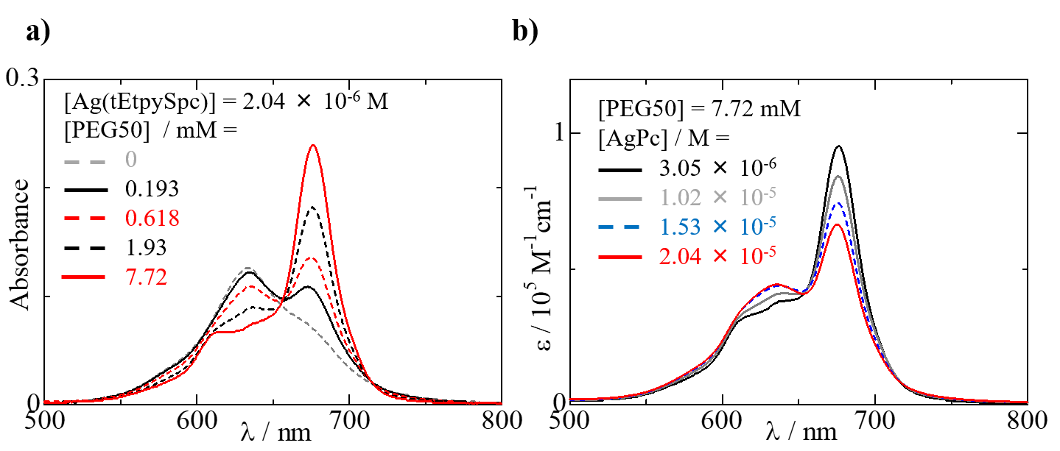
Fig.4 (a) Optical absorption spectra of aqueous [Ag(tEtpySpc)] solutions (2.04×10⁻⁶ M) containing various concentration of PEG50 as surfactant. (b) Optical absorption spectra of aqueous [Ag(tEtpySpc)] solutions at various concentrations with [PEG50] kept constant (7.72 mM).
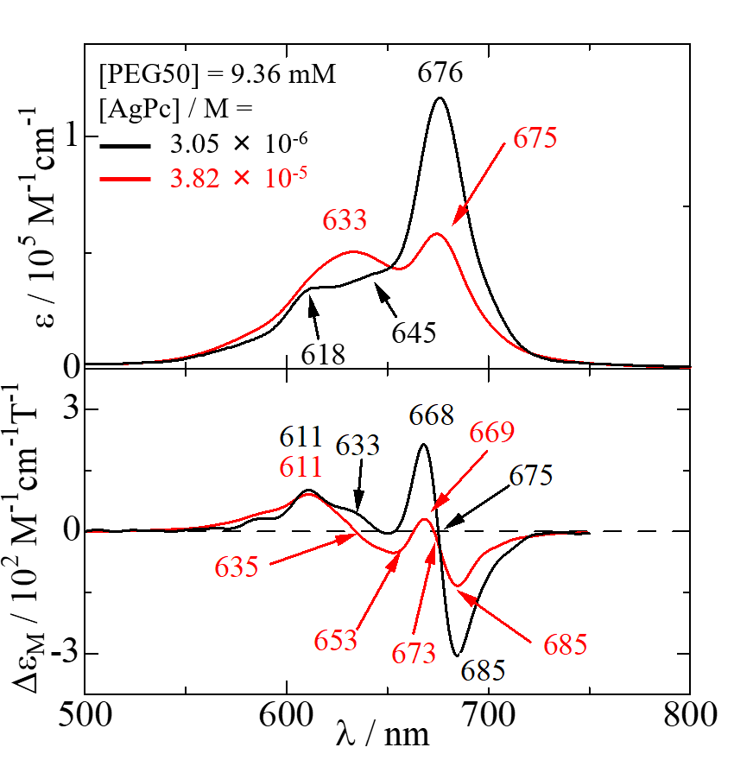
Fig.5 Optical absorption (top) and MCD (bottom) spectra of dilute (black solid line) and concentrated (red solid line) aqueous [Ag(tEtpySpc)] solutions around the Q-band envelope. [PEG50] = 9.36 mM.

Reactions with thiols.
Earlier works on AgPcs have demonstrated that the reduction of essentially non-fluorescent AgPcs is followed by rapid demetallation^{20,31} and generates a more fluorescent metal-free macrocyclic ligand.²⁰ Therefore, it is easy to monitor the reaction by optical emission and absorption spectral changes under appropriate conditions. As expected, both the water-soluble AgPcs rapidly react with biothiols, such as Cys, GSH, and Hcys. For example, figures 6a and 6b exhibit typical optical absorption and emission spectral changes observed for an aqueous [Ag(tEtpySpc)] solution containing PEG50 (as a surfactant) and Cys. The absorption spectra without thiols are assignable as a mixture of AgPc monomer and dimer as described above while those of the reaction products show two absorption bands with almost the same intensity in the Q-band region and hence are characteristic of metal-free Pcs.^{33―35} Moreover, the excitation spectra (the blue dashed lines in Fig.6b) corresponding to the optical emission of the reaction products are very close to absorption spectra of metal-free Pcs, confirming the absence of silver ion within the fluorophore. Figure 6c shows photographs of an aqueous solution containing [Ag(tEtpySpc)] and PEG50 under irradiation of a blacklight (365 nm) before and after the addition of Cys to the solution. It should be noted that the conditions are arranged so that the reaction can conventionally be monitored by measuring spectral changes (when [thiol] is on the order of 1 mM, the reaction is essentially completed within a minute or two). Eventually, rapid turn-on switching phenomena have been observed upon the addition of thiols under irradiation of a blacklight in real-time; see Video 1. Other amino acids with a sulfhydryl group such as GSH and Hcys react with [Ag(tEtpySpc)] in a similar manner (Fig. S3) as well. The reaction of [Ag(tMepySpc)] and the thiols proceeds in essentially the same way (Fig.S4). These AgPcs likewise react with not only amino acids with an SH group but also water-soluble thiols such as Mesna (see below for more details) and TGL. Reactions of Mesna and AgPcs are faster than those of the other thiols studied here under the same conditions and allowed us to determine the stoichiometry between AgPcs and thiols. Figure 7a shows absorption spectra of aqueous solutions containing [Ag(tEtpySpc)] (with its concentration kept constant) and Mesna at various concentrations (and PEG50 as a surfactant). Elevated [Mesna] gave rise to the growth of the 700-nm band attributable to generated H₂Pc up to their molar ratio (R = [Mesna]/[AgPc]) to be unity while essentially unchanged above this value (Fig. 7b). Thus, the stoichiometry between AgPc and thiol has been determined to be 1:1. It should be noted that neither ethyl nor methyl derivative reacts with other amino acids (without an SH group) such as alanine, histidine, or even methionine or cystine where sulfur is present therein (Fig. 8). Although it appears that a small portion of AgPcs reacts with cystine, this may be due to the presence of a trace amount of Cys contaminated therein.
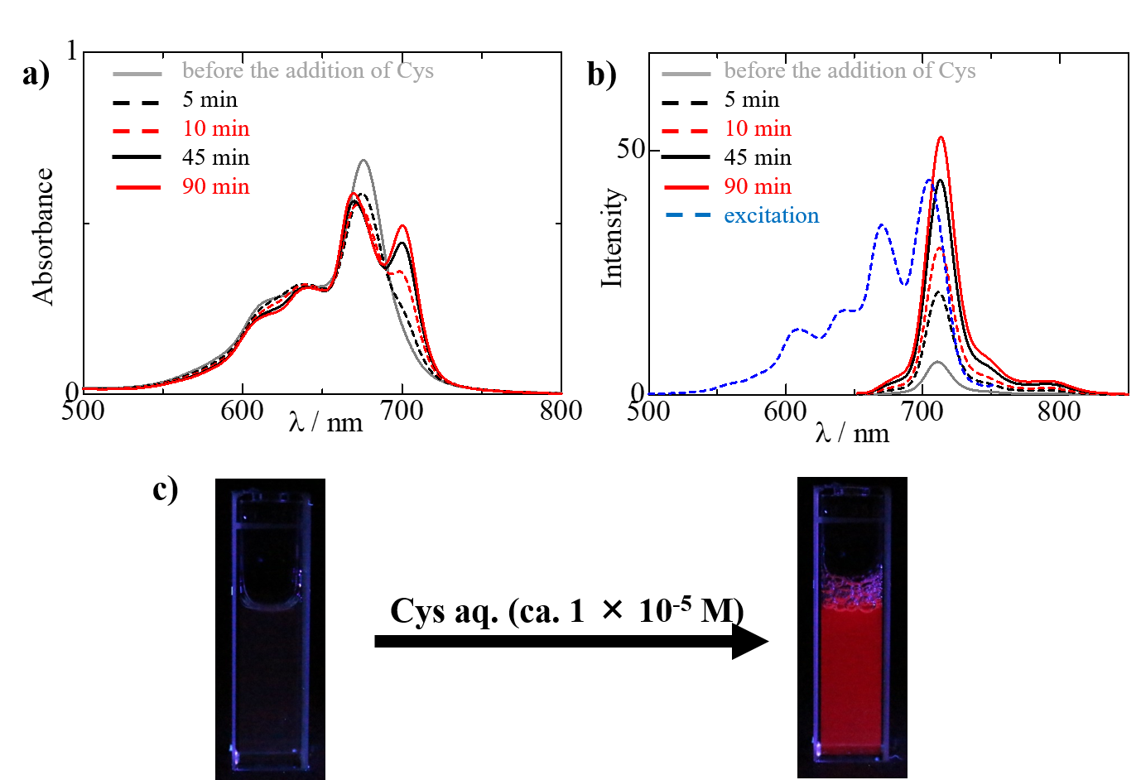
Fig.6 (a) Optical absorption and (b) emission (excited at 585 nm) spectral changes observed in an aqueous solution containing [Ag(tEtpySpc)] (6.51 × 10⁻⁶ M) and PEG50 (23.2 mM) upon the addition of Cys (9.91 × 10⁻⁶ M) after the addition of Cys. The blue dashed line in Fig. 6b represents a typical excitation spectrum corresponding to the emission, which was monitored at 780 nm. (c) Photographs of an aqueous solution containing [Ag(tEtpySpc)] (ca. 1 × 10⁻⁵ M) and PEG50 (0.77 mM) before (leftmost) and after (rightmost) the addition of Cys (ca. 1 × 10⁻⁵ M) under irradiation of a blacklight (365 nm); note that the conditions were arranged so that the pictures are photogenic.
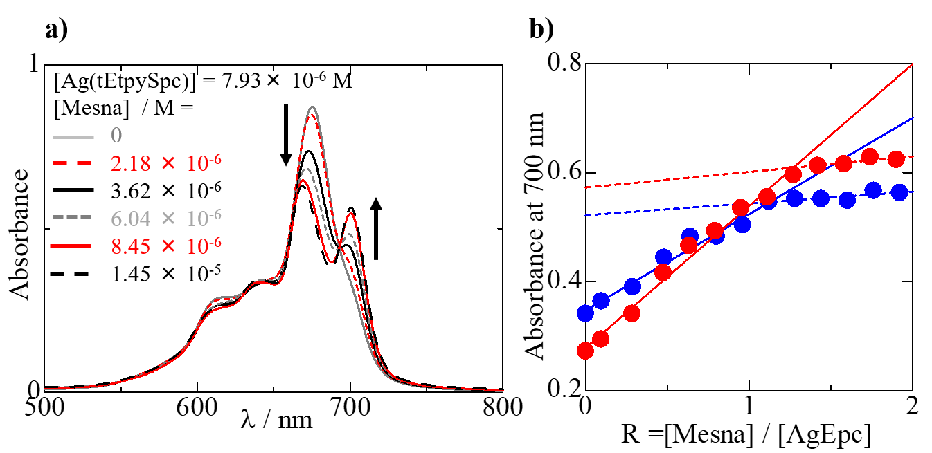
Fig.7 Optical absorption spectra of aqueous [Ag(tEtpySpc)] solutions (7.54 × 10⁻⁶ M) containing various concentration of Mesna. [PEG50] = 23.2 mM. (b) Plots of absorbance at 700 nm versus molar ratio of [Mesna] / [AgPc]. Red circles and lines are for methyl and blue ones are for ethyl derivatives, respectively.
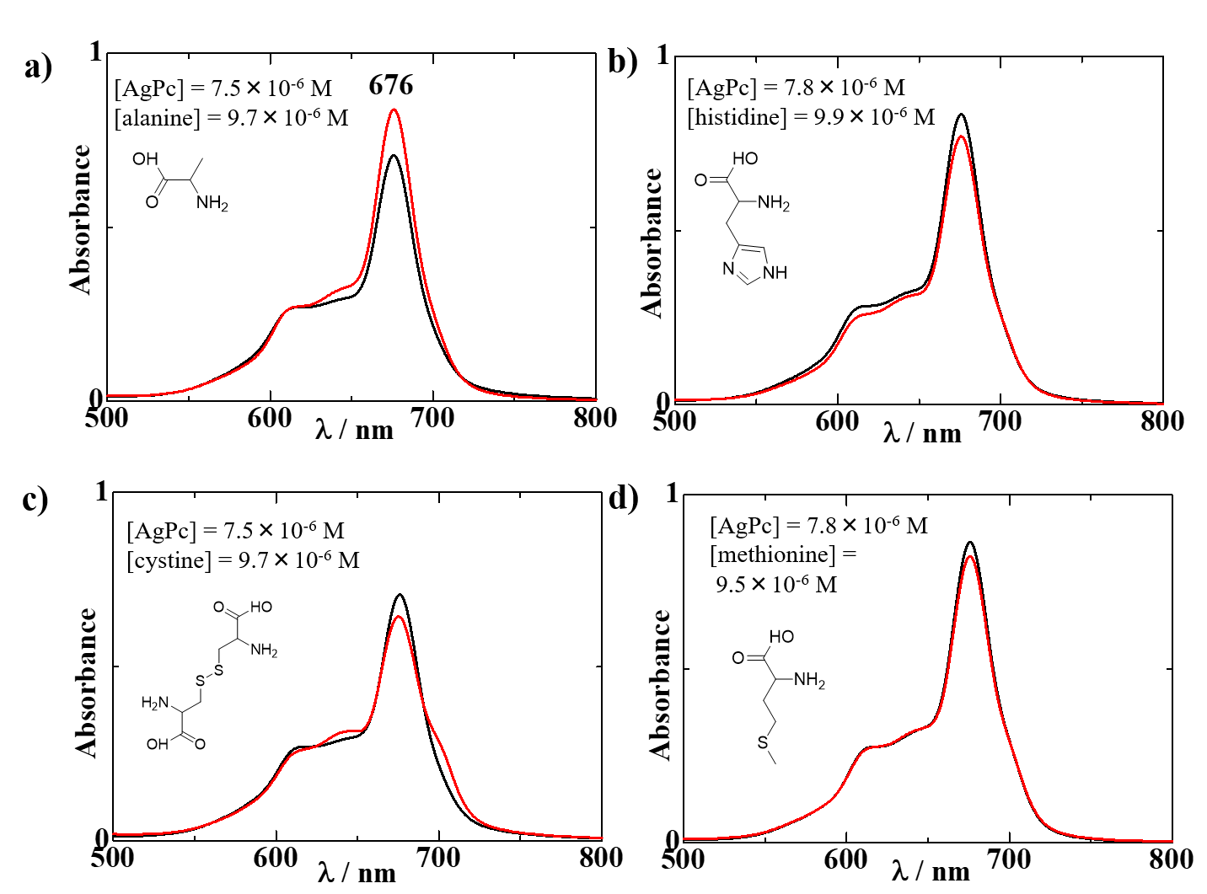
Fig.8 Optical absorption spectral changes observed in an aqueous solution containing [Ag(tEtpySpc)] and PEG50 (23.2 mM) before (black lines) and after (45 min later; red lines) the addition of a) alanine, b) histidine, c) cystine, and d) methionine.

Reactions with halides
Our previous work²⁰ has reported that AgPcs react with reductants such as tetrahydroborate or iodide to liberate their corresponding metal-free macrocyclic ligand. As Lever and coworkers have reported that reduction of silver(II) is followed by rapid demetallation because silver(I) is too large to stay in the cavity of the macrocyclic ligand,²⁹ this finding is understandable in terms of the reduction of the central metal ion. Figure 9 illustrates the difference in reactivity of AgPc against halide under the same conditions. As is reported in the previous work,²⁰ water-soluble AgPcs studied in this work rapidly react with iodide (whether potassium or tetrabutylammonium salt) in water and are demetallated (Fig. 9a). Besides, the difference in absorption spectra between the reaction products and metal-free Pc is close to the spectrum of triiodide (with an absorption peak at 295 and 365 nm; shown as a dashed blue line). Reaction with bromide brings about the much slower growth of a new absorption band around 700 attributable to metal-free Pc ligand (Fig.9b), which was further confirmed by the emergence of fluorescence at around 713 nm and the corresponding excitation spectrum close to the absorption spectrum of H₂Pc. Chloride little reacts with AgPcs under the same conditions. Thus, the order in the reactivity of iodide > bromide > chloride is in line with that in the reducing power of halide.
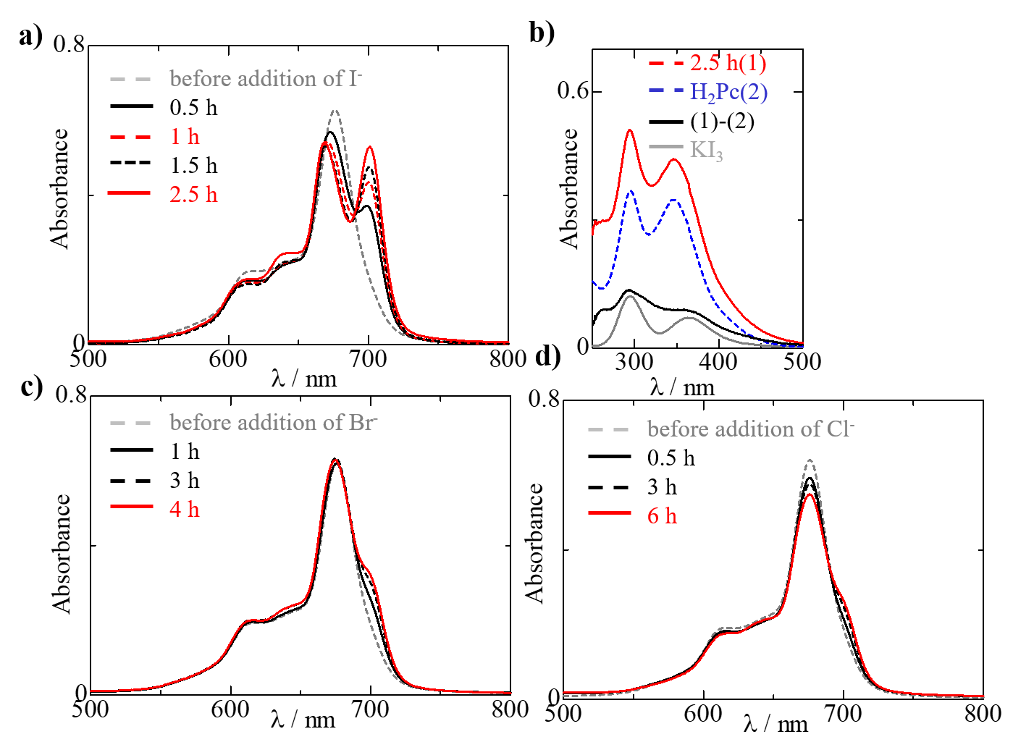
Fig.9 Optical absorption spectral changes observed in aqueous solutions containing [Ag(tEtpySpc)] and PEG50 (23.2 mM) in the presence of various potassium halides (KX; X = I, Br, and Cl; 8.4 × 10⁻⁵ M). a) Reaction with KI (around the Q-band envelope and b) around the Soret-band region. Reactions with KBr (c) and with KCl (d) under the same conditions.

Proposed mechanisms for the thiol sensing.
As described above, this phenomenon is interpreted in terms of liberation of H₂Pc emitting red fluorescent as a result of the demetallation of non-fluorescent AgPcs by contact with thiols in aqueous solutions. Water-soluble AgPcs can be a potent biothiol sensor because of the rapidness, high sensitivity, and selectivity against thiols as well as the bold contrast between before and after the reaction. Earlier works on AgPcs have reported that reduction of AgPcs gave rise to expulsion of silver ion from the cavity of the macrocyclic ligand.^{20,29} Lever and coworkers have rationalized the change in lability of the central metal ion upon the reduction as the increase in ionic radius (126 nm for silver(I) while 89 pm for silver(II)).²⁹ There have been similar discussions for porphyrin analogs.^{22, 23} Therefore, the reaction of AgPcs with thiols may involve electron transfer from thiols to silver(II). The possibility of outer-sphere electron transfer may be excluded because neither thiols nor halides react with AgPcs in aqueous SDS solutions. Interestingly, although SDS shows excellent performance in disaggregating AgPcs in water, sodium dodecyl sulfonate with an alkyl chain of the same length does not. These findings suggest that SDS plays a role not only as a surfactant but also as the fifth ligand on the silver ion. It is known that axial ligation on the central metal effectively inhibits the molecular aggregation of water-soluble MPcs.^{32,38,41} Shirai and coworkers have elucidated the reaction mechanism for the oxidation of thiols catalyzed by MPcs (M = Fe and Co) and revealed that the first step should be the coordination of thiolates to the central metal ion.³⁰ Our previous work on AgPcs in organic solvents²⁰ has reported that AgPcs are capable of oxidizing iodide whereas they do not react with thiols under the same conditions. This is understandable because thiols are mostly present in a protonated form (-SH) in organic solvents while in part deprotonated (i.e., as thiolate) in aqueous solutions.

Conclusion
Two water-soluble AgPcs have successfully been synthesized for the first time by quaternizing their tetra-pyridylthio-substituted precursor. Although they strongly aggregate in a face-to-face fashion in aqueous solutions, some surfactants such as PEG50 and SDS effectively disaggregate AgPc molecules to monomeric species. They rapidly react with thiols such as Cys, GSH, Hcys, and Mesna with a stoichiometric ratio of 1:1 in aqueous PEG50 solutions at room temperature even on the order of 0.01 mM to liberate the corresponding free-base, H₂Pc. These phenomena involve inner-sphere electron-transfer from thiols to silver(II). Because AgPcs are essentially non-fluorescent while the corresponding free-bases emit intense red fluorescence, AgPcs can be a potent thiol-sensor. One weak point in the application of these compounds to biothiol-sensing that could be a problem may be their strong propensity to aggregate in water. Without surfactant, liberated H₂Pc molecules also strongly aggregate and are little fluorescent. However, this problem may be overcome by introducing appropriate hydrophilic, bulky groups into the macrocyclic ligand.¹⁶

ASSOCIATED CONTENT
Supporting Information. Additional spectral properties, aggregation/disaggregation studies, reactions with thiols (spectra and video) in water. “This material is available free of charge via the Internet at http://pubs.acs.org.”
AUTHOR INFORMATION
Corresponding Author
* E-mail ISAGO.Hiroaki@nims.go.jp Tel. +81-29-859-2734
ORCID
Hiroaki Isago: 0000-0003-0963-9057
Tamotsu Sugimori: 0000-0002-8820-1020
Author Contributions
All authors have approved the final version of the manuscript.
Notes
The authors declare no competing financial interest.
ACKNOWLEDGMENT
This work was in part supported by the Japan Society for the Promotion of Science (KAKENIHI; 17K06850).
ABBREVIATIONS
AgPc, silver(II)-phthalocyanine (see below too for Pc); Cys, cysteine; GSH, glutathione; Hcys, hemosysteine; MCD, magnetic circular dichroism; Mesna, sodium 2-mercaptoethanesulfonate; Pc, phthalocyanine (where it is not desired or unnecessary to specify the substituent); PEGn, polyethyleneglycol-monooleyl ether (n = approximately 50, 20, and 10); SDS, sodium dodecyl sulfate; TGL, 3-mercapto-1,2-propanediol; tpySpc, tetrakis(4-pyridylthio)phthalocyaninate; tRpySpc, tetrakis{4-(N-alkylpyridinium)thio}phthalocyaninate (R = ethyl or methyl).
REFERENCES
1] Brand, V. T.; Keyworth, D. A. A. Rapid Determination of Individual Mercaptans in Gasoline Boiling Range Stocks Anal. Chem., 1965, 37, 1424-1425.
[2] Earle, T. E. Determination of Disulfides in the Presence of Thiols Anal. Chem., 1953, 25, 769-771.
[3] Alqahtani, Y.; Wang, S.; Najmi, A. Huang, Y.; Guan, X. Thiol-specific fluorogenic agent for live cell non-protein thiol imaging in lysosomes Anal. Bioanal. Chem., 2019, 411, 6463-6473.
[4] Bouffard, J.; Kim, Y.; Swager, T. M. Weissleder, R.; Hilderbrand, S. A. A Highly Selective Fluorescent Probe for Thiol Bioimaging Org. Lett., 2008, 10, 37-40.
[5] Sies, H. Glutathione and its Role in Cellular Functions Free Radical Biol. Med., 1999, 27, 916-921.
[6] Gu L.; Robinson, R. A. S. High-throughput endogenous measurement of S-nitrosylation in Alzheimer’s disease using Oxidized Cysteine-Selective cPILOT Analyst, 2016, 141, 3904-3915.
[7] Silva, F. A. S.; Silva, M. G. A.; Lima, P. R.; Meneghetti, M. R.; Kubota, L. T.; Goulart, M. O. F. A A Very Low Potential Electrochemical Detection of L-Cysteine Based on a Glassy Carbon Electrode Modified with Multi-walled Carbon Nanotubes/Gold Nanorods Biosens. Bioelectron., 2013, 50, 202-209.
[8] Reichmann, D.; Voth, W.; Jakob, U. Maintaining a Healthy Proteome during Oxidative Stress Mol. Cell, 2018, 69, 203-213.
[9] Cheignon, C.; Tomas, M.; Bonnefont-Rousselot, D.; Faller, P.; Hureau, C.; Collin, F. Oxidative Stress and the Amyloid Beta Peptide in Alzheimer’s Disease Redox Biol., 2018, 14, 450-464.
[10] McBean, G. J.; Aslan, M.; Griffiths, H. R.; Torrao, R. C. Thiol Redox Homeostasis in Neurodegenerative Disease Redox Biol., 2015, 5, 186-194.
[11] Ntziachristos, V.; Bremer, C.; Weissleder, R. Fluorescence Imaging with Near-infrared Light: New Technological Advances that Enable in vivo Molecular Imaging Eur. Radiol., 2003, 13, 195-208.
[12] Pansare, V. J.; Hejazi, S.; Faenza, W. J.; Prud’homme, R. K. Review of Long-Wavelength Optical and NIR Imaging Materials:
Contrast Agents, Fluorophores, and Multifunctional Nano Carriers Chem. Mater., 2012, 24, 812-827.
[13] Kobayashi, H., Ogawa, M., Alford, R., Choyke, P. L., Urano, Y. New Strategies for Fluorescent Probe Design in Medical Diagnostic Imaging Chem. Rev., 2010, 110, 2620-2640.
[14] Lavis, L. D.; Raines, R. T. Bright Ideas for Chemical Biology ACS Chem. Biol., 2008, 3, 142-155.
[15] Isago, H.; Fujita, H.; Sugimori, T. Amphoteric Phosphorous(V)-Phthalocyanines as Proton-Driven Switchable Fluorescers toward Deep-Tissue Bio-Imaging J. Inorg. Biochem., 2018, 180, 222-229.
[16] Liu, W.; Jensen, T. J.; Fronczek, F. R.; Hammer, R. P.; Smith, K. M.; Vicente, M. G. H. Synthesis and Cellular Studies of Nonaggregated Water-Soluble Phthalocyanines J. Med. Chem., 2005, 48, 1033-1041.
[17] Lochman, L.; Machacek, M.; Miletin, M.; Uhlírová, S.; Lang, K.; Kirakci, K.; Zimcik, P.; Novakova, V. Red-Emitting Fluorescence Sensors for Metal Cations: The Role of Counteranions and Sensing of SCN⁻ in Biological Materials ACS Sens., 2019, 4, 1552-1559.
[18] Novakova, V.; Donzello, M. P.; Ercolani, C.; Zimcik, P.; Stuzhin, P. A. Tetrapyrazinoporphyrazines and their Metal Derivatives. Part II: Electronic Structure, Electrochemical, Spectral, Photophysical and Other Application Related Properties Coord. Chem. Rev., 2018, 361, 1–73.
[19] Isago, H. Optical Emission Spectra of Phthalocyanines In Optical Spectra of Phthalocyanines and Related Compounds; A Guide for Beginners, Springer, Tokyo, 2015, Chapter 4, pp107-132.
[20] Isago, H.; Fujita, H.; Nakai, S.; Sugimori T. Spectral Investigation of Phthalocyanine Complexes of High-Valence Silver and their Aggregates J. Inorg. Biochem., doi.org/10.1016/j.jinorgbio.2021.111427.
[21] MacMillan, J. A. Higher Oxidation States of Silver Chem. Rev., 1962, 62, 65-80.
[22] Kadish, K. M.; Lin, X. Q.; Ding, J. Q.; Wu, Y. T.; Araullo, C. A Reinvestigation of Silver Porphyrin Electrochemistry. Reactions of Ag(III), Ag(II), and Ag(I) Inorg. Chem., 1986, 25, 3236-3242.
[23] Antipas, A.; Dolphin, D.; Gouterman, M.; Johnson, E. C. Porphyrins. 38. Redox Potentials, Charge Transfer Transitions, and Emission of Copper, Silver, and Gold Complexes J. Am. Chem. Soc., 1978, 100, 7705-7709.
[24] Sinha, W.; Sommer, M.G.; Deibel, N.; Ehret, F.; Sarkar, B.; Kar, S. Silver Corrole Complexes: Unusual Oxidation States and Near-IR-Absorbing Dyes Chem. Eur. J., 2014, 20, 15920-15932.
[25] Barefield E. K.; Mocella, M. T. Complexes of Silver(II) and Silver(III) with Macrocyclic Tetraaza Ligands Inorg. Chem., 1973, 12, 2829-2832.
[26] Mertes, K. B. Crystal and Molecular Structure of a Silver(II) Complex with a Synthetic Macrocyclic Ligand Inorg. Chem., 1978, 17, 49-52.
[27] Anderson, J. S.; Bradbrook, E. F.; Cook, A. H.; Linstead, R. P. Phthalocyanines and Associated Compounds. Part XIII. Absorption Spctra J. Chem. Soc. 1938, 1151-1156.
[28] A. MacCragh and W. S. Koski, The Electron Paramagnetic Resonance Spectrum of Silver Phthalocyanine J. Am. Chem. Soc., 1962, 84, 2375-2376.
[29] Fu, G.; Fu, Y.; Jayaraj, K.; Lever, A. B. P. Silver (II) Tetraneopentoxyphthalocyanine and Its Redox Chemistry Inorg. Chem., 1990, 29, 4090-4095.
[30] Shirai, H.; Tsuiki, H.; Masuda, E.; Koyama, T.; Hanabusa, K.; Kobayashi, N. Functional Metallomacrocycles and Their Polymers. 25. Kinetics and Mechanism of the Biomimetic Oxidation of Thiol by Oxygen Catalyzed by Homogeneous (Polycarboxyphthalocyaninato)metals J. Phys. Chem., 1991, 95, 417-423.
[31] Tasso, T. T.; Yamasaki, Y.; Furuyama, T.; Kobayashi, N. An Exemplary Relationship between the Extent of Cofacial Aggregation and Fluorescence Quantum Yield as Exhibited by Quaternized Amphiphilic Phthalocyanines Dalton Trans., 2014, 43, 5886-5892.
[32] Isago, H.; Fujita, Sugimori, T. The Synthesis and Spectral Investigation of a Novel Highly Water-Soluble, Aggregation-Free Antimony(V)-Phthalocyanine Absorbing Light in Optical Therapeutical Window J. Inorg. Biochem., 2012, 117, 111-117.
[33] Isago, H. Optical spectra of Phthalocyanines and Related Compounds, Springer (2015), Tokyo.
[34] Stillman, M. J. Nyokong, T. Absorption and Magnetic Circular Dichroism Spectral Properties of Phthalocyanines Part 1: Complexes of the Dianion, Pc(-2) In Phthalocyanines, Properties and Applications, Vol. 1; Leznoff, C. C.; Lever A. B. P., Eds.; VCH: New York, 1989, pp135-289.
[35] Nyokong, T.; Isago, H. The Renaissance in Optical Spectroscopy of Phthalocyanines and Other Tetraazaporphyrins J. Porphyrins Phthalocyanines, 2004, 8, 1083-1090.
[36] Isago, H.; Fujita, H. Solvent Effects on Molecular Aggregation of Highly Water-Soluble Phthalocyanines J. Porphyrins Phthalocyanines, 2018, 22, 102-111.
[37] Tasso, T. T.; Furuyama, T.; Kobayashi, N. Absorption and Electrochemical Properties of Cobalt and Iron Phthalocyanines and Their Quaternized Derivatives: Aggregation Equilibrium and Oxygen Reduction Electrocatalysis Inorg. Chem., 2013, 52, 9206-9215.
[38] Snow, A. W. Phthalocyanine Aggregation In Porphyrin Handbook, Vol. 17; Kadish, K. M.; Smith, K. M.; Guilard, R. Eds.; Academic Press：Amsterdam, 2003 Chap. 109; pp129-176.
[39] Isago, H.; Kagaya, Y.: Oyama, Y.; Fujita, H.; Sugimori, T. The Syntheses of Amphiphilic Antimony(V)-Phthalocyanines and Spectral Investigation on their Aggregation Behaviors in Aqueous and Non-aqueous Solutions J. Inorg. Biochem., 2012, 111, 91-98.
[40] Isago, H. Fujita, H. Dissociation of Imino Proton(s) of a Highly Water-Soluble Metal-Free Phthalocyanine and Determination of its pKa Value in Water J. Porphyrins Phthalocyanines, 2013, 17, 447-453.
[41] Dumoulin, F.; Durmus, M.; Nyokong, T. Synthetic Pathways to Water-Soluble Phthalocyanines and Close Analogs Coord. Chem. Rev., 2010, 254, 2792-2848.
[42] Kasha, M.; Rawls, H. R.; El-Bayoumi, M. A. The Exciton Model in Molecular Spectroscopy Pure Appl. Chem., 1965, 11, 371-392.
TOC

The first water-soluble silver(II)-phthalocyanines (AgPcs) have been synthesized through quaternization of pyridyl groups in the substituents of their precursor, tetrakis(4-pyridylthio)phthalocyaninato silver(II) complex by using Meerwein reagents. These AgPcs rapidly react with thiols in aqueous solutions to liberate their corresponding metal-free macrocyclic ligand that emit intense red fluorescence.
