Supplementary Information for
Manipulation of Spin Polarization in Boron-Substituted Graphene Nanoribbons

Kewei Sun¹, Orlando J. Silveira², Shohei Saito³, Keisuke Sagisaka¹, Shigehiro Yamaguchi⁴, Adam S. Foster*^{2,5}, Shigeki Kawai*^{1,6}
¹Research Center for Advanced Measurement and Characterization, National Institute for Materials Science, 1-2-1 Sengen, Tsukuba, Ibaraki 305-0047, Japan.
²Department of Applied Physics, Aalto University, PO Box 11100, FI-00076 Aalto, Finland.
³Graduate School of Science, Kyoto University, Kyoto 606-8502, Japan.
⁴ Department of Chemistry, Graduate School of Science, Nagoya University, Furo, Chikusa, Nagoya 464-8602, Japan.
⁵WPI Nano Life Science Institute (WPI-NanoLSI), Kanazawa University, Kakuma-machi, Kanazawa 920-1192, Japan.
⁶Graduate School of Pure and Applied Sciences, University of Tsukuba, Tsukuba 305-8571, Japan

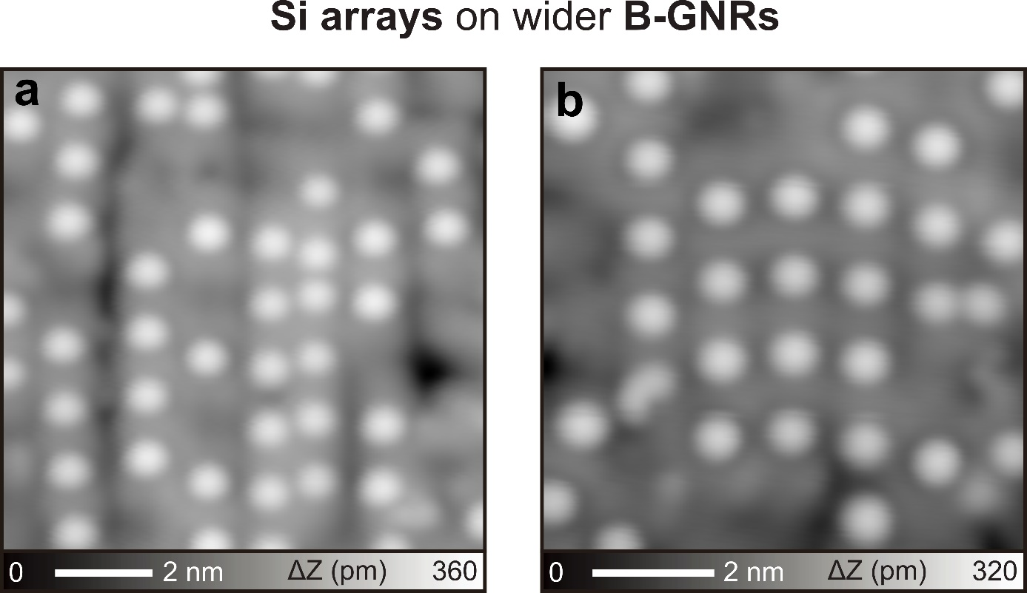
Figure S1. Si atoms adsorbed on laterally fused B-GNR. (a)(b) STM topographies of Si atoms on wider B-GNRs. Measurement parameters: Sample bias voltage V = 200 mV and tunneling current I = 10 pA in (a). V = 200 mV and I = 5 pA in (b).

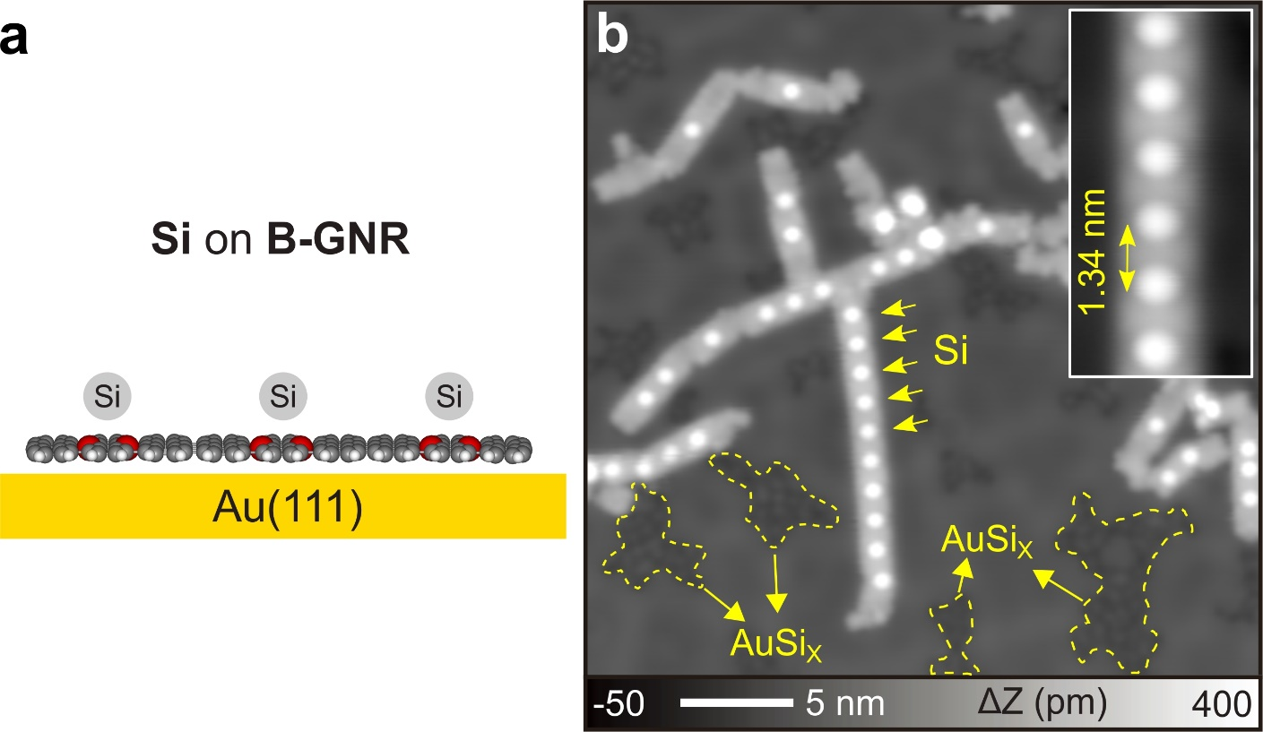
Figure S2. B-GNR with adsorbed Si atoms on Au(111). (a) Schematic drawing of Si atoms adsorbed on B-GNR on Au(111). (b) STM topography of B-GNRs with adsorbed Si atoms after depositing Si atoms on Au(111) kept at 150 ℃. Inset: Closeup of Si atoms on B-GNR. Measurement parameters: V = 200 mV and I = 10 pA.

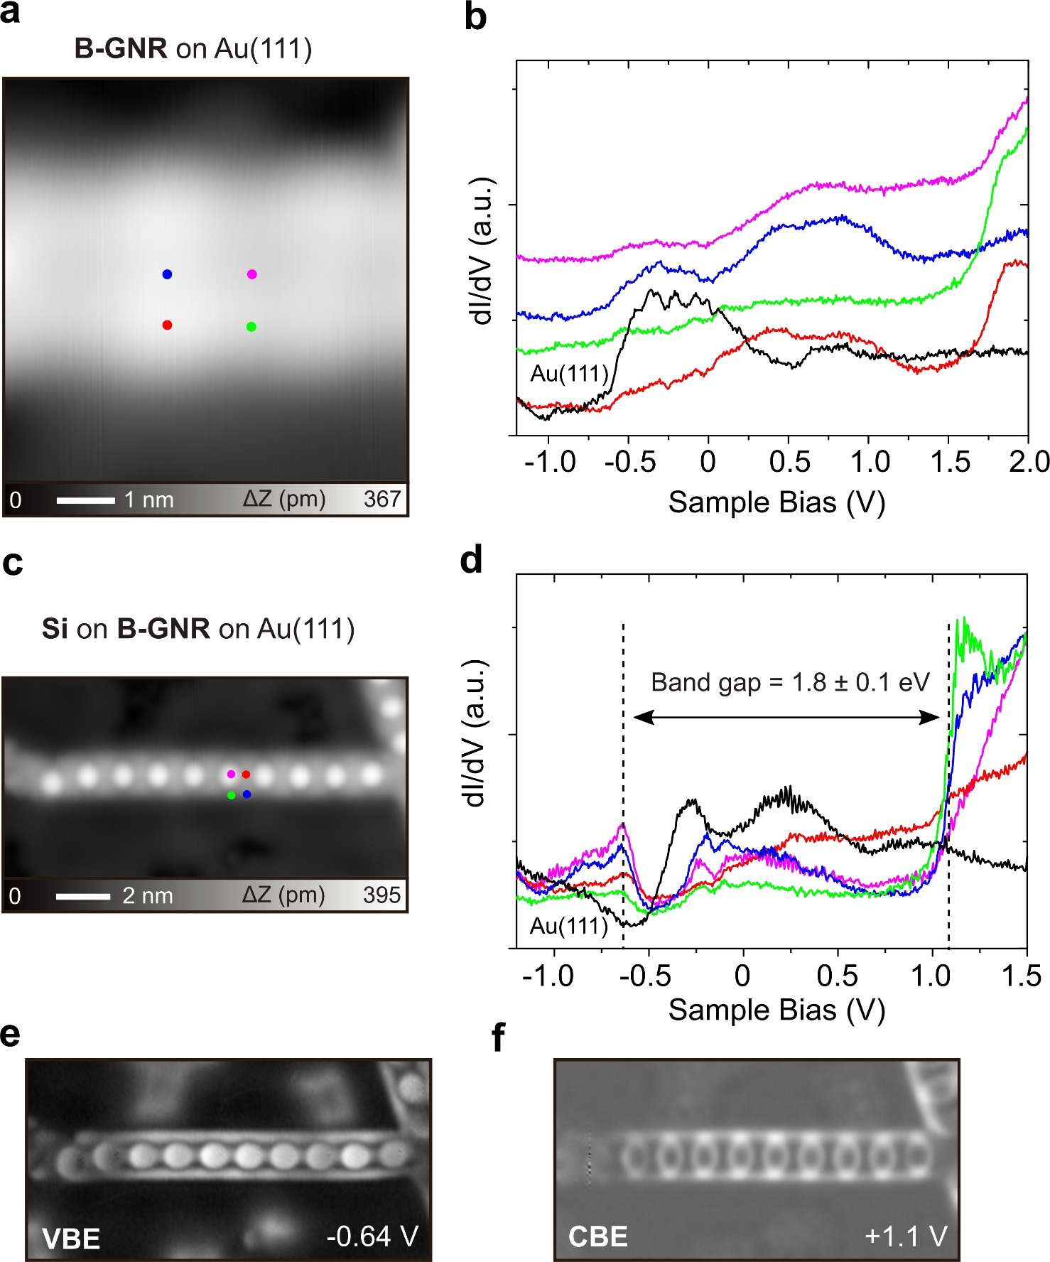
Figure S3. STS measurements on B-GNR with and without adsorbed Si atoms on Au(111). (a) STM topography of the bare B-GNR. (b) dI/dV curves measured on colored points indicated in (a). The conduction band edge (CBE) is at ~ +1.8 V while no clear valance band edge (VBE) was observed. (c) STM topography of B-GNR with periodic Si atoms formed on Au(111). (d) dI/dV curves measured on colored points indicated in (a). (e)(f) Constant current dI/dV maps measured at VBE and CBE, respectively, resulting in a band gap of 1.8 ± 0.1 eV. Measurement parameters: V = 200 mV and I = 10 pA in (a), V = 200 mV and I = 3 pA in (c).

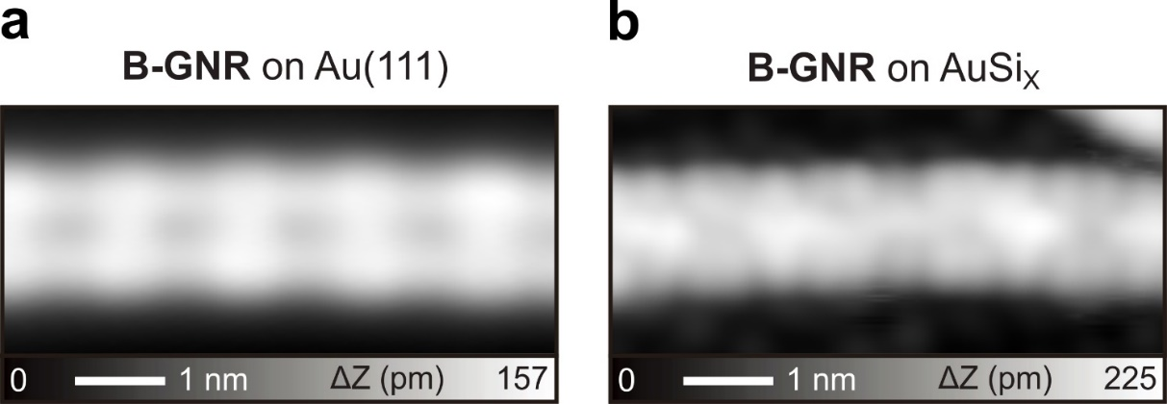
Figure S4. B-GNR on Au(111) and AuSi_{X}. (a) STM topographies of B-GNR on Au(111) and (b) on AuSi_{X}/Au(111). The AuSi_{X} intercalation layer significantly changes the STM contrast. Measurement parameters: V = 200 mV and I = 10 pA.

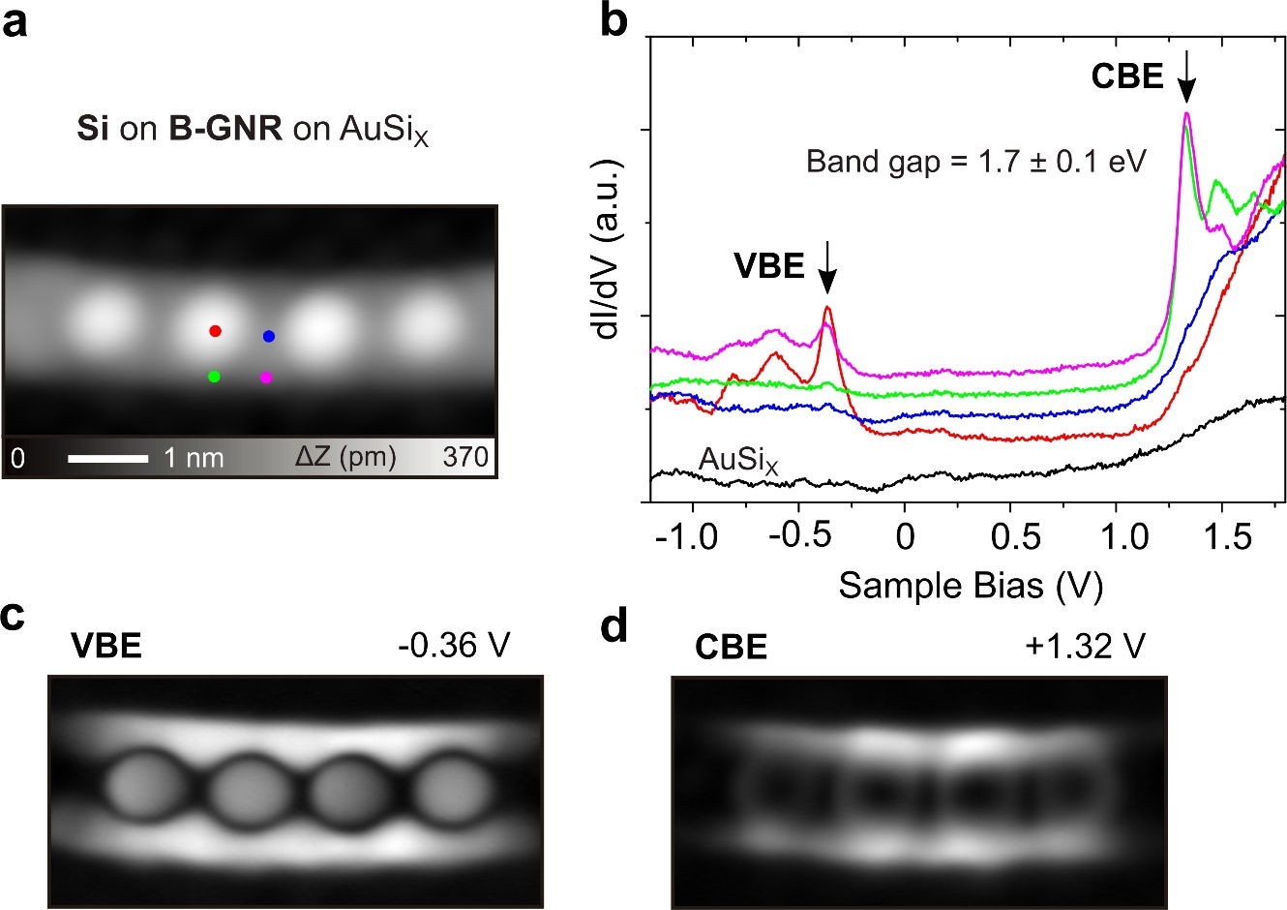
Figure S5. STS measurements on B-GNR with and without adsorbed Si atoms on AuSi_{X}. (a) STM topography of B-GNR with adsorbed Si atoms on AuSi_{X}/Au(111). (b) dI/dV curves measured on colored points indicated in (a). (c)(d) Constant current dI/dV maps at VBE and CBE, respectively. Clear peaks of VBE at -0.36 V and of CBE at +1.32 V can be observed, resulting in a band gap 1.7 ± 0.1 eV. Measurement parameters: V = 200 mV and I = 5 pA in (a).

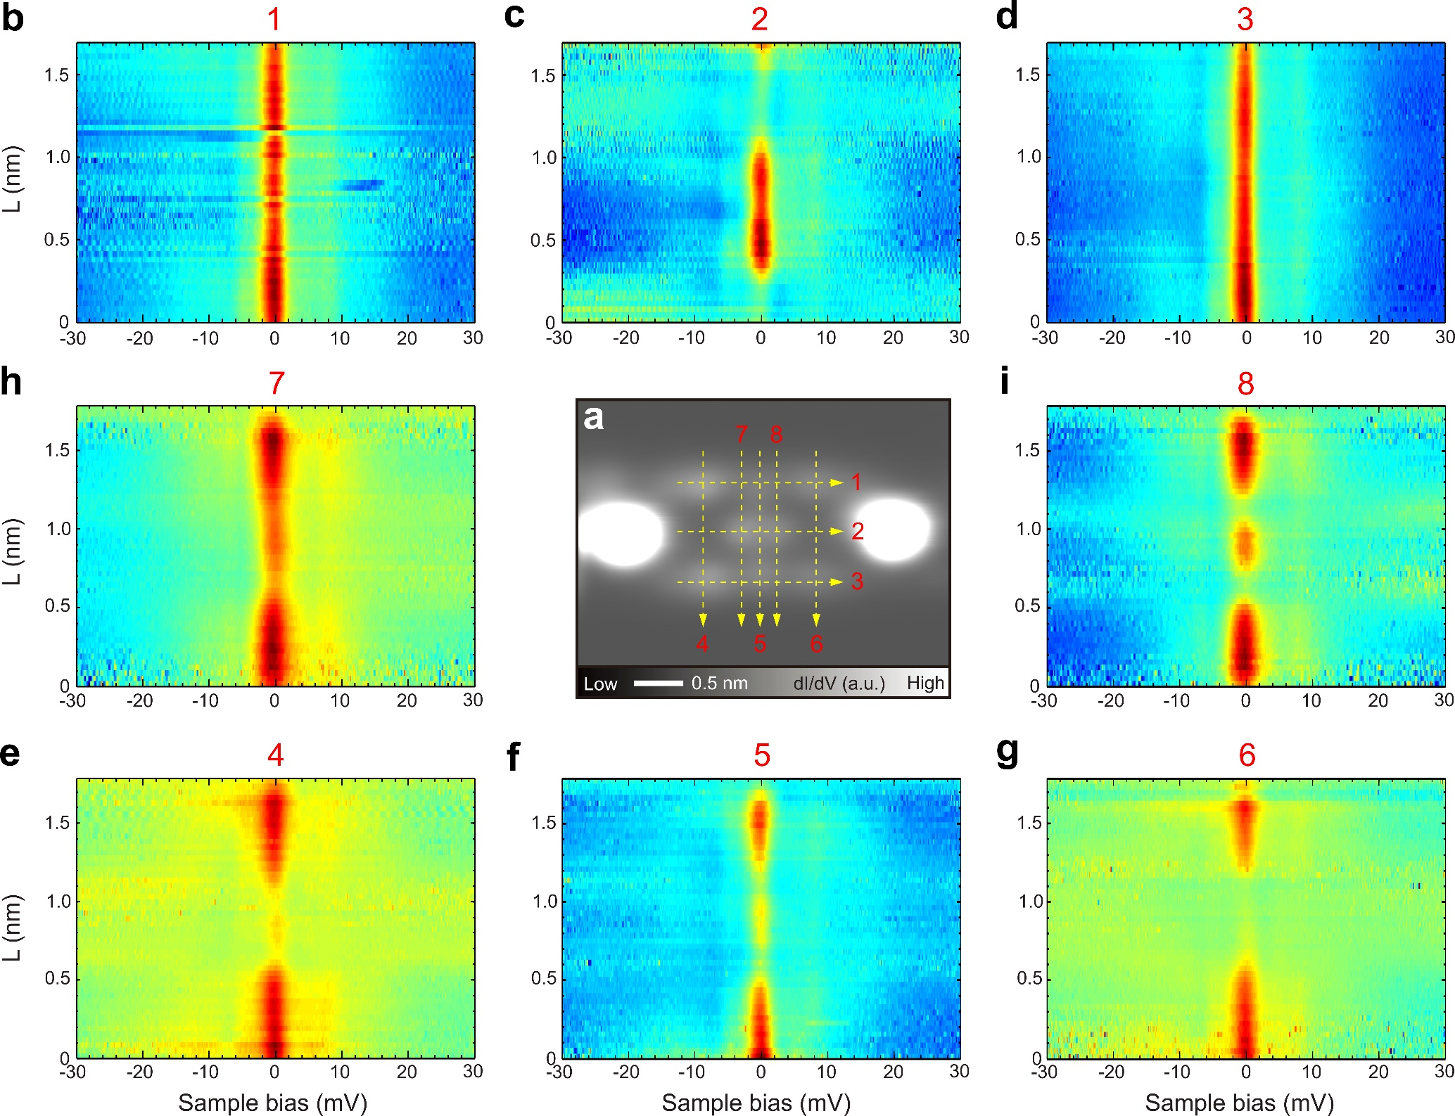
Figure S6. Spatial distribution of spin on B-GNR. (a) Constant dI/dV map with the recovered spin after removing one Si atom by the tip. (b)-(g) A series of dI/dV curves measured along 1,2,3,4,5,6,7,8 lines indicated in (a). Measurement parameters: V = 0 mV, V_{ac} = 1 mV in (a). V = 30 mV, I = 400 pA, V_{ac} = 0.3 mV in (b)-(g).

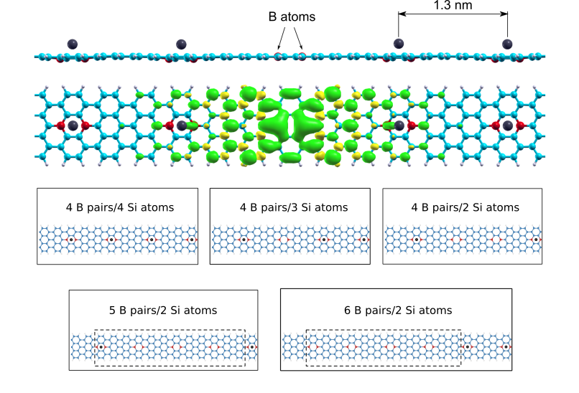
Figure S7. DFT calculations of B-GNR with boron pairs and adsorbed Si atoms. TOP: Side and top view of the B-GNR considering five pairs of boron atoms, where four of them are considered with Si adsorbed while the middle pair has no Si adsorbed. The spin density is shown in the top view of the B-GNR, revealing the spin polarization of the B-GNR around the pair of boron atoms with no Si adsorbed, where the green and yellow colors represent spin up and down densities, respectively. The isosurface value for the spin density was set to 4 × 10⁻⁴ a.u.. BOTTOM: Different unit cells of the periodic ribbons used for the simulations of the spin recovery by the tip-induced manipulation shown in Figure 3a of the main manuscript. The unit cells are represented by the solid black lines. We selected first a unit cell with four B pairs and four Si atoms adsorbed, and then we proceeded to remove the Si atoms one by one until two consecutive Si atoms remained. We then expanded the cell further in order to isolate the chain with 4 B pairs for the cases where only one and none Si atoms are present in the 4 B pair chain. The 4 B pairs chain is highlighted by the dashed black lines. For a better visualization and better comparison to the experiment, we selected only the interesting portions of the large ribbons to make the images shown in Figure 3a of the main paper.

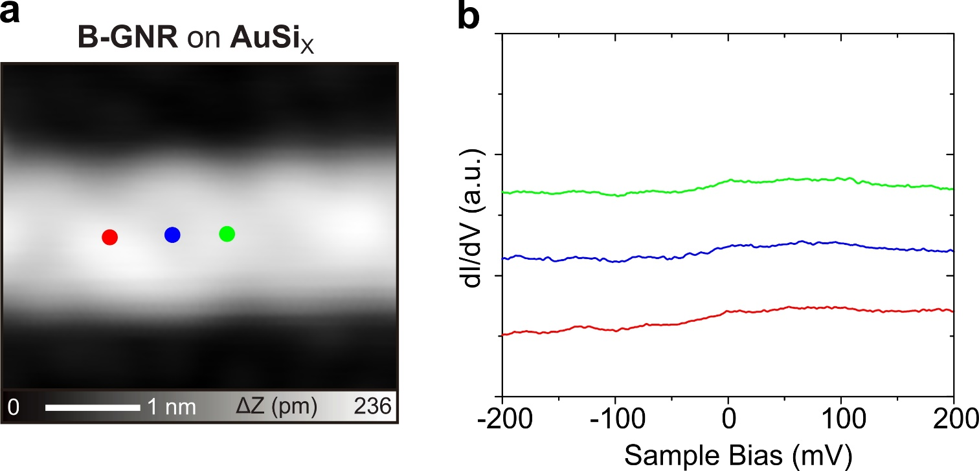
Figure S8. Checking zero-bias peak on B-GNR on AuSi_{X}. (a) STM topography of B-GNR on AuSi_{X}/Au(111). (b) dI/dV curves measured above three sites indicated in (a). B-GNR adsorbed on AuSi_{X}/Au(111) hosts no Kondo resonance if the adsorbed Si atoms was removed by the tip. Measurement parameters: V = 200 mV and I = 5 pA in (a). V = 200 mV, I = 100 pA, and V_{ac} = 10 mV in (b).

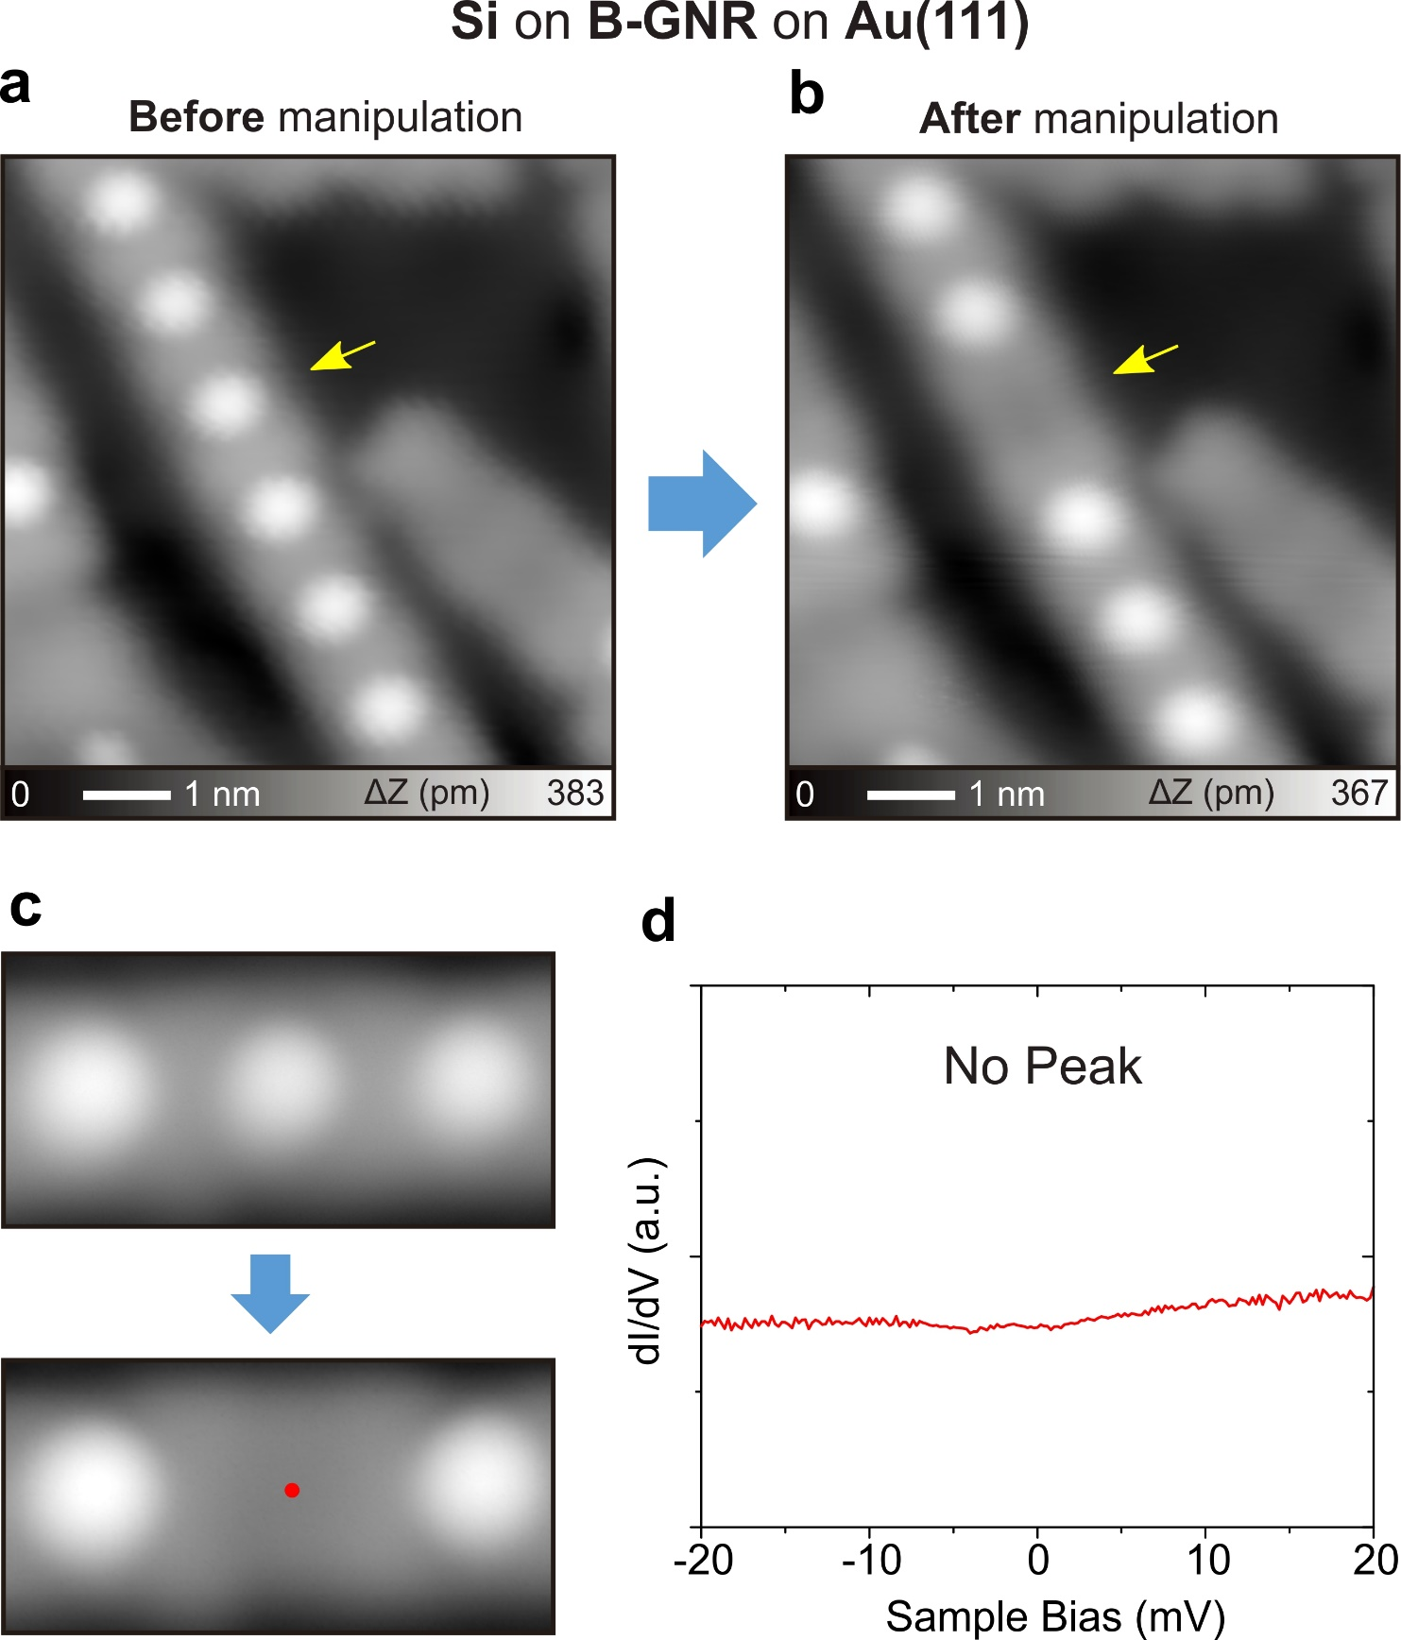
Figure S9. Checking zero-bias peak on B-GNR with Si atoms on Au(111). (a) STM topographies of B-GNR with adsorbed Si atoms on Au(111) before and (b) after removing single Si atom, indicated by arrows. (c) Another example of the Si removal. (d) dI/dV curve measured above the site indicated in (c). If the B-GNR is adsorbed on Au(111) directly, no Kondo resonance was detected even after removal of a Si atom. Measurement parameters: V = 200 mV and I = 10 pA in (a) and (b), V = 200 mV and I = 10 pA in (c), and V = 20 mV, I = 400 pA, V_{ac} = 0.5 mV in (d).

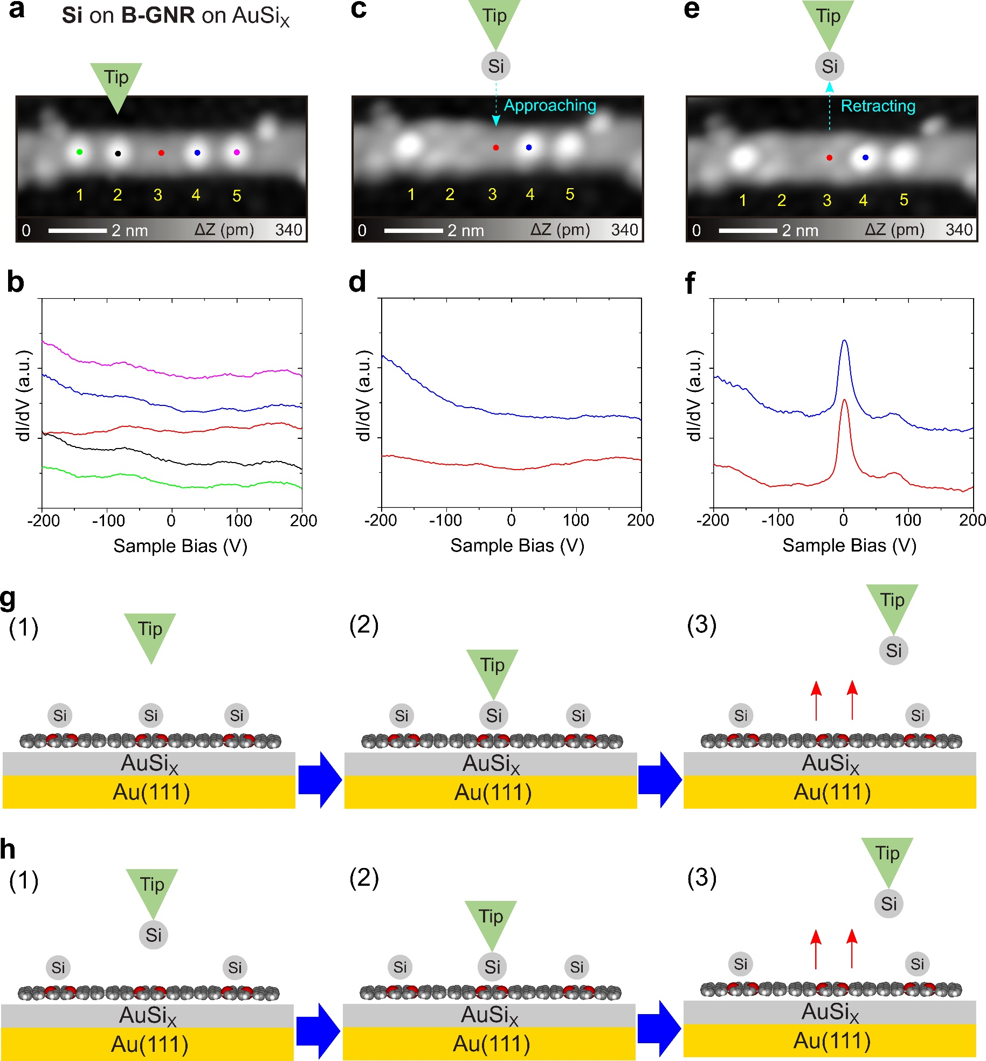
Figure S10. Si-tip inducing zero-bias peak. (a) STM topography of B-GNR with Si atoms adsorbed on AuSi_{X}/Au(111). Site 3 has no Si atom before the experiment. (b) dI/dV curves measured on five sites indicated in (a). No Kondo resonance was detected, which is in agreement with the result in Figure S8. (c) STM topography after removing single Si atom on site 2. The tip apex was terminated by the Si atom. After the removal, the topographic contrast around site 2 became the same as that around the boron site, hosting the Kondo resonance. (d) dI/dV curves measured at two sites indicated in (c). No Kondo resonance was detected at site 3. (e) STM topography after the Si terminated tip contacted to site 3. Detailed procedure: (i) The Si terminated tip was placed above site 3 with setpoints of V = 200 mV and I = 10 pA. (ii) Opened the feedback and set the Si-tip close to site 3 by 0.8 nm. (iii) Retracted the tip and closed the feedback. Note that no significant tip condition was changed. (f) dI/dV curves measured on two sites indicated in (e). Distinct Kondo resonances were measured. Apparently, the gentle contact with the Si tip is responsible for the recovery of S=1/2. (g) Schematic drawings of spin recovery by tip-induced Si atom removal on B-GNR on AuSi_{X}/Au(111) and (h) by contacting with a Si tip. Measurement parameters: V = 200 mV and I = 10 pA in (a), (c), and (e), V = 200 mV, I = 100 pA, V_{ac} = 10 mV in (b), (d), and (f).

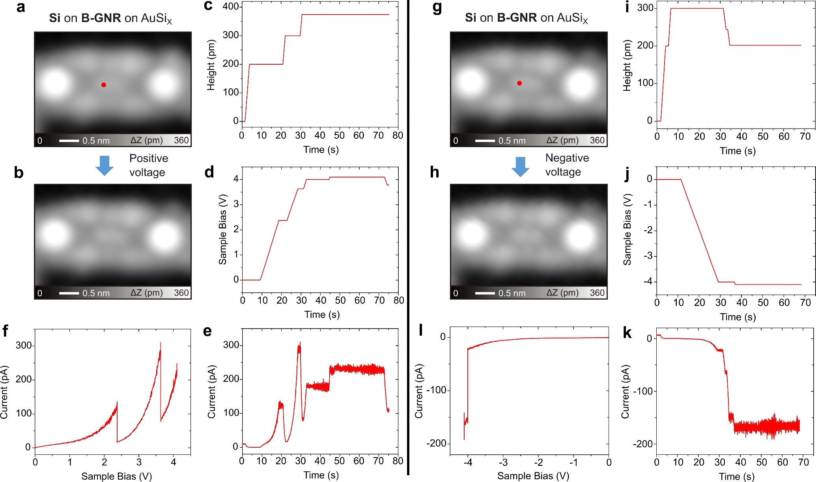
Figure S11. Tip-charging process for B-GNR with Si on AuSi_{X}. (a) STM topography of B-GNR on AuSi_{X}/Au(111) after removing a Si atom in the center. The typical brick-like contrast indicates the presence of zero-bias peak around the boron sites. (b) STM topography of B-GNR after sweeping the sample bias voltage to 4V. The tip position was set to the site indicated by a red dot in (a). During the bias voltage sweeping, (c) tip-sample separation, (d) applied sample bias voltage, and (e) tunneling current as a function of time were recorded. (f) Represented tunneling current versus sample bias voltage curve. The sudden drops of the current indicate the events where the tip-sample separation was changed. No significant change in the spin feature was observed. (g) STM topography of the same B-GNR in (b). (h) STM topography of B-GNR after sweeping the sample bias voltage to -4.1 V. The tip position was set to the site indicated by a red dot in (g). During the bias voltage sweeping, (i) tip-sample separation, and (j) applied sample bias voltage, and (k) tunneling current as a function of time were recorded. (l) Represented tunneling current versus sample bias voltage curve. The sudden drops of the current indicate the events where the tip-sample separation was changed. No significant change in the spin feature was observed. These data indicate the robustness of the spin state by the temporal charging process.

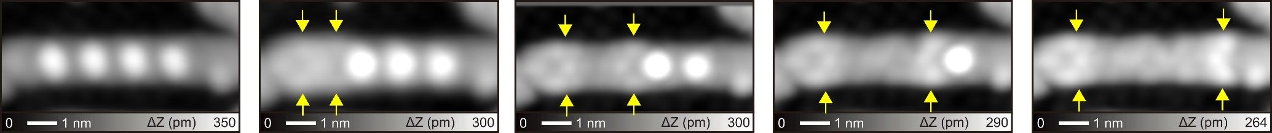
Figure S12. A series of Si removals from B-GNR on AuSi_{X}/Au(111). Arrows indicate bright parts, corresponding the spin features.

Figure S13. Spatial distribution of spin state on B-GNR. The corresponding constant height dI/dV image (the area in Figure 3f) shows the spatial distribution of spin state on B-GNR. Measurement parameters: V = 16 mV, V_{ac} = 5 mV.

